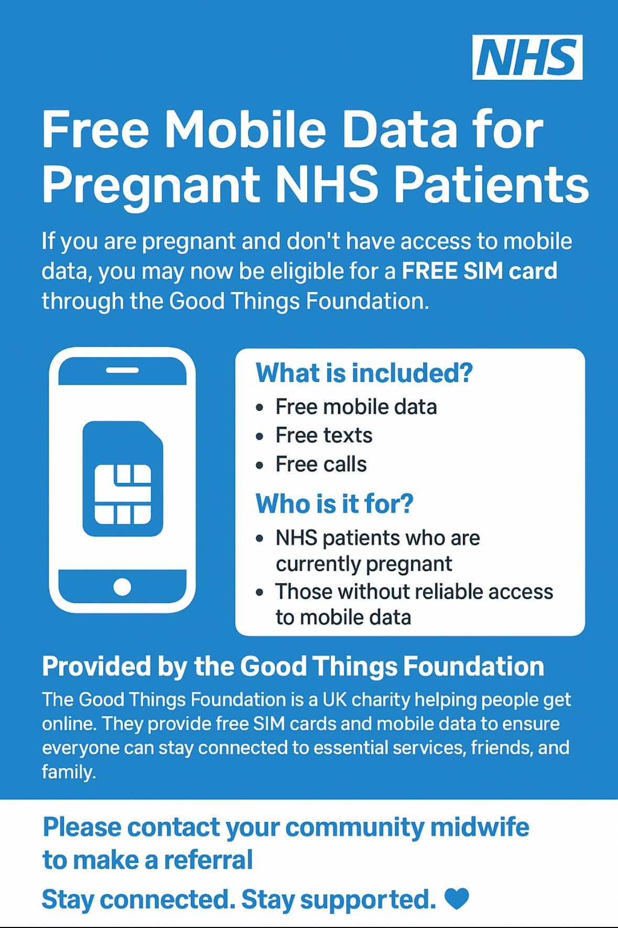
- This allows access to the NHS app & Badger Notes app.
- Please contact your community midwife to make a referral.
- Stay Connected. Stay Supported.

