Tier 1 - Paper ref: | GPC (09/24) XXX

Report title: | Gender Pay Gap Reporting
Sponsoring executive: | Clair Bond – Interim Director of Operational HR and OD  clair.bond2@nhs.net
Report author: | Marsha Belle – Associate Director of People, OD & Culture  mgbelle1@nhs.net
Meeting title: | Group People Committee
Date: | 28 March 2025

1. Summary of key issues two or three issues you consider the PC should focus on in discussion]
- This report is provided to GPC ahead of the mandatory reporting via the Government reporting portal by the 31 March 2025. Search and compare gender pay gap data - Gender pay gap service - GOV.UK
- The report is specific to Walsall Healthcare NHS Trust (WHT) and covers the 2023/2024 reporting period but also draws reference to 2024/2025 data. It should be noted The Royal Wolverhampton NHS Trust Gender Pay Gap Report for the same period has already been received by the Committee. In future, Gender Pay Gap reporting will be provided jointly together with a Gorup based action plan.
- The data for Walsall Healthcare NHS Trust identified that:
- the gender pay gap continues to be a barrier to women accessing the upper middle and upper pay quartiles within the Trust.
- Across the Trust, Women make up 68.2% of employees in the highest-paid quarter, and 85.3% of employees in the lowest-paid quarter. Compared to 14.75% of men in the lower and 31.79% in the upper. Men make up 19.60% of the workforce, just over 1,000 out of over 5000 employees.
- Median hourly pay shows women earned 80p, for every £1 men earned.
- There is a significant difference from figures reported from March 2023, when the average women’s wage was 29% lower, equating to £6.79 per hour lower than male employees.
- 26.0% of women received bonus pay, compared with 74.0% of men, and the women’s bonus pay was 11.0% lower than men’s.

2. Alignment to our Vision [indicate with an ‘X’ which Strategic Objective[s] this paper supports]
Care | - Excel in the delivery Care | ☒
Colleagues | - Support our Colleagues | ☒
Collaboration | - Effective Collaboration | ☐
Communities | - Improve the health and wellbeing of our Communities | ☒

3. Previous consideration [at which meeting[s] has this paper/matter been previously discussed?]
n/a

4. Recommendation(s)
The People Committee is asked to:
- Note the content of the report
- Assure the Trust’s compliance with the legal requirement to produce a gender pay gap report annually.
- Note the Trust’s commitment to reduce the gender pay gap by introducing initiatives that attract a diverse workforce and encourage women to apply for senior posts, clinical, medical and corporate, within the Trust.
- Note that future Gender Pay Gap reporting for RWT and WHT will be aligned and a Group action plan will be developed with clear timescales and outcome measures.

5. Impact [indicate with an ‘X’ which governance initiatives this matter relates to and, where shown, elaborate in the paper]
RWT Board Assurance Framework Risk SR15 | ☐ | Financial sustainability and funding flows.
RWT Board Assurance Framework Risk SR16 | ☐ | Activity levels, performance and potential delays in treatment.
RWT Board Assurance Framework Risk SR17 | ☒ | Addressing health inequalities and equality, diversity and inclusion.
RWT Board Assurance Framework Risk SR18 | ☐ | Potential cyber vulnerabilities and data breaches.
WHT Board Assurance Framework Risk NSR101 | ☐ | Data and systems Security (Cyber-attack)
WHT Board Assurance Framework Risk NSR102 | ☒ | Culture and behaviour change (incorporating Population Health)
WHT Board Assurance Framework Risk NSR103 | ☒ | Attracting, recruiting, and retaining staff
WHT Board Assurance Framework Risk NSR104 | ☐ | Consistent compliance with safety and quality of care standards
WHT Board Assurance Framework Risk NSR105 | ☐ | Resource availability (funding)
WHT Board Assurance Framework Risk NSR106 | ☒ | Equality, Diversity, and Inclusion (incorporating Staff, Patients and Population Health)
Corporate Risk Register [Datix Risk Nos] | ☐
Is Quality Impact Assessment required if so, add date:
Is Equality Impact Assessment required if so, add date:

Report to the Group People Committee on 24 March 2025

Walsall Healthcare NHS Trust Gender Pay Gap Reporting as of 31st March 2024

- Introduction

  - This report aims to assure the Group People Committee of Walsall Healthcare’s compliance with legal and statutory obligations to publish and produce a gender pay gap report annually.
  - Gender Pay Gap reporting legislation requires employers with 250 or more employees to publish annual statutory calculations, to identify if there are pay gap differences between male and female employees and the proportion of the pay gap.
  - The specific requirements of the Equality Act 2010 Act (Gender Pay Gap Information) Regulations 2017 are to publish information for the six specific measures detailed in this report.
  - This report contains a snapshot of pay gap figures for Walsall Healthcare NHS Trust for the Gender Pay Gap reporting period to 31st March 2024.
- Background
2.1 Gender Pay reporting is different from equal pay in that:
- Equal pay concerns men and women earning equal pay for the same or similar work.
- The Gender Pay Gap is the difference between the mean (average) and median hourly rate of all men and women across a workforce
  - Staff working at Walsall Health Care NHS Trust are on the NHS Agenda for Change (AfC) pay grades ranging from Band 2 to Band 9. The amended increments, with quicker progression, mean that staff can reach the top of pay bands through fewer pay step points.
  - A Performance and Development Review process supports the pay progression system. The aim is to ensure that within each pay band, staff have the appropriate knowledge and skills they need to carry out their roles, allowing them to make the greatest possible contribution to patient care.
  - For gender pay gap reporting Employees are defined as:
- Employees – individuals who have a contract of employment
- Workers and agency workers and those with a contract to do work or
- Some self-employed people

- Gender Pay Gap reporting

  - The total number of employees for the reporting period to 31st March 2024 is:

Gender | Total Substantive Workforce | % Substantive Workforce
Female | 4234 | 80.40%
Male | 1033 | 19.60%
Total | 5267 | 100

  - The published data is taken from the Employee Staff Records System (ESR) and has been calculated to show:
- Average gender pay gap as a mean – the average hourly wage
- Average gender pay gap as a median – the median shows the mid-point salary
- The proportion of men and women receiving a bonus payment
- The proportion of men and women in each quartile payment

- Walsall Healthcare Gender Pay Gap Analysis

4.1 Mean Hourly Wage Hourly wage pay gap (all staff)

- The mean is the overall across the whole Trust and is influenced by extremes in high or low hourly rates of pay and uses the hourly pay of all employees to calculate the difference between the average pay of men and women.
- Across the Trust, Women made up 68.2% of employees in the highest-paid quarter, and 85.3% of employees in the lowest-paid quarter. Compared to 14.75% of men in the lower and 31.79% in the upper. Men make up 19.60% of the workforce, just over 1,000 out of over 5000 employees.
The table below sets out the mean average difference over the last 4 years that highlights a contrast in the average hourly pay for women in March 2024 data.

Gender | Mean Hourly Rate - Overall
 | 2023/24 | 2024/25
Male | £23.07 | £24.85
Female | £16.27 | £17.53
Difference | £6.79 | £7.32
Pay Gap % | 29% | 29.44%

  - Median Hourly Wage Hourly wage pay gap (all staff)

- Median hourly pay shows women earned 80p, for every £1 men earned.
- When comparing mean (average) hourly wages, for 2023/24 women’s mean hourly wage was 4.85% lower than men's. This equates to male employees earning an extra £1.20 per hour compared to female employees at the end of March 2024.
- This is a vast difference from figures reported from March 2023, when the average women’s wage was 29% lower, equating to £6.79 per hour lower than male employees.
- This change may be due to a slight increase in the number of staff members and more employees receiving higher salaries. As a result, when the total payroll is divided by the number of employees, the distribution of pay is more balanced.
- 26.0% of women received bonus pay, compared with 74.0% of men, and the women’s bonus pay was 11.0% lower than men’s
- The median is the midpoint salary calculated by sorting the hourly rates of pay from lowest to highest to find the middle value.

The table below sets out the median difference and shows that there is a median difference of 19.74% in favour of male employees.

Gender | Median of Hourly Rate - Overall
 | 2024/25
Male | £18.10
Female | £14.53
Difference | £3.57
Pay Gap % | 19.74%

The median is more accurate as variant hourly rates do not alter it.

4.3 Median and Mean hourly rate analysis of non-medical staff

When looking at the median hourly rate inclusive of medical staff, the gap is magnified and highlights that men earn more than women in medical roles. This can be influenced by various factors such as occupational segregation, where women are concentrated in lower-paying jobs and men in higher-paying positions. The following tables consider the median and mean hourly rate for non-medical staff.

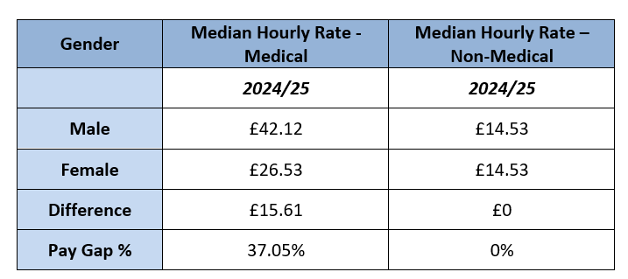
The mean gives a different perspective when the range of hourly rates is used to give an average and indicates that in medical roles, men are paid on average £9.43 more than women, giving a pay gap of -33.48%.

Gender | Mean (Average) Hourly Rate – Medical | Mean (average) Hourly Rate – Non-Medical
 | 2024/25 | 2024/25
Male | £28.16 | £17.14
Female | £18.73 | £14.19
Difference | £9.43 | £2.96
Pay Gap % | 33.48% | 17.25%

4.4 The proportion of males and females in each pay quartile.

The hourly pay quarter shows the percentage of men and women in 4 equally sized groups, ranked from highest to lowest hourly pay.
The tables below set out the proportion of male and female employees by quartile pay bands by number and as a percentage of the total workforce as of March 2024 compared to March 2023.

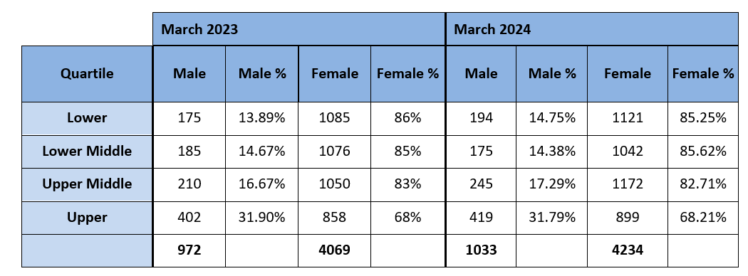
Comparing the data from March 2023 with March 2024 there have been slight changes in each quartile.
There has been an increase in substantive staff within the Trust across all 4 quartile pay bands, except for the lower middle quartile for males, where there has been a small decrease.

There has been an increase in the number of males in the upper middle quartile of 16.67% in 2022/23 data to 17.29% in 2023/24 and a slight decrease in the upper quartile from 31.90% to 31.79% in 2023/24. For females in the upper and upper middle, the rate remains similar, a year on.
I note that males make up only 19.60% of the workforce yet males have an equal percentage in the upper quartile to women, who make up 80.40% of the total workforce.

This will require ongoing monitoring of our recruitment processes and approach to ensure that we are attracting a diverse group of applicants and following these applicants through the recruitment process to identify if there is a trend in inequality when making appointments to upper middle and upper pay band quartiles.

In the lower quartile, there was also a slight increase in numbers with an additional 19 males and 36 females, however, there has been an increase in substantive posts across the Trust of 226 compared to March 2023 data, of which 165 were women. The change to the percentage difference at the lower quartile is minor at 0.86% and a reduction of 0.75% for females. The increase in numbers at the lower quartile may be attributed to an increase in substantive staff from bank workers, within E&F following staffing reviews.

- Actions to be taken to improve the gender pay gap

There is recognition that a gender pay gap still exists and the position has remained static over a few years. However, this is a prevalent issue across the NHS and local government and is not unique to Walsall Healthcare NHS Trust.

Pay gaps often indicate that female workers are missing out on opportunities that could lead to higher pay, such as opportunities to progress in their careers, or to work full-time hours through flexible working patterns. Closing the gender pay gap is about more than just the numbers, it’s about increasing support for female staff.

As a result, the Trust will carry out several actions to address the Gender Pay Gap to improve its overall position. These are outlined below.
- Develop a mentoring pool of senior staff including consultants from divisions who can take on a mentoring role to support career progression.
- Review the approach to advertising within the Trust by considering the language, images and branding used to advertise roles and careers within the organisation with a particular focus on consultant posts.
- Ensure transparency about recruitment, promotion, pay and reward processes through clear communication via internal and external communication processes.
- Ensure that we support career progression for part-time roles and flexible working for existing and new staff, by including this proposition in our adverts for all posts paying attention to the wording in job adverts for all posts with a focus on consultant posts.
- Work with divisions to review which clinical posts can be advertised as part-time or posts that have low female numbers to identify how the post can be made more attractive to encourage more females, to apply for consultant or other posts where there is low female representation.
- Develop career progression roles for new and existing staff to encourage retention.

Wellbeing and Retention
- Encourage a more flexible working approach to job design.
- Ensure that current parental and maternity/paternity leave policies are actively promoted to encourage new parents to take advantage of the scheme.
- Actively support women on maternity leave and encourage line managers to ensure staff use keep-in-touch days to create a positive return to work experience.
Supporting our female colleagues
- Identify and support aspiring women leaders within our organisation to maximise their potential and provide opportunities for development and career progression.
- Reestablish the Women’s and Allies network to champion career progression and development opportunities and offer female employees opportunities to access coaching and mentoring from peers and colleagues.
Data Analysis and Reporting
- Continue detailed analysis of workforce data to identify patterns and trends within divisional areas regarding gender and ethnicity representation, and work with divisions to address any gaps
- Publish further analysis of National Clinical Impact Awards to identify any trends by division, speciality, or demographic, which are impacting the reward of bonuses to female consultants.

- Recommendations

The Group People Committee is asked to:

- Note the content of the report
- Be assured of the Trust’s compliance with the legal requirement to produce a gender pay gap report annually.
- Note the Trust’s commitment to reducing the gender pay gap by introducing initiatives that attract a diverse workforce and encourage women to apply for senior posts, clinical, medical and corporate, within the Trust.
- Note that future Gender Pay Gap reporting for RWT and WHT will be aligned and a Group action plan will be developed with clear timescales and outcome measures.

Marsha Belle
Associate Director of People- OD & Culture

