Information for Professionals
Accessing the School Nurse Service
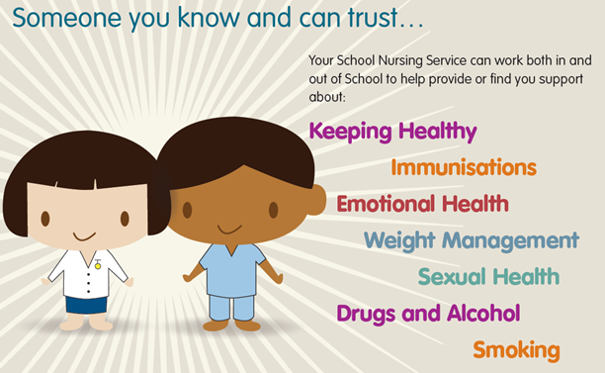

Introduction
The role of Walsall School Nursing Service (SNS) leads on the delivery of the Healthy Child Programme (HCP) 5-19 with the aim of improving the health and well-being of children and young people (CYP). This is achieved by working with partner agencies including the voluntary sector to:
- Help children and young people to lead healthy lives by providing support, information and signposting to other services to enable healthier choices. We provide advice and support on a range of physical and mental health issues.
- Provide a universal health intervention and health promotion in accordance with the Healthy Child Programme 5-19 (DH 2009).
- Working with partners to offer the Right Help, Right time for children, young people and families who need additional support.
- Work within local guidelines and follow the recommendations of ‘Working Together to Safeguard Children’ to keep children and young people safe and well.
- Support CYP with additional health needs such as those in need with long term physical conditions, special educational needs and disability (up to the age of 25 years old).
Age range
- Children and young people between the ages of 4 (in Reception Year) and 19 years (25 years of young people with physical long term conditions and/or disabilities) can access the service.
- They must attend a school in Walsall borough, including private and independent schools or
- Be electively home educated and resident in Walsall
- Children who have continence problems, including night time wetting and are resident in Walsall, attend a Walsall school or have a Walsall GP.
Accessing the School Nursing Service
The service is an ‘open access’ provision which means that parents/carer and young people can self-refer to our service and request access to any of our provision. A professional referral is not always needed. The best way for a parent/carer to contact us is on our Single Point of Access 01922 423449 or via our text service (see below).
Professionals from any agency/service can refer a child or young person to the service. The parent/carer and when appropriate the young person must consent to the referral (see below).
How do we support children and young people?
We offer a range of support for children, young people and their parents/carers. We use a pathway approach to our support. The pathway starts with self help and sign posting, access to parent workshops providing information and strategies to help manage problems and/or group provision for children, young people and parent. Then, if additional support is required we offer a health assessment with a nurse.
We work as part of multi-disciplinary team with our health colleagues in community paediatrics, therapies and CAMHS. On receipt of a referral, if the information provide indicates that the child or young person might need support from another health professional then we might request support from these other services. We will inform you and the parent/carer if we decide this is the most appropriate option.

Referral from Professionals. Professionals must complete the referral form and send it to our secure email schoolnursingadmin.walsall@nhs.net.
Referral form for GP’s and no school based professionals: https://www.walsallhealthcare.nhs.uk/our-services/school-nursing/gps-and-other-professionals/
Referrals from school staff must be accompanied by a school report: https://www.walsallhealthcare.nhs.uk/our-services/school-nursing/schools-and-education-settings/

Referral criteria
Children and young people can be referred to the School Nursing Service for the following reasons:
- Children who are subject of an initial child protection meeting or on a child protection plan will automatically accept into our service and offer a health assessment to identify health needs. Referral must be made via Social Care.
- Children who have a Child in Need. Referrals will be accepted from the child’s Social Worker.
- Children who have an Early Help plan. Referrals will be accepted from the child’s the lead professional
- Children with long term conditions or medical problems which are impacting on their education
- Children who have emotional health and/or behaviour problems
- Children who have moved ‘new’ into the country
- Concerns about weight (overweight or underweight).
- Enuresis bedwetting/Continence
- Children whose development is impacting on their daily activities or education
- Children who have concerns about their sexual health and wellbeing

Exclusion criteria
Children who are not yet attending full time school (i.e. of Early Years Age) are offered support from the Health Visiting Team.
We do not take referrals for health problems which professionals can directly refer to or parents can self-refer to. These include:
- Child and Adolescent Mental Health Services (GP referral only)
- Physiotherapy:https://www.walsallhealthcare.nhs.uk/our-services/physiotherapy/paediatric-physiotherapy-community/
- Podiatry Services: https://www.walsallhealthcare.nhs.uk/our-services/podiatry-community/
- Occupational Therapy: https://www.walsallhealthcare.nhs.uk/our-services/paediatric-occupational-therapy/
- Speech and Language: https://www.walsallhealthcare.nhs.uk/our-services/speech-and-language-therapy/paediatrics/
- Orthoptist – 01922 721172
- Audiology - 01922 721172
- Counselling services -WPH Counselling, Corner House Play Therapy, Kooth Counselling
What will happen once a referral is received from a professional.
All referrals are discussed weekly at our service referral meeting or, if appropriate, at the multi-agency paediatric panel which includes representation from community paediatricians, CAMHS and therapies (Speech & Language, Physiotherapy and Occupational Therapy).
Once a referral is accepted then the parent/carer will be contacted, by letter/email and invited to attend workshop, group intervention or bring their child to a health assessment. The service operates an ‘opt-in’ system. The parent/carer will be provided with the contact details for the School Nursing service and requested to contact the service to book onto the intervention.
If referral forms have incomplete or insufficient information they will be returned to the professional who has made the referral asking for further details to be provided before they can be progressed.
How can I contact my local School Nurse Service?
Professionals, parents/carers and young people can contact the School Nurse Service via the ‘Single Point of Access’ which operates Monday to Friday 9am to 5pm.

Tel: 01922 423349

Email: schoolnursingadmin.walsall@nhs.net

ChatHealth - Confidential and anonymous text service

Parents/carers: 07520 634 909
Young People (aged 11-19): 079480 635 363
Our Websites

Information for young people: www.healthforteens.co.uk

Information for children and their parents: www.healthforkids.co.uk

Information for professionals: https://www.walsallhealthcare.nhs.uk/our-services/school-nursing/

If a child or young person is experiencing an acute and/or urgent medical problem then please advise the parent/carer to make a GP appointment, seek advice from a local pharmacist, contact 111, visit an urgent care centre or in a life threatening emergency phone 999 or attend Emergency Department. More information about helping to StayWell can be found at http://walsallccg.nhs.uk/stay-well-walsall

