

Living Healthy Lifestyles
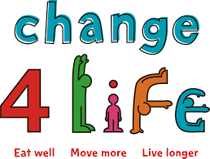

“These days, 'modern life' can mean that we’re a lot less active. With so many opportunities to watch TV or play computer games, and with so much convenience and fast food available, we don't move about as much, or eat as well as we used to” (Change4Life)
The School Nursing Service offer free workshops to parents and carers of children aged 4-19 years. These workshops explore:
- What is a healthy lifestyle
- Thinking about food
- Time to exercise
- 5 Ways to Wellbeing
- Information about our healthy lifestyles programmes for children and families

To find out more about our workshops or book a place on a workshop contact our Single Point of Access on Tel: 01922 423349 or Email schoolnursing@walsallhealthcare.nhs.uk


