Bundle Public Trust Board 4 November 2021
0
Agenda
0. Public Board Agenda - 4 November 21.docx
1
Chair's Welcome; Apologies and Confirmation of Quorum
Chair to present
Declarations of interest
2. Public Declarations of Interest November 2021.docx
2
3
Minutes of the last meeting
3. Public Board Minutes - 07.10.21 CD KW.docx
4
Matters arising and Action Log
4. Action Log Public Trust Board - 4 November 2021.xlsx
5
Trust Values and Nolan Principles
5.1 The Seven Principles of Public Life - Nolan Principles.docx
5.2 Vision Values and Objectives v.2.pdf
6
Chair's Report
Verbal - Steve Field
Chief Executive's Report
7. Chief Executive Officer's Report 4 November 2021 Trust Board.docx
7
8
Quality, Patient Experience and Safety Committee Report
Pam Bradbury
8. QPES Highlight Report FINAL Oct.docx
9
Safe High Quality Care Executive Report
Leads - Manjeet Shehmar, Lisa Carroll
9. SHQC Executive Report to Trust Board 4th Novermber 2021.docx
9a. Trust Board - Agenda Item 26a - BAF SO 01 - Safe, High Quality Care - 13.10.2021.pdf
10
Maternity Update
10. DDoM Board report Nov 2021 V1.docx
11
Mortality Report
Lead - Manjeet Shehmar
11. Mortality Report Oct 21.docx
12
Performance, Finance and Investment Committee Report
Lead - John Dunn
12. PFIC Highlight Public TB.docx
13
Use Resources Well Executive Report
Lead - Ned Hobbs and Russell Caldicott
13. Use Resources Well Executive Report Trust Board Nov 2021 v2 (2).docx
13.2 Appendix 2 BR_New_UseResourcesWell_Presentation_Charts NH.pptx
13.3 Trust Board - Agenda Item 26a - BAF SO 05 - Use Resources Well - 13.10.2021.pdf
14
People and Organisation Development Committee Report
Lead - Junior Hemans
14. PODC Highlight Report September for November 2021 Board.docx
15
Value Our Colleagues Executive Report
Lead - Catherine Griffiths
15. Value our ColleaguesTrust Board November 2021 Exec Update.docx
15a. Trust Board - Agenda Item 26a - BAF SO 04a - Leadership Culture & OD - 13.10.2021.pdf
15b. Trust Board - Agenda Item 26a - BAF SO 04b - Organisational Effectiveness - 13.10.2021.pdf
15c. Trust Board - Agenda Item 26a - BAF SO 04c - Making Walsall & BC BPTW - 13.10.2021.pdf

16
Staff Staffing Report
Lead - Lisa Carroll
16. Safe Staffing Report to Public Trust Board 4th November 2021.docx
17
Guardian of Safe Working Report
Lead - Manjeet Shehmar
17. GOSWH front page for Nov 20 Dec 20 Jan 21 quarterly report 2021.docx
17.1 GOSWH Nov 20 Dec 20 Jan 21 quarterly report for PODC Sept 21.docx
17.2 Appendix 1 GOSWH Nov 20 Dec 20 Jan 21 quarterly report Sept 21.xlsx
18
Freedom to Speak Up Guardians Report
Lead - Catherine Griffiths
18. Board Report FTSU 4 November 2021.docx
19
Walsall Together Partnership Board Report
Lead - John Dunn
19. Walsall Together Partnership Board Highlight Report Nov 21 v2.docx
20
Care at Home Executive Report
20.Care At Home Executive Report Nov 21 v2.docx
20a. Operational Update Cover September 2021.docx
20b. WT Operational Update Oct 1.1 Added whg.pptx
20c. Trust Board - Agenda Item 26a - BAF SO 02 - Care at Home - 13.10.2021.pdf
21
Acute Provider Programme Board Update
Lead - Simon Evans and Ned Hobbs
21. Acute Provider Programme Board and working closely with partners update.docx
22
COVID-19 Board Assurance Framework
22. Trust Board - Agenda Item 26a - BAF SO 06 - COVID - 13.10.2021.pdf
23
24
25
Any Other Business Questions from the Public
Date and Time of Next Meeting


MEETING OF THE PUBLIC TRUST BOARD
Held in public on Thursday 4 November 2021 from 10.30am to 13.30pm
Meeting held virtually via Microsoft Teams
AGENDA
#
Agenda Item
Purpose
Lead
Format
Time
OPENING ITEMS
1.

Chair’s welcome; apologies and confirmation of quorum
Inform

Steve Field

Verbal

10.30

2.
Declarations of interest
Inform
Steve Field
Enclosure
3.
Minutes of last meeting
Approve
Steve Field
Enclosure
4.
Matters arising and action log
Review
Steve Field
Enclosure
10.35
5.
Trust Values and Nolan Principles
Inform
Steve Field
Enclosure
10.40
6.
Chair’s Report
Inform
Steve Field
Verbal
10.45
7.
Chief Executive’s Report
Inform
David Loughton
Enclosure
10.50
PROVIDE SAFE, HIGH QUALITY CARE
8.

Quality, Patient Experience and Safety Committee Report
Assure Inform
Pamela Bradbury

Enclosure

11.00

9.

Safe High Quality Care Executive Report (including Board Assurance Framework and performance)
Assure Inform

Manjeet Shehmar Ann-Marie Cannaby Lisa Carroll
Enclosure

11.15

10.

Maternity Update

Assure Inform
Carla Jones-Charles

Enclosure

11.25

11.

Mortality Report

Assure Inform
Manjeet Shehmar

Enclosure

11:35

USE RESOURCES WELL
12.

Performance, Finance and Investment Committee Report

Assure Inform

John Dunn

Enclosure

11.45

13.

Use Resources Well Executive Report (including Board Assurance Framework and performance)
Assure Inform

Ned Hobbs Russell Caldicott

Enclosure

11.50

12.05 – 12.15 COMFORT BREAK
VALUE OUR COLLEAGUES
14.

People and Organisational Development Committee Report
Assure Inform
Junior Hemans

Enclosure

12.10

15.

Value Our Colleagues Executive Report (including Board Assurance Framework and performance)
Assure Inform

Catherine Griffiths

Enclosure

12.15

16.

Safe Staffing Report

Assure

Ann-Marie Cannaby
/Lisa Carroll
Enclosure

12.25

17.

Guardian of Safe Working Report

Assure Inform
Manjeet Shehmar

Enclosure

12.30

18.
Freedom to Speak Up Guardians Report
Assure
Catherine Griffiths
Enclosure
12:35
CARE AT HOME
19.

Walsall Together Partnership Board Report

Assure Inform
Matthew Dodd

Enclosure

12.40

Lead Presenters
Name of Lead
Position of Lead
Prof Steve Field
Chair of Trust Board
Mr John Dunn

Vice Chair of Trust Board; Chair of Performance, Finance and Investment Committee
Mrs Pamela Bradbury

Non-Executive Director; Chair of Quality, Patient Experience and Safety Committee
Mr Junior Hemans

Non-Executive Director; Chair of People and Organisational Development Committee
Mrs Mary Martin
Non-Executive Director; Chair of Audit Committee
Mr Paul Assinder
Non-Executive Director; Chair of Charitable Funds Committee
Prof David Loughton
Interim Chief Executive Officer
Prof Ann-Marie Cannaby
Interim Chief Nursing Officer/Deputy Chief Executive Officer
Dr Manjeet Shehmar
Interim Medical Director
Mr Russell Caldicott
Director of Finance and Performance
Ms Catherine Griffiths
Director of People and Culture
Mr Ned Hobbs
Chief Operating Officer
Mrs Glenda Augustine
Director of Planning and Improvement
Ms Lisa Carroll
Director of Nursing
Mrs Carla Jones-Charles
Divisional Director of Midwifery, Gynaecology & Sexual Health
Mr Simon Evans
Acting Chief Strategy Officer
Mr Matthew Dodd
Acting Director of Integration
#
Agenda Item
Purpose
Lead
Format
Time
20.

Care at Home Executive Report (including Board Assurance Framework and performance)
Assure Inform

Matthew Dodd

Enclosure

12.45

WORK CLOSELY WITH PARTNERS
21.

Acute Provider Programme Board update

Assure

Ned Hobbs Simon Evans
Enclosure

12.55

GOVERNANCE AND WELL LED
22.
COVID-19 Board Assurance Framework
Assure
Ned Hobbs
Enclosure
13.10
CLOSING ITEMS
23.
Any other business
Discuss
Steve Field
Verbal
13.20
24.
Questions from the Public
Discuss
Steve Field
Verbal
DATE AND TIME OF NEXT MEETING
Thursday 2 December 2021 at 10.30am
EXCLUSION OF THE PRESS AND MEMBERS OF THE PUBLIC
Exclusion to the Public – To invite the Press and Public to leave the meeting because of the confidential nature of the business about to be transacted (pursuant to Section 1(2) of the Public Bodies (Admission to Meetings) Act 1960).

1

MEETING OF THE PUBLIC TRUST BOARD - Thursday 4th November 2021

Declarations of Interest

AGENDA ITEM: 2

Report Author and Job Title:

Keith Wilshere
Interim Trust Secretary
Responsible Director:

Steve Field, Trust Board Chair

Action Required

Approve ☐ Discuss ☐ Inform ☐ Assure ☒

Executive Summary

The report presents a Register of Directors’ interests to reflect the interests of the Trust Board members.
The register is available to the public and to the Trust’s internal and external auditors, and is published on the Trust’s website to ensure both transparency and also compliance with the Information Commissioner’s Office Publication Scheme.

Recommendation

Members of the Trust Board are asked to note the report

Does this report mitigate risk included in the BAF or Trust Risk Registers? please outline

There are no risk implications associated with this report.

Resource implications

There are no resource implications associated with this report.

Legal and Equality and Diversity implications

It’s fundamental that staff at the Trust are transparent and adhere to both our local policy and guidance set out by NHS England and declare any appropriate conflicts of interest against the clearly defined rules.

Strategic Objectives

Safe, high quality care ☒
Care at home ☒
Partners ☒
Value colleagues ☒
Resources ☒

Register of Directors Interests at October 2021
2
Name

Position held in Trust

Description of Interest

Professor Steve Field

Chair

Chair: Royal Wolverhampton NHS Trust
Director: EJC Associates
Trustee for Charity: Pathway Healthcare for Homeless People
Trustee: Nishkam Healthcare Trust Birmingham
Honorary Professor: University of Warwick
Honorary Professor: University of Birmingham
Mr John Dunn

Vice Chair
Non-executive Director
Non-Executive Director, Royal Wolverhampton NHS Trust
Ms Pamela Bradbury

Non-executive Director

STP Workforce Bureau (Vaccination Programme)
Partner, Dr George Solomon is a Non- Executive Director at Dudley Integrated Health and Care Trust
Mr Junior Hemans

Non-executive Director

Non-executive Director - Royal Wolverhampton NHS Trust
Visiting Lecturer – University of Wolverhampton
Director – Libran Enterprises (2011) Ltd
Chair/Director - Wolverhampton African Caribbean Resource Centre
Chair - Tuntum Housing Association (Nottingham)
Company Secretary – The Kairos Experience Ltd.
Member – Labour Party
Mentor – Prince’s Trust
Spouse is a therapist at Royal Wolverhampton NHS Trust
Ms Mary Martin

Non-executive Director

Royal Wolverhampton NHS Trust - Non- Executive Director
Trustee/Director, Non-Executive Member of the Board for the charity - Midlands Art Centre
LTDTrustee/Director, Non-Executive - B:Music
Director - Friday Bridge Management Company Ltd
Non-Executive Director/Trustee - Extracare
3
Name

Position held in Trust

Description of Interest

Charitable Trust (stood down 21 June 21)
Mr Paul Assinder

Associate Non- executive Director

Chief Executive Officer - Dudley Integrated Health & Care Trust
Director of Rodborough Consultancy Ltd.
Governor of Solihull College & University Centre
Honorary Lecturer, University of Wolverhampton
Associate of Provex Solutions Ltd.
Mr Rajpal Virdee

Associate Non- executive Director

Lay Member, Employment Tribunal Birmingham
Vice President of Pelsall Branch Conservative Party Association (from 19th June 2021)
Mrs Sally Rowe

Associate Non- Executive

Executive Director Children’s Services - Walsall MBC
Trustee of the Association of Directors of Children’s Services
Professor David Loughton

Interim Chief Executive

Chief Executive – Royal Wolverhampton NHS Trust
Health policy advisor to the Labour and Conservative Parties
Member – Dementia Health and Care Champion Group
Member of Advisory Board – National Institute for Health Research
Chair – West Midlands Cancer Alliance

Prof Ann-Marie Cannaby

Interim Chief Nursing Officer/Deputy Chief Executive

Chief Nurse – Royal Wolverhampton NHS Trust
Director – Ann-Marie Cannaby Limited

Visiting Professor – Staffordshire University

Honorary Fellow – La Trobe University, Victoria, Australia
Teaching Fellow – Higher Education Academy

Member – Royal College of Nursing

Visiting Professor – Birmingham City University
RECOMMENDATIONS
The Board is asked to note the report
4
Name

Position held in Trust

Description of Interest

Mr Russell Caldicott

Director of Finance and Performance

Member of the Executive for the West Midlands Healthcare Financial Management Association (HFMA)
Dr Manjeet Shehmar

Acting Medical Director

Company Director Association of Early Pregnancies Units UK
Executive Member Association of Early Pregnancy Units UK
Private Practice Health Harmonie ceased August 2021
Ms Catherine Griffiths
Director of People and Culture
Catherine Griffiths Consultancy ltd
Chartered Institute of Personnel (CIPD)
Mr Ned Hobbs

Chief Operating Officer

Father – Governor Oxford Health FT
Sister in Law – Head of Specialist Services St Giles Hospice
Mrs Lisa Carroll

Director of Nursing

Spouse - Royal College of Paediatrics and Child Health (RCPCH) Officer for Research
Spouse - RCPCH Assistant Officer for exams
Spouse - Chair of NHS England/Improvement Children and Young People’s Asthma Effective Preventative Medicines Group
Spouse - Consultant Paediatrician and Clinical Lead for Respiratory Paediatrics at University Hospitals of North Midlands NHS Trust (UHNM)
Spouse - Guardian of Safe Working and Deputy Clinical Tutor UHNM
Spouse - West Midlands National Institute for Health Research (NIHR) Clinical Research Scholar
Ms Glenda Augustine

Director of Performance & Improvement
No interests to declare


MEETING OF THE PUBLIC TRUST BOARD
HELD ON THURSDAY, 7TH OCTOBER 2021 AT 10.30AM HELD VIRTUALLY VIA MICROSOFT TEAMS
PRESENT
Members
Prof Steve Field CBE Mrs Pamela Bradbury Mr Junior Hemans Ms Mary Martin
Mr Paul Assinder Mr Rajpal Virdee
Prof David Loughton CBE Prof Ann-Marie Cannaby Ms Lisa Carroll
Mr Russell Caldicott Miss Catherine Griffiths Mr Ned Hobbs
Dr Manjeet Shehmar
Chair of the Board of Directors Non-Executive Director
Non-Executive Director Non-Executive Director
Associate Non-Executive Director Associate Non-Executive Director Interim Chief Executive
Interim Chief Nursing Officer/Deputy Chief Executive Director of Nursing
Director of Finance and Performance Director of People and Culture
Chief Operating Officer Acting Medical Director
In attendance
Mr Kevin Bostock Mr Matthew Dodd
Mrs Carla Jones-Charles Ms Sally Evans
Mr Simon Evans Mr Mike Sharon Mrs Jane Wilson Ms Charlotte Hill Mr Garry Perry Mr Keith Wilshere Ms Cody Long Ms Fiona Pickford
Advisory Director of Governance, RWT Support Team Director of Transformation, Walsall Together
Divisional Director of Midwifery, Gynaecology and Sexual Health Director of Communications and Engagement
RWT Chief Strategy Officer
RWT Strategic Advisor to the Board Staff Side Representative
Medical Directorate Programme Lead
Associate Director - Patient Relations & Experience Interim Company Secretary
Head of Regulations and Standards Head of Safeguarding
Apologies
Mrs Glenda Augustine Mr John Dunn
Director of Planning and Improvement
Non-Executive Director; Vice Chair, Board of Directors
1
148/21
Welcome, Apologies and Confirmation of Quorum

Prof Field welcomed everyone to the meeting and noted the apologies. He reported the departure of several Board members, Mrs Anne Baines and Mr Ben Diamond - Non-Executive Directors; Dr Matthew Lewis moving to University Hospitals North Midlands, Mr Daren Fradgley on secondment to Sandwell and West Birmingham and Mr Richard Beeken appointed Chief Executive of Sandwell & West Birmingham Trust and he wished them all well. He confirmed the recruitment process was in place for replacements and additional non-executive and associate non-executive directors. He welcomed Mr Matthew Dodd covering Mr Fradgley’s role with Mr Sharon and Walsall Together, Mr Simon Evans covering strategy in the interim, and Mr Stringer the Senior Information Risk Owner (SIRO) and IT technical aspects. He confirmed John Dunn was to take the chair of Walsall Together in the interim alongside a review of the Chair and Terms of Reference for the committee by Mr Sharon. Dr Shehmar had joined at the last meeting and Prof. Field noted that there was already positive feedback on her activities since taking on the role. He outlined his commitment to further develop the Board, increase its challenge and assurance roles, and to increase the diversity of the members.
149/21
Declarations of Interest

No further interests were declared in addition to those published.
150/21
Minutes of Last Meeting

The minutes of the meeting held on 2nd September 2021 were approved as read.

2
151/21
Matters Arising and Action Log

The Board received the action log and updates were noted.
152/21
Trust Values and Nolan Principles

Prof Field brought the attention of the Board to the seven principles of public life (the Nolan Principles) and the Trust Values. Mr Perry joined the meeting.
153/21
Chair’s Report

Prof. Field presented his report. He highlighted that he had met with the Chairs of the Dudley Foundation Trust, Mental Health Trust, and Integrated Care system (ICS) and had constructive discussions on collaboration across the trusts. He highlighted the leadership Diane Wake and Jonathan Odum in developing clinical co-operation. He also noted that he had had very positive discussions with the Chief Executive of the Council who was very supportive of the changes being made at the Trust and the review of Walsall Together as a Partnership review.

Resolved: that the Chair’s Report be received and noted by the Board.
154/21
Chief Executive’s Report

Prof Loughton presented his report and highlighted the involvement in local, regional and national meetings of significance and interest to the Board including developments in research, his concerns regarding additional pressures over the winter period and what he regarded as lasting changes to patterns of demand and activity levels and achieving safe staffing levels.

Resolved: that the Chief Executive’s Report be received and noted.
155/21
COVID-19 Board Assurance Framework

Prof. Field suggested this item in future was moved to later in the agenda as Winter Pressures were now dominating discussions. He also reminded the board to ensure they had their flu and Covid booster vaccinations, and he reiterated the importance of all staff getting their vaccinations as a professional responsibility. He also highlighted that staff absences created pressure on other staff that impacted on patient care.
Action: that the report is moved to later in the agenda.
Resolved: that the COVID-19 Board Assurance Framework be received and noted.
PATIENT STORY
156/21
Patient Story

Ms Carroll introduced the Patient story, Jason, shared by Garry Perry telling the story from the perspective of a relative who lost his brother to COVID-19 and who died in the hospital. He related the experiences of his family with the hospital, and he commended the care he and his family had received as compassionate and caring throughout. Prof. Field expressed, on behalf of the Board, it’s thanks and condolences to Garry and his family. He thanked all the staff that had supported them through a tragic and difficult time. Mr Virdee noted the care received and the support given by staff was commendable.

Mr Perry said many other staff members across the organisation had gone through similar experiences and that he and his family had taken comfort from knowing they had not been on their own. He said that the support he had received from his team and other staff groups was exceptional and that if any group of staff embodied the trust values, it was the staff on ICU and in the emergency department who had done everything they possibly could. Mrs Bradbury acknowledged the bravery of sharing the story and noted the comfort of the heart keepsake and the skin to skin contact at the bedside and she reflected on the seemingly small things that had made a difference for the family.

Mr Assinder noted the caring provided and asked whether, on reflection, there was anything that could have been done differently. Mr Perry reiterated the importance of families being able to visit their loved one. Dr Shehmar spoke about a doctor working on the frontline in AMU whose parents lived in another country and had passed away. She said he had started his own support group as he had found strength in supporting other people and that had helped him get through it. Mr Perry thanked the Board for listening to the story and asked that it continued to ensure the patient voice was central to what the Trust did.

Resolved: that the Patient Story be received and noted.
3
PROVIDE SAFE, HIGH QUALITY CARE
157/21
Quality, Patient Experience and Safety Committee Report

Mrs Bradbury Chair of the Quality, Patient Experience & Safety Committee (QPES), presented her Chairs report from the meeting held on 30th September and noted:
- patient story had been received.
- combined elective (overnight) and day case surgery was restored to 108% of 2019 activity.
- 6 of 7 theatres had been open during August with 601 elective procedures completed.
- 6 Week Wait (DM01) Diagnostics performance was reported to be the best in the country in July, however temporary staff absence within the ultrasound service (sickness and self- isolation) had meant performance had deteriorated in August with an anticipated recovery by the end of October and any implications would be monitored at QPES.
- despite the cessation of routine elective services during the pandemic, the 18-week Referral to Treatment (RTT) performance was stable; with 70.27% of patients now waiting under 18 weeks at the end of August.
- recommended the approval of the Urgent & Emergency Care Resilience Winter Plan, and noted that should the worst-case scenario be realised, the plan was currently insufficient to address potential demands from increased acuity of non-elective admissions, higher prevalence of flu/norovirus/COVID/Respiratory Syncytial Virus (RSV) in children, and challenges in social care provision for Medically Stable for Discharge (MSFD) patients.
- the Community update had reported increased levels of demand with a high level of absence.
- the Care Navigation Centre had continued to operate as an escalation point for clinical deterioration in the community and the clinical teams supporting care homes had been able to provide a full schedule of ward rounds within the homes.
- the number of patients medically stable for discharge had continued to be under more pressure due to the package of care crisis, although new services such as the Integrated Assessment Hub had continued to have a positive impact in reducing numbers of admissions.
- referrals into community pathways for patients with COVID had increased in August and referrals into the Long COVID pathway had remained high, exacerbated by strong numbers of weekly referrals from Primary Care since it had commenced in May 2021.
- the target for Clostridium difficile 2021/22 had been agreed internally at 29 cases and this was in line with the trajectory.
- VTE compliance for August was 92.03% with Divisional teams reporting performance and plans to Patient Safety Group (PSG).
- the percentage of adult patients screened and receiving antibiotics within 1 hour in the Emergency Department was 93.8%, the prevalence of timely observations 88.14%, and 19 clinical areas had achieved more than the 85% target, an increase from 17 in July 2021
- falls per 1000 bed days in August was 3.76 and remained significantly below the national average of 6.1.
- the maternity update reported a high level of demand last month, that an active recruitment programme was in place that had already appointed 2 new consultants.
- there was 1 serious incident reported last month with a rapid review of the incident and actions taken included supporting the staff involved and a review of foetal monitoring training.
- she was happy to hear of the 2 new significant appointments of Head of Serious Incident Management who was overseeing the backlog of issues, and a Patient Safety specialist who was leading the Serious Incident (SI) process redesign and who was to support future divisional compliance with the SI process and using the lessons learned from SIs.
- good progress had been made to address gaps in the mental health service provision for adults, children and young people with engagement from the CCG and STP and included the recruitment of a mental health team with supporting infrastructure, alongside training for staff in the resilience training programme plus closer working with the Mental Health Trust and CAMHS

Resolved: that the report from the Chair of the Quality, Patient Experience and Safety Committee be received and noted.
158/21
Safe High Quality Care Executive Report

Dr Shehmar presented the Safe High-Quality Care Executive report that included the relevant Board Assurance Framework (BAF) risk and the performance dashboard.
4

She reported on work on sepsis and hospital acquired infections including pneumonia increases during the winter; she had met with the Infection Control Team and the Speech and Language Team in trying to improve mouth care to reduce hospital acquired infections. She advised that the Trust had a clinical lead for sepsis who was building a team to include outreach in line with other trusts services. She stressed the importance of the recruited core mental health team. She said was pleased that NHS England/Improvement (NHSE/I) had taken on board the issues for services for young children and young adults and the regional lack of Tier 4 beds that had placed a huge strain on Paediatric services. She said she was pleased that the Clinical Fellowship had been approved to get a future pipeline of staff.

Dr Shehmar reiterated that services were doing what they could for sick children with RSV and that the regional critically sick children team was not necessarily able to respond in the way that they do previously. She said that the Trust had already rolled out a training package for all intensive care consultants, paediatrics and emergency department and was running simulations to make sure that the best care that could be provided, across extended hours, was provided. Ms Carroll added that the international nursing recruitment was underway and going well as an important part of the winter plan. She added that the outcome of the CQC inspection report published 1st October indicated ‘Requires Improvement’ was maintained and that there would be a detailed action plan in place.

Ms Carroll said that there had been outbreaks of COVID-19 on wards 21, 1 and 3, and an outbreak meeting had been held with Public Health England and NHSE/I with no further cases. She said there had been some positive feedback on management of the outbreak with some lessons identified relating to staff LAMP testing. Mr Assinder asked how timely observations had been tackled. Ms Carroll said that the process was robust with a set parameter for observations with a flag on the system for if it took place outside accepted timings. She said that these had been subject of manual audits and checks and that the 85% compliance figure was internally set.

Ms Martin referred to the winter plan and asked how the decision-making process worked. She also noted differences on manual and IT audits on sepsis asking which was correct and the timeline to get sorted. Mr Hobbs responded that there was two key decision-making structures responding to changing patterns of demand with 3 times a day meetings, cross divisional meetings and the cross divisional tactical command addressing small/medium demand issues. Dr Shehmar said the manual sepsis audit was correct and that she had met with the IT and Informatics teams to address the issues regarding the denominator and way of reporting. She said she hoped to have an update in the next fortnight.

Prof. Loughton asked whether staff could opt out of LAMP testing. Ms Carroll said that all staff would be registered and if they declined to do the test they would have to say why. Prof.
Loughton said he was clear that staff could not decide to opt out of having a lamp test. Mr Virdee agreed that this was one of the things staff could not opt out of and there should be sanctions and he asked if there was any national regulation or guidance on mandatory LAMP testing. Prof Loughton said his priority was to the patients and other staff.

Resolved: that the Safe High-Quality Care Executive report be received and noted.
159/21
Maternity Update

Mrs Jones-Charles presented the report. She notified the Board that recruitment had continued despite there being a national shortage and competition with neighbouring Trusts. Prof. Field commented on the thorough and well-presented paper, and he asked if there had been any comment on the CQC unannounced inspection feedback and final report.

Mrs Jones-Charles confirmed the CQC Final Report had been published with a difficult impact on staff and staff morale with lessons to be learned, things to be done better, and to make sure that staff were fully informed and supported with pressures in staffing, vacancies, staff wanting to leave, absences due to covid and other reasons. She said that an action plan was in place with a focus on how to raise concerns that had completed its first phase of listening exercises. She said she expected to be able to provide and update at November or December Board. She said that some functional things had been corrected quickly and were being closely monitored.
5

Prof. Field said he was confident the service was moving in right direction judging from reports, that the feedback and the quality of the assessment was fair, that it was important to understand the staff feelings and need to move forward quickly and improve for our staff and patients. Dr Shehmar confirmed an external consultant with previous leadership experience had been brought in to help support the maternity team and obstetricians work through the report. Prof. Field recommended a further discussion with the non-executives for a better understanding. Mr Virdee said he was pleased to see an action point about empowering staff to speak up. Mrs Jones-Charles said it was an absolute priority was to feature in the mandatory maternity specific training as an element around how to raise concerns.

Resolved: that the Maternity Update be received and noted.
160/21
Safeguarding Annual Report

Ms Carroll introduced Ms Pickford, the Head of Safeguarding. Ms Pickford advised that the report was presented at QPES on a regular basis, demonstrating the correct level of assurance using the STP Assurance Framework. She said she thought it was a good start with positive feedback to date. She recommended the planned actions for the year ahead. Ms Carroll reiterated that the feedback from the CCG and the local authority was that the required systems and processes were in place and that monthly reporting was no longer required and would now be quarterly. Prof. Field said that was really good feedback and reassuring and he congratulated the team. Ms Pickford advised she was reviewing the staffing model at Walsall as changes were required for staffing and infrastructure to tackle the challenges. She also said that the learning disability provision needed a complete review and scoping as the current level of support from the mental health Trust was limited. Prof. Field suggested a report in March 2022 on progress. Professor Loughton asked that Ms Pickford continue with the rapid progress and recruitment as Safeguarding was not optional. Ms Pickford also raised an issue related to the safe recruitment processes and Disclosure and Barring Service (DBS) checking assurance. Mr Wilshere confirmed that the DBS checks were undertaken on the Board members.

Resolved: that the Safeguarding Annual Report be received and noted.

There was a break from 12.00pm to 12.10pm.
USE RESOURCES WELL
161/21
Performance, Finance and Investment Committee Report

Mr Assinder presented the report in the absence of Mr Dunn, the Chair’s Report of the Performance, Finance and Investment Committee held on 29 September 2021 and noted that;
- the declining financial position was noted with a deficit at month 5 of circa £300k.
- approved plan for the H2 theatres insourcing proposal.
- approved the business case for the safety and quality management module of the Datix system with a 2-year annual licensing contract.
- approved the business case to convert the Service Level Agreement (SLA) with Royal Wolverhampton to a substantive fellowship structure.
- the committee reviewed the acute and community restoration and recovery plans.
- noted the 7th elective theatre has been back on stream to the benefit of our performance.
- noted operational performance remains strong both in the acute and community.
- noted potential significant financial and performance risks ahead.
- reviewed the winter planning arrangements and commended the quality of the work and the granular description of contingency and mitigation opportunities.
- noted concern regarding the realisation of a ‘worst case scenario’ and the lack of a clear contingency.
- noted an expected continuation in the deterioration of the financial position.
- noted the report on financial risk arrangements across the ICS from the Director of Finance.
- discussed the accountability for performance within the divisions.
- asked for further mitigation plans to deliver increased efficiencies.

Mr Hobbs highlighted constitutional standard performance noting that August 2021's emergency care performance was the worst on record for England as a nation, at the four-hour emergency access standard performance and the ambulance handover times standard that were both causing considerable concern.
6

Mr Hobbs said that whilst relative to other trusts, the Walsall performance was holding up reasonably well, it was nevertheless deteriorating like other trusts with very high emergency department attendances. He added that with the challenges in the domiciliary care market, the resilient winter plan was important, including cancer services access given the impact on clinical outcomes of delayed diagnosis and treatment. He said there had been improvements in access to both two week wait appointments and 62-day treatment standards throughout August.

Mr Caldicott confirmed the Chair’s report with a forecast deficit of circa £950k by end of September, largely driven by urgent emergency care pressures and ambulance conveyancing. He said that the Trust had invoked the ‘risk share’ through the STP and the allocation of additional resource to offset that risk related to West Midlands Ambulance Service. He confirmed that efficiency operational plans had been developed with the divisions and were factored into the financial position with a remaining gap. He said that the presentation of the plan had been deferred pending further information regarding income and efficiency delivery. Finally, he confirmed that a revised draft integrated performance and quality report with actual figures included was presented and was well received. He said that a further updated version was to be shared at the next Committees of the Board meetings shadow form along with consideration of the impact of the changes to the Board Reporting cycle that he was to resolve with the Interim Company Secretary. Prof Loughton thanked Mr Caldecott for his actions with the STP regarding the risk sharing.

Ms Martin noted that the extension of the insourcing contract for the theatre staff was approved and she asked whether there was a clear transition plan and timescales as she could not see one therein. Mr Assinder said he had reviewed a detailed exit strategy running to May 2022 Mr Hobbs said he would provide this to Ms Martin. He went on to detail several actions already underway. Ms Martin said that would be as she was keen that the Trust had its own staff to improve the quality of work and the patient experience. Mrs Bradbury asked for clarification of the number of theatres position as her report had different numbers contained in it. Mr Hobbs advised that both were correct but referred to different time periods. He said that in August reported to QPES, 6 elective operating theatres were running and not every day, but on some days that had increased that to 7 as critical care demands had become more stable.

Prof Cannaby said she was fully supportive of that plan and of the timeline. She also reiterated that staffing changes were focussed as much on changing how work was done to enhance quality, patient experience and that may prove more efficient in the long run.

Resolved: that the highlight report from the Performance, Finance and Investment Committee Chair be received and noted.
162/21
Use Resources Well Executive Report

Mr Hobbs and Mr Caldicott confirmed that the content of this reported had been discussed in relation to the Chair’s report.

Resolved: that the Use Resources Well Executive Report be received and noted.
VALUE OUR COLLEAGUES
163/21
People and Organisational Development Committee Report

Mr Virdee presented in the absence of Mr Hemans, the Chair of the People and Organisational Development Committee report of the committee meeting held on 30 September 2021 and noted:
- progress with the assessment, diagnostic work and action plan on the race code, adopted in conjunction with Wolverhampton and all the Black Country trusts.
- safe staffing presentation including the overseas recruitment progress and reductions in agency staff targets.
- a verbal update on the gender pay gap with a data-backed presentation at the next meeting.
- an update on the Guardian of Safe Working from Doctor Naqvi where there was concern expressed about redeployment and access to senior staff support from senior staff. She agreed to discuss these concerns further with the key individuals and report at the next meeting.
7

- an excellent presentation from Pharmacy Director, Gary Fletcher, of how, through organization development, he has managed to transform a team in the service from a poor place to a very good place and the journey travelled – it was recommended that this be presented to the Board at a near future date.
- other items were deferred as the meeting had become inquorate.

Mr Hemans said he hoped the race code accreditation would follow soon on completion of the initial work. Mr Hobbs agreed and applauded the work on the gender pay gap and he wondered about whether there was data regarding pay differentials affecting other protected characteristics. Ms Griffiths advised that all Trusts provided a Statutory report on the gender pay gap. She said the improvement program had identified a tool that was intended to enable the development of a full equality impact report to show the differentials across the characteristics but that this required investment and then review of the emerging data at a service level.

Resolved: that the highlight report from the People and Organisational Development Committee be received and noted.
164/21
Value Our Colleagues Executive Report

Prof. Field received and noted the report provided as the main points had been discussed in relation to the Chair’s report.

Resolved: that the Value Our Colleagues Executive Report be received and noted.
165/21
Safe Staffing Report

Ms Carroll presented the Safe Staffing report and highlighted that registered nursing and midwifery vacancies remain just under 7% for the last couple of months. She said that the overseas recruitment would help the position by the end of October with all the 75 having undertaken their OSCE. She added that another 19 that had been due to arrive in September now had flights rebooked. She reiterated the need to ensure they were well supported and referred to the buddy system in place. She also referred to the nursing associate recruitment with a further 9 training nursing associates having started in September to add to the 38 already in training and who would start to qualify from December 2021 onwards. She said there remained a challenge relating to the use of ‘Off Framework Agency’ usage as it had been a struggle to fill several shifts with the on-framework agencies, particularly in neonates that presented a regional and national challenge. She said it was crucial to continue reducing agency use.

Ms Carroll said that the ‘staffing hub’ continued to meet at least twice a day and redeployed staff across the organization to maintain safe staffing on a day to day and shift by shift basis. She said that the forward view of staffing and the use of the allocate system would also help and be the subject of future updates.

Resolved: that the Safe Staffing Report be received and noted.
CARE AT HOME
166/21
Walsall Together Partnership Board Report

Prof. Field wished Ms Baines all the best for her new venture at the Mental Health Trust in Birmingham and Mr Fradgely best wishes at Sandwell and West Birmingham. He confirmed that Mr Dodd would be leading on community services with Mr Dunn as the interim Chair of Walsall Together whilst there was a review of the future chair arrangements and the terms of reference, led by Mr Sharon with colleagues across the partners.

Mr Dodd presented the report on behalf of the Chair of the Walsall Together Partnership Board from the committee meeting held on 22nd September 2021 and noted:
- a discussion about the first contact practitioners and how positively received this service had been and the impact that it had on primary care.
- discussion about workforce and how new kinds of roles.
- review the BAF in relation to the review of risk registers and Community services pressures and key themes.

8

- that demand had stabilized with pressure created by gaps in the service and vacancies.
- areas of strong performance such as the navigation admission avoidance schemes.
- issues regarding care agencies, where gaps and staffing issues in those organizations had led to reduced capacity for packages of care with increased pressure regarding patients medically stable and the multi-agency forum to look at a variety of responses to create interim beds.
- other provision due to come online.
- the impact of the package day-care responses reduction,
- the allocated £700k as part of the urgent community response and the aging well purchase ring fenced to community schemes, working with partners to develop a range of services around assessment, admission avoidance, care and care navigation building on pre-existing schemes.
- contingency planning continued with the question remaining as to what to do if and when the situation gets worse.
- Primary care concern regarding high levels of paediatric activity that they haven't the capacity to deal with.
- concentration on the future outcomes’ frameworks development through the clinical interpersonal Leadership group.
- the offer of support for participation in a national place development program. Prof. Field thanked Mr Dodd for good and clear update.

Mr Hemans thanked Mr Dodd for the comprehensive overview. He wondered whether a partner had a pipeline to help us attract people into care services, such as the NHS HCA training initiatives and some of the work by Walsall Housing. He added that Walsall and Wolverhampton had ranked high and very high on the Fuel Poverty list that would bring additional challenges into winter period.

Mr Dodd said the focus was bringing recruits into the NHS and creating that pipeline as an anchor institution. He said that might be expanded to encompass care staff in future but the more favourable terms and conditions the NHS often offered might mean inadvertent competition. He said the Trust had offered to support the care agencies recruitment program, but they had been a bit reticent because of the terms and conditions and rates of pay. He said a wide range of possible schemes was being considered from rotations to apprenticeships to training. He said that into this was considerations relating to fuel poverty and focussing on help within resident communities to reduce the need for travel. He said that with regards to fuel poverty, the focus of the resilient communities work stream was on addressing inequalities within the borough and seeking local solutions.

Mrs Bradbury referenced the impending new legislation and the ICS PC Boards and Walsall Together. She asked whether, given recent departures, there was a strong enough Trust presence on the Walsall Together Partnership Board. Prof. Field confirmed that the Trust would maintain a strong presence and be part of the partnership in the future but that it was timely to look at the terms of reference of Walsall Together, given the ICS/ICP agenda. Mr Sharon said he was listening to what our partners vision was for Walsall Together, which had provided food for thought and more questions than answers. He said these would be taken with the impact of the changes in legislation over the next six months to confirm the preferred ICP model for Walsall. Prof. Field reiterated his view of the importance of this work in partnership.

Resolved: that the Chair of Walsall Together Partnership Board be received and noted.
167/21
Care at Home Executive Report

Prof. Field received and noted this report.

Resolved: that the Care at Home Executive Report be received and noted.
WORK CLOSELY WITH PARTNERS
168/21
Work Closely with Partners Executive Report

Mr Hobbs presented the report and highlighted three points. First, he said that the urology integration proposal between Walsall and Wolverhampton Trusts had been accepted by both
9

overview and scrutiny committees with a likely implementation date for phase one in early 2022 and that it had to be resolved regarding sufficient inpatient surgical bed capacity at New Cross. He said his second point related to the 2 elective orthopaedic pilot operating lists undertaken at Cannock Hospital and he was pleased that the two teams at Walsall and Wolverhampton now had a formalized timetabled weekly operating list each Thursday and that it was hoped to continue to build on the partnership for elective Orthopaedics. He said his third and final point was the work that the Trust was undertaking with partners across the Black Country in West Birmingham on establishing a bariatric surgical hub for the ICS supported by Tier 3 non-surgical specialist weight management services including all the Allied disciplines for weight management services including dietetics and psychology. Prof. Field reported the ‘mood music’ was very positive and thanked Mr Hobbs for his contribution to that.

Resolved: that the Working Closely with Partners Executive Report be received and noted.
169/21
Winter Plan

Mr Hobbs presented the Plan and said the winter period was likely to be even more challenging than any that the Trust had previously dealt with. He said that factors related to COVID-19, higher than previous years prevalence of influenza and norovirus due to reduced population immunity from social distancing last year, along with higher general emergency care demands that had continued throughout the summer and autumn. He highlighted the risks to being able to deliver safe and timely emergency care and the safety risks to delayed emergency care and increased mortality. He said the plan has been developed with all four of clinical divisions, community services and key corporate services, such as infection control. He said the main foci related to interventions that could prevent or avoid including learning from previous winters. He confirmed that the financial quantum of the plan was costed at £6.158m and specific to H2. Mr Caldicott confirmed the financial plan quantum including the RSV response in Paediatrics.

Resolved: that the Winter Plan Report be approved.
170/21
Emergency Preparedness, Resilience and Response (EPRR) Annual Assurance Report

Mr Hobbs presented the report and highlighted that the Trust was required to undertake a self- assessment against NHS England core standards annually. He said the self-assessment was ‘substantially compliant’ so not fully compliant. He said that the Trust was strengthening the exercise program for testing incidents and strengthening the business continuity plans to achieve full compliance. He asked the Board to consider and approve the self-assessment of ‘substantial compliance’ that had been reviewed and examined by the EPR steering group and at PFIC. Prof. Field thanked Mr Hobbs for the update and asked members to approve the plan.

Resolved: that the Emergency Preparedness, Resilience and Response (EPRR) Annual Assurance Report be approved.
GOVERNANCE AND WELL LED
171/21
Audit Committee Highlight Report

Ms Martin, Chair of the Audit Committee, presented the report from the committee meeting held on 6th September 2021 and noted that the timetable for publishing the external auditors’ commentary on value for money had been met. She said that the terms of reference for the Audit Committee would be reviewed and revised with the Chair of Auditing Wolverhampton, to bring about consistent Terms of Reference at each organisation. Prof. Field thanked everybody who supported on that work and said he felt more assured and reassured around the direction of the audit committee.

Resolved: that the Audit Committee Chairs Highlight report be received and noted.
CHARITABLE FUNDS
172/21
Charitable Committee Highlight Report

Mr Assinder, Chair of the Charitable Funds Committee, gave a verbal update from the committee meeting held on 16th September 2021 and noted;
- discussion of relationships with external agencies including the Walsall Manor League of Friends and the Well Wishers Charity and the League of Friends.
- discussion regarding the St. Giles Hospice and it being subsumed within the overall Well Wishers charity fund. He thanked Ms Rowe and Mr Caldicott for their work to achieve this.
10

- recent generous legacies and bequests.

- current fund balances of £962k with around £171k and around £800K uncommitted. He asked for sensible proposals to spend the funds as well as the circa £44k of Captain Tom monies earmarked for refurbishment of the Chapel hopefully completed soon.
- investments placed in the hands of investment brokers, Brewin Dolphin that are performing well.
- a note on the accounting and annual report process as the Charity was pleased to receive a Clean Audit report from MAZARS with the accounts now filed some four months in advance of the deadline.
Prof. Field thanks Mr Assinder for the report. Prof Loughton asked for a report at a future meeting on the activities of the League of Friends and that he would ask Ms Evans to facilitate a meeting.
Action: Ms Evans to arrange a meeting with the CEO, Charity Chair and League of Friends. Resolved: that the Charitable Funds Committee Chairs verbal report be received and noted.
CLOSING ITEMS
173/21
Any Other Business
174/21
Questions from Public

There were no questions from the public.
Resolution
The Board resolved to invite the Press and Public to leave the meeting because of the confidential nature of the business about to be transacted (pursuant to Section 1(2) of the Public Bodies (Admission to Meetings) Act 1960.

Prof. Field confirmed that the next meeting was to take place on Thursday 4th November 2021.
Ref
Date
Agenda Item
Action Note
Responsible
Due Date
Progress/Comment
Status

042/20

04 June 2020

BAF and CRR
The BAF will continue to remain on the Board agenda each month until further notice.
Director of Governance

Monthly
Update: Agreed to close action as BAF risks reported in committee reports to Board

Complete

01 July 2021
AOB
(memorial/reflection garden)
Proposal for event to honour staff – possibly a tree planting – to come to September meeting.
Director of Communications and Engagement

07 October 2021
Update 07/10./21: Engagement being undertaken with staff to explore options. Item to remain open for updates.

Open
127/21
02 September 2021
COVID-19 BAF
Non-Executive Directors at both Trusts to be registered for LAMP testing.
Interim Board Secretary
07 October 2021
Update: Supply of LAMP test kits are available in Trust HQ for members.
Complete

132/21

02 September 2021

Mortality Report
Update on the work being completed by the external consultant to be provided at the next meeting
Acting Medical Director

07 October 2021
Verbal update provided 07/10/2021 - close item.

Complete
133/21
02 September 2021
7 Day Services Assurance Report
Update on implementation of stamps for all clinical staff to be provided in October.
Acting Medical Director
07 October 2021
Verbal update provided 07/10/2021 - close item.
Complete

146/21

02 September 2021

Any other Business
Update on the programme for relocating Afghanistan refugees was requested for the next meeting.
Director of Transformation, Walsall Together

07 October 2021
Verbal update provided 07/10/2021 - close item.

Complete

155/21

07 October 2021
COVID-19 Board Assurance Framework

Item to be moved to later in the agenda
Interim Board Secretary

04 November 2021

Item moved to later in the agenda

Complete
Public Trust Board - Item 5
The Seven Principles of Public Life ‘Nolan principles’
The Seven Principles of Public Life (also known as the Nolan Principles) apply to anyone who works as a public office-holder. This includes all those who are elected or appointed to public office, nationally and locally, and all people appointed to work in the Civil Service, local government, the police, courts and probation services, non- departmental public bodies (NDPBs), and in the health, education, social and care services. All public office-holders are both servants of the public and stewards of public resources. The principles also apply to all those in other sectors delivering public services.
1. Selflessness
Holders of public office should act solely in terms of the public interest.
2. Integrity
Holders of public office must avoid placing themselves under any obligation to people or organisations that might try inappropriately to influence them in their work. They should not act or take decisions in order to gain financial or other material benefits for themselves, their family, or their friends. They must declare and resolve any interests and relationships.
3. Objectivity
Holders of public office must act and take decisions impartially, fairly and on merit, using the best evidence and without discrimination or bias.
4. Accountability
Holders of public office are accountable to the public for their decisions and actions and must submit themselves to the scrutiny necessary to ensure this.
5. Openness
Holders of public office should act and take decisions in an open and transparent manner. Information should not be withheld from the public unless there are clear and lawful reasons for so doing.
6. Honesty
Holders of public office should be truthful.
7. Leadership
Holders of public office should exhibit these principles in their own behaviour. They should actively promote and robustly support the principles and be willing to challenge poor behaviour wherever it occurs.
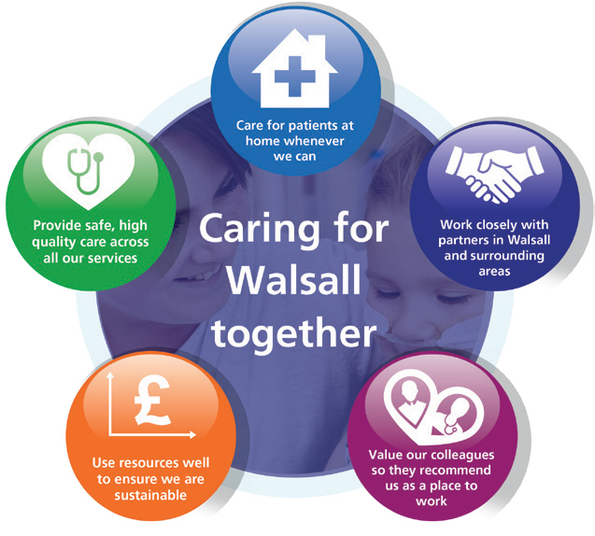

















Our Vision, Objectives & Values
Walsall Healthcare NHS Trust is guided by five strategic objectives which combine to form the overall ‘vision’ for the organisation.
Complementing this are our ‘values’, a set of individual behaviours that we wish to project amongst our workforce in order to deliver effective care for all.
Our Values: Upholding what’s important to us as a Trust
Our values, coupled with individual behaviours, represent what we wish to project in our working environments.
Our Vision: Caring for Walsall together
“Caring for Walsall together” reflects our ambition for safe integrated care, delivered in partnership with social care, mental health, public health and associated charitable and community organisations.
Our Objectives: Underpinning the vision
The organisation has five strategic objectives which underpin our vision of ‘Caring for Walsall together’, and they are to:
Provide Safe, high-quality care;
We will deliver excellent quality of care as measured by an outstanding CQC rating by 2022.
Care at Home;
We will host the integration of Walsall together partners, addressing health inequalities and delivering care closer to home.
Work Closely with Partners;
We will deliver sustainable best practice in secondary care, through working with partners across the Black Country and West Birmingham System.
Value our Colleagues;
We will be an inclusive organisation which lives our organisational values without exception.
Use Resources Well;
We will deliver optimum value by using our resources efficiently and responsibly.
Respect

We are open, transparent and honest, and treat everyone with dignity and respect.
- I appreciate others and treat them courteously with regard for their wishes, beliefs and rights.
- I understand my behaviour has an impact on people and strive to ensure that my contact with them is positive.
- I embrace and promote equality and fairness. I value diversity and understand and accept our differences. I am mindful of others in all that I do.
Compassion

We value people and behave in a caring, supportive and considerate way.
- I treat everyone with compassion. I take time to understand people’s needs, putting them at the heart of my actions.
- I actively listen so I can empathise with others and include them in decisions that affect them.
- I recognise that people are different and I take time to truly understand the needs of others.
- I am welcoming, polite and friendly to all.
Professionalism

We are proud of what we do and are motivated to make improvements, develop and grow.
- I take ownership and have a ‘can-do’ attitude.
I take pride in what I do and strive for the highest standards.
- I don’t blame others. I seek feedback and learn from mistakes to make changes to help me achieve excellence in everything I do.
- I act safely and empower myself and others to provide high quality, effective patient-centred services.
Teamwork

We understand that to achieve the best outcomes we must work in partnership with others.
- I value all people as individuals, recognising that everyone has a part to play and can make a difference.
- I use my skills and experience effectively to bring out the best in everyone else.
- I work in partnership with people across all communities and organisations.


1
MEETING OF THE PUBLIC TRUST BOARD – Thursday, 4th November 2021
Interim Chief Executive Officer’s Report
AGENDA ITEM: 7
Report Author and Job Title:

Prof David Loughton, Interim Chief Executive Officer
Responsible Director:

Prof David Loughton, Interim Chief Executive Officer
Action Required

Approve ☐ Discuss ☐ Inform ☒ Assure ☐

Executive Summary

The paper includes details of key activities undertaken since the last Trust Board meeting.

Recommendation

Members of the Trust Board are asked to note the report

Does this report mitigate risk included in the BAF or Trust Risk Registers? please outline
None in this report.

Resource implications

There are no resource implications associated with this report.

Legal and Equality and Diversity implications

None in this report.

Strategic Objectives

Safe, high quality care ☒
Care at home ☒
Partners ☒
Value colleagues ☒
Resources ☒

INTERIM CHIEF EXECUTIVE OFFICER’S REPORT
2
1.0
Review

This report indicates my involvement in local, regional and national meetings of significance and interest to the Board.

2.0
Consultants

There have been no consultant appointments this month:

3.0

Policies and Strategies

The following policies were approved this month:
- Policy WHT-CP58: Venous Thromboembolism – Reducing the risk of hospital acquired deep vein thrombosis and pulmonary embolism in over 16s
- Policy WHT-OP47: Interpretation and Translation Policy

4.0

Visits and Events

- Since the last Board meeting I have undertaken a range of duties, meetings and contacts locally and nationally including:
- Since Friday 27 March 2020 I have participated in weekly virtual calls with Chief Executives, led by Dale Bywater, Regional Director – Midlands – NHS Improvement/ England
- Since Monday 3 August 2020 I have participated in weekly calls with the Black Country and West Birmingham Strategic Transformation Partnership (STP) on the co-ordination of a collective Birmingham and the Black Country restoration and recovery plan and COVID-19 regional update
- 28 September 2021 – presented at the Healthcare Excellence Through Technology (HETT) conference in relation to Tele-tracking
- 29 September 2021 – participated in the Regional Cancer Board
- 30 September 2021 – led a virtual Senior Managers Leadership Briefing Forum and participated in the virtual Healthier Futures Partnership Board
- 7 October – undertook a meet and greet session with Consultants
- 8 October 2021 – joined virtually the Clinical Directors Boot Camp for Walsall Healthcare NHS Trust (WHT) and The Royal Wolverhampton NHS Trust (RWT)
- 12 October 2021 – undertook a meet and greet session with Consultants
- 13 October 2021 – undertook a virtual Non-Executive Directors (NEDs) briefing session
- 14 October 2021 – met virtually with Dr Helen Paterson – Chief Executive, Walsall Local Authority
- 15 October 2021 – participated in the virtual System Leadership Chief Executives meeting

3
5.0

Board Matters

There are no Board Matters to report on this month.

1 | P a g e
MEETING OF THE PUBLIC TRUST BOARD – Thursday 4th November 2021
Quality, Patient Experience and Safety Committee (QPES) Highlight Report
AGENDA ITEM: 8

Report Author and Job Title:
Mrs Pam Bradbury - Non-Executive Director

Responsible Director:
Mrs Pam Bradbury – Non- Executive Director

Action Required
Approve ☐ Discuss ☒ Inform ☒ Assure ☒

Executive Summary

This report provides the key messages from the Quality, Patient Experience and Safety Committee meeting held on 28th October 2021. Of note are:
Acute Access:
Restoration of elective and day cases to 103% of year-to-date of 2019 activity.

Diagnostic activity is currently challenged following the continued unexpected staffing issues within the ultrasound service. It was anticipated the recovery of the non-obstetric ultrasound backlog would be achieved by October, this is unlikely given further sickness during the month, and with the current substantive staffing levels, although imaging service are currently recruiting sonography staff. There are currently 413 patients waiting >6 weeks, and a prioritisation system is in place to mitigate potential clinical risk. Monthly progress will be reported to QPES.

It was noted that national and regional comparison data is showing WHT to be performing better than most other Trusts post Covid.

RTT 18-week wait is stable at 68% and 52 week wait is ranked 5th out of 20 Midland Trusts.

70% of priority 2 elective cases had surgery within 28 days, anyone waiting longer was a result of patient choice or deemed to be unfit fit for surgery.

The Urgent and Emergency Care system is under severe pressure with ambulance handovers being a significant risk to deteriorating patients. The Committee noted that the West Midlands Ambulance Service has raised their risk associated with delayed handovers to hospitals to a maximum score of 25.

Further mitigations have been put in place following sign off of the Winter Plan last month. 9 Bioquell Isolation pods have been

purchased to be used to segregate patients on wards to prevent potential spread of infection; the CCG have supported the decision to extend the opening hours of the urgent care treatment centre (until 3am) and plans are in place to execute enhanced community support in the event of further challenges in the domiciliary care market, the latter has been costed but not funded.
Community Access
Staff absence continued to be high last month, mix of maternity leave and attrition which led to less hours of care delivery being undertaken.
The care navigation service continued to provide support and handled 850 calls and supported care homes and vaccination programme.
WHT not meeting best practice standards for diabetes due to gaps in psychology, dietetics services and consultant capacity. Funding has been approved and vacancies in these services are hoping to be filled by Autumn.
There were concerns around the number of pressure ulcers in community and this is the now the focus of a more detailed review to identify potential themes which will be reported back to QPES.
Safe High Quality Care:
VTE compliance for September 2021 was 92.52% which is below target of 95%, several measures have been reported including divisional teams reporting on their performance and plans to Patient Safety Group (PSG).
The prevalence of timely observations is 86.63% and consistently is remaining above trust target. Eighteen clinical areas achieved in excess of 85% trust target.
Falls per 1000 bed days was 4.09 in September 2021 and remains significantly below the national average of 6.1.
Mental Capacity Act Audit for August shows that 57.14% of patients who lacked capacity had a stage 2 assessment undertaken in September 2021, this is a deterioration from 71.05% in August 2021. Discussion with patient’s relatives or attorney has decreased to 35.71% (August 57.81%) of cases audited. Further work is being undertaken to understand potential reasons for the decrease so improvements can be made.
2 | P a g e

CQC must do and should do actions are now part of the corporate action log and all have Executive ownership, progress will be reported to QPES monthly.
Recruitment to the mental health team is underway. Collaborations with the mental health liaison service and CAHMs are addressing the need to implement CORE 24, closer working, gaps in service and agreed pathways.
Maternity
The CQC Report: following an unannounced inspection of maternity services in August 2021 the inspection report was published on the 1 October 2021. A detailed action plan was presented which included the implementation of a reputable new triage system BSOTS from Monday 1st November 2021.
Pressures continue to be a problem due to high level of acuity and reduced staff in some areas. There is an active recruitment programme in place which should facilitate improvements. This is in line with the improved trajectory in vacancy position from 35wte in December 2020 to an anticipated 15 wte in December 2021. Despite pressures 1:1 care in labour was maintained by redeploying staff as required.
There were no new SI reported by the service in September. HSIB acknowledged appropriate reporting and action planning from the Trust.
QPES received assurance that all necessary actions recommended by the coroner following the death by natural causes of baby ZM will be closed by December.
Serious incidents:
An update was received and the focussed work that has been undertaken was acknowledged. Historical SI’s should all be closed by December.
Papers were also presented to support a new Quality Assurance Assessment Team (QAAT) that has been created to work proactively on an annual programme for ward audits based on CQC reviews.
Electronic patient record.
QPES were sighted on the clinical risks associated with manual processes and
the Electronic Patient Record (EPR). Concerns and constraints were reported to be experienced by the Medical Directorate, Digital
3 | P a g e

4 | P a g e

Services and clinical teams. An internal audit was supported to review appropriate levels of resource and agree prioritisation for delivery

The next meeting of the Committee will take place on 25th November 2021
Recommendation

Members of the Trust Board are asked to note the escalations and any support sought from the Trust Board.

Risk in the BAF or Trust Risk Register
This report aligns to BAF risk S01 for safe high quality care and COVID- 19 BAF risk S06.

Resource implications
There are no new resource implications associated with this report.

Legal, Equality and Diversity implications
There are no legal or equality & diversity implications associated with this paper

Strategic Objectives

Safe, high quality care ☒

Care at home ☐
Partners ☐

Value colleagues ☐
Resources ☐

1
MEETING OF THE PUBLIC TRUST BOARD - Thursday 4th November 2021
Safe High-Quality Care Oversight Report – September 2021 data
AGENDA ITEM: 9
Report Author and Job Title:

Lisa Carroll Director of Nursing

Responsible Director:

Manjeet Shehmar Interim Medical Director Lisa Carroll
Director of Nursing
Action Required

Approve ☐ Discuss ☐ Inform ☒ Assure ☒

Executive Summary

This report describes the continuing actions that are taking place to provide Safe, High Quality Care (SHQC) in the Trust. The report includes details relating to the Board Assurance Framework (BAF), the Corporate Risk Register and the Performance Report, relevant to SHQC.
Recommendation

The Board is requested to note the contents of the report and make recommendations as needed.
Does this report mitigate risk included in the BAF or Trust Risk Registers?

208 - Failure to achieve 4 hour waits as per National Performance Target of 95%, resulting in patient safety, experience and performance risks. (Risk Score = 16).
2066 – Risk of avoidable harm to patients due to wards & departments being below the agreed substantive staffing levels. (Risk Score = 15).
2439 - External inadequate paediatric mental health and social care provision leading to an increase in CYP being admitted to our acute Paediatric ward whilst awaiting a Tier 4 bed or needing a 'place of safety'. (Risk Score = 20).
2475 - The Mental Health Act (MHA) Code of Practice is not being applied in day-to-day practices for providing safeguards & protection for individuals who require mental health services. (Risk Score = 25).
2540 - Risk of avoidable harm going undetected to patient’s, public and staff due to ineffective safeguarding systems. (Risk Score = 16).
2245 - Risk of suboptimal care and potential harm to patients from available midwives being below agreed establishment level.(Risk score =20)
2325 - Incomplete patient health records documentation and lack of access to patient notes to review care. This is due to a known organisational backlog of loose filing and increased reported incidents of missing patient notes. (Risk score = 16)
2430 - Child Health Records are currently held across various systems and in locations on service shared drives which prevent a clinician having access to the full child record. (Risk score = 20)
2540 - Risk of avoidable harm going undetected to patients, public and staff as a result of ineffective safeguarding systems.(Risk score = 16)
2581 - Internal risk for patients awaiting Tier 4 hospital admission. (Risk score = 15) 2512 - Walsall Healthcare NHS Trust failure to meet Paediatric Diabetes Best Practice Tariff Standards. (Risk score = 16)
2587 - Not having sufficient staffing levels available to support the release for fit testing in line with Control of Substances Hazardous to Health Regulations 2002 (COSHH) requirements & Department of Health & Social Care (DHSC). (Risk score = 20)
Resource implications

2
Legal and Equality, Diversity and inclusion implications
Failure to deliver safe, high quality care may result in breaches of legal requirements under the Health and Social Care Act 2008

Strategic Objectives

Safe, high quality care ☒
Care at home ☐
Partners ☒
Value colleagues ☐
Resources ☒

Provide Safe High-Quality Care – Executive Update
1. Executive Summary
The delivery of safe, high quality care remains a key priority for the Trust.
The associated Board Assurance Framework (BAF) and corporate risks have been reviewed and updated as required. Where there are gaps in control and assurance these are detailed in the monthly report to the Quality, Patient Safety and Experience Committee and actions taken and in progress are explained.
Projects within the Safe, High Quality Care Improvement Programme have continued to progress and some of the key highlights are:
•
VTE compliance for September 2021 is 92.52%. Surgery has instigated a QI project to review and improve compliance. Improvements made and lessons learnt will be shared through the Patient Safety Group to ensure Trust wide learning.
The prevalence of timely observations is 86.63% and consistently is remaining above trust target. Falls per 1000 bed days was 4.09 in September 2021 and remains significantly below the national average of 6.1 as recognised as the Royal College Physicians.
Nursing establishment reviews have been undertaken across all wards and a business case has been approved to support changes to establishments based on the Safer Nursing Care Tool and professional judgment in line with nationally recognised best practice for this process Safeguarding adults and children’s training is achieving trust target for all level 1 and level 2 training. Level 3 adult and children’s training remains below trust target
•
•
•
•
2.
CQC Inspections
Maternity Services
The CQC report following the unannounced inspection of maternity services was published on the 1st October 2021. The division have developed an action plan and progress is being made against the actions.
3. Links to corporate risk register
Following a review of the risks held on the corporate risk register a number have been added to the Safe High Quality Care report as they are aligned to the focus of this report.
208 - Failure to achieve 4 hour waits as per National Performance Target of 95%, resulting in patient safety, experience and performance risks. (Risk Score = 16).
2066 – Risk of avoidable harm to patients due to wards & departments being below the agreed substantive staffing levels. (Risk Score = 15).
2439 - External inadequate paediatric mental health and social care provision leading to an increase in CYP being admitted to our acute Paediatric ward whilst awaiting a Tier 4 bed or needing a 'place of safety'. (Risk Score = 20).
3
2475 - The Mental Health Act (MHA) Code of Practice is not being applied in day-to-day practices for providing safeguards & protection for individuals who require mental health services. (Risk Score = 25).
2540 - Risk of avoidable harm going undetected to patient’s, public and staff due to ineffective safeguarding systems. (Risk Score = 16).
2245 - Risk of suboptimal care and potential harm to patients from available midwives being below agreed establishment level.(Risk score =20)
2325 - Incomplete patient health records documentation and lack of access to patient notes to review care. This is due to a known organisational backlog of loose filing and increased reported incidents of missing patient notes. (Risk score = 16)
2430 - Child Health Records are currently held across various systems and in locations on service shared drives which prevent a clinician having access to the full child record. (Risk score = 20)
2540 - Risk of avoidable harm going undetected to patients, public and staff as a result of ineffective safeguarding systems.(Risk score = 16)
2581 - Internal risk for patients awaiting Tier 4 hospital admission. (Risk score = 15)
2512 - Walsall Healthcare NHS Trust failure to meet Paediatric Diabetes Best Practice Tariff Standards. (Risk score = 16)
2587 - Not having sufficient staffing levels available to support the release for fit testing in line with Control of Substances Hazardous to Health Regulations 2002 (COSHH) requirements & Department of Health & Social Care (DHSC). (Risk score = 20)
4. Performance Report
4.1 Getting it Right First Time (GIRFT)
The summary report below illustrates the performance of specialties against their implementation plan. The RAG rating relates to the level of engagement by service and not to the completion of local and national recommendations, this is measured by a percentage figure. For example, it can be seen from the below table that engagement from Dermatology team is rated as green showing good engagement, 100% of local actions completed with the service working towards the national recommendations, currently at 7%. The GIRFT team Local actions are progressing well with many specialties having completed all recommendations.
Annual leave impacted on GIRFT visits during September with just one visit taking place. The implementation plan for Orthopaedics was discussed and updated with the GIRFT team. Good progress has been made with most of the local recommendations actioned and closed. The next meeting will review the national recommendations.
4
Speciality

RAG

Action Progress
National Recommenda tions Progress
Acute and General Medicine
Green
95%

Breast Surgery
Green
76%

0%
Dermatology
Green
100%

7%
Diabetes
Green
97%
60
%
Ear, Nose and Throat
Green
100%
54
%
Endocrinology
Green
100%
0%
Gastroenterology
Green
100%
3%
General Surgery
Green
97%
4
1%
Geriatric Medicine
Green
100%

Gynaecology and Maternity
Green
100%

Hospital Dentistry
Green
100%

Imaging and Radiology
Green
100%

Lung Cancer
Green
100%

Ophthalmology
Green
100%
0%
Orthopaedic Surgery
Green
96%
84%

Paediatric Surgery
Green
100%

Respiratory
Green
100%
0%
Spinal Surgery
Green
67%

4
5%

Urology
Green
85%

77%

Vascular
Green
100%
3
8%

4.2 Falls
The number of falls inpatient falls recorded for September is reported as 65, a slight increase from 58 in August 2021. Work continues on the falls strategy aligned with the ‘Key Performance Indicators’ in the Safe High Quality Care Improvement Programme (SHQC).
The Trust had identified 12 historic falls that have not previously been investigated and have been identified as potential Serious Incidents (SI’s). It has been agreed with the CCG that the Trust will investigate 11 of these falls as a cluster review which is due to be completed and shared with the CCG by the end of November 2021.
4.3 Tissue Viability
The total number of Trust acquired pressure ulcers in September 2021 is 26. There has been a slight decrease in pressure ulcers since last month. All pressure ulcers of stage 3 and above and those that are unstageable have a Root Cause Analysis completed none met the SI criteria in September 2021.
4.4 Mouth care
A business case is being developed to recruit a dental nurse/mouth care matters practitioner to focus on a mouth care matters work stream with an ambition to reduce incidence of HAP.
4.5 Venous Thromboembolism (VTE)
VTE compliance for September 2021 was 92.52% compared to compliance for August 2021 of 92.03%, compliance rates are steady but below the 95% target. Monthly reports continue to be sent to Divisions, in addition to the daily reporting to consultants.
Surgery have instigated a QI project that commenced in October 2021, to review and improve compliance. A report will be presented to the Thrombosis Group in due course. Medicine and Long- Term Conditions have finalised their audit and the outcome will be discussed at the Thrombosis Group.
4.6 104-day harm
There were 3 patients identified in August 2021, 2 in urology 1 in head & neck Harm is currently being evaluated.
4.7 Sepsis
A Trust sepsis team has been agreed and being recruited to. The newly appointed Trust Clinical Lead for sepsis, Miss Rushi Joshi, Clinical Director for Emergency Medicine commenced in this post on 1 September 2021. A business case for the sepsis team has been presented to and approved by the Trust Management Committee.
Work is being undertake with IT to understand and take the appropriate corrective action to address data discrepancy issues previously reported to Board that persist.
4.8 Clostridium difficile
5
The Trust target for 2021/22 had been internally agreed again at 29 cases; the national targets have now been released and have been set at 33 cases. There were 3 reported cases in September 2021 Following investigation all were deemed unavoidable with a justified use of antibiotics.
4.9 Outbreaks
There has been one COVID-19 outbreak in the last month on wards 16. Outbreak meetings have been held in accordance with Trust policy and these continue as the outbreak remains in the monitoring period.
4.10 Percentage of observations undertaken within timeframe
The prevalence of timely observations has decreased slightly to 86.63% in month from 88.14% in August 2021 but remains above the Trust target of 85% for the sixth month running and within normal variation
4.11 Mental Capacity Assessment
Audit for September 2021 shows that 57.14% of patients who lacked capacity had a stage 2 assessment undertaken, this is a decrease from 71.05% in August 2021. Discussion with patient’s relatives or attorney has decreased to 35.71% (August 57.81%) of cases audited.
The low compliance with stage 2 assessment is of significant concern and a review will be undertaken over the next month to ascertain what action needs to be taken to address this persistent low compliance.
4.12 Safeguarding, Prevent, DoLs, MCA and Dementia Awareness Training
Safeguarding Adult and Childrens levels 1 and 2 training remain above trust target. Level 3 training remains under target for both adults and children.
A review of ESR has been undertaken to ensure only staff required to undertake level 3 training in line with the Intercollegiate Guidance have this recorded on their record. Divisions have been requested to share their plan for achiveing compliance with level 3 training at the next Safeguarding Committee.
5. Staffing Update
The RN and Midwifery vacancy rate for September 2021 has reduced to 6% from the 7% reported in August 2021
Rosters are designed to fill out of hours first and this is reflected in the fill rate as the lowest fill rate was seen in the CSWs on day shifts at 77.90%. This is a decrease from the 86.38% reported last month. The overall fill rate for September (combined RN and CSW) was 90.18% a decrease from the 91.66% reported month.
6
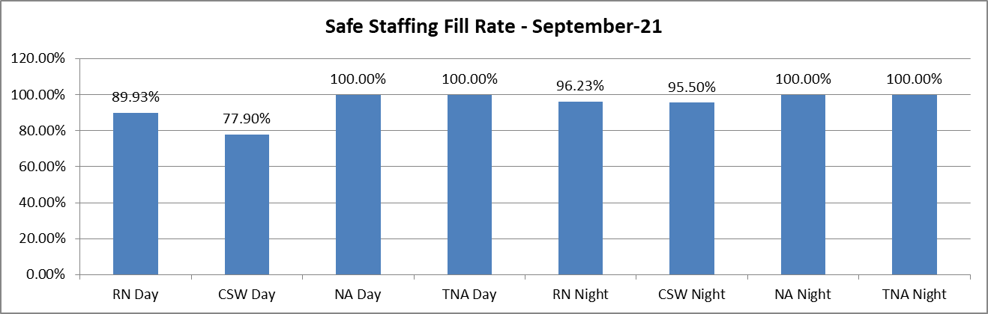
95 overseas Nurses have commenced working within the Trust by end of September 2021. 45 of those have now successfully registered with the NMC and are working as Registered Nurses. A further cohort is arriving in October.
Pastoral care is being delivered by Team FORCE. The current expectation is that approximately 200 overseas RN will be recruited by the end of 2021.
End of Report
7

Page 1 of 5
Risk Summary
BAF Strategic Objective Reference & Summary Tile:
BAF SO 01 - Safe, High Quality Care; We will deliver excellent quality of care as measured by an outstanding CQC rating by 2022.
Risk Description:
The Trust fails to deliver excellence in care outcomes, and/or patient/public experience, which impacts on the Trust’s ability to deliver services which are safe and meet the needs of our local population.
Lead Director:
Director of Nursing/Medical Director.
Lead Committee:
Quality, Patient Experience & Safety Committee.

Links to Corporate Risk Register:

Title:
Current Risk Score Movement:
- 208 - Failure to achieve 4 hour waits as per National Performance Target of 95%, resulting in patient safety, experience and performance risks. (Risk Score = 16).
- 2066 - Risk of avoidable harm to patients due to wards & departments being below the agreed substantive staffing levels. (Risk Score = 15).
- 2245 - Risk of suboptimal care and potential harm to patients from available midwives being below agreed establishment level. (Risk Score
= 20).
- 2325 - Incomplete patient health records documentation and lack of access to patient notes to review care. This is due to a known organisational backlog of loose filing and increased reported incidents of missing patient notes. (Risk Score = 16).
- 2430 - Child Health Records are currently held across various systems and in locations on service shared drives which prevent a clinician having access to the full child record. (Risk Score = 20).
- 2439 - External inadequate paediatric mental health and social care provision leading to an increase in CYP being admitted to our acute Paediatric ward whilst awaiting a Tier 4 bed or needing a 'place of safety'. (Risk Score = 20).
- 2475 - The Mental Health Act (MHA) Code of Practice is not being applied in day-to-day practices for providing safeguards & protection for individuals who require mental health services. (Risk Score = 25).
- 2512 - Walsall Healthcare NHS Trust failure to meet Paediatric Diabetes Best Practice Tariff Standards. (Risk Score = 16).
- 2540 - Risk of avoidable harm going undetected to patient’s, public and staff due to ineffective safeguarding systems. (Risk Score = 16).
- 2581 - Internal risk for patients awaiting Tier 4 hospital admission. (Risk Score = 15).
- 2587 - Not having sufficient staffing levels available to support the release for fit testing in line with Control of Substances Hazardous to Health Regulations 2002 (COSHH) requirements & Department of Health & Social Care (DHSC) resilience principles & performance measures, to protect staff from harmful substances (e.g. COVID-19). (Risk Score = 20).
- 2601 - Inadequate Electronic Module for Sepsis/deteriorating patient identification, assessment and treatment of the sepsis 6. (Risk Score
= 12).
- 2654 - Risk of patient harm from significant delay in management of serious incidents. (Risk Score = 20).
- 2663 - Lack of Practice Education Facilitators to support new to Trust nursing staff, including but not limited to International Nurses. (Risk Score = 9).
- 2664 - Patient Safety and Training Issues in Medicine / ED. (Risk Score = 20).

Likelihood = 5
Consequence = 5
= 25 High ↔

Forecasted Risk Score Movement for Q3:

Likelihood = 5
Consequence = 5
= 25 High ↔

Risk Appetite
Status:
Averse
Averse
Cautious
Balanced
Open
Hungry
Appetite Score:
< 4
1
2
3
4
5
6
7
8
9
10
11
12
13
14
15
16
17
18
19
20
21
22
23
24
25
Tolerate Score:
< 9

Latest Board/Committee/Group - 11/10/2021 Version V5.02
Page 2 of 5
Risk Scoring
Quarter:
Q1 2021/22
Q2
Q3
Q4
Rational for Risk Level:
Target Risk Level (Risk Appetite):
Target Date:
Likelihood:
3
5

- Risk score increased in line with worst case scenario SHQC risk, Mental Health Act (ID 2475) with a risk score of 25.
- The Trust’s Quality Strategy is evolving to address the emerging priorities from reviews of systems, process and services.
- A review of the process for ensuring lessons learnt from incidents and patient feedback is embedded in practice is under way.
- A CQC Assurance Oversight Group has been established to ensure compliance with all CQC must and should do actions.
- The Trust is an early adopter site for the new patient complaint standards and will be rolling these out with additional support from the national team over the coming months.
- A number of clinical guidelines policies and procedures are out of date. The Trust has a clear plan for reviewing and updating these.
- Potential to breach statutory requirements under the Mental Health Act due to inconsistent knowledge and application of Trust Policy.
- Evidence that safeguarding training is not embedded in practice with staff not recognising potential or actual abuse, reporting and escalating in a consistent manner.
- Substantive staffing levels are below those agreed in establishment reviews to deliver safe, high quality care resulting in high usage of temporary staff.
Likelihood:
2

31 December
2021

Consequence:
5
5

Consequence:
5

Risk Level:

15
High

25
High

Risk Level:

10
Moderate

Control & Assurance Framework - 3 Lines of Defence

1st Line of Defence
2nd Line of Defence
3rd Line of Defence

Controls:

- Clinical audit programme & monitoring. Clinical divisional structures, accountability & quality governance arrangements at Trust, division, care group & service levels.
- Central staffing hub co-ordinating
- Patient Experience group in place.
- Governance and quality standards managed and monitored through the governance structures of the organisation, performance reviews and the CCG/CQC.

- CQC Inspection Programme.
- Process in place with Commissioners to undertake Clinical Quality Review Meetings (CQRM).
- External Performance review meetings in

Page 3 of 5

nurse staffing numbers in line with acuity and activity arrangements with staff re-deployed across clinical units and divisions as required to maintain safe staffing levels
- Safety Alert process in place and assured through QPES.
- Perfect Ward app allows local oversight of key performance metrics.
- Freedom to speak up process in place, reporting to the People and organisational development committee.
- Covid-19 SJR undertaken for all deaths process of assurance for lessons learnt developed.
- CQC registration for the regulated activity of assessment or medical treatment for persons detained under the Mental Health Act 1983 at Manor Hospital.
- Weekly CQC Action Plan oversight meeting in place.
- Improvement programme in place to oversee and monitor improvements associated with the Trust delivery of Safe, and High Quality Care.
- Support to safeguarding team in place from RWT
- Safeguarding Committee meetings increased to monthly
- International Registered Nurse recruitment underway with 200 recruits expected by the end of 2021
- Learning from death framework supporting local mortality review.
- Faculty of Research and Clinical Education (FORCE) established to promote research and professional development in the trust.

place with NHSEI/CQC/CCG.

Gaps in Controls:

- Performance targets not being met for all activities, including complaints, Mental Capacity Act compliance and VTE assessments.
- Out of date clinical policies, guidelines and procedures.
- Training performance not meeting set targets.
- Quality Impact Assessment process requires embedding within the trust.
- Sepsis audit frequency and performance.
- CQC rating of ‘Requires Improvement’ in 2019; Medicine rated as ‘Inadequate’ in May 2021 report.
- NHSEI review of Division of Surgery, focussing on meetings, leadership, and governance highlighted remedial actions required.
- Dementia screening performance.
Page 4 of 5

- Failure to demonstrate compliance with terms of the Mental Health Act.

Assurance:

- Process in place through ward, business unit and divisional reviews and sub-committees of QPES to confirm and challenge and gain assurance with overarching report and assurance at QPES.

- Patient priorities for 2021 identified which aim to improve patient experience. Assurance of impact via patient feedback.
- Learning Matters Newsletter published monthly
- Fortnightly assurance meeting with CQC and CQRM meeting with CCG.

- NHSI and CCG reviews of IPC practice in ED and Maternity have not highlighted any immediate concerns.
- NHSEI scrutiny of Covid-19 cases/Nosocomial infections/Trust implementation of social distancing, Patient/Staff screening and PPE Guidance.
- Quality Review 6 monthly reviews in place with NHSEI/CQC.

Gaps in Assurance:

- Some CQC ‘MUST’ and ‘SHOULD’ do actions remain outstanding.
- Inconsistent evidence, both through quality governance structures and performance reviews, of practice having changed as a result of learning from adverse events.
- Lack of assurance regarding equality, diversity and inclusion and actions to reduced inequalities.
- Lack of evidence of risk assessments and quality impact assessments relating to staffing contingency planning and/or activity changes.
- Lack of robust strategic approach to ensuring effective patient/public engagement and involvement.
- Lack of clinical engagement and leadership oversight of the Quality Governance agenda.
- Lack of assurance regarding dementia screening data collection process.
- Lack of assurance internally and externally regarding staff ability to recognise, report and escalate safeguarding concerns
Future Opportunities
- Improvement Programme offers a structured programme to achieve excellence in care outcomes, patient/public experience, and staff experience.
- Implementation of new technologies as a clinical or diagnostic aid (such as electronic patient records, e-prescribing & patient tracking; artificial intelligence; telemedicine).
- Development of Prevention Strategy.
- National Patient Safety Strategy will give an improved framework for the Trust to work.
- Well Led work stream working on quality governance structures and patient safety.
- Leadership Development programme to address and mitigate gaps within clinical leadership.
Future Risks
- Ongoing impact of Covid-19 plus additional significant time pressured programmes of work such as COVID vaccination, staff testing, etc. Communications across the organisation to share programme objectives.
- Performance targets not being met for all activities, including Mental Capacity Act and VTE.
- Sepsis audit frequency and performance.
- NHSEI review of Division of Surgery, focussing on meetings, leadership, and governance highlighted remedial actions required.
Future Actions (to further reduce the Likelihood / Consequence of the risk in order to achieve the Target Risk Level in line with the Risk Appetite)
No.
Action Required:
Executive Lead:
Due Date:
Progress Report:
BRAG:

1.

Define action plan for addressing lack of assurance around provision of services in line with requirements of Mental Health Act

Medical Director

01/10/2021

Risk included on corporate risk register in May 2021. Action plan in place.
14/07/2021 - Business case in development to ensure adequate resource to Mental Health team. To be presented to PFIC July 2021.If approved recruitment

Page 5 of 5

will take approx. 3 months. Due date re-aligned tor reflect this process

2.
Develop a Clinical Audit Strategy and Policy
Director of Governance
01/08/2021

3.

Oversight of progress to address out of date policies and procedures will be strengthened via the Clinical Effectiveness Group which be reflected in the revised terms of reference

Medical Director

01/04/2021

Complete - Terms of reference agreed through Clinical

4.

NHSI re-inspection of cleanliness and IPC practice in maternity services

Director of Nursing

31/10/2021

NHSE/I IPC inspection is booked for 22.06.2021. Report expected end of w/c 12.7.2021. Feedback on the day very positive with no significant concerns.
Review undertaken and report received
15.9.2021 - Action plan in place and monitored through IPC committee

5.

Further develop processes to provide assurance that lessons learnt from adverse events
Medical Director/ Director of Nursing

31/10/2021

Scoping of new ward performance boards continues.

6.

Development of Patient Engagement and Involvement Strategy

Patient Experience Lead / Lead for Patient Involvement

30/09/2021

Work ongoing.

7.

Review of dementia screening data collection process. Initial deep dive completed. Scoping of improvement options commence April 2021

Director of Nursing

30/09/2021

Scoping of improvement options complete; documentation options still under consideration. Collaboration with RWT to review resources, share best practice and where possible align documentation and process.
14.07.2021 - Monthly audit in place and demonstrates improved compliance with dementia screening. Work is underway to review documentation across WHT and RWT to align. Due date re-aligned to reflect this work

8.
Develop Maternity Services BAF
Interim Director of Nursing
30/12/2021
Ongoing review.

Divisional Director of Midwifery Report
1
MEETING OF THE PUBLIC TRUST BOARD - Thursday 4th November 2021
Divisional Director of Midwifery report
AGENDA ITEM: 10
Report Author and Job Title:

Carla Jones-Charles, Divisional Director of Midwifery, Gynaecology and Sexual Health
Responsible Director:

Ann Marie Cannaby, Interim Deputy Chief Executive and Chief Nurse
Action Required
Approve ☐ Discuss ☒ Inform ☒ Assure ☒
Executive Summary

- The service has maintained one to one care in labour as a focus to provide optimum safe care to women in labour despite the staffing challenges.
- There is an active recruitment program Recruitment update
- Maternity Serious Incidents update
- CQC update
- Update on perinatal mortality for Q1
Recommendation

Members of the Board are asked to:
- Review and note the contents of this report

Does this report mitigate risk included in the BAF or Trust Risk Registers? please outline
BAF 1: Safe, high quality care
2066 Lack of registered nurses and midwives

Resource implications

There are no funding resource implications associated with this report.
Legal and Equality and Diversity implications
There are no legal or equality & diversity implications associated with this paper.
Strategic Objectives

Safe, high quality care ☒

Care at home ☐

Partners ☐
Value colleagues ☒
Resources ☒

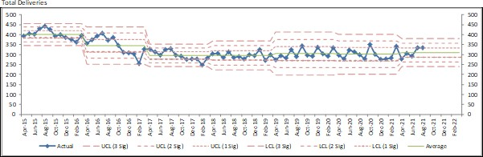
1.0 PURPOSE OF REPORT
The purpose of the report is to provide a monthly update to assure the Board in relation to:
•
•
•
•
•
•
•
Activity within the maternity unit Midwifery staffing and acuity Maternity dashboard Recruitment update
Maternity Serious Incidents (SIs) A CQC update
Stillbirths and mortality rate
2.0 BACKGROUND
This report will update the on-going position on the key elements above by exception.
2.1 Activity within the Maternity Unit
Table one highlight the monthly activity within the Maternity Unit: table one is the total number of births per month and this activity is outlined in the SPC chart. The second SPC chart represents the total caesarean sections per month; this includes elective and emergency caesarean sections. The service is currently auditing emergency caesarean sections and the findings are due in January 2022.
The chart outlines the induction of labour rate, this again this demonstrates natural
3rd
variation that occurs month on month. Induction of labour and caesarean section variances are monitored on the maternity dashboard.
Table 1: Activity Aug 20 – Aug 21
2
Aug- Sep- Oct- Nov- Dec- Jan- Feb Mar Apr May Jun Jul Aug Sept
20 20 20 20 20 21 21 21 21 21 21 21 21 21
Births 299 279 351 301 276 279 285 342 279 307 293 334 337 322

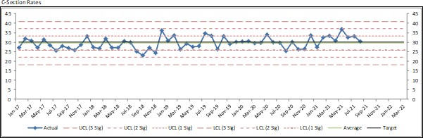
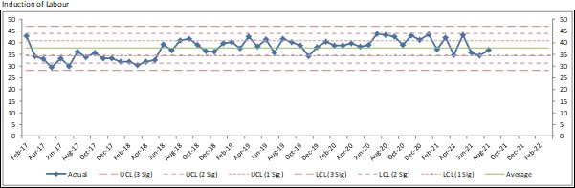
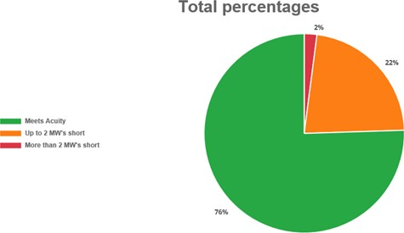
3.0 MIDWIFERY STAFFING / ACUITY / 1:1 CARE IN LABOUR
Staffing is monitored daily and staffing deficits are manged using the maternity escalation policy. The current Trust uplift is 21%, this is to account for annual leave, sickness and training. The table below is a breakdown of absence for September 21.
Acuity is monitored 6 times a day on the delivery suite and is used to assess staffing needs. The national recommendation is to maintain an average acuity of 85%. The table 2 below demonstrates average acuity over a period of a month.
Table 2
The target is to maintain an average acuity of 85% or above.
acuity data
3
The acuity was 76% green for September, 22% amber and 2% red. 1:1 care was maintained by redeploying staff as required.

Aug- Sep- Oct- Nov- Dec - Jan- Feb Mar Apr May June- Jul Aug Sept 20 20 20 20 20 21 21 21 21 21 21 21 21 21

Acuity

87% 84%

83%

87% 85% 85%

74% 76%

87%

60% 72% 66% 61% 76%

1:1 Care in Labour

98.5 100 100 100
100% % 100% 100% 100% % % 100% 100% %

99%

100 100 100
% % %

Annual Leave
Other Leave
Parenting
Sickness
Study Leave
Working Day
Women's Services (Are)
Delivery Suite - Nursing

15.8%

1.0%

6.7%

9.6%

1.3%

4.9%

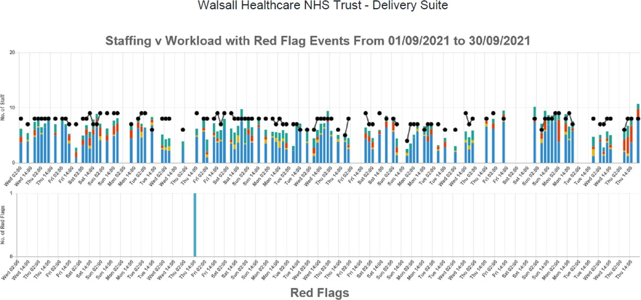
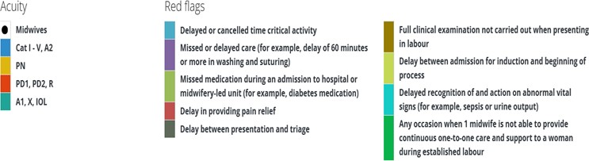
Table 3 illustrates that activity peaks against staffing as well as red flags. The service continues to use its escalation policy to mitigate staffing gaps in times of high acuity to maintain safety.
It also demonstrates the staffing pressures however only one reported red flag event which was managed appropriately by the staff, see below. Graph 1 below highlights the actions taken to mitigate and assure safety.
Table 3
Recruitment update:
The current vacancy position is 19.61 wte. The service has recruited all its students and is awaiting start dates for the final 2 who were subject to retaking their exams. We anticipate 3 starters in November and 2 in December.
The new Deputy Divisional Director of midwifery Gynaecology and sexual health has started which will provide strengthened leadership and support for the teams.
The current midwifery advert closes on the 26th October with a plan to interview on the 15th November.
The graphs below outline the number of midwives that have commenced employment with the service since the January 2021 and the second graph gives the vacancy position trajectory to the end of the year based on midwives interview. The ongoing focus and commitment to recruitment will continue until the service is fully established. This includes participation in the international recruitment bid program being across the ICS and hosting maternity focused recruitment fairs.
4
There was one reported red flag event documented as delay in induction activity due to acuity. This was a no harm incident.

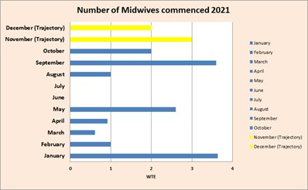
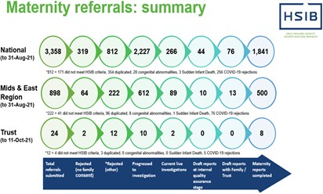
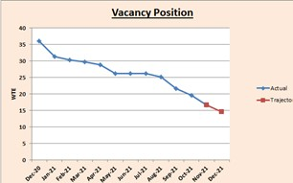
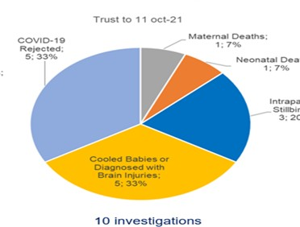
3.1 Birth to Midwife Ratio
The national average birth to midwife ratio 1:28
Table 3: Birth to Midwife Ratio Jul 2020 – Jul 2021
4.0
Maternity Serious Incidents (SI’s).
The Ockenden report (2020) outlined the need for Trusts board to have clear oversight of all maternity Si’s. There we no new SI reported by the service in September. There are 2 on- going Health Service Investigation Branch (HSIB) investigations on-going and 1 completed report. The actions and learning from this will be shared at the next report.
5

There have been 24 referrals since Apr 2019 with 10 of these investigated and currently 2 reports are outstanding

Aug- Sep- Oct- Nov- Dec- Jan- Feb- Mar- Apr- May- June- Jul- Aug Sept- 20 20 20 20 20 21 21 21 21 21 21 21 -21 21
Actual Ratio - Worked
30.8 28.3
37.0 31.4 28.9
27.2
29.1
34.4
29.3 30.4
32 36 35 31

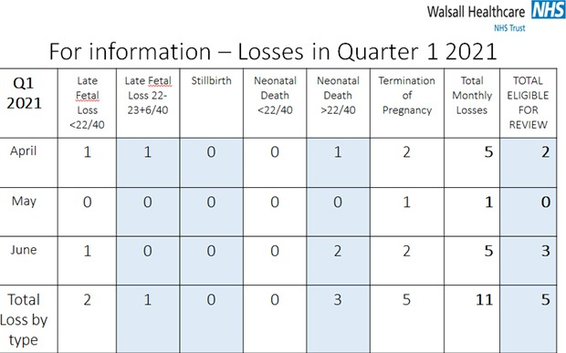
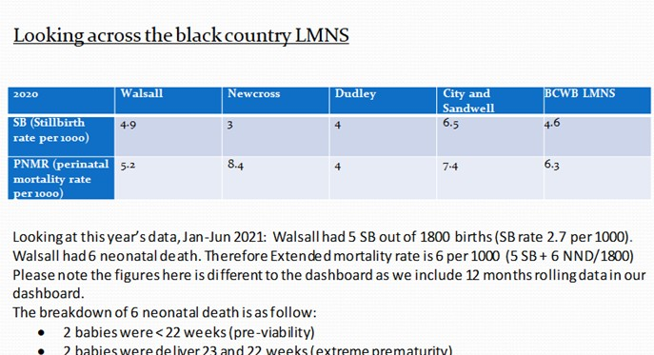
5.0 CQC update
The CQC report was published on the October 2021, the service has maintained it’s rating of ‘Requires Improvement’ and has completed and submitted an action plan to the corporate team.
Key actions were-:
1st
•
Concerns about risk assessment of women in the Triage department
o Birmingham
Symptom
specific
Obstetric
System
(BSOTS)
will
be
implemented on the 1st November and is on track. This provides a systematic assessment and management for women attending maternity triage and is used in many units across the UK.
•
Aspects of medicine management related to storage on the postnatal ward
- Weekly audit being conducted in conjunction with the pharmacy team until changes/ compliance is fully embedded.
On-going vacancy position resulting in difficulty filling shifts to the expected level
- There is a clear plan regarding recruitment and monitoring our vacancy trajectory as detailed above.
Some postnatal ward staff reporting feeling undervalued and focus being given to the delivery suite.
- All staff on the postnatal ward were invited to a 1:1 meeting. Of the 47 staff, 19 attended. Themes have been collated and 2 feedback sessions have been
•
•
conducted with a date scheduled in November. Information gained at these meetings will contribute to the formulation of an action plan which will be co-produced with staff.
o Meetings with staff will be extended to all staff within the service with further dates planned for November.
3rd
6.0 Stillbirth and Perinatal Mortality Rate
In line with national ambition of reducing stillbirth, neonatal and perinatal mortality rate, we have advised the local maternity and neonatal system quality and safety work stream to review the trajectory across the Black Country and west Birmingham LMNS against 2010 crude baseline. We will update Walsall trajectory with the Black Country and West
6

Birmingham LMNS targets once agreed. SPC charts will capture Stillbirth and mortality rate against the agreed targets and in line with MBRRACE reports.
Neonatal
7.0 RECOMMENDATIONS
Members of the Board are asked to review and note the contents of this report.
7
1
MEETING OF PUBLIC TRUST BOARD - Thursday 4th November 2021
Hospital Mortality Report (Quarter 2, 2021/22)

AGENDA ITEM: 11

Report Author and Job Title:

Lorraine Moseley Business Manager

Responsible Director:

Dr Manjeet Shehmar, Acting Medical Director

Action Required
Approve ☐ Discuss ☒ Inform ☒ Assure ☒
Executive Summary

- The Trust SHMI for May 2021 is 109 and HSMR for July is 112
- Year to date, there have been 593 deaths in scope and 214 have had an SJR.
- In the last quarter, there have been 312 deaths at the Trust. A structured judgement (SJR) review has been raised for 22 deaths. In Q2, 209 SJRs have been completed (this includes the reviews of wave 2 Covid HCAI deaths).
- For deaths where an SJR was raised, year to date; as assessed by SJR level 1 reviews, 10.2% (22 of 214) and this quarter 10.5% (22 of 209 have found there was deficiencies in care which may have contributed to avoidable deaths. These cases have had an incident raised to be investigated as part of the Trust incident reporting and learning policy.
- For all in scope deaths, from SJR level 1 reviews, the Trust has a rate of potentially avoidable deaths in Q2 of 7% (22 of 312 deaths) and 3.7% YTD (22 of 593 deaths). Of these, there was strong evidence of avoidability in 0.97% (3/312 deaths) in Q2 and 0.5% (3/593 deaths) YTD.
- The backlog of notes have now been delivered, the administrator started in post on 6th September 2021 and has now started the process of following up completed SJRs to be reported next quarter. The LFD process is now electronic with the CORS system fully embedded and ongoing training for clinicians.
- There have been a total of 736 Covid positive deaths in the hospital (to 13/10/21)
- Learning from deaths is part of the SHQC Improvement Programme, with learning monitored via the Mortality Surveillance Group.
- This paper summarises the learning and improvements as a result of the learning from deaths programme.
- An external consultant is providing independent advice to the Trust of its mortality data and areas of focus.

Members of the Trust Board are asked to note:
- Performance data
- Key areas for attention and learning
Does this report mitigate risk included in the BAF or Trust Risk Registers? please outline
- BAF001 Failure to deliver consistent standards of care to patients across the Trust results in poor patient outcomes and incidents of avoidable harm
- Performance against SHMI is recorded on the trust risk register
- Systems and processes for the identification and learning from issues in care have been identified as ineffective by the CCG
Resource implications

- Office space to enable the Trust statutory requirement to roll out the LFD process to include community deaths by April 2022
Legal and Equality and Diversity implications

- The equality and diversity implications to the trust for patients with learning disabilities are managed according to the trust policy and LeDeR recommendations.
- National legislation relating to the review of child and perinatal deaths has
Introduction
This report details:
1.
Performance data relevant to the trust, compared with regional and national comparator sites, where appropriate
Key areas for attention, together with analysis, actions and outcomes
Future actions and developments in understanding mortality data
2.
3.
1. PERFORMANCE
National Benchmarks
The Trust uses two national benchmarks as primary indicators for mortality, Hospital Standard Mortality rate (HSMR) and Standard Hospital Mortality Index (SHMI). Table 1 shows the Trust SHMI and HSMR. The appendices at the end of this report show SPC charts and benchmarks of mortality metrics.
Table 1: Trust mortality 2020-21
2

HSMR
SHMI
Crude Mortality Rate
Jun-20
99.26
110.35
3.93
Jul-20
96.55
89.96
3.87
Aug-20
97.31
112.04
3.82
Sep-20
110.59
111.16
3.55
Oct-20
120.99
110.48
3.84
Nov-20
138.91
127.88
3.20
Dec-20
122.71
101.57
3.84
Jan-21
149.95
124.19
4.62
Feb-21
133.48
94.16
3.77
Mar-21
104.24
99.95
3.13
Apr-21
83.37
83.78
2.21
May-21
115.04
109.24
2.92
Jun-21
112.80

2.59

been implemented.

Strategic Objectives

Safe, high quality care ☒
Care at home ☒
Partners ☒
Value colleagues ☒
Resources ☒

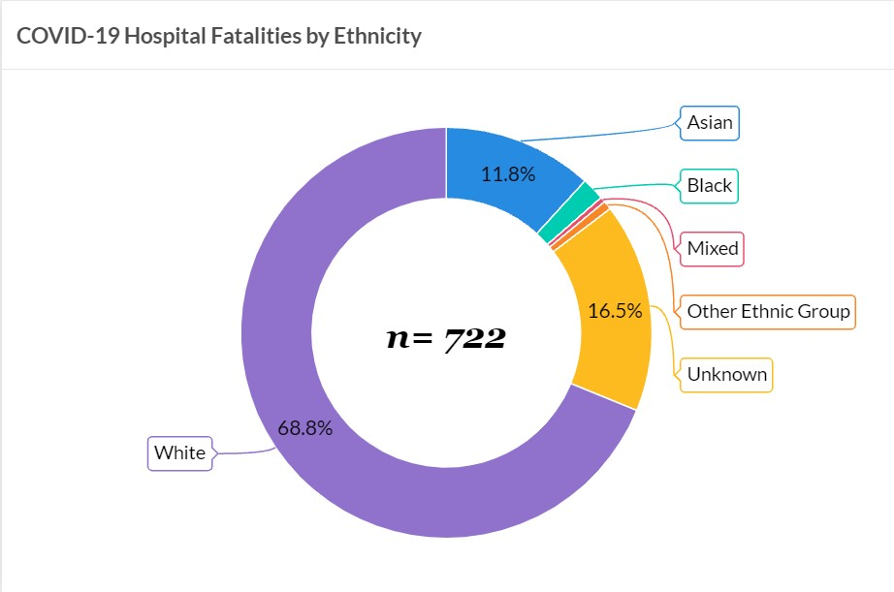
KEY AREAS FOR ATTENTION
Covid-19 Deaths Dashboard
There have been a total of 736 Covid positive deaths in the hospital (to 13/10/21). Covid deaths are scrutinised by the medical examiners and escalated at SJRs in line with the Learning from Deaths Policy. Any Covid deaths associated with a hospital acquired infection are reported with an incident via Safeguard.
Mortality - Covid by Ethnicity
The figure shows that the vast majority of deaths are in the white ethnic group. Unknown groups are where the Trust is not able to source this data.
Non Covid excess death rate
There have been 294 non Covid related deaths in Q2 2021 as compared to 241 in Q1 2021. This is likely to reflect the more varied clinical presentations now being admitted as compared to the same time period last year.
Covid HCAI deaths
Covid HCAI deaths were reviewed by our external medical support worker reviewers. A review of HCAI deaths in from June 2020 has been completed with the following outcome. The review identified that all patients had serious comorbidities and/or Covid risk factors.
3

*deaths that occurred in care homes were difficult to confirm as definite hospital acquired
The Learning from Deaths team continues to liaise with the Infection Control team to identify and investigate deaths from hospital acquired Covid. All Covid deaths meet the serious incident framework and are in the process of a cluster root cause investigation by an external investigator.
MEDICAL EXAMINER UPDATE
Extending Medical Examiner scrutiny to non-acute settings
Acute trusts were asked to set up medical examiner offices to initially focus on the certification of all deaths that occur in their own organisation on a non-statutory basis. In February 2021, the government published Working together to improve health and social care for all, the white paper which includes provisions for medical examiners to be put on a statutory footing.
During 2021/22, the services provided by medical examiner offices will start to be extended beyond acute trusts to provide independent scrutiny of all non-coronial deaths, wherever they occur. Implementation of this next phase will happen incrementally, to allow time for capacity and processes to be put in place. Providers were informed of this development by letter from NHSE&I on 8th June 2021 and the system is expected to be statutory in the first quarter of 2022.
The Trust’s medical examiner office will lead the work to establish arrangements with local GPs to embed the system for reviewing deaths. The service will be hosted at the Trust.
This additional workload will necessitate the expansion of the medical examiner office. Recruitment is currently underway to double to size of the medical examiner team to support the additional reviews. GPs are being approached to work as medical examiners alongside the existing Trust medical examiners.
The Trust’s Lead Medical Examiner, supported by the Business Manager, Medical Directorate are working closely with local PCNs to implement this process. Initial contact has been made and meetings with each of the PCNs are planned for October and November 2021.
Accommodation
The current medical examiner team are working from two small offices adjacent to the General Office. This accommodation was a temporary solution which
4
No of HCAI deaths

No of deaths identified as definite hospital acquired*
Covid main or contributory cause of death
Number of deaths potentially avoidable (score of 3a and below)
206
35
27
21
refurbishment works of the old Coroner’s Court took place. This arrangement is not suitable for the following reasons:
•
The medical examiners review medical records in order to complete their reports and there is very little space available to support this.
Telephone calls to families to discuss deceased relatives cannot be made in the office as there is no privacy.
The nature of the work of the General Office is not conducive to undertaking the role of a medical examiner.
There is no office space for the Learning from Deaths/ME administrator which makes it very difficult for them to undertake their role.
•
•
•
The refurbishment works have not started despite this being agreed in February 2020. A paper was presented at the Trust Executive Team meeting, the paper had two recommendations: the refurbishment of the old Coroner’s Court should be a stand-alone scheme; or if Skanska cannot undertake this work then alternative arrangements must be sought. Steps have been taken to find an alternative company to carry out the work.
Accommodation is of vital importance to enable the Trust to provide this statutory requirement.
LEARNING FROM DEATHS
Process for reviewing deaths in hospital
A number of reviews as referenced in the NQB guidelines as a minimal requirement undergo formal structured judgment review (SJR):
•
•
•
•
•
All deaths where a bereaved family, carer or staff have raised a concern Patient deaths of those with a learning disability
Patient deaths of those with a mental illness
Unexpected deaths, such as following an elective procedure
Particular groups where an alarm has been raised for example via HSMR, SHMI or CQC
Deaths where learning will inform the providers quality improvement work All maternal deaths
All child deaths, over 16 years of age All perinatal and still birth deaths.
•
•
•
•
Learning from deaths performance
The Trust has four medical examiners, two are anaesthetists and one is a microbiologist. Despite clinical pressures requiring these doctors to contribute to clinical care for Covid, the team have been able to maintain performance in scrutinising deaths shown in the figure 3:
Figure 3: Learning from deaths performance.
5
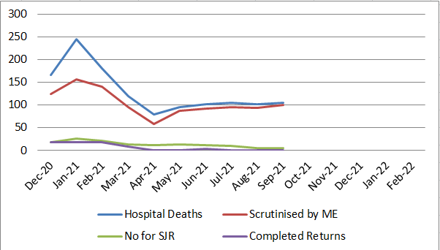
There has been a reduction in number of notes delivered and SJRs completed due to a vacancy in the learning from deaths co-ordinator post since May 2021. Administration has focussed prior to this on completing all Covid relating structured judgment reviews. The new administrator commenced at the start of September 2021 and has concentrated efforts in following up the outstanding SJRs by delivering notes, this exercise was completed at the beginning of October and results are being followed up. CORS (electronic system for recording and reporting mortality in the Trust) was introduced in August 2021 and has been successfully embedded. CORS provides the Trust with transparency of the death process from completion of death certificates to SJRs. The Learning from Deaths Administrator holds admin rights for the system and is currently following up requests for SJRs in order to present updated data for the next report.
National Learning from Deaths Dashboard
•
The Trust has adopted reporting via the National Learning from Deaths Dashboard (https://view.officeapps.live.com/op/view.aspx?src=https://www.england.nhs.uk/w p-content/uploads/2017/03/nqb-learning-from-deathsdashboard.xlsm). In the last quarter, there have been 312 deaths at the Trust. In Q2, 3 SJRs have been completed. Care has been assessed as level 3a or below in none of these cases (table 3).
•
Year to date; as assessed by SJR level 1 reviews, 0.5% of deaths were definitely avoidable, 0.9% strong evidence of avoidability, 8.9% were probably avoidable (more than 50/50), 23.8% probably not avoidable (less than 50/50), 55.6% probably not avoidable and 10.3% of deaths slight evidence or definitely not avoidable (table 4)
6
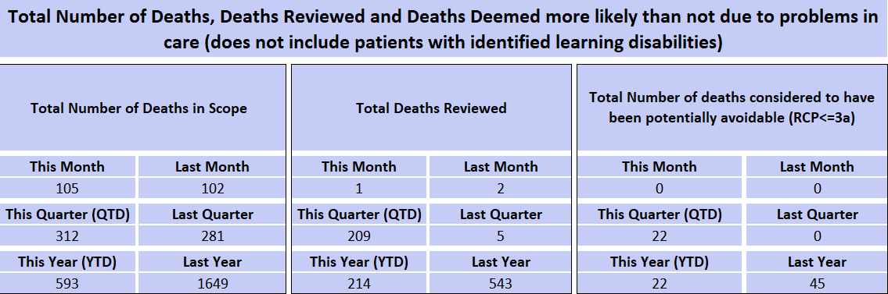
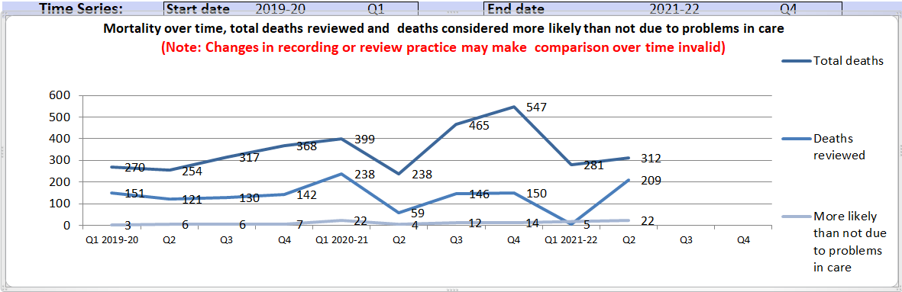
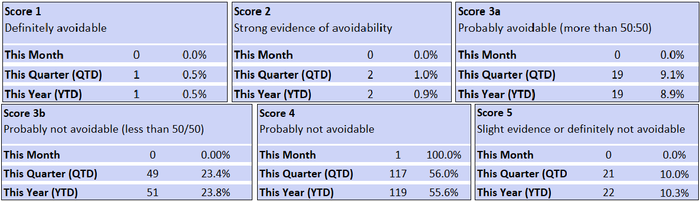
Table 3: National Dashboard Learning from Deaths Performance
Figure 4: Trend of Learning from Deaths Performance 2019-2021
Table 4:
Deaths of patients with a learning disability
There were 2 deaths of patients with learning disability in Q2 2021 (table 5). These deaths are reviewed as part of the LeDer review process.
7
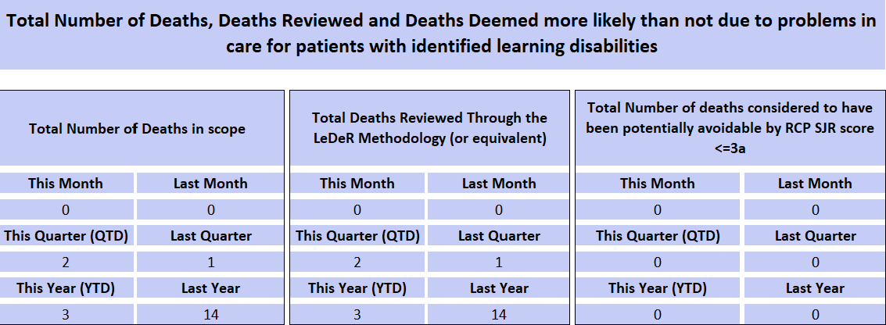
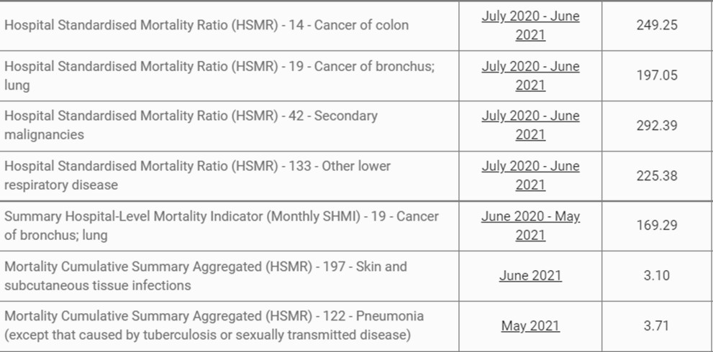
Table 5: Deaths of patients with a learning disability
Figure 5: Alerts and notifications
The following Trust alerts have been received from the National HED database.
A Lung Cancer QI project has been completed. The surgical lung cancer pathway has been affected by delays in tertiary centre at University Hospital Birmingham thoracic service waiting lists. The Trust is currently in discussion with RWT to see if the pathway can be moved there. The respiratory team are also recruiting additional consultants.
Two new alerts have been received; 197 – Skin and subcutaneous tissue infection and 42 – Secondary malignancies. The relevant teams have been asked to review
8
Indicator Name
Period
Value

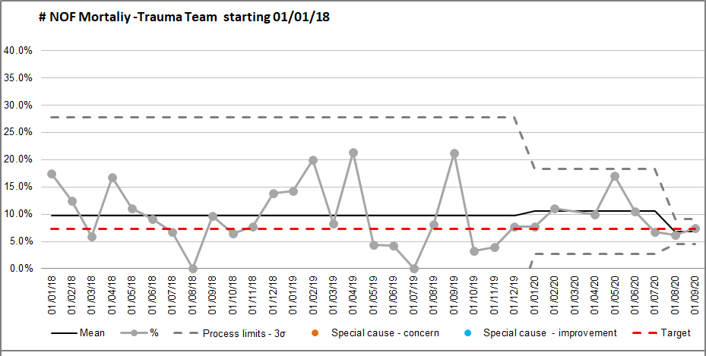
and report back to Mortality Surveillance Group. An update will be provided in the next quarterly QPES report.
LEARNING FROM MORTALITY SURVEILLANCE GROUP
The Mortality Surveillance Group meets monthly to focus on the learning shared and implemented from the deaths within the speciality care groups. Each thematic focus group reports to the MSG quarterly.
Learning from Structured Judgments Reviews
Examples of learning from mortality reviews in the last quarter include:
•
•
•
•
Review of Oncology Service SLA with UHB
CCNs have received training form COPD reporting Band 6 End of Life nurse appointed (not yet in post)
Ward based Non Invasive Ventilation unit in W17 planned for October 2021
QUARTERLY UPDATES FROM SHQC LEARNING FROM DEATHS THEMES
Fractured neck of femur
Monthly mortality from fractured neck of femur is tracked through MSG. For quarter 2, mortality rates are stable and the group will continue to monitor until there is a sustained reduction.
Figure 4: Mortality from fractured neck of femur
9

Health Care Associated Infection (HCAI)
A Trust Point Prevalence Study was undertaken in June 2021 and reported to MSG in September 2021. The aim of the study was to estimate the burden of HCAI within Walsall Healthcare NHS Trust. The outcome of the study showed that the top 3 HCAI at the Trust are the same as National point prevalence study (pneumonia, urinary tract and surgical site).
The Study concluded that the point prevalence study showed an overall reduction in HCAIs in comparison to 2017, but at 16% overall a higher rate than the National average (6.4%).
(UTI Urinary tract infection, SSI Site specific infection)
The Trust infection control team recommended the recruitment of dental hygiene nurses to improve mouth care, which would subsequently lead to a reduction in hospital acquired pneumonia (one of the top causes of in patient deaths in the Trust). There is good evidence that this approach has worked elsewhere. The team are building a case which is being supported by the DoN and acting MD. A new SSI group has been established across the Trust to scrutinize these cases in conjunction with the theatre and infection control team.
A Trust Sepsis team has been established with a new Clinical Lead. They will be part of the Trust Critical Outreach Team and be responsible for response to deterioration, standardized management of sepsis and training. A business case to add resilience into the team is underway.
Elderly Care
The specialty reviewed SJRs completed since March 2021 and identified the following improvements required around review of patients, DNARCPR discussions around malignancy, Duty of Candour and quality of mortality reviews. The care group has initiated a local improvement plan to utilize the ReSPECT form to drive these improvements.
Emergency Department
A review of deaths in ED was carried out and reported to MSG in August 2021.
•
The total number deaths in ED in the last 12 months was 150 (August 2020 – July 2021)
The month with the highest recorded deaths was January 2021 (24, mostly aged 60-90yrs of age), followed by the month of March 2021 (17) and then June 2021 (15)
•
10
Point Prevalence
2011 UK
Trust 2017
Trust 2021
Overall % rate
6.4
23
16
Respiratory
22.8
51
32
UTI
17.2
34
24
SSI
15.7
8
17

- These deaths were mostly due to breathing difficulties and out of hospital cardiac arrest
The review highlighted a number of themes of excellence and good practice:
Patients were seen immediately on arrival by senior members of the team (consultants, middle grades, senior ACPs)
Good documentation/timeline ALS protocol was applied
Timely escalation to specialties (Medical team, ITU, Surgical etc.)
Early involvement of senior clinician in decision making wherever necessary ( Consultant in charge from 0800-2400) daily bases
Involvement of next of kin
Most patients received adequate to excellent care
DNA CPR status reviewed in time and used in decision making and escalation to other specialties
•
•
•
•
•
•
•
•
The review also highlighted areas for improvement:
Delayed review by the specialty teams
Some patients had no nursing staff documentation Medway system notes unavailable
Documentation of any discussions with medical examiner/coroner referral and outcomes
Staffing level in resuscitation room Initiation of end of life care.
•
•
•
•
•
•
As a result of the review the department introduced a number of improvements, including monthly teaching & simulation sessions in partnership with the Trust simulation lead. One such session recently focused on how to care for a critically sick child.
There is an ED monthly newsletter and e-mail with feedback from serious incidents, SJR learning points, mortality surveillance group meeting meetings and learning from local mortality meetings to ensure staff are updated on a regular basis.
In order to make learning and resources more available, Askearl.co.uk, a clinical resources app for Walsall Manor Emergency Department was launched in May 2021 which provides easy access for staff and patients and includes clinical guidelines, patient information leaflets and news items. Staff are able to make e- referrals to other specialties using the app.
Cardiology
Cardiology have introduced guidance “When to Talk to Heart and Lung” and this has been published on the AskEarl system (see details above).
11
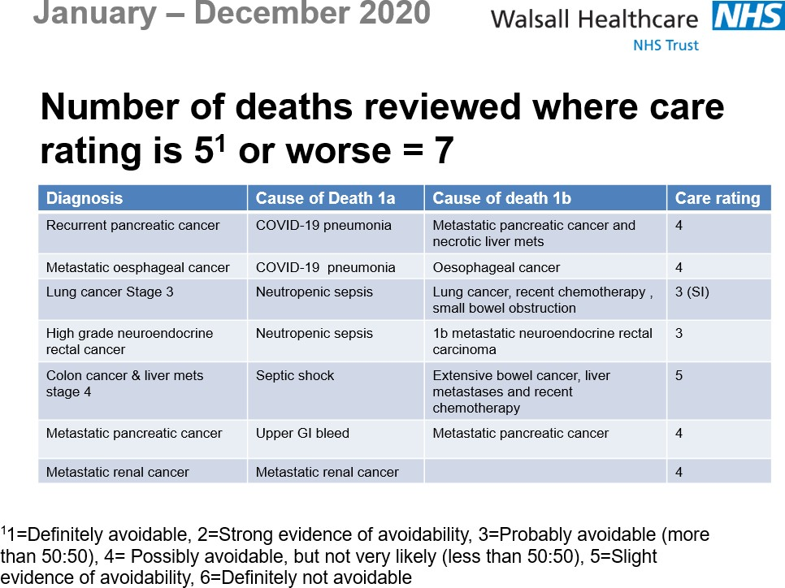
A review of the service highlighted two areas of improvement:
•
•
Prescribing
Post take ward rounds
The following themes were also highlighted during the review and work is ongoing to make improvements in the diagnostic pathway with purchase of a new ECHO machine, by implementing an early referral and treatment pathway, supporting same day emergency care and with changes around conscious sedation for cardiology procedures.
Areas of good practice included effective board rounds for early safe discharges, 7 day consultant ward round and 6 days cardiac diagnostic supported by consultants.
Cancer Services
A new 104 day harms review process has commenced with Executive and CCG oversight. Focus remains on the urology and respiratory cancer pathways.
Collaboration is underway with RWT to move urology pathways across WHCT and RWT with a joint on call service.
In response to mortality alerts for cancer, the team have reviewed deaths from January to December 2020
12
Improvements in progress include:
- Identification and treatment of Neutropenic Sepsis
Introduction of a 7 day Acute Oncology Service with 7 day telephone service to support earlier presentation to Hospital
- Septic Shock
Introduction of a Rapid Response Team to support early identification of sepsis and delivery of the Sepsis Six
- Referral to Palliative Care
Only 2 / 13 palliative patients known to Palliative Services. Work in conjunction with end of life team.
End of Life
A New task and finish group has been established in the Trust with links to Walsall Together strategic group. The task and finish group as a broad representation including Healthwatch and is chaired by the Deputy Medical Director. The aim of the group is to improve the end of life care for patients.
In addition to the implementation of the task and finish group the following developments have also taken place:
•
Palliative & End of Life Care Group
–
–
–
–
Band 6 EOL nurse appointed recently – not in post yet ‘refresh’ of Blossom Box initiative
Closer working with the integrated assessment hub and front door AMU board round attendance
•
ICS – ongoing work in EOL group, education group, frailty group and respiratory group
New staff – new consultant due to start, FY3 funding agreed for 12 months at Goscote Hospice, ANP started Aug
Collaborative working – admissions to and from Goscote Hospice, pathways between community and acute, MDT working with other specialties
•
•
Community
Update: Fraility nurse now embedded within the locality model, patient pathway working, integrated care deliver across the locality. Education pathway delivered from June – September, work continuing and locality evaluation taking place.
Ongoing work now in place across the division supporting patient pathways Sepsis, VTE, mortality, feeding into patient safety and divisional board.
13
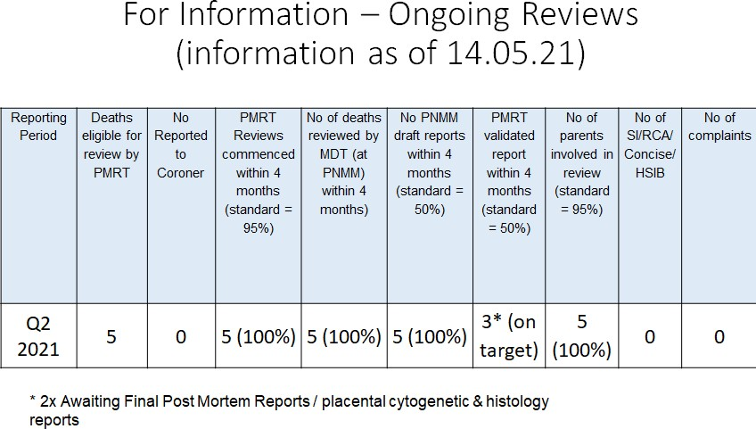
QUARTERLY REPORTS
Child deaths report
The trust reviews child deaths through the Black Country Child Deaths programme (CDOP). This is reported quarterly through MSG. The next Child Death Report is due to be presented at the October meeting and will be included in the next Mortality report to QPES.
Perinatal mortality report
In Q2 2021, 5 cases were eligible for review by the National Perinatal Mortality Review Tool as shown in table 6 below
Table 6:
Lessons:
•
The PMRT enables the review team to identify contributory factors (task/ organisational / staff / patient), to any issues found during the review and to develop action points to address any issues with care.
Points identified as part of the initial MDT review and the monthly Perinatal Mortality and Morbidity Meeting can be incorporated into lessons learnt where relevant
•
14
Assurance
•
All elements of Saving Babies Lives Care Bundle have been implemented achieving SNSR safety action 6 for 2021.
All eligible cases are referred to HSIB with a low lack of family agreement rate. There have been no repeat themes reported by HSIB for the Trust this quarter. All cases are reviewed through PMRT with external obstetrician and neonatologist input.
There is an improvement project within antenatal clinic to improve access to preterm prevention clinic and review clinical templates and job plan for consultants
•
•
END OF REPORT
15
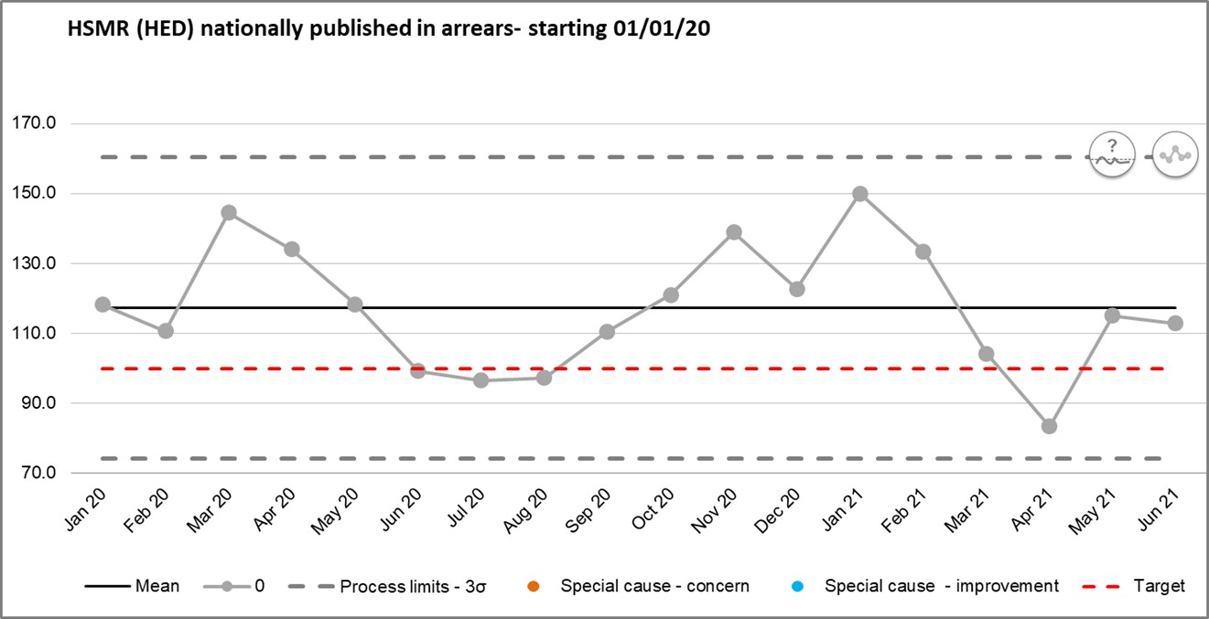
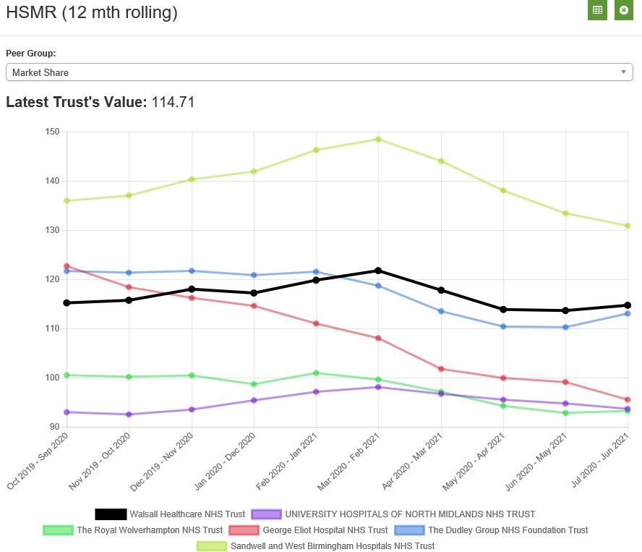
Appendices
Monthly Rolling Hospital Standardised Mortality Rate (HSMR)
Market Benchmark HSMR
16
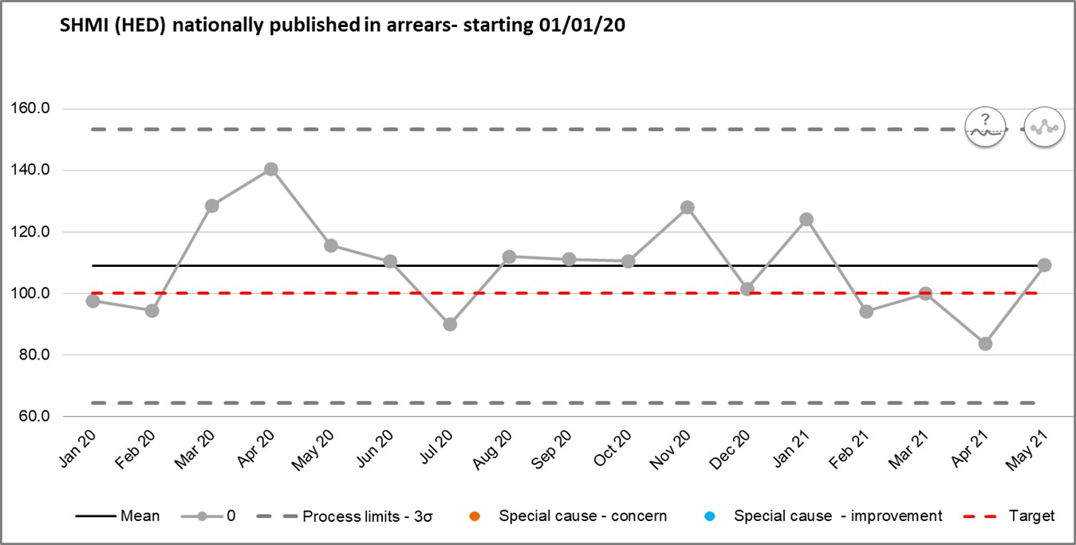
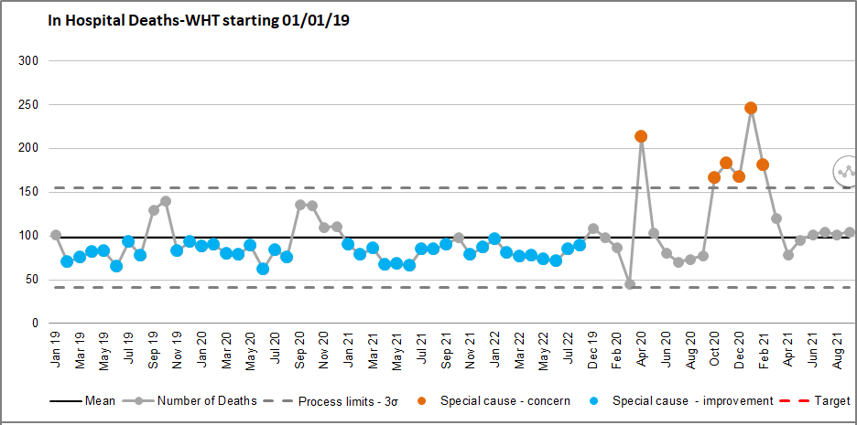
Standardised Hospital Mortality Index (SHMI)
Monthly SHMI
Market Benchmark SHMI
In Hospital Deaths
17
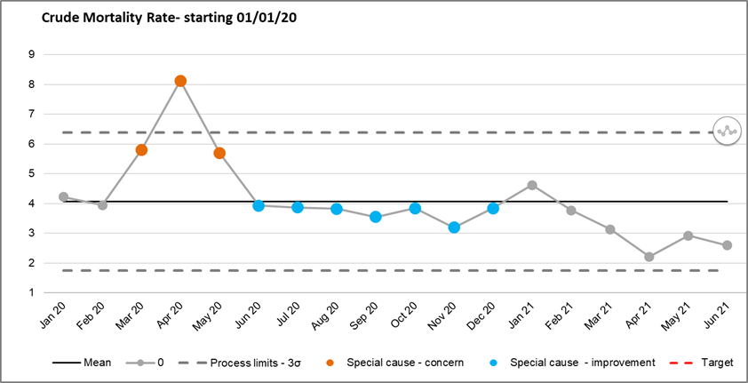
Crude Mortality June 2020 – June 2021 (deaths per 1000)
18
Glossary of Terms
HSMR Hospital Standard Mortality Rate SHMI Standard Hospital Mortality Index NQB National Quality Board
CQC Care Quality Commission NHSI NHS Improvement
SJR Structured Judgement Review ME Medical Examiner
MEO Medical Examiner Officer
LeDeR Learning Disability Mortality Review Programme LD Learning Disability
DNAR Do not attempt resuscitation MCA Mental Capacity Act
SI Serious Incident
RCA Root Cause Analysis
MTLC Medicine and Long Term Conditions division LFD Learning from Death
CuSuM Cumulative Summary, a performance deviation from the mean
PALS Patient Advisory and Liaison Services CCG Clinical Commissioning Group
MSG Mortality Surveillance Group MDT Multidisciplinary Team
indicator
demonstrating
persistent
19
1 | P a g e
MEETING OF THE PUBLIC TRUST BOARD - Thursday 4th November 2021
Performance, Finance & Investment Committee (PFIC) Highlight Report

AGENDA ITEM: 12

Report Author and Job Title:

Russell Caldicott – Director of Finance and Performance
Responsible Director:

Mr John Dunn – Chair of PFIC (Non- Executive)
Action Required

Approve ☐ Discuss ☐ Inform ☒ Assure ☒
Executive Summary

This report provides the key messages from the Performance, Finance & Investment Committee meeting on 27th October 2021. Of note are:

- The Financial position of the Trust has moved to a £0.011m surplus at month 6 YTD (H1). The trust has previously forecast a deficit of £0.950m for H1. The primary cause for the deficit was additional urgent and emergency care activity caused by intelligent ambulance conveyancing. The Trust invoked the Black Country and West Birmingham STP risk share agreement which provided additional funding of
£0.950m, with partners recognising the support the trust was providing. Current indications are the Trust will receive additional funding to support the ward refurbishment of c£1.8m (written confirmation awaited).

- The Committee reviewed the constitutional standards report and discussed the very significant pressures on Urgent and Emergency Care services nationally and locally. The committee commended the strong relative performance in both timeliness of ambulance handover and of the 4-hour Emergency Access Standard compared to other Trusts, and recognised the significant efforts taken across Community, Hospital and partner services to sustain this. The Chief Operating Officer briefed the committee on a letter received from the National Director for Emergency & Elective Care, the National Medical Director and the Regional Director for the Midlands in relation to NHSEI’s increasing concerns about ambulance handover delays, and the importance of the Trust’s Winter Plan to maintain timely ambulance handovers.

2 | P a g e

- Under Community performance progress was reported around the actions relating to the availability of packages of care. The numbers of MSFD has reduced in October to an average of 41 from 52 in September. It must be signaled to the Trust Board however, that despite this response, there are indicators of pressure within social care community pathways (numbers of referrals to brokerage; people waiting for domiciliary support in order to leave care homes) which raise concerns about the resilience of domiciliary care provision to deal with sustained demand. This could have an adverse impact on the numbers of MSFD at Walsall Manor Hospital over the coming months

The next meeting of the Committee will take place on 24th November 2021.
Recommendation

Members of the Trust Board are asked to note the escalations and any support sought from the Trust Board.

Does this report mitigate risk included in the BAF or Trust Risk Registers?
This report aligns to the BAF risk for use of resources and working with partners, and associated corporate risks.

Resource implications
The resource implications are set out in this highlight report.

Legal and Equality and Diversity implications

There are no legal or equality & diversity implications associated with this paper

Strategic Objectives

Safe, high quality care ☒
Care at home ☐
Partners ☒
Value colleagues ☐
Resources ☒

1
MEETING OF THE PUBLIC TRUST BOARD - Thursday 4th November 2021
Use Resources Well Executive Report
AGENDA ITEM: 13
Report Author and Job Title:

Ned Hobbs, Chief Operating Officer Russell Caldicott, Director of Finance & Performance
Responsible Director:

Ned Hobbs, Chief Operating Officer Russell Caldicott, Director of Finance & Performance
Action Required
Approve ☐ Discuss ☐ Inform ☒ Assure ☒

Executive Summary

This report provides an overview of the risks to delivery of the Use Resources Well strategic objective, mitigations in place to manage the risks identified, and actions identified to address gaps in controls and assurance. It provides the Trust Board with assurance on performance for Use Resources Well and NHS constitutional standards successes and areas for improvement.

This report recognises the financial arrangements within which the Trust is operating during the 2021/22 financial year, a result of the impact of the COVID-19 pandemic. Board members receiving an update on financial performance following formal adoption of the financial plan for April to September 2021 (Horizon 1 – H1).

The Trust has delivered a surplus in September 2021 of £0.01m following receipt of £0.95m from the Sustainability and Transformation Partnership (STP) using the risk share agreement.

The initial forecast deficit of £0.95m centred upon the Medicine and Long-term Conditions Division exceeding planned resource allocations. The drivers of this adverse variance centred almost entirely upon the Urgent & Emergency Care demands that the Trust is experiencing from increased attendances and ambulance conveyances (supporting the STP in emergency care) contributing to high levels of temporary workforce.

The Trust invoked the risk share agreed within the STP, resulting in the Trust delivering break-even for H1, maintaining the success in delivery of a surplus for the previous two financial years.

The Trust has also negotiated the receipt of STP capital slippage,
the resources sufficient to mitigate the risk to overspends contained within the capital programme and finance the essential ward refurbishment works commenced in year.
The report then focuses upon plans being developed for October to March 2022, Horizon 2 (H2). The expenditure run rate plans developed and owned by Operational teams, to include provision for both investments and winter initiatives as endorsed by Board colleagues.
The expenditure plans developed with Operational teams include provision in H2 for the increased costs for MLTC incurred in H1 (the risk share) winter plan and investments such as the Nursing establishment increase.
However, delivery of H2 Operational plans within resource envelopes will be challenging. The primary risks being (a) Provider H2 actual income allocations are still to be confirmed (b) Agency cessation aligns to Nurse Investment business case (c) delivery of efficiencies at 1.6% of H1 (d) additional costs exposure over winter
The H2 financial plan has been presented and endorsed through the Executive and Trust Management Committee, presented to Performance, Finance and Investment Committee (PFIC) and is to be debated in Private Session with Board colleagues.
In summary, whilst the 2021/22 H2 plan delivers breakeven, significant risks remain. Mitigations will largely centre upon securing an appropriate income settlement for the Trust, attainment of some cost out efficiency and cessation of nursing agency in accordance with the investment case.
Members further noted the risk to delivery of efficiencies for H2 financial plans and to support 2022/23 modelling, this was noted as a key risk to financial sustainability by PFIC members.
Members of PFIC a business case for endorsement to Trust Board for Theatre staffing. Whilst this increased costs over current H2 plans by c£0.3m, members noted the safety concerns associated with not supporting the investment.
2

The improved theatre productivity will offer potential to offset the costs of the case as we move into 2022/23 (subject to the financial regime in force). As such, the case was recommended for endorsement by Board colleagues and is to be received in private session.
The focus is then placed upon 2022/23 and the expected income allocation reductions expected. The current run rate c£3m more than historic periods, though costs are expected to reduce for Covid-19 and elective recovery non-recurrent measures.
If income allocations were to return to pre-Covid-19 levels the Trust would need to reduce costs significantly to live within its means. However, the provider base for the NHS would face a similar challenge.
Whilst the Trust awaits formal guidance on allocations for 2022/23, the focus remains on identifying baseline (normalised) expenditure exit run rate for March 2022 for when we enter 2022/23. The March 2022 plan totalling c£29m in overall expenditure and c£26.2m as a normalised position.
The report identifies continued strong operational performance. Despite challenges in the sonography service it highlights continued good constitutional standard performance in the DM01 6 week wait diagnostic standard with the eighth consecutive month of waiting times amongst the Top 20 general acute Trusts in the country.
It highlights consistently strong relative performance in emergency care with the Trust’s ambulance handover times (within 30mins) amongst the Top 3 best performing Trusts in the West Midlands for the eleventh consecutive month. It notes significant and persistent pressure on Urgent & Emergency Care services across the country, however. The Trust’s 4 hour Emergency Access Standard performance is under pressure associated with record high levels of Type 1 Emergency Department attendances, increasing numbers of ambulances received that have been intelligently conveyed away from neighbouring Emergency Departments due to excessive ambulance handover times, and with higher hospital bed occupancy associated with increased numbers of Medically Stable
3

4

For Discharge patients as a result of challenges in the domiciliary care market. It notes that the country as a whole has delivered the lowest 4-hour Emergency Access Standard performance on record again in August 2021, and that Urgent & Emergency Care systems are under unprecedented strain. The approval of the Trust’s Winter Plan at the last Board meeting will mitigate the risk of Urgent & Emergency Care pressures deteriorating further over the Winter Period.

The report highlights the stable Trust performance against the 18- week Referral To Treatment waiting time standard, which is mirrored by the Trust having the fifth lowest proportion of its elective waiting list over 52-weeks in the (combined West and East) Midlands.

The Trust’s GP referred 62-day Referral to Treatment Cancer waiting time performance is significantly better than the West Midlands average and the national average (August 2021), and both suspected cancer and Breast Symptomatic 2 week wait performance are now demonstrating statistically significant (special cause variation) improvement.

The report notes that the Trust is providing mutual aid to The Dudley Group NHS Foundation Trust for the suspected Skin Cancer pathway, to The Royal Wolverhampton NHS Trust for long waiting patients needing Urology surgery and to a number of neighbouring Trusts for intelligently conveyed ambulances away from Emergency Departments with prolonged Ambulance Handover times.

Recommendation

Members of the Trust Board are asked to note the contents of this report, key messages, and the next steps:
- Trust (£0.01m) and STP (£0.3m) delivered a small surplus for Horizon 1 (April to September 2021)
- Whilst provider income for Horizon 2 is yet to be confirmed, the Trust has developed a run rate model endorsed by Operational teams (to include winter costs and Nurse investment) less an efficiency ask that attains break-even.
- PFIC reviewed the H2 financial plan. However, noted risks remain to delivery with further review at Private Trust Board. PFIC requesting an update on the risks and
5

mitigations to its next meeting.
- The Trust has developed exit run rate models to understand expenditure baselines for 2022/23, when income allocations are known the Trust can then develop plans for 2022/23.
- PFIC noted the efficiency programme delivery 2021/22 and moving into 2022/23 to be key for sustainable services, requesting an update for the next meeting.
- STP capital has been agreed (written confirmation pending) offsetting risk to overspend within the capital programme, financing the ward infrastructure works.
- The Trust has prioritised the capital programme to purchase Bioquell Pods to support urgent and emergency care during the winter period (at a cost of c£0.3m).
- The theatres business case to support safe staffing was reviewed, to be debated at Private Trust Board.

Mitigate risk included in the BAF or Trust Risk Registers?
This report addresses BAF Risk S05 – Use Resources Well to provide positive assurance that there are mitigations in place to manage this risk and the related corporate risks.

Resource implications

This strategic objective is: We will deliver optimum value by using our resources efficiently and responsibly - Financial impacts are as described within the recommendations section.
Legal and Equality and Diversity implications

There is clear evidence that greater deprivation is associated with a higher likelihood of utilising Emergency Department services, meaning longer Emergency Access Standard waiting times will disproportionately affect the more deprived parts of the community we serve.

Whilst not as strongly correlated as emergency care, there is also evidence that socioeconomic factors impact the likelihood of requiring secondary care elective services and the stage of disease presentation at the point of referral. Consequently, the Restoration and Recovery of elective services, and the reduction of waiting times for elective services must be seen through the lens of preventing further exacerbation of existing health inequalities too.

The published literature evidence base for differential access to secondary care services by protected characteristic groups of the community is less well developed. However, there is clear evidence that young children and older adults are higher users of services, there is some evidence that patients who need interpreters (as a
6

proxy for nationality and therefore a likely correlation with race) are higher users of healthcare services. And in defined patient cohorts there is evidence of inequality in use of healthcare services; for example end of life cancer patients were more likely to attend ED multiple times if they were men, younger, Asian or Black.

In summary, further research is needed to make stronger statements, but there is published evidence of inequity in consumption of secondary care services against the protected characteristics of age, gender and race.
Strategic Objectives

Safe, high quality care ☐
Care at home ☐
Partners ☐
Value colleagues ☐
Resources ☒

WALSALL HEALTHCARE NHS TRUST - TRUST BOARD USE RESOURCES WELL
AUTHOR - CHIEF OPERATING OFFICER & DIRECTOR OF FINANCE
1.
EXECUTIVE SUMMARY
This report provides an overview of the risks to delivery of the Use Resources Well strategic objective, mitigations in place to manage the risks identified, and actions identified to address gaps in controls and assurance. It provides the Trust Board with assurance on performance for Use Resources Well and NHS constitutional standards successes and areas for improvement.
This report recognises the financial circumstances that the Trust is now operating in during the new 2021/22 financial year, and the continued uncertainty surrounding financial allocations for Q3 and Q4.
It updates Board members on attainment of a surplus of £0.01m to September 2021 of the financial year (month 6 of 2021/22). The Trust was forecasting at month
5 reporting a trading deficit of £0.95m that has been mitigated through securing additional income from the Sustainability and Transformation Partnership (STP) and therefore has attained financial plans for H1 (Horizon 1 to September 2021). This representing the continued achievement of a surplus and financial plan (as has been the case for the previous two financial years).
The report also confirms key performance against financial plans for Horizon 1 (H1 - April to September 2021) of the 2021/22 financial year and reflects on the basis for development of expenditure plans for Horizon 2 (H2 – October 2021 to March 2022) income allocations post 30th September 2021 to be confirmed.
The report identifies continued strong operational performance following the extreme pressure experienced during the third wave of the Covid-19 pandemic in early 2021. It highlights good constitutional standard performance in the DM01 6 week wait
diagnostic standard with the
14th
best performance of 122 reporting general acute
Trusts in the country. It highlights strong relative performance in emergency care with the Trust’s ambulance handover times (within 30mins) amongst the Top 3 best performing Trusts in the West Midlands for the eleventh consecutive month, and 4-hour
Emergency Access Standard performance ranked
26th
nationally of 112 reporting
Trusts. However, the report notes the significant and persistent pressures on Urgent &
7
Emergency Care services with 4-hour EAS performance and ambulance handover performance the worst on record nationally again in September 2021. The report highlights the Trust’s stable 18-week Referral To Treatment waiting time standard performance, which is mirrored by the Trust having the fifth lowest proportion of its elective waiting list over 52-weeks in the (combined West and East) Midlands. The Trust’s GP referred 62-day Referral to Treatment Cancer waiting time performance is now significantly better than the West Midlands and national average, and both suspected cancer and breast symptomatic 2-week waiting performance are now showing statistically significant (special cause variation) improvement.
2.
BOARD ASSURANCE FRAMEWORK
The Use Resources Well Board Assurance Framework (BAF) risk has been further updated to include:
-
Confirmation of revised forecast to break-even for H1, following receipt of
£950k STP risk share income associated with significant mutual aid for patients conveyed by ambulance from outside the Walsall borough to Walsall Manor ED due to prolonged ambulance handover times at neighbouring Trusts.
-
Confirmation that H2 Planning Guidance was issued on
30th
September
2021, but that at the time of writing this report the Trust’s H2 income allocation is still to be finalised.
-
Key financial risks centre upon the remaining uncertainty over income levels for H2 (October 2021 to March 2022) further articulated within the corporate risk register, and inform the Use Resources Well section of the Board Assurance Framework, namely:
•
Efficient running of the Trust, using every pound wisely in delivery of the financial plan and securing improved run rate performance to ensure financial sustainability in the longer-term
- Modelling trajectories for temporary workforce
- Identification of efficiencies to service the plan and enable re-investment into services
- Confirmation of income allocations for October 2021 and onwards
•
Capital
resource
availability
to
service
current
Estate
backlog
works
requirements and future major capital developments
The Chief Operating Officer and Director of Finance reviewed the risk score in light in advance of the September Committee meeting. The review noting risks articulated centring upon a lack of clarity on income envelopes, uncertain demand for urgent and
8
emergency care and delivery of winter plan initiatives within a reduced resource allocation from H1 (H1 less an efficiency ask) combined with a need to attain efficiencies to offset reduced income but also enable investment in services.
The conclusion of the review was for the risk to remain as reported, owing to the significant uncertainties regarding income to be received for H2 and the level of efficiencies that can be generated to offset income reductions and service investments.
3.
PERFORMANCE REPORT
3.1.1 Financial Performance - background
The Trust entered the 2020/21 financial year having attained planned financial outturn for 2019/20. However, the onset of COVID-19 resulted in emergency budgets being set by NHSEI and the normal planning process halted. However, the Trust attained a
£0.14m surplus for the 2020/21 financial year.
The 2021/22 financial planning was also affected by the pandemic, and has been divided into two periods, Horizon 1 (H1) covering April to September 2021 and Horizon 2 (H2) covering October to March 2022. This section of the report will update members on H1, H2 and 2022/23 revenue and then capital & cash.
3.1.2 Revenue position – Horizon 1 (April 2021 to September 2021)
Income allocations have been confirmed for H1 (April to September 2021) and the Trust has endorsed a plan for income and expenditure for this period 2021/22. This H1 plan supported by Executive and Trust Management Board, and recommended for adoption by Performance, Finance, & Investment Committee, was endorsed at Private Board.
The Trust has achieved a surplus at month 6 of 2021/22’s financial plan of
£0.01m. The Trust was forecasting a trading deficit against the H1 overall plan of
£0.95m at month 5. However, the Trust secured further income from the Sustainability and Transformation Partnership to offset this forecast deficit.
The Trust is attaining financial plan, the following key elements that are worthy of note:
•
Divisional performance against run rate
9
The Medicine and Long-term Conditions Division exceeded planned resources and was driving the Trust overall trading deficit. The drivers of this adverse variance centre almost entirely upon the Urgent & Emergency demands the Trust is experiencing from increased attendance and ambulance conveyance (increased urgent and emergency care demand).
The increased emergency activity largely a result of West Midlands Ambulance Service Intelligent Conveyancing to Walsall Manor ED, due to shorter patient handover times. As such, the Trust successfully invoked the risk share agreed within the sustainability and Transformation Partnership (STP) resulting in the Trust securing additional income of £0.95m. This offsets the forecast trading deficit and results in the Trust revising its forecast back to break-even for H1.
The cost exposure in H1 has been modelled within the H2 run rates and expenditure plans (to mitigate this risk re-occurring in the latter half of the financial year).
•
Elective Incentive Scheme
The Trust can receive additional income should performance of the STP exceed historic elective activity, whilst in addition the STP will need to attain key gateways.
There is risk to receipt of this income, and whilst the Trust has modelled expected performance to deliver a c£2.2m income gain, this income has been excluded through accruing out the benefit comparable to the income, owing to the risk to receipt of these funds.
It is of note the Trust is not expecting to receive significant further income from projected elective performance, largely owing to performance needed to trigger payment against historic activity thresholds increasing in future months.
STP members are accruing out the benefit from ERF potential income on a comparable basis, owing to the uncertainty regarding actual receipt. If receivable this will be available therefore to support financial planning in H2.
•
Sustainability and Transformation Partnership (STP) Risk Share
The Trust has entered a risk share with the STP, essentially indicating no member will be in surplus if one is in deficit. This presents an obvious risk should a member go into deficit to the Trust attaining break-even performance.
10
The STP has reported a small surplus of c£0.3m for H1 (year to date) post allocation of resources to the Trust and WMAS.
This WMAS forecast deficit mitigated through the STP risk share offsetting 23% of the deficit (the proportion of activity relating to the STP). The balance offset by allocations from other STP’s (relative to the activity from outside of the STP boundary serviced).
All other members attained break-even or small surplus for H1 of 2021/22 and agreement reached for Walsall to receive c£0.95m from the risk share to offset the forecast trading deficit.
In summary, the Trust and STP has attained financial balance for H1 (a small surplus) with ERF potentially offering a financial benefit if receivable for H2 for the Trust and wider STP (STP ERF estimated to total c£19m).
3.1.3 Revenue position Horizon 2 (H2 – October 2021 to March 2022)
Income allocations whilst known to the STP for H2 have yet to be aligned to provider allocations (at the time of writing). This remains a key uncertainty in production of financial plans for the latter half of the 2021/22 financial year.
The Operational teams have worked to develop robust run rate models for the 2021/22 financial years, the plans and finances owned by the teams, with further expenditure on winter plans and for investments within services then overlayed within the modelling to identify the expenditure for the financial year.
The Operational Plans have been modelled with resultant overall run rates presented to the Executive, Trust Management Committee and Performance Finance and Investment Committee. However, the modelling identifies risks associated with:
(a)
(b)
(c)
(d)
Provider H2 actual income allocations to be confirmed
Agency cessation aligning to the Nurse Investment business case Delivery of efficiencies at 1.6% of Horizon 1 (previously targeting 3%)
Cost exposure over winter (mitigation being the winter plan and H1 risk share)
The Executive and Trust Management Committee received and endorsed the financial plans for H2. The draft plan then presented to members of the Performance, Finance and Investment Committee, the plan identifying delivery of break-even performance for the financial year.
11
Whilst PFIC members acknowledged the operational team involvement and sign off for the plans, debate was held regarding key risks remaining to delivery of the plan and further assurances were sought for the next meeting of PFIC on income confirmation and mitigations.
The Trust remains within a risk share (so no member in surplus whilst another is in
deficit).
However, it is clear the second half of the financial year will be more
challenging in delivery of break-even performance for the Trust and wider STP (so the risk share may not be sufficient to offset cost overruns).
The Financial Plan for H2 is to be debated further through Private Trust Board.
3.1.4 Revenue financial modelling to 2022/23
Income allocations are expected to further reduce as the Government seeks to revise expenditure commitments post Covid-19. This is expected to place further pressure on expenditure budgets.
Expenditure totalled c£3m more than historic pre-covid levels, and whilst an element of this cost will be expected to reduce as Covid-19 subsides and (or in part will be driven by separate funding for elective recovery) there will also be an expectation some costs will remain (Infection Prevention Control protocols for example). If income allocations for 2022/23 are in line with 2019/20 pre-Covid-19 allocations the Trust would need to reduce costs significantly to attain a balanced financial model.
This would not be an uncommon situation faced throughout the provider base for the NHS, and income allocations are expected to be revised to reflect an element of Covid- 19 remaining. However, the expectation will be for reduced income to that currently received, and as such focus will be needed on controlling temporary workforce costs and delivery of efficiencies through the Improvement Programme as we move forwards.
The expectation is that for 2022/23 income allocations are set to further reduce and hence the focus has been placed upon normal (recurrent) expenditure and exit run rates for March 2022 included within the H2 financial plan workings (c£29m in total and c£26.2m normalised) to assure delivery of future financial plans (when guidance on income allocation methodology and values are known).
3.1.5 Capital and cash
Capital expenditure in the 2021/22 financial year will place focus upon investment within critical infrastructure works, Digital and Medical Equipment, with the most
12
significant scheme being the Emergency Department New build for which we are now seeing the steel works completed and the buildings walls fitted to the frame (it is an impressive addition to the estate of the Trust).
The capital programme was over committed following placement of contracts for much needed capital infrastructure works within the ward environments. However, the Trust has been successful in securing a commitment to increase capital resources from the STP overall allocations. This offsets these commitments and thus balances the programme accordingly (written confirmation of award is pending).
In order to offer enhanced resilience over the winter period for urgent and emergency care, the Capital Control Group has supported re-allocation of funding within the
programme to purchase 9 Bioquell PODS.
These PODS create additional single
patient enclosures, this potentially releases beds ‘blocked’ by infected patients and are supported by Infection Control approaching winter.
The Trust has substantial cash holdings (c£41m) at the close of H1 (September 2021).
Operational
Emergency Care:
The Trust has maintained statistically significant improvements in the percentage of patients triaged within 15 minutes of arrival to the Emergency Department (ED) with 10 consecutive months above the mean average, and continue to deliver some of the best Ambulance Handover times (<30 minutes) in the West Midlands, with the Trust one of the Top 3 performing organisations for 11 consecutive months. This has been achieved despite sustained high number of Type 1 ED attendances through September 2021,
13.4% higher than September 2019, and whilst supporting neighbouring mutual aid through receipt of 103 ambulances intelligently conveyed neighbouring Trusts with prolonged ambulance handover times during 2021.
Trusts with away from September
4-hour Emergency Access Standard performance in August 2021 has deteriorated further to 78.83% of patients admitted or discharged within 4 hours of arrival to ED, but the Trust was still ranked 26th nationally out of 113 reporting Trusts. The deterioration in 4-hour Emergency Access Standard performance has been in part due to increased bed occupancy as a result of a significant increase in the number of Medically Stable For Discharge (MSFD) patients in hospital due to challenges discharging patients who require domiciliary packages of care. The detail and actions to address this are included in the Community performance section, and are important given that timely
13
emergency care is crucial given the clear association between prolonged duration of stay within ED and both increased mortality for admitted patients, and worse patient experience. The Community Division and Walsall Together partnership have undertaken excellent work to mitigate this risk, and the number of MSFD patients has stabilised in late September and in to early October. Given the worst access to emergency care ever recorded at national (England) level in September 2021, it was positive that the Trust Board approved the Trust’s Winter Plan on 7th October 2021, in public session, to mitigate further emergency care risks for the months ahead.
Trusts received correspondence (dated
26th
October 2021) from the National Director
for Emergency & Elective Care, the National Medical Director and the Regional Director for the Midlands in relation to NHSEI’s increasing concerns about ambulance handover delays, and indeed West Midlands Ambulance Service University NHS Trust Board has formally increased its risk assessment associated with ambulance handover delays at hospital to a score of 25, with catastrophic consequences almost certain. Walsall Healthcare NHS Trust already reports ambulance handover performance to Trust Board (as requested in the letter) and remains committed to the safe, timely handover of patients conveyed by ambulance, and to consistently maintaining some of the best ambulance handover times in the West Midlands, to support ambulance crews to get back on the road to the next 999 call.
Elective Care:
Despite challenges in the sonography service, the Trust’s 6 Week Wait (DM01) Diagnostics performance remains strong and is 14th best (August 2021 reporting), out of 122 reporting general acute Trusts. Temporary staff absence within the ultrasound service during August and September (sickness, and self-isolation) and further sickness during October have meant that performance has deteriorated as a result and will take until December, at least, to recover. Recovery of access to ultrasound diagnostics is important to ensure that serious disease that needs urgent treatment is detected and acted upon promptly, and to ensure GP and other community clinicians have access to timely diagnostic information to support the management of patients in community settings.
Despite cessation of routine elective services during March and April 2020, and reduced elective operating capacity again from November 2020 to March 2021 over the second and third waves of the pandemic, the Trust’s 18-week RTT performance is stable with 68.23% of patients waiting under 18 weeks at the end of September 2021, and is 54th nationally (out of 122 reporting Trusts) for August 2021 performance. In addition, the Trust’s 52-week waiting time performance is 5th best in the Midlands (out
14
of 20 Midlands Trusts). The Trust now has 557 patients waiting in excess of 52-weeks as at the end of September 2021. Providing timely routine elective care is important given many patients will be suffering pain, discomfort and loss of independence whilst awaiting treatment and the clear evidence that patient outcomes can be adversely affected by excessive waiting times for treatment.
In August 2021, for 62-day Cancer performance the Trust was materially better than West Midlands average (70.7%) and national average (70.74%), with 79.22% of our patients treated within 62 days of GP referral. Patients referred by their GP on 2 week wait suspected cancer and Breast symptomatic pathways are both now experiencing statistically significant (special cause variation) improvement in waiting times. Timely care for patients with cancer is vital given the clear evidence that clinical outcomes (including survival rates) correlate with the stage of the cancer disease on diagnosis, and thus detecting and treating cancer early directly improves patient outcomes.
4.
IMPROVEMENT PROGRAMME
The Operational Productivity improvements forming a key tenet of the Use Resources Well improvement programme are now being evidenced through the Trust’s improved relative performance against key Model Hospital operational productivity metrics, including. Performance, Finance & Investment Committee at its September meeting received assurance on the following operational productivity improvements:
-
Cost per Weighted Activity Unit (19/20) now below peer and national median (Model Hospital)
Day case rates for British Association of Day Case Surgery better than peer and national medians (Q1 2021/22 – Model Hospital).
Average Length of Stay for elective admissions rolling 6 months below peer and national median (Q1 2021/22 – Model Hospital)
Average Length of Stay for emergency admissions rolling 6 months below peer and national median (Q1 2021/22 – Model Hospital)
Average late starts in Operating Theatres better than peer and national median (August 2021 – Model Hospital)
Touchtime Theatre utilisation better than peer and national median (August 2021 – Model Hospital)
-
-
-
-
-
A report to the Performance, Finance & Investment Committee in September 2021 from the Chief Operating Officer and Director of Integration recognised that the altered operating environment of the Covid-19 pandemic has meant that the majority of the
operational
productivity improvements
have not been cash-releasing cost
improvements, and the block contract environment similarly means that they are not PbR income generating improvements either.
15
The H2 Financial plan has set a cash-releasing financial improvement target of 1.6% for the Trust. Divisions are consolidating local plans against their constituent targets, and are making good progress. However, Performance, Finance & Investment Committee could not yet take assurance that the schemes would all be delivered to meet the 1.6% requirement, and therefore the October Committee meeting recognised that there was inherent risk to the delivery of this financial improvement. Performance, Finance & Investment Committee noted the progress and will receive the fully developed cash-releasing financial improvement programme at its November meeting.
5.
RECOMMENDATIONS
Members of the Trust Board are asked to note the contents of this report, key messages, and the next steps:
Trust and STP has delivered a small surplus for Horizon 1 (April to September 2021)
Whilst provider income for Horizon 2 is yet to be confirmed, the Trust has developed a run rate model endorsed by Operational teams (to include winter costs and Nurse investment) less an efficiency ask that delivers break-even. PFIC reviewed the H2 financial plan. However, noted risks remain to delivery with further review at Private Trust Board. PFIC requesting an update on the risks and mitigations to the next meeting.
The Trust has developed exit run rate models to understand expenditure baselines for 2022/23, when income allocations are known the Trust can then develop plans for 2022/23.
The efficiency programme delivery and opportunities in 2021/22 and moving into 2022/23 will be key for delivery of sustainable services, PFIC asking for an updated report to the next meeting.
STP capital has been agreed (written confirmation pending) offsetting risk to overspend within the capital programme, funding ward infrastructure works. The Trust has prioritised the capital programme to purchase Bio-Pods to support urgent and emergency care during the winter period.
The theatres business case to support safe staffing was recommended for review at Private Trust Board by members of PFIC
o
o
o
o
o
o
o
o
APPENDICES
1.
2.
Board Assurance Framework Risk S05
Performance Report (Finance and Constitutional Standards)
16


Use Resources well



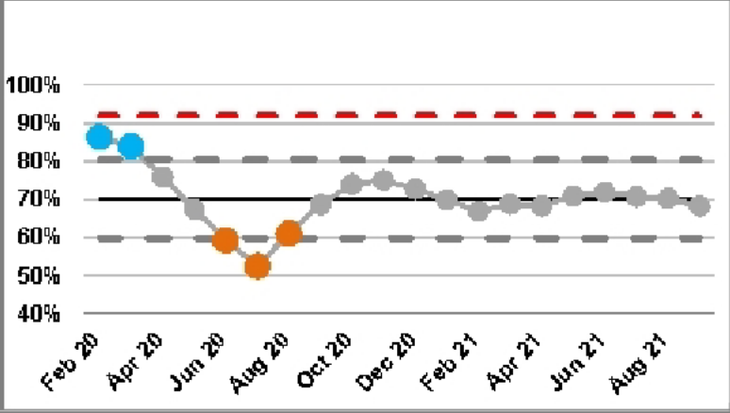






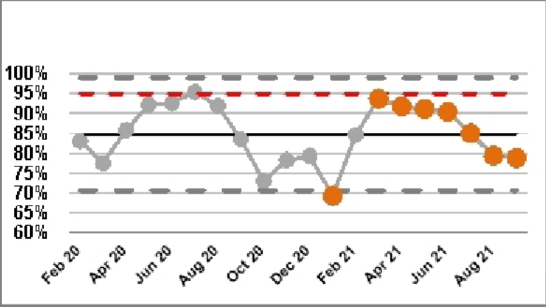
Feb 20
Apr 20
Jun 20
Aug 20
Oct 20
Dec 20
Feb 21
Feb 20
Apr 20
Jun 20
Aug 20
Oct 20
Dec 20
Feb 21
Apr 21
Jun 21
Aug 21
Apr 21
Jun 21
Aug 21
Use Resources Well - Performance
SPC Key
Narrative (supplied by Chief Operating Officer)
Emergency/Urgent Care
The 4-hour Emergency Access Standard (EAS) performance achieved 78.83% of patients admitted or discharged within four hours of arrival to the Emergency Department for the month of September 2021. This is a minimal deterioration in performance from the August position of 79.37%. These waiting times are of concern for our patients given the well established link between duration of time spent in ED and mortality risk, and this mirrors pressure being seen nationally .
In September 2021, the Trust was ranked 26th best for Emergency Access Standard performance nationally and 5th best regionally. This is a improvement from August’s position and demonstrates that the Trust’s urgent and emergency care pathways are more resilient to the increasing numbers of attendances compared to other trusts nationally.
RTT (18 weeks Referral to Treatment)
In September 2021, 18 week RTT incomplete is sitting just below the anticipated trajectory of 69%. This is a result of higher than anticipated numbers of patients waiting >18 weeks across the Divisions.
September saw a continuation of Critical Care and Theatres staffing pressures, which impacted on theatre capacity. This resulted in the team not being able to protect 7 elective theatres each day. 7 theatres were restored at the beginning of October. The use of insourcing theatre teams will reduce; one team leaving at the end of October. The second team will remain until the end of May 22.
August 2021’s performance sees the Trust placed 54th (out of 122 reporting general Acute Trusts) across the NHS and 7th in the Region.
ED - % within 4 hours – Overall (Type 1 & 3)
18 weeks RTT – Incomplete Pathways

18 weeks Referral to Treatment - % within 18 weeks - Incomplete- starting 01/02/20
100%
90%
80%
70%
60%
50%
40%

Total time spent in ED - % within 4 hours - Overall (Type 1 and 3)- starting 01/02/20
100%
95%
90%
85%
80%
75%
70%
65%
60%



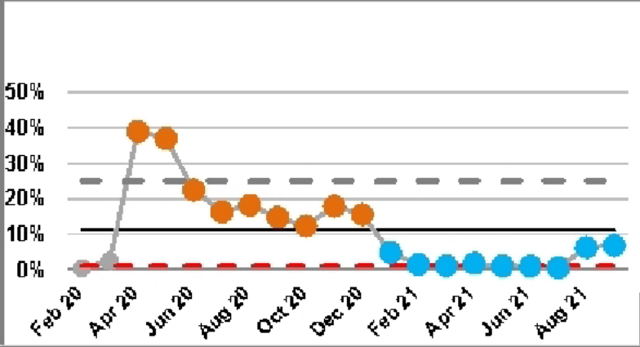



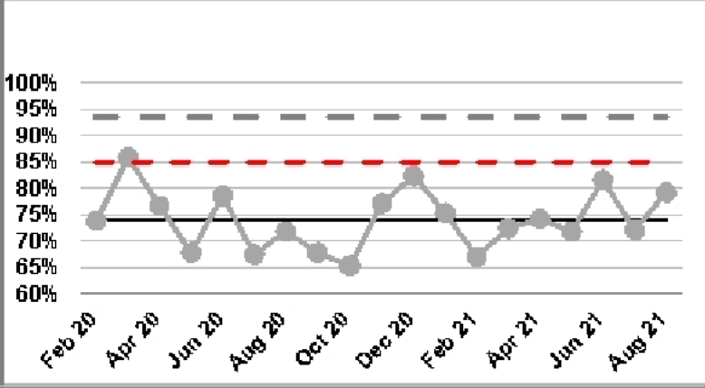
Feb 20
Apr 20
Jun 20
Aug 20
Oct 20
Dec 20
Feb 21
Apr 21
Jun 21
Aug 21
Feb 20
Apr 20
Jun 20
Aug 20
Oct 20
Dec 20
Feb 21
Apr 21
Jun 21
Aug 21
Use Resources Well - Performance
Cancer
Good progress has been made against trajectory to deliver the 62 day from GP referral to treatment constitutional standard with August’s position being 79.2%, materially better that the West Midlands and national average.
62 day screening and upgrade standards were achieved again, which is the fourth month in succession.
The Trust’s national position now places the Trust at 33th of 123 general acute Trusts reported against the 62-day GP RTT constitutional standard
Diagnostic waiting times & activity (DM01)
Trust diagnostic performance has deteriorated further from 6.30% of patients waiting over 6 weeks in August, to 6.83% of patients waiting over 6 weeks in September 2021.
In month the Imaging service reported 450 breaches (an increase of 65 patients from the previous month), almost exclusively non-obstetric sonography and attributed to a combination of significant increase in demand coupled with continued acute staffing sickness absence. Following recent trust approval of a Business case, the Imaging service is actively recruiting additional sonography staffing (including trainee Midwife sonographers).
Figures reported for August 2021 still equated to the Trust being ranked 14th Nationally (of 122 reporting general acute Trusts) for DM01 performance demonstrating the organisation is performing better than the majority in terms of managing post-COVID restoration and recovery and delivery of diagnostics. It is recognised that the September rankings will also reflect a drop due to the continued workforce challenges within sonography.
Diagnostic waiting times (DM01)
Cancer 62 Day RTT

% of Service Users waiting 6 weeks or more from Referral for a Diagnostic Test- starting 01/02/20
50%
40%
30%
20%
10%
0%

Cancer - 62 day referral to treatment of all cancers - starting 01/02/20
100%
95%
90%
85%
80%
75%
70%
65%
60%

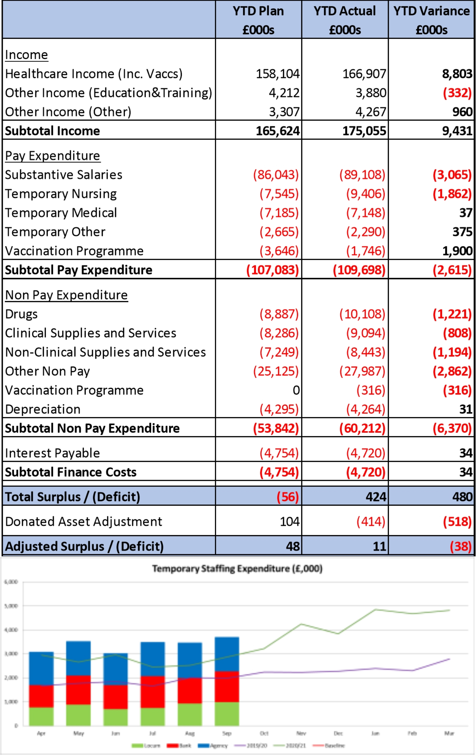
Financial Performance to September 2021 (Month 6)

Financial Performance
- The Trust has a small surplus at the end of September 2021 of £0.011m, a slight deterioration from plan of £0.038m (planned surplus £0.048m)
- The Trust had forecast a deficit position of £0.95m driven by increased urgent and emergency care, largely a consequence of intelligent ambulance conveyance. The Trust bid for and received additional resources from the Sustainability and Transformation Partnership (STP) which enabled attainment of break-even performance for H1
- As noted, the deteriorating position has been driven by high levels of temporary staffing spend particularly in areas of increased activity, the main driver being temporary nurse staffing as a result of increased activity in ED, ICU and Maternity
- The Trust has included an assumed ERF receipt of £2.172m YTD. Inclusion of these funds has been requested by NHSEI in the YTD position. However, working across the STP the Trust believes there remains risk to receipt of ERF monies.
- The risks centre upon underperformance against targets from other providers in the STP (most notably use of independent sector) reducing the income Walsall can ‘earn’ and the STP not achieving 1 or more of the 5 Gateways
- The Trust has therefore included additional non pay costs to negate the impact of the ERF income. This complies with the NHSEI reporting requirement but negates risk to the Trust and is consistent with the approach taken by all STP Providers.
- Excluding ERF, Non Pay was above forecast due to High Cost Drugs and Devices usage and purchase of healthcare which has been offset by increased income.

Capital
- The approved programme for the year is made up of £17.4m for Emergency Department,
£10.3m of other expenditure and £1.1m to support PFI Lifecycle (total of £28.8m). However, the Trust were informed in early May that some funding may not be released to the STP and the £10.3m would need to be reduced to £10m (total of £28.5m).
- Capital expenditure totals £6.198m for the financial year to date. The Trust has received support from the STP for further capital allocations. These additional allocations will finance the ward infrastructure works, thus balancing the capital programme (written confirmation pending).

Cash
- The Trust has a positive cash holding of £41.2m as at 30 th September 2021.

Efficiency attainment
- The emergency budget planning letter and guidance states there was no efficiency requirement for Months 1-6. However, development of Improvement Programme initiatives is key to ensuring financial sustainability moving forwards.
- The outputs of this program are to be reviewed further by Performance, Finance and Investment Committee.
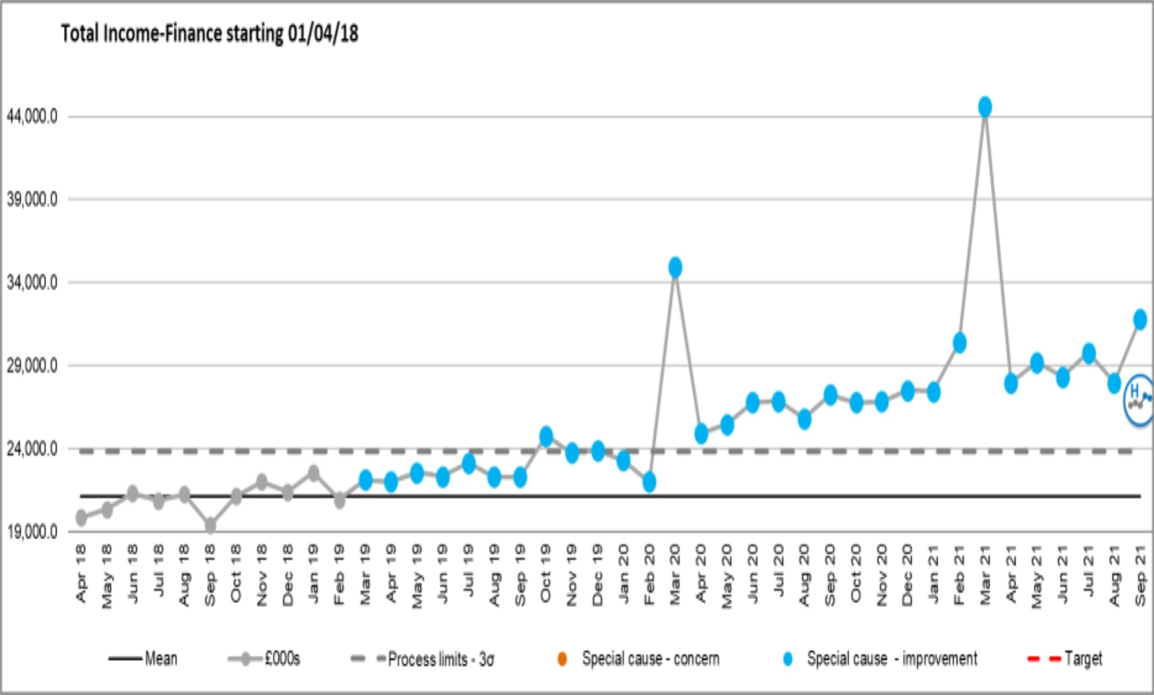
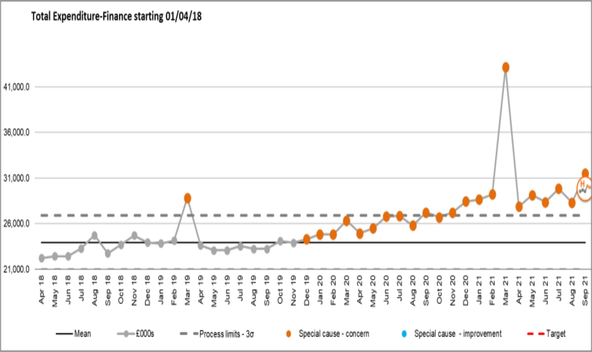
Income and expenditure run rate charts
Income additional information
•
Income has continued to increase year on year, this reflects
largely a level of tariff inflation and growth serviced through the Trust.
January and February 2020 income reduced as the Trust lost central income from the Financial Recovery Fund (FRF) and Provider Sustainability Fund (PSF) as forecast was off plan.
March 2020 the Trust back on plan and received the quarters FRF and PSF in month accordingly.
April’s income reflects the emergency budget income allocation (increasing monthly to reflect the increase in the top up of funding received).
October 2021 ceased retrospective top up funding received, block income has been agreed based on operation run rates.
In March 2021 the Trust received non recurrent income - £3.2m for annual leave accrual, £4.5m to offset the value of central supplied stock, £3.7m Digital Aspirant funding, £0.6m for donated equipment.
The increased income in September 2021 relates to accrued income to offset the impact of the pay award arrears.
•
•
•
•
•
•
Expenditure additional information
•
March 2019 the Trust accounted for the ICCU Impairment of
£6.2m
March 2020 costs increased to reflect the Maternity theatre impairment £1m & Covid-19 expenditure
Costs increased in support of COVID-19, with June and July seeing these costs increase further for elective restart and provision for EPR, Clinical Excellence Awards impacts on cost base.
A reduction in expenditure in August occurred due to the non recurrent nature of costs incurred in the previous month.
Expenditure increased in September due to back dated Medical Pay Award, increased elective activity.
Increases in Q4 20/21 were driven by the additional pressures of a second wave of COVID activity.
March 21 spend includes non recurrent items such as Annual leave accrual, adjustments for central stock, and non recurrent spend on the Digital Aspirant Programme (offset by income movement).
In September 2021 the back dated pay award was paid to staff, increasing in month spend by £2.5m
•
•
•
•
•
•
•

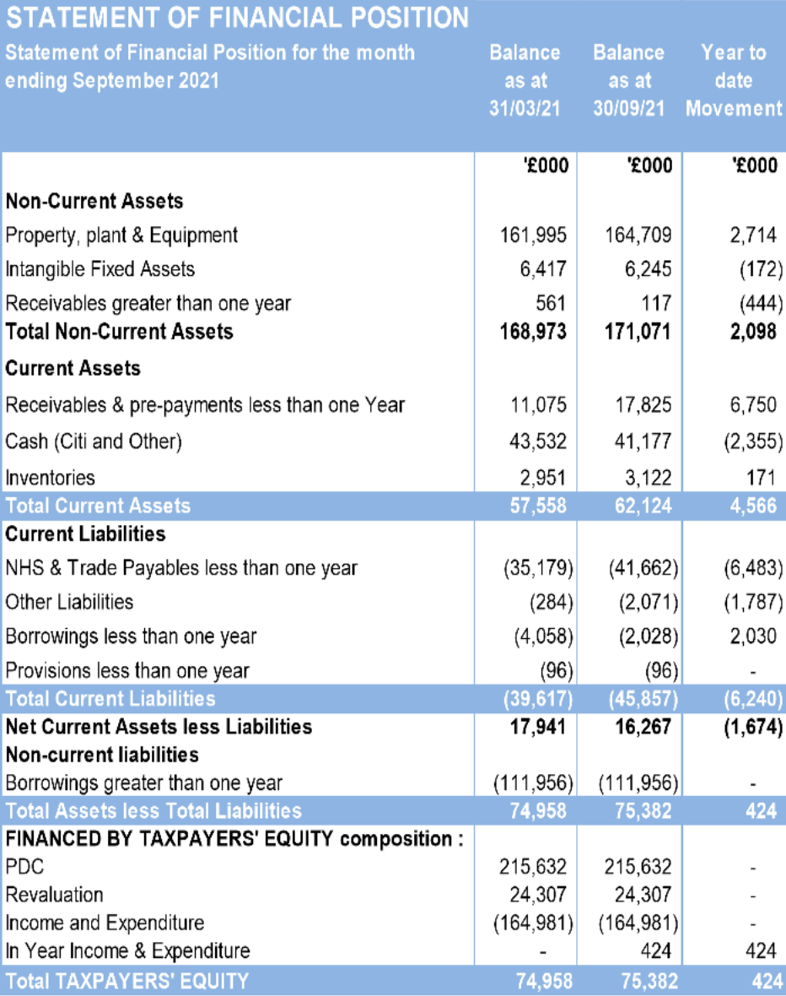
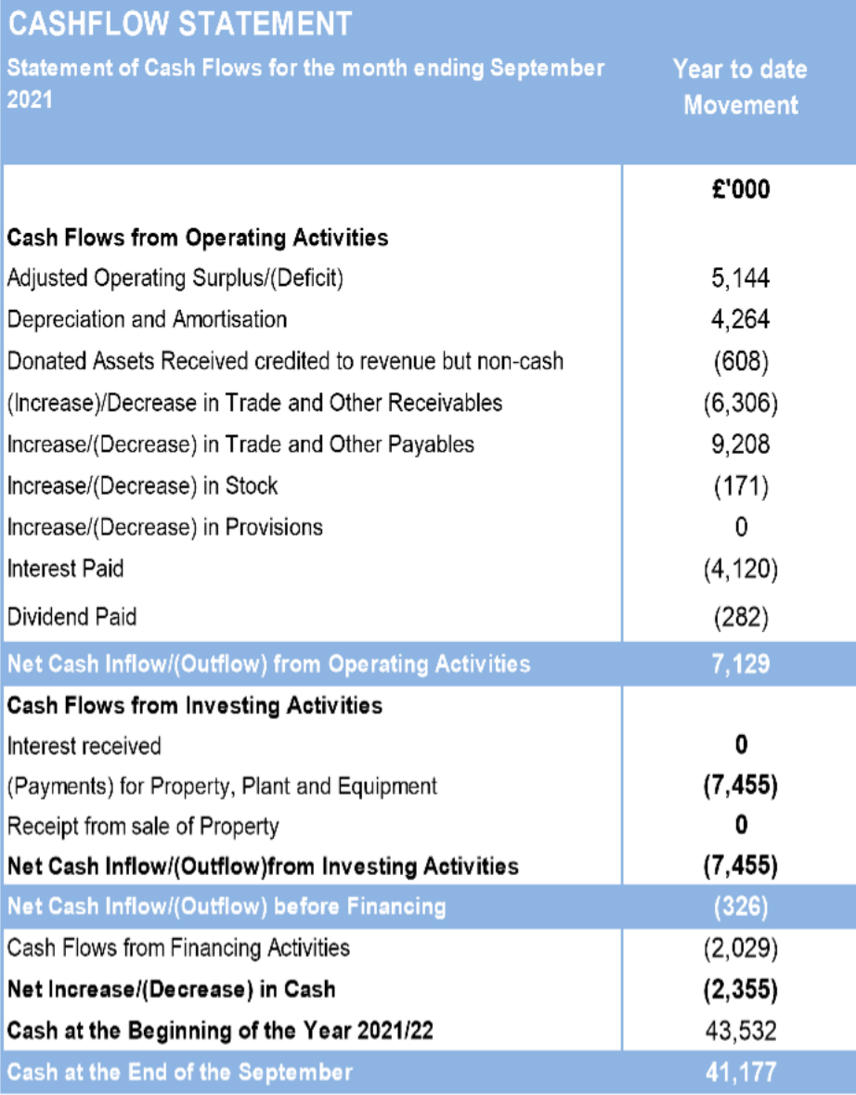
Cash Flow Statement & Statement of Financial Position (M6)

Page 1 of 5
Risk Summary
BAF Strategic Objective Reference & Summary Tile:
BAF SO 05 - Use Resources Well; We will deliver optimum value by using our resources efficiently and responsibly.

Risk Description:

The Trust’s financial sustainability is jeopardised if it cannot deliver the services it provides to their best value.
If resources (financial, human, physical assets & technology) are not utilised to their optimum, opportunities are lost to invest in improving quality of care.
Failure to deliver agreed financial targets reduces the ability of the Trust to invest in improving quality of care, & constrains available capital to invest in Estate, Medical Equipment & Technological assets in turn leading to a less productive use of resources.
Lead Director:
Chief Operating Officer.
Lead Committee:
Performance, Finance, & Investment Committee.

Links to Corporate Risk Register:

Title:
Current Risk Score Movement:
- 208 - Failure to achieve 4 hour wait as per National Performance Target of 95% resulting in patient safety, experience and performance risks (Risk Score = 16).
- 665 - Risk of a cyberattack (ransomware, spearfishing, doxware, worm, Trojan, DDoS etc) upon a NHS or partner organisation within the West Midlands Conurbation (Risk Score = 15).
- 1005 - Insufficient capital funding for the estate relating to lifecycle, critical infrastructure and mechanical/engineering risks. (Risk Score = 15).
- 1155 - Fire Certification in the Retained Estate in order to demonstrate compliance with fire compartmentation (Risk Score = 8).
- 2081 - Delivery Operational Financial Plan. (Risk Score = 16).
- 2082 - Future Financial Sustainability. (Risk Score = 9).
- 2398 - Insufficient/ out-of-date equipment, utilised beyond its life cycle, has the potential to result in sub-optimal patient care. (Risk Score = 12).

Likelihood = 3
Consequence = 5
= 15 High
↔
Forecasted Risk Score Movement for Q3:

Likelihood = 3
Consequence = 5
= 15
↔

Risk Appetite
Operational Status:
Balanced
Averse
Cautious
Balanced
Open
Hungry
Appetite Score:
< 14
1
2
3
4
5
6
7
8
9
10
11
12
13
14
15
16
17
18
19
20
21
22
23
24
25
Tolerate Score:
< 16

Financial Status:
Cautious
Averse
Cautious
Balanced
Open
Hungry
Appetite Score:
<10
1
2
3
4
5
6
7
8
9
10
11
12
13
14
15
16
17
18
19
20
21
22
23
24
25
Tolerate Score:
<11

Compliance Status:
Cautious
Averse
Cautious
Balanced
Open
Hungry
Appetite Score:
<9
1
2
3
4
5
6
7
8
9
10
11
12
13
14
15
16
17
18
19
20
21
22
23
24
25
Tolerate Score:
<11

Latest Board/Committee/Group - 11/10/2021 Version V5.03
Page 2 of 5
Risk Scoring
Quarter:
Q1 2021/22
Q2
Q3
Q4
Rational for Risk Level:
Target Risk Level (Risk Appetite):
Target Date:
Likelihood:
3
3

Evidence of risk control
- Achievement of 19/20 and 20/21 financial plans.
- Adherence to revised financial arrangements during 20/21 as a result of the Covid-19 pandemic, despite significant planning uncertainty
- Strong operational performance measured through constitutional standards, and associated operational performance metrics.
- Development of draft 5-year capital programme
- Majority of allied Corporate Risks associated with Use Resources Well mitigated to scores of 16 or less.
- Improved Cost per WAU, and operational productivity indicators (Model Hospital)
Evidence of risk gaps in control
- The Trust experienced run rate risk for the 19/20 financial year that led to needing to re-forecast outturn during the financial year.
- High reliance on temporary workforce remains, whilst international nurse recruitment
- West Midlands Ambulance Service Intelligent Conveyancing protocol resulting in significant out of borough ambulances conveyed to the Trust, forecast to equate to circa £1.5m of ED attendance and non-elective admission activity during 21/22.
- Formal Month 5 submission to NHSEI Midlands/ICS re-forecast to a £952k adverse variance to H1 plan, subsequently revised to break- even following confirmation of additional income through the STP risk-share agreement, in recognition of the additional ambulance activity received on behalf of BCWB Trusts.
- Increasing general risk in the UEC system due to high demand on EDs, and compromised domiciliary care market resulting in excessively high hospital bed occupancy.
- Lack of credible capital plan to fully address backlog maintenance requirements, despite 5-year Capital Programme in place.
Evidence of planning uncertainty
- Normal national financial planning cycle for 21/22
Likelihood:
2

31 March 2022

Consequence:
5
5

Consequence:
5

Risk Level:

15
High

15
High

Risk Level:

10
Moderate

Page 3 of 5

financial year was postponed due to the Covid-19 pandemic
- H2 (Q3 and Q4) 21/22 Planning guidance issued on 30th September 2021, but final Trust income allocation not yet confirmed.
- Uncertainty still associated with 22/23 financial arrangements.

Control & Assurance Framework - 3 Lines of Defence

1st Line of Defence
2nd Line of Defence
3rd Line of Defence

Controls:

- Financial position reported monthly via Care Groups, Divisions, Divisional Performance Reviews and Executive Governance Structures.
- Revised financial governance in place for COVID-19 through the Trust’s Governance Continuity Plan.
- Board Development session for the Improvement Programme with identified 3-year targeted financial benefits.
- Performance, Finance & Investment Committee in place to gain assurance.
- Audit Committee in place to oversee and test the governance/financial controls.
- Adoption of business rules (Standing Orders, Standing Financial Instructions and Scheme of Delegation).
- Use Resources Well work stream of the Improvement Programme has Governance infrastructure in place.

- Externally benchmarked Financial and operational productivity performance data, particularly (but not exclusively) through Model Hospital.

Gaps in Controls:

- Business planning processes require strengthening.
- Accountability Framework has been approved however needs review further to the NHSI Governance Review report.
- Leadership development needs at Care Group, Divisional and corporate support service levels, with commencement of Faculty of Medical Leadership and Management leadership development programme deferred to Spring 2021 due to Covid-19 second wave.
- Covid-19 second and third waves significantly exceeded planning parameter assumptions.

Assurance:

- Model Hospital Use of Resources assessments.
- Proportion of acute surgical patients managed without overnight hospital stay has risen from less than 30% to over 50%.
- Number of patients managed through the Integrated Assessment Unit’s Frailty service without overnight hospital stay has increased by over 50%.
- Inpatient Length of Stay in MLTC (excluding 0-day LoS) has reduced from over 9 days to less than 8 days on average.
- Number of Medically Stable for Discharge inpatients sustained at lowest level on record through 20/21 (although rising since June 2021).
- Internal Audit reviews of a number of areas of financial and operational performance
- Covid-19 ‘top-up’ resource in line with peers as a percentage of turnover
- Top 10 in the country out of 122 general acute reporting Trusts for the 7th consecutive month (July 2021) for 6 week wait Diagnostic (DM01) performance
- Top 40 in the country (out of 113 reporting general acute Trusts) (August 2021) for the 7th consecutive month for 4-hour Emergency Access Standard, and best in the West Midlands out of 14 reporting Trusts for Ambulance handover <30 mins for the 7th consecutive month
- 55th best in the country out of 122 reporting Trusts (July 2021) for 18-week RTT performance and 5th lowest proportion of elective waiting list waiting over 52 weeks in the Midlands (out of 20 reporting Midlands Trusts)
- Annual Report and Accounts presented to NHSE/I
- NHSE/I oversight of performance both financial and operational
- External Audit Assurance of the Annual Accounts
- Cost per WAU (19/20) now below peer and national median (Model Hospital)
- Day case rates for British Association of Day Case Surgery better than peer and national medians (May 2021 – Model Hospital).
- Average LoS for elective admissions rolling 6 months below peer and national median (May 2021 – Model Hospital)
- Average LoS for emergency admissions rolling 6 months below peer and national median (May 2021 – Model Hospital)
- Average late starts and average early finishes in Operating Theatres better than national
Page 4 of 5

- Delivery of 2020/21 Financial plan, representing the second consecutive year of meeting financial plan.

- 62-day Cancer performance (July 2021) materially better than West Midlands average (60.5%) and in line with the national average (72.1%), with 72.04% of our patients treated within 62 days of GP referral.
median (August 2021 – Model Hospital)
- Medical specialties Same Day Emergency Care rates for ambulatory emergency care conditions rated second best in the country by the AEC Network.

Gaps in Assurance:

- NHSi Governance review highlighted areas of improvement for business process and accountability framework.
- Trust scored requires improvement on its assessment of ‘Use of Resources’ owing to low productivity and high staff and support costs being evident. Time lag on updating of some Model Hospital metrics means there is a delay in receiving some independent assurance of improved financial and operational productivity metrics.
- External Audit limited due to Covid-19.
- Uncertainty surrounding 22/23 financial planning.
- NHS Digital Templar Execs external review (Cyber Operational Readiness Support) has identified improvements required for the Trust’s Cyber Security.
Future Opportunities
- Further Development of LTFM to include potential additional income sources, such as non-clinical commercial opportunities and repatriation of patients resident to Walsall currently receiving care out of area.
- International Nurse Recruitment with RWT to significantly decrease reliance on temporary workforce.
- Enhanced clinical economies of scale through Acute Hospital Collaboration (Working with Partners).
- Reduced reliance on inpatient hospital care through Walsall Together Partnership (Care at Home).
- Improved Equality, Diversity and Inclusion in the Trust to harness the skills of the whole workforce and leadership development programme for Care Group and Divisional leaders to enhance capability (Valuing Colleagues).
- Utilisation of national productivity benchmark information (e.g. GIRFT and Model Hospital) to target work through the Use of Resources Improvement Programme.
- Development of major capital upgrades (e.g. new Emergency Department) to support improved recruitment of staff.
- Harnessing the teamwork and innovation so evident throughout the Covid-19 pandemic to develop service improvements that lead to improved use of resources.
- Capitalising on the digital advancement during Covid-19 to harness technology to improve effective use of resources.
- Rationalising Estate requirements through increased remote working.
- Enhanced leadership capability through Well-led Improvement Programme work stream.
Future Risks
- Covid-19 second and third waves have significantly exceeded planning parameter assumptions, leading to increased costs delivering emergency and critical care, and reduced leadership time dedicated to long time resource planning during the height of the pandemic. Risk of a 4th wave in late Summer/early Autumn 2021.
- Likely move away from PbR towards block contracts and the associated paradigm shift for elective care in particular.
- Adverse Covid-19 impact on ability to deliver improved productivity for elective care in 20/21, and early 21/22.
- Additional costs associated with safe non-elective and critical care during Covid-19.
- Significant changes to elective and non-elective demand during Covid-19 and in early 21/22 in emergency care in particular leading to difficulty planning for the future with confidence.
- Insufficient Capital to enable investments in the Estate, equipment and technology that would in turn support more effective use of resources, and significant lead time for deployment of capital.
- Impact of Covid-19 on the wider economy and supply chain markets may destabilise some costs of goods/services upon which the Trust relies.
- Workforce exhaustion and/or psychological impact from Covid-19 may result in higher sickness rates and/or colleagues deciding to leave the healthcare professions, and thus further reliance on temporary workforce.
Future Actions (to further reduce the Likelihood / Consequence of the risk in order to achieve the Target Risk Level in line with the Risk Appetite)
Page 5 of 5
No.
Action Required:
Executive Lead:
Due Date:
Progress Report:
BRAG:

1.

Review and update Accountability Framework further to the NHSI Governance Review report.

R. Caldicott

Oct 2020

Revisions to assessment, content and agenda in conjunction with the Divisional Directors, Trust Management Board, Executive and the Improvement Programme Board have been enacted and work on development of key metrics is progressing.
However, a key element of the review centres upon wider Trust consultation to gain ownership of the framework and metrics used for assessment. This has been difficult to progress in light of the pandemic which results in the current rating of amber. Target completion June 2021.

2.
Financial regime post 31st September 2020 to be approved by Board in October 2020 - Russell Caldicott
R. Caldicott
Oct 2020
Complete

3.
All work-streams to have Improvement programme benefits defined.
G. Augustine
Oct 2020
Complete - Presented to Trust Board Development Session on 1st October 2020.

4.
Development of 2021/22 Financial plan
R. Caldicott
March 2021 Nov 2021
H1 21/22 financial plan approved at Board. H2 plan to be received at extraordinary PFIC 20/10/21.

1 | P a g e
MEETING OF THE PUBLIC TRUST BOARD - Thursday 4th November 2021
People and Organisational Development Committee (PODC) Highlight Report
AGENDA ITEM: 14

Report Author and Job Title:

Catherine Griffiths Director of People and Culture
Responsible Director:

Junior Hemans (Non- Executive Director and Chair)
Action Required
Approve ☐ Discuss ☐ Inform ☒ Assure ☒
Executive Summary

The report provides the key messages from the People and Organisational Committee meeting on 28th October 2021. Of note are:
- The Trust accreditation following the completion of the RACE Equality Code 2020 Assessment and is now eligible to use the RACE Equality Code Quality Mark on official stationary, website and social media. This important milestone demonstrates the Trust Board’s commitment to becoming an anti-racist organisation.

- The People and Organisation Development Committee noted the Safer Staffing report and commended the programme of international recruitment which is on track to achieve 200 appointments planned by the end of the calendar year [95 overseas nurses have arrived in the Trust. 45 of those are now successfully registered with the NMC]. The Committee noted the RN and Midwifery vacancy rate is currently below 6%. The programme to reach full establishment continues with a particular focus on CSW recruitment. There are 44 Clinical Support Workers undertaking apprenticeships and 36 Trainee Nursing Associates on apprenticeship programmes in the Trust.

- The Committee noted the update and assurances on the Health and Wellbeing approach, noting within this the improvements against the health and wellbeing indicators within the recent Pulse Survey and the plans for a strong focus on the Financial Wellbeing element of the health and wellbeing framework.

- The People and Organisation Development Committee received an update on progress on achieving the actions contained within the National People Plan. The Committee reviewed the self- assessment document presented and noted the Board can take assurance the trust is complying with the provisions. There is an

2 | P a g e

assurance gap relating to the provisions for flexible working nad the Trust has joined the national NHSE/I Flex for the Future programme as cohort 1 to learn from best practice nationally to shape and design a flexible and agile workforce that is sustainable for the future.

- The People and Organisation Development Committee approved the first draft of the Workforce Plan, noting in particular the workforce narrative and actions relating to developing approaches to apprenticeships and the approaches to employment as an anchor institution and employer.

- The Committee noted assurances on the approach to engagement with the National Staff Survey 2021, the Divisional Oversight Group continues to pro-actively promote the importance of everyone having a say and completing the survey. The current response rate is at 30.47%, weekly reminders are sent for the electronic forms and further copies of the paper forms are being distributed and the survey will close at the end of November.

- The Womens, Childrens’ and Clinical Support Services provided a presentation for committee to provide a detailed assurance on the Division and workforce performance, this item was noted and the People and Organisation Development Committee heard a staff story from Pharmacy presented by the Director of Pharmacy Mr Gary Fletcher, the committee commended the excellent work on organisational development led by Mr Fletcher which led to significant improvements in the service and resolved to present this staff story for learning to a future Trust Board.

- The Committee noted the Board Assurance Framework risks, which encompass three separate risks and noted that a full review of the gaps in assurance is taking place for all BAF and Corporate risks. The Committee noted that the Improvement Programme actions for Valuing our Colleagues are on track.

- The next meeting of the Committee will take place on 25th November 2021.
Recommendation

Members of the Trust Board are asked to note the report and the escalations for its attention.
Risk in the BAF or Trust Risk Register

BAF S04 – Culture (lack of an Inclusive and open culture impacts on staff morale, staff engagement, staff recruitment, retention and patient care)

3 | P a g e
Resource implications
There are no new resource implications associated with this report.
Legal, Equality and Diversity implications

This Committee supports the Trust’s approach to delivering equality, diversity and inclusion for the benefit of the patient population and staff who work for the Trust and who live in Walsall. .
Strategic Objectives

Safe, high quality care ☐
Care at home ☐
Partners ☐
Value colleagues ☒
Resources ☐

MEETING OF THE PUBLIC TRUST BOARD – Thursday 7th November 2021
Value our Colleagues – Executive Update
AGENDA ITEM: 15
Report Author and Job Title:

Catherine Griffiths – Director of People and Culture

Responsible Director:

Catherine Griffiths – Director of People and Culture
Action Required

Approve ☐ Discuss ☐ Inform ☒ Assure ☒

Executive Summary

This report provides an update on actions taken last month relating to the Value Our Colleagues work-stream of the improvement programme. The following points seek to inform the Trust Board of progress, identify where assurance can be taken and where required to seek approval for actions proposed.

- Progress on Race Code – Accreditation for the Equality Code Quality Mark.
The Trust successfully completed its RACE Equality Code Assessment, and achieved accreditation and is eligible to use the RACE Equality Code Quality Mark on our official stationary, website and social media to demonstrate the Board and Trust commitment to race equality as detailed in the Board pledge below. The next full review and reassessment will take place no later than May 2024.

“We the Trust Board, pledge to demonstrate through our actions that we listen and support people and that we are an anti-racist trust. We will ensure that the organisation treats people equally, fairly and inclusively with zero tolerance of bullying. We uphold and role-model the Trust values chosen by you”

- Black History Month.
There have been events throughout the month celebrating Black History Month and board members have been honoured to attend and support these.

The month culminated in the Black Country and West Birmingham NHS Trusts Black History Month Celebrations October 2021 – Award Ceremony awards were presented across a number of categories Dr Femi Osunlusi, Walsall Healthcare NHS Trust was the winner for the Black African/Black Caribbean Frontline Hero category below:
Black African/Black Caribbean Frontline Hero (Above and beyond during COVID-19 Award) This award recognises an individual who has worked tirelessly throughout the pandemic to ensure the highest levels of patient care were maintained under extremely difficult circumstances. This individual often goes above and beyond the call of duty to ensure minimal disruption to services provided to patients, whilst at the same boosting and maintaining the morale of team members and other colleagues working in challenging and uncertain circumstances. This individual demonstrates the highest levels of resilience and an outstanding commitment to providing excellence in patient care.
Carla Charles Jones Walsall Healthcare NHS Trust was highly commended in the leadership category below:
Black African / Black Caribbean Leadership Award during COVID 19 This award recognises an individual that has demonstrated exemplary leadership abilities over the past 18 months by the very nature of their genuine commitment to race equality and the integrity of their character. This award recognises an individual that has been a pillar of support to other colleagues from a Black African /Black Caribbean background over the past 18 months going above and beyond to champion work force race equality in their day to day work for the benefit of colleagues from diverse backgrounds, often operating outside of the boundaries of their job scope to promote race equality and working across organisational boundaries
In addition, Joan Dyer Chair and Angela Cope Vice Chair from Walsall Healthcare NHS Trust’s Black, Asian and Minority Ethnic (BAME) Shared Governance Network were highly commended for their leadership work under the award category below:
Black, Asian and Minority Ethnic (BAME)Staff Network of the year This award recognises a staff network that has demonstrated exemplary leadership during the height of the COVID 19 pandemic and resurgence of the Black Lives Matter movement to offer support, pastoral care and advice to other BAME colleagues during a time of great uncertainty. This network demonstrated their ability
2

1 CID Coronavirus (COVID-19): Flexible working during the pandemic and beyond – 30th September 2021
3

3.

4.

5.

to effectively engage with senior leadership teams to advocate race equality on behalf of colleagues from a BAME background. They played a proactive role in supporting improvements in vaccination uptake and risk assessments by encouraging BAME colleagues to ensure they had a risk assessment and explained the benefits and importance of having the COVID-19 vaccine.

Freedom to Speak Up Month
There have been events throughout the month celebrating Freedom to Speak Up Month and board members have been honoured to attend and support these.

Recruitment and Retention
The People and Organisation Development Committee noted the Safer Staffing report and commended the programme of international recruitment which is on track to achieve 200 appointments planned by the end of the calendar year [95 overseas nurses have arrived in the Trust. 45 of those are now successfully registered with the NMC]. The Committee noted the RN and Midwifery vacancy rate is currently below 6%. The programme to reach full establishment continues with a particular focus on CSW recruitment. There are 44 Clinical Support Workers undertaking apprenticeships and 36 Trainee Nursing Associates on apprenticeship programmes in the Trust.

The programme for recruiting Clinical Support Workers and other clinical support services locally as part of the anchor employer approach continues with success in filling entry level vacancies. The establishment for Clinical Support Workers has been increased and this, plus absence and low fill rate from bank on day shifts has impacted operationally. The CSW vacancy rate stood at 0% in July 2021 and the resourcing plan is to return to zero vacancy.

The Trust has secured a place on the national Flex for the Future programme as a pilot site to develop the organisation culture to attain the benefits of flexible and agile working which has a positive evidence based impact on retention1. The first elements of the programme are competed and a baseline is being compiled.

Progress on Staff Experience and Engagement
The National Staff Survey 2021 closes at the end of November, with weekly reminders to those who have not yet completed the survey. In addition the second reminder paper copy is being sent out this week. The Trust has 30% of its workforce covered by

paper based responses and the remaining 70% electronically. The Divisional Oversight Group has met monthly since the 2020 staff survey results were published in March 2021 to take learning from national best practice and from each other. Each month the People and Organisation Development Committee receives an update a division on actions taken and the Trust Board also has had the opportunity to seek assurance from each division on plans for the National Staff Survey 2021. The Divisional Oversight group has been working with the Communications team to promote uptake and working with corporate support services including volunteers to highlight the importance of completing the survey and having a say. The current response rate is at 31% and the communications campaign has focused on actions taken as a result of staff survey themes, in terms of a ‘you said, we did’ approach. The table of responses by division was reviewed at PODC and is within this report for information:
The last Pulse Survey reported to Trust Board in July had a response rate of 53.45%.
Health and Wellbeing support is being expanded all the time based on feedback on staff experience and requested support. In this month, Health and Wellbeing Chats have launched with comprehensive support for managers and colleagues. These have been very well received and the offer is being expanded to match the demand for support with this important approach to wellbeing.
The People and Organisation Development Committee has scheduled deep dives into the people metrics for each division to support assurance against the Board Assurance Framework for the following three elements of the Organisation Development Plan:
- Leadership, Culture and Organisation Development
- Organisation Effectiveness – recruitment, retention and career development
- Making Walsall (and the Black Country STP) the best place to work
This report provides an overview of the risks to delivery for the Value Our Colleagues’ strategic objective and provides an update on the mitigations in place to manage the risks identified, as well as the actions identified to address gaps in controls and assurance. It provides the Trust Board with assurance relating to the improvement programme Value Our Colleagues work-stream.
4

5
Recommendation

- Members of the Trust Board are asked to note the report and in particular note the success in reaching accreditation on the Race Code Quality Mark.

- Members of the Trust Board are asked to note the update on the organisational development work in progress and note the update on the National Staff Survey 2021.
Does this report mitigate risk included in the BAF or Trust Risk Registers? please outline
This report addresses BAF Risk Value our Colleagues (appendix two) in order to provide positive assurance the mitigations in place to manage this risk and the related corporate risks. In particular the risk of tackling the reported bullying and harassment and achieving an improved organisation culture.

Resource implications

There are resource implications that flow from recommendations in the report. In the short-term the resource requirements are being met from base budgets. The improvement programme priorities outlined in this report will require investment beyond the base budget in order to achieve the milestones and progress envisaged by 2022-2023. There is a business case in development to support the trust approach to Health and Wellbeing. There is a business case in development to support the trust approach to Equality, Diversity and Inclusion.
Legal and Equality and Diversity implications

There are significant issues relating to equality arising from matters addressed in the report. The Trust Board has been presented with the evidence base for differential staff experience based on ethnicity, disability, age, sexuality, gender, religion and other protected characteristics.

This goes to the heart of both the Trust Board pledge and the Trust values and supporting behaviours. The improvement programme seeks to mitigate the risk on the BAF, noting the low baseline and the considerable challenge of achieving outstanding performance across the metrics by 2022-23. In addition the valuing our colleagues work-stream seeks to ensure the systems the Trust relies upon can delivery equality of outcome relating to career progression, development, promotion, talent management and recruitment such that the workforce is representative of the communities it serves and can be seen as an anchor institution within Walsall.

The leadership and management development programmes both focus on equality outcomes and developing skills and understanding of an
6

inclusive leadership approach, whilst leading for performance improvement in a compassionate framework that supports a just, restorative and learning culture.

Strategic Objectives

Safe, high quality care ☐
Care at home ☐
Partners ☐
Value colleagues ☒
Resources ☐

Value Our Colleagues – Organisation Development Plan and Improvement Programme
1.
EXECUTIVE SUMMARY
The Trust Board made a pledge relating to Value Our Colleagues as follows:
“We the Trust Board, pledge to demonstrate through our actions that we listen and support people and that we are an anti-racist trust. We will ensure that the organisation treats people equally, fairly and inclusively with zero tolerance of bullying. We uphold and role-model the Trust values chosen by you”
The People and Organisation Development Committee agreed the pledge remained current and following diagnostic work and updated the pledge to reflect the commitment made as part of the Race Code accreditation preparation to being an anti-racist Trust. With the report to private board from the Royal Wolverhampton support team in August 2021, the Trust Board has prioritised eliminating bullying and harassment within the workplace such that colleagues can feel and see the difference. The programme supporting the Just and Learning approach is the mechanism for delivering this pledge which is dependent upon providing robust leadership and management development and investment.
The Pulse Survey reported in July 2021 offered further insights on the qualitative metrics measuring staff experience and the degree to which the pledge is achieved by directorate and department level. The Pulse Survey Workforce Tool provides the ability to focus in on workforce demographics by ethnicity, age, disability, sexuality, disability.
The Workforce Equality Tool provides data and evidence on the outcomes achieved at directorate and department level on the ambitions and actions within the Equality, Diversity and Inclusion Strategy.
Accreditation and Quality Mark on the Race Code
The work on the Race Code seeks to ensure the board assurance and governance is robust, in this month the trust successfully completed its RACE Equality Code 2020 Assessment, and achieved accreditation so is eligible to use the RACE Equality Code Quality Mark on our official stationary, website and social media.
Compliance with the Code was achieved by:-
- Outlining how we will apply the main principles of the code
- Complying with the provisions on a comply or explain basis
- Providing explanations of how we will achieve the Must provisions that were assessed as partial compliance
7

The commitment and application of the Race Code principles are an important part of the collective effort to radically move the dial on representation in the boardroom and senior leadership and shows the Trust is a targeted approach to Race equality, whilst ensuring that it forms part of a wider inclusion strategy, which is documented and defined within the Equality, Diversity and Inclusion Strategy approved by Board.
The Governance Forum (Race Code) expects Walsall NHS Healthcare Trust to carry out a full review after 3 years (with a monitoring review within 18 months of your report date). Therefore the next full review and reassessment should take place no later than May 2024.
Update on Recruitment and Retention
The People and Organisation Development Committee noted the Safer Staffing report and commended the programme of international recruitment which is on track to achieve 200 appointments planned by the end of the calendar year [95 overseas nurses have arrived in the Trust. 45 of those are now successfully registered with the NMC]. The Committee noted the RN and Midwifery vacancy rate is currently below 6%. The programme to reach full establishment continues with a particular focus on CSW recruitment. There are 44 Clinical Support Workers undertaking apprenticeships and 36 Trainee Nursing Associates on apprenticeship programmes in the Trust.
The programme for recruiting Clinical Support Workers and other clinical support services locally as part of the anchor employer approach continues with success in filling entry level vacancies. The programme for recruiting Clinical Support Workers and other clinical support services locally as part of the anchor employer approach continues with success in filling entry level vacancies. The establishment for Clinical Support Workers has been increased and this, plus absence and low fill rate from bank on day shifts has impacted operationally. The CSW vacancy rate stood at 0% in July 2021 and the resourcing plan is to return to zero vacancy.
The Trust has secured a place on the national Flex for the Future programme as a pilot site to develop the organisation culture to attain the benefits of flexible and agile working which has a positive evidence based impact on retention. The first elements of the programme are competed and a baseline is being compiled.
Update on Staff Experience and Engagement
The National Staff Survey 2021 closes at the end of November, with weekly reminders to those who have not yet completed the survey. In addition the second reminder paper copy is being sent out this week. The Trust has 30% of its workforce covered by paper based responses and the remaining 70% electronically. The Divisional Oversight Group has met monthly since the 2020 staff survey results were published in March 2021 to take learning from national best practice and from each other. Each month the People and Organisation Development Committee receives an update a division on actions taken and the Trust
8

Board also has had the opportunity to seek assurance from each division on plans for the National Staff Survey 2021. The Divisional Oversight group has been working with the Communications team to promote uptake and working with corporate support services including volunteers to highlight the importance of completing the survey and having a say. The current response rate is at 31% and the communications campaign has focused on actions taken as a result of staff survey themes, in terms of a ‘you said, we did’ approach.
The table of information:
responses
by
division
was
reviewed
at
PODC
and
is
replicated
below
for
9
Whole Trust

Headcount

Response Rate

Response %

Grand Total

4395

1370

31.17%

Division/Directorate

Headcount

Response Rate

Response %

Chief Executive Directorate

22

14

63.64%

Community

891

293

32.88%

Directorate of Transformation & Strategy

25

12

48.00%

Estates and Facilities

371

94

25.34%

Finance Directorate

77

58

75.32%

Governance Directorate

26

18

69.23%

Informatics Directorate

128

41

32.03%

Medical Directorate

60

27

45.00%

Medicine & Long-Term Conditions

872

195

22.36%

Nurse Directorate

79

34

43.04%

Operations Directorate

27

19

70.37%

People & Culture Directorate

91

62

68.13%

Surgery

886

253

28.56%

Women's, Children's & Clinical Support Services

840

250

29.76%

The last Pulse Survey reported to Trust Board in July had a response rate of 53.45%.
Health and Wellbeing support is being expanded all the time based on feedback on staff experience and requested support. In this month, Health and Wellbeing Chats have launched with comprehensive support for managers and colleagues. These have been very well received and the offer is being expanded to match the demand for support.
2. BOARD ASSURANCE FRAMEWORK
The People and Organisational Development Committee has a schedule of accountability reviews with each Division to allow a deep dive into the qualitative and quantitative people metrics within the Board Assurance Framework (BAF) risk mitigations (appendix one) which have been divided into the three elements of assurance as follows:
•
•
•
The BAF
Leadership, Culture and Organisation Development
Organisation Effectiveness – recruitment, retention and career development Making Walsall (and the Black Country STP) the best place to work
is now being reviewed following the completion of much of the foundation work
planned within the Improvement programme, to identify the gaps in assurance remaining and the targeted action to close these gaps over the coming 18 months. A significant part of this is with the divisional accountability process and the effectiveness of leadership approaches and action, especially organisational development approaches targeting culture change. For this reason the People and Organisation Development Committee is taking a deep dive by Division into the Divisional approach to people management. The format will cover the workforce metrics and KPIs and also the cultural indicators, such as representative workforce, support for employee networks, links and relationships with the Freedom to Speak Up Guardians and the Confidential Contact links, as well as Staff Side, Health and Wellbeing Champions, Pulse Survey Results and National Staff Survey Results and engagement indicators such as flu, Covid vaccination and LAMP uptake. In addition, a risk based approach is being taken to the early resolution of case work and HR activity is monitored by division with a new HR Dashboard launched to complement the FTSU Dashboard. The next step is to link the indicators from these sources to the prevalence of incident reporting to draw a more comprehensive picture of risk for the Board. The work on talent management and succession planning is critical to both colleagues perception of the trust as a place to work, the equity with which people can progress and meet their ambitions and access development opportunities and ultimately both the retention rates and the advocacy (FFT) rates within the trust.
The first Division to provide a presentation to the People and Organisation Development Committee was the Womens, Childrens and Clinical Support Services Division, the committee heard in detail from Mr Gary Fletcher on the organisation development approach
10
taken over 18 months to create a high performing culture within Pharmacy. The committee commended the approach and referred this staff story to Trust Board in December along with a case study detailing the approach as one where both the approach and the learning can be replicated across the Trust. A further detailed review of the Divisional People Performance metrics will take place in November, in this way, the committee can provide more detailed assurance to the Trust Board.
3. ORGANISATION DEVELOPMENT PLAN AND IMPROVEMENT PROGRAMME
The purpose of the Value Our Colleagues Organisation Development Plan is to deliver workforce improvement so colleagues recommend the Trust as a place to work and as a place to be treated. Colleague experience has a direct correlation with patient experience
and outcomes.
The focus on developing leaders and managers to role model the
behaviours and values of the trust is a critical lever to change the direction of travel and to appreciate and build on good practice, learn from it and embed it elsewhere.
The People and Organisation Development Committee reviews the plan and holds to account on the outcomes and benefits defined within the Value our Colleagues organisation
development Improvement consequently
plan. The People and Organisation Development Committee noted the programme actions are on track or have completed and noted that a review of the gaps in assurance is taking place with further action and
activity to improve the advocacy scores within the trust for recommend as a place to work and a place to be treated.
4.
RECOMMENDATIONS
- Members of the Trust Board are asked to note reaching accreditation on the Race Code Quality Mark.
- Members of the Trust Board are asked to note the update on the organisation development work in progress and note the update on the National Staff Survey 2021
APPENDICES
Appendix One – Board Assurance Framework for information.
11
Page 1 of 5
Risk Summary
BAF Strategic Objective Reference & Summary Tile:
BAF SO 04 - Value our Colleagues; We will be an inclusive organisation which lives our organisational values at all times.
- 04a - Leadership Culture & Organisational Development.
Risk Description:
Lack of an inclusive and open culture impacts on staff morale, staff engagement, staff recruitment, retention and patient care.
Lead Director:
Director of People and Culture
Lead Committee:
People & Organisational Development Committee

Links to Corporate Risk Register:

Title:
Current Risk Score Movement:

- 2489 - Poor colleague experience in the workplace. (Risk Score = 16, Consequence 4 x Likelihood 4).

Likelihood = 4
Consequence = 4
= 16 High ↔
Forecasted Risk Score Movement for Q3:
Likelihood = 4
Consequence = 4
= 16 High ↔
Risk Appetite
Status:
Averse
Averse
Cautious
Balanced
Open
Hungry
Appetite Score:
< 4
1
2
3
4
5
6
7
8
9
10
11
12
13
14
15
16
17
18
19
20
21
22
23
24
25
Tolerate Score:
< 9

Risk Scoring
Quarter:
Q1 2021/22
Q2
Q3
Q4
Rational for Risk Level:
Target Risk Level (Risk Appetite):
Target Date:
Likelihood:
4
4

Level of BAF risk previously assessed on single BAF framework. From May 2021 the BAF has been divided into three distinct areas to assess, understand and monitor impact of mitigating actions in greater detail.

Evidence of risk gaps in control.
- Staff recommending Walsall as a place to work is below all England average.
- Staff recommending Walsall as a place to be treated is below all England average.
- Employee Engagement Index of 6.7 below sector average of 7.0
- Bullying and Harassment Index of 7.6 below
Likelihood:
2

31 March 2022

Consequence:
5
4

Consequence:
4

Risk Level:

20
High

16
High

Risk Level:

8

Latest Board/Committee/Group - 11/10/2021 Version V5.03

2 | P a g e

sector average of 8.1.
- EDI Index of 8.7 below sector average of 9.1.
- Safety culture index of 6.3 below sector average of 6.8
- WRES indicator 2; recruitment 1.52 [2020] – best performing organisations 1.0 or below.
- WRES indicator 4: access to non-mandatory training and CPD 1.34 [2020].
- IPDR rates remain consistently below 90% Trust KPI.

Progress towards risk control - September 2021
  - Leadership offer with RWT in place.
  - Divisional Talent Forums in place.
  - Secondment with legal partner to support conclusion of outstanding Employment Relations cases commenced.
  - Annual leave Policy, employment Break Policy, Retirement Policy, Flexible Working Policy all under active review with trade unions.
  - 2021 NHS National Staff Survey published across the organisation. (6.24% response rate after 3 days @30 September 2021)
  - Race Code assessment and action plan reviewed and accepted by PODC.
  - Gender Pay Gap report submitted via Government Portal.
  - Collaboration with RWT across recruitment, HR, EDI, F2SU, OH & HWB, recruitment, medical staffing and OD functions via Joint Working Group chaired by HRD’s.
  - Internal audit re Staff Survey effectiveness draft completed. [due to November audit committee].

Control & Assurance Framework - 3 Lines of Defence

1st Line of Defence
2nd Line of Defence
3rd Line of Defence

Controls:

- Cycle of local Pulse Survey implemented
- Participation in NHS National Staff Survey
- Equality, Diversity and Inclusion Strategy co-designed through consultation agreed at Board May 2021.
- Freedom to Speak-Up (F2SU) Strategy in
- People and Organisational Development Committee in place to gain assurance.
- Implementation of delivery plan overseen by Equality, Diversity & Inclusion Group (reviewed monthly) and monitored by People and Organisational Committee (PODC) (reviewed
- Assessment of activities in line with requirements of National NHS People Plan and BCWB STP People Plan.
- Improved outcomes from annual NHS Staff Survey which match sector average scores.
- Improvement of Workforce Equality and

3 | P a g e

place and service improvement programme embedded within Value Our Colleagues Improvement Programme.
- Trust Board Pledge in place to eliminate workplace inequality, detriment, discrimination and bully & harassment.
- Divisional cultural heat maps reflecting F2SU, Employee Relations activity (via dashboards) and local staff experience pulse survey produced for Divisional Boards to inform insight into local colleague experience.
- Employee Engagement and Experience Oversight Group implemented to engage senior leaders across all divisions to address issues which have a detrimental impact on experience at work.
- In depth Restorative Just and Learning Culture (RJLC) training secured for 30 leaders across Trust.
quarterly).
- Quarterly report to PODC and Trust Board.
- Annual update against strategy received by PODC.
- Progress against F2SU improvement programme monitored by PODC and Improvement Board.
- PODC monitors progress against agreed metrics for Trust Board Pledge and provides assurance to the Board.
- Monthly monitoring of Employee Engagement and Experience Oversight Group progress and actions via PODC.
- Comparative performance against organisational workforce and culture indictors available via Model Hospital.
- Joint Race Code action plan with RWT in place.

Workforce Disability Standards Performance (WRES / WDES).
- Externally benchmarked people performance data, particularly (but not exclusively) through Model Hospital.

Gaps in Controls:

- Limited capability and capacity to provide depth and breadth of leadership development for leaders / people managers across the Trust.
- Workforce policies require review and update.
- Management competency framework is not yet available, impact and evaluation not complete
- RJLC and Civility and Respect leadership modules to be developed.

Assurance:

- Divisional and organisational performance monitored by Accountability Framework.
- Staff recommending Trust as a place to be treated has increased from 49% [2019] to 53.4% [2020 NSS].
- Staff recommending Trust as a place to work has increased from 47.8% [20190 to 52.3% [2020 NSS].
- Turnover has decreased from 11.64% in 2019 to 8.66% in 2020 against Trust target of 10%.
- WRES indicator 2; recruitment improved from 2.73 to 1.52 [2020]
- WRES indicator 3; disciplinary improved from 2.04 to 0.65 [2020]
- Faculty of Leadership and Management Development programme has commenced Divisional Leadership and Care Group Management Teams.
- Increased BAME representation in B7
- NHSIE support to develop F2SU service and achieve improvements identified within programme.
- NHSIE culture programme

- NHSIE central and regional team oversight of progress against NHS People Plan.
- Quarterly deep dive of key workforce metrics by CCG.

4 | P a g e

and above roles from 18.81% to 19.17%

Gaps in Assurance:

- Trust 2020 National Staff Survey results score below sector average for 9/10 indicators.
- Independent review of all work streams identified in Value Our Colleagues Improvement Programme to be undertaken.
- Less staff feel like the Trust acts fairly with regard to career progression or promotion, regardless of ethnic background, gender, religion, sexual orientation, disability or ageLack of senior managers representing ethnic minority and disability.
- Inability of colleagues with a disability or from an ethnic minority background to access training and promotion has increased from 0.94 [WRES 2019] to 1.34 [WRES 2020] – indicator 4.
- Only 55.8% of BME colleagues believe that we provide equal opportunity for career progression and promotion compared to 81.8% of White colleagues. From a BME perspective the experience has worsened for the second consecutive year decreasing further from 63.2% in 2019.
- The number of staff reporting that they have experienced discrimination at wok from their manager / team leader or other colleague has increased to 11.4% and is 4.2% higher than in 2018.
- Insufficient representation of managers from an ethnic minority background across the Trust [19.17% against a target of 28%].
Future Opportunities
- Enhanced leadership capability through strategic alliance with RWT and collaborative working with BCWB STP.
- Closer collaboration with RWT and across BCWB STP to increase capability and capacity to provide leadership and management development.
Future Risks
- Workforce exhaustion and/or psychological impact from Covid-19 may impact on the ability of managers to practice compassionate and inclusive leadership.
- Uncertainty regarding senior leadership arrangements of the Trust may impact on extent to which colleagues feel psychologically safe in their role/work.
Future Actions (to further reduce the Likelihood / Consequence of the risk in order to achieve the Target Risk Level in line with the Risk Appetite)
No.
Action Required:
Executive Lead:
Due Date:
Progress Report:
BRAG:

1.

Internal Audit re Effectiveness of National Staff Survey preparation to be completed.

Catherine Griffiths

30/09/2021
30/11/2021
Draft audit complete. Due for finalisation and presentation to Audit committee in November 2021.

2.
Review of leadership offer / options / opportunities across Walsall Healthcare NHS Trust and RWT.
Catherine Griffiths
30/09/2021
Review process agreed between RWT and WHCT leads.

3.

Restorative Just and Learning Cultural Programme to be implemented for operational managers.

Catherine Griffiths

31/10/2021

Supplier identified. Course content to be developed and agreed by 30 September 2021. This has now been completed and dates for next cohorts are being arranged.

4.
Senior Leadership Team to complete succession and talent mapping
Catherine Griffiths
31/10/2021
Templates and guidance circulated.

5.

Launch Management Framework and Leadership Development opportunities

Catherine Griffiths

30/11/2021

SLA for leadership development provision with RWT in place. Final sign off for Management Framework to be agreed.

6.

As a result from Freedom to Speak up Month review and update Raising Concerns Policy and F2SU strategy for 2022/23 working in collaboration with RWT

Catherine Griffiths

31/12/2021

Updated policy in draft form.

7.

Establish collaborative working between RWT and WHCT staff inclusion networks

Catherine Griffiths

30/11/2021

EDI leads at RWT and WHCT are developing collaborative working plan. This will be overseen by the HR Collaborative Working Group.

5 | P a g e

8.

Divisional Leadership Teams to be supported to strengthen accountability towards improving the EDI agenda across their services.

Catherine Griffiths

30/09/2021

Completed - Divisional Talent Forums scheduled.

9.

Staff Engagement and Experience Oversight Group to produce menu of best practice from Divisional feedback re response to NSS and Pulse Survey

Catherine Griffiths

31/07/2021
31/08/2021

Completed.

10.
Review of self-assessment / progress against NHS People Plan to be received by PODC in August 2021
Catherine Griffiths
31/08/2021
Completed - Presented to PODC in August 2021.

11.
WRES and WDES national data submission
Catherine Griffiths
31/07/2021
Completed.

Page 1 of 4
Risk Summary
BAF Strategic Objective Reference & Summary Tile:
BAF SO 04 - Value our Colleagues; We will be an inclusive organisation which lives our organisational values at all times.
- SO 04b - Organisational Effectiveness.
Risk Description:
Lack of an inclusive and open culture impacts on staff morale, staff engagement, staff recruitment, retention and patient care.
Lead Director:
Director of People and Culture
Lead Committee:
People & Organisational Development Committee

Links to Corporate Risk Register:

Title:
Current Risk Score Movement:

- 2072 - Inability to recruit and retain the right staff with the right skills which impacts on fundamentals of care (both patients and staff), and undermines financial efficiency. (Risk Score = 16, Consequence 4 x Likelihood 4).

Likelihood = 4
Consequence = 4
= 16 High ↔
Forecasted Risk Score Movement for Q3:
Likelihood = 4
Consequence = 4
= 16 High ↔
Risk Appetite
Status:
Averse
Averse
Cautious
Balanced
Open
Hungry
Appetite Score:
< 4
1
2
3
4
5
6
7
8
9
10
11
12
13
14
15
16
17
18
19
20
21
22
23
24
25
Tolerate Score:
< 9

Risk Scoring
Quarter:
Q1 2021/22
Q2
Q3
Q4
Rational for Risk Level:
Target Risk Level (Risk Appetite):
Target Date:
Likelihood:
4
4

Level of BAF risk previously assessed on single BAF framework. From May 2021 the BAF has been divided into three distinct areas to assess, understand and monitor impact of mitigating actions in greater detail.

Evidence of risk gaps in control.
- Staff recommending Walsall as a place to work is below all England average.
- Staff recommending Walsall as a place to be treated is below all England average.
- Employee Engagement Index of 6.7 below sector average of 7.0.
- High reliance on temporary workforce.
Likelihood:
2

31 March 2022

Consequence:
5
4

Consequence:
4

Risk Level:

20
High

16
High

Risk Level:

8

Latest Board/Committee/Group - 11/10/2021 Version V5.03

2 | P a g e

- Apprenticeship levy underutilised.
- High levels of turnover for Allied Health Professional rolls which has increased consecutively for the last 3 months reaching 16.29%.
- As of 31 March 2021 there were 98 FTE registered nurse vacancies.
- 48 vacancies within band 2 positions in Estates & Facilities (E&F) to be filled during Q1 campaign planned for June.

Evidence of risk control - September 2021:
- RN turnover remains steady at 7%
- Paper to outline proposed collaborative bank between RWT and WHCT developed.
- 75 overseas nurses commenced, 75 due to complete OSCE and NMC registration process to be completed end of Oct/Nov.
- Paper developed to support Acute Provider Collaborative and identify hard to recruit job roles
/ staff groups.
- Joined AHP Workforce Supply Strategy Planning (via HEE) Programme.

Control & Assurance Framework - 3 Lines of Defence

1st Line of Defence
2nd Line of Defence
3rd Line of Defence

Controls:

- Participating in STP Acute Collaboration to enable movement of staff via MOU and identify vacancy hotspots.
- ESR data cleanse work stream supported by Informatics Team in place to accurately reflect organisational hierarchies.
- International nurse recruitment programme in place supported by Regional NHSIE and RWT Clinical Fellowship Scheme.
- Partnership with Walsall Housing Group, Job Centre and local higher education providers to fill all clinical support worker, housekeeping and porter vacancies by end of October 2021.
- Community division reviewing therapy services to understand demands and AHP
- People and Organisational Development Committee in place to gain assurance.
- Education and Steering Group in place and reports through to PODC for assurance.
- Use of temporary staffing and ambition to eliminate agency staff by end of December monitored via PFIC and QPES for assurance.

- ICS 2021/22 priorities and operational plan.
- Annual Internal audit of financial controls and payroll.
- Annual ESR Data Quality Audit carried out by ESR.
- Assessment of activities in line with requirements of National NHS People Plan and BCWB STP People Plan.
- Participant of STP collaborate bank proposal.
- Leading STP BCWB Workforce Supply Group and member of STP Workforce Flexibility working groups.
- Improved outcomes from annual NHS Staff Survey which match sector average scores
- Externally benchmarked Financial and

3 | P a g e

capacity to deliver ensure effective use of resources and support recruitment to existing and new roles in accordance with service pathways.
- Implemented Step Into Health programme which connects Trusts with the Armed Forces community, by offering an access route into employment and career development opportunities.
- Anchor Employer model in place with WHG
- Collaboration with Health Education England to pilot new role of Medical Support Worker.

operational productivity performance data, particularly (but not exclusively) through Model Hospital.
- STP Acute collaboration focus to enable movement of staff across the system and work in partnership to address recruitment hotspots.

Gaps in Controls:

- ESR data cleanse improvement project has slipped from 31 March 21 to 31 July 21.
- Apprenticeship levy underutilised.
- High levels of turnover for Allied Health Professional rolls which has increased consecutively for the last 3 months reaching 16.29%.
- As of 31 March 2021 there were 98 FTE registered nurse vacancies.
- 48 vacancies within band 2 positions in Estates & Facilities (E&F) to be filled during Q1 campaign planned for June.

Assurance:

- Model Hospital Use of Resources assessments.
- Staff recommending Trust as a place to be treated has increased from 49% [2019] to 53.4% [2020 NSS].
- Staff recommending Trust as a place to work has increased from 47.8% [20190 to 52.3% [2020 NSS].
- Turnover has decreased from 11.64% in 2019 to 8.66% in 2020 against Trust target of 10%.
- Average 2-year retention rate across the Trust of 82.4%.
- Time to hire 55 days - 2nd quartile of Model Hospital data
- Clinical Support Worker (CSW) vacancies reduced to 0 as of 31 Mach 2021.
- 21/98 nurse vacancies filled by 10 May 2021.
- Implementation of Anchor Institute Recruitment Campaign
- Associate Director of AHP appointed and commenced in role [May 2020].

- Work with education organisations and Health education England.
- NHSIE central and regional team oversight of progress against NHS People Plan.
- Quarterly deep dive of key workforce metrics by CCG.

Gaps in Assurance:
- There is a lack of workforce planning capability across leaders within the Trust.
- Lack of ability to meet local and national professional clinical staffing models / guidelines.
Future Opportunities
- Following growth in the number and variety of apprenticeships support colleagues to recognise and access apprenticeships as an opportunity to develop in current or alternative roles.

4 | P a g e
- Collaborative recruitment campaigns with STP partners to attract candidates outside of the Black Country for hard to fill roles to reduce competition for same pool of staff within the system.
Future Risks
- Impact of Covid-19 restrictions on international travel which may delay the planned start date of newly recruited international nurses.
- Workforce exhaustion and/or psychological impact from Covid-19 may impact on the ability of managers to practice compassionate and inclusive leadership.
- Uncertainty regarding senior leadership arrangements of the Trust may impact on ability to; attract, recruit and retain required skills and talent to the organisation.
Future Actions (to further reduce the Likelihood / Consequence of the risk in order to achieve the Target Risk Level in line with the Risk Appetite)
No.
Action Required:
Executive Lead:
Due Date:
Progress Report:
BRAG:

1.

Official Launch of formal partnership with Walsall Housing Group to support local people into healthcare careers to be completed.

Catherine Griffiths

31/08/2021
31/10/2021
Delayed. Manager’s briefings to be completed and post appointed to provide pastoral support for new healthcare workers.

2.

Update report to PODC re Anchor Institute and employment models to include overview of system work streams to be presented in August 2021.

Catherine Griffiths

31/08/2021

Complete.

3
Work with Acute Provider Collaboration to identify hard to recruit roles and staff groups.
Catherine Griffiths
30/09/2021
Completed - WHCT paper re recruitment hotspots.

4.
Identify opportunities to work collaboratively across RWT and WHCT to support recruitment and retention of people
Catherine Griffiths
31/10/2021
Complete and ongoing. Joint paper developed – oversight provided by Joint HR Working Group.

5.
Ongoing recruitment and on boarding of international nurses via Clinical Fellowship Programme
Catherine Griffiths
31/12/2021
86 international nurses in the UK of 235 planned to be in place by end of December 2021.

6.

NHSEI sponsored ICS work stream to develop Anchor Institute network across Walsall involving healthcare, local government and voluntary a partners.

Catherine Griffiths

31/03/2022.

Lead appointed - hosted by Walsall.

7.
Formal TNA requirements informed by IPDR process to be collated to inform L&D funds and distribution.
Catherine Griffiths
31/01/2022
IPDR process updated to support data capture - July 2021.

8.
Consideration of case to align WLI rates between Walsall and RWT
Catherine Griffiths
31/08/2021
Complete - Acute Collaborative paper outlining options to be considered by Executive Team.

9.

Scoping of collaborative bank model between RWT and WHCT

Catherine Griffiths

31/08/2021

Complete - Outline paper to identify opportunity and what would be required to formalise collaborative approach due for joint HRD consideration. Progress towards Acute collaborative bank continues. Outline paper completed and submitted.

Page 1 of 4
Risk Summary
BAF Strategic Objective Reference & Summary Tile:
BAF SO 04 - Value our Colleagues; We will be an inclusive organisation which lives our organisational values at all times.
- 04c - Making Walsall (and the Black Country) the Best Place to Work.
Risk Description:
Lack of an inclusive and open culture impacts on staff morale, staff engagement, staff recruitment, retention and patient care
Lead Director:
Director of People and Culture
Lead Committee:
People & Organisational Development Committee

Links to Corporate Risk Register:

Title:
Current Risk Score Movement:

- 2072 - Inability to recruit and retain the right staff with the right skills which impacts on fundamentals of care (both patients and staff), and undermines financial efficiency (Risk Score = 16, Consequence 4 x Likelihood 4).
- 2093 - Risk of staff contracting COVID-19 through the course of their duties in Walsall Healthcare NHS Trust (Risk Score = 12, Consequence 3 x Likelihood 4).
- 1937 - Risk of failure to protect staff from harmful substances (e.g. COVID-19) as a result of matching capacity for FIT mask testing and supply of PPE (Risk Score 10, Consequence 5 x Likelihood 2)

Likelihood = 4
Consequence = 4
= 16 High ↔
Forecasted Risk Score Movement for Q3:
Likelihood = 4
Consequence = 4
= 16 High ↔
Risk Appetite
Status:
Averse
Averse
Cautious
Balanced
Open
Hungry
Appetite Score:
< 4
1
2
3
4
5
6
7
8
9
10
11
12
13
14
15
16
17
18
19
20
21
22
23
24
25
Tolerate Score:
< 9

Risk Scoring
Quarter:
Q1 2021/22
Q2
Q3
Q4

Rational for Risk Level:
Target Risk Level (Risk Appetite):
Target Date:
Likelihood:
4
4

Level of BAF risk previously assessed on single BAF framework. From May 2021 the BAF has been divided into three distinct areas to assess, understand and monitor impact of mitigating actions in greater detail.

Evidence of risk gaps in control.
- Staff recommending Walsall as a place to work is below all England average.
- Staff recommending Walsall as a place to be treated is below all England average.
- Employee Engagement Index of 6.7 below sector average of 7.0.
- Lack of SEQOHS accreditation.
Likelihood:
2

31 March 2022

Consequence:
5
4

Consequence:
5

Risk Level:

20
High

16
High

Risk Level:

10

Latest Board/Committee/Group - 11/10/2021 Version V5.03

2 | P a g e

- Sickness absence levels were 5.3% excluding Covid-19 related absence against target of 4.5% [30 June 2021].

Evidence of risk control - September 2021:
- COVID-19 booster programme commenced.
- Flu vaccination programme commenced.
- Health and Wellbeing CHATS resources completed.
- Assessment against updated NHSEI Health and Wellbeing framework complete.
- Deep dive of divisional LTS cases completed.
- Schwartz Round completed – 30 September 2021.
- Fit Mask Testing compliance group in place consisting of H&S, IFC and L&D representatives.
- Collaborative working across H&WB with RWT commenced.

Control & Assurance Framework - 3 Lines of Defence

1st Line of Defence
2nd Line of Defence
3rd Line of Defence

Controls:

- Schwartz rounds have been implemented in accordance with Point of Care Foundation license.
- Internal Mental First Aider network established, accredited training complete and network contact details and support available to staff promoted.
- Detailed project improvement programme plans for; Health & Wellbeing Strategy, Achieving SEQOSH accreditation and Enhancing Flexible Working.
- Calendar of Black Country career events in place to attract and recruit to health and social care employment opportunities (NHS, Social Care and Voluntary Sector)
- Development of system workforce metric.
- Digital passport (improving education and training and mobility of workforce)
- Anchor employer
- Implementation of BMA Facilities and
- People and Organisational Development Committee in place to gain assurance.
- Monthly Schwartz Round Steering Group established to plan, prepare and debrief agreed rounds.
- Colleague Health and Wellbeing group continues to meet and address feedback / act on ideas to enhance wellbeing in the workplace.
- Trust Health and Wellbeing meets monthly to progress HWB activity and reports through to PODC.
- Value Our Colleagues Improvement Programme has Governance infrastructure in place.
- 2021 Pulse Survey completed.

- Achievement of SEQOHS accreditation and rolling improvement plan in Occupational Health
- Assessment of activities in line with requirements of National NHS People Plan and BCWB STP People Plan.
- Improved outcomes from annual NHS Staff Survey which match sector average scores.
- Externally benchmarked people performance data, particularly (but not exclusively) through Model Hospital.
- Leading STP (BCWB) Workforce Supply Programme Delivery Group.
- Members of STP (BCWB) Work
- Leadership & Culture
- Workforce flexibility & consistency (improving workforce capacity)
- Education & Training
- Workforce Support (HWB)
- Health Education England QA process re-

3 | P a g e

Fatigue Charter.

experience of Doctors in Post Graduate Training.

Gaps in Controls:

- More colleagues require training to apply the CHATS Framework when undertaking HWB conversations
- Working towards gifting apprenticeship levy with social care partners / providers.
- Development of Black Country Employer Brand.
- Development of system health and social care roles to support system workforce gaps.

Assurance:

- Increase in occupational health resources secured.
- Divisional and organisational performance monitored by Accountability Framework.
- Staff recommending Trust as a place to be treated has increased from 49% [2019] to 53.4% [2020 NSS].
- Staff recommending Trust as a place to work has increased from 47.8% [20190 to 52.3% [2020 NSS].
- Turnover has decreased from 11.64% in 2019 to 8.66% in 2020 against Trust target of 10%.
- % of colleagues confirming manager takes interest in wellbeing has increased from 65% to 69% in 2020 NSS.
- Stage 3 hearings re ill health capability have reduced.
- Opportunities for flexible working patterns increased from 50.9% to 54.6 % in 2020 NSS.
- Funding for Covid / infection risk team agreed until March 2022.
- Health and Wellbeing Guardian appointed at Trust Board

- Quarterly deep dive of key workforce metrics by CCG.
- NHSIE central and regional team oversight of progress against NHS People Plan.
- Development of ICS Workforce Metric
- SEQOHS Accreditation.

Gaps in Assurance:

- Trust 2020 National Staff Survey results score below sector average for 9/10 indicators.
- Independent review of all work streams identified in Value Our Colleagues Improvement Programme to be undertaken.
- Approved Health and Wellbeing Strategy
- Not all colleagues are recorded as having completed an individual Covid-19 Risk Assessment.
- Not all colleagues have accessed two Covid-19 vaccines.
- Currently lack ability to consistently achieve and sickness absence levels of 4.5% or below.
- Junior Doctor national training programme feedback.
Future Opportunities
- Potential to rely upon complete Covid-19 vaccination of staff to reduce individual Covid-19 risk assessments to enable more staff to return to full roles in a Covid-19 secure way.
- Once SEQOHS accreditation achieved - potential to enhance service and develop commercial OH service across Walsall Partner.
- Closer collaboration with RWT and across BCWB STP to increase capability and capacity to enhance health and wellbeing of NHS and HSC staff.
- Formation of an evidence HWB strategy with closer working of OH / HWB teams on track to start Q2.

4 | P a g e
Future Risks
- Workforce exhaustion and/or psychological impact from Covid-19, flu and the general pressure on all NHS services may impact on the ability of managers to practice compassionate and inclusive leadership.
- Impact of managing further Covid-19 outbreaks via the occupational health team would reduce ability of OH to use specialist skills to support colleagues to remain at / return to work and in enabling clearance for new staff, and supporting the recovery from the reduced morale and increased health demands caused by the pandemic including Long Covid.
- Uncertainty regarding senior leadership arrangements of the Trust may impact on extent to which colleagues feel psychologically safe in their role/work.
Future Actions (to further reduce the Likelihood / Consequence of the risk in order to achieve the Target Risk Level in line with the Risk Appetite)
No.
Action Required:
Executive Lead:
Due Date:
Progress Report:
BRAG:
1.
Substantively recruit to Occupational Health Consultant
Catherine Griffiths
31/10/2021
Recruitment paperwork in place. Interview took place 13 September 2021 - conditional offer made.

2.

Complete gap analysis on Health and Wellbeing offer – for completion by end August 2021- to shape HWB strategy

Catherine Griffiths

31/08/2021

Complete - Document now supporting completion of National HWB Framework.

3.
Develop evidenced based Health and Wellbeing Strategy
Catherine Griffiths
31/12/2021
New project lead, milestones now on track

4.
Achieve Occupational Health accreditation
Catherine Griffiths
31/03/2022
All milestones ahead or on track

5
Deep dive review of sickness absence at divisional level
Catherine Griffiths
17/09/2021
Complete - Workforce data and narrative from HR Advisory team shared with Divisions for Sept/Oct DPR

6.

Rapid roll out of Health and Wellbeing Conversation’s via CHAT framework following successful pilot

Catherine Griffiths

30/09/2021

Pilot complete. HR Training to deliver sessions scheduled completed. Roll out plan complete and ongoing.

7.
Update interim Home Working Procedure
Kevin Bostock
30/11/2021
Under review at Corporate Tactical

8.
Implement regular Fit Mask Testing data reports
Catherine Griffiths
31/10/2021
Action Plan completed by compliance group (HSE, L&D, IFC).

9.
Formally bring OH and HWB services together as one team.
Catherine Griffiths
30/09/2021
Complete.

Introduction
1

MEETING OF THE PUBLIC TRUST BOARD – Thursday 4th November 2021
Safe Staffing Report
AGENDA ITEM: 16
Report Author and Job Title:

Gaynor Farmer
Corporate Senior Nurse for Workforce
Responsible Director:
Lisa Carroll Director of Nursing
Action Required

Approve ☐ Discuss ☐ Inform ☒ Assure ☒

Executive Summary

- Registered Nurse (RN) /Midwife vacancy rate for September 2021 is below 6%, this is a reduction from that reported for August 2021.
- 95 overseas nurses have arrived in the Trust. 45 of those are now successfully registered with the NMC. A further cohort is expected to arrive in the Trust during October 2021.The Trust expects to recruit 200 overseas RN by the end of 2021.
- There are 44 Clinical Support Workers undertaking apprenticeships and 36 Trainee Nursing Associates on apprenticeship programmes in the Trust. In addition, 1 Healthcare Sciences apprentice is in post within the Trust.
- Off framework agency use has increased during September 2021 to 2495 hrs, in August we used 1374 hrs.
- The lowest fill rate for September 2021 was for the CSW day shift at 77.9%. The overall fill rate (combined RN and CSW) was 90.18%, this is a slight reduction on the 91.66% reported for August 2021
- In September 2021, before consideration of escalation to Off Framework Agency, Matrons redeployed 1033 hours of substantive RN and 496 hours of CSW during the twice daily Staffing Hub meetings.
- All Eroster areas are now transferred into Allocate with 2 outstanding bank only areas to move before the end of October-Theatres and Imaging.
- The staff experience audit score was 82.5% with 11 clinical areas completing this audit
Recommendation
The Committee is requested to note the contents of the report
Does this report mitigate risk included in the BAF or Trust Risk Registers? please outline

BAF S01: Safe High Quality Care

Corporate risks:
2066 - Risk of avoidable harm to patients due to wards & departments being below the agreed substantive staffing levels. (Risk Score = 15).
2245 - Risk of suboptimal care and potential harm to patients from available midwives being below agreed establishment level.(Risk score =20)

Resource implications

Covid-19 impact - staff are working in different ways and locations; risk to staff health and well-being; impact on training and continual professional development
Legal and Equality and Diversity implications

Covid-19 has impacted disproportionally on people who are men, from low socioeconomic backgrounds and from BAME backgrounds
Our local population is subject to multiple inequalities which affect quality of life, health and mortality.
Further work is required to consider how best we provide assurance on equality, diversity and inclusion and the resulting impact on outcomes.
Strategic Objectives

Safe, high quality care ☒
Care at home ☐
Partners ☒
Value colleagues ☐
Resources ☒

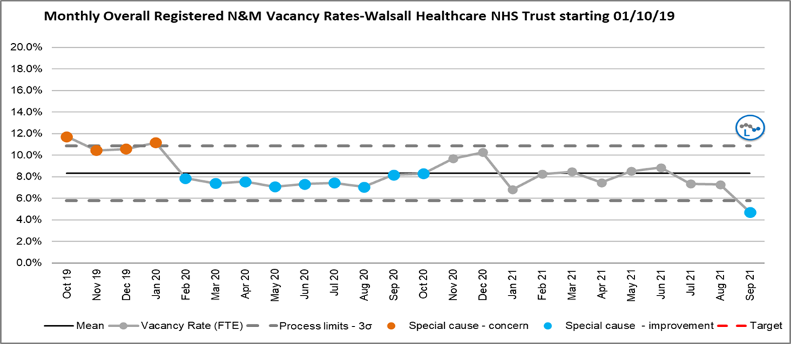
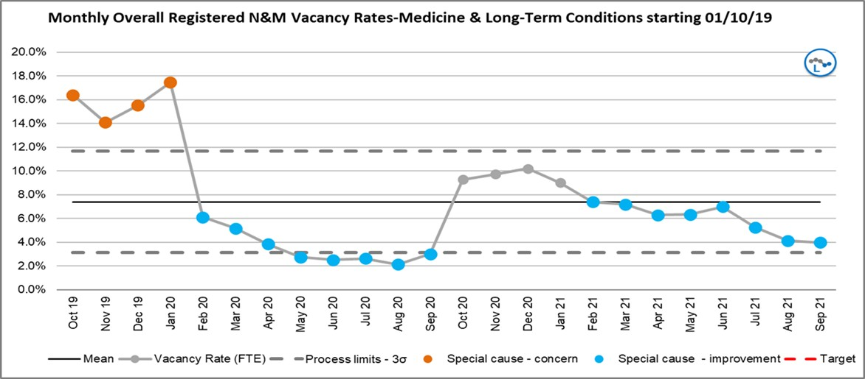
The Covid-19 impact has reduced across the Trust with many services now resuming ordinary business. There
are still a small number of reconfigured areas within the acute departments which are working with Covid streaming, different patient groups and vacancies/absences that are impacting the ability to have complete fill of shift requirements. September 2021 has seen 59 shifts where the Ward Manager was used as an RN on duty to fill an RN gap and management time was impacted. This is an increase from 56 last month.
Nurse Staffing Update
1.1 Vacancy Position
The RN and Midwifery vacancy rate for September 2021 has improved and is now less than 6%. The following
SPC charts provide details on the number of vacancies against the current approved establishments at a Trust and divisional level. It does not reflect vacancies against recently agreed establishment review increases which are yet to be actioned.
Chart 1: Nursing and Midwifery vacancy % (excluding Nurse Associates)
Chart 2: MLTC Vacancy position (information via ESR)
Chart 3: Surgery Vacancy position (information via ESR)
2

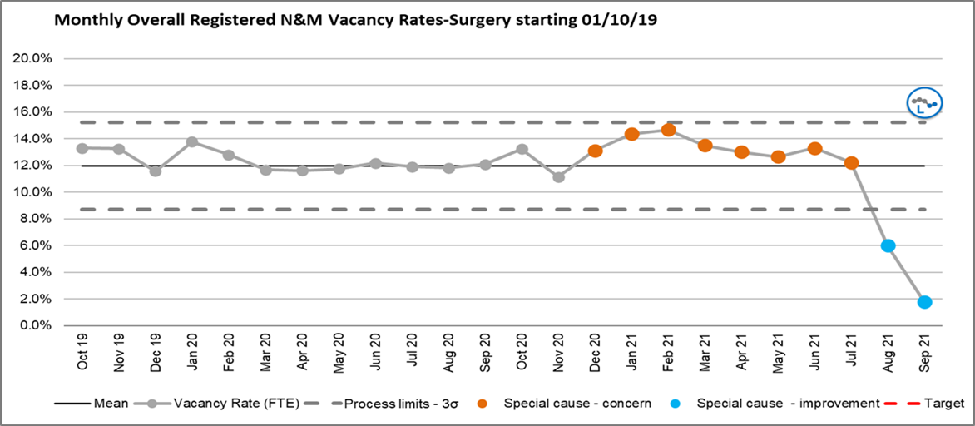
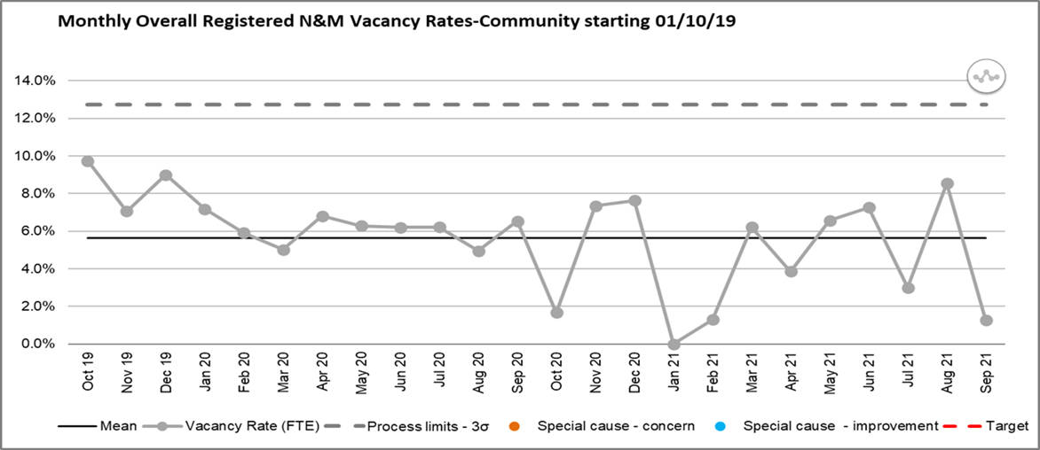
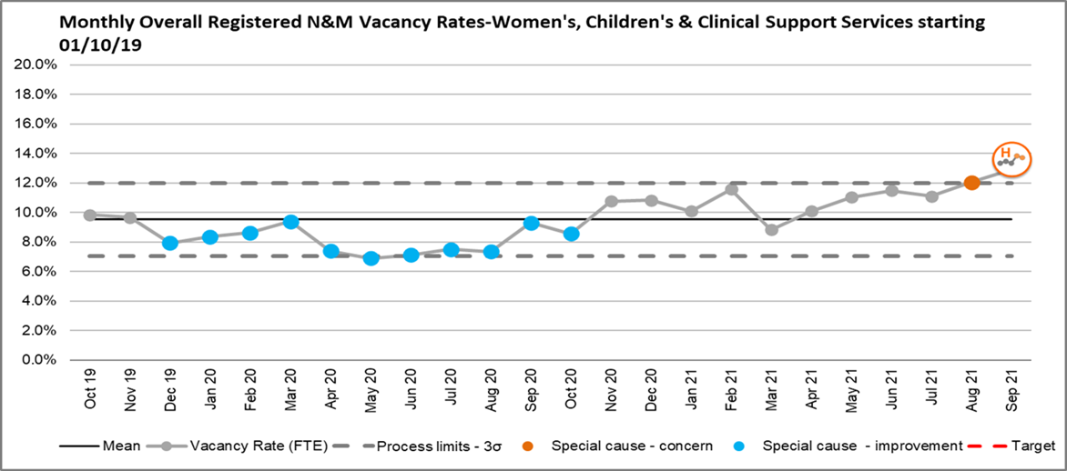
Chart 4: Community Vacancy position (information via ESR)
Chart 5 WCCSS: Vacancy position (information via ESR)
1.2 Overseas Recruitment
95 overseas Nurses have commenced working within the Trust by end of September 2021. 45 of those have
now successfully registered with the NMC and are working as Registered Nurses. A further cohort is arriving in October.
Pastoral care is being delivered by Team FORCE. The current expectation is that approximately 200 overseas
RN will be recruited by the end of 2021.
1.3 CSW Recruitment
3

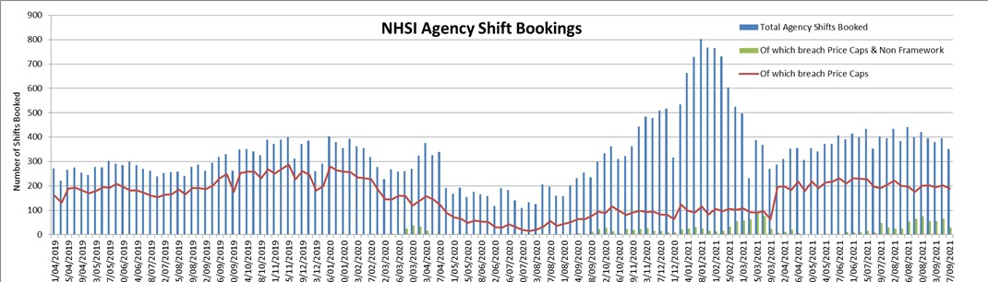
The Trust currently has 83 individuals undertaking apprenticeships. One individual has been employed as a
healthcare science apprentice, thirty eight are Trainee Nursing Associates and forty four are CSWs undertaking either a level 2 or level 3 programme.
During September 2021 there were recruitment activities related to both substantive and bank CSWs.
Interviews are taking place in October 2021.
1.4 Nursing Associate Recruitment
Twelve Trainee Nurse Associates (TNAs) are expected to qualify in December 2021, one has been delayed due
to personal circumstances.
Nine TNAs are expected to complete their training programme in June 2022, one has been delayed due to
personal circumstances. A further six are expected to complete in November 2022. Nine TNA’s commenced their two year training programme in September 2021.
1.5 NHSI Agency Cap Breaches
NHSI Agency Cap Breaches (Chart 7) have continued to be reported weekly to NHSI and have increased
compared to the previous month (792 shifts in August and 1058 in September).
Off framework use has increased during September and has been used to support ICU (1712 hours), A&E
(463.5 hours), NNU (182.75 hours), Ward 1 (34 hours), Ward 3 (28.75 hours), Ward 29 (23 hours), Ward 4
(17.25 hours); and Ward 2, Ward 5/6, Ward 17 all 11.5 hours each.
Chart 7: Agency Cap Performance
The lowest fill rate for September 2021 was for CSWs on day shifts at 77.90%. This is a decrease since last
month (86.38%). The overall fill rate for September (combined RN and CSW) was 90.18%, the previous month was 91.66%.
Chart 8: Ward Area Staffing Fill Rates
4

1.6 NHSI Model Hospital Staffing Fill Rates

1.7 Staffing Hub Activities
The Staffing Hub provides oversight of staffing levels across the Trust and supports and facilitates the speedy
escalation of issues in relation to staffing, acuity and outstanding shift demand. The staffing hub maintains a 72 hour forward view of Trust wide staffing. The staffing hub supports twice daily matron led, safe staffing meetings. These meetings provide a forum for re-deploying staff across clinical units and divisions, management of red flags, assurance regarding safe staffing levels across the Trust and escalation if risks cannot be mitigated. Through the safe staffing meetings 1033 hours of RN and 496 hours of CSW were re- deployed across the trust in September 2021. This is a decrease since August 2021 when 1323 hours of RN and 686 hours of CSW time were re-deployed.
Red Flags are recorded, reviewed and where possible mitigated, within the safe staffing meeting. Matrons
oversee the accuracy of the Red Flags recorded and their appropriateness. In September 2021 there were 167 Red Flags that were raised and 41 were resolved and mitigated during the safe staffing meeting. For the 126 Red Flags that could not be immediately mitigated this is escalated to the appropriate Divisional Director of Nursing for oversight, support and decisions regarding next steps via the Nursing and Midwifery Advisory Forum.
1.8 Electronic Rostering (E-roster) Levels of Covid-19 Related Absence
The Trust records all absence within the e-roster system. The system enables COVID-19 related absence to be
recorded separately from other sickness absence (chart 9).
Chart 9: Covid-19 Related Absence in Erosters
In September 2021 the temporary staffing bookings to cover for sickness and Covid-19 related absence for
RN’s was 6784.5 hrs less than the actual hours of absence recorded. For CSWs there were 5898.5 hours fewer hours booked than hours of absence recorded. There was an overall increase in sickness/Covid-19 related absence recorded in E-Roster in September 2021 compared to those recorded in August 2021 (Chart 10).
Chart 10: Comparison of Sickness/Covid-19 Absence against Temporary Staffing
5

Staff Type

Sum of Covid-19 Related Absence Hours + Sickness Absence
Temporary Staffing Hours Booked for Sickness and Covid-19 related absence
RN
9938 hours
3153.5 hours
CSW
8621 hours
2722.5 hours
Staff Type
Covid Related Absence Hours (Eroster)
RN

September=1076 hrs (decrease since previous month 1221- Aug 21)
CSW

September = 545 hrs (decrease since previous month 1319- Aug 21)

In September 2021 there were 2844.5 fewer RN hours of temporary staff booked compare to the actual hours
of maternity related absence. For CSWs there were 1070.5 fewer hours of temporary staff booked compared to the actual hours of maternity absence (Chart 11).
Chart 11: Comparison of Maternity/Paternity absence against Temporary Staffing
1.9 Allocate System Roll Out
All departments requiring E-Roster have now been moved from the RosterPro (RPC) system to the Allocate
System for Roster Management. Two departments who only utilise bank staff are still required to move to the Allocate E-Roster system. This will be completed by 31st October 2021. In the interim the Nurse Bank are manually supporting the transfer of information into Allocate.
The RPC system licence ceased at the end of September 2021.
In addition to the training delays Allocate have updated the user interface (version 11). This migration will
require all Allocate Managers, in forty departments to undertake further training. An initial trial of Version 11 training has highlighted some issues with the functionality which has been reported to Allocate but planning will be the next priority. Extended support from Allocate is in place to support the continuation of use of v10 until the end of October so training will be completed during October 2021.
1.10: Staff experience audits – Perfect ward
The corporate nursing team has been working closely with the performance team to continue to develop the
perfect ward audits. Within this suite of audits a monthly staff experience audit is undertaken. In September 2021 the staff experience audit score was 82.5% with 11 clinical areas completing this audit. The audit results, action plans, continued monitoring of progress and re-audit will be overseen and assurance on progress gained through the Trust wide Nursing, Midwifery and AHP Forum and Divisional Governance meetings.
END OF REPORT
6

Staff Type

Maternity/Paternity Absence hours

Temporary Staffing Hours Booked for maternity/paternity related absence
RN
4135 hours
1290.5 hours
CSW
2250 hours
1179.5 hours

1 | P a g e
MEETING OF THE PUBLIC TRUST BOARD - Thursday 4th November 2021
Guardian Of Safe Working Hours Quarterly Report For Nov20/Dec20/Jan21
AGENDA ITEM: 17

Report Author and Job Title:

Mushal Naqvi, Guardian of Safe Working Hours (GOSWH)
Responsible Director:

Manjeet Shehmar, Acting Medical Director
Action Required

Approve ☐ Discuss ☐ Inform ☒ Assure ☐

Executive Summary

The report covers the following elements:
- Introduction and context of the Guardian of Safe Working Hours role
- Guardian’s quarterly report for November 2020, December 2020 & January 2021
- Summary of progress and concerns
Recommendation

Members of the Trust Board are asked to note the report and discuss the contents
Does this report mitigate risk included in the BAF or Trust Risk Registers? please outline
There are no risk implications associated with this report

Resource implications

Implementation of the revised Junior Doctor contract may adversely impact on rotas and the ability to cover services effectively resulting in additional workforce requirements
Legal and Equality and Diversity implications

There are no legal or equality & diversity implications associated with this paper

Strategic Objectives

Safe, high quality care ☒

Care at home ☐

Partners ☐
Value colleagues ☒
Resources ☒

GUARDIAN OF SAFE WORKING QUARTERLY (NOV 20/DEC 20/JAN 21) ON SAFE WORKING HOURS OF DOCTORS IN TRAINING
1.
PURPOSE OF REPORT
The purpose of the reports is to provide a report from the Guardian of Safe Working to the Board on the safety of doctors’ working hours and rota gaps as required under the terms and conditions of the 2016 Junior Doctor Contract.
2.
BACKGROUND
GUARDIAN OF SAFE WORKING - Safeguarding the working hours of doctors
The safety of patients is a paramount concern for the NHS. Significant staff fatigue is a hazard both to patients and to the staff themselves. The guardian of safe working has been introduced to protect patients and doctors by making sure doctors aren’t working unsafe hours.
To do this, the guardian will:
•
•
act as the champion of safe working hours
receive junior doctors trainees’ exception reports and record and monitor compliance against the 2016 terms and conditions of service for doctors in training
escalate issues to the relevant executive director or equivalent for decision and action
intervene to reduce any identified risks to junior doctors or their patients’ safety undertake a work schedule review where there are regular or persistent breaches in safe working hours
distribute monies received as a consequence of financial penalties, to improve junior doctor training and service experience.
•
•
•
•
The role sits independently from the management structure, with a primary aim to represent and resolve issues related to working hours for the junior doctors employed by the Trust. The work of the guardian will be subject to external scrutiny of doctors’ working hours by the Care Quality Commission (CQC) and by the continued scrutiny of the quality of training by Health Education England (HEE). These measures ensure the safety of doctors and therefore of patients.
For more information about the guardian role, visit www.nhsemployers.org/juniordoctors
3.
EXECUTIVE SUMMARY
•
25 exception reports were submitted this quarter
2 | P a g e

•
Exceptions submitted were within the expected range for the time of year with a the usual annual reduction around Christmas/New Year
Almost 75% of exceptions came from the General Medicine department, the other quarter being from General Surgery
Exceptions submitted from the General Medicine department included four “Immediate Safety Concerns” relating to the senior support available during on call cover for General Medicine shifts; I have therefore asked for a work schedule review in General Surgery
The lack of senior support in medicine relates to rota gaps in the RMO2 rota which is predominantly staffed by Trust Grade doctors, but the data on trust grade shift vacancies are not accessible for the Guardian of Safe Working quarterly reports, making it difficult to identify issues and make recommendations for improvement
The work schedule review for FY1 level doctors working in Surgery requested at the end of the last quarter remains outstanding
The covid-19 pandemic and the associated staff-sickness plus the redeployment of trainees to Medicine have further worsened the situation in Medicine and Surgery
There was better communication with junior doctors regarding redeployment through weekly Junior Doctor Forum meetings as the start of the second wave, but the responsibility for such frequent meetings needs to be shared if this is required again in the future
Redeployment could be further improved by providing more advance notice to redeployed junior doctors or their individual work schedule and ensuring they are not required to work back to back night on calls when moving from their base specialty to medicine
Although work is in process to address the deficiencies identified in this report, at the end of this quarter I am not in a position to provide assurance with the overall safety of working hours for junior doctors.
•
•
•
•
•
•
•
•
3 | P a g e

Higher level data
a)
Exception Reports
Total number of exception reports received per month within this quarter:
Immediate
safety concerns (ISCs)
Total
hours of work and/or pattern
Service
support available
Working
hours/pattern AND Service support
Educational
opportunities/ support
TOTAL
The number of exception reports in this quarter was lower than expected for the month of December (previously, median number of reports per month = 10 with an interquartile range of 5 – 20). However, there often is an annual drop in exception reports submitted in the month of December, which is likely to reflect leave taken by many around the Christmas/New Year period, together with the associated reduction in elective workload and additionally, the concerted efforts to discharge many patients home so they also are able to spend the holiday season with their family and loved ones rather than remaining in hospital.
Similar to previous quarters, FY1 level doctors submitted the majority of exception reports:
NOV 20

DEC 20

JAN 21

QUARTER

0 8 3 2 0 13
(52%)
2 0 0 0 0 2
(8%)
2 5 0 1 2 10
(40%)
4 13 3 3 2 25
(16%) (52%) (12%) (12%) (8%) (100%)
Number of doctors in training (total)
160
Number of doctors in training on 2016 TCS (total)
160

Amount of time available in job plan for Guardian role
1 PA/4 hours per week

Admin support provided to Guardian
(within the 37.5 hours per week worked by the Guardian admin support, additional responsibilities are also undertaken including:
- appraisal & job planning administrator
- medical staffing support
- clinical fellowship programme support)
1 WTE/37.5 hours per week

Amount of job plan time for educational supervisors
0.25 PAs/trainee (with a maximum of 0.5 PAs/2 hours per week)
The mean number of days between an exception occurring and the exception being reported was 5.3 days (median = 2 days, range = 0 – 30 days).
Just over a quarter (28% n=7) of the exception reports related to the Surgical division with remainder emanating from the Department of Surgery:
60% of exception reports this quarter had a review meeting conducted by the supervisor – this is a reduction on the last quarter. To improve this number, I plan on keeping a “repeat offenders” chart, where these supervisors will be highlighted to the Director of Postgraduate Medical Education (DPME), where I hope this feedback will form part of their annual educational appraisal.
I personally reviewed 8 out of the 10 remaining outstanding reports, organizing payment as compensation for these exceptions, allowing them also to be closed. There were two outstanding reports relating to educational exceptions;
Exception reports by department
Division

Specialty

No. exceptions carried over from last report
No. exceptions raised

No. exceptions closed

No. exceptions outstanding

Medicine

Acute Medicine – AMU ward
0

5 (%)

3 + 2

0

Medicine

On call/ward cover
0

3 (%)

3 + 0

0

Medicine

Gastroenterology
– ward 16
0

9 (%)

2 + 5

2
(Educational)
Medicine
Elderly care
0
1 (%)
0 + 1
0
Surgery

Gen Surg – wards 11 & 12
0

2 (%)

2 + 0

0

Surgery

Gen Surg – wards 20A & 23
0

1 (%)

1 + 0

0

Surgery
Gen Surg – on call
0
4 (%)
4 + 0
0
Total

Med 18; Surg 7
(72%; 28%)
0 (%)
25
(100%)
15 + 8
(64% + 32%)
2
(8%)
Exception reports by grade
Grade

No. exceptions carried over from last report
No. exceptions raised

No. exceptions closed

No. exceptions outstanding

F1

0

24 (%)
15 + 7

2 (Educational)

F2

0

1 (%)
1 + 0

0

Total

0

25
(100%)
16 + 7
(64% + 28%)
2 (Educational)
(8%)
educational exceptions are managed by the DPME rather than the Guardian of Safe Working Hours (GoSWH).
The mean number of days between an exception report being submitted by a trainee and a review meeting occurring between the trainee and their supervisor was 14.1 days (median = 3.5 days, range = 1 – 43 days). This represents a marked improvement since the last quarter and reflects the efforts of the recently acquired guardian admin support.
The data regarding the resolution of exception reports for each month of this quarter is as follows:
TOIL
granted
Payment
for additional hours
Work
schedule reviews
Resolved –
no action required
Unresolved
TOTAL
b)
Work Schedule Reviews
The FY1 level junior doctors have tried to devise a new rota in General Surgery in response to the work schedule review that was requested at the end of the last quarter. Unfortunately, the rotas suggested would not be compliant with the TC&S of the 2016 Junior Doctor Contract. The General Surgery FY1s are wanting an additional FY1 to be rostered on weekend day shifts to cover ward work for Urology/General Surgery & ENT patients on wards 11 & 12, thereby easing the workload on the on call FY1 who currently has to do this as well as covering SACU ward and any emergency admissions the ward receives plus taking urgent GP referral calls. Often this role can be unsupported if the SHO and Registrar on call for General Surgery end up operating on emergency cases in theatre. However, to gain this additional weekend ward cover shift, a minimum of 15 FY1s are needed on the rota for it to remain compliant - currently there are
NOV 20
DEC 20
JAN 21
QUARTER

2 4 + 3 1 3 0 13
0 1 + 0 0 1 0 2
0 1 + 5 0 2 2 10
2 14 1 6 2 25
(8%) (56%) (4%) (8%) (8%) (100%)
Exception reports (response time)
Grade

Addressed within 48 hours

Addressed within 7 days

Addressed in longer than 7 days
Still open

F1
5
3
6 + 8
2 (Educational)
F2
0
1
0 + 0
0
Total

5
(20%)
4
(16%)
6 + 8
(24% + 32%)
2
(8%)
only 13. For this reason, the work schedule in General Surgery remains outstanding.
At the end of this quarter, I have also asked for a work schedule review in Medicine, in part relating to the weekend FY1 shift on AMU which should end at 4.30pm, but FY1s are regularly working over and submitting exceptions reports but also relating to reoccurring themes mentioned in the “Immediate safety concern” (ISC) exception reports submitted this quarter (more detail provided later in this report) and also from feedback received from the junior doctor forum (JDF) meetings, which echo the concerns raised in the ISC exceptions.
c)
Locum bookings
Data not available
d)
Locum Work Carried Out By Trainees
Data not available
e)
Vacancies
Vacancies by month
Specialty

Grade

NOV 20

DEC 20

JAN 21

Mean gaps/month
Total shifts uncovered
A&E
GP ST1/2
16
17
15
16
48

ST Higher (40%)
0

0

0

0

0

AMU
ST Higher
0
0
13
4.3
13
Elderly Care
CT 1/2
4
0
0
1.3
4

ST Higher (40%)

0
Trust Dr covering slot but not on- call (on- call covered with locums)
0
Trust Dr covering slot but not on- call (on- call covered with locums)
7

2.3

7

Gastroenterology
CT 1/2
2
18
14
11.3
34
Cardiology
FY 1
0
23
0
7.7
23
Respiratory
GP ST1/2
14
24
15
17.7
53
Paediatrics
FY 1
23
0
0
7.7
23

ST3 (20%)
1
2
2
1.7
5
Obs & Gynae

ST Higher (20%)
2

3

1

2

6

General Surgery

ST Higher (20%)
2

2

2

2

6

It should be noted, these vacancies are only training post vacancies and do not include gaps relating to vacant trust grade doctors working at junior doctor level. Junior trust grade doctor shift vacancies are not available to include in this report. However, this information is important to consider as it does impact the workload of trainees (for instance a 1:6 rota made up of five trainees and one trust grade doctor may have a rota gap if the department has not managed to recruit to the trust grade post, and this will no doubt increase the workload for the trainees working on this rota as they are taking on additional work that could have otherwise been shared with the additional trust grade post. Unfortunately, despite asking for these figures for inclusion in my quarterly reports and permit triangulation of data, thereby allowing improvements to be made, I have not been able to gain these numbers.
f)
Fines
Qualitative Information
The JDF highlighted issues with senior support during General Medicine on calls. The junior doctors linked the problem to rota gaps in the RMO2 rota, where the RMO2 rota is predominately staffed by trust grade doctors.
The staffing levels both in the Division of Surgery and in the Division of Medicine have been exacerbated by the second wave of covid-19, with its associated increase in staff sickness as well as the implementation of redeployment rotas.
There was better communication with junior doctors regarding redeployment on this occasion, where weekly JDF meetings were held for 4 weeks from mid-November,
Fines (cumulative)
Balance at End of Last Quarter
Not known + £304.51
Fines Paid to GOSWH This Quarter
£81.66
Expenses This Quarter
£0
Total Paid to Trainees this Quarter
£412.78
Balance at End of this Quarter
Not known + £412.78
Fines by department
Department
Number of fines levied
Value of fines levied
General Surgery
1
£81.66
Total
1
£81.66
T&O

CT 1/2 (40%)
5

5

4

4.7

14

TOTAL

69
94
73
78.7
236
allowing junior doctor to air their concerns promptly and helping to allay their anxieties. However, a significant amount of my time as GoSWH was dedicated to these meetings and the actions arising; in the future, such an undertaking needs to be shared, which is probably best achieved between the DPME, the Local Negotiating Committee Chair and the Medical Director (or their deputy) in addition to the GoSWH. But feedback received from the JDF suggested the redeployment process could have been improved further through providing more advance notice of the individual working schedules to be worked, especially as these short notice rotas affected plans trainees were making for the Christmas/New Year period, something which was already being put up in the air by ever changing Government Restrictions at the time, adding to stress felt by junior doctors. Also, some redeployed doctors found having just finished a set of nights for their on specialty, they were then asked to do a further set of nights on being redeployed to medicine – again, better planning could mitigate such occurrences.
Issues Arising
There have been four “Immediate Safety Concern” exception reports this quarter, all from General Medicine and all relate to senior support available:
1)
“Stayed late due to being only junior looking after 17 patients with no senior support. Felt I was asked to do things outside of my skill level”
“I am an F1 doctor on Medicine; I am part of the gen med on call rota. Monday to Thursday this week I am on C shift, which comprises of clerking from 12-5 and whole hospital ward cover from 5-9. Normally there is an RMO2 - registrar who is also on ward cover and who should be the first point of contact when an F1 needs to escalate. Both today and yesterday there has been no registrar RMO2 to cover the wards and help the F1. I have hugely struggled over the past 2 nights and am deeply concerned that harm will come to patients if this is not sorted out immediately. Although there has been a registrar covering resus and sick patients being admitted over the past 2 nights I have struggled to be able to contact them for help, as they have been very busy with their own tasks. Yesterday, the RMO1s bleep was not working for 2 hours. I have had to prioritise patients to the extreme over the past 2 nights and feel that I have had to make decisions that an F1 should not be solely responsible for. I have used outreach and escalated in other ways where I can but this is not enough. There have been times over the past 2 nights where I have had to stabilise a patient quickly and certainly not thoroughly, before rushing to a sicker patient on a different ward. Tonight I received around 50-80 bleeps where a large portion of patients were very unwell. Not only have I had a lack of senior support, but I suspect I have also
2)
been receiving bleeps that would have otherwise been directed to the RMO2. Whilst I have handed over tasks and patients to the night team, the likelihood of them getting round to see everyone/do all the important jobs whilst dealing with the e-handover AND getting further bleeps is very small. I have left work feeling upset and worried that I have missed something. I understand that the whole country and certainly the whole hospital are having severe issues with staffing issues but this really must be a priority. I have had F1 colleagues report that they have been in similar positions over the past few weeks.” “Walked into the morning handover on Monday morning to find out the day medical on-call team consisted of two F1s (including myself) and a registrar. Usually the minimal staffing is at least 2 F1's, 2 F2's and 2 Registrars (RMO1 and RMO2). The team was effectively cut in half (consisting primarily of members with less than 6 months experience as doctors) for what was the week where covid cases have been the highest since the beginning of the pandemic. Another F1 would join from 12pm-9pm, however from 5pm to 9pm one F1 would cover AMU, one F1 would cover ward 29, and the third F1 would cover the wards. This left the registrar alone in A&E to clerk, whilst the AMU and ward 29 doctor did ward jobs and clerked patients on those wards. This meant that by handover 20-30 patients were consistently being handed over to the night team to clerk.”
“Attended the morning handover to find that the entirety of the medical on-call team consisted of two F1's. No SHO's or Registrars. All scheduled registrars and SHO's had been unavailable all week (from Monday to Thursday) as I believe they had recently been told to self-isolate due to being covid contacts. Medical staffing were aware of the situation and had filled one registrar position for the Monday to Wednesday shift, but all other positions remained unfilled until we pulled in favours from colleagues. That meant that the most senior member of the on-call medical team for Walsall Manor Hospital on Thursday morning had less than 6 months experience, during the peak of covid. We had a medical cardiac arrest call that morning. Thankfully the night team offered to stay behind and help until the patient was stable and then left. The patient did end up in ITU. We informed medical staffing. We then informed the divisional director (whom I was told handled the rota). He informed us there was a registrar but found out there was not when checking. I then informed the medical director and was informed that I should clinical incident the situation and add him in. We still did not have a registrar at this point. Thankfully I caught up with my F1 colleague and a senior registrar who said he would hold the bleep whilst they found a replacement. Whilst I was in ITU my F1 colleague informed the on-call consultant about the situation and she asked to be added to a WhatsApp group and to be informed if we had any issues. Dr R (who also covered the Monday shift and to whom I owe a massive debt to) stepped in as registrar at around 10:30am. We got SHO cover from 12pm to 9pm after being asked to by a consultant, and another F2 helped clerk any patients that went to AMU without any clerking up until 4pm.”
3)
4)
Actions Taken to Resolve Issues
The Divisional Director of Medicine was informed of all the ISC outlined above and a work schedule review was requested in General Medicine regarding the on call staffing. In response the Divisional Director formulated a Standard Operating Procedure, where the on call consultant (or the on call registrar at night) is aware of the staffing issues and how to designate staff accordingly.
Summary
As previous quarters, the majority of exception reports were submitted by FY1 level doctors with reporting levels lying within the usual expected range for the time of year when compared to previous years.
Almost 75% of exception reports were from the General Medicine department with the remaining quarter emanating from the General Surgery department. The main reason to exception report in General Medicine related to lack of senior support due to vacancies on the on call rota, particularly the RMO2 rota which although is predominately staffed by trust grade doctors, is designed to share the workload experienced by trainees who are coving the General Medicine on call. This has been further exacerbated by staff-sickness related to covid. I have therefore asked for a work schedule review in Medicine.
The work schedule in General Surgery at FY1 level, requested at the end of the last quarter, remains outstanding. The staffing levels compared to the workload has been worsened by redeployment of junior doctors in general Surgery to General Medicine in response to the second wave of the pandemic where the effects are now also being felt by more senior trainees.
Communication with junior doctors regarding redeployment has improved from the first wave through weekly JDF meetings, but this was an onerous task when only undertaken by the Guardian of Safe Working. Further improvements in the redeployment process could be made with more notice of individual work schedules so trainees are more able to plan their personal time, and also by more sensitivity when planning redeployment rotas so junior doctors who have just finished a set of night for their specialty aren’t being asked to so back onto nights when redeployed to medicine.
Questions for Consideration
As guardian, I am not in a position to provide assurance with the overall safety of working hours for junior doctors this quarter.
This is with particular reference to junior doctors providing on call cover for General Medicine due the lack of senior support available as a consequence of rota gaps on the RMO2 rota. The effects of these rota gaps have been even more pronounced by staff sickness related to the second wave of the covid-19 pandemic. Additionally, the work schedule review for the FY1s in General Surgery which was requested at the end of last quarter remains outstanding. The situation in Surgery has deteriorated further through redeployment of junior doctors to Medicine, where the burden of the surgical workload is now being felt by more senior grade junior doctors.
I would therefore ask the board to note the report and to consider the assertions provided by the Guardian.
Appendix
Appendix 1 – Exception Report
Evening
finish & Breaks
Working
Hours
02/11/2020
02/11/2020
0
Monday
Medicine
Working
Evening
finish & Breaks
Hours &
Service Support Working Hours & Service Support Working Hours
03/11/2020
03/11/2020
0
Tuesday
Medicine
Evening
finish
13/11/2020
08/11/2020
5
Sunday
Surgery
Evening
finish Evening finish & Breaks Evening finish Evening finish Evening finish
14/11/2020
14/11/2020
0
Saturday
Medicine
Working
Hours
15/11/2020
15/11/2020
0
Sunday
Medicine
Working
Hours Working Hours Working Hours
19/11/2020
15/11/2020
4
Sunday
Surgery
26/11/2020
25/11/2020
1
Wednesday
Surgery
26/11/2020
26/11/2020
0
Thursday
Surgery
Working
Hours
Evening
finish
30/11/2020
28/11/2020
2
Saturday
Medicine
Working
Hours
Evening
finish
30/11/2020
29/11/2020
1
Sunday
Medicine
Service
Support
30/11/2020
23/11/2020
7
Monday
Surgery
Service
Support
30/11/2020
24/11/2020
6
Tuesday
Surgery

NUMBER OF
SUBMISSION DATE OF DAYS FROM DAY OF TYPE OF TIME OF SPECIALTY DATE EXCEPTION INCIDENT TO EXCEPTION REPORT DAY
SUBMISSION

Service
Support
30/11/2020
25/11/2020
5
Wednesday
Surgery
Working
Hours &
Service Support
Evening
finish
04/12/2020
04/12/2020
0
Friday
Medicine
Service
Support
09/12/2020
09/12/2020
0
Wednesday
Medicine
Working
Hours
Evening
finish
20/01/2021
20/01/2021
0
Wednesday
Medicine
Service
Support
23/01/2021
18/01/2021
5
Monday
Medicine
Service
Support
23/01/2021
21/01/2021
2
Thursday
Medicine
Education
al Education al Working Hours Working Hours Working Hours Working Hours & Service Support Working Hours
25/01/2021
21/01/2021
4
Thursday
Medicine
25/01/2021
14/01/2021
11
Thursday
Medicine
Evening
finish Evening finish Evening finish
25/01/2021
21/01/2021
4
Thursday
Medicine
25/01/2021
06/01/2021
19
Wednesday
Medicine
26/01/2021
27/12/2020
30
Sunday
Medicine
Evening
finish
26/01/2021
01/01/2021
25
BH Friday
Medicine
Evening
finish
30/01/2021
29/01/2021
1
Friday
Medicine
Gastro
16
FY1
18/11/2020
16
Payment
Gastro
16
FY1
Outstanding
Gen Surg
20A
FY1
19/11/2020
6
TOIL
Gen Med
AMU
FY1
Outstanding
Gen Med
AMU
FY1
18/11/2020
3
Payment
Gen Surg
on call
FY1
20/11/2020
1
TOIL
Gen Surg
11 & 12
FY1
15/12/2020
19
Payment
Gen Surg
11 & 12
FY1
15/12/2020
19
Payment
Work
Schedule Review No further action
Gen Med
AMU
FY1
12/01/2021
43
Gen Med
AMU
FY1
12/01/2021
43
No further
action - unresolved
Night on
call
Gen Surg
FY1
02/12/2020
2
Request for
Night on
call
further
information - unresolved
Gen Surg
FY1
02/12/2020
2
NUMBER OF
DATE OF DAYS
SUBSPECIALITY WARD GRADE MEETING BETWEEN OUTCOME
SUBMISSION
AND MEETING
No further
action - unresolved
Night on
call
Gen Surg
FY1
12/01/2021
43
NWD
Elderly care
Geriatric
Medicine
FY1
Outstanding
12noon -
9.30pm on call and ward cover
Gen Med
FY1
10/12/2020
1
ISC
Gastro
16
FY2
25/01/2021
5
Payment
12noon -
9.30pm on call and ward cover
Gen Med
FY1
25/01/2021
2
ISC
12noon -
9.30pm on call and ward cover
Gen Med
FY1
29/01/2021
6
ISC
Gastro
16
FY1
Outstanding
Gastro
16
FY1
Outstanding
Gastro
16
FY1
Outstanding
Gastro
16
FY1
Outstanding
Gen Med
AMU
FY1
Outstanding
Gastro
16
FY1
Outstanding
Gastro
16
FY1
Outstanding
Payment - 1hr (standard)
£15.89
?Payment - 2hrs (standard)
£23.84
Not able to take 3hrs TOIL awarded - Payment
£47.67
?Payment - 1hr 30 mins (standard)
£23.84
?Payment - 1hr 15 mins (standard)
£19.87
?Payment - 30 mins (standard) + 1hr 30 mins
(enhanced + breach)
£56.91
£81.66
£138.57
Payment - 30 mins (standard)
£7.95
Payment - 30 mins (standard)
£7.95
?Payment - 1hr 30 mins (standard)
£23.84
?Payment - 2hrs (standard)
£31.78
No Gen Surg SHO (who also covers Urol and
ENT for which no other senior support onsite overnight) on call overnight
?Junior doctor not contactable to arrange
review meeting with supervisor No Gen Surg SHO (who also covers Urol and ENT for which no other senior support onsite overnight) on call overnight

COMMENTS PAYMENT PAYMENT TOTAL TO DR TO GOSWH PAYMENT

Junior doctor not contactable initially by
supervisor in order to conduct review meeting. Finally conducted on 12/01/2021. No Gen Surg SHO (who also covers Urol and ENT for which no other senior support onsite overnight) on call overnight
?Payment - 3hrs (standard)
£47.67
No RMO2 to support FY1 - out of depth and
workload too heavy causing patient safetly issue. Escalated to DD of Medicine - arranged RMO2 cover for upcoming shifts for FY1 and also instigated escalation SOP to address this situation. Clinical Supervisor highlighted this issue to department at Grand Round that week.
Payment - 2hrs 30mins (standard pay)
£45.98
2 FY2s absent (self isolating) plus no RMO2 to
support FY1 - out of depth and workload too heavy causing patient safetly issue. I subsequently escalated to DD on receiving this ISC and received an escalation SOP to address this situation which I circulated to all medical junior doctors in addition to the FY1 concerned in the hope this situation would be avoided in the future.
2 FY2s absent (self isolating) plus no RMO1 or
RMO2 to support FY1 - out of depth and workload too heavy causing patient safetly issue. Escalated to deputy DD and MD by FY1 concerned at the time of incident. Additional staff identified by both FY1 and deputy DD of medicine to support FY1. I subsequently highighted to DD of medicine on receiving this ISC on receiving this ISC who investigated the cause for this incident (staff sickness at short notice and medical staffing not able to find cover), and an escalation SOP was developed by the DD of medicine to address this situation was instigated and I circulated all junor doctors in medicine, including the FY1 concerned.
Missed half of FY1 teaching as asked to stay on
ward for ward round
Missed all of FY1 teaching as asked to stay on ward for ward round
Payment - ?for how long
?Payment - ?for how long
?Payment - 2hrs (standard)
£31.78
?Payment - 1hr (standard)
£15.89
?Payment - 45 mins (standard)
£11.92
Report of the Freedom to Speak Up Guardians
MEETING OF THE PUBLIC TRUST BOARD - Thursday 4th November 2021
Progress on Freedom to Speak Up
AGENDA ITEM: 18
Report Author and Job Title:

Freedom to speak Up Guardians:

Kim Sterling Val Ferguson

Ayshia Aziz
Responsible Director:

Catherine Griffiths Director of People and Culture

Action Required
Approve ☒ Discuss ☒ Inform ☒ Assure ☒
Executive Summary

An account of the speaking up activity for the quarter 1st April 2021 to 30th June 2021

Highlight decrease in the freedom to speak up metrics
Recommendation

- Note the report and discuss the contents within
- Seek assurance from the organisation that speaking up is established as routine core day-to-day practice
Does this report mitigate risk included in the BAF or Trust Risk Registers? please outline

BAF 04 (a) - Value our Colleagues Lack of an inclusive and open culture impacts on staff engagement, staff morale, patient care, Leadership, Organisational Development and Culture.

Resource implications

There are some costs implications associated with following this programme of work; all resource will be aligned through existing budgets.
Legal and Equality and Diversity implications

Black, Asian or minority ethnic employees often face more barriers than non BAME employees when raising concerns.
The data available is not yet sufficient to reliably determine and evidence equality and diversity impacts. This is being addressed through collecting concerns electronically through the incident reporting system, Safeguard and work being undertaken by the Equality, Diversity and Inclusion Committee.
Strategic Objectives

Safe, high quality care ☒

Care at home ☐

Partners ☐
Value colleagues ☒
Resources ☒

1.
PURPOSE OF REPORT
The Freedom to Speak Up (FTSU) guardians reported to the Personnel and Organisation Development Committee (PODC) in September 2021 providing oversight of freedom to speak up activity between 1 April 2021 and 30 June 2021.
2.
BACKGROUND
Following the inquiry and subsequent Francis report into the failings at the Mid Staffordshire Hospitals, every NHS trust was recommended to appoint a FTSU guardian
Speaking up is one route available to colleagues to raise concerns about their own wellbeing and patient safety; the FTSU guardians form part of a network to support colleagues to do so.
The role is broadly two fold; to escalate concerns on behalf of staff and to work with the senior leadership to improve patient safety culture.
3.
DETAILS
In addition to the quarterly update on the numbers of concerns raised and the themes; the following was also highlighted to the committee (please see appendices):
3.1.
3.2.
3.3.
National Guardians Office Annual Report.
Information on FTSU e-Learning available through ESR
FTSU Index – The committee was presented with updated data.
This metric is calculated using four questions from the NHS Annual Staff Survey, and can help build a much broader picture of the speaking up culture in any organisation.
The following table shows the trend since the introduction of the FTSU Index
2
The organisation will need to implement actions to address the decline in this index that signifies that there has been some movement away from a healthy speak up culture.
A new speaking up question was included in the 2020 NHS Staff Survey. The question asked respondents whether they feel safe to speak up about anything that concerns them in their organisation. The results of this question also showed a strong positive correlation with the FTSU Index. In Walsall, 59% of staff responded positively to the question.
These cultural metrics indicate the organisation will have to improve speak up culture in order to meet the requirements of the well led component of Care Quality Commission inspection.
4. RECOMMENDATIONS
4.1.
The Board of Directors receives this report for information
4.2.
The Board seeks assurance from PODC for full commitment of the FTSU training modules and provide evidence of uptake of this training by each division and report the figures.
4.3.
Assurance from the Director of People and Culture that the organisation develops an action plan to improve the safety culture which will be reflected in an improvement in the FTSU metrics.
APPENDICES
Appendix 3.1 NGO Freedom to Speak Up Annual Report 2020
https://nationalguardian.org.uk/wp-content/uploads/2021/07/Annual-Speaking- Up-Data-Report-2020-21.pdf
3

2016
2017
2018
2019
2020
National
76.7%
76.8%
78.1%
78.7%
79.2%
Midlands
76.4%
76.5%
78.0%
78.7%
79.6%
Acute and Community Trust
76.4%

76.5%

78.1%

78.5%

79%

Walsall
71.9%
74.9%
76.6%
75.2%
74.4%

Appendix 3.2 Information on FTSU e-Learning available through ESR
https://themanor.xwalsall.nhs.uk/Data/Sites/1/media/downloads/how-to-access- speak-up-training.pdf
Appendix 3.3 Freedom to Speak Up Index Report 2020
https://nationalguardian.org.uk/wp-content/uploads/2021/05/FTSU-Index-Report- 2021.pdf
4

1
MEETING OF THE PUBLIC TRUST BOARD - Thursday 4th November 2021
Walsall Together Partnership Highlight Report

AGENDA ITEM: 19

Report Author and Job Title:
Michelle McManus, Head of Transformation
Responsible Director:
John Dunn,
Non-Executive Director
Action Required

Approve ☐ Discuss ☐ Inform ☒ Assure ☐

Executive Summary

This report provides an overview of the key items discussed at the Walsall Together Partnership Board at its meeting on Wednesday 22nd September 2021. The key points for the attention of the Trust Board are:

- The Partnership Board received a story about the end of life care that somebody had received within Walsall. The presentation outlined positive and negative experiences regarding the care that was both provided and commissioned by health and social care partners within the borough. The Board resolved to work with the person presenting the story to highlight to partners the issues raised and to seek to address those aspects of care that were felt to require improvement.
- The Partnership Board considered the systems pressures within Walsall which were affecting all partners. The work that had been done with partners around the availability of packages of care was highlighted as an example of where a joint approach gave benefit. The number of patients who were medically stable for discharge had risen to an average of 52 during September but had reduced to 40 in October (up to the date of the Partnership Board).
- A presentation was received about Primary Mental Health services and the expansion of the service locally. It was agreed to establish a group to look at integrated working within primary care to ensure that people with mental health needs were not subject to multiple referral pathways which carry the risk of duplicated referrals and poor patient experience.
- The System Pressure Plan developed within the partnership was reviewed. It was noted that Primary Care were concerned that this would not address all the pressures they are encountering, particularly with regards to paediatric attendances. It was agreed that plans would be reviewed with a view to increasing support in this area.
- An escalation was received by the Partnership Board regarding a slippage in the implementation of the Shared Care Record due to the need to harmonise with the plans of other health economies within the Black Country. It was
2

agreed to escalate the concern of the Partnership Board to the ICS central digital team in order to emphasise the importance of maintaining the pace of implementation at local level
- The Alliance Agreement between partners was due to expire at the end of October 2021. It was agreed that it should continue in its present form for six months while discussions continued with partners about future arrangements
- The Board received the partnership risk register and noted that a detailed review was in progress, with senior expertise provided by Walsall Healthcare as Host Provider.

Recommendation

Members of the Trust Board are asked to note the contents of this report.
Does this report mitigate risk included in the BAF or Trust Risk Registers? please outline
BAF Risk- S03 - Failure to understand population health and inequalities, integrate place-based services and deliver them through a whole population approach would result in a continuation if not widening of health inequalities.

Resource implications

There are no new resources implications associated with this report.
Legal and Equality and Diversity implications

The issue of health inequalities continues to receive growing prominence in all forums across Walsall Together and there is now a dedicated Population Health & Inequalities workstream. It is reflected in the strategic objectives of the partnership and the associated BAF risk for Walsall Healthcare.
Strategic Objectives (highlight which Trust Strategic objective this report aims to support)
Safe, high quality care ☐
Care at home ☒
Partners ☐
Value colleagues ☐
Resources ☐

1
MEETING OF THE PUBLIC TRUST BOARD – 4th November 2021
Care at Home Executive Report
AGENDA ITEM: 20
Report Author and Job Title:

Matthew Dodd Director of Transformation
Responsible Director:

Matthew Dodd Director of Transformation
Action Required

Approve ☐ Discuss ☐ Inform ☒ Assure ☒

Executive Summary

This report provides an overview performance, risk, assurance, and transformation in the Care at Home Strategic domain. It covers:
- Operational performance for community services and Adult Social Care, situated within the context of the Walsall Together Partnership (Appendix 1);
- Board Assurance Framework (BAF) for Care at Home;
- An update on the transition to obtain Integrated Care Provider (ICP) status

Detailed discussions in these areas have been covered in the relevant Board Committees in addition to that noted in the Partnership Board highlight report.
Recommendation

Members of the Trust Board are asked to note the contents of this report.
Does this report mitigate risk included in the BAF or Trust Risk Registers? please outline
BAF Risk- S03 - Failure to understand population health and inequalities, integrate place-based services and deliver them through a whole population approach would result in a continuation if not widening of health inequalities.

Resource implications

There are no new resources implications associated with this report.
Legal and Equality and Diversity implications

The issue of health inequalities continues to receive growing prominence in all forums across Walsall Together and there is now a dedicated Population Health & Inequalities workstream. It is reflected in the strategic objectives of the partnership and the associated BAF risk for Walsall Healthcare.
Strategic Objectives (highlight which Trust Strategic objective this report aims to support)
Safe, high quality care ☐
Care at home ☒
Partners ☐
Value colleagues ☐
Resources ☐

Care at Home Executive Summary
October 2021
1.
PURPOSE OF THE REPORT
This report provides an overview performance, risk, assurance, and transformation in the Care at Home Strategic domain during September 2021. Detailed discussions in these areas have been covered in the relevant Board Committees in previous months in addition to that noted in the Partnership Board highlight report.
•
Operational performance for community services and Adult Social Care, situated within the context of the Walsall Together Partnership (Appendix 1);
Board Assurance Framework (BAF) for Care at Home;
An update on the transition to obtain Integrated Care Provider (ICP) status;
•
•
2.
PERFORMANCE, ASSURANCE AND RISK – COMMUNITY SERVICES
The key risks to community services and assurances around the level of service provision are included in Appendix 1 and all relevant Board Committees have been briefed on these risks in October.
Appendix 1 incorporates the Community Services data in the context of Walsall
Together services.
The report continues its evolution towards greater focus on
assurance around the Tiers of the Walsall Together clinical operating model. The ICP has allocated some funds to develop a dashboard & mechanism for integrated reporting across partner organisations. A specification has been developed and has gone out to
tender with responses due back by the end of October 2021.
The intention is to
commission external consultancy by November 2021 to deliver the project. This work will inform the future structure of the Walsall Together performance reports.
2.1. Demand
The slight abatement in demand for Community Services was maintained in September (7,326 hours of demand compared to 7,491 in August) but it must be noted that the demand for the Care Navigation Centre rose to 869 calls in month, which is its highest ever.
2
2.2. Capacity
Concerns remain about the capacity of providers to respond to demand. Despite the stabilisation of service need, Community Nursing was unable to respond to 21% of its demand within localities. As reported in previous months, Care Agencies continue to report staff shortages which adversely impact on their ability to provide packages of care to people in their own homes. This led to an increase in the number of people in the Manor Hospital and other Hospitals who are Medically Stable for Discharge and awaiting packages of care as well as those in the community requiring long term
support.
The total number of MSFD patients on the MSFD list increased in
September to an average of 52 people, which is the highest it has been since April 2020.
2.3. Response to diminishing availability of Packages of Care (POC):
A response has been coordinated within Walsall Together which involves:
•
Use of interim care home beds and dedicated staff to support these people as required
Reduction of demand for packages of care through support with the Bedside Mobility Assessment Tool and accelerated discharge at the Manor Hospital
Recruitment of additional providers by Commissioning teams
Greater flexibility within the contracts for provision of packages of care Offer to care agencies for support with recruitment
•
•
•
•
During the month, Commissioners were able to bring in two new providers and from late September they increased the hours of domiciliary care available. This continued during October and has resulted in an additional 700 care hours being available per week. There has been a concomitant reduction in the number of MSFD patients at the Manor Hospital (41 on average, up to 27/10/21).
It must be signaled to the Trust Board however, that despite this response, the Partnership has noted in late October that there are indicators of pressure within social care community pathways (numbers of referrals to brokerage; people waiting for domiciliary support in order to leave care homes) which raise concerns about the resilience of domiciliary care provision to deal with sustained demand. This could have an adverse impact on the numbers of MSFD at Walsall Manor Hospital over the
coming months. Partnership.
Further escalations and mitigations are being considered by the
3
2.4 Planning in response to System Pressures:
Community Services has been recruiting to posts outlined in the System Pressures Plan which was considered at last month’s Trust Board. There has been a request from both Primary Care and the Emergency Department at Walsall Manor Hospital to
support them with non-elective demand associated with children.
Community
Services is working with the Trust Paediatrics Service and Primary Care to develop a community-based response for children who have been seen by a doctor and can be monitored at home.
3.
BOARD ASSURANCE FRAMEWORK
The BAF and the risks it identifies are being systematically reviewed with the Trust’s governance team. In October it is proposed to increase the in-month risk score from
12 to 16 to reflect the concerns being raised across the partnership about the resilience in the workforce capacity to deal with rising demand for routine services, as outlined in section 2 above.
4.
ICP ROADMAP
The transition of services provided by Walsall Healthcare Trust into separate acute and community contract schedules remains on track. Further progress towards a more formal Integrated Care Provider contract is paused whilst further national guidance is awaited in relation to the proposed legislation for Integrated Care Systems and Place- Based Partnerships.
A series of Board development sessions with the Walsall Healthcare Trust Board and the Walsall Together Partnership Board respectively are scheduled over the coming months, to allow for adequate review, interpretation and local decision-making in response to the guidance as it becomes available. A revised roadmap for the future scope and pace of integration within Walsall Together is expected to be developed in preparation for the 2022/23 financial year.
5.
RECOMMENDATIONS
Members of the Trust Board are asked to note the contents of this report.
4

MEETING OF THE WALSALL TOGETHER PARTNERSHIP BOARD – 20th October 2021
Operational Update
AGENDA ITEM:
Report Author and Job Title:
Matthew Dodd, Director of Transformation
Responsible Director:
Matthew Dodd, Director of Transformation
Action Required
Approve ☐ Discuss ☐ Inform ☒ Assure ☒
Executive Summary

This report provides an overview of the operational performance for services in scope. The content of the report is reviewed at the SMT.

A summary of performance, assurance and risks is included in the attached report.

Demand continues to outstrip capacity in some services and is manifesting in cancelled hours for Community Nurses, prioritisation of workload in Adult Community Services and a rise in the numbers of Medically Stable for Discharge patients in hospital & people in the community waiting for packages of care.

The impact of mitigations to address these pressures is outlined as are the measures to deal with systems pressures this winter.

A separate report is attached which outlines activity undertaken by the Primary Care Mental Health Team. Since this is the first time the WTPB has seen this data it has been kept as a separate presentation for this month to enable greater focus and consideration.
Recommendation

The Board is asked to note the impact of growing demand within services across the partnership, the impact this is having and the responses that are being implemented
Does this report mitigate risk included in the Walsall Together BAF or Risk Registers? please outline
Some operational risks have now been recorded on the Walsall Together risk register and a formal process for identification, reporting and monitoring of operational risks has now been defined. Further work is ongoing, particularly across partner organisations, to share risks pertinent to the partnership.
Resource implications

The number of MSFD patients has increased (and use of acute hospital and community spot purchase beds)

Additional capacity in the short term and over winter will necessitate extra expenditure across the system
Legal and Equality and Diversity implications
None

Strategic Objectives

Improving Health & Wellbeing Outcomes ☒
Improving Quality of Care Provision ☒
Improving System Financial Sustainability ☒

Operational Update September 2021
1. Introduction
This report provides an overview of the operational performance of services in scope for Walsall Together. The data in the appended report relates to September 2021 (Appendix 1).
2. Background
The report continues the process of evolving from a descriptive report showing selected aspects of activity under the banner of Walsall Together into a vehicle aimed at providing assurance to the WT Partnership Board.
3. Data Quality
The ICP has been allocated some funds to develop a dashboard & mechanism for
integrated reporting across partner organisations.
A specification has been
developed and has gone out to tender with responses due back by the end of
October 2021. The intention is to commission external consultancy by November 2021 to deliver the project. This work will inform the structure of this report.
4. Performance, Assurance and Risks
Full details of the performance of key services are included in the appended slide pack.
In September, key points to be raised to the Board concern:
Demand: The slight abatement in demand for Community Services has been maintained this month (7,326 hours of demand compared to 7,491 in August) but it must be noted that the demand for the Care Navigation Centre has risen to 869 calls in month, which is its highest ever. Demand coming into Adult Social Care was slightly higher in September than August.
Capacity: Concerns remain about the capacity of providers to respond to demand. Despite the drop in demand, Community Nursing was unable to respond to 21% of its demand within localities, while reduced staffing levels in Adult Social Care meant that they have prioritised in order to maintain normal activity for completion of Care
Act assessments and reviews to support individuals with change of need.
As
reported in previous months, Care Agencies continue to report staff shortages which adversely impact on their ability to provide packages of care to people in their own homes. This has led to an increase in the number of people in the Manor Hospital and other Hospitals who are Medically Stable for Discharge and awaiting packages of care as well as those in the community requiring long term support. The total number of MSFD patients and the LOS on the MSFD list increased again to an average of 52 people during September, which is the highest it has been since April 2020.
5. Mitigation
In September the partnership has focused on two key areas:
Response to diminishing availability of Packages of Care (POC): The tactical
response has been outlined in previous reports to the Partnership Board. month saw the fruition of some of the approaches:
This
Greater flexibility for providers in delivery of care has been agreed by
•
commissioning teams
The work on reducing demand for packages of care through support with mobilization work at the Manor Hospital has continued
Additional providers have been commissioned in a way which ensures this does not destabilize existing providers within the borough. Additional hours for packages of care have been phased in from mid-September, with the intention to provide 750 hours of care from mid-October
Creation of a dashboard of pressures across Walsall which is reviewed by partners and resources redeployed & targeted across the borough as required
•
•
•
This has had the impact of reducing the numbers of people waiting for packages of care at the Manor and the patients who are medically stable for discharge has reduced to an average of 39 during the first 12 days of October. In addition, the use of interim beds has declined, as more people are able to access packages of care. The focus is now on ensuring that Walsall residents in out of borough hospitals and people within the community requiring support are now included equally in the multi- agency response
Planning to deal with System Pressures: The plan discussed at the last WTPB around the £700k of systems funding to support the urgent community response and Ageing Well work has been finalised. This was agreed by the WHT Trust Board at the start of October. Recruitment has commenced for these roles.
6. Recommendations
The Board is asked to:
- Note the impact of sustained demand against a background of limited capacity within services across the partnership
•
Note the mitigations that have been implemented to address these pressures


Walsall Together Partnership Operational Update: October 2021
Matthew Dodd Director of Transformation

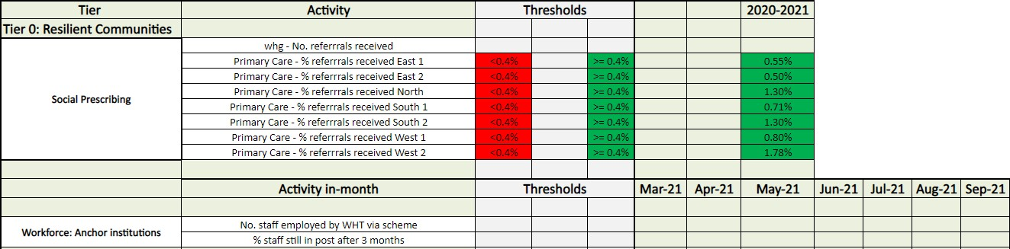
[Emergent] Score Card for WT Tiers – Tiers 0
Walsall Together | Collaborating for happier communities
2

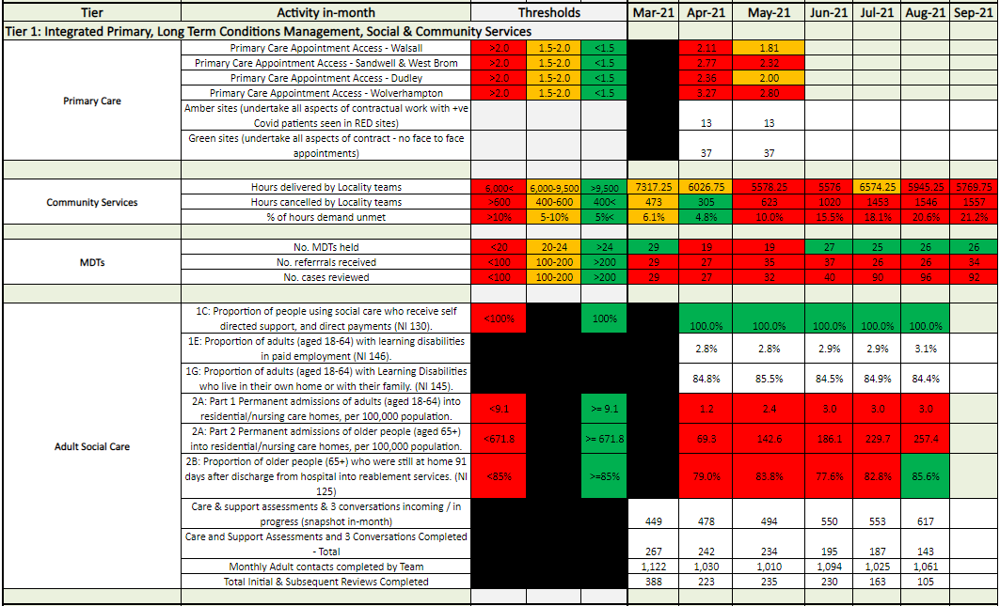
[Emergent] Score Card for WT Tiers – Tiers 1
Walsall Together | Collaborating for happier communities
3

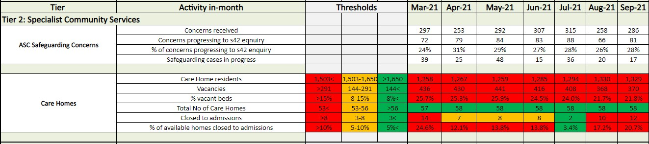
[Emergent] Score Card for WT Tiers – Tier 2
Supporting the Covid Vaccination Programme: Saddlers (and Manor Walk In Centre)
As of 11/10/21 combined they have delivered 162,761 vaccinations.
Walsall Together | Collaborating for happier communities
4

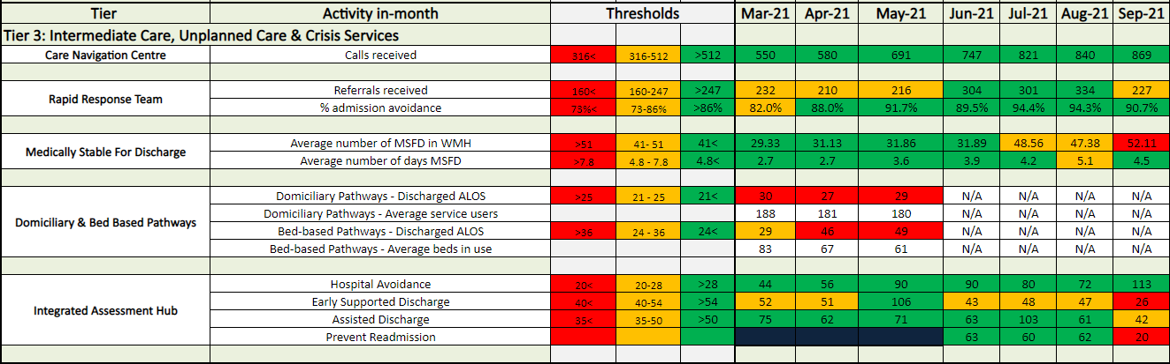
[Emergent] Score Card for WT Tiers – Tiers 3 (& 4)
Walsall Together | Collaborating for happier communities
5

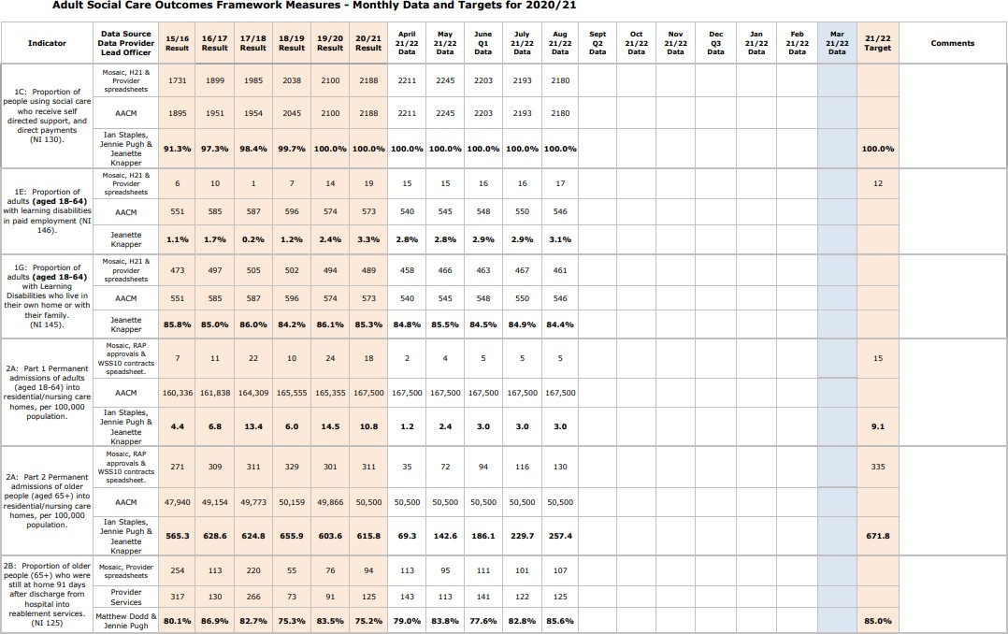
Walsall Together | Collaborating for happier communities
6

Tier 0: Walsall’s Voluntary & Community Sector – One Walsall
Approximately £50,000 of external funding has been secured by the voluntary sector in the previous quarter in support of community projects and supporting the wider sector's contribution to Resilient Communities.
Youth work is progressing in partnership with Walsall Police, looking to bring
young ambassadors together to drive work around support for the health and wellbeing of young people in Walsall. Discussions with young people began in the summer and is now looking to support young people with mental health advice, career advice and look to reduce isolation by connecting with peers.
The current Black Country Moving project is hoping to be extended via funding from the Commonwealth Community Activities Fund. This programme will continue to support those people who are least active become engaged in physical activities that promote improvement in general health and wellbeing.
A pilot of reward and recognition for volunteers has begun in partnership with OW and Walsall College, offering free training to eligible volunteers on a range of subjects to enhance their skills and/or employment prospects. This will be monitored and reported on as it may form a template for volunteer reward recognition across the Black Country health and care system.
•
•
•
•
Walsall Together | Collaborating for happier communities
7

Tier 0 Resilient Communities
The Kindness Counts Team are funded by a grant from NHS Charities and whg . The work of the team is focussed upon reducing loneliness and isolation , encouraging kindness at a community and individual level and engaging people in activities which increase resilience . Research shows that being kind and helpful has a positive impact on both physical and mental health it helps to form new relationships , it releases serotonin into the body reducing the impact of anxiety or depression and helps the body deal with pain with the release of endorphins .The MAYO Clinic 2021
During this quarter the team have organised and attended three face to face community events . They took place in Palfrey and Darlaston South and Walsall Town Centre ( Women's Bike Tour ) .
The theme of the evens was Kindness Counts with an overall objective to provide people with an opportunity to connect and also to receive information advice and guidance from a range of support services . The team had a Clever Conversation with 463 local residents of which 231 are adults . They completed 100 Loneliness and Isolation Assessments ( UCL and ONS4 ) gave out 150 Kindness Bags which contain health promotion advice and recorded over 300 acts of kindness and it was clear that people were benefitting from face to face support . The questionnaires will be analysed with residents offered longer term support to reduce loneliness and isolation .
•
•
Walsall Together | Collaborating for happier communities
8

Tier 0 Resilient Communities
What Matters To Me
In recognition that older people may have been shielding at home for over 12 months the Kindness Champions organised a number of activities which would bring people together and reduce their feelings of loneliness or isolation . During August 102 people and over took part in visits to Black Country Museum , Burnham on Sea and Stratford Upon Avon . These individuals had been identified as lonely or isolated during the pandemic . The activities provided opportunities to develop new friendships , take part in new experiences , increase confidence and learn about the support that is available through the Kindness Counts programme . A number of those who attended told us that this was the first time they had been out since the pandemic started and they now felt more confident to continue to go out in the future .
We used this ‘social’ activity to begin a Clever Conversation with customers about What Matters To Them in respect of their Health and Wellbeing . Their responses have helped us to co produce a questionnaire which we will use with other customers to design a range of health engagement activities .
•
•
•
Walsall Together | Collaborating for happier communities
9

Tier 0 Resilient Communities
Workforce Development
Work 4 Health project This project continues to be an excellent pathway for long term unemployed residents or people employed in temporary employment . Walsall Manor have recently asked whg to undertake the interviews on their behalf and put forward their preferred candidates .
This model is now of interest to NHS Trusts in Birmingham and Sandwell . WM confirm that job retention is high ( although early days ), the workforce is more diverse . To date 31 local people now have a career within the NHS reducing the impact of the social determinants of health .
September Recruitment Figures : Interviews Pending
- Numbers Applied 125
- Numbers completing support session 125
- Numbers who are unemployed 79
- Numbers applying on a Zero Hour Contract 43
- Numbers of whg customers who have applied 40
Walsall Together | Collaborating for happier communities
10

Tier 0 Resilient Communities Social Prescribing
Walsall Together | Collaborating for happier communities
11

whg’s Social Prescribing Team continue to work with people impacted by the social determinants of health . To date the team have supported 251 people . On average people remain on the programme between 12 and 24 weeks . During September we have recorded the following outcomes from 60 participants

- 45 have improved their confidence
- 43 have improved self esteem
- 33 have improved thinking about training and volunteering opportunities
- 43 have improved access to support services
- 45 have improved optimism about their future and personal life goals
- 51 have improved positivity about wellbeing
- 51have improved health and wellbeing scores
Primary reason for referrals in September

- Mental Health loneliness and isolation 43%
- Bereavement 2 %
- Domestic Abuse 1%
- Housing Advice 15%
- Social Exclusion – Poverty – Disadvantage 39%

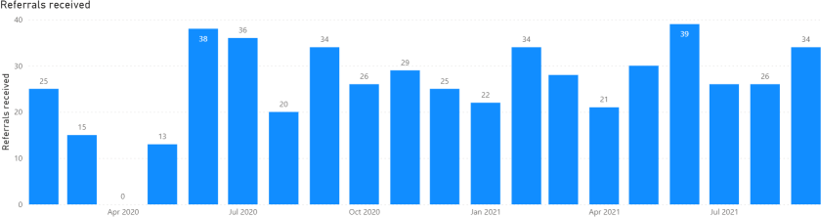
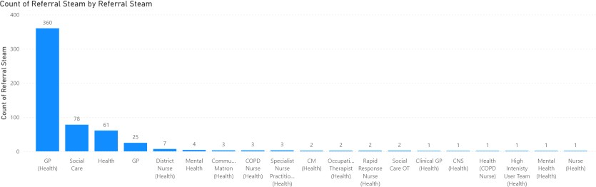
Tier 0: MDTs
Demand is significantly below capacity for GP-led MDTs
Walsall Together | Collaborating for happier communities
12

The service is established for 7 x MDTs with up to 50 cases to be reviewed per week
In July, 26 cases were considered It has been agreed with PCNs that
the risk stratification will change [eg case finding by the MDT Coordinators to focus on people who have had four admissions in the last year]
Further review meeting planned with PCN MDT lead to look at how to increase referrals from other teams

Tier 1: Primary Care Appointment Access ( Aug 2021)
- Black Country STP
  - 570,191 appts
  - 516,053 attended (90%) remains the same
  - 31,094 – DNA (5.45%) remains the same
  - 23,044 – Not Booked(4.04%) up by 0.6%
  - X1 appt per 2.62 pt ( appt vs patient)
  - 104,288 more appointments compared to August 2020 - 20% more
- 56 % F2F appts compared to 50% in August 2020
- 22,807 more appointment then in August 2019 ( pre-covid) -> 4%
Walsall Together | Collaborating for happier communities
13

CCG

Population

Number of Appts
Appt vs pt
BCC
1,494,115
570,191
2.62
Tier 1: Primary Care SOP
- Primary care operating telephone triage first – if patients require clinical face-to- face (F2F) examination they are invited in for an appointment
- Consultations are being completed via telephone, video consult, online and F2F Current Pressures:
- Access to appointments
- Ongoing delivery of the Vaccine programme Phase 3 & Flu Vaccination
- Access to Out-patient services
- Patient Demand
- Zero Tolerance and abuse
Walsall Together | Collaborating for happier communities
14

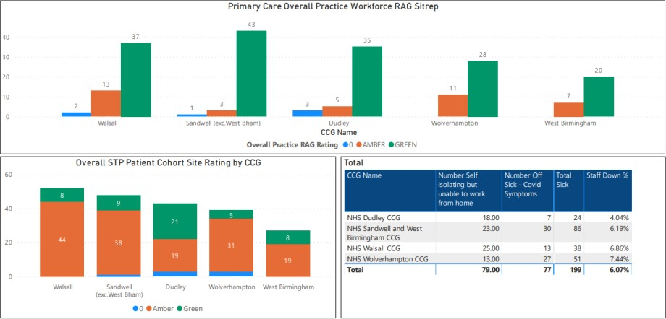
Tier 1: Primary Care Daily SitRep
- Amber & Green Practices in Walsall.
- Amber Sites – perform all aspects of contractual work -
+ve COVID or COVID
symptoms are seen in Red Sites
- Green Sites – perform all aspects of contract – no Face2Face appointments
Walsall Together | Collaborating for happier communities
15

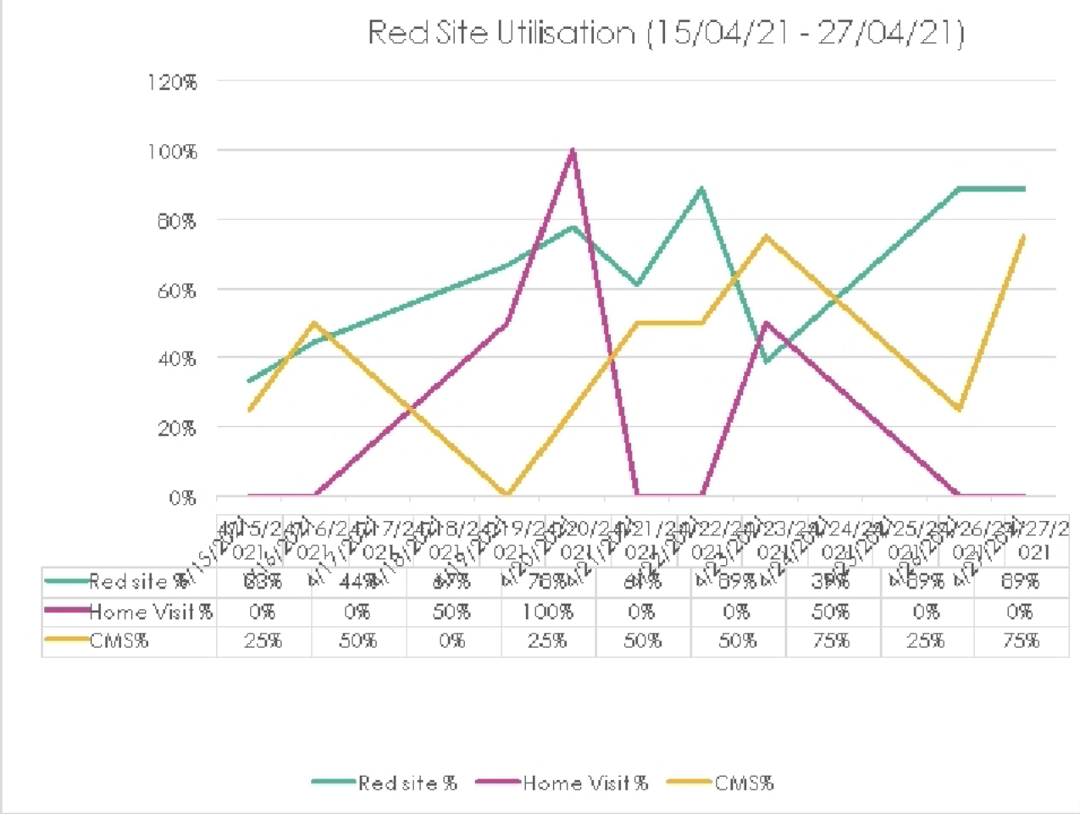
4/15/2021
4/16/2021
4/17/2021
4/18/2021
4/19/2021
4/20/2021
4/21/2021
4/22/2021
4/23/2021
4/24/2021
4/25/2021
4/26/2021
4/27/2021
Tier 1: Primary Care Red site demand
capacity
Home visits conducted by red sites have stopped from the 30th April and practices complete these for all HB patients.
Red sites are commissioned until Mid October - current discussions ongoing surrounding the future of these services to support Primary Care
Winter planning for COVID +ve patients in primary to be discussed
•
•
•
Walsall Together | Collaborating for happier communities
16

Red Site Utilisation (15/04/21 - 27/04/21)
120%

100%

80%

60%

40%

20%

0%
4/15/2 4/16/2 4/17/2 4/18/2 4/19/24/20/2 4/21/2 4/22/2 4/23/2 4/24/2 4/25/2 4/26/2 4/27/2
021 021 021 021 021 021 021 021 021 021 021 021 021
Red site % 33% 44% 67% 78% 61% 89% 39% 89% 89%
Home Visit % 0% 0% 50% 100% 0% 0% 50% 0% 0%
CMS% 25% 50% 0% 25% 50% 50% 75% 25% 75%

Red site % Home Visit % CMS%
Tier 1: PCN – ARRS
- Currently 3 projects involving PCN ARRS and WT.
  - First Contact Practitioner (FCP)
  - Nursing Associates (NA)
  - Mental Health Practitioner
  - FCPs currently working in 4 PCNs – Data to follow in future meetings – initial feedback is very positive with reductions in MSK referrals and increase in access in primary care
- NAs awaiting start date – x1 NA starting in South 2 PCN in the next 4-6 weeks
- Mental Health Practitioner recruitment has been challenging with x1 successful applicant - pilot to take place in East 1 PCN
- Risk – SLAs are currently the hold up which have taken a considerable amount of time to draft.
Walsall Together | Collaborating for happier communities
17

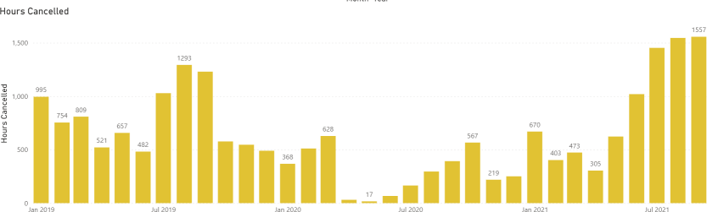
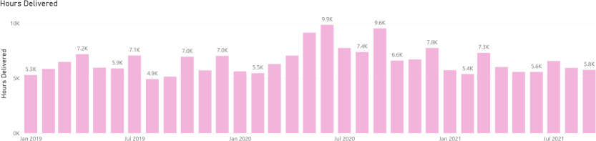
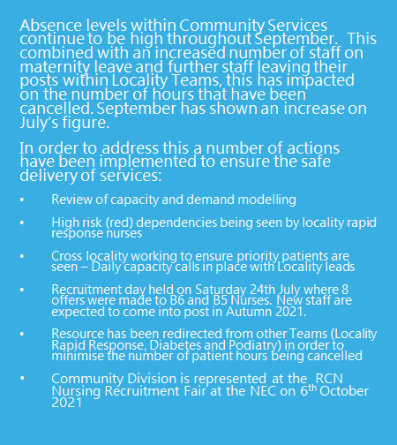
Tier 1:
Community Nursing Capacity and Demand: In September 2021, Community Services delivered less hours of care and cancelled more than in the previous month
Walsall Together | Collaborating for happier communities
18

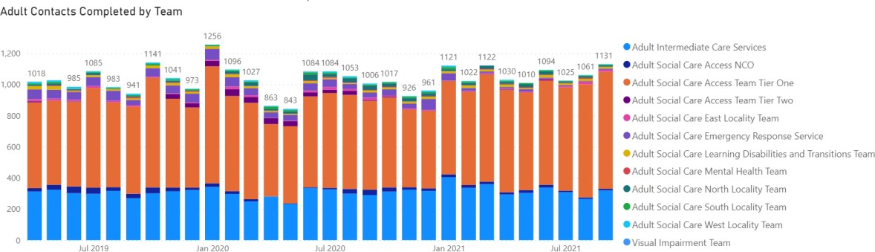
Tier 1:
Adult Social Care

Demand coming into Adult Social Care was slightly higher in September than August. Annual leave, absences and redeploying some staff to ICS to support demand in September has resulted in reduced staffing capacity in our locality teams therefore we have continued to maintain normal activity for completion of Care Act assessments and prioritised our reviews to support individuals with change of need.

Walsall Together | Collaborating for happier communities

19
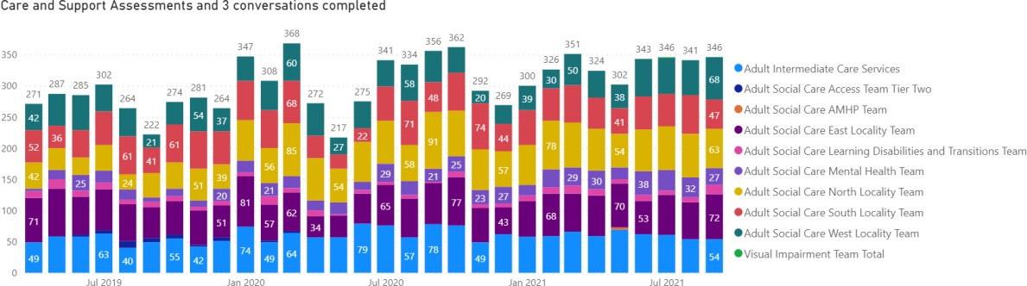
Walsall Together | Collaborating for happier communities
20

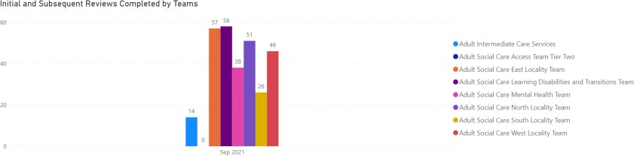
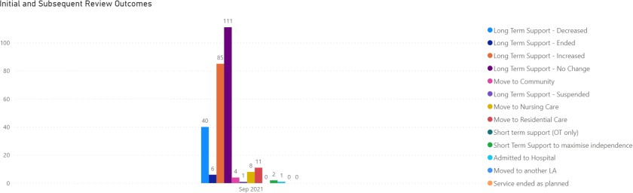
Walsall Together | Collaborating for happier communities
21

Date
Sum of Total Initial and Subsequent Reviews Completed
Feb-21
380
Mar-21
451
Apr-21
295
May-21
323
Jun-21
334
Jul-21
327
Aug-21
268
Sep-21
290
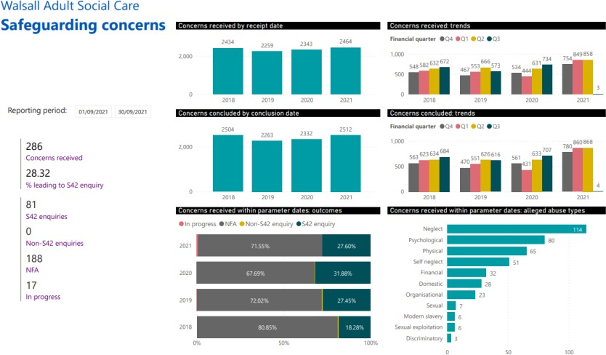
Tier 2:
Adult Social Care
Walsall Together | Collaborating for happier communities
22

ASC have received 286 concerns which is an increase of 28 referrals on the previous month.

The number of cases progressing to a s42 enquiry is a 28.32% received.

A recent safeguarding partnership audit has been undertaken to establish why the conversion rate is often less than a third of all concerns raised. Findings suggest that this is due to the understanding of the Care Act and what is considered to be a safeguarding matter requiring a concern to be raised. Work will now commence to progress the learning with a view to improving the quality of referrals. This may impact on the data moving forward.

Neglect & Psychological abuse remain the two highest categories of alleged abuse in this period.

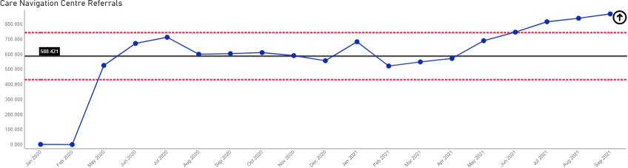
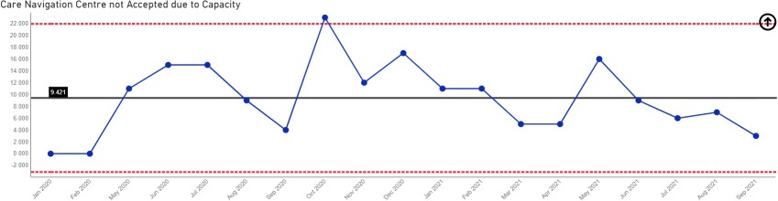
Tier 3:
Care Navigation Centre:
2020) and calls continue to rise
Hours of availability have increased (November
The operational hours for the CNC as of 5th July increased to 08.00-22.00 to 08.00
- 00.00. This will provide operational resilience for the Hospital avoidance and Covid pathways through the Winter period.
An enhanced service is also being developed for Winter in order to direct more patients away from the “Front Door”. This will include a further expansion of CNC capacity, placing a team within the WMAS Control Centre, Paediatric and Pharmacist support for CNC and strengthening of the disposition pathways into Rapid Response and Integrated Front Door.
Work is in progress with WMAS and Acute to create a 999/111 SPA through CNC for hospital ED Divert including FES, AEC, SAKU and Gynae/ Early pregnancy
Walsall Together | Collaborating for happier communities
23
services.

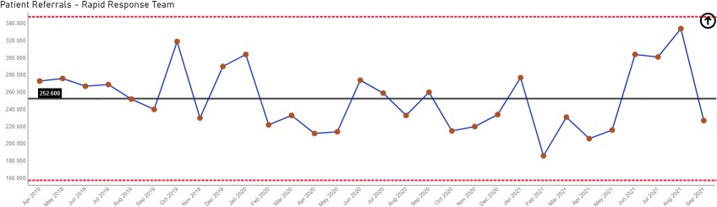
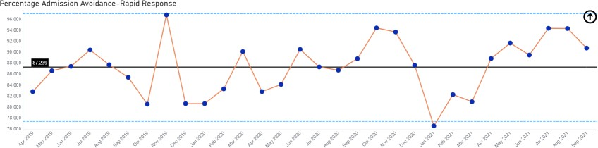
Tier 3: Rapid Response
The pattern of demand is changing [impact of CNC]
Walsall Together | Collaborating for happier communities
24

Referrals into Rapid Response have increased, while the percentage of admissions avioded has also climbed. The service increased the
operational hours until midnight from the 5th July to capture referrals later in the day. This will provide operational resilience for the Hospital avoidance through the Winter period.
Rapid Response is now visible to NHS111 and WMAS as a direct referral / call disposal route for clinical and non- clinical referrals( non –clinical calls as 3 month pilot with 6 identified conditions).

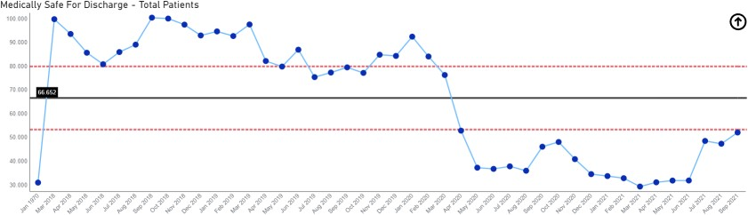
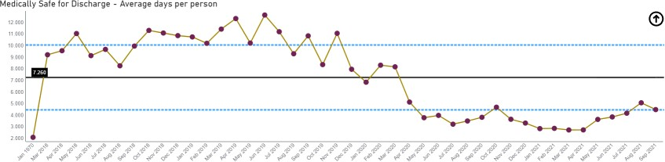
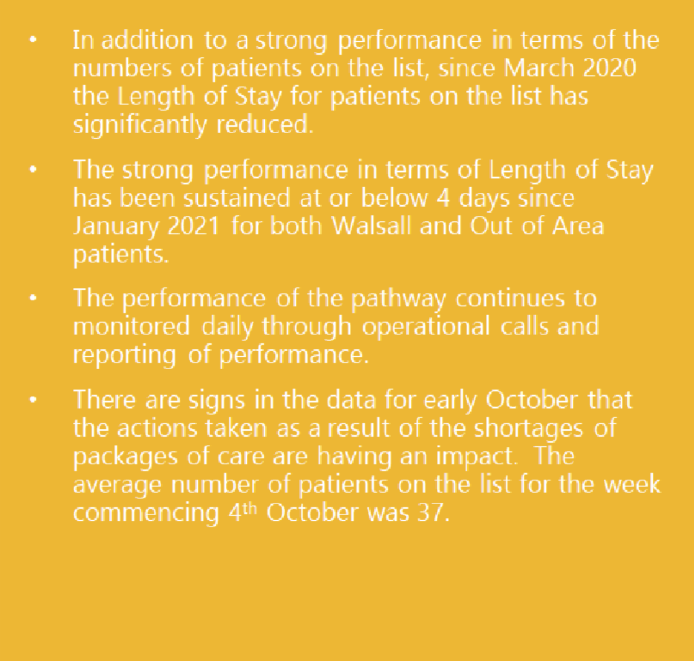
Tier 3: Medically Stable for Discharge (MSFD): numbers remain low
Walsall Together | Collaborating for happier communities
25

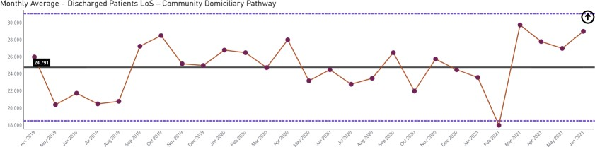
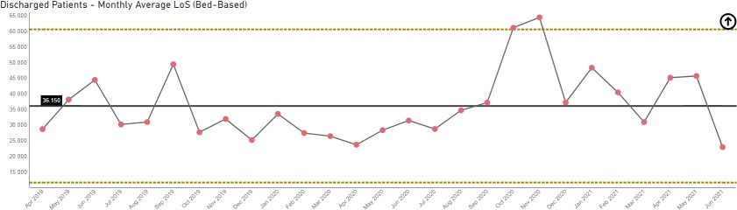
Tier 3: Domiciliary and Bed-Based Pathways
Walsall Together | Collaborating for happier communities
26

- Therapy demands and the change in national model is having a significant impact on community ICS therapists, unplanned crisis demands and hospital discharges remain key priorities in patient safety.
- Due to Covid, individuals have been more unwell and therefore have needed rehab/Reablement for a longer period of time- Long Covid MDT exceptional success.
- There is a recruitment plan underway for gaps in the social care workforce which is impacting on LOS

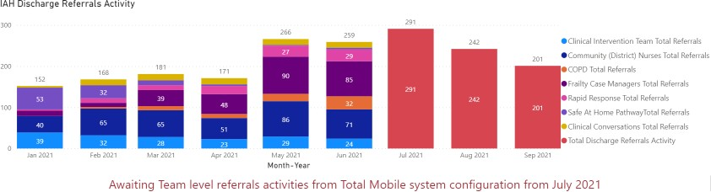
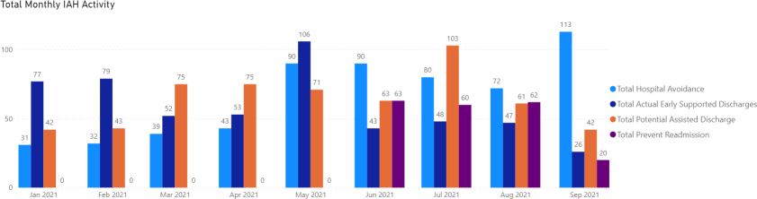
Tier 3/4:
Integrated Assessment Hub:
Recruitment is still in progress last B6 post
avoid readmission.
Walsall Together | Collaborating for happier communities
27

Integrated Assessment Hub
- Hospital Avoidance: This IAH pathway enables people directly contacting the Frail Elderly Service or Ambulatory Care at the Manor with post-discharge complications to be seen by Rapid Response, Enhanced Care Home Support Team or CIT team instead and receive a community-based assessment & clinical review, thereby avoiding conveyance to hospital. The numbers of people accessing this pathway increased again for July
- In order to measure the success of the Hospital Avoidance, Early and Potential Discharge pathways the Team in addition to the Case Management undertaken in the Community the Team have started to report the numbers of patients that have been prevented from readmission within 30 days. This will enable the service to measure the impact of Quality driven case findings
Page 1 of 5
Risk Summary
BAF Strategic Objective Reference & Summary Tile:
BAF SO 02 - Care at Home; We will work with partners in addressing health inequalities and delivering care closer to home through integration as the host of Walsall together.
Risk Description:
Failure to work with partners and communities to understand population health and inequalities, integrate place-based services and deliver them through a whole population approach would result in a continuation of poor health and wellbeing and widening of health inequalities.
Lead Director:
Director of Integration.
Lead Committee:
Walsall Together Partnership Board.

Links to Corporate Risk Register:

Title:
Current Risk Score Movement:
- Risks in this area relate to Walsall Together programme risks. The biggest ones are associated with the limited investment and the size and complexity of the population health challenges.
- Non-programme risks relating to Community Services at the current time. These are updated through the divisional structure.
- Each organisation retains its own risk log although the section 75 presents the opportunity to start to bring the logs together.
- Risks associated with creating an ICP contract will be considered through a formal due diligence process, supported by NHSI/E.
- Operational capacity due to an increase in community prevalence of Covid since December 2020.
- Winter preparedness due to change in patient flows during Covid 19 on the Trusts operating model
- Programme risk register for the Walsall Together Partnership Board:
  - 2370 - Population Health Management (Risk Score = 16).
  - 2624 - Primary Care demand and capacity (Risk Score = 20).
  - 2625 - WHT investment in Community/WT services in scope (Risk Score = 20).
  - 2626 - COVID vaccinations (Risk Score = 16).
  - 2628 - Funding for ICS beds (Risk Score = 16).
  - 2641 - Delayed discharges for MSFD patients as a result of low availability of packages of care (Risk Score = 20).
Likelihood = 4
Consequence = 3
= 12 Moderate
↔
Forecasted Risk Score Movement for Q3:

Likelihood = TBC Consequence = TBC
= TBC ↑↔↓

Risk Appetite
Status:
Hungry
Averse
Cautious
Balanced
Open
Hungry
Appetite Score:
< 21
1
2
3
4
5
6
7
8
9
10
11
12
13
14
15
16
17
18
19
20
21
22
23
24
25
Tolerate Score:
< 25

Risk Scoring
Quarter:
Q1 2021/22
Q2
Q3
Q4
Rational for Risk Level:
Target Risk Level (Risk Appetite):
Target Date:
Likelihood:
3
4

- Operational pressures are increasing across the system following the restart of routine activity post-COVID. Whilst staffing levels continue to be impacted by self-isolation and a loss of workforce to other sectors, demand is exceeding capacity in
several areas. The care provider market has been impacted by COVID and Brexit and there is a
Likelihood:
3

30 June 2021

Consequence:
3
3

Consequence:
3

Risk Level:

9
Moderate

12
Moderate

Risk Level:

9
Moderate

Latest Board/Committee/Group - 11/10/21 Version V5.02
2 | P a g e

shortage in packages of care (POC) for people MSFD within Walsall Manor and other healthcare settings. There is a further risk to capacity and flow during the winter pressures period.
- The transformation pace has now been addressed as Covid pressures reduce through the relaunch of both the Walsall Together Senior Management Team and the Clinical Professional Leadership Group meetings.
- Demand on partnership services continues to climb quickly as the Covid risks decreasing presenting additional pressure on urgent care. In addition to routine services, the system is preparing to administer booster vaccines.
- Strongly established relationship with 50% of General Practice on robust vaccine delivery. Other practices chose not to connect with partnership and deploy alone.
- Maturing place-based teams in all areas of Walsall on physical health and Social Care. Place-based mental health provision, including IAPT, Primary Mental Health, additional roles in general practice is not yet established and it is unclear how the contractual arrangements will be
aligned to the place-based integration of services.
- Significant maturity in communications and confidence in Walsall Together however public profile now needs to be established.
- Funding has been secured and specification agreed for the development of a fully integrated performance, quality and risk scorecard.
- Risk Stratification process for COVID developed with partners which demonstrates the evolving maturity of the partnership.
- Substantial improvements in medically stable for discharge before and during Covid 19. However, challenges referenced above regarding stability of the care provider market, particularly during winter.
- Virtual clinics & community outpatients maturing and triage & referral services now in place during Covid & being planned for the long term.
- Partnership approach to managing care home support and intervention being embedded into business as usual. The long-term financial model

3 | P a g e

is not yet confirmed.
- Strong evidence base being established for ICP due diligence and work now progressing at pace with the support of the ICS and NHSI/E.
- The step up of the risk in Q3 2020/21 has now been de-escalated and predicted to fall through Q1 in 2021/22.
- The number of safeguarding referrals has levelled off since June. Post-COVID increase in referrals is within tolerance levels and was predicted.
- Capacity in the community teams as a result of the success of the WT has led to a new demand and capacity challenge which requires addressing with a demand and capacity review.

Control & Assurance Framework - 3 Lines of Defence

1st Line of Defence
2nd Line of Defence
3rd Line of Defence

Controls:

- Executive Director appointed.
- Non-Executive Director / Chair to be advertised
- Partnership Board/Groups and meetings in place.
- Business Case developed.
- PMO/Project in place and reporting.
- Daily operational coordination taking place.
- Covid Vaccine delivery plan in place and operational.
- WT acting as recruitment partner for PCN’s on the new national roles
- Alliance agreement signed by Partners.
- Governance structure in place and working.
- S75 in place and operational practices now maturing.
- Integration of performance data across the partnership is being progressed and reported to the Walsall Together Committee.
- Business case approved by all partners.
- Monthly report to Board and partner organisations.

- External assessment - CQC/Audit.
- STP Scrutiny.
- Health and Wellbeing Board Reporting.
- Overview and Scrutiny Committee.

Gaps in Controls:

- No strategic finance plan for investment across the partnership which potentially impacts on the delivery notwithstanding the recent investment from the Trust. This has been mitigated short term with Covid funding, but further work required to establish ongoing formal mechanisms through ICP contracts
- Commissioner contracts not yet aligned to Walsall Together although ICP planning will resolve this issue
- Data needs further aligning to project a common information picture.
- Effective engagement with community in development with local groups limited due to Covid social restrictions.
- Organisational development for wider integrated working not yet outlined or agreed and delayed due to Covid.
- Enactment of section 75 in terms of monitoring meetings.
- Place based demand and capacity plan addressing the new flows apparent after Covid-19.
- Variance in the understanding of other place based services in scope across the Black Country which is preventing the ICS due diligence commencing

Assurance:

- Divisional quality board now starting to look at the integrated team response.
- Risk management established at a
- Walsall-Together included on Internal Audit Programme.
- Walsall Together Committee in place overseeing
- NHSE/I support of Walsall Together.
- STP support.
- NHSE/I validation of ICP due diligence.

4 | P a g e

programme level and a service level integrating risks.

assurance of the partnership.
- STP oversight of ‘PLACE’ based model.
- Reporting to Board and Partners.
- Oversight on service change from other committees.
- ICP due diligence underway.
- Safeguarding board to align reporting with WTPB

Gaps in Assurance:

- Limited in overall external assurance as regulators inspect individual organisations and as yet have not developed ‘PLACE’ based inspections although Walsall Together put forward as part of ICP development.
- For Community services and ACS within the Section 75 there is direct accountability to WT / WHT; these formal arrangements do not cover other partners hence limited accountability for delivery of Walsall Together strategic aims.
Future Opportunities
- Further development of the Governance around risk sharing.
- S75 Deployment based on other services relating to health prevention and public health commissions.
- PCN partnership alignment and risk share with building trust and confidence.
- Covid-19 offers an opportunity to increase the pace of delivery and more importantly stress test benefits before substantive deployment.
- Strategic partnership(s) with major primary care organisations to further accelerate vertical and horizontal integration of care in the borough.
- Formal contract through an ICP mechanism.
- Formal working with other partners to support their ability to achieve additional income and support via a partnership approach.
- CQC action oversight group.
Future Risks
- Insufficient promotion of success narrative.
- Inability to deliver enough investment up front to change demand flows in the system.
- Changes to commissioner & provider environment / landscape within the Black Country may change mechanisms for resourcing and resolution of service issues.
- A mechanism for gaining and sustaining resources to support strategic aims for 2021/22+ are unclear.
- National influences on constitutional targets moves focus from place to ICS.
- Retention of inspirational and committed leadership across partners.
- Estates - ability to fund the full business case offering (4 Health & Wellbeing Centres).
- Misalignment of provider strategies created by mergers or form changes or senior personnel turnover.
- Lack of uninterrupted community clinic space due to Covid Restrictions.
- Programme Resource - Capacity to deliver the WT programme will become more difficult as the same resource will be required to support the delivery of Covid-19 work streams, e.g. mass swabbing, flu vaccination programme, Covid-19 vaccination programme, outbreak management and the Covid-19 Management Service (CMS).
- Maintenance of the ICP agenda through the ICS Board by both the system partners and the Trust in relation to strategic objectives.
- Transition to a new chair and maintaining the current BAU
Future Actions (to further reduce the Likelihood / Consequence of the risk in order to achieve the Target Risk Level in line with the Risk Appetite)
No.
Action Required:
Executive Lead:
Due Date:
Progress Report:
BRAG:

1.

Agree an investment plan initially with commissioners through 2021/22 funding round to address the current gaps in funding provision.
Director of Integration

July 21

Work is underway to confirm maintenance of transformation funding for the diabetes and care home services into established baselines. A longer-term conversation will then need to be coordinated with other ICP’s through the ICS

5 | P a g e

board for Health Commissioning.

2.

Agree & implement joint service development opportunities between Walsall Together and PCNs that foster improved delivery of care through more integrated working.
Director of Integration

July 21

Work has started on revised recruitment and management arrangements for roles such as First Contact Practitioners and Pharmacists. Further opportunities are being identified.

3.

Refresh strategic case for Resilient Communities, ensuring appropriate focus on reducing health inequalities and alignment of strategic objectives across partner organisations.

Director of Integration

July 21

The Resilient Communities work stream has held three sessions.

The work stream has presented to WTPB (March 2021) the following next steps:
- Discussion at the CPLG to confirm the local population challenges that we want to address, aligning to population health management and inequalities priorities for the partnership.
- Establishment of the Steering group including confirmation of membership and Terms of Reference.
- Review of the multiple strands of work pertaining to citizen and communities engagement to create a single, defined approach.
- Review of the full proposal to Changing Futures and proposal for how some or all of the elements can be taken forward without the external investment.

4.

Develop population health management strategy across Walsall Together and PCNs including the deployment of the population health module (Digital work stream).

Director of Integration

July 21

This work is underway with the support of the STP Academy and Public health. The Population Health module as part of the Medway deployment is also in our test environment. The final strategy is interdependent with the production of the Health & Well Being strategy which is focused on the end of Q2.

5.

Develop robust governance and legal frameworks for Walsall Together with devolved responsibility within the host (WHT) structure. This should include an outline governance structure that shows the links to other WHT committees and acknowledge the transition to holding a formal ICP contract.

Director of Governance

July 21

This work is on track as part of the ICP programme.

6.

Prepare for implementation of a formal ICP contract under a Lead Provider model with WHT as Lead Provider. This will include confirmation of all services in scope and a clear rationale for the change in the context of improving outcomes for the population.

Director of Integration

July 21

On track and formally reported to WTPB monthly

1 | P a g e
MEETING OF THE PUBLIC TRUST BOARD - Thursday 4th November 2021
Combined update from the Black Country and West Birmingham Acute Provider Collaboration Programme and the Working closely with Partners Improvement Programme workstream
AGENDA ITEM: 22

Report Author and Job Title:

Simon Evans, Acting Chief Strategy Officer Ned Hobbs, Chief Operating Officer
Responsible Director:

Simon Evans, Acting Chief Strategy Officer Ned Hobbs, Chief Operating Officer
Action Required
Approve ☐ Discuss ☐ Inform ☒ Assure ☐
Executive Summary

The paper covers programmes of Acute Provider collaboration including updates on priority works streams for diagnostics; clinical and back office updates as well as workforce and OD, governance, technology and data.

The Acute Provider Collaboration (APC) programme has confirmed its intention to become a work stream within a wider provider collaborative model within the ICS. The APC has also been accepted onto the national ‘deep dive test site’ to evaluate progress of provider collaboratives.

Following a tender, a provider to review options for future potential clinical configuration across the hospital sites has been selected.

Local Working closely with Partners improvement programme workstream updates are included for Dermatology, Haematology, Orthopaedics, Urology and Estates & Facilities.

Recommendation

Members of the Trust Board are asked to note the key issues discussed at the Acute Provider Collaboration Programme Board held on 21st October 2021, and local Working closely with Partners improvement programme workstream updates.
Does this report mitigate risk included in the BAF or Trust Risk Registers? please outline
There are no risk implications associated with this report.

Resource implications

There is a commitment from all organisations to commit resources in terms of time for key roles. As a minimum this includes the roles identified so far: CEO, Chair, DoN and DoS.

Legal and Equality and Diversity implications

There are no legal or equality & diversity implications associated with this paper.

Integration of clinical specialisms provides an opportunity to address inequity of access to healthcare.

Strategic Objectives

Safe, high quality care ☒

Care at home ☐

Partners ☒
Value colleagues ☒
Resources ☒

ACUTE PROVIDER COLLABORATION PROGRAMME AND LOCAL WORKING CLOSELY WITH PARTNERS IMPROVEMENT PROGRAMME WORKSTREAM UPDATES
UPDATE TO THE BOARD
NOVEMBER 2021
1. PURPOSE
The purpose of this paper is to provide an update to the Board on the Acute Provider Collaboration Programme.
2. KEY ISSUES AND DECISIONS TAKEN AT THE PROGRAMME BOARD MEETING ON 21st OCTOBER 2021
a) Programme Review
The Board reviewed the original programme objectives, scope, structure and governance arrangements and then considered how this should fit within the new architecture for ICSs. It was clear that good progress had been made, not least in terms of clinical engagement, and this gives a strong platform to move forward to develop a provider collaborative.
It was agreed that the existing programme should become a work stream within the overarching provider collaborative, with work undertaken over the coming months to describe how that will operate, including scope and governance arrangements. This will be brought back to the Programme Board (and onwards to Boards) for development and discussion each month, with the new arrangements agreed by March 2022.
b) Test Bed Site
Following submitting an expression of interest, it was confirmed that the programme has been accepted to be part of the national ‘deep dive test site’ into how acute provider collaboratives are working. This will inform best practice and guidance for other systems and give us access to NHSE/I expertise. More information on what is required should follow shortly.
c) Clinical Work stream
The third clinical summit was held on
24th
September, attended by over 100 people from
across the four organisations, largely clinicians. One of the presentations was on robotic
surgery which has generated significant interest. It was agreed that a robotics strategy should be developed as part of the programme in order that outcomes are optimised. It was
noted that Royal Wolverhampton are in the process of commissioning a second robot and agreed that other Trusts would pause on any further investment at this stage until the strategy has been agreed. It was also noted that the ICS Directors of Finance group had started to consider how a system bid should be supported.
It was also noted that recruitment to cancer leads is progressing well, with appointments likely to be finalised in the next week.
d) ‘Back Office’ / support services Work stream
It was noted that this work stream has been more difficult to progress, however, leads have now been confirmed and work can accelerate.
e) Workforce and OD Work stream
- Waiting List Initiatives
Work is progressing to align payments for waiting list initiatives across the Trusts. It was agreed that once more detail has been developed and subject to appropriate engagement, the new arrangements should be implemented from April 2022.
▪
Staff ‘passporting’ across organisations.
The Memorandum of Understanding to enable staff to work across the four organisations was agreed in June 2021 and has been signed off. Several issues which need to be addressed to facilitate this have been identified, including use of NHS mail; shared IT helpdesk; transfers on ESR; estates issues; mandatory training. These are being taken forward by the HR and Digital work stream leads, with a lead to be identified by the CEOs for the estates issues.
f) Communications and Engagement Work stream
It was noted that the inaugural newsletter for the programme would be launched in the next few days. This would focus on the vision and objectives, and include content from the clinical leads to highlight their vision for their services.
g) Governance and Implementation Work stream
A revised programme budget was shared and agreed.
It was also noted that the tender to select a provider to review options for clinical configuration across the hospital sites has been selected and following the stand-still period should commence during the first week of November.
h) Digital, Data and Technology
It was agreed by the Programme Board that the tender for support to develop automatic analytics tools should be focused on elective recovery and cancer pathways.
3. LOCAL WORKING CLOSELY WITH PARTNERS IMPROVEMENT PROGRAMME UPDATES
The following functional integration updates are included for Trust Board to note progress in individual specialism integration.
Dermatology
The Dermatology integration programme continues, under the joint clinical leadership of Dr Halpern, Clinical Director. Recent decisions taken include:
-
The joint Dermatology service will be called The Walsall and Wolverhampton Dermatology Service and any communication from the service will include this name along with the Logos for each Trust including patient/GP letters and appointments.
The service will be managed via an integrated structure across the organisations made up of a Directorate Manager (RWT), a Senior Matron (RWT) and a Clinical Director (from WHT).
The Management Team will be responsible to Walsall Healthcare NHS Trust as the lead provider. The integrated structure is intended to commence from Wednesday 1st December 2021.
There will be a single Governance meeting for the integrated service at Directorate/Care Group level.
Staff will remain on their current terms and conditions and will be employed by their current organisation.
-
-
-
-
Haematology
Collaborative working continues with the last Haematology Steering Group meeting
held on
21st
October 2021. Recruitment is underway for 2 clinical fellows to work
across both Walsall and Wolverhampton sites. A multidisciplinary clinical workshop is scheduled in December to discuss integrated pathways.
Orthopaedics
A WHT and RWT T&O Working Group was established in May 2021 to review opportunities for collaboration in the provision of elective Orthopaedic services. The first two pilot WHT operating lists at Cannock Hospital were successfully undertaken in July, under Mr Goude, Consultant T&O Surgeon and Clinical Director, supported by WHT Consultant Anaesthetists and with Theatre staff and support staff from RWT. The pilot operating lists have been evaluated, and are now timetabled as a weekly, all-day operating list every Thursday which commenced 21st October 2021.
Urology
A joint Executive to Executive meeting was held on Tuesday
19th
October 2021
between RWT and WHT Executives to reaffirm key workforce, clinical and financial
principles to support the integration of the Urology service between the two Trusts. The Trust and RWT are now targeting implementation of phase 1 of the programme in early 2022, upon resolution of sufficient inpatient bed capacity at New Cross Hospital.
Estates & Facilities
WHT and RWT are working collaboratively to share expertise across a number of Estates and Facilities functions including Catering, Fire, Hard Facilities Management, Sustainability and PFI Contract management. The two Estates & Facilities Divisional leadership teams have reviewed options for a fully integrated management structure, and it is anticipated that the final proposal for that management structure will be brought forward for approval by both Trusts’ Executive Teams in November 2021.
4.
KEY NEXT STEPS
The next Programme Board meeting will be held on 18th November 2021. This will include further consideration of how the programme should develop in light of the advent of provider collaboratives, with the CEO of the Mental Health Trust invited.
A key piece of work over the next two months will be the review of clinical configuration across the sites, which is expected to be completed by Christmas.
Alongside this, the programme board will agree speciality priorities for change.
5. RECOMMENDATIONS
To note the key issues discussed and decisions taken at the Acute Provider Collaboration Programme Board held on 21st October 2021.
To note the local Working closely with Partners Improvement Programme workstream updates.

Page 1 of 6
Risk Summary
BAF Strategic Objective Reference & Summary Tile:
BAF SO 06 - COVID; This risk has the potential to impact on all of the Trust’s Strategic Objectives.

Risk Description:
The impact of Covid-19 and recovering from the initial wave of the pandemic on our clinical and managerial operations is such that it prevents the organisation from delivering its strategic objectives and annual priorities.
Lead Director:
Chief Operating Officer.
Lead Committee:
Trust Board

Links to Corporate Risk Register:

Title:
Current Risk Score Movement:
- 208 - Failure to achieve 4 hour wait as per National Performance Target of 95% resulting in patient safety, experience and performance risks (Risk score = 16).
- 2066 - Risk of avoidable harm to patients due to wards & departments being below the agreed substantive staffing levels. (Risk Score = 15).
- 2081 - Delivery Operational Financial Plan (Risk Score = 9).
- 2082 - Future Financial Sustainability. (Risk Score = 12).
- 2093 - Risk of staff contracting COVID-19 through the course of their duties in WHC NHS Trust. (Risk Score = 6).
- 2095 - Inability of the NHS supply chain to provide an adequate and on-going supply of PPE to meet the demand to ensure that Walsall Healthcare NHS staff are fully protected during the Covid-19 pandemic (Risk Score = 9).
Likelihood = 4
Consequence = 3
= 12 Moderate ↔
Forecasted Risk Score Movement for Q3:
Likelihood = 5
Consequence = 3
= 15 High ↑
Risk Scoring
Quarter:
Q1 2021/22
Q2
Q3
Q4
Rational for Risk Level:
Target Risk Level (Risk Appetite):
Target Date:
Likelihood:
2
4

- The initial wave of Covid-19 had a profound impact on the services that the Trust provides, both in terms of urgent, emergency and critical care services to manage Covid-19 positive patients (in the hospital and the community), and in terms of the reduction in capacity of elective care services. The initial wave had a particularly significant impact on care home residents within the Borough’s population.
- The initial wave of Covid-19 had a profound impact on the workforce of the Trust. By May 2020, almost 1 in 4 Trust staff that had undergone a Covid-19 Antibody test had been antibody positive that suggested a significant proportion of the workforce had experienced the disease themselves. Moreover, the challenges of managing the initial wave of the pandemic had a significant psychological impact on staff too.
Likelihood:
2

30 June 2021 (at which point the Covid BAF risk would be recommended to be dissolved).

Consequence:
3
3

Consequence:
3

Risk Level:

6
Low

12
Moderate

Risk Level:

6
Low

Latest Board/Committee/Group - 11/10/2021 Version V5.03
2 | P a g e

- The Trust is operating in an uncertain financial planning environment resulting in additional challenges to restoring and recovering services impacted by the initial wave of Covid-19, and planning for the second half (H2) of the 2021/22 financial year, and 22/23 financial year.
- Covid-19 has exposed existing significant health inequalities in the population the Trust serves. Covid-19 has exacerbated some existing inequalities in colleague experience within the Trust.
- Nosocomial deaths reported in Learning from Nosocomial Covid deaths report received at QPES 27/08/20, with further analysis presented to QPES 28/01/21 confirming 21 probable or definite nosocomial deaths from Covid in Wave 1.
- Planning assumptions for a second wave of Covid-19 cases assumed a peak at half the level of the April 2020 peak. In November 2020 the Trust exceeded 80% of the April peak in terms of Covid-19 positive bed occupancy. In January 2021 the Trust had exceeded 140% of the April 2020 peak. As of 8th October 2021 the Trust’s Covid-19 positive inpatients are at 14.9% of the April 2020 peak or 10.4% of the January 2021 peak. Walsall borough’s rolling 7-day average Covid-19 prevalence per 100,000 population has been between 300/100,000 and 400/100,000 for most of the last month
- The Trust had the 7th highest proportion of its hospital beds occupied by Covid-19 positive patients in the country in early November 2020, and the second highest proportion of its hospital beds occupied by Covid-19 positive patients in the Midlands during January 2021.
- The Trust consistently had one of the highest Critical Care bed occupancy relative to baseline commissioned capacity across the Midlands region during the second wave. In January 2021 Critical Care bed occupancy has exceeded 250% of baseline commissioned capacity, peaking at 306% of baseline commissioned capacity. In early August 2021 the Trust Critical Care bed occupancy has increased and exceeded 100% of baseline commissioned capacity. The Trust

3 | P a g e

reduced from 7 to 6 elective operating theatres in July 2021 to release reservists to support Critical Care staffing, and began reinstating a 7th elective operating theatre on some days during September 2021.
- The Trust has been successful in rolling out the Pfizer Vaccine to Patients and staff across BCWB Health and Social Care organisations, with 90.3% of high-risk staff having received their first vaccination, and 89.09% of high risk staff having received their second vaccination. 86.66% of all staff have received their first vaccination dose and 84.79% have received their second dose (as of 15/09/21).
- The success of the vaccination programme has reduced the conversion of community cases into hospitalisations, however this has meant that community prevalence is sustained at higher levels, and therefore there is increased risk of staff absence as a result of being Covid positive or living with a Covid positive household member
- The Trust has 28 Covid positive in-patients within the hospital (as of 8/10/21).

Control & Assurance Framework - 3 Lines of Defence

1st Line of Defence
2nd Line of Defence
3rd Line of Defence

Controls:

Governance:
- Incident Command structure in place incorporating Strategic Command, Hospital Tactical Command, Walsall Together Community Tactical Command and Corporate Tactical Command.
- Bespoke Incident Command structure in place for Covid-19 Vaccination programme.
- Governance continuity plan in place to ensure Board and the Committees continue to receive assurance.
- Specific Covid-19 related SOPs and guidelines.
- ITU Surge Plan in place.
- Covid Streaming processes in place.
- Enhanced Health and Safety/IPC Process in place in relation to Covid-
- Individual committees consider specific impact relevant to their portfolio, i.e. Financial Matters and Restoration and Recovery of elective services under PFIC; Quality, Safety and Patient experience matters under QPES and Workforce matters including staff wellbeing under P&ODC.
- Board Development sessions (x2) on approach to Restoration and Recovery from Wave 1. Further Board Development session on Restoration and Recovery scheduled summer 2021.
- UEC and Covid resilience Winter Plan approved by Trust Board October 2020.
- Covid-19 Deaths incorporated into SJR processes.
- Nosocomial Covid-19 Infections are subjected to RCA and reported to the Infection Control Committee.

- Regional and National Incident Control structure.

4 | P a g e

19, with particular focus on social distancing, patient/staff, screening, zoning of Ward/Department areas, visiting guidance and PPE Guidance.
- Daily risk assessment (RAG rating) of Community Locality teams to prioritise resource according to need.
- Division of Surgery 8-week elective Surgery restoration plan commenced 08/03/21 and completed on 04/05/21.

Gaps in Controls:

- Walsall borough disproportionately hard hit. 7th highest proportion of beds occupied by Covid positive patients in the country, in early November 2020. One of the highest Critical Care bed occupancy levels relative to baseline funded Critical capacity in the Midlands Critical Care Network throughout waves 2 in the autumn of 2020 and 3 over the Winter of 2020/21. The Trust has had the second highest proportion of its hospital beds occupied by Covid-19 positive patients in the Midlands during January 2021.
- Resurgence of Covid-19 cases resulting in significant staff isolation required. Government Autumn and Winter Plan (21/22) that is unlikely to re- introduce social restrictions and thus community prevalence is likely to remain high resulting in significant staff members required to isolate due to being positive, or having a positive household member.
- Increased fragility in the domiciliary care market resulting in higher bed occupancy in hospital, and compromised ability to optimally manage Infection Prevention and Control.
- Significantly increased Critical Care demand resulting in a dilution of ratios of specialist Critical Care Nurses to patients, partially mitigated through use of Category B and Category C registrants.
- Reduction in elective surgical operating theatre capacity due to requirement to support Critical Care staffing, resulting in prolonged waits for elective surgery.
- Vaccine hesitancy, particularly amongst younger people, resulting in unvaccinated COVID-19 positive pregnant women and evidence that Maternal COVID-19 infection is associated with an approximately doubled risk of stillbirth and may be associated with an increased incidence of small-for- gestational age babies.
- Increased risk of complications for pregnant women with COVID-19 coinciding with increased birth rate evident over Spring and Summer 2021.
- High demand on key Covid-19 Community pathways including Community Pulse Oximetry monitoring (Safe at Home pathway) and Long Covid pathways.
- Ability for neighbouring Trust’s to manage demand from patients conveyed by ambulance resulting in additional ambulance patients being conveyed to Walsall Manor through WMAS Intelligent Conveyancing protocol.
- National directives and mandates impact on the Trust’s ability to make local decisions.
- Ability of the Midlands Critical Care Network to successfully manage demand Critical Care demand across the region.
- Unable to progress all elements of the improvement programme owing to capacity of senior leaders.
- Comprehensive OD/Culture Improvement plan.

Assurance:

- IPC Board Assurance Framework.

- Nosocomial Covid-19 infection rate in line with peer-reviewed published evidence.
- Antibody positive staff rate in line with BCWB peers.
- Financial top up requests in line (or lower) as a proportion of turnover than BCWB peers.
- Faculty of Research and Clinical Education evaluation of response to first wave.
- 60-day readmission rate for Covid-19 patients in
- Elective waiting times best in the country for Diagnostics (DM01) and Top half nationally for routine elective treatment (18-week Referral to Treatment) in July 2021 national reported performance, out of 122 general acute Trusts.
- GP referred Cancer treatment commencing within 62-days 67th (July 2021) out of 122 general acute Trusts.

5 | P a g e

line with peer-reviewed published evidence.

- Elective 52-week wait performance 4th best in the Midlands (July 2021).
- 4hr EAS performance 34th best in the country (Aug 2021), and the 7th consecutive month in the Top 50.
- Ambulance handover times (<30mins) best in the West Midlands for 7th consecutive month (Aug 2021).
- CQC Assurance of the IPC Board Assurance Framework.
- Productivity of Vaccination Programme compares favourably with other Acute Trusts.
- Risk adjusted mortality rate (ICNARC) for Critical Care within expected range despite significant over-occupancy.
Gaps in Assurance:
- Lack of assurance of communications within the organisation to ensure that staff members feel well informed and engaged.
- Evidence of higher staff absence rates than BCWB peers during initial wave of Covid-19, absence rates consistent with peers in second/third wave
Future Opportunities
- With a more digital/virtual enabled organisation further opportunity to explore clinical application in improvement programme deliverables.
- Increased focus on Walsall Together and partnership working to support reduced reliance on hospital care, and to support reduced health inequalities in the borough.
- Covid-19 has necessitated closer collaboration with other acute hospitals which can continue to be built upon.
- Increased profile and appreciation of the NHS within the general public could be harnessed to attract and retain staff.
- National planning guidance for Phase 3 (Recovery & Transformation) creates an expectation that services must not be reintroduced based on historical models.
- Identifying and adapting the workforce and professions to create a modern and adaptable workforce group.
Future Risks
- Potential for further resurgence in Covid-19 cases over Autumn 2021 and Winter 2021/22.
- Risk of further resurgence coinciding with RSV season, influenza season and norovirus season.
- Limited political appetite to re-introduce lockdown measures evidenced through Governments Autumn and Winter (21/22) Plan A.
- Uncertain vaccine efficacy against novel variants.
- Ongoing pressure on community services associated with patients rehabilitating following Covid-19, including Long Covid patients.
- Delayed and/or prolonged impact of managing the initial wave, second wave and third wave of the pandemic on staff wellbeing and mental health.
- Potential workforce absence in the event of a further wave.
- Limited management and leadership capacity to address core objectives due to the significant demands of managing covid-19 pandemic, and the restoration and recovery of services affected by covid-19.
- More constrained financial operating environment.
- Logistical challenges of delivering the Covid-19 Vaccination, including the requirement for booster vaccination.
Future Actions (to further reduce the Likelihood / Consequence of the risk in order to achieve the Target Risk Level in line with the Risk Appetite)
No.
Action Required:
Executive Lead:
Due Date:
Progress Report:
BRAG:

6.

Confirmation of 2021/22 Financial arrangements.

DoF

Feb 2021 Oct 2021
Delayed due to delayed national planning guidance. Q1 and Q2 Financial Plan agreed at Private Board 03/06/2021, with Q3 and Q4 Financial Plan to be

6 | P a g e

received at extraordinary PFIC 20/10/2021.

