AGENDA
MEETING OF THE PUBLIC TRUST BOARD
Held in public on Thursday 1 July 2021 from 10.30am to 2.45pm
Meeting held virtually via Microsoft Teams

# | Agenda Item | Purpose | Lead | Format | Time
OPENING ITEMS
1. | Chair’s welcome; apologies and confirmation of quorum | Inform | Steve Field | Verbal | 10.30
2. | Declarations of interest | Inform | Steve Field | Enclosure | 10.30
3. | Minutes of last meeting | Approve | Steve Field | Enclosure | 10.30
4. | Matters arising and action log | Review | Steve Field | Enclosure | 10.35
5. | Trust Values and Nolan Principles | Inform | Steve Field Junior Hemans | Enclosure | 10.40
6. | Chair’s Report | Inform | Steve Field | Verbal | 10.45
7. | Chief Executive’s Report | Inform | David Loughton | Enclosure | 10.55
8. | COVID-19 Board Assurance Framework | Assure | Ned Hobbs | Enclosure | 11.05
PATIENT STORY
9. | Patient Story | Discuss | Introduced by Ann- Marie Cannaby | Audio | 11.10
PROVIDE SAFE, HIGH QUALITY CARE
10. | Quality, Patient Experience and Safety Committee Report | Assure Inform | Ben Diamond | Enclosure | 11.30
11. | Safe High Quality Care Executive Report (including Board Assurance Framework and performance) | Assure Inform | Matthew Lewis  Ann-Marie Cannaby Lisa Carroll | Enclosure | 11.35
12. | Maternity Update | Assure Inform | Carla Jones-Charles | Enclosure | 11.50
13. | Clinical Negligence Scheme for Trusts (CNST) Incentive Scheme | Approve | Ann-Marie Cannaby | Enclosure | 12.00
14. | Infection Prevention and Control Annual Report | Assure Inform | Amy Wallett | Enclosure | 12.10
USE RESOURCES WELL
15. | Performance, Finance and Investment Committee Report | Assure Inform | John Dunn | Enclosure | 12.20
16. | Use Resources Well Executive Report (including Board Assurance Framework and  performance) | Assure Inform | Ned Hobbs Russell Caldicott | Enclosure | 12.25
12.40 – 13.10 COMFORT BREAK
VALUE OUR COLLEAGUES
17. | People and Organisational Development Committee Report | Assure Inform | Junior Hemans | Enclosure | 13.10
18. | Value Our Colleagues Executive Report  (including Board Assurance Framework and performance) | Assure Inform | Catherine Griffiths | Enclosure | 13.15
19. | Staff Survey (Digital Services and People | Inform | Introduced by | Enclosure | 13.30

# | Agenda Item | Purpose | Lead | Format | Time
 | and Culture Divisions) |  | Catherine Griffiths
20. | Safe Staffing Report | Assure | Ann-Marie Cannaby  /Lisa Carroll | Enclosure | 13.45
21. | Freedom to Speak Up Annual Report | Inform | Val Ferguson Kim Sterling | Enclosure | 13.55
CARE AT HOME
22. | Walsall Together Partnership Board Report | Assure Inform | Anne Baines | Enclosure | 14.05
23. | Care at Home Executive Report (including Board Assurance Framework and  performance) | Assure Inform | Daren Fradgley | Enclosure | 14.10
WORK CLOSELY WITH PARTNERS
24. | Work Closely with Partners Executive Report (including Board Assurance  Framework) | Assure Inform | Ned Hobbs | Enclosure | 14.25
GOVERNANCE AND WELL LED
25. | Audit Committee Highlight Report | Assure Inform | Mary Martin | Enclosure | 14.35
26. | Provider License Certification | Approve | Jenna Davies | Enclosure | 14.40
CHARITABLE FUNDS
27. | Charitable Funds Highlight Report | Assure Inform | Paul Assinder | Enclosure | 14.45
CLOSING ITEMS
28. | Any other business | Discuss | Steve Field | Verbal | 14.50
29. | Questions from the Public | Discuss | Steve Field | Verbal | 14.50
DATE AND TIME OF NEXT MEETING
Thursday 2 September 2021 at 10.30am
EXCLUSION OF THE PRESS AND MEMBERS OF THE PUBLIC
Exclusion to the Public – To invite the Press and Public to leave the meeting because of the confidential
nature of the business about to be transacted (pursuant to Section 1(2) of the Public Bodies (Admission to Meetings) Act 1960).

Lead Presenters

Name of Lead | Position of Lead
Prof Steve Field | Chair of Trust Board
Mr John Dunn | Vice Chair of Trust Board; Chair of Performance, Finance and Investment Committee
Mrs Pamela Bradbury | Non-Executive Director; Chair of Quality, Patient Experience and Safety Committee
Mrs Anne Baines | Non-Executive Director; Chair of Walsall Together Partnership Board
Mr Junior Hemans | Non-Executive Director; Chair of People and Organisational Development Committee
Mrs Mary Martin | Non-Executive Director; Chair of Audit Committee
Prof David Loughton | Interim Chief Executive Officer
Mr Daren Fradgley | Director of Integration/Deputy Chief Executive Officer

Name of Lead | Position of Lead
Prof Ann-Marie Cannaby | Interim Chief Nursing Officer/Deputy Chief Executive Officer
Dr Matthew Lewis | Medical Director
Mr Russell Caldicott | Director of Finance and Performance
Ms Catherine Griffiths | Director of People and Culture
Mr Ned Hobbs | Chief Operating Officer
Ms Jenna Davies | Director of Governance
Mrs Glenda Augustine | Director of Planning and Improvement
Ms Val Ferguson | Freedom to Speak Up Guardian
Ms Kim Sterling | Freedom to Speak Up Guardian
Ms Amy Wallett | Lead Infection Prevention and Control Nurse
Ms Lisa Carroll | Deputy Director of Nursing


1

MEETING OF THE PUBLIC TRUST BOARD – 1st July 2021
Declarations of Interest |  |  |  | AGENDA ITEM: 2
Report Author and Job Title: | Trish Mills  Trust Secretary | Responsible Director: |  | Steve Field, Trust Board Chair
Action Required | Approve ☐ Discuss ☐ Inform ☐ Assure ☒
Executive Summary | The report presents a Register of Directors’ interests to reflect the interests of the Trust Board members.  The register is available to the public and to the Trust’s internal and external auditors, and is published on the Trust’s website to ensure both transparency and also compliance with the Information Commissioner’s Office Publication Scheme.
Recommendation | Members of the Trust Board are asked to note the report
Does this report mitigate risk included in the BAF or Trust Risk Registers? please outline | There are no risk implications associated with this report.
Resource implications | There are no resource implications associated with this report.
Legal and Equality and Diversity implications | It’s fundamental that staff at the Trust are transparent and adhere to both our local policy and guidance set out by NHS England and declare any appropriate conflicts of interest against the clearly defined rules.
Strategic Objectives | Safe, high quality care ☒ |  | Care at home ☒
Strategic Objectives | Partners ☒ |  | Value colleagues ☒
Strategic Objectives | Resources ☒

Name | Position held in Trust | Description of Interest
Professor Steve Field | Chair | Chair: Royal Wolverhampton NHS Trust
Professor Steve Field | Chair | Director: EJC Associates
Professor Steve Field | Chair | Trustee for Charity: Pathway Healthcare for  Homeless People
Professor Steve Field | Chair | Trustee: Nishkam Healthcare Trust  Birmingham
Professor Steve Field | Chair | Honorary Professor: University of Warwick
Professor Steve Field | Chair | Honorary Professor: University of Birmingham
Mr John Dunn | Vice Chair  Non-executive Director | Non-Executive Director, Royal Wolverhampton  NHS Trust
Mrs Anne Baines | Non-executive Director | Director/Consultant at Middlefield Two Ltd
Mrs Anne Baines | Non-executive Director | Associate Consultant at Provex Solutions  Ltd (no longer an interest as at 25th May 2021)
Ms Pamela Bradbury | Non-executive Director | STP Workforce Bureau (Vaccination Programme)
Ms Pamela Bradbury | Non-executive Director | Partner, Dr George Solomon is a Non-  Executive Director at Dudley Integrated Health and Care Trust
Mr Ben Diamond | Non-executive Director | Director of the Aerial Business Ltd.
Mr Ben Diamond | Non-executive Director | Volunteer at Gracewell of Sutton Coldfield Care Home
Mr Ben Diamond | Non-executive Director | Partner - Registered nurse and General Manager at Gracewell of Sutton Coldfield Care  Home
Mr Ben Diamond | Non-executive Director | Volunteer Vaccinator with St John's Ambulance
Mr Junior Hemans | Non-executive Director | Non-executive Director - Royal Wolverhampton NHS Trust
Mr Junior Hemans | Non-executive Director | Visiting Lecturer – University of Wolverhampton
Mr Junior Hemans | Non-executive Director | Director – Libran Enterprises (2011) Ltd
Mr Junior Hemans | Non-executive Director | Chair/Director - Wolverhampton African Caribbean Resource Centre
Mr Junior Hemans | Non-executive Director | Chair - Tuntum Housing Association (Nottingham)
Mr Junior Hemans | Non-executive Director | Company Secretary – The Kairos Experience Ltd.
Mr Junior Hemans | Non-executive Director | Member – Labour Party
Mr Junior Hemans | Non-executive Director | Mentor – Prince’s Trust
Ms Mary Martin | Non-executive Director | Royal Wolverhampton NHS Trust - Non-


3

Name | Position held in Trust | Description of Interest
 |  | Executive Director
 |  | Trustee/Director, Non-Executive Member of the Board for the charity - Midlands Art Centre
 |  | LTDTrustee/Director, Non-Executive - B:Music
 |  | Director - Friday Bridge Management Company Ltd
 |  | Non-Executive Director/Trustee - Extracare Charitable Trust
Mr Paul Assinder | Associate Non- executive Director | Chief Executive Officer - Dudley Integrated  Health & Care Trust
Mr Paul Assinder | Associate Non- executive Director | Director of Rodborough Consultancy Ltd.
Mr Paul Assinder | Associate Non- executive Director | Governor of Solihull College & University  Centre
Mr Paul Assinder | Associate Non- executive Director | Honorary Lecturer, University of  Wolverhampton
Mr Paul Assinder | Associate Non- executive Director | Associate of Provex Solutions Ltd.
Mr Rajpal  Virdee | Associate Non-  executive Director | Lay Member, Employment Tribunal  Birmingham
Mrs Sally Rowe | Associate Non- Executive | Executive Director Children’s Services -  Walsall MBC
Mrs Sally Rowe | Associate Non- Executive | Trustee of the Association of Directors of  Children’s Services
Professor David Loughton | Interim Chief Executive | Chief Executive – Royal Wolverhampton NHS Trust
Professor David Loughton | Interim Chief Executive | Health policy advisor to the Labour and Conservative Parties
Professor David Loughton | Interim Chief Executive | Member – Dementia Health and Care Champion Group
Professor David Loughton | Interim Chief Executive | Member of Advisory Board – National Institute for Health Research
Professor David Loughton | Interim Chief Executive | Chair – West Midlands Cancer Alliance
Mr Daren Fradgley | Director of Integration | Director of Oaklands Management Company
Mr Daren Fradgley | Director of Integration | Spouse, Helen Willan, is Systems Manager at West Midlands Ambulance Service
Mr Daren Fradgley | Director of Integration | Clinical Adviser NHS 111/Out of Hours
Mr Daren Fradgley | Director of Integration | Non-Executive Director at whg
Mr Russell Caldicott | Director of Finance and Performance | Member of the Executive for the West Midlands Healthcare Financial Management Association  (HFMA)
Dr Matthew  Lewis | Medical Director | Spouse, Dr Anne Lewis, is a GP and partner at  The Oaks Medical Practice (Great Barr) and

Name | Position held in Trust | Description of Interest
 |  | Blackwood Health Centre (Streetly)
 |  | Director of Dr MJV Lewis Private Practice Ltd.
Ms Jenna  Davies | Director of Governance | No Interests to declare.
Ms Catherine  Griffiths | Director of People and  Culture | Catherine Griffiths Consultancy ltd
Ms Catherine  Griffiths | Director of People and  Culture | Chartered Institute of Personnel (CIPD)
Mr Ned Hobbs | Chief Operating Officer | Father – Governor Oxford Health FT
Mr Ned Hobbs | Chief Operating Officer | Sister in Law – Head of Specialist Services St  Giles Hospice
Ms Ann-Marie  Riley | Interim Director of  Nursing | No interests to declare
Ms Glenda  Augustine | Director of Performance  & Improvement | No interests to declare

RECOMMENDATIONS

The Board is asked to note the report

MEETING OF THE PUBLIC TRUST BOARD HELD ON THURSDAY, 3rd JUNE 2021 AT 10.30AM
HELD VIRTUALLY VIA MICROSOFT TEAMS

PRESENT

Members
Prof Steve Field CBE | Chair of the Board of Directors
Mr John Dunn | Non-Executive Director; Vice Chair, Board of Directors
Mrs Anne Baines | Non-Executive Director
Mrs Pamela Bradbury | Non-Executive Director
Mr Ben Diamond | Non-Executive Director
Mr Junior Hemans | Non-Executive Director (left meeting after Patient Story)
Ms Mary Martin | Non-Executive Director
Mr Paul Assinder | Associate Non-Executive Director (joined at the Staff Story)
Mr Rajpal Virdee | Associate Non-Executive Director
Prof David Loughton CBE | Interim Chief Executive
Mr Daren Fradgley | Director of Integration/Deputy Chief Executive
Dr Matthew Lewis | Medical Director
Ms Ann-Marie Riley | Director of Nursing
Mr Russell Caldicott | Director of Finance and Performance
Mr Ned Hobbs | Chief Operating Officer
Ms Catherine Griffiths | Director of People and Culture
Mrs Glenda Augustine | Director of Planning and Improvement

In attendance
Prof Ann-Marie Cannaby | Interim Deputy Chief Executive
Val Ferguson | Freedom to Speak Up Guardian
Kim Sterling | Freedom to Speak Up Guardian
Kate Salmon | Divisional Director, Medicine and Long Term Conditions
Delreita Ohai | Divisional Director, Women’s Children’s and Clinical Support Services
Mrs Trish Mills | Trust Secretary
Mr Clifton Lemord | WHT Unison Representative
Mr Keith Wilshere | RWT Trust Secretary
Mr Mike Sharon | RWT Strategic Advisor to the Board
Karen Kiteley | Healthwatch Walsall
Alison Nunney | Advanced Occupation Therapist Stafford ESD and Community Stroke Service;
Becky Edwards | WHT Personal Assistant
Lisa Carroll | WHT Deputy Director of Nursing
Kevin Bostock | Governance Advisor
Thomas Parkes | Express and Star
Tina Faulkner | WHT Senior Communications and Engagement  Manager/ICC Information Officer

Apologies
Mrs Sally Rowe | Associate Non-Executive Director
Ms Jenna Davies | Director of Governance
Ms Sally Evans | Director of Communications and Stakeholder Engagement

056/21 | Welcome, Apologies and Confirmation of Quorum
Prof Field welcomed everyone to the meeting and the apologies above were noted.
Prof Field expressed his personal thanks and that of the Board to Mrs Riley ahead of her move to University Hospital of the North Midlands NHS Trust, and wished her the best for new role.
057/21 | Declarations of Interest
 | The register of interests was received by the Board, and the Chair requested Members to update the meeting if there were interests that were not noted. None were updated.
058/21 | Minutes of Last Meeting
 | The minutes of the meeting on 6th May 2021 were approved as a true record.
059/21 | Matters Arising and Action Log
The Board received the action log and noted updated position statements and the items for closure as follows:
Action 194/20 – Mortality Board development session: This has been diarised for 1st September and the action closed.
Action 015/21 - Long Covid Board development session: Mr Fradgley was unable to connect to the meeting at this stage therefore this action was held over.
Action 019/21 - FTSU statement: This is complete.
Action 020/21 – CQC action plan. This is complete.
060/21 | Nolan Principles and Trust Values
Prof Field brought the attention of the Board to the seven principles of public life (the Nolan Principles) and the Trust Values.
Mrs Bradbury welcomed having these at the beginning of each meeting and encouraged members to remind each other about these principles where these might not be present in behaviours at any time.
Prof Field invited Prof Cannaby to share her views and she shared a video from Cleveland Clinic which illustrated her own values of selflessness and empathy. She stated that these reflected the reasons she started nursing, which was to help people and put others before herself.
The Chair reflected that discussing the values and the Nolan principles at the beginning of the meeting reminds the Board that we are putting these at the heart

 | of what we do for the people we serve.
061/21 | Chairs Report
Prof Field noted that he had approved the revised Standing Financial Instructions by way of Chair’s action and the Board noted that the feedback from staff had been extremely positive.
Resolution:
The Board accepted the Chair’s action taken by Prof Field with respect to the revised Standing Financial Instructions.
062/21 | Interim Chief Executive’s Report
 | Prof Loughton presented his report, noting he continues to divide his time between Walsall Healthcare NHS Trust (WHT) and the Royal Wolverhampton NHS Trust (RWT). He has met many of the Walsall staff who are very committed and have been very welcoming. He also attended the consultants’ committee which was attended by around 70 consultants who were all very positive, and he took the opportunity to reiterate that any mergers of clinical services will be clinically led, and driven by the Chief Operating Officers at WHT and RWT.
063/21 | Acute Care Collaboration
Mrs Augustine presented the acute care collaboration paper and confirmed that there will be a sustainability review of all the services in the Black Country to inform decisions going forward. Clinical summits will be held in June, July and September on 16 specialities, and as the plan develops the Board will be updated.
Mrs Bradbury, Mr Virdee and Mr Dunn requested that the communications and engagement with the public on review of clinical services be focused on actively ensuring their involvement at an early stage as plans are developing. Mr Fradgley sought to include Walsall Together in the discussions on how the collaboration will address health inequalities and support the communications through place. Prof Field requested a specific agenda item on the Walsall Together Partnership Board to discuss this.
Mrs Baines requested high level timelines as to when some of the changes can be expected to take place.
Mrs Augustine responded that the communications and engagement will be included in future report as will high level timelines, and that she will provide the feedback on engagement of the public to the next acute care collaboration meeting.
Action 063/21(a): A discussion to take place at the Walsall Together Partnership Board on how the acute care collaboration will address health inequalities and support the communications through place.

 | Action 063/21(b): Mrs Augustine to provide the feedback on engagement of the public to the next acute care collaboration meeting.
064/21 | COVID-19 Board Assurance Framework
Mr Hobbs presented the COVID-19 Board Assurance Framework (BAF) risk noting that the overall risk score had reduced to a nine as a result of reduced demand on services from COVID-19 positive patients, and the impact on elective services reducing with the re-opening of the seventh elective operating theatre. Mr Hobbs informed the Board that the intention is to move the risk into other BAF risks when looking at the score again at the end of June.
He added that the first version of the end summer/early autumn COVID-19 contingency plans based on modelling by NHSEI has been developed and the Board and Committees will be updated on this in subsequent meetings.
In response to Mr Virdee’s question on how the pressures of long-Covid are being mitigated, Mr Fradgley advised that a long-Covid pathway has been developed with capacity for 20 new referrals a week, funded in perpetuity, and at the moment there are 46 people having been referred.
Prof Field sought assurance that the Trust was clearly communicating the new COVID-19 vaccination guidance that was published last week nationally and which was clear about the use of the Pfizer and Moderna vaccine for pregnant women. Mr Hobbs responded that the Obstetrics and Gynaecology Team were following and communicating the new guidance
Prof Field commended the Trust for the way in which the pandemic had been handled and thanked all staff for their hard work and dedication.
065/21 | Improvement Programme Update
Mrs Augustine presented the Improvement Programme update, noting that progress on the delivery of the programme and efficiencies was good, and that there was robust reporting in place that will provide Board Committees with assurance on delivery and benefits from July.
Mrs Bradbury stated that she did not feel that she had the information she required as Chair of the Quality, Patient Experience and Safety Committee to be assured that work is on track. Mrs Bradbury, Mr Dunn, Mrs Baines and Mr Hemans as Chairs of other Board Committees to which Improvement Programme reporting is provided, will meet with the leads of the workstreams to discuss future assurance reporting to Committees. Mr Dunn noted that discussions would include confirming the relevance of the priorities post-covid to meet our strategic objectives, and whether the Trust is making progress in all quadrants of the balanced scorecard. Mrs Augustine responded that a rephrasing of the programme earlier in the year mapped the priorities post-covid, however validation of what was delivered in 2020/21 will go to the Performance, Finance and
Investment Committee (PFIC) in June which will illustrate the impact of the

projects delivered.
Prof Field pointed out that a significant amount of work had been done in the Improvement Programme despite the pandemic, and thanked staff for their resilience in making such progress. Prof Field sought to have the outcomes of the discussions at PFIC feature in Mr Dunn’s highlight report in July, given that this paper provided only reassurance on the programme, rather than assurance.
Action 065/21: Mr Dunn to provide details of the discussions with the chairs and workstream leads on future reporting and prioritisation at the July meeting.
066/21 | Patient Story
A video of a patient story was shared which was narrated by Jodie Kirby, Lead Nurse for Mental Health and Charlotte Yale, Interim Divisional Director of Nursing for Children, Young People and Neonates which focused on the journey of a patient who attended the organisation through the children and young people in crisis pathway. The patient, who had a diagnosis of ADHD, was admitted via the Children and Adolescent Mental Health Service (CAMHS) and the Emergency Department to the paediatric unit with no risk history being provided on handover. The patient’s behaviour escalated from day one of her admission and continued to escalate throughout which resulted in her being detained under the Mental Health Act. It was noted that there had been a delay in the patient being read her section rights under the section 132 Mental Health Act and the law was not fully upheld in relation to the patient’s rights. This was due to a poor understanding of the Mental Health Act for staff on the paediatric unit and gaps in training and experience. There was a plan in place to support staff with enacting this going forward. There were also delays in access to appropriate support for this patient and the initial assessment from mental health services which would have enabled the team to treat her appropriately. A lot of communication with partners regarding the plan for this patient had taken place virtually which had also resulted in delays in the appropriate treatment. There were up to eight members of staff caring for the patient during her stay which included nursing staff, agency staff, security and members of the police. A number of staff suffered injuries as a result of the patient’s behaviour and required further treatment in the Emergency Department. It was thought that improved communication with partners and more information regarding the child’s medical history would have enabled the team within paediatrics to manage her care more effectively, for example providing a lower stimulus environment, sensory de-escalation techniques and support from the play specialist. It would have also assisted in the patient being moved from the paediatric ward into a more suitable location that would have met her needs. It was noted that although the patient had to be restrained on a number of occasions and there had been assaults to several members of staff and damaged property, the patient sustained very minimal physical injuries and her safety was maintained whilst she was in crisis and distress. This was a positive reflection of the hard work of all of the ward staff, agency staff, security and police. It was however
recognised that there was significant learning to be gained from this patient story

and an action plan had been devised to improve the management of children and young people in crisis on the paediatric ward.

Members of the Trust Board commended all of the staff involved in the care of the patient and their hard work to ensure the patient was kept safe during a time of crisis and distress. Mrs Riley confirmed that the patient had been discharged home from the mental health hospital with a support package from community mental health services and CAMHS.
Dr Lewis said this story illustrated of some of the concerns the Trust has with regard to mental health provisions, stating that as an acute trust we do have adult and children mental health patients and it is right we look after them and aspire to give the right level of care to them as we do with others. He noted that the Safe High Quality Care Report at this meeting noted a new mental health risk on the corporate risk register that outlines broadly the concerns regarding compliance with the law and provision of care for patients. There are ongoing discussions with the Black Country Healthcare NHS Foundation Trust and escalations to the Clinical Commissioning Group (CCG) and NHSE/I regionally and nationally around the provision of Tier 4 beds for mental health patients. Dr Lewis clarified that Tier 4 bed provision is specialist care that the Trust has little control over through our services as it is determined nationally.
Mr Hemans requested to see the planning that was in place for further training to come to the People and Organisational Development Committee, given the likely increase in mental health patients the Trust is will see post pandemic. Prof Field will request that this issue is included for discussion at the Acute Collaboration Board.
Mrs Bradbury informed the Board that the patient story was also heard by the Quality, Patient Experience and Safety Committee, as was the risk added to the corporate risk register. The Committee will continue to be updated on these risks and the ongoing work with our partners to help the patients presenting at the Trust.
Action 066/21(a): Details of the planning in place for mental health training to come to the People and Organisational Development Committee and Mr Hemans to report back to Board.
Action 066/21(b): Prof Field to add mental health provision to the agenda of the Acute Care Collaboration Board.
Action 066/21(c): Dr Lewis to provide an update at the July meeting as to progress of escalations regarding mental health provision and tier 4 beds to NHSE/I and CCG.

Mr Hemans left meeting

PROVIDE SAFE, HIGH QUALITY CARE
067/21 | Quality, Patient Experience and Safety Committee Report
Mrs Bradbury, Chair of the Quality, Patient Experience and Safety Committee presented the highlight report from the Committee’s meeting on 27th May 2021, noting the following:
- The Committee was advised that an invited service review relating to trauma and orthopaedics was carried out by the Royal College of Surgeons in July 2020 and the final report was received in November 2020. On the basis of this, further investigations are underway by the Trust in collaboration with the Royal College of Surgeons, and the Committee will receive regular updates.
- Mrs Carla Jones-Charles Divisional Director of Midwifery, Gynaecology & Sexual Health, and Mr Fateh Ghazal, Clinical Director, Obstetrics & Gynaecology presented the maternity report. There had been two serious incidents initially reported in April, however they had both been downgraded by the Health Service Investigation Branch who felt they had been appropriately managed and were not serious incidents.
- The Committee were not assured by the quarterly Trust wide serious incidents report. Whilst the report provides details on the numbers of serious incidents and actions, it does not yet provide the embedded learning or illustrate where systematic change has been made. The Committee were reassured to learn that more resources and robust governance around timeliness, ownership and accountability were being introduced, which will allow the report to further mature to provide the necessary assurance to the Committee and to allow long outstanding actions (including the oldest from 2018) to be closed.
- The 2020/21 Quality Account was reviewed in draft prior to its presentation at Audit Committee. Subject to any comments from stakeholders, the Committee were satisfied with the draft.
- The temporary nursing staff internal audit review was received for information.
- The Committee reviewed its progress against priorities set for 2020/21 and noted progress follows:
  - The development and finalisation of the PIDs for the Safe, High Quality Care workstream. Completed: These were approved in November 2020.
  - Scrutiny of the board assurance framework and actions to mitigate and manage risks (both strategic and corporate). Completed: These are reviewed at each meeting.
  - Initiatives and outcomes on the engagement and involvement of patients
and the public. Completed: The Committee receives updates on engagement and involvement of patients and the public; patient stories;

national CQC patient survey action plan; patient experience/engagement reports, including annual complaints report and patient relations/engagement reports throughout the year.
- A review of the Terms of Reference and reporting requirements for each group reporting to the Committee. Not completed: Reviews are being prioritised for the Clinical Effectiveness Group and Patient Safety Group, together with a review of their TORs and reporting templates. However a wholesale review of the tier 2 committees will carry over into 2021/22 under the Well-Led workstream of the Improvement Programme
- The Committee has set the following priorities for 2021/22:
  - A review of the Terms of Reference and reporting requirements for each group reporting to the Committee (carried over from 2020/21)
  - Quarterly reporting on the 2021/22 quality account priorities

  - Oversight of the completion of all policies within its remit by March 2022
068/21 | Safe, High Quality Care Executive Report and CQC Inspection
Ms Riley and Dr Lewis presented the Safe, High Quality Care Report which included the BAF risk and performance dashboard which were also reviewed at the Quality, Patient Experience and Safety Committee in May.
Dr Lewis noted that timely observations are improving, specifically in terms of sepsis, and he is confident there is a robust reporting tool in terms of e-sepsis. The areas of focus for sepsis include the Emergency Department and retrospective data collection to ensure performance in that area is satisfactory. In addition, corporate sepsis nursing and medical staff are being identified and managed through peer review.
Dr Lewis noted that Mental Capacity Act assessment is below expectation as discussed in the patient story item and that ward champions are rolling out training.
Progress is being made on the outstanding policies, however the pace of that work needs to be accelerated. The Quality, Patient Experience and Safety Committee will have oversight of this work being completed and have this prioritised in their work programme.
Mrs Riley noted that oversight of progress against the CQC Must and Should Do actions continues via the monthly CQC action plan oversight group and progress against 2019 and 2020 actions is as follows:
- 2019 Actions: 53 of the 55 actions have been completed; 2 actions are in progress but overdue.
- 2020 Actions: 26 of the 29 actions have been completed; 3 actions are in progress
The Board noted the report and commended staff in the collaborative working with

 | the RWT with respect to safeguarding.
USE RESOURCES WELL
069/21 | Performance, Finance and Investment Committee Report
Mr Dunn, Chair of the Performance, Finance and Investment Committee presented the highlight report from the Committee’s meeting on 26th May 2021, noting the following:
- An update was received on the estates, and it was agreed that corporate risk 1005 would be further reviewed as a matter of urgency to ensure the appropriate priorities for maintenance are in place and the risk was scored appropriately.
- Given the size of the digital transformation programme, it was agreed to include digital performance and risks as a separate standing item at each meeting. Whilst there is some slippage due to the pandemic, there are no escalations required to Board.

- The Committee reviewed the BAF Risks for Use Resources Well and Working Closely with Partners, noting that there has not been movement in the risk ratings for either in month.
- The Committee reviewed the list of business cases approved in 2019/20 and 2020/21. Further assurance on key benefits delivered was requested, with post-implementation reviews remaining on the standard agenda until they are finalised.
- Financial performance remains strong with a surplus of £100K in month 1. The financial plan run rates for quarter two of 2021/22 were reviewed and will be discussed further at the private session of the Trust Board.
- Operational (acute and community) is also evidencing strong performance, with the Committee commending the teams for recovery of diagnostic waiting time which is 3rd best in the country. There is consistent performance on discharge through ICS and avoidance of admissions through the Integrated Assessment Hub – both of which are interfaces that have enabled a good flow of patients during the pandemic.
- Progress on the development of the integrated performance report will be reviewed by the Committee in the coming meetings and reported back to the Board.
070/21 | Use Resources Well Executive Report
 | Mr Hobbs and Mr Caldicott presented the Use Resources Well report.

Mr Hobbs reported that for the third month the Trust has the timeliest ambulance handovers in the West Midlands and he commended the Emergency Department, the hospital staff and community services for this and for sustaining a statistically significant improvement to the 4-hour Emergency Access Standard in April. Strong access to diagnostic services has been sustained and for the third month the Trust is in the top five position in the country, which is of critical importance for our patients to receive timely access to these services that allow early detection and treatment.
Mr Hobbs reported that 18 week referral to treatment (RTT) is now in the top 40 nationally and improving, and that the list of patients waiting over a year for treatment is reducing, and is currently fourth lowest in the combined East and West Midlands. He emphasised the importance of this given that delays to even routine surgery having an impact on quality of life, pain and mobility so it is important to minimise waiting times.
Cancer care time from referral to definitive cancer treatment, measured by the 62 day referral to treatment is materially better than the West Midlands regional average, and in line with national performance. Mr Hobbs pointed out that the primary challenge in cancer pathways has related to patients referred with suspected breast cancer or other breast symptoms, with waiting times across the Black Country being very challenged over the last few months. The Trust has run additional clinics to bring the waiting times down, and he reported that as of this week it was back down to 12 days, with the constitutional standard being two weeks.
Mr Caldicott presented the financial report and informed the Board that the external auditors are currently on site in preparation for the presentation of the annual filings to the Audit Committee on 23rd June. He also reported that as at month 1 there is a Board endorsed financial plan and a surplus of around
£100,000. Mr Caldicott reminded the Board that there is additional income available to the Integrated Care System (ICS) should the ICS reach over 70% in the first instance of pre-Covid elective activity – otherwise known as the Elective Recovery Fund (ERF). He reported that the Trust is on track to exceed that activity in month 1. In response to a question from Prof Field regarding whether the four Trusts which comprise the ICS are likewise performing, Mr Caldicott reported each organisation is reporting small underspends and being on track for the ERF, however he will provide further information at the next meeting as the month 1 position is not yet finalised at the ICS. Prof Field requested that this information is included in Mr Caldicott’ s reports each month.
Mr Caldicott reported that the cash position remains positive so there were no liquidity issues to report. The Divisions are looking at run rates into Horizon 2 i.e. October 20221 to March 2022, to develop financial plans for the second half of the year. These will include efficiency targets which are expected to be mandated nationally. He noted that the Horizon 1 i.e. March 2021 to September 2021
income allocation was endorsed in private session in May and expenditure for the

same period would be reviewed today.
Mrs Martin pointed out that the report did not contain the financial performance information that Mr Caldicott had provided verbally, to which Mr Caldicott apologised for its omission and confirmed he would circulate it to the Board following the meeting.
Action 070/21: Month 1 financial performance information to be circulated to Board.
A break was called at 12.30pm to convene again at 1.00pm.
VALUE OUR COLLEAGUES
071/21 | Staff Story
The Board were shown a video from Miss Ruchi Joshi, Clinical Director for the Emergency Department and Emergency Department Matron Liz Slevin, illustrating the various initiatives the department had developed which had seen significant improvements in performance, training, nurse vacancies, consultant recruitment, ambulance handover, patient pathways and staff culture.
Dr Lewis said that it was a pleasure to see the alliance between medical and nursing staff to address problems in the department, and he applauded their innovation and commitment during a very difficult time. Mr Hobbs echoed this and commended their performance which was improved not only during the pandemic but also while working in a challenging environment as the new Emergency Department complex is being built.
Mr Hobbs and Mr Fradgley applauded the way in which the department embraced the introduction of the electronic patient record, with the department being held up as digital exemplars in the Trust.
Ms Griffiths paid tribute to the team and the way they met their ambition whilst displaying the Trust values – particularly that of teamwork – which shines through.
The Board thanked Miss Ruchi, Matron Slevin and their teams for the video story and for the excellent work they are doing.
072/21 | People and Organisational Development Committee Report
Mr Hemans had to leave the meeting earlier, therefore Ms Griffiths presented the People and Organisational Development Committee highlight report from the Committee meeting on 27th May 2021, noting the following:
- The Committee commended the performance and the improvements made in the workforce metrics including sickness, turnover, staff retention and statutory and mandatory training levels, whilst recognising there is still work
to do to improve appraisal compliance.

- The Committee reviewed it progress against priorities set for 2020/21 and noted:
  - Development and finalisation of the Project Initiation Documents (PIDs) for the Value our Colleagues workstream. Completed: The PIDs were approved in January 2021
  - Review at a greater depth the board assurance framework and actions to mitigate and manage risks (both strategic and corporate). Completed: The Committee reviews these at each meeting.
  - Development of the equality, diversity and inclusion strategy. Completed: Initial review of the strategy in January 2020 and approval in April 2021, with final approval by Board in May 2021.
  - Development of the health and wellbeing strategy. Not Completed: The timelines for delivery of the strategy have been re-phased in the Improvement Programme IP and the Occupational Health team are maturing this into an evidence based strategy. This will be carried forward into 2021/22 for review by the Committee in Q3.
  - The Committee has set the following priorities for 2021/22:
    - Development of the health and wellbeing strategy (carried over from 2020/21).
    - A review of the Terms of Reference and reporting requirements for each group reporting to the Committee.
    - Agree and monitor reporting and assurance regime from the Equality, Diversity and Inclusion Group on the Equality, Diversity and Inclusion Strategy.
073/21 | Value Our Colleagues Executive Report
Ms Griffiths presented the Value Our Colleagues executive report, which included the Board Assurance Framework risk and workforce performance data.
The Board commended the vacancy rate for Clinical Support Workers which was at 0.37%, with 36 clinical support workers having started work with the trust in April 2021. Ms Griffiths advised that agency use in estates and portering will be the focus of the recruitment campaign in partnership with Walsall Housing Group and Walsall College.
Prof Field and Mrs Bradbury requested that the workforce metrics are clearer with respect to the narrative on the whether the targets were met, with Mrs Bradbury requesting that the SPC charts and symbols are used for consistency of reporting as had previously been agreed at Board, rather than the narrative.
074/21 | Board Pledge update
 | Ms Griffiths presented the Board Pledge update, noting that the report was before the Board for information and reassurance only at this stage as it outlines the indictors that will measure progress. The Board pledge is that we will

“demonstrate through our actions that we listen and support people. We will ensure the organisation treats people equally, fairly and inclusively, with zero tolerance of bullying. We uphold and role model the Trust values chosen by you”.
Ms Griffiths pointed out that between September 2020 and March 2021 there have been small improvements which indicate that operational and strategic interventions within the Value our Colleagues Improvement Programme are beginning to make a positive impact.
There has been an increase in the number of concerns relating to behaviours represented in employment relations activity. Whilst the ultimate intention is to seek to create healthy organisational and team cultures to reduce such incidences, it is reassuring that colleagues are speaking up and seeking support to address inappropriate behaviours.
Ms Griffiths advised that the People and Organisational Development Committee would monitor progress quarterly and a full report would come to the Board bi- annually.
Mr Virdee emphasised that the ethical and inclusive recruitment package the Trust has developed, once fully embedded, will ensure people new staff coming in to the Trust in the future have the right values and culture to mirror our own. In response, Ms Griffiths advised the Board that over 300 managers had now been trained in value-based recruitment and culture champions are in place to do compliance checks.
075/21 | Safe Staffing Report
Mrs Riley presented the safe staffing report which had also been presented at the People and Organisational Development Committee.
Mr Hobbs said he would welcome the fill rate information being shown over time by way of SPC charts so any increases since the challenging period the CQC identified regarding staffing gaps could be illustrated and assurance received. Mrs Riley responded that Ms Lisa Carroll would be picking this up in the next report.
Mr Fradgley welcomed the shorter more digestible report, but noted that the community division information was not in the report so there was a gap in assurance. Mrs Riley noted the omission and will ensure it is included for the July report.
076/21 | Freedom to Speak Up Report Q4 2020/21
Ms Sterling presented the report for quarter 4, noting that there was a 68% increase in cases of speaking up from this time last year, with the higher number of reports mirroring Divisions where there are a higher number of clinical incidents. Ms Sterling emphasised that a rise in reporting of concerns was healthy and
indicated that staff felt they could speak up and raise concerns, and that this was

the case from a good spread of grades in the organisation. Ms Sterling noted however that there is a notable lack of medical staff raising concerns, with the majority coming from nursing.
The CQC inspection report noted that staff knew who the Freedom to Speak Up Guardians were but were not confident that their concerns would make a difference or would be listened to. As a result a new system is in place to close the loop on concerns raised so that staff have more confidence that they will be listened to and that action will be taken and they will be made aware of that action.
Mr Diamond welcomed the moves to improve the feedback loop and asked if there was any further work that could be done to help with the reputation of speaking up so people can understand better the value. Ms Sterling responded that the Freedom to Speak Up Guardians are working with the divisions to raise awareness through presentations to the care groups and ward manager levels on how they can influence cultural change at the Trust. This is also an opportunity to discuss the themes coming through to more effectively close the loop.
Mr Virdee asked for future reports to include details of staff suffering detriment as a result of raising concerns, and Ms Sterling confirmed that they will be following up specifically on detriment at 3 and 6 months and that will be included in future reports.
Mrs Bradbury queried the level of confidence of the Freedom to Speak Up Guardians that the speaking up message is reaching the lower grades – bands 2 and 3 – who traditionally have shown low levels of raising concerns and may not have the confidence to do so. Ms Sterling advised that freedom to speak up ambassadors/confidential contact links are in place but have not been as active as they would like. Peer training is being delivered to them to allow them to more easily reach those lower grades, however more confidential contact links would assist in extending the reach of the message to those lower grades.
Ms Griffiths paid tribute to the Freedom to Speak Up Guardians and the Non- Executive Directors who have built this work over several years. She noted that the Trust’s culture in terms of speaking up is developing, and that Model Hospital shows that a high level of concerns raised is a good indicator of that.
Mrs Bradbury was encouraged that staff are aware of the routes to speaking up, and are confident in that vehicle as a way to be heard. There is still work to be done to close the loop on feedback as well as an opportunity to triangulate staffing concerns reported with the safe staffing report that also comes to the People and Organisational Development Committee.
Prof Field thanked Ms Sterling and the Freedom to Speak Up Guardians for their report and presentation.
077/21 | Staff Survey
 | Mr Assinder joined the meeting.

Ms Griffiths introduced Ms Kate Salmon, Divisional Director for Operations for Medicine and Long Term Conditions, and Ms Delreita Ohai, Divisional Director for Women’s Children’s and Clinical Support Services. Both Directors have been invited to present the staff survey and action plans for their divisions.
Medicine and Long Term Conditions:
Ms Salmon presented her slides and noted there had been a poor response rate to the survey from the division. There had been improvements in safety, culture and health and wellbeing, but the Division did not score well on it being a safe environment and on bullying and harassment. Ms Salmon expressed that the Division was disappointed with the results and have welcomed the focus on the staff survey.
The care groups and whole Division have been involved in the development of the action plan which was presented to the Board.
Women’s, Children’s and Clinical Support Services:
Mrs Ohai presented her slides and noted there had been some improvements following the previous Staff Survey. A drive to continuous improvement was described with the results being shared with the teams and putting their staff first. The action plan to address areas of concern was being developed with the teams so that they had ownership of the plan.
Prof Field and Mr Assinder reflected that, with the triangulation of issues raised from the CQC inspection, Staff Survey and Health Education England report, the Medicine and Long Term Conditions Division requires improvement more rapidly from other Divisions, and they offered the Board’s assistance for any help the Division needs to do this. Prof Field noted there is a common theme picked up from both areas that we need to work harder on, which relates to bulling and harassment. Ms Salmon responded that the Division has received good support from the Board and the Executive Team in terms of resources, Team Time and Schwarz Rounds, discussions with Sherwood Forest NHS Trust who are number one nationally in the Staff Survey, and support from RWT in the design of materials. She also indicated that all three Divisions are triangulating the issues raised by CQC, Staff Survey and Health Education England when developing their action plans.
Mr Hobbs echoed the offer of support to the Divisions, and was encouraged by the level of commitment to improve further.
Mr Virdee stated that confidence is created in staff when those who are bullying and harassing staff are seen to be taken through the performance management process. He called for firm action to be taken when bullying and harassment arises as the effects of it have a profound impact on people and consequently on patient safety and the quality of care.
Prof Field thanked both Ms Salmon and Mrs Ohai for coming to Board and sharing their survey results, and asked that the thanks of the Board is passed on to the

 | teams for the work they have put in to the action plans. He said he felt very positive and optimistic hearing from them both and the action plans in place.
CARE AT HOME
078/21 | Walsall Together Partnership Board Report
Mrs Baines, Chair of the Walsall Together Partnership Board presented the highlight report from the Board’s meeting on 19th May 2021, noting the following:
- The level of partnership and shared debate on key items was highlighted as positive, with all partners able to both contribute to the presentation of papers they had contributed to, and comment equally in the discussions and sharing of concerns and risks welcomed.
- An increase in adult safeguarding continues and was highlighted. Reassurance was given that numbers were considered to be within tolerance levels with the anticipation that this was a temporary situation.
- Further detail was requested on the capacity and demand requirements for Multi-Disciplinary Teams (MDTs) where activity has reduced over recent months. Details of reasons for reduction and potential solutions must be reviewed.
- Although there is currently reduced occupancy within Care Homes, assurance was given that provider viability was not at risk.
- A reframing of the Transformational Plan for Horizon 1 projects was approved, with the priority of the Family Safeguarding Programme sustainability reiterated across partners.
- Significant progress has been made by the Resilient Communities Workstream led by One Walsall and Walsall Housing Group. In particular the links to reducing health inequalities were noted with detail provided on a
number of key schemes.
079/21 | Care At Home Executive Report
Mr Fradgley presented the Care at Home Executive Report, noting the following key points and that all relevant Board Committees have been sighted on the detail in May.
The primary care multi-disciplinary teams (MDTs) have recommenced but are slow to pick up volume and have lots of spare capacity currently. This is now a key focus for the operational teams, particularly as the GPs move to a return to normal working, the teams are being focused on long term care management.
The substantial improvements made on the flow of patients means that more community beds are used, reaching between 80 and 90 beds during the pandemic, with the funding pattern being for 33 beds. Mr Fradgley noted that we currently have 51 community beds and that he is in discussion with the CCG to increase the number of funded beds.

Mr Fradgley noted that the Care Navigation Centre continues to operate as an escalation point for clinical deterioration in the community and responded to over
580 calls during the month. The Integrated Assessment Hub maintained its approach to reducing pressure at Walsall Manor Hospital through its three pathways aimed at Hospital Avoidance (56 patients), Early Supported Discharge (51 patients) and Assisted Discharge (62). He noted that as this service beds in, the patterns are changing and more attendances are being avoided which is the desired effect. NHSE/I nationally and regionally and the CQC are impressed by the operation of the hub and will be doing some profiling of it as best practice. He advised that the medically stable for discharge patients is currently at 26 which is excellent and continues to consistently perform well.
Mr Fradgley congratulated the Walsall Together team for the delivery of over 100,000 COVID-19 vaccinations, with another 30,000 booked in and the Autumn booster programme being planned. Mr Virdee asked for a breakdown of the BAME community vaccine uptake, and Mr Fradgley agreed to provide that to him.
With respect to the Integrated Care Partnership (ICP) work, the Integrated Care System (ICS) has provided £250,000 in funding to complete the due diligence for Walsall Together to gain full ICP status. In addition, the CQC has been impressed by the work of Walsall Together and will be using it as the blueprint nationally on how ICPs should be formed and work.
Mr Fradgley also confirmed that funding had been agreed for the long-Covid and diabetes services.
Mrs Bradbury congratulated the team on securing funding for the diabetes service, which the Quality, Patient Experience and Safety Committee had discussed over the past months. She queried whether, with the health inequalities agenda, the demographics are being captured. Mr Fradgley responded that they have that data and that he will look at incorporating and cross-referencing it in future reports.
Mr Hobbs commented that he was very grateful for the support from the Walsall Together team with respect to patient flows through the hospital, noting that the work of the Integrated Assessment Hub and Ambulatory Emergency Care services is now managing almost half the acute medical admission intake without overnight admission.
Mr Virdee queried whether, given the capacity in care homes has decreased, whether they remain sustainable, and Mr Fradgley responded that this was raised at the Walsall Together Partnership Board and it was confirmed that they are all financially sustainable at the moment.
Action 079/21: Mr Fradgley to share with Mr Virdee the breakdown of the BAME community vaccine uptake.
WORK CLOSELY WITH PARTNERS
080/21 | Work Closely with Partners Executive Report

Mr Hobbs presented the Work Closely with Partners report, noting that it related to functional integration, largely of clinical specialties and some back office functions.
He noted that the inaugural West Midlands Imaging Network Shadow Board meeting was held in May and all acute Trusts and the ICS in the wider West Midlands region attended with some clear work programmes developing. He will keep board appraised of the work taking part in that network in future reports.
With respect to the collaboration with RWT with in orthopaedics, Mr Hobbs reported that the first pilot operating list for WHT at Cannock Hospital has been scheduled for July. In bariatric surgery, two consultant Upper Gastrointestinal Surgeons with Bariatric training from Sandwell and West Birmingham Hospital have been identified to participate in bariatric surgery operating at WHT, with the first operating lists aiming to be scheduled in July 2021. This is the first step in seeking to ensure all Country & West Birmingham patients can receive local access to bariatric surgery.
GOVERNANCE AND WELL LED
081/21 | Audit Committee Report
Ms Martin, Chair of the Audit Committee presented the highlight report from the Committee meeting held on 19th May 2021.
- The draft unaudited accounts and annual report were reviewed, and the External Auditors confirmed they were on track with their annual filings review.
- The final audited accounts and annual report will be discussed at the Audit Committee meeting on 23rd June and Mrs Martin sought the Trust Board’s delegation to the Audit Committee to approve the annual filings on behalf of the Board at that meeting in order to meet the national deadlines. This was agreed.
- The draft Head of Internal Audit Opinion was received and the final opinion will be reviewed at the June meeting. The draft currently reports partial assurance with improvement required, but notes a strengthened position with respect to risk management arrangements in year.
- The Internal Auditors presented the following audit reports and the Committee will continue to monitor progress against recommendations raised for:
  - Temporary staffing review – medical. Rated partial assurance with improvement required. The Committee expressed their concern over two high rated findings related to authorisation in line with policies and procedures and monitoring of long term locum bookings, and requested these be addressed quickly

  - Board Assurance Framework review. Rated partial assurance with improvement required

- The 2021/22 internal audit plan and 3 year strategy were approved, as was an escalation process for reviews and recommendations.

Resolution
The final audited accounts, annual report and quality account to be approved by the Audit Committee on behalf of the Board at their meeting on 23rd June.
CLOSING ITEMS
082/21 | Any Other Business
 | No other business was raised.
084/21 | Questions from Public
Mr Clifton Lemord, Unison Representative, was welcomed to the meeting and Prof Field noted he had raised a question relating to the last meeting and had since met with Prof Loughton to discuss this. The question related to Prof Loughton’s comments at the last meeting that there was ‘no blame on the Board’ but he was not sure what that related to as the reports showed good performance. Following that discussion he was made aware that the comment related to the CQC inspection report. Prof Field extended an invitation to meet Mr Lemord and his colleagues should he or they have any further questions and that he was welcome and encouraged to attend further public Board meeting.
Ms Karen Kiteley, Healthwatch Walsall, notified the Board that the Healthwatch report on patient experience at the Manor Hospital will be released in a few weeks, and that will allow Healthwatch to set its priorities with the Trust for the next 12 months. Mrs Bradbury thanked Ms Kiteley for her attendance and commended the work of Healthwatch, as did Mrs Baines who noted that the Healthwatch representative also attends the Walsall Together Partnership Board and is an active member of the Board.
Resolution
The Board resolved to invite the Press and Public to leave the meeting because of the confidential nature of the business about to be transacted (pursuant to Section 1(2) of the Public Bodies (Admission to Meetings) Act 1960.
The meeting finished at 2:50
 | The next meeting will take place on Thursday 1st July 2021.

Ref | Date | Agenda Item | Action Note | Responsible | Due Date | Progress/Comment | Status
042/20 | 04 June 2020 | BAF and CRR | The BAF will continue to remain on the Board  agenda each month until further notice. | Director of  Governance | Monthly | Will remain open action for the agenda for  foreseeable future | Open
015/21 | 01 April 2021 | Care at Home Executive Report | A development session to be held to understand more thoroughly the issues around long-Covid, and the ways in which the Trust and the Walsall Together partnership is addressing this. | Director of Integration Medical Director | 01 July 2021 | Update from June Trust Board: Mr Fradgley was unable to connect to meeting at this point therefore the action was held over.  Update from May Trust Board: Development session on long Covid is being prepared – scope will cover impact on health inequalities, current services and proposed responses.  Verbal update will be provided to the Trust  Board in May | Open
063/21 (a) | 06 May 2021 | Acute Care Collaboration | A discussion to take place at the Walsall Together Partnership Board on how the acute care collaboration will address health inequalities and support the communications  through place. | Director of Integration | 02 September 2021 |  | Not due
063/21 (b) | 06 May 2021 | Acute Care Collaboration | Mrs Augustine to provide the feedback on engagement of the public to the next acute care collaboration meeting. | Director Planning and Improvement | 01 July 2021 | The request for public engagement and involvement in the co-production of services developed through the Black Country and West Birmingham Acute Care Collaboration was raised at the Programme Board on 17th June. There is work underway with the Communication and Engagement Lead of the Black Country and West Birmingham Clinical Commissioning Group to address patient and public involvement. Communication and engagement is a standing agenda item on the Programme Board to ensure regular updates are received, and the Trust Board will be informed of developments through the Acute Care Collaboration papers | Complete
065/21 | 06 May 2021 | Improvement Programme | Mr Dunn to provide details of the discussions with the chairs and workstream leads on future reporting and prioritisation at the July meeting | Chair of PFIC | 01 July 2021 | Verbal update from Mr Dunn | Open
066/21 (a) | 06 May 2021 | Patient Story (mental health) | Details of the planning in place for mental health training to come to the People and Organisational Development Committee and Mr  Hemans to report back to Board. | Medical Director Chair of PODC | 02 September 2021 |  | Not due
066/21 (b) | 06 May 2021 | Patient Story (mental health) | Prof Field to add mental health provision to the agenda of the Acute Care Collaboration Board. | Chair | 01 July 2021 | Verbal update from Prof Field | Open
066/21 (c) | 06 May 2021 | Patient Story (mental health) | Dr Lewis to provide an update at the July meeting as to progress of escalations regarding mental health provision and tier 4 beds to  NHSE/I and CCG. | Medical Director | 01 July 2021 | Verbal update from Dr Lewis | Open
070/21 | 06 May 2021 | Use Resources Well (month 1 financials) | Month 1 financial performance information to be circulated to the Board | Director of Finance and Performance | ASAP | Circulated 21st June | Complete
079/21 | 06 May 2021 | Care at Home (vaccinations) | Mr Fradgley to share with Mr Virdee the breakdown of the BAME community vaccine  uptake. | Director of Integration | 01 July 2021 | This information has been shared | Complete

Public Trust Board - Item 5

The Seven Principles of Public Life ‘Nolan principles’

The Seven Principles of Public Life (also known as the Nolan Principles) apply to anyone who works as a public office-holder. This includes all those who are elected or appointed to public office, nationally and locally, and all people appointed to work in the Civil Service, local government, the police, courts and probation services, non- departmental public bodies (NDPBs), and in the health, education, social and care services. All public office-holders are both servants of the public and stewards of public resources. The principles also apply to all those in other sectors delivering public services.

- Selflessness
Holders of public office should act solely in terms of the public interest.

- Integrity
Holders of public office must avoid placing themselves under any obligation to people or organisations that might try inappropriately to influence them in their work. They should not act or take decisions in order to gain financial or other material benefits for themselves, their family, or their friends. They must declare and resolve any interests and relationships.

- Objectivity
Holders of public office must act and take decisions impartially, fairly and on merit, using the best evidence and without discrimination or bias.

- Accountability
Holders of public office are accountable to the public for their decisions and actions and must submit themselves to the scrutiny necessary to ensure this.

- Openness
Holders of public office should act and take decisions in an open and transparent manner. Information should not be withheld from the public unless there are clear and lawful reasons for so doing.

- Honesty
Holders of public office should be truthful.

- Leadership
Holders of public office should exhibit these principles in their own behaviour. They should actively promote and robustly support the principles and be willing to challenge poor behaviour wherever it occurs.

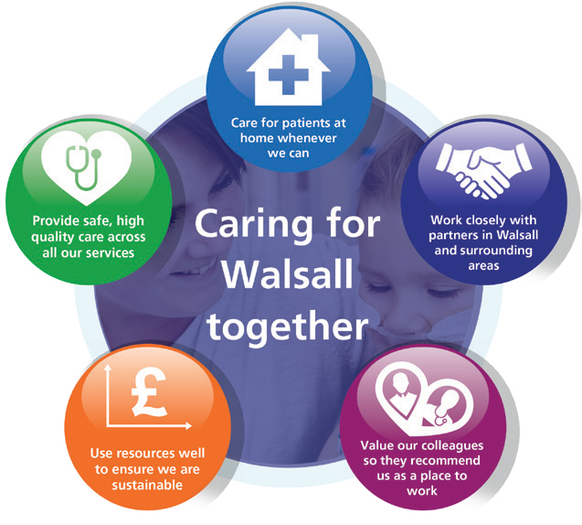Our Vision, Objectives & Values
Walsall Healthcare NHS Trust is guided by five strategic objectives which combine to form the overall ‘vision’ for the organisation.
Complementing this are our ‘values’, a set of individual behaviours that we wish to project amongst our workforce in order to deliver effective care for all.

Our Vision: Caring for Walsall together
“Caring for Walsall together” reflects our ambition for safe integrated care, delivered in partnership with social care, mental health, public health and associated charitable and community organisations.
Our Objectives: Underpinning the vision
The organisation has five strategic objectives which underpin our vision of ‘Caring for Walsall together’, and they are to:

Our Values: Upholding what’s important to us as a Trust
Our values, coupled with individual behaviours, represent what we wish to project in our working environments.
Respect | We are open, transparent and honest, and treat everyone with dignity and respect.  - I appreciate others and treat them courteously with regard for their wishes, beliefs and rights.  - I understand my behaviour has an impact on people and strive to ensure that my contact with them is positive.  - I embrace and promote equality and fairness. I value diversity and understand and accept our differences. I am mindful of others in all that I do.
Compassion | We value people and behave in a caring, supportive and considerate way.  - I treat everyone with compassion. I take time to understand people’s needs, putting them at the heart of my actions.  - I actively listen so I can empathise with others and include them in decisions that affect them.  - I recognise that people are different and I take time to truly understand the needs of others.  - I am welcoming, polite and friendly to all.
Professionalism | We are proud of what we do and are motivated to make improvements, develop and grow.  - I take ownership and have a ‘can-do’ attitude.  I take pride in what I do and strive for the highest standards.  - I don’t blame others. I seek feedback and learn from mistakes to make changes to help me achieve excellence in everything I do.  - I act safely and empower myself and others to provide high quality, effective patient-centred services.
Teamwork | We understand that to achieve the best outcomes we must work in partnership with others.  - I value all people as individuals, recognising that everyone has a part to play and can make a difference.  - I use my skills and experience effectively to bring out the best in everyone else.  - I work in partnership with people across all communities and organisations.


Provide Safe, high-quality care;
We will deliver excellent quality of care as measured by an outstanding CQC rating by 2022.

Care at Home;
We will host the integration of Walsall together partners, addressing health inequalities and delivering care closer to home.
Work Closely with Partners;
We will deliver sustainable best practice in secondary care, through working with partners across the Black Country and West Birmingham System.
Value our Colleagues;
We will be an inclusive organisation which lives our organisational values without exception.
Use Resources Well;
We will deliver optimum value by using our resources efficiently and responsibly.

MEETING OF THE PUBLIC TRUST BOARD – 1 July 2021
Interim Chief Executive Officer’s Report |  |  |  | AGENDA ITEM: 7
Report Author and Job Title: | Prof David Loughton, Interim Chief Executive Officer | Responsible Director: |  | Prof David Loughton, Interim Chief Executive Officer
Action Required | Approve ☐ Discuss ☐ Inform ☒ Assure ☐
Executive Summary | The paper includes details of key activities undertaken since the last Trust Board meeting.
Recommendation | Members of the Trust Board are asked to note the report
Does this report mitigate risk included in the BAF or Trust Risk Registers? please outline | None in this report.
Resource implications | There are no resource implications associated with this report.
Legal and Equality and Diversity implications | None in this report.
Strategic Objectives | Safe, high quality care ☒ |  | Care at home ☒
Strategic Objectives | Partners ☒ |  | Value colleagues ☒
Strategic Objectives | Resources ☒

INTERIM CHIEF EXECUTIVE OFFICER’S REPORT – JULY 2021
2

1.0 | Review
 | This report indicates my involvement in local, regional and national meetings of significance and interest to the Board.
2.0 | Consultants
The following consultant was appointed this month: Surgery
Dr Sunil Dondapati – Anaesthetics Consultant
3.0 | Policies and Strategies
The following policies were approved this month:
- Conflicts of Interest Policy (revised)
4.0 | Visits and Events
- Since the last Board meeting I have undertaken a range of duties, meetings and contacts locally and nationally including:
- Since Friday 27 March 2020 I have participated in weekly virtual calls with Chief Executives, led by Dale Bywater, Regional Director – Midlands – NHS Improvement/ England
- Since Monday 3 August 2020 I have participated in weekly calls with the Black Country and West Birmingham Strategic Transformation Partnership (STP) on the co-ordination of a collective Birmingham and the Black Country restoration and recovery plan and COVID-19 regional update
- 24 May 2021 – participated in a virtual Senior Medical Committee
- 25 May 2021 – participated in a virtual Trust Management Board (TMB) and participated in the Care Quality Commission (CQC) Well-led virtual meeting
- 26 May 2021 – participated in a virtual Health Education England (HEE) Local Medical Liaison Committee meeting
- 27 May 2021 - participated in a virtual Healthier Futures Partnership Board
- 28 May 2021 – hosted a visit from Ted Baker, Chief Inspector of Hospitals, Care Quality Commission (CQC) and participated in the virtual Regional Cancer Board
- 1 June 2021 – participated in a virtual Care Quality Commission (CQC) Trust Engagement meeting
- 7 June 2021 - Prof Steve Field and I met virtually Valerie Vaz MP
- 8 June 2021 – participated in a virtual Trust Management Board (TMB)
- 9 June 2021 – participated in a virtual Joint Liaison Committee meeting with the Privately Funded Initiative (PFI) Provider – Skanska
- 10 June 2021 – participated in an Health Service Journal (HSJ) Chief Executives Roundtable Discussion and virtual met with Dr Helen Paterson, Chief Executive – Walsall Council

- 15 June 2021 – participated in a virtual Black, Asian and Minority Ethnic (BAME) Shared Decision Making Council meeting
- 17 June 2021 – participated in a virtual Joint Negotiating Committee (JNC), participated in a Black Country and West Birmingham Sustainability and Transformation Partnership (STP) System Leadership virtual event and participated in a virtual Acute Collaboration Programme Board
- 18 June 2021 – participated in a virtual Walsall Proud Partnership (WPP) meeting
5.0 | Board Matters
 | There are no Board Matters to report on this month.

MEETING OF THE PUBLIC TRUST BOARD - 1st July 2021
SO6 COVID-19 Board Assurance Framework Report |  |  | AGENDA ITEM: 8
Report Author and Job Title: | Vicky Haddock - Corporate Risk Manager | Responsible Director: | Ned Hobbs - Chief Operating Officer
Action Required | Approve ☒ Discuss ☒ Inform ☒ Assure ☒
Executive Summary | The Board Assurance Framework (BAF) provides a structure and process that enables a focus for the Board on the key risks which might compromise the achievement of the organisation’s Strategic Objectives. The BAF maps out the key controls which are in place to support delivery of those objectives and to mitigate risk and provide a framework of assurance which the Board can draw upon when considering the effectiveness of those controls. These controls and assurances have been set out in line with the ‘3 lines of defence’ model, aiding the identification of areas of weakness. The ‘Strategic Risk Heat Map’ is drawn from the content of the BAF and aims to illustrate at a high level the degree of risk exposure associated with the Strategic Objectives.  Each BAF risk has been reviewed and updated in month as part of the regular process through executive lead review, the Executive Risk Management Group and (where applicable) the lead Board sub-committee.  The updated June 2021 BAF risk for SO 06 COVID-19 has seen a further decreased risk score from 9 (Likelihood 3 x Consequence 3) to 6 (Likelihood 2 x Consequence 3). The primary rationale for this reduction is highlighted as follows:  - The Trust has only 4 Covid positive in-patients within the hospital as of 07/06/21.  - During May & June 2021, the Trust’s Critical Care occupancy has been consistently within baseline funded capacity.  - The Trust has been successful in rolling out the Pfizer Vaccine to Patients, and staff across BCWB Health and Social Care organisations, with 89.57% of Trust high-risk staff having received their first vaccination, and 80.92% of trust high risk staff having received their second vaccination (as of 07/06/21).  - The Trust has restored our 7th elective operating theatre taking us back to pre-Covid levels of elective operating theatre capacity since 04/05/21.
Recommendation | The Board is asked to note the BAF risk and the relevant updates.


Does this report mitigate risk included in the BAF or Trust Risk Registers? | Risk implications are outlined within the document.
Resource implications | There are no resource implications associated with this report.
Legal and Equality and Diversity implications | The BAF and indeed elements of the attached risks form part of our registration and licence requirements to both NHSi and CQC, which may result in regulatory or legal action under the Health and Social Care Act.  There is clear evidence1 of unequal and differential impact of COVID-19 on sections of our society including differential impact associated with levels of deprivation, occupations and ethnicity.  1. https://www.health.org.uk/sites/default/files/upload/publications/2020/Build-back-fairer-the-COVID-19-Marmot- review.pdf#:~:text=Building%20back%20fairer%20will%20require%20fundamental%20thinking%20about,must%20be%20dealt%20with%20at%20the%20same%2 0time
Strategic Objectives | Safe, high quality care ☒ | Care at home ☒
Strategic Objectives | Partners ☒ | Value colleagues ☒
Strategic Objectives | Resources ☒


Latest Board/Committee/Group - 21/06/2021 Version V2.04

Risk Summary
BAF Strategic  Objective Reference & Summary Tile: | BAF SO 06 - COVID; This risk has the potential to impact on all of the Trusts Strategic Objectives.
Risk Description: | The impact of Covid-19 and recovering from the initial wave of the pandemic on our clinical and managerial operations is such that it prevents the organisation from delivering its strategic objectives and annual priorities.
Lead Director: | Chief Operating Officer.
Lead Committee: | Trust Board
Links to Corporate Risk Register: | Title: |  |  |  |  |  |  | Current Risk Score Movement:
Links to Corporate Risk Register: | - 2066 - There is a risk of lack of skilled registered nurses (RN's)/registered midwives (RM's) on a shift by shift basis affecting our ability to consistently maintain delivery of excellent standards of care (Risk Score = 15).  - 2093 - Risk of staff contracting COVID-19 through the course of their duties in WHC NHS Trust (Risk Score = 6).  - 2095 - Inability of the NHS supply chain to provide an adequate and on-going supply of PPE to meet the demand to ensure that Walsall Healthcare NHS staff are fully protected during the Covid-19 pandemic (Risk Score = 9).  - 208 - Failure to achieve 4 hour wait as per National Performance Target of 95% resulting in patient safety, experience and performance risks (Risk score = 12).  - 2081 - Operational expenditure incurred during the current financial year exceeds income allocations, which results in the Trust being unable to deliver a break even financial plan (Risk Score = 12).  - 2082 - Failure to realise the benefits associated with the outcomes of the improvement programme work-streams, results in the Trust not delivering efficiencies required to attain agreed financial control targets, and deliver financial balance without  central support, which therefore impacts on the Trusts ability to deliver financial and clinical sustainability (Risk Score = 12). |  |  |  |  |  |  | Likelihood = 2  Consequence = 3  6  Moderate  ↓
Risk Scoring
Quarter: | Q1 2021/22 | Q2 | Q3 | Q4 2020/21 | Rational for Risk Level: | Target Risk Level (Risk Appetite): |  | Target Date:
Likelihood: | 2 |  |  | 3 | - Covid-19 is a novel virus and therefore there is only an emerging understanding of the disease, how it behaves and the likely trajectory of further resurgence in cases.  - The initial wave of Covid-19 had a profound impact on the services that the Trust provides, both in terms of urgent, emergency and critical care services to manage Covid-19 positive patients (in the hospital and the community), and in terms of the reduction in capacity of elective care services. The initial wave had a particularly significant impact on care home residents within the Borough’s population.  - The initial wave of Covid-19 had a profound | Likelihood: | 2 | 30 June 2021 (at which point the Covid BAF risk would be recommended to be dissolved).
Consequence: | 3 |  |  | 5 |  | Consequence: | 3
Risk Level: | 6  Moderate |  |  | 15  High |  | Risk Level: | 6  Moderate

impact on the workforce of the Trust. By May 2020, almost 1 in 4 Trust staff that had undergone a Covid-19 Antibody test had been antibody positive that suggested a significant proportion of the workforce had experienced the disease themselves. Moreover, the challenges of managing the initial wave of the pandemic had a significant psychological impact on staff too.
- The Trust is operating in an uncertain financial planning environment resulting in additional challenges to restoring and recovering services impacted by the initial wave of Covid-19, and planning for the 2021/22 financial year.
- Covid-19 has exposed existing significant health inequalities in the population the Trust serves. Covid-19 has exacerbated some existing inequalities in colleague experience within the Trust.
- Nosocomial deaths reported in Learning from Nosocomial Covid deaths report received at QPES 27/08/20, with further analysis presented to QPES 28/01/21 confirming 21 probable or definite nosocomial deaths from Covid in Wave 1.
- Planning assumptions for a second wave of Covid-19 cases assumed a peak at half the level of the April peak. In November 2020 the Trust exceeded 80% of the April peak in terms of Covid-19 positive bed occupancy. In January 2021 the Trust had exceeded 140% of the April
peak. As of 7th June the Trust’s Covid-19 positive inpatients have reduced to 2% of the April 2020 peak.
- The Trust has had the 7th highest proportion of its hospital beds occupied by Covid-19 positive patients in the country in early November 2020, and the second highest proportion of its hospital beds occupied by Covid-19 positive patients in the Midlands during January 2021. The situation improved over February and March and Ward 10, Ward 14 and the 6 extra capacity beds on Ward 4 are all now closed.
- The Trust has consistently had one of the highest Critical Care bed occupancy relative to baseline
commissioned capacity across the Midlands region during the second wave. In January 2021

Critical Care bed occupancy has exceeded 250% of baseline commissioned capacity, peaking at 306% of baseline commissioned capacity. During May & June 2021, the Trust’s Critical Care occupancy has been consistently within baseline funded capacity.
- As a result of reduced Critical Care occupancy, the Trust commenced its 8-week Elective Surgery restoration plan on 8th March 2021. The Trust has restored our 7th elective operating theatre taking us back to pre-Covid levels of elective operating theatre capacity (as of 04/05/21).
- The Trust has been successful in rolling out the Pfizer Vaccine to Patients, and staff across BCWB Health and Social Care organisations, with 89.57% of high-risk staff having received their first vaccination, and 80.92% of high risk staff having received their second vaccination (as of 07/06/21).
- The Trust has only 4 Covid positive in-patients within the hospital (as of 07/06/21).
Control & Assurance Framework - 3 Lines of Defence
 | 1st Line of Defence |  |  |  | 2nd Line of Defence | 3rd Line of Defence
Controls: | Governance:  - Incident Command structure in place incorporating Strategic Command, Hospital Tactical Command, Walsall Together Community Tactical Command and Corporate Tactical Command.  - Bespoke Incident Command structure in place for Covid-19 Vaccination programme.  - Governance continuity plan in place to ensure Board and the Committees continue to receive assurance.  - Specific Covid-19 related SOPs and guidelines.  - ITU Surge Plan in place.  - Covid Streaming processes in place.  - Enhanced Health and Safety/IPC Process in place in relation to Covid- 19, with particular focus on social  distancing, patient/staff, screening, |  |  |  | - Individual committees consider specific impact relevant to their portfolio, i.e. Financial matters and Restoration and Recovery of elective services under PFIC; Quality, Safety and Patient experience matters under QPES and Workforce matters including staff wellbeing under P&ODC.  - Board Development sessions (x2) on approach to Restoration and Recovery from Wave 1.  - UEC and Covid resilience Winter Plan approved by Trust Board October 2020.  - Covid-19 Deaths incorporated into SJR processes.  - Nosocomial Covid-19 Infections are subjected to RCA and reported to the Infection Control Committee. | - Regional and National Incident Control structure.

zoning of Ward/Department areas, visiting guidance and PPE Guidance.
- Daily risk assessment (RAG rating) of Community Locality teams to prioritise resource according to need.
- Division of Surgery 8-week elective Surgery restoration plan commenced
08/03/21 and completed on 04/05/21.
Gaps in Controls: | - Walsall borough disproportionately hard hit in second wave again. 7th highest proportion of beds occupied by Covid positive patients in the country, in early November 2020. One of the highest Critical Care bed occupancy levels relative to baseline funded Critical capacity in the Midlands Critical Care Network throughout waves 2 in the Autumn of 2020 and 3 over the Winter of 2020. The Trust has had the second highest proportion of its hospital beds occupied by Covid-19 positive patients in the Midlands during January 2021.  - Resurgence of Covid-19 cases has coincided with Winter pressures resulting in severe pressures on the emergency care pathway, and stretching the RN, medical and WHP workforce significantly.  - Significantly increased Critical Care demand resulting in a dilution of ratios of specialist Critical Care Nurses to patients, partially mitigated through use of Category B and Category C registrants.  - Significant reduction in elective surgical operating theatre capacity due to requirement to support Critical Care staffing, resulting in prolonged waits for elective surgery.  - Reduction in some elective Community services - particularly MSK therapies and Phlebotomy, to redeploy resource into non-elective pathways.  - Considerably higher demand than anticipated on key Covid-19 Community pathways including Community Pulse Oximetry monitoring (Safe at Home pathway) and Long Covid pathways.  - Ability for neighbouring Trust’s to manage demand from patients conveyed by ambulance resulting in additional ambulance patients being conveyed to Walsall Manor through WMAS Intelligent Conveyancing protocol.  - National directives and mandates impact on the Trust’s ability to make local decisions.  - Ability of the Midlands Critical Care Network to successfully manage demand Critical Care demand across the region.  - Unable to progress all elements of the improvement programme owing to capacity of senior leaders.  - Comprehensive OD/Culture Improvement plan.
Assurance: | - IPC Board Assurance Framework. | - Nosocomial Covid-19 infection rate in line with peer-reviewed published evidence.  - Antibody positive staff rate in line with BCWB peers.  - Financial top up requests in line (or lower) as a proportion of turnover than BCWB peers.  - Faculty of Research and Clinical Education evaluation of response to first wave.  - 60-day readmission rate for Covid-19 patients in line with peer-reviewed published evidence. | - Elective waiting times 6th best in the country for Diagnostics (DM01) and Top 45 nationally for routine elective treatment (18-week Referral to Treatment) in April 2021 national reported performance.  - GP referred Cancer treatment commencing within 62-days in line with national average (Apr 2021).  - Elective 52-week wait performance 4th best in the Midlands (March 2021).  - 4hr EAS performance 17th best in the country, and 5th best in the Midlands (May 2021).  - Ambulance handover times (<30mins) best in the West Midlands for 4th consecutive month (May 2021).  - CQC Assurance of the IPC Board Assurance

Framework.
- Productivity of Vaccination Programme compares favourably with other Acute Trusts.
Gaps in Assurance: |  | - Lack of assurance of communications within the organisation to ensure that staff feel well informed and engaged.  - Evidence of higher staff absence rates than BCWB peers during initial wave of Covid-19, absence rates consistent with peers in second/third wave.  - PODC still working to gain sufficient assurance on the vulnerable staff risk assessment process.
Future Opportunities
- With a more digital/virtual enabled organisation further opportunity to explore clinical application in improvement programme deliverables.
- Increased focus on Walsall Together and partnership working to support reduced reliance on hospital care, and to support reduced health inequalities in the borough.
- Covid-19 has necessitated closer collaboration with other Acute hospitals which can continue to be built upon.
- Increased profile and appreciation of the NHS within the general public could be harnessed to attract and retain staff.
- National planning guidance for Phase 3 (Recovery & Transformation) creates an expectation that services must not be reintroduced based on historical models.
- Identifying and adapting the workforce and professions to create a modern and adaptable workforce group.
Future Risks
- Potential for further resurgence in Covid-19 cases over Summer/Autumn 2021.
- Second wave of Covid-19 cases has coincided with Winter pressures including seasonal Influenza and norovirus, and delayed and advanced (in terms of disease progression) presentation of patients that have not accessed healthcare services in recent months.
- Ongoing pressure on community services associated with patients rehabilitating following Covid-19, including Long Covid patients.
- Delayed and/or prolonged impact of managing the initial wave, second wave and third wave of the pandemic on staff wellbeing and mental health.
- Potential workforce absence in the event of a second wave.
- Limited management and leadership capacity to address core objectives due to the significant demands of managing covid-19 pandemic, and the restoration and recovery of services affected by covid-19.
- More constrained financial operating environment.
- Logistical challenges of delivering the Covid-19 Vaccination, including the requirement booster vaccination.
Future Actions (to further reduce the Likelihood / Consequence of the risk in order to achieve the Target Risk Level in line with the Risk Appetite)
No. | Action Required: |  | Executive Lead: | Due Date: | Progress Report: |  | BRAG:
6. | Confirmation of 2021/22 Financial arrangements. |  | DoF | Feb 2021 | Delayed due to delayed national planning guidance. Q1 and Q2 Financial Plan agreed at Private Board  03/06/21, with Q3 and Q4 Financial Plan TBC.


1

MEETING OF THE PUBLIC TRUST BOARD – 1st July 2021
Quality, Patient Experience and Safety Committee (QPES) Highlight Report |  |  | AGENDA ITEM: 10
Report Author and Job Title: | Trish Mills Trust Secretary | Responsible Director: | Mr Ben Diamond –Non-  Executive Director (chaired June meeting)
Action Required | Approve ☐ Discuss ☒ Inform ☒ Assure ☒
Executive Summary | This report provides the key messages from the Quality, Patient Experience and Safety Committee meeting held on 24th June 2021. Of note are:  - The patient story, which was heard at today’s Trust Board, was also heard by the Committee, and we discussed in some detail the changes put in place, and further actions planned, to address the issues raised by the patient’s relative.  - The Committee was assured that the historical CQC patient survey action plans had been signed off as complete and that the team were focusing on emerging surveys. Of note is an increase in the maternity survey of 43% compared to an average of around 35% for most survey returns. The Committee will receive further information and assurance throughout the year as the surveys complete.  - The Serious Incidents report was presented following input from the Committee in May.  - Three Serious Incidents were noted for May 2021, one of which was HCAI related; one identified as sub optimal care of the deteriorating patient; and one identified as a slip, trip or fall.  - The action plan for closure of the overdue actions was reviewed, and the Committee provided with a verbal update that the oldest actions had been closed.  - All overdue actions are forecast to be closed by the end of July, pending a validation process.  - The Committee noted a downward trajectory in the reporting of Serious Incidents. Whilst this was not statistically significant, the Committee will keep a watching brief on it.  - The Committee was assured that safeguarding training was improving, and heard from the Interim Director of Nursing and  the Interim Head of Safeguarding about the training,


2
governance improvements, and partnership working underway and that which is planned, to ensure training is embedded in the Trust, and translated into practice. The Committee will continue to monitor this via exception reporting from the Safeguarding Committee. The quarterly safeguarding report was deferred to the July meeting.
- Mrs C Jones-Charles Divisional Director of Midwifery, Gynaecology & Sexual Health presented the maternity report, and provided assurance in relation to recruitment to midwife and consultant positions. The quarterly maternity update is on the agenda for this Board meeting.
- The Infection Prevention and Control 2020/21 Annual Report was approved.
- The Clinical Audit Plan for 2021/22 was approved.
- Good progress was noted on restoration and recovery for both the acute and community. The Committee will receive further details in July on the risk to restoration and recovery from increasing paediatric Respiratory Syncytial Virus (RSV) presentations over the summer and autumn.
- A report was provided by the Deputy Medical Director on medical staff.
The next meeting of the Committee will take place on 29th July
2021
Recommendation | Members of the Trust Board are asked to note the escalations and any support sought from the Trust Board.
Risk in the BAF or Trust Risk Register | This report aligns to BAF risk S01 for safe high quality care and COVID-19 BAF risk S06.
Resource implications | There are no new resource implications associated with this report.
Legal, Equality and Diversity implications | There are no legal or equality & diversity implications associated with this paper
Strategic Objectives | Safe, high quality care ☒ | Care at home ☐
Strategic Objectives | Partners ☐ | Value colleagues ☐
Strategic Objectives | Resources ☐

MEETING OF THE PUBLIC TRUST BOARD – 1ST JULY 2021
Safe High-Quality Care – Executive Update |  |  | AGENDA ITEM: 11
Report Author and Job Title: | Lisa Carroll  Interim Deputy Director of Nursing | Responsible Director: | Matthew Lewis Medical Director
Action Required | Approve ☐ Discuss ☐ Inform ☒ Assure ☒
Executive Summary | This report describes the continuing actions that are taking place to provide Safe, High Quality Care (SHQC) in the Trust. The report includes details relating to the Board Assurance Framework (BAF), the Corporate Risk Register and the Performance Report, relevant to SHQC.
Recommendation | - Note the update to Trust Board on actions relating to the Improvement Programme through the Quality, Patient Experience & Safety Committee (QPES) and supporting groups.  - Note the highlighted updates to BAF risk S01 and related risks on the Corporate Risk Register.  - Note the relevant updates and assurance in relation to the performance report.
Does this report mitigate risk included in the BAF or Trust Risk Registers? | This report highlights updates relevant to Board Assurance Framework (BAF) Risk SO1 and provides assurance or mitigations in place to manage this risk. The related corporate risks are:  208 - Failure to achieve 4 hour wait as per National Performance Target of 95%, resulting in patient safety, experience and performance risks.(Risk score =8)  2066 – Staffing levels are below the agreed staffing levels for wards and departments leading to the potential for avoidable harm (Risk score = 15) 2437 - Service wide impact as a result of the risk of CYP are being admitted to our acute Paediatric ward whilst awaiting a Tier 4 bed or needing a 'place of safety'. (Internal factors.) (Risk score = 20)  2439 - External inadequate paediatric mental health and social care provision leading to an increase in CYP being admitted to our acute Paediatric ward whilst awaiting a Tier 4 bed or needing a 'place of safety'. (Risk score =20)  2398 - Insufficient/ out-of-date equipment, utilised beyond its life cycle, has the potential to result in sub-optimal patient care. (Risk score =12)  2475 - The Mental Health Act (MHA) Code of Practice is not being applied in line with CQC legislations in the day-to-day practices for providing safeguards & protection for individuals who require mental health services.(Risk score = 25)

 | 2540 – Risk of avoidable harm going undetected to patient’s, public and staff due to ineffective safeguarding systems. (Risk score = 16)
Resource implications | Current resource implications relate to the delivery of the Safe High Quality Care improvement programme.
Legal and Equality, Diversity and inclusion implications | Failure to deliver safe, high quality care may result in breaches of legal requirements under the Health and Social Care Act 2008
Strategic Objectives | Safe, high quality care ☒ | Care at home ☐
Strategic Objectives | Partners ☒ | Value colleagues ☒
Strategic Objectives | Resources ☒

PROVIDE SAFE HIGH QUALITY CARE – EXECUTIVE UPDATE

- Executive Summary

The delivery of safe, high quality care remains a key priority for the Trust.

The associated Board Assurance Framework (BAF) and corporate risks have been reviewed and updated as required. The gaps in control and assurance were discussed in detail at the Quality, Patient Safety and Experience Committee and progress has been made to reduce the number of gaps overall.
Oversight of progress against the CQC Must and Should Do actions continues via the monthly CQC action plan oversight group and progress against 2019 and 2020 actions is as follows:

- 2019 Actions: 51 of the 55 actions have been completed; 2 actions are in progress but overdue; 2 actions are deferred.
- 2020 Actions: 26 of the 29 actions have been completed; 2 actions are in progress; 1 action is deferred.

Evidence of progress against outstanding and deferred actions was presented to the Quality, Patient Safety and Experience Committee and details are included further in the report.

Projects within the Safe, High Quality Care Improvement Programme have continued to progress despite the COVID-19 pandemic and some of the key highlights are:

  - Falls per 1000 bed days are reported as 3.57 for May 2021, a reduction from 3.66 in April 2021.
  - A Trust Continence Ambition is currently in draft with the aim to launch in July 2021.
  - Completion of stage 2 Mental Capacity Act assessments for those who lack capacity continues to improve at 88.46%. This compares to 64.29% reported in April 2021
  - VTE compliance for May 2021 is 93.2%. Work continues with divisional teams and oversight by the Patient Safety Group.

- Board Assurance Framework (BAF)

Our strategic objective is to deliver excellent quality of care as measured by an outstanding CQC rating by 2022. The BAF for SHQC appears in appendix 1. The Trust continues to have a low risk appetite for compromising quality and safety of patient care.

Gaps in control

  - Falls reduced in month and remain below the average of 6.1 reported by the Royal College of Physicians. There was one fall resulting in severe harm in May 2021.This has been reported as a Serious Incident and is under investigation.
  - VTE compliance has dropped slightly in month to 93.2%.Divisional teams continue to focus on improvement and report compliance, actions and progress through the Patient Safety Group.
  - 100% of patients requiring ReSPECT discussion had a form completed. However audit has identified that there is documented evidence of a discussion with the patient’s relatives or attorney in 57.89% of cases. A Trust wide end of life improvement working group has been established to focus on improving care for these patients. This will report to the Patient Safety Group.
  - A new corporate risk has been added – 2540; Risk of avoidable harm going undetected to patients, public and staff due to ineffective safeguarding systems. This was discussed at QPES and a Trust wide safeguarding improvement plan has been developed and is overseen by the Safeguarding Committee.

Gaps in assurance

  - An NHSEI review in 2019 highlighted insufficient assurance on infection control standards in maternity services resulting in a red rating. We are assured that improvement in standards has been sustained which has also been reflected in feedback from inspections by the CCG, NHSEI and CQC. NHSEI undertook a planned review of maternity and other services on the 22nd June 2021. Verbal feedback on the day was very positive and the written report is expected within 10 working days.
  - Oversight of progress against the CQC Must and Should Do actions continues via the monthly CQC action plan oversight group and progress against 2019 and 2020 actions is as follows:
    - 2019 Actions: 51 of the 55 actions have been completed; 2 actions are in progress but overdue; 2 actions are deferred.
    - 2020 Actions: 26 of the 29 actions have been completed; 2 actions are in progress; 1 action is deferred.

Overdue actions for 2019 / 2020:

Inspection report Date | Ref | Agreed action agreed with CQC / Taken from PCIP | Division | Executive Lead | RAG | Baseline Target Month | Progress Update
Jul-19 | SHOULD S16 | Ensure any store room where medication is stored is locked and doors are closed | Surgery | Medical Director | RED | Dec-20 | This work required is now included in the estates scoping works being supported by  RWT.
Jul-19 | SHOULD 32 | Consider exploring ways of pathway options for patients requiring discharge from the critical care unit to expedite discharge | Critical Care | Medical Director | RED | Dec-20 | Div Director of Ops Surgery incorporating requirements into the 5 year plan for critical care which will be presented to STP and critical care network  this month

CQC Unannounced Inspection 9 March 2021:

The CQC conducted an unannounced inspection across 5 medical wards on Tuesday 9 March 2021. Three inspectors were on site and visited wards 1, 2, 3, 16, and 17. A Section 29a warning notice was served on the Trust on the 31 March 2021. The Section 29a actions must be completed by the end of June 2021 with evidence of compliance confirmed in writing to the CQC. The Trust is currently finalising the response to the CQC and this will be submitted ahead of the 30th June deadline.
- Link to corporate risk register

The aligned corporate risks have been reviewed in month and one new risk added.

208 - Failure to achieve 4 hour wait as per National Performance Target of 95%, resulting in patient safety, experience and performance risks.(Risk score =8)
2066 – Staffing levels are below the agreed staffing levels for wards and departments leading to the potential for avoidable harm (Risk score = 15)
2437 - Service wide impact as a result of the risk of CYP are being admitted to our acute Paediatric ward whilst awaiting a Tier 4 bed or needing a 'place of safety'. (Internal factors.) (Risk score = 20)
2439 - External inadequate paediatric mental health and social care provision leading to an increase in CYP being admitted to our acute Paediatric ward whilst awaiting a Tier 4 bed or needing a 'place of safety'. (Risk score =20)
2398 - Insufficient/ out-of-date equipment, utilised beyond its life cycle, has the potential to result in sub-optimal patient care. (Risk score =12)
2475 - The Mental Health Act (MHA) Code of Practice is not being applied in line with CQC legislations in the day-to-day practices for providing safeguards & protection for individuals who require mental health services.(Risk score = 25)
2540 – Risk of avoidable harm going undetected to patient’s, public and staff due to ineffective safeguarding systems. (Risk score = 16)

- Performance Report

The performance report was discussed at the Quality Performance and Safety Committee. Key areas to report are as follows:

  - Clostridium difficile
There were three cases of Clostridium difficile reported in May 2021. These cases are currently being investigated in accordance with the Trusts HCAI policy.

  - Outbreaks
There was an outbreak of MRSA colonisation reported at the end of May 2021. This was managed in accordance with Trust policy. A total of 6 patients were identified and all received decolonisation. There was no harm to patients during this outbreak and the outbreak is now closed.

A VRE outbreak was declared in May 2021 with 2 patients affected. This was investigated as a serious incident and managed through the Trusts outbreak management process. The outbreak has now been closed.

  - MRSA Bacteraemia

There was one case of hospital acquired MRSA Bacteraemia. A case review was undertaken on the 4th June 2021 and this was classified as an unavoidable infection.

  - Percentage of observations rechecked within time

The percentage of observations rechecked within time is 89.7%, a slight improvement from the 89.02% reported for April 2021.

  - Pressure Ulcers

A total of 24 pressure ulcers of grade 2 or above were reported in May 2021. 14 attributable to the acute hospital and 10 to the community. This is an improvement on the 33 reported in April 2021.

4.4 Clinical guidelines

A clinical guidelines group has been established to ensure all Trust guidelines are updated to reflect latest guidance and practice. In March 2021 the Trust reported 106 guidelines as being out of date. In May 2021 there are 68 out of date.

- Staffing Update

The RN and Midwifery vacancy rate for May 2021 is 7%. This is a reduction in the vacancy rate reported for April 2021 of 9%.

Rosters are designed to fill out of hours first and this is reflected in the fill rate as the lowest fill rate was seen in the CSW day shift at 90.97%. The overall fill rate (combined RN and CSW)) was 93.8%. The redeployment of staff and temporary staffing cover has supported the maintenance of ward fill rates.

Ward area fill rates
Safe Staffing Fill Rate - May-2021
105.00%
100.00%
95.00%
90.00%
85.00%
RN Day CSW Day NA Day TNA Day RN Night
CSW
Night
NA Night TNA Night

100.00% 100.00% 98.27% 100.00% 100.00%
92.26% 90.97%
93.95%

19 overseas nurses commenced in the Trust in May 2021 and OSCE’s are booked for the end of July.
27 overseas nurses will commence in June 2021 and OSCE’s are booked for August.

Pastoral care is being delivered by Team FORCE. There are a further 4 cohorts of overseas RNs due to commence in the Trust between July and October 2021. The current expectation is that approximately 200 overseas RN will be recruited by the end of 2021.
- Improvement Programme

- The Trust took part in the ‘National Audit of Inpatient Falls’ (2020). The interim annual report has been published with the full report expected in September 2021. The recommendations will be reported to the falls steering group in June 2021 and this group will oversee actions and progress going forward.
- A Trust wide safeguarding improvement plan has been developed, bringing all safeguarding action plans into one place. Progress against this plan will be overseen by the Safeguarding Committee.
- Work with ‘Getting It Right First Time’ continues and regular meetings are taking place with specialities to track progress. The Trust continues to engage with the Midlands

Elective Recovery Programme with orthopaedics and ENT as well as the STP GIRFT programme for respiratory medicine and Urology.
- Work continues to develop and launch the harm free care ambitions for safe mobility, skin integrity and continence. The continence and skin integrity ambitions are in draft format for comment and will be presented to QPES next month. Harm free care champions are to be introduced over the coming months to further drive continual improvement in practice and outcomes.
- The Infection Prevention and Control team will undertake a point prevalence study for hospital acquired infections across our bed base in June 2021. This was last undertaken in 2018

Latest Board/Committee/Group - 27/05/2021 Version V2.03

Risk Summary
BAF Strategic  Objective Reference & Summary Tile: | BAF SO 01 - Safe, High Quality Care; We will deliver excellent quality of care as measured by an outstanding CQC rating by 2022.
Risk Description: | The Trust fails to deliver excellence in care outcomes, and/or patient/public experience, which impacts on the Trust’s ability to deliver services which are safe and meet the needs of our local population.
Lead Director: | Director of Nursing/Medical Director.
Lead Committee: | Quality, Patient Experience & Safety Committee.
Links to Corporate Risk Register: | Title: |  |  |  |  |  |  |  |  |  |  |  |  |  |  |  |  |  |  |  |  |  |  |  | Current Risk Score Movement:
Links to Corporate Risk Register: | - 208 - Failure to achieve 4 hour wait as per National Performance Target of 95%, resulting in patient safety, experience and performance risks. (Risk Score = 8).  - 2066 - Substantive staffing levels are below the agreed safe staffing levels for wards and departments leading to the potential for avoidable harm. (Risk Score = 15).  - 2398 - Insufficient/ out-of-date equipment, utilised beyond its life cycle, has the potential to result in sub-optimal patient care. (Risk Score = 12).  - 2437 - Service wide impact as a result of the risk of CYP are being admitted to our acute Paediatric ward whilst awaiting a Tier 4 bed or needing a 'place of safety'. (Internal factors). (Risk Score = 20).  - 2439 - External inadequate paediatric mental health and social care provision leading to an increase in CYP being admitted to our acute Paediatric ward whilst awaiting a Tier 4 bed or needing a 'place of safety'. (Risk Score = 20).  - 2475 - The Mental Health Act (MHA) Code of Practice is not being applied in day-to-day practices for providing safeguards & protection for individuals who require mental health services. (Risk Score = 25)  - 2540 - Risk of avoidable harm going undetected to patient’s, public and staff due to ineffective safeguarding systems. (Risk Score = 16) |  |  |  |  |  |  |  |  |  |  |  |  |  |  |  |  |  |  |  |  |  |  |  | Likelihood = 3  Consequence = 5  15  High  ↔
Risk Appetite
Status: | Averse | Averse |  |  |  |  | Cautious |  |  |  |  | Balanced |  |  |  |  | Open |  |  |  |  |  | Hungry
Appetite Score: | < 4 | 1 | 2 | 3 | 4 | 5 | 6 | 7 | 8 | 9 | 10 | 11 | 12 | 13 | 14 | 15 | 16 |  | 17 | 18 | 19 | 20 | 21 | 22 |  | 23 | 24 | 25
Tolerate Score: | < 9
Risk Scoring
Quarter: | Q1 2021/22 | Q2 |  | Q3 |  | Q4 2020/21 |  | Rational for Risk Level: |  |  |  |  |  |  |  |  |  | Target Risk Level (Risk Appetite): |  |  |  |  |  |  | Target Date:
Likelihood: | 3 |  |  |  |  | 3 |  | - The Trust’s Quality Strategy is out of date and doesn’t reflect the environment in which we are currently operating. There are gaps in oversight of the strategy and a lack of clear alignment to the Quality Priorities.  - We have strengthened clinical leadership and |  |  |  |  |  |  |  |  |  | Likelihood: |  |  |  | 2 |  |  | 31 December  2021
Consequence: | 5 |  |  |  |  | 5 |  |  |  |  |  |  |  |  |  |  |  | Consequence: |  |  |  | 5
Risk Level: | 15  High |  |  |  |  | 15  High |  |  |  |  |  |  |  |  |  |  |  | Risk Level: |  |  |  | 10  Moderate

accountability at the tier 2 level of our governance with the Director of Nursing and Medical Director taking on the leadership in Patient Safety and Clinical Effectiveness.
- Evidence of lessons learnt from incidents and patient feedback is inconsistent.
- Robust acuity and activity review process for community activity.
- The Trust is leading the COVID Vaccination programme as part of the Walsall Vaccination programme thus far 84.5% of Trust staff have been vaccinated at Manor site, around 10,508 members of the pubic have been vaccinated at the Saddlers Centre.
- Progress and assurance against CQC Must and Should Do actions from inspections in 2019 and 2020.
- Progress against CQC Must and Should Do actions from May 2021 report and associated Section 29a notice.
- Concerns have been raised in relation to the staff experience on the NIV unit. As consequence of these concerns, and the reduction of critical care activity, the NIV unit has temporarily paused.
- Reduced COVID-19 cases enable the closure of additional capacity beds (Wards 14, 10 and additional beds on Ward 4) and subsequently reduced demand on staffing requirement.
- We currently do not respond to complaints within 30 days to the Trust target.
- Impact of pandemic of COVID-19 resulting in delays to patient treatment and potential for harm.
- Gaps in the number and quality of clinical guidance, policies and procedures to ensure safe and quality care.
- Duty of Candour below target performance level.
- Incomplete 7 Day Services to provide uniform levels of care throughout the week.
- Partial compliance against Ockenden recommendations.
- Potential to breach statutory requirements under the Mental Health Act due to inconsistent knowledge and application of Trust Policy.
- Gap in the Trust’s approach to patient engagement and patient involvement.

- Dementia screening data collection process under review.
- Evidence that safeguarding training is not embedded in practice with staff not recognising potential or actual abuse, reporting and escalating in a consistent manner
- Substantive staffing levels are below those agreed in establishment reviews to deliver safe, high quality care resulting in high usage of
temporary staff
Control & Assurance Framework - 3 Lines of Defence
 | 1st Line of Defence |  |  |  | 2nd Line of Defence | 3rd Line of Defence
Controls: | - Clinical audit programme & monitoring. Clinical divisional structures, accountability & quality governance arrangements at Trust, division, care group & service levels.  - Central staffing hub co-ordinating nurse staffing numbers in line with acuity and activity arrangements with staff re-deployed across clinical units and divisions as required to maintain safe staffing levels  - Safety Alert process in place and assured through QPES.  - Perfect Ward app allows local oversight of key performance metrics.  - Freedom to speak up process in place, reporting to the People and organisational development committee.  - Covid-19 SJR undertaken for all deaths process of assurance for lessons learnt developed.  - CQC registration for the regulated activity of assessment or medical treatment for persons detained under the Mental Health Act 1983 at Manor Hospital.  - Weekly CQC Action Plan oversight meeting in place.  - Improvement programme in place to oversee and monitor improvements  associated with the Trust delivery of |  |  |  | - Patient Experience group in place.  - Governance and quality standards managed and monitored through the governance structures of the organisation, performance reviews and the CCG/CQC.  - Learning from death framework supporting local mortality review.  - Faculty of Research and Clinical Education (FORCE) established to promote research and professional development in the trust. | - CQC Inspection Programme.  - Process in place with Commissioners to undertake Clinical Quality Review Meetings (CQRM).  - Royal College of Surgeons Invited Service Review of upper limb surgery.  - External Performance review meetings in place with NHSEI/CQC/CCG.

Safe, and High Quality Care.
- Support to safeguarding team in place from RWT
- Safeguarding Committee meetings increased to monthly
- International Registered Nurse recruitment underway with 200 recruits
expected by the end of 2021
Gaps in Controls: | - Performance targets not being met for all activities, including complaints, Mental Capacity Act compliance and VTE assessments.  - Out of date clinical policies, guidelines and procedures.  - Training performance not meeting set targets.  - Quality Impact Assessment process is not yet established within the trust.  - Sepsis audit frequency and performance.  - CQC rating of ‘Requires Improvement’ in 2019; Medicine rated as ‘Inadequate’ in May 2021 report.  - NHSEI review of Division of Surgery, focussing on meetings, leadership, and governance highlighted remedial actions required.  - Dementia screening performance.  - Failure to demonstrate compliance with terms of the Mental Health Act.  - Absence of SLA to cover management of patients requiring mental health liaison support in ED and wards.
Assurance: | - Ward Review process in place which provides assurance on the quality of care; performance reported to QPES within the SHQC report. | - Patient priorities for 2021 identified which aim to improve patient experience. Assurance of impact via patient feedback.  - Learning Matters Newsletter published regularly. | - NHSI and CCG reviews of IPC practice in ED and Maternity have not highlighted any immediate concerns.  - NHSEI scrutiny of Covid-19 cases/Nosocomial infections/Trust implementation of social distancing, Patient/Staff screening and PPE Guidance.  - Quality Review 6 monthly reviews in place with NHSEI/CQC.
Gaps in Assurance: | - CQC ‘MUST’ and ‘SHOULD’ do actions remain outstanding.  - NHSEI review in 2019 highlighted insufficient assurance on infection control standards resulting in RED rating. Division have made sustained improvement and external review of practice from NHSI, CCG and CQC have not highlighted gaps in practice. NHSI plan to re-inspect maternity services in April or May 2021.  - External audit assurance relating to the annual quality account has been deferred owing to COVID-19.  - Inconsistent evidence, both through quality governance structures and performance reviews, of practice having changed as a result of learning from adverse events.  - Gaps in assurance noted from the recent CQC inspection including management of sepsis and robust audit data.  - Lack of assurance regarding equality, diversity and inclusion and actions to reduced inequalities.  - Lack of evidence of risk assessments and quality impact assessments relating to staffing contingency planning and/or activity changes.  - Lack of robust strategic approach to ensuring effective patient/public engagement and involvement.  - Lack of clinical engagement and leadership oversight of the Quality Governance agenda.  - Lack of assurance regarding dementia screening data collection process.  - Lack of assurance internally and externally regarding staff ability to recognise, report and escalate safeguarding concerns
Future Opportunities
- Improvement Programme offers a structured programme to achieve excellence in care outcomes, patient/public experience, and staff experience.

- Implementation of new technologies as a clinical or diagnostic aid (such as electronic patient records, e-prescribing & patient tracking; artificial intelligence; telemedicine).
- Development of Prevention Strategy.
- National Patient Safety Strategy will give an improved framework for the Trust to work.
- Well Led work stream working on quality governance structures and patient safety.
- Leadership Development programme to address and mitigate gaps within clinical leadership.
Future Risks
- Ongoing impact of Covid-19 plus additional significant time pressured programmes of work such as COVID vaccination, staff testing, etc. Communications across the organisation to share programme objectives.
- Performance targets not being met for all activities, including Mental Capacity Act and VTE.
- Sepsis audit frequency and performance.
- NHSEI review of Division of Surgery, focussing on meetings, leadership, and governance highlighted remedial actions required.
Future Actions (to further reduce the Likelihood / Consequence of the risk in order to achieve the Target Risk Level in line with the Risk Appetite)
No. | Action Required: | Executive Lead: | Due Date: | Progress Report: | BRAG:
1. | Define action plan for addressing lack of assurance around  provision of services in line with requirements of Mental Health Act | Medical Director | 01/07/2021 | Risk included on corporate risk register in May 2021.  Draft action plan due for discussion through QPES in May 2021.
2. | Develop a Clinical Audit Strategy and Policy | Director of  Governance | 01/08/2021
3. | Oversight of progress to address out of date policies and procedures will be strengthened via the Clinical Effectiveness Group which be reflected in the revised terms  of reference | Medical Director | 01/04/2021 | Complete - Terms of reference agreed through Clinical
4. | NHSI re-inspection of cleanliness and IPC practice in  maternity services | Director of  Nursing | 31/06/2021 | NHSE/I IPC inspection is booked for 22.06.2021
5. | Further develop processes to provide assurance that lessons learnt from adverse events | Medical Director/ Director of  Nursing | 03/09/2021 | Scoping of new ward performance boards continues.
6. | Development of Patient Engagement and Involvement Strategy | Patient Experience Lead/Lead for Patient  Involvement | 30/09/2021 | Work ongoing.
7. | Review of dementia screening data collection process. Initial deep dive completed. Scoping of improvement options commence April 2021 | Director of Nursing | 31/07/2021 | Scoping of improvement options complete; documentation options still under consideration. Collaboration with RWT to review resources, share  best practice and where possible align documentation and process.
8. | Develop Maternity Services BAF | Interim Director of  Nursing | 30/06/2021 | Ongoing review.

Dec-20 | Jan-21 | Feb-21 | Mar-21 | Apr-21 | May-21

2021/22  YTD | 2021/22  Target | 2020/21  YTD | SPC  Variance | SPC  Assurance

SAFE, HIGH QUALITY CARE
No. | Sleeping Accommodation Breaches
No. | HSMR (HED) nationally published in arrears
No. | SHMI (HED) nationally published in arrears
Rate | Crude Mortality Rate
No. | Number of Deaths in Hospital
% | % of patients who achieve their chosen place of death
No. | MRSA - No. of Cases
No. | Clostridium Difficile - No. of cases
0 | Sepsis - % of patients screened who recieved antibiotics within 1 hour - ED (Manual Audit)
% | Sepsis - % of patients screened who recieved antibiotics within 1 hour - ED (E-Sepsis Module) (Adults only)
% | Sepsis - % of patients screened who received antibiotics within 1 hour - Inpatients (E-Sepsis Module) (Adults only)
% | Deteriorating patients: Percentage of observations rechecked within time
Rate | Pressure Ulcers (category 2, 3, 4 & Unstageables) Hospital Acquired per 1,000 beddays
Rate | Pressure Ulcers (category 2, 3, 4 & Unstageables) Community Acquired per 10,000 CCG Population
No. | Pressure Ulcers (category 2, 3, 4 & Unstageables) - Hospital
No. | Pressure Ulcers (category 2, 3, 4 & Unstageables) - Community
No. | Falls - Total reported

0 | 0 | 0 | 0 | 0 | 0
123.47 | 151.02 | 135.08 | 103.95
97.68 | 118.2 | 89.09
3.83 | 4.60 | 3.73 | 3.09
153 | 227 | 169 | 105 | 69 | 91
72.00% | 61.43% | 77.97% | 86.36% | 68.52% | 78.33%
0 | 1 | 0 | 1 | 0 | 1
0 | 2 | 2 | 3 | 1 | 3
 |  |  | 97.36%
 | 47.01% | 55.47% | 61.84% | 58.00% | 61.80%
 | 26.16% | 24.87% | 32.12% | 39.10% | 34.33%
83.96% | 81.10% | 84.14% | 88.51% | 89.13% | 89.70%
0.75 | 0.63 | 1.07 | 1.24 | 0.91 | 0.92
0.34 | 0.48 | 0.38 | 0.65 | 0.72 | 0.34
11 | 10 | 14 | 17 | 12 | 14
10 | 14 | 11 | 19 | 21 | 10
71 | 74 | 70 | 51 | 51 | 52

0 | 0 | 210 |  | 
 | 100 |  |  | 
 | 100 |  |  | 
 |  |  |  | 
160 |  | 1518 |  | 
73.68% |  | 69.04% |  | 
1 | 0 | 2 |  | 
4 |  | 32 |  | 
60.14%
36.70%
 | 85.00% |  |  | 
 |  |  |  | 
 |  |  |  | 
26 |  | 132 |  | 
31 |  | 164 |  | 
103 |  | 761 |  | 


Dec-20 | Jan-21 | Feb-21 | Mar-21 | Apr-21 | May-21

2021/22  YTD | 2021/22  Target | 2020/21  YTD | SPC  Variance | SPC  Assurance

Rate | Falls - Rate per 1000 Beddays
No. | Falls - No. of falls resulting in severe injury or death
No. | Falls - Avoidable Falls resulting in severe harm or injury (subject to RCAs)
No. | Falls - Unavoidable Falls resulting in severe harm or injury (subject to RCAs)
% | VTE Risk Assessment
No. | National Never Events
No. | Serious Incidents (inc cat 3 & 4 pressure ulcers, HCAI's & Falls) - Hospital Acquired
No. | Serious Incidents (inc cat 3 & 4 pressure ulcers, HCAI's & Falls) - Community Acquired
No. | Clinical incidents causing actual harm severity 3 to 5 - Hospital Acquired
No. | Clinical incidents causing actual harm severity 3 to 5 - Community Acquired
% | % of total incidents resulting in moderate, severe harm or death
% | Trust-wide Safety Index - % of medication incidents resulting in harm (one month in arrears)
No. | No. of reported medication incidents level 3, 4 or 5 (one month in arrears)
Rate | Midwife to Birth Ratio
% | One to One Care in Established Labour
% | C-Section Rates
% | Instrumental Delivery

5.02 | 4.7 | 5.11 | 3.39 | 3.66 | 3.57
0 | 0 | 2 | 0 | 1 | 0
91.08% | 90.75% | 92.06% | 94.45% | 94.34% | 93.22%
0 | 0 | 0 | 0 | 1 | 0
9 | 12 | 14 | 7 | 7 | 3
0 | 0 | 0 | 0 | 0 | 0
44 | 47 | 36 | 42 | 30 | 31
6 | 9 | 7 | 6 | 11 | 4
4.64% | 4.80% | 3.92% | 3.72% | 3.65% | 2.67%
12.00% | 19.00% | 23.00% | 21.00% | 19.00%
0 | 0 | 1 | 3 | 1
28.9 | 27.2 | 29.1 | 34.4 | 29.3 | 30.4
100.00% | 100.00% | 100.00% | 100.00% | 100.00% | 100.00%
33.70% | 27.44% | 32.51% | 33.33% | 30.82% | 36.81%
5.36% | 7.53% | 5.96% | 6.32% | 8.21% | 5.75%

 | 6.1 |  | 
1 | 0 | 12 | 
 |  | 2 | 
 |  | 0
93.77% | 95.00% | 91.56% | 
1 | 0 | 0 | 
10 |  | 115
0 |  | 0
61 |  | 378
15 |  | 77
3.12% |  | 3.67% |  | 
19.00% | 12.00% | 17.73% |  | 
1 | 0 | 13 |  | 
 | 28 |  |  | 
100.00% | 100.00% | 99.88% |  | 
33.96% | 30.00% | 29.81% |  | 
6.91% | 10.00% | 6.50% |  | 

Dec-20 | Jan-21 | Feb-21 | Mar-21 | Apr-21 | May-21

2021/22  YTD | 2021/22  Target | 2020/21  YTD | SPC  Variance | SPC  Assurance

% | Induction of Labour
% | % of Emergency Readmissions within 30 Days of a discharge from hospital (one month in arrears)
% | Electronic Discharges Summaries (EDS) completed within 48 hours
% | Dementia Screening 75+ (Hospital) (Internal audit Dec17 onwards) - Methodology Under Review
% | Compliance with MCA 2 Stage Tracking
% | Complaints - % responded to within 30 working days
% | Complaints - % responded to within 45 working days
No. | No. of Open Complaints
No. | No. of Closed Complaints
No. | Longest Wait for an Open Complaint
No. | Clinical Claims (New claims received by Organisation)
No. | No urgent op to be cancelled for a second time
% | % of RN staffing Vacancies
% | Friends and Family Test - Inpatient (% Recommended)
% | Friends and Family Test - Outpatient (% Recommended)
% | Friends and Family Test - ED (% Recommended)
% | Friends and Family Test - Community (% Recommended)

41.30% | 43.68% | 37.10% | 42.11% | 34.77% | 43.32%
12.00% | 12.54% | 12.71% | 11.91% | 11.46%
84.25% | 82.22% | 82.49% | 83.34% | 85.32% | 86.71%
81.82% | 52.38% | 60.87% | 21.05% | 49.15%
34.88% | 43.48% | 46.00% | 81.25% | 64.29% | 88.46%
31.82% | 56.52% | 55.17% | 55.88% | 65.38% | 66.67%
50.00% | 69.57% | 68.97% | 61.76% | 65.38% | 80.00%
69 | 76 | 71 | 61 | 70 | 73
22 | 15 | 29 | 43 | 22 | 28
80 | 99 | 117 | 142 | 165 | 87
7 | 5 | 8 | 10 | 14 | 8
0 | 0 | 0 | 0
10.90% | 8.73% | 8.17% | 7.49%
85% | 87% | 88% | 88% | 87% | 87%
90% | 91% | 92% | 91% | 91% | 91%
79% | 82% | 84% | 83% | 84% | 78%
 | 100% | 93% | 91% | 96% | 92%

39.25% |  | 41.12%
11.46% | 10.00% | 13.44% | 
86.05% | 100.00% | 85.75% | 
49.15% | 90.00% | 66.52% | 
75.93% | 100.00% | 52.35% | 
65.85% | 80.00% | 49.08% | 
70.73% |  | 57.93%
50 |  | 212
22 |  | 103
 | 0 | 0 | 
 | 96%
 | 96% |  |  | 
 | 85% |  |  | 
 | 97% |  | 


Dec-20 | Jan-21 | Feb-21 | Mar-21 | Apr-21 | May-21

2021/22  YTD | 2021/22  Target | 2020/21  YTD | SPC  Variance | SPC  Assurance

% | Friends and Family Test - Maternity - Antenatal (% Recommended)
% | Friends and Family Test - Maternity - Birth (% Recommended)
% | Friends and Family Test - Maternity - Postnatal (% Recommended)
% | Friends and Family Test - Maternity - Postnatal Community (% Recommended)
% | PREVENT Training - Level 1 & 2 Compliance
% | PREVENT Training - Level 3 Compliance
% | Adult Safeguarding Training - Level 1 Compliance
% | Adult Safeguarding Training - Level 2 Compliance
% | Adult Safeguarding Training - Level 3 Compliance
% | Children's Safeguarding Training - Level 1 Compliance
% | Children's Safeguarding Training - Level 2 Compliance
% | Children's Safeguarding Training - Level 3 Compliance

79% | 73% | 71% | 78% | 78% | 65%
84% | 76% | 84% | 83% | 95% | 86%
78% | 80% | 71% | 59% | 93% | 82%
83% | 92% | 100% | 79% | 78% | 86%
90.46% | 90.00% | 91.41% | 93.00% | 87.21% | 91.34%
85.62% | 85.09% | 89.07% | 92.06% | 94.48% | 94.65%
94.97% | 93.42% | 94.21% | 95.48% | 96.46% | 96.23%
94.89% | 93.26% | 93.64% | 94.09% | 93.01% | 95.00%
71.92% | 73.69% | 75.16% | 81.22% | 84.56% | 85.30%
90.73% | 91.44% | 93.11% | 95.24% | 97.04% | 97.57%
89.25% | 88.98% | 90.12% | 92.14% | 92.91% | 92.40%
82.61% | 84.08% | 84.41% | 90.10% | 90.09% | 81.24%

 | 95% |  |  | 
 | 96% |  |  | 
 | 92% |  |  | 
 | 97% |  |  | 
 | 90.00% | 93.00% |  | 
 | 90.00% | 92.06% |  | 
 | 90.00% | 95.48% |  | 
 | 90.00% | 94.09% |  | 
 | 701.00% | 81.22% |  | 
 | 90.00% | 95.24% |  | 
 | 90.00% | 92.14% |  | 
 | 90.00% | 90.10% |  | 

Dec-20 | Jan-21 | Feb-21 | Mar-21 | Apr-21 | May-21

2021/22  YTD | 2021/22  Target | 2020/21  YTD | SPC  Variance | SPC  Assurance

RESOURCES
No. | Total Deliveries

276 | 277 | 283 | 342 | 279 | 307

586 | 3580 | 3619 |  | 

MEETING OF THE PUBLIC TRUST BOARD – 1ST JULY 2021
Divisional Director of Midwifery Report |  |  |  | AGENDA ITEM: 12
Report Author and Job Title: | Carla Jones-Charles, Divisional Director of Midwifery, Gynaecology and Sexual Health | Responsible Director: |  | Prof Ann-Marie Cannaby, Interim Chief Nursing Officer/Deputy Chief Executive
Action Required | Approve ☐ Discuss ☒ Inform ☒ Assure ☒
Executive Summary | - Maternity activity.  - The service is on track with Clinical Negligence Scheme for Trusts (CNST) Incentive Scheme and its Ockenden action plan and is preparing for the opening of the national Ockenden evidence portal. The CNST paper has been submitted separately for board approval.  - Update on maternity Sis from the Health Service  Investigation Branch (HSIB)
Recommendation | Members of the Committee are asked to review and note the contents of this report
Does this report mitigate risk included in the BAF or Trust Risk Registers? please outline | BAF 1: Safe, high quality care: We will deliver excellent quality of care as measured by an outstanding CQC rating by 2022.
Resource implications | None
Legal and Equality and Diversity implications | There are no legal or equality & diversity implications associated with this paper.
Strategic Objectives | Safe, high quality care ☒ |  | Care at home ☐
Strategic Objectives | Partners ☐ |  | Value colleagues ☒
Strategic Objectives | Resources ☒

Divisional Director of Midwifery Report

  - PURPOSE OF REPORT

The purpose of the report is to provide a monthly update to assure the Public Board:
    - Activity within the maternity unit
    - Maternity Incentive scheme update
    - Ockenden update
    - Maternity Investigations

  - BACKGROUND

This report will update the on-going position on the key elements above by exception.

  - Activity within the Maternity Unit

Table one highlight the monthly activity within the Maternity Unit:

Table 1: Activity July 20 – May 2021
 | Jul-20 | Aug-20 | Sep-20 | Oct- 20 | Nov-20 | Dec-20 | Jan-21 | Feb 21 | Mar 21 | Apr 21 | May 21
Births | 314 | 299 | 279 | 351 | 301 | 276 | 279 | 285 | 342 | 279 | 307

Total Deliveries
500
450
400
350
300
250
200
150
100
50
0
500
450
400
350
300
250
200
150
100
50
0
Actual
UCL (3 Sig)
UCL (2 Sig)
UCL (1 Sig)
LCL (3 Sig)
LCL (2 Sig)
LCL (1 Sig)
Average

3.0 MIDWIFERY STAFFING / ACUITY / 1:1 CARE IN LABOUR
Apr-15
Jun-15 Aug-15 Oct-15
Dec-15 Feb-16 Apr-16 Jun-16 Aug-16 Oct-16
Dec-16 Feb-17 Apr-17 Jun-17 Aug-17 Oct-17
Dec-17 Feb-18 Apr-18 Jun-18 Aug-18 Oct-18
Dec-18 Feb-19 Apr-19 Jun-19 Aug-19 Oct-19
Dec-19 Feb-20 Apr-20 Jun-20 Aug-20 Oct-20
Dec-20 Feb-21 Apr-21 Jun-21 Aug-21 Oct-21
Dec-21 Feb-22

Staffing is monitored daily and staffing deficits are managed using the maternity escalation policy. The current Trust uplift is 21%, this is to account for annual leave, sickness and training.

Acuity is monitored 6 times a day on the delivery suite and is used to assess staffing needs. The Trust has maintained 100% 1:1 care in labour (Table 2). The national recommendation is to strive to maintain an average acuity of 85%. The table below demonstrates average acuity over a period of a month. It illustrates that activity peaks against staffing. The service continues to use its escalation policy to mitigate staffing gaps in times of high acuity to maintain safety.

Table 2
 | Jul- 20 | Aug-20 | Sep- 20 | Oct-20 | Nov- 20 | Dec - 20 | Jan- 21 | Feb 21 | Mar 21 | Apr 21 | May 21
Acuity | 80% | 87% | 84% | 83% | 87% | 85.2% | 85% | 74% | 76% | 87% | 60%
1:1 Care in Labour | 100% | 100% | 98.5% | 100% | 100% | 100% | 100% | 100% | 100% | 100% | 100%
The target is to maintain an average acuity of 85% or above.

The service has continued to maintain 1:1 care in labour by ensuring the staffing is focused on acute need. This is achieved by ensuring staff are moved within the acute service as necessary. There is on-going increased demand on current staff with ward staff and community midwives supporting the delivery suite when activity demands are higher than available staff.

4.0 OCKENDEN Update

The service has submitted a bid for national funding that has been endorsed by the Local Maternity System and is preparing to submit evidence against the 7 immediate and essential actions.
The national evidence portal is due to open within the next couple of weeks and the service is collating the information required. Key:

completed
On target for completion but not complete
Work not started.

Actions | updates
Maternal medicine networks | Local maternity system coordination and is held at STP level | WHT working with Trusts across the Black country  and the Midlands perinatal team |  | Sept 2021
perinatal surveillance network | Local maternity system coordination and is held at STP level | WHT working with Trusts across the Black country |  | Sept 2021
Formal risk assessment for women at every contact | Working with Maternity notes partners to provide the infrastructure | Engagement with current provider is on-going and is currently in test phase. |  | July 2021
Maternity staffing | Staffing review paper approved. | The staffing pressures remain as the service  works to recruit into the gap. |  | October 2021
Confirmation that monies allocated for maternity staff training is ring fenced for maternity  including CNST refunds | All training funds have been allocated and last years CNST has been allocated. | CNST refunds going forward is not yet assured. |  | Sept 2021
All maternity serious incidents shared local | Agreement across the black country that this will

maternity and neonatal network | be shared at the monthly quality and safety  meetings.

All outstanding actions remain on trajectory and are monitored by the care group. The next action is due in July and is currently on trajectory.

5.0 Health Service Investigative Branch (HSIB)

The maternity service is required to submit all qualifying cases to HSIB and declare as a serious incident as part of the process. Please see the update from the last quarterly report.
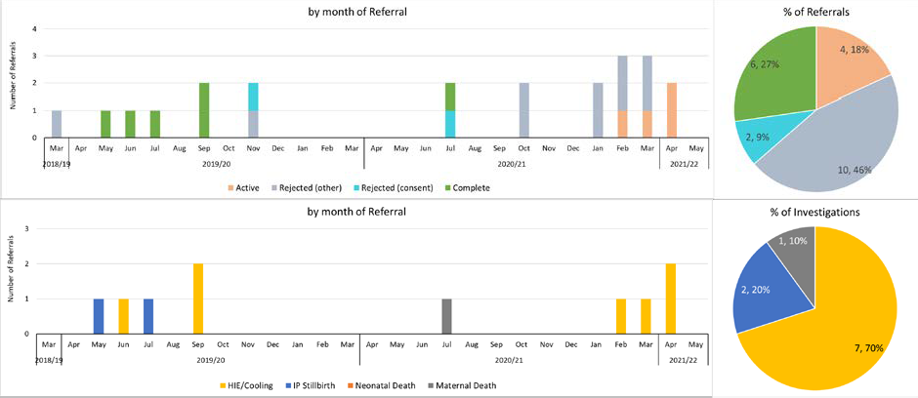

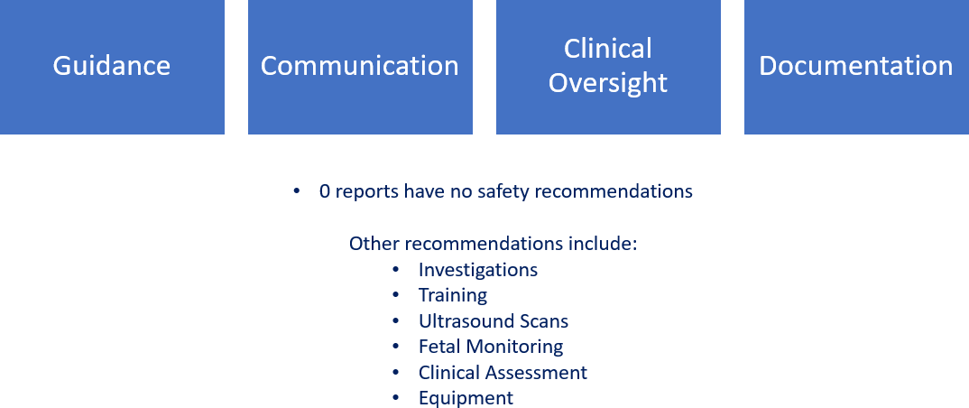

The maternity service continues to monitor all actions and quarterly reviews with HSIB.

6.0 RECOMMENDATIONS

Members of the Committee are asked to review and note the contents of this report.

MEETING OF THE PUBLIC TRUST BOARD – 1ST JULY 2021
Clinical Negligence Scheme for Trusts (CNST) Incentive Scheme |  |  | AGENDA ITEM: 13
Report Author and Job Title: | Carla Jones-Charles – Director of Midwifery Gynaecology and Sexual Health  Fateh Ghazal – Clinical Director Women’s services  Julie Newton – Care Group Manager, Obstetrics, Gynaecology and Sexual Health | Responsible Director: | Prof Ann-Marie Cannaby, Interim Chief Nursing Officer/Deputy Chief Executive
Action Required | Approve ☒ Discuss ☐ Inform ☐ Assure ☐
Executive Summary | NHS Resolution is operating a third year of the Clinical Negligence Scheme for Trusts (CNST) maternity incentive scheme to continue to support the delivery of safer maternity care.  The maternity incentive scheme applies to all acute Trusts that deliver maternity services and are members of the CNST. As in year two, members will contribute an additional 10% of the CNST maternity premium to the scheme creating the CNST maternity incentive fund. In order to mitigate the financial impact of COVID- 19, CNST maternity incentive fund contributions were not taken in April 2020 as would otherwise have occurred. Effectively this means that trusts have had a ‘year off’ paying their contributions and additional time to implement the year three scheme, albeit with some revisions to the requirements when relaunched on 1 October 2020.  With the delay in the funding element of the maternity incentive scheme in 2020/21, contributions into the incentive fund and distributions from it will be carried out in 2021/22 as per the usual timeframes.  As in year two, the scheme incentivises ten maternity safety actions. Trusts that can demonstrate they have achieved all of the ten safety actions will recover the element of their contribution relating to the CNST maternity incentive fund and will also receive a share of any unallocated funds.  Trusts that do not meet the ten-out-of-ten threshold will not  recover their contribution to the CNST maternity incentive fund, but

 | may be eligible for a small discretionary payment from the scheme to help them to make progress against actions they have not achieved. Such a payment would be at a much lower level than the 10% contribution to the incentive fund.
Recommendation | To review the report and agree with the Care Group finding that we have achieved compliance with 10 out of 10 standards .
Does this report mitigate risk included in the BAF or Trust Risk Registers? please outline
Resource implications | Savings: Achieving the ten safety actions will recover the element of contribution to the CNST maternity incentive fund.
Legal and Equality and Diversity implications | There are no legal or equality & diversity implications associated with this paper.
Strategic Objectives | Safe, high quality care ☒ | Care at home ☐
Strategic Objectives | Partners ☐ | Value colleagues ☐
Strategic Objectives | Resources ☒

Clinical Negligence Scheme for Trusts (CNST) Incentive Scheme

- PURPOSE OF REPORT

The purpose of the reports is to inform the Trust Board of our CNST incentive scheme progress for 2020/21

- BACKGROUND

The Trust currently spends £4m per year for our Maternity Department to be a member of the Clinical Negligence Scheme for Trusts (CNST). Maternity safety is an important issue for all members of the CNST. Obstetric incidents can be catastrophic and life- changing, with related claims representing the scheme’s biggest area of spend.

The Maternity Safety Strategy sets out the Department of Health and Social Care’s ambition to reward those who have taken action to improve maternity safety. For a third year CNST have joined forces with the national maternity safety champions to support the delivery of safer maternity care through an incentive element to the contribution to the CNST, rewarding trusts meeting ten safety actions designed to improve the delivery of best practice in maternity and neonatal services.

Provision for the maternity incentive scheme has been built into the CNST maternity pricing for 2020/21. The scheme incentivises ten maternity safety actions (please see appendix A). Trusts that can demonstrate they have achieved all of the ten safety actions will recover the element of their contribution to the CNST maternity incentive fund and will also receive a share of any unallocated funds.

In order to be eligible for payment under the scheme, Trusts must submit their completed Board declaration form to NHS Resolution (MIS@resolution.nhs.uk) by 12 noon on Thursday 15 July 2021 and must comply with the following conditions:

  - Trusts must achieve all ten maternity safety actions.
  - The Board declaration form must be signed three times and dated by the Trust chief executive to confirm that:
    - The Trust Board are satisfied that the evidence provided to demonstrate achievement of the ten maternity safety actions meets the required safety actions’ sub-requirements as set out in the safety actions and technical guidance document.
    - The content of the Board declaration form has been discussed with the commissioner(s) of the Trust’s maternity services.
  - Submissions and any comments/corrections received after 12noon on Thursday 15 July 2021 will not be considered.

- DETAILS

Safety action 1: Are you using the National Perinatal Mortality Review Tool to review perinatal deaths to the required standard?
Required Standard:
- i.All perinatal deaths eligible to be notified to MBRRACE-UK from Monday 11 January 2021 onwards must be notified to MBRRACE-UK within seven working days and the surveillance information where required must be completed within four months of the death. ii. A review using the Perinatal Mortality Review Tool (PMRT) of 95% of all deaths of babies, suitable for review using the PMRT, from Friday 20 December 2019 to 15 March 2021 will have been started before 15 July 2021.

- At least 50% of all deaths of babies (suitable for review using the PMRT) who were born and died in your Trust, including home births, from Friday 20 December 2019 to Monday 15 March 2021 will have been reviewed using the PMRT, by a multidisciplinary review team. Each review will have been completed to the point that at least a PMRT draft report has been generated by the tool before 15 July 2021.

- For 95% of all deaths of babies who were born and died in your Trust from Friday 20 December 2019, the parents will have been told that a review of their baby’s death will take place, and that the parents’ perspectives and any concerns they have about their care and that of their baby have been sought. This includes any home births where care was provided by your Trust staff and the baby died. If delays in completing reviews are anticipated parents should be advised that this is the case and be given a timetable for likely completion. Trust should ensure that contact with the families continues during any delay and make an early assessment of whether any questions they have can be addressed before a full review has been completed; this is especially important if there are any factors which may have a bearing on a future pregnancy. In the absence of a bereavement lead ensure that someone takes responsibility for maintaining contact and these actions.

- i. Quarterly reports will have been submitted to the Trust Board from Thursday 1 October 2020 onwards that include details of all deaths reviewed and consequent action plans. The quarterly reports should be discussed with the Trust maternity safety champion.
Minimum evidential requirement for trust Board | Action met? (Y/N)
Notifications must be made and surveillance forms completed using the MBRRACE-UK reporting website.  The perinatal mortality review tool must be used to review the care and draft reports should be generated via the PMRT.  A report has been received by the Trust Board each quarter from Thursday 1 October 2020 onwards that includes details of the deaths reviewed and the consequent action plans. The report should evidence that the PMRT has been used to review eligible | Y – Enc 1 (Three months PMRT Presentation)  Y – Enc 2 (Three months PMRT meeting minutes)  Y – Enc 3 ( Mortality Surveillance Group Minutes)  Y - Enc 4 (PMRT terms of reference)

perinatal deaths and that the required standards a), b) and c) have been met.

Update: All the eligible babies are reported via the MBRACE site and we have met the criteria for reporting within 7 days. The PMRT reviews are up to date and there are no outstanding cases awaiting review. MDT reviews of all cases are standard practice and please see enclosed terms of reference. A quarterly report on PMRT is submitted to the sub-committee of the board (mortality surveillance group) with any actions monitored via that group. The Divisional Director report to Quality Patient Experience and Safety
Committee (QPES) for February 2021 also included an update on PMRT.

Safety action 2: Are you submitting data to the Maternity Services Data Set (MSDS) to the required standard?
Required Standard
This relates to the quality, completeness of the submission to the Maternity Services Data Set (MSDS) and ongoing plans to make improvements.
Minimum evidential requirement for trust Board | Action met? (Y/N)
NHS Digital will issue a monthly scorecard to data submitters (Trusts) that can be presented to the Board. It will help Trusts understand the improvements needed in advance of the assessment.  The scorecard will be used by NHS Digital to assess whether each MSDS data quality criteria has been met. | Y - Enc 5  Scored Card confirming achievement and Email from Performance
All 13 criteria are mandatory. Items 1, 2, 4-13 will be assessed by NHS Digital and included in the scorecard. Item 3 will be reported to NHS Resolution.
Item 14 related to the Maternity Record Standard has been removed from the MIS safety action two. Validation process
Self-certification by the Trust Board and submitted to NHS Resolution using the Board declaration form.
NHS Resolution will cross-reference self-certification against NHS Digital data.
Update: The trust submitted data for MSDS2 in December 2020 and achieved all elements

Safety action 3: Can you demonstrate that you have transitional care services to support the recommendations made in the Avoiding Term Admissions into Neonatal units Programme?
Required Standard
D) Commissioner returns for Healthcare Resource Groups (HRG) 4/XA04 activity as per Neonatal Critical Care Minimum Data Set (NCCMDS) version 2 have been shared, on request, with the Operational Delivery Network (ODN) and commissioner to inform a future regional approach to developing TC.

- A review of term admissions to the neonatal unit and to TC during the Covid-19 period (Sunday 1 March 2020 – Monday 31 August 2020) is undertaken to identify the impact of:
  - closures or reduced capacity of TC
  - changes to parental access
  - staff redeployment
  - changes to postnatal visits leading to an increase in admissions including those for jaundice, weight loss and poor feeding.

- An action plan to address local findings from Avoiding Term Admissions Into Neonatal units (ATAIN) reviews, including those identified through the Covid-19 period as in point e) above has been agreed with the maternity and neonatal safety champions and Board level champion.

- Progress with the revised ATAIN action plan has been shared with the maternity, neonatal and Board level safety champions.
Minimum evidential requirement for trust Board | Action met? (Y/N)
Evidence for standard d) to include:  - As and when requested, commissioner returns for Healthcare Resource Groups (HRG) 4/XA04 activity as per Neonatal Critical Care Minimum Data Set (NCCMDS) version 2 are shared with the Local Maternity System (LMS), ODN or commissioner.  Evidence for standard e) to include:  - An audit trail is available which provides evidence that a review of term admissions during the period Sunday 1 March 2020 – Monday 31 August 2020 has been undertaken  - Evidence that the review specifically considered the impact of changes to parental access; staff redeployment, closure or reduced TC capacity and changes to postnatal visits on admission rates including those for jaundice, weight loss and poor feeding .  Evidence for standard f) to include:  - An audit trail is available which provides evidence and rationale for developing the agreed action plan to address local findings from ATAIN reviews.  - Evidence of an action plan to address identified and modifiable factors for admission to transitional care.  - Evidence that the action plan has been revised in the light of learning from term admissions during Covid-19. Where no changes have been made, the rationale should be clearly stated.  - Evidence that the action plan has been shared and agreed with the neonatal, maternity safety champion and Board level champion  Evidence for standard g) to include:  - Evidence that progress with the revised ATAIN action plan has been | Y - Enc 6- Email confirmation from contracting team.  Y - Enc 7 - ATAIN report (1/3/20 / 31/8/20)  Enc 8 - ATAIN action plan updated during Covid 19 and email evidence of sharing with safety champions  Enc 8 - ATAIN action plan updated during

shared with the neonatal, maternity safety champion and Board level champion.  - Self-certification by the Trust Board and submitted to NHS Resolution using Board declaration form  Update: The Trust have not been requested to send any data regarding returns to ODN or commissioner, however would be able to send based on the criteria. Term admissions have been reviewed and included in the ATIAN report. The action plan and report have been shared with the safety  champions. | Covid 19 and email evidence of sharing with safety champions

Safety action 4: Can you demonstrate an effective system of clinical* workforce planning to the required standard?
Required Standard
Anaesthetic medical workforce
- An action plan is in place and agreed at Trust Board level to meet Anaesthesia Clinical Services Accreditation (ACSA) standards 1.7.2.5, 1.7.2.1 and 1.7.2.6

Neonatal medical workforce
- The neonatal unit meets the British Association of Perinatal Medicine (BAPM) national standards of junior medical staffing. If this is not met, an action plan to address deficiencies is in place and agreed at board level

Neonatal nursing workforce
- The neonatal unit meets the service specification for neonatal nursing standards. If these are not met, an action plan is in place and agreed at board level to meet these recommendations
Minimum evidential requirement for trust Board | Action met? (Y/N)
Anaesthetic medical workforce  Trust Board minutes formally recording the proportion of ACSA standards 1.7.2.5, 1.7.2.1 and 1.7.2.6 that are met. Where Trusts did not meet these standards, they must produce an action plan (ratified by the Trust Board) stating how they are working to meet the standards.  Neonatal medical workforce  The Trust is required to formally record in Trust Board minutes whether it meets the recommendations of the neonatal medical workforce training action. If the requirements are not met, an action plan should be developed to meet the recommendations and should be signed off by the Trust Board.  Neonatal nursing workforce  The Trust is required to formally record to the Trust Board minutes the compliance to the service specification standards annually using the neonatal clinical reference group nursing workforce calculator. For units that do not meet the standard, an action plan should be developed to meet | Yes - Enc 9 – Copies of Rotas  Yes - Enc 10 – Email confirmation with Rota  Yes - Enc 11 – Staffing Review and action plan.

the standards and should be signed off by the Trust board and a copy submitted to the Royal College of Nursing (Fiona.Smith@rcn.org.uk) and Neonatal Operational Delivery Network (ODN).  Update: Confirmation by Lead Anaesthetist that WHT meet ACSA standards. Confirmed by Clinical Lead that NN medical workforce meets the BAPM standard for junior medical staffing . Neonatal Nursing have undertaken a staffing review and have provided an action plan to achieve BAPM compliance within our Level 2  neonatal unit with LMNS and ODN | .

Safety action 5: Can you demonstrate an effective system of midwifery workforce planning to the required standard?
Required Standard
- A systematic, evidence-based process to calculate midwifery staffing establishment is completed.

- The midwifery coordinator in charge of labour ward must have supernumerary status; (defined as having no caseload of their own during their shift) to ensure there is an oversight of all birth activity within the service

- All women in active labour receive one-to-one midwifery care

- Submit a midwifery staffing oversight report that covers staffing/safety issues to the Board at least once a year, during the maternity incentive scheme year three reporting period (December 2019 – July 2021).
Minimum evidential requirement for trust Board | Action met? (Y/N)
The report submitted will comprise evidence to support a, b and c progress or achievement. It should include:  - A clear breakdown of BirthRate+ or equivalent calculations to demonstrate how the required establishment has been calculated  - Details of planned versus actual midwifery staffing levels. To include evidence of mitigation/escalation for managing a shortfall in staffing.  - An action plan to address the findings from the full audit or table-top exercise of BirthRate+ or equivalent undertaken, where deficits in staffing levels have been identified.  - Maternity services should detail progress against the action plan to demonstrate an increase in staffing levels and any mitigation to cover any shortfalls.  - The midwife to birth ratio  - The percentage of specialist midwives employed and mitigation to cover any inconsistencies. BirthRate+ accounts for 8-10% of the establishment, which are not included in clinical numbers. This includes those in management positions and specialist midwives. | Y - Enc 12 – BirthRate Plus report  Enc 12A – PFIC Paper  Enc 12A PFIC paper and Enc 13 Business Continuity Plan  Enc 12A – PFIC paper  Enc 14 – Maternity Dashboard  Enc 12 – BirthRate Plus report.

- Evidence from an acuity tool (may be locally developed), local audit, and/or local dashboard figures demonstrating 100% compliance with supernumerary labour ward co-ordinator status and the provision of one-to-one care in active labour. Must include plan for mitigation/escalation to cover any shortfalls.  - Did Covid-19 cause impact on staffing levels? - Was the staffing level affected by the changes to the organisation to deal with Covid- 19? - How has the organisation prepared for sudden staff shortages in terms of demand, capacity and capability during the pandemic and for any future waves?  Any consecutive twelve month period between Wednesday 1st July 2020 and Thursday 15 July 2021.  Update: BirthRate Plus report was completed in October 2020 and a paper was presented to PFIC in March 2021 to include current staffing, proposed staffing and mitigations until staff are in post. The funding was approved in April 2021. The service have utilised the BCP and escalation policy to support actions for  shortfalls. The service has achieved 1:1 care in labour in the last 6 months and can provide evidence where the team leader is supernumerary if required on the rota. | Enc 14 - Maternity Dashboard  Enc 13 Business continuity Plan

Safety action 6: Can you demonstrate compliance with all five elements of the Saving Babies’ Lives care bundle version two?
Required Standard
- Trust Board level consideration of how its organisation is complying with the Saving Babies' Lives care bundle version two (SBLCBv2), published in April 2019. Note: Full implementation of the SBLCBv2 is included in the 2019/20 standard contract.

- Each element of the SBLCBv2 should have been implemented. Trusts can implement an alternative intervention to deliver an element of the care bundle if it has been agreed with their commissioner (CCG). It is important that specific variations from the pathways described within SBLCBv2 are also agreed as acceptable clinical practice by their Clinical Network

4. The quarterly care bundle survey should be completed until the provider trust has fully implemented the SBLCBv2 including the data submission requirements. The corroborating evidence is the SBLCBv2 survey and MSDS data, availability of this depends on the COVID-19 status.

The survey will be distributed by the Clinical Networks and should be completed and returned to the Clinical Network or directly to England.maternitytransformation@nhs.net.
Minimum evidential requirement for trust Board | Action met? (Y/N)

Evidence of the completed quarterly care bundle surveys for 2020/21 should be submitted to the Trust board.  Element one:  - Recording of carbon monoxide reading for each pregnant woman on Maternity Information System (MIS) and inclusion of these data in the providers’ Maternity Services Data Set (MSDS) submission to NHS Digital.  - Percentage of women where Carbon Monoxide (CO) measurement at booking is recorded.  - Percentage of women where CO measurement at 36 weeks is recorded.  Note: The relevant data items for these indicators should be recorded on the provider’s Maternity Information System (MIS) and included in the MSDS submissions to NHS Digital in an MSDSv2 Information Standard Notice compatible format, including SNOMED-CT coding. The Trust board should receive data from the organisation’s MIS evidencing 80% compliance  If CO monitoring remains paused due to Covid-19, the audit described above needs to be based on the percentage of women asked whether they smoke at booking and at 36 weeks. The Very Brief Advice and referral to smoking cessation services remain part of the pathway. The timing of the audit is at the Trust’s discretion but should include the dates when women booked, and reference to the national CO testing policy at that time.  A threshold score of 80% compliance should be used to confirm successful implementation.  If the process metric scores are less than 95% Trusts must also have an action plan for achieving >95%.  Element two:  A. Percentage of pregnancies where a risk status for fetal growth restriction (FGR) is identified and recorded at booking.  Note: The relevant data items for these indicators should be recorded on the provider’s Maternity Information System (MIS) and included in the MSDS submissions to NHS Digital in an MSDSv2 Information Standard Notice compatible format, including SNOMED-CT coding. The Trust board should receive data from the organisation’s MIS evidencing 80% compliance.  If there is a delay in the provider Trust MIS’s ability to record these data at | Y - See evidence for all actions: Enc 15 (Midlands Clinical  Network Report Findings for the West Midlands – Page 5) Enc 15A . Audits have been performed  Guidance in place

the time of submission an in house audit of 40 consecutive cases using locally available data or case records should have been undertaken to assess compliance with this indicator.

A threshold score of 80% compliance should be used to confirm successful implementation.

If the process indicator scores are less than 95% Trusts must also have an action plan for achieving >95%.

In addition the Trust board should specifically confirm that within their organisation:

- women with a BMI>35 kg/m2 are offered ultrasound assessment of growth from 32 weeks’ gestation onwards

- in pregnancies identified as high risk at booking uterine artery Doppler flow velocimetry is performed by 24 completed weeks gestation

- There is a quarterly audit of the percentage of babies born <3rd centile
>37+6 weeks’ gestation.

If Trusts have elected to follow Appendix G due to staff shortages related to the Covid-19 pandemic Trust Boards should evidence they have followed the escalation guidance for the short term management of staff (https://www.england.nhs.uk/publication/saving-babies-lives-care-bundle- version-2-Covid-19-information/). They should also specifically confirm that they are following the modified pathway for women with a BMI>35 kg/m2.

If this is not the case the Trust board should describe the alternative intervention that has been agreed with their commissioner (CCG) and that their Clinical Network has agreed that it is acceptable clinical practice.

Q: How should Trust board specifically confirm that within their organisation standard 1-2 above have been implemented? This should be confirmed as a minimum via inclusion in the Trust’s standard operating procedure/guidelines.

Element three:

  - Percentage of women booked for antenatal care who had received leaflet/information by 28+0 weeks of pregnancy.

  - Percentage of women who attend with RFM who have a computerised CTG.

Note: The SNOMED CT code is still under development for RFM and

therefore an in-house audit of two weeks’ worth of cases or 20 cases whichever is the smaller to assess compliance with the element three indicators.

A threshold score of 80% compliance should be used to confirm successful implementation.

If the process indicator scores are less than 95% Trusts must also have an action plan for achieving >95%.

Element four:

- Percentage of staff who have received training on intrapartum fetal monitoring in line with the requirements of Safety Action eight, including: intermittent auscultation, electronic fetal monitoring, human factors and situational awareness.
- Percentage of staff who have successfully completed mandatory annual competency assessment.

Note: An in-house audit should have been undertaken to assess compliance with these indicators. Each of the following groups should be attending the training:

- Obstetric consultants
- All other obstetric doctors (including staff grade doctors, obstetric trainees (ST1-7), sub speciality trainees, obstetric clinical fellows and foundation year doctors contributing to the obstetric rota
- Midwives (including midwifery managers and matrons, community midwives; birth centre midwives (working in co-located and standalone birth centres and bank/agency midwives). Maternity theatre midwives who also work outside of theatres.

In the current year we have removed the threshold of 90%. This applies to fetal monitoring requirement of safety action 6. We recommend that trusts identify any shortfall in reaching the 90% threshold and commit to addressing this as soon as possible.

Trust Board should minute in their meeting records a written commitment to facilitate local, in-person, fetal monitoring training when this is permitted.

Element 5:

- Percentage of singleton live births (less than 34+0 weeks) receiving a full course of antenatal corticosteroids, within seven days of birth.
- Percentage of singleton live births (less than 30+0 weeks) receiving

magnesium sulphate within 24 hours prior birth.
C. Percentage of women who give birth in an appropriate care setting for gestation (in accordance with local ODN guidance).

Note: The relevant data items for these indicators should be recorded on the provider’s Maternity Information System (MIS) and included in the MSDS submissions to NHS Digital in an MSDSv2 Information Standard Notice compatible format, including SNOMED-CT coding. The Trust board should receive data from the organisation’s MIS evidencing 85% compliance.

If there is a delay in the provider Trust MIS’s ability to record these data at the time of submission an in-house audit of a minimum of four weeks’ worth of consecutive cases up to a maximum of 20 cases to assess compliance with the element five indicators.

Completion of the audits for element 5 standards A, B and C should be used to confirm successful implementation.

If the process indicator scores are less than 85% Trusts must also have an action plan for achieving >85%.

In addition, the Trust board should specifically confirm that within their organisation:
- women at high risk of pre-term birth have access to a specialist preterm birth clinic where transvaginal ultrasound to assess cervical length is provided. If this is not the case the board should describe the alternative intervention that has been agreed with their commissioner (CCG) and that their Clinical Network has agreed is acceptable clinical practice.

- an audit has been completed to measure the percentage of singleton live births occurring more than seven days after completion of their first course of antenatal corticosteroids.

Safety action 7: Can you demonstrate that you have a mechanism for gathering service user feedback, and that you work with service users through your Maternity Voices Partnership (MVP) to coproduce local maternity services?
Required Standard
Can you demonstrate that you have a mechanism for gathering service user feedback, and that you work with service users through your Maternity Voices Partnership (MVP) to coproduce local maternity services?
Minimum evidential requirement for trust Board | Action met? (Y/N)

Evidence should include:  - Terms of Reference for your MVP  - A minimum of one set of minutes of MVP meetings demonstrating explicitly how feedback is obtained and the consistent involvement of Trust staff in coproducing service developments based on this feedback  - Evidence of service developments resulting from coproduction with service users  - Written confirmation from the service user chair that they are being remunerated for their work and that they and other service user members of the Committee are able to claim out of pocket expenses  - Evidence that the MVP is prioritising hearing the voices of women from Black, Asian and Minority Ethnic backgrounds and women living in areas with high levels of deprivation, as a result of UKOSS 2020 coronavirus data. A template pack has been developed by the safety action leads in order to support trusts with evidencing compliance with the requirements of safety action seven. The pack can be found here https://resolution.nhs.uk/services/claims- management/clinical-schemes/clinical-negligence-scheme-for- trusts/maternity-incentive-scheme | Y - Enc 16 ToRs  Y - See Enc 17 – Minutes from meeting  Y - see Enc 18 – List of Coproduction with MVP  Y – Enc 19 Email confirmation.  Y - Enc 20 Black Country Co- production of services through LMNS

Safety action 8: Can you evidence that the maternity unit staff groups have attended an 'in- house' multi-professional maternity emergencies training session since the launch of MIS year three in December 2019?
Required Standard
90% of each maternity unit staff group have attended an 'in-house' multi-professional maternity emergencies training session within the last training year for the following staff groups:
Minimum evidential requirement for trust Board | Action met? (Y/N)
Can you confirm that:  - Covid-19 specific e-learning training has been made available to the multi-professional team members?  - Team required to be involved in immediate resuscitation of the newborn and management of the deteriorating new born infant have attended your in-house neonatal resuscitation training or Newborn Life Support (NLS) course since the launch of MIS | Y - Enc 21 – Virtual Prompt package  Y – Enc 22 Training details

year three in December 2019?  c) There is a commitment by the trust board to facilitate multi- professional training sessions, including fetal monitoring training once when this is permitted. | Y – face to face resuming July 2021.

Safety action 9: Can you demonstrate that the Trust safety champions (obstetric, midwifery and neonatal) are meeting bi-monthly with Board level champions to escalate locally identified issues?
Required Standard
- A pathway has been developed that describes how frontline midwifery, neonatal, obstetric and Board safety champions share safety intelligence from floor to Board and through the local maternity system (LMS) and MatNeoSIP Patient Safety Networks.

- Board level safety champions are undertaking feedback sessions every other month, for maternity and neonatal staff to raise concerns relating to safety issues, including those relating to Covid-19 service changes and service user feedback and can demonstrate that progress with actioning named concerns are visible to staff.

- Board level safety champions have reviewed their continuity of carer action plan in the light of Covid-19. Taking into account the increased risk facing women from Black, Asian and minority ethnic backgrounds and the most deprived areas, a revised action plan describes how the maternity service will resume or continue working towards a minimum of 35% of women being placed onto a continuity of carer pathway, prioritising women from the most vulnerable groups they serve.

- Together with their frontline safety champions, the Board safety champion has reviewed local outcomes in relation to:

  - Maternal and neonatal morbidity and mortality rates including a focus on women who delayed or did not access healthcare in the light of Covid-19, drawing on resources and guidance to understand and address factors which led to these outcomes.
  - The UKOSS report on Characteristics and outcomes of pregnant women admitted to hospital with confirmed SARS-CoV-2 infection in UK.
  - The MBRRACE-UK SARS-Covid-19 https://www.npeu.ox.ac.uk/assets/downloads/mbrrace-uk/reports/MBRRACE- UK_Maternal_Report_2020_v10_FINAL.pdf IV. The letter regarding targeted perinatal support for Black, Asian and Minority Ethnic groups

And considered the recommendations and requirements of II, III and IV on I.
Minimum evidential requirement for trust Board | Action met? (Y/N)

- Evidence of a written pathway which describes how frontline midwifery, neonatal, obstetric and Board safety champions share safety intelligence between a) each other, b) the Board, c) the LMS and d) Patient Safety Networks.  - Evidence that a clear description of the pathway and names of safety champions are visible to maternity and neonatal staff.  - Evidence that discussions regarding safety intelligence, concerns raised by staff and service users in relation to, but not exclusively, the impact of Covid-19 on maternity and neonatal services; progress and actions relating to the local improvement plan(s) and QI activity are reflected in the minutes of Board, LMS and Patient Safety Network meetings. Minutes should also include discussions on where efforts should be positively recognised.  - Evidence of a safety dashboard or equivalent, visible to both maternity and neonatal staff which reflects action and progress made on identified concerns raised by staff and service users. This should include concerns relating to the Covid-19 pandemic.  - Evidence that Board level safety champions have reviewed their continuity of carer action plan in light of Covid-19. Plans should reflect how the Trust will continue or resume continuity of carer models so that at least 35% of women booking for maternity care are being placed onto continuity of carer pathways. In light of the increased risk facing, women from Black, Asian and minority ethnic backgrounds and women from the most deprived areas, local systems should consider bringing forward enhanced continuity of carer models primarily targeting these groups.  - Evidence of Board level oversight and discussion of progress in meeting the revised continuity of carer action plan.  - Evidence that the frontline and Board safety champions have reviewed local outcomes as set out in standard d) above and are addressing relevant learning, drawing on insights and recommendations from the two named reports and undertaking the requirements within the letter targeting perinatal support for Black, Asian and Minority Ethnic groups.  - Evidence of how the Board has supported staff involved in the four key areas outlined in part e) of the required standard and specifically to:  - work with Patient Safety Networks, local maternity systems, clinical networks, commissioners and others on Covid-19 and non Covid-19 related challenges and safety concerns, ensuring learning and intelligence is actively shared across systems  - utilise SCORE safety culture survey results to inform the Trust | Y – Enc 23  Organogram  Y - Boards are available on the Wards  Y – Enc 24  Escalation Report.  Concerns are also reported through LMNS Engagement and Advsiory workstream  Y – Enc 25  Action plan  Y - Enc 26  Board report  and project plan.  Y – Enc 26  Board report and project plan  Y – Enc 27 Gap analysis  Y – Safety

quality improvement plan  - Patient Safety Network and Undertaking of improvement work aligned to the MatNeoSIP national driver diagram and key enablers | champion leading on the programme – lead clinician support the  programme of works.

Safety action 10: Have you reported 100% of qualifying cases to HSIB and (for 2019/20 births only) reported to NHS Resolution's Early Notification (EN) scheme?
Required Standard
- Reporting of all outstanding qualifying cases for the year 2019/20 to NHS Resolution’s EN scheme.
- Reporting of all qualifying cases to the Healthcare Safety Investigation Branch (HSIB) for 2020/21.
- For qualifying cases which have occurred during the period 1 October 2020 to 31 March 2021 the Trust Board are assured that: 4.

- the family have received information on the role of HSIB and the EN scheme; and

- there has been compliance, where required, with Regulation 20 of the Health and Social Care Act 2008 (Regulated Activities) Regulations 2014 in respect of the duty of candour.
Minimum evidential requirement for trust Board | Action met? (Y/N)
Trust Board sight of Trust legal services and maternity clinical governance records of qualifying Early Notification incidents and numbers reported to HSIB and the NHS Resolution Early Notification team.  Trust Board sight of evidence that the families have received information on the role of HSIB and EN scheme.  Trust Board sight of evidence of compliance with the statutory duty of candour. | Y – Enc 28 HSIB  report  Y – Enc 29  parent inforamtion  Y – guidelines. DoC is  monitored through Div  Huddle and DQB


Maternity incentive scheme - Guidance

Trust Name | Walsall Healthcare NHS Trust
Trust Code | T099

This document must be used to complete your trust self-certification for the maternity incentive scheme safety actions and a completed action plan must be submitted for actions which have not been met. Please select your trust name from the drop down menu above. Your trust name will populate each tab. If the trust name box is coloured pink please update
Guidance Tab - This has useful information to support you to complete the maternity incentive scheme safety actions excel spreadsheet. Please read the guidance carefully.

The Board declaration form must not include any narrative, commentary, or supporting documents. Evidence should be provided to the Trust Board only, and will not be reviewed by NHS Resolution, unless requested.
There are multiple additional tabs within this document:
Tab A - safety actions entry sheets (1 to 10) - Please select 'Yes', 'No' or 'N/A' to demonstrate compliance as detailed within the condition of the scheme with each maternity incentive scheme safety action. Note, 'N/A' (not applicable) is available only for set questions. The information which has been populated in this tab, will automatically populate onto tab D which is the board declaration form.

Tab B - action plan summary sheet - This will provide you information on your Trust's progress in completing the board declaration form and will outline on how many Yes/No/N/A and unfilled assessments you have. This will feed into the board declaration sheet - tab D.

Tab C - action plan entry sheet - This sheet will enable your Trust to insert action plan details for any safety actions not achieved.

Tab D - Board declaration form - This is where you can track your overall progress against compliance with the maternity incentive scheme safety actions. This sheet will be protected and fields cannot be altered manually. If there are anomalies with the data entered, then comments will appear in the validations column (column I) this will support you in checking and verifying data before it is discussed with the trust board, commissioners and before submission to NHS Resolution.

Upon completion of the following processes please add an electronic signature into the three allocated spaces within this document: one signature to declare compliance stated in the board declaration form with the safety actions and their sub-requirements, one signature to confirm that the maternity incentive scheme evidence have been discussed with commissioners and a third signature to declare that there are no external or internal reports covering either 2020/21 financial year or the previous financial year (2019/20) that relate to the provision of maternity services that may subsequently provide conflicting information to your Trust's declaration. Any such reports should be brought to the MIS team's attention before 15 July 2021.
Any queries regarding the maternity incentive scheme and or action plans should be directed to MIS@resolution.nhs.uk
Technical guidance and frequently asked questions can be accessed here:
https://resolution.nhs.uk/services/claims-management/clinical-schemes/clinical-negligence-scheme-for-trusts/maternity-incentive-scheme/

Submissions for the maternity incentive scheme must be received no later than 12 noon on Thursday 15 July 2021 to MIS@resolution.nhs.uk You are required to submit this document signed and dated. Please do not send evidence to NHS Resolution.

Safety action No. 1
Are you using the National Perinatal Mortality Review Tool to review and report perinatal deaths to the required standard?
Requirements number | Safety action requirements | Requirement met?  (Yes/ No /Not applicable)
1 | Were all perinatal deaths eligible notified to MBRRACE-UK from the 11 January 2021 onwards to MBRRACE-UK within 7 working days and the surveillance information where required completed within four months of each death? | Yes
2 | Has a review using the Perinatal Mortality Review Tool (PMRT) of 95% of all deaths of babies, suitable for review using the PMRT, from 20 December 2019 to 15 March 2021 been started before 15 July 2021? | Yes
3 | Were at least 50% of all deaths of babies (suitable for review using the PMRT) who were born and died in your Trust, including home births, from 20 December 2019 to 15 March 2021 reviewed using the PMRT, by a multidisciplinary review team?  Each review will have been completed to the point that at least a PMRT draft report has been generated by the tool  before 15 July 2021. | Yes
4 | For 95% of all deaths of babies who were born and died in your Trust from Friday 20 December 2019, were parents told that a review of their baby’s death will take place? This includes any home births where care was provided by  your Trust staff and the baby died. | Yes
5 | For 95% of all deaths of babies who were born and died in your Trust from Friday 20 December 2019, were parents' perspectives, questions and any concerns they have about their care and that of their baby sought? This includes  any home births where care was provided by your Trust staff and the baby died. | Yes
6 | If delays in completing reviews were anticipated, were parents advised of this and were they given a timetable for  likely completion? | Yes
7 | Have you submitted quarterly reports to the Trust Board from 1 October 2020 onwards?  This must include details of all deaths reviewed and consequent action plans. | Yes
8 | Were the quarterly reports discussed with the Trust maternity safety champion from 1 October 2020 onwards? | Yes

Are you submitting data to the Maternity Services Data Set to the required standard?

Requirements number | Safety action requirements
1 | Were your Trust compliant with all 13 criteria in either the December 2020 or the January 2021's submission?
2 | Has the Trust Board confirmed that they have fully conformed with the MSDSv2 Information Standards Notice, DCB1513 And 10/2018, which was expected for April 2019 data, or that a locally funded plan is in place to do this, and agreed with the maternity safety champion and the LMS. This should include submission of the relevant clinical  coding in MSDSv2 in SNOMED-CT.

Requirement met?
(Yes/ No /Not applicable)
Yes
Yes

Can you demonstrate that you have transitional care services to support the Avoiding Term Admissions Into Neonatal units

f
Requirements number | Safety action requirements
Please note standard a), b) and c) of safety action 3 have now been removed.
Standard D) Commissioner returns on request for Healthcare Resource Groups (HRG) 4/XA04 activity as per Neonatal Critical Care Set (NCCMDS) version 2 have been shared, on request, with the Operational Delivery Network (ODN) and commissioner to inform a approach to developing TC.
1 | Commissioner returns for Healthcare Resource Groups (HRG) 4/XA04 activity as per Neonatal Critical Care Minimum Data Set (NCCMDS) version 2 have been shared, on request, with the Operational Delivery Network  (ODN) and commissioner to inform a future regional approach to developing TC. Is this in place?
Standard E) A review of term admissions to the neonatal unit and to TC during the Covid-19 period (Sunday 1 March 2020 – Monday 2020) is undertaken to identify the impact of:
- closures or reduced capacity of TC
- changes to parental access
- staff redeployment
- changes to postnatal visits leading to an increase in admissions including those for jaundice, weight loss and poor feeding.
2 | Has a review of term admissions to the neonatal unit and to TC during the COVID period (Sunday 1 March 2020 – Monday 31 August 2020) been undertaken and completed by 26 February 2021 to identify the impact of:  - closures or reduced capacity of TC  - changes to parental access  - staff redeployment  - changes to postnatal visits leading to an increase in admissions including those for jaundice, weight loss and poor feeding
An action plan to address local findings from Avoiding Term Admissions Into Neonatal units (ATAIN) reviews, including those identifie Covid-19period as in point e) above has been agreed with the maternity and neonatal safety champions and Board level champion.
3 | Do you have evidence of the following  - An audit trail is available which provides evidence and rationale for developing the agreed action plan to address local findings from ATAIN reviews.  - Evidence of an action plan to address identified and modifiable factors for admission to transitional care.  - Evidence that the action plan has been revised in the light of learning from term admissions during Covid-19. Where no changes have been made, the rationale should be clearly stated.  - Evidence that the action plan has been shared and agreed with the neonatal, maternity safety champion and Board level champion.
Progress with the revised ATAIN action plan has been shared with the maternity, neonatal and Board level safety champions.
4 | Has the ATAIN action plan been revised in the light of learning from term admissions during Covid-19 and has it been shared and agreed with the neonatal, maternity and Board level champions, with progress on Covid-19 related requirements monitored monthly by the neonatal and board safety champions from January 2021?
5 | Has the progress with the Covid-19 related requirements been shared and monitored monthly with the neonatal and maternity safety champion ?
6 | Has the progress on Covid-19 related requirements been monitored monthly by the board safety champions from  January 2021?

Programme?

Requirement met?
(Yes/ No /Not applicable)
Minimum Data uture regional
Yes
31 August
Yes
d through the
Yes
Yes
Yes
Yes

Can you demonstrate an effective system of clinical workforce planning to the required standard?

Requirements number | Safety action requirements
Please note that the standards related to the obstetric workforce have been removed.
1 | Anaesthetic medical workforce  Have your Trust Board minuted formally the proportion of ACSA standards 1.7.2.5, 1.7.2.1 and 1.7.2.6 that are met?
2 | If your Trust did not meet these standards, has an action plan been produced (ratified by the Board) stating how the  Trust is working to meet the standards?
3 | Neonatal medical workforce  Does the neonatal unit meet the British Association of Perinatal Medicine (BAPM) national standards of junior medical staffing?
4 | If your Trust did not meet the standards outlined in requirement no.3, has an action plan been produced (signed off  by the Board) stating how the Trust is working to meet the standards?
5 | Neonatal nursing workforce  Does the neonatal unit meet the service specification for neonatal nursing standards?
6 | If your Trust did not meet the standards outlined in requirement no.5, has an action plan been produced (signed off  by the Board) and shared with the RCN, stating how the Trust is working to meet the standards?

Requirement met?
(Yes/ No /Not applicable)
Yes
N/A
Yes
N/A
No
Yes

Can you demonstrate an effective system of midwifery workforce planning to the required standard?

Requirements number | Safety action requirements
1 | Has a systematic, evidence-based process to calculate midwifery staffing establishment been completed?
2 | Has your review included the percentage of specialist midwives employed and mitigation to cover any  inconsistencies?
3 | Has an action plan been completed to address the findings from the full audit or table-top exercise of BirthRate+ or  equivalent been completed, where deficits in staffing levels have been identified?
4 | Do you have evidence that the Maternity Services detailed progress against the action plan to demonstrate an  increase in staffing levels and any mitigation to cover any shortfalls?
5 | Do you have evidence from an acuity tool (may be locally developed), local audit, and/or local dashboard figures  demonstrating 100% compliance with supernumerary labour ward co-ordinator status in the scheme reporting period? This must include mitigations to cover shortfalls.
6 | If trust did not meet this standard, has an action plan been produced detailing how the maternity service intends to  achieve 100% supernumerary status for the labour ward coordinator which has been signed off by the Trust Board, and includes a timeline for when this will be achieved?”
7 | Do you have evidence from an acuity tool (may be locally developed), local audit, and/or local dashboard figures  demonstrating 100% compliance with 1:1 care in labour in the scheme reporting period? This must include mitigations to cover shortfalls.
8 | If trust did not meet this standard, has an action plan been produced detailing how  the maternity service intends to achieve 100% compliance with 1:1 care in labour has been signed off by the Trust Board, and includes a timeline for when this will be achieved?”
9 | Do you have evidence that a review has been undertaken regarding COVID-19 and possible impact on staffing levels to include:  - Was the staffing level affected by the changes to the organisation to deal with COVID?  - How has the organisation prepared for sudden staff shortages in terms of demand, capacity and capability during the pandemic and for any future waves?
10 | Has a midwifery staffing oversight report that covers staffing/safety issues been submitted to the Board at least  once every 12 months within the scheme reporting period?

Requirement met?
(Yes/ No /Not applicable)
Yes
Yes
Yes
Yes
Yes
N/A
Yes
N/A
Yes
Yes

Can you demonstrate compliance with all four elements of the Saving Babies' Lives V2 ?

Requirements number | Safety action requirements
1 | Do you have evidence of Trust Board level consideration of how the Trust is complying with the Saving Babies'  Lives Care Bundle Version 2 (SBLCBv2), published in April 2019?
2 | Has each element of the SBLCBv2 been implemented?  Trusts can implement an alternative intervention to deliver an element of the care bundle if it has been agreed with their commissioner (CCG). It is important that specific variations from the pathways described within SBLCBv2 are also agreed as acceptable clinical practice by the Clinical Network.
3 | The quarterly care bundle survey must be completed until the provider Trust has fully implemented the SBLCBv2 including the data submission requirements. The survey will be distributed by the Clinical Networks and should be completed and returned to the Clinical Network or directly to England.maternitytransformation@nhs.net.  Have you completed and submitted this?
ELEMENT 1 - Reducing smoking in pregnancy
Standard a) Recording of carbon monoxide reading for each pregnant woman on Maternity Information System (MIS) and inclusion of the providers’ Maternity Services Data Set (MSDS) submission to NHS Digital. If CO monitoring remains paused due to Covid-19, the described above needs to be based on the percentage of women asked whether they smoke at booking and at 36 weeks.
4 | Has standard a) been successfully implemented (80% compliance or more)?
5 | If the process metric scores are less than 95% for Element 1 standard A, has an action plan for achieving >95%  been completed?
Standard b) Percentage of women where Carbon Monoxide (CO) measurement at booking is recorded.
6 | Has standard b) been successfully implemented (80% compliance or more)?
7 | If the process metric scores are less than 95% for element 1 standard b), has an action plan for achieving >95% been completed?
Standard c) Percentage of women where CO measurement at 36 weeks is recorded.
8 | Has standard c) been successfully implemented (80% compliance or more)?
9 | If the process metric scores are less than 95% for element 1 standard c), has an action plan for achieving >95%  been completed?
ELEMENT 2 - Risk assessment, prevention and surveillance of pregnancies at risk of fetal growth restriction
Standard a) Percentage of pregnancies where a risk status for fetal growth restriction (FGR) is identified and recorded at booking.
10 | Has standard a) been successfully implemented (80% compliance or more)?
11 | If the process metric scores are less than 95% for element 2 standard a), has an action plan for achieving >95%  been completed?
Do you have evidence that the Trust Board has specifically confirm that all the following 3 standards are in place within their
12 | 1) women with a BMI>35 kg/m2 are offered ultrasound assessment of growth from 32 weeks’ gestation onwards
13 | 2) in pregnancies identified as high risk at booking uterine artery Doppler flow velocimetry is performed by 24  completed weeks gestation
14 | 3) There is a quarterly audit of the percentage of babies born <3rd centile >37+6 weeks’ gestation
15 | If your Trust have elected to follow Appendix G due to staff shortages related to the COVID pandemic, has Trust Board evidenced that they have followed the escalation guidance for the short term management of staff?
16 | If the above is not the case, has your Trust Board described the alternative intervention that has been agreed with their commissioner (CCG) and that their Clinical Network has agreed that it is acceptable clinical practice?
17 | If your Trust have elected to follow Appendix G due to staff shortages related to the COVID pandemic, has Trust Board confirmed that the Maternity Services are following the modified pathway for women with a BMI>35 kg/m2?
18 | If Trusts have elected to follow Appendix G due to staff shortages related to the Covid-19 pandemic Trust Boards should evidence they have followed the escalation guidance for the short term management of staff (https://www.england.nhs.uk/publication/saving-babies-lives-care-bundle-version-2-Covid-19-information/). They should also specifically confirm that they are following the modified pathway for women with a BMI>35 kg/m2. If this is not the case, has your Trust Board described the alternative intervention that has been agreed with their commissioner (CCG) and that their Clinical Network has agreed that it is acceptable clinical practice?
ELEMENT 3 Raising awareness of reduced fetal movement
Standard a) Percentage of women booked for antenatal care who had received leaflet/information by 28+0 weeks of pregnancy.
19 | Has standard a) been successfully implemented (80% compliance or more)?

20 | If the process metric scores are less than 95% for element 3 standard a), has an action plan for achieving >95%  been completed?
Standard b) Percentage of women who attend with RFM who have a computerised CTG
21 | has standard b) been successfully implemented (80% compliance or more)?
22 | If the process metric scores are less than 95% for element 3 standard b), has an action plan for achieving >95%  been completed?
ELEMENT 4 Effective fetal monitoring during labour
Standard a) Percentage of staff who have received training on fetal monitoring in labour in line with the requirements of Safety Action including: intermittent auscultation, electronic fetal monitoring, human factors and situational awareness.
23 | Has the Trust Board minuted in their meeting records a written commitment to facilitate local, in-person, fetal monitoring training when this is permitted?
24 | If the process metric scores are less than 90% for Element 4 standard a), has the trust identify shorfall in reaching  the 90% and commit to addressing those?
Standard b) Percentage of staff who have successfully completed mandatory annual competency assessment.
25 | Have training resources been made available to the multi-professional team members?
26 | If the process metric scores are less than 90% for Element 4 standard b), has the trust board identify shorfall in  reaching the 90% and commit to addressing those when this is permitted?
ELEMENT 5 Reducing preterm births
Standard a) Percentage of singleton live births (less than 34+0 weeks) receiving a full course of antenatal corticosteroids, within seve
27 | Has standard a) been audited?  Completion of the audit for element 5 standards A should be used to confirm successful implementation.
28 | If the process metric scores are less than 85% for Element 5 standard a), has an action plan for achieving >85%  been completed?
Standard b) Percentage of singleton live births (less than 30+0 weeks) receiving magnesium sulphate within 24 hours prior birth.
29 | Has standard b) been audited?  Completion of the audits for element 5 standards B should be used to confirm successful implementation.
30 | If the process metric scores are less than 85% for Element 5 standard b), has an action plan for achieving >85%  been completed?
Standard c) Percentage of women who give birth in an appropriate care setting for gestation (in accordance with local ODN guidance)
31 | Has standard c) been audited?  Completion of the audits for element 5 standards C should be used to confirm successful implementation.
32 | If the process metric scores are less than 85% for Element 5 standard c), has an action plan for achieving >85%  been completed?
33 | Do you have evidence that the Trust Board has specifically confirmed that:  - women at high risk of pre-term birth have access to a specialist preterm birth clinic where transvaginal ultrasound to assess cervical length is provided. If this is not the case the board should describe the alternative intervention that has been agreed with their commissioner (CCG) and that their Clinical Network has agreed is acceptable clinical practice.  - an audit has been completed to measure the percentage of singleton live births occurring more than seven days after completion of their first course of antenatal corticosteroids.

Requirement met?
(Yes/ No /Not applicable)
Yes
Yes
Yes
these data in audit
Yes
Yes
Yes
Yes
Yes
Yes
Yes
Yes
organisation:
Yes
Yes
Yes
N/A
N/A
N/A
N/A
Yes

Yes
Yes
Yes
eight,
Yes
Yes
Yes
Yes
n days of birth
Yes
Yes
Yes
Yes
.
Yes
Yes
Yes

Can you demonstrate that you have a patient feedback mechanism for maternity services and that you regularly act on feedb

Requirements number | Safety action requirements
1 | Do you have Terms of Reference for your Maternity Voices Partnership group meeting?
2 | Are minutes of Maternity Voices Partnership meetings demonstrating explicitly how feedback is obtained and the  consistent involvement of Trust staff in coproducing service developments based on this feedback?
3 | Do you have evidence of service developments resulting from coproduction with service users?
4 | Do you have a written confirmation from the service user chair that they are being remunerated for their work and  that they and other service user members of the Committee are able to claim out of pocket expenses?
5 | Do you have evidence that the MVP is prioritising the voice of woman from Black Asian and Minority Ethnic  backgrounds and women living in areas with high levels of deprivation as a result of UKOSS 2020 coronavirus data?

ack?

Requirement met?
(Yes/ No /Not applicable)
Yes
Yes
Yes
Yes
Yes

Can you evidence that the maternity unit staff groups have attended as a minimum an half day 'in-house' multi-professional emergencies training session, which can be provided digitally or remotely, since the launch of MIS year three in December 2

Requirements number | Safety action requirements
MULTI-PROFESSIONAL MATERNITY EMERGENCY TRAINING, including Covid-19 specific training, including maternal critica training and mental health & safeguarding concerns training
In the current year we have removed the threshold of 90% for this year. This applies to all safety action 8 requirements. We recomme identify any shortfall in reaching the 90% threshold and commit to addressing this as soon as possible.
Can you confirm that:
Covid-19 specific e-learning training has been made available to the multi-professional team members listed below:
1 | Obstetric consultants
2 | All other obstetric doctors (including staff grade doctors, obstetric trainees (ST1-7), sub speciality trainees, obstetric  clinical fellows and foundation year doctors contributing to the obstetric rota
3 | Midwives (including midwifery managers and matrons, community midwives; birth centre midwives (working in co-  located and standalone birth centres and bank/agency midwives)
4 | Maternity support workers and health care assistants (to be included in the maternity skill drills as a minimum)
5 | Obstetric anaesthetic consultants
6 | All other obstetric anaesthetic doctors (staff grades and anaesthetic trainees) contributing to the obstetric rota
7 | Maternity critical care staff (including operating department practitioners, anaesthetic nurse practitioners, recovery  and high dependency unit nurses providing care on the maternity unit)
8 | Can you evidence that 90% of all staff groups in line 1-7 above have attended the the multi-professional training  outlined in the technical guidance?
9 | If the trust has identify any shortfall in reaching the 90% threshold described above in requirement no.8, can you evidence that there is a commitment by the trust board to facilitate multi-professional training sessions when this is permitted?
NEONATAL RESUSCITATION TRAINING
Can you evidence that the following staff groups involved in immediate resuscitation of the newborn and management of the deteriora infant have attended your in-house neonatal resuscitation training or Newborn Life Support (NLS) course since launch of MIS year thr December 2019:
10 | Neonatal Consultants or Paediatric consultants covering neonatal units
11 | Neonatal junior doctors (who attend any deliveries)
12 | Neonatal nurses (Band 5 and above)
13 | Advanced Neonatal Nurse Practitioner (ANNP)
14 | Midwives (including midwifery managers and matrons, community midwives, birth centre midwives (working in co- located and standalone birth centres and bank/agency midwives) Maternity theatre midwives who also work outside  of theatres
15 | Can you evidence that 90% of all staff groups in line 10-14 above have attended the the neonatal resuscitation  training as outlined in the technical guidance?
16 | If the trust has identify any shortfall in reaching the 90% threshold described above in requirement no.15, can you evidence that there is a commitment by the trust board to facilitate multi-professional training sessions once when  this is permitted?

maternity 019?

Requirement met?
(Yes/ No /Not applicable)
l care

nd that trusts
Yes
Yes
Yes
Yes
Yes
Yes
Yes
Yes
N/A
ting new born ee in
Yes
Yes
Yes
Yes
Yes
Yes
N/A

Can you demonstrate that the Trust safety champions (obstetric, midwifery and neonatal) are meeting bi-monthly with Board champions to escalate locally identified issues?
Requirements number | Safety action requirements
1 | Has a pathway been developed that describes how frontline midwifery, neonatal, obstetric and Board safety  champions, share safety intelligence between each other, the Trust Board, the LMS and MatNeoSIP Patient Safety Networks?
2 | Do you have evidence that the written pathway is in place, visible to staff and meeting the requirements detailed in  part a) and b) of the action is in place by Friday 28 February 2020?
3 | Do you have evidence that a clear description of the pathway and names of safety champions are visible to  maternity and neonatal staff?
4 | Are Board level safety champions undertaking monthly feedback sessions for maternity and neonatal staff to raise concerns relating to safety issues, including those relating to COVID-19 service changes and service user  feedback?
5 | Was a monthly feedback sessions for staff undertaken by the Board Level safety champions in January 2020 and  February 2020?
6 | Were feedback sessions for staff undertaken by the Board Level safety champions every other month from 30  November 2020 going forward?
7 | Do you have a safety dashboard or equivalent, visible to both maternity and neonatal staff which reflects action and  progress made on identified concerns raised by staff and service users? This must include concerns relating to the Covid-19 pandemic.
8 | Is the progress with actioning named concerns from staff workarounds visible from no later than 26 February 2021?
9 | Has the CoC action plan been agreed by 26/02/2021 and progress in meeting the revised CoC action plan is  overseen by the Trust Board on a minimum of a quarterly basis commencing January 2021?
10 | Has the Board level safety champion reviewed the continuity of carer action plan in the light of Covid-19, taking into account the increased risk facing women from Black, Asian and minority ethnic backgrounds and the most deprived areas? The revised action plan must describe how the maternity service will resume or continue working towards a minimum of 35% of women being placed onto a continuity of carer pathway, prioritising women from the most  vulnerable groups they serve.
11 Do you have evidence of Board level oversight and discussion of progress in meeting the revised continuity of
carer action plan?
Together with their frontline safety champions, has the Board safety champion has reviewed local mortality and morbidity cases has undertaken and an action plan, drawing on insights from the two named reports and the letter has been agreed
12 | I) Maternal and neonatal morbidity and mortality rates including a focus on women who delayed or did not access  healthcare in the light of COVID-19, drawing on resources and guidance to understand and address factors which led to these outcomes by Monday 30 November 2020?
13 | II) The UKOSS report on Characteristics and outcomes of pregnant women admitted to hospital with confirmed  SARS-CoV-2 infection in UK.
14 | III) The MBRRACE-UK SARS-COVID19 report
15 | IV) The letter regarding targeted perinatal support for Black, Asian and Minority Ethnic groups
16 | Together with their frontline safety champions, has the Board safety champion considered the recommendations  and requirements of II, III and IV on I by Monday 30 November 2020?
Do you have evidence that the Board Level Safety Champions actively supporting capacity (and capability), building for all staff to be involved in the following areas:
17 | - work with Patient Safety Networks, local maternity systems, clinical networks, commissioners and others on Covid- 19 and non Covid-19 related challenges and safety concerns, ensuring learning and intelligence is actively shared  across systems
18 | - utilise SCORE safety culture survey results to inform the Trust quality improvement plan
19 | Attendance or representation at a minimum of two engagement events such as Patient Safety Network meetings, MatNeoSIP webinars and/or the annual national learning event held in March 2020 by 30 June 2021

b

level

Requirement met?
(Yes/ No /Not applicable)
Yes
Yes
Yes
Yes
Yes
Yes
Yes
Yes
Yes
Yes
Yes
een
Yes
Yes
Yes
Yes
Yes
actively
Yes
Yes
Yes

Have you reported 100% of qualifying incidents under NHS Resolution's Early Notification scheme?

Requirements number | Safety action requirements
1 | Have all outstanding qualifying cases for 2019/2020 been reported to NHS Resolution EN scheme?
2 | Have all qualifying cases for 2020/21 been reported to Healthcare Safety Investigation Branch (HSIB)?
3 | For cases which have occurred from 1 October 2020 to 31 March 2021 the Trust Board are assured that:  - the family have received information on the role of HSIB and EN scheme: and  - there has been compliance with Regulation 20 of the Health and Social Care Act 2008 (Regulated Activities) Regulations 2014 in respect of the duty of candour.
4 | Have the Trust Board had sight of Trust legal services and maternity clinical governance records of qualifying Early  Notification incidents and numbers reported to NHS Resolution Early Notification team?

Requirement met?
(Yes/ No /Not applicable)
Yes
Yes
Yes
Yes



Section A : Maternity safety actions - Walsall Healthcare NHS Trust

Action No. | Maternity safety action | Action met?  (Y/N)
1 | Are you using the National Perinatal Mortality Review Tool to review and report perinatal deaths to the required standard? | Yes
2 | Are you submitting data to the Maternity Services Data Set to the required standard? | Yes
3 | Can you demonstrate that you have transitional care services to support the Avoiding Term Admissions Into Neonatal units Programme? | Yes
4 | Can you demonstrate an effective system of clinical workforce planning to the required standard? | Yes
5 | Can you demonstrate an effective system of midwifery workforce planning to the required standard? | Yes
6 | Can you demonstrate compliance with all four elements of the Saving Babies' Lives V2 ? | Yes
7 | Can you demonstrate that you have a patient feedback mechanism for maternity services and that you regularly act on feedback? | Yes
8 | Can you evidence that the maternity unit staff groups have attended as a minimum an half day 'in-house' multi- professional maternity emergencies training session, which can be provided digitally or remotely, since the  launch of MIS year three in December 2019? | Yes
9 | Can you demonstrate that the Trust safety champions (obstetric, midwifery and neonatal) are meeting bi- monthly with Board level champions to escalate locally identified issues? | Yes
10 | Have you reported 100% of qualifying incidents under NHS Resolution's Early Notification scheme?  - Reporting of all outstanding qualifying cases to NHS Resolution EN scheme for 2019/2020  - Reporting of all qualifying cases to Healthcare Safety Investigation Branch (HSIB) for 2020/21 | Yes

Met | Not Met | Not filled in
8 | 0 | 0
2 | 0 | 0
6 | 0 | 0
4 | 0 | 0
8 | 0 | 0
33 | 0 | 0
5 | 0 | 0
14 | 0 | 0
19 | 0 | 0
4 | 0 | 0



Section B : Action plan details for Walsall Healthcare NHS Trust

An action plan should be completed for each safety action that has not been met

Action plan 1

Safety action To be met by

Work to meet action
Brief description of the work planned to meet the required progress.

Does this action plan have executive level sign off Action plan agreed by head of midwifery/clinical director?

Action plan owner Lead executive director
Does the action plan have executive sponsorship?
Who is responsible for delivering the action plan?
Amount requested from the incentive fund, if required

Reason for not meeting action | Please explain why the trust did not meet this safety action
Rationale | Please explain why this action plan will ensure the trust meets the safety action.
Benefits | Please summarise the key benefits that will be delivered by this action plan and how these will deliver the required progress against the safety action. Please ensure these are SMART.
Risk assessment | What are the risks of not meeting the safety action?

 | How? | Who? | When?
Monitoring

Safety action To be met by

Work to meet action
Brief description of the work planned to meet the required progress.

Does this action plan have executive level sign off Action plan agreed by head of midwifery/clinical director?

Action plan owner Lead executive director
Does the action plan have executive sponsorship?
Who is responsible for delivering the action plan?
Amount requested from the incentive fund, if required

Reason for not meeting action | Please explain why the trust did not meet this safety action
Rationale | Please explain why this action plan will ensure the trust meets the safety action.
Benefits | Please summarise the key benefits that will be delivered by this action plan and how these will deliver the required progress against the safety action. Please ensure these are SMART.
Risk assessment | What are the risks of not meeting the safety action?

 | How? | Who? | When?
Monitoring

Safety action To be met by

Work to meet action
Brief description of the work planned to meet the required progress.

Does this action plan have executive level sign off Action plan agreed by head of midwifery/clinical director?

Action plan owner Lead executive director
Does the action plan have executive sponsorship?
Who is responsible for delivering the action plan?
Amount requested from the incentive fund, if required

Reason for not meeting action | Please explain why the trust did not meet this safety action
Rationale | Please explain why this action plan will ensure the trust meets the safety action.
Benefits | Please summarise the key benefits that will be delivered by this action plan and how these will deliver the required progress against the safety action. Please ensure these are SMART.
Risk assessment | What are the risks of not meeting the safety action?

 | How? | Who? | When?
Monitoring

Safety action To be met by

Work to meet action
Brief description of the work planned to meet the required progress.

Does this action plan have executive level sign off Action plan agreed by head of midwifery/clinical director?

Action plan owner Lead executive director
Does the action plan have executive sponsorship?
Who is responsible for delivering the action plan?
Amount requested from the incentive fund, if required

Reason for not meeting action | Please explain why the trust did not meet this safety action
Rationale | Please explain why this action plan will ensure the trust meets the safety action.
Benefits | Please summarise the key benefits that will be delivered by this action plan and how these will deliver the required progress against the safety action. Please ensure these are SMART.
Risk assessment | What are the risks of not meeting the safety action?

 | How? | Who? | When?
Monitoring

Safety action To be met by

Work to meet action
Brief description of the work planned to meet the required progress.

Does this action plan have executive level sign off Action plan agreed by head of midwifery/clinical director?

Action plan owner Lead executive director
Does the action plan have executive sponsorship?
Who is responsible for delivering the action plan?
Amount requested from the incentive fund, if required

Reason for not meeting action | Please explain why the trust did not meet this safety action
Rationale | Please explain why this action plan will ensure the trust meets the safety action.
Benefits | Please summarise the key benefits that will be delivered by this action plan and how these will deliver the required progress against the safety action. Please ensure these are SMART.
Risk assessment | What are the risks of not meeting the safety action?

 | How? | Who? | When?
Monitoring

Safety action To be met by

Work to meet action
Brief description of the work planned to meet the required progress.

Does this action plan have executive level sign off Action plan agreed by head of midwifery/clinical director?

Action plan owner Lead executive director
Does the action plan have executive sponsorship?
Who is responsible for delivering the action plan?
Amount requested from the incentive fund, if required

Reason for not meeting action | Please explain why the trust did not meet this safety action
Rationale | Please explain why this action plan will ensure the trust meets the safety action.
Benefits | Please summarise the key benefits that will be delivered by this action plan and how these will deliver the required progress against the safety action. Please ensure these are SMART.
Risk assessment | What are the risks of not meeting the safety action?

 | How? | Who? | When?
Monitoring

Safety action To be met by

Work to meet action
Brief description of the work planned to meet the required progress.

Does this action plan have executive level sign off Action plan agreed by head of midwifery/clinical director?

Action plan owner Lead executive director
Does the action plan have executive sponsorship?
Who is responsible for delivering the action plan?
Amount requested from the incentive fund, if required

Reason for not meeting action | Please explain why the trust did not meet this safety action
Rationale | Please explain why this action plan will ensure the trust meets the safety action.
Benefits | Please summarise the key benefits that will be delivered by this action plan and how these will deliver the required progress against the safety action. Please ensure these are SMART.
Risk assessment | What are the risks of not meeting the safety action?

 | How? | Who? | When?
Monitoring

Safety action To be met by

Work to meet action
Brief description of the work planned to meet the required progress.

Does this action plan have executive level sign off Action plan agreed by head of midwifery/clinical director?

Action plan owner Lead executive director
Does the action plan have executive sponsorship?
Who is responsible for delivering the action plan?
Amount requested from the incentive fund, if required

Reason for not meeting action | Please explain why the trust did not meet this safety action
Rationale | Please explain why this action plan will ensure the trust meets the safety action.
Benefits | Please summarise the key benefits that will be delivered by this action plan and how these will deliver the required progress against the safety action. Please ensure these are SMART.
Risk assessment | What are the risks of not meeting the safety action?

 | How? | Who? | When?
Monitoring

Safety action To be met by

Work to meet action
Brief description of the work planned to meet the required progress.

Does this action plan have executive level sign off Action plan agreed by head of midwifery/clinical director?

Action plan owner Lead executive director
Does the action plan have executive sponsorship?
Who is responsible for delivering the action plan?
Amount requested from the incentive fund, if required

Reason for not meeting action | Please explain why the trust did not meet this safety action
Rationale | Please explain why this action plan will ensure the trust meets the safety action.
Benefits | Please summarise the key benefits that will be delivered by this action plan and how these will deliver the required progress against the safety action. Please ensure these are SMART.
Risk assessment | What are the risks of not meeting the safety action?

 | How? | Who? | When?
Monitoring

Safety action To be met by

Work to meet action
Brief description of the work planned to meet the required progress.

Does this action plan have executive level sign off Action plan agreed by head of midwifery/clinical director?

Action plan owner Lead executive director
Does the action plan have executive sponsorship?
Who is responsible for delivering the action plan?
Amount requested from the incentive fund, if required

Reason for not meeting action | Please explain why the trust did not meet this safety action
Rationale | Please explain why this action plan will ensure the trust meets the safety action.
Benefits | Please summarise the key benefits that will be delivered by this action plan and how these will deliver the required progress against the safety action. Please ensure these are SMART.
Risk assessment | What are the risks of not meeting the safety action?

 | How? | Who? | When?
Monitoring



Maternity incentive scheme - Board declaration Form

Trust name | Walsall Healthcare NHS Trust
Trust code | T099

All electronic signatures must also be uploaded. Documents which have not been signed will not be accepted.
Q1 NPMRT
Q2 MSDS
Q3 Transitional care
Q4 Clinical workforce planning
Q5 Midwifery workforce planning
Q6 SBL care bundle
Q7 Patient feedback
Q8 In-house training
Q9 Safety Champions
Q10 EN scheme

Safety actions | Action plan
Yes
Yes
Yes
Yes
Yes
Yes
Yes
Yes
Yes
Yes

Funds requested
-
-
-
-
-
-
-
-
-
-

Validations

Total safety actions
10 | -

Total sum requested -

Sign-off process:

Electronic signature

For and on behalf of the board of
Walsall Healthcare NHS Trust

Confirming that:
The Board are satisfied that the evidence provided to demonstrate compliance with/achievement of the maternity safety actions meets standards as set out in the safety actions and technical guidance document and that the self-certification is accurate.
Electronic signature
For and on behalf of the board of

Walsall Healthcare NHS Trust

Confirming that:
The content of this form has been discussed with the commissioner(s) of the trust’s maternity services
Electronic signature
For and on behalf of the board of

Walsall Healthcare NHS Trust

Confirming that:
There are no reports covering either this year (2020/21) or the previous financial year (2019/20) that relate to the provision of maternity services that may subsequently provide conflicting information to your declaration. Any such reports should be brought to the MIS team's attention.
Electronic signature
For and on behalf of the board of

Walsall Healthcare NHS Trust

Confirming that:
If applicable, the Board agrees that any reimbursement of maternity incentive scheme funds will be used to deliver the action(s) referred to in Section B (Action plan entry sheet)
We expect trust Boards to self-certify the trust’s declarations following consideration of the evidence provided. Where subsequent verification checks demonstrate an incorrect declaration has been made, this may indicate a failure of board governance which the
Name:
Position:
Date:

MEETING OF THE PUBLIC TRUST BOARD – 1st July 2021
Infection Prevention and Control Quarterly Report |  |  |  | ENCLOSURE: 14
Report Author and Job Title: | Amy Wallett Head of Infection  Prevention and Control | Responsible Director: |  | Prof Ann-Marie Cannaby, Interim Chief Nursing Officer/Deputy Chief Executive
Action Required | Approve ☐ Discuss ☐ Inform ☒ Assure ☒
Executive Summary | - The Infection Prevention and Control (IPC) Board Assurance Framework has been updated to capture progress against the required actions  - IPC audits are embedded in practice with a programme of work planned throughout the year  - There have been two outbreaks during May and June managed as per policy  - The old estate remains a significant challenge in maintaining environmental cleaning standards  - NHSE/I are undertaking a planned inspection on 22nd June as a follow up to the maternity review where the Trust was RAG rated as red
Recommendation | The report is for information and to promote the sustainability of improvements made across the organisation in infection prevention and control practices.
Does this report mitigate risk included in the BAF or Trust Risk Registers? please outline | Findings and gaps in assurance are included on the IPC BAF assurance tool.
Resource implications | None
Legal and  Equality and Diversity implications | None
Strategic Objectives | Safe, high quality care ☒ |  | Care at home ☐
Strategic Objectives | Partners ☐ |  | Value colleagues ☐
Strategic Objectives | Resources ☐

Summary of Infection Prevention and Control Board Assurance Framework

Action | Required action | Risk Score
Action | Required action | Q1  current position | Q2 | Q3 | Q4 2020/21 | Change in level of risk
1 | Systems are in place to manage and monitor the prevention and control of infection. These systems use risk assessments and consider the susceptibility of service users and any risks posed by their environment and other services users. | 12 |  |  | 20
2 | Provide and maintain a clean and appropriate environment in managed premises that facilitate the prevention and control of infections | 20 |  |  | 15
3 | Ensure appropriate antimicrobial use to optimise patient outcomes and to reduce the risk of adverse events and antimicrobial resistance | 6 |  |  | 16
4 | Provide suitable accurate information on infections to services users, their visitors and any person concerned with providing further support or nursing/medical care, in a timely fashion | 3 |  |  | 6
5 | Ensure prompt identification of people who have or are at risk of developing an infection so that they receive timely and appropriate treatment to reduce the risk of transmitting infection to other people | 6 |  |  | 12
6 | Systems to ensure that all care workers (including contractors and volunteers) are aware of and discharge their responsibilities in the process of preventing and controlling infection | 3 |  |  | 6
7 | Provide or secure adequate isolation facilities | 20 |  |  | 20
8 | Secure adequate access to laboratory support as appropriate | 15 |  |  | 15

Action | Required action | Risk Score
9 | Have and adhere to policies designed for the individuals and provide organisations that will help prevent and control infections | 6 |  |  | 8
10 | Have a system in place to manage the occupational health needs and obligations of staff in relation to infection | 6 |  |  | 8

Details of gaps in control/assurance captured in BAF COVID-19 routine screening compliance
Since February 2021 in line with national guidance the Trust implemented a policy of Covid-19 screening on the day of admission, day 3, day 5 and then every 7 days until discharge.

In May 2021 33% of patients were screened on day 3, 43% on day 5 and 42% have subsequent screens every 7 days.

There was one confirmed case of a HCAI Covid-19 infection in May 2021. The patient was screened on admission, day 4, 9 and 14 before testing positive.

Actions being taken to improve screening compliance

  - Systems are already in place to assist staff in identifying when screens are due; these include flashing tags on fusion, education, posters and screen savers

  - Ward 2 is trialling a simplified screening process screening inpatients every Monday and Thursday; review of this process is planned to be undertaken in July 2021 and shared at Infection Prevention and Control Committee.

  - The Medicine and Long Term Conditions Division Quality Matron has been focusing on inpatient screening with overall improved compliance and has shared checking processes undertaken in Ward 17.

  - Communications video has been completed with the Head of Infection Prevention and Control, Director of Infection Prevention and Control and Consultant Microbiologist and will be available on the intranet; this includes information regarding the importance of screening.

MRSA screening

Admission screening for MRSA should be completed within 48 hours of admission. Since the Trust moved to the Black Country Pathology Service in December 2020 a report on screening compliance is no longer available and manual checks are required.

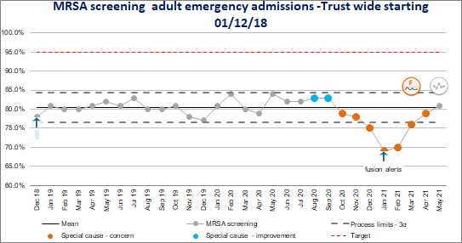
Average Admission screening rates by month

Estimated average weekly rates of screening complance based on manual checks of inpatient areas
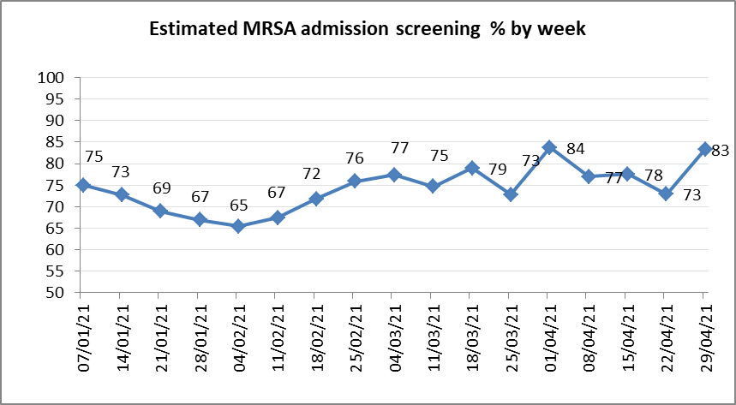

Actions to improve compliance:

  - Infection Prevention focus of the month for June will be on screening for different alert organisms, including MRSA.
  - Fusion alerts in place to prompt screening required.

Rapid testing for other infections

  - Molecular testing for rapid identification of Norovirus or Influenza is not currently available. Samples from suspected cases require processing via Black Country Pathology service leading to potential prolonged bay/ward closures pending results.
Screening for other alert organisms and clinical samples

During recent Infection Prevention and Control reviews, colleagues have shared concerns regarding different samples not being processed, including catheter specimen of urine (CSU), wound samples, VRE screens and MRSA screens. The correct process to follow for each of these has been confirmed with Black Country Pathology Service and this is being communicated across the Trust through a number of channels to ensure all staff understand the process to follow.
Ventilation

Ventilation in the older parts of the Hospital estate (West Wing) is poor. In order to address this during the colder month’s air disinfection units were placed in ward bays. Spot checks identified that these are not always switched on.
In June 2021, the air disinfection units have been replaced with air conditioning units to support a more comfortable room temperature for patients and staff during the warmer months. The air conditioning units require windows to be open as the hose connected to the units need access to outside. This allows for natural ventilation to the clinical areas.
A ventilation group has recommenced, consisting of estates, facilities, consultant microbiologist and infection prevention and control representation. The group will continue to review assurances around ventilation in the healthcare environment and support long term planning to improve.
Inpatient environments

The old estate and current poor condition of many of the wards has resulted in a number of department environment audits not achieving >90% compliance score. The Infection Prevention and Control Team are currently undertaking full ward audits as part of Quarter One annual programme of work plans. The limited availability of side rooms in the Trust can lead to an inability to isolate all patients who require isolation in a timely manner.
Actions to improve compliance:

    - Estates issues highlighted on audit reports and shared with divisions and estates team.

    - IPC supporting upcoming refurbishment plans.
    - Further review of the healthcare environment being undertaken via ATP testing. Testing on Wards 1 and 9 demonstrated a higher count of environmental contamination on surfaces that were worn and damaged in comparison to undamaged/cleanable surfaces.
    - Plans for Estates IPC group to be commenced where minutes and actions shared at IPC Committee.
    - Full report of Quarter One environment audits will be shared at IPC Committee.
Outbreaks during Quarter One

Norovirus Full ward Closures - None

Bay Closures - Increased diarrhoea and vomiting - None COVID Full ward closures – None
Bay closures due to COVID: April 2021 – 5
May 2021- 6
June 2021 – 0 at time of writing report

There have been no confirmed cases of transmission resulting from any of the bay closures during this time
MRSA outbreak:

During May/June 20216 cases of MRSA colonisation have been identified in patients on Ward 11. 2 cases of colonisation were initially identified on 28th May 2021 through routine inpatient screening and a further 4 were identified as part of the outbreak management process.. Following notification of the results, the IPCT completed a serious incident and commenced the outbreak review process. Outbreak meetings have been established to review actions with Trust and external colleagues in attendance.
VRE outbreak:

During May 2021, 2 patients had clinical samples obtained that were classified as hospital acquired VRE. A serious incident was completed and the outbreak review process commenced. Outbreak meetings have been established to review actions with Trust and external colleagues in attendance. All patients identified as contacts have been tagged on the ICNet system to prompt the requirement of screening if they are readmitted within the next 12 months.
COVID-19 HCAI Deaths

The Trust is required to report and investigate all Covid-19 HCAI deaths as a serious incident.

Definitions of HCAI acquired COVID-19 infection are:

8-14 days post admission – Probable Healthcare Associated 15 + days – Trust acquired.
The IPC Team are currently reviewing all COVID -19 HCAI reported deaths to identify opportunities to learn and improve patient outcomes and process.
Infection Prevention and Control Audit Programme: Quarter One Progress

The table below shows the audit plan for 2021/22. In addition to this, the Infection Prevention and Control Team will undertake audits based on incidents or obtaining assurances on updated infection prevention guidance/policy.

Audit | Location | Plan | Related  Compliance Criterion | Related  Strategic Theme | Q1  Progress
Full ward audit | All inpatient wards | To be completed by August 2021 | 1,2,6,9 | Infection Prevention in the Environment,  Hand Hygiene | 76%  completed
Community audits | Community clinics and units | To be completed by October 2021 | 1,2,6,9 | Infection Prevention in the Environment,  Hand Hygiene | To be completed during Q2
Full departmental audits | Acute site departments | To be completed January 2022 | 1,2,6,9 | Infection Prevention in the Environment,  Hand Hygiene | To be completed during Q3
Ward kitchens | Inpatient wards | To be completed by March 2022 | 1,2,9 | Infection Prevention in the Environment,  Hand Hygiene | To be completed during Q4
Support services cupboards | Inpatient wards | To be completed by March 2022 | 1,2,9 | Infection Prevention in the  Environment, Hand Hygiene | To be completed during Q4
Hand hygiene | Acute site | Quarterly: June 2021 September 2021  December 2021  March 2022 | 6,9 | Hand Hygiene, Invasive Devices | Q1 report for completion 30.06.21
Compliance to wearing personal | Acute site | Quarterly: June 2021 September | 6,9,10 | Hand Hygiene, Invasive | Q1 report for completion

protective equipment (PPE) |  | 2021  December 2021  March 2022 |  | Devices | 30.06.21

IPC Annual Report and Annual Programme of Work

The IPC Annual Report for 2020-2021 and the Annual Programme of Work for 2021- 2022 were approved by the IPC Committee on the 18th June 202. The Annual Report is attached at Appendix 1.
Progress against the Annual Programme of Work will be overseen by the IPC Committee.
NHSE/I Visit Plan

NHSE/I undertook a review of IPC practice in maternity services during 2019 with an overall “red” rating. This has led to a range of actions from maternity services to improve standards of practice, decontamination and management of the healthcare environment. NHSE/I have postponed a further review over the last 12 months due to COVID-19.
A visit has been scheduled for 22nd June 2021. During this visit they will review maternity services, wards 11 and 4, the paediatric wards and any other areas they choose.
Initial feedback is expected on the day and the written report will be shared as soon as it becomes available.

Appendices:

IPC Annual Report 2020-2021



Infection Prevention & Control Annual Report 2020/21

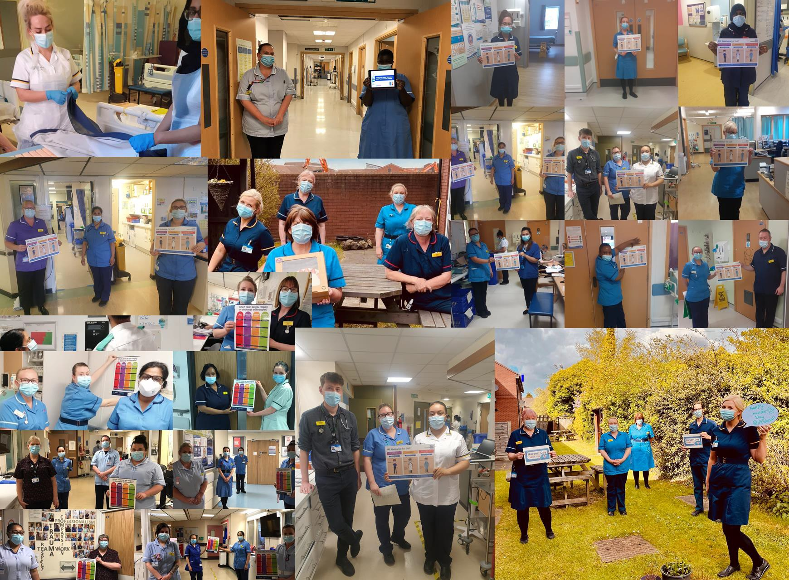

Ann-Marie Riley,
Director of Infection Prevention & Control

Amy Wallett,
Head of Infection Prevention and Control

Louise Fox,
Clinical Lead Nurse Infection Prevention and Control

Dr Aiden Plant, Consultant Microbiologist

Dr Stephen Jones, Consultant Microbiologist

Infection Prevention & Control Annual Report 2020-21

Contents
1.0 | Executive Summary | Page 3
2.0 | Introduction | Page 3
3.0 | Reporting Arrangements | Page 4
4.0 | Infection Prevention and Control Team Structure | Page 4
5.0 | Links to Clinical Governance/Patient Safety | Page 5
6.0 | Infection Prevention and Control Committee | Page 5
6.1 | Decontamination Group | Page 5
6.2 | Antimicrobial Stewardship | Page 6
6.3 | Water Safety Group | Page 10
6.4 | Annual Work Plan | Page 11
6.5 | Assurance Framework for Infection Prevention and Control | Page 11
7.0 | Hospital acquired Clostridioides difficile | Page 12
8.0 | Meticillin Resistant Staphylococcus Aureus (MRSA)  bacteraemia | Page 13
9.0 | Meticillin Sensitive Staphylococcus Aureus (MSSA)  bacteraemia | Page 14
10.0 | E.coli bacteraemia | Page 14
11.0 | Klebsiella species bacteraemia | Page 15
12.0 | Pseudomonas bacteraemia | Page 15
13.0 | Carbapenemase-producing Enterobacterales (CPE) | Page 16
14.0 | Vancomycin Resistant Enterococcus (VRE) | Page 16
15.0 | Infection Prevention Acute Services Audits | Page 17
16.0 | Viral outbreaks of Infection (including COVID-19) | Page 18
17.0 | Surgical Site Surveillance | Page 19
18.0 | Education | Page 19
Appendix
Appendix 1 | Terms of Reference for Infection Prevention and Control Committee | Page 21
Appendix  2 | Antimicrobial Stewardship Team Strategy Work Plan | Page 23
Appendix 3 | Reporting Structure for Infection Prevention and Control Committee | Page 27
Appendix  4 | Annual plan of work 2021/2022 | Page 28

1.0. Executive Summary

- The Annual Infection Prevention and Control (IPC) Report reports on infection prevention and control activities within Walsall Healthcare NHS Trust for April 2020 to March 2021. The publication of the IPC Annual Report is a requirement to demonstrate good governance, adherence to Trust values and public accountability.

- The following organisms are subject to mandatory reporting. These are MRSA, MSSA, Clostridiodes difficile and Gram-negative bloodstream infections (Escherichia coli, Klebsiella species, Pseudomonas aeruginosa).

- The Trust has achieved the planned infection prevention and control activities outlined in the annual programme 2020/21 including planned audits, teaching sessions and undertook additional duties to support the Trust in response to the COVID-19 pandemic.

- The Trust experienced 2 cases of MRSA bacteraemia during 2020-21 against a target of zero.

- There were 32 toxin positive reportable cases of Clostridium Difficile (C. diff) against a trajectory of no more than 29 cases, ending the year 3 cases over trajectory.

- Mandatory surgical site surveillance was completed in elective orthopaedic hip and knee replacements for 1 quarter; no infections were identified.

- During 2020/21 the COVID-19 pandemic was a challenging year for the IPC team and Trust wide services, posing additional demand in the prevention and control of infection within healthcare premises.

- The Trust is currently rated red by NHS England and Improvement for Infection Prevention and Control following a review of maternity services in 2019. The Trust is due to be visited during the 2021/22 financial year for a review of infection prevention.

2.0. Introduction

Healthcare Associated Infections (HCAI) can cause harm to patients, compromising their safety and leading to a suboptimal patient experience and increased length of stay in hospital. Maintaining low rates of HCAI remains a cornerstone of the Trust’s approach to providing safe, high quality care across all the services. The Trust has been working hard to improve infection prevention and to raise the rating by NHSI to green. This report acknowledges the hard work and diligence of all grades of staff, clinical and non-clinical who play a vital role in improving quality of patient experience as well as helping to reduce the risk of acquiring an infection. Additionally, the Trust

continues to work collaboratively with a number of outside agencies as part of its IPC and governance arrangements.

3.0. Reporting arrangements

The Infection Prevention & Control Team (IPCT) is based at the Manor Hospital site. The team works closely with all Trust colleagues and external contractors to support a vision of no person being harmed by an avoidable infection. The service provides IPC support to the Manor Hospital site and the community services provided by the Trust.. In addition, they work closely with Walsall Council’s Health Protection team to deliver a health economy approach to infection prevention strategies.

The role of Director of Infection Prevention and Control (DIPC) was undertaken by the Medical Director until January 2021 when the role moved to the Director of Nursing. Both Directors report directly to the Chief Executive on matters pertaining to infection prevention and control in line with the requirements of the Health and Social Care Act 2008. The role of Deputy DIPC is undertaken by the Head of Infection Prevention and Control. The new Head of IPC commenced in post in March 2021.

The Infection Prevention and Control Committee (IPCC) is chaired by the DIPC or Deputy DIPC and met monthly during 2020-2021.

4.0. IPC team structure 2021

During 2020, a business case was approved to expand the Infection Prevention nursing team to support the delivery of the annual programme in addition and ensure its continued ability to respond to the needs of the Trust in relation to all IPC matters including infection incidents such as outbreaks. The IPC structure for 2021 is detailed below. Recruitment into posts was achieved at the end of March 2021.

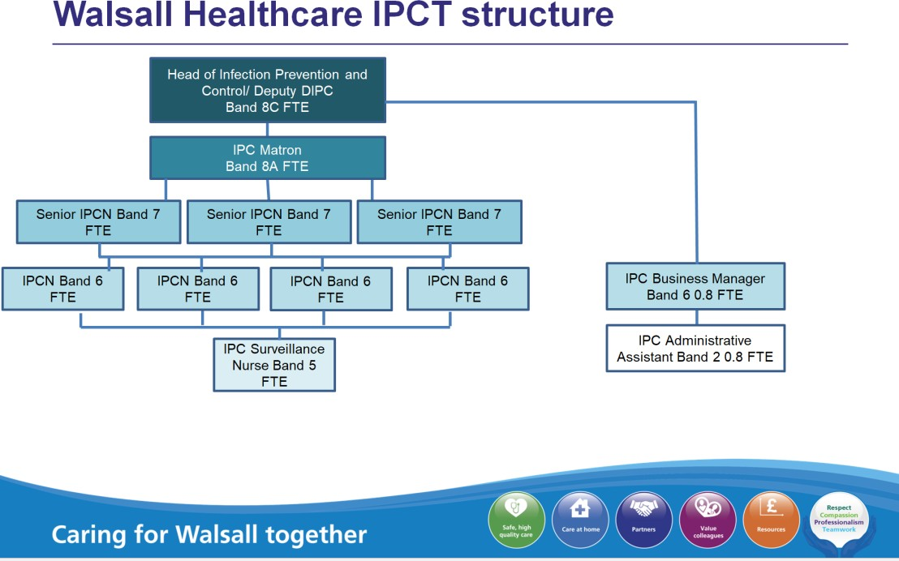

5.0. Links to Clinical Governance/Risk Management/Patient Safety

The DIPC is a member of the Quality, Patient Experience and Safety Committee and Infection Prevention and Control specialists attend the Health and Safety Committee and Divisional Quality Boards.

Monthly reports are prepared by the IPCT and presented to the IPCC, the Quality, Patient Experience and Safety Committee and the Board. Ad hoc reports and audit requests are also undertaken to meet service requirements.

  - Infection Prevention and Control Committee (IPCC)

The role of the IPCC is to provide strategic direction for the prevention and control of Healthcare Associated Infections (HCAI) in Walsall Healthcare Trust. The committee members ensure a confirm and challenge approach and assurance that the Trust meets the requirements and mandates of the National Infection prevention and control standards and the Trust’s own policies and procedures. It ensures that there is a strategic response to new legislation and national guidelines. In addition, the committee seeks assurance from the divisions and ensures compliance with the Health and Social Care Act 2008. Terms of reference (ToR) for the IPCC can be found in Appendix 1.

Compliance with The Health and Social Care Act is measured using the hygiene code. A full assessment of this was undertaken during 2020/21 by capturing compliance with the Health and Social Care Act criterion within the Infection Prevention and Control Board Assurance Framework (BAF).

  - Decontamination Group

The Hospital Sterilisation Disinfection Unit (HSDU) is a purpose built building that is situated opposite the main hospital. The HSDU is ISO 13485:2016 accredited and provides a service to Walsall Healthcare and the Community. The HSDU is audited on a yearly basis by our external auditors, who provide an inspection, verification, testing and certification company. In addition the Trust conducts monthly internal audits undertaken by our own trained internal auditors. This assurance process includes yearly management review meetings to address non-conformances, supplier failures, quality performance, education & training, customer feedback, Medicines Health Products and Regulatory Authority (MHRA) alerts, water safety and any new legislation. Discussions also take place regarding any departmental changes and improvements that can be made to the service. This review is reported to the external auditors and quarterly to IPCC. .

The HSDU provides decontamination services (over 7 days) throughout the Trust with the main customers being Theatres.

The HSDU also provides an endoscope decontamination service for Endoscopy, ENT, Urology and Theatres (over 6 days) which was Joint Advisory Group on Gastrointestinal Endoscopy (JAG) accredited in April 2019.

Decontamination group meetings take place quarterly and cover all aspects of decontamination throughout the Trust and reports to IPCC.

  - Antimicrobial Stewardship Group

Antimicrobial resistance (AMR) arises when the organisms that cause infection evolve ways to survive treatments. The term antimicrobial includes antibiotic, antiprotozoal, antiviral and antifungal medicines.

Resistance is a natural biological phenomenon but is increased and accelerated by various factors such as misuse of medicines, poor infection control practices and global trade and travel.

This is a particular concern with antibiotics. Many of the medical advances in recent years, for example, organ transplantation and cancer chemotherapy need antibiotics to prevent and treat the bacterial infections that can be caused by the treatment. Without effective antibiotics, even minor surgery and routine operations could become high risk procedures if serious infections can’t be treated.

The UK’s 20-year vision and 5-year national action plan on AMR 2019-2024 were co- developed across government, its agencies, the health family and administrations in Scotland, Wales and Northern Ireland with support from a range of stakeholders. The national action plan builds upon the UK 5-year AMR strategy (2013 to 2018) and sets out the first step towards the UK’s vision for AMR in 2040. It focuses on three key ways of tackling antimicrobial resistance:
    - Reducing need for, and unintentional exposure to, antimicrobials
    - Optimising use of antimicrobials; and

    - Investing in innovation, supply and access

The plan also sets out key measures of success to ensure progress towards the 20-year vision which include:
      - Halve healthcare associated Gram-negative blood stream infections
      - Reduce the number of specific drug-resistant infections in people by 10% by 2025
      - Reduce UK antimicrobial use in humans by 15% by 2024
      - Be able to report on the percentage of prescriptions supported by a diagnostic test or decision support tool by 2024

Antimicrobial Stewardship Team (AMST); governance and reporting

The Antimicrobial Lead is Dr. Aiden Plant. Dr. Plant and the lead Antimicrobial Pharmacists meet weekly and report monthly to the Medicines Management Group which is chaired by the Medical Director. The AMST also provides clinical governance support to the Outpatient Parenteral Antimicrobial Treatment (OPAT) team in the form of virtual ward-rounds and critical review of OPAT referrals from in-patients.
The Antimicrobial Pharmacists participates in a regional antimicrobial pharmacist forum and monthly meetings which feed into a national group.
There is a daily consultant microbiologist ward round Monday-Friday, and a weekly Clostridioides difficile ward round.
The Trust has an Antimicrobial Strategy which provides a framework to support appropriate antimicrobial use across the organisation.
The Trusts Antimicrobial priorities for 2020/2021 and continuing into 2021/1022 include:
      - update and maintain the MicroGuide antimicrobial formulary. All sections were revised in August 2020 and there has been one update since
      - Improve recording of allergy, including nature of allergy
      - Improve documentation of antimicrobial indication and intended duration
      - Improve evidence of antimicrobial review within 72 hours
      - Reduce consumption of high-profile antimicrobials

In addition, in 2020/2021 Patient Group Directions (PGDs) for antimicrobial treatment of neutropenic sepsis and management of sexually-transmitted infections were peer- reviewed and ratified by the AMST.
Performance measures are reported monthly and our progress to date is as follows:

- Charted allergy; including nature:
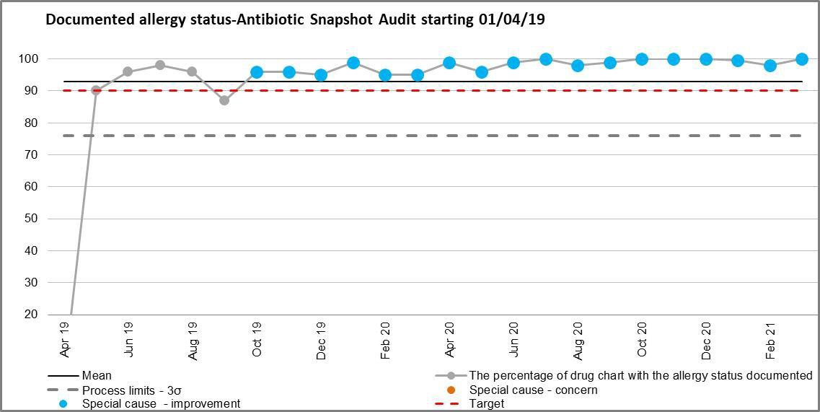

  - Charted indication:
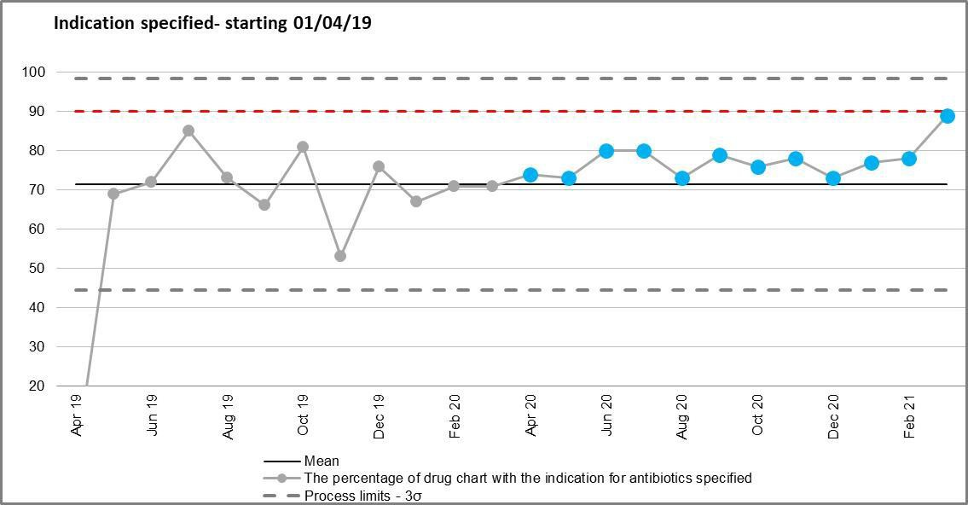

  - Evidence of review within 72hrs:
Apr 18
Jun 18
Aug 18
Oct 18
Dec 18
Feb 19
Apr 19
Jun 19
Aug 19
Oct 19
Dec 19
Feb 20
Apr 20
Jun 20
Aug 20
Oct 20
Dec 20
Feb 21
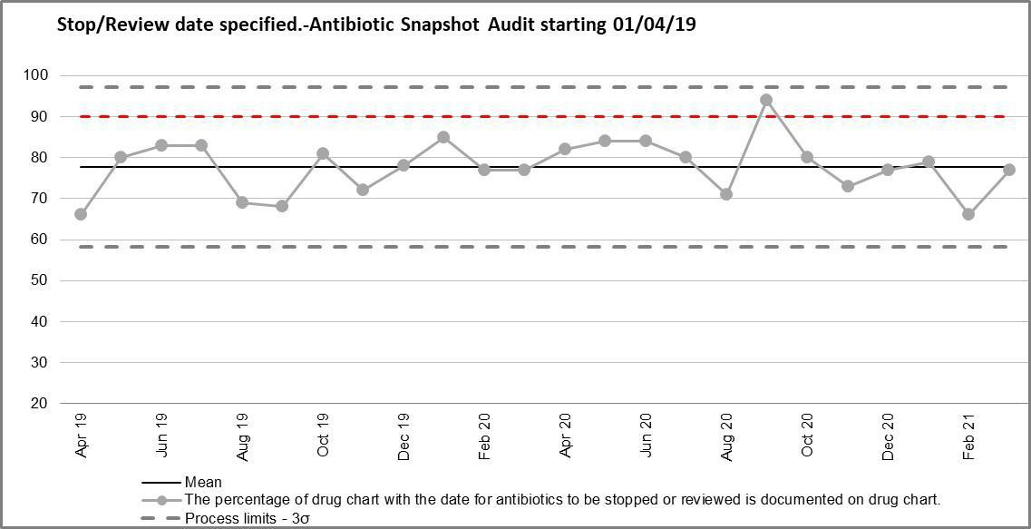

- Consumption of high-profile antibiotics:
Chart Title
Total IV antimicrobial use across the Trust- starting 01/04/18
22,000
17,000
12,000
7,000
Mean
Process limits - 3σ
C
Special cause - concern

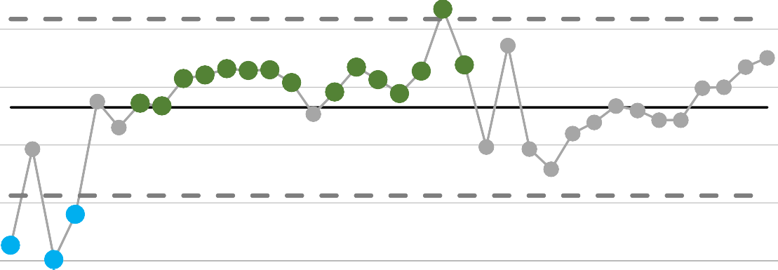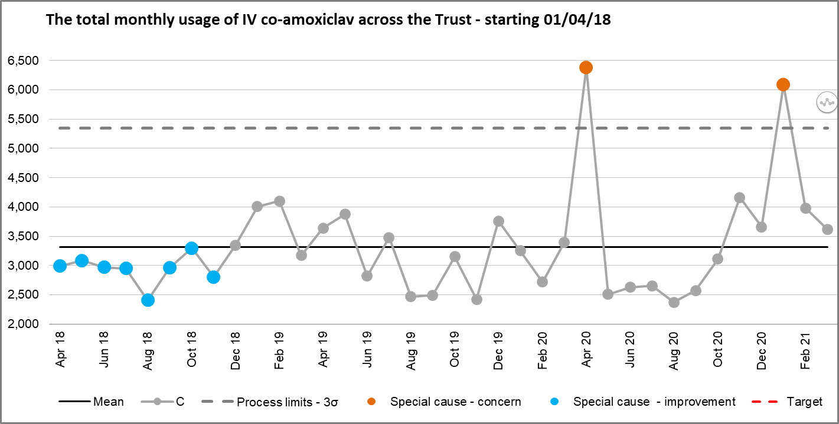
Chart Title
Monthly usage of Piperacillin Tazobactam across the Trust-B starting
01/04/18
4,010

3,010

2,010

1,010

10
Mean
Process limits - 3σ
C
Special cause - concern
Apr 18
Jun 18
Aug 18
Oct 18
Dec 18
Feb 19
Apr 19
Jun 19
Aug 19
Oct 19
Dec 19
Feb 20
Apr 20
Jun 20
Aug 20
Oct 20
Dec 20
Feb 21

Chart Title

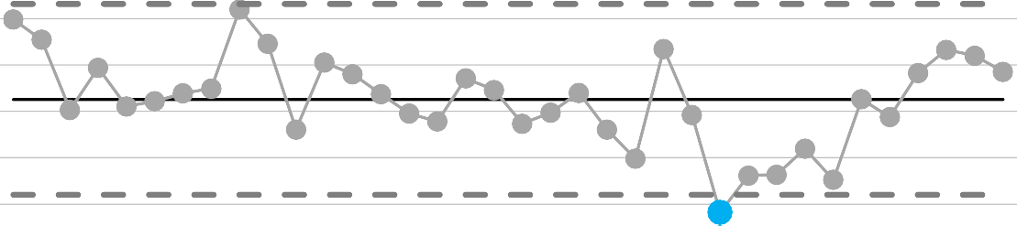The AMST priorities for 2021/2022 are outlined in the current annual strategy (Appendix 2).
The total monthly usage of Carbapenem across the Trust - starting
1,400
1,200
1,000
800
600
400
200
0
01/04/18
Mean
Process limits - 3σ
C
Special cause - concern
Apr 18
Jun 18
Aug 18
Oct 18
Dec 18
Feb 19
Apr 19
Jun 19
Aug 19
Oct 19
Dec 19
Feb 20
Apr 20
Jun 20
Aug 20
Oct 20
Dec 20
Feb 21

  - Water Safety group

The Water Safety Group provides a forum in which people with a range of competencies can be brought together to share responsibility and take collective ownership for ensuring water related hazards are assessed and monitoring/control measures developed and instigated.

The aim of the Water Safety Group is to ensure the safety of all water used by patients, visitors, relatives and staff, to minimise the risk of infection associated with waterborne pathogens across WHT estate.

The Group meet on a monthly basis and work closely with the Infection Prevention Team. The group’s remit is to:
    - Ensure the Water Safety Plan is reviewed.
    - Review and action risk assessments and other associated documentation.
    - Review new builds, refurbishments, modifications and equipment and ensure they are designed, installed, commissioned and maintained to the required standards.
    - Ensure maintenance and monitoring procedures are in place.
    - Surveillance of environmental monitoring, specifically in respect of determining water sampling requirements and agreeing location of augmented areas.
    - Ensure augmented units within the Trust are tested monthly and results are reviewed and actioned as required.

The remit will include all elements as per Section 6.9 of Health Technical Memorandum 04-01 Part B 2016.

  - Assurance Framework for Infection Prevention and Control

The framework can be found in Appendix 3 and demonstrates the reporting structure for the IPCC.

  - Annual work plan

An annual work plan runs throughout the financial year; it is prepared by the IPCT, agreed each year by the IPCC and approved by the Board. And can be found in appendix 4

7.0. Hospital acquired Clostridioides difficile

The graphs below identify Clostridioides difficile hospital attributed toxin positive specimens at the Manor Hospital between April 2020 and March 2021.
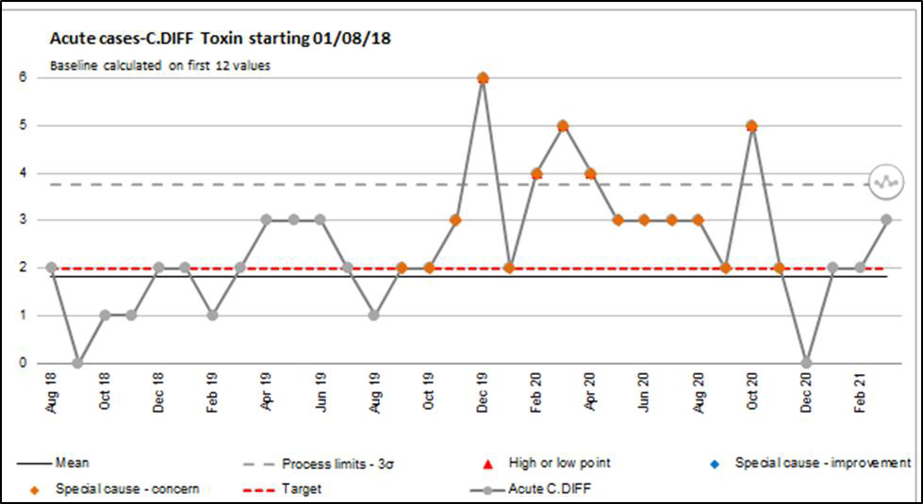
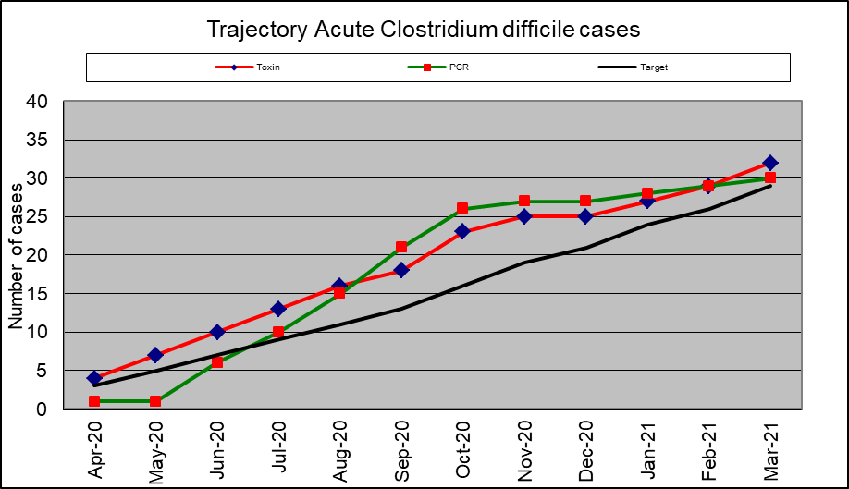

The Trust carries out reviews of all Trust apportioned C.difficile cases and a multidisciplinary review is undertaken to investigate cases where new lessons can be learnt. These are reported to the divisional quality meetings and at IPCC.

Total Acute Toxin cases | 32
Avoidable | 5
Unavoidable | 27

Between April 2020 and March 2021 there have been 32 cases confirmed of acute C.difficile
Toxins against annual trajectory of 29.

Of the 36 cases 27 were deemed unavoidable and 5 avoidable.

Avoidable cases
- 4 inappropriate acute prescribing of antibiotics with failure to review therapy
- 1 community onset with delay in obtaining specimen, leading to meeting acute acquired criteria

Common Trends in Risk Factors
- Multiple antibiotics in last 6 weeks
- Over 65
- Proton Pump Inhibitor (PPI)
- Previous history of C.difficile

Trend issues and learning in the Trust
- Delay in sending specimens for C.difficile testing
- Failure to isolate patient when specimen was obtained (due to unavailable isolation facilities, these are captured in incident reports).
- Failure or delay in sending clinical specimens to confirm correct antibiotic therapy / confirmation of infective organism
- Inconsistent review of antibiotic therapy

Actions that have been taken to address the issues have included:

  - Feedback of learning to divisions
  - Ward based education
  - Antimicrobial Stewardship
  - Daily side room checks by IPCT
  - Capacity access to ICNet

  - Meticillin Resistant Staphylococcus Aureus (MRSA) bacteraemia

There were 2 cases of MRSA bacteraemia (blood-stream infection) attributed to the Trust during 2020-21.

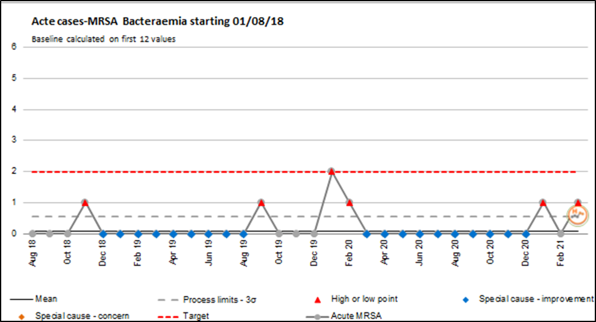

Root causes

Case 1 – Infected Peripherally Inserted Central Catheter (PICC) line Case 2 – Contaminated blood culture

Learning points
    - Need to reduce incidence of blood culture contamination through education, retraining, competencies (captured in 2021-2022 annual programme of work).
    - Improve care and monitoring of intravenous devices.
    - Need for review of vascular access policy
    - Need for development of vascular access group.

Actions taken
    - Education
    - Blood culture task and finish group
    - Review of competencies
    - Review of procedure

9.0. Meticillin Sensitive Staphylococcus Aureus (MSSA) bacteraemia

A total of 15 hospital associated cases were reported in 2020-2021 compared to 19 reported 2019-2020.

This represents a reduction of hospital cases by 4 in 2019-2020.

There were no local or National mandatory reporting trajectories for MSSA during 2020/2021 however it is anticipated that there may be National trajectories for 2021-2022.

The Infection Prevention & Control Team aims to maintain low rates of MSSA and investigate all cases to ascertain if there are further actions that can be taken. Performance of MSSA bacteraemia continues to be monitored at the Infection Prevention and Control Committee.

All cases are reviewed on an individual basis to identify the cause and if there are any lessons to be learnt.

6 of the reported cases in 2020-2021 were reported as avoidable and 9 unavoidable.

Root cause of avoidable cases:
- 3 contaminated specimens
- 2 infected peripheral vascular devices
- 1 related to invasive procedure undertaken

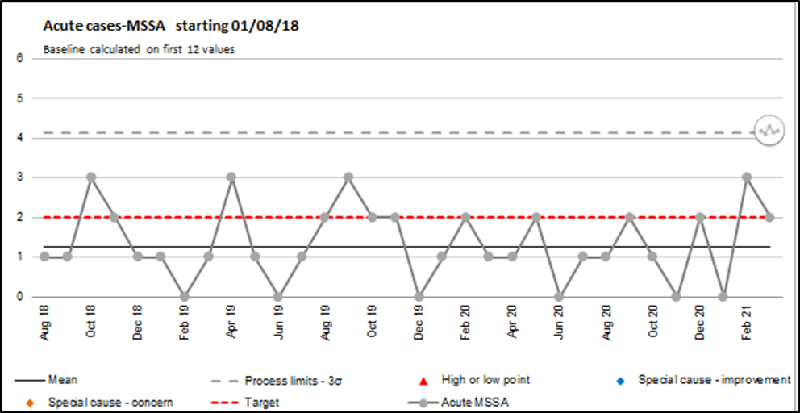

10.0. E.coli bacteraemia

Reporting of E.coli bacteraemia has been mandatory since June 2011. All cases are reviewed and a table top review completed if the patient dies and E.coli is indicated as a cause of death or areas of concern are identified during the review.

There is no national or locally agreed acute target for E.coli bacteraemia however the objective of the Trust is to reduce the numbers of cases on a year by year basis

There were a total of 38 hospital attributed cases of E.coli bacteraemia in 2019-2020 compared to 31 in 2020-2021 a reduction of 7 cases. All cases are reviewed on an individual basis regarding cause. If there are any lessons to be learnt including whether these could have been avoided, these are shared across the Trust.
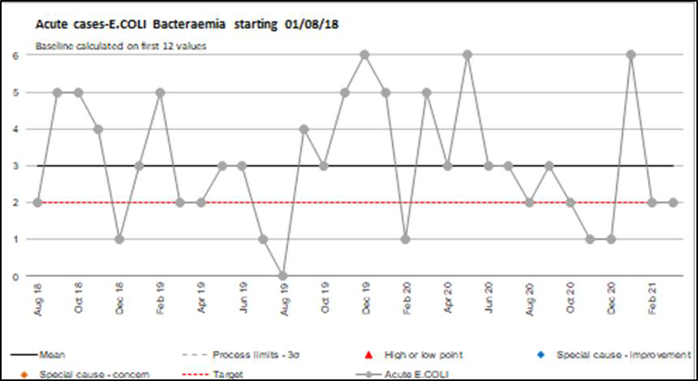

11.0. Klebsiella species

Reporting of Klebsiella Species bacteraemia has been mandatory since April 2017. During 2020/2021 the Trust reported 15 acute cases which is a decrease of 1 case from 2019/2020 when 16 cases were reported

All cases are reviewed and a table top review completed if the patient dies and this organism is indicated as a cause of death or areas of concern are identified during the review.
The increase in April was investigated to check for any links between cases, outcome of investigation was that cases were not linked

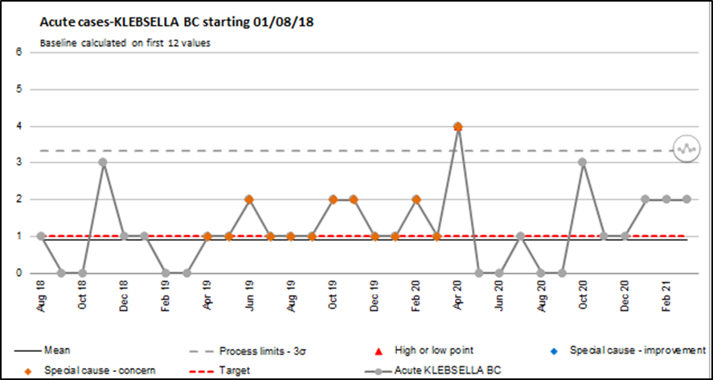

12.0. Pseudomonas

Reporting of Pseudomonas aeruginosa bacteraemia has been mandatory since April 2017. A total of acute 8 cases were reported in 2020/2021

All cases are reviewed and a table top review completed if the patient dies and this organism is indicated as a cause of death or areas of concern are identified during the review.
The increase in January was investigated to check for any links between cases, outcome of investigation was that cases were not linked

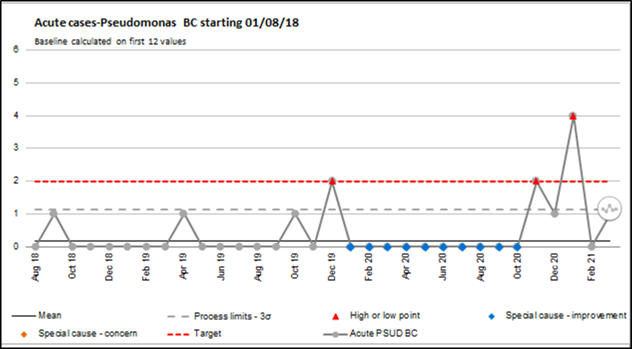

13.0. Carbapenemase-producing Enterobacterales (CPE)

CPE can spread rapidly in healthcare settings and lead to poor clinical outcomes due to limited therapeutic options. Increased incidence or CPE has significant cost and operational implications for healthcare providers. The Trust closely monitor for CPE by undertaking screening based on risk factors to promptly identify and isolate patients who are colonised with the organism.
There were no acute CPE cases reported during 2020/2021compared to 2 cases in the previous year.
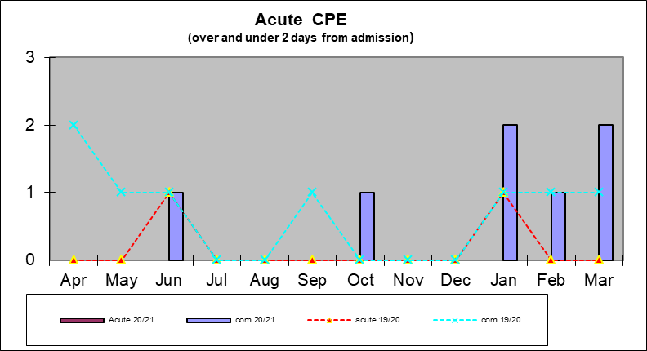

14.0. Vancomycin Resistant Enterococcus (VRE)

Enterococci are intrinsically resistant to many antibiotics and treatment options are always limited, usually being sensitive to Amoxicillin, Teicoplanin and Vancomycin and a few other reserve antibiotics.

Sometimes Enterococci develop resistance to these first line antibiotics. VRE stands for Vancomycin Resistant Enterococcus and this usually denotes that the organism isolated has developed resistance to Amoxicillin, Teicoplanin and Vancomycin. Glycopeptide Resistant Enterococcus (GRE) is another term used as Teicoplanin and Vancomycin are classed as

Glycopeptide antibiotics. With subtle technical differences, the two terms amount to the same thing and are often used interchangeably.

As infections caused by these organisms are difficult to treat requiring 2nd or 3rd line antibiotics, and because of the potential for environmental contamination and nosocomial transmission they are regarded as an Infection Control priority. Rapid identification of patients carrying VRE within the Trust and imposition of comprehensive infection control barriers/ precautions is therefore essential. The Trust monitors patients with a previous history by screening and isolating on a new admission to hospital.
There were 8 acute VRE cases reported during 2020/2021compared to 15 cases in the previous year
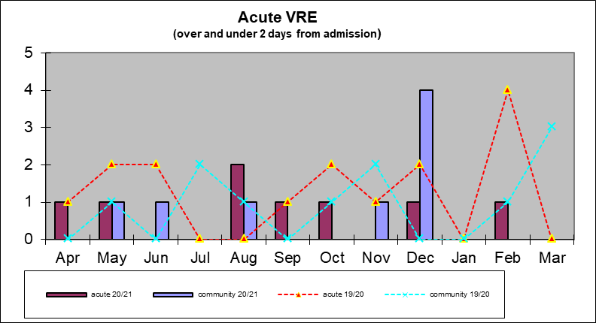

15.0. Acute Services Infection Prevention audits

The following infection prevention audits were undertaken during 2020/2021 covering the Manor Hospital site. A comparison to similar audits undertaken during the previous year is provided in the table below.

Audit results are shared with Heads of Service and are reported to and discussed at Infection Prevention and Control Committee and Divisional Quality team meetings.

Any non-compliance is fed back to the area at the time of audit. These annual audits are in addition to the monthly observational audits for all ward areas which were undertaken by the Infection Prevention & Control Team throughout the year in conjunction with Matrons.

Audit | 2020/2021 | 2019/2020 | Trajectory
Sharps | 100 | 88
Isolation | 99 | 97
PPE | 96 | 84
Patient Equipment | 94 | 92
Waste | 90 | 91
Linen | 95 | 93
Environmental | 89 | 85

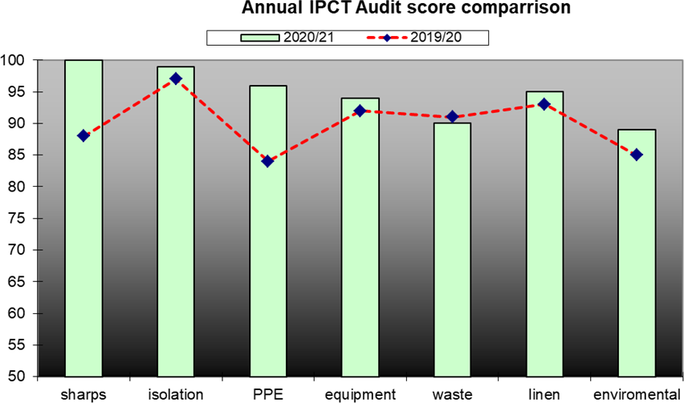

16.0. Viral outbreaks of Infection

The IPCT recognises and responds to any significant episode, incident or outbreak of infection. Incidents and outbreaks may be reported in several different ways: by the clinical areas, through microbiology results and IPC visits to the ward. All outbreaks and incidents are included in the IPCT monthly reports and reported via the Infection Prevention and Control Committee.

Outbreaks of Healthcare Associated Infection are reported via the Trust’s incident reporting arrangements as serious incidents. An outbreak report is also prepared for the Infection Prevention and Control Committee for significant outbreaks to ensure any relevant lessons are learnt. An outbreak committee is convened to manage and monitor the situation.

Outbreaks of infection, for example Norovirus, influenza or periods of increased incidence of Clostridium difficile are classified as serious incidents and reported on the serious incident reporting system STEIS. A full investigation and 50 day report is subsequently submitted.

Norovirus
No closures due to norovirus.

Influenza
No closures due to influenza.

COVID-19

In December 2019 a novel coronavirus (COVID-19) caused an outbreak in Wuhan, China, and soon spread to other parts of the world.

The Trust followed National guidance regarding precautions that needed to be taken to prevent the spread of the virus. The infection prevention and control team increased the service by providing additional cover over weekends and evenings. The IPC team supported the Trust and clinical areas with management of patients, providing data required for the National Sitrep and

attending tactical meetings (both in the acute and the Community), responding to actions required accordingly.

In April 2020 the number of cases continued to rise in the UK (first wave) and between October and February 2021 a second wave was nationally experienced. The number of reported COVID- 19 infections and admissions to hospital have started to decline both nationally and locally with the introduction of vaccination and other National lock down measures including wearing masks, social distancing and restrictions on movements and gatherings in public places.

The impact of COVID-19 on the Trust resulted in a total 23 ward closures plus multiple bay closures.

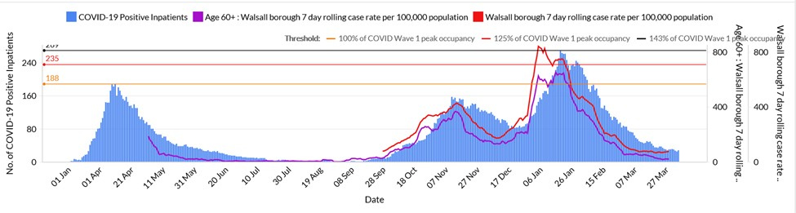

Compliance with standards to prevent transmission of COVID-19 is monitored by the Infection Prevention and Control Team by undertaking assurance audits of practice in different Walsall Healthcare settings based on the standards set out in updated National guidance.

17.0. Surgical Site Surveillance

In 2004 it became a mandatory requirement for all Trusts undertaking orthopaedic surgery to conduct surveillance of surgical site infections, using the Surgical Site Infection (SSI) Surveillance Service of Public health England, (PHE). The data set collected as part of the surveillance is forwarded to Public Health England (PHE) for analysis and reporting. Surveillance is divided into reporting quarters (Jan-Mar, Apr-Jun, July-Sept and Oct- Dec) and each site is required to participate in at least one surveillance period every 12 Months in at least one orthopaedic category.

In 2020/2021 the Trust completed one quarter mandatory surveillance due to COVID-19 pressures.

Reporting Period: October 2020 – December 2020
Modules completed: Total Hip Replacements and Total Knee Replacements.

Operation | Total no of cases | Surgical Site infections
Total knee replacement | 13 | 0
Total hip replacement | 14 | 0
Total | 27 | 0

18.0. Education

Education remains a core element of the work of the Infection Prevention & Control Team in both hospital and community settings.

2020/2021 was a particularly challenging year due to COVID 19: induction and mandatory training was moved into e-learning modules as face to face teaching sessions were reduced due to social distancing measures.

The IPCT contribute to the Trust Induction and mandatory updates and a range of planned and bespoke education sessions whenever a specific need arises. These included junior medical staff inductions, sessions for medical and nursing students and intravenous line care. In 2020/2021 the IPCT deliver 76 sessions virtually or in small groups plus 10 additional sessions for staff who were redeployed due to COVID-19.

The IPC team also supported Walsall public health nurses and Walsall CCG with support and education regarding COVID-19 in the nursing and residential homes within the borough.

Appendix 1
INFECTION PREVENTION AND CONTROL GROUP

TERMS OF REFERENCE: Version 2 – Reviewed June 2020
RATIFIED BY THE QUALITY, PATIENT EXPERIENCE AND SAFETY COMMITTEE ON: NEXT REVIEW DUE: June 2021

- CONSTITUTION

  - The Quality, Patient Experience and Safety Committee hereby resolve to establish a sub group of the Committee to be known as the Infection Prevention and Control Group (The Group). The Group is an executive group of the Committee and has no executive powers, other than those specifically delegated in these Terms of Reference.

- PURPOSE

  - The purpose of this group is to provide strategic direction for the prevention and control of Healthcare Acquired Infections in Walsall Healthcare Trust. It will performance manage the organisation against the Trust’s Infection Prevention and Control Strategy and will ensure that there is a strategic response to new legislation and national guidelines. In addition the committee will seek assurance from the divisions and ensure compliance with the Health and Social Care act.

- MEMBERSHIP

  - The Group will comprise:

    - Medical Director / Director of Infection Prevention and Control (DIPC) (Chair)
    - Director of Nursing or Deputy
    - Head of Infection Prevention (Deputy Director of Infection Prevention)
    - Infection Prevention Team Members
    - Consultant Microbiologists
    - Divisional Directors of Nursing
    - Allied Health Professional Representative
    - CCG Lead for Quality
    - Public Health England representative
    - Director of Public Health or Deputy
    - One representative from Local Authority
      - Health Protection Nurse
      - Public Health Consultant
    - Divisional Directors of Nursing & Midwifery (Acute & Community) – Walsall Healthcare NHS Trust
    - Antimicrobial Pharmacist
    - Occupational Health Service Manager
    - Divisional Director Estates & Facilities
    - Health and Safety Officer

    - Decontamination Lead

- ATTENDEES

  - The Group Chair may extend invitations to attend Group meetings to any individual considered appropriate to progress the work plan of the Group.

- ATTENDANCE

  - It is expected that each member attends a minimum of 75% of meetings and performance will be reported for each member in terms of attendance at the end of each financial year. A named deputy must be identified for core members of the Group and must attend when a member is unable to be present. A named deputy will count towards quorum and members or their named deputy should ensure 100% attendance.
- QUORUM

  - A quorum will be a minimum of seven representatives of which one will be an Executive Director from the Trust, one a member of the Infection Prevention and Control Team and a Consultant Microbiologist.
- FREQUENCY OF MEETINGS
  - The Group will meet formally on monthly basis. Meetings will be expected to last no more than 2 hours routinely. Cancellation of meetings will be at the discretion of the Chair and extraordinary meetings of the Group may be called by any member of the Group, with the consent of the Chair.
- CHANGES TO TERMS OF REFERENCE
  - Changes to the terms of reference including changes to the Chair or membership of the Group are a matter reserved to the Trust board.
- ESTABLISHMENT OF SUB GROUPS
  - The Group may establish sub groups made up wholly or partly of members of the Group to support its work. The terms of reference of such sub group will be approved by the Group and reviewed at least annually. The Group may delegate work to the sub group in accordance with the agreed terms of reference. The Chair of each sub group will be expected to provide a Chairs report to the Group and review its effectiveness on an annual basis.
- ADMINISTRATIVE ARRANGEMENTS

  - The Chair of the Group will agree the agenda for each meeting. The Group shall be supported administratively by the EA to the Director of Nursing who’s duties in this respect will include:
    - Agreement of agenda with Chair and attendees and collation of papers
    - Taking the action notes
    - Keeping a record of matters arising and issues to be carried forward
    - Advising the Group on pertinent issues / areas
    - Enabling the development and training of Group members

All papers presented to the Group should be prefaced by a summary of key issues and clear recommendations setting out what is required of the Group.
- ANNUAL CYCLE OF BUSINESS
  - The Group will develop an annual cycle of business for approval by the Committee meeting at its first meeting of the financial year. The Group work plans informs the standing agenda items as described within the terms of reference, to ensure that all regulatory and legislative items are adequately reviewed and acted upon.
- REPORTING TO THE COMMITTEE

  - The Chair of the Group will provide a highlight report monthly to the Committee outlining key actions taken with regard to the patient safety issues, key risks identified and key levels of assurance given.

- STATUS OF THE MEETING

  - All Groups of the Committee will meet in private. Matters discussed at the meeting should not be communicated outside the meeting without prior approval of the Chair of the Group.

- MONITORING
  - The annual report on assurance will provide a statement that enables the Group to monitor the effectiveness of the Group. This will include levels of attendance, delivery against the forward looking work programme and the management of identified risk.
- DUTIES

  - To develop an Annual Work Plan in the agreed Trust format, denoting the objectives of the Group for approval by the Committee ensuring these are aligned with the Trust’s vision, strategy and values and the relevant risks contained in the Board Assurance Framework.
  - To identify any risks and issues that may prevent the achievement of the Work Plan and ensure that they are assessed and placed on the Trust’s Risk Register and the action plan is monitored and mitigating actions are undertaken to ensure progress is made.
  - Strategic responsibilities include the development of a strategic plan for the reduction of healthcare acquired infections and will performance manage the delivery of that strategic plan.
  - Approve, review and monitor the Infection Prevention and Control Team’s annual programme of work/Code of Practice for Healthcare Associated Infection Action Plan.
  - Receive and approve the Infection Prevention and Control Annual Report in the first quarter of the following year prior to submission to the Committee and Trust Board.
  - Receive advice from the Infection Prevention and Control Team on new national policy and guidance and its implementation within the organisation, highlighting potential areas of non- compliance.
  - Address outstanding areas of non-compliance with national standards and requirements (e.g. CQC/Hygiene Code) and advise the Committee and Trust Board/Executive Team as appropriate.
  - Drive improvements through teaching and education to uphold standards in reducing HCAI, monitor SSIs and will have oversight of mandatory reporting
  - Review and ensure adequacy of the Trust’s Uniform policy.
  - Ratify Infection Prevention and Control and Occupational Health policies prior to submission to the TMB.

  - Seek assurance from quarterly and annual reports from each division on progress with the Infection Prevention and Control Annual Programme of Work/Code of Practice for Healthcare Associated Infection Action Plan and will monitor progress in implementing these plans.
  - Seek assurance from reports from each division on performance against HCAI Key Performance Indicators (KPIs), and will monitor progress in achieving targets and delivering agreed actions.
  - Seek assurance from reports from the Director of Infection Prevention and Control (DIPC) on the outcome of discussions following all HCAI Root Cause Analyses (RCAs) including receipt of the RCA Action Plan(s).
  - Receive a monthly report from the Antimicrobial pharmacist, regarding antibiotic prescribing audits and performance.
  - Receive exception reports on compliance with the National Specifications for Cleanliness (2004, revised in 2014). The Group will also receive the quarterly reports to QPES from the Matrons.
  - Seek assurance reports from the Infection Prevention and Control Team against national and local HCAI targets, use of isolation facilities, trends of infectious diseases reported from CCDC and review the work plan of the IPC.
  - Receive a highlight report and minutes of the Decontamination Group and reports by exception from the Chair of that Group in order to ensure that decontamination risks are appropriately escalated and managed.
  - Receive the minutes of the Accidental Inoculation/Exposure Group and reports by exception from the Chair of that Group in order to ensure that inoculation / exposure incidents and risks are appropriately escalated and managed.
  - Receive the minutes of the Water Safety Group and reports by exception from the Chair of that Group in order to ensure that issues are dealt with or escalated as appropriate.
  - Receive and review analysis reports on Infection Prevention and Control incidents and make recommendations for further action as necessary and appropriate.

Version Control:

Version 2.0

Reviewed by Patient Safety Group and approved July 2020.

Appendix 2

Antimicrobial Stewardship team 2020-21 strategy work plan
Strategy | Actions
Recognition of responsible antimicrobial use | - Certificate of appreciation:
Improved audit, feedback and benchmarking of antimicrobial use to clinical team | - Monthly point-prevalence audit
 | - Feedback to clinical teams via monthly/quarterly Antimicrobial Management Group
 | - Benchmarking via Antimicrobial Update presented to Infection Control Committee + Medicines Management Committee
Teaching & training;  Public engagement | - Regular rota of teaching to doctors in training
Teaching & training;  Public engagement | - Grand Round presentations
Teaching & training;  Public engagement | - Public campaign during Antibiotic Awareness Week
User-friendly antimicrobial formulary;  Updated surgical prophylaxis guidance | - New revision to current antimicrobial formulary to be published
 | - New revision to current surgical antimicrobial prophylaxis guidelines to be published
New evidence-based dose + duration recommendations | - Standard meropenem dosage: 500 mg IV q6h
New evidence-based dose + duration recommendations | - Weight-based dosing instructions to be incorporated into antimicrobial formulary
New evidence-based dose + duration recommendations | - Durations for antimicrobials to be limited to shortest possible duration on antimicrobial formulary
Better antimicrobial dosing for the sickest patients on ITU | - Introduce prolonged infusions of Tazocin, meropenem and temocillin for patients with septic shock on ITU
Quality improvement project: gentamicin use | - Develop gentamicin dosing calculator with clinical assessment on trial wards (QIP)
Empowered pharmacists, ready to make a change | - Educational update of pharmacists on improving antimicrobial prescribing, including IV-to-oral switch and avoiding unnecessary dual therapy
Empowered pharmacists, ready to make a change | - Recruit to antimicrobial pharmacist job share
An engaged & visible antimicrobial team | - Daily-to-weekly antimicrobial team ward-rounds for trouble shooting, audit, spot checks, education, etc.
A safe + reliable OPAT service | - Introduce a new policy overseeing the provision of OPAT
A safe + reliable OPAT service | - Maintain a safe OPAT service with adequate governance
New ‘discharge enabling’ antimicrobials | - Formulary application and laboratory testing of fosfomycin oral salts
Spotlight on ‘high risk’ antimicrobials: cephalosporins, quinolones, carbapenems, clindamycin, Tazocin | - Audit, feedback and restriction of cephalosporin use

Appendix 3 – Reporting Structure for IPCC
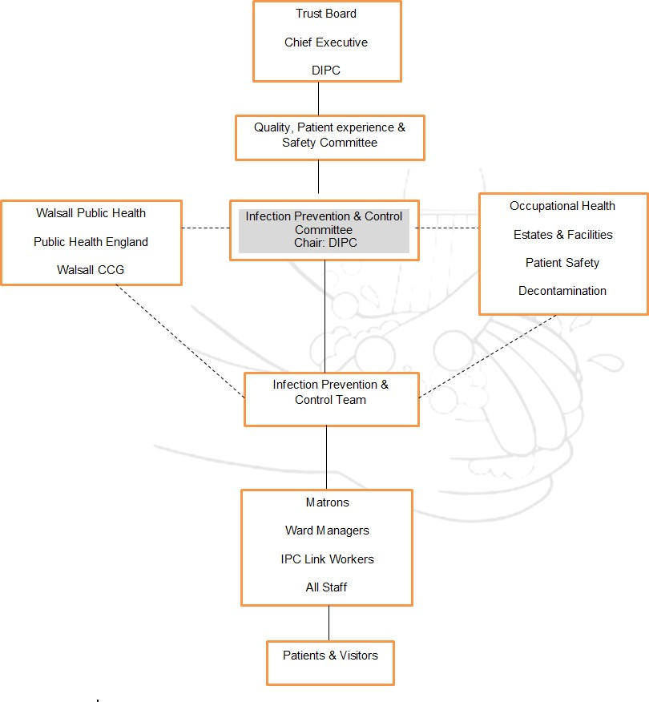



Introduction
Infection Prevention and Control (IPC) Service Annual Programme of Work April 2021 – March 2022

Infection prevention and control is a top priority for Walsall Healthcare NHS Trust. Keeping our patients safe from avoidable harm is everyone’s responsibility. In this summary document we set out our programme for the year to keep our patients, staff and the public informed of our planned activity at Walsall Healthcare.
Each year the Infection Prevention & Control Team undertakes a review of the Trust's compliance with the Health & Social Care Act 2008 Code of Practice on the Prevention and Control of Infections (2015). The team’s aim is to provide an infection prevention & control service that supports our clinical teams to deliver safe care. This annual plan covers strategic themes we have identified as areas of focus for the financial year 2021/2022. This annual programme of work for the year includes the annual plan, audit plan and our monthly themed focus plan. The programme also takes into consideration flexibility in approach whilst continuing to manage the COVID-19 Pandemic and related local actions required.

Vision
Our vision is to prevent harm from avoidable infection

Strategic themes
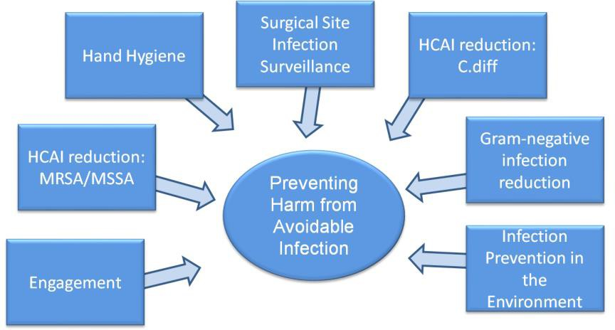Our strategic themes in 2021/2022 focus on improving outcomes for our patients and provide a framework for our operational work plan.

Compliance with the Health and Social Care Act 2008 (updated 2015)

This programme will refer each operational objective to related compliance criterion within the Health and Social Care Act Hygiene Code.

Hand hygiene

The programme will be reviewed on a monthly basis by the Infection Prevention and Control Team and feedback on progress shared at the monthly Infection Prevention and Control Committee.

Strategic Theme | Operational Objective | Action | Related Compliance Criterion
Infection Preven | Produce and implement a multimodal hand hygiene improvement strategy. Standardise hand hygiene practices and availability of materials across Trust sites.  tion and Control (IPC) Service Annual Programme of Work April 2021 – Marc | Develop a revitalised hand hygiene campaign with innovative prompts focusing on moment 1 of hand hygiene as part of the WHO 2021 Hand Hygiene Day focus.  Collaborative work between Infection Prevention and Control and Occupational Health on reducing glove use in clinical practice to promote hand hygiene in the prevention of infection, supporting staff skin health and improving sustainability. To update PPE guidance to reflect indications for appropriate glove use and promotion of hand hygiene.  Engage with colleagues in the organisation to understand perceived barriers towards hand hygiene to influence education of communication materials.  Involve patients in improving hand hygiene whilst receiving care, utilising patient experience volunteers in encouraging use of hand wipes prior to meal times and encouraging to ask health care workers to clean their hands prior to contact with them.  Clinical areas to undertake hand hygiene audits reported monthly to Infection Prevention and Control Committee. Infection Prevention and Control Team to undertake quarterly hand hygiene audits submitted to Infection Prevention and Control Committee.  h 2022 | 2, 6, 9  6,9,10  6  4  1, 6

Strategic Theme | Operational Objective | Action | Related  Compliance Criterion
HCAI Reduction: MRSA/MSSA | Strong governance processes to embed learning from incidents of MRSA/MSSA bacteraemias | Review the process for ensuring that themes identified as part of the infection review process for MRSA/MSSA bacteraemias are shared at Infection Prevention and Control Committee and Divisional Quality Meetings. | 1, 6, 9
HCAI Reduction: MRSA/MSSA | Ensure patients are screened and effectively decolonised for MRSA when admitted to the Trust | Improve full MRSA screening (including additional specimen sites) for patients admitted on an emergency care pathway.  Provide updated education on decolonisation and screening processes. Utilise the role of Infection Prevention Surveillance Nurse and ICNet to monitor MRSA screening compliance and target areas for improvement. | 1, 9  3  6
HCAI Reduction: MRSA/MSSA | Safe delivery of IV care | Review devices used within the Trust and standardise products based on current evidence base.  Develop an updated Trust education package on aseptic technique, incorporating IV access into the bundle. Infection Prevention and Control Team to continue support in delivery of IV training.  Education and monitoring of standards of line care to prevent line infections, including clear indication for continued use of IV access, VIP scoring to frequency of 3 times a day and strong supportive evidence of  aseptic technique in all aspects of insertion and ongoing care.develop a vascular access policy and vascular access group | 5  6, 9  1, 6, 9

Strategic Theme | Operational Objective | Action | Related Compliance  Criterion
HCAI Reduction: C.difficile | Strong governance and MDT processes to embed learning from incidents of C.difficile infections | Review the process for ensuring that themes identified as part of the infection review process for C.difficile infections are shared at Infection Prevention and Control Committee and Divisional Quality Meetings. | 1, 6, 9
HCAI Reduction: C.difficile | Monitor the treatment and IPC management of inpatients with a C.difficile infection | Undertake an MDT weekly C.difficile ward round, consisting of Consultant Microbiologist, Infection Prevention and Control Nurse, Antimicrobial Pharmacist and clinical team to review and advise on current patient treatment and infection prevention management within the setting. | 1, 3, 5, 6
HCAI Reduction: C.difficile | Embed learning from incidents with an updated educational campaign on C.diff | Incorporate C.difficile into Infection Prevention focus of the month, including:  - BugBuster Newsletter  -Updated education package for acute and community staff | 1, 6, 9

Strategic Theme | Operational Objective | Action | Related Compliance Criterion
HCAI Reduction: Gram negatives | Reduce the incidence of Hospital Acquired Pneumonia (HAP) at Walsall Manor Hospital. | Build on actions taken in the mouth care matters group as part of a multimodal strategy to reduce the incidence of HAP.  Undertake a point prevalence study of Hospital Acquired Infections at Walsall Healthcare to determine prevalence of HAP and identify further areas for learning. | 1  5
HCAI Reduction: Gram negatives | Water safety measures to reduce inpatient acquisition of Pseudomonas/Legionella. | Continuation of water safety groups with reports circulated to Infection Prevention and Control Committee.  Follow up process from Estates to review clinical area for any water interventions following a positive Pseudomonas case.  Water safety to be captured and reported in Infection Prevention and Control Reports.  Review of clinical area systems and processes for capturing water flushing and identification of underused outlets. | 1  2  1, 6  2
HCAI Reduction: Gram negatives | Strengthen the identification of CPE colonised patients | Review the current microbiology laboratory process for identification of CPEs, with a view to more sensitive and quicker detection Implementation of updated CPE policy to include increase in screening criteria for at risk patient groups as per updated National Guidance. | 8  5, 9
HCAI Reduction: Gram negatives | Produce a care process to reduce Catheter Associated Urinary Tract Infection (CAUTI) across the health economy. | Input from Infection Prevention and Control in the Continence Steering Group to incorporate reduction of infection associated with catheters.  Explore and implement chlorhexidine meatal cleaning for catheter insertion/care.  Incorporate focus of the month in IPC education programme to incorporate UTI awareness and reduction strategies. | 1, 6  6  5,6

 | Work across the health economy to strengthen Gram negative reduction | System wide approach to infection prevention through collaborative working with Health Protection Walsall on syndromic approaches to infection prevention. | 5

Strategic Theme | Operational Objective | Action | Related Compliance Criterion
Infection Prevention in the Environment | Validate current cleaning standards across Walsall Healthcare | Standardise and implement an updated cleaning matrix and process at Walsall Manor Hospital to deliver effective decontamination of clinical environments following discharge/transfer of patients with different infections, including implementation of UV technology.  Estates and Facilities reports to continue to be submitted for review by the Infection Prevention and Control Committee and development of an estates and facilities IPC meeting  Develop and deliver an education campaign on the importance of cleaning in the prevention of HCAI, utilising the National Cleaning for Confidence campaign.  Infection Prevention audit programme for assurance of maintaining a clean, safe environment at Walsall Healthcare. Themes shared at Infection Prevention and Control Committee. | 2  1  2, 6, 9  1, 2, 9

 | Improvement of the healthcare environment in Trust premises | Development of an Infection Prevention Environment Group to feed into Infection Prevention and Control Committee to ensure a robust process of managing Infection Prevention in the built environment. Continue IPC representation for the Trust Water Safety Group.  Infection Prevention team input through all stages of Trust refurbishment plans and purchasing of new equipment. | 1, 2  2
 | Increase isolation facilities to support increased demand for circulating infections | Infection Prevention involvement in refurbishment plans to incorporate increase permanent isolation facilities.  Develop a business case to provide temporary isolation facilities/pods during increased demand for isolation at Walsall Manor Hospital. | 7

Strategic Theme | Operational Objective | Action | Related Compliance Criterion
Surgical Site Surveillance | Embed updated process for identification and surveillance of SSI | Utilisation of ICNet, Infection Prevention Team and surgical division SSI nurse to support identification and review of SSI cases. | 1, 5
Surgical Site Surveillance | Establish a Trust wide SSI group | Create and implement a Trust wide SSI group  Undertake a Trust wide review of the One Together framework along with theatre environmental audits to share with the SSI group and Infection Prevention and Control Committee.  Collaborative working with the MDT to improve practice where learning has been identified. | 1, 6  2, 3, 6  1, 6, 9

Strategic Theme | Operational Objective | Action | Related Compliance Criterion
Engagement | Engage with divisions to support continuity in delivering infection prevention | New members of the Infection Prevention team to support a divisional structure to provide continuity of support to clinical area and build strong working relationships.  Continue to attend bed bureau/capacity meetings regularly Engage with Departments and Divisions – working together as one  IPCN to be a facilities link, providing updates to domestic services on a routine basis  Deliver an awards programme to positively recognise contributions individuals make to infection prevention and control agenda | 1,2,6,9
Engagement | Re-establish and build on the link practitioner/IPC champion programme | Create an updated Infection Prevention Champion programme. Incorporate adaptable and flexible methods to support attendance to link meetings/updates.  Trial a shift IPC champion on the acute medical unit to provide a continuous prompt for best practice in infection prevention and control. | 1, 3, 5, 6, 9
Engagement | Delivering an IPC service from highly skilled specialist nurses. | Develop close working relationship within the IPC team, through a new programme of team meetings, nurse one to ones and IPC development programme.  IPC team to deliver nursing team development programme, supporting and developing new and existing members of the IPC team, creating a  supportive environment for continuing professional development. | 1,3,5,6,9
Engagement | Ensure that front line staff receive vaccinations including Influenza and COVID-19 | Participate in the Trust flu planning groups and ensure that the vaccination programme is implemented in a timely manner, updating  campaign materials to include risks associated with combined Influenza and COVID-19 management | 1,10

 | Engage the workforce in the infection prevention and control agenda | Ensure medical staff attend and engage in table top review meetings and antimicrobial stewardship  Identify and attend medical forums to update on the IPC agenda and share learning  Identify and engage IPC leaders across different medical specialities  Deliver an IPC syndromic approach to engage the workforce, considering alternative options in education delivery including Webinar  functions. | 6  6  6  6
 | Engage patients in the infection prevention and control agenda | Participate in patient engagement forums to enable patient inclusion in the hand hygiene improvement strategy.  Work with the “Ewe” volunteers to support patient engagement in  clinical areas to encourage patient hand hygiene and increase patient awareness of standards to expect | 4

Annual audit plan

The table below shows audit plan for 2021/2022. In addition to this, the Infection Prevention and Control Team will undertake audits based on incidents or obtaining assurances on updated infection prevention guidance/policy.

Audit | Location | Plan | Related Compliance  Criterion | Related Strategic Theme
Full ward audit | All inpatient wards | To be completed by August 2021 | 1,2,6,9 | Infection Prevention in the Environment, Hand Hygiene
Community audits | Community clinics and units | To be completed by October 2021 | 1,2,6,9 | Infection Prevention in the Environment, Hand Hygiene
Full departmental audits | Acute site departments | To be completed January 2022 | 1,2,6,9 | Infection Prevention in the Environment, Hand Hygiene
Ward kitchens | Inpatient wards | To be completed by March 2022 | 1,2,9 | Infection Prevention in the Environment, Hand Hygiene
Support services cupboards | Inpatient wards | To be completed by March 2022 | 1,2,9 | Infection Prevention in the Environment, Hand Hygiene
Hand hygiene | Acute site | Quarterly: June 2021  September 2021  December 2021  March 2022 | 6,9 | Hand Hygiene, Invasive Devices
Compliance to wearing personal protective equipment (PPE) | Acute site | Quarterly: June 2021  September 2021  December 2021  March 2022 | 6,9,10 | Hand Hygiene, Invasive Devices

Infection Prevention Focus of the Month

The below schedule highlights educational campaigns the Infection Prevention and Control Team plan to deliver across Walsall Healthcare. This is based on seasonal activity, local learning and existing recognised National campaigns.
IPC activity can be found on Trust communications including Daily Dose, Intranet pages and followed on Twitter by searching for @IPCWalsall.

Month | Focus | Month | Focus
April | Clostridoides difficile | October | International Infection Control Week
May | Hand Hygiene and Glove Aware | November | Antimicrobial Resistance and Stewardship
June | Screening for Alert Organisms | December | Winter illnesses and PPE updates
July | Care of Devices and Aseptic Technique | January | Winter illnesses and PPE updates
August | Urinary Tract Infections | February | Surgical Site Infections Showcase
September | Mattresses | March | Spring into Cleaning


1

MEETING OF THE PUBLIC TRUST BOARD – 1st July 2021
Performance, Finance & Report |  | Investment | Committee | (PFIC) Highlight |  | AGENDA ITEM: 15
Report Author and Job Title: | Trish Mills, Trust Secretary |  |  | Responsible Director: |  | Mr John Dunn – Chair  of PFIC (Non- Executive)
Action Required | Approve ☐ |  | Discuss ☐ | Inform ☒ | Assure ☒
Executive Summary | This report provides the key messages from the Performance, Finance & Investment Committee meeting on 23rd June 2021. Of note are:  - Post Implementation Reviews (PIRs) of business cases were presented, and it was agreed that the PIR for Walsall Together would be reviewed at a separate Committee meeting given the importance of the programme, and the success it has had in meeting its strategic objectives. Board members will be invited to that session and the results shared with the Board in due course.  - The Committee reviewed the Board Assurance Framework Risks for Use Resources Well, and Working Closely with Partners, noting that the latter had reduced its rating in month to 6. Discussion ensued regarding application of the risk appetite statement and our risk tolerance, particularly when ratings require escalation at either end of the rating spectrum. A Board Development session will be held in August to explore this further.  - Financial performance remains strong with a surplus of £150K in month 2 and within budget for Horizon 1 (April to September 2021).  - Restoration and recovery efforts in both the acute and community are on track. A Board Development session will be held to explore this further on 7th July.  - Operational performance is strong, with the Committee commending the teams for exceptional performance in the community despite vacancies and recruitment pressures, and to the acute for excellent performance along the emergency pathways, despite significant demand.  - The Committee reviewed the critical IT incident on 26th May,


2

when the trust experienced a power outage and Uninterruptable Power Supply failure during a standard monthly generator test. This resulted in power loss to the primary communications and data centre areas located in West Wing. The Committee commended the digital team and leadership for their swift recovery of the system. Mr Fradgley will share the learning from this incident across the wider system via the Integrated Care System Digital Board.
The next meeting of the Committee will take place on 28th July 2021.
Recommendation | Members of the Trust Board are asked to note the escalations and any support sought from the Trust Board.
Does this report mitigate risk included in the BAF or Trust Risk Registers? | This report aligns to the BAF risk for use of resources and working with partners, and associated corporate risks.
Resource implications | The resource implications are set out in this highlight report.
Legal and Equality and Diversity implications | There are no legal or equality & diversity implications associated with this paper
Strategic Objectives | Safe, high quality care ☐ | Care at home ☐
Strategic Objectives | Partners ☒ | Value colleagues ☐
Strategic Objectives | Resources ☒


1
MEETING OF THE PUBLIC TRUST BOARD – 1st July 2021
Use Resources Well Executive Report |  |  | AGENDA ITEM: 16
Report Author and Job Title: | Ned Hobbs, Chief Operating Officer Russell Caldicott, Director of Finance &  Performance | Responsible Director: | Ned Hobbs, Chief Operating Officer Russell Caldicott, Director of Finance &  Performance
Action Required | Approve ☐ Discuss ☐ Inform ☒ Assure ☒
Executive Summary | This report provides an overview of the risks to delivery of the Use Resources Well strategic objective, mitigations in place to manage the risks identified, and actions identified to address gaps in controls and assurance. It provides the Trust Board with assurance on performance for Use Resources Well and NHS constitutional standards successes and areas for improvement.  This report recognises the financial arrangements within which the Trust is operating as it commences the 2021/22 financial year, as a result of the impact of the COVID-19 pandemic.  It updates Board members on financial performance following formal adoption of the financial plan for April to September 2021 (Horizon 1). The Trust has attained a £0.1m surplus over plan at May 2021 (month 2 of the 2021/22 financial year) with both Divisional and Corporate teams overall achieving run rate expenditure plans.  This further builds on the success in delivery of a surplus for the previous two financial years and delivering the current financial plan year-to-date. The report then focuses upon plans being developed for October to March 2022, Horizon 2 (H2). The Trust is still awaiting confirmation of income allocations, though expectations are a reduction of income when compared to H1.  Expenditure plans (run rates) for H2 are being developed in draft based on receiving H1’s allocation less a 3% efficiency ask. This will then be amended upon notification of actual resource allocations.

H2 is expected to present a more challenging financial climate than that of H1. Key being the need to redirect resources of c£3m for expected urgent and emergency care need over the winter, whilst a 3% efficiency requirement would reduce available resources by c£4m.

The report therefore identifies the primary risks to delivery of 2021/22 financial plans as H2 income allocations, temporary workforce costs and the need to deliver efficiencies to enable investment (Improvement Programme delivery therefore key).

In addition, the income allocations for the 2022/23 financial year are expected to further reduce. The run rate in May 2021 c£3m more than historic periods (costs are expected to reduce for Covid-19 and elective recovery non-recurrent measures).

If income allocations were to return to pre-Covid-19 levels the Trust would need to reduce costs significantly. However, the provider base for the NHS would face a similar challenge. As such, whilst the Trust awaits guidance on income and financial planning for the 2022/23 financial, year, the focus remains on identifying baseline (normalised) expenditure exit run rate for March 2022, as we enter 2022/23.

The report identifies continued strong operational performance following the extreme pressure experienced during the third wave of the Covid-19 pandemic in early 2021. It highlights exceptional constitutional standard performance in the DM01 6 week wait diagnostic standard with the fourth consecutive month of waiting times amongst the Top 10 general acute Trusts in the country. It highlights consistently strong performance in emergency care with the Trust’s ambulance handover times (within 30mins) the best performing in the West Midlands for the fourth consecutive month, and 4-hour Emergency Access Standard performance in the Top 20 performing Trusts in the country for the third consecutive month, despite May 2021 being the highest month of Emergency Department attendances on record. The report highlights the incrementally improving Trust performance and strong relative benchmarked performance against the 18-week Referral To Treatment waiting time standard, which is mirrored by the Trust having the fourth lowest proportion of its elective waiting list over

 | 52-weeks in the (combined West and East) Midlands. The Trust’s GP referred 62-day Referral to Treatment Cancer waiting time performance remains significantly better than the West Midlands average, and although not yet reflected in reported performance (due to reporting in arrears) 2 week wait access for both suspected Breast cancer and Breast Symptomatic referrals have now been recovered back in line with the constitutional standard.
Recommendation | Members of the Trust Board are asked to note the contents of this report, and the next steps:  - Re-forecasting elective restoration and recovery plans for 2021/22.  - H1 2021/22 plan endorsed and for month 2 the Trust is  £0.1m above plan.  - Income for Horizon 2 is yet to be confirmed and the Trust is developing run rate models based on H1 less 3% for this period (to include winter costs).  - The Trust is developing exit run rate models to understand expenditure baselines for 2022/23, so that when income allocations are known the Trust can model financial outturn accordingly.  - The Trust is seeking additional capital allocations to off-set the risk to the capital programme for much needed ward infrastructure works
Mitigate risk included in the BAF or Trust Risk Registers? | This report addresses BAF Risk S05 – Use Resources Well to provide positive assurance that there are mitigations in place to manage this risk and the related corporate risks.
Resource implications | This strategic objective is: We will deliver optimum value by using our resources efficiently and responsibly - Financial impacts are as described within the recommendations section.
Legal and Equality and Diversity implications | There is clear evidence that greater deprivation is associated with a higher likelihood of utilising Emergency Department services, meaning longer Emergency Access Standard waiting times will disproportionately affect the more deprived parts of the community we serve.  Whilst not as strongly correlated as emergency care, there is also evidence that socioeconomic factors impact the likelihood of requiring secondary care elective services and the stage of disease  presentation at the point of referral. Consequently, the Restoration

and Recovery of elective services, and the reduction of waiting times for elective services must be seen through the lens of preventing further exacerbation of existing health inequalities too.

The published literature evidence base for differential access to secondary care services by protected characteristic groups of the community is less well developed. However, there is clear evidence that young children and older adults are higher users of services, there is some evidence that patients who need interpreters (as a proxy for nationality and therefore a likely correlation with race) are higher users of healthcare services. And in defined patient cohorts there is evidence of inequality in use of healthcare services; for example end of life cancer patients were more likely to attend ED multiple times if they were men, younger, Asian or Black.

In summary, further research is needed to make stronger statements, but there is published evidence of inequity in consumption of secondary care services against the protected characteristics of age, gender and race.
Strategic Objectives | Safe, high quality care ☐ | Care at home ☐
Strategic Objectives | Partners ☐ | Value colleagues ☐
Strategic Objectives | Resources ☒

WALSALL HEALTHCARE NHS TRUST - TRUST BOARD USE RESOURCES WELL
AUTHOR - CHIEF OPERATING OFFICER & DIRECTOR OF FINANCE

- EXECUTIVE SUMMARY

This report provides an overview of the risks to delivery of the Use Resources Well strategic objective, mitigations in place to manage the risks identified, and actions identified to address gaps in controls and assurance. It provides the Trust Board with assurance on performance for Use Resources Well and NHS constitutional standards successes and areas for improvement.

This report recognises the financial circumstances that the Trust is now operating in during the new 2021/22 financial year, and the continued uncertainty surrounding financial allocations for Q3 and Q4.

It updates Board members on attainment of a surplus for the 2020/21 financial year of £0.14m and a £0.15m surplus delivered to May 2021 (month 2 of 2021/22). This represents the second consecutive year of achievement of a surplus and financial plan.

The report also confirms key performance against financial plans for Horizon 1 (H1 - April to September 2021) of the 2021/22 financial year. In addition, the report reflects on the agreed basis for development of expenditure plans for Horizon 2 (H2 – October 2021 to March 2022) income allocations post 30th September 2021 still to be confirmed.

The report identifies continued strong operational performance following the extreme pressure experienced during the third wave of the Covid-19 pandemic in early 2021. It highlights exceptional constitutional standard performance in the DM01 6 week wait diagnostic standard with the fourth consecutive month of waiting times amongst the Top 10 general acute Trusts in the country. It highlights consistently strong performance in emergency care with the Trust’s ambulance handover times (within 30mins) the best performing in the West Midlands for the fourth consecutive month, and 4-hour Emergency Access Standard performance in the Top 20 performing Trusts

in the country for the third consecutive month, despite May 2021 being the highest month of Emergency Department attendances on record. The report highlights the incrementally improving Trust performance and strong relative benchmarked performance against the 18-week Referral To Treatment waiting time standard, which is mirrored by the Trust having the fourth lowest proportion of its elective waiting list over 52-weeks in the (combined West and East) Midlands. The Trust’s GP referred 62- day Referral to Treatment Cancer waiting time performance remains significantly better than the West Midlands average, and although not yet reflected in reported performance (due to reporting in arrears) 2 week wait access for both suspected Breast cancer and Breast Symptomatic referrals have now been recovered back in line with the constitutional standard.

- BOARD ASSURANCE FRAMEWORK

The Use Resources Well Board Assurance Framework (BAF) risk has been further updated to include:

  - Attainment of 2020/21 financial plan and delivery of a surplus.
  - Updated NHS constitutional standard performance, showing sustained improvement in national rankings for access to care.
  - Updated Model Hospital benchmarking showing operational productivity against key indicators including inpatient Length of Stay and cost per Weighted Activity Unit (WAU) improvements.

Key financial risks centre upon the uncertainty over income levels for H2 (October 2021 to March 2022) further articulated within the corporate risk register, and inform the Use Resources Well section of the Board Assurance Framework, namely:

  - Efficient running of the Trust, using every pound wisely in delivery of the financial plan and securing improved run rate performance to ensure financial sustainability in the longer-term
    - Modelling trajectories for temporary workforce
    - Identification of efficiencies to enable re-investment into services
    - Confirmation of income allocations for October 2021 and onwards

  - Capital resource availability to service current Estate backlog works requirements and future major capital developments

- PERFORMANCE REPORT

    - Financial Performance - background

The Trust entered the 2020/21 financial year having attained planned financial outturn for 2019/20. However, the onset of COVID-19 has resulted in emergency budgets being set by NHSEI and the normal planning process halted. However, the Trust attained a £0.14m surplus for the 2020/21 financial year.

The 2021/22 financial planning was also affected by the pandemic, and has been divided into two periods, Horizon 1 covering April to September 2021 and Horizon 2 covering October to March 2022. This section of the report will update members on H1, H2 and 2022/23 revenue and then capital & cash.

    - Revenue position – Horizon 1 (April 2021 to September 2021)

Income allocations have been confirmed for H1 (April to September 2021) and the Trust has endorsed a plan for income and expenditure for this period 2021/22. This H1 plan supported by Executive and Trust Management Board, and recommended for adoption by Performance, Finance, & Investment Committee, was endorsed at Private Board.

The Trust is reporting attainment of month 2 2021/22’s financial plan, attaining a
£0.15m surplus to May 2021.

The Trust is attaining financial plan, the following key elements that are worthy of note:

      - Divisional performance against run rate

Divisional expenditure (excludes high cost drugs) | Month 2  (May 2021)  Actual  £000’s | Year to date Variance in £000’s
Medicine & Long Term Conditions (MLTC) | 5,004 | (177)
Division of Surgery | 4,859 | 61
Women, Children & Clinical Support Services | 4,863 | 53
Community | 2,937 | 30

Estates | 1,776 | 50
Total Operational Budgets | 19,439 | 17

The Divisions are within financial run rate overall, though additional reviews are being undertaken within the MLTC Division to identify cost overruns and move back into run rate accordingly.

      - Elective Incentive Scheme

The Trust can receive additional income should performance of the STP exceed historic elective activity (see below table) whilst in addition the STP will need to attain key gateways.
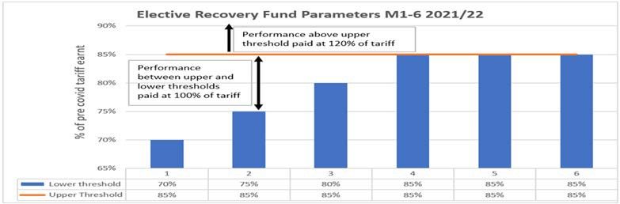

There is risk to receipt of this income, and whilst the Trust has modelled expected performance to month 2 to deliver a £1m income gain, this income has been excluded through accrual of costs comparable to the income, owing to the risk to receipt of these funds.

It is of note the Trust is not expecting to receive significant further income from projected elective performance, largely owing to the historic activity thresholds increasing to 85% in future months. The STP as a whole has modelled receipt of an expected c£17m income allocation for ERF, though costs to be incurred will off-set an element of this income gain and members are accruing in costs on a comparable basis owing to the uncertainty regarding actual receipt.

      - Sustainability and Transformation Partnership (STP) Risk Share

The Trust has entered a risk share with the STP, essentially indicating no member will be in surplus if one is in deficit. This presents an obvious risk, should a member go into deficit to the Trust attaining break-even performance. The below table indicating performance to month 2 for the STP:

STP - Surplus / (Deficit) | Plan Year to Date  £000’s | Actual Year to date  £000’s | Year to date Variance  £000’s
Black Country & West Birmingham CCG | - | 328 | 328
Black Country Healthcare Foundation Trust | (1) | 5 | 6
Dudley Integrated Health & Care NHS Trust | - | 9 | 9
The Dudley Group NHS Foundation Trust | 1,322 | 1,498 | 176
The Royal Wolverhampton NHS Trust | 232 | 2,763 | 2,532
Sandwell & West Birmingham Hospitals NHS Trust | (689) | - | 689
Walsall Healthcare NHS Trust | 19 | 151 | 132
West Midlands Ambulance Service | (43) | (1,486) | (1,443)
Total STP | 840 | 3,269 | 2,428

The STP has reported a surplus of more than £2m YTD, though there are further costs expected to be realised within providers that will reduce this favourable variance.

The key risk being costs incurred above plan in relation to the West Midlands Ambulance Service, these costs forecast to continue. This has been escalated to regulators for resolution as the STP is reporting the deficit, whilst the service covers activity from outside of the STP boundary (the full cost impact reported owing to the STP hosting the partner organisation).

In summary, the Trust is on plan to attain financial performance for H1, with ERF potentially offering a financial benefit if receivable, the STP risk share being managed as a surplus has been attained, with escalation of WMAS deficit with the regulator and neighbouring STP’s.

    - Revenue position Horizon 2 (H2 – October 2021 to March 2022

Income allocations for H2 have not been released, this remains a key uncertainty in production of financial plans for the later half of the 2021/22 financial year.

The Executive, Trust Management Board and Performance, Finance and Investment Committee aligned to the recommendation of production of an expenditure plan for H2 in advance of confirmation of income. The key assumption in development of the plan being that the Trust will:

- produce a balanced financial plan
- base expenditure run rates on H1 allocations

- assume the H1 allocation will receive a 3% reduction for efficiency

The development of run rate modelling to ‘live within the expected income allocations’ for H2 will result in a need to move expenditure between Divisional run rates, to off-set the increased ask of urgent and emergency care services during winter (expected to total c£3m) and in addition, reducing overall costs by c£4m to deliver the efficiency ask.

It is clear, the second half of the financial year is set to be more challenging in delivery of break-even performance. However, it is of note that the Trust will be expecting additional income associated with hypothecated funds and approved developments (Emergency Department and Ockenden).

The results of the expenditure modelling and final allocations for H2 will then be used to refine the plans presented to members for endorsement in due course, to assure delivery of breakeven performance for the 2021/22 financial year.

    - Revenue financial modelling to 2022/23

Income allocations are expected to further reduce as the Government seeks to revise expenditure commitments post Covid-19. This is expected to place further pressure on expenditure budgets.

Expenditure totalled £3m more in May 2021 than historically, and whilst an element of this cost will be expected to reduce as Covid-19 subsides and in part will be driven by separate funding for elective recovery, there will also be an expectation some costs will remain (Infection Prevention Control protocols for example). If income allocations for 2022/23 are in line with 2019/20 pre-Covid-19 allocations the Trust would need to reduce costs significantly to attain a balanced financial model.
This would not be an uncommon situation faced throughout the provider base for the NHS, and income allocations are expected to be revised to reflect an element of Covid- 19 remaining. However, the expectation will be for reduced income to that currently received, and as such focus will be needed on controlling temporary workforce costs and delivery of efficiencies through the Improvement Programme as we move forwards.
In summary, H2 is expected to result in a reduced income allocation, with costs needing to reduce to deliver a balanced position. The expectation is that for 2022/23 income allocations are set to further reduce and hence the focus will need to be centred upon normal (recurrent) expenditure and exit run rates for March 2022 to assure delivery of future financial plans (when guidance and income allocation methodology and values are known).

    - Capital and cash

Capital expenditure in the 2021/22 financial year will place focus upon investment within critical infrastructure works, Digital and Medical Equipment, with the most significant scheme being the Emergency Department New build for which we are now seeing the steel works in progress and the development rise from the groundworks following their completion.

The capital programme remains over committed following placement of contracts for much needed capital infrastructure works within the ward environments. The Trust continues to seek additional allocations from the regulator to support these commitments and balance the programme accordingly.

The Trust has substantial cash holdings at the end of the financial year, and this has continued into the initial months of 2021 for the new financial year.

Operational

Emergency Care:

Despite the highest month of Emergency Department (ED) attendances on record in May 2021, with 9.8% more patients than May 2019, the Trust maintained strong and statistically significantly improved performance for the percentage of patients triaged within 15 minutes of arrival to ED with 83.56% of patients triaged within 15 minutes of arrival in April 2021. In addition the Trust delivered the best Ambulance Handover times (<30 minutes) in the West Midlands for the fourth consecutive month in May 2021, supporting West Midlands Ambulance Service crews to get back on the road to attend to the next 999 call in a timely fashion. Of note, the Trust achieved this whilst assisting neighbouring Trusts, having received 31 ambulances Intelligently Conveyed away from neighbouring EDs due to their prolonged ambulance handover times during May.

- hour Emergency Access Standard performance sustains its statistically significant improvement with 91.2% of patients admitted or discharged within 4 hours of arrival to ED in May 2021, and the Trust was ranked in the Top 20 performing organisations nationally (out of 113 reporting general acute Trusts) for the third consecutive month. Timely access to emergency care is directly associated with better patient experience and clinical outcomes, including mortality rates, and thus is a vital component of delivering safe, high quality care.

Elective Care:

The Trust’s 6 Week Wait (DM01) Diagnostics performance remains in the Top 10 in the country for the fourth consecutive month (April 2021 reporting), out of 122 reporting Trusts, and has improved further in May 2021 with just 1.04% of patients now waiting over 6 weeks. The Trust forecasts to meet the constitutional standard of less than 1% of patients waiting over 6 weeks by the end of June 2021. Maintaining timely access to Diagnostics is vital to detect serious conditions early, and thus to enable quicker treatment. In addition, the DM01 Diagnostic access standard includes GP requested Diagnostic tests, and thus timely access is also crucial to support primary care and community clinicians to manage patients safely without requiring hospital treatment. The one diagnostic modality with challenged access is for Cystoscopies, and the Surgical Division is forecasting the backlog of over 6 week cystoscopies to be addressed by the end of June 2021.

Despite cessation of routine elective services during March and April 2020, and reduced elective operating capacity again from November 2020 to March 2021 over the second and third waves of the pandemic, the Trust now has 70.9% of patients waiting under 18 weeks at the end of May 2021, and remains in the Top 45 (out of 122 reporting Trusts) Trusts nationally for April 2021 performance. In addition, the Trust’s 52-week waiting time performance is 4th best in the Midlands (out of 20 Midlands Trusts) and has reduced from 750 patients waiting over 52-weeks in March 2021, to
554 in April 2021 to 445 in May 2021. Whilst 18 week and 52 week waiting time standards are predominantly measures of access to routine elective care, it must be recognised that there is extensive published research evidence of the detrimental impact of delayed routine surgery on quality of life, pain and suffering, and for some procedures efficacy of clinical outcomes, and thus it is vital to minimise waiting times for patients to access definitive surgical treatments. Furthermore there is clear evidence of the association between increased access to elective treatments and reduced requirement for emergency care services, and so providing timely elective care can actually reduce demand for emergency care.

In April 2021, for 62-day Cancer performance the Trust was materially better performing than West Midlands average (67.5%) and in line with national average (75.4%), with 74.2% of our patients treated within 62 days of referral. Whilst not yet reflected in reported performance (due to reporting in arrears), the Board should be assured that patients referred with suspected Breast Cancer, or with other Breast symptoms are now being seen within 2 weeks of referral following implementation of an extensive recovery plan. Moreover, the Board can now be assured that all tumour sites are booking patients within 2 weeks (as of 6th June 2021). Timelier access to

suspected cancer clinic appointments, and ultimately to treatment is crucial given the extensive evidence of the association between the stage a cancer is detected (and treated) and the clinical outcome, including mortality risk, for patients.

- IMPROVEMENT PROGRAMME

The Use Resources Well component of the Improvement Programme was re-prioritised in light of the scale of the second and third waves of COVID-19. The focus for the Clinical Divisions has been on workstreams that improve emergency care pathways, as there was a direct benefit for the COVID-19 response. Highlights include the fact that Surgery have delivered record Same Day Emergency Care rates through improvements to the Surgical Ambulatory Emergency Care pathway, taking the proportion of acute surgical patients managed without overnight hospital stay from less than 30% to over 50. Medicine & Long Term Conditions have similarly delivered significant improvements with the number of patients being managed without overnight admission through the Frail Elderly Service (which is now in its new home alongside Community Services as part of our Integrated Assessment Unit) increasing by over 50% this year, and with significant increases in the number of patients managed through the Ambulatory Emergency Care unit too. This has supported the Trust being ranked second nationally for Same Day Emergency Care in medical specialties through the Ambulatory Emergency Care network. Furthermore, Medicine & Long Term Conditions average Length of Stay for those patients who do require overnight admission has reduced from over 8.5 days to less than 7 days over the course of the last 18 months, supporting patients to be cared for in their usual place of residence in partnership with Community services.

In elective care, the Surgical Division have maximised the use of scarce elective operating theatre capacity over the year by transferring cases that can be done outside of an operating theatre setting into alternative procedure rooms, freeing up full elective operating theatre capacity for those cases that truly require it and reducing waiting times as a result. The Operating Theatre productivity improvement programme has contributed to May 2021 having the highest month of in-session Theatre utilisation and of average cases per list for over 12 months. 631 operations were delivered through Operating Theatres in May 2021, with a targeted delivery of 700 cases in June 2021.

Good progress has been made in quantifying the anticipated benefits (including financial benefits) of schemes within the Use Resources Well programme, which is crucial to developing the comprehensive financial plan for H2, and indeed 2022/23.

- RECOMMENDATIONS

Members of the Trust Board are asked to:
  - Note the contents of the report.
  - Note the following actions;
    - Re-forecasting elective restoration and recovery plans for 2021/22 following second and third waves of COVID-19 that have far exceeded the original planning parameters.
    - H1 2021/22 plan endorsed and for month 2 the Trust is £0.1m above plan.
    - Income for Horizon 2 is yet to be confirmed and the Trust is developing run rate models based on H1 less 3% for this period (to include winter costs).
    - The Trust is developing exit run rate models to identify expenditure baselines for 2022/23, so when income allocations are known the Trust can model outturn accordingly.
    - Seeking additional capital allocations to off-set the risk to the capital programme for much needed ward infrastructure works

APPENDICES

- Board Assurance Framework Risk S05
- Performance Report (Finance and Constitutional Standards)

Latest Board/Committee/Group - 26/05/2021 Version V2.03

Risk Summary
BAF Strategic  Objective Reference & Summary Tile: | BAF SO 05 - Use Resources Well; We will deliver optimum value by using our resources efficiently and responsibly.
Risk Description: | The Trust’s financial sustainability is jeopardised if it cannot deliver the services it provides to their best value.  If resources (financial, human, physical assets & technology) are not utilised to their optimum, opportunities are lost to invest in improving quality of care.  Failure to deliver agreed financial targets reduces the ability of the Trust to invest in improving quality of care, & constrains available capital to invest in Estate, Medical Equipment & Technological assets in turn leading to a less productive use of resources.
Lead Director: | Chief Operating Officer.
Lead Committee: | Performance, Finance, & Investment Committee.
Links to Corporate Risk Register: | Title: |  |  |  |  |  |  |  |  |  |  |  |  |  |  |  |  |  |  |  |  |  |  | Current Risk Score Movement:
Links to Corporate Risk Register: | - 208 - Failure to achieve 4 hour wait as per National Performance Target of 95% resulting in patient safety, experience and performance risks (Risk Score = 8).  - 2398 - Insufficient/ out-of-date equipment, utilised beyond its life cycle, has the potential to result in sub-optimal patient care (Risk replaces the archived risk - 274) (Risk Score = 12).  - 665 - Risk of a cyberattack (ransomware, spearfishing, doxware, worm, Trojan, DDoS etc) upon a NHS or partner organisation within the West Midlands Conurbation (Risk Score = 15).  - 1005 - The Trust has insufficient resources available to ensure the essential maintenance of the Trust's Estate (Risk Score = 16).  - 1155 - Failure to demonstrate fire stopping certification for all areas of the Trust would breach fire safety regulation, risking public/ patient safety (Risk Score = 16).  - 2081 - Operational expenditure incurred during the current financial year exceeds income allocations, which results in the Trust being unable to deliver a break even financial plan (Risk Score = 16).  - 2082 - Failure to realise the benefits associated with the outcomes of the improvement programme work-streams, results in the Trust not delivering efficiencies required to attain agreed financial control targets, and deliver financial balance without central support, which therefore impacts on the Trusts ability to deliver financial and clinical sustainability (Risk Score =16).  - 2188 - A continued dependency on suboptimal legacy patient information infrastructure, will limit the flow of clinical information, reduce professional confidence and increase administrative burden for healthcare professionals, ultimately  impacting on patient care and the ability to transform healthcare services (Risk Score = 10). |  |  |  |  |  |  |  |  |  |  |  |  |  |  |  |  |  |  |  |  |  |  | Likelihood = 3  Consequence = 5  15  High  ↔
Risk Appetite
Operational Status: | Balanced | Averse |  |  |  |  | Cautious |  |  |  |  | Balanced |  |  |  |  | Open |  |  |  |  | Hungry
Appetite Score: | < 14 | 1 | 2 | 3 | 4 | 5 | 6 | 7 | 8 | 9 | 10 | 11 | 12 | 13 | 14 | 15 | 16 | 17 | 18 | 19 | 20 | 21 | 22 |  | 23 | 24 | 25
Tolerate Score: | < 16
Financial Status: | Cautious | Averse |  |  |  |  | Cautious |  |  |  |  | Balanced |  |  |  |  | Open |  |  |  |  | Hungry
Appetite Score: | <10 | 1 | 2 | 3 | 4 | 5 | 6 | 7 | 8 | 9 | 10 | 11 | 12 | 13 | 14 | 15 | 16 | 17 | 18 | 19 | 20 | 21 | 22 |  | 23 | 24 | 25
Tolerate Score: | <11

Compliance Status: | Cautious | Averse |  |  |  |  | Cautious |  |  |  |  | Balanced |  |  |  |  | Open |  |  |  |  | Hungry
Appetite Score: | <9 | 1 | 2 | 3 | 4 | 5 | 6 | 7 | 8 | 9 | 10 | 11 | 12 | 13 | 14 | 15 | 16 | 17 | 18 | 19 | 20 | 21 | 22 |  | 23 | 24 | 25
Tolerate Score: | <11
Risk Scoring
Quarter: | Q1  2021/22 | Q2 |  | Q3 |  | Q4  2020/21 |  | Rational for Risk Level: |  |  |  |  |  |  |  |  |  | Target Risk Level  (Risk Appetite): |  |  |  |  |  | Target Date:
Likelihood: | 3 |  |  |  |  | 3 |  | Evidence of risk control  - Achievement of 19/20 and 20/21 financial plans.  - Adherence to revised financial arrangements during 20/21 as a result of the Covid-19 pandemic, despite significant planning uncertainty  - Strong operational performance measured through constitutional standards, and associated operational performance metrics.  - Development of draft 5-year capital programme  - Majority of allied Corporate Risks associated with Use Resources Well mitigated to scores of 16 or less.  Evidence of risk gaps in control  - The Trust experienced run rate risk for the 19/20 financial year that led to needing to re-forecast outturn during the financial year.  - High reliance on temporary workforce  - Lack of credible capital plan to fully address backlog maintenance requirements, despite 5-year Capital Programme in place.  Evidence of planning uncertainty  - Normal national financial planning cycle for 21/22 financial year was postponed due to the Covid-19 pandemic  - Financial improvement planning and delivery has been impacted by Covid-19.  - Significant uncertainty still associated with H2 (Q3 and Q4) 2021/22 financial arrangements. |  |  |  |  |  |  |  |  |  | Likelihood: |  |  | 2 |  |  | 31 March 2022
Consequence: | 5 |  |  |  |  | 5 |  |  |  |  |  |  |  |  |  |  |  | Consequence: |  |  | 5
Risk Level: | 15  High |  |  |  |  | 15  High |  |  |  |  |  |  |  |  |  |  |  | Risk Level: |  |  | 10  Moderate
Control & Assurance Framework - 3 Lines of Defence
 | 1st Line of Defence |  |  |  |  |  |  | 2nd Line of Defence |  |  |  |  |  |  |  |  |  | 3rd Line of Defence
Controls: | - Financial position reported monthly via Care Groups, Divisions, Divisional Performance Reviews and Executive Governance Structures.  - Revised financial governance in place for COVID-19 through the Trust’s |  |  |  |  |  |  | - Performance, Finance & Investment Committee in place to gain assurance.  - Audit Committee in place to oversee and test the governance/financial controls.  - Adoption of business rules (Standing Orders, Standing Financial Instructions and Scheme of |  |  |  |  |  |  |  |  |  | - Externally benchmarked Financial and operational productivity performance data, particularly (but not exclusively) through Model Hospital.

 | Governance Continuity Plan.  - Board Development session for the Improvement Programme with  identified 3-year targeted financial benefits. | Delegation).  - Use Resources Well work stream of the Improvement Programme has Governance infrastructure in place.
Gaps in Controls: | - Business planning processes require strengthening.  - Accountability Framework has been approved, however needs review further to the NHSI Governance Review report.  - Leadership development needs at Care Group, Divisional and corporate support service levels, with commencement of Faculty of Medical Leadership and Management leadership development programme deferred to Spring 2021 due to Covid-19 second wave.  - Covid-19 second and third waves significantly exceeded planning parameter assumptions.
Assurance: | - Model Hospital Use of Resources assessments.  - Proportion of acute surgical patients managed without overnight hospital stay has risen from less than 30% to over 50%.  - Number of patients managed through the Integrated Assessment Unit’s Frailty service without overnight hospital stay has increased by over 50%.  - Inpatient Length of Stay in MLTC (excluding 0-day LoS) has reduced from over 9 days to less than 8 days on average.  - Number of Medically Stable for Discharge inpatients sustained at lowest level on record through 20/21.  - Delivery of 2020/21 Financial plan, representing the second consecutive year of meeting financial plan. | - Internal Audit reviews of a number of areas of financial and operational performance  - Covid-19 ‘top-up’ resource in line with peers as a percentage of turnover  - Top 10 in the country out of 122 general acute reporting Trusts for the 4th consecutive month (Apr 2021) for 6 week wait Diagnostic (DM01) performance  - Top 20 in the country out of 113 reporting general acute Trusts (May 2021) for the 3rd consecutive month for 4-hour Emergency Access Standard, and best in the West Midlands out of 14 reporting Trusts for Ambulance handover <30 mins for the fourth consecutive month  - 44th best in the country out of 121 reporting Trusts (Mar 2021) for 18-week RTT performance and 4th lowest proportion of elective waiting list waiting over 52 weeks in the Midlands (out of 20 reporting Midlands Trusts)  - Better than West Midlands and in line with England average for Cancer 62-day waiting time  performance | - Annual Report and Accounts presented to NHSE/I  - NHSE/I oversight of performance both financial and operational  - External Audit Assurance of the Annual Accounts  - Cost per WAU (19/20) now below peer and national median (Model Hospital)  - Day case rates for British Association of Day Case Surgery in line with peer median (Q2 20/21 – Model Hospital).  - Average LoS for elective admissions rolling 6 months below peer and national median (Oct 2020 – Model Hospital)  - Average LoS for emergency admissions rolling 6 months in line with peer and national median (Oct 2020 – Model Hospital)  - Medical specialties Same Day Emergency Care rates for ambulatory emergency care conditions rated second best in the country by the AEC Network.
Gaps in Assurance: | - NHSi Governance review highlighted areas of improvement for business process and accountability framework.  - Trust scored requires improvement on its assessment of ‘Use of Resources’ owing to low productivity and high staff and support costs being evident. Time lag on updating of some Model Hospital metrics means there is a delay in receiving some independent assurance of improved financial and operational productivity metrics.  - External Audit limited due to Covid-19.  - Late confirmation of 21/22 financial architecture for Q3 and Q4.  - NHS Digital Templar Execs external review (Cyber Operational Readiness Support) has identified improvements required for the Trust’s Cyber Security.
Future Opportunities
- Further Development of LTFM to include potential additional income sources, such as non-clinical commercial opportunities and repatriation of patients resident to Walsall currently receiving care out of area.

- International Nurse Recruitment with RWT to significantly decrease reliance on temporary workforce.
- Enhanced clinical economies of scale through Acute Hospital Collaboration (Working with Partners).
- Reduced reliance on inpatient hospital care through Walsall Together Partnership (Care at Home).
- Improved Equality, Diversity and Inclusion in the Trust to harness the skills of the whole workforce and leadership development programme for Care Group and Divisional leaders to enhance capability (Valuing Colleagues).
- Utilisation of national productivity benchmark information (e.g. GIRFT and Model Hospital) to target work through the Use of Resources Improvement Programme.
- Development of major capital upgrades (e.g. new Emergency Department) to support improved recruitment of staff.
- Harnessing the teamwork and innovation so evident throughout the Covid-19 pandemic to develop service improvements that lead to improved use of resources.
- Capitalising on the digital advancement during Covid-19 to harness technology to improve effective use of resources.
- Rationalising Estate requirements through increased remote working.
- Enhanced leadership capability through Well-led Improvement Programme work stream.
Future Risks
- Covid-19 second and third waves have significantly exceeded planning parameter assumptions, leading to increased costs delivering emergency and critical care, and reduced leadership time dedicated to long time resource planning during the height of the pandemic. Risk of a 4th wave in late Summer/early Autumn 2021.
- Likely move away from PbR towards block contracts and the associated paradigm shift for elective care in particular.
- Adverse Covid-19 impact on ability to deliver improved productivity for elective care in 20/21, and early 21/22.
- Additional costs associated with safe non-elective and critical care during Covid-19.
- Significant changes to elective and non-elective demand during Covid-19 and in early 21/22 in emergency care in particular leading to difficulty planning for the future with confidence.
- Insufficient Capital to enable investments in the Estate, equipment and technology that would in turn support more effective use of resources, and significant lead time for deployment of capital.
- Impact of Covid-19 on the wider economy and supply chain markets may destabilise some costs of goods/services upon which the Trust relies.
- Workforce exhaustion and/or psychological impact from Covid-19 may result in higher sickness rates and/or colleagues deciding to leave the healthcare professions, and thus further reliance on temporary workforce.
Future Actions (to further reduce the Likelihood / Consequence of the risk in order to achieve the Target Risk Level in line with the Risk Appetite)
No. | Action Required: | Executive Lead: | Due Date: | Progress Report: | BRAG:
2. | Review and update Accountability Framework further to the NHSI Governance Review report. | R. Caldicott | Oct 2020 | Revisions to assessment, content and agenda in conjunction with the Divisional Directors, Trust Management Board, Executive and the Improvement Programme Board have been enacted and work on development of key metrics is progressing.  However, a key element of the review centres upon wider Trust consultation to gain ownership of the framework and metrics used for assessment. This has been difficult to progress in light of the pandemic which  results in the current rating of amber. Target completion June 2021.
3. | Financial regime post 31st September 2020 to be approved  by Board in October 2020 - Russell Caldicott | R. Caldicott | Oct 2020 | Complete
4. | All work-streams to have Improvement programme benefits  defined. | G. Augustine | Oct 2020 | Complete - Presented to Trust Board Development  Session on 1st October 2020.

5. | Development of 2021/22 Financial plan | R. Caldicott | March 2021 | Likely to be delayed due to delayed receipt of national planning guidance. Q2 21/22 plan for approval at PFIC  26/05/21.


Public Trust Board – 1st July 2021 Agenda Item 16, Appendix 2

Use Resources Well - Performance

SPC Key
Narrative (supplied by Chief Operating Officer)
Emergency/Urgent Care
ED performance within 4 hours - overall(Type 1 & 3)- starting 01/04/19
100%
95%
90%
85%
80%
75%
70%
65%
60%
ED - % within 4 hours – Overall (Type 1 & 3)
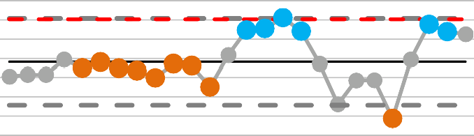
  - hour Emergency Access Standard performance in May 2021 has continued to demonstrate statistically significant improvement with 91.2% of patients admitted or discharged within 4 hours of arrival to ED, and the Trust was ranked 17th nationally out of 113 reporting Trusts – the third consecutive month of being in the Top 20 performing Trusts in the country.
May 2021 was the highest month for total ED attendances on record. 7820 Type 1 patients attended ED in May 2021 which is an increase of 13.8% on April 2021.
This is 67% higher than May 2020 which had low attendances due to the first lockdown. Significantly, it is 9.8% more than May 2019 which is much higher than our planning assumption that ED activity would return to pre-pandemic levels.
The Trust has maintained statistically significant improvements in the percentage of patients triaged within 15 minutes of arrival to ED with 8 consecutive months above the mean average, and has delivered the best Ambulance Handover times (<30 minutes) in the West Midlands for the fourth consecutive month in May 2021.
18 weeks Referral to treatment- % Within 18 weeks- Incomplete pathways- starting 01/04/19
100%
95%
90%
85%
80%
75%
70%
65%
60%
55%
50%

RTT (18 weeks Referral to Treatment)
18 weeks RTT – Incomplete Pathways
Despite cessation of routine elective services during March and April 2020, and reduced elective operating capacity again from November 2020 to March 2021 over the second and third waves of the pandemic, the Trust’s 18-week RTT national ranking position has improved with 70.9% of patients now waiting under 18 weeks at the end of May 2021, and remains in the Top 45 (out of 122 reporting Trusts) Trusts nationally for April 2021 performance. In addition, the Trust’s 52- week waiting time performance is 4th best in the Midlands (out of 20 Midlands Trusts) and has reduced from 750 patients waiting over 52-weeks in March 2021, to 554 in April 2021 to 445 in May 2021.

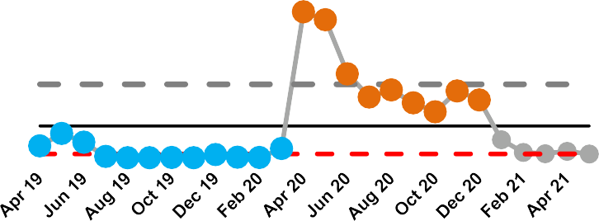
Diagnostic waiting times & activity (DM01)
The Trust’s 6 Week Wait (DM01) Diagnostics performance remains in the Top 10 in the country for the 4th consecutive month (April 2021 reporting), out of 122 reporting Trusts, and has improved further in May 2021 with just 1.04% of patients now waiting over 6 weeks. The Trust forecasts to meet the constitutional standard of less than 1% of patients waiting over 6 weeks by the end of June 2021.
% Of Service Users waiting 6 weeks or more from Referral for a diagnostic test- starting 01/04/19
50%
45%
40%
35%
30%
25%
20%
15%
10%
5%
0%

Use Resources Well - Performance


Cancer
Cancer 62 day referral to treatment of all cancers- starting 01/04/19
100%
95%
90%
85%
80%
75%
70%
65%
60%
55%
50%
In April 2021, for 62-day Cancer performance the Trust was materially better than West Midlands average (67.5%) and in line with national average (75.4%), with 74.2% of our patients treated within 62 days of referral. Whilst not yet reflected in reported performance (due to reporting in arrears), the committee should be assured that patients referred with suspected Breast Cancer, or with other Breast symptoms are now being seen within 2 weeks of referral following implementation of an extensive recovery plan. Moreover, the Trust board can now be assured that all tumour sites are booking patients within 2 weeks (as of 6th June 2021).
Diagnostic waiting times (DM01)
Cancer 62 Day RTT

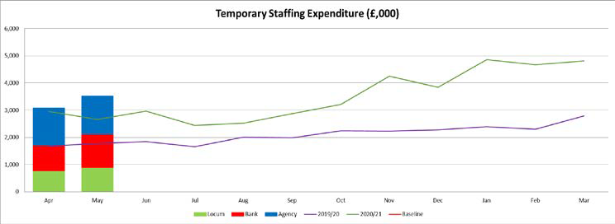
Financial Performance to May 2021 2021 (Month 2)
 | YTD Plan  £000s | YTD Actual  £000s | YTD Variance  £000s
Income
Healthcare Income (Inc. Vaccs) | 52,699 | 54,804 | 2,105
Other Income (Education&Training) | 1,404 | 1,293 | (111)
Other Income (Other) | 1,290 | 1,066 | (224)
Subtotal Income | 55,393 | 57,162 | 1,769
Pay Expenditure
Substantive Salaries | (28,296) | (28,452) | (155)
Temporary Nursing | (2,944) | (2,748) | 196
Temporary Medical | (2,377) | (2,406) | (30)
Temporary Other | (876) | (647) | 229
Vaccination Programme | (1,213) | (959) | 254
Subtotal Pay Expenditure | (35,706) | (35,213) | 493
Non Pay Expenditure
Drugs | (2,977) | (3,451) | (474)
Clinical Supplies and Services | (2,571) | (2,660) | (89)
Non-Clinical Supplies and Services | (2,428) | (3,094) | (666)
Other Non Pay | (8,719) | (9,463) | (744)
Vaccination Programme | 0 | (88) | (88)
Depreciation | (1,470) | (1,394) | 76
Subtotal Non Pay Expenditure | (18,165) | (20,150) | (1,985)
Interest Payable | (1,532) | (1,687) | (155)
Subtotal Finance Costs | (1,532) | (1,687) | (155)
Total Surplus / (Deficit) | (10) | 112 | 122
Donated Asset Adjustment | 30 | 40 | 10
Adjusted Surplus / (Deficit) | 20 | 152 | 132

Financial Performance
- The Trust has a small surplus at the end of May 2021 of £0.152m, an improvement against plan of £0.132m (planned £0.020m surplus).
- The improved position has been driven by reducing temporary staffing spend and overall pay spend below forecast, the main driver being temporary nurse staffing as a result of reduced escalation capacity.
- The Trust has included an assumed ERF receipt of £0.999m for May YTD. Inclusion of these funds has been requested by NHSEI in the May YTD position. However, working across the STP the Trust believes there remains significant risk to receipt of ERF monies.
  - Underperformance against targets from other providers in the STP
  - STP level failure to achieve 1 or more of the 5 Gateways
o A need to re-direct income around the STP in line with the risk share agreement (something Walsall benefited from in 2020/21)
- The Trust has therefore included additional non pay costs to negate the impact of the ERF income. This complies with the NHSEI reporting requirement but negates risk to the Trust and is consistent with the approach taken by all STP Providers.
- Excluding ERF, Non Pay was above forecast due to High Cost Drugs usage and purchase of healthcare which has been offset by increased income.
Capital
- The approved programme for the year is made up of £17.4m for Emergency Department, £10.3m of other expenditure and £1.1m to support PFI Lifecycle (total of £28.8m). However, the Trust were informed in early May that some funding may not be released to the STP and the £10.3m would need to be reduced to £10m (total of £28.5m).
- Capital expenditure totals £1.237m for the financial year to date. The Trust seeking a further allocation from the STP of £1.6m and £1.8m from NHSEI to support the ward refurbishment programme.
Cash
- The Trust has a positive cash holding of £31.6m as at 31st May 2021.
Efficiency attainment
- The emergency budget planning letter and guidance states there was no efficiency requirement for Months 1-6. However, development of Improvement Programme initiatives is key to ensuring financial sustainability moving forwards, with the outputs of this program to be reviewed by Performance, Finance and Investment Committee.

Income and expenditure run rate charts

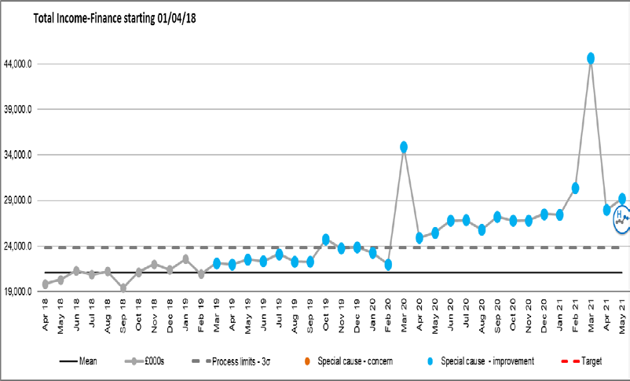
Income additional information
    - Income has continued to increase year on year, this reflects a level of tariff inflation and growth serviced through the Trust over this period.
    - January and February 2020 income reduced as the Trust moved away from plan, losing central income from the Financial Recovery Fund (FRF) and Provider Sustainability Fund (PSF) during these months
    - March 2020 saw the Trust move back on plan and receive the quarters FRF and PSF in month accordingly.
    - April’s income reflects the emergency budget income allocation (increasing monthly to reflect the increase in the top up of funding received).
    - From October there will no longer be retrospective top up funding received, block income has been agreed based on operation run rates.
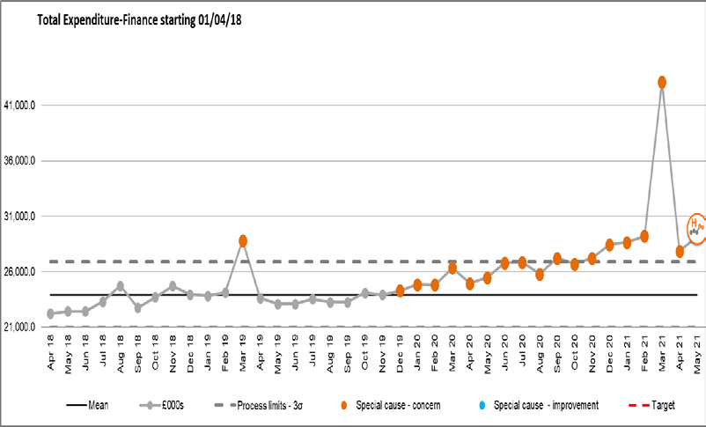
    - February 2021 saw the receipt of additional NHSEI Income allocation to offset the ‘Lost Income’ assumed in the Deficit Plan.
Expenditure additional information
    - March 2019 the Trust accounted for the ICCU Impairment of £6.2m
    - March 2020 costs increased to reflect the Maternity theatre impairment £1m & Covid-19 expenditure
    - Throughout April and May 2020 costs increased in support of COVID-19, with June and July seeing these costs increase further for elective restart and provision for EPR, Clinical Excellence Awards impacts on cost base, noting a reduction in expenditure in August due to the non recurrent nature of these. Spend increased again in September due to back dated Medical Pay Award, increased elective activity and non recurrent consultancy spend and remains high driven by the additional pressures of a second wave of COVID activity.

Cash Flow Statement & Statement of Financial Position (M2)
CASHFLOW STATEMENT  Statement of Cash Flows for the month ending May 2021 | Year to date Movement
 | £'000
Cash Flows from Operating Activities
Adjusted Operating Surplus/(Deficit) | 1,798
Depreciation and Amortisation | 1,394
Donated Assets Received credited to revenue but non-cash | 0
(Increase)/Decrease in Trade and Other Receivables | (13,994)
Increase/(Decrease) in Trade and Other Payables | 1,400
Increase/(Decrease) in Stock | (91)
Increase/(Decrease) in Provisions | 0
Interest Paid | (1,373)
Dividend Paid | (676)
Net Cash Inflow/(Outflow) from Operating Activities | (11,542)
Cash Flows from Investing Activities
Interest received | 0
(Payments) for Property, Plant and Equipment | (412)
Receipt from sale of Property | 0
Net Cash Inflow/(Outflow)from Investing Activities | (412)
Net Cash Inflow/(Outflow) before Financing | (11,954)
Cash Flows from Financing Activities | 0
Net Increase/(Decrease) in Cash | (11,954)
Cash at the Beginning of the Year 2021/22 | 43,532
Cash at the End of the May | 31,578

STATEMENT OF FINANCIAL POSITION  Statement of Financial Position for the month Balance ending May 2021 as at  31/03/21 |  | Balance as at 31/05/21 | Year to date Movement
 | '£000 | '£000 | '£000
Non-Current Assets
Property, plant & Equipment | 161,995 | 162,009 | 14
Intangible Fixed Assets | 6,417 | 6,247 | (170)
Receivables greater than one year | 561 | 67 | (494)
Total Non-Current Assets | 168,973 | 168,323 | (650)
Current Assets
Receivables & pre-payments less than one Year | 11,075 | 25,564 | 14,489
Cash (Citi and Other) | 43,532 | 31,578 | (11,954)
Inventories | 2,951 | 3,043 | 92
Total Current Assets | 57,558 | 60,185 | 2,627
Current Liabilities
NHS & Trade Payables less than one year | (35,179) | (36,491) | (1,312)
Other Liabilities | (284) | (1,513) | (1,229)
Borrowings less than one year | (4,058) | (3,382) | 676
Provisions less than one year | (96) | (96) | -
Total Current Liabilities | (39,617) | (41,482) | (1,865)
Net Current Assets less Liabilities Non-current liabilities  Borrowings greater than one year | 17,941  (111,956) | 18,703  (111,956) | 762  -
Total Assets less Total Liabilities | 74,958 | 75,070 | 112
FINANCED BY TAXPAYERS' EQUITY composition :  PDC  Revaluation  Income and Expenditure  In Year Income & Expenditure | 215,632  24,307  (164,981)  - | 215,632  24,307  (164,981)  112 | -  -  - 112
Total TAXPAYERS' EQUITY | 74,958 | 75,070 | 112


1

MEETING OF THE PUBLIC TRUST BOARD – 1ST JULY 2021
People and Organisational Development Committee (PODC) Highlight Report |  |  | AGENDA ITEM: 17
Report Author and Job Title: | Trish Mills Trust Secretary | Responsible Director: | Junior Hemans (Non- Executive Director and Chair)
Action Required | Approve ☐ Discuss ☐ Inform ☒ Assure ☒
Executive Summary | The report provides the key messages from the People and Organisational Committee meeting on 24TH June 2021. Of note are:  - The Committee noted good engagement with the staff pulse survey, the results from which are in the Value our Colleagues Executive Report for this meeting.  - The People and Culture and the Digital Services Divisions presented their staff survey results and the action plans to address them. The Committee was encouraged to hear that the Staff Survey Oversight Group was a forum where the Divisions were able to adopt good practices from the learning, improvements and action plans of the other Divisions.  - Future meetings will hear directly from the Division as to their plans to improve workforce performance metrics.  - The Committee reviewed and adopted the Board Assurance Framework risks, which now encompass three separate risks and are included on the agenda of this meeting.  - The Freedom to Speak Up Guardians’ Annual Report for 2020/21, which is also before the Board, was received by the Committee.  - The teams involved in recruiting and on-boarding the overseas nurses were commended, particularly for their partnership working and the pastoral care provisions that are in place.  The next meeting of the Committee will take place on 29th July 2021.
Recommendation | Members of the Trust Board are asked to note the report and the escalations for its attention.

Risk in the BAF or Trust Risk Register | BAF S04 – Culture (lack of an Inclusive and open culture impacts on staff morale, staff engagement, staff recruitment, retention and patient care)
Resource implications | There are no new resource implications associated with this report.
Legal, Equality and Diversity implications | This Committee supports the Trust’s approach to delivering equality, diversity and inclusion for the benefit of the patient population and staff who work for the Trust and who live in Walsall. .
Strategic Objectives | Safe, high quality care ☐ | Care at home ☐
Strategic Objectives | Partners ☐ | Value colleagues ☒
Strategic Objectives | Resources ☐



MEETING OF THE PUBLIC TRUST BOARD – 1st July 2021
Value our Colleagues – Executive Update |  |  | AGENDA ITEM: 18
Report Author and Job Title: | Catherine Griffiths – Director of People and Culture | Responsible Director: | Catherine Griffiths – Director of People and  Culture
Action Required | Approve ☐ Discuss ☐ Inform ☒ Assure ☒  This report provides an update on actions taken last month relating to the Value Our Colleagues work-stream of the improvement programme. The following points seek to inform the Trust Board of progress, identify where assurance can be taken and where required to seek approval for actions proposed.  - Progress on Recruitment and Retention  The People and Organisation Development Committee noted and approved the safe staffing report, which shows a Registered Nurse vacancy rate of 7%, a reduction of 2% from previous month. The work on reducing agency use continues with a target to remove all general agency use by end October 2021.  The Trust is leading system work on retention as part of the Workforce Supply work-stream of the People Board. The aim is to improve the experience of our people so they choose to say within the NHS. The ‘Looking After Our People (LAOP) – Retention Programme’ brings together national and local experience and expertise to offer information, tools and practical support (including funding) for systems and organisations to help deliver the NHS People Promise.  - Progress on Staff Experience and Engagement  The Pulse Survey closed with a response rate of 53.45% this is a 20% increase in the Trust response rate from the NHS national staff survey 2020 and it exceeds the benchmark average (45%). Over 2,100 colleagues took time to share their views, there were significant improvements – the most improved score related to health and  wellbeing over 87% of colleagues say the organisation takes positive

action on health and wellbeing, this exceeds the best scores in the National Staff Survey 2020. The biggest deterioration was on whether the organisation acts fairly relating to career progression regardless of ethnic background, gender, religion, sexual orientation, disability or age down 21%.The high level results have been shared (appendix one) and are being analysed for an assurance report is due to the People and Organisation Development Committee in July.

- The People and Organisational Development Committee approved the Board Assurance Framework (BAF) risk mitigations which have been divided into the three elements of assurance.

  - Leadership, Culture and Organisation Development
  - Organisation Effectiveness – recruitment, retention and career development
  - Making Walsall (and the Black Country STP) the best place to work

- The People and Organisation Development Committee noted that the Value our Colleagues work-stream of the improvement programme has been profiled to focus on priority areas capable of transforming the organisational culture.
Executive Summary | This report provides an overview of the risks to delivery for the Value Our Colleagues’ strategic objective and provides an update on the mitigations in place to manage the risks identified, as well as the actions identified to address gaps in controls and assurance. It provides the Trust Board with assurance relating to the improvement programme Value Our Colleagues work-stream and performance against the Value Our Colleagues strategic objective, this report highlights successes and identifies assurance gaps  and areas for improvement.
Recommendation | - Members of the Trust Board are asked to note the report and in particular note the activity and progress on reaching a position of no general agency use and close to zero vacancies within the trust by October 2021.  - Members of the Trust Board are asked to note the update on Pulse Survey response.

Does this report mitigate risk included in the BAF or Trust Risk Registers? please outline | This report addresses BAF Risk Value our Colleagues in order to provide positive assurance the mitigations in place to manage this risk and the related corporate risks.
Resource implications | There are resource implications that flow from recommendations in the report. In the short-term the resource requirements are being met from base budgets. The improvement programme priorities outlined in this report will require investment beyond the base budget in order to achieve the milestones and progress envisaged by 2022-2023.
Legal and Equality and Diversity implications | There are significant issues relating to equality arising from matters addressed in the report. The Trust Board has been presented with the evidence base for differential staff experience based on ethnicity, disability, age, sexuality, gender, religion and other protected characteristics.  This goes to the heart of both the Trust Board pledge and the Trust values and supporting behaviours. The improvement programme seeks to mitigate the risk on the BAF, noting the low baseline and the considerable challenge of achieving outstanding performance across the metrics by 2022-23. In addition the valuing our colleagues work-stream seeks to ensure the systems the Trust relies upon can delivery equality of outcome relating to career progression, development, promotion, talent management and recruitment such that the workforce is representative of the communities it serves and can be seen as an anchor institution within Walsall.  The leadership and management development programmes both focus on equality outcomes and developing skills and understanding of an inclusive leadership approach, whilst leading for performance improvement in a compassionate framework that supports a just,  restorative and learning culture.
Strategic Objectives | Safe, high quality care ☐ | Care at home ☐
Strategic Objectives | Partners ☐ | Value colleagues ☒
Strategic Objectives | Resources ☐

Value Our Colleagues – Improvement Programme

- EXECUTIVE SUMMARY

The Trust Board made a pledge relating to Value Our Colleagues as follows:

“We the Trust Board, pledge to demonstrate through our actions that we listen and support people. We will ensure that the organisation treats people equally, fairly and inclusively with zero tolerance of bullying. We uphold and role-model the Trust values chosen by you”

The People and Organisation Development Committee discussed this and agreed the pledge remained current and relevant noting the work on embedding the behavioural framework to support consistent demonstration of values across the Trust. There are areas of good practice from which we need to learn; equally there are areas of poor and discriminatory practice which run counter to the trust values and which are normalised in some areas. The Pulse Survey offers further insights on the qualitative metrics measuring staff experience and the degree to which the pledge is achieved by directorate and department level. In addition the Pulse Survey Workforce Tool provides the ability to focus in on workforce demographics by ethnicity, age, disability, sexuality, disability.

The purpose of the Value Our Colleagues enabling work-stream of the improvement programme is to deliver workforce improvement so colleagues recommend the Trust as a place to work and as a place to be treated. Colleague experience has a direct correlation with patient experience and outcomes. The focus on developing leaders and managers to role model the behaviours and values of the trust is a critical lever to change the direction of travel and to appreciate and build on good practice, learn from it and embed it elsewhere.

- BOARD ASSURANCE FRAMEWORK

The People and Organisational Development Committee approved the Board Assurance Framework (BAF) risk mitigations which have been divided into the three elements of assurance as follows:
  - Leadership, Culture and Organisation Development (Appendix 2.1)
  - Organisation Effectiveness – recruitment, retention and career development (Appendix 2.2)
  - Making Walsall (and the Black Country STP) the best place to work (Appendix 2.3)

- IMPROVEMENT PROGRAMME

The People and Organisation Development Committee noted that the Value our Colleagues work-stream of the improvement programme has been profiled to focus on priority areas capable of transforming the organisational culture, including the just and learning culture work which will require investment, the shared governance approach, delivery of the Equality, Diversity and Inclusion (EDI) strategy and the leadership and management development programme, which will also require investment to accelerate the programme following delay through the pandemic. The Committee considered the importance of the trust values and the Trust Board pledge and considered embedding the behavioural framework through the performance review process.

The following are key updates in month:

Progress on Recruitment and Retention

The People and Organisation Development Committee noted and approved the safe staffing report, which shows a Registered Nurse vacancy rate of 7%, a reduction of 2% from previous month, the trust expects to recruit 200 overseas nurses by the end of 2021. The work on reducing agency use continues with a target to remove all general agency use by end October 2021. The partnership work developing the anchor employer model continues with Walsall Housing Group, to keep close to a 0% vacancy position for CSW’s and to reduce vacancies in the support workforce to near 0%.

The Trust is leading system work on retention as part of the Workforce Supply work- stream of the People Board, in line with the NHS People Plan. This is improvement work within the Black Country system which has a high percentage of its workforce at retirement age. The aim is to improve the experience of our people so they choose to say within the NHS. The ‘Looking After Our People (LAOP) – Retention Programme’ brings together national and local experience and expertise to offer information, tools and practical support (including funding) for systems and organisations to help deliver the NHS People Promise.

Progress on Staff Experience and Engagement

This month the People and Culture Directorate and the Digital Services Directorate presented their actions to date. The Pulse Survey closed with a response rate of 53.45% this is a 20% increase in the Trust response rate from the NHS national staff survey

2020 and it exceeds the benchmark average (45%). Over 2,100 colleagues took time to share their views, there were significant improvements. The most improved score related to health and wellbeing over 87% of colleagues say the organisation takes positive action on health and wellbeing; this exceeds the best scores in the National Staff Survey 2020, by a considerable margin.

The Trust Board can therefore be assured that the investment in health and wellbeing has had an impact on the workforce metrics; reflected in a further significant increase in advocacy scores for place to work +3% and place to be treated +4%, improved satisfaction with flexible working +8% and improvement on attendance -1%. The biggest deterioration was on whether the organisation acts fairly relating to career progression regardless of ethnic background, gender, religion, sexual orientation, disability or age down 21% to 54%, underlining the critical importance of investing and accelerating the talent management and succession planning work. The Divisions have access to the Pulse Survey Workforce Tool which provides the ability to ‘cut data’ by demographic, work place or work group. The high level results have been shared (appendix one) and are being analysed for an assurance report is due to the People and Organisation Development Committee in July.

- PERFORMANCE REPORT

The workforce metrics performance report takes a standard set of quantitative metrics and tracks performance over time (summary Appendix 3). The People and Organisation Development Committee agreed to have a divisional focus for future meetings in order to focus on specific improvement areas by division for both qualitative and quantitative metrics.

- RECOMMENDATIONS
- Members of the Trust Board are asked to note the report and in particular note the activity and progress on reaching a position of no general agency use within the trust by October 2021 and close to zero vacancies within the workforce.

- Members of the Trust Board are asked to note the update on pulse survey response and agree to receive the assurance report at their next meeting.

APPENDICES

Appendix 1 – High level Pulse Survey Results. Appendix 2 – Board Assurance Framework
Appendix 3 – Workforce Metrics Summary Report for information.

Public Trust Board – 1st July 2021 Agenda item 18, Appendix 1

Pulse Survey 2021 V Staff Survey 2020

The National Staff Survey is facilitated by Quality Health.

Introduction

- The Pulse survey was conducted between 7th May 2021 and closed on 11 June 2021. The survey was open to all staff. This is a local survey run by the organisation that contains some similar or the same questions to some of those asked in the national staff survey. The results are reported within our organisation and are a useful way to see trends compared to the staff survey. 2130 surveys were returned equating to a 53.45% response rate.

- From September 2020 – December 2020 the National staff survey was distributed via Quality Health. A full census of the organisation was undertaken. Every NHS organisation takes part in this survey, the results are reported nationally. 1396 surveys were received equating to a 33% response rate.

This is a significant increase of 20% responses compared to the National Staff survey 2020
A full survey was undertaken all Trust staff were invited and encouraged to participate in the National Staff survey and the Pulse survey survey. The Pulse survey was run via mixed mode which included paper, electronic link and a QR code which could be scanned using a mobile device.

Executive Summary

- The National Staff Survey asks several questions structured into sections and split into 10 themes.
- The recent Pulse Survey containerised 19 Questions
- All but 1 question in the Pulse survey are the same or similar to those asked in the National Staff Survey.
  - Pulse Survey analysis tool available, which allows divisional breakdown.
Pulse Survey Analysis Tool

Headlines

- There has been an improvement in 10 of the 19 questions asked and a deterioration for scores in 5 questions. These questions cover the themes Immediate Managers and Equality Diversity and Inclusion. Equality Diversity and Inclusion question 11in the Pulse survey (Q14 in the staff survey) has shown the most significant deterioration of 21%
- More colleagues participated in the Pulse survey 53% compared to the National Staff Survey (33%)
- The response rates varied across the divisions ranging from Corporate 75% to 27% Estates & Facilities.
- The most improved score was against Health and wellbeing Q12 Pulse Survey (Q11a Staff Survey) a very impressive 61% gain.
- The number of colleagues that would recommend the Trust as a place to work increased by 3%, and the number of colleagues that would recommend the Trust as place for treatment increased by 4%.
- There are number of additional comments received which are referenced on pages 11 and 12 for a snap shot of the feedback.

Pulse Survey Response v NSS Response

80%
75%
60%
53%
46%
47%
45%
42%
33%
34%
25%
20%
-
27%
36%

70%

60%

50%

40%

30%

Pulse NSS

20%

10%

0%
Trust

Community Corporate

E&F

MLTC

Surgery

WCCSS

Work is being undertaken to break the corporate level of analysis from the Pulse survey into divisional data.


Comparison of Pulse V Staff Survey 2020 Organisationally

Pulse Survey 2021 | Positive  Responses | 2020 NHS Staff Survey | Positive  responses | Changes since the 2020  Staff Survey
Q1: I would  Recommend my | 55% | Q18c I would  Recommend my | 52% | 3%
organisation as a place  to work |  | organisation as a place to  work
Q2: If a friend or relative needed treatment I would be happy with the standard of care provided by this  organisation. | 57% | Q18d If a friend or relative needed treatment I would be happy with the standard of care provided by this  organisation. | 53.% | 4%
Q3: I am involved in deciding on changes introduced that affect  my work area/team/department? | 48% | Q4C I am involved in deciding on changes introduced that affect my  work area / team / department. | 50% | 2%
Q4: I receive the respect  I deserve from my colleagues at work? | 68% | Q4J: I receive the respect  I deserve from my colleagues at work? | 65% | 5%
Q5:The team I work in has a set of shared  objectives? | 70% | Q4H: The team I work in  has a set of shared objectives? | 67% | 3%
Q6:The team I work in often meet to discuss | 63% | Q4i: The team I work in often meet to discuss the | 57% | 6%
the teams’  effectiveness? |  | teams’ effectiveness?

get for good work? 52% for good work? 52%
Pulse Survey 2021 | Positive  Responses | 2020 NHS Staff Survey | Positive  responses | Changes since the 2020  Staff Survey
Q7: The recognition I |  | Q5a The recognition I get
Q8: I am satisfied with |  | Q5b:: I am satisfied with
the support I get from | 68% | the support I get from | 65% | 3%
my immediate line |  | my immediate line
manager? |  | manager?
Q9: I am satisfied with |  | Q5e:I am satisfied with
the opportunities I have | 64% | the opportunities I have | 67% | 3%
to use my skills? |  | to use my skills?
Q10: I am satisfied with |  | Q5h: I am satisfied with
the opportunities for | 63% | the opportunities for | 55% | 8%
flexible working |  | flexible working
patterns? |  | patterns?
Q11: Does the |  | Q14:Does the
organisation act fairly in  regard to career |  | organisation act fairly in  regard to career |  | 21%
progression/promotion, | 54% | progression/promotion, | 76%
regardless of ethnic |  | regardless of ethnic
background, gender, |  | background, gender,
religion, sexual |  | religion, sexual
orientation, disability or |  | orientation, disability or
age?
Q12: Does the |  | Q11a: Does the
organisation take | 87% | organisation take | 26% | 61%
positive action on |  | positive action on health
health and well-being? |  | and well-being?

Pulse Survey 2021 | Positive  Responses | 2020 NHS Staff Survey | Positive  responses | Changes since the 2020  Staff Survey
Q`13: My Manager |  | Q8f:My Manager takes a
takes a positive interest | 68% | positive interest in my | 69% | 1%
in my health and Well- |  | health and Well-being?
being?
Q14: My manager | 69% | Q8g:My manager values | 69%
values my work? |  | my work?
Q15: My manager |  | Q8a: My manager
encourages me at work? | 66% | encourages me at work? | 67% | 2%
Q16: My manager gives |  | Q8c: My manager gives
me clear feedback on | 59% | me clear feedback on my | 61% | 2%
my work? |  | work?
Q18: When errors, near |  | Q16c: When errors, near
misses or incidents are |  | misses or incidents are
reported, my | 61% | reported, my | 61%
organisation takes |  | organisation takes action
action to ensure they do |  | to ensure they do not
not happen again? |  | happen again?
Q19: We are given |  | Q16d: We are given
feedback about changes |  | feedback about changes
made in response to | 53% | made in response to | 47% | 6%
reported errors, near |  | reported errors, near
misses and incidents? |  | misses and incidents?

Pulse Survey Question

This question is not directly asked nor similar to any in the Staff survey.
Q17: My manager encourages me to take a break at work? | 58%

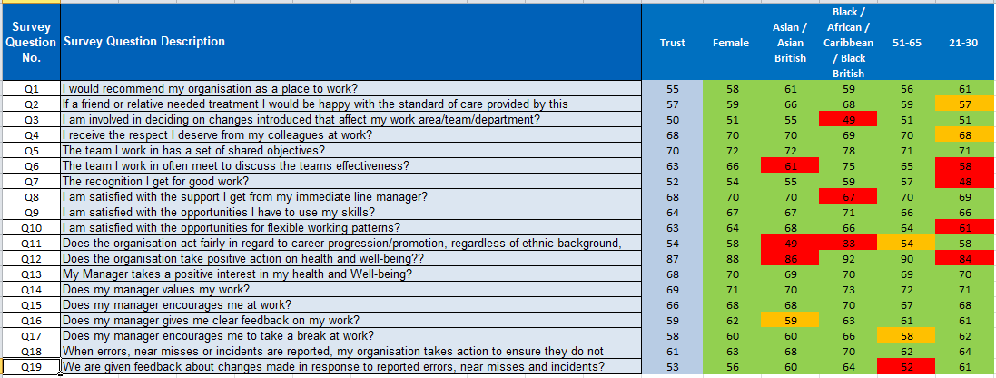

Analysis via Workforce Demography

A high level analysis against a selection of workforce demographics has been undertaken at organisational level to understand how the experience of colleague from different age groups, ethnicity and gender differs.

Recommend the Trust as a place to work
Comments

Positive For Improvement

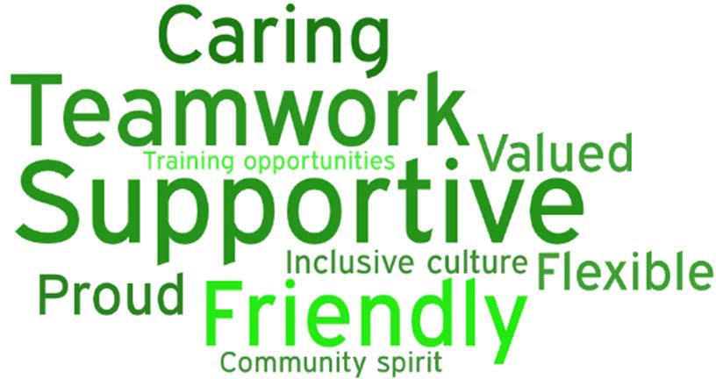
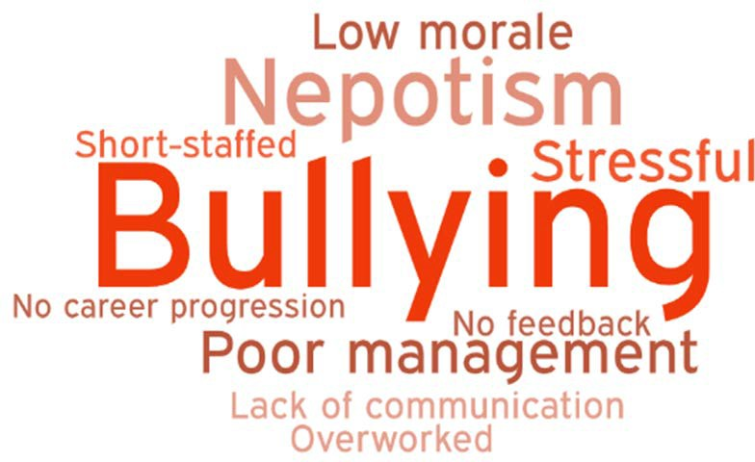

Recommend the Trust as a place for Treatment - Comments

Positive For Improvement

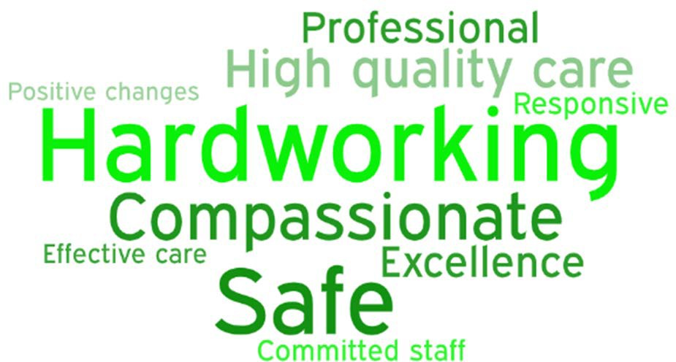
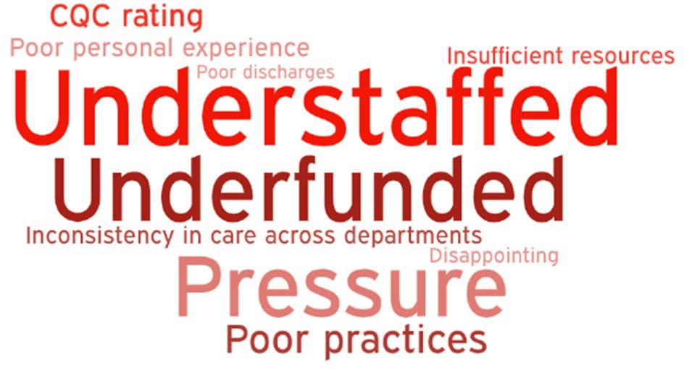

Latest Board/Committee/Group - [Date] Version V0.02

Risk Summary
BAF Strategic  Objective Reference & Summary Tile: | BAF 04 - Value our Colleagues; We will be an inclusive organisation which lives our organisational values at all times
Risk Description: | Lack of an inclusive and open culture impacts on staff morale, staff engagement, staff recruitment, retention and patient care
Lead Director: | Director of People and Culture
Lead Committee: | People & Organisational Development Committee
Links to Corporate Risk Register: | Title: Leadership, Organisational Development and Culture |  |  |  |  |  |  |  |  |  |  |  |  |  |  |  |  |  |  |  |  |  |  |  | Current Risk  Score Movement:
Links to Corporate Risk Register: | - 2489 - Poor colleague experience in the workplace. A significant loss of workforce diversity, talent, productivity and retention arising from poor colleague experience which prevents staff from reaching their potential and being their best selves at work (reduction in effort above and beyond contractual requirements), lack of opportunity to develop and progress, not feeling safe due to unacceptable behaviours such as racism, bullying and harassment, workforce fatigue and not valued for the incredible  job that they do and therefore not recommending the trust as a place to work or a place to be treated. (Risk Score = 16, Likelihood 4 x Consequence 4). |  |  |  |  |  |  |  |  |  |  |  |  |  |  |  |  |  |  |  |  |  |  |  | Likelihood = 4  Consequence = 5  20  High  ↔
Risk Appetite
Status: | Averse | Averse |  |  |  |  | Cautious |  |  |  |  | Balanced |  |  |  |  | Open |  |  |  |  |  | Hungry
Appetite Score: | < 4 | 1 | 2 | 3 | 4 | 5 | 6 | 7 | 8 | 9 | 10 | 11 | 12 | 13 | 14 | 15 | 16 |  | 17 | 18 | 19 | 20 | 21 | 22 |  | 23 | 24 | 25
Tolerate Score: | < 9
Risk Scoring
Quarter: | Q1 2021/22 | Q2 |  | Q3 |  | Q4 2020/21 |  | Rational for Risk Level: |  |  |  |  |  |  |  |  |  | Target Risk Level (Risk Appetite): |  |  |  |  |  |  | Target Date:
Likelihood: | 4 |  |  |  |  | 4 |  | Level of BAF risk previously assessed on single BAF framework. From May 2021 the BAF has been divided into three distinct areas to assess, understand and monitor impact of mitigating actions in greater detail.  Evidence of risk gaps in control.  - Staff recommending Walsall as a place to work is below all England average.  - Staff recommending Walsall as a place to be treated is below all England average.  - Employee Engagement Index of 6.7 below sector average of 7.0  - Bullying and Harassment Index of 7.6 below sector average of 8.1. |  |  |  |  |  |  |  |  |  | Likelihood: |  |  |  | 2 |  |  | 31 March 2022
Consequence: | 5 |  |  |  |  | 5 |  |  |  |  |  |  |  |  |  |  |  | Consequence: |  |  |  | 5
Risk Level: | 20  High |  |  |  |  | 20  High |  |  |  |  |  |  |  |  |  |  |  | Risk Level: |  |  |  | 10

- EDI Index of 8.7 below sector average of 9.1.
- Safety culture index of 6.3 below sector average of 6.8
- WRES indicator 2; recruitment 1.52 [2020] – best performing organisations 1.0 or below.

Evidence of risk control to be assessed following outcome of Pulse Survey (end of June 2021).
Control & Assurance Framework - 3 Lines of Defence
 | 1st Line of Defence |  |  |  |  |  | 2nd Line of Defence |  | 3rd Line of Defence
Controls: | - Cycle of local Pulse Survey implemented  - Participation in NHS National Staff Survey  - Equality, Diversity and Inclusion Strategy co-designed through consultation agreed at Board May 2021.  - Freedom to Speak Up (F2SU) Strategy in place and service improvement programme embedded within Value Our Colleagues Improvement Programme.  - Trust Board Pledge in place to eliminate workplace inequality, detriment, discrimination and bully & harassment.  - Divisional cultural heat maps reflecting F2SU, Employee Relations activity (via dashboards) and local staff experience pulse survey produced for Divisional Boards to inform insight into local colleague experience.  - Employee Engagement and Experience Oversight Group implemented to engage senior leaders across all divisions to address issues which have a detrimental impact on experience at work.  - In depth Restorative Just and Learning Culture (RJLC) training secured for 30  leaders across Trust. |  |  |  |  |  | - People and Organisational Development Committee in place to gain assurance.  - Implementation of delivery plan overseen by Equality, Diversity & Inclusion Group (reviewed monthly) and monitored by People and Organisational Committee (PODC) (reviewed quarterly).  - Quarterly report to PODC and Trust Board.  - Annual update against strategy received by PODC.  - Progress against F2SU improvement programme monitored by PODC and Improvement Board.  - PODC monitors progress against agreed metrics for Trust Board Pledge and provides assurance to the Board.  - Monthly monitoring of Employee Engagement and Experience Oversight Group progress and actions via PODC.  - Comparative performance against organisational workforce and culture indictors available via Model Hospital.  - Joint Race Code action plan with RWT in place. |  | - Assessment of activities in line with requirements of National NHS People Plan and BCWB STP People Plan.  - Improved outcomes from annual NHS Staff Survey which match sector average scores.  - Improvement of Workforce Equality and Workforce Disability Standards Performance (WRES / WDES).  - Externally benchmarked people performance data, particularly (but not exclusively) through Model Hospital.
Gaps in Controls: | - Limited capability and capacity to provide depth and breadth of leadership development for leaders / people managers across the Trust.  - Workforce policies require review and update.  - Management competency framework is not yet available, impact and evaluation not complete  - RJLC and Civility and Respect leadership modules to be developed.
Assurance: | - Divisional and organisational performance monitored by Accountability Framework.  - Staff recommending Trust as a place to be |  |  |  |  |  | - NHSIE support to develop F2SU service and achieve improvements identified within programme. |  | - NHSIE central and regional team oversight of progress against NHS People Plan.  - Quarterly deep dive of key workforce

 |  | treated has increased from 49% [2019] to 53.4% [2020 NSS].  - Staff recommending Trust as a place to work has increased from 47.8% [20190 to 52.3% [2020 NSS].  - Turnover has decreased from 11.64% in 2019 to 8.66% in 2020 against Trust target of 10%.  - WRES indicator 2; recruitment improved from 2.73 to 1.52 [2020]  - WRES indicator 3; disciplinary improved from 2.04 to 0.65 [2020]  - Faculty of Leadership and Management Development programme has commenced Divisional Leadership and Care Group Management Teams.  - Increased BAME representation in B7 and above roles from 18.81% to 19.17% |  | - NHSIE culture programme |  |  | metrics by CCG.
Gaps in Assurance: |  | - Trust 2020 National Staff Survey results score below sector average for 9/10 indicators.  - Independent review of all work streams identified in Value Our Colleagues Improvement Programme to be undertaken.  - Less staff feel that the Trust acts fairly with regard to career progression or promotion, regardless of ethnic background, gender, religion, sexual orientation, disability or ageLack of senior managers representing ethnic minority and disability.  - Inability of colleagues with a disability or from an ethnic minority background to access training and promotion has increased from 0.94 [WRES 2019] to 1.34 [WRES 2020] – indicator 4.  - Only 55.8% of BME colleagues believe that we provide equal opportunity for career progression and promotion compared to 81.8% of White colleagues. From a BME perspective the experience has worsened for the second consecutive year decreasing further from 63.2% in 2019.  - The number of staff reporting that they have experienced discrimination at wok from their manager / team leader or other colleague has increased to 11.4% and is 4.2% higher than in 2018.  - Insufficient representation of managers from an ethnic minority background across the Trust [19.17% against a target of 28%].
Future Opportunities
- Enhanced leadership capability through strategic alliance with RWT and collaborative working with BCWB STP.
- Closer collaboration with RWT and across BCWB STP to increase capability and capacity to provide leadership and management development.
Future Risks
- Workforce exhaustion and/or psychological impact from Covid-19 may impact on the ability of managers to practice compassionate and inclusive leadership.
- Uncertainty regarding senior leadership arrangements of the Trust may impact on extent to which colleagues feel psychologically safe in their role/work.
Future Actions (to further reduce the Likelihood / Consequence of the risk in order to achieve the Target Risk Level in line with the Risk Appetite)
No. | Action Required: |  | Executive Lead: |  | Due Date: | Progress Report: |  | BRAG:
1.
2.
3.
4.

Latest Board/Committee/Group - [Date] Version V0.02

Risk Summary
BAF Strategic  Objective Reference & Summary Tile: | BAF 04 - Value our Colleagues; We will be an inclusive organisation which lives our organisational values at all times
Risk Description: | Lack of an inclusive and open culture impacts on staff morale, staff engagement, staff recruitment, retention and patient care
Lead Director: | Director of People and Culture
Lead Committee: | People & Organisational Development Committee
Links to Corporate Risk Register: | Title: Organisational Effectiveness |  |  |  |  |  |  |  |  |  |  |  |  |  |  |  |  |  |  |  |  |  |  |  | Current Risk  Score Movement:
Links to Corporate Risk Register: | - 2072 - Inability to recruit and retain the right staff with the right skills which impacts on fundamentals of care (both patients and staff), and undermines financial efficiency. (Risk Score = 16, Likelihood 4 x Consequence 4). |  |  |  |  |  |  |  |  |  |  |  |  |  |  |  |  |  |  |  |  |  |  |  | Likelihood = 4  Consequence = 5  20  High  ↔
Risk Appetite
Status: | Averse | Averse |  |  |  |  | Cautious |  |  |  |  | Balanced |  |  |  |  | Open |  |  |  |  |  | Hungry
Appetite Score: | < 4 | 1 | 2 | 3 | 4 | 5 | 6 | 7 | 8 | 9 | 10 | 11 | 12 | 13 | 14 | 15 | 16 |  | 17 | 18 | 19 | 20 | 21 | 22 |  | 23 | 24 | 25
Tolerate Score: | < 9
Risk Scoring
Quarter: | Q1 2021/22 | Q2 |  | Q3 |  | Q4 2020/21 |  | Rational for Risk Level: |  |  |  |  |  |  |  |  |  | Target Risk Level (Risk Appetite): |  |  |  |  |  |  | Target Date:
Likelihood: | 4 |  |  |  |  | 4 |  | Level of BAF risk previously assessed on single BAF framework. From May 2021 the BAF has been divided into three distinct areas to assess, understand and monitor impact of mitigating actions in greater detail.  Evidence of risk gaps in control.  - Staff recommending Walsall as a place to work is below all England average.  - Staff recommending Walsall as a place to be treated is below all England average.  - Employee Engagement Index of 6.7 below sector average of 7.0  - High reliance on temporary workforce  - Apprenticeship levy underutilised |  |  |  |  |  |  |  |  |  | Likelihood: |  |  |  | 2 |  |  | 31 March 2022
Consequence: | 5 |  |  |  |  | 5 |  |  |  |  |  |  |  |  |  |  |  | Consequence: |  |  |  | 5
Risk Level: | 20  High |  |  |  |  | 20  High |  |  |  |  |  |  |  |  |  |  |  | Risk Level: |  |  |  | 10

- High levels of turnover for Allied Health Professional rolls which has increased consecutively for the last 3 months reaching 16.29%.
- As of 31 March 2021 there were 98 FTE registered nurse vacancies.
- 48 vacancies within band 2 positions in Estates & Facilities (E&F) to be filled during Q1 campaign planned for June
Evidence of risk control:
- Leading STP BCWB Workforce Supply Group and member of STP Workforce Flexibility working groups.
- As at end of May Registered Nurse (RN) /Midwife vacancy rate is currently just below 9%
- 16 overseas nurses have commenced in post. Total of 125 overseas RN to be recruited by the end of 2021.
- 36 Clinical Support Workers (CSW) that have been recruited with the assistance of Walsall Housing and Walsall College that commenced in the Trust in April 2021.
- MOU in development via STP Acute Collaboration to enable movement of staff.
Control & Assurance Framework - 3 Lines of Defence
 | 1st Line of Defence |  |  |  |  |  | 2nd Line of Defence |  | 3rd Line of Defence
Controls: | - Participating in STP Acute Collaboration to enable movement of staff via MOU and identify vacancy hotspots.  - ESR data cleanse work stream supported by Informatics Team in place to accurately reflect organisational hierarchies.  - International nurse recruitment programme in place supported by Regional NHSIE and RWT Clinical Fellowship Scheme.  - Partnership with Walsall Housing Group, Job Centre and local higher education providers to fill all clinical support worker, housekeeping and porter vacancies by end of October 2021.  - Community division reviewing therapy services to understand demands and AHP capacity to deliver, ensure effective use of |  |  |  |  |  | - People and Organisational Development Committee in place to gain assurance.  - Education and Steering Group in place and reports through to PODC for assurance.  - Use of temporary staffing and ambition to eliminate agency staff by end of October monitored via PFIC and QPES for assurance. |  | - ICS 2021/22 priorities and operational plan.  - Annual Internal audit of financial controls and payroll.  - Annual ESR Data Quality Audit carried out by ESR.  - Assessment of activities in line with requirements of National NHS People Plan and BCWB STP People Plan.  - Participant of STP collaborate bank proposal.  - Leading STP BCWB Workforce Supply Group and member of STP Workforce Flexibility working groups.  - Improved outcomes from annual NHS Staff Survey which match sector average scores  - Externally benchmarked Financial and operational productivity performance data,

 | resources and support recruitment to existing and new roles in accordance with service pathways.  - Implemented Step Into Health programme which connects Trusts with the Armed Forces community, by offering an access route into employment and career development opportunities.  - Anchor Employer model in place with WHG  - Collaboration with Health Education England to pilot new role of Medical  Support Worker. |  | particularly (but not exclusively) through Model Hospital.  - STP Acute collaboration focus to enable movement of staff across the system and work in partnership to address recruitment hotspots.
Gaps in Controls: | - ESR data cleanse improvement project has slipped from 31 March 21 to 31 July 21  - Apprenticeship levy underutilised  - High levels of turnover for Allied Health Professional rolls which has increased consecutively for the last 3 months reaching 16.29%.  - As of 31 March 2021 there were 98 FTE registered nurse vacancies.  - 48 vacancies within band 2 positions in Estates & Facilities (E&F) to be filled during Q1 campaign planned for June
Assurance: | - Model Hospital Use of Resources assessments.  - Staff recommending Trust as a place to be treated has increased from 49% [2019] to 53.4% [2020 NSS].  - Staff recommending Trust as a place to work has increased from 47.8% [20190 to 52.3% [2020 NSS].  - Turnover has decreased from 11.64% in 2019 to 8.66% in 2020 against Trust target of 10%.  - Average 2-year retention rate across the Trust of 82.4%.  - Time to hire 55 days - 2nd quartile of Model Hospital data  - Clinical Support Worker (CSW) vacancies reduced to 0 as of 31 Mach 2021.  - 21/98 nurse vacancies filled by 10 May 2021. | - Implementation of Anchor Institute Recruitment Campaign  - Associate Director of AHP appointed and commenced in role [May 2020]. | - Work with education organisations and Health education England.  - NHSIE central and regional team oversight of progress against NHS People Plan.  - Quarterly deep dive of key workforce metrics by CCG.  •
Gaps in Assurance: | - There is a lack of workforce planning capability across leaders within the Trust.  - Lack of ability to meet local and national professional clinical staffing models / guidelines.
Future Opportunities
- Following growth in the number and variety of apprenticeships support colleagues to recognise and access apprenticeships as an opportunity to develop in current or alternative roles.
- Collaborative recruitment campaigns with STP partners to attract candidates outside of the Black Country for hard to fill roles to reduce competition for

same pool of staff within the system.
Future Risks
- Impact of Covid-19 restrictions on international travel which may delay the planned start date of newly recruited international nurses.
- Workforce exhaustion and/or psychological impact from Covid-19 may impact on the ability of managers to practice compassionate and inclusive leadership.
- Uncertainty regarding senior leadership arrangements of the Trust may impact on ability to attract, recruit and retain required skills and talent to the organisation.
Future Actions (to further reduce the Likelihood / Consequence of the risk in order to achieve the Target Risk Level in line with the Risk Appetite)
No. | Action Required: | Executive Lead: | Due Date: | Progress Report: | BRAG:
1.
2.
3.
4.

Latest Board/Committee/Group - [Date] Version V0.02

Risk Summary
BAF Strategic  Objective Reference & Summary Tile: | BAF 04 - Value our Colleagues; We will be an inclusive organisation which lives our organisational values at all times
Risk Description: | Lack of an inclusive and open culture impacts on staff morale, staff engagement, staff recruitment, retention and patient care
Lead Director: | Director of People and Culture
Lead Committee: | People & Organisational Development Committee
Links to Corporate Risk Register: | Title: Making Walsall (and the Black Country) the Best Place to Work. |  |  |  |  |  |  |  |  |  |  |  |  |  |  |  |  |  |  |  |  |  |  | Current Risk  Score Movement:
Links to Corporate Risk Register: | - 2093 - Staff are exposed to infection with COVID-19 through contact with infected patients, visitors and colleagues. There is a risk of significant physical and mental illness, including death (Risk Score = 6, Likelihood 3 x Consequence 2). |  |  |  |  |  |  |  |  |  |  |  |  |  |  |  |  |  |  |  |  |  |  | Likelihood = 4  Consequence = 5  20  High  ↔
Risk Appetite
Status: | Averse | Averse |  |  |  |  | Cautious |  |  |  |  | Balanced |  |  |  |  | Open |  |  |  |  | Hungry
Appetite Score: | < 4 | 1 | 2 | 3 | 4 | 5 | 6 | 7 | 8 | 9 | 10 | 11 | 12 | 13 | 14 | 15 | 16 | 17 | 18 | 19 | 20 | 21 | 22 |  | 23 | 24 | 25
Tolerate Score: | < 9
Risk Scoring
Quarter: | Q1 2021/22 | Q2 |  | Q3 |  | Q4 2020/21 |  | Rational for Risk Level: |  |  |  |  |  |  |  |  |  | Target Risk Level (Risk Appetite): |  |  |  |  |  | Target Date:
Likelihood: | 4 |  |  |  |  | 4 |  | Level of BAF risk previously assessed on single BAF framework. From May 2021 the BAF has been divided into three distinct areas to assess, understand and monitor impact of mitigating actions in greater detail.  Evidence of risk gaps in control.  - Staff recommending Walsall as a place to work is below all England average.  - Staff recommending Walsall as a place to be treated is below all England average.  - Employee Engagement Index of 6.7 below sector average of 7.0  - Health and Wellbeing Index of 5.7 below sector average of 6.1 |  |  |  |  |  |  |  |  |  | Likelihood: |  |  | 2 |  |  | 31 March 2022
Consequence: | 5 |  |  |  |  | 5 |  |  |  |  |  |  |  |  |  |  |  | Consequence: |  |  | 5
Risk Level: | 20  High |  |  |  |  | 20  High |  |  |  |  |  |  |  |  |  |  |  | Risk Level: |  |  | 10

- Lack of SEQOHS accreditation.
Evidence of risk control:
- Sickness absence levels were 4.57% against target of 4.5%. [end of April 21]
- Turnover has reduced from 11.64% in 2019 to 8.66% as of 31 March 2021.
- % of colleagues confirming manager takes interest in wellbeing has increased from 65% to 69% in 2020 NSS.
- Stage 3 hearings re ill health capability have reduced.
- Opportunities for flexible working patterns increased from 50.9% to 54.6 % in 2020 NSS.
- Increased HWB offer.
- 85% staff have received 1st vaccine (79% BAME) & 75% of shave received 2nd vaccine (66%
BAME)
Control & Assurance Framework - 3 Lines of Defence
 | 1st Line of Defence |  |  |  |  |  | 2nd Line of Defence |  | 3rd Line of Defence
Controls: | - Schwartz rounds have been implemented in accordance with Point of Care Foundation license.  - Internal Mental First Aider network established, accredited training complete and network contact details and support available to staff promoted.  - Detailed project improvement programme plans for; Health & Wellbeing Strategy, Achieving SEQOSH accreditation and Enhancing Flexible Working.  - Calendar of Black Country career events in place to attract and recruit to health and social care employment opportunities (NHS, Social Care and Voluntary Sector)  - Development of system workforce metric.  - Digital passport (improving education and training and mobility of workforce)  - Anchor employer  - Implementation of BMA Facilities and Fatigue Charter. |  |  |  |  |  | - People and Organisational Development Committee in place to gain assurance.  - Monthly Schwartz Round Steering Group established to plan, prepare and debrief agreed rounds.  - Colleague Health and Wellbeing group continues to meet and address feedback / act on ideas to enhance wellbeing in the workplace.  - Trust Health and Wellbeing meets monthly to progress HWB activity and reports through to PODC.  - Value Our Colleagues Improvement Programme has Governance infrastructure in place. |  | - Achievement of SEQOSH accreditation.  - Assessment of activities in line with requirements of National NHS People Plan and BCWB STP People Plan.  - Improved outcomes from annual NHS Staff Survey which match sector average scores.  - Externally benchmarked people performance data, particularly (but not exclusively) through Model Hospital.  - Leading STP (BCWB) Workforce Supply Programme Delivery Group.  - Members of STP (BCWB) Work  - Leadership & Culture  - Workforce flexibility & consistency (improving workforce capacity)  - Education & Training  - Workforce Support (HWB)  - Health Education England QA process re experience of Doctors in Post Graduate Training.
Gaps in Controls: | - The Trust has not formally introduced the individual wellbeing plan which is a requirement on the NHS People Plan from March 2021.  - Working towards gifting apprenticeship levy with social care partners / providers

- Development of Black Country Employer Brand
- Development of system health and social care roles to support system workforce gaps
Assurance: | - Increase in occupational health resources secured.  - Divisional and organisational performance monitored by Accountability Framework.  - Staff recommending Trust as a place to be treated has increased from 49% [2019] to 53.4% [2020 NSS].  - Staff recommending Trust as a place to work has increased from 47.8% [20190 to 52.3% [2020 NSS].  - Turnover has decreased from 11.64% in 2019 to 8.66% in 2020 against Trust target of 10%.  - % of colleagues confirming manager takes interest in wellbeing has increased from 65% to 69% in 2020 NSS.  - Stage 3 hearings re ill health capability have reduced.  - Opportunities for flexible working patterns increased from 50.9% to 54.6 % in 2020 NSS.  - Funding for Covid / infection risk team agreed until March 2022 | - Health and Wellbeing Guardian appointed at Trust Board | - Quarterly deep dive of key workforce metrics by CCG.  - NHSIE central and regional team oversight of progress against NHS People Plan.  - Development of ICS Workforce Metric  - SEQOHS Accreditation.
Gaps in Assurance: | - Trust 2020 National Staff Survey results score below sector average for 9/10 indicators.  - Independent review of all work streams identified in Value Our Colleagues Improvement Programme to be undertaken.  - Formal Health and Wellbeing Strategy  - Not all colleagues are recorded as having completed an individual Covid-19 Risk Assessment.  - Not all colleagues have accessed a Covid-19 vaccine.  - Ability to consistently achieve and sickness absence levels of 4.5% or below.  - Junior Doctor national training programme feedback  - Approved HWB Strategy
Future Opportunities
- Potential to rely upon complete Covid-19 vaccination staff to reduce individual Covid-19 risk assessments may enable more staff to return to full roles in a Covid-19 secure way.
- Once SEQOHS accreditation achieved - potential to develop commercial OH service across Walsall Partners.
- Closer collaboration with RWT and across BCWB STP to increase capability and capacity to enhance health and wellbeing of NHS and HSC staff.
- Formation of an evidence HWB strategy with closer working of OH / HWB teams on track to start Q2
Future Risks
- Workforce exhaustion and/or psychological impact from Covid-19 may impact on the ability of managers to practice compassionate and inclusive leadership.
- Impact of managing further Covid-19 outbreaks via the occupational health team reduces ability of OH to use specialist skills to support colleagues to remain at / return to

work.
- Uncertainty regarding senior leadership arrangements of the Trust may impact on extent to which colleagues feel psychologically safe in their role/work.
Future Actions (to further reduce the Likelihood / Consequence of the risk in order to achieve the Target Risk Level in line with the Risk Appetite)
No. | Action Required: | Executive Lead: | Due Date: | Progress Report: | BRAG:
1.
2.
3.
4.



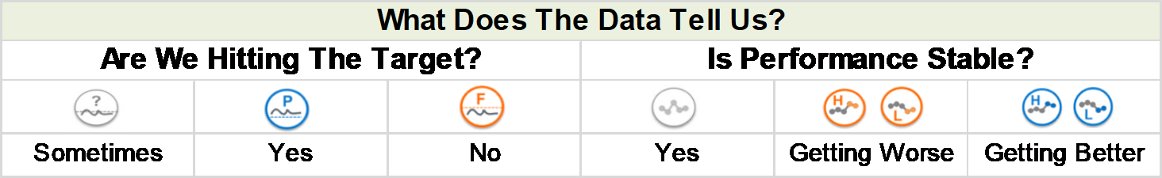Public Trust Board – 1st July 2021 Agenda item 18, Appendix 3

Workforce Performance Summary – May 2021
Turnover
(12 Months)
9.6%
Appraisals
72.0%
Key Workforce Indicators
Retention
(24 Months)
83.0%
Mandatory Training
91.3%
Sickness (In Month) 4.8%
(Rolling 12M)
4.9%

 | Target | Are We Hitting The Target? | Is Performance Stable?
Sickness Absence | 4.5% | Sometimes | Getting Better
Mandatory Training Compliance | 90% | No | Getting Better
Appraisal Compliance | 90% | No | Yes
Turnover (12 Months) | 10% | Sometimes | Getting Better
Retention (24 Months) | 85% | No | Yes



MEETING OF THE PUBLIC TRUST BOARD - 1st July 2021
Update on Staff Experience and Engagement Oversight Group |  |  | AGENDA ITEM: 19
Report Author and Job Title: | Catherine Griffiths – Director of People and Culture | Responsible Director: | Catherine Griffiths – Director of People and Culture
Action Required | Approve ☐ Discuss ☐ Inform ☒ Assure ☐
Executive Summary | The Staff Experience and Engagement Oversight Group was established in March 2021 to provide a Trust-wide response to the National Staff Survey (NSS) report 2020 and to plan for the NSS 2021.  The group is a multi-disciplinary forum representing all divisions and corporate areas. The Freedom to Speak Up Guardians, Staff Network Groups and Staff Side which meets on a monthly basis to improve response to the 2020 NHS staff survey.  The update on short-term actions required is as follows:  - Improving the response rate to the 2021 survey to at least national median level at 45% with an aspiration to achieve 60%. The Pulse survey closed in June with a 53.45% response rate.  - Engaging the Divisions and all colleagues in defining improvement action in the short term, including learning from the best organisations for each of the national survey themes. This month the People and Culture Division and the Digital Services Division presented to the People and Organisation Development Committee and Board presentation packs at appendices one and two.  - Introduce Pulse survey during May 2021, to temperature check key indicators such as colleague advocacy, ability to contribute to improvement, ability to speak up confidently, leadership and culture including bullying and harassment and discrimination. Completed in June and high level report to Trust Board in July 2021.  - Drawing together an action plan to complete short term actions in response to the 2020 staff survey before the 2021 NHS staff survey is released. The action plan is on target for completion.  - Ensuring the communications and engagement plan is effective in communicating the positive changes that have taken place as a result of colleagues taking time to voice their opinions.

Recommendation | The Trust Board is asked to:  - Note the progress on response rate within the Pulse Survey and progress on the other actions 1 to 5 above.  - Consider the Divisional presentations from People and Culture Division and Digital Services Division on plans for action and progress on improving the NHS staff survey results for 2021.
Does this report mitigate risk included in the BAF or Trust Risk Registers? | There implications associated with this paper are specifically to bring clarity and assurance on the action planned to improve the advocacy scores and NHS staff survey results in 2021.
Resource implications | There are resource implications associated with this paper relating to the need to increase engagement resource within the trust.
Legal, Equality and Diversity | There are legal, equality & diversity implications associated with this paper. There is differential colleague experience evidenced through the national staff survey, WRES and WDES data. The Oversight Group seeks to ensure the plans put in place are sufficient to address these implications and achieve equality of outcome on colleague experience.
Strategic Objectives | Safe, high quality care ☐ | Care at home ☐
Strategic Objectives | Partners ☐ | Value colleagues ☒
Strategic Objectives | Resources ☐

Public Trust Board – 1st July 2021 Agenda Item 19, Appendix 1

People and Culture 2020 NHS Staff Survey

Summary of results and plans for improvement

June 2021

People & Culture

At the time of the National Staff Survey (September 2020) the following teams were part of the People & Culture Directorate.

Recruitment (EDI, Talent & Resourcing)

Library & MLCC
Management
Occupational Health & Wellbeing

HR Advisory (Employee Relations)

Learning & Development

* Medical Education (including Resus)

Workforce Intelligence

* Comms Team

ESR System Management

* Aligned to CEO from April 2021.

Freedom to Speak Up
* Transferred to Medical Directorate
from 01 June 2021

Hosted by the Directorate

2020 NSS Indicator Results
Benchmark Average |  | Trust | Community | MLTC | Surgery | WCCSS | E&F | CEO &  Governance | Transformation & Strategy | Finance | Informatics | Nursing Directorate | Operations | P&C
Response Rate (%) | 45 | 33 | 42 | 20 | 25 | 34 | 36 | 74 | n/a | 51 | 37 | 51 | 38 | 57
EDI | 9.1 | 8.7 | 9.2 | 8.0 | 8.6 | 8.7 | 8.9 | 9.3 | 7.1 | 9.3 | 8.3 | 9 | 6.5 | 8.8
HWB | 6.1 | 5.7 | 5.9 | 5.5 | 5.3 | 5.6 | 6.1 | 5.9 | 6.8 | 7 | 4.9 | 5.8 | 3.4 | 6.8
Immediate Managers | 6.8 | 6.6 | 7.2 | 6.7 | 6.2 | 6.8 | 5.1 | 7.1 | 5.8 | 7.1 | 5.6 | 7.1 | 5.3 | 7.5
Morale | 6.2 | 5.9 | 6.1 | 5.7 | 5.7 | 6 | 5.9 | 5.9 | 4.7 | 5.9 | 4.8 | 5.8 | 5.2 | 6.2
Quality of Care | 7.5 | 7.3 | 7.6 | 7.1 | 7.2 | 7.3 | 7.4 | n/a | n/a | 7.3 | 6.5 | 6.9 | n/a | 7.5
Safe Environment Bullying & Harassment | 8.1 | 7.6 | 8.3 | 6.4 | 7 | 7.7 | 8.7 | 8.1 | 7.7 | 9.1 | 7.6 | 8.1 | 3.6 | 8.4
Safe Environment Violence | 9.5 | 9.5 | 9.7 | 8.6 | 9.5 | 9.7 | 9.5 | 10 | 9.6 | 9.8 | 9.9 | 9.8 | 8.1 | 9.9
Safety Culture | 6.8 | 6.3 | 6.6 | 6.4 | 6 | 6.4 | 6.1 | 6.6 | 5.9 | 5.7 | 5.1 | 6.2 | 5.4 | 6.5
Staff Engagement | 7 | 6.7 | 7 | 6.7 | 6.4 | 6.7 | 6.5 | 7.2 | 6.6 | 6.8 | 5.6 | 6.7 | 6.3 | 7.3
Team Working | 6.5 | 6.3 | 6.9 | 6.3 | 5.8 | 6.6 | 5.1 | 6.6 | 5.4 | 7.2 | 5.3 | 7.1 | 3.6 | 7

Divisional Heat map

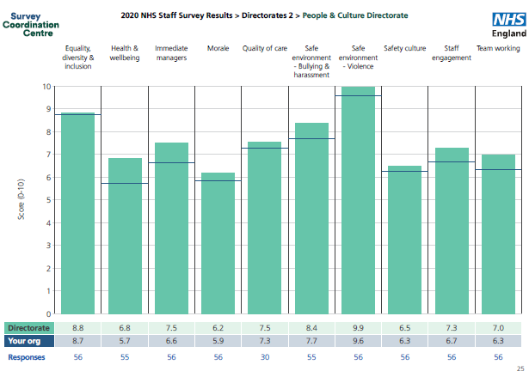
- 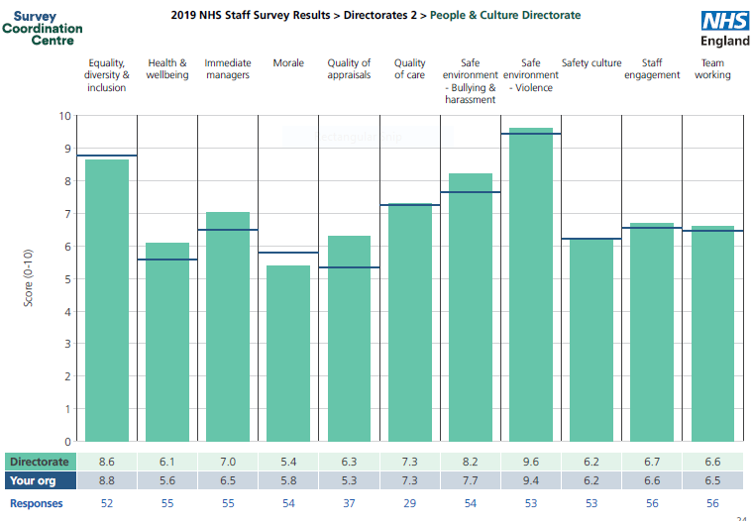The only division to receive a response rate (57%) lower than 2019 response rate of 71%.

2019 Directorate Results

- Against 2019 results, improvements have been made across all themes with the most significant being;
  - Morale
  - Health & Wellbeing
  - Staff engagement
  - Immediate line managers

- The division exceed the best scores across the peer group benchmark in;
  - immediate line managers,
2020 Directorate Results
  - safe environment – bullying & harassment
  - safe environment – violence.

P&C Overview of Indicator Scores

No. of Respondents | 162,691 | 168,691 | 1,299 | 1,396 | 57 | 56
 | 2019 | 2020 | 2019 | 2020 | 2019 | 2020
Indicator | Comparator |  | Trust |  | People & Culture

1. Equality, diversity & inclusion | 9.03 | 8.96 | 8.78 | 8.74 | 8.64 | 8.82
2. Health & wellbeing | 5.93 | 6.07 | 5.58 | 5.72 | 6.09 | 6.81
3. Immediate managers | 6.87 | 6.81 | 6.52 | 6.62 | 7.00 | 7.48
4. Morale | 6.19 | 6.23 | 5.79 | 5.85 | 5.39 | 6.16
5. Quality of care | 7.49 | 7.50 | 7.26 | 7.27 | 7.31 | 7.53
6. Safe Environment - Bullying & Harassment | 8.00 | 8.02 | 7.66 | 7.70 | 8.21 | 8.36
7. Safe Environment - Violence | 9.47 | 9.49 | 9.44 | 9.56 | 9.62 | 9.94
8. Safety Culture | 6.73 | 6.76 | 6.24 | 6.26 | 6.22 | 6.48
9. Staff Engagement | 7.07 | 7.04 | 6.56 | 6.68 | 6.70 | 7.28
10. Team Working | 6.65 | 6.51 | 6.45 | 6.33 | 6.61 | 6.96

P&C Employee Engagement Index

 |  |  | Trust |  | Comparator |  | P&C
Theme | Q | Statement | 2019  % | 2020  % | 2019  % | 2020  % | 2019  % | 2020  %
Motivation | 2a | I look forward to going to work | 54 | 54 | 60 | 59 | 45 | 61
Motivation | 2b | I am enthusiastic about my job | 71 | 70 | 75 | 73 | 57 | 78
Motivation | 2c | Time passes quickly when I am working | 75 | 76 | 77 | 75 | 65 | 80
Involvement | 4a | There are frequent opportunities for me to show initiative in my role | 67 | 67 | 73 | 72 | 75 | 77
Involvement | 4b | I am able to make suggestions to improve the work of my team/department | 69 | 70 | 75 | 73 | 80 | 89
Involvement | 4d | I am able to make improvements happen in my areas of work | 51 | 53 | 57 | 56 | 64 | 73
Advocacy | 18a | Care of patients / service users is my organisation's top priority | 67.6 | 72 | 78 | 80 | 76 | 82
Advocacy | 21c | I would recommend my organisation as a place to work | 48 | 52 | 64 | 67 | 76 | 82
Advocacy | 21d | If a friend or relative needed treatment, I would be happy with the standard of care provided by this organisation | 49 | 53 | 49 | 53 | 49 | 55

Improvement Journey (ongoing)

Where have come from (2018 & 2019)
What we have done

- Consistent senior leadership.
- Connected teams and individuals with organisational objectives via Value our Colleagues Improvement Programme.
- Invested in services aligned to organisational needs; EDI, OH, HWB, Workforce Intelligence.
- Regular cascade of communication.
- Developed peer network of Directorate leaders.
- Encouraged distributive leadership model
- Introduce team leader roles to enable career progression.

- Inconsistent senior leadership across the service.
- Lack of strategic direction, leading to functions not addressing organisational needs.
- Poor internal governance processes.
- Lack of resource & investment across some services.
- Limited collaborative work with system partners.
- Teams / individuals not recognising impact of role / work on patient care.
- Limited career progression.
- Ineffective working relationships between teams within the directorate.
- Lack of improvement focus.

We are most improved
No. of Respondents | 162,691 | 168,691 | 1,299 | 1,396 | 57 | 56
 | 2019 | 2020 | 2019 | 2020 | 2019 | 2020
Question | Comparator |  | Trust |  | People & Culture
During the last 12 months have you felt unwell as a result of work related stress? | 39 | 44 | 45 | 49 | 47 | 42
I look forward to going to work. | 60 | 59 | 54 | 54 | 45 | 61
I am enthusiastic about my job. | 75 | 73 | 71 | 70 | 57 | 78
Time passes quickly when I am working. | 77 | 75 | 75 | 76 | 65 | 80
If a friend or relative needed treatment I would be happy with the standard of care provided by this organisation. | 71 | 75 | 49 | 53 | 49 | 55
Staff feel trusted to do their job | 92 | 91 | 90 | 88 | 89 | 93
Agreed that staff are able to the job to a standard they are personally pleased with | 80 | 80 | 73 | 73 | 72 | 76
Agreed that staff are able to meet all the conflicting demands on their time at work | 47 | 47 | 40 | 39 | 40 | 45
Agreed that staff have adequate materials, supplies and equipment to do their work | 55 | 59 | 41 | 45 | 39 | 48
Satisfied with the recognition received for good work | 58 | 57 | 51 | 52 | 49 | 63
Satisfied with opportunities to use skills | 73 | 72 | 67 | 66 | 65 | 75
Agreed they would know how to report concerns of unsafe clinical practice | 94 | 94 | 94 | 95 | 91 | 95

Still work to do

Our detailed 2020 Divisional Results indicate there is more we need to do:

- Understand in more detail the toll that working through and living with Covid-19 has taken on our team members. Using HWB conversations to identify actions that can improve individual, team and collective experience.
- Undertake ‘stay conversations’ with colleagues whom may have indicated an intention to leave the Trust to understand if any actions can be taken.
- Ensure clarity of individual and team objectives across teams and through this process….
- Help individuals and teams reconnect with understanding how their role impacts on the quality of patient care / outcomes.

What could be better

No. of Respondents | 162,691 | 168,691 | 1,299 | 1,396 | 57 | 56
 | 2019 | 2020 | 2019 | 2020 | 2019 | 2020
Question | Comparator |  | Trust |  | People & Culture
Does your organisation act fairly with regard to career progression / promotion, regardless of ethnic background, gender, religion, sexual orientation, disability or age? | 84 | 83 | 76 | 76 | 67 | 74
Experienced discrimination at work from a manager / team leader or other colleagues in the last 12 months. | 8 | 9 | 10 | 11 | 16 | 13
I often think about leaving this organisation. | 27 | 26 | 34 | 33 | 48 | 36
I will probably look for a job at a new organisation in the next 12 months. | 20 | 19 | 26 | 25 | 46 | 36
As soon as I can find another job, I will leave this organisation. | 14 | 14 | 21 | 19 | 31 | 25
I am satisfied with the quality of care I give to patients / service users. | 81 | 82 | 75 | 77 | 81 | 69
Experienced harassment, bullying or abuse at work from managers in the last 12 months. | 12 | 13 | 17 | 17 | 23 | 18
Experienced harassment, bullying or abuse at work from other colleagues in the last 12 months. | 20 | 20 | 23 | 23 | 13 | 23
My organisation treats staff who are involved in an error, near miss or incident fairly. | 60 | 62 | 51 | 48 | 53 | 46
We are given feedback about changes made in response to reported errors, near misses and incidents. | 61 | 62 | 48 | 46 | 30 | 39
My organisation acts on concerns raised by patients / service users. | 73 | 74 | 63 | 68 | 57 | 68
Agreed that staff always know what their work responsibilities are | 88 | 87 | 85 | 82 | 69 | 77
Staff saying they have worked additional UNPAID hours | 55 | 55 | 56 | 58 | 65 | 65
Agreed that organisation encourages staff to report errors, near misses or incidents | 88 | 88 | 87 | 85 | 84 | 81

During May and June, our directorate colleagues will be invited to contact a senior leader to arrange a confidential conversation to share their experiences and , concerns and discuss how their experience at work can be improved.
Comms to P&C Leaders

What you as a leader needs to do next!

- How much time and energy have you given to discussing SS engagement and results in your teams?
- Consider and share your insight following these results?
- What are you doing in between the annual survey as a leader to make difference?
- What action are you taking?
- Be honest, if something is not good, admit it and share what you intend to do about it – then share progress
- Use the conversation with your team to build trust and respect
- Ask team members how the results resonate with their experience, collect stories (you don’t have to disclose names) and feedback.

Public Trust Board – 1st July 2021 Agenda Item 19, Appendix 2
Digital Services

Response to staff survey



People and Organisation Development Committee

Richard Pearson, Chief Information Officer May 2021

The ask

Following on from April’s meeting, you will recall a request for Corporate areas to provide insight and assurance through to the group regarding the actions you are taking in your areas in relation to the staff survey. Therefore as the senior leader for a corporate division and as a member of the Staff Engagement and Experience Oversight Task Group, in advance of the next meeting on Monday 24 May 2021 you are required to submit a brief/short report covering the following points.

  - The national staff survey indicators you are going to focus improving and why.
  - The actions you have identified and taken in response to high level results for your directorate / division.
  - How you are assured that people within your teams are aware of (a) Trust wide results and (b) directorate / divisional results.
  - Any support / resource you require to address/respond to your local feedback from the survey.
  - Please submit your report to Cara Fraser by Friday 14 May 2021 and be prepared to update at the next meeting. If you are unable to attend, please ensure that arrange for an appropriate colleague to deputise for you.

The 2020 results

 | Benchmark Average | Trust | Community | MLTC | Surgery | WCCSS | E&F | CEO &  Governance | Transformation & Strategy | Finance | Informatics | Nursing Directorate | Operations | P&C
Response Rate (%) | 45 | 33 | 42 | 20 | 25 | 34 | 36 | 74 | n/a | 51 | 37 | 51 | 38 | 57
EDI | 9.1 | 8.7 | 9.2 | 8.0 | 8.6 | 8.7 | 8.9 | 9.3 | 7.1 | 9.3 | 8.3 | 9 | 6.5 | 8.8
HWB | 6.1 | 5.7 | 5.9 | 5.5 | 5.3 | 5.6 | 6.1 | 5.9 | 6.8 | 7 | 4.9 | 5.8 | 3.4 | 6.8
Immediate Managers | 6.8 | 6.6 | 7.2 | 6.7 | 6.2 | 6.8 | 5.1 | 7.1 | 5.8 | 7.1 | 5.6 | 7.1 | 5.3 | 7.5
Morale | 6.2 | 5.9 | 6.1 | 5.7 | 5.7 | 6 | 5.9 | 5.9 | 4.7 | 5.9 | 4.8 | 5.8 | 5.2 | 6.2
Quality of Care | 7.5 | 7.3 | 7.6 | 7.1 | 7.2 | 7.3 | 7.4 | n/a | n/a | 7.3 | 6.5 | 6.9 | n/a | 7.5
Safe Environment Bullying & Harassment | 8.1 | 7.6 | 8.3 | 6.4 | 7 | 7.7 | 8.7 | 8.1 | 7.7 | 9.1 | 7.6 | 8.1 | 3.6 | 8.4
Safe Environment Violence | 9.5 | 9.5 | 9.7 | 8.6 | 9.5 | 9.7 | 9.5 | 10 | 9.6 | 9.8 | 9.9 | 9.8 | 8.1 | 9.9
Safety Culture | 6.8 | 6.3 | 6.6 | 6.4 | 6 | 6.4 | 6.1 | 6.6 | 5.9 | 5.7 | 5.1 | 6.2 | 5.4 | 6.5
Staff Engagement | 7 | 6.7 | 7 | 6.7 | 6.4 | 6.7 | 6.5 | 7.2 | 6.6 | 6.8 | 5.6 | 6.7 | 6.3 | 7.3
Team Working | 6.5 | 6.3 | 6.9 | 6.3 | 5.8 | 6.6 | 5.1 | 6.6 | 5.4 | 7.2 | 5.3 | 7.1 | 3.6 | 7

Honest reflection on poor results. 2020 was a very challenging year for the organisation and Digital Services but will not be used as a justification for the poor results.

Immediate Response

  - Dedicated session in Digital SMT meeting to review the survey results and discuss with team leaders and managers.
  - Sharing of the staff survey report with all members of SMT.
  - Survey results fedback to all staff using our bi-weekly Digital Services huddles.
  - Staff survey and staff experience will continue to be discussed as standing agenda items on bi-weekly huddle and SMT meetings.

Focus areas

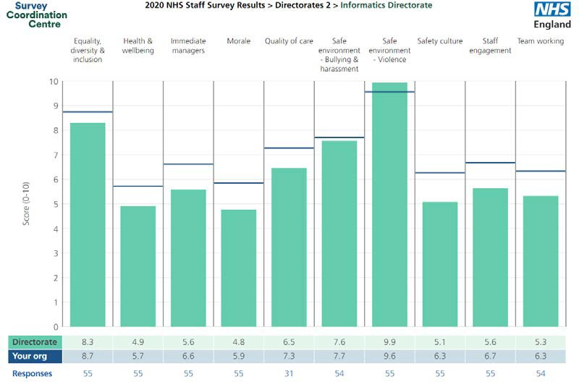
We have initially focussed on the 4 areas with the lowest returned score in addition to staff engagement as this is key to effectively embedding the changes we are implementing

- Health and Wellbeing
- Morale
- Safety Culture
- Team Working
- Staff Engagement

Our approach is to focus on and improve these before moving onto the other areas that are below organisational average

Engaging with staff

  - We had already engaged with the trusts Quality Improvement Team prior to the results being published as part of our internal Service Improvement work.
  - Three staff engagement sessions were facilitated by the QI Team between 25th March and 1st April 2021. 46 staff in total attended these sessions and recorded over 200 items for review.
  - These sessions captured staff feedback using the 4N model and feedback was then themed and grouped
  - The collated feedback was then shared with all attendees to encourage openness and transparency
  - Themed detail of the feedback received is shown on the next slide

Engaging with staff - output

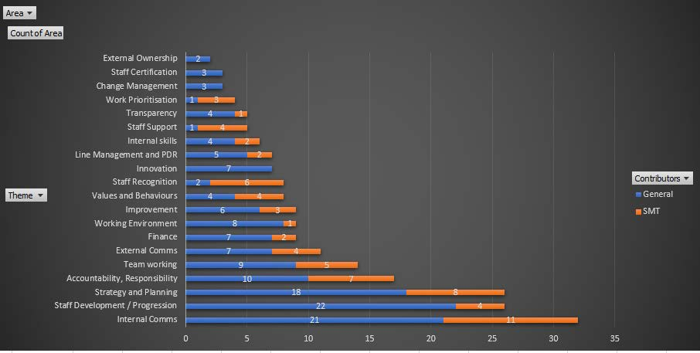

Current Actions

    - Reviewing the detail of a specific theme each week in our SMT meeting and agreeing immediate and future actions to be taken.
    - Set up new Communications channel in Teams and weekly Digital Services newsletter to provide immediate cascade of information to all members of Digital Services.
Staff Engagement
Staff Engagement
    - Identification and appointment of Communications Champions within each Digital Services Team to work on designing and building Digital Services pages on the new trust intranet and facilitate cross team working and sharing of information.
Team Working
    - In-confidence colleagues – 3 staff have volunteered to be ‘In- confidence colleagues’ and be available for staff to contact confidentially if they have something they would like to raise but are uncomfortable in doing so
Health and wellbeing
    - Mental Health First aiders being trained within Digital Services
Health and wellbeing

Current Actions

      - Promoting of Pulse survey to the entire directorate
      - Staff skills matrix survey. Capturing staff current skills and desires to learn new skills. Provides opportunity for looking at professional development and working across teams
Morale
Staff Engagement

Future Items

  - Agree how best to protect time for staff to be able to participate in the staff survey
  - Future discussion about how to engage all of our workforce including the large number of part time workers in both Health Records library and Switchboard who will need alternative communication methods
  - Review the detailed survey output once received to identify specific areas of action that are required
  - Review plan and response for..
- Equality Diversity and Inclusion
- Immediate Managers
- Quality of Care
- Safe Environment – Bullying and harassment

MEETING OF THE PUBLIC TRUST BOARD - 1st July 2021
Monthly Nurse Staffing Report – May 2021Data |  |  | AGENDA ITEM: 20
Report Author and Job Title: | Lisa Carroll  Deputy Director of Nursing | Responsible Director: | Prof Ann-Marie Cannaby, Interim Chief Nursing Officer/Deputy Chief Executive
Action Required | Approve ☐ Discuss ☐ Inform ☒ Assure ☒
Executive Summary | - Registered Nurse (RN) /Midwife vacancy rate is 7% a decrease from the 9% reported in May 2021  - 19 overseas nurses arrived in May 2021 with Objective Structured Clinical Examinations (OSCE) booked for end of July.  - 27 overseas nurses commence in June 2021 with OSCE’s booked for August.  - The Trust expects to recruit 200 overseas RN by the end of 2021.  - There are 44 Clinical Support Workers (CSW) undertaking apprenticeships and 38 Trainee Nursing Associates on apprenticeship programmes in the Trust. In addition, 1 Healthcare Sciences apprentice is in post within the Trust.  - Off Framework Agency use has reduced in May 2021 from the  351 hours used in April 2021 to 80.5 hours used in the Emergency Department (ED) in month.  - The lowest fill rate for May 2021 was for the CSW day shift at 90.97%. The overall fill rate (combined RN and CSW) was 93.8%, a decrease from the 95.7% reported for April 2021.  - In May 2021, before consideration of escalation to Off Framework Agency, Matrons redeployed 421.5 hours of substantive RN and 316.5 hours of CSW during the twice daily Staffing Hub meetings.  - The staff experience audit score was 86.3% with 22 clinical areas completing this audit
Recommendation | The Board is requested to note the contents of the report and make recommendations as needed
Does this report mitigate risk included in the BAF or Trust Risk Registers? please outline | BAF S01: We will deliver excellent quality of care as measured by an outstanding CQC rating by 2022  Corporate Risk No 2066: Substantive staffing levels are below the agreed safe staffing levels for wards and departments leading to the potential for avoidable harm. (Risk Score = 15).

Resource implications | COVID-19 impact – during COVID-19 staff have worked in different ways and locations; there has been a risk to staff health and well- being and as we come out of the pandemic we must remain focused on the potential long term impacts; there has been an impact on training and continual professional development during the height of the pandemic which is now being addressed.  Establishment and skill mix reviews are underway and international recruitment is a focus with an aim of reducing agency staff usage to zero by the end of 2021
Legal and Equality and Diversity implications | None
Strategic Objectives | Safe, high quality care ☒ | Care at home ☐
Strategic Objectives | Partners ☒ | Value colleagues ☐
Strategic Objectives | Resources ☒

Introduction

COVID-19 impact has reduced across the Trust with many services now resuming ordinary business. There are still a small number of reconfigured areas within the acute departments which are working with Covid streaming, different patient groups and vacancies/absences that are impacting the ability to have complete fill of shift requirements. May 2021 has seen a continued reduction in the reliance on the Ward Manager and Matron workforce to departments for redeployments.
- Vacancy and Recruitment Position

  - Vacancy Position

The RN and Midwifery vacancy rate for May 2021 is 7%. This is a reduction in the vacancy rate reported for April 2021 of 9%.

Trust wide Nursing and Midwifery vacancy % (excluding Nurse Associates)
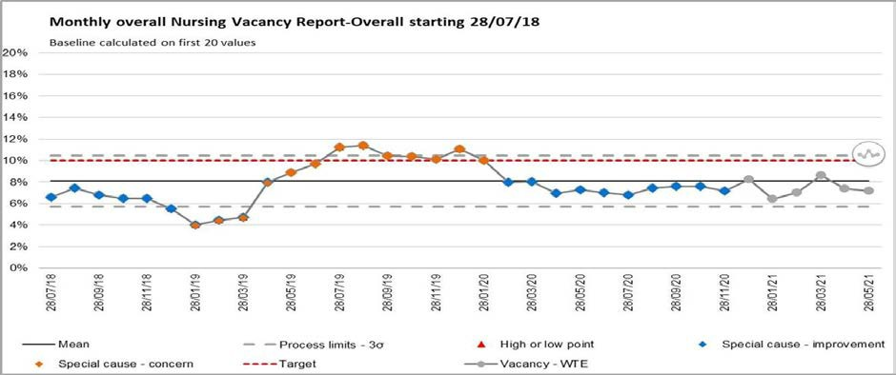

  - Overseas Recruitment

19 overseas nurses commenced in the Trust in May 2021 and OSCE’s are booked for the end of July. 27 overseas nurses will commence in June and OSCE’s are booked for August.

Pastoral care is being delivered by Team FORCE (Faculty of Research and Medical Education). There are a further four cohorts of overseas RNs due to commence in the Trust between July and October 2021. The current expectation is that approximately 200 overseas RN will be recruited by the end of 2021.

  - CSW Recruitment

The Trust currently has 83 individuals undertaking apprenticeships. One individual has been employed as a healthcare science apprentice, 38 are Trainee Nursing Associates and 44 are

CSWs undertaking either a level 2 or level 3 programme.

  - Nursing Associate Recruitment

Of the 38 Trainee Nursing Associates eight are expected to complete in the next month. An additional eleven individuals will commence training in September 2021.

- Shift Fill Rates

The overall fill rate (combined RN and CSW) for May 2021 was 93.8%, a decrease from the 95.7% reported for April 2021. The lowest fill rate for May 2021 was for CSWs on day shifts at 90.97%.
Ward Area Staffing Fill Rates
Safe Staffing Fill Rate - May-2021
105.00%
100.00%
95.00%
90.00%
85.00%
100.00% 100.00%
98.27%
100.00% 100.00%
92.26%
93.95%
90.97%
RN Day CSW Day NA Day TNA Day RN Night CSW Night NA Night TNA Night

- Temporary Staffing

  - Agency use

Agency bookings remain static between 300 and 400 shifts being booked per week. Agency filled shifts week by week
Agency
Week Number
Commencing Shifts Variance From Prev Week
W.C 12.04.21 | 301 | - | -
W.C 19.04.21 | 377 | 76 | Increase
W.C 26.04.21 | 360 | -17 | Decrease
W.C 03.05.21 | 336 | -24 | Decrease
W.C 10.05.21 | 358 | 22 | Increase
W.C 17.05.21 | 375 | 17 | Increase
W.C 24.05.21 | 366 | -9 | Decrease

Bank filled shifts week by week
Bank
Week  Commencing | Number  Shifts | Variance From Prev Week
W.C 12.04.21 | 670 | - | -
W.C 19.04.21 | 768 | 98 | Increase
W.C 26.04.21 | 846 | 78 | Increase
W.C 03.05.21 | 896 | 50 | Increase
W.C 10.05.21 | 902 | 6 | Increase
W.C 17.05.21 | 780 | -122 | Decrease
W.C 24.05.21 | 781 | 1 | Increase

Agency cap breaches are reported weekly to NHSI. The number of reported breaches has remained unchanged for the last two months. In May 2021 there were 802 shifts reported as breaching the cap compared to 796 reported in April 2021. Off framework agency use has reduced in May 2021 from the 351 hours used in April 2021 to 80.5 hours used in ED in month.
Agency bookings and cap breaches
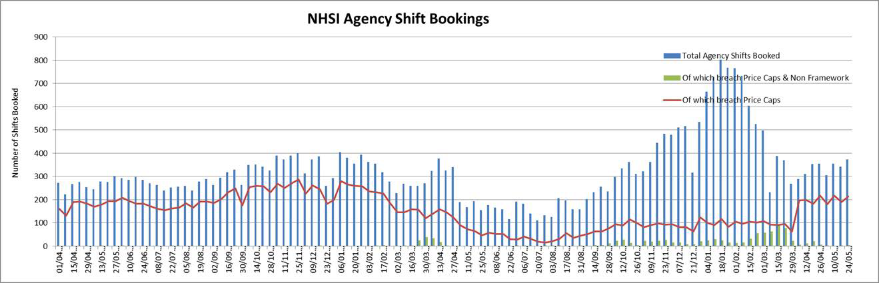

Agency Cost per week

£120,000.00
£100,000.00
£80,000.00
£60,000.00
£40,000.00
£20,000.00
£0.00
Agency - Community Division
Agency - DIRECTOR OF
NURSING
Agency - DIVISION OF SURGERY

Agency - MEDICINE AND LONG TERM CONDIT
Agency - WOMENS CHILDRENS CLIN SUPT SER

Bank Cost Per week

£100,000.00
£90,000.00
£80,000.00
£70,000.00
£60,000.00
£50,000.00
£40,000.00
£30,000.00
£20,000.00
£10,000.00
£0.00
Bank - Community Division
Bank - COVID Programme

Bank - DIRECTOR OF NURSING

Bank - DIRECTOR OF OPERATIONS
Bank - DIVISION OF SURGERY

Bank - MEDICINE AND LONG TERM CONDIT
Bank - WOMENS CHILDRENS CLIN SUPT SER

  - Electronic Rostering (E-roster) Levels of COVID-19 Related Absence and Temporary Staff Use

The Trust records all absence within the e-roster system. The system enables COVID-19 related absence to be recorded separately from other sickness absence

Covid-19 Related Absence in E-roster
Staff Type | Covid Related Absence Hours (E-roster)
RN | May= 566 hrs (reduction since previous month-April  21)
CSW | May= 545 hrs (reduction since previous month-April  21)

In May 2021 the temporary staffing bookings to cover for sickness and COVID-19 related absence for RN’s was 2037 less than the actual hours of absence recorded. For CSWs there were 1980 hours fewer hours booked than hours of absence recorded. There was an overall reduction in sickness/COVID-19 related absence in May 2021 compared to those recorded in April 2021 ( 8218 RN hours and 6883 CSW hours), (Chart 10).

Ward 9 increased its bed base opening additional capacity on ward 10 during May 2021 and the establishment and safe staffing levels increased to reflect this.

Comparison of Sickness/Covid-19 Absence against Temporary Staffing
Staff Type | Sum of Covid-19 Related Absence  Hours + Sickness Absence | Temporary Staffing Hours Booked for  Sickness and Covid-19 related absence
RN | 7560 hours | 5523 hours
CSW | 5213 hours | 3233 hours

In May 2021 there were 3247 fewer RN hours of temporary staff booked compare to the actual hours of maternity related absence. For CSWs there were 1355 fewer hours of temporary staff booked compared to the actual hours of absence. There was an overall reduction in maternity related absence in May 2021 compared to those recorded in April 2021 (6308 RN hours and 2491 CSW hours).

Comparison of Maternity/Paternity absence against Temporary Staffing
Staff Type | Maternity/Paternity Absence hours | Temporary Staffing Hours Booked for  maternity/paternity related absence
RN | 5064 hours | 1817 hours
CSW | 2243 hours | 888 hours

4.0 Establishment Reviews

During June 2021 all wards are undertaking establishment reviews using the Safer Nursing Care tool (SNCT) data collection. The ED will utilise the Baseline Emergency Staffing Tool (best), theatres the Association for Peri-Operative Practice (AFPP) standards and Critical Care the Faculty of Intensive Care Medicine guidelines. The data collection will inform establishment and skill mix reviews across the Trust and adjustments to safe staffing levels as required.

5.0 Allocate System Roll Out

Forty two departments have attended Roster Manager training on Allocate to date and have implemented the Allocate system. There are six remaining departments to move onto Allocate from RosterPro (RPC) that receive enhancements. The ED and the Emergency Department Paediatric Service implemented the Allocate System following training in April 2021. There are six departments yet to move into Allocate. These areas provide a Monday - Friday service but require the system in order to book temporary staff.
The RPC system licence has been extended until September 2021 to enable full roll out of the Allocate system. The Covid-19 pandemic has delayed the roll out plan for Allocate due to the inability to train clinical staff. Virtual methodologies have been tried without success. Face to face training in a COVID secure way has re-commenced.

6.0 Staff experience audits – Perfect ward

The corporate nursing team has been working closely with the performance team to continue to develop the perfect ward audits. Within this suite of audits a monthly staff experience audit is undertaken. In May 2021 the staff experience audit score was 86.3% with 22 clinical areas completing this audit. The audit results, action plans, continued monitoring of progress and re-audit will be overseen and assurance on progress gained through the Trust wide Nursing, Midwifery and AHP Forum and Divisional Governance meetings.



MEETING OF THE PUBLIC TRUST BOARD – 1ST JULY 2021
Freedom to Speak Up Annual Report |  |  |  |  | AGENDA | ITEM: | 21
Report Author and Job Title: | Kim Sterling Val Ferguson  Freedom to Speak Up Guardians  Ayshia Aziz | Responsible Director: |  |  | Catherine Griffiths Director of People and Culture
Action Required | Approve ☐ Discuss ☒ | Inform ☒ |  | Assure ☐
Executive Summary | Analysis of the number of concerns generated though Freedom to Speak Up (FTSU) for the financial year 2020 to 2021 is supplied.  A revised strategy on FTSU and improvement plan is presented
Recommendation | Members of the Trust Board are asked To:  - Note the report and discuss the contents within  - Commit to making Speaking Up routine day-to-day practise.  - Support whether work required to progress the FTSU function to improve the WHT safety culture
Does this report mitigate risk included in the BAF or Trust Risk Registers? please outline | The work programme described within this report will provide positive assurance on the following BAF risk:  Lack of an inclusive and open culture impacts on staff engagement, staff morale and patient care.
Resource implications | There are some cost implications associated with following this programme of work, all resource will be aligned through existing budgets.
Legal and Equality and Diversity implications | Black, Asian or minority ethnic employees often face more barriers than non BAME employees when raising concerns.  The data available is not yet sufficient to reliably determine and evidence equality and diversity impacts. This is being addressed through collecting concerns electronically through the incident reporting system, Safeguard and work being undertaken by the Equality, Diversity and Inclusion Committee.
Strategic Objectives | Safe, high quality care ☒ |  | Care at home ☐
Strategic Objectives | Partners ☐ |  | Value colleagues ☒
Strategic Objectives | Resources ☐

Freedom to Speak Up Annual Report

PURPOSE OF REPORT
This report presents the number of concerns and themes raised by colleagues through the Freedom to Speak Up (FTSU) route in 2020/2021.
To update the members on the development of Speaking Up within WHT, set the scene and gain support for the improvement plan for the year. The provision of FTSU benchmarking information is included.

BACKGROUND
All NHS Trusts and providers of NHS care subject to the NHS standard contract are required to appoint a Freedom to Speak Up Guardian and follow the National Guardians Office (NGO)’s guidance on speaking up.

Workers voices form one of the pillars of the People Plan. Guardians are key in ensuring workers are heard, particularly those groups of workers facing barriers to speaking up. FTSUGs are one of many routes through which workers may speak up. Information about the speaking up cases raised with FTSU forms part of a bigger picture of an organisation’s speaking up culture and arrangements.

The data collection process continues to provide an insight into speaking up and the use of the Freedom to Speak Up Guardian route.

Contained within this report are trends of the FTSU Index, case numbers and themes. The Model Hospital (appendix 1) is an NHS digital information service designed to help the NHS improve productivity and efficiency. Data has been extracted from the culture and engagement compartment on the Model Hospital to compare metrics and benchmark data to illustrate how the WHT compares with other similar trusts.
An update on the improvement plan for the next 12 months is included and reflects the WHT FTSU strategy objectives.

Data Analysis
The annual NHS staff survey contains several questions that are helpful indicators of speaking up culture. The FTSU index was calculated as the mean average of responses to the following four questions from the NHS Staff Survey:

  - % of staff "agreeing" or "strongly agreeing" that their organisation treats staff who are involved in an error, near miss or incident fairly (question 17a)
  - % of staff "agreeing" or "strongly agreeing" that their organisation encourages them to report errors, near misses or incidents (question 17b)
  - % of staff "agreeing" or "strongly agreeing" that if they were concerned about unsafe clinical practice, they would know how to report it (question 18a)
  - % of staff "agreeing" or "strongly agreeing" that they would feel secure raising concerns about unsafe clinical practice (question 18b)

FTSU Index  % | WHT | Acute/Community Average | CQC Rating same as WHT | National Average | Outstanding Trusts
2015 | 70. | 75.3 | 75.1 | 75.7 | No data  captured nationally
2016 | 71.9 | 77.2 | 75.6 | 76.6 | No data  captured nationally
2017 | 74.9 | 77.2 | 75.5 | 77.0 | No data  captured nationally
2018 | 76.6 | 77.8 | 76.8 | 78.4 | 87%
2019 | 75.2 | 78.4 | 77.3 | 78.9 | 86.6%

The index is an indicator of potential areas of good practice and concern when it comes to the speaking up culture in trusts and is shard the with stakeholders, including the Care Quality Commission (CQC), and NHS England and NHS Improvement, so it directs their work to support trusts appropriately. The Trust with the highest percentage for 2018/2019 was Cambridgeshire Community Services NHS Trust.

There has been a steady increase in all the peer averages and the index nationally. This upward trajectory is mirrored in the Trust up until 2018, when there was a fall in the percentage at Walsall.

Benchmarking with comparators from Model Hospital Data
35

30

25

20

15

10
WHT
Acute/Community trust average Same CQC rating
Regional average
National Average
5

0
2018
2019
2020 (up to Q3 2020-
21)

In the chart above, the total number of cases brought to FTSU is shown and the Trust appears to be an outlier for all the years portrayed. This data could suggest that we have a poor organisational culture for speaking up and raising concerns at source, suggesting that FTSU is the preferred route for WHT employees to raise concerns. There are 7% (2021), 23% (2019) and 60% (2018) more cases reported in the Trust than the closest comparator. This could indicate that additional work is necessary to examine the reasons for the prevalence of reporting concerns using methods external to the divisions. This may include improving communication and engagement channels with colleagues from all decisions to resolve issues at a local level. Staff should be commended for their dedication to speaking up.

Concerns with a patient safety and quality theme are illustrated below.
18
16
14
12
10
8
6
4
2
0
WHT
Acute/Community trust
average
Same CQC rating Regional average
National Average
2018 2019 2020 (up to Q3 2020-
21)

As represented above, the number of cases with an element of patient safety and quality surpasses the number reported by the Trust’s comparators. On closer inspection, there were 76% more concerns reported in the Trust in 2018; 25% more in 2019 and 100% more in 2020.This is an indication that further work is required to ascertain whether there are obstacles, perceived or real to raising concerns of a patient safety and quality nature through other routes other than FTSU.

Cases relating to bullying and harassment are shown below

25
20
WHT
15
Acute/Community trust
average
Same CQC rating
10
Regional average
5
National Average
0
2018
2019
2020 (up to Q3 2020-
21)

The number of cases reported through FTSU with an element of bullying and harassment for the comparators are within a range of difference of one or two cases. The picture for Walsall is markedly different in 2018 and 2019 though it is comparatively similar in 2020, with two more cases than the average for trusts of a similar type.

Total Cases Reported to FTSU Guardians

12 months rolling average | WHT | Acute/Community trust average | Same CQC rating | Regional average | National Average
2019 | 86 | 32 | 43 | 48 | 38
2020 | 99 | 62 | 63 | 61 | 56

Trend in number of bullying & harassment cases
25
20
15
10
Bullying & Harassment
Patient Safety
5
0
2018
2019
2020 (up to Q3
2020-21)

Trend in number of themes
60

50

40

30

20

10

0
Attitudes & Behaviour
Equipment & Maintenance Staffing Levels
Policies, Procedure & Processes Quality & Safety
Patient Experience Performance Capability Service Changes
Other
2018 2019 2020 (up to Q3 2020-
21)

Divisional Data

Concerns by Division April 2019 – March 2020
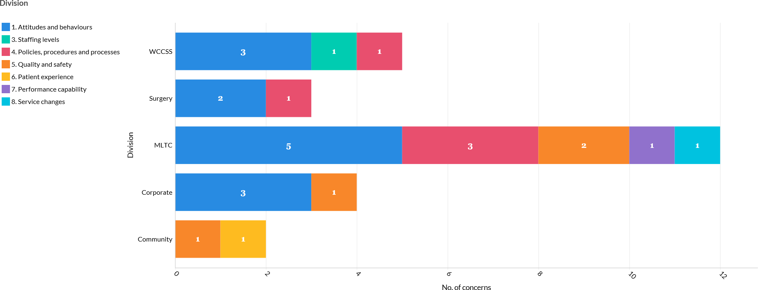

Concerns by Division April 2020 – March 2021
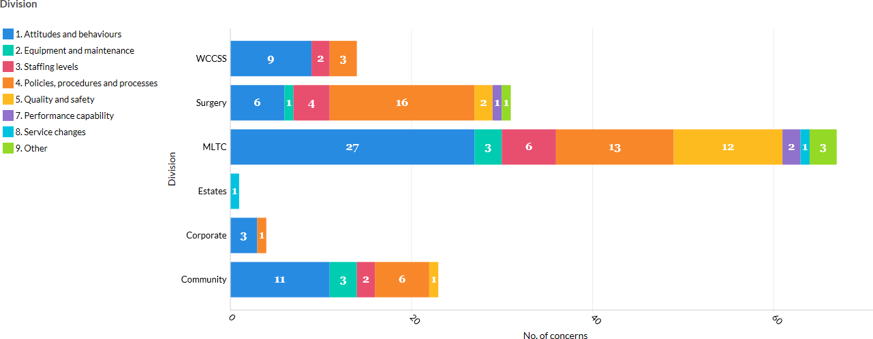

Themes of concerns April 2019 - March 2020
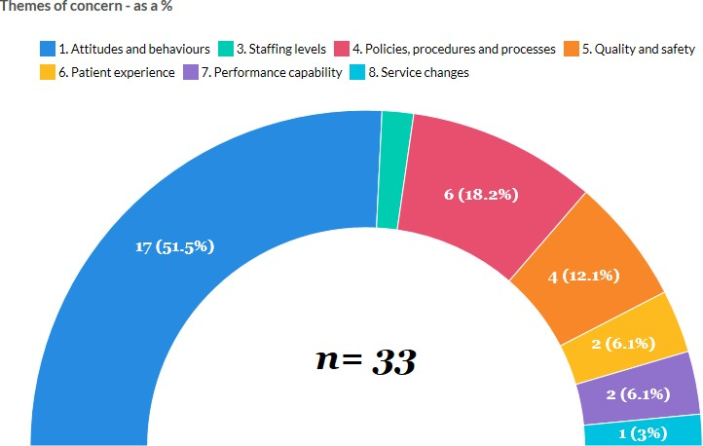

*Staffing levels = 3%

Themes of concerns April 2020 to March 2021

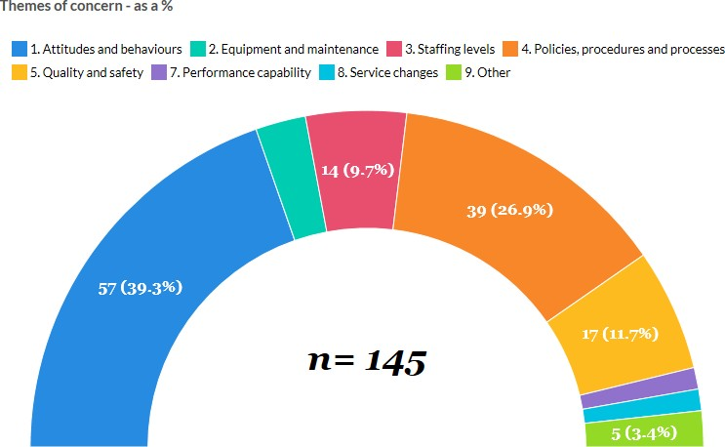

It can be seen from the charts above that there is a significant increase in concerns from the period April 2019 to March 2020 compared to April 2020 to March 2021. There was an extra
112 concern which equates 339% increase. It can clearly be seen that Attitudes and Behaviour has generated the highest percentage of concerns in both years and the top three themes remain the same for both periods, however, the number of concerns raised in April 2020 to March 2021 has significantly increased. This increase could be attributed to the COVID-19 pandemic which began in March 2020. Channels of communication with staff were greatly increased and any concerns encouraged to be raised. During this period the FTSU service evolved and adapted to offer support in alternative ways such as; flexible service and availability times, Pull Up a Chair with the Chair initiative, attending the weekly Director of Nursing conference calls with the senior nursing teams, regular Daily Dose articles with the promotion of the FTSU service and referrals from other support services i.e. the Haven.
Concerns by grade for the period April 2019 to March 2020
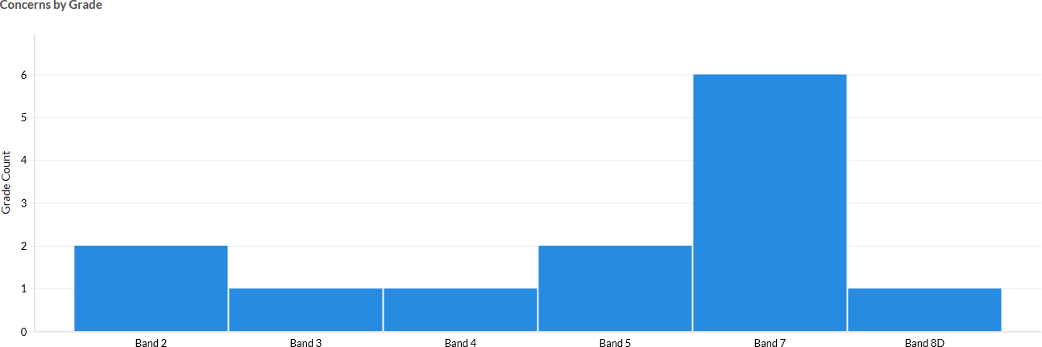

The above diagram shows that 24% of cases raised with the FTSU team were by colleagues whose jobs are graded in bands 5 and 7.

Concerns by grade for the period April 2020 to March 2021
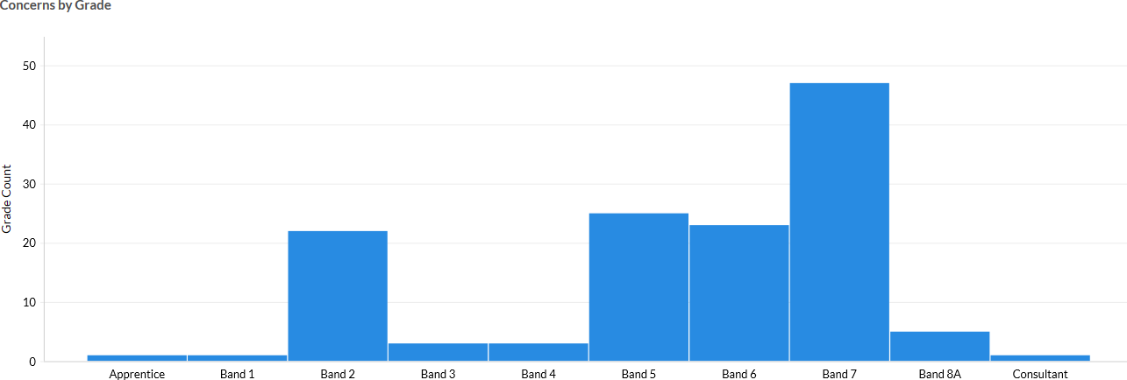

The above graph clearly highlights that the medical workforce raise minimal concerns via the FTSU route, we are unsure why this is, however, we are now working closely with key stakeholders to establish how we can best support and hear their concerns. The medical workforce do have other avenues where they can raise concerns such as, the Deanery, access to the Medical Director, Guardian of Safe Working Hours and also their lead clinician or supervisor.
Total Number of concerns received April 2019 – March 2020

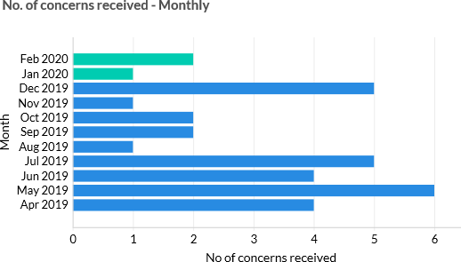

Total Number of concerns received April 2019 – March 2020

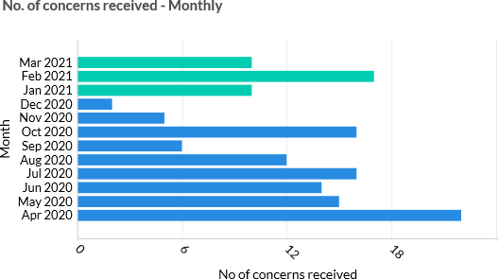

Objectives from FTSU Strategy

For the realisation of our FTSU vision, five strategic objectives were set for 2020/21:

  - The executive team and mangers are required to model behaviours to promote an open and positive organisational culture. This was discussed at the board development session and pledges were made by all of the executives. Further work could involve virtual surgeries and real board to ward, and volunteering to be present at departmental/team meetings in community and hospital settings. The Pull up a Chair initiative continues to provide opportunity for board members to listen to the experiences of staff.
  - The setting up of the BAME Decision Making Council and the BAME Colleagues Support Network has progressed the work to remove barriers to facilitate a diverse and inclusive approach to Speaking Up as set out in the third objective. The FTSUGs will also have a presence at further colleague networks as they become established for other underrepresented groups.
  - Regular drop in/call sessions are provided for staff to meet with FTSUGs where they can ask for advice and provide a forum for listening to concerns.
  - More extensive work is required to ensure staff receive timely feedback and details of what action has been taken to address concerns.

  - The volume of concerns received, is much higher than our regional neighbours or similar trusts would imply that the strategic objective relating to accessing the trust’s speaking up channels has been met.
WHT FTSU Improvement Plan

The project initiation document was developed for FTSU in June 2020, the work packages were devised and based on the elements within the improvement plan.
There are outstanding elements that require input from the directorate of People and Culture, including the review and revision of the Raising Concerns Policy. This should include removal of references to the Public Interest Disclosure Act and the mention of malicious intention removed. Inclusion of explicit wording in the policy stating, that all those who raise concerns are thanked.
Ensure that any trust policy/procedure under review is in alignment with good practice in relation to FTSU.
Support colleagues who speak up and protect them from detriment. All investigations into alleged conduct of employees who have spoken up, identify whether allegations are motivated by a desire to cause detriment. Where evidence is found, take appropriate action.
FTSU Achievements

The establishment of the Non-Executive Director-led Colleague Health and Wellbeing Assurance group that met weekly at the start of the pandemic ensured that colleagues concerns were investigated and actioned quickly. The organisation responded in a timely and appropriate way to support staff, particularly those working in close contact with patients.
Speak up month in October ran, all communications were virtual due to the COVID-19 pandemic. Through daily dose activities such as the FTSU alphabet, word search and other competitions were key engagement with staff across the Trust. The uptake during Speak Up month was considerably less than previous years due to the service and staffing demands, many of our colleagues were shielding or working from home.
The recent introduction of the Speaking up/Listening up training modules is now being offered to all staff on the electronic staff record. The uptake will be closely monitored, collated and reported on.
We have successfully recruited and are currently training eight Confidential Contact Links (CCL), who are represented by all divisions across the Trust except for Estates. We have a cross sectional representation of CCLs that range from Advanced Clinical Practitioner, Mangers, Nursing, and Corporate staff.

Our previous chair Danielle Oum undertook a number of Pull Up a Chair sessions. Danielle successfully met and listened to over 30 staff members raising their concerns to her in a 1:1 forum. Concerns were then escalated appropriately for further investigation and any actions required.
Lessons learnt – “Speaking Up during COVID-19.” During COVID, it was evident that staff did not speak up as in previous years, this could be for numerous reasons such as;
    - Too busy with the increased workload
    - Reduces staffing
    - Staff shielding - disconnection from the Trust
    - Staff working from home – disconnection from the Trust
    - Re-deployed staff – disconnection from their usual place of work
    - Heightened sense of fear in general

Plans for the coming year

    - Exit monitoring process review
    - Community Roadshows
    - Pull up a Chair
    - Survey employees before and during Speak up month to include questioning (to understand why staff are not speaking up). The results could be used to set objectives for the coming year
    - Follow up survey 2/3 months post speak up month. Publish results in Newsletter

Recommendations

  - Note the report
  - Commit to making speaking up day to day practice
  - Support further work required to progress the FTSU function to improve WHT safety culture

Appendix 1 – Model Hospital Data for WHT





Walsall Healthcare NHS Trust

Culture & Engagement
Report Date: 22 March 2021 Generated by: Catherine Griffiths
The Model Hospital website: https://model.nhs.uk

© 2021 NHS Improvement

FTSU Index

An index created from a subset of questions of the NHS Annual Staff Survey Data period: latest available at the time of generating this report
Peer group: 'Global Digital Exemplars'

Data  FTSU Index period  FTSU Index 2019  % Change in FTSU Index (over 2019  previous 3 calendar years) | Trust value Performance band description  □ 75.2% In quartile 1 - Lowest 25% (blue)  - 4.6% In quartile 3 - Mid-High 25% (blue) | Peer National  median median  79.1% 78.9%  2.5% 2.4%

Data  Component Metrics of the FTSU Index period  q17a - My organisation treats staff 2019  who are involved in an error, near miss or incident fairly .  q17b - My organisation encourages us 2019 to report errors, near misses or  incidents.  q18a - If you were concerned about 2019  unsafe clinical practice, would you know how to report it?  q18b - I would feel secure raising 2019  concerns about unsafe clinical practice. | Trust value Performance band description  - 52% In quartile 1 - Lowest 25% (red)  - 87% In quartile 1 - Lowest 25% (red)  - 94% In quartile 1 - Lowest 25% (red)  - 67% In quartile 1 - Lowest 25% (red) | Peer National  median median 61% 60%  89% 89%  94% 95%  72% 72%

FTSU Guardian Cases

Freedom to Speak Up (FTSU) cases reported to Guardians

Data period: latest available at the time of generating this report Peer group: 'Global Digital Exemplars'
FTSU: All Cases  Total cases reported to FTSU Guardians  Total cases reported to FTSU Guardians per 1,000 WTE  Total cases reported to FTSU Guardians (12 month rolling average) | Data period  Q2 2020/21  Q2 2020/21  Sep 2020 | Trust value  - 33  - 9.19  - 82 | Performance In quartile 4  In quartile 4  In quartile 4 | band description  - Highest 25% (blue)  - Highest 25% (blue)  - Highest 25% (blue) | Peer National  median median  11 16  1.63 3.37  26 34
FTSU: Cases relating to Bullying &  Harrassment | Data period | Trust value  - 15  - 4.18  - 45%  - 21 | Performance | band description | Peer National  median median  5 4  0.60 0.91  38% 30%  12 9
Bullying & harrassment cases | Q2 2020/21 | Trust value  - 15  - 4.18  - 45%  - 21 | In quartile 4 | - Highest 25% (blue) | Peer National  median median  5 4  0.60 0.91  38% 30%  12 9
reported to FTSU Guardians |  | Trust value  - 15  - 4.18  - 45%  - 21 |  |  | Peer National  median median  5 4  0.60 0.91  38% 30%  12 9
Bullying & harrassment cases | Q2 2020/21 | Trust value  - 15  - 4.18  - 45%  - 21 | In quartile 4 | - Highest 25% (blue) | Peer National  median median  5 4  0.60 0.91  38% 30%  12 9
reported to FTSU Guardians per 1,000 |  | Trust value  - 15  - 4.18  - 45%  - 21 |  |  | Peer National  median median  5 4  0.60 0.91  38% 30%  12 9
WTE |  | Trust value  - 15  - 4.18  - 45%  - 21 |  |  | Peer National  median median  5 4  0.60 0.91  38% 30%  12 9
Bullying & harrassment cases | Q2 2020/21 | Trust value  - 15  - 4.18  - 45%  - 21 | In quartile 3 | - Mid-High 25% (blue) | Peer National  median median  5 4  0.60 0.91  38% 30%  12 9
reported to FTSU Guardians as% of |  | Trust value  - 15  - 4.18  - 45%  - 21 |  |  | Peer National  median median  5 4  0.60 0.91  38% 30%  12 9
total cases |  | Trust value  - 15  - 4.18  - 45%  - 21 |  |  | Peer National  median median  5 4  0.60 0.91  38% 30%  12 9
Bullying & harrassment cases | Sep 2020 | Trust value  - 15  - 4.18  - 45%  - 21 | In quartile 4 | - Highest 25% (blue) | Peer National  median median  5 4  0.60 0.91  38% 30%  12 9
reported to FTSU Guardians (12 |  | Trust value  - 15  - 4.18  - 45%  - 21 |  |  | Peer National  median median  5 4  0.60 0.91  38% 30%  12 9
month rolling average) |  | Trust value  - 15  - 4.18  - 45%  - 21 |  |  | Peer National  median median  5 4  0.60 0.91  38% 30%  12 9
FTSU: Cases relating to Patient Safety Data  &Quality period |  | Trust value | Performance | band description | Peer National  median median  2 3  0.29 0.54  17% 17%  3 6
Patient safety & quality cases reported Q2 2020/21 to FTSU Guardians |  | - 3 | In quartile 2 | - Mid-Low 25% (blue) | Peer National  median median  2 3  0.29 0.54  17% 17%  3 6
Patient safety & quality cases reported Q2 2020/21 to FTSU Guardians per 1,000 WTE |  | - 0.84 | In quartile 3 | - Mid-High 25% (blue) | Peer National  median median  2 3  0.29 0.54  17% 17%  3 6
Patient safety & quality cases reported Q2 2020/21 to FTSU Guardians as% of total cases |  | - 9% | In quartile 2 | - Mid-Low 25% (blue) | Peer National  median median  2 3  0.29 0.54  17% 17%  3 6
Patient safety & quality cases reported Sep 2020 to FTSU Guardians (12 month rolling  average) |  | - 13 | In quartile 4 | - Highest 25% (blue) | Peer National  median median  2 3  0.29 0.54  17% 17%  3 6

FTSU: Cases relating to Detriment as a Data  result of Speaking Up period |  | Trust value | Performance | band description | Peer National  median median  0 0  0.00 0.00  0% 0%  0 0
Cases of Detriment as a result of Q2 2020/21 Speaking Up reported to FTSU  Guardians |  | - 1 | In quartile 3 | - Mid-High 25% (blue) | Peer National  median median  0 0  0.00 0.00  0% 0%  0 0
Cases of Detriment as a result of Q2 2020/21 Speaking Up reported to FTSU  Guardians per 1,000 WTE |  | - 0.28 | In quartile 4 | - Highest 25% (blue) | Peer National  median median  0 0  0.00 0.00  0% 0%  0 0
Cases of Detriment as a result of Q2 2020/21 Speaking Up reported to FTSU  Guardians as% of total cases |  | - 3% | In quartile 3 | - Mid-High 25% (blue) | Peer National  median median  0 0  0.00 0.00  0% 0%  0 0
Cases of Detriment as a result of Sep 2020 Speaking Up reported to FTSU  Guardians (12 month rolling average) |  | - 1 | In quartile 3 | - Mid-High 25% (blue) | Peer National  median median  0 0  0.00 0.00  0% 0%  0 0
FTSU: Cases reported anonymously | Data period | Trust value | Performance | band description | Peer National  median median 0  0.00 0.13  0% 2%  2
Cases reported to FTSU Guardians anonymously | Q2 2020/21 | - 1 | In quartile 2 | - Mid-Low 25% (blue) | Peer National  median median 0  0.00 0.13  0% 2%  2
Cases reported to FTSU Guardians anonymously per 1,000 WTE | Q2 2020/21 | - 0.28 | In quartile 3 | - Mid-High 25% (blue) | Peer National  median median 0  0.00 0.13  0% 2%  2
Cases reported to FTSU Guardians anonymously as% of total cases | Q2 2020/21 | - 3% | In quartile 3 | - Mid-High 25% (blue) | Peer National  median median 0  0.00 0.13  0% 2%  2
Cases reported to FTSU Guardians anonymously (12 month rolling average) | Sep 2020 | - 8 | In quartile 4 | - Highest 25% (blue) | Peer National  median median 0  0.00 0.13  0% 2%  2

Friends & Family

Friends & Family Tests Results
Data period: latest available at the time of generating this report Peer group: 'Global Digital Exemplars'
 | Data | Trust value  □ 55.4%  □ 74.4%  - 98.2%  □ 93.7%  - 100.0% | Performance In quartile 1  In quartile 1  In quartile 3  In quartile 1  In quartile 3 | band description  - Lowest 25% (blue)  - Lowest 25% (blue)  - Mid-High 25% (blue)  - Lowest 25% (blue)  - Mid-High 25% (blue) | Peer National
New Domain | period | Trust value  □ 55.4%  □ 74.4%  - 98.2%  □ 93.7%  - 100.0% |  |  | median median
Staff Friends and Family Test% | Q2 2019/20 | Trust value  □ 55.4%  □ 74.4%  - 98.2%  □ 93.7%  - 100.0% |  |  | 83.2% 80.7%
Recommended - Care |  | Trust value  □ 55.4%  □ 74.4%  - 98.2%  □ 93.7%  - 100.0%
A&E Scores from Friends and Family | Feb 2020 | Trust value  □ 55.4%  □ 74.4%  - 98.2%  □ 93.7%  - 100.0% |  |  | 88.5% 86.6%
Test - % positive |  | Trust value  □ 55.4%  □ 74.4%  - 98.2%  □ 93.7%  - 100.0%
Community Scores from Friends and | Feb 2020 | Trust value  □ 55.4%  □ 74.4%  - 98.2%  □ 93.7%  - 100.0% |  |  | 95.5% 97.0%
Family Test - % positive |  | Trust value  □ 55.4%  □ 74.4%  - 98.2%  □ 93.7%  - 100.0%
Inpatient Scores from Friends and | Feb 2020 | Trust value  □ 55.4%  □ 74.4%  - 98.2%  □ 93.7%  - 100.0% |  |  | 95.8% 96.2%
Family Test - % positive |  | Trust value  □ 55.4%  □ 74.4%  - 98.2%  □ 93.7%  - 100.0%
Maternity Scores from Friends and | Feb 2020 | Trust value  □ 55.4%  □ 74.4%  - 98.2%  □ 93.7%  - 100.0% |  |  | 97.7% 98.7%
Family Test - question 2 Birth% |  | Trust value  □ 55.4%  □ 74.4%  - 98.2%  □ 93.7%  - 100.0%
positive |  | Trust value  □ 55.4%  □ 74.4%  - 98.2%  □ 93.7%  - 100.0%

Staff Survey: How People are Treated

How peop e are treated: Violence, Bullying, Harassment, Respect & Value Data period: latest available at the time of generating this report
Peer group: 'Global Digital Exemplars'

q13b - In the last 12 months how 2019 ■
Staff Survey - How people are treated: Violence, Bullying, Harassment, Respect & Value | Data period | Trust value | Performance band description | Peer median | National median
q4j - I receive the respect I deserve from my colleagues at work. | 2019 | - 66% | In quartile 1 - Lowest 25% (red) | 72% | 73%
q8g - My immediate manager (who may be referred to as your 'line manager') values my work. | 2019 | - 68% | In quartile 1 - Lowest 25% (red) | 74% | 74%
q12b - In the last 12 months how many times have you personally | 2019 | □ 1% | In quartile 3 - Mid-High 25% (amber/ red) | 1% | 0%
experienced physical violence at work from managers?
q12c - In the last 12 months how  many times have you personally experienced physical violence at work | 2019 | □ 2% | In quartile 3 - Mid-High 25% (amber/ red) | 1% | 1%
from other colleagues?
q12d - The last time you experienced physical violence at work, did you or a colleague report it? | 2019 | - 64% | In quartile 1 - Lowest 25% (red) | 69% | 71%

18% | In quartile 4 - Highest 25% (red) | 12% | 12%
24% | In quartile 4 - Highest 25% (red) | 18% | 18%
49% In quartile 3 - Mid-High 25% (amber/ green) |  | 47% 48%

many times have you personally
experienced harassment, bullying or abuse at work from managers?
q13c - In the last 12 months how 2019 ■
many times have you personally
experienced harassment, bullying or abuse at work from other colleagues?
q13d - The last time you experienced 2019 □
harassment, bullying or abuse at work,
did you or a colleague report it?

Staff Survey: Improvement & Change

Speaking up about and responding to views about Improvement and Change Data period: latest available at the time of generating this report
Peer group: 'Global Digital Exemplars'

Staff Survey - Speaking up about and responding to views about Data
Improvement and Change period

q4b - I am able to make suggestions 2019 to improve the work of my team/ department.
q4c - I am involved in deciding on 2019
changes introduced that affect my work area/ team/ department.
q4i - The team I work in often meets 2019
to discuss the team's effectiveness.
q8c - My immediate manager (who 2019
may be referred to as your 'line manager') gives me clear feedback on my work.
q8d - My immediate manager (who 2019
may be referred to as your 'line manager') asks for my opinion before making decisions that affect my work.
q9b - Communication between senior 2019 management and staff is effective.
q9c - Senior managers here try to 2019
involve staff in important decisions.
q9d - Senior managers act on staff 2019
feedback.

Trust value Performance band description

■
70% | In quartile 1 - Lowest 25% (red) | 75% | 75%
47% | In quartile 1 - Lowest 25% (red) | 54% | 53%
58% In quartile 1 - Lowest 25% (red) |  | 61% 63%
58% | In quartile 1 - Lowest 25% (red) | 64% | 64%
52% | In quartile 1 - Lowest 25% (red) | 57% | 57%
35% In quartile 1 - Lowest 25% (red)  31% In quartile 1 - Lowest 25% (red)  29% In quartile 1 - Lowest 25% (red) |  | 44% 42%  39% 36%  36% 34%

■

■
■

■

■
■
■

Peer National
median median

Staff Survey: Unsafe Practices & Incidents

Speaking up about and responding to unsafe Practices, Errors and Incidents Data period: latest available at the time of generating this report
Peer group: 'Global Digital Exemplars'

Data
Staff Survey - Question Values period

q16c - The last time you saw an error, 2019 near miss or incident that could have
hurt staff or patients/ service users, did you or a colleague report it?
q17a - My organisation treats staff 2019
who are involved in an error, near miss or incident fairly.
q17b - My organisation encourages us 2019 to report errors, near misses or
incidents.

q17c - When errors, near misses or 2019
incidents are reported, my organisation takes action to ensure that they do not happen again.
q17d - We are given feedback about 2019
changes made in response to reported errors, near misses and incidents.
q1Sa - If you were concerned about 2019
unsafe clinical practice, would you know how to report it?
q1Sb - I would feel secure raising 2019
concerns about unsafe clinical practice.
q1Sc - I am confident that my 2019
organisation would address my conce rn.

Trust value Performance band description

■
95% | In quartile 1 - Lowest 25% (red) | 96% | 95%
52% | In quartile 1 - Lowest 25% (red) | 61% | 60%
87% In quartile 1 - Lowest 25% (red) |  | 89% 89%
59% | In quartile 1 - Lowest 25% (red) | 73% | 71%
48% | In quartile 1 - Lowest 25% (red) | 63% | 62%
94% | In quartile 1 - Lowest 25% (red) | 94% | 95%
67% | In quartile 1 - Lowest 25% (red) | 72% | 72%
51% In quartile 1 - Lowest 25% (red) |  | 62% 60%

■

■

■

■

■

■

■
Peer National
median median

Workforce Statistics

Key HR metrics for the Trust
Data period: latest available at the time of generating this report Peer group: 'Global Digital Exemplars'
Number of Substantive Staff &  All Substantive Staff (FTE)  All Substantive Staff (Pay Cost) Clinical to Non Clinical Staff | Cost | Data period  Q3 2020/21  Q3 2020/21 Q3 2020/21 | Trust value  - 3,576.80  - £4 0.79m  - 7.5 | Performance band description  In quartile 2 - Mid-Low 25% (blue) In quartile 2 - Mid-Low 25% (blue)  In quartile 2 - Mid-Low 25% (blue) |  | Peer National  median median  5,9 84.60 4,273.62  £68.S0m £50.0Sm 8.1 7.9
 | Data |  | Trust value  - 4.63%  - 10.90%  □ 0.92%  □ 5.42%  - 3.38 | Performance In quartile 4  In quartile 4  In quartile 3 red)  In quartile 3 red)  In quartile 1 | band description  - Highest 25% (red)  - Highest 25% (red)  - Mid-High 25% (amber/  - Mid-High 25% (amber/  - Lowest 25% (red) | Peer National
HR Indicators | period |  | Trust value  - 4.63%  - 10.90%  □ 0.92%  □ 5.42%  - 3.38 |  |  | median median
Staff Sickness | Jul 2020 |  | Trust value  - 4.63%  - 10.90%  □ 0.92%  □ 5.42%  - 3.38 |  |  | 3.75% 3.96%
Overall Vacancy Rate | Dec 2020 |  | Trust value  - 4.63%  - 10.90%  □ 0.92%  □ 5.42%  - 3.38 |  |  | 6.76% 7.37%
Staff Turnover | Dec 2020 |  | Trust value  - 4.63%  - 10.90%  □ 0.92%  □ 5.42%  - 3.38 |  |  | 0.90% 0.89%
Proportion of Temporary Staff | Feb 2020 |  | Trust value  - 4.63%  - 10.90%  □ 0.92%  □ 5.42%  - 3.38 |  |  | 3.14% 4.01%
NHS Staff Survey | Mar 2018 |  | Trust value  - 4.63%  - 10.90%  □ 0.92%  □ 5.42%  - 3.38 |  |  | 3.81 3.74

CQC Rating

CQC Rating (as of most recent inspection)
Data period: latest available at the time of generating this report Peer group: 'Global Digital Exemplars'
 | Data | Trust value Performance band description  - Requires (amber/ red) improvement  - Requires (amber/ red) improvement  - Outstandiitgeen)  - Requires (amber/ red) improvement  - Requires (amber/ red) improvement  - Requires (amber/ red) improvement
CQC Rating | period
CQC Inspection Rating: Overall | Feb 2021
CQC Inspection Rating: Well-Led | Feb 2021
CQC Inspection Rating: Caring | Feb 2021
CQC Inspection Rating: Effective | Feb 2021
CQC Inspection Rating: Responsive | Feb 2021
CQC Inspection Rating: Safe | Feb 2021

Patient Safety

Patient Safety indicators across the Trust
Data period: latest available at the time of generating this report Peer group: 'Global Digital Exemplars'
Data  Patient Safety period |  | Trust value Performance band description |  |  | Peer National  median median
Summary Hospital Mortality Indicator (SHMI) | Jan 2021 | ■ | 1.10 | In quartile 4 - Highest 25% (blue) | N/A | 1.01
Escherichia coli (E.coli) bacteraemia bloodstream infection (BSI) | Dec 2020 | ■ | 98 | In quartile 2 - Mid-Low 25% (blue) | 98 | 110
Meticillin-sensitive staphylococcus aureus (MSSA) rates to quality | Dec 2020 | ■ | 8 | In quartile 2 - Mid-Low 25% (blue) | 8 | 8
indicators
Clostridium Difficile - infection rate | To Mar | □ | 11.87 | In quartile 3 - Mid-High 25% (amber/ | 13.29 | 11.12
 | 2019 |  |  | red)
Emergency c-section rate Nov 2020  VTE Risk Assessment Q3 2019/20 |  | □ 13.95% In quartile 1 - Lowest 25% (green)  - 91.08% In quartile 1 - Lowest 25% (red) |  |  | 18.67% 17.87%  96.42% 95.95%

About the peer group referenced in this report

Peer group
Your trust is benchmarked against the peer group Global Digital Exemplars

Peer group members
Worcestershire Health and Care NHS Trust

Oxford University Hospitals NHS Foundation Trust Royal Free London NHS Foundation Trust
Imperial College Healthcare NHS Trust

West Midlands Ambulance Service NHS Foundation Trust

Chelsea and Westminster Hospital NHS Foundation Trust Wirral University Teaching Hospital NHS Foundation Trust South London and Maudsley NHS Foundation Trust
West Suffolk NHS Foundation Trust

University Hospital Southampton NHS Foundation Trust

Birmingham and Solihull Mental Health NHS Foundation Trust City Hospitals Sunderland NHS Foundation Trust

University Hospitals Bristol NHS Foundation Trust Cambridge University Hospitals NHS Foundation Trust Salford Royal NHS Foundation Trust
South Central Ambulance Service NHS Foundation Trust Northumberland, Tyne and Wear NHS Foundation Trust

Alder Hey Children's NHS Foundation Trust

Royal Liverpool and Broadgreen University Hospitals NHS Trust Berkshire Healthcare NHS Foundation Trust
Oxford Health NHS Foundation Trust

University Hospitals Birmingham NHS Foundation Trust

Luton and Dunstable University Hospital NHS Foundation Trust Mersey Care NHS Foundation Trust

Newcastle Upon Tyne Hospitals NHS Foundation Trust Taunton and Somerset NHS Foundation Trust

North East Ambulance Service NHS Foundation Trust

Colour meanings
The Model Hospital uses colour to indicate a trust's performance relative to a national median or other benchmark. Different colours represent quartiles of the national data set or your trust's position on a red-amber-green scale .
For some metrics a relatively low value, putting the trust into Quartile 1, would indicate a weak performance, but for other metrics a low value can indicate a strong performance . The colour coding helps you understand whether low values should be interpreted as weak or strong.

■ | Green | Either  - Lowest quartile , where low represents best productivity  - Highest quartile, where high represents best productivity  - Performance better than benchmark, in a chart using a red-amber-green scale
■ | Amber/green | Either  - Mid-low quartile, where low represents best productivity  - Mid-high quartile, where high represents best productivity
■ | Amber/red | Either  - Mid-high quartile, where low represents best productivity  - Mid-low quartile, where high represents best productivity
■ | Amber | Performance approaching benchmark, in a chart using a red-amber-green scale
■ | Red | Either  - Highest quartile, where low represents best productivity  - Lowest quartile, where high represents best productivity  - Performance below benchmark, in a chart using a red-amber-green scale
■■ | Blue | We have not judged whether a high or low quartile is more desirable.

Terms of Use
htt ps:/ / model.nhs.uk (the Portal) is operated by NHS England and NHS Improvement.
Restrictions apply to the use of data in the Portal. By using this Portal, you confirm that you accept the terms of use and that you agree to comply with them. If you do not agree to these terms of use, you must not use the Portal.
Please read and make sure you understand these terms and if you agree, scroll down to accept them .
We may amend these terms and conditions for use from time to time. If we do, you will be asked to review them and provide your acceptance agai n.

Use of the Portal
Users must:
- keep account details safe - users must keep their access username and password confidential and must not allow any other individual to access the data using their access credentials.
- ensure they have registered for an account with the organisation in which they are have an employment contract and notify NHS England and NHS Improvement immediately of any change so organisational details can be update d. This is particularly important for staff who leave employment in the NHS.
- not disclose the outputs to any third parties - users must treat all information contained within the Portal as confidential and not share it with any third parties who are not entitled to access the information, without prior written approval of NHS England and NHS Improvement. Please see
htt p:/ / feedback. model.nhs.u k/knowledgebase/ arti cles/ 1143313for list of approved organisatio ns.
- use information on the Portal for supporting NHS operational and 'system' level improvements in quality, efficiency and productivity of patients' care ('the Purpose').This purpose may be delivered at a local trust/provider level, regionally (e.g. across a Sustainability and Transformation Partnership/STP footprint) or national level. Examples of using data at a national level include by NHS England and NHS Improvement using the portal data to meet its functions, by another approved executive non-departmental public body of the Department of Health and Social Care, such as NHS England and the Care Quality Commission or by an Executive agency such as Public Health England. Please see
htt p:/ / feedback .model.nhs.uk/knowledgebase/ arti cles/ 1143313 for list of approved organisatio ns.
- seek NHS England and NHS Improvement's prior written approval for use of the information on the Portal for any other purposes.
- use national benchmarking and variation data relating to multiple trusts/providers for NHS operational and 'system'/health economy management information purposes only. This may be delivered at a local, regional or national level. Users should not share national benchmarking and variation data externally with any third parties in a format that identifies other trusts/providers, this should be suitably anonymise d.
- when using portal data to inform 'system' level improvements, cost improvement or transformation plans, ensure that all organisations whose data is used are involved in the analysis and inferences drawn from using the data.
- not use data in the Portal for commercial purposes or to inform development of other commercial products.
- notify NHS England and NHS Improvement of any breaches - users must promptly, and in any event within 48 hours, inform NHS England and NHS Improvement on help@model.nhs.uk if they become aware of
o a breach of these terms and conditions of use; and / or
o any unauthorised users accessing the Portal and/ or
o the need to de-activate a user's access to the Portal (e.g. where time limited access has been approved for a management consultant).
- not disassemble, reverse engineer, de-compile, copy, adapt, edit or create any derivative works from, the

source code of the whole or any part of the Portal, nor attempt to do such things.
If users are found to have breached any of these terms of use, access to the Portal will be suspended immediately .
You can consult NHS England and NHS Improvement on help@m odel.nhs.uk if you have any questions on appropriate use of the data on the Portal.

Access to the Portal
Access is permitted for:
- NHS staff working for a trust/provider or NHS commissioning organisation (including Commissioning Support Units/ CSU's ). They can view (where available) their own organisation's data alongside high level national benchmarking data . As well as being able to switch view to any trust/provider that falls within their STP/ICS system footprint.
- Staff working for NHS England and NHS Improvement or another approved executive non-departmental public body of the Department of Health and Social Care or an executive agency responsible for undertaking some of the executive functions of the Department of Health. They can view information for all trusts/providers
nati onally .

Exceptions
- By exception, time limited access to the Portal may be granted to other types of user by evidence of explicit consent from a trust/provider board member. The board member must approve access on the trust's/provider's behalf, for the purposes of supporting operational and 'system' level improvements in quality, efficiency and productivity of patients who use the NHS. For example, requests can be made for access for a management consultant who may require access to the trust's/provider's data derived from the Portal. The provider contract lead must monitor and seek assurances that the use of the data is in accordance 'the Purpose' as set out above. The trust/provider will be responsible for informing NHS England and NHS Improvement of local changes so that we can remove access when it is no longer appropriate, by emailing help@model.nhs.uk.
- Access by exception may also be approved by NHS England and NHS Improvement, in accordance with a service contract or non-disclosure agreement, to ensure use of information in the Portal is aligned to the original data collection purposes and/ or licence conditions. For example, access could be approved for a partner or management consultant delivering a piece of work for NHS England and NHS Improvement.

Privacy
NHS England and NHS Improvement will monitor use of the Portal and will comply with Data Protection requirements when processing any data collected. Please see our Privacy Policy which sets out the terms on which we process any personal data we collect. By using the Portal you agree that we can collect and process personal data about you and your use of the Portal. This is for legitimate purposes of administration of a user account, audit and as part of our efforts to keep the Portal safe and sec ure.
Where we would like to further analyse or process your personal data about how you are using the Portal, we will seek your consent.

Warranties and liability
- NHS England and NHS Improvement does not warrant the accuracy or completeness of the data on the Portal. NHS England and NHS Improvement does not guarantee that the data will be suitable for the user's purposes.
- NHS England and NHS Improvement excludes all liability arising from use of the Portal, including any loss of profits, revenue, opportunity, contracts, turnover, anticipated savings, goodwill, reputation, business opportunity

or loss to or corruption of data (regardless of whether any of these losses or damages are direct, indirect or consequential) .
- The user warrants that it will not use the Portal or any information contained in it for any purpose that is in contravention of any applicable law or regulation or in a manner that will infringe the copyright, trademarks, service marks or other intellectual property rights of third parties or violate the privacy, publicity or other personal rights of others or in any defamatory, obsce ne, threatening, abusive or hateful manner.
- The user shall indemnify and hold harmless NHS England and NHS Improvement, its employees and agents, against all claims, liability, losses, damages and expenses including, without limitation, legal fees and costs arising out of or incurred as a result of any claims made, or limitation brought, against NHS England and NHS Improvement, its employees or agents, as a result of the user's use of the Portal or any information contained in it, for any purpose whatsoever.

Intellectual Property Rights (IPR)
Except where specified otherwise on the Portal or agreed in writing with NHS England and NHS Improvement, you acknowledge that all IPR in the Portal and its contents throughout the world belong to NHS England and NHS Improvement, and that you have no IPR in, or to, the Portal and its contents other than the right to use the Portal in accordance with these terms and condition s.

Viruses
Every attempt has been made to ensure the Portal is of high quality and free from malicious code, but NHS England and NHS Improvement does not guarantee that the Portal will be free from viruses. You should use your own virus protection software and take appropriate safeguards before downloading information from the Portal.

Access to the Portal
NHS England and NHS Improvement does not guarantee that the Portal, or any content on it, will always be available or be uninterrupted. NHS England and NHS Improvement may suspend or withdraw or restrict the availability of all or any part of the Portal without notice for any reason at any time.

Governing law and jurisdictions
The terms and conditions of use of the Portal shall be governed by the law of England and Wales and shall be subject to the non-exclusive jurisdiction of the courts of England and Wales.


1

MEETING OF THE PUBLIC TRUST BOARD – 1st July 2021
Walsall Together Partnership Board Highlight Report |  |  | AGENDA ITEM: 22
Report Author and Job Title: | Trish Mills Trust Secretary | Responsible Director: | Mrs Anne Baines –  Chair and Non- Executive Director
Action Required | Approve ☐ Discuss ☐ Inform ☒ Assure ☒
Executive Summary | The report provides the key messages from the Walsall Together Partnership Board (Partnership Board) meeting on 23rd June 2021. Key points for the attention of the Trust Board are:  - The Partnership Board watched a video from the Institute of General Practice Management entitled ‘If I die it will be your fault’ ( https://youtu.be/hAM3fSDq9kA ). This demonstrated the verbal abuse staff in GP surgeries have been exposed to. It was recognised that this has been experienced by all partners, and that a partnership approach to communication to combat it should be coordinated by the partnership. The partnership’s response to the issues of access that may be driving the behaviour was also discussed and will be explored further, as will the support that can be offered to staff.  - The Partnership Board approved an approach to the governance and oversight of its response to reducing health inequalities in Walsall. This includes a Population Health and Inequalities Steering Group to coordinate this work and ensure strategic alignment for the reduction of health inequalities with the Integrated Care System (ICS) and at place. It was widely agreed that the health inequalities work is driven at place, and discussions at the ICS should find commonality across the system to address these. Further work is ongoing to map the governance structures and relationship with the Health and Wellbeing Board.  - The Walsall Together Outcomes Framework dashboard has matured to include broader the metrics on the wider determinants of health. The dashboard also enables benchmarking of Walsall against the other four Black Country  and West Birmingham CCG places, and against regional and

national level data.
- As part of the ICS/Integrated Care Provider development across the Black Country, each of the place-based partnerships have been allocated £250,000. The Partnership Board approved allocation of these funds for organisational development support; finance and contracting; and integrated performance and outcomes. An additional allocation for the position of Associate Medical Director for Primary Care will be discussed further at the July meeting.
- There are 3 risks currently rated at 16 (major) and another 2 risks rated at 20 (major). These relate to the size and scale of population health challenges; funding for ICS beds; COVID vaccination uptake in BAME communities; Walsall Healthcare recurrent investment in Community Services; and Primary care demand and capacity. Mitigations for these risks are in progress and have oversight from the integrated governance workstream and SMT respectively.
- A further two risks were identified at the meeting and will be added to the risk register, including (a) the community nurses vacancies; and (b) the success of the interventions the partnership has and continues to put in place may place it in danger of not reaching the targets for Improving Access to Psychological Therapy (IAPT).
- A revised programme plan was approved with no issues of concern to escalate. A review of multi-disciplinary team (MDT) approach was approved, with the potential to introduce specialist MDT sessions as well as local MDTs. The project initiation document was approved to establish an integrated acute therapy service.
- Given the extent of the membership of the Partnership Board and the pace of work underway, meetings will now be extended to 2.5 hours to allow partners more time for discussion.
Recommendation | Members of the Board are asked to note the report.
Risk in the BAF or Trust Risk Register | This report aligns to the BAF risks for Care at Home (S02) and COVID-19 (S06)
Resource implications | There are no new resource implications associated with this report.

2

3
Legal, Equality and Diversity implications | There are no legal, or equality & diversity implications in this paper, however the developing approach to health inequalities is noted.
Strategic Objectives | Safe, high quality care ☒ | Care at home ☒
Strategic Objectives | Partners ☐ | Value colleagues ☒
Strategic Objectives | Resources ☒


1
MEETING OF THE PUBLIC TRUST BOARD – 1st July 2021
Care at Home Executive Report |  |  |  |  |  | AGENDA ITEM: | 23
Report Author and Job Title: | Matthew Dodd Director of Transformation |  | Responsible Director: |  |  | Daren Fradgley Executive Director of Integration / Deputy CEO
Action Required | Approve ☐ | Discuss ☐ | Inform ☒ |  | Assure ☒
Executive Summary | This report provides an overview performance, risk, assurance, and transformation in the Care at Home Strategic domain. It covers:  - Operational performance for community services and Adult Social Care, situated within the context of the Walsall Together Partnership (Appendix 1);  - Board Assurance Framework (BAF) for Care at Home (Appendix 2).  - An update on the transition to obtain Integrated Care Provider (ICP) status.  - An update on the Care at Home Improvement Programme.  Detailed discussions in these areas have been covered in the relevant Board Committees this month in addition to that noted in the Partnership Board highlight report.
Recommendation | Members of the Trust Board are asked to note the contents of this  report.
Does this report mitigate risk included in the BAF or Trust Risk Registers? please  outline | BAF Risk- S03 - Failure to understand population health and inequalities, integrate place-based services and deliver them through a whole population approach would result in a continuation if not widening of health inequalities.
Resource implications | There are no new resources implications associated with this  report.
Legal and Equality and Diversity implications | The issue of health inequalities continues to receive growing prominence in all forums across Walsall Together and there is now a dedicated Population Health & Inequalities workstream. It is reflected in the strategic objectives of the partnership and the  associated BAF risk for Walsall Healthcare.
Strategic Objectives (highlight which Trust Strategic objective this  report aims to support) | Safe, high quality care ☐ |  |  | Care at home ☒
 | Partners ☐ |  |  | Value colleagues ☐
 | Resources ☐

Care at Home Executive Summary July 2021

- PERFORMANCE, ASSURANCE AND RISK – COMMUNITY SERVICES

The key risks to community services and assurances around the level of service provision are included in Appendix 1 and all relevant Board Committees have been briefed on these risks in June.
Appendix 1 incorporates the Community Services data in the context of Walsall Together services. The report continues its evolution towards greater focus on assurance around the Tiers of the Walsall Together clinical operating model. In April, the emergent balanced score card highlighted two areas requiring further assurance, both of which have been worked on during the month and reported back on at the last Walsall Together Partnership Board in June:
  - Locality Multidisciplinary Teams, where short-term actions to increase throughput have been initiated with a longer-term review being undertaken by PCN leads the throughput of locality Multidisciplinary Teams;
  - Community bed utilisation within both the Intermediate Care Services pathways and the local authority long-term bed stock is being reviewed, with oversight by the Executive Director of Adult Social Care and the Executive Director of Integration. A formal review of the ICS pathway is now underway to ensure that supporting functions such as therapies and rehabilitation is now supportive of the transformed pathway sustainably. This review will be complete within the next month and subsequent transformations will be informed through the relevant governance committees of the board and that of the partners

  - Performance and Activity
In June, the issues to raise to Trust Board and provide assurance over involve:

Maintaining essential planned activity: Community Services cancelled more hours of care in May than in the three previous months and has linked this to a sustained vacancy gap within community nursing which is now being positively addressed. While launching a further recruitment drive, the Community management team have outlined mitigations which involve using flexibility elsewhere in the system such as Rapid Response capacity and cross working between locality and speciality teams. Community Services are now working with corporate training and development teams to sponsor 8 Trainee Nurse Associates within the September cohort and are creating a rotation and development scheme to deliver all the requisite core competencies

within Community Services. Although this is a longer-term solution, it is part of a broader recruitment and retention strategy within Community Services to address service need.

This is further exacerbated by the visit times increasing due to the case complexity in the community setting due to Covid and social isolation. In the West, average visits times have increased three-fold to 48 minutes. This is placing additional pressure that the partners are assisting to address through additional social isolation support.

Avoiding hospital admission:

    - The Care Navigation Centre (CNC) continued to operate as an escalation point for clinical deterioration in the community and responded to over 691 calls during the month. The CNC has a range of disposal routes for referrals (advice and guidance; referral to locality teams; referral to Rapid Response) and the correlation between the growth of the CNC and the reduction in referrals to the Rapid Response Service continues. The focus on Rapid Response is on extending its hours of availability to increase the number of referrals.
    - The Integrated Assessment Hub increased its impact on reducing pressure at Walsall Manor Hospital through its three pathways aimed at Hospital Avoidance (90 patients), Early Supported Discharge (106 patients) and Assisted Discharge (71)
Supporting hospital discharge: the numbers of patients who are medically stable for discharge remained low at an average of 32 patients. Whilst this pathway has seen a marginal increase over the last few weeks due to a 30% increase in activity, recovery has already been achieved and numbers still remain low.

- BOARD ASSURANCE FRAMEWORK

The BAF was reviewed following the Walsall Together Partnership Board and has been reprofiled down from a 12 to a 9.

- The reduction in the BAF relates to the consequence score moving from a level 4 to level 3. This was assessed with the risk manager and the Walsall Healthcare members of the board.
- The collaborative working continues to mature in the partnership with proposals now coming forward for the partnership t host recruitment for the PCN’s and act as a training and development provider.

- The new risk rating reflects the growing maturity of providers to understand pressures in the system and how each providers performance affects another provider
- The continued high performance in all areas sustains the support to the system and the reduction of pressure on the Acute bed base.

- ICP ROADMAP

The transition to delivery of an Integrated Care Provider (ICP) remains in progress. The key points of assurance for June include:

- Work to review the next version of the Alliance Agreement, as reported in previous months, to strengthen the primacy of place versus system and to reflect areas of increased appetite for integration, is ahead of schedule. A dedicated session is being arranged to map out the system governance structure including alignment to the Health & Wellbeing Board and Joint Commissioning Committee. The current version of the Alliance Agreement remains in place during this work and has been re confirmed by providers.
- The Walsall Together Board has approved the spending breakdown of the additional funding from the STP, which has been secured to provide GP clinical leadership, financial due diligence, integrated outcomes and performance reporting, and workforce & OD.
- Work to facilitate the transfer of CCG Medicines Management functions continues and is on track for August 2021.

The key risks remain in respect of the release of information to support financial due diligence, and to finalise the scope of services to be included in the full ICP contract. As reported last month, work is continuing in parallel whilst these risks have been escalated to system level. Directors of Finance are fully sighted and leading on the mitigations for this risk. An alternative roadmap for the finance and contracting workstream has been drafted and is currently under review with the relevant place and system partners.

- IMPROVEMENT PROGRAMME

The focus of the programme in June has been on reviewing the alignment of the respective Care at Home and Walsall Together programmes to ensure we can better identify the principles upon which financial benefits are measured and transacted across the acute and community boundary. The intention is to secure advanced agreement on the principles upon which future investments are made that will allow the

shift in resources and activity in line with the Walsall Together operating model and in the best interests of patient outcomes. Clarity on the scope of forward-look programme for Care at Home will be presented through the Improvement Programme Board in July.

- RECOMMENDATIONS

Members of the Trust Board are asked to note the contents of this report.


Public Trust Board – 1st July 2021 Agenda item 23, Appendix 1

Walsall Together Partnership Operational Update: June 2021
Daren Fradgley

Director of Integration / Deputy CEO

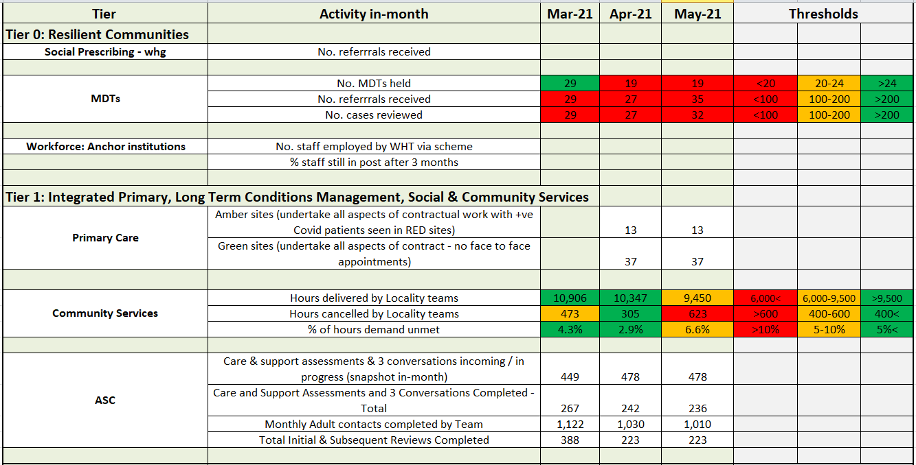


[Emergent] Score Card for WT Tiers – Tier 2

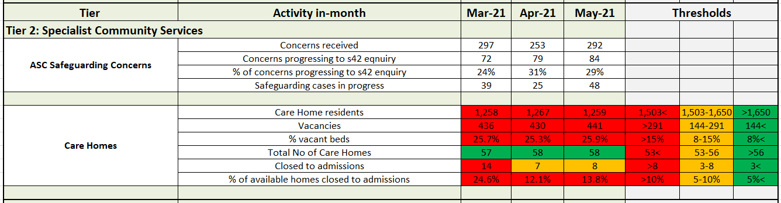

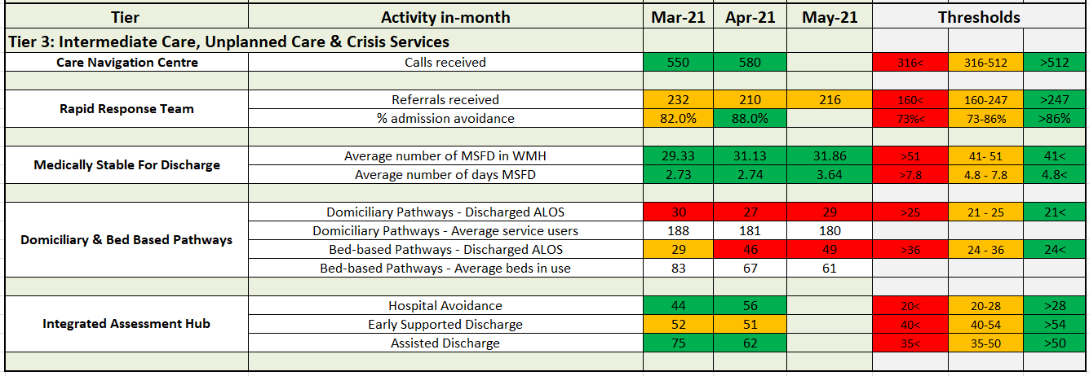

- The SP evaluation has been commissioned by whg and is being completed by HACT ( Housing Association Charities Trust ) . HACT have now begun to contact key stakeholders . We expect the evaluation to be completed over a 9-12 month period with a view to presenting the findings in March 2022. Colleagues from WT maybe asked to contribute to this piece of work .
- The SP programme is currently working with a gentleman aged 59 . Prior to the LW involvement this resident was isolated at home c aring for his sister who has complex health needs and disabilities . He was referred by whg’s housing team who were conc erned about his isolation . Initially he was very distrustful and reluctant to engage with the programme . Using Motivational Interviewing Techniques and Coaching conversation skills the SPLW developed a positive relationship beginning with ‘informal’ chats which helped him to relax and build the trust required to open up and tell us his wants and needs .
- This gentleman is impacted by the wider determinants of health . He lives in a disadvantaged community , is long term UE , is impacted by poverty and lacks the confidence and skills to self help .He and his sister are very reliant on clinic al services and medication relying on the health service to make things better .
- The LW provided practic al help and guidance around his income and benefits , this immediately reduced anxiety and stress enabling him to focus upon other things . He developed a 6 month plan which included taking part in social activities away from his c aring responsibilities , walk and talk activities and arts and crafts . 12 weeks into the programme this gentleman has a different mindset he is positive and hopeful . He is currently keen to gain work experience and has begun to believe he c an get more out of life . We think he c an !

  - OW facilitated the opportunities for statutory and VCS organisations to come together to work in partnership as part of the Community Renewal Fund and were the only CVS in the Black Country and West Birmingham to take this approach and has been received very positively.
  - Volunteers who c ame forward during the pandemic have been recognised as part of
Volunteers’ Week which ran from 1 st-7th June. All those placed were sent a certificate and badge as a small token of thanks and the One Walsall web site was host to an online celebration, inviting
people to share their volunteering stories on social media. https://onewalsall.org /volunteers -week- 2021/
  - OW continues to work with the Mental Health and Wellbeing Cell to focus on VCSE provision for bereavement, financial and social connectivity support, as demand for mental health support continues.
  - OW Volunteer Centre working with DGFT as it transfers to a new system (Allocate), which will require the training of volunteers to utilise. OW will also be providing new screening processes to allow DGFT to undergo this transition. Support is also underway to support the Council Holiday
Activities and Food Programmes over summer and Christmas periods.
  - Some ‘business as usual’ returning as funding surgeries with both National and Heritage Lottery are re -commencing.

    - whg's internal Employment and Training Team continue to work with Walsall
Manor Hospital supporting local residents to apply for Health Care Assistant posts . This contributes to Resilient Communities therefore reducing health inequalities which are driven by social and economic fa ctors .
    - We are really pleased to report that as a direct result of the partnership work within WT a total of 29 unemployed residents have been appointed as clinical support workers within the Manor Hospital . This group have long standing barriers to work with some recently losing their job due to the pandemic . There is clear evidence that recruiting local people for
local jobs contributes to a more stable workforce therefore reducing organisational costs .
Importantly these jobs have provided disadvantaged residents with a career pathway within health and social care .
    - Reducing unemployment is a significant objective within the Resilient Communities
programme . This is therefore a great outcome for the individual , the organisation and the wider community .

Demand is significantly below capacity for GP -led MDTs
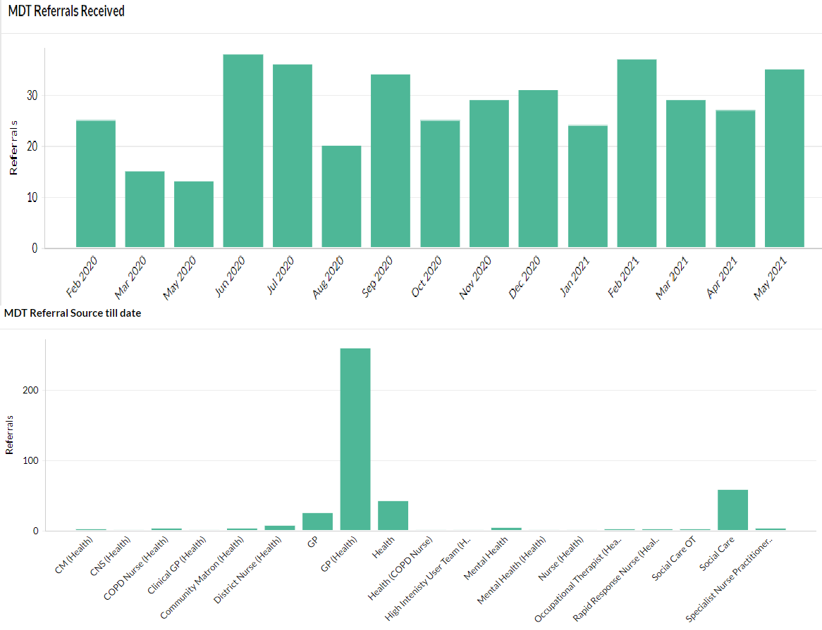

The service is established for 7 x MDTs with up to 50 cases to be reviewed per week

In April, 27 cases were discussed (28 in March)

A review of the MDT function has now commenced which will look at referral criteria and ways of harnessing Consultants to support speciality MDTs. The slow down in MDT’s is a consequence of primary care changes due to C19. This is being re focused and the MDTs are being used to facilitate complex case management due to the prevailing pressure in the system.

      - Black Country STP
        - 676,437 appts
        - 569,202 attended (84.14%) up 3%
        - 55,863 – DNA (8.25%) down 1.75%
        - 51,372 – Not Booked(7.59%) down 1%
        - 2.19 ( appt vs patient)
        - Compared to Feb 2021 2.59 (appt vs patient)
      - 64 % F2F appts compared to 50% in August 2020
      - 23,068 more appts in General Practice than in Feb 2021 -15% increase
      - Birmingham & Solihull – 2.01 (appt vs patient)

Wolv

Dudley

Sand/ West Birm

Walsall

0 400,000 800,000
CCG | Population | Number of Appts | Appt vs pt
Walsall | 293,396 | 161,376 | 1.81
Sand / West Birm | 575,481 | 248,132 | 2.32
Dudley | 328,093 | 163,405 | 2.00
Wolv | 290,831 | 103,524 | 2.80
Total | 1,487,801 | 676,437 | 2.19

Population Number of Appts

- Data on SP during pandemic
 | Raw list size 2020 -21 | Number of Referrals | % of referrals
East 1 | 33246 | 184 | 0.55%
East 2 | 42806 | 212 | 0.50%
North | 52162 | 677 | 1.30%
South 1 | 42776 | 303 | 0.71%
South 2 | 41070 | 532 | 1.30%
West 1 | 33376 | 268 | 0.80%
West 2 | 46516 | 827 | 1.78%
Total | 291952 | 3003 | 1.03%

- Links required to have a consistent SP offer
a cross Walsall
- Most common SP Px need = mental health services and Carers support - see
next slide they
represent nearly 50% of all SP Px Treatment

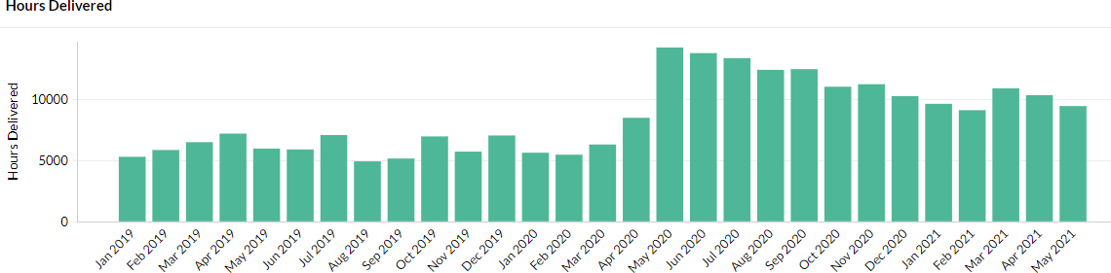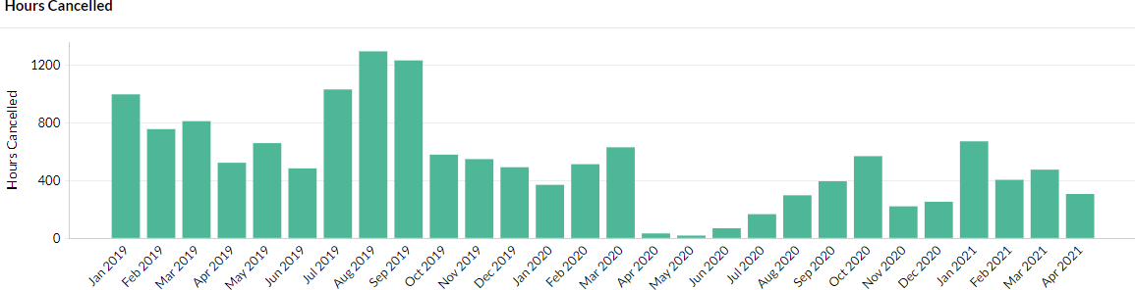Community Nursing Capacity and Demand: In April 2021, Community Services delivered more hours and cancelled less hours of activity than before Covid
•
Absence levels within Community Services
overall reduced during April, but pressures remained in two areas: therapy services staffing and demand within Phlebotomy
•
Proxy indicators of demand (hours
delivered + cancelled) remain higher than pre-Covid

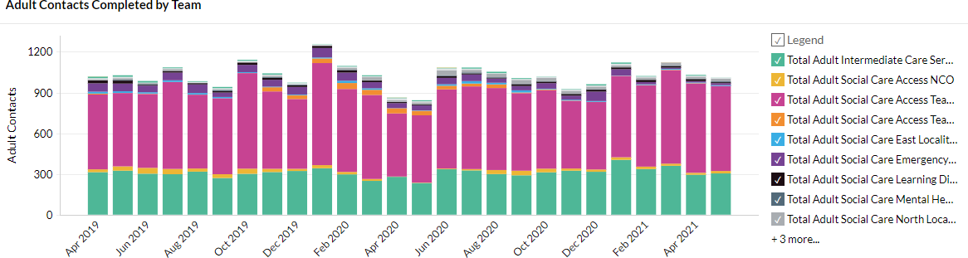

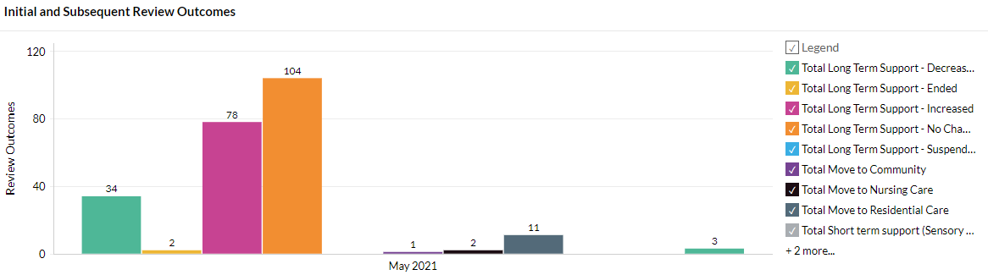
Date | Sum of Total Initial and Subsequent Reviews Completed
Feb-21 | 334
Mar-21 | 388
Apr-21 | 223
May-21 | 235

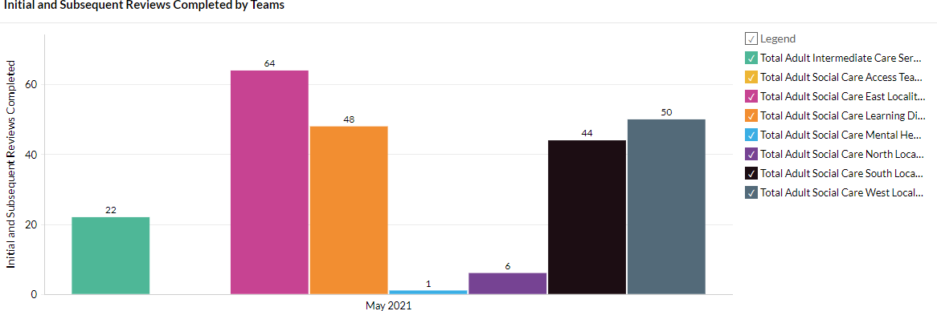

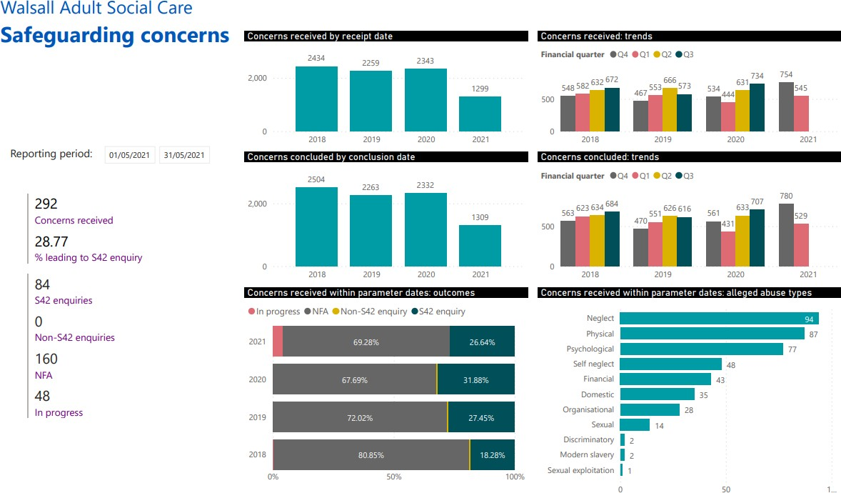

ASC have received 292 concerns in
May which is an increase of 39 concerns on the April data.

The number of cases progressing to a s42 enquiry is higher for May with 84 noting April was 79. The number of cases NFA in
this period is quite high with only 28.77% of concerns proceeding to an enquiry.

Safeguarding cases in
progress have significantly increased on April.

Neglect & Physical abuse are the two highest categories of alleged abuse in this period.

      - There are still no Covid deaths reported in the 58 homes since 28.02.21.
      - In May 2021, there was only 1 staff member who reported positive for Covid -19. Whole swabbing of the home resulted in zero further individuals being identified.
      - Bed Based providers have received their Infection Control and Testing grants they must remain compliant with the terms and conditions or the monies will be clawed back.
      - Occupancy in the market remains around 70% which is low in comparison to pre Covid levels.
      - Ongoing question about future viability of some providers.
      - Staff absenteeism was 5.24% at the end of March and has declined further to 4.58%. The actual figure is 96 members of staff.
      - As of 07.06.21 - 96.10% of residents have received the first dose and 90.74% have received the 2nd dose.
- As of 07.06.21 – 84.36% of staff members have received the first dose and 68.14% have received their second dose.

As per 07/06/2021:
Provider | Covid-19 - Confirmed or suspected Deaths | Non Covid 19 related since 1st of April 2020
1 | 1 | 81
2 | 6 | 62
3 | 10 | 29
4 | 17 | 16
5 | 17 | 16
6 | 13 | 20
7 | 18 | 13
8 | 10 | 16
9 | 5 | 17
10 | 13 | 8

  - 1268 residents
  - 435 vac ancies
  - 2 homes with positive cases
  - 7 closed to admissions (6 due to no va cancies)
  - 51 open to admissions

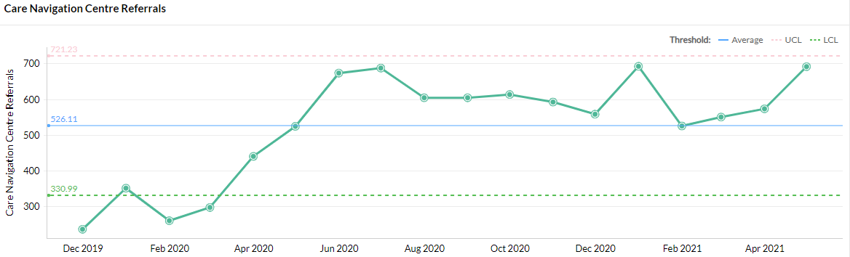
2020) with highest number of calls recorded in January 2021
From 4th May the long covid pathway has been opened for GP's to refer patients in order to access support and self care management for their patients, CNC have received 76 referrals within the first month.
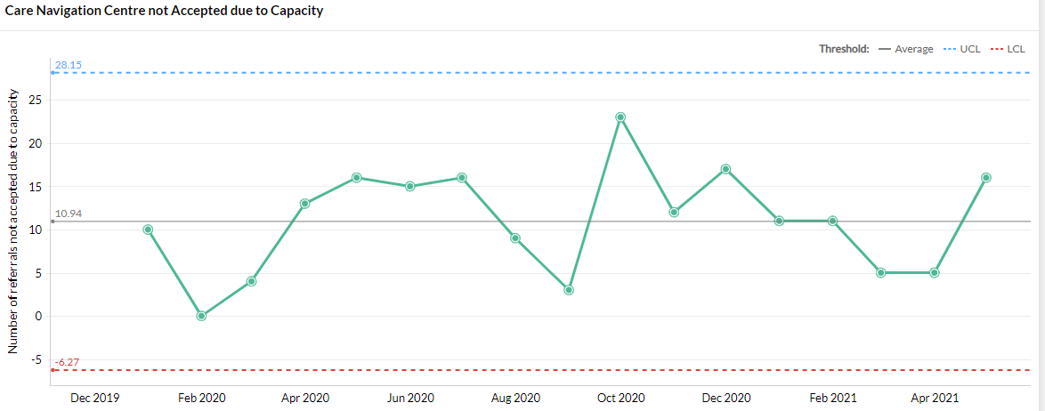
    - The Safe at Home pathway continues to operate with patients being referred from Acute Hospital services and GP practices, however, the current demand for this pathway is low.
    - The operational hours for the CNC as of 1st June is 08.00-22.00, 7 days a week, further expansion is planned from 5th July as part of the phased approach to expanding the service.

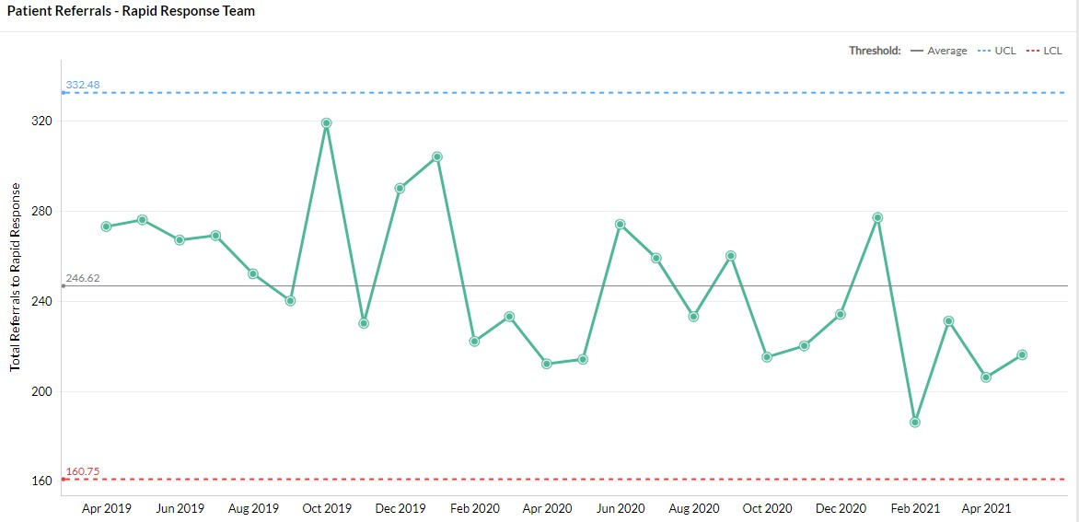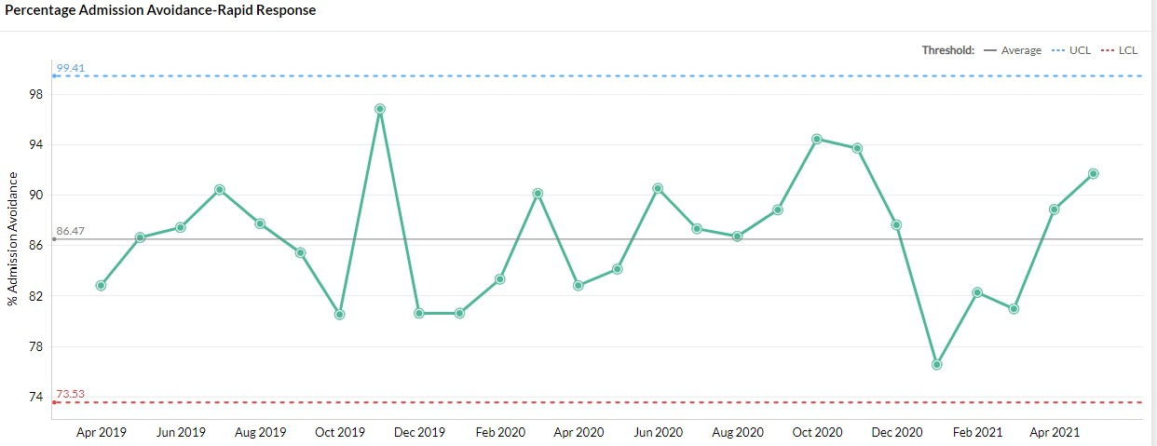
Referrals into Rapid Response remain volitile due to the expansion of CNC and the enhanced case managers across care homes, the service plans to increase operational hours until midnight from the 5th July to capture referrals later in the day.

Rapid Response is now visible to NHS111 and WMAS as a direct referral / call disposal route

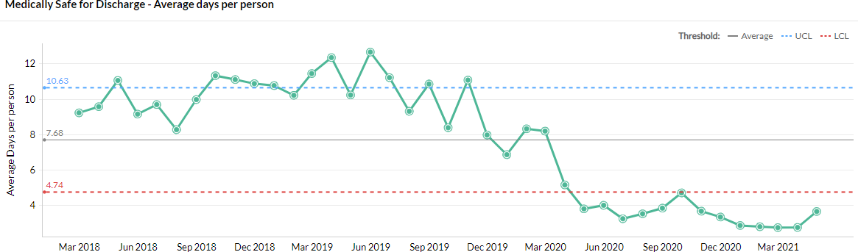
- The number of MSFD patients continues to be low throughout May.
- A review of ICS has now commenced during Q1 2021/22 as the flow through ICS community pathways will need to be accelerated in order to meet demand within the commissioned capacity.
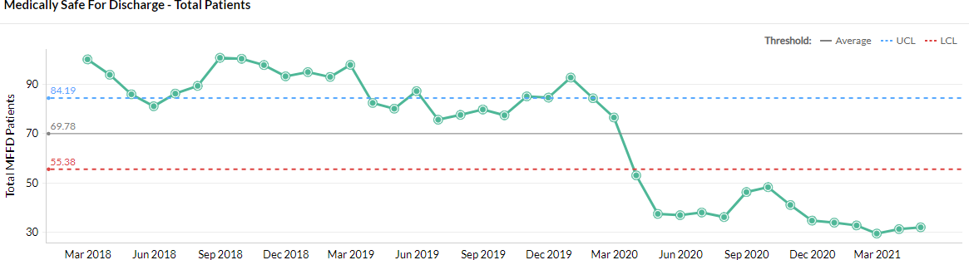
- The team have achieved a return of pre- covid bed based pathway levels of 51 as of 3rd June
- The risks associated with this were reviewed at the WT SMT on 09/04/21 and the funding options are to be considered by the Joint Commissioning Group

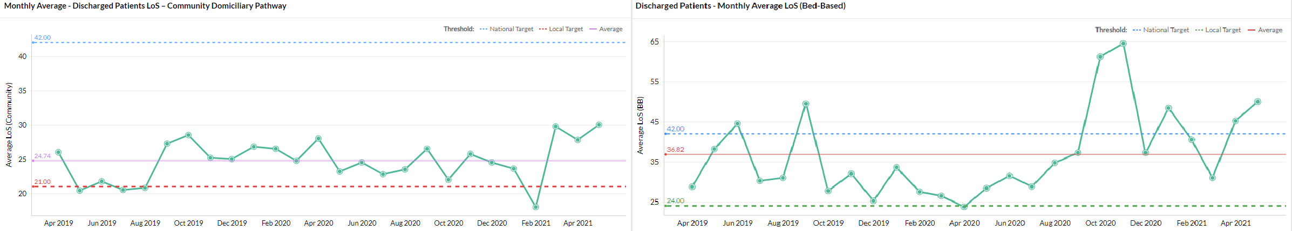
•
•

•
There continues to be some therapy delays in terms of reviewing individuals once on the reablement pathway
Due to Covid, individuals have been more unwell and therefore have needed rehab/Reablement for a longer period of time
There is a recruitment plan underway for gaps in the social care workforce which is impacting on LOS

Tier 3 / 4:
Integrated Assessment Hub: Integrated Assessment Hub

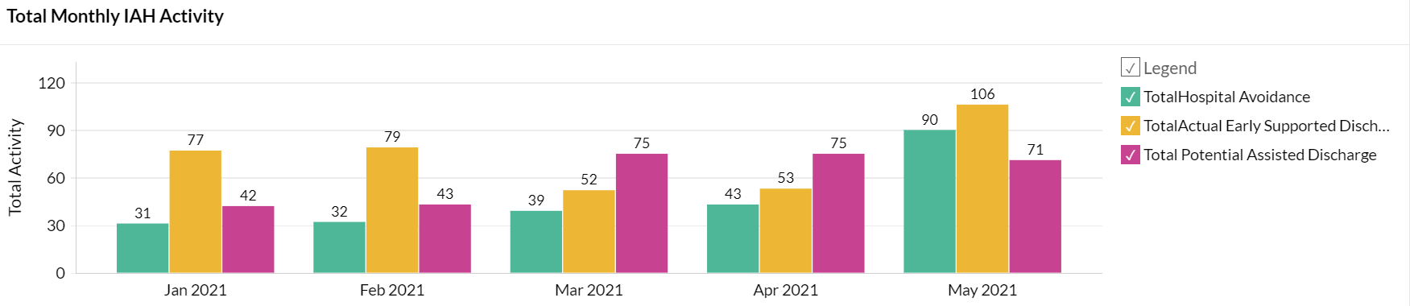Recruitment is still in progress last B6 post
    - Hospital Avoidance: This IAH pathway enables people directly contacting the Frail Elderly Service or Ambulatory Care at the Manor with post-discharge complications to be seen by Rapid Response, Enhanced Care Home Support Team or CIT team instead and receive a community-based assessment & clinical review, thereby avoiding conveyance to hospital. The numbers of people accessing this pathway increased again for May
    - Early Supported Discharge: Patients who have been identified in ED, assessment units & wards are discharged into a community service (including DVTs from ambulatory).
    - Assisted Discharge: IAH team signpost / support wards with navigating discharge pathways which result in a discharge same / next day (e.g. out of area patients; Safe at Home scheme; ICS; therapy)
    - To gain a view on impact of Quality driven case findings relating to stabilisation in community to avoid readmission

Latest Board/Committee/Group - 23/06/21 Version V1.09

Risk Summary
BAF Strategic  Objective Reference & Summary Tile: | BAF SO 02 - Care at Home; We will work with partners in addressing health inequalities and delivering care closer to home through integration as the host of Walsall together.
Risk Description: | Failure to work with partners and communities to understand population health and inequalities, integrate place-based services and deliver them through a whole population approach would result in a continuation of poor health and wellbeing and widening of health inequalities.
Lead Director: | Director of Integration.
Lead Committee: | Walsall Together Partnership Board.
Links to Corporate Risk Register: | Title: |  |  |  |  |  |  |  |  |  |  |  |  |  |  |  |  |  |  |  |  |  |  |  | Current Risk Score Movement:
Links to Corporate Risk Register: | - Risks in this area relate to Walsall Together programme risks. The biggest ones are associated with the limited investment and the size and complexity of the population health challenges.  - Non-programme risks relating to Community Services at the current time. These are updated through the divisional structure.  - Each organisation retains its own risk log although the section 75 presents the opportunity to start to bring the logs together.  - Risks associated with creating an ICP contract will be considered through a formal due diligence process, supported by NHSE/E.  - Operational capacity due to an increase in community prevalence of Covid since December 2020.  - Programme risk register for the Walsall Together Partnership Board:  - R002 - Population Health Management. (Risk Score = 16).  - R015 - Funding for ICS beds. (Risk Score = 16).  - R017 - COVID vaccinations. (Risk Score = 16).  - R018 - WHT investment in Community/WT services in scope. (Risk Score = 20).  - R019 - Primary Care demand and capacity. (Risk Score = 20). |  |  |  |  |  |  |  |  |  |  |  |  |  |  |  |  |  |  |  |  |  |  |  | Likelihood = 3  Consequence = 3  9  Moderate  ↓
Risk Appetite
Status: | Hungry | Averse |  |  |  |  | Cautious |  |  |  |  | Balanced |  |  |  |  | Open |  |  |  |  |  | Hungry
Appetite Score: | < 21 | 1 | 2 | 3 | 4 | 5 | 6 | 7 | 8 | 9 | 10 | 11 | 12 | 13 | 14 | 15 | 16 |  | 17 | 18 | 19 | 20 | 21 | 22 |  | 23 | 24 | 25
Tolerate Score: | < 25
Risk Scoring
Quarter: | Q1 2021/22 | Q2 |  | Q3 |  | Q4 2020/21 |  | Rational for Risk Level: |  |  |  |  |  |  |  |  |  | Target Risk Level (Risk Appetite): |  |  |  |  |  |  | Target Date:
Likelihood: | 3 |  |  |  |  | 3 |  | - The increased operational pressures due to Covid wave 2 have continued to abate and business continuity measures are being stood down in many areas of Community Services as capacity is better able to meet demand. However the locality teams as experiencing continued complexity in  the community which is affecting productivity (as |  |  |  |  |  |  |  |  |  | Likelihood: |  |  |  | 3 |  |  | 30 June 2021
Consequence: | 3 |  |  |  |  | 4 |  |  |  |  |  |  |  |  |  |  |  | Consequence: |  |  |  | 3
Risk Level: | 9  Moderate |  |  |  |  | 12  Moderate |  |  |  |  |  |  |  |  |  |  |  | Risk Level: |  |  |  | 9  Moderate

of 23/06/21).
- The transformation pace has now been addressed as Covid pressures reduce through the relaunch of both the Walsall Together Senior Management Team and the Clinical Professional Leadership Group meetings.
- Demand on partnership services continues to climb quickly as the Covid risks decreasing presenting additional pressure on urgent care (as of 23/06/21).
- Strongly established relationship with 50% of General Practice on robust vaccine delivery. Other practices chose not to connect with partnership and deploy alone.
- Vaccine delivery with operational teams mainly in primary care and latterly around the Saddlers Centre retains the potential to dilute focus on core delivery items and to increase system pressure.
- Maturing place-based teams in all areas of Walsall on physical health and Social Care. Additional integration required for Mental Health with IAPT & primary care but not established yet.
- Significant maturity in communications and confidence in Walsall Together however public profile now needs to be established.
- Advancing maturity of integrated performance data - Work now commenced on aligned quality governance.
- Risk Stratification process for COVID developed with partners which demonstrates the evolving maturity of the partnership.
- Substantial improvements in medically stable for discharge before and during Covid 19.
- Virtual clinics & community outpatients maturing and triage & referral services now in place during Covid & being planned for the long term.
- Partnership approach to managing care home support and intervention being embedded into business as usual.
- Strong evidence base being establish for ICP due diligence and work now progressing at pace with the support of the ICS and NHSI/E.
- The step up of the risk in Q3 2020/21 has now been de-escalated and predicted to fall through Q1 in 2021/22.

 |  |  |  |  | - Safeguarding board being aligned with WT as the number of referrals climbs post lock down (as of 23/06/21).
Control & Assurance Framework - 3 Lines of Defence
 | 1st Line of Defence |  |  |  | 2nd Line of Defence | 3rd Line of Defence
Controls: | - Executive Director appointed.  - Non-Executive Director appointed.  - Partnership Board/Groups and meetings in place.  - Business Case developed.  - PMO/Project in place and reporting.  - Daily operational coordination taking place.  - Covid Vaccine delivery plan in place and operational.  - WT acting as recruitment partner for PCN’s on the new national roles |  |  |  | - Alliance agreement signed by Partners.  - Governance structure in place and working.  - S75 in place and operational practices now maturing.  - Integration of performance data across the partnership is being progressed and reported to the Walsall Together Committee.  - Business case approved by all partners.  - Monthly report to Board and partner organisations. | - External assessment - CQC/Audit.  - STP Scrutiny.  - Health and Wellbeing Board Reporting.  - Overview and Scrutiny Committee.
Gaps in Controls: | - No strategic finance plan for investment across the partnership which potentially impacts on the delivery notwithstanding the recent investment from the Trust. This has been mitigated short term with Covid funding, but further work required to establish ongoing formal mechanisms through ICP contracts.  - Commissioner contracts not yet aligned to Walsall Together although ICP planning will resolve this issue.  - Data needs further aligning to project a common information picture.  - Effective engagement with community in development with local groups limited due to Covid social restrictions.  - Organisational development for wider integrated working not yet outlined or agreed and delayed due to Covid.  - Enactment of section 75 in terms of monitoring meetings.  - Variance in the understanding of other place based services in scope across the Black Country which is preventing the ICS dud diligence commencing
Assurance: | - Divisional quality board now starting to look at the integrated team response.  - Risk management established at a programme level and a service level integrating risks. |  |  |  | - Walsall Together included on Internal Audit Programme.  - Walsall Together Committee in place overseeing assurance of the partnership.  - STP oversight of ‘PLACE’ based model.  - Reporting to Board and Partners.  - Oversight on service change from other committees.  - ICP due diligence underway.  - Safeguarding board to align reporting with WTPB | - NHSE/I support of Walsall Together.  - STP support.  - NHSE/I validation of ICP due diligence.
Gaps in Assurance: | - Limited in overall external assurance as regulators inspect individual organisations and as yet have not developed ‘PLACE’ based inspections although Walsall Together put forward as part of ICP development.  - For Community services and ACS within the Section 75 there is direct accountability to WT / WHT; these formal arrangements do not cover other partners hence limited accountability for delivery of Walsall Together strategic aims.

Future Opportunities
- Further development of the Governance around risk sharing.
- S75 Deployment based on other services relating to health prevention and public health commissions.
- PCN partnership alignment and risk share with building trust and confidence.
- Covid-19 offers an opportunity to increase the pace of delivery and more importantly stress test benefits before substantive deployment.
- Strategic partnership(s) with major primary care organisations to further accelerate vertical and horizontal integration of care in the borough.
- Formal contract through an ICP mechanism.
- Formal working with other partners to support their ability to achieve additional income and support via a partnership approach.
- CQC action oversight group.
Future Risks
- Insufficient promotion of success narrative.
- Inability to deliver enough investment up front to change demand flows in the system.
- Changes to commissioner & provider environment / landscape within the Black Country may change mechanisms for resourcing and resolution of service issues.
- A mechanism for gaining and sustaining resources to support strategic aims for 2021/22+ are unclear.
- National influences on constitutional targets moves focus from place to ICS.
- Retention of inspirational and committed leadership across partners.
- Estates - ability to fund the full business case offering (4 Health & Wellbeing Centres).
- Misalignment of provider strategies created by mergers or form changes or senior personnel turnover.
- Lack of uninterrupted community clinic space due to Covid Restrictions.
- Programme Resource - Capacity to deliver the WT programme will become more difficult as the same resource will be required to support the delivery of Covid-19 work streams, e.g. mass swabbing, flu vaccination programme, Covid-19 vaccination programme, outbreak management and the Covid-19 Management Service (CMS).
- Maintenance of the ICP agenda through the ICS Board by both the system partners and the Trust in relation to strategic objectives.
Future Actions (to further reduce the Likelihood / Consequence of the risk in order to achieve the Target Risk Level in line with the Risk Appetite)
No. | Action Required: | Executive Lead: | Due Date: | Progress Report: | BRAG:
1. | Agree an investment plan initially with commissioners through 2021/22 funding round to address the current gaps in funding provision. | Director of Integration | July 21 | Work is underway to confirm maintenance of transformation funding for the diabetes and care home services into established baselines. A longer-term conversation will then need to be coordinated with other ICP’s through the ICS  board for Health Commissioning.
2. | Agree & implement joint service development opportunities  between Walsall Together and PCNs that foster improved delivery of care through more integrated working. | Director of Integration | July 21 | Work has started on revised recruitment and management  arrangements for roles such as First Contact Practitioners and Pharmacists. Further opportunities are being identified.
3. | Refresh strategic case for Resilient Communities, ensuring appropriate focus on reducing health inequalities and alignment of strategic objectives across partner organisations. | Director of Integration | July 21 | The Resilient Communities work stream has held three sessions.  The work stream has presented to WTPB (March 2021) the following next steps:  - Discussion at the CPLG to confirm the local population challenges that we want to address, aligning to population health management and inequalities  priorities for the partnership.

- Establishment of the Steering group including confirmation of membership and Terms of Reference.
- Review of the multiple strands of work pertaining to citizen and communities engagement to create a single, defined approach.
- Review of the full proposal to Changing Futures and proposal for how some or all of the elements can be
taken forward without the external investment.
4. | Develop population health management strategy across Walsall Together and PCNs including the deployment of the population health module (Digital work stream). | Director of Integration | July 21 | This work is underway with the support of the STP Academy and Public health. The Population Health module as part of the Medway deployment is also in our test environment. The final strategy is interdependent with the production of the Health & Well Being strategy which is  focused on the end of Q2.
5. | Develop robust governance and legal frameworks for Walsall Together with devolved responsibility within the host (WHT) structure. This should include an outline governance structure that shows the links to other WHT committees and  acknowledge the transition to holding a formal ICP contract. | Director of Governance | July 21 | This work is on track as part of the ICP programme.
6. | Prepare for implementation of a formal ICP contract under a Lead Provider model with WHT as Lead Provider. This will include confirmation of all services in scope and a clear rationale for the change in the context of improving outcomes  for the population. | Director of Integration | July 21 | On track and formally reported to WTPB monthly

MEETING OF THE PUBLIC TRUST BOARD – 1ST JULY 2021
Work Closely with Partners |  |  |  | AGENDA ITEM: 24
Report Author and Job Title: | Ned Hobbs, Chief Operating Officer | Responsible Director: |  | Ned Hobbs, Chief Operating Officer
Action Required | Approve ☐ Discuss ☐ Inform ☒ Assure ☒
Executive Summary | This report provides an overview of the risks to delivery of the Work Closely with Partners Strategic Objective, mitigations in place to manage the risks identified, and actions identified to address gaps in controls and assurance.  The Work Closely with Partners Improvement Programme reflects the work of Divisional teams and the progression of functional integration between Acute Hospitals. This report gives a brief update on Urology, Dermatology, Radiology, Orthopaedics and Bariatric Surgery functional integration, and appends a list of previously completed integration work.
Recommendation | Members of the Trust Board are asked to note the contents of this report.
Does this report mitigate risk included in the BAF or Trust Risk Registers? please outline | This report addresses BAF Risk S04 Work Closely with Partners to provide positive assurance the mitigations in place to manage this risk and the related corporate risks  There are no direct corporate risks associated with Partnership working. However increased partnership working provides a mitigation to the following Corporate risks;  2066- Nursing and Midwifery Vacancies 2072- Temporary workforce
Resource implications | There are no direct resource implications associated with this report.
Legal and Equality and Diversity implications | There are no legal or equality & diversity implications associated with this paper.
Strategic Objectives | Safe, high quality care ☐ |  | Care at home ☐
Strategic Objectives | Partners ☒ |  | Value colleagues ☐
Strategic Objectives | Resources ☐

WORK CLOSELY WITH PARTNERS

- EXECUTIVE SUMMARY

COVID-19 affected the ability of the Trust to formally oversee and manage the programme of integration between Acute Hospital services. However, COVID-19 has also necessitated and accelerated significant collaboration between Trusts on many matters including mutual aid for Personal Protective Equipment, standardisation of policies in relation to the workforce, approaches to restoration and recovery planning, Critical Care mutual aid, mutual aid for the management of patients conveyed to Emergency Departments by ambulance, and shared learning to deal with a novel virus pandemic.

As a result, collaboration between Black Country & West Birmingham Trusts is stronger due to the experience of this year. There is a clear appetite to use this opportunity to build upon those foundations and progress functional service integration where there is an opportunity to improve care for the patients we serve and/or to improve the working lives of our staff. Recent developments including a single Chief Executive Officer and single Chair for both Walsall Healthcare NHS Trust and the Royal Wolverhampton NHS Trust have also facilitated strengthened bilateral service collaboration between the two Trusts.

- BOARD ASSURANCE FRAMEWORK

The Working Closely With Partners BAF risk has been reviewed and updated. The risk has been brought up to date to reflect the evidence of successful partnership working, the demonstrable progress in functional service integration in further specialties now, and to recognise the approved Strategic Collaboration between The Royal Wolverhampton NHS Trust (RWT) and Walsall Healthcare NHS Trust (WHT), the new Integrated Supplies and Procurement Department (ISPD) alliance with RWT and University Hospitals North Midlands NHS Trust, and the introduction of a shared Chair and Chief Executive Officer between the Trust and RWT.

The risk score has been reduced from a 9 (likelihood 3 x consequence 3) to a 6 (likelihood 2 x consequence 3) on the grounds that strong collaboration with partners is meaning that partnership working is not a barrier to providing high quality, sustainable care. The trajectory to reduce the overall risk score in Quarter 2 is subject to assurance on and approval of the Urology integration plan, which remains the top priority specialism within the Trust to strengthen and give greater resilience to be able to provide sustainable high quality care.

- IMPROVEMENT PROGRAMME

The Work Closely with Partners Improvement Programme reflects the work of Divisional teams and the progression of functional integration between Acute Hospital specialties to support improved patient care, and improved working lives for our people.

Urology

Work continues to finalise the full proposals for integration of Urology services between RWT and WHT, and the Collaborative Working Integration Executive Group between the two Trusts received a project update on Tuesday 22nd June 2021. WHT and RWT Directors of Finance are currently reviewing the modelled financial implications of the proposal.

The proposed model of care will be presented to the Black Country & West Birmingham Urgent and Emergency Care Board on 2nd July 2021, followed by Walsall Borough Council’s Scrutiny Committee on 14th July 2021.

Active patient and user engagement is currently taking place, including a formal survey of Walsall Urology patients who have used our services over the last 18 months.

A further Urology working group meeting between both Trusts is scheduled for 30th June 2021.

Subject to endorsement through CCG, Urgent & Emergency Care Board and Walsall Borough Council’s Scrutiny Committee, and then to approval through both Trusts’ internal Governance forums, the Trust and RWT are targeting implementation of phase 1 of the programme in Quarter 3 of 2021/22.

Dermatology

The joint Dermatology Steering Group has made recommendations on the future structural form of the Dermatology service between WHT and RWT. These proposals were received at the Collaborative Working Integration Executive Group between the two Trusts on Tuesday 22nd June 2021, and were supported. The Steering Group has now been reconfigured to work through the structural integration of the departments.

Radiology

The 2nd West Midlands Imaging Network Board meeting was held on 8th June 2021.

The Board received updated Terms of Reference and Memorandum of Understanding which were approved subject to final amendments.

The Board received presentations from Stephen Chilton (University Hospitals Birmingham) regarding the West Midlands Shared Care Record programme and from Phil Williams from the NHSEI Midlands Digital Transformation Team. Digital support is recognised as being vital in Imaging services to facilitate image sharing and interoperability between Trusts, clinical decision support and home reporting. The Black Country & West Birmingham ICS is submitting a bid for access to Digital Capital monies to support this work.

Orthopaedics

A WHT and RWT T&O Working Group was established in May 2021 to review opportunities for collaboration in the provision of elective Orthopaedic services. Successful agreement has been reached for the first pilot WHT operating list at Cannock Hospital, which is scheduled on the 8th July 2021, and a second operating list is being scheduled for 15th July 2021 – both under Mr Goude, Consultant T&O Surgeon and Clinical Director, both supported by WHT Consultant Anaesthetists and with Theatre staff and support staff from RWT.

The two pilot operating lists will be evaluated to inform options for future service models, including the potential for regular WHT elective Orthopaedic operating lists at Cannock.

Bariatric Surgery

Mr Mirza, Consultant General Surgeon and Divisional Director for Surgery has presented the proposed model of a Black Country & West Birmingham Tier 4 Bariatric Surgical hub at Walsall Manor Hospital to the Black Country Obesity forum, the Black Country & West Birmingham Clinical Leadership Group, and the WHT and RWT Collaborative Working Integration Executive Group where the proposal has been received favourably and has received support in principle to now develop an implementation plan.

- RECOMMENDATIONS

Members of the Trust Board are asked to note the contents of this report.

APPENDICES

  - List of secondary care partnership integration already delivered
  - BAF SO3

APPENDIX 1

List of secondary care partnership integration already delivered

Recently integrated/networked services
ENT Consultant on-call rota with RWT and DGFT Sentinel Lymph Node Biopsy pathway with DGFT
Integrated Supplies and Procurement Department (ISPD) alliance with RWT and University Hospitals North Midlands NHS Trust
Offer of Colorectal Cancer Surgery capacity to other BCWB ICS partners Black Country Pathology Service with RWT, DGFT and SWBH
Payroll with RWT
Clinical Fellowship programme with RWT International Nurse recruitment programme with RWT

Historically integrated/networked services
Cardiology with RWT Renal with RWT Ophthalmology with RWT
Oral and Maxillofacial Surgery with RWT Oncology with UHB
Neurology with UHB
Hyper Acute Stroke with RWT Vascular Surgery with DGFT and RWT Haematology with RWT Rheumatology with SWBH

Latest Board/Committee/Group - 26/05/2021 Version V2.03

Risk Summary
BAF Strategic  Objective Reference & Summary Tile: | BAF SO 03 - Working with partners; We will deliver sustainable best practice in secondary care, through working with partners across the Black Country and West Birmingham System.
Risk Description: | Failure to integrate functional and organisational form change within the Black Country will result in lack of resilience in workforce and clinical services, potentially damaging the trust’s ability to deliver sustainable high quality care.
Lead Director: | Chief Operating Officer.
Lead Committee: | Performance, Finance, & Investment Committee.
Links to Corporate Risk Register: | Title: |  |  |  |  |  |  |  |  |  |  |  |  |  |  |  |  |  |  |  |  |  |  |  | Current Risk Score Movement:
Links to Corporate Risk Register: | - There are no direct corporate risks associated with Partnership working. However increased partnership working provides a mitigation to the following Corporate risks;  - 2066 - Nursing and Midwifery Vacancies (Risk Score = 15),  - 2072 - Temporary workforce (Risk Score = 16). |  |  |  |  |  |  |  |  |  |  |  |  |  |  |  |  |  |  |  |  |  |  |  | Likelihood = 2  Consequence = 3  6  Low  ↔
Risk Appetite
Status: | Hungry | Averse |  |  |  |  | Cautious |  |  |  |  | Balanced |  |  |  |  | Open |  |  |  |  |  | Hungry
Appetite Score: | < 22 | 1 | 2 | 3 | 4 | 5 | 6 | 7 | 8 | 9 | 10 | 11 | 12 | 13 | 14 | 15 | 16 |  | 17 | 18 | 19 | 20 | 21 | 22 |  | 23 | 24 | 25
Tolerate Score: | < 24
Risk Scoring
Quarter: | Q1 2021/22 | Q2 |  | Q3 |  | Q4 2020/21 |  | Rational for Risk Level: |  |  |  |  |  |  |  |  |  | Target Risk Level (Risk Appetite): |  |  |  |  |  |  | Target Date:
Likelihood: | 2 |  |  |  |  | 3 |  | - This risk has been reduced to moderate due to the advancement of a number of key work streams.  - Executive group established across provider organisations to review opportunities for collaboration.  - Success of Black Country Pathology Service (BCPS).  - Transfer of WHT payroll service to RWT.  - Advanced collaboration in Dermatology including appointment of joint clinical director, and cross-site working of Consultant Dermatologists.  - Advanced discussions in Urology including cross site working. |  |  |  |  |  |  |  |  |  | Likelihood: |  |  |  | 2
Consequence: | 3 |  |  |  |  | 3 |  |  |  |  |  |  |  |  |  |  |  | Consequence: |  |  |  | 2
 |  |  |  |  |  |  |  |  |  |  |  |  |  |  |  |  |  |  |  |  |  |  |  |  | Q2 2021/22
Risk Level: | 6  Low |  |  |  |  | 9  Moderate |  |  |  |  |  |  |  |  |  |  |  | Risk Level: |  |  |  | 4  Low |  |  | Subject to assurance on and approval of Urology integration plan.

- Integrated ENT on-call rota in place.
- Initial discussions re: bariatric services and radiology.
- STP Clinical Leadership Group, relevant restoration and recovery groups and relevant network collaboration continue to drive Clinical Strategy.
- Shared Clinical Fellowship Programme agreed with RWT, and first round of appointments made.
- Shared international nurse recruitment programme agreed with RWT, and first round of appointments made.
- New Integrated Supplies and Procurement Department (ISPD) alliance with Royal Wolverhampton NHS Trust and University Hospitals North Midlands NHS Trust commencing April 2021.
However, despite progress, integration plans are not all yet fully implemented and the sustainability of the Urology service prevents the score being reduced further at this stage.
Control & Assurance Framework - 3 Lines of Defence
 | 1st Line of Defence |  |  |  | 2nd Line of Defence | 3rd Line of Defence
Controls: | - Sustainability review process completed.  - Regular oversight through the Board and its sub committees.  - Improvement Programme to progress clinical pathway redesign with partner organisations.  - Executive to Executive Integration oversight meeting established between WHT and RWT (first meeting held 10/03/21) and agreed to be held every 4-6 weeks.  - Black Country & West Birmingham Acute Care Collaboration Programme  Board established March 2021. |  |  |  | - Public Trust Board approved Strategic Collaboration between The Royal Wolverhampton NHS Trust and Walsall Healthcare NHS Trust at February 2021 Board meetings, and approved a Memorandum of Understanding at March 2021 Board meetings.  - West Midlands Imaging Network Board established with Trust Chief Operating Officer as voting member. | - Third line of control NHSE/I regulatory oversight.  - Black Country and West Birmingham STP plan and governance processes in place.
Gaps in Controls: | - Lack of co-alignment by our organisation and all neighbouring trusts.  - Lack of formal integration at Trust level across all four BCWB Acute Trusts.  - Mandated arrangements by regional networks.
Assurance: | - Track record of functional integration of clinical services including hyper |  |  |  | - Demonstrable evidence of recent functional integration in ENT, Urology and Dermatology and | - Progress overseen nationally and locally.

2 | P a g e

 |  | acute stroke, vascular surgery, cardiology, rheumatology, ophthalmology, neurology, oncology, Black Country Pathology Service and OMFS.  - Non-clinical service integration such as Payroll and Procurement. | with the clinical fellowship programme.  - Emerging commitment from BCWB Acute Collaboration partners to more formalised collaborative working.  - Audit Committee has oversight of partnership working within its terms of reference.  - System Review Meetings providing assurance to regulators on progress.
Gaps in Assurance: |  | - Clinical strategy is still emerging.  - Additional pressures with Covid-19 have delayed acute collaboration, and organisational capacity is concentrated on managing the second and third waves of the pandemic.  - Limited independent assessment of integrated services or collaborative working arrangements.  - Embryonic independent evidence-base for successful collaborations to assess progress against.
Future Opportunities
- Consolidate other services, including back office functions.
- Collaborate with partner organisations outside the Black Country Acute Trusts, including community and third sector organisations.
- Promote Walsall as an STP hub for selected, well-established services.
- Collaborative working during COVID-19 presents an opportunity to accelerate some elements of clinical pathway redesign.
- Shared Chair and CEO with RWT creates opportunities to accelerate bilateral collaboration where applicable.
- First WHT elective Orthopaedic operating list scheduled to take place at Cannock in July 2021.
Future Risks
- Conflicting priorities and leadership capacity to deliver required changes.
- STP level governance does not yet have statutory powers.
- Lack of engagement/involvement with the wider public.
- Acute Hospital Collaboration may not progress at the anticipated pace due to the resurgence of COVID-19 coinciding with a challenging winter.
- Disrupted relationships with neighbouring trusts due to altered visions of the form and pace of future collaboration.
Future Actions (to further reduce the Likelihood / Consequence of the risk in order to achieve the Target Risk Level in line with the Risk Appetite)
No. | Action Required: |  | Executive Lead: | Due Date: | Progress Report: |  | BRAG:
1. | Keep abreast of Trust Acute collaboration discussions and  updates accordingly. |  | G. Augustine | Dec 2020 | COMPLETE - Trust Board endorsed the benefits of  BCWB Trust collaboration for the population of Walsall
2. | Develop over-arching programme plan to support individual projects for each phase (Phase 1, emergencies, Phase 2,  Elective/Cancer work). |  | Programme Manager | Dec 2020 | COMPLETE - Delayed due to resurgence of Covid-19.  To be incorporated into re-phased Improvement Programme Plan for June 2021.
4. | Assess resource requirement to support Imaging Network programme |  | G Augustine & N Hobbs | Feb 2021 | COMPLETE - Delayed due to resurgence of Covid-19.  To be discussed at Black Country wide working group in April 2021.
5. | Approve Urology integration plan through QPES, PFIC and Trust Board (if applicable) |  | N Hobbs | June 2021 | Trust Management Board received proposal on 9th March setting out engagement and Consultation  requirements to enable approval.


1

MEETING OF THE PUBLIC TRUST BOARD – 1st July 2021
Audit Committee Highlight Report |  |  | AGENDA ITEM: 25
Report Author and Job Title: | Trish Mills Trust Secretary | Responsible Director: | Mrs Mary Martin, Chair of Audit Committee (Non-Executive Director)
Action Required | Approve ☒ Discuss ☒ Inform ☒ Assure ☒
Executive Summary | This report provides the key messages from the Audit Committee meeting on 23rd June 2021. The report sets out escalations for the attention of the Trust Board, and key issues discussed and work underway.  - The 2020/21 annual report, audited financial statements, and quality account were approved by the Committee in accordance with the delegated authority provided to the Committee by the Trust Board on 3rd June 2021. The Annual General Meeting to present the annual filings will take place on 8th September.  - The external auditors are still completing their work to issue their commentary on Value for Money. This should be available at the next Audit Committee for review and then publication on the Trust website by the deadline of 20th September 2021.  - The Committee received the Head of Internal Annual Audit Opinion which was partial assurance with improvement required. It also received the final audit review of the 2020/21 programme, which was the Improvement Programme Review. That review provided partial assurance with improvement required.  - The self-certification for the Trust’s provider license was reviewed. This appears on the Trust Board agenda for this meeting. The Committee endorses the Trust Board’s approval that the condition G6 and FT4 self-certification is formally signed off as “Confirmed” and publicised on the Trust website.  - The Audit Committee would like to extend their thanks to the teams who prepared the annual filings, and the External and Internal auditors for their assistance throughout the financial year.  The next meeting of the Audit Committee will be held on 26th July 2021.


2
Recommendation | Members of the Trust Board are asked to note the report and escalations.
Does this report mitigate risk included in the BAF or Trust Risk Registers? please outline | Audit Committee is essential to Trust Board managing risk across the organisation.
Resource implications | Poor internal control and/or management of risk would almost  certainly result in financial loss.
Legal and Equality and Diversity implications | There are no legal or equality & diversity implications associated with this paper.
Strategic Objectives | Safe, high quality care ☒ | Care at home ☒
Strategic Objectives | Partners ☒ | Value colleagues ☒
Strategic Objectives | Resources ☒

MEETING OF THE PUBLIC TRUST BOARD – 1ST JULY 2021
Provider Licence |  |  |  | AGENDA ITEM: 26
Report Author and Job Title: | Jenna Davies Director of Governance | Responsible Director: |  | Jenna Davies  Director of Governance
Action Required | Approve ☒ Discuss ☒ Inform ☐ Assure ☒
Executive Summary | As part of the Trust’s provider licence the Trust is required to make a self-declaration against a number of the licence specific conditions. The Trust’s self-declarations must be published on its web site.  NHS improvement provide a template for these declarations where explanations are required if the Trust cannot provide a compliant declaration. Only for condition FT4 does the template allow for a rationale to be included for the Trust’s ability to signify compliance to be included therefore as well as the required template a short explanatory paper has been prepared to allow the Board to understand the supporting rationale for the complaint declaration being recommended.
Recommendation | The Trust Board is requested to approve and formally sign off as confirmed, the condition G6 and FT4 Self-Certification, and publicise in line with the deadlines. This paper and the certification was considered by the Audit Committee on 23rd June 2021 and is endorsed by the Committee.
Does this report mitigate risk included in the BAF or Trust Risk Registers? please  outline | This paper provides assurance to the Trust Board that there are adequate corporate governance arrangements in place, although it is noted that improvements are required
Resource implications | There are no resource implications associated with this report.
Legal and Equality and Diversity implications | Failure to comply with the provider licence may result in regulatory action
Strategic Objectives | Safe, high quality care ☒ |  | Care at home ☒
Strategic Objectives | Partners ☒ |  | Value colleagues ☒
Strategic Objectives | Resources ☒

Provider Licence

- PURPOSE OF REPORT

NHS trusts are required to self-certify that they can meet the obligations set out in the NHS provider licence. The annual self-certification provides assurance that NHS providers are compliant with the conditions of their licence. On an annual basis, the licence requires NHS providers to self-certify as to whether they have:
  - Complied with governance arrangements (condition FT4);
  - Effective systems to ensure compliance with the conditions of the NHS provider licence, NHS legislation and the duty to have regard to the NHS Constitution (condition G6);

The Trust is not required to submit the self-certification to NHS Improvement, but the Board is required to sign off the certificates and publish the outcome of the self-certification exercise. The Trust intends to make positive confirmations on all declarations.

- Condition FT4 - Declaration

- The Board is satisfied that the Licensee (the Trust) applies those principles, systems and standards of good corporate governance which reasonably would be regarded as appropriate for a supplier of health care services to the NHS.

Rationale: The Trust has in place a scheme of delegation, standing orders, and a set of standing financial instructions. It has all statutory governance requirements in place and is subject to internal and external audit on the robustness of its arrangements. The Trust was subject to a CQC Well-led inspection in March 2019 and is rated as Requires Improvement.

Rating: Confirmed

- The Board has regard to such guidance on good corporate governance as may be issued by NHS Improvement from time to time

Rationale: The Board receives advice on compliance with updated guidance and information on new guidance issued by regulators. During the height of the pandemic this was delivered through weekly COVID-19 meetings with Non-Executive Directors and through the COVID-19 Governance Continuity Plan and reports from executive directors. The Committee received regular reports on risk management, and COVID-19 and improvement programme updates. Individual Directors also provide specific advice on specialist areas where required.

Rating: Confirmed

- The Board is satisfied that the Licensee has established and implements: (a) Effective board and committee structures; (b) Clear responsibilities for its Board, for committees reporting to the Board and for staff reporting to the Board and those committees; and (c) Clear reporting lines and accountabilities throughout its organisation.

Rationale: Board has an established a Quality Governance Structure which ensures Board to ward and ward to Board reporting on quality. All Committees are supported by terms of reference

which are regularly reviewed & approved by Board. The Annual Governance Statement, contained within the Annual Report, sets out developments each year.

Executive Director responsibilities are set out in job descriptions & annual objectives.
NHSI/E undertook a detailed self-assessment of our clinical/corporate governance structures in 2019/20, and through the Trusts to respond to the recommendations, which will help strengthen and make more consistent the Ward to Board governance processes

Rating: Confirmed

- The Board is satisfied that the Licensee has established and effectively implements systems and/or processes:
  - To ensure compliance with the Licensee’s duty to operate efficiently, economically and effectively;
  - For timely and effective scrutiny and oversight by the Board of the Licensee’s operations;
  - To ensure compliance with health care standards binding on the Licensee including but not restricted to standards specified by the Secretary of State, the Care Quality Commission, the NHS Commissioning Board and statutory regulators of health care professions;
  - For effective financial decision-making, management and control (including but
not restricted to appropriate systems and/or processes to ensure the Licensee’s ability to continue as a going concern);
  - To obtain and disseminate accurate, comprehensive, timely and up to date information for Board and Committee decision-making;
  - To identify and manage (including but not restricted to manage through forward plans) material risks to compliance with the Conditions of its Licence;
  - To generate and monitor delivery of business plans (including any changes to such plans) and to receive internal and where appropriate external assurance on such plans and their delivery; and
  - To ensure compliance with all applicable legal requirements.

Rationale: The Trust has sufficient skills and capacity at Board level to undertake financial decision making, management and control. The self-certification provides evidence of the Board's review and assessment of its going concern status. The Annual Governance Statement identifies that the Board is sighted on concerns and risks to the Trust through its monthly reporting structures.

Rating: Confirmed

- The Board is satisfied that the systems and/or processes (above) should include but not be restricted to systems and/or processes to ensure:
  - That there is sufficient capability at Board level to provide effective organisational leadership on the quality of care provided;
  - That the Board’s planning and decision-making processes take timely and appropriate account of quality of care considerations
  - The collection of accurate, comprehensive, timely and up to date information on quality of care;
  - That the Board receives and takes into account accurate, comprehensive, timely and up to date information on quality of care;
  - That the Licensee, including its Board, actively engages on quality of care with patients,

Page 3 of 4

staff and other relevant stakeholders and takes into account as appropriate views and information from these sources; and
  - That there is clear accountability for quality of care throughout the Licensee including but not restricted to systems and/or processes for escalating and resolving quality issues including escalating them to the Board where appropriate.

Rationale:
- The Trust Board has mix of clinical, quality and performance expertise to provide leadership across the organisation and to take account of all Board accountabilities in relation to quality.
- The Trust Board receives regular information via the performance reports in Executive Director reports on each strategic objective from the preceding month, on finance, performance and quality, which is subject to more detailed scrutiny by Board Committees as well as the Trust Board.
- There are specific reports monthly providing timely and accurate data on quality of care, using a variety of sources,
- which enable the Board to take an accurate, timely and accurate account of quality of care, and other reports throughout the year, which provide more comprehensive oversight of quality.
(e & f) The Trust Board concerns itself with quality of care at each Trust Board meeting including hearing patient stories, and through its committee structure; The Trust Board receives intelligence on staff and patient experience through a number of routes during the year - annual staff survey, Friends and Family test, and Patient Experience reporting. Boardwalks took place virtually to engage with staff and to triangulate the information at board

Rating: Confirmed

- The Board is satisfied that there are systems to ensure that the Licensee has in place personnel on the Board, reporting to the Board and within the rest of the organisation who are sufficient in number and appropriately qualified to ensure compliance with the conditions of its NHS provider licence.

Rationale: The Trust has systems in place to ensure that staff employed at every level are appropriately qualified for their role. The Board and its committees receive data on staffing figures regularly and the impact of staffing issues on delivery of its NHS contracts. The Trust reports monthly on Clinical staff fill-rates.

Rating: Confirmed

Condition G6 - Declaration
The Board is satisfied that the Trust has processes and systems that:
- identify risks to compliance with the licence, NHS acts and the NHS Constitution
- guard against those risks occurring.

Rationale: For the purposes of licence condition G6, the Board are satisfied that the Trust took all such precautions as were necessary in order to comply with the conditions of the licence, the NHS acts and Constitution. The Corporate Governance function monitors compliance, and reports to the Board via the Director of Governance, with respect to any aspect.

1

MEETING OF THE PUBLIC TRUST BOARD – 1st July 2021
Charitable Funds Committee Highlight Report |  |  | AGENDA ITEM: 27
Report Author and Job Title: | Trish Mills Trust Secretary | Responsible Director: | Mr Paul Assinder – Chair and Associate Non-Executive Director
Action Required | Approve ☐ Discuss ☐ Inform ☒ Assure ☒
Executive Summary | The report provides the key messages from the Charitable Funds Committee meeting on 17th June 2021. Key points for the attention of the Trustees are:  - There is good collaborative working between the charity and the Royal Wolverhampton NHS Trust (RWT) charity. Regular discussions are taking place on joint working, and the sharing of intelligence from a RWT review of their charity will inform the long term strategy for Well Wishes. A tactical programme of work for the remainder of 2021/22 is underway, with the first draft of the long term strategy due to be reviewed by the Committee at their 9th December meeting.  - The fundraising update was well received by the Committee, which noted the significant amount of work and events that have taken place and are planned. These include:  - Bereavement cards given to families to help them deal with the death of a loved one;  - Well Wishers FC charity football match;  - Captain Tom 100 Challenge, which raised £600;  - RockinR Gaming Carts to help in the rehabilitation of children and adults;  - Rose and Daisy Foundation supplying parents with wellbeing and memory boxes as part of the bereavement support offered following the loss of a baby;  - Ian’s Walk, which will take place on 27th June. This is a 26 mile fundraising walk for the Critical Care Rehabilitation Team led by Ian Hawkins.  - The Committee reviewed expenditure requests under delegated  authority, and approval was sought for requests over £5,000, with

those considered being:
- On the occasion of the 73rd birthday of the NHS, NHS Charities Together are inviting members, colleagues and the general public to participate in The Big Tea. Approval was given by way of Chair’s action on 21st May in the amount of
£12,000 for ‘goody bags’ for staff to coincide with The Big Tea which will take place on 5th July.
- Walsall Together will use £50,000 received followed a successful bid through the Black Country and West Birmingham ICS to reduce isolation in Walsall through targeted communication and action.
- Patient flat lift inflatable lifting aid to reposition patients from the floor to bed level in Palliative Care in the amount of £9,558.
- Long service vouchers in the amount of £10,000. This represents £100 per staff member that has completed 20 years’ service within the NHS.
- Memorial Garden contribution of £10,000.
- The financial value of the fund is relatively healthy and has grown to £845,609 as at 31st March 2021. The Committee is now able to see where the funds are split between those from NHS Charities, COVID-19 donations, and Captain Sir Tom Moore funds.
- The investment portfolio has grown from £773,000 at the start of the financial year to around £827,000 – growth of £54,000 which was welcomed. The Committee will arrange an early meeting with the new investment broker, Brewin Dolphin, to discuss the investment strategy with them and bring that back to Trustees.
- The papers were received in a timely manner and were of good quality.

The Committee meets quarterly, with the next scheduled meeting taking place on 16th September 2021.
Recommendation | Trustees are asked to note the report.
Risk in the BAF or Trust Risk Register | There are no risk implications in this report.
Resource implications | There are no new resource implications associated with this report.
Legal, Equality and Diversity implications | There are no legal, or equality & diversity implications in this paper, however the developing approach to health inequalities is noted.
2

3
Strategic Objectives | Safe, high quality care ☒ | Care at home ☒
Strategic Objectives | Partners ☐ | Value colleagues ☒
Strategic Objectives | Resources ☒

