AGENDA
MEETING OF THE PUBLIC TRUST BOARD
Held in public on Thursday 3 June 2021from 10.30am to 3.00pm
Meeting held virtually via Microsoft Teams

# | Agenda Item | Purpose | Lead | Format | Time
OPENING ITEMS
1. | Chair’s welcome; apologies and confirmation of quorum | Inform | Steve Field | Verbal | 10.30
2. | Declarations of interest | Inform | Steve Field | Enclosure | 10.30
3. | Minutes of last meeting | Approve | Steve Field | Enclosure | 10.30
4. | Matters arising and action log | Review | Steve Field | Enclosure | 10.35
5. | Trust Values and Nolan Principles | Inform | Steve Field  Ann-Marie Cannaby | Enclosure | 10.40
6. | Chair’s Report | Inform | Steve Field | Enclosure | 10.45
7. | Chief Executive’s Report | Inform | David Loughton | Enclosure | 10.55
8. | Acute Care Collaboration | Inform | Glenda Augustine | Enclosure | 11.05
9. | COVID-19 BAF Risk | Assure | Ned Hobbs | Enclosure | 11.15
10. | Improvement Programme Update | Assure | Glenda Augustine | Enclosure | 11.20
PATIENT STORY
11. | Patient Story | Discuss | Introduced by Ann- Marie Riley | Video | 11.30
PROVIDE SAFE, HIGH QUALITY CARE
12. | Quality, Patient Experience and Safety Committee Report | Assure Inform | Pamela Bradbury | Enclosure | 11.45
13. | Safe High Quality Care Executive Report | Assure Inform | Matthew Lewis Ann-Marie Riley | Enclosure | 11.50
14. | CQC Inspection  (Note this is now included in item 13 above) | Inform Assure | Jenna Davies | Item 13 | 12.05
USE RESOURCES WELL
15. | Performance, Finance and Investment Committee Report | Assure Inform | John Dunn | Enclosure | 12.15
16. | Use Resources Well Executive Report | Assure Inform | Ned Hobbs Russell Caldicott | Enclosure | 12.20
12.35 – 13.00 COMFORT BREAK
STAFF STORY
17. | Staff Story | Discuss | Introduced by Catherine Griffiths | Video | 13.00
VALUE OUR COLLEAGUES
18. | People and Organisational Development Committee Report | Assure Inform | Junior Hemans | Enclosure | 13.15
19. | Value Our Colleagues Executive Report | Assure Inform | Catherine Griffiths | Enclosure | 13.20
20. | Staff Survey (with appearances from Medicine and Long Term Conditions  Division and Women’s, Children’s and | Inform | Introduced by Catherine Griffiths | Enclosure | 13.35

# | Agenda Item | Purpose | Lead | Format | Time
 | Clinical Support Services Division)
21. | Board Pledge Update | Assure | Catherine Griffiths | Enclosure | 13.45
22. | Safe Staffing Report | Assure | Ann-Marie Riley | Enclosure | 13.55
23. | Freedom To Speak Up Report Q4 2020/21 | Assure | Val Ferguson Kim Sterling | Enclosure | 14.05
CARE AT HOME
24. | Walsall Together Partnership Board Report | Assure Inform | Anne Baines | Enclosure | 14.20
25. | Care at Home Executive Report | Assure Inform | Daren Fradgley | Enclosure | 14.25
WORK CLOSELY WITH PARTNERS
26. | Work Closely with Partners Executive Report | Assure Inform | Ned Hobbs | Enclosure | 14.40
GOVERNANCE AND WELL LED
27. | Audit Committee Report | Assure Inform | Mary Martin | Verbal | 14.50
CLOSING ITEMS
28. | Any other business | Discuss | Steve Field | Verbal | 14.55
29. | Questions from the Public | Discuss | Steve Field | Verbal | 14.55
DATE AND TIME OF NEXT MEETING
Thursday 1 July 2021 at 10.30am
EXCLUSION OF THE PRESS AND MEMBERS OF THE PUBLIC
Exclusion to the Public – To invite the Press and Public to leave the meeting because of the confidential nature of the business about to be transacted (pursuant to Section 1(2) of the Public Bodies (Admission to
Meetings) Act 1960).

Lead Presenters

Name of Lead | Position of Lead
Prof Steve Field | Chair of Trust Board
Mr John Dunn | Vice Chair of Trust Board; Chair of Performance, Finance and Investment Committee
Mrs Pamela Bradbury | Non-Executive Director; Chair of Quality, Patient Experience and Safety Committee
Mrs Anne Baines | Non-Executive Director; Chair of Walsall Together Partnership Board
Mr Junior Hemans | Non-Executive Director; Chair of People and Organisational Development Committee
Mrs Mary Martin | Non-Executive Director; Chair of Audit Committee
Prof David Loughton | Interim Chief Executive Officer
Prof Ann-Marie Cannaby | Interim Deputy Chief Executive Officer
Mr Daren Fradgley | Director of Integration/Deputy Chief Executive Officer
Dr Matthew Lewis | Medical Director
Ms Ann-Marie Riley | Director of Nursing
Mr Russell Caldicott | Director of Finance and Performance
Ms Catherine Griffiths | Director of People and Culture
Mr Ned Hobbs | Chief Operating Officer

Name of Lead | Position of Lead
Ms Jenna Davies | Director of Governance
Mrs Glenda Augustine | Director of Planning and Improvement
Ms Val Ferguson | Freedom to Speak Up Guardian
Ms Kim Sterling | Freedom to Speak Up Guardian


1

MEETING OF THE PUBLIC TRUST BOARD – 3rd June 2021
Declarations of Interest |  |  |  | AGENDA ITEM: 2
Report Author and Job Title: | Trish Mills  Trust Secretary | Responsible Director: |  | Steve Field, Trust Board Chair
Action Required | Approve ☐ Discuss ☐ Inform ☐ Assure ☒
Executive Summary | The report presents a Register of Directors’ interests to reflect the interests of the Trust Board members.  The register is available to the public and to the Trust’s internal and external auditors, and is published on the Trust’s website to ensure both transparency and also compliance with the Information Commissioner’s Office Publication Scheme.
Recommendation | Members of the Trust Board are asked to note the report
Does this report mitigate risk included in the BAF or Trust Risk Registers? please outline | There are no risk implications associated with this report.
Resource implications | There are no resource implications associated with this report.
Legal and Equality and Diversity implications | It’s fundamental that staff at the Trust are transparent and adhere to both our local policy and guidance set out by NHS England and declare any appropriate conflicts of interest against the clearly defined rules.
Strategic Objectives | Safe, high quality care ☒ |  | Care at home ☒
Strategic Objectives | Partners ☒ |  | Value colleagues ☒
Strategic Objectives | Resources ☒

Name | Position held in Trust | Description of Interest
Professor Steve Field | Chair | Chair: Royal Wolverhampton NHS Trust
Professor Steve Field | Chair | Director: EJC Associates
Professor Steve Field | Chair | Trustee for Charity: Pathway Healthcare for  Homeless People
Professor Steve Field | Chair | Trustee: Nishkam Healthcare Trust  Birmingham
Professor Steve Field | Chair | Honorary Professor: University of Warwick
Professor Steve Field | Chair | Honorary Professor: University of Birmingham
Mr John Dunn | Vice Chair  Non-executive Director | Non-Executive Director, Royal Wolverhampton  NHS Trust
Mrs Anne Baines | Non-executive Director | Director/Consultant at Middlefield Two Ltd
Mrs Anne Baines | Non-executive Director | Associate Consultant at Provex Solutions  Ltd (no longer an interest as at 25th May 2021)
Ms Pamela Bradbury | Non-executive Director | STP Workforce Bureau (Vaccination Programme)
Ms Pamela Bradbury | Non-executive Director | Partner, Dr George Solomon is a Non-  Executive Director at Dudley Integrated Health and Care Trust
Mr Ben Diamond | Non-executive Director | Director of the Aerial Business Ltd.
Mr Ben Diamond | Non-executive Director | Volunteer at Gracewell of Sutton Coldfield Care Home
Mr Ben Diamond | Non-executive Director | Partner - Registered nurse and General Manager at Gracewell of Sutton Coldfield Care  Home
Mr Ben Diamond | Non-executive Director | Volunteer Vaccinator with St John's Ambulance
Mr Junior Hemans | Non-executive Director | Non-executive Director - Royal Wolverhampton NHS Trust
Mr Junior Hemans | Non-executive Director | Visiting Lecturer – University of Wolverhampton
Mr Junior Hemans | Non-executive Director | Director – Libran Enterprises (2011) Ltd
Mr Junior Hemans | Non-executive Director | Chair/Director - Wolverhampton African Caribbean Resource Centre
Mr Junior Hemans | Non-executive Director | Chair - Tuntum Housing Association (Nottingham)
Mr Junior Hemans | Non-executive Director | Company Secretary – The Kairos Experience Ltd.
Mr Junior Hemans | Non-executive Director | Member – Labour Party
Mr Junior Hemans | Non-executive Director | Mentor – Prince’s Trust
Ms Mary Martin | Non-executive Director | Royal Wolverhampton NHS Trust - Non-


3

Name | Position held in Trust | Description of Interest
 |  | Executive Director
 |  | Trustee/Director, Non-Executive Member of the Board for the charity - Midlands Art Centre
 |  | LTDTrustee/Director, Non-Executive - B:Music
 |  | Director - Friday Bridge Management Company Ltd
 |  | Non-Executive Director/Trustee - Extracare Charitable Trust
Mr Paul Assinder | Associate Non- executive Director | Chief Executive Officer - Dudley Integrated  Health & Care Trust
Mr Paul Assinder | Associate Non- executive Director | Director of Rodborough Consultancy Ltd.
Mr Paul Assinder | Associate Non- executive Director | Governor of Solihull College & University  Centre
Mr Paul Assinder | Associate Non- executive Director | Honorary Lecturer, University of  Wolverhampton
Mr Paul Assinder | Associate Non- executive Director | Associate of Provex Solutions Ltd.
Mr Rajpal  Virdee | Associate Non-  executive Director | Lay Member, Employment Tribunal  Birmingham
Mrs Sally Rowe | Associate Non- Executive | Executive Director Children’s Services -  Walsall MBC
Mrs Sally Rowe | Associate Non- Executive | Trustee of the Association of Directors of  Children’s Services
Professor David Loughton | Interim Chief Executive | Chief Executive – Royal Wolverhampton NHS Trust
Professor David Loughton | Interim Chief Executive | Health policy advisor to the Labour and Conservative Parties
Professor David Loughton | Interim Chief Executive | Member – Dementia Health and Care Champion Group
Professor David Loughton | Interim Chief Executive | Member of Advisory Board – National Institute for Health Research
Professor David Loughton | Interim Chief Executive | Chair – West Midlands Cancer Alliance
Mr Daren Fradgley | Director of Integration | Director of Oaklands Management Company
Mr Daren Fradgley | Director of Integration | Spouse, Helen Willan, is Systems Manager at West Midlands Ambulance Service
Mr Daren Fradgley | Director of Integration | Clinical Adviser NHS 111/Out of Hours
Mr Daren Fradgley | Director of Integration | Non-Executive Director at whg
Mr Russell Caldicott | Director of Finance and Performance | Member of the Executive for the West Midlands Healthcare Financial Management Association  (HFMA)
Dr Matthew  Lewis | Medical Director | Spouse, Dr Anne Lewis, is a GP and partner at  The Oaks Medical Practice (Great Barr) and

Name | Position held in Trust | Description of Interest
 |  | Blackwood Health Centre (Streetly)
 |  | Director of Dr MJV Lewis Private Practice Ltd.
Ms Jenna  Davies | Director of Governance | No Interests to declare.
Ms Catherine  Griffiths | Director of People and  Culture | Catherine Griffiths Consultancy ltd
Ms Catherine  Griffiths | Director of People and  Culture | Chartered Institute of Personnel (CIPD)
Mr Ned Hobbs | Chief Operating Officer | Father – Governor Oxford Health FT
Mr Ned Hobbs | Chief Operating Officer | Sister in Law – Head of Specialist Services St  Giles Hospice
Ms Ann-Marie  Riley | Interim Director of  Nursing | No interests to declare
Ms Glenda  Augustine | Director of Performance  & Improvement | No interests to declare

RECOMMENDATIONS

The Board is asked to note the report

MEETING OF THE PUBLIC TRUST BOARD HELD ON THURSDAY, 6th MAY 2021 AT 10.30AM
HELD VIRTUALLY VIA MICROSOFT TEAMS

PRESENT

Members
Prof Steve Field | Chair of the Board of Directors
Mr John Dunn | Non-Executive Director; Vice Chair, Board of Directors
Mrs Anne Baines | Non-Executive Director
Mrs Pamela Bradbury | Non-Executive Director
Mr Ben Diamond | Non-Executive Director
Mr Junior Hemans | Non-Executive Director
Ms Mary Martin | Non-Executive Director
Mr Paul Assinder | Associate Non-Executive Director
Mrs Sally Rowe | Associate Non-Executive Director
Mr Rajpal Virdee | Associate Non-Executive Director
Mr David Loughton | Interim Chief Executive
Mr Daren Fradgley | Director of Integration/Deputy Chief Executive
Dr Matthew Lewis | Medical Director
Ms Ann-Marie Riley | Director of Nursing
Mr Russell Caldicott | Director of Finance and Performance
Mr Ned Hobbs | Chief Operating Officer
Ms Catherine Griffiths | Director of People and Culture
Ms Jenna Davies | Director of Governance
Mrs Glenda Augustine | Director of Planning and Improvement

In attendance
Mrs Trish Mills | Trust Secretary
Prof Ann-Marie Cannaby | Interim Deputy Chief Executive
Ms Jo Wells | Senior Executive Assistant
Ms Sally Evans | Director of Communications
Mr Gurdip Thandi | Local democracy reporting service (reporter)
Mr Clifton Lemord | WHT Unison Representative
Mrs J Wilson | Staff side Representative
Ms Carla Jones-Charles | Divisional Director of Midwifery, Gynaecology & Sexual Health (item 19)
Ms Rachel Dee | Midwife (item 19)

029/21 | Welcome, Apologies and Confirmation of Quorum
 | Prof Field welcomed everyone to the meeting, and noted that there were no apologies received from Members for the meeting.
030/21 | Declarations of Interest
 | The register of interests was received by the Board, and the Chair requested Members to update the meeting if there were interests that were not noted. None were updated.
031/21 | Minutes of Last Meeting

The minutes of the meeting on 1st April 2021 were approved as a true record.
Mrs Bradbury had an amendment to the SLI element of the minutes which she had highlighted to Mrs Mills.
032/21 | Matters Arising and Action Log
The Board received the action log and noted updated position statements and the items for closure as follows:
Action 194/20 – Mortality Report: The Board Development session was in progress of development and likely to be held in September. Prof Field asked for a date to be scheduled in order to close the action.
Action 018/21 – Value our Colleagues Executive Report: Ms Griffiths updated that the staff survey briefings had started and that the result packs were ready and would be circulated prior to the Board Walks.
Action 019/21 – FTSU Q3 Report: The FTSU draft had been completed and Ms Griffiths was awaiting a date to publish.
033/21 | Nolan Principles
 | Prof Field brought the attention of the Board to the seven principles of public life (the Nolan Principles).
034/21 | Trust Values
The Board received the Values of the Trust – those being:
- Respect
- Compassion
- Professionalism
- Teamwork
Prof Field invited Mr Dunn to share his view of the Trust Values. Mr Dunn reflected that the values are not just what we do and how we do it, upholding them was important to give the best possible care we can to the people of Walsall. He focused on Professionalism – our approach, attitude and taking ownership of whatever we do. Being proud of what we do, feeling motivated to make improvements, grow and that every day is a learning experience. Mr Dunn encouraged colleagues to seek advice and feedback from others and be prepared to ask about what we don’t know.
035/21 | Chairs Report
Prof Field welcomed Prof Loughton, Interim Chief Executive and Prof Cannaby, Interim Deputy Chief Executive to the Trust.
Prof Field announced that Ms Martin had been formally appointed as Audit Committee Chair.

 | Thanks, were given to Mr Fradgley for his commitment, hard work and professionalism as Acting Chief Executive since Mr Beeken was seconded to Sandwell and West Birmingham NHS Trust.
036/21 | Chief Executive’s Report
Prof Loughton gave a verbal report and outlined his approach to the workplace plan during the transition of the two Trusts into a group. Mr Loughton stated that there would be no redundancies, and that we needed to increase the workforce, not diminish it. Prof Loughton commended the Trust for the progress it had made on place and outlined his commitment to continue the work with Walsall Together partners.
Prof Loughton went on to explain that Royal Wolverhampton NHS Trust (RWT) is the tertiary centre and has been working in partnership with Walsall for generations, he also gave further examples of partnership working between the two Trusts including Black Country Pathology, shared payroll and procurement (lead by Stoke).
Prof Loughton highlighted the issue of recruitment at Walsall and outlined his plan for achieving no agency utilisation by 1st December 2021, subject to international travel restrictions. Clinical Nurse Fellows were to be expanded as was the Clinical Fellowship Programme for Doctors.
RWT staff who would be working with the Trust in focused areas were: Ms Linda Holland – Human Resources
Ms Sandra Roberts – Estates
Mr Mike Fry – Walsall Hospital Company
Mr Mike Sharon – Executive Director Portfolios Mr Stuart Watson – Capital Developments
Mr Kevin Bostock – Clinical and Corporate Governance Ms Rose Baker – Establishment Review
Ms Catherine Wilson – Nurse education
Ms Zoe Marsh and Ms Louise Nickell – Education and Training
Board members welcomed the focus on frontline recruitment to move away from dependency of agency. Prof Loughton reiterated the importance of ensuring that international recruits were supported in every step from being met at the airport to shopping and accommodation and that staff were recruited from trusted sources.
Dr Lewis supported the engagement of the Clinical Fellowship Programme, informing that the Trust had received its first new starters. Dr Lewis commended the work of Medicine and Long Term Conditions to recruit 20 doctors within the last year which had filled the rota gaps.
Prof Loughton welcomed Ms Rowe’s input both locally and national regarding a sustainable workforce.

 | Praise was given to Prof Cannaby who was presented a Gold Award for nursing at the RWT Trust Board.
037/21 | COVID-19 Board Assurance Framework Risk
 | The Board noted the de-escalation of the COVID-19 Board Assurance Framework (BAF) risk to a score of 12 as pressures are reduced. If the risk is mitigated down to a score of 8 by the end of Quarter 1, it would be dissolved and included within the general BAF risks.
038/21 | Patient Story
A patient story was shared by a gentleman who had been treated at the Trust during October 2020 in the Emergency Department, Ward 22 and Ward 12 with an abscess that was at risk of going septic and required draining. He was told to attend the Emergency Department following a discussion with his GP as the abscess did not seem to be getting better following a course of antibiotics. He was led to believe that if he had left it much later the situation could have been much worse. He talked about his experience in the Emergency Department which felt rather fraught because of the COVID-19 pandemic and was told he needed to go to the Urgent Treatment Centre. After leaving the department he was unsure of where he needed to go but there was a kind nurse on the car park who not only told him where he needed to go but took him there. The patient explained how he was tested for sepsis in the Urgent Treatment Centre and the results were border line which meant that the team responded very quickly and he was admitted to ward 22. The ward seemed much calmer and the staff were very informative, and a decision was made for him to be put onto a stronger course of antibiotics. The patient was told he could remain on the ward but due to the risks associated with COVID-19, it was agreed that he would be discharged home and was given antibiotics in tablet form.
The patient was brought into the Emergency Department by an ambulance four days later after being in a lot of pain and it was later discovered that the abscess had begun to leak. His experience was very traumatic as the department was very busy and he described that it was “like a war zone”. He was later admitted to ward 22 where again it was much calmer and there were two members of staff, Hayley and Stuart, who put him at ease by communicating with him and included him in decisions. Dr Angus was also very helpful and explained the severity of his condition. A decision was then made for him to be admitted to ward 12 to be operated on very quickly.
Dr Lewis commended the individual members of staff, recognising the impact of hospital admission upon patients. The story was an excellent illustration of the home pathways antibiotics administration within the community.
Mrs Baines asked for clarification of the policy of patients placed in the corridor, particularly how they were how supervised and managed. Ms Riley responded that this particular time, the department was extremely busy with COVID-19 patients but there were assurance checks in place, depending on the influx per
hour, due to social distancing. Overflow areas were staffed with an allocated

nurse. It was a credit to the team how it was managed during busy periods. Mr Hobbs added that the patient’s attendance was prior to the expansion of 11 spaces which mitigated such issues at this.
Prof Field encouraged the sharing of such stories both internally and externally. Providing excellent care for patients should be celebrated.
PROVIDE SAFE, HIGH QUALITY CARE
039/21 | Quality, Patient Experience and Safety Committee Report
Mrs Bradbury, Chair of the Quality, Patient Experience and Safety Committee presented the highlight report from the Committee’s meeting on 29th April 2021, noting the following:
- The Committee continued to monitor and question the actions taken as result of the Health Education England (HEE) inspection on 1st April. Concerns in relation to workforce issues had been reviewed by the People & Organisational Development Committee, focusing on assurance that patients were safe. The action plan was to be presented back to HEE within the next 2 weeks, overseen by Dr Lewis.
- There was increased concern regarding the Phlebotomy backlog. Community clinics were being established to address the issue with the assistance of Primary Care Networks.
- High attrition and demand had impacted the service provided by Therapies. The Committee was pleased to hear we that an Allied Health Professional would be coming in to review and profile the service.
- Though Safeguarding training reports outlined that targets on compliance had been achieved, there was less assurance about embedding training into learning. Audits would continue to be monitored to ensure of learning and safety.
- There were concerns about Maternity workforce due to sickness and paternity leave, however targets were still being achieved and the Committee were assured that the actions regarding Ockenden are on track.
- The Patient Experience Annual Report was received. Many lessons learnt were included within and the Committee were pleased that the team were identifying learning. Patient Experience were asked to include SMART objectives of how priorities for 21/22 would be achieved.
- The Committee heard how the Medical Director of Surgery initiated a pathways programme for lung cancer which has been so successful it has been embedded into other cancer pathways.

040/21 | Safe, High Quality Care Executive Report
Ms Riley and Dr Lewis presented the Safe, High Quality Care Report. Ms Riley informed of an improvement in performance at 88.5% against a target of 85%, adding that there had been a dip during the introduction of Medway.
Safeguarding adults level 3 compliance is still short of the target and would continue to be monitored.
There were only two overdue actions on the CQC action plan which dated back to 2019, one of which were replacement doors for medicines. Ms Riley updated that funding had been agreed, the design underway and that the action would remain on the plan until it was complete.
The business case for therapy support for patients post critical care was progressing.
Factual accuracy amendments had been submitted following the receipt of the CQC section 29a notice and the draft CQC report. Both were awaiting response. There were eight ‘Must Do’ actions as a result and additional support had been given to divisions. Progress would be monitored through the CQC Action Plan Group. Prof Field asked for sight of the action plan within the next few days. Ms Davies informed that an early draft would be reviewed at the Executive Team Meeting on 11th May and would share with the wider Board following that meeting.
International nurses were arriving on 10th May and pastoral support was in place. The Trust would work with colleagues from RWT for future intakes given the processes that are in place.
Midwife to Patient ratio was on target and active recruitment is underway. Current students had been approached and there was confidence that they would be retained. Assurance was also given that the C-section rates were all appropriate
Dr Lewis referred to the HEE inspection that took place on 1st April, confirming the immediate steps to be taken and that the Trust had responded within one week of receipt of the report. Detailed actions were being drafted which focused upon staffing, training and supervision.
A new risk had been added to the Risk Register regarding mental health. Further discussion would take place at the Quality, Safety and Patient Experience committee during May.
Dr Lewis noted that Mental Capacity Act (MCA) assessment compliance continues to be below the Trust’s Standards. Champions were being developed and that the audit tool had been improved to make it more responsive and reflective of current practice.
VTE compliance for March was reported at 94%, which is below the 95% target but is a reflection of the work underway to capture assessments and remind doctors of their professional responsibilities. Additionally, extensive work was ongoing to improve EDS performance.
E-Sepsis was considerably below standard, though there is not yet an established reporting tool within ED. Retrospective reviews completed had shown that 97% of

patients had received antibiotics within 1 hour or were removed from the pathway. The topic would form part of the Improvement Programme. Dr Lewis shared concern with Mrs Baines, advising that a resolution would be sought within a short number of months and that it was a key objective within the department.

Action 020/21
The CQC Action plan to be shared with Board colleagues following review at the Executive Team meeting.
041/21 | Mortality Report Q4
Dr Lewis presented the Mortality Report, advising of an error on page 64 of the pack, in relation to trajectory. It was clarified that it was an aspirational target, not actual.
689 deaths relating to COVID-19 had been reported and reviews would continue to be carried out. It was reported that there were approximately 441 additional deaths than average in total over the last financial year. Dr Lewis commended the team who had been assisting with the reviews.
It was noted that 22 concerns relating to problems with care were raised in quarter 1 but were much less in subsequent quarters.
HSMR figures had been rising. A process to review had commenced to ascertain whether there were any specific changes or data interpretation issues and an update would be given when such information had been received.
Prof Field welcomed the work underway relating to child deaths, linking and sharing appropriate information with social care.
Dr Lewis informed that a Learning from Deaths action that had been on the Risk Register for 10 years had now been removed as the CQC were appropriately assured.
042/21 | Patient Experience Annual Report and Strategy 21/22
Ms Riley presented the Patient Experience Annual Report and Strategy which had been approved at the Quality, Safety and Patient Experience Committee and provided detail of activity from April 2020 to April 2021. The paper highlighted the fantastic contribution and support of volunteers over the last year.
The Patient Experience Annual Report and Strategy 21/22 was approved.
USE RESOURCES WELL
043/21 | Performance, Finance and Investment Committee Report
Mr Dunn, Chair of the Performance, Finance and Investment Committee presented the highlight report from the Committee’s meeting on 28th April 2021, noting the following:
- The Committee looked in detail at restoration and recovery. Mr Dunn urged of

the need to take another view of current issues, the impact on patients and how the programme is addressing this. A Board Development session would be arranged to look at impacts upon workforce, key objectives from a performance point of view, quality of care during the period of recovery and the reliance of agency staff.
- The Committee reviewed performance and constitutional standards but the production of an Integrated Performance Report was critical in order to know the impact of workforce, quality of care to patients and costs, triangulated from each Committee. All were asked to support Ms Davies and Mr Caldicott in compiling the report.
- The Vaccination Plan achievements needed to be highlighted as it had executed well and Mr Dunn thanked the teams involved.
- The Committee approved the Respiratory Business Case.
044/21 | Use Resources Well Executive Report
Mr Hobbs and Mr Caldicott presented the Use Resources Well report.
Mr Hobbs paid tribute to the teams in the Emergency Department who had achieved the timeliest triage, ambulance handover and the highest national ranking the Trust had ever achieved. The Trust had also had its lowest number of nursing vacancies and its best training performance.
Elective care services achieved the second best diagnostic waiting times in the country which should be celebrated. The seventh elective surgery operating theatre had reopened, resuming normal operating capacity.
A current risk was the 2 week wait performance and referrals with breast cancer and breast symptoms. Recovery actions were reviewed at the Performance, Finance and Investment Committee where assurance was given that performance should be achieved by the end of May.
Mr Caldicott advised that the ground works of the new ED were approaching completion.
The Trust received capital allocations in year totalling more than £21m, and there was strong performance with cash holding of £40m. The quarter 1 financial plan had been endorsed but income for quarter 2 was not yet known.
Mr Caldicott was working with Ms Riley and Ms Davies to create the Integrated Performance Report and would share when processes had been put in place.
Mr Assinder reiterated the financial uncertainty and revenue flows. There were a clinical set of challenges to manage such as long covid, the potential of another spike, restoration and recovery and management challenges. There needed to be a sophisticated modelling and planning capability going forward.
CARE AT HOME
045/21 | Walsall Together Partnership Board Report

Mrs Baines, Chair of the Walsall Together Partnership Board presented the highlight report from the Board’s meeting on 21st April 2021, noting the following:
- Mrs Baines gave thanks to Mr Dodd for his contribution while Acting Director of Integration. Thanks and well done were also extended to Mr Fradgley and Ms Riley around the vaccine roll out and the opening of Saddlers Centre.
- The Committee hear from patients and members of staff and at this meeting, there was a hybrid, hearing from community champions through whg who were supporting members of the public. There was a very clear inspiring message that with the right mentoring support, you can help others and develop ambition. A key message that the Committee took from the story was the importance of talking to the community and reinforcing linking in with others.
- The Committee reviewed the Board Assurance Framework following the meeting.
- An additional Board Development meeting was held and well attended by partners to talk about the White Paper on innovation. There were concerns around governance and discussion took place regarding thinking clearly about making decisions, engagement and transparency with partners.
- The Committee were taking part in discussions with services for children and families. The Family Safeguarding Scheme bid was supported and consideration should to be given to committing support.
- Mrs Baines and Mr Diamond have started to visit community services as part of the Board Walks which would be undertaken every month.
046/21 | Care At Home Executive Report
Mr Fradgley presented the Care at Home Executive Report, noting the following key points:
Risks are known and recovery/mitigation plans were in place including therapies, lengths of stay and step down beds.
The next phase of Walsall Together was progressing to include children’s services and preparation was underway for ICP. The ICP roadmap had been included within the papers for information.
Care navigation has been a big success and work was underway reviewing how to replicate safe care at home with other services such as Cardiology.
Resource was required to assist with Integrated Reporting.
Medically fit for discharge performance had been exceptional and length of stay was beginning to fall – length of stay was typically 2.5 days at current.
Signs of safeguarding risks were emerging as lockdown eases with neglect and abuse cases which had not been visible. The integrated nature of services had highlighted this issue.
Tier 3 and 4 integrated assessment hubs were excelling and would be national best practice. Hospital avoidance through integrated working has risen from 19 to

41. Assisted discharge packages of care with partners has also risen from 39 to
83. These numbers were the equivalent of 2.5 wards of beds avoided.
Prof Field supported the integrated system working and encouraged sharing the good news stories and learning across all aspects of the Trust.
Prof Cannaby queried whether there had been any national recognition for Walsall Together as it was really commendable what had been achieved Mr Fradgley responded that the teams had won some HSJ awards such as Rapid Response and the 2 hour Urgent Response within community as well as fronting some of the Kings Fund work. Mr Fradgley added that the teams had been very modest and the work undertaken had not been largely celebrated.
VALUE OUR COLLEAGUES
047/21 | Staff Story
Ms Riley presented a video that had been shared prior to the meeting which was a positive story of a lady who had a previous negative birthing experience. Two midwives shared their approaches taken.
Ms Jones-Charles, Divisional Director of Midwifery, Gynaecology & Sexual Health and Ms Dee, Midwife, joined the meeting. Ms Dee shared her journey with the patient, advising that the patient was keen for a home birth and though this wasn’t possible, the patient did have the birth journey she wanted.
The Board expressed their thanks for the great example of putting the patient first and going the extra mile with care and compassion and asked whether any learning could be taken from this story. Ms Dee acknowledged that it is a busy department and sometimes it is difficult to offer that care but remembering why they are there and doing that job was helpful for her own satisfaction. Experience was a factor in managing to achieve that level of care when you have other demands upon you.
Ms Jones-Charles advised that de-briefs were important, listening and interacting with staff, fostering that environment and a whole system approach.
It was noted that the department had gone above and beyond during the pandemic to allow partners to be with mothers giving birth.
Prof Field asked that comments were passed on to thank the wider staff in the department and that the work they are doing is appreciated.
048/21 | People and Organisational Development Committee Report
Mr Hemans, Chair of the People and Organisational Development Committee presented the highlight report from the Committee meeting on 29th May 2021, noting the following:
- The HEE report was reviewed and sought clarity on the plan that was being implemented and the response being prepared for submission on 21st May.
- The Committee reviewed progress against seven areas of the disciplinary

policy. One item was still to be implemented and the committee will confirm assurance.
- The Equality, Diversity & Inclusion Strategy was approved and recommended for Board approval. Equality, Diversity & Inclusion Group (EDIG) discussions were taking place regarding its implementation and reporting framework.
- The Committee focused on how they are networked to ensure that the Committee is properly sighted.
- Men’s Health Week was being promoted across both sites on a collaborative basis. Mr Diamond and Mr Hemans will feature in videos promoting health and wellbeing for men and encouraging them to enter into discussions.
049/21 | Value Our Colleagues Executive Report
Ms Griffiths presented the Value Our Colleagues report, advising that there was a clear trajectory on staff experience, appraisals, WRES and sickness. Priority was being given to achieving a sustainable workforce and was working with RWT with Clinical Fellowship and international recruitment.
As part of the role as an anchor employer, opportunities were being developed and barriers for entry being removed by working with whg and the STP. There were currently zero Allied workforce vacancies and focus now shifted to Portering services.
In regard to morale and workforce recovery, it was highlighted that there was a gap in aspiration of staff experience. PODC had explored the gap and though it was high risk, plans were in place through the improvement programme and are on track with a view to accelerating the actions regarding on staff experience and outcomes.
The Pulse staff survey had been approved and Ms Evans, Director of Communications was reviewing the distribution approach in order to improve response rate, tackle issues around advocacy, discrimination, bullying and harassment.
Thanks were extended to Ms Nickell in delivering the Trust’s first Schwartz round. Ms Griffiths explained that Schwartz rounds were a legacy, designed to bring people together in a safe psychological space. They are based around a panel to share their story and the audience sharing their reflections, experience and emotions. A breakfast or a lunch social is usually included. A programme had been created for each month running until the end of the year including Team Time and Listening Circle sessions planned in.
Staffside were also thanked for their sponsorship of the Haven and the Trust was committed to doing more in terms of staff health and wellbeing.
Prof Loughton encouraged Non-executive Directors to take part in the Schwartz rounds but suggested only one Executive Director to attend per round.
Mr Hobbs informed that Sherwood Forest NHS Trust were providing assistance to

 | share their learning with staff survey uptake in order to improve results.
050/21 | Equality, Diversity and Inclusion Strategy
Ms Griffiths introduced the Equality, Diversity and Inclusion Strategy which had been endorsed by PODC. Key objectives had been focused upon and action plans co-produced with over 400 people being included in building the Strategy.
Mr Virdee, Chair of the Equality, Diversity and Inclusion Group thanked The Chair and Non-executive Directors for their contribution and input to the BAME Cabinet and BAME summit. All were encouraged to reflect upon the actions, behaviour and perception. The targets were currently set to achieve in 2022 but will be drilled down. Non-executive Directors and Executive Directors have teamed up on characteristics and were linking up with staff inclusion networks.
Mr Hemans added that the Strategy would be a team effort, collective ownership and working together.
Ms Griffiths reiterated that implementation is critical. The RACE code would put some clear governance in place along with working with RWT.
The Equality, Diversion & Inclusion Strategy was approved.
051/21 | Safe Staffing Report
Ms Riley presented the safe staffing report, providing an update on ongoing recruitment, including international recruitment and from the local population. The Trust had welcomed 20 young people volunteers, all with an interest in working in health.
Fill rates had improved in month, there had been a reduction in capacity and an improved sickness position has had a big impact in reduction of agency staff.
There is a digital audit system in place called Perfect Ward and the additional tool of staff experience has been added. Work is underway to embed and report upon to focus efforts on hotspots. Anyone can have access to the app and have specific, tailored reports sent directly.
Mr Assinder noted that 30 Clinical Support Worders from the community had been recruited which was commendable as an anchor organisation.
WORK CLOSELY WITH PARTNERS
052/20 | Work Closely with Partners Executive Report
Mr Hobbs presented the Work Closely with Partners report, updating that NHSI/E had been facilitating workshops with Radiology with a collective view of maintaining collaboration as an ICS. NHSI/E have advised of implementing a north and south business unit. Natural clinical pathways work together and there is clear appetite to work to together but the Trust would do so with the north area.
A Shadow Imaging Board is scheduled for the following week, being led by Mr Hobbs and Dr Lewis as deputy.

Joint work with RWT was underway with Orthopaedic services at Cannock and working together to maximise those facilities.
Plans were being drafted to bring in more operative outpatients for Bariatric surgery rather than patients having to travel outside of the Black Country.
GOVERNANCE AND WELL LED
053/21 | Audit Committee Report
 | Ms Martin, Chair of the Audit Committee presented the highlight report from the Committee meeting held on 26th April 2021. Mr Martin updated that she had met with Mr Caldicott, Mrs Mills and internal Auditors. The plan for internal audit in the current year will be reviewed at the Executive Team meeting the following week. Comments were sought from the Non-executive Directors and asked all to support Mrs Mills in the programme to complete the annual report and quality report.
CLOSING ITEMS
054/21 | Any Other Business
 | No other business was raised.
055/21 | Questions from Public
No questions were received from the public, and the Board resolved to invite the Press and Public to leave the meeting because of the confidential nature of the business about to be transacted (pursuant to Section 1(2) of the Public Bodies (Admission to Meetings) Act 1960.
The meeting finished at 2:10
 | The next meeting will take place on Thursday 3rd June 2021.

Ref | Date | Agenda Item | Action Note | Responsible | Due Date | Progress/Comment | Status
042/20 | 04 June 2020 | BAF and CRR | The BAF will continue to remain on the Board  agenda each month until further notice. | Director of  Governance | Monthly | Will remain open action for the agenda for  foreseeable future | Open
194/20 | 04 March 2021 | Mortality Report | Board development session looking at mortality more broadly from a prevention, promotion and treatment perspective. | Medical Director | 03/06/2021 | Update for June Trust Board: Development session scheduled for 1st September  Update from May Trust Board: A board development session is being planned to include the impact of social determinants of health on local mortality. The intention is to include key representatives from PHE and Walsall Council to consider actions that can improve population health in the borough. | Complete
015/21 | 01 April 2021 | Care at Home Executive Report | A development session to be held to understand more thoroughly the issues around long-Covid, and the ways in which the Trust and the Walsall Together partnership is addressing this. | Acting Director of Integration Medical Director | 03 June 2021 | Update from May Trust Board: Development session on long Covid is being prepared – scope will cover impact on health inequalities, current services and proposed responses.  Verbal update will be provided to the Trust  Board in May | Open
019/21 | 01 April 2021 | FTSU Q3 Report | Development of a joint statement from Prof Field and Mr Fradgley encouraging staff to speak up and speak up freely and see it as a positive step, and reinforcing the commitment that complaints will be taken seriously and without fear of detriment. The draft to be approved by Mr Diamond and Mr Hemans. | Director of People and Culture | 06 May 2021 | Update from May Meeting: The FTSU draft had been completed and Ms Griffiths was awaiting a date to publish. | Open
020/21 | 06 May 2021 | Safe High Quality Care Executive  Report | CQC action plan to be reviewed by the Executive Team then shared with the wider  Board colleagues | Director of Nursing | 03 June 2021 | Action plan distributed as per action | Complete

Public Trust Board - Item 5

The Seven Principles of Public Life ‘Nolan principles’

The Seven Principles of Public Life (also known as the Nolan Principles) apply to anyone who works as a public office-holder. This includes all those who are elected or appointed to public office, nationally and locally, and all people appointed to work in the Civil Service, local government, the police, courts and probation services, non- departmental public bodies (NDPBs), and in the health, education, social and care services. All public office-holders are both servants of the public and stewards of public resources. The principles also apply to all those in other sectors delivering public services.

Selflessness
Holders of public office should act solely in terms of the public interest.

Integrity
Holders of public office must avoid placing themselves under any obligation to people or organisations that might try inappropriately to influence them in their work. They should not act or take decisions in order to gain financial or other material benefits for themselves, their family, or their friends. They must declare and resolve any interests and relationships.

Objectivity
Holders of public office must act and take decisions impartially, fairly and on merit, using the best evidence and without discrimination or bias.

Accountability
Holders of public office are accountable to the public for their decisions and actions and must submit themselves to the scrutiny necessary to ensure this.

Openness
Holders of public office should act and take decisions in an open and transparent manner. Information should not be withheld from the public unless there are clear and lawful reasons for so doing.

Honesty
Holders of public office should be truthful.

Leadership
Holders of public office should exhibit these principles in their own behaviour. They should actively promote and robustly support the principles and be willing to challenge poor behaviour wherever it occurs.

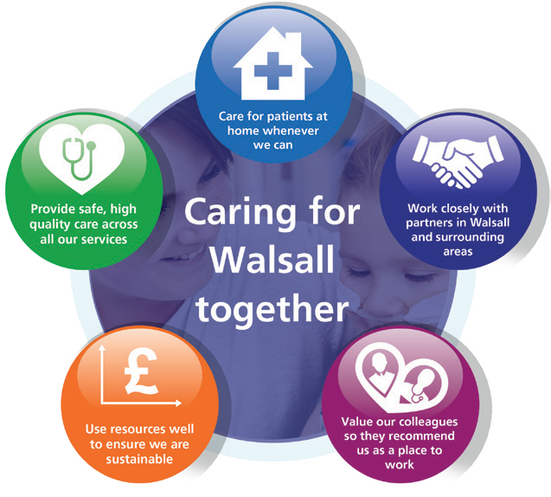Our Vision, Objectives & Values
Walsall Healthcare NHS Trust is guided by five strategic objectives which combine to form the overall ‘vision’ for the organisation.
Complementing this are our ‘values’, a set of individual behaviours that we wish to project amongst our workforce in order to deliver effective care for all.

Our Vision: Caring for Walsall together
“Caring for Walsall together” reflects our ambition for safe integrated care, delivered in partnership with social care, mental health, public health and associated charitable and community organisations.
Our Objectives: Underpinning the vision
The organisation has five strategic objectives which underpin our vision of ‘Caring for Walsall together’, and they are to:

Our Values: Upholding what’s important to us as a Trust
Our values, coupled with individual behaviours, represent what we wish to project in our working environments.
Respect | We are open, transparent and honest, and treat everyone with dignity and respect.  - I appreciate others and treat them courteously with regard for their wishes, beliefs and rights.  - I understand my behaviour has an impact on people and strive to ensure that my contact with them is positive.  - I embrace and promote equality and fairness. I value diversity and understand and accept our differences. I am mindful of others in all that I do.
Compassion | We value people and behave in a caring, supportive and considerate way.  - I treat everyone with compassion. I take time to understand people’s needs, putting them at the heart of my actions.  - I actively listen so I can empathise with others and include them in decisions that affect them.  - I recognise that people are different and I take time to truly understand the needs of others.  - I am welcoming, polite and friendly to all.
Professionalism | We are proud of what we do and are motivated to make improvements, develop and grow.  - I take ownership and have a ‘can-do’ attitude.  I take pride in what I do and strive for the highest standards.  - I don’t blame others. I seek feedback and learn from mistakes to make changes to help me achieve excellence in everything I do.  - I act safely and empower myself and others to provide high quality, effective patient-centred services.
Teamwork | We understand that to achieve the best outcomes we must work in partnership with others.  - I value all people as individuals, recognising that everyone has a part to play and can make a difference.  - I use my skills and experience effectively to bring out the best in everyone else.  - I work in partnership with people across all communities and organisations.


Provide Safe, high-quality care;
We will deliver excellent quality of care as measured by an outstanding CQC rating by 2022.

Care at Home;
We will host the integration of Walsall together partners, addressing health inequalities and delivering care closer to home.
Work Closely with Partners;
We will deliver sustainable best practice in secondary care, through working with partners across the Black Country and West Birmingham System.
Value our Colleagues;
We will be an inclusive organisation which lives our organisational values without exception.
Use Resources Well;
We will deliver optimum value by using our resources efficiently and responsibly.


1
MEETING OF THE PUBLIC TRUST BOARD – 3rd June 2021
Trust Board Chair’s Report |  |  |  | AGENDA ITEM: 6
Report Author and Job Title: | Prof Steve Field, Trust Board Chair | Responsible Director: |  | Prof Steve Field, Trust Board Chair
Action Required | Approve ☐ Discuss ☐ Inform ☒ Assure ☐
Executive Summary | On 27th May, in accordance with the Trust’s Standing Orders, and discussions and agreement at the private Trust Board on 6th May, I took Chair’s action to approve revisions to the Standing Financial Instructions. The revisions, rationale, risks and mitigations taken into account when taking Chair’s action are attached to this report at Appendix 1. The Chairs of the Performance, Finance and Investment Committee and the Audit Committee, Mr John Dunn and Mrs Mary Martin, reviewed the recommendation prior to Chair’s action being taken.
Recommendation | Members of the Trust Board are asked to note the Chair’s action taken.
Does this report mitigate risk included in the BAF or Trust Risk Registers? please outline | The risk implications are set out in appendix 1.
Resource implications | The resource implications are set out in appendix 1.
Legal and Equality and Diversity implications | There are no implications.
Strategic Objectives | Safe, high quality care ☒ |  | Care at home ☒
Strategic Objectives | Partners ☒ |  | Value colleagues ☒
Strategic Objectives | Resources ☒

Public Trust Board – 3rd June 2021 Item 6, Appendix 1
Chairs Action Report
Changes to Standing Financial Instructions- Limits |  |  |  | AGENDA ITEM: TBC
Report Author and Job Title: | Jenna Davies- Director of Governance  Russell Caldicott-  Director of Finance and Performance |  | Responsible Director: | David Loughton Interim Chief Executive
Action Required | Approve ☒ Discuss ☐ Inform ☐ Assure ☐
Executive Summary | At the Board meeting on the 6th May, the Interim Chief Executive requested a change to Standing Financial Instructions specifically the delegated limits. The request was made on the basis that the current limits were too restrictive, prevented innovation and the pace of change required. Mr Loughton highlighted the staff survey and the feedback from staff as the driver of the change.  The Board supported a change to the delegated limits, and it was agreed that we would take a chairs action to implement the change from the 1st June 2021  This paper outlines the proposed changes to the delegated authority levels within the SFIs (in respect of expanding authority levels of certain authorisation of requisitions). In line with the Well Led improvement programme the full governance framework including SFI’s, Standing Orders, and Scheme of Delegation will be presented to the Audit Committee for review and ratification.  The Trust Board has a responsibility to ensure that staff at all levels of the organisation confidently understand what delegated authority they have to make decisions and are clear what to do when they do not have authority.  The Trust Board debated key risks being enhanced risk to delivery of financial plans, from increasing the delegated authority without providing clarity as to mitigations. The Trust moving into financial oversight by the regulator three years prior to this report.  The report articulates how the Executive will ensure officers are aware of the accountability framework and budgetary control policy. Executive and Senior Officers will hold officers to account owing to this increased delegation of limits aligning to increased accountability. A plan of communication and engagement to support staff when the changes go live from the 1st June 2021 is articulated within the report.

1

It is important that budget holders recognise the increased limits enables them to commit resources within their delegated budgets. Increasing delegated authority levels does not increase the resources individuals hold, members needing to be cognisant of the increased risk to delivery of financial plans.

The Trust’s Care Groups and Divisions are not independent, they are part of the Trust. They are granted powers through the Scheme of Delegation to allow them to manage themselves effectively to organise and deliver high quality services.

However, they will be expected to use the authority delegated to them in the best interests of the organisation and patients and through the accountability framework will be accountable for the use of delegated authority.
Recommendation | Members of the Trust Board are asked to approve the revised Standing Financial Instructions, noting the increased risks associated with delivery of sustainable services and mitigations  referred to within the report.
Does this report mitigate risk included in the BAF or Trust Risk Registers? | This report aligns to the BAF risk for use of resources and more specifically the risk to financial sustainability from increased delegated authority. The Accountability Framework implementation key and a fundamental aspect of Well Led and Care Quality Commission (CQC) assessment
Resource implications | The resource implications are set out in this report. They centre on increased autonomy leading to increased risk of financial  sustainability
Legal and Equality and Diversity implications | There are no legal or equality & diversity implications associated with this paper
Strategic Objectives | Safe, high quality care ☒ | Care at home ☒
Strategic Objectives | Partners ☒ | Value colleagues ☒
Strategic Objectives | Resources ☒

Report on Proposed Changes to Standing Financial Instructions and specifically the Delegated Limits

- Introduction

These Standing Financial Instructions (SFIs) are issued for the regulation of the conduct of its members and officers in relation to all financial matters with which they are concerned.

Standing Financial Instructions ensure that our financial transactions are carried out in accordance with the law and government policy in order to achieve probity, accuracy, economy, efficiency and effectiveness. It is important that the standing financial instructions enable appropriate oversight to be offered, so as to offer assurance the Trust achieves a balanced approach and future financial sustainability.

The SFI form part of the wider governance framework of the Trust which includes standing orders, and the scheme of delegation.

- Background

Walsall Healthcare NHS Trust faced financial challenge prior to and during the 2016/17 and 2017/18 financial years (not uncommon with other small to medium sized District General Hospital NHS Providers). In addition, the Trust services a fixed debt Private Finance Initiative (PFI) which resulted in the Trust receiving scrutiny in relation to achievement of a sustainable financial model.

The Trust received national support from the regulator (NHSI) and moved into the National Financial Improvement Programme (FIP). Therefore, owing to development needed on the Accountability Framework to hold officers to account, the Trust implemented reduced delegation limits for officers.

During the 2018/19 financial year, a full review of governance arrangements was undertaken to ensure that the SFIs and Scheme of Delegation reflect current organisational responsibilities and current guidance and legislation. A comparison exercise was undertaken against local and comparable Trusts, and revised limits were presented to the Board in October of that year,

However, at this time the financial standing of the Trust remained challenged and there were clear risks to non-achievement of financial plans, with concern that a change in delegated limits without clearly defined accountability would continue the financial uncertainty. Hence, at this time the changes to delegated limits was not approved.

The enhanced controls within the SFI’s contributed to the Trust delivering financial plans in the previous two fiscal years, attaining surpluses for 2019/20 and 2020/21. It



is also of note that the Trust has set a balanced financial plan for the initial 6 months of the 2021/22 financial year.

The Trust also developed an Accountability Framework (AF) that was endorsed in 2019 for operation (which also supported financial delivery). However, the Trust commissioned a Governance and Accountability Review early in the calendar year of 2020, the finding of the review presented to the Trust in March 2020. The review concluded that

‘The Standing Financial Instructions (SFIs) which were in place at the time of the review were highly restrictive with even Executives having limited levels of delegated authority. This was a source of significant frustration but also seemed to be distorting priorities.’

In response to COVID-19, a level 4 national incident was declared In March 2020. The Trust implemented a Governance continuity plan, which included increased delegated limits for Covid-19 expenditure as follows;

- the Incident Commander of the Acute Hospital, and the Incident Commander of the Community to approve spend aligned to the national definitions to £75,000
- Increase in spending limits to the Chief Executive Officer & Director of Finance to approve spend aligned to the national definitions of up to £150,000

During this period the financial governance and accountability arrangements ensured that spending was controlled, through paperwork requiring managers to exercise this delegation through reference to how additional commitments were to be resourced, as per the below;

- Weekly tactical command meetings (Community, Corporate and Operations)
- Proformas generated to articulate how the decision was to be resourced within the overall envelop of funds
- The Trust reporting of expenditure through Executive, PFIC and Trust Board, attaining financial performance with regular updates of the expenditure levels during this period

The Trust has now a track record of achievement of financial performance, and with the AF embedded over a two-year period (in conjunction with the recommendations of March 2020). It is felt essential to release the delegated limits to enable managers the freedom to respond to the current challenges in regard to staff engagement and quality concerns raised through the Care Quality Commission.

- Methodology and revised limits

Trust Board members debated the rational for the increase in limits, noting that the Trust has no more resources so wanted assurance over financial sustainability, reflections being:

  - The Trust has operated increased limits throughout Covid-19 and delivered financial balance
  - The freedom is required to enable responses at pace to staff and patient care challenges
  - The movement in the limits should be reflective of both historic levels at the Trust (Interim CEO direction) and the current The Royal Wolverhampton NHS Trust (RWT) levels, to reflect our closer collaborative working and direction of travel.

This paper reflects on the proposed limit changes, reflective of historic levels deployed by Walsall and as such, a proposal for the level of delegation increases is contained in Appendix I of this report.

- Key Risks

The key risks associated with the increase in delegated limits centres upon;

  - Officers being able to commit significantly higher levels of expenditure
  - Risks the AF is not being fully embedded and so officers not held to account
  - The Trust faces greater risk to achievement of financial plans (a key Board Assurance Risk)

Members will need to be assured the Trust has appropriate mechanisms in place to hold officers to account. Communications with officers targeted at ensuring they understand increased delegation does not imply an ability to spend more, merely an ability to commit resources allocated within their control to a greater degree.

- Recommendations & mitigations to risks

The report recommends the delegated limits are revised to those contained within appendix I. In addition, the mitigations to risks identified within the report as listed below are implemented:

  - The Accountability Framework is re-launched alongside the increased delegated limits (if approved) by 1st June 2021
  - The Budgetary Control Policy is re-circulated to officers within the Trust to coincide with the movement in delegated authority
  - Development sessions are held with the Divisions and Care Groups to ensure appropriate understanding exists in regard to responsibilities (throughout the remainder of May 2021) and in advance of the launch of the increased delegation limits

It is important officers understand, that with increased delegated powers comes the enhanced accountability, essential to ensure sustainability of services.

- Next Actions

  - Presentation of the report to Non-Executive representatives, whom have received delegated authority from Board and Chair to amend delegated limits contained within the SFI’s of the Trust (decision recorded at 3rd June 2021 Trust Board)
  - Executive review of the Accountability Framework (meeting 18th May 2021)
  - Divisional meetings held to review AF (TBC)
  - Trust Management Board meeting to endorse refreshed Accountability Framework for launch and receive the Budgetary Control Policy (meeting of the 25th May 2021)
  - Head of Communications launch ‘Trust Wide’ communication on revised delegations and Accountability Framework (should these be endorsed) 26th May 2021.

- Appendices

Appendix I – Recommended changes to delegated limits for SFI’s

Appendix I – Proposed Revised Delegated Limits

Standing Financial Instruction Limits (proposed)

Authorisation of Expenditure | Proposed limits | Additional information
Budget Manager e.g. Ward Manager | up to £9,999
Senior Budget Manager- Care Group | up to £15,000
Divisional leadership;  - Clinical Director  - Divisional Director of Operations  - Divisional Director of Nursing | up to £50,000
Deputy Director | up to £50,000
Executive Director | up to £75,000 | As per Covid-19 limit changes
Chief Executive and Director of Finance | Up to £150,000 | As per Covid-19 limit changes
Business case approval
Divisional Board | Above £25,000 | For Divisional oversight (within budget)
Trust Management Board | Above £50,000 | CSS, Estates and Corporate oversight
Performance, Finance and Investment Committee | Above £150,000 to £750,000
Trust Board | Over 750,000

7

MEETING OF THE PUBLIC TRUST BOARD – 3rd June 2021
Chief Executive Officer’s Report |  |  |  | AGENDA ITEM: 7
Report Author and Job Title: | Prof David Loughton, Interim Chief Executive Officer | Responsible Director: |  | Prof David Loughton, Interim Chief Executive Officer
Action Required | Approve ☐ Discuss ☐ Inform ☒ Assure ☐
Executive Summary | The paper includes details of key activities undertaken since the last Trust Board meeting.
Recommendation | Members of the Trust Board are asked to note the report
Does this report mitigate risk included in the BAF or Trust Risk Registers? please outline | None in this report.
Resource implications | There are no resource implications associated with this report.
Legal and Equality and Diversity implications | None in this report.
Strategic Objectives | Safe, high quality care ☒ |  | Care at home ☒
Strategic Objectives | Partners ☒ |  | Value colleagues ☒
Strategic Objectives | Resources ☒

2
CHIEF EXECUTIVE OFFICER’S REPORT – JUNE 2021

1.0 | Review
 | This report indicates my involvement in local, regional and national meetings of significance and interest to the Board.
2.0 | Policies and Strategies
Policies, Procedures, Guidelines and Strategies Update Report
- Data Quality Policy
- Bring Your Own Device (BYOD) Policy
- Sharps/Splash Contamination Incident Policy
- Outbreak Management Policy
3.0 | Visits and Events
Since the last Board meeting I have undertaken a range of duties, meetings and contacts locally and nationally including:
- Since Friday 27 March 2020 I have participated in weekly virtual calls with Chief Executives, led by Dale Bywater, Regional Director – Midlands – NHS Improvement/ England
- Since Monday 3 August 2020 I have participated in weekly calls with the Black Country and West Birmingham Strategic Transformation Partnership (STP) on the co-ordination of a collective Birmingham and the Black Country restoration and recovery plan and COVID-19 regional update
- Since 1 March 2021 I have participated in weekly STP Gold Command – Coronavirus meetings
- 21 April 2021 – chaired a Senior Managers Briefing
- 22 April 2021 – participated in an Acute Collaboration Programme Board virtual meeting
- 23 April 2021 – undertook a site visit of Manor Hospital to meet staff
- 5 May 2021 – participated in an Acute Collaboration virtual operational meeting
- 7 May 2021 – participated in the Local Negotiating Committee (LNC)
- 11 May 2021 - chaired the virtual West Midlands Cancer Alliance Board and chaired the Trust Management Board (TMB)
- 13 May 2021 – undertook a site visit of Manor Hospital to meet staff and met with Pat Usher and Jane Wilson, local union representatives
- 14 May 2021 – participated in the virtual Black Country and West Birmingham Quarterly STP NHS Improvement / England (NHSI E) System Review meeting
- 18 May 2021 – undertook a site visit of Manor Hospital to meet staff and virtually
met with representatives of CQC in relation to the Inspection Report of Walsall

NHS Healthcare Trust and its publication
- 21 May 2021 - was a Panel Member of the West Midlands Combined Authority (WMCA) Media briefing
4.0 | Board Matters
 | The Care Quality Commission (CQC) published their findings and rating following their inspection carried out on 9 March 2021, it rated the Trust – Requires Improvement.


MEETING OF THE PUBLIC TRUST BOARD – 3rd June 2021
Acute Care Collaboration in the Black Country and West  Birmingham – June 2021 Update |  |  | AGENDA ITEM: 8
Report Author and Job Title: | Rob Wood, Programme  Manager – Acute Care Collaboration | Responsible Director: | Glenda Augustine,  Director of Planning & Improvement
Action Required | Approve ☐ Discuss ☒ Inform ☒ Assure ☐
Executive Summary | The Trust Board approved a formal approach to Acute Care Collaboration (ACC) across the four acute and community care providers in the Black Country and West Birmingham (BCWB) at the December 2020 Board meeting. An initial meeting of the four Acute Care Provider Trust Chief Executive Officer (CEO) and Trust Chair, with the Trust Executive Directors of Strategy/Planning supporting the ACC in attendance, was held on 25th February. The proposal for an ACC Programme Board was agreed, chaired by the each Trust Chair on a rotating basis and the joint Senior Responsible Officers, who will report to NHS England and Improvement, are Richard Beeken (Acting CEO Sandwell and West Birmingham Hospitals NHS Trust) and Diane Wake (CEO Dudley Group of Hospitals).  The first ACC Programme Board meeting was held on 18th March 2021 and a recommendation was made for submission of the Case for Change and the Programme Board Terms of Reference for formal approval by each sovereign Trust Board in April 2021. These documents were received in the Private Board as the meeting occurred during the pre- election period. This paper provides an update on the progress of the Programme Board and two key documents. The Case for Change document (Appendix 1) outlines the ambition to deliver sustainable, high quality services to drive improvement in patient access, experience and outcomes for the whole population of BCWB. This is a high level case for change proposing a clinically led, evidenced based collaboration that aims to share best practice, address unwarranted variation and subsequently reduce inequalities.  The Terms of Reference (Appendix 2) outlines the purpose, duties and reporting responsibilities of the Programme Board and indicates the representative membership of the Board.
Recommendation | The Board is requested to note the Black Country and West Birmingham Acute Care Collaboration progress to date and the key governance documents.
Does this report mitigate risk included in | BAF Risk 1: The Trust fails to deliver excellence in care outcomes, and/or patient/public experience, which impacts on the Trust’s ability to deliver

the BAF or Trust Risk Registers? please outline | services which are safe and meet the needs of our local population. Trust collaboration has the potential  BAF Risk S03: Failure to integrate functional and organisational form change within the Black Country will result in lack of resilience in workforce and clinical services, potentially damaging the trust’s ability to deliver sustainable high quality care.  BAF Risk S04: Lack of an Inclusive and open culture impacts on staff morale, staff engagement, staff recruitment, retention and patient care.  BAF Risk S05: The Trust’s financial sustainability is jeopardised if it cannot deliver the services it provides to their best value. If resources (financial, human, physical assets, and technology) are not utilised to their optimum, opportunities are lost to invest in improving quality of care. Failure to deliver agreed financial targets reduces the ability of the Trust to invest in improving quality of care, and constrains available capital to invest in Estate, Medical Equipment and Technological assets in turn  leading to a less productive use of resources.
Resource implications | There are resource implications associated with Trust collaboration that, whilst not currently fully defined, include resources associated with overall governance of the collaboration process which may require the establishment of a Programme Board (and the associated subgroups) to oversee the clinical, workforce, operational, corporate, financial, communication and engagement alongside patient and public involvement elements of the agreed collaborative arrangements to ensure the  proposed benefits are maximised across all BCWB Trusts.
Legal and Equality and Diversity implications | The current NHS statutory framework does not provide any specific mechanisms for NHS provider collaboration and advice will be needed to address any legal barriers that may arise in relation to the chosen option for collaboration. There will need to be consideration of a number of areas such as the legal powers for decision-making, employment and pensions, regulatory issues, information governance, procurement and existing contracts. There are also equality and diversity implications related to employment and service delivery. An equality impact assessment would be required to assess the agreed option for collaboration to mitigate against equality and diversity risks in relation to employment and service delivery. Trust collaboration is likely to provide greater opportunities for increasing and widening employee participation, talent management, personal and professional development. Shared learning across organisations around patient access and the provision of  inclusive services for the population we service will be beneficial.
Strategic Objectives | Safe, high quality care ☒ | Care at home ☒
Strategic Objectives | Partners ☒ | Value colleagues ☒
Strategic Objectives | Resources ☒

Acute Provider Collaboration Programme Update to the Board
June 2021

- Purpose

The purpose of this paper is to provide an update to the Board on the Acute Provider Collaboration Programme and note the key governance documents which have been approved in private board sessions (see below).

- Background

This is an update on the progress of the Acute Provider Collaboration since the previous report to the Board in February 2021. At that time there was some uncertainty relating to potential organisational form changes to deliver acute collaboration across the Black Country and West Birmingham. As previously reported, the consensus across all four acute provider Trusts in the region was to establish a clinically led programme which focuses on services where quality and outcomes can be improved with no imminent change in organisational leadership arrangements. This has now been accepted as the most appropriate route to realising the benefits of collaboration.

Work on programme started after a request from NHSEI that the four acute providers in the Black Country work together on a plan for collaboration, each trust Board agreed to the establishment of a clinical driven change programme (Dec 2020).

During January and February 2021, Directors of Strategy at the four Trusts began the work to establish the programme, including revising the case for change, scoping out Terms of Reference for the programme board and outlining the programme. A meeting was held with Trust Chairs and Chief Executives to share this output in order to ensure on-going alignment across organisations in advance of the first meeting of the programme board.
The Acute Provider Collaboration Programme Board has met on three occasions, most recently 20th May 2021, attended by the Chairs and CEOs of each Trust, Directors of Strategy and other leads.

The meetings have been positive and action focused, with good debate and commitment to moving the programme forward successfully.

- Key issues and decisions taken at first two Programme Boards

The Programme Board recommended the following governance documents for approval by each Board, and these have been approved in private session whilst purdah was in place:

  - Programme Board Terms of Reference

  - The Case for Change. Minor changes were agreed by the Programme Board which have now been included, namely strengthening the leadership section to reflect the opportunities collaboration offers and highlighting that previously agreed clinical priorities needed to be revisited. It was also noted that there are likely to be financial opportunities from collaboration that are not yet fully articulated, and that as such each organisation may want to highlight separately.

The Programme Board also considered the following documents:

  - The high-level timeline. An additional workstream was added to the programme in May 2021, Digital, Data and Technology the timeline for which is not yet complete. The workstream leads have prepared and shared overview documents that summarise the objectives and desired outcomes from their work.

  - The approach to developing the intelligence to support decision making which was agreed.

  - A proposal for significant clinical engagement to commence in Quarter 2 with a series of full day events to bring clinical leaders together from across the 4 trusts. They will review the intelligence gathered and agree priorities areas for collaborative models.

  - A risk register highlighting the current risk profile was agreed.

  - The Programme Board also agreed to focus on the following ‘quick wins’:
    - Progression of a Urology Network
    - Formalisation of critical care support arrangements established to deal with impact of Covid-19
    - Alignment of waiting list initiative payment rates
    - Repatriation of vascular services
    - Acceleration of staff passporting
    - Development of back office synergies, and
    - Commitment to share consistent performance dashboards

Progress at latest Programme Board – 20 May 2021

The programme’s focus on two “delivery workstreams” – clinical projects and back office efficiency was confirmed. Together with the structure of the six enabling workstreams, which now includes a digital, data and technology workstream. The Programme Board reviewed and noted the progress made by each workstream, including:

  - The Resource requirements for the programme. An initial estimate of resources required to deliver the programme has been prepared. This indicates resources totalling £2.8m per annum for the first 2 years will be required, the majority of which will come from existing Trust resources. Discussions are on-going with the Integrated Care System / Clinical Commissioning Group regarding how existing staff are utilised and what further resources will be available as they transition to support the new NHS architecture.
  - Scheduling and agreeing an agenda for the first of a series of clinical engagement events which will ensure clinical ownership of the plans that emerge to improve outcomes in the region through collaboration;
  - The approach to refreshing Model Hospital data to understand the latest performance of the Trusts’ back office and the engagement process needed to explore quality focused back office efficiency improvement;
  - Understanding the approach to information gathering to provide the programme with robust data to drive decision making;
  - Setting out the approach to Communication and Engagement;
  - Understanding areas of potential collaboration to improve the flexibility of staff movement between providers;
  - Establishing a digital, data and technology workstream to assess and implement the necessary changes that will enable the effective collaborative services, and
  - Agreeing to review the quick wins previously agreed to confirm that they remain appropriate.

6. Next Steps

Programme Board meetings will be held monthly, in the 3rd week of the month in order that issues and decisions can then be taken to Boards early the following month.

It should be highlighted that this work is now central to delivering the new architecture and environment for the NHS described in the recently published White Paper ‘Integration and

Innovation: working together to improve health and social care for all’. As such, it will require significant clinical, managerial and Board leadership to secure its delivery as part of a successful Integrated Care System.

Public Trust Board – 3rd June 2021
Agenda item 8, Appendix 1: Case for Change for Black Country and West Birmingham Acute Care Collaboration


CASE FOR CHANGE FOR
BLACK COUNTRY AND WEST BIRMINGHAM ACUTE CARE COLLABORATION

SANDWELL AND WEST BIRMINGHAM HOSPITALS NHS TRUST THE DUDLEY GROUP NHS FOUNDATION TRUST
THE ROYAL WOLVERHAMPTON NHS TRUST WALSALL HEALTHCARE NHS TRUST

MARCH 2021

Version 4.3

VERSION HISTORY

Version | Date Issued | Submitted to | Brief Summary of Change | Owner’s Name
4 | 2/2/2021 | Exec Leads | Refresh of whole case for change based on Acute Care ownership and Board approvals in December 2020 | Jo Cadman
4.1 | 15/2/2021 | Exec Leads & CEO/Chair | Updates from initial comments from Exec leads:  - Restructured sections for easier read – i.e. strategic case from national, system, place and organisational level; separated out workforce to have more sections; tidied up presentation for new page for each section  - Added restoration & recovery section to link between strategic and clinical case  - Restructured clinical section to start with evidence and move to ambition  - Added in RWT to Wolverhampton place partnership table  - Included comments of local shared care record to support collaboration  - Removed some reference to previous group plans  - Updated risk schedule to reflect impact of agreeing plan not in line with NHSEI preferred option and contribution to system efficiencies not solution in totality  - Revised governance structure proposal to reflect ownership of efficiency and infrastructure through system and link to acute care; and leadership as programme wide work programme
4.2 | 14/03/2021 | Programme Board | - Reference to proposed new areas of focus  i.e. clinical engagement plan and the new Intelligence, Insight and Outcomes programme  - Removal of detail on resources, risks etc to be received at the March Programme Board as part of delivery of the programme  - Updates to governance following the February meeting with CEOs/Chairs for onward approval at the March Programme Board
4.3 | 19/3/21 | Trust Boards | Agreement at Programme Board:  - Section 3.6 updated to reflect agreed approach to determine priorities – i.e. Intelligence, Insight and Outcomes and Clinical Engagement  - Section 4 – acknowledge opportunity to strengthen leadership through potential shared roles, and from sustainability review identifying potential improvement areas  - Update throughout to reflect timing that Programme Board has taken place

Contents
- INTRODUCTION 4
- STRATEGIC CASE 5
  - NATIONAL CONTEXT 5
  - SYSTEM CONTEXT 5
  - LOCAL CONTEXT – PLACE 6
  - ORGANISATIONAL CONTEXT 10
  - RESTORATION AND RECOVERY 10
- CLINICAL CASE 11
  - HEALTH INEQUALITIES 11
  - HEALTHY LIFE EXPECTANCY 11
  - UNWARRANTED VARIATION 12
  - STRENGTHENING SUSTAINABILITY THROUGH COLLABORATION 12
  - ENABLING CLINICAL EXCELLENCE BY DELIVERING THE DIGITAL STRATEGY 13
  - OUR CLINICAL PRIORITIES 14
- WORKFORCE CASE 17
- FINANCIAL CASE 18
- PRIORITIES 19
- BENEFIT REALISATION 21
- DELIVERY 23
  - PROPOSED PROGRAMME GOVERNANCE 23
  - PROGRAMME PLAN 26
  - PROGRAMME RESOURCING 28
  - COMMUNICATION & ENGAGEMENT 28
  - CULTURE 28
  - RISK MANAGEMENT 29

- Introduction
This paper captures our high level case for change for acute care collaboration, and the actions required to deliver it. Our high level plans have been developed by a working group of executives from the four Trusts, and overseen by the CEOs and Chairs. Provider collaboration is one of the key priorities in the Black Country and West Birmingham (BCWB) ICS plan aimed at providers working together to optimise health outcomes, service delivery and efficiency for the whole population.
Each of the Trust Boards received and discussed a paper (appendix 1) in December 2020, where they agreed that a clinically led collaboration was critical to maximise benefits. We will use our collective knowledge experience and capacity to deliver sustainable world class services for the BCWB. Whilst all Trusts agreed that a clinically led programme was required there were differences of opinion in the most appropriate mechanism to deliver change, and therefore a Programme Board should oversee the development of the plans and their delivery.
Our plans will ensure that everyone in the BCWB will receive access to high quality services, regardless of where they live. We will engage and empower those closest to our services to deliver our vision for world class care, supporting them with the resources and support to deliver our planned improvements.
The impact of COVID on acute care delivery, our staff and patients has been unprecedented, and will be felt for years to come. There were national workforce challenges prior to the pandemic, and the impact on the health and wellbeing of our staff is not yet understood.
We believe that our clinically driven programme will inspire and focus our staff on an exciting future as we work together, and is our best chance of jointly delivering our restoration and recovery plans.
Whilst we have great ambition through this programme, our plans will ensure that the pace supports our staff, and enables full engagement in the development of detailed plans.

- Strategic Case

  - National Context

The NHS Long Term Plan (2019) set out the requirement for the creation of Integrated Care Systems (ICSs) across England by April 2021. Further guidance was included in the national direction of travel set out in ‘Integrating Care: Next steps to building strong and effective integrated care systems across England’ and a summary of the proposed next steps in November 2020.
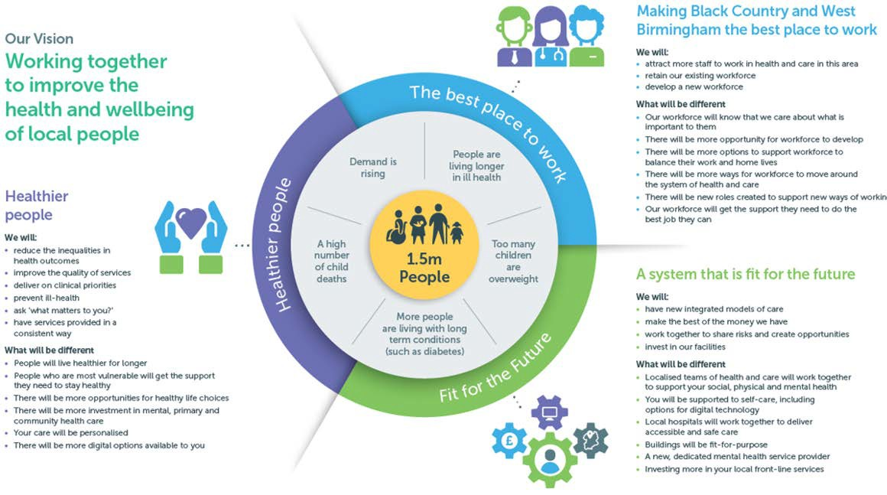There have been difference approaches to collaboration nationally, and whilst there is guidance published describing the requirement to collaborate the expectation is that this will not be prescriptive, and systems will be required to develop plans that are most appropriate for them. This will require working with our system partners as we develop and implement our plans.

  - System Context

Across the eleven systems in the NHS Midlands region, the Black Country and West Birmingham (BCWB) system has the second highest financial allocation, the smallest geographical footprint and the most organisations providing acute care services.

Around 1.5 million people live in our area, across the five localities of Dudley, Sandwell, Walsall, West Birmingham and Wolverhampton. We have an increasingly ethnically diverse population, with 26% from BAME origins compared to 9% nationally and in 1 in every 25 or our households there is no one who has English as their main language. There are many deprived areas in the Black Country and West Birmingham; some of the highest infant mortality rates; poorest academic achievement of school leavers which in turn impacts upon economic prospects; growing prevalence of obesity accompanied by low physical activity; and many households living in fuel poverty. In addition, healthy life expectancy is below the national average by more than 6 years, whilst there is also a much higher proportion of people with mental health problems.

Our acute care collaboration fully aligns to the BCWB system priorities, building on the plans to be an Integrated Care System (ICS):

Figure 1. BCWB system priorities

We have been working together as partners in the Sustainability and Transformational Partnership (STP) for some time, and committed to becoming an Integrated Care system by April 2021. This closer collaboration between NHS and other partners, such as councils, police etc, will encourage collective responsibility for managing resources, delivering NHS standards, and improving the health of the population as a whole.

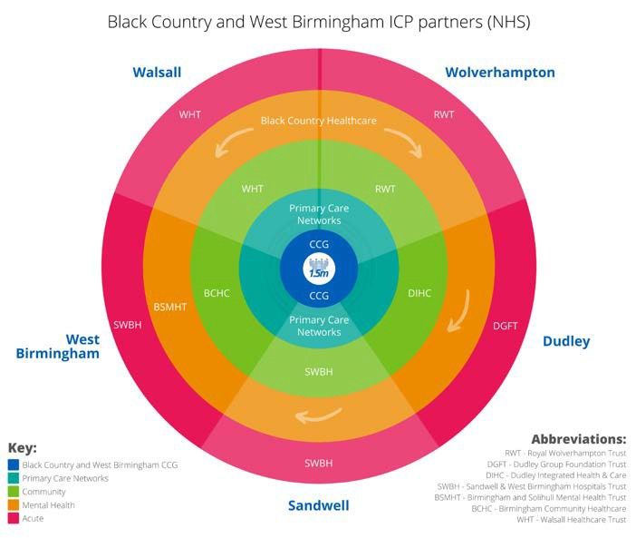Our plans are also aligned to the NHSEI guidance published on 26th November 2020 on the development of Integrated Care Systems (ICS), which expects providers to play an active and strong leadership role joining up the provision of services within and between places. All NHS provider trusts will be expected to be part of a provider collaborative across their system, or spanning multiple systems. Further guidance on provider collaborative models will be published in early 2021.

  - Local Context – Place

The BCWB system has always acknowledged the strength of place in our system and the importance of strong locally focused partnerships, whilst optimising the opportunities for working at scale across BCWB. Our collaboration will only deliver the maximum benefits by working alongside our Integrated Care Provider (ICP) place based partnerships, and the STP as a whole.
Whilst there are similarities across places, it is crucial that our programme is sensitive to, and engages our partners to build on their excellent progress.
Our plans will also be mindful of the development of the Midland Metropolitan University Hospital
(MMUH), which focuses on reducing hospital care from the two sites in Sandwell and Birmingham to integrate them on to the MMUH site. There is a potential impact on all the other places from the flow of patients caused by this transformation and therefore acute care collaboration could also better mitigate this risk.
The changing landscape does provide risk to all existing organisations providing community services, and the potential shift in resources. Our collaboration offers a shared strategic mitigation to this risk whilst delivering against the shared place based priorities:
    - Improve population health – a focus on seamlessly wrapping services around individuals, improving pathways ensuring that these are integrated regardless of which organisation is providing the elements of care, addressing unwarranted variation, improving access and ensuring that the BCWB population receives the best care regardless of where they live. Utilising our learning, and the opportunity to reset our services post COVID-19, together we have a much better opportunity to improve this more quickly.

    - Infrastructure to support that effectively – these are slightly different depending on each place and their positions, but this includes governance arrangements (depending on how

far progressed the place based integration is); workforce; investment across the place; and digital improvements to support improvement of outcomes.

    - The place based partnerships fully align with organisational objectives and an acute care collaboration must fit with that (see figure 1 above). The learning from our mental health and learning disability colleagues is that merger across the BCWB allowed resources to focus on delivery at Primary Care Network level, but also develop the specialist services that required a population of over 1 million people.

Figure 2. BCWB Place based arrangements

Walsall Together:  Walsall Healthcare NHS Trust (WHT) Walsall Clinical Commissioning Group (WCCG)  Black Country Heathcare NHS Foundation Trust (BCH) Walsall Council (Social Care and Public Health) (WLA) Primary Care Networks (PCN)  One Walsall (Council for Voluntary Services) WCVS) Walsall Housing Group (WHG) (representing housing sector) |  | Wolverhampton Integrted Care Partnership: The Royal Woverhampton NHS Trust; Wolverhampton CCG;  PCNs; BCHFT;  Local Authority;  Considering third sector membership eg hospice provider |  | All Together Better Dudley  The Dudley Group NHS Foundation Trust; Dudley Integrated Health & Care NHS, Black Country Healthcare Foundation Trust, Dudley Metropolitan Borough Council; PCNs; WMAS; Dudley Council for Voluntary services; Dudley Healthwatch |  | Sandwell Integrated Care Partnership |  | Ladywood and Perry Barr Integrated Care Partnership
How does Place align to organisational objectives? |  | How does Place align to organisational objectives? |  | How does Place align to organisational objectives? |  | How does Place align to organisational objectives? |  | How does Place align to organisational objectives?
Place objectives align to the trust strategic objective Care at Home incorporating outpatient transformation and delivery of integrated services |  | RWT vision is an organsation that continually strives to improve the outcomes and experiences for the communities we serve. Place is therefore integeral to that vision |  | Emerging themes in strategy refresh: the hospital and care at the heart of the community; delivering and supporting excellent services in the Black Country and beyond; driving forward research, development and innovation |  | They support integrated working and through that; safe high quality care; access and responsiveness; care closer to home; good use of resources; a 21st century infrstructure and an engaged and effective place. |  | They support integrated working and through that; safe high quality care; access and responsiveness; care closer to home; good use of resources; a 21st century infrstructure and an engaged and effective place.
Top 3 priorities for Place | Top 3 risks for Place | Top 3 priorities for Place | Top 3 risks for Place | Top 3 priorities for Place | Top 3 risks for Place | Top 3 priorities for Place | Top 3 risks for Place | Top 3 priorities for Place | Top 3 risks for Place
Improve the health and wellbeing outcomes of their population | Ability to manage population health | Population health management | Ageing and sicker population | Health and Wellbeing 3 goals: Promoting healthy weight; reducing the impact of poverty; reduce loneliness and isolation | Introduction of Integrated Provider organisation | Leadership Alignment and Development (including purpose, prototype and operating model) | Clarity of Purpose, Vision, Values, Priorities and Trusting one another prevents progress. Mitigation through alignment work. | Leadership Alignment and Development (including clear vision, headspace/investment in ICP Board and Citizen's voice) | Clarity of Purpose, Vision,  Values, Priorities and Trusting one another prevents progress. Mitigation through alignment work and ensuring effective cross-boundary
Increase the quality of care provided | Investment | Digital Transformation- | Inahbility to agree clear governance arrangements | Improving healthy life expectency (lower than average in England; high mortality in Cancer, CHD and liver disease) | Development of clinical pathways | Reducing Obesity in Adults | Lack of a funding formula and the lack of an agreed contrcatual mechanism that encourages long term, whole place innovative change - mitigation capitated budgets into the ICPs | Reducing Obesity in Children aged 5 and aged 11 | Lack of a funding formula and the lack of an agreed contrcatual mechanism that encourages long term, whole place innovative change - mitigation capitated budgets into the ICPs
Meet statutory financial duties of all partner organisations | Workforce | Admission avoidance/managing transfers of care | Inability to deliver digital transformation | Delivering the ICP to improve population health sustainably | Workforce recruitment and retention | Increasing the numbers of people who die in their place of choice | Prioritisation and Delivery Capacity with other organisational pressures prevents the ICP from learning to win together - mitigation focus on building trust through prototype. Use purpose and values to dis invest in those things that  don't move the ICPs towards the purpose. | Increasing the numbers of people who die in their place of choice | Prioritisation and Delivery Capacity with other organisational pressures prevents the ICP from learning to win together - mitigation focus on building trust through prototype. Use purpose and values to dis invest in those things that  don't move the ICPs towards the purpose.
 |  |  |  |  |  | Increasing the number of kids that are "school ready"
 |  |  |  |  |  | Reducing Loneliness

  - Organisational Context

A summary of Board Assurance Framework strategic risks is captured in the table below. Acute care collaboration offers an opportunity to share the risk to patient care, particularly if mitigations are focused on patients rather than from an organisational perspective:
Figure 3. Potential impact of collaboration on strategic risks

Strategic risk theme | Potential Mitigations
Sustainability in a challenging environment  Walsall Healthcare NHS Trust (WHT) has identified that sustainability is a strategic risk on their Board Assurance Framework (BAF); The Dudley Group Foundation Trust has identified that the development of DIHC has resulted in sustainability risks which mean that growth is the only viable strategy for the organisation; Sandwell and West Birmingham NHS Trust (SWBH) have a long term financial model which relies on close working through place, and contribution to efficiencies through acute care collaboration; and The Royal Wolverhampton NHS Trust has long felt that collaboration is a driver to sustainability. | Collaboration to better meet the demands of the population and commissioners  Stakeholder engagement to maintain and improve reputation with stakeholders  Economies of scale to support capacity and capability of managing the complex environment
Workforce  All Trusts have workforce as a key strategic risk. National and local workforce challenges are likely to worsen in the future if a co-ordinated response is not in place. | More attractive organisation and development opportunities to improve recruitment and retention  Improved flexibility of the workforce, and temporary staffing resource across the Black Country  Engagement and involvement of all staff to develop vision, values, behaviours and priorities as part of the integration programme  Economies of scale to improve leadership, and improve organisational development capacity
Impact of COVID-19 and restoration & recovery in an uncertain environment  The continued impact of COVID-19 on delivery of services, and impact on the resilience of staff and the capacity to be able to provide key services effectively in the short, medium and long term | Collaboration to better meet the demands of the population and commissioners, and share resources to be able to deliver restoration and recovery plans  Opportunity to redefine core services across BCWB and share resources to ensure that the population continue to receive care locally even if that means not where they are used to  Economies of scale to support capacity and capability of managing the complex environment
Quality / clinical sustainability  Whilst not all organisations have identified immediate concerns about the safety and quality of care delivered the continued pressures from demand, workforce and continued financial constraints could risk future clinical sustainability.  WHT undertook sustainability review and established an improvement programme focused on fundamentals of care.  DGFT have specifically identified this as a risk due to the impact of DIHC. | Scale and scope to innovate and deliver specialist services Scale and scope to create efficiencies that don’t impact quality Improved recruitment and retention and flexibility of workforce Resilience for vulnerable services  Opportunity to use economies of scale to invest and share risks on estate and digital solutions

  - Restoration and Recovery

COVID has had an unprecedented impact on the NHS, and the country as a whole. Whilst our staff have demonstrated incredible resilience in our response, the impact on them and our services has been huge and will take time to learn, recover and reset our services so that they are fit for the future. We have worked together throughout our response, and our continued collaboration will be critical to our recovery plans.

- Clinical Case
Our collaboration is clinically driven and will improve access, outcomes and experience for everyone in the BCWB regardless of where they live. We have great ambition to provide our population with world class services.
We are passionate about ensuring that our plans are clinically driven, focusing on maximising benefits to our patients and will ensure that they are developed through clinical engagement, and utilising our approach to intelligence, insight and outcomes working with partners to systematically share data to deliver system priorities:

  - 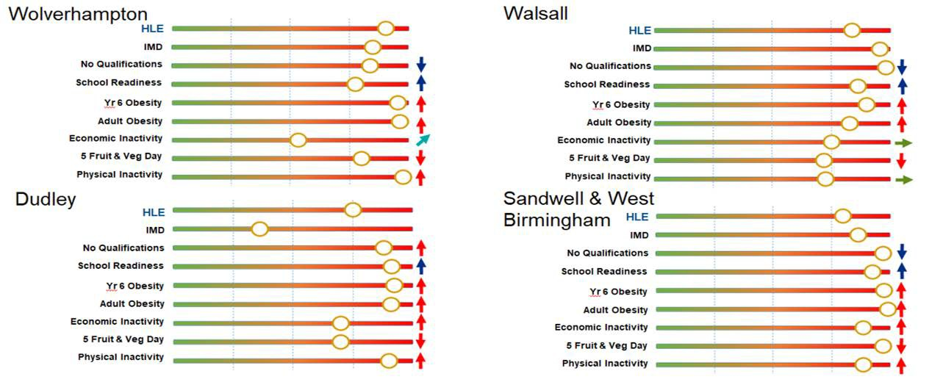Health Inequalities

The above graphs clearly show that there is significant room for improvement in the majority of indicators. There is also commonality in the issues that BCWB, for example by working together at scale on something like school readiness we can better support our partners outside of health and play a stronger role as anchor institutions to tackle them for our communities.

  - Healthy Life Expectancy

Healthy Life Expectancy (HLE) is a measure that combines length of life and quality of life, and a good indicator to suggest that more work is required to improve outcomes in all the areas that drive HLE. Whilst the Acute care collaboration is not the only driver to improve this the focus of the STP is to ensure that all aspects are addressed and that partners work together to implement the change which will have the biggest positive impact on that.

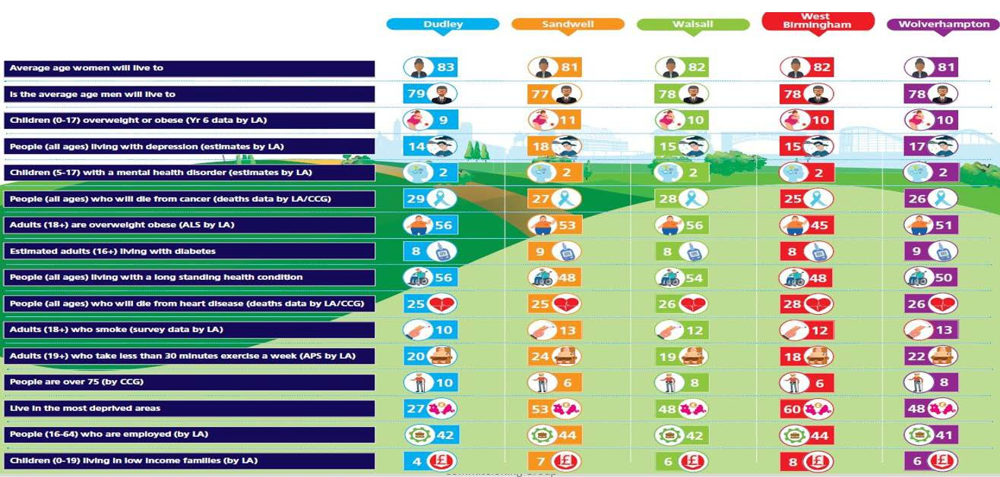Figure 4. Healthy Life Expectancy variance across BCWB

Life expectancy is approximately 78 years for men and 82 years for women in BCWB. Healthy Life Expectancy is approximately 58 years for men 59 years for women in BCWB. All BWCB CCGs have lower life expectancy and lower healthy life expectancy than England (80 years and 62 years respectively for men and 83 years and 63 years respectively for women).
There are inequalities in healthy life expectancy between different groups in BCWB. People living in more deprived areas have lower healthy life expectancy, people from some ethnic minority groups have lower healthy life expectancy and people from socially excluded groups e.g. people living with mental health problems and people living with learning disabilities have lower life expectancy. Appendix 3 includes more detail around the drivers for healthy life expectancy.

Again there is commonality in our issues, and rather than work independently to address these in place, we could use the scale of BCWB and our strength through collaboration to reduce the gap in healthy life expectancy.

  - Unwarranted Variation

Robust guidance has been published by NICE and other bodies to support evidence-based management of different conditions. Yet, stark variation in clinical care persists. Quality of care and the outcomes experienced vary in different parts of England for any condition you choose to focus on.
An individual’s chance of being admitted or readmitted to hospital as an emergency, of dying or even being diagnosed in the first place differs according to where they live.
Some degree of variation may be explained by population composition, levels of deprivation or disease prevalence. However, much of the variation is unwarranted.
Some variation is inevitable in healthcare and outcomes experience by patients. However, much of the variation is accounted for by the willingness and ability of doctors to offer treatment rather than differences in illness of patient preference.
We must ensure that the experience a member of our population has is not dependent on which part of the BCWB they live in. Appendix 2 contains a wide range of evidence demonstrating the current levels of variation.

  - Strengthening sustainability through collaboration

Each organisation undertook a rapid assessment of the services that would need to be retained on each hospital site, areas that would benefit from collaboration to support vulnerable services or

improve outcomes. Appendix 4 includes the detail of this assessment and provides some assurance that there are generally shared views on services to be retained on each site, and there are a variety of opportunities where sharing of expertise and strength by one Trust would support vulnerable services at another.
By working together we will provide world class acute care services that are safe, high quality and efficient. We will do this by attracting and retaining our staff, standardising provision, maximising use of our shared assets, and leading teaching and research across the Black Country and West Birmingham. We will continually improve the quality and accessibility of our services and deliver outstanding services and become a global exemplar of modern acute care.
We have proved what can be achieved when we set aside competition, and work in an open and transparent, ambitious way focused on delivering the best care to all of the BCWB communities in our pathology and maternity services, and in shared response to COVID. The Black Country Pathology Service now provides what is considered as an exemplar model delivering a sustainable, attractive, high quality service at each of the four hospital sites from improved estate, improved IT and at a reduced cost. Our collaboration will afford all other services the same opportunity by reconfirming our commitment to acute care collaboration, providing our leaders with the authority to act and supporting them with appropriate shared resources.
Whilst it would be ideal to present a fully developed evidence based case for change for each and every service the timescale for the development of this case for change has not allowed for this, however, there is an agreed plan to develop a systematic approach to clinically led improvement which prioritises based on evidence and opportunities which deliver maximum benefit.

  - Enabling Clinical Excellence by Delivering the Digital Strategy

We have an established, collaborative STP Digital Board across the BCWB with the aim to become a catalyst for change, empowering improvements through innovation which can be better aligned through a more formal acute care collaboration.
People will have greater choice on how and where to access services, together with the ability to personalise and manage their own care needs, which will empower patients to take greater control and responsibility for their care. For our workforce, the move to paperless processes, reduction in administration and elimination of duplication will lead to more productive and more fulfilling working environments as well as freeing up more time to focus on patient care.
Having system interoperability that helps to remove unnecessary variation in quality of care and services and also improves the integration between health and social care will allow the creation of new service models that address the health challenges and inequalities for our population. We are on track to deliver a shared care record during 2021/2 and combined with our collaboration this will enable successful delivery at pace by:
- A focus on the development of improvement capability across the system rather than in individual organisations;
- Organisations and their respective boards changing how they operate to give primacy to improvements to population health;
- Shared ownership to deliver on system strategic priorities. Our digital vision will improve outcomes and experience through:
- Empowerment - Through the use of technology patient and citizens can access and contribute to their health and care in both interactions and transactions such as online booking, virtual appointments, accessing records;
- Innovation - By working in partnership and across traditional organisational boundaries, new ways of working are already driving, and being driven by innovative ways of working. A sub-group of the STP Digital Board is already implementing cutting edge technologies across the health economy;

- Infrastructure - A resilient infrastructure across the BCWB health and social care economy enabling access to required information to support decisions from anywhere supporting place based working;
- Integration - With the enabling economy wide infrastructure, system standards and principles are a fundamental requirement for the interlinking of systems. Standards adopted nationally with the appropriate information governance framework and agreements eliminate organisational and regional boundaries to wider digital interoperability;
- Intelligence - Development of robust business intelligence across the BCWB to support decision making and identification of best practice models leading to improved patient care.
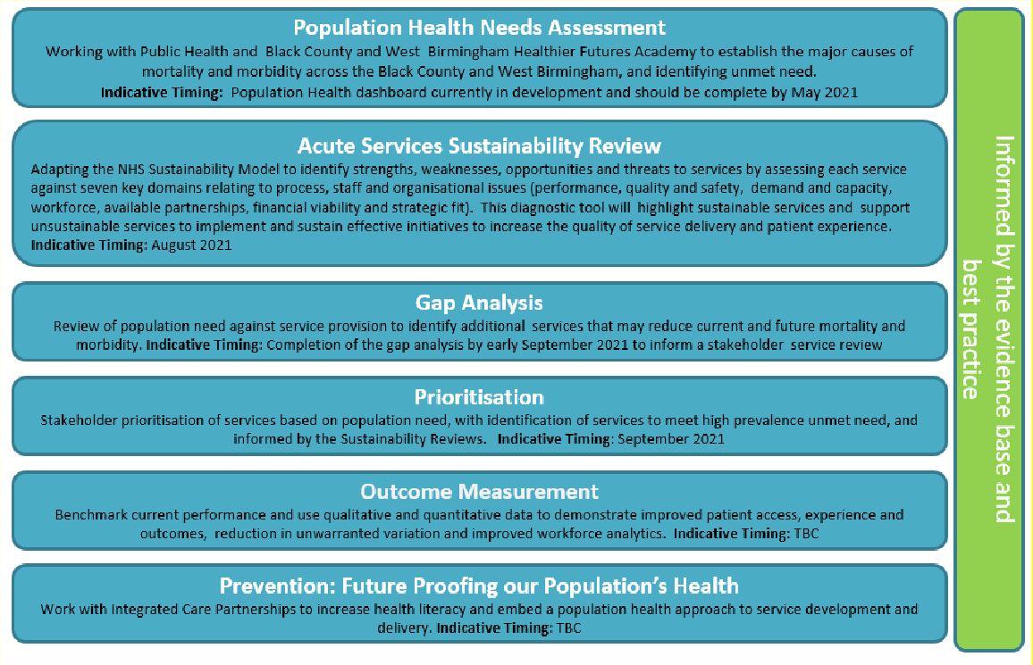
3.6 Our Clinical Priorities

Our clinical ambition will only be successfully if it is delivered by working with those closest to service delivery, as we develop and implement our plans. The pressures of responding to COVID have delayed our intention to fully engage, however, this is now planned for the spring and summer of 2021.

We have agreed an approach to Intelligence, Insight and Outcomes that works with our system partners to ensure that our solutions will be evidence based, and focused on population health for now and the future:

Figure 5. Approach to Intelligence, Insight and Outcomes

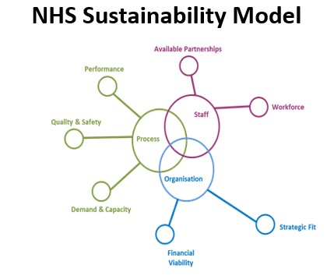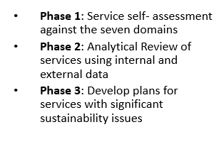Figure 6. Adapted NHS Sustainability model

We have also worked with the National Clinical Advisor for System
Transformation NHSEI, who is an experienced Medical Director with extensive knowledge of system-wide collaboration to identify Medical Leadership priorities to
inform our vision and opportunities for quick wins. This experience will also be invaluable as we move forward in planning our clinical engagement events, and the detailed plans that result from them.

As we will plan we will also be mindful of the priorities that were identified in the 2016 and 2019 STP plans. We didn’t deliver these at the pace and scale that we had originally planned, and must now take stock of our priorities also taking into account our learning from COVID. We will collaborate to remove unwarranted variation in care in access, outcome and experience by providing more joined up working across more than one hospital:

  - Assessing the benefits to develop clinically effective and sustainable 7 day working;
  - Setting out a strategy to improve cancer services and outcomes;
  - Reviewing the potential separation of emergency and elective care, by speciality or groups of co-dependent specialties, to create centres of excellence for elective care;
  - Sharing best practice and remove variation in trauma and orthopaedics, cardiovascular disease, chronic heart disease, renal, stroke, diabetes pathways, respiratory and cancer;
  - Reviewing the potential to move to a single service for less acute surgical disciplines, including plastics, ophthalmology and urology;
  - Collaboration for paediatric services on a network basis;
  - Collaboration to support acute general services across 4 A&E departments;
  - Shared service plans for orthopaedics;
  - Shared maternity and neo-natal models of care;
  - Service reviews of rheumatology, urology, neurology, cardiology, out of hours and seven- day services;

Enabled through the integration of non-clinical support services across both provider and commissioner organisations:

  - Identifying distributions of services which optimise utilisation of facilities and to enable the easiest release of physical capacity; and
  - Identifying where efficiencies can be achieved by the sharing of corporate and support services including payroll, staff employment models, procurement, HR, telephony, legal services, call centres and IT applications;
  - Exploring shared leadership across functions;
  - Sharing transactional services;

  - Collaborating on HR enabling processes including ESR;
  - Consistent employment administration, systems, processes and rates;
  - Reducing agency by working together;
  - Establishing a BCWB staff bank.

We have already developed some strong collaborative approaches clinically, and will build on these as we progress with our shared vision and through our wide engagement.

- Workforce case
The ability of the NHS to attract and retain high quality staff is well documented and becoming more of a challenge. The collaboration will strengthen the standing of the BCWB as a player in the West Midlands providing an inspiring platform for new and existing employees with improved opportunities to develop new roles, specialist opportunities, improved career choices, strengthened development options, strengthen research and development and supporting them with an improved health and wellbeing offer by combining resources.
There are significant workforce challenges, which will become even more challenging over the coming years and that they can be better mitigated through working together:
  - Recruitment and retention – superior opportunities for career development which would avoid people needing to leave to enhance their careers and build up loyalty; by building reputation as outstanding service providers the system will become a more attractive employer, which in turn improves resilience. The scale will provide improved opportunities to redesign our workforce which would be impossible as standalone organisations, not only does this further attract staff but also will be more cost effective through skill-mixes and reduction in agency costs.

  - System efficiency – there are huge opportunities to align systems and transactional processes to have a single approach in areas such as e-rostering, job planning, TRAC/recruitment, payroll, occupational health and E-learning. There would be opportunities to negotiate better costs for systems through the scale of the BCWB; opportunities to remove duplication and share the workload across our existing resources which would provide an opportunity to exploit benefits not currently resourced. In addition areas of best practice such as international recruitment could be rolled out to deliver opportunities to reduce agency costs. The opportunity to align this to system wide alignment could offer even greater opportunities.

  - Innovation - with the opportunity to deliver transactional costs at scale this would provide more capacity to look strategically and develop new roles across the system to be more proactive to manage current and future workforce risks. Investment on organisational and leadership development would also provide an opportunity to build a culture which resulted in a great place to work, as well as empower a culture of innovation.

  - Leadership – our collaboration provides opportunities for a number of aspects:

    - Our sustainability review will enable us to focus on leadership roles, ensuring that we support our leaders to be the best that they can. We acknowledge that there is a paucity of general management and good clinical leadership and that, in time, there is an opportunity to share leadership roles which will ensure we have world class services
    - our staff have endured the most challenging period of their careers and this will not only engage them in developing our future plans, but ensure we have a compelling vision for them to help them to re-energise, have clear priorities, remove duplication and develop an organisational development programme to build back up their resilience.

- Financial case
Whilst the case for change is fundamentally a clinical case, it will not be achievable without a sustainable financial position. The availability of financial resources is an important enabler of the case for change, and allows our main focus to be clinical improvement and efficiency.
The BCWB system is similar to many others in the challenging financial context in which it operates, and will work together to ensure there is a sustainable long term plan. An independent assessment, worked on with the Acute Trust Directors of Finance, identified a projected system Do Nothing position before any individual Trust CIP or provider collaboration benefits of £171m deficit in 2025/26. This is driven by growth in activity and cost inflation. The level of deficit projected is less than 9% which is not an outlier in terms of systems nationally. High level assumptions have estimated the potential to deliver £28m - £41m of collaboration benefits, which will contribute to a balanced position over the medium term.
There are a number of potential risks included in that forecast position:
- Growth and Income levels. If income growth is higher than 3% then this generates system financial pressures. For each 1% above this it would generate a £46m system pressure. The system will continue to work together on forecasting and managing demand, including progressing local, place-based care models that manage patients outside of the acute hospital, where appropriate. Planning guidance has yet to be released, and until such time there is uncertainty.
- COVID. The impact of COVID on operational costs is huge, and has affected the startpoint. It is unknown he potential for these costs to become recurrent. More detailed system planning is underway to forecast the overall impact and system challenge.
- Inflationary pressures. There are a number of areas of inflation that have been above national assumptions for a number of the providers in recent years including both medical and non-medical pay, and CNST. Additional inflation would worsen the end point position.
- Delivery of collaboration benefits. Whilst there are some good examples of collaboration across BCWB providers, delivery of collaboration programmes and benefits on this breadth and scale would be a step up. This risk is recognised and there is a commitment to increasing the breadth and depth of collaboration. The lower end of the estimated benefits has been used as a prudent estimate and because the benefits are currently gross, rather than net of transformation costs (which are not currently known)

Planning for 2021/22 financial year is underway, and the initial system gap identified is c. £196m, significantly worse than that modelled. Further work on this is required and agreed by the system. A number of different assumptions drive this more concerning position, such as unavailability of expected support, different start-point, developmental funding and contingency. Further work will be completed to compare the models to fully understand the system gap. It will be crucial for the collaboration to consider these financial risks, and the actions required to mitigate them, and also mitigate against the potential for further COVID costs.
As the 2021/22 detailed planning exercise is concluded more detailed plans will be worked up to understand the potential forecast and benefits in more detail. The actual numbers may vary significantly from this initial assessment. This will depend on the findings of detailed development work and on the specific range of clinical, clinical support and corporate services in the future scope of collaboration. It is noteworthy that the BCWB system has been in an overall breakeven position now for two financial years, albeit not necessarily on a recurrent basis.

- Priorities
The Boards of Directors have agreed three priority areas of work to progress through the Acute Care Collaboration programme, with key focus areas shown in section 8.1 figure 7.

- Shared clinical improvement programme:
We are ambitious in our plans to substantially improve the outcomes and experience for our population by removing unwarranted variation; working with our partners in place to support the prevention agenda and improve out of hospital care; and across the system to focus on population heath to improve healthy life expectancy in a sustainable way regardless of where people live. The impact of COVID on delivery has been unprecedented, so our collaboration will be crucial in planning our recovery; indeed, we will not achieve restoration and recovery without it.

We will achieve this through systemic review of shared data and national and regional guidance/evidence to enable peer review to implement evidence based pathways of care. Given the importance of this aspect in driving forward the programme we have identified this as a separate programme of work – Intelligence, Insight and Outcomes - which will work with our partners in the BCWB Academy, CCG and public health to ensure that our plans will respond to system demand.

Our Programme Governance and shared commitment from all the Trusts will provide clinicians with the authority to act, and decision making; and the prioritisation of resources to support them will ensure that our clinical programme will be a success.

Our first priority will be to engage with clinicians to determine our priorities and develop our detailed plans, however, the Clinical Leadership Group (CLG) has also identified some initial key areas of focus:
  - the development of centres of excellence at the BCWB scale, or wider;
  - improving cancer pathways and outcomes;
  - and the development of shared solutions to vulnerable services, such as those with recruitment or demand issues.

- Joint Leadership, workforce and organisational development programme:
We will develop a shared approach to supporting the workforce and leadership capacity across the four Trusts to ensure we maximise the benefits of collaboration.

We will achieve this by developing a programme which aligns to the on-going Integrated Care System (ICS) development programme, and work through the System and Transformational Partnership (STP) People Board. The Programme Board will oversee this development. We will define a shared vision, ensure there is appropriate capacity and capability across our collaboration, and locally to deliver our benefits in addition to on-going operational challenges. We will continually review our plans, leadership, governance and operations to maximise our benefits from collaboration.

Our initial focus will be:
  - support our staff wellbeing following such an unprecedented impact through COVID

  - build relationships at all levels – through the programme board; joint development sessions; clear responsibilities and accountabilities; support to clinicians through dedicated time; engagement; and communication
  - involvement and influence in the ICS development programme

- Shared Efficiency and Infrastructure programme:
We will work with system partners to develop a shared efficiency and infrastructure programme, which will enable the clinical and workforce priorities. We will remove unnecessary duplication, so that we can invest it in opportunities to drive change at pace, or, where possible, deliver efficiencies.

COVID has had a significant impact on all of our services, and we will need to collaborate to ensure we can achieve our restoration and recovery plans, and our expected efficiency targets. The collaboration will provide further opportunities to share risk, and use economies of scale to improve efficiency across all the infrastructure and back-office costs such as digital, recruitment, estate utilisation, and productivity. Wherever possible we will look for system-wide opportunities and benefits, but also anything specifically related to the four Acute Trusts.

Our initial focus will be on:
  - Agreeing a plan, and the priorities which will have the biggest impact to enable clinical improvement such as diagnostics
  - Ensuring the resources are in place to support delivery of our priorities
  - Shared bank, and opportunities to support the workforce agenda

- Benefit realisation
We will use our collaboration to develop our contribution towards the over-arching BCWB clinical strategy, and expect the benefits to include, but not be limited to:
  - Create and deliver an ambitious Black Country vision that aligns with national and local policy imperatives
  - Clear leadership vision, with the authority to act
  - Simple governance which is clear about accountability and responsibility, enabling those closest to the services to deliver improvement, is clear about where decisions are made, how issues and risks are escalated, and supported by leadership
  - Shared capacity to address day to day challenges whilst driving strategic and operational improvement
  - Sharing of best practice through a collaborative peer review approach, which is not focused on competition but learning from each other and sharing best practice
  - Sustainability of all services offering opportunities to better mitigate risk for more vulnerable services affected by activity or workforce risks, and improve outcomes for others
  - More resilient teams better able to be agile to respond to demands and pressures in the system with improved development opportunities for staff to retain and attract to the system
  - Greater potential to influence health behaviours, socio-economic factors and the physical environment
  - Most effective usage of scarce resources, where possible doing things once, rather than four times.
  - Open and trusting relationship to share data and deliver change for improvement
  - Support clinical sub-specialties to flourish and operate at scale with the consequent opportunities to grow and re-design services across the Black Country and West Birmingham for the benefit of patients.
  - Scale to develop additional specialist services across the Black Country, or wider
  - Support improved patient safety through standardising optimal clinical protocols
  - Enhanced access to specialist services
  - Improved and better co-ordinated training offer to staff
  - Enhanced opportunities to attract high calibre clinical and managerial staff to the Black Country and West Birmingham
  - Standardised pathways for patients which builds on best practice and improves outcomes
  - Improved clinical service resilience in smaller services and improved management of
capacity
  - Enhanced approach to system wide learning from incidents
  - Reduced unwarranted variation in waiting times, lengths of stay and access
  - Enhanced opportunities to benefit from research and innovation
  - Joint investment in infrastructure including digital, estates and back-office to improve services
We expect each organisation to continue to deliver key general acute services at each site, this is likely to include general surgery, medicine, elderly etc. Whilst we all have professional standards and challenges there are always conflicting priorities, and therefore to have an agreed shared vision, targets and resources will enable us to better drive forward improvement at pace.

The Programme Board will monitor achievement against the deliverables and review the programme to ensure that benefits are delivered as planned, and risks mitigated wherever possible.

We are currently not jointly using the evidence that is available to us to improve services, and whilst the academy has been set up to coordinate this response it has not yet been sufficiently resourced to do that systematically and work with and push our services to drive improvement. With this in mind we have identified a separate work programme which will work with our partners in the BCWB Academy, CCGs and public health to develop a systematic approach to sharing, and using data for decision making and prioritisation of our ambitious programme.

Our engagement events will provide our staff with a clear message to work in an open and transparent, and we will demonstrate that through our behaviours at every level. The potential to combine analytical resource will enable a higher proportion of time focused on strategic issues.

Our programme will utilise the data and evidence captured through our Intelligence, Insight and Outcomes programme to enable prioritisation of effort and resources based on the impact and pace that benefits can be delivered. Our existing joint working will identify any opportunities for quick wins, to demonstrate the benefits that can be achieved for the system as a whole at as early a stage as possible, and will achieve benefits to all stakeholders:

Figure 7. Stakeholder Benefits

Benefits to service users and carers | Benefits to staff | Benefits to local communities | Benefits to commissioners | Benefits to partners
Sustainable improved choice and access | Stability & improved recruitment and retention and reduced reliance on agency | Local provision enhanced by peer review and sharing of evidence to develop improvement plans | Addressing unwarranted variation in access and quality | Improved Reputation & simplified relationships/  governance
Reduce unwarranted variation | Improved development opportunities | Maintain and improve services in each place | Economies of scale to develop sustainable solution | Collaboration rather than competition
Improved experience from learning and opportunities for specialist clinicians | Shared learning to continuously improve & innovate | Higher proportion of investment in front line services through economies of scale on infrastructure | Reduce duplication and improved agility to respond | Capacity to develop innovative solutions

- Delivery
Our Trusts have been collaborating for some time, however, from Autumn 2020 the programme was stepped up to ensure that the benefits could be delivered at pace. Initial discussions had taken place focused on potential structural change in the way of a group model, however there was not consensus from all Boards that this approach should be explored until there was evidence to support delivery of the greatest benefit.
Each Board received a paper at their December Board meetings, where they confirmed their support of a clinically driven collaboration, which could review any structural solutions if evidence demonstrated that this enabled improved delivery of benefits. Whilst this does not exclude a group model as a solution, the current plans do not confirm any intention to change the organisational form, but this will be kept under review and consideration by the Programme Board.
The current alliance model is in line with the view of both Sandwell and West Birmingham Hospitals NHS Trust and The Dudley Group NHS Foundation Trust; whilst Walsall Healthcare NHS Trust (WHT) and The Royal Wolverhampton NHS Trust (RWT) preferred a group model approach with shared leadership and governance. WHT and RWT have progressed a more formal approach separately, but have committed that this will not impact their ability to be an active partner in the BCWB collaboration.
As part of the work carried out in December the BCWB CCG, STP and the regulators, NHSEI, confirmed their preference for a group model, due to the scale and complexity of work required and the likelihood that this could be delivered more quickly and easily with shared leadership in place. They were appreciative that the timing of this would need to be clearly considered as part of the plans, given the other system agendas.
There has been a significant impact on the plan and timeline due to the continue pressures caused by COVID, so this paper takes stock of progress to date and describes a way forward for approval.
As system partners within the STP there is already significant partnership working, which needs to be aligned to this programme. We have built strong relationships through existing clinical learning networks, Clinical Leadership and Clinical Reference groups, which we will use as a foundation to deliver long-lasting and continual improvement. This not only demonstrates our clinically driven approach, but also provides the foundations for innovation and improvement. We will support this by providing a clear shared vision, appropriate governance and the right resources to drive and deliver our ambitions.
We will share our successes and learning to build a culture which thrives on continuous improvement. Our clinicians are passionate about achieving evidence based transformation. To do this effectively we have set up an Intelligence, Insights and Outcomes programme which will develop a systematic approach to sharing data across the system and the shared resources to analyse it. We will openly discuss challenges, their causes and the opportunities from collaboration. To do this, we will support our clinicians with the right resources to turn our best practice solutions into action, at a pace that maximises benefits, but takes people with us on our improvement journey.
The BCWB is a complex system combined with a population with high healthcare needs, and our programme needs to fully align to existing programmes to manage interdependencies and avoid duplication of effort. We have worked with the STP and CCG to ensure that our proposed governance maximises the benefits from existing system-wide meetings, but also ensures ownership for the four Trusts which provide acute services.

  - Proposed Programme Governance

To ensure that this case for change represents the views of all the Trusts providing acute care it has been developed jointly with a lead executive from each Trust:
- Chief Finance Officer, Sandwell and West Birmingham Hospitals NHS Trust
- Director of Strategy and Transformation, The Dudley Group NHS Foundation Trust

- Strategic Advisor, The Royal Wolverhampton NHS Trust (replaced by Chief Strategy Officer in January 2021)
- Director of Planning and Improvement, Walsall Healthcare NHS Trust
The proposed programme and governance to deliver Acute Care collaboration is accountable to sovereign Boards, but will also feed into the overarching STP governance as one of their key priorities.
To provide oversight to Boards it is proposed that a joint programme board is set up to challenge and oversee plans, and delivery of benefits is maximised. This governance will need o be approved by each sovereign Board in April 2021.
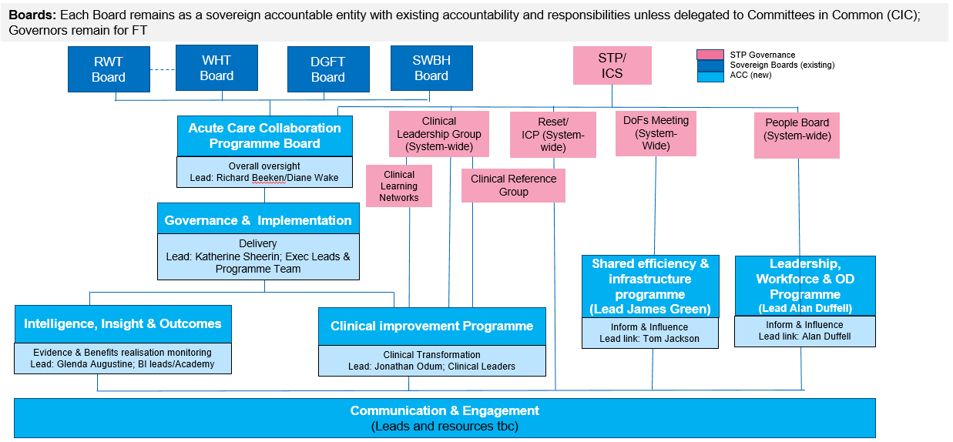Figure 8. Proposed Governance

The Programme Board membership is made up of a fair representation across all organisations and key executive functions to ensure that delivery is successful. Leads have been identified for each area of work, and a high level plan was reviewed at the first Programme Board held on 18th March 2021. Detailed plans will be developed with the identified leads for each element of the programme, once the Programme Board has agreed the outline plans.
Figure 7 shows a high level view of the scope and deliverables from each area. To ensure alignment and management of interdependencies across the system the governance we have been fully engaged in the review of STP/ICS governance and agree that both our shared efficiency and infrastructure, and workforce priorities will be overseen by existing system-wide groups (Directors of Finance, and People Board respectively) with a reporting line in from the lead Executive members of the Programme Board.
To maximise benefits it is important that membership of all groups has good multi-disciplinary representation and interdependencies across aligned STP programmes are managed – this will maximise the ambition, and opportunity for innovation through robust challenge and sharing of ideas.
There is an outline plan in place for clinical engagement, which will be further developed by a working group over quarter one of 2021, which will be supported by the work of the Intelligence, Insight and Outcomes programme. The chair of the STP/ICS Clinical Leadership Group has been identified as the lead for the Clinical Improvement Programme and will review the existing governance arrangements (shown in appendix 6) as the detailed planning progresses.

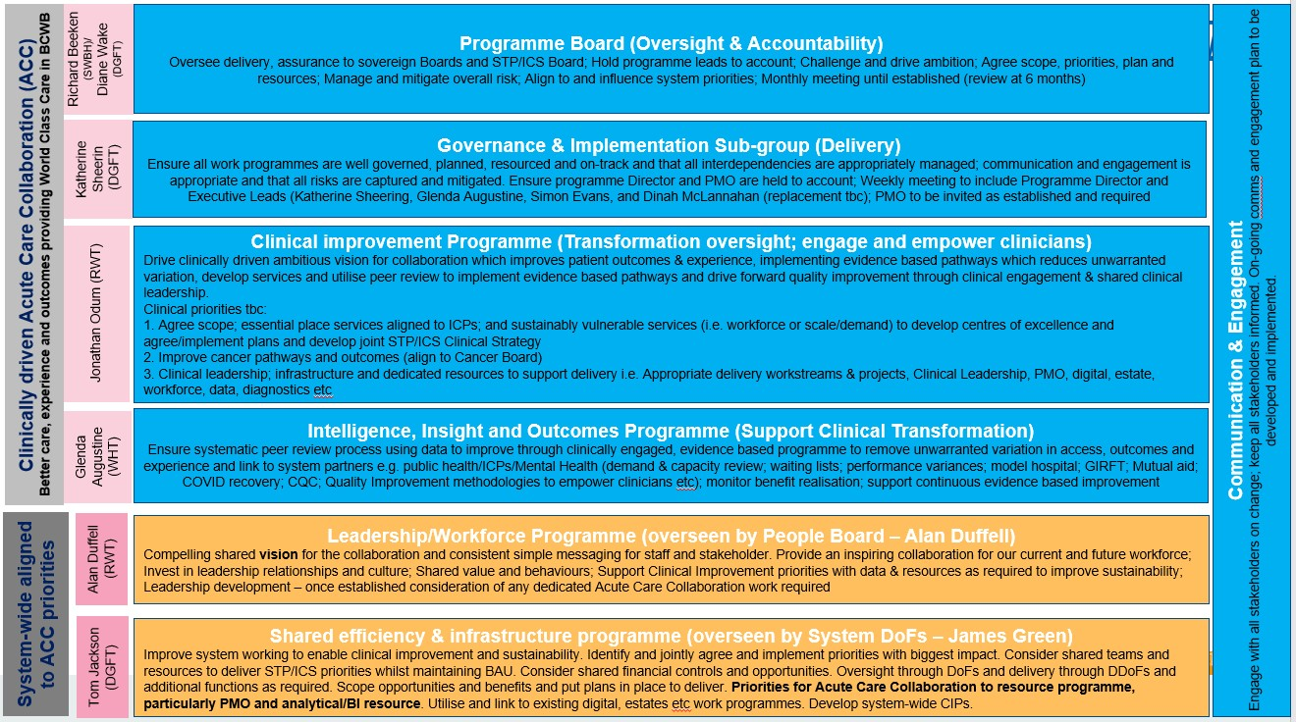

  - Programme Plan

We have made good progress in agreeing the key focus of our collaboration, however, the impact of COVID has restricted our ability to fully engage with clinicians to develop our detailed plans, and we believe this is crucial to delivering maximum long-term benefit. The first Programme Board received high level proposals for each priority area, and once agreed by Boards more detailed plans will be developed with the leads. Any agreements at the Programme Board will require approval at each sovereign Board.
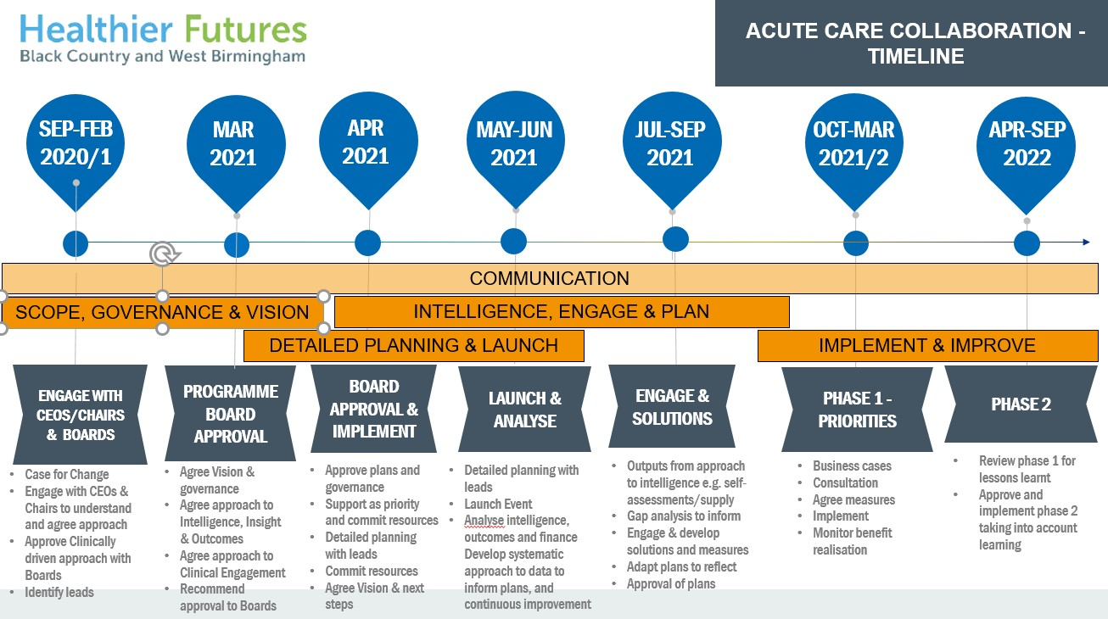An indicative timeline for the change, and preparatory planning and work to deliver it is shown below in figure 8, which can be further developed through the programme Board. An initial assessment of resources and risks has been made, which will require on-going review by the leads for each of the programme areas as more detailed plans are developed.

Figure 10. High level timeline

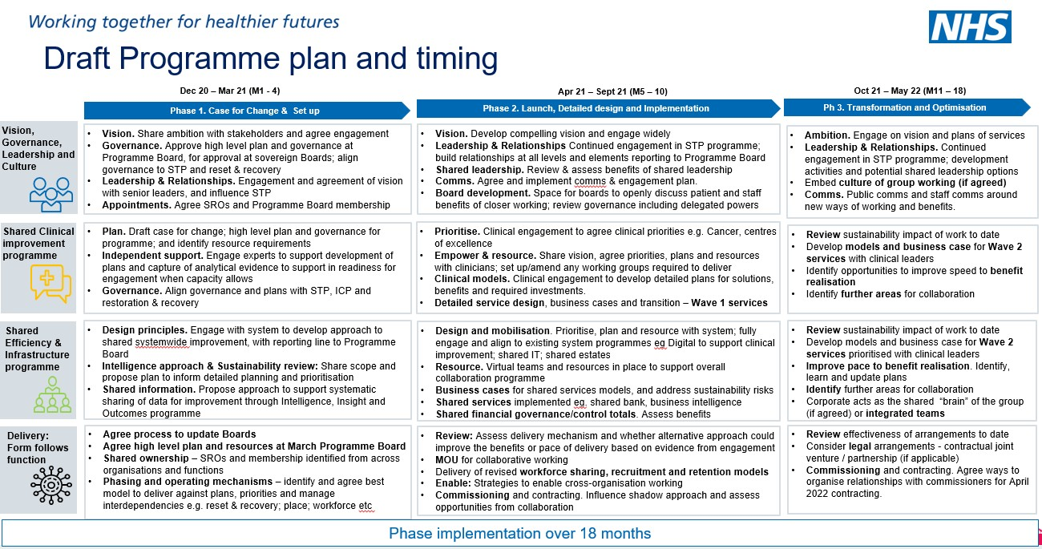

  - Programme resourcing

The BCWB STP has invested some initial resource to support the development of the case for change, and plan:
- Programme Director, who is working closely with the executive leads for each organisation to develop the plans, is contracted to the end of March 2021
- PA Resourcing provided a financial scoping of the “do nothing” and “do something” cases; and an assessment of delivery mechanisms such as group and alliance, which can be used as detailed plans are further developed
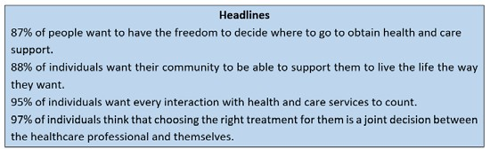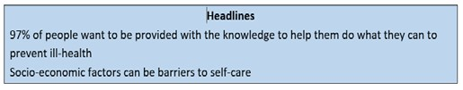An initial assessment of the resources required to support delivery from April 2021 was received at the March Programme Board for approval. This is an ambitious programme of work, and therefore the commitment from Trusts and support from the system will be crucial to ensure maximum benefits are deliverable. Whilst there are opportunities to reprioritise the work of existing staff to support the delivery, there is likely to be a requirement for additional resourcing in project management, business intelligence and engagement; in addition to a significant time commitment from senior leadership and clinicians from across each of the Trusts.

  - Communication & Engagement

Our communication and engagement will be aligned to the principles described in the STP Communication and engagement strategy. Whilst we have no current plans to change services, we do aim to have sustainable world class services which is likely to include transformation in the future. We are committed to ensuring that the work we do is informed by those using the services, those working within them, our partners and the populations we serve. Our plans will take into

account headlines which were captured as part of the development of the 2019 STP plan:

The expectation of our population, combined with the chance to reset and redefine our services following our COVID-19 response provides a great opportunity to use our scale and shared expertise to sustainably improve care. We want to be able to go back to our population and say we listened and this is what we have put in place.
Our engagement also had clear feedback from our staff:
“The results of the survey identified ‘increasing demand’ for NHS services as the biggest challenge facing the STP, closely followed by the ‘ageing population’, ‘more people with complex needs’ and ‘not enough resources’. When asked what the solutions to these issues might be, the three most popular responses were ‘sharing clinical expertise across organisations’, ‘more personalised care’ and ‘new types of workforce’.” Again, we need to demonstrate we have heard and are responding to the views of our staff in delivering effective acute care collaboration.

  - Culture

We will lead by example and ensure that our leadership behaviour mirror those in our agreed principles. This will engender a culture of trust so that our staff are openly able to share their thoughts on current services, and jointly develop plans for improvement.

Our key principles will be the driving force behind all of our communication and actions:
- Transparent and fair
- Collaborative and kind
- Driven by clinicians
- Evidence based
- Open and inclusive
- Respectful towards all of our leaders, including clinical leaders
We are mindful that there will be significant work to understand the sub-cultures, potential barriers to deliver and opportunities in developing this acute care collaborative, which will be critical to ensure that people support the direction of travel. There is a real opportunity to use this to define an inspirational vision for our staff, which builds a reputation for innovation, inclusion and action which retains our existing talented workforce, but also attracts new talent. This will be crucial following such a difficult period in responding to the many challenges they have endured responding to COVID.
By combining resources across the system there is an opportunity to develop an organisational development programme which is clear about our expectation of leadership, behaviours and team development to provide an enviable culture which improves productivity and quality and becomes the best place to work.

  - Risk Management

The initial draft risk register was shared at the March Programme Board, and has been shared with the identified risk owners for update prior to the April Programme Board. It will be regularly monitored by both the Programme Board and the programmes within the governance structure.

Black Country & West Birmingham Acute Care Collaboration Programme Board

Terms of Reference

Reference to “the Committee” shall mean the Black Country & West Birmingham Acute Care Collaboration – Programme Board.
.
Reference to “the Board(s)” shall mean each sovereign Board of Directors for the four Acute Trusts.

- Purpose

  - The Committee will:

    - Review, challenge and approve all elements of the acute care collaboration programme and associated benefits realisation;
    - Provide assurance on the delivery of the acute care collaboration to the sovereign Boards and the STP/ICS Board;
    - Agree the scope and priorities of the programme;
    - Agree and provide on-going review of the governance of the programme;
    - Agree and direct resources to support the delivery of the programme;
    - Identify, and ensure there are opportunities to identify, further transformation and benefits to ensure opportunities for creativity and innovation are maximised;
    - Manage and mitigate risks to the delivery of the programme and;
    - Ensure that plans are fully aligned to any other system priorities and plans

(Further detail is included within Section 7)

- Membership

  - Membership of the committee shall consist of one (1) non-executive director; the Chief Executive; and another two (2) nominated Executive Directors from each Trust which in total provide a representative mix across Medical, Nursing, Finance, Operations and HR.

  - Other stakeholders e.g. CCG / STP / NHSEI / MH etc will be considered and asked to attend bi-annually, or more frequently at the request of the Chair, where it improves the opportunity to deliver benefits.

  - Where a member is unable to attend they should nominate a Deputy who must have authority for decision making on behalf of the organisation, to avoid any delay in progress and pace.

  - To ensure independence the chair will rotate between the non-executive director members of the committee. In the absence of an appointed chair, another non-executive director shall be appointed by other members of the committee.

  - Other directors and senior managers may be requested to attend the meetings of the committee by the Chair.

- Quorum

  - The quorum necessary for the transaction of business shall be two members from each organisation, one of whom should be the CEO or NED. A duly convened meeting of the committee at which a quorum is present shall be competent to exercise all or any of the authorities, powers and discretions vested in or exercisable by the committee.

- Frequency of Meetings

  - The committee shall meet every month until the programme is fully established and assured that sub-groups are sufficiently planned, resourced and monitored. This will be reviewed at 6 months with an expectation to move to less frequent as agreed by the Committee.

- Notice of Meetings

  - Unless otherwise agreed by the chair of the committee, notice of each meeting, confirming the venue, time and date together with an agenda of items to be discussed, shall be forwarded to each member of the committee, any other person required to attend such meeting, and all other directors no later than five (5) working days before the meeting. Supporting papers shall be sent to committee members and attendees at the same time.

- Minutes of the Meetings

  - A secretary for the meeting needs to be nominated and agreed.

  - The secretary to the committee shall minute the proceedings and resolutions of each meeting of the committee, including the names of those present, those in attendance and those who tendered apologies.

  - The chair of the committee shall ascertain, and the secretary shall record, at the beginning of each meeting, the existence of any conflicts of interest and minute them accordingly.

  - Minutes of the committee meetings, shall with the agreement of the chair of the Committee, be circulated promptly to all members of the committee, and once approved, to all other board members with a monthly update on the status of the programme.

- Duties

  - Responsible for the full acute care collaboration programme and associated benefits realisation

  - Responsible for appropriate governance to provide assurance to Boards on the delivery of the programme and associated benefits
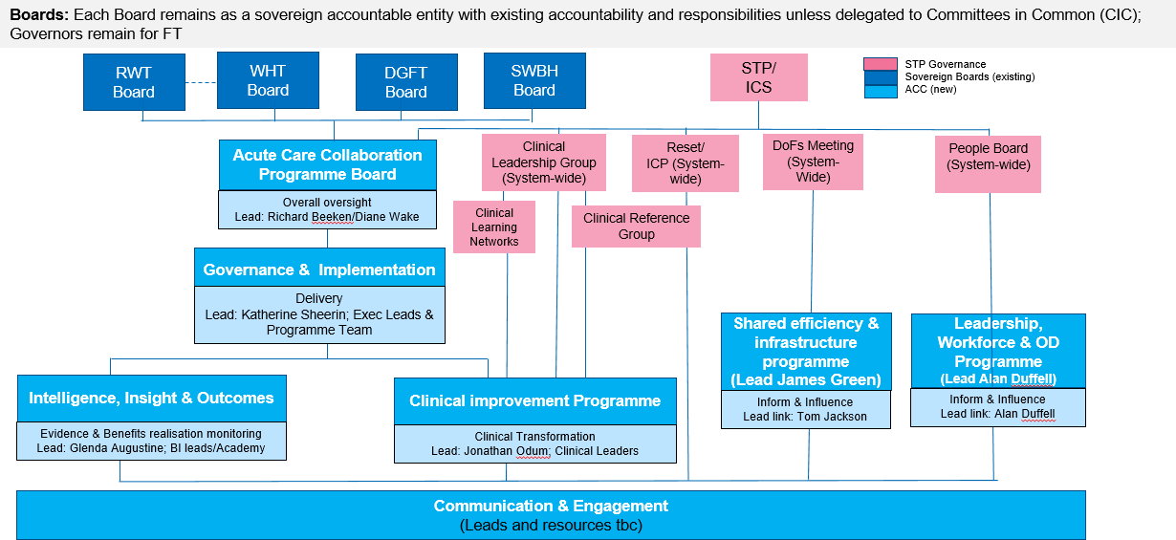

  - Ensure that there is a deliverable programme plan in place for the Clinical Improvement programme that maximises the opportunities at BCWB scale, aligned to place based plans and appropriately engages stakeholders throughout the programme

  - Ensure that there is a deliverable programme plan in place for the shared leadership, OD and workforce programme which builds a culture of improvement and works with the People Board and STP to make BCWB the employer of choice

  - Ensure that opportunities from shared efficiency and infrastructure are explored, planned, resourced and delivered

  - Responsible for communication and engagement with stakeholders throughout the programme

  - Responsible to ensure that plans align to other system priorities and plans, and interdependencies managed

  - Receive and consider reports from directors/managers concerning any exceptional issues affecting the implementation of the plans

  - Agree and propose to the Board for its approval any significant changes to the agreed plans or terms of reference

  - Consider the assessment of identified risks to achievement of the plans and review and assure the adequacy of associated mitigation plans.
  - Provide assurance to the Boards that the collaboration is effectively delivering on a successful approach to transformation and overseeing delivery of the major transformation programmes (internal and external).

- Reporting Responsibilities

  - The Committee chair shall report formally to the sovereign Boards on its proceedings after each meeting on all matters within its duties and responsibilities.

  - The Committee shall make whatever recommendations to the Boards it deems appropriate on any area within its remit where action or improvement is needed.

- Other

The Committee shall:

  - Have access to sufficient resources in order to carry out its duties.

  - Ensure that there is a nominated Executive lead from each organisation o work with the Programme Director, and oversee the work of the governance and implementation group.

  - Ensure that there is an Acute Trust SRO in place for each priority area of the programme i.e. Clinical Improvement; Leadership, workforce and OD; and Efficiency and Infrastructure who can report into the Programme Board accordingly, and where there is a link to the system governance a member of that group.

  - Hold the responsible leads and Programme Director to account on the delivery of the agreed programme and priorities.

- Authority

  - The Committee is authorised to seek any information it requires from any director or employee in order to perform its duties.

  - In connection with its duties to obtain any outside legal or other professional advice.

- Review

  - The Terms of Reference will be reviewed in September 2021, once the programme is fully established, and annually thereafter.

MEETING OF THE PUBLIC TRUST BOARD - 3rd June 2021
SO6 COVID-19 Board Assurance Framework Report |  |  | AGENDA ITEM: 9
Report Author and Job  Title: | Vicky Haddock -  Corporate Risk Manager | Responsible  Director: | Ned Hobbs - Chief  Operating Officer
Action Required | Approve ☒ Discuss ☒ Inform ☒ Assure ☒
Executive Summary | The Board Assurance Framework (BAF) provides a structure and process that enables a focus for the Board on the key risks which might compromise the achievement of the organisation’s Strategic Objectives. The BAF maps out the key controls which are in place to support delivery of those objectives and to mitigate risk and provide a framework of assurance which the Board can draw upon when considering the effectiveness of those controls. These controls and assurances have been set out in line with the ‘3 lines of defence’ model, aiding the identification of areas of weakness. The ‘Strategic Risk Heat Map’ is drawn from the content of the BAF and aims to illustrate at a high level the degree of risk exposure associated with the Strategic Objectives.  Each BAF risk has been reviewed and updated in month as part of the regular process through executive lead review, the Executive Risk Management Group and (where applicable) the lead Board sub-committee.  The updated May 2021 BAF risk for SO6 COVID-19 (at Appendix 1) has seen a decreased risk score from 12 (likelihood 3 x consequence 4) to 9 (likelihood 3 x consequence 3). The primary rationale for this reduction is highlighted as follows:  - The Trust has only 7 Covid positive in-patients within the hospital as of 26/05/21.  - During May 2021, the Trust’s Critical Care occupancy has been consistently within baseline funded capacity.  - The Trust has restored our 7th elective operating theatre taking us back to pre-Covid levels of elective operating theatre capacity since 04/05/21.  - The Trust has been successful in rolling out the Pfizer Vaccine to Patients, and staff across BCWB Health and Social Care organisations, with 89.25% of Trust high-risk staff having received their first vaccination, and 80.44% of  trust high risk staff having received their second vaccination


 | (as of 26/05/21).
Recommendation | The Board is asked to note the BAF risk and the relevant updates.
Does this report mitigate risk included in the BAF or Trust Risk  Registers? | Risk implications are outlined within the document.
Resource implications | There are no resource implications associated with this report.
Legal and Equality and Diversity implications | The BAF and indeed elements of the attached risks form part of our registration and licence requirements to both NHSi and CQC, which may result in regulatory or legal action under the Health and Social Care Act.  There is clear evidence1 of unequal and differential impact of COVID-19 on sections of our society including differential impact associated with levels of deprivation, occupations and ethnicity.  1. https://www.health.org.uk/sites/default/files/upload/publications/2020/Build-back-fairer-the-COVID-19-Marmot- review.pdf#:~:text=Building%20back%20fairer%20will%20require%20fundamental%20thinking%20about,must%20be%20dealt%20with%20at%20the%20same%2 0time
Strategic Objectives | Safe, high quality care ☒ | Care at home ☒
Strategic Objectives | Partners ☒ | Value colleagues ☒
Strategic Objectives | Resources ☒


Latest Board/Committee/Group - 17/05/2021 Version V1.02

Risk Summary
BAF Strategic  Objective Reference & Summary Tile: | BAF SO 06 - COVID; This risk has the potential to impact on all of the Trusts Strategic Objectives.
Risk Description: | The impact of Covid-19 and recovering from the initial wave of the pandemic on our clinical and managerial operations is such that it prevents the organisation from delivering its strategic objectives and annual priorities.
Lead Director: | Chief Operating Officer.
Lead Committee: | Trust Board
Links to Corporate Risk Register: | Title: |  |  |  |  |  |  | Current Risk Score Movement:
Links to Corporate Risk Register: | - 2051 - Inability to mitigate the impact of Covid-19, results in possible harm and poor patient experience to the people of Walsall.  - 2066 - There is a risk of lack of skilled registered nurses (RN's)/registered midwives (RM's) on a shift by shift basis affecting our ability to consistently maintain delivery of excellent standards of care.  - 2093 - Risk of staff contracting COVID-19 through the course of their duties in Walsall Healthcare NHS Trust.  - 2095 - Inability of the NHS supply chain to provide an adequate and on-going supply of PPE to meet the demand to ensure that Walsall Healthcare NHS staff are fully protected during the Covid-19 pandemic.  - 208 - Failure to achieve 4 hour wait as per National Performance Target of 95% resulting in patient safety, experience and performance risks (Risk score = 16).  - 2081 - Operational expenditure incurred during the current financial year exceeds income allocations, which results in the Trust being unable to deliver a break even financial plan (Risk Score = 16).  - 2082 - Failure to realise the benefits associated with the outcomes of the improvement programme work-streams, results in the Trust not delivering efficiencies required to attain agreed financial control targets, and deliver financial balance without  central support, which therefore impacts on the Trusts ability to deliver financial and clinical sustainability (Risk Score = 16). |  |  |  |  |  |  | Likelihood = 3  Consequence = 3  9  Moderate  ↓
Risk Scoring
Quarter: | Q1 2021/22 | Q2 | Q3 | Q4 2020/21 | Rational for Risk Level: | Target Risk Level (Risk Appetite): |  | Target Date:
Likelihood: |  |  |  | 3 | - Covid-19 is a novel virus and therefore there is only an emerging understanding of the disease, how it behaves and the likely trajectory of further resurgence in cases.  - The initial wave of Covid-19 had a profound impact on the services that the Trust provides, both in terms of urgent, emergency and critical care services to manage Covid-19 positive patients (in the hospital and the community), and in terms of the reduction in capacity of elective  care services. The initial wave had a particularly significant impact on care home residents within | Likelihood: | 2 | 30 June 2021 (at which point the Covid BAF risk would be recommended to be dissolved).
Consequence: |  |  |  | 5 |  | Consequence: | 4
Risk Level: |  |  |  | 15  High |  | Risk Level: | 8  Moderate

the Borough’s population.
- The initial wave of Covid-19 had a profound impact on the workforce of the Trust. By May 2020, almost 1 in 4 Trust staff that had undergone a Covid-19 Antibody test had been antibody positive that suggested a significant proportion of the workforce had experienced the disease themselves. Moreover, the challenges of managing the initial wave of the pandemic had a significant psychological impact on staff too.
- The Trust is operating in an uncertain financial planning environment resulting in additional challenges to restoring and recovering services impacted by the initial wave of Covid-19, and planning for the 2021/22 financial year.
- Covid-19 has exposed existing significant health inequalities in the population the Trust serves. Covid-19 has exacerbated some existing inequalities in colleague experience within the Trust.
- Nosocomial deaths reported in Learning from Nosocomial Covid deaths report received at QPES 27/08/20, with further analysis presented to QPES 28/01/21 confirming 21 probable or definite nosocomial deaths from Covid in Wave 1.
- Planning assumptions for a second wave of Covid-19 cases assumed a peak at half the level of the April peak. In November 2020 the Trust exceeded 80% of the April peak in terms of Covid-19 positive bed occupancy. In January 2021 the Trust had exceeded 140% of the April peak. As of 15th March the Trust’s Covid-19 positive inpatients have reduced to 26% of the April peak.
- The Trust has had the 7th highest proportion of its hospital beds occupied by Covid-19 positive patients in the country in early November 2020, and the second highest proportion of its hospital beds occupied by Covid-19 positive patients in the Midlands during January 2021. The situation improved over February and March and Ward 10, Ward 14 and the 6 extra capacity beds on Ward 4 are all now closed.
- The Trust has consistently had one of the highest Critical Care bed occupancy relative to baseline

commissioned capacity across the Midlands region during the second wave. In January 2021 Critical Care bed occupancy has exceeded 250% of baseline commissioned capacity, peaking at 306% of baseline commissioned capacity. During May 2021, the Trust’s Critical Care occupancy has been consistently within baseline funded capacity.
- As a result of reduced Critical Care occupancy, the Trust commenced its 8-week Elective Surgery restoration plan on 8th March 2021. The Trust has restored our 7th elective operating theatre taking us back to pre-Covid levels of elective operating theatre capacity (as of 04/05/21).
- The Trust has been successful in rolling out the Pfizer Vaccine to Patients, and staff across BCWB Health and Social Care organisations, with 89.25% of high-risk staff having received their first vaccination, and 80.44% of high risk staff having received their second vaccination (as of 26/05/21).
- The Trust has only 7 Covid positive in-patients within the hospital (as of 26/05/21).
Control & Assurance Framework - 3 Lines of Defence
 | 1st Line of Defence |  |  |  | 2nd Line of Defence | 3rd Line of Defence
Controls: | Governance:  - Incident Command structure in place incorporating Strategic Command, Hospital Tactical Command, Walsall Together Community Tactical Command and Corporate Tactical Command.  - Bespoke Incident Command structure in place for Covid-19 Vaccination programme.  - Governance continuity plan in place to ensure Board and the Committees continue to receive assurance.  - Specific Covid-19 related SOPs and guidelines.  - ITU Surge Plan in place.  - Covid Streaming processes in place.  - Enhanced Health and Safety/IPC Process in place in relation to Covid- |  |  |  | - Individual committees consider specific impact relevant to their portfolio, i.e. Financial matters and Restoration and Recovery of elective services under PFIC; Quality, Safety and Patient experience matters under QPES and Workforce matters including staff wellbeing under P&ODC.  - Board Development sessions (x2) on approach to Restoration and Recovery from Wave 1.  - UEC and Covid resilience Winter Plan approved by Trust Board October 2020.  - Covid-19 Deaths incorporated into SJR processes.  - Nosocomial Covid-19 Infections are subjected to RCA and reported to the Infection Control Committee. | - Regional and National Incident Control structure.

19, with particular focus on social distancing, patient/staff, screening, zoning of Ward/Department areas, visiting guidance and PPE Guidance.
- Daily risk assessment (RAG rating) of Community Locality teams to prioritise resource according to need.
- Division of Surgery 8-week elective Surgery restoration plan commenced
08/03/21.
Gaps in Controls: | - Walsall borough disproportionately hard hit in second wave again. 7th highest proportion of beds occupied by Covid positive patients in the country, in early November 2020. One of the highest Critical Care bed occupancy levels relative to baseline funded Critical capacity in the Midlands Critical Care Network throughout waves 2 in the Autumn of 2020 and 3 over the Winter of 2020. The Trust has had the second highest proportion of its hospital beds occupied by Covid-19 positive patients in the Midlands during January 2021.  - Resurgence of Covid-19 cases has coincided with Winter pressures resulting in severe pressures on the emergency care pathway, and stretching the RN, medical and WHP workforce significantly.  - Significantly increased Critical Care demand resulting in a dilution of ratios of specialist Critical Care Nurses to patients, partially mitigated through use of Category B and Category C registrants.  - Significant reduction in elective surgical operating theatre capacity due to requirement to support Critical Care staffing, resulting in prolonged waits for elective surgery.  - Reduction in some elective Community services - particularly MSK therapies and Phlebotomy, to redeploy resource into non-elective pathways.  - Considerably higher demand than anticipated on key Covid-19 Community pathways including Community Pulse Oximetry monitoring (Safe at Home pathway) and Long Covid pathways.  - Ability for neighbouring Trust’s to manage demand from patients conveyed by ambulance resulting in additional ambulance patients being conveyed to Walsall Manor through WMAS Intelligent Conveyancing protocol.  - National directives and mandates impact on the Trust’s ability to make local decisions.  - Ability of the Midlands Critical Care Network to successfully manage demand Critical Care demand across the region.  - Unable to progress all elements of the improvement programme owing to capacity of senior leaders.  - Comprehensive OD/Culture Improvement plan.
Assurance: | - IPC Board Assurance Framework. | - Nosocomial Covid-19 infection rate in line with peer-reviewed published evidence.  - Antibody positive staff rate in line with BCWB peers.  - Financial top up requests in line (or lower) as a proportion of turnover than BCWB peers.  - Faculty of Research and Clinical Education evaluation of response to first wave.  - 60-day readmission rate for Covid-19 patients in line with peer-reviewed published evidence. | - Elective waiting times 2nd best in the country for Diagnostics (DM01) and Top 50 nationally for routine elective treatment (18-week Referral to Treatment) and GP referred Cancer treatment commencing within 62- days (Feb 2021).  - Elective 52-week wait performance 3rd best in the Midlands (Feb 2021).  - 4hr EAS performance 14th best in the country, and 3rd best in the Midlands (March 2021).  - Ambulance handover times (<30mins) best in the West Midlands (March 2021).  - CQC Assurance of the IPC Board Assurance Framework.

 |  |  |  |  |  | - Productivity of Vaccination Programme compares favourably with other Acute Trusts.
Gaps in Assurance: |  | - Lack of assurance of communications within the organisation to ensure that staff feel well informed and engaged.  - Evidence of higher staff absence rates than BCWB peers during initial wave of Covid-19, absence rates consistent with peers in second/third wave.  - PODC still working to gain sufficient assurance on the vulnerable staff risk assessment process.
Future Opportunities
- With a more digital/virtual enabled organisation further opportunity to explore clinical application in improvement programme deliverables.
- Increased focus on Walsall Together and partnership working to support reduced reliance on hospital care, and to support reduced health inequalities in the borough.
- Covid-19 has necessitated closer collaboration with other Acute hospitals which can continue to be built upon.
- Increased profile and appreciation of the NHS within the general public could be harnessed to attract and retain staff.
- National planning guidance for Phase 3 (Recovery & Transformation) creates an expectation that services must not be reintroduced based on historical models.
- Identifying and adapting the workforce and professions to create a modern and adaptable workforce group.
Future Risks
- Potential for further resurgence in Covid-19 cases.
- Second wave of Covid-19 cases has coincided with Winter pressures including seasonal Influenza and norovirus, and delayed and advanced (in terms of disease progression) presentation of patients that have not accessed healthcare services in recent months.
- Ongoing pressure on community services associated with patients rehabilitating following Covid-19, including Long Covid patients.
- Delayed and/or prolonged impact of managing the initial wave, second wave and third wave of the pandemic on staff wellbeing and mental health.
- Potential workforce absence in the event of a second wave.
- Limited management and leadership capacity to address core objectives due to the significant demands of managing covid-19 pandemic, and the restoration and recovery of services affected by covid-19.
- More constrained financial operating environment.
- Logistical challenges of delivering the Covid-19 Vaccination.
Future Actions (to further reduce the Likelihood / Consequence of the risk in order to achieve the Target Risk Level in line with the Risk Appetite)
No. | Action Required: |  | Executive Lead: | Due Date: | Progress Report: |  | BRAG:
6. | Confirmation of 2021/22 Financial arrangements. |  | DoF | Feb 2021 | Delayed due to delayed national planning guidance. Q1  and Q2 Financial Plan present to PFIC 26/05/21, with Q3 and Q4 Financial Plan TBC.

MEETING OF THE PUBLIC TRUST BOARD – 3rd JUNE 2021
Improvement Programme Update Report - May 2021 |  |  | AGENDA ITEM: 10
Report Author and Job Title: | Glenda Augustine, Director of Planning and  Improvement | Responsible Director: |  | Glenda Augustine, Director of Planning  and Improvement
Action Required | Approve ☐ Discuss ☐ Inform ☒ Assure ☒
Executive Summary | The first year of the Improvement Programme has been significantly impacted by the global pandemic, with projects paused or partially continuing, and resource diverted to support the COVID-  19 response. However, the Improvement Programme has still delivered key projects and project components despite these challenging circumstances. Programme efficiencies are being validated and will be reported to the Performance, Finance and Investment Committee in June 2021. The programme re-phasing in February 2021 indicates that overall programme delivery is still on target to complete by March 2023. However, COVID-19 still remains an underlying risk to programme delivery.  A robust governance process is in place to ensure consistent reporting and escalation, with a benefits tracking process on target for completion in June 2021 to provide assurance on the achievement of non-financial benefits.  There is an on-going resource issue with the completion of the Governance and well Led Workstream documentation and internal, interim support has been mobilised to ensure completion by 30th June 2021.
Recommendation | Members of the Trust Board are asked to note:  - The Improvement Programme Workstream project delivery for 2020/21 and proposed delivery for 2021/22 and 2022/23  - The revised Improvement Programme reporting cycle and governance process for programme assurance  - The benefits tracking process that will be completed by the end of June 2021 to monitor project/programme achievement
Does this report mitigate risk included in  the BAF or Trust Risk | BAF 06: The impact of COVID-19 and recovering from the initial wave of the pandemic on our clinical and managerial operations is  such that it prevents the organisation form delivering its strategic

Registers? please outline | objectives and annual priorities.
Resource implications | There may be subsequent resource implications related to this paper as additional project specific support and service investment may be required to ensure there is sufficient capacity to deliver the  proposed improvements.
Legal and Equality and Diversity implications | Each workstream/project will complete the following assessments as required:  - Quality Impact Assessment  - Equality and Diversity Impact Assessment, and  - Information Governance/Data Protection Impact Assessment
Strategic Objectives | Safe, high quality care ☒ | Care at home ☒
Strategic Objectives | Partners ☒ | Value colleagues ☒
Strategic Objectives | Resources ☒

IMPROVEMENT PROGRAMME UPDATE REPORT – MAY 2021

- PURPOSE OF REPORT

The purpose of this paper is to provide an update on the Improvement Programme delivery for 2020/21, the financial impact of COVID-19 on the proposed efficiencies for 2021 and outline the planned programme delivery for 2021/22. The robust reporting and governance process will be briefly highlighted to provide assurance on project monitoring and delivery, with an example of the benefits tracking that is in development. It should be noted that programme efficiencies for 2021/22 were being refreshed as part of the reporting cycle, so this information was not available in time for this update.

- BACKGROUND

A critical review of the trust Improvement Programme was undertaken in January 2020 and the development phase was due to be completed by the end of March 2020. The aim was to create an overarching three year programme with clear priorities, structure, governance and resources aligned to the trust strategic objectives. In May 2020 the impact of COVID-19 on programme development and mobilisation was noted, with staff being focused to support operational activity reducing the available resource to support the programme. The need for additional resources was highlighted and a plan to address the capacity and capability gap was presented at the Improvement Programme Board in August 2020. The subsequent COVID-19 related pause of 19 of the 121 projects and the partial continuation of the remaining projects, between November 2020 and February 2021 has impacted on the planned delivery for 2020/21.

- WORKSTREAM DELIVERY
The Improvement Programme has delivered key achievements under challenging circumstances during 2020/21 and the re-phasing exercise undertaken in February has outlined the proposed Programme delivery for year 2 (2021/22) and year 3 (2022/23). A granular view of project delivery is being validated and the outcome of the projects completed and the associated benefits will be presented at the Performance Finance and Investment Committee (PFIC) in June 2021. It is currently anticipated that all projects will deliver as planned by March 2023 and the monthly project reviews will monitor any slippage in delivery and escalate accordingly. However, COVID-19 still remains an underlying risk to programme delivery.

- PROGRAMME GOVERNANCE

A robust programme governance process has been established, approved by the Improvement Programme Board in April 2021. The monthly highlight reports, programme summaries, exception reporting and escalation process will provide assurance of consistent reporting of programme progress and escalation of risk and issues as they arise. (See Appendix 1 - reporting and governance cycle; Appendix 2 - programme summary reports and Appendix 3 for exception report – workstream example).

The one issue to escalate to the Board for information is the lack pf progress in the completion of three of the five project initiation documentation (PID) for the
Governance and Well Led Workstream. This is due to lack of consistent project management resource which was diverted to support lateral flow testing and the vaccination programme. Whilst there has been a substantive appointment made, the post will not be filled until 1st August 2021. Internal resource has been mobilised to ensure PID completion by 30th June 2021 and to support monthly project reporting.

- BENEFITS TRACKING

The tracking of the non-financial project and workstream benefits is being configured and will be complete by 30th June 2021. An example of the information and reporting that will be available is presented in Appendix 4, which highlights the length of stay for inpatient elective admissions by Division, benchmarked against Model Hospital. Whilst the indicators used to monitor the non-financial benefits may be reported in other forums, benefit tracking in Verto provides an automated summary of the Improvement Programme projects contributing to delivery of the benefit. There is also the opportunity to identify and assess projects that are not yielding the anticipated benefits, to allow amendments that will improve project outcomes. The benefits report presented is a draft for illustration purposes, the finalised report will be developed to provide more refined graphs.
- PROGRAMME EFFICIENCIES 2020/21 and 2021/22

The COVID-19 pandemic impacted on the estimated Improvement Programme efficiencies that were outlined to PFIC in October 2020. The validated outcome for 2020/21 alongside the estimated opportunities for 2021/22, which are dependent on the financial environment for the second half of the financial year, will be presented at PFIC in June 2021. It should be noted that future reporting of Improvement Programme efficiency savings will be available each month via the Verto Programme Summary Report and individual project highlight reports, where efficiency opportunities

have been identified.

- RECOMMENDATIONS

Members of the Trust Board are asked to note:

  - The Improvement Programme Workstream project delivery for 2020/21 and proposed delivery for 2021/22 and 2022/23
  - The revised Improvement Programme reporting cycle and governance process for programme assurance
  - The benefits tracking process that will be completed by the end of June 2021 to monitor non-financial project/programme delivery

Public Trust Board – 3rd June 2021 Item 10, Appendix 1

Improvement Programme Workstream Reporting
March 2021

Improvement Programme Reporting

- Workstreams will be reporting project progress by exception from 1st April 2021 (that is – all projects that are rated amber or red)
- Project updates will be facilitated by the Workstream Leads and the Improvement Support Team (previously PMO)
- Automated reports will be generated in Verto on a monthly basis (see cycle on next slide)
- Licences are available for all Project Leads to have access to Verto
- Notifications will be set up in Verto and sent to named individuals within a project as a reminder that tasks, milestones and actions require updating. The Improvement Team and Workstream Leads will provide support as required.
- The aim is that by December 2021 all Project Leads will be updating their projects in Verto independently and discussing the changes with the Workstream Lead.

Working Day
Improvement Monthly
Reporting Cycle

6 - 14
Improvement Support Team meetings with Project Leads to update Milestones/Risk/Issues and Benefits in Verto
15
Improvement Support Team generate:
- Highlight reports for projects reporting red and amber
- Workstream Summary Report

15 - 20
Workstream summary report and highlight reports forwarded for preview by Core Team

1-5

Core Team Meeting discussion of Workstream progress with focus on amber and red projects and Workstream Summary Report

Project Summary Table
- The Workstream Summary Report will provide an overview of all projects in the Workstream (completed, on target, at risk and compromised)
- A Workstream Project Summary table (see below) will be provided to quantify project delivery and allow comparison of progress each month.

Workstream Project Status Summary: Date (reporting month)
Complete | On Target | At Risk | Compromised | Total
Number (%) | Number (%) | Number (%) | Number (%) | Number (%)
Previous month Project Status
Number (%) | Number (%) | Number (%) | Number (%) | Number (%)

Core Team Meeting Agenda
- Action log from previous meeting
- Review of Highlight Reports
- Review of Workstream Summary Report
- Identification of areas (risk, issues etc.) for escalation to Improvement Programme Board
- Opportunity for ‘deep dive’ or discussion on a specific project – current or future
- Celebrating success – promoting achievements to date

Improvement Programme Governance

Improvement Programme Workstreams:
Reporting by exception (red and amber projects) with review of
Workstream progress via Summary Report
Highlight risks and issues for escalation
Monthly
Reporting by exception (red and amber projects) with overview of Workstream Summary Report
Discussion of risks and issues escalated from Core team Highlight risks and issues for escalation
Monthly
Reporting by exception (red projects) with overview of Workstream
Summary Report
Discussion of escalated risks and issues
Monthly
Provide Safe , High Quality Care; Care at Home; Work Closely with Partners; Value Our Colleagues; Use Resources Well; Governance and Well-Led

Core Team Meetings

Improvement Programme Board

Board Committees: QPES, PFIC and PODC

Trust Board

Board Committee Reports

Quality, Patient Experience and Safety Committee
  - CQC Actions update
  - Provide safe high quality care Workstream performance and escalation

Performance, Finance and Investment Committee
  - Care at Home Workstream performance and escalation
  - Use Resources Well Workstream performance and escalation
  - Work Closely with Partners Workstream performance and escalation

People and Organisational Development Committee

    - Value Our Colleagues Workstream performance and escalation


 |  |  |  |  |  |  |  |  |  |  |  |  |  | Year to Date |  |  | In Month |  |  | Recurrent Full Year
Scheme Ref | Scheme / Project | Scheme / Project Description | Type | Project Manager | Executive Sponsor | Overall | Milestones | Benefits | Risks | Issues | Delivery RAG  Rating | Quality Risk Score | Total Plan  £ | £ YTD  Plan | £ YTD  Actual | £ Variance YTD | £ in month Plan | £ in month Actual | £ Variance in Month | Plan (£) | Forecast (£) | Variance (£) | Comments
Improvement Programme
Safe, High Quality Care
Care Excellence Priorities
Patient Experience & Involvement, Self-care Management and Volunteer Service
PR00039 0 | Care Excellence Priorities (Draft) | To have a rating of Outstanding as measured against the CQC inspection criteria, the Trust will deliver Care Excellence and make improvements in all areas identified below  Learning from Deaths Improved cancer pathways  Embed the principles of Continuous quality improvement  Best Practice Care – includ | Corporate and Admin |  |  |  |  |  |  |  |  | 9 | 59,988 | 4,999 |  | 4,999 | 4,999 |  | 4,999
CQC Action Plan
CQC Action Plan
PR00039 2 | CQC  (Draft) | In order to deliver the improvements required to address the CQC Mandatory actions and recommendations from the latest 2019 CQC inspection | Corporate and Admin |  | Anne-Marie Riley, Matthew Lewis |  |  |  |  |  |  | 9
Harm Free Care
Tissue Viability
PR00037 3 | Harm Free Care (Draft) | In order to achieve the Trust Vision of becoming a CQC Outstanding Rated organisation, the Trust must deliver Harm Free Care and therefore make improvements in all areas identified  within this project. | Corporate and Admin |  | Anne-Marie Riley, Matthew Lewis |  |  |  |  |  |  | 9
Pathway to Excellence
Perfect Ward
PR00039 1 | Pathway to Excellence (Draft) | In order to have a rating of Outstanding as measured against the CQC inspection criteria, the Trust will deliver Pathway to Excelllence and make improvements in all areas identified within this document. | Corporate and Admin |  |  |  |  |  |  |  |  | 9 | -70,320 | -5,860 |  | -5,860 | -5,860 |  | -5,860
Totals |  |  |  |  |  |  |  |  |  |  |  |  | -10,332 | -861 |  | -861 | -861 |  | -861

 |  |  |  |  |  |  |  |  |  |  |  |  |  | Year to Date |  |  | In Month |  |  | Recurrent Full Year
Scheme Ref | Scheme / Project | Scheme / Project Description | Type | Project Manager | Executive Sponsor | Overall | Milestones | Benefits | Risks | Issues | Delivery RAG  Rating | Quality Risk Score | Total Plan  £ | £ YTD  Plan | £ YTD  Actual | £ Variance YTD | £ in month Plan | £ in month Actual | £ Variance in Month | Plan (£) | Forecast (£) | Variance (£) | Comments
Improvement Programme
Care at Home
Outpatients
Modality Community service
PR000488 | Modality Cardiology Dignostics (Draft) | WHT will subcontract a set number of their routine cardiac physiology services to Modality and Modality will establish community-based cardiology clinics to provide initial consultation and follow ups outside of the Trust. This ensures that patients can be seen within a timely manner, closer to home | Outpatients | Alan Deacon | Daren Fradgley |  |  |  |  |  |  |  |  |  |  |  |  |  |  |  |  |  | Service is now in operation
Outpatient Phase 3
PR000409 | Care at Home (Draft) | With the inception of Walsall Together there has been a clear direction of travel to shift activity where safe and beneficial to do so, into a Community setting. We are working in partnership across Community services, and developing new models of care with proven providers to see and assess patient | Patient Pathway |  | Daren Fradgley |  |  |  |  |  |  | 9 | 3,284,818 | 271,415 |  | 271,415 | 271,415 |  | 271,415 |  |  |  | heart failure pathways has been able to address service pressures internally using case manager, improved access to diagnostics and MDT support from Cardiologists  Service review within therapies has commenced
Walsall Together
Integrated Assessment Hub
PR000446 | Integrated assessment hub  (Draft) | Establish an integrated front door service at the Manor Hospital to avoid admssions | Patient Pathway | Sandie Lal | Daren Fradgley |  |  |  |  |  |  |  |  |  |  |  |  |  |  |  |  |  | - Draft SOP awaiting finalisation pending agreement with MLTC  - Request for documentation and workflow build in Total Mobile approved  - Ongoing discussions continue with MLTC regarding medical cover / patient deterioration on the unit  - 2nd Nurse appointed due to commence in post on 29 March  - Service will move to 7 days a week, 08:00 – 18:00 hrs, from 1 May 2021  - Daily inreach to emergency areas continues, along with supported discharge activity at ward level  - Interim figures as at 24 March are as follows: IAH Activity Jan Feb Mar  Hospital Avoidance 29 29 30  Early Supported Discharge 73 82 63  Potential Assisted Discharge 39 52 43
ReSPECT
PR000453 | ReSPECT  (Draft) | Implementation of ReSPECT documentation to replace existing DNAR forms. Form states prefered care at end of life which needs to be checked rather  than assumed. | Patient Pathway | Simon Cooper | Daren Fradgley |  |  |  |  |  |  |  |  |  |  |  |  |  |  |  |  |  | Still awaiting final authorisation on new MCA form. Once signed off, re ordering process can be finalised and project will be handed back as BAU.
Maternity CoC
PR000454 | Continuity of Carer - Maternity (Draft) | To provide consistency in the midwife or clinical team that provides care for a woman and her baby throughout the three phases of her maternity journey: pregnancy, labour and postnatal period. | Patient Pathway | Sandie Lal |  |  |  |  |  |  |  |  |  |  |  |  |  |  |  |  |  |  | 2nd locality hub identified in WS1/WS2 South district (room in Antenatal Clinic and local SureStart Centre). Expected to go live in Q2 upon recruitment of team. Pelsall Village Centre (Hub 1/East) has recruited a 6th Midwife, enabling the team to increase capacity from 154 to 175 caseloads from April.  Since going live on 25/01/21, 16% of booked women are on the CoC pathway.  A further 7 additional Midwives have successfully been recruited and should commence in post from May 2021. Once trained, they will form the 2nd CoC locality hub team covering the Antenatal clinic / SureStart room facility (Hub 2/South).  ·Since going live on 25/01/21, 16% of booked women are on the CoC pathway. Whilst the national target has been set at 35% by 31/03/21, the project has faced unprecedented delays due to the impact of the Covid-19 pandemic. To reach 16% within 8 weeks has been a remarkable achievement.
Totals |  |  |  |  |  |  |  |  |  |  |  |  | 3,284,818 | 271,415 |  | 271,415 | 271,415 |  | 271,415

 |  |  |  |  |  |  |  |  |  |  |  |  |  |  | Year to Date |  |  | In Month |  |  | Recurrent Full Year
Scheme Ref | Scheme / Project | Scheme / Project Description | Type | Care Group | Project Manager | Executive Sponsor | Overall | Milestones | Benefits | Risks | Issues | Delivery RAG  Rating | Quality Risk Score | Total Plan  £ | £ YTD  Plan | £ YTD  Actual | £ Variance YTD | £ in month Plan | £ in month Actual | £ Variance in Month | Plan (£) | Forecast (£) | Variance (£) | Comments
Programme |  |  |  | Overall Target
PR000213 | ENT On Call |  | Workforce (Medical) | Work Closeley with Partners |  |  |  |  |  |  |  |  |  |  |  |  |  |  |  |  |  |  |  | Financial savings on target - require tracking via Verto
PR000213 |  | ENT have recruited a 5th consultant, so based on number of consultants on rota, the on call rota will be 1 in 5, which attracts a 55 supplement, frequency has gone up from 1:4 to 1:5, the % for other consultants on the rota will need to be reduced from 8% to 5%
PR000394 | Dermatology Partnership (Draft) | To consolidate the two dermatology departments across Royal Wolverhampton Trust (RWT) and Walsall Healthcare Trust for the short term with a view to expanding to an STP  / Regional model in the longer term | New Care Models (NCM) | Work Closely with Partners | Sarah Haywood |  |  |  |  |  |  |  |  |  |  |  |  |  |  |  |  |  |  | Discussions with RWT re structure.  Initial proposal for consideration is that WHT becomes the provider and that staff would TUPE to the trust.
PR000459 | Imaging Network | Based on NHSLTP and Sir Mike Richards' Report relating to Imaging Networks across the country. | New Care Models (NCM) | Work Closely with Partners | Alan Deacon |  |  |  |  |  |  |  |  | 300,000 |  |  |  |  |  |  |  |  |  | Second workshop held. Draft model of imaging network reviewed and discussions on staffing. Proposal that Black Country will be part of North Midlands Network: including Staffordshire, Shropshire and Telford and Wrekin. A further meeting is being held with CEOs  - no response received re  system response to initial workshop.
PR000460 | Haematology Collaboration | Exploration of opportunities to collaborate on the delivery of Haematology services between WHT and RWT to ensure sustainability, and to provide safe, high quality care. | Workforce (Medical) | Work Closely with Partners |  |  |  |  |  |  |  |  |  |  |  |  |  |  |  |  |  |  |  | SLA to be finalised and signed off.
PR000486 | Urology Collaboration with RWT | RWT and WHT are discussing collaborations in Urology services. In two phases:- 1) the transfer of all emergency cases from WHT to RWT.  2) Then the transfer of elective patients from WHT to RWT and the transfer of day case patients from RWT to WHT, with joint on call rota and x-site working. | Patient Pathway | Work Closely with Partners | Julie Earl |  |  |  |  |  |  |  |  |  |  |  |  |  |  |  |  |  |  | The team is still in the process of carrying out an analysis to inform modelling. The business case requires finalisation.
Totals |  |  |  |  |  |  |  |  |  |  |  |  |  | 300,000

 |  |  |  |  |  |  |  |  |  |  |  |  |  | Year to Date |  |  | In Month |  |  | Recurrent Full Year
Scheme Ref | Scheme / Project | Scheme / Project Description | Type | Project Manager | Executive Sponsor | Overall | Milestones | Benefits | Risks | Issues | Delivery RAG  Rating | Quality Risk Score | Total Plan  £ | £ YTD  Plan | £ YTD  Actual | £ Variance YTD | £ in month Plan | £ in month Actual | £ Variance in Month | Plan (£) | Forecast (£) | Variance (£) | Comments
Improvement Programme
Valuing Colleagues
Leadership & Culture & OD
EDI
PR000374 | Equality Diversity inclusion Workstream (EDI)  (Draft) | Leadership, Culture & OD - To design and implement an organisational development approach to support an inclusive and just cultures  To co-design EDI strategy with staff, patient, community/voluntary groups Organisational Effectiveness - To extend the equality, diversity, inclusion approach within t | Workforce (Other) | Sabrina Richards | Catherine Grififths |  |  |  |  |  |  |  |  |  |  |  |  |  |  |  |  |  | Rainbow Badge initiative launched in February in conjunction with LGBT History Month- over 100 rainbow badges distributed to various teams and individuals across the organisation  Coordinated and hosted targeted briefings in partnership with the BAME Shared decision making
Employee Voice and Recognition
PR000371 | Employee Voice/Engagement (part of Leadership Culture & OD) (Draft) | - To deliver against the Valuing Colleagues Programme of work which cuts across the following domains.  - To design and implement an organisational development approach to support an inclusive and just cultures  - To create and embed an environment where staff voice is the norm and not an initiat | Workforce (Other) | Jayne Ilic | Catherine Grififths |  |  |  |  |  |  | 9 |  |  |  |  |  |  |  |  |  |  | Whilst it has been acknowledged that this workstream needs to be reinvigorated, there has been no opportunity to do so since the last core team meeting.
FTSU
PR000463 | Freedom to Speak up (Draft) | Effective speaking up arrangements help to protect patients and improve the experience of workers. We know that the main reasons workers do not speak up are because they fear they might be victimised or because they do not believe that anything will change. This project aims to create an environme | Workforce (Other) | Kim Sterling / Val Ferguson | Catherine Grififths |  |  |  |  |  |  |  |  |  |  |  |  |  |  |  |  |  | Strategy agreed. Project re- phased and PID updated
Talent Management
PR000379 | Talent Management (Draft) | To deliver the aims and objectives outlined in the Valuing Colleagues Programme of Work: Leadership Culture & OD  Develop a systematic approach to managing talent and succession  planning | Workforce (Other) | Sabrina Richards | Catherine Grififths |  |  |  |  |  |  | 25 |  |  |  |  |  |  |  |  |  |  | Planning re-initiated for PDR training package and PDR process  Re-phasing of plan has been agreed with VC Core Team members  Restart of project to commence in
Values & Behaviours
PR000376 | Just Learning Culture (Value & Behaviours) (Draft) | - In order to deliver against key objective in the Valuing Colleagues Programme of Work: Leadership, Culture & OD  - To design and implement an organisational development approach to support an inclusive and just culture. Organisational Effectiveness  - To design a framewok to introduce Divisional | Workforce (Other) | Clair Bond | Catherine Grififths |  |  |  |  |  |  | 9 |  |  |  |  |  |  |  |  |  |  | Projects have been rephased and none are currently due, however no updates have been received this month. PID requires review and refresh
Making Walsall the Best Place to Work
SEQOHS
PR000378 | SEQOHS (Health & Wellbeing)  (Draft) | To deliver against the Valuing Colleagues Programme of work which cuts across the following domains:- Making Walsall the best Place to Work primary focus  Organisational Effectiveness Leadership, Culture & OD | Workforce (Other) | Tamsin Radford | Catherine Grififths |  |  |  |  |  |  | 4 |  |  |  |  |  |  |  |  |  |  | This project is currently paused due to Covid
H&WB
PR000375 | Health and Wellbeing (Draft) | Making Walsall the best place to work To provide a structured and holistic approach to workplace health and wellbeing in collaboration with STP partners | Workforce (Other) | Michala Dytor | Catherine Grififths |  |  |  |  |  |  | 25 | 107,568 | 8,964 |  | 8,964 | 8,964 |  | 8,964 |  |  |  | Whilst projects are paused, many H&WB activities were actioned and accelerated in response to COVID and support for colleagues
Organisational Effectiveness
Attraction & Recruitment
PR000372 | Attraction and Recruitment (Draft) | The purpose of this project is deliver against Key aims and objective agreed in the Valuing Colleagues Programme of work  To identify and design new roles and career pathways to shape the future workforce for Walsall and across the Black Country STP.  To develop a sustainable operational workforce pla | Workforce (Other) | Reece Hodgen | Catherine Grififths |  |  |  |  |  |  | 4 | 89,940 | 7,495 |  | 7,495 | 7,495 |  | 7,495 |  |  |  | Business as usual is continuing. There has not been a review of the PID or an update this month
OD Training & Development
PR000377 | OD Training and Development (Draft) | We need to develop a Managers Programme/ Management competency Framework (WP1) this will ensure that new managers and existing managers are given the fundamental skills to manage teams to perform effectively. | Workforce (Other) | Marsha Belle | Catherine Grififths |  |  |  |  |  |  | 9 |  |  |  |  |  |  |  |  |  |  | PID has been reviewed and updated  Acheived over 90% compliance for mandatory
Temporary Staffing

PR000380 | Temporary Staffing (Draft) |  | Workforce (Other) | Clair Bond | Catherine Grififths |  |  |  |  |  |  | 25 |  |  |  |  |  |  |  |  |  |  | PID requires review and update. No updates have been received  this month
Workforce Planning
PR000382 | Workforce Planning (Draft) | To deliver against key objectives set out in the Valuing Collegues Programme of work under the domain of Organisational Effectiveness:-  To identify and design new roles and career pathways to shape the future workforce for Walsall and across the Black Country STP.  To develop a sustainable operationa | Workforce (Other) | Marsha Belle | Catherine Grififths |  |  |  |  |  |  | 1 |  |  |  |  |  |  |  |  |  |  | PID requires review and update. No updates have been received this month
Totals |  |  |  |  |  |  |  |  |  |  |  |  | 197,508 | 16,459 |  | 16,459 | 16,459 |  | 16,459

Use of Resources Improvement Report as of April 2021

 |  |  |  |  |  |  |  |  |  |  |  |  |  | Year to Date |  |  | In Month |  |  | Recurrent Full Year
Scheme Ref | Scheme / Project | Scheme / Project Description | Type | Project Manager | Executive Sponsor | Overall | Milestones | Benefits | Risks | Issues | Delivery RAG  Rating | Quality Risk Score | Total Plan  £ | £ YTD  Plan | £ YTD  Actual | £ Variance YTD | £ in month Plan | £ in month Actual | £ Variance in Month | Plan (£) | Forecast (£) | Variance (£) | Comments
Division of Estates
Effective use of Resources
Estates & Facilities
Estates and Facilities Strategy Development
PR000423 | Estates Strategy Development (Draft) | Develop Estates and Facilities Strategy to incorporate the Trust Objectives.  Ensure that there all Divisions have input into the Strategy. | Estates and Facilities |  |  |  |  |  |  |  |  |  |  |  |  |  |  |  |  |  |  |  | Estates Manager has been backfilled however will need to go out to advert for an estates manager.
Estates Productivity
PR000344 | EUoR (Services) My Porter (Draft) | Improvements to portering services are required, to ensure that it is contributing to the delivery of a better patient experience. Move to My porter software (away from existing Teletracking software) will allow for allocating, tracking and reporting portering tasks. This will also includes making i | Pay - WTE  Reduction - Recurrent | Andrew Hall |  |  |  |  |  |  |  |  | 150,000 | 12,500 |  | 12,500 | 12,500 |  | 12,500
PR000353 | EUoR (Services): Improvements to the On-Site Patient Catering Services including Meal Orders & Menu Choice  (Draft) | Improving the on-site catering services to ensure that it is contributing to the delivery of a better patient experience, reduces food waste and is more cost effective to the Trust. We will achieve this by looking at new systems available  e.g. Menumark  The Meal Orders & Menu Choice element will redu | Non Pay - Recurrent | Andrew Hall |  |  |  |  |  |  |  |  |  |  |  |  |  |  |  |  |  |  | We have reviewed 3 catering software's from  Meumark, Saffron and Athena Current and Future State process map process map of the catering service has been carried out  1 months waste data for Feb 21 data is currently being analysed to determine number of meals sent out and meals wasted
PR000355 | EUoR (Services) Housekeeping Service - introducing a Digital Work Scheduling systems (Draft) | Improvements to housekeeping facilities service is required and this will be achieved by investing in a digital work scheduling system to allow us to manage rotas, absences and productivity more effectively. Currently we use a paper system which is not efficient and can lead to a number of staff bei | Non Pay - Recurrent | Andrew Hall |  |  |  |  |  |  |  | 9 |  |  |  |  |  |  |  |  |  |  | We have viewed a DEMO by Flexikeep which is a company that specialises in hospitaltiy housekeeping software. The company has a whole module around housekeeping and which can be adapted to meet NHS and our hospital specific requirements. We have secured a trial period with flexikeep so that
PR000363 | EUoR (Services): Stock Control, FoodBuy & Reduction of Food Waste  (Draft) | Procuring and introducing a stock control system will deliver financial savings and a reduction in food waste, the system will be a LIVE system so that we will have this information at the click of a button.  A move to using Bidfood to source and deliver all of our food will result in a more strea | Non Pay - Recurrent | Andrew Hall |  |  |  |  |  |  |  |  |  |  |  |  |  |  |  |  |  |  | We have reviewd 3 catering software: menumark, athena and saffron as part of the on-site meals scheme. All 3 software packages have a stock control module.  An options appraisal paper is currently being written for presenting at the May Improvment Board.
PR000481 | Facilities Strategy Development (Draft) | Develop Facilities Strategy to support Housekeeping, Catering & Portering  Service | Estates and Facilities | Andrew Hall
Estates Service (energy)
PR000356 | EUoR (Energy) Lighting Improvements across Estates On Site  (Draft) | Implementation of lighting improvements across estates, in conjunction with a campaign to encourage staff to switch off lights when not in use.  Improvement to patient/staff experience, reducing errors and reducing energy and carbon. | Non Pay - Recurrent |  |  |  |  |  |  |  |  |  | 68,232 | 5,686 |  | 5,686 | 5,686 |  | 5,686 |  |  |  | Campaign to encourage staff to switch off lights when not in use is on-going.  Light Sensors are in some areas of the new build
PR000357 | EUoR (Energy) Setback on Theatre Air Handling Units (AHU) (Draft) | Use set-back on theatre AHUs | Non Pay - Recurrent |  |  |  |  |  |  |  |  |  | 15,264 | 1,272 |  | 1,272 | 1,272 |  | 1,272 |  |  |  | Design document produced, initial meetings are being booked to discuss technical and  specification AHU design.
PR000358 | EUoR (Energy) Drop Down the Maximum Authorised Supply Capacity (ASC)  (Draft) | Drop down the maximum authorised supply capacity (ASC). | Non Pay - Recurrent |  |  |  |  |  |  |  |  |  |  |  |  |  |  |  |  |  |  |  | Trident Utility (broker) who deals with our energy usage on gas and electricity are looking at KVA  (maximum capacity energy) . A
PR000359 | EUoR (Energy) Meter Installation and Automatic Monitoring and Target  (Draft) | Meter installation and automatic monitoring and targetting.  Carbon Trust field studies demonstrate average savings of 5% utility cost.  Installation of meters in high-priority areas, allowing energy consumption to be measured. | Non Pay - Recurrent |  |  |  |  |  |  |  |  |  |  |  |  |  |  |  |  |  |  |  | Note: STP Green Plan will be presented to the execs and  will supersede the Skanska 2017 report
PR000360 | EUoR (Energy) Oxygen Trim  Control for Steam Boilers (Draft) | Requires capital or bid money to fund which we do not have currently. | Non Pay - Recurrent | Paul Richardson |  |  |  |  |  |  |  |  | -35,556 | -2,963 |  | -2,963 | -2,963 |  | -2,963 |  |  |  | Note: STP Green Plan will be presented to the execs and  will supersede the Skanska 2017
PR000361 | EUoR ( Energy) Implementation of a Combined Heat and Power scheme (CHP)  (Draft) | Plan for CHP scheme developed and Salix funding applied for. | Non Pay - Recurrent | Paul Richardson |  |  |  |  |  |  |  |  | -1,205,004 |  |  |  |  |  |  |  |  |  | Note: STP Green Plan will be presented to the execs and  will supersede the Skanska 2017 report
PR000362 | EUoR(Energy) Reduced Water Costs though AQUA Fund (Draft) | Plan for Aquafund proposal and national grant funding applied for. This again requires capital or bid money to fund which we do not have currently. | Non Pay - Recurrent | Paul Richardson |  |  |  |  |  |  |  |  | 30,000 |  |  |  |  |  |  |  |  |  | Note: STP Green Plan will be presented to the execs and  will supersede the Skanska 2017 report
Totals |  |  |  |  |  |  |  |  |  |  |  |  | -285,588 | 26,495 |  | 26,495 | 26,495 |  | 26,495

 |  |  |  |  |  |  |  |  |  |  |  |  |  | Year to Date |  |  | In Month |  |  | Recurrent Full Year
Scheme Ref | Scheme / Project | Scheme / Project Description | Type | Project Manager | Executive Sponsor | Overall | Milestones | Benefits | Risks | Issues | Delivery RAG  Rating | Quality Risk Score | Total Plan  £ | £ YTD  Plan | £ YTD  Actual | £ Variance YTD | £ in month Plan | £ in month Actual | £ Variance in Month | Plan (£) | Forecast (£) | Variance (£) | Comments
Division of WCCSS
Effective use of Resources
Operational Productivity - Clinical
WCCSS Phase 3 Recovery & Transformation
PR000145 | Paediatric CAMHS Tariff (Draft) | This scheme is rolled over from 19/20, pending agreement from the CCG on a local tariff for specialist care 1:1 for high risk paediatric mental health patients.  Whilst discussions have continued throughout 19/20, the Care Group awaits a decision from the contract setting rounds for 20/21 (expected M | Income - Patient Related Recurrent | Sandie Lal, Becky Hill |  |  |  |  |  |  |  |  | 150,000 |  |  |  |  |  |  |  |  |  | It has been agreed that this scheme will be managed separately from the rest of the transactional schemes for WCCSS

PR000146 | HIV Pharmacy Homecare (Draft) | To use the Homecare delivery service for HIV drugs, enabling the safe dispensing and delivery of prescription  items to HIV patients. | Non Pay Savings | Becky Hill |  |  |  |  |  |  |  |  | 100,000 |  |  |  |  |  |  |  |  |  | Recruitment has taken place for forumlary and high cost drugs pharmacist
PR000147 | Pharmacy – New Biosimilars Medicines  (Draft) | New Biosmilars Medicines - Inflectra switch to Stelara (previously Zesley). Biosimilars are thoroughly tested in clinical trials to show they work just as well and are just as safe as the original biological medicine. To be used in the UK, biosimilars must be approved and licensed in the same w | Non Pay - Recurrent | Sandie Lal, Becky Hill |  |  |  |  |  |  |  |  | 16,746 |  |  |  |  |  |  |  |  |  | Project is in benefits monitoring phase
PR000161 | Maternity – CNST Discount (Draft) | To receive a discount on CNST medical insurance. A saving of £300k is expected from December 2020 | Non Pay - Non Recurrent | Sandie Lal, Becky Hill |  |  |  |  |  |  |  |  | 300,000 |  |  |  |  |  |  |  |  |  | - On target for Continuity of Carer.  - Assurance around the Safety Champion work is on
PR000166 | Maternity – Pertussis vaccines and Flu injections for pregnant women  (Draft) | Continuation of the Pertussis and Flu vaccinations for pregnant women which commenced in August 2019. | Income - Patient Related Recurrent | Sandie Lal, Becky Hill |  |  |  |  |  |  |  |  | 22,140 |  |  |  |  |  |  |  |  |  | Review of 12 months worth of data:  Flu
PR000328 | Gynae Community Activity - Health Harmonie Partnership (Draft) | The Trust will subcontract low-risk routine gynaecology services to Health Harmonie to establish community-based gynaecology clinics providing initial consultation and follow-ups outside of the Trust. Initially, 2 clinics per week will be set up in 2 sites to see 10 patients each (20 pts per week), | Run Rate | Emily Bissell, Becky Hill |  |  |  |  |  |  |  |  | 4,200 | 1,400 |  | 1,400 | 1,400 |  | 1,400 |  |  |  | Criteria for referrals has changed therefore we have been able to increase our numbers back up to the original agreement of 20 ladies per week and we foresee this increasing as our demand for gynae services is increasing.
PR000347 | Pharmacy - Removal of FP10 Prescriptions  (Draft) | The use of FP10 prescriptions is more costly than either referring patients to the GP or supplying via a Trust yellow Outpatient prescription. FP10s are not subject to formulary control or challenge by pharmacy. It is possible to remove FP10 access and switch all prescribing to yellow Outpatient pr | Run Rate | Gary Fletcher, Becky Hill |  |  |  |  |  |  |  |  | 300,000 | 25,000 |  | 25,000 | 25,000 |  | 25,000 |  |  |  | Project paused - dependant on funding for DTC pharmacy BC
PR000348 | Pharmacy - Electronic Prescribing & Medicines Administration (EPMA)  (Draft) | All prescribing and drug administration will be managed on an electronic system. This will remove all paper based systems and will remove transcription errors, provide a decision support tool, force formulary compliance, and control drug prescribing errors | No Financial Details | Gary Fletcher, Becky Hill |  |  |  |  |  |  |  |  |  |  |  |  |  |  |  |  |  |  | Project paused due to NHSE funding application being rejected
PR000349 | Pharmacy - Managed Information Service (MIS)  (Draft) | This service will provide clinicians with a formal resource tool to support in the prescribing of medicines which is supported by Regional and National MI  Service | No Financial Details | Gary Fletcher, Becky Hill |  |  |  |  |  |  |  |  |  |  |  |  |  |  |  |  |  |  | High cost drug and formulary pharmacist vacancy appointed to. Principal MSO is currently supporting the formulary and high  cost drug processes due to this
PR000351 | PAU - Improving Same Day Emergency Care (SDEC) (Draft) | Improve SDEC with the new ED/PAU dedicated facility, reducing the patient's pathway. The new PAU will provide the facilities needed to increase SDEC via different clinical pathways and will see increased throughput as detailed in the ED Business case | Income - Patient Related Recurrent | Becky Hill |  |  |  |  |  |  |  |  |  |  |  |  |  |  |  |  |  |  | SDEC rates for Paediatrics remains stable
PR000352 | Paediatrics - Maximising Day Case Elective Surgery (Draft) | Provide an opportunity to increase our elective surgery capacity with a dedicated children's Day Case facility | Income - Patient Related Recurrent | Becky Hill |  |  |  |  |  |  |  |  |  |  |  |  |  |  |  |  |  |  | Restarted paediatric elective surgery on 15th April - 2 days per week (6 per day = 12 per week)  for April and May with a view to
PR000364 | Maternity - Induction of Labour (using Dilapan in OPD)  (Draft) | Induction of labour in low risk pregnancies by using an alternative method of treatment (Dilapan) in an outpatient setting. This will consequently reduce the need for a hospital admission, thereby reducing LOS by 1 day per case. We would expect to see approx 16 patients per month for this inductio | Run Rate | Becky Hill |  |  |  |  |  |  |  |  |  |  |  |  |  |  |  |  |  |  | Increase in women accessing the service
PR000365 | Maternity - Actim Prom for patients with SROM (Draft) | Actim Prom will be used to detect premature rupture of fetal membranes, a common cause of pre-term births, allowing for early diagnosis and treatment to minimise complications. The quick dipstick test will support admission avoidance and contribute to reducing length of stay by 1 day per case. | No Financial Details | Becky Hill |  |  |  |  |  |  |  |  |  |  |  |  |  |  |  |  |  |  | N/A Project in development.  Delays to PID development as a result of the availability of the lead consultant to meet. In addition, the Women's care group are currently focussing on the work identified in the Ockenden report.
PR000366 | Maternity - Placental Immune Growth Factor (PIGF) test for Query Pre-Eclampsia  (Draft) | For pregnant women presenting with query pre-eclampsia, a PIGF will be offered following triage to determine whether the patient requires an inpatient admission. If not, this will save an average LOS of 2-3 days. The test simply requires a blood sample to be taken and taxied to Russells Hall Hospit | Run Rate | Emily Bissell, Becky Hill |  |  |  |  |  |  |  |  | 76,200 | 6,350 |  | 6,350 | 6,350 |  | 6,350 |  |  |  | - Have established what the cost of providing the test in house will be  - 4 months of data has been collected (December-March) - 64 samples  - On-going discussions with supplier regarding funding - Question mark around whether  thids will requite a WHT Business
PR000367 | CSS - Community Phlebotomy Service  (Draft) | To run an effective Phlebotomy service in the community, supporting care closer to home and allowing for timely booked appointments in preparation for follow-up consultations. Having a Phlebotomist in the locality hubs will reduce the need for patients to come into the acute setting for blood tests | No Financial Details | Becky Hill |  |  |  |  |  |  |  |  |  |  |  |  |  |  |  |  |  |  | - Demand and capacity modelling undertaken  - Increase in substantive staff hours increased  - Service has recommenced on a Friday in the community  - Locations have been identified for a 5 day service
PR000368 | CSS - CMU Paperless Referrals (Draft) | To have all referrals on order comms, fully traceable, trackable and readily available from the patient's bedside. Eliminates risk of known / unknown lost referrals, clerical errors, duplicate requests, as well as time lost in trying to locate paper versions. Supports a seamless systems transfer f | No Financial Details | Becky Hill |  |  |  |  |  |  |  |  |  |  |  |  |  |  |  |  |  |  | Clinical review of questions relevant to specific examinations has been completed
PR000369 | Imaging - Improved Patient Pathways  (Draft) | To improve all-round productivity by minimising ineffective processes and ensuring efficient service delivery through streamlined pathways. The service will see improved diagnostic turnaround times, a reduction in investigations of limited clinical value, a reduction in inappropriate referrals for | No Financial Details | Becky Hill |  |  |  |  |  |  |  |  |  |  |  |  |  |  |  |  |  |  | PID refreshed and high level implementation plan developed
PR000410 | Use of Intrauterine Manipulator within gynae surgery  (Draft) | The Trust has purchased an Intrauterine Manipulator for use in laparoscopic gynaecology procedures with a view to releasing surgeon capacity as the 2nd assistant will no longer be required in theatre. | Workforce (Medical) |  |  |  |  |  |  |  |  |  |  |  |  |  |  |  |  |  |  |  | - Consumables have been purchased for the intra-uterine manipulator  - Consultants are currently having training to use the new equipment

PR000414 | Maternity - Fetal Fibronectomy  (Draft) |  |  |  |  |  |  |  |  |  |  |  |  |  |  |  |  |  |  |  |  |  | N/A Project in development.
PR000415 | Imaging - Improve Inpatient turnaround times  (Draft) | To improve the 12 hour turnaround times for imaging exams for inpatients from referral to reporting across all modalities using a phased approach | Imaging |  |  |  |  |  |  |  |  | 16 |  |  |  |  |  |  |  |  |  |  | - CT audit is complete  - Ultrasound audit is complete
PR000416 | Imaging reduced DNAs (inc. ERS) (Draft) | Various interventions to reduce DNA rates in imaging including the implementation of an Electronic Referral system(ERS) and digital directory of  services (DOS). | Imaging |  |  |  |  |  |  |  |  |  |  |  |  |  |  |  |  |  |  |  | PID documentation has been developed with the care group  Review of DNA rates to establish first clinic to concentrate on.
PR000417 | Imaging - Change of supplier for wipes - gold standard for infection control  (Draft) |  |  |  |  |  |  |  |  |  |  |  |  |  |  |  |  |  |  |  |  |  | Agreement that this scheme will be reported separately from the WCCSS transactional PID.
PR000418 | Pathology - Develop marketing collateral targeting funeral homes and local authority to assess storage demand and offer additional capacity.  (Draft) |  |  |  |  |  |  |  |  |  |  |  | 1,100,000 |  |  |  |  |  |  |  |  |  | Meeting arranged with head of clinical support services, Care group manager and improvement support manager to develop PID
PR000456 | Paediatrics Outpatients efficiencies  (Draft) | This scheme covers the on-going continuous improvement cycle in paediatrics outpatients.  The first clinic identified for improvement is the paediatric blood clinic.  Additional clinics to be scoped throughout the year. | Outpatients | Becky Hill |  |  |  |  |  |  |  |  |  |  |  |  |  |  |  |  |  |  | Apprentice post has been advertised and shortlisted. There are 17 candidates being interviewed across 28th and 29th April
PR000457 | Divisional drugs budget management  (Draft) |  |  | Becky Hill |  |  |  |  |  |  |  |  |  |  |  |  |  |  |  |  |  |  | Initial meeting with pharmacy lead and improvement support team to  scope project
PR000483 | Route 020 redesign - improved space utilisation  (Draft) | Co-location of CMU clinical areas and imaging reporting areas into route 020 which has been vacated by microbiology as a result of BCPS. | Imaging |  |  |  |  |  |  |  |  |  |  |  |  |  |  |  |  |  |  |  | Decomissioning works nearly complete on route 020
Totals |  |  |  |  |  |  |  |  |  |  |  |  | 2,735,302 | 28,583 |  | 28,583 | 28,583 |  | 28,583

 |  |  |  |  |  |  |  |  |  |  |  |  |  | Year to Date |  |  | In Month |  |  | Recurrent Full Year
Scheme Ref | Scheme / Project | Scheme / Project Description | Type | Project Manager | Executive Sponsor | Overall | Milestones | Benefits | Risks | Issues | Delivery RAG  Rating | Quality Risk Score | Total Plan  £ | £ YTD  Plan | £ YTD  Actual | £ Variance YTD | £ in month Plan | £ in month Actual | £ Variance in Month | Plan (£) | Forecast (£) | Variance (£) | Comments
Division of MLTC
Effective use of Resources
Operational Productivity - Clinical
MLTC Phase 3 Recovery & Transformation
PR000395 | Increase EBUS Procedure Capacity  (Draft) | To increase the EBUS capacity to assist in the delivery of the 62-day performance of the Lung Cancer pathway and, therefore, improve the  patient journey | GIRFT | Tracy Crutchley |  |  |  |  |  |  |  | 4
PR000396 | Streaming booking Process Endocscopy  (Draft) | To streamline the endoscopy booking process by implementing an effective sustainable triage process to ensure patients receive the correct diagnostic test as well as avoid any inappropriate referrals wasting appointments. Support safe quality care and improve the overall trust DM01 performance. | Other Savings Plans | Rabeena Narwain, Steve Murray
PR000398 | Lung Cancer Pathway (Draft) | To improve the 62-day performance of the Lung Cancer pathway and, therefore, improve the patient journey | Patient Pathway | Tracy Crutchley |  |  |  |  |  |  |  | 9 |  |  |  |  |  |  |  |  |  |  | 100% of Urgent referrals seen within 62 day period.
PR000400 | Pleural Effusion  (Draft) | Pleural Effusion as a Day Case OP  Procedure | Patient Pathway | Sarah Haywood |  |  |  |  |  |  |  |  |  |  |  |  |  |  |  |  |  |  | 6 patients seen in the clinic during  the month of March 2021.
PR000401 | Cardiology Registrar Support for ED/AEC  (Draft) | To avoid inappropriate admissions with Cardiac Symptoms from ED | Patient Pathway | Rabeena Narwain |  |  |  |  |  |  |  | 9
PR000402 | LOS  (Draft) | Reduce overall LoS in the division |  |  |  |  |  |  |  |  |  | 4 |  |  |  |  |  |  |  |  |  |  | Divisional LoS for the month of  April currently stands at 7.6 days.
PR000403 | Same Day Emergency Care (SDEC)  (Draft) | Improve SDEC rate for the division in- line with national standards | Urgent and Emergency Care  (UEC) |  |  |  |  |  |  |  |  |  |  |  |  |  |  |  |  |  |  |  | Divisional SDEC rate for the month of April 2021 currently  stands at 43.97%
PR000432 | Heart Failure Virtual Ward (Draft) | An audit conducted at WHT in 2012 highlighted a trend that majority of Heart Failure fatalities were reported outside Cardiac Ward i.e. in elderly care and other non-cardiac wards and amongst patients with multiple comorbidities.  This improvement programme is designed for the sole purpose of identi | Patient Pathway |  |  |  |  |  |  |  |  |  |  |  |  |  |  |  |  |  |  |  | Completed re-baselining Completed PID documentation Sign off at Core Team Meeting Completed opportunity assessment
PR000436 | Alcohol Pathway Redesign (Draft) | It is estimated that the annual cost of alcohol-related harm to the NHS in England is £3.5 billion. Of this cost, 78% was for hospital-based care, and 45% was for inpatient care. A significant proportion of this spending is avoidable. Alcohol services could be more effective, cheaper and person-cent | Patient Pathway |  |  |  |  |  |  |  |  |  |  |  |  |  |  |  |  |  |  |  | Dashboard created to monitor emergency admissions with "Mental and behavioural disorders due to use of alcohol" as primary diagnosis
PR000440 | Implementation of RAS Cardiology delivered Year 1 / Gastro Year 2  (Draft) | Currently there is no effective clinical triage process in place as the GPs book appointments directly through Choose and Book resulting in appointments being offered to patients who do not need to be seen at the hospital. This practice has an adverse impact on DNA and Cancelation rates for the divi | New Care Models (NCM)
PR000437 | Training & Development Ward 7 / Cath Lab Staff  (Draft) | The service has put forward an improvement plan which aims to streamline the process by appointing a Band 7 nurse to manage staff absence and rotas for both Ward 7 and CathLab. Both the rotas will be merged and the new process will ensure effective nurse cover in both the units in order to improve s | Workforce (Nursing) | Rabeena Narwain |  |  |  |  |  |  |  |  |  |  |  |  |  |  |  |  |  |  | Completion of rebaseling due to impact of COVID

PR000438 | CNS Upskilling - Sustainability and Resilience of Service (Draft) | As more people will be living with cancer, COPD and other long-term conditions, they will regularly interact with different parts of the health system. The multidisciplinary workforce needs to have a mix of appropriate skills and training to communicate with people living with such illnesses and man | Workforce (Nursing) | Rabeena Narwain |  |  |  |  |  |  |  |  |  |  |  |  |  | Program not yet finalized due to the 2nd wave of COVID-19

 |  |  |  |  |  |  |  |  |  |  |  |  |  | Year to Date |  |  |  | In Month |  |  | Recurrent Full Year
Scheme Ref | Scheme / Project | Scheme / Project Description | Type | Project Manager | Executive Sponsor | Overall | Milestones | Benefits | Risks | Issues | Delivery RAG  Rating | Quality Risk Score | Total Plan  £ | £ YTD  Plan |  | £ YTD  Actual | £ Variance YTD | £ in month Plan | £ in month Actual | £ Variance in Month | Plan (£) | Forecast (£) |  | Variance (£) | Comments
Division of Surgery
Effective use of Resources
Operational Productivity - Clinical
Surgery Phase 3 Recovery & Transformation
PR000443 | Theatre Staffing/Workforce (Draft) | The budgeted operating theatre staffing does not support the current emergency and timetabled elective activity . The staffing requirement has been reviewed against the Association for Perioperative Practice (AfPP) guidance for safe staffing levels. This indicates that the department is currently o | Workforce (Nursing) | Becky Hill, Louisa Adams
PR000444 | The purchase of Urology Prostate Biopsy Equipment  (Draft) | Prostate cancer is the most common cancer in men and the second most common cancer in the UK. More than 130 cases of prostate cancer are diagnosed every day in the UK. In 2017, 48,561 cases of prostate cancer were diagnosed. Prostate cancer mainly affects men over 50 years of age, the risk increase | Workforce (AHP) | Kithlitany Mawarire, Becky Hill |  |  |  |  |  |  |  |  | 563,971
PR000447 | Recruitment Surgery (Draft) | The recruitment of 2 Consultant  Surgeons into General Surgery Care Group | Workforce (AHP) | Becky Hill
PR000449 | Introduction of Advanced Nurse Practitioners  (Draft) | Project Not Yet Started | Other Savings Plans | Kithlitany Mawarire, Becky  Hill
PR000450 | Increased Clinical Utilisation (Draft) | Project not yet started | Workforce (Nursing) | Kithlitany Mawarire, Becky  Hill
PR000451 | Additional Physio Support on elective wards  (Draft) | To increase physio staffing levels on elective wards | Workforce (AHP) | Kithlitany  Mawarire, Becky Hill
PR000465 | 7 Day Acute Oncology Nursing Service  (Draft) | An effective Acute Oncology Service (AOS) will enhance patient experience and clinical effectiveness as well as ensuring equitable, safe, high quality emergency care is consistently provided for non-elective/emergency adult patients with known or suspected cancer (NHSE Chemotherapy Clinical Referen | Workforce (Nursing) | Becky Hill, Jayne Breen
PR000475 | Increasing Elective Theatre Utilisation to 85%  (Draft) | increase in session theatre utilisation to 85% to ensure appropriate use of resource to provide timely care for patients through the increasing of the average cases per list. | Theatres | Kithlitany Mawarire, Becky Hill
PR000484 | Outpatient Self Check-In | To introduce patient Self Check-In Kiosks | Outpatients | Jayne Cox, Kithlitany  Mawarire
PR000448 | Spinal Service Review | Streamlining of the Spinal Service | Workforce (Nursing) | Alison Fletcher,  Kithlitany Mawarire
PR000219 | Procurement | Walsall NHS Trust is an active partner of the Black Country Alliance until 31/03/2021 where we join Integrated Supplies and Procurement Department. The purpose of the Alliance is to identify where collaborative agreements can deliver commercial and clinical benefits for all organisations participating | Non-pay Recurrent | Abi Mason, Gill Far, Kithlitany Mawarire
PR000209 | Theatre Stock Control - Consumables | Introduce theatre stock control system | Non-pay Recurrent | Gill Far, Louisa Adams, Kithlitany Mawarire
PR000455 | Introduction of Electronic ICU | Procure and implement eICU product . Aim is to digitise data collection from monitoring equipment which feeds into central hub. This central hub is used to inform clinical decision making, improve data quality, and allow for telehealth | Patient Pathway | Angela Dixon, Kithlitany Mawarire, William Roberts
PR000452 | Introduction of Digital Dictation | Introducing new technology to reduce  time spent on transcription of outpatient letters | Workforce (Other) | Jayne Cox,  Kithlitany Mawarire
Totals |  |  |  |  |  |  |  |  |  |  |  |  | 1,939,245 | 24,728 |  |  | 24,728 | 24,728 |  | 24,728

 |  |  |  |  |  |  |  |  |  |  |  |  |  | Year to Date |  |  | In Month |  |  | Recurrent Full Year
Scheme Ref | Scheme / Project | Scheme / Project Description | Type | Project Manager | Executive Sponsor | Overall | Milestones | Benefits | Risks | Issues | Delivery RAG  Rating | Quality Risk Score | Total Plan  £ | £ YTD  Plan | £ YTD  Actual | £ Variance YTD | £ in month Plan | £ in month Actual | £ Variance in Month | Plan (£) | Forecast (£) | Variance (£) | Comments
Division of Corporate
Effective use of Resources
Carter Efficiencies
Service Line Reporting / Mgmt (annual process)
PR000425 | Service Line Reporting / Mgmt (annual process)  (Draft) | The intention of this project is to drive improvement in delivery, deliver effiiciency savings through the analysis of Model Hospital, PLICs, GIRFT and  HED data sets. |  | Paul Steventon | Dan Mortiboys |  |  |  |  |  |  |  |  |  |  |  |  |  |  |  |  |  | Met with suppliers and discussed costs
Capital Equipment Strategy & Equipment Utilisation (Annual processes)
PR000426 | Capital Equipment Strategy & Equipment Utilisation  (Draft) | Development and implementation of Capital Equipment Strategy do drive and  deliver improvements | Estates and Facilities | Michael Koushi |  |  |  |  |  |  |  |  |  |  |  |  |  |  |  |  |  |  | New data base will go live on the 10th May which will a fully  managed medical devices data
Procurement Optimisation

PR000424 | Procurement Optimisation (Draft) | What this Project aims to deliver Deliver CIP  Go up the League Table Deliver enabling projects  Engage and benefit from the ISPD Procurement hub  The right team with the right culture | Procurement | Gillian Farr | Dan Mortiboys |  |  |  |  |  |  |  | 500,004 | 41,667 |  | 41,667 | 41,667 |  | 41,667 |  |  |  | We have counted Theatres Stock and it has been valued incorrectly and we are investigating where the errors are in recording (value of inventory)  Next steps implement automated
Corporate Function productivity / efficiency (annual process)
PR000427 | Corporate Function productivity / efficiency (annual process) (Draft) | This PID sets out a range of recommendations made by the Finance Department to deliver against key objectives outlined in the Carter Review to assess and benchmark performance and areas of improvement in the following areas:  ? HR -£0.4m -£1m  ? Procurement -£0.1 -£0.2m  ? Finance & Payroll -£0-£0.1 | Corporate and Admin | Paul Steventon | Dan Mortiboys |  |  |  |  |  |  |  |  |  |  |  |  |  |  |  |  |  | Escalation to Improvement Board re slippage Year 1 deliverables Outcome Ned Hobbs to discuss and review original Unwarranted variation analysis and recommend next steps
PR000428 | Transactional efficiencies (annual process)  (Draft) | Finance Team to support Divisions and  Services to carry out analysis of transactional opportunities | Other Savings Plans | Paul Steventon | Russell Caldicott |  |  |  |  |  |  |  |  |  |  |  |  |  |  |  |  |  | Improvement Leads have worked with DBA's to validate 20/21  schemes
Improved Resource Management
Nurse / AHP e-Rostering
PR000429 | Nurse / AHP e-Rostering (Draft) | Implementation of E-Rostering system  across all inpatient wards for Nurses and AHP's | Workforce (Nursing) | Gaynor Farmer | Anne-Marie Riley
Medical Job Planning (annual process)
PR000430 | Medical Job Planning (annual process)  (Draft) | Expenditure on temporary medical staffing has been high in recent years, reflecting a reliance on locum and agency staff to fill gaps in all clinical areas, including ED, wards, theatres, clinics and on-call rotas. Mapping expenditure to vacancies reflects problems with recruitment and retention but | Other Savings Plans | Charlotte Hill | Matthew Lewis |  |  |  |  |  |  |  |  |  |  |  |  |  |  |  |  |  | Ned Hobbs to Meet with Matthew Lewis to agree reporting of action plan, progress has been delayed
Non-clinical staff e-Rostering e.g. Porters etc
PR000431 | Non-clinical staff - e-Rostering  e.g. Porters etc (Draft) | Implementation of e-Rostering system for porters to increase productivity | Other Savings Plans | Andrew Hall | Jane Longden |  |  |  |  |  |  |  |  |  |  |  |  |  |  |  |  |  | The Service has met with a number of suppliers to review non  clinical e-rostering systems
Totals |  |  |  |  |  |  |  |  |  |  |  |  | 633,004 | 41,667 |  | 41,667 | 41,667 |  | 41,667

Governance and Well Led Improvement Report as of April 2021

 |  |  |  |  |  |  |  |  |  |  |  |  |  | Year to Date |  |  | In Month |  |  | Recurrent Full Year
Scheme Ref | Scheme / Project | Scheme / Project Description | Type | Project Manager | Executive Sponsor | Overall | Milestones | Benefits | Risks | Issues | Deliver y  RAG  Rating | Quality Risk Score | Total Plan  £ | £ YTD  Plan | £ YTD  Actual | £ Variance YTD | £ in month Plan | £ in month Actual | £ Variance in Month | Plan (£) | Forecast (£) | Variance (£) | Comments
Improvement Programme
Well Led
Assurance
Assurance Framework
PR000404 | Assurance Framework (Draft) | Our vision is to ensure an assurance system exists that adds value to the Trust by eliminating duplication of effort and resources, reducing the burden of bureaucracy and providing a central point of expertise in relation to governance, risk management and assurance. This will be achieved via the f | Corporate and Admin |  |  |  |  |  |  |  |  | 9 |  |  |  |  |  |  |  |  |  |  | Operational governance structure is being implemented in divisions
Audit (Clinical and Corporate)
PR000487 | Clinical Audit and Effectiveness (Draft) | Clinical audit is one of a range of quality improvement methodologies that can deliver improved processes and outcomes for service users and provide the Trust Board and Regulators with confidence that the organisation is delivering its strategic objectives as well as high-quality care for patients |  |  |  |  |  |  |  |  |  | 9
Risk Management/BAF
PR000491 | Risk Mangement (Draft) | Effective risk management processes are central to providing the Trust Board with assurance on the framework for clinical, non-clinical and corporate  governance | Corporate and Admin
External review process
PR000492 | External Review/Quality Assurance (Draft) | External Review/Quality Assurance provides good co-ordination and evaluation of the work of external agency visits, inspections and accreditations to bring increased benefits to both the organisation and the review bodies.
Board Governance
Governance Framework
PR000493 | Governance Framework (Board Governance) (Draft) | An opportunity exists for WHT to articulate its expectations for good governance in a handbook which can be applied at Board, Tier 1, Tier 2 and Tier 3 committees. The Governance Framework project covers the production of a governance handbook. |  |  |  |  |  |  |  |  |  |  |  |  |  |  |  |  |  |  |  |  | - An agreement with the Value Circle for the apporach to the first Board Development session, which will be a diagnostic.  - Initial revision of standing orders complete  - Revision of Conflict of Interest  (COI) policy completed and
Board Effectiveness
PR000494 | Board Effectiveness (Board Governence) (Draft) | A project which identifies and implements continuous improvement to the board and its committees in line with the principles articulated in the framework. It is the application of the handbook and principles of good governance to board and Tier 1 committees, with the same occurring in the integrate |  |  |  |  |  |  |  |  |  |  |  |  |  |  |  |  |  |  |  |  | - Audit Committee approved approach to committee effecrivness reviews for 2020/21  - Developed checklist for consistent apporach to effectiveness reviews acorss committees
Statutory and regulatory compliance
PR000495 | Statutory and Regulatory Compliance (Board Governance) (Draft) | Statutory and Regulatory Compliance provides clarity on the statutory and regulatory obligations that the Trust Board has an obligation to oversee and monitor. Whilst some elements of this will be clear from our license or be included in our annual filings, other elements may not be so transparent |  |  |  |  |  |  |  |  |  |  |  |  |  |  |  |  |  |  |  |  | Initial Statutory, Regulatory and Best Practice universe developed incorporating NHS strucure, legislation with themes and key information.
Integrated Governence
Operational Governance - ward to Board/Board to ward
PR000407 | Integrated Governance (Draft) | The purpose of this workstream is to develop and embed systems, processes and behaviours by which the Trust leads, directs and controls its functions to achieve the delivery of its strategy to achieve a CQC Well Led rating of Outstanding by 2022/23. This will involve establishing an Integrated appr | Corporate and Admin | Nicola Boyes
PR000496 | Operational Governance  (Draft) |  |  | Nicola Boyes |  |  |  |  |  |  |  |  |  |  |  |  |  |  |  |  |  |  | Project PID set up on Verto
Health & Safety Accreditation
PR000497 | Health & Safety  Accreditation (Draft) |  |  | Nicola Boyes |  |  |  |  |  |  |  |  |  |  |  |  |  |  |  |  |  |  | Set up PID on Verto
Accreditation & Compliance _professional/clinical
PR000498 | Accreditation Compliance  (Draft) |  |  | Nicola Boyes |  |  |  |  |  |  |  |  |  |  |  |  |  |  |  |  |  |  | Set up PID on verto
Policy for policies & procedures

PR000499 | Policies for Policies (Draft) |  |  | Nicola Boyes |  |  |  |  |  |  |  |  |  |  |  |  |  |  |  |  |  |  | PID added to Verto
Incident framework
PR000500 | Incident Framework (Draft) |  |  | Nicola Boyes |  |  |  |  |  |  |  |  |  |  |  |  |  |  |  |  |  |  | Added PID to Verto
Information Governance/data security
PR000490 | Information Governance & Data Security  (Draft) | Information Governance describes the holistic approach to managing information by implementing processes, roles and mechanisms to transform information into a business asset. The purpose of this project is to support the organisation in complying with legislation and standards, and by consequence re | Corporate and Admin | Nicola Boyes |  |  |  |  |  |  |  | 4 |  |  |  |  |  |  |  |  |  |  | Set up PID on Verto and partially transferred information over
Safeguard Software
PR000501 | Safeguard Project  (Draft) |  |  | Nicola  Boyes |  |  |  |  |  |  |  |  |  |  |  |  |  |  |  |  |  |  | Set up PID on verto
Accountability and Support
PR000393 | Accountability and Support (Draft) |  |  | Russell Caldicott |  |  |  |  |  |  |  |  |  |  |  |  |  |  |  |  |  |  | We have reviewed overarching Accountability Framework PID in  Verto and the recommendation is
Strategy
PR000408 | Strategy (Draft) | The CQC reviewers advised that the strategy and short/long-term planning should have a golden thread linking Trust objectives and priorities throughout the divisions, corporate teams and care groups. Strategic objectives should also clearly shape the BAF and monitoring via the Integrated Performance Report. The Trust has a planning process in place, and work must be done to ensure wide stakeholder engagement to embed the process throughout the organisation |  | Roseanne Crossey |  |  |  |  |  |  |  |  |  |  |  |  |  |  |  |  |  |  | The appointment of joint Chair and CEO will impact the future direction of travel for the organisation. This will need to be clarified and potentially costed as timescales are revealed.
Totals


Projects in Exception (Escalated or At Risk) - Carter Efficiencies

Verto Ref | Project Name | Gateway | Project Manager | RAG Status | Report Date | Summary
PR000426 | Capital Equipment Strategy & Equipment Utilisation  (Draft) | Live Projects | Michael Koushi | At Risk | 22/04/21 | Point for escalation:  Funding has been approved by STP but the actual has not been confirmed therefore there is a risk depending on allocation of funding to cover costs at WHT
PR000424 | Procurement Optimisation (Draft) | Live Projects | Gill Farr | At Risk | 22/04/21 | Team is currently responding Vaccination Programme and this has impacted on ability to prioritise BAU (project). In addition we have 2 vacancies which we have not been able to recruit to due to capacity of team, we require HR support. Wifi Connectivity issues at base need urgent support from IT - resolution/investment
PR000429 | Nurse / AHP e-Rostering (Draft) | Live Projects |  | Compromised | 22/04/21 | Training Purposes – We will need staff to bring laptops for training to be carried out if an IT  room is not available or the team may need to purchase these. Need to ensure Allocate can be accessed on all IT equipment. Availability of staff due to staffing/annual leave (I know this has been said elsewhere but this will affect roll-out). To achieve any roll-out in the 6 months allocated, the ERoster Team workload will suffer as one member of staff will be training, one member of staff will be completing Change Forms and Helpdesk queries as a minimum. All other work will need to be prioritised and completed by the Band 6.  Payroll Supplementary – The latest date we can use RPC for Payroll and Absence purposes will be Mid-June due to supplementary run for BANK and absences for substantive staff, for all departments that are not LIVE in Allocate by this date will be impacted. The contract for the system expires in September 2021 but due to payroll run, we are unable to achieve this target. May require extension of financial support for RPC continuation. Even when Jase’s BANK ONLY areas are not using
PR000430 | Medical Job Planning (annual process)  (Draft) | Live Projects |  | At Risk | 22/04/21 | Ned Hobbs to Meet with Matthew Lewis to agree reporting of action plan, progress has been delayed
PR000427 | Corporate Function productivity / efficiency (annual process) (Draft) | Live Projects |  | At Risk | 22/04/21 | Escalation to Improvement Board re slippage Year 1 deliverables  Outcome Ned Hobbs to discuss and review original Unwarranted variation analysis and recommend next steps

Projects in Exception (Escalated or At Risk) April 2021 - Women, Children and Clinical Support Services

Verto Ref | Project Name | Gateway | Project Manager | RAG Status | Report Date | Summary
PR000348 | Pharmacy - EPMA | Project Initiation | Becky Hill |  | 23/04/21 | To be escalated for discussion at the Core Team Meeting and Improvement Board  NHSE/I funding request rejected. System is likely to cost in the region of £300-500k. Options appraisal has been completed by digital services.
PR000161 | CNST Discount | Project Initiation | Becky Hill |  | 23/04/21 | Current area of concern is the PROMT training for anaesthetic team - 90% of anaesthetic staff  are required to have this traning to meet the CNST standards however the current trajectory suggests this will not have happened by th deadline date.  This has been escalated to through to the Divisional Team of 6.
PR000347 | Pharmacy - Removal of FP10s | Project Initiation | Becky Hill |  | 23/04/21 | The removal of FP10s from outpatients is dependant on the success of the DTC pharmacy  business case. The additional activity that will be generated for pharmacy by removing FP10s cannot be absorbed within current capacity.
PR000349 | Pharmacy - MIS | Project Initiation | Becky Hill |  | 23/04/21 | High cost drug and formulary pharmacist vacancy appointed to. Principal MSO is currently  supporting the formulary and high cost drug processes due to this vacancy. Formal MIS service will be implemented once the new recuit starts in post therefore the go live date will be delayed until the summer
PR000351 | Paediatrics - Improving Same Day  Emegency Care (SDEC) | Project Initiation | Becky Hill |  | 23/04/21 | PCOW 2 that supports Paediatric SDEC is not funded therefore provision is inconsistent which  could impact on the delivery of improvements within the service until the ED build is complete (funded as part of ED BC)
PR000352 | Paediatrics - Maximising daycase  elective activity | Project Initiation | Becky Hill |  | 23/04/21 | Paediatric surgery re-commenced mid-April however any increase in activity is reliant on the  availability of the theatre and the surgeon. A 3rd wave of Covid 19 could also compromise this scheme.
PR000366 | Maternity - Placental Immune  Growth Factor (PIGF) test for Query Pre-Eclampsia | Project Initiation | Becky Hill |  | 23/04/21 | Pilot is complete however service is now paused as the funding for the tests has now ceased.  Review of the data is required to establish whether the pilot had any impact on patient care. On-going discussions with supplier regarding funding - Question mark around whether this will require a WHT Business Case or at STP level.
PR000415 | CSS - Imaging turnaround times | Project Initiation | Becky Hill |  | 23/04/21 | Audit data has been collected however there has been some slippage regarding the analysis  of this data and the planning for the next steps
PR000368 | CSS - CMU Paperless referrals | Project Initiation | Becky Hill |  | 23/04/21 | Approximately a 1 month delay on the implementation of paperless referalls due to capacity  of PACs team to undertake the config work


Estates & Facilities Projects in Exception (Escalated or At Risk) - Estates and Facilities

Verto Ref | Project Name | Gateway | Project Manager | RAG Status | Report Date | Summary
PR000423 | Estates Strategy Development (Draft) | Project Initiation | Jane Longden to Assign  Lead | At Risk | 20.04.21 | E&F will need to recruit a sustainability lead to support the  development and implementation of the strategy
PR000353 | EUoR (Services): Improvements to the On-Site Patient Catering Services including Meal Orders & Menu Choice  (Draft) | Live Projects | Andrew Hall | At Risk | 20.04.21 | This scheme is dependant on securing investment to purchase  software. Options appraisal paper to be presented to the Improvement Board in May 21
PR000355 | EUoR (Services) Housekeeping Service - introducing a Digital Work Scheduling systems (Draft) | Live Projects | Andrew Hall | At Risk | 20.04.21 | This scheme is dependant on securing investment to purchase  software. Options appraisal paper to be written following review of 3 software programmes
PR000363 | EUoR (Services): Stock Control, Food Buy & Reduction of Food Waste  (Draft) | Live Projects | Andrew Hall | At Risk | 20.04.21 | This scheme links into Scheme PR000353 On-site Meals and is  dependant on securing investment to purchase software which contains a Stock Control Module. Options appraisal paper to be presented to the Improvement Board in May 21
PR000481 | Facilities Strategy Development  (Draft) | Project Initiation | Andrew Hall | At Risk | 20.04.21 | PID to be written outlining plan to develop a facilities strategy with  Andy Hall
PR000357 | EUoR (Energy) Setback on Theatre Air Handling Units (AHU)  (Draft) | Project Initiation | Paul Richardson | At Risk | 20.04.21 | Pending STP Green Report and priorities locally within the Trust
PR000359 | EUoR (Energy) Meter Installation and Automatic Monitoring and Target  (Draft) | Project Initiation | Paul Richardson | At Risk | 20.04.21 | Pending STP Green Report and priorities locally within the Trust
PR000360 | EUoR (Energy) Oxygen Trim Control for Steam Boilers  (Draft) | Project Initiation | Paul Richardson | At Risk | 20.04.21 | Pending STP Green Report and priorities locally within the Trust
PR000361 | EUoR ( Energy) Implementation of a Combined Heat and Power scheme (CHP)  (Draft) | Project Initiation | Paul Richardson | At Risk | 20.04.21 | Pending STP Green Report and priorities locally within the Trust
PR000362 | EUoR(Energy) Reduced Water Costs though AQUA Fund  (Draft) | Project Initiation | Paul Richardson | At Risk | 20.04.21 | Pending STP Green Report and priorities locally within the Trust


Projects in Exception (Escalated or At Risk) - Surgery

Verto Ref | Project Name | Gateway | Project Manager | RAG Status | Report Date | Summary
PR000209 | Theatre Stock Control -  Consumables | Project Initiation | Gill Farr | At Risk | 26/04/21 | PID requires review and update
PR000372 | Procurement | Project Initiation | Gill Farr | At Risk | 26/04/21 | PID requires review and update

Overarching Metric for LOS Inpatient Elective Admissions
LOS IP Elective - Overarching Metric for LOS Inpatient Elective Admissions
General Information
Status | At Risk
Rationale | LOS is within the Effective Use of Resources workstream of the Improvement Programme (IP).  Benchmarking to Model Hospital for all Elective Admissions (excluding short stays) reveals that in Oct 20 WHT had a favourable position of  2.7 days to its Peers at 4.1 days and the National Median at 2.9 days but has yet to reach the outstanding median target of circa 2 days. The IP goal is to drive WHT to achieving the outstanding top decile.  A number of projects across the WHT Divisions within the IP will have an impact on Elective LOS (level of impact for each project is yet to be determined). Most of the indicators below are within Surgery and WCCSS.  Other IP workstreams, such as Sepsis Mgt in SHQC, will also provide impacts across LOS.  Although the individual indicator below for All LOS Inpatient Elective Admissions is Green, the overarching metric is stated in mock form as “At Risk” due to a mix of ratings for the underlying indicators within the IP (most of which are within Surgery). Surgery is currently the weakest element of the 3 divisional LOS metrics. This means that there is more required to influence and drive the overarching performance up to outstanding.  The indicator ratings are separate from PID ratings at the bottom of this report. The PID ratings are focussed on overall project management progress.
Contributing Services | MLTC Division, Surgery Division, WCC Division, Improvement Programme

Overarching Indicator
 | Avg LOS All | Avg LOS Inpatients All Elective Admissions (excluding short stays)
Last 8 data points - ONLY actuals displayed
03/20
3.00
10/20
2.70

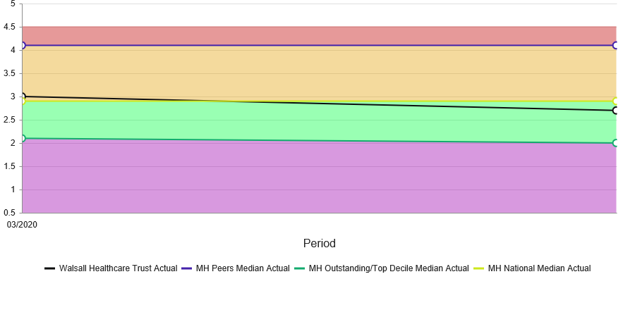

Divisional Indicators
 | BEN.402.01 MLTC | Avg LOS MLTC (not same day)
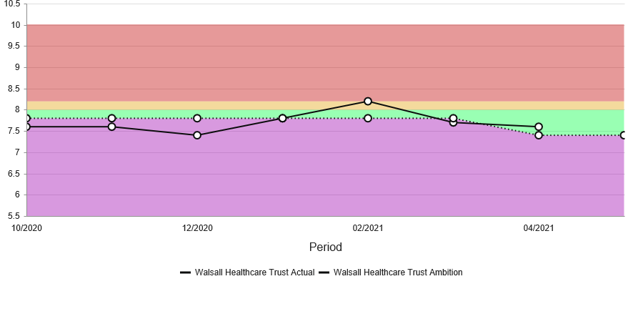
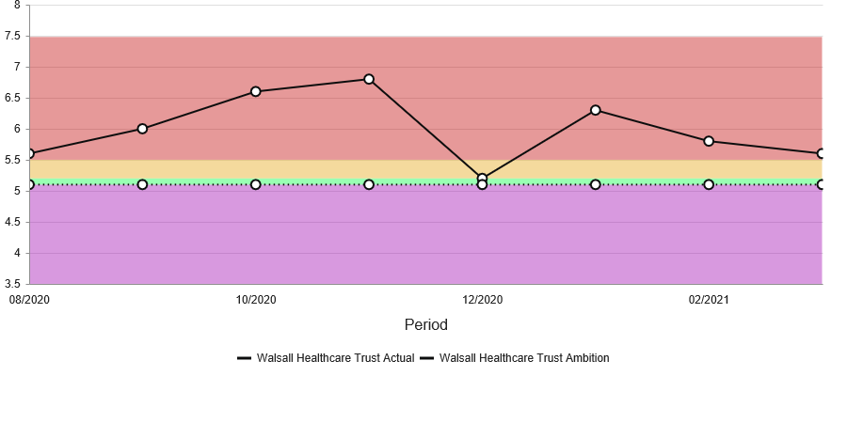

 | Avg LOS Surgery | Avg LOS Surgery (not same day)

 | Avg LOS WCCSS | Avg LOS WCCSS (not same day)

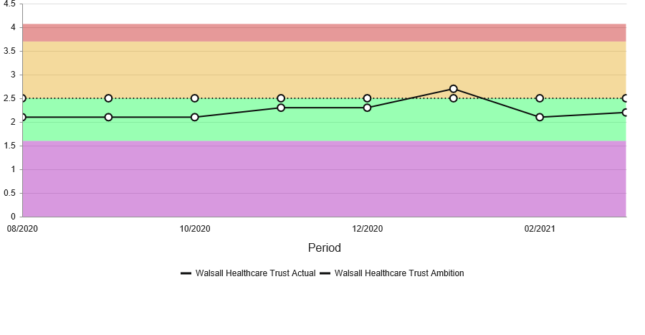

Workstream Project Indicators
 | BEN.364.01  WCCSS | No of Labour Inductions using Dilapan

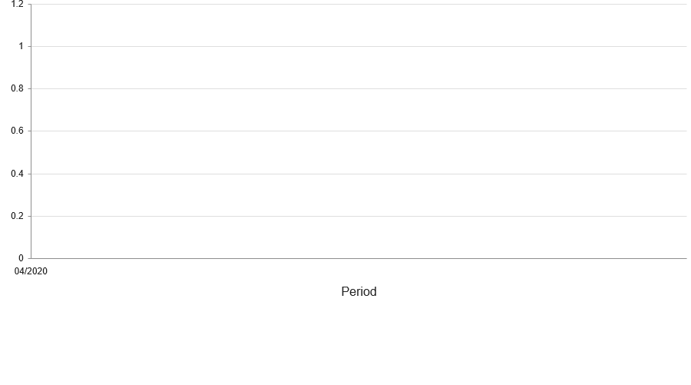
04/20

 | BEN.365.02  WCCSS | No of SROM Patients having Actim Prom
Last 8 data points - ONLY actuals displayed
04/20
 | BEN.366.01  WCCSS | No of PIGF Tests for Maternity Patients

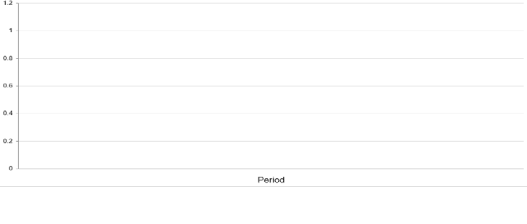

 | BEN.220.02 Col  Surg | Reduce Avg LOS for Colorectal Surgery
Last 8 data points - ONLY actuals displayed
04/20

 | Avg LOS ENT  Elective | Avg LOS for ENT Elective Admissions (excluding short stays)
Last 8 data points - ONLY actuals displayed
06/20 | 07/20 | 08/20 | 09/20 | 10/20 | 11/20 | 12/20 | 01/21
2.60 | 1.40 | 1.00 | 2.00 | 1.10

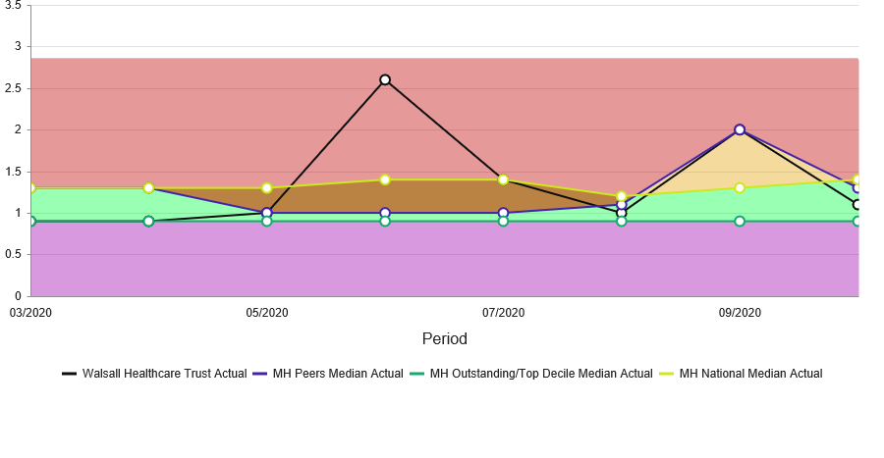

 | Avg LOS Urology  Elec | Avg LOS Urology Elective Admissions (excluding short stays)
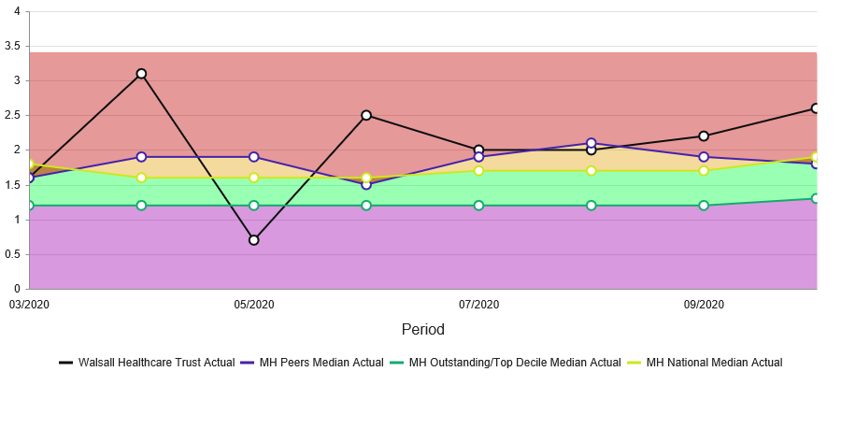
Last 8 data points - ONLY actuals displayed
06/20 | 07/20 | 08/20 | 09/20 | 10/20 | 11/20 | 12/20 | 01/21
2.50 | 2.00 | 2.00 | 2.20 | 2.60

 | Avg LOS T&O Elect | Avg LOS T&O Elective Admissions (excluding short stays)

03/20 | 04/20 | 05/20 | 06/20 | 07/20 | 08/20 | 09/20 | 10/20
3.20 | 24.30 | 1.70 | 1.70 | 3.00 | 2.80 | 3.20 | 3.80

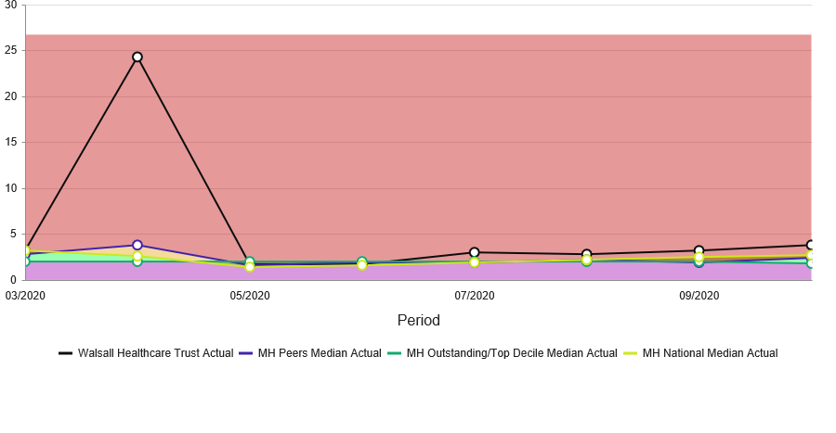

 | SDEC WCCSS  Children | Increase No of Child Patients Using Dedicated Day Case Facility
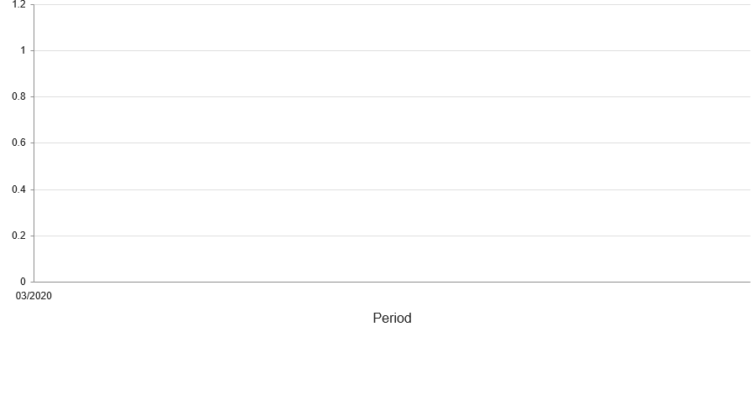Last 8 data points - ONLY actuals displayed
03/20

 | BEN.373  SepsisMgt | % Risk Assessments Completed - particularly in relation to Sepsis Management

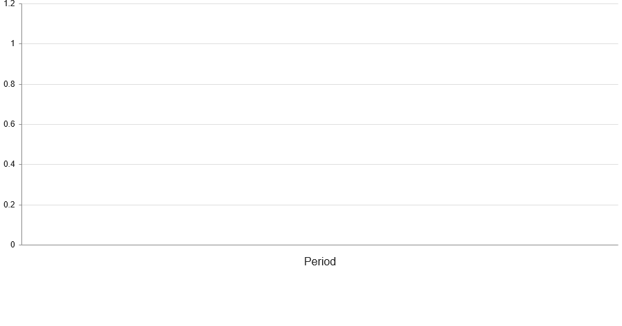

PIDs
 | PR000220 |  |  | Johnson & Johnson LOS Colorectal |  | 01/04/20 | 31/03/21
 |  |  | BEN.220.02 Col  Surg |  | Reduce Avg LOS for Colorectal Surgery
 | PR000336 |  |  | Minimising LoS - T&O - Discharge planning from admission (FNOF) |  | 27/07/20 | 29/03/24
 |  |  | Avg LOS T&O  Elect |  | Avg LOS T&O Elective Admissions (excluding short stays)
 | PR000364 |  |  | Maternity - Induction of Labour (using Dilapan in OPD) |  | 30/11/20 | 31/03/23 | On Target
 |  |  | BEN.364.01  WCCSS |  | No of Labour Inductions using Dilapan
 | PR000365 |  |  | Maternity - Actim Prom for patients with SROM |  | 01/04/21 | 31/03/22 | PID in development
 |  |  | BEN.365.02  WCCSS |  | No of SROM Patients having Actim Prom
 | PR000366 |  |  | Maternity - Placental Immune Growth Factor (PIGF) test for Query Pre-Eclampsia |  | 07/12/20 | 31/03/23 | Paused awaiting funding
 |  |  | BEN.366.01  WCCSS |  | No of PIGF Tests for Maternity Patients
 | PR000373 |  |  | Harm Free Care |  | 01/04/20
 |  |  | BEN.373  SepsisMgt |  | % Risk Assessments Completed - particularly in relation to Sepsis Management
 | PR000402 |  |  | LOS |  | 01/04/20 | 31/03/21 | On Target
 |  |  | BEN.402.01  MLTC |  | Avg LOS MLTC (not same day)
 |  |  | Avg LOS Surgery |  | Avg LOS Surgery (not same day)
 |  |  | Avg LOS Urology  Elec |  | Avg LOS Urology Elective Admissions (excluding short stays)
 |  |  | Avg LOS WCCSS |  | Avg LOS WCCSS (not same day)
 | PR000403 |  |  | Same Day Emergency Care (SDEC) |  | 01/07/20 | 31/03/21 | On Target
 |  |  | SDEC WCCSS  Children |  | Increase No of Child Patients Using Dedicated Day Case Facility
 | PR000474 |  |  | ENT - reduced LoS & increased same day procedures
 |  |  | Avg LOS ENT |  | Avg LOS for ENT Elective Admissions (excluding short stays)


1
MEETING OF THE PUBLIC TRUST BOARD – 3rd June 2021
Quality, Patient Experience and Safety Committee (QPES) Highlight Report |  |  | AGENDA ITEM: 12
Report Author and Job Title: | Trish Mills Trust Secretary | Responsible Director: | Mrs Pamela Bradbury –  Chair of QPES (Non- Executive Director).
Action Required | Approve ☐ Discuss ☒ Inform ☒ Assure ☒
Executive Summary | This report provides the key messages from the Quality, Patient Experience and Safety Committee meeting held on 27th May 2021. Of note are:  - The patient story which will be told at today’s Trust Board was also heard by the Committee, and we discussed in some detail the risks now added to the risk register for mental health, which included legal and regulatory risks and those related to quality of care and support of staff. The Committee will continue to be updated on these risks and the ongoing work with our partners to help the patients presenting at the Trust.  - The Committee was advised that an invited service review relating to trauma and orthopaedics was carried out by the Royal College of Surgeons in July 2020 and the final report was received in November 2020. On the basis of this, further investigations are underway by the Trust in collaboration with the Royal College of Surgeons, and the Committee will receive regular updates.  - Mrs C Jones-Charles Divisional Director of Midwifery, Gynaecology & Sexual Health, and Mr F Ghazal, Clinical Director, Obstetrics & Gynaecology presented the maternity report. There had been two serious incidents initially reported in April, however they had both been downgraded by the Health Service Investigation Branch who felt they had been appropriately managed and were not serious incidents.  - The Committee were not assured by the quarterly Trust wide serious incidents report. Whilst the report provides details on the numbers of serious incidents and actions, it does not yet provide the embedded learning or illustrate where systematic change has been made. The Committee were reassured to learn that more resources and robust governance around  timeliness, ownership and accountability were being introduced,


2

which will allow the report to further mature to provide the necessary assurance to the Committee and to allow long outstanding actions (including the oldest from 2018) to be closed.
      - The 2020/21 Quality Account was reviewed in draft prior to its presentation at Audit Committee. Subject to any comments from stakeholders, the Committee were satisfied with the draft.
      - The Committee is regularly made aware of a great deal of improvement work under the Improvement Programme for the workstream of Safe, High Quality Care, and, particularly in relation to the serious incidents report, in the Well- Led workstream. The Committee Chairs have agreed to meet with the workstream leads before the next round of meetings to discuss the ways in which assurance reporting will be presented to the Committees on progress and outcomes from the Improvement Programme.
      - The temporary nursing staff internal audit review was received for information.
      - Effectiveness reviews for Board Committees will take place in July/August, however this Committee has reviewed it progress against its priorities set for 2020/21 ahead of that review. Those priorities were as follows:
        - The development and finalisation of the PIDs for the Safe, High Quality Care workstream. Completed: These were approved in November 2020.
        - Scrutiny of the board assurance framework and actions to mitigate and manage risks (both strategic and corporate). Completed: These are reviewed at each meeting.
        - Initiatives and outcomes on the engagement and involvement of patients and the public. Completed: QPES receives updates on engagement and involvement of patients and the public; patient stories are heard at meetings, with actions and lessons learnt discussed and positive feedback shared; national CQC patient survey action plan discussed at October QPES; Received patient experience/engagement reports, including annual complaints report and patient relations/engagement reports throughout the year.
        - A review of the Terms of Reference and reporting requirements for each group reporting to the Committee.

Not completed: Reviews are being prioritised for the Clinical Effectiveness Group and Patient Safety Group, together with a review of their TORs and reporting templates. However a wholesale review of the tier 2 committees will carry over into 2021/22 under the Well-Led workstream of the Improvement Programme
- The Committee has set the following priorities for 2021/22:
  - A review of the Terms of Reference and reporting requirements for each group reporting to the Committee (carried over from 2020/21)
  - Quarterly reporting on the 2021/22 quality account priorities
  - Oversight of the completion of all policies within its remit by March 2022

The next meeting of the Committee will take place on 24th June 2021
Recommendation | Members of the Trust Board are asked to note the escalations and any support sought from the Trust Board.
Risk in the BAF or Trust Risk Register | This report aligns to BAF risk S01 for safe high quality care and COVID-19 BAF risk S06.
Resource implications | There are no new resource implications associated with this report.
Legal, Equality and Diversity implications | There are no legal or equality & diversity implications associated with this paper
Strategic Objectives | Safe, high quality care ☒ | Care at home ☐
Strategic Objectives | Partners ☐ | Value colleagues ☐
Strategic Objectives | Resources ☐
3

MEETING OF THE PUBLIC TRUST BOARD – 3rd June 2021
Safe High Quality Care – Executive Update |  |  |  |  |  | AGENDA ITEM: 13
Report Author and Job Title: | Ann-Marie Riley, Director of Nursing |  |  | Responsible Director: |  | Ann-Marie Riley, Director of Nursing  Matthew Lewis, Medical  Director
Action Required | Approve ☐ | Discuss ☐ | Inform ☒ |  | Assure ☒
Executive Summary | This report describes the continuing actions that are taking place to provide Safe, High Quality Care (SHQC) in the Trust. The report includes details relating to the Board Assurance Framework (BAF), the Corporate Risk Register and the Performance Report, relevant to SHQC.  The report also outlines the working high level action plan in response to the recent CQC inspection report.
Recommendation | - Note the update to Trust Board on actions relating to the Improvement Programme through the Quality, Patient Experience & Safety Committee (QPES) and supporting groups.  - Note the highlighted updates to BAF risk S01 and related risks on the Corporate Risk Register.  - Note the relevant updates and assurance in relation to the performance  report.
Does this report mitigate risk included in | This report highlights updates relevant to Board Assurance Framework (BAF) Risk SO1 and provides assurance or mitigations in place to manage this risk.  The related corporate risks are:
the BAF or Trust Risk | 208 - Failure to achieve 4 hour wait as per National Performance Target of 95%,
Registers? | resulting in patient safety, experience and performance risks.  274 - Failure to resource backlog maintenance and medical equipment
 | replacement. (This risk has been closed and replaced with 2398).
 | 2066 - Lack of registered nurses and midwives.
 | 2437 - Service wide impact as a result of the risk of CYP are being admitted to
 | our acute Paediatric ward whilst awaiting a Tier 4 bed or needing a 'place of
 | safety'. (Internal factors.)
 | 2439 - External inadequate paediatric mental health and social care provision
 | leading to an increase in CYP being admitted to our acute Paediatric ward whilst
 | awaiting a Tier 4 bed or needing a 'place of safety'.
 | 2398 - Insufficient/ out-of-date equipment, utilised beyond its life cycle, has the
 | potential to result in sub-optimal patient care.
 | 2475 - The Mental Health Act (MHA) Code of Practice is not being applied in line
 | with CQC legislations in the day-to-day practices for providing safeguards &
 | protection for individuals who require mental health services.
Resource implications | Current resource implications relate to the delivery of the Safe High Quality Care improvement programme.

Legal and Equality Diversity implications | Failure to deliver safe, high quality care may result in further breaches of legal requirements under the Health and Social Care Act 2008
Strategic Objectives | Safe, high quality care ☒ | Care at home ☐
Strategic Objectives | Partners ☐ | Value colleagues ☒
Strategic Objectives | Resources ☒

PROVIDE SAFE HIGH QUALITY CARE – EXECUTIVE UPDATE

- EXECUTIVE SUMMARY

The delivery of safe, high quality care remains a key priority for the Trust. The associated BAF and corporate risks have been reviewed and updated as required and gaps in control and assurance were discussed in detail at the Quality, Patient Safety and Experience Committee.
Oversight of progress against the CQC Must and Should Do actions continues via the monthly CQC action plan oversight group and progress against 2019 and 2020 actions is as follows:

  - 2019 Actions: 53 of the 55 actions have been completed; 2 actions are in progress but overdue.
  - 2020 Actions: 26 of the 29 actions have been completed; 3 actions are in progress

Evidence of progress against outstanding and deferred actions was presented to the Quality, Patient Safety and Experience Committee and details are included further in the report.

The CQC action plan in response to the CQC inspection conducted on 9 March 2021 is included in the report.

Projects within the Safe, High Quality Care Improvement Programme have continued to progress despite the COVID19 pandemic and some of the key highlights are:
  - Falls per 1000 bed days was 3.66 in April 2021 which remains significantly below the national average of 6.1 as recognised as the Royal College Physicians
  - A new Continence Ambition is in draft and will launch in June
  - Timely observations performance has improved again in month and is at 89.02%
  - VTE compliance for April is 94.37% Work continues as per the plan outlined in this report last month and Divisional teams are now reporting on their performance and plans to Patient Safety Group (PSG).

- BOARD ASSURANCE FRAMEWORK (BAF)

Our strategic objective is to deliver excellent quality of care as measured by an outstanding CQC rating by 2022. The BAF for SHQC appears at Appendix 1. The Trust continues to have a low risk appetite for compromising quality and safety of patient care. Key updates on progress over the last month are highlighted below.
- Gaps in Control

  - VTE compliance for March is 94.37%. Divisional teams are now reporting their performance and action plans to Patient Safety Group (PSG).
  - The Trust proposed a trajectory to reduce falls by 10% in 20/21, compared to 19/20. This was achieved with a reduction of 18.5% (933 falls in 19/20 and 762 falls in 20/21). There was one severe harm falls in April on Ward 3. This has been reported as a serious incident and is under investigation.

  - Mental Capacity Act compliance below the Trust’s Standards – Performance for March 2021 shows that 74% of patients who lacked capacity had a two stage assessment undertaken. A Power BI dashboard is available and includes data about use of the ReSPECT form.
  - Sepsis audit frequency and performance – the Sepsis 6 dashboard is now live in the trust and allows all teams to review real time data against agreed national standards. Performance against these standards is monitored through monthly divisional sepsis reviews, Patient Safety Group and Performance Reviews. An extraordinary Patient Safety Group Meeting took place in the last month which focused solely on sepsis performance and divisional action plans.
  - A new corporate risk has been added – 2475: The Mental Health Act (MHA) Code of Practice is not being applied in line with CQC legislations in the day-to-day practices for providing safeguards & protection for individuals who require mental health services. This risk was discussed in detail at Quality, Patient Experience and Safety Committee.

- Gaps in assurance

  - NHSEI review in 2019 highlighted insufficient assurance on infection control standards in maternity services resulting in RED rating –We are assured that improvement in standards has been sustained which has also been reflected in feedback from inspections by the CCG, NHSEI and CQC. NHSEI have now confirmed a re-inspection date in June.
  - CQC ‘MUST’ and ‘SHOULD’ Do actions remain outstanding - Oversight of progress against the CQC Must and Should Do actions continues via the monthly CQC action plan oversight group and progress against 2019 and 2020 actions is as follows:
2019 Actions: 53 of the 55 actions have been completed; 2 actions are in progress but overdue.
2020 Actions: 26 of the 29 actions have been completed; 3 actions are in progress The 2 overdue actions for 2019 are detailed below along with a progress update (Table 1):
Table 1: Overdue actions for 2019 / 2020
Inspection report Date | Ref | Agreed action agreed with CQC / Taken from PCIP | Division | Executive Lead | Baseline Target Month | Progress Update
Jul-19 | SHOULD S16 | Ensure any storeroom where medication is stored is locked  and doors are closed | Surgery | Medical Director | Dec-20 | Required works now incorporated into the  planned estates upgrade
Jul-19 | SHOULD 32 | Consider exploring ways of pathway options for patients requiring discharge from the critical care unit to expedite discharge | Critical Care | Medical Director | Dec-20 | Division incorporating requirements into the 5 year plan for critical care which will be presented to STP and critical care network  this month

CQC Unannounced Inspection 9 March 2021

The CQC conducted an unannounced inspection across 5 medical wards on Tuesday 9 March 2021. Three inspectors were on site and visited wards 1, 2, 3, 16, and 17. A S29a warning notice was served on the Trust on the 31 March 2021. The S29a actions must be completed by the end of June 2021 and these are all on track.

The final CQC report was published 19th May 2021. The Must and Should do high level actions are noted in Appendix 1.

- LINK TO CORPORATE RISK

The aligned corporate risks have been reviewed in month:
208 - Failure to achieve 4 hour wait as per National Performance Target of 95%, resulting in patient safety, experience and performance risks.
2066 - Lack of registered nurses and midwives.
2260 - Lack of a whole system approach across health and social care for the management of Children and Young People (CYP) in mental health or behavioural crisis. (This risk has been closed and replaced with 2437 and 2439).
2437 - Service wide impact as a result of the risk of CYP are being admitted to our acute Paediatric ward whilst awaiting a Tier 4 bed or needing a 'place of safety'. (Internal factors.)
2439 - External inadequate paediatric mental health and social care provision leading to an increase in CYP being admitted to our acute Paediatric ward whilst awaiting a Tier 4 bed or needing a 'place of safety'.
2398 - Insufficient/ out-of-date equipment, utilised beyond its life cycle, has the potential to result in sub-optimal patient care.
2475 - The Mental Health Act (MHA) Code of Practice is not being applied in line with CQC legislations in the day-to-day practices for providing safeguards & protection for individuals who require mental health services.

- PERFORMANCE REPORT

The performance report was discussed at the Quality Performance and Safety Committee. A few key areas to report as follows:

4.1 Clostridium Difficile number of cases
There has been 1 Clostridium Difficile toxin case reported during April which is currently under investigation.

4.2.% of observations rechecked within time
The prevalence of observations completed on time has increased again in month to 89.02%

  - Dementia Screening – As noted last month, the Director of Nursing undertook a review of the data collection mechanism process as there is limited assurance on the current performance data. A digital solution has now been agreed and updates on development will be discussed at Quality, Patient Experience and Safety Committee.

  - Sepsis – The Trust has developed an E-Sepsis dashboard (Power BI 0843) to monitor
performance against the Sepsis 6 bundle of care. The utilisation and data input to the dashboard is being improved. Currently, performance on the E-sepsis dashboard is lower than local audit such as that in the emergency department. Divisional plans to improve their performance against Sepsis 6 have been reviewed and agreed at patient safety group. E-sepsis dashboards are now available at ward level for Divisions to manage local performance, supported by project management in the SHQC team and professional development. Plans for a Trust Sepsis team working with the Critical

Outreach team in line with best performing units are being worked through. A trust Clinical Lead for Sepsis will be advertised, and Sepsis E-learning has been agreed. Bespoke maternity and paediatric dashboards have been developed and a Regional Neonatal Sepsis dashboard has been launched with associated training.

  - MCA assessment - Performance for March 2021 shows that 74% of patients who lacked capacity had a two stage assessment undertaken. The Trust Power BI dashboard data shows that 100% of forms were completed and evidence of MDT discussion has improved to 95%. Discussion with patient’s relatives or attorney has improved to 87% of cases audited following focused work to improve this.

- STAFFING UPDATE

The RN and Midwifery vacancy rate for April 2021 was just below 9%.

Rosters are designed to fill out of hours first and this is reflected in the fill rate as the lowest fill rate was seen in the RN day shift at 91.72% (Chart 2). The overall fill rate was 95.7%. The redeployment of staff and temporary staffing cover has supported the maintenance of ward fill rates.

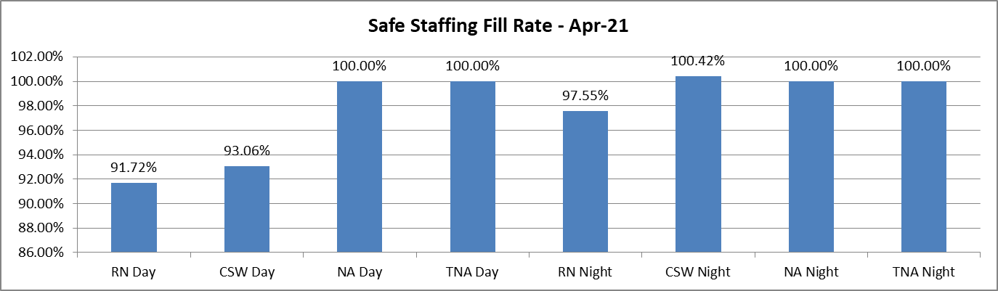
Chart 2: Ward Area Staffing Fill Rates

Proactive recruitment continues to deliver our plan to recruit 125 international nurses by the end of December 2021. 35 international nurses will have joined us by the end of May and another 40 are planned to join us in June.
There is a Cohort of 12 trainee nursing associates planned for September 2021 who will be supporting plans to fill the NA vacancies within hospital ward areas.
After recruitment with the assistance of Walsall Housing and Walsall College, clinical support worker recruits have been allocated against Divisional vacancies. A total of 36 commenced during April and they have been supported through a 2 week induction for fundamentals of care.

  - IMPROVEMENT PROGRAMME
The Safe High Quality Improvement Programme has continued in full despite the pandemic. A number of key highlights are:

    - The third of our Harm Free Care ambitions will launch June 2021 alongside the Skin Integrity Ambition
    - A refocus on hospital acquired pneumonia (HAP) is planned to take place in July

    - Our Infection Prevention and Control team have planned a point prevalence study for hospital acquired infections across our bed base to take place in June. This was last undertaken in 2018
    - Nutrition and hydration week is 14-20 June - in line with our Nutrition Ambition objectives, there is a plan to refresh the Malnutrition Universal Screening Tool in June
    - Deaths from fractured neck of femur show a consistent fall to an improved special cause variation after a continued quality improvement programme
    - Two new life task and finish groups have been commenced:
End of Life Care to improve care in the acute Trust. This will include a demand and capacity review of the Trust Palliative care service.
AMU documentation project for improved documentation, reduced number of finished consultant episodes and coding for more accurate Trust data to gain assurance against mortality statistics.

RECOMMENDATIONS

Members of the Trust Board are asked to note the update and progress made relating to the SHQC portfolio.
APPENDICES

Appendix 1: CQC action plan Appendix 2: BAF Risk S01 Appendix 3: Performance Report

Appendix 1: CQC Action Plan

The CQC conducted an unannounced inspection across 5 medical wards on Tuesday 9 March 2021. Three inspectors were on site and visited wards 1, 2, 3, 16, and 17. A S29a warning notice was served on the Trust on the 31 March 2021.

The final CQC report was published 19th May 2021. The Must and Should do actions are noted below.

Please note the current working high level action plan below which is subject to ongoing review and additions as required. There is a detailed action plan that is monitored closely by the Director of Nursing and Director of Governance. The S29a actions must be completed by the end of June 2021; these are on track and highlighted in grey for ease.

Must or Should | CQC Requirement | Regulation for Enforcement Action/ Requirement  Notice | Action required | Date for completion | Evidence of sustainability
MUST | The Trust must ensure that all staff are competent in the use of the recommended summary plan for emergency care and treatment (ReSpect)  forms. | Regulation 12 Safe care and treatment | The Trust deliver the Training programme developed to support the implementation of the RESPECT toolkit for all relevant staff  Divisional targeted actions will be taken by managers and clinical leaders to improve compliance | 31/072021 | MLTC will deliver training rates consistently at  >90%
MUST | The trust must ensure staff have access to the information they need to provide person centred care. This includes the maintenance of complete and accurate records that describe patients individual needs and preferences, including those highlighted  on the ReSpect forms. | Regulation 9 Person centred care | Review how staff gain accessing to information and ensure that is available in a timely manner.  review the documentation audit and ensure all the information required is included in the records | 31st July 2021 | Documentation audit results ( including spot checks)  Perfect Ward data

Must or Should | CQC Requirement | Regulation  for Enforcement Action/ Requirement Notice | Action required | Date for  completion | Evidence of sustainability
MUST | The Trusts must ensure  systems are put into place to ensure staffing is actively assessed, reviewed and escalated appropriately to prevent exposing patients to the risk of harm | Regulation 18  Staffing | Trust to implement Quality Impact assessment tool  Division to embed Trust wide risk assessment and ensure risk assessments are signed off through the appropriate governance where there are changes in the bed base or the acuity of patients  Complete Gap analysis of Trust vs Workforce Safeguards document  Complete gap analysis of Trust vs RCN Workforce Standards  Workforce governance processes to be reviewed Modified establishment review of medical wards  KPIs are established to monitor use of SafeCare system  Workforce paper to board outlining plan to reduce/eliminate agency nursing by Nov  Proactive international recruitment is underway with the aim to recruit 125 international nurses before the end Dec 2021 with the following nurses arriving;  17 April  18 May  40 June  50 each month thereafter as required | 30/06/21  30/07/21  31/12/21 | Matron audits  Staffing hub data Establishment review process Safecare data  Recruitment and retention data Staff satisfaction data  FTSU notifications Temporary staffing data Staffing incident/red flag data
MUST | The Trust must ensure  systems are put in place to ensure that staff are suitably qualified, skilled and competent to care for | Regulation 18  Staffing | The Division to develop a robust workforce plan  following a nursing establishment review using the safer care nursing tool  The Team will develop and deliver the vacancy and | 30/06/21  31/12/21 | Establishment review  Ward/ unit induction checklist audit data  Matron audits

Must or Should | CQC Requirement | Regulation  for Enforcement Action/ Requirement Notice | Action required | Date for  completion | Evidence of sustainability
 | and meet the needs of  patients within all areas of the medical services |  | recruitment plan to support elimination of agency nurse  usage by Dec 2021 |  | Staffing hub data  Establishment review process Safecare data  Recruitment and retention data Staff satisfaction data  FTSU notifications  Temporary staffing data Staffing incident/red flag data
MUST | The Trust must ensure  effective risk and governance systems are embedded that supports safe, quality care | Regulation 17  Good Governance | The Division will reinstate and ensure compliance  against the Trusts governance framework  This will require support from the corporate services to support the division with the delivery of the governance systems within governance | 30/09/21 | Recommence the Trust risk and governance  systems at divisional level.  The division will ensure risk management confirm and challenges meetings are taking place
MUST | The Trust must ensure  systems and processes are established and operated to effectively investigate, immediately upon becoming aware of, any allegation or evidence of such abuse | Regulation 13  Safeguarding service users from abuse and improper treatment | Safeguarding support package in place from RWT.  Single Safeguarding lead across RWT and WHT  Ensure Safeguarding policies are comprehensive, up to date and accessible to all staff.  Training programme for all aspects of Safeguarding identified, implemented and monitored  Develop and ratify PiPOT policy with HR when managing allegations or evidence of abuse  Standardised Safeguarding dashboard  Scoping exercise underway of current service provision to support alignment to RWT processes  Implement all actions from safeguarding external review and ensure any safeguarding risks are considered across all the CQC actions within the detailed action plan.  Safeguarding focused policies will be comprehensive, | 30/09/21 | All care groups in Medicine will have  Safeguarding escalation reports outlining:  -safeguarding training compliance for all staff groups in MLTC  -Review incidents and complaints relating to safeguarding and themes for improvement  Divisional Safeguarding escalation/assurance reports to Trust Safeguarding Committee  Safeguarding CCG committee review the safeguarding referrals.  Review the Safeguarding incidents or concerns have been death with in 2 days from Safeguard system.  Standardised nursing staff handover to include any particular requirements to support person centred care.  Perfect Ward data Safeguarding team audit data

Must or Should | CQC Requirement | Regulation  for Enforcement Action/ Requirement Notice | Action required | Date for  completion | Evidence of sustainability
up to date and accessible to all staff and effective
processes in place for monitoring, updating and ratifying policies

Training and support/supervision for staff – includes all statutory and mandatory training that contributes to safe and effective patient care.

Comprehensive HR policies and processes

Staff encouraged to utilise Freedom to Speak up Guardian
MUST | The Trust must ensure all  staff adhere to policies and procedures to ensure patients are kept safe from avoidable harm of infection | Regulation 12  Safe care and treatment | Ensure IPC policies are comprehensive, up to date and  accessible to all staff.  Training programme for all aspects of IPC identified, implemented and monitored  Ensure all required resources e.g. PPE are available and accessible  Standardised audit tools available which inform KPIs around IPC | 30/09/21 | IPC team audit data  Training compliance data
MUST | The Trust must ensure staff  are documenting that discharge planning is taking place and discharge checklists are used to ensure a safe discharge | Regulation 12  Safe care and treatment | Implement revised Discharge checklist adapted from  RWT | 30/06/21 | To be incorporated into Perfect Ward monthly  audit data
SHOULD | The Trust should consider  adapting the international rounding timings so that they are individualised to the patient and meet the needs of the patient |  | The division will implement individualised rounding  Develop audit questions for inclusion on perfect ward | 30/09/21
SHOULD | The Trust should consider  how they assure themselves patients observations are completed |  | The Trust will continue to monitor and oversee the  performance of timely observations on a monthly basis via performance reviews | 30/09/21

Must or Should | CQC Requirement | Regulation for Enforcement Action/ Requirement  Notice | Action required | Date for completion | Evidence of sustainability
 | within the specified  timeframe |  | The Trust will deliver against the deteriorating patient  milestones within the improvement programme
SHOULD | The Trust should consider improving awareness and knowledge amongst all staff in the use of alternative communication aides when meeting the individual  needs of patients |  | The Trust will continue to monitor and oversee practice standards on a monthly basis via patient experience group  Relevant communications and education material will continue to be shared widely across the organisation | 30/08/21

Latest Board/Committee/Group - 17/05/2021 Version V1.02

Risk Summary
BAF Strategic  Objective Reference & Summary Tile: | BAF SO 01 - Safe, High Quality Care; We will deliver excellent quality of care as measured by an outstanding CQC rating by 2022.
Risk Description: | The Trust fails to deliver excellence in care outcomes, and/or patient/public experience, which impacts on the Trust’s ability to deliver services which are safe and meet the needs of our local population.
Lead Director: | Director of Nursing/Medical Director.
Lead Committee: | Quality, Patient Experience & Safety Committee.
Links to Corporate Risk Register: | Title: |  |  |  |  |  |  | Current Risk Score Movement:
Links to Corporate Risk Register: | - 208 - Failure to achieve 4 hour wait as per National Performance Target of 95%, resulting in patient safety, experience and performance risks.  - 274 - Failure to resource backlog maintenance and medical equipment replacement. (This risk has been closed and replaced with 2398).  - 2066 - Lack of registered nurses and midwives.  - 2260 - Lack of a whole system approach across health and social care for the management of Children and Young People (CYP) in mental health or behavioural crisis. (This risk has been closed and replaced with 2437 and 2439).  - 2398 - Insufficient/ out-of-date equipment, utilised beyond its life cycle, has the potential to result in sub-optimal patient care.  - 2437 - Service wide impact as a result of the risk of CYP are being admitted to our acute Paediatric ward whilst awaiting a Tier 4 bed or needing a 'place of safety'. (Internal factors.)  - 2439 - External inadequate paediatric mental health and social care provision leading to an increase in CYP being admitted to our acute Paediatric ward whilst awaiting a Tier 4 bed or needing a 'place of safety'.  - 2475 - The Mental Health Act (MHA) Code of Practice is not being applied in day-to-day practices for providing safeguards & protection for individuals who require mental health services. |  |  |  |  |  |  | Likelihood = 3  Consequence = 5  15  High  ↔
Risk Scoring
Quarter: | Q1 2021/22 | Q2 | Q3 | Q4 2020/21 | Rational for Risk Level: | Target Risk Level (Risk Appetite): |  | Target Date:
Likelihood: |  |  |  | 3 | - The Trust’s Quality Strategy is out of date and doesn’t reflect the environment in which we are currently operating. There are gaps in oversight of the strategy and a lack of clear alignment to the Quality Priorities.  - We have strengthened clinical leadership and accountability at the tier 2 level of our governance with the Director of Nursing and Medical Director taking on the leadership in Patient Safety and Clinical Effectiveness.  - Evidence of lessons learnt from incidents and patient feedback is inconsistent. | Likelihood: | 2 | 31 December  2021
Consequence: |  |  |  | 5 |  | Consequence: | 5 | 31 December  2021
Risk Level: |  |  |  | 15  High |  | Risk Level: | 10  Moderate | 31 December  2021

- Robust acuity and activity review process for community activity.
- The Trust is leading the COVID Vaccination programme as part of the Walsall Vaccination programme thus far 84.5% of Trust staff have been vaccinated at Manor site, around 10,508 members of the pubic have been vaccinated at the Saddlers Centre.
- Progress and assurance against CQC Must and Should Do actions from inspections in 2019 and 2020.
- Progress against CQC Must and Should Do actions from May 2021 report and associated Section 29a notice.
- Concerns have been raised in relation to the staff experience on the NIV unit. As consequence of these concerns, and the reduction of critical care activity, the NIV unit has temporarily paused.
- Reduced COVID-19 cases enable the closure of additional capacity beds (Wards 14, 10 and additional beds on Ward 4) and subsequently reduced demand on staffing requirement.
- We currently do not respond to complaints within 30 days to the Trust target.
- Impact of pandemic of COVID-19 resulting in delays to patient treatment and potential for harm.
- Gaps in the number and quality of clinical guidance, policies and procedures to ensure safe and quality care.
- Duty of Candour below target performance level.
- Incomplete 7 Day Services to provide uniform levels of care throughout the week.
- Partial compliance against Ockenden recommendations.
- Potential to breach statutory requirements under the Mental Health Act due to inconsistent knowledge and application of Trust Policy.
- Gap in the Trust’s approach to patient engagement and patient involvement.
- Dementia screening data collection process under review.

Control & Assurance Framework - 3 Lines of Defence
 | 1st Line of Defence | 2nd Line of Defence | 3rd Line of Defence
Controls: | - Clinical audit programme & monitoring. Clinical divisional structures, accountability & quality governance arrangements at Trust, division, care group & service levels.  - Central staffing hub co-ordinating nurse staffing numbers in line with acuity and activity arrangements.  - Safety Alert process in place and assured through QPES.  - Perfect Ward app allows local oversight of key performance metrics.  - Freedom to speak up process in place, reporting to the People and organisational development committee.  - Covid-19 SJR undertaken for all deaths process of assurance for lessons learnt developed.  - CQC registration for the regulated activity of assessment or medical treatment for persons detained under the Mental Health Act 1983 at Manor Hospital.  - Monthly CQC Action Plan oversight meeting in place.  - Improvement programme in place to oversee and monitor improvements  associated with the Trust delivery of Safe, and High Quality Care. | - Patient Experience group in place.  - Governance and quality standards managed and monitored through the governance structures of the organisation, performance reviews and the CCG/CQC.  - Learning from death framework supporting local mortality review.  - Faculty of Research and Clinical Education (FORCE) established to promote research and professional development in the trust. | - CQC Inspection Programme.  - Process in place with Commissioners to undertake Clinical Quality Review Meetings (CQRM).  - Royal College of Surgeons Invited Service Review of upper limb surgery.  - External Performance review meetings in place with NHSEI/CQC/CCG.
Gaps in Controls: | - Performance targets not being met for all activities, including complaints, Mental Capacity Act compliance and VTE assessments.  - Out of date clinical policies, guidelines and procedures.  - Training performance not meeting set targets.  - Quality Impact Assessment process is not yet established within the trust.  - Sepsis audit frequency and performance.  - CQC rating of ‘Requires Improvement’ in 2019; Medicine rated as ‘Inadequate’ in May 2021 report.  - NHSEI review of Division of Surgery, focussing on meetings, leadership, and governance highlighted remedial actions required.  - Dementia screening performance.  - Failure to demonstrate compliance with terms of the Mental Health Act.  - Absence of SLA to cover management of patients requiring mental health liaison support in ED and wards.
Assurance: | - Ward Review process in place which | - Patient priorities for 2021 identified which aim to | - NHSI and CCG reviews of IPC practice in ED

 |  | provides assurance on the quality of care; performance reported to QPES within the SHQC report. | improve patient experience. Assurance of impact via patient feedback.  - Learning Matters Newsletter published regularly. |  |  | and Maternity have not highlighted any immediate concerns.  - NHSEI scrutiny of Covid-19 cases/Nosocomial infections/Trust implementation of social distancing, Patient/Staff screening and PPE Guidance.  - Quality Review 6 monthly reviews in place with NHSEI/CQC.
Gaps in Assurance: |  | - CQC ‘MUST’ and ‘SHOULD’ do actions remain outstanding.  - NHSEI review in 2019 highlighted insufficient assurance on infection control standards resulting in RED rating. Division have made sustained improvement and external review of practice from NHSI, CCG and CQC have not highlighted gaps in practice. NHSI plan to re-inspect maternity services in April or May 2021.  - External audit assurance relating to the annual quality account has been deferred owing to COVID-19.  - Inconsistent evidence, both through quality governance structures and performance reviews, of practice having changed as a result of learning from adverse events.  - Gaps in assurance noted from the recent CQC inspection including management of sepsis and robust audit data.  - Lack of assurance regarding equality, diversity and inclusion and actions to reduced inequalities.  - Lack of evidence of risk assessments and quality impact assessments relating to staffing contingency planning and/or activity changes.  - Lack of robust strategic approach to ensuring effective patient/public engagement and involvement.  - Lack of clinical engagement and leadership oversight of the Quality Governance agenda.  - Lack of assurance regarding dementia screening data collection process.
Future Opportunities
- Improvement Programme offers a structured programme to achieve excellence in care outcomes, patient/public experience, and staff experience.
- Implementation of new technologies as a clinical or diagnostic aid (such as electronic patient records, e-prescribing & patient tracking; artificial intelligence; telemedicine).
- Development of Prevention Strategy.
- National Patient Safety Strategy will give an improved framework for the Trust to work.
- Well Led work stream working on quality governance structures and patient safety.
- Leadership Development programme to address and mitigate gaps within clinical leadership.
Future Risks
- Ongoing impact of Covid-19 plus additional significant time pressured programmes of work such as COVID vaccination, staff testing, etc. Communications across the organisation to share programme objectives.
- Performance targets not being met for all activities, including Mental Capacity Act and VTE.
- Sepsis audit frequency and performance.
- NHSEI review of Division of Surgery, focussing on meetings, leadership, and governance highlighted remedial actions required.
Future Actions (to further reduce the Likelihood / Consequence of the risk in order to achieve the Target Risk Level in line with the Risk Appetite)
No. | Action Required: |  | Executive Lead: | Due Date: | Progress Report: |  | BRAG:
1. | Define action plan for addressing lack of assurance around provision of services in line with requirements of Mental  Health Act |  | Medical Director | 01/07/2021 | Risk included on corporate risk register in May 2021. Draft action plan due for discussion through QPES in  May 2021.
2. | Develop a Clinical Audit Strategy and Policy |  | Director of  Governance | 01/08/2021

3. | Oversight of progress to address out of date policies and procedures will be strengthened via the Clinical Effectiveness Group which be reflected in the revised terms  of reference | Medical Director | 01/04/2021 | Complete - Terms of reference agreed through Clinical
4. | NHSI re-inspection of cleanliness and IPC practice in  maternity services | Director of  Nursing | 31/05/2021 | Inspection anticipated before end of May 2021.
5. | Further develop processes to provide assurance that lessons learnt from adverse events | Medical Director/ Director of  Nursing | 03/09/2021 | Scoping of new ward performance boards continues.
6. | Development of Patient Engagement and Involvement Strategy | Patient Experience Lead/Lead for Patient  Involvement | 30/09/2021 | Work ongoing.
7. | Review of dementia screening data collection process.  Initial deep dive completed. Scoping of improvement options commence April 2021 | Director of Nursing | 31/05/2021 | Scoping of improvement options complete; documentation options still under consideration.
8. | Develop Maternity Services BAF | Director of  Nursing | 31/05/2021 | Ongoing review.


Nov-20 | Dec-20 | Jan-21 | Feb-21 | Mar-21 | Apr-21

2021/22  YTD | 2021/22  Target | 2020/21  YTD | SPC  Variance | SPC  Assurance

SAFE, HIGH QUALITY CARE
No. | Sleeping Accommodation Breaches
No. | HSMR (HED) nationally published in arrears
No. | SHMI (HED) nationally published in arrears
Rate | Crude Mortality Rate
No. | Number of Deaths in Hospital
% | % of patients who achieve their chosen place of death
No. | MRSA - No. of Cases
No. | Clostridium Difficile - No. of cases
% | Sepsis - % of patients screened who recieved antibiotics within 1 hour - ED (Adults only)
% | Sepsis - % of patients screened who received antibiotics within 1 hour - Inpatients (Adults only)
% | Deteriorating patients: Percentage of observations rechecked within time
Rate | Pressure Ulcers (category 2, 3, 4 & Unstageables) Hospital Acquired per 1,000 beddays
Rate | Pressure Ulcers (category 2, 3, 4 & Unstageables) Community Acquired per 10,000 CCG Population
No. | Pressure Ulcers (category 2, 3, 4 & Unstageables) - Hospital
No. | Pressure Ulcers (category 2, 3, 4 & Unstageables) - Community
No. | Falls - Total reported
Rate | Falls - Rate per 1000 Beddays

1 | 0 | 0 | 0 | 0 | 0
138.69 | 122.77 | 149.92 | 129.47
120.28 | 96.34 | 117.32
3.18 | 3.83 | 4.60 | 3.62
168 | 153 | 227 | 169 | 105 | 69
72.00% | 72.00% | 61.43% | 77.97% | 86.36% | 68.52%
0 | 0 | 1 | 0 | 1 | 0
2 | 0 | 2 | 2 | 3 | 1
 |  | 47.01% | 55.47% | 61.78%
 |  | 26.16% | 24.87% | 32.12%
82.38% | 83.96% | 81.10% | 84.14% | 88.51% | 89.13%
0.53 | 0.75 | 0.63 | 1.07 | 1.24 | 0.68
0.59 | 0.34 | 0.48 | 0.38 | 0.65 | 0.65
8 | 11 | 10 | 14 | 17 | 9
17 | 10 | 14 | 11 | 19 | 19
65 | 71 | 74 | 70 | 51 | 51
4.57 | 5.02 | 4.7 | 5.11 | 3.39 | 3.66

0 | 0 | 210
 | 100
 | 100
69 |  | 1518
68.52% |  | 69.04%
0 | 0 | 2
1 |  | 32 |  | 
 | 85.00% |  |  | 
 |  |  |  | 
 |  |  |  | 
9 |  | 133 |  | 
19 |  | 164 |  | 
51 |  | 761 |  | 
 | 6.1 |  |  | 


Nov-20 | Dec-20 | Jan-21 | Feb-21 | Mar-21 | Apr-21

2021/22  YTD | 2021/22  Target | 2020/21  YTD | SPC  Variance | SPC  Assurance

No. | Falls - No. of falls resulting in severe injury or death
No. | Falls - Avoidable Falls resulting in severe harm or injury (subject to RCAs)
No. | Falls - Unavoidable Falls resulting in severe harm or injury (subject to RCAs)
% | VTE Risk Assessment
No. | National Never Events
No. | Serious Incidents (inc cat 3 & 4 pressure ulcers, HCAI's & Falls) - Hospital Acquired
No. | Serious Incidents (inc cat 3 & 4 pressure ulcers, HCAI's & Falls) - Community Acquired
No. | Clinical incidents causing actual harm severity 3 to 5 - Hospital Acquired
No. | Clinical incidents causing actual harm severity 3 to 5 - Community Acquired
% | % of total incidents resulting in moderate, severe harm or death
% | Trust-wide Safety Index - % of medication incidents resulting in harm (one month in arrears)
No. | No. of reported medication incidents level 3, 4 or 5 (one month in arrears)
Rate | Midwife to Birth Ratio
% | One to One Care in Established Labour
% | C-Section Rates
% | Instrumental Delivery
% | Induction of Labour

1 | 0 | 0 | 2 | 0 | 1
90.93% | 91.08% | 90.75% | 92.06% | 94.45% | 94.34%
0 | 0 | 0 | 0 | 0 | 1
12 | 9 | 12 | 14 | 7 | 7
0 | 0 | 0 | 0 | 0 | 0
47 | 44 | 47 | 36 | 42 | 30
5 | 6 | 9 | 7 | 6 | 11
5.03% | 4.64% | 4.80% | 3.92% | 3.72% | 3.65%
25.00% | 12.00% | 23.00%
1 | 0 | 1
31.4 | 28.9 | 27.2 | 29.1 | 34.4 | 29.3
100.00% | 100.00% | 100.00% | 100.00% | 100.00% | 100.00%
26.58% | 33.70% | 27.44% | 32.51% | 33.33% | 30.82%
4.87% | 5.36% | 7.53% | 5.96% | 6.32% | 8.21%
43.19% | 41.30% | 43.68% | 37.10% | 42.11% | 34.77%

1 | 0 | 12
 |  | 2
 |  | 0
94.34% | 95.00% | 91.56%
1 | 0 | 0
7 |  | 115
0 |  | 0
30 |  | 378
11 |  | 77
3.65% |  | 3.67% |  | 
 | 12.00% | 17.71% |  | 
 | 0 | 10 |  | 
 | 28 |  |  | 
100.00% | 100.00% | 99.88% |  | 
30.82% | 30.00% | 29.81% |  | 
8.21% | 10.00% | 6.50% |  | 
34.77% |  | 41.12% |  | 


Nov-20 | Dec-20 | Jan-21 | Feb-21 | Mar-21 | Apr-21

2021/22  YTD | 2021/22  Target | 2020/21  YTD | SPC  Variance | SPC  Assurance

% | % of Emergency Readmissions within 30 Days of a discharge from hospital (one month in arrears)
% | Electronic Discharges Summaries (EDS) completed within 48 hours
% | Dementia Screening 75+ (Hospital) (Internal audit Dec17 onwards) - Methodology Under Review
% | Compliance with MCA 2 Stage Tracking
% | Complaints - % responded to within 30 working days
% | Complaints - % responded to within 45 working days
No. | No. of Open Complaints
No. | No. of Closed Complaints
No. | Longest Wait for an Open Complaint
No. | Clinical Claims (New claims received by Organisation)
No. | No urgent op to be cancelled for a second time
% | % of RN staffing Vacancies
% | Friends and Family Test - Inpatient (% Recommended)
% | Friends and Family Test - Outpatient (% Recommended)
% | Friends and Family Test - ED (% Recommended)
% | Friends and Family Test - Community (% Recommended)
% | Friends and Family Test - Maternity - Antenatal (% Recommended)

13.26% | 12.00% | 12.54% | 12.71% | 11.91%
85.00% | 84.25% | 82.22% | 82.49% | 83.34%
48.28% | 81.82% | 52.38% | 60.87% | 21.05% | 49.15%
32.50% | 34.88% | 43.48% | 46.00% | 81.25% | 64.29%
32.26% | 31.82% | 56.52% | 55.17% | 55.88% | 65.38%
35.48% | 50.00% | 69.57% | 68.97% | 61.76% | 65.38%
66 | 69 | 76 | 71 | 61 | 70
23 | 22 | 15 | 29 | 43 | 22
87 | 80 | 99 | 117 | 142 | 165
8 | 7 | 5 | 8 | 10 | 14
0 | 0 | 0 | 0 | 0
10.59% | 10.90% | 8.73% | 8.17% | 7.49%
87% | 85% | 87% | 88% | 88% | 87%
91% | 90% | 91% | 92% | 91% | 91%
79% | 79% | 82% | 84% | 83% | 84%
 |  | 100% | 93% | 91% | 96%
73% | 79% | 73% | 71% | 78% | 78%

 | 10.00% | 13.44% |  | 
 | 100.00% | 85.75% |  | 
49.15% | 90.00% | 66.52%
64.29% | 100.00% | 52.35%
65.38% | 80.00% | 49.08%
65.38% |  | 57.93%
22 |  | 212
14 |  | 103
 | 0 | 0
 | 96% |  |  | 
 | 96% |  |  | 
 | 85% |  |  | 
 | 97% |  |  | 
 | 95% |  | 


Nov-20 | Dec-20 | Jan-21 | Feb-21 | Mar-21 | Apr-21

2021/22  YTD | 2021/22  Target | 2020/21  YTD | SPC  Variance | SPC  Assurance

% | Friends and Family Test - Maternity - Birth (% Recommended)
% | Friends and Family Test - Maternity - Postnatal (% Recommended)
% | Friends and Family Test - Maternity - Postnatal Community (% Recommended)
% | PREVENT Training - Level 1 & 2 Compliance
% | PREVENT Training - Level 3 Compliance
% | Adult Safeguarding Training - Level 1 Compliance
% | Adult Safeguarding Training - Level 2 Compliance
% | Adult Safeguarding Training - Level 3 Compliance
% | Children's Safeguarding Training - Level 1 Compliance
% | Children's Safeguarding Training - Level 2 Compliance
% | Children's Safeguarding Training - Level 3 Compliance

79% | 84% | 76% | 84% | 83% | 95%
77% | 78% | 80% | 71% | 59% | 93%
60% | 83% | 92% | 100% | 79% | 78%
90.15% | 90.46% | 90.00% | 91.41% | 93.00% | 87.21%
85.49% | 85.62% | 85.09% | 89.07% | 92.06% | 94.48%
95.88% | 94.97% | 93.42% | 94.21% | 95.48% | 96.46%
95.40% | 94.89% | 93.26% | 93.64% | 94.09% | 93.01%
71.50% | 71.92% | 73.69% | 75.16% | 81.22% | 84.56%
89.65% | 90.73% | 91.44% | 93.11% | 95.24% | 97.04%
90.35% | 89.25% | 88.98% | 90.12% | 92.14% | 92.91%
84.61% | 82.61% | 84.08% | 84.41% | 90.10% | 90.09%

 | 96%
 | 92%
 | 97%
 | 90.00% | 93.00%
 | 90.00% | 92.06%
 | 90.00% | 95.48%
 | 90.00% | 94.09%
 | 90.00% | 81.22%
 | 90.00% | 95.24%
 | 90.00% | 92.14%
 | 90.00% | 90.10% |  | 

Nov-20 | Dec-20 | Jan-21 | Feb-21 | Mar-21 | Apr-21

2021/22  YTD | 2021/22  Target | 2020/21  YTD | SPC  Variance | SPC  Assurance

RESOURCES
No. | Total Deliveries

301 | 276 | 277 | 283 | 342 | 279

279 | 3580 | 3619 |  | 

1

MEETING OF THE PUBLIC TRUST BOARD – 3rd June 2021
Performance, Finance & Report |  | Investment | Committee | (PFIC) Highlight |  | AGENDA ITEM: 15
Report Author and Job Title: | Trish Mills, Trust Secretary |  |  | Responsible Director: |  | Mr John Dunn – Chair of PFIC (Non-  Executive)
Action Required | Approve ☐ |  | Discuss ☐ | Inform ☒ | Assure ☒
Executive Summary | This report provides the key messages from the Performance, Finance & Investment Committee meeting on 27th May 2021. Of note are:  - An update was received on the estates, and it was agreed that corporate risk 1005 would be further reviewed as a matter of urgency to ensure the appropriate priorities for maintenance are in place and the risk was scored appropriately.  - Given the size of the digital transformation programme, it was agreed to include digital performance and risks as a separate standing item at each meeting. The Committee was updated at the May meeting on the size of the programme and improvements the Trust are putting through the system, both vertically and horizontally across the partnerships. Whilst there is some slippage due to the pandemic, there are no escalations required to Board.  - The Committee reviewed the Board Assurance Framework Risks for Use Resources Well and Working Closely with Partners, noting that there has not been movement in the risk ratings for either in month.  - The Committee reviewed the list of business cases approved in 2019/20 and 2020/21. Further assurance on key benefits delivered was requested, with post-implementation reviews remaining on the standard agenda until they are finalised.  - Financial performance remains strong with a surplus of £100K in month 1. The financial plan run rates for quarter two of 2021/22 were reviewed and will be discussed further at the private session of the Trust Board.  - Operational (acute and community) is also evidencing strong performance, with the Committee commending the teams for recovery of diagnostic waiting time which is 3rd best in the  country. There is consistent performance on discharge


2

through ICS and avoidance of admissions through the Integrated Assessment Hub – both of which are interfaces that have enabled a good flow of patients during the pandemic. Further evidence of this will come to a future Board as the Committee felt this was an excellent example of teamwork that shows real benefits to the people of Walsall.

The next meeting of the Committee will take place on 23rd June 2021.
Recommendation | Members of the Trust Board are asked to note the escalations and any support sought from the Trust Board.
Does this report mitigate risk included in the BAF or Trust Risk Registers? | This report aligns to the BAF risk for use of resources and working with partners, and associated corporate risks.
Resource implications | The resource implications are set out in this highlight report.
Legal and Equality and Diversity implications | There are no legal or equality & diversity implications associated with this paper
Strategic Objectives | Safe, high quality care ☐ | Care at home ☐
Strategic Objectives | Partners ☒ | Value colleagues ☐
Strategic Objectives | Resources ☒


1
MEETING OF THE PUBLIC TRUST BOARD – 3rd June 2021
Use Resources Well Executive Report |  |  | AGENDA ITEM: 16
Report Author and Job Title: | Ned Hobbs, Chief Operating Officer Russell Caldicott, Director of Finance &  Performance | Responsible Director: | Ned Hobbs, Chief Operating Officer Russell Caldicott, Director of Finance &  Performance
Action Required | Approve ☐ Discuss ☐ Inform ☒ Assure ☒
Executive Summary | This report provides an overview of the risks to delivery of the Use Resources Well strategic objective, mitigations in place to manage the risks identified, and actions identified to address gaps in controls and assurance. It provides the Trust Board with assurance on performance for Use Resources Well and NHS constitutional standards successes and areas for improvement.  This report recognises the financial arrangements within which the Trust is operating as it commences the 2021/22 financial year, as a result of the impact of the COVID-19 pandemic.  It updates Board members on financial performance, attaining a  £0.1m surplus over plan during April 2021, with Divisional and Corporate teams achieving planned run rate expenditure forecasts.  This further builds on the success in delivery of a surplus for the 2020/21 financial year (subject to audit of the financial statements). This second successive year of achieving a surplus and delivering financial plan.  The report then focuses upon plans being developed for quarter 2 of the 2021/22 financial year (with quarter 1 plans already endorsed by members) income allocations for this period based upon actual expenditure incurred during quarter 3 of 2020/21. The Trust is awaiting confirmation of income allocations relating to the period from 1st October 2021.  The report identifies key risks to delivery of 2021/22 financial plans centring upon temporary workforce and the need to deliver  efficiencies to enable investment in services (Improvement

Programme delivery therefore key).

The report identifies continued strong operational performance following the extreme pressure experienced during the third wave of the Covid-19 pandemic in early 2021. It highlights exceptional constitutional standard performance in the DM01 6 week wait diagnostic standard, ambulance handover times and the 4-hour Emergency Access Standard, and strong and improving benchmarked 18-week Referral To Treatment waiting times and 62- day Cancer waiting times. It highlights continued pan-Black Country challenges for waiting times for suspected Breast Cancer and Breast symptomatic patients, and the progress being made in improving access for patients referred on this pathway in Walsall.
Recommendation | Members of the Trust Board are asked to note the contents of this report, and the next steps:  - Re-forecasting elective restoration and recovery plans for 2021/22.  - Q1 2021/22 plan endorsed last month. Income for quarter 2 agreed by Trust Board, expenditure plans for Quarter 2 of 2021/22 to be debated at Private Board.  - Delivery of April of 2021 financial plans (a £0.1m surplus)  - The Trust is developing expenditure run rate plans for the remainder of 2021/22.  - It is of note that post 30th September 2021 income allocations are still to be confirmed, the plan for adoption presented to Trust Board in June for Q2 of 2021/22 only.  - Identification within the Horizon 2 period (October to March 2022) financial plan, future use of temporary workforce and efficiency attainment (Improvement Programme).
Mitigate risk included in the BAF or Trust Risk Registers? | This report addresses BAF Risk S05 – Use Resources Well to provide positive assurance that there are mitigations in place to manage this risk and the related corporate risks.
Resource implications | This strategic objective is: We will deliver optimum value by using our resources efficiently and responsibly  Financial impacts are as described within the recommendations section.

2

Legal and Equality and Diversity implications | There is clear evidence that greater deprivation is associated with a higher likelihood of utilising Emergency Department services, meaning longer Emergency Access Standard waiting times will disproportionately affect the more deprived parts of the community we serve.  Whilst not as strongly correlated as emergency care, there is also evidence that socioeconomic factors impact the likelihood of requiring secondary care elective services and the stage of disease presentation at the point of referral. Consequently, the Restoration and Recovery of elective services, and the reduction of waiting times for elective services must be seen through the lens of preventing further exacerbation of existing health inequalities too.  The published literature evidence base for differential access to secondary care services by protected characteristic groups of the community is less well developed. However, there is clear evidence that young children and older adults are higher users of services, there is some evidence that patients who need interpreters (as a proxy for nationality and therefore a likely correlation with race) are higher users of healthcare services. And in defined patient cohorts there is evidence of inequality in use of healthcare services; for example end of life cancer patients were more likely to attend ED multiple times if they were men, younger, Asian or Black.  In summary, further research is needed to make stronger statements, but there is published evidence of inequity in consumption of secondary care services against the protected  characteristics of age, gender and race.
Strategic Objectives | Safe, high quality care ☐ | Care at home ☐
Strategic Objectives | Partners ☐ | Value colleagues ☐
Strategic Objectives | Resources ☒

USE RESOURCES WELL
4

- EXECUTIVE SUMMARY

This report provides an overview of the risks to delivery of the Use Resources Well strategic objective, mitigations in place to manage the risks identified, and actions identified to address gaps in controls and assurance. It provides the Trust Board with assurance on performance for Use Resources Well and NHS constitutional standards successes and areas for improvement.

This report recognises the financial circumstances that the Trust is now operating in during the new 2021/22 financial year, and the continued uncertainty surrounding financial allocations for Q3 and Q4.

It updates Board members on attainment of a surplus for the 2020/21 financial year of £0.14m and a £0.1m surplus delivered for April 2021 (month 1 of 2021/22). This represents the second consecutive year of achievement of a surplus and of financial plan (subject to Audit of the financial statements).

The report also confirms the development of a financial plans for Horizon 1 (April to September 2021) of the 2021/22 financial year. Income for H1 has been agreed in addition to expenditure for the initial three months of 2021/22. The expenditure plans for quarter two are to be debated within Private Board and upon endorsement the Trust will then have a financial plan (income and expenditure) that spans Horizon 1 (the period April 2021 to September 2021).

The Trust continues to work on development of expenditure plans for the remainder of the financial year (post 30th September 2021). However, income allocations post 30th September 2021 are still to be confirmed.

This report identifies continued strong operational performance following the extreme pressure experienced during the third wave of the Covid-19 pandemic in early 2021. It highlights exceptional constitutional standard performance in the DM01 6 week wait diagnostic standard, ambulance handover times and the 4-hour Emergency Access Standard, and strong and improving benchmarked 18-week Referral To Treatment waiting times and 62-day Cancer waiting times. It highlights continued pan-Black Country challenges for waiting times for suspected Breast Cancer and Breast symptomatic patients, and the progress being made in improving access for patients referred on this pathway in Walsall.

- BOARD ASSURANCE FRAMEWORK

The Use Resources Well Board Assurance Framework (BAF) risk has been further updated to include:
  - Attainment of 2020/21 financial plan and delivery of a surplus.
  - Updated NHS constitutional standard performance, showing sustained improvement in national rankings for access to care.
  - Updated Model Hospital benchmarking showing operational productivity against key indicators including inpatient Length of Stay and cost per Weighted Activity Unit (WAU) improvements.

Key financial risks centre upon the uncertainty over income levels for H2 (October 2021 to March 2022) further articulated within the corporate risk register, and inform the Use Resources Well section of the Board Assurance Framework, namely;
  - Efficient running of the Trust, using every pound wisely in delivery of the financial plan and securing improved run rate performance to ensure financial sustainability in the longer-term.
    - Modelling trajectories for temporary workforce
    - Identification of efficiencies to enable re-investment into services
    - Confirmation of income allocations for October 2021 and onwards
  - Capital resource availability to service current Estate backlog works requirements and future major capital developments

- PERFORMANCE REPORT

Financial

The Trust entered the 2020/21 financial year having attained planned financial outturn for 2019/20. However, the onset of COVID-19 has resulted in emergency budgets being set by NHSEI and the normal planning process halted.

The Trust had a deficit plan of £3.8m for the 2020/21 financial year, the deficit for the Trust driven by omissions contained within NHSE/I’s income allocation methodology. However, the Trust has received additional income of £3.8m that off-sets these income allocation shortfalls and as such has attained a £0.14m surplus for the 2020/21 financial year.

Planning for 2021/22 was moved to quarter 1 of the new financial year (current income allocations rolled forward into quarter 1 of 2021/22) with resource plans for quarter one

completed. This Q1 plan was adopted by Executive and Trust Management Board, and recommended for adoption by Performance, Finance, & Investment Committee, and subsequently endorsed at April Private Board.

The Trust is reporting attainment of month 1 2021/22’s financial plan, attaining a
£0.1m surplus for the month of April 2021.

Income allocations for quarter 2 of 2021/22 are based upon expenditure incurred within quarter 3 of 2020/21. The income envelope for H1 (April to September 2021) now endorsed by Trust Board members (in May 2021’s meeting).

The Trust is to now endorse the expenditure plans for quarter 2 of 2021/22 (on the June 2021 Private Board agenda) the expenditure plans recommended for endorsement by members of Performance, Finance and Investment Committee for adoption by Private Trust Board in June 2021.

The Trust (upon endorsement of expenditure plans for Quarter 2 of 2021/22) will have an income and expenditure endorsed financial plan for the period known as Horizon 1 (April to September 2021).

The Trust is developing an expenditure plan for the period known as H2 (October to March 2022) and thus have a full year 2021/22 financial plan. However, the income allocation post 30th September 2021 is yet to be confirmed.

The financial plan for the remainder of the year will need to include clear trajectories for use of temporary workforce. Securing efficiencies from the Improvement Programme will be key to securing a balanced financial model for clinical care, and to enabling the financial latitude to invest in key developments moving forwards.

It is expected that the income allocation post 30th September 2021 will be less than that of the initial two quarters of the financial year, though clearly any resurgence of the pandemic may impact on the resultant allocations.

Capital expenditure in the 2021/22 financial year will place focus upon investment within critical infrastructure works, Digital and Medical Equipment, the most significant scheme being the Emergency Department New build for which we are now seeing the steel works in progress and the development rise from the groundworks following their completion.

The Trust has substantial cash holdings at the end of the financial year, and this has continued into the initial month of April 2021 for the new financial year.

Operational

Emergency Care:

Despite the highest month of Emergency Department (ED) attendances since the onset of the COVID-19 pandemic, the Trust maintained strong and statistically significantly improved performance for the percentage of patients triaged within 15 minutes of arrival to ED with 85.39% of patients triaged within 15 minutes of arrival in April 2021. In addition the Trust delivered the best Ambulance Handover times (<30 minutes) in the West Midlands for the third consecutive month in April 2021, supporting West Midlands Ambulance Service crews to get back on the road to attend to the next 999 call in a timely fashion.

4-hour Emergency Access Standard performance sustained its statistically significant improvement in April 2021 with 91.78% of patients admitted or discharged within 4 hours of arrival to ED, and the Trust was ranked in the Top 20 performing organisations nationally (out of 113 reporting general acute Trusts) for the second consecutive month. Timely access to emergency care is directly associated with better patient experience and clinical outcomes, including mortality rates, and thus is a vital component of delivering safe, high quality care.

Furthermore, improved access to emergency care correlates with exceptional mandatory training compliance in ED, the lowest ED nursing vacancies in recent history for the department, and strong clinical pathway improvements evidenced through the department’s recent (manual) Sepsis audits.

Elective Care:

Despite cessation of most routine 6 Week Wait (DM01) Diagnostics during March and April 2020, and the associated deterioration in waiting times, the Trust’s performance remains in the Top 5 in the country for the 3rd consecutive month, out of 122 reporting general acute Trusts, and remains stable in April 2021 with just 1.72% of patients waiting over 6 weeks. This correlates with strong performance with workforce metrics in large Diagnostic services such as Imaging whose sickness levels are below Trust target, and whose Mandatory Training compliance is above Trust target. Maintaining timely access to Diagnostics is vital to detect serious disease early, and thus to enable quicker treatment. In addition, the DM01 Diagnostic access standard includes GP requested Diagnostic tests, and thus timely access is also crucial to support primary

care and community clinicians to manage patients safely without requiring hospital treatment. The one diagnostic modality of concern is access to Cystoscopies, and the Surgical Division has developed a recovery plan to run additional sessions in June to bring waiting times back down within 6 weeks.

Despite cessation of routine elective services during March and April 2020, and reduced elective operating capacity again since November 2020 over the second and third waves, the Trust’s most recent 18-week RTT national ranking position has improved and is now in the Top 40 (out of 122 reporting general acute Trusts). The Trust had 554 patients waiting in excess of 52-weeks for definitive treatment in April 2021, and Board members should take assurance that this is a reduction on the number in March 2021 and that the Trust has the fourth lowest proportion of its elective waiting list over 52-weeks in the Midlands. The Division of Surgery developed an elective surgical restoration plan that, over an 8-week period, cemented in recuperation time (through annual leave) and psychological wellbeing support for staff that have worked on Critical Care during the pandemic, before material increases in routine elective surgical operating begin. These plans commenced on 8th March 2021. The Division increased, as planned, to 6 elective operating theatres on 12th April 2021, and then to 7 elective operating theatres on 4th May 2021. This approach has supported wider workforce indicators too, with Operating Theatres sickness levels below Trust target, and Mandatory Training compliance above Trust target. Whilst 18 week and 52 week waiting time standards are predominantly measures of access to routine elective care, it must be recognised that there is extensive published research evidence of the detrimental impact of delayed routine surgery on quality of life, pain and suffering, and for some procedures efficacy of clinical outcomes, and thus it is vital to minimise waiting times for patients to access definitive surgical treatments.

In March 2021, for 62-day Cancer performance the Trust was materially better than West Midlands average (60%) and in line with national average (73.9%), with 72.4% of our patients treated within 62 days of referral from their GP. Minimising cancer waiting times is essential to support good clinical outcomes, given the clear association between the stage at which cancer is detected and survival rates. Whilst in line with STP and West Midlands Cancer Alliance performance, both 2 week wait Suspected Cancer (all tumour sites) and 2 week wait Breast Symptomatic standards remain highly challenged across the Black Country. Additional Breast clinics have been run through April and May with the assistance of insourced Breast Imaging support. Waiting times for access to Breast clinics have reduced from 30 days 2 months ago to 15 days entering the final week in May, and are expected to be back within the constitutional standard of 14 days in June 2021. Reducing local waiting times has been more challenging as a result of significant increases in out of area referrals, predominantly from the Wolverhampton borough.

- IMPROVEMENT PROGRAMME

The Use Resources Well component of the Improvement Programme was re-prioritised in light of the scale of the second and third waves of COVID-19. The focus for the Clinical Divisions has been on workstreams that improve emergency care pathways, as there was a direct benefit for the COVID-19 response. Highlights include the fact that Surgery have delivered record Same Day Emergency Care rates through improvements to the Surgical Ambulatory Emergency Care pathway, taking the proportion of acute surgical patients managed without overnight hospital stay from less than 30% to over 50%, and delivering 31 consecutive weeks above the mean average Same Day Emergency Care rate. Medicine & Long Term Conditions have similarly delivered significant improvements with the number of patients being managed without overnight admission through the Frail Elderly Service (which is now in its new home alongside Community Services as part of our Integrated Assessment Unit) increasing by over 50% this year, and with significant increases in the number of patients managed through the Ambulatory Emergency Care unit too. This has supported the Trust being ranked second nationally for Same Day Emergency Care in medical specialties through the Ambulatory Emergency Care network. The improvements to Same Day Emergency Care within medical specialties has culminated in 49.02% of the Acute Medical take being managed without overnight stay in April 2021 – the highest month on record for the Trust. Furthermore, Medicine & Long Term Conditions average Length of Stay for those patients who do require overnight admission has reduced from over 8.5 days to less than 7 days over the course of the last 18 months, supporting patients to be cared for in their usual place of residence in partnership with Community services.

In elective care, the Surgical Division have maximised the use of scarce elective operating theatre capacity over the year by transferring cases that can be done outside of an operating theatre setting into alternative procedure rooms, freeing up full elective operating theatre capacity for those cases that truly require it and reducing waiting times as a result. This has included establishing a Minor Operations Centre for Orthopaedics at Pelsall Village health centre including procedures for trigger finger and ganglion repair, the transfer of prostate biopsies into outpatient procedure room setting at the Manor Hospital for Urology, and the development of radio frequency ablation of varicose veins undertaken in an outpatient procedure room setting rather than operating theatres for Vascular Surgery. The Operating Theatre productivity improvement programme has contributed to April 2021 having the highest month of in- session Theatre utilisation and of average cases per list for over 12 months. 482

operations were delivered through Operating Theatres in April 2021, with a forecast delivery of approaching 600 cases for May 2021.

The attainment of recurrent financial efficiency improvement through the Use Resources Well workstream is key to securing future sustainability of services, ensuring the Trust exits H1 of the 2021/22 financial year with a run rate that can be supported by the income earned by the Trust.

- RECOMMENDATIONS

Members of the Trust Board are asked to:
  - Note the contents of the report.
  - Note the following actions;
    - Re-forecasting elective restoration and recovery plans for 2021/22 following second and third waves of COVID-19 that have far exceeded the original planning parameters.
    - Quarter 1 2021/22 plan endorsed last month. Income for quarter 2 agreed by Trust Board, expenditure plans for Quarter 2 of 2021/22 to be debated at Private Board.
    - Horizon 1 (April to September 2021) financial plan will be complete upon endorsement of the quarter two expenditure plans
    - Delivery of April of 2021 financial plans (a £0.1m surplus)
    - The Trust is developing expenditure run rate plans for the remainder of 2021/22 (October 2021 to March 2022).
    - It is of note that post 30th September 2021 income allocations are still to be confirmed, hence the June 2021 meeting is to receive plans for adoption by Trust Board that relate to Q2 2021/22 only.
    - Identification within the 2021/22 plan trajectories for use of temporary workforce and efficiency attainment (from the Improvement Programme)

APPENDICES

1(a). Board Assurance Framework Risk S05
2(a). Performance Report (Finance and Constitutional Standards)

Latest Board/Committee - 06/05/2021 Version V1.02

Risk Summary
BAF Strategic  Objective Reference & Summary Tile: | BAF SO 05 - Use Resources Well; We will deliver optimum value by using our resources efficiently and responsibly.
Risk Description: | The Trust’s financial sustainability is jeopardised if it cannot deliver the services it provides to their best value.  If resources (financial, human, physical assets & technology) are not utilised to their optimum, opportunities are lost to invest in improving quality of care.  Failure to deliver agreed financial targets reduces the ability of the Trust to invest in improving quality of care, & constrains available capital to invest in Estate, Medical Equipment & Technological assets in turn leading to a less productive use of resources.
Lead Director: | Chief Operating Officer.
Lead Committee: | Performance, Finance, & Investment Committee.
Links to Corporate Risk Register: | Title: |  |  |  |  |  |  | Current Risk Score Movement:
Links to Corporate Risk Register: | - Risk 208 - Failure to achieve 4 hour wait as per National Performance Target of 95% resulting in patient safety, experience and performance risks (Risk Score = 16).  - Risk 2398 - Insufficient/ out-of-date equipment, utilised beyond its life cycle, has the potential to result in sub-optimal patient care (Risk replaces the archived risk - 274) (Risk Score = 16).  - Risk 665 - Risk of a cyberattack (ransomware, spearfishing, doxware, worm, Trojan, DDoS etc) upon a NHS or partner organisation within the West Midlands Conurbation (Risk Score = 15).  - Risk 1005 - The Trust has insufficient resources available to ensure the essential maintenance of the Trust's Estate (Risk Score = 16).  - Risk 1155 - Failure to demonstrate fire stopping certification for all areas of the Trust would breach fire safety regulation, risking public/ patient safety (Risk Score = 16).  - Risk 2081- Operational expenditure incurred during the current financial year exceeds income allocations, which results in the Trust being unable to deliver a break even financial plan (Risk Score = 16).  - Risk 2082-Failure to realise the benefits associated with the outcomes of the improvement programme work-streams, results in the Trust not delivering efficiencies required to attain agreed financial control targets, and deliver financial balance without central support, which therefore impacts on the Trusts ability to deliver financial and clinical sustainability (Risk Score =16).  - Risk 2188 - A continued dependency on suboptimal legacy patient information infrastructure, will limit the flow of clinical information, reduce professional confidence and increase administrative burden for healthcare professionals, ultimately  impacting on patient care and the ability to transform healthcare services (Risk Score = 10). |  |  |  |  |  |  | Likelihood = 3  Consequence = 5  15  High  ↔
Risk Scoring
Quarter: | Q1 2021/22 | Q2 | Q3 | Q4 2020/21 | Rational for Risk Level: | Target Risk Level (Risk Appetite): |  | Target Date:
Likelihood: |  |  |  | 3 | Evidence of risk control  - Achievement of 19/20 and 20/21 financial plans.  - Adherence to revised financial arrangements during 20/21 as a result of the Covid-19 pandemic,  despite significant planning uncertainty | Likelihood: | 2 | 31 March 2022
Consequence: |  |  |  | 5 |  | Consequence: | 5 | 31 March 2022
Risk Level: |  |  |  | 15  High |  | Risk Level: | 10  Moderate | 31 March 2022

- Strong operational performance measured through constitutional standards, and associated operational performance metrics.
- Development of draft 5-year capital programme
- Majority of allied Corporate Risks associated with Use Resources Well mitigated to scores of 16 or less.
Evidence of risk gaps in control
- The Trust experienced run rate risk for the 19/20 financial year that led to needing to re-forecast outturn during the financial year.
- High reliance on temporary workforce
- Lack of credible capital plan to fully address backlog maintenance requirements, despite 5-year Capital Programme in place.
- Although the Trust can evidence improved productivity of many core services, there is not yet benchmarked comparative Model Hospital evidence to show improved relative productivity.
Evidence of planning uncertainty
- The Trust has an Emergency Budget for the financial year 20/21, the principles of which will roll into Q1 of 21/22.
- Normal national financial planning cycle for 21/22 financial year was postponed due to the Covid-19 pandemic
- Financial improvement planning and delivery has been impacted by Covid-19.
Significant uncertainty still associated with H2 (Q3 and Q4) 2021/22 financial arrangements.
Control & Assurance Framework - 3 Lines of Defence
 | 1st Line of Defence |  |  |  | 2nd Line of Defence | 3rd Line of Defence
Controls: | - Financial position reported monthly via Care Groups, Divisions, Divisional Performance Reviews and Executive Governance Structures.  - Revised financial governance in place for COVID-19 through the Trust’s Governance Continuity Plan.  - Board Development session for the Improvement Programme with  identified 3-year targeted financial benefits. |  |  |  | - Performance, Finance & Investment Committee in place to gain assurance.  - Audit Committee in place to oversee and test the governance/financial controls.  - Adoption of business rules (Standing Orders, Standing Financial Instructions and Scheme of Delegation).  - Use Resources Well work stream of the Improvement Programme has Governance infrastructure in place. | - Externally benchmarked Financial and operational productivity performance data, particularly (but not exclusively) through Model Hospital.

Gaps in Controls: | - Business planning processes require strengthening.  - Accountability Framework has been approved, however needs review further to the NHSI Governance Review report.  - Leadership development needs at Care Group, Divisional and corporate support service levels, with commencement of leadership development programme deferred to Spring 2021 due to Covid-19 second wave.  - Covid-19 second and third waves have significantly exceeded planning parameter assumptions.
Assurance: | - Model Hospital Use of Resources assessments.  - Proportion of acute surgical patients managed without overnight hospital stay has risen from less than 30% to over 50%.  - Number of patients managed through the Integrated Assessment Unit’s Frailty service without overnight hospital stay has increased by over 50%.  - Inpatient Length of Stay in MLTC (excluding 0-day LoS) has reduced from over 9 days to less than 8 days on average.  - Number of Medically Stable for Discharge inpatients sustained at lowest level on record through 20/21.  - Delivery of 2020/21 Financial plan, representing the second consecutive year of meeting financial plan. | - Internal Audit reviews of a number of areas of financial and operational performance  - Covid-19 ‘top-up’ resource in line with peers as a percentage of turnover  - 3rd best in the country out of 122 reporting Trusts (Mar 2021) for 6 week wait (DM01) performance  - 19th best in the country out of 113 reporting Trusts (Apr 2021) for 4-hour Emergency Access Standard, and best in the West Midlands out of 14 reporting Trusts for Ambulance handover <30 mins for third consecutive month  - 40th best in the country out of 121 reporting Trusts (Mar 2021) for 18-week RTT performance and 4th lowest proportion of elective waiting list waiting over 52 weeks in the Midlands (out of 20 reporting Midlands Trusts)  - Better than West Midlands and in line with England average for Cancer 62-day waiting time performance | - Annual Report and Accounts presented to NHSE/I  - NHSE/I oversight of performance both financial and operational  - External Audit Assurance of the Annual Accounts  - Cost per WAU (19/20) now below peer and national median (Model Hospital)  - Day case rates for British Association of Day Case Surgery in line with peer median (Q2 20/21 – Model Hospital).  - Average LoS for elective admissions rolling 6 months below peer and national median (Oct 2020 – Model Hospital)  - Average LoS for emergency admissions rolling 6 months in line with peer and national median (Oct 2020 – Model Hospital)  - Medical specialties Same Day Emergency Care rates for ambulatory emergency care conditions rated second best in the country  by the AEC Network.
Gaps in Assurance: | - NHSi Governance review highlighted areas of improvement for business process and accountability framework.  - Trust scored requires improvement on its assessment of ‘Use of Resources’ owing to low productivity and high staff and support costs being evident. Time lag on updating of some Model Hospital metrics means there is a delay in receiving independent assurance of improved financial and operational productivity metrics.  - External Audit limited due to Covid-19.  - Late confirmation of 21/22 financial architecture for Q3 and Q4.  - NHS Digital Templar Execs external review (Cyber Operational Readiness Support) has identified improvements required for the Trust’s Cyber Security.
Future Opportunities
- Further Development of LTFM to include potential additional income sources, such as non-clinical commercial opportunities and repatriation of patients resident to Walsall currently receiving care out of area.
- Enhanced clinical economies of scale through Acute Hospital Collaboration (Working with Partners).
- Reduced reliance on inpatient hospital care through Walsall Together Partnership (Care at Home).
- Improved Equality, Diversity and Inclusion in the Trust to harness the skills of the whole workforce and leadership development programme for Care Group and Divisional leaders to enhance capability (Valuing Colleagues).
- Utilisation of national productivity benchmark information (e.g. GIRFT and Model Hospital) to target work through the Use of Resources Improvement Programme.
- Development of major capital upgrades (new Emergency Department) to support improved recruitment of staff.

- Harnessing the teamwork and innovation so evident throughout the Covid-19 pandemic to develop service improvements that lead to improved use of resources.
- Capitalising on the digital advancement during Covid-19 to harness technology to improve effective use of resources.
- Rationalising Estate requirements through increased remote working.
- Enhanced leadership capability through Well-led Improvement Programme work stream.
Future Risks
- Covid-19 second and third waves have significantly exceeded planning parameter assumptions, leading to increased costs delivering emergency and critical care, and reduced leadership time dedicated to long time resource planning during the height of the pandemic. Risk of a 4th wave in late Summer/early Autumn 2021.
- Likely move away from PbR towards block contracts and the associated paradigm shift for elective care in particular.
- Adverse Covid-19 impact on ability to deliver improved productivity for elective care in 20/21, and early 21/22.
- Additional costs associated with safe non-elective and critical care during Covid-19.
- Significant changes to elective and non-elective demand during Covid-19, leading to difficulty planning for the future with confidence.
- Insufficient Capital to enable investments in the Estate, equipment and technology that would in turn support more effective use of resources, and significant lead time for deployment of capital.
- Impact of Covid-19 on the wider economy and supply chain markets may destabilise some costs of goods/services upon which the Trust relies.
- Workforce exhaustion and/or psychological impact from Covid-19 may result in higher sickness rates and/or colleagues deciding to leave the healthcare professions, and thus further reliance on temporary workforce.
Future Actions (to further reduce the Likelihood / Consequence of the risk in order to achieve the Target Risk Level in line with the Risk Appetite)
No. | Action Required: | Executive Lead: | Due Date: | Progress Report: | BRAG:
2. | Review and update Accountability Framework further to the NHSI Governance Review report. | R. Caldicott | Oct 2020 | Revisions to assessment, content and agenda in conjunction with the Divisional Directors, Trust Management Board, Executive and the Improvement Programme Board have been enacted and work on development of key metrics is progressing.  However, a key element of the review centres upon wider Trust consultation to gain ownership of the framework and metrics used for assessment. This has been difficult to progress in light of the pandemic which results in the current rating of amber. Target completion  June 2021.
3. | Financial regime post 31st September 2020 to be approved  by Board in October 2020- Russell Caldicott | R. Caldicott | Oct 2020 | Complete
4. | All work-streams to have Improvement programme benefits  defined. | G. Augustine | Oct 2020 | Complete - Presented to Trust Board Development  Session on 1st October 2020.
5. | Development of 2021/22 Financial plan | R. Caldicott | March 2021 | Likely to be delayed due to delayed receipt of national planning guidance. Q2 21/22 plan for approval at PFIC  26/05/21.


Public Trust Board – 3rd June 2021 Item 16, Appendix 2

Use Resources well


Despite cessation of routine elective services due to Covid-19, the Trust’s 18- week National performance ranking is now in the Top 40 nationally. In April, performance has remained consistent with 68.24% of patients waiting less than 18 weeks. In May 2021, All 7 elective theatres opened up with 2 running on weekends to support activity restoration.
Insourced theatre team continue to support opening to 7 daily all day lists, to ensure the continued health & wellbeing of our theatre staff, many of whom were re-deployed to support Critical Care.
In April 2021, the number of patients waiting over 52 weeks for elective treatment has also reduced to 554 from 768 in March 2021, as a result of the re-opening of elective theatres.

100%
95%
90%
85%
80%
75%
70%
65%
60%
55%
50%

Use Resources Well - Performance

SPC Key
Narrative (supplied by Chief Operating Officer)
Emergency/Urgent Care

100%
95%
90%
85%
80%
75%
70%
65%
60%
55%
50%
ED - % within 4 hours – Overall (Type 1 & 3)
The Trust achieved the 19th best Emergency Access Standard performance nationally and the 5th best regionally for the month of April. 91.8% of patients were admitted or discharged within four hours of arrival. This continues the statistically significant improvement in performance seen following ED’s Perfect Week in March. Given attendances increased in April 2021, it also demonstrates the increasing resilience of the changes made within ED in the past two months.

The Trust achieved the best ambulance handover performance in the region for the third consecutive month with 97.54% of patients being handed over within 30 minutes and have maintained significant improvements of percentage of patients triaged within 15 minutes of arrival.

RTT (18 weeks Referral to Treatment)
18 weeks RTT – Incomplete Pathways



Use Resources Well - Performance

Cancer
In March 2021, for 62-day Cancer performance the Trust was materially better than West Midlands average (60%) and in line with national average (73.9%), with 72.4% of our patients treated within 62 days of referral. Cancer 62 day screening & consultant upgrade standards were achieved, with a performance of 86% and 94.7% respectively.
Cancer - 62 day referral to treatment of all cancers - starting 01/09/19
100%
95%
90%
85%
80%
75%
70%
65%
60%
Cancer 62 Day RTT
Whilst in line with STP and West Midlands Cancer Alliance performance, both 2 week wait Suspected Cancer (all tumour sites) and 2 week wait Breast Symptomatic standards remain highly challenged across the Black Country.
Additional Breast clinics have been scheduled with the assistance of insourced Breast Imaging support. 2 Week Wait Breast Symptomatic standard performance will take until June to recover fully, as a result of significant increases in out of area referrals, predominantly from the Wolverhampton area.

Diagnostic waiting times & activity (DM01)

50%
45%
40%
35%
30%
25%
20%
15%
10%
5%
0%
Diagnostic waiting times (DM01)
In April 2021, Trust diagnostic 6 week wait (DM01) performance is sustained with 1.72% of patients waiting over 6 weeks. As a result of the overall sustained performance, the Trust is now 3rd best nationally and regionally.
Cystoscopy is the single modality which reports significant numbers of 6 week patient breaches which in turn affects the overall Trust DM01 position. Flexible cystoscopy sessions have now been restored to pre-COVID levels and appointment times have been reconfigured to increase capacity. Additional weekend lists are also now in place. In combination these measures are forecast to start to reduce the backlog of patients waiting over 6 weeks from week commencing 7th June 2021.

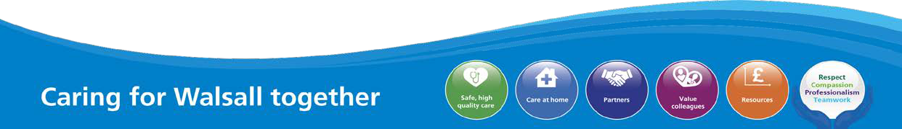
1

MEETING OF THE PUBLIC TRUST BOARD – 3rd June 2021
People and Organisational Development Committee (PODC) Highlight Report |  |  | AGENDA ITEM: 18
Report Author and Job Title: | Trish Mills Trust Secretary | Responsible Director: | Junior Hemans (Non- Executive Director and Chair)
Action Required | Approve ☐ Discuss ☐ Inform ☒ Assure ☒
Executive Summary | The report provides the key messages from the People and Organisational Committee meeting on 27th May 2021. Of note are:  - The Committee received the Freedom to Speak Up Guardians’ report for Q4 2020/21, which is also before the Board. The Committee is encouraged by an increase in the reporting of concerns. Whilst this highlights issues, it also illustrates that staff are aware of the routes to speaking up, and are confident in that vehicle as a way to be heard. There is still work to be done to close the loop on feedback as well as an opportunity to triangulate staffing concerns reported with the safe staffing report that also comes to the Committee.  - The Committee commended the performance and the improvements made in the workforce metrics including sickness, turnover, staff retention and statutory and mandatory training levels, whilst recognising there is still work to do to improve appraisal compliance.  - There is a great deal of improvement work underway in the Value our Colleagues workstream of the Improvement Programme. The Committee Chairs have agreed to meet with the workstream leads before the next round of meetings to discuss the ways in which assurance reporting will be presented to the Committees on progress and outcomes from the Improvement Programme.  - Effectiveness reviews for Board Committees will take place in July/August, however this Committee has reviewed it progress against its priorities set for 2020/21 ahead of that review. Those priorities were as follows:  - Development and finalisation of the Project Initiation  Documents (PIDs) for the Value our Colleagues workstream.


2
Completed: The PIDs were approved in January 2021
- Review at a greater depth the board assurance framework and actions to mitigate and manage risks (both strategic and corporate). Completed: The Committee reviews these at each meeting.
- Development of the equality, diversity and inclusion strategy. Completed: Initial review of the strategy in January 2020 and approval in April 2021, with final approval by Board in May 2021.
- Development of the health and wellbeing strategy. Not Completed: This was due for review in December and was delayed due to COVID-19 and the capacity of the Occupational Health team who were diverted to support the pandemic. In December 2020 the Committee were updated on progress. The timelines for delivery of the strategy have been re-phased in the Improvement Programme IP and the Occupational Health team are maturing this into an evidence based strategy. This will be carried forward into 2021/22 for review by the Committee in Q3.
- The Committee has set the following priorities for 2021/22:
  - Development of the health and wellbeing strategy (carried over from 2020/21).
  - A review of the Terms of Reference and reporting requirements for each group reporting to the Committee.
  - Agree and monitor reporting and assurance regime from the Equality, Diversity and Inclusion Group on the Equality, Diversity and Inclusion Strategy.
- The Committee received the compliance with attendance at work policy internal audit review for noting.
The next meeting of the Committee will take place on 24th June 2021.
Recommendation | Members of the Trust Board are asked to note the report and the escalations for its attention.
Risk in the BAF or Trust Risk Register | BAF S04 – Culture (lack of an Inclusive and open culture impacts on staff morale, staff engagement, staff recruitment, retention and patient care)
Resource implications | There are no new resource implications associated with this report.

Legal, Equality and Diversity implications | This Committee supports the Trust’s approach to delivering equality, diversity and inclusion for the benefit of the patient population and staff who work for the Trust and who live in Walsall. .
Strategic Objectives | Safe, high quality care ☐ | Care at home ☐
Strategic Objectives | Partners ☐ | Value colleagues ☒
Strategic Objectives | Resources ☐



MEETING OF THE PUBLIC TRUST BOARD – 3rd June 2021
Value our Colleagues – Executive Update |  |  | AGENDA ITEM: 19
Report Author and Job Title: | Catherine Griffiths – Director of People and Culture | Responsible Director: | Catherine Griffiths – Director of People and  Culture
Action Required | Approve ☐ Discuss ☐ Inform ☒ Assure ☒  This report provides an update on actions taken last month relating to the Value Our Colleagues work-stream of the improvement programme. The following points seek to inform the Trust Board of progress, identify where assurance can be taken and where required to seek approval for actions proposed.  1. Progress on agency reduction  The People and Organisation Development Committee noted and approved the safe staffing report, which shows that at 30th April 2021, there was a gap of 100 registered nurses, a vacancy rate of just below 9%. The scheduled international recruitment will close this gap by October 2021 by bringing 125 RN’s to the Trust in cohorts, supported by the FORCE team and the Royal Wolverhampton programme which includes comprehensive pastoral support to ensure retention of international nurses. The first cohort of 30 international nurses started with the Trust in May 2021, a further 40 will arrive in June; all are being supported with development including OSCE. In addition a further 60 RN positions will be filled by domestic recruitment drawing on the successful Clinical Fellow approach from the RWT support team.  The vacancy rate for Clinical Support Workers remains close to zero percent at 0.37% - 36 clinical support workers (CSW) started work with the trust in April 2021. The recent recruitment campaign delivered in partnership with Walsall Housing Group and Walsall College has been very successful both in terms of closing the gap for CSWs which stood at 55 WTE in November 2020 and in establishing the principles and approach for the trust becoming recognised as an anchor institution and employer within the borough, this recruitment  was also cross sector including health and social care. NHSI/E has

used the trust approach as a case study for best practice across the Black Country STP system and across the region.

The other area of significant agency activity is estates and facilities with a gap of 52 WTE in support and ancillary roles. The recruitment campaign is taking place in partnership with Walsall Housing Group and Walsall College with the aim of reaching full establishment by end of quarter one.

- The Staff Experience and Engagement Oversight Group exists to give assurance to the People and Organisation Development Committee and Trust Board on the outcomes of the action plan for improving NHS Staff Survey results for the 2021 Survey. This month the Medicine and Long Term Conditions Division (MLTC) and the Women’s and Children’s Division (WCSS) present their actions to date. The Pulse Survey is live with a current trust response rate of 36% at 27th May 2021, the Corporate Services response rate is currently 60% and the survey closes in two weeks. During this month Sherwood Forest presented to members of the group on their three year journey from special measures to high performance on NHS staff survey outcomes and indicators. There is a joint forum established with RWT and learning from good practice survey results is an element of the collaboration taking place. The action plan is on track and the communication and engagement plan leading up to the National Staff Survey 2021 has been initiated.

- The Trust Board approved the improvement trajectory for People Management metrics at its April meeting, these show significant improvement and are shown at appendix one. In this month there has been significant focus on recruitment and retention, specifically with 287 managers trained on the Recruitment and Selection process and a newly launched policy and toolkit to achieve the inclusive recruitment outcomes detailed within the EDI strategy. The Cultural Ambassadors have completed their training and are actively supporting panels with a values based approach to recruitment and compliance challenge on recruitment decisions.

- The Trust Board can be assured that plans for health and wellbeing continue to be developed and during the month the Haven has opened for extended hours into the evening and at weekends as a pilot following requests from colleagues. The Occupational Health

and Wellbeing team is in the process of recruiting to an occupational psychologist post in order to support the commitment given by the Board that mental health support will be available to colleagues for as long as it is required. This month, the first Schwartz Round steering group met to develop the annual plan, next round due in June 2021 and there is a detailed programme of Team Time sessions to complement the rounds.

- The Faculty of Medical Leadership and Management development programme continues to focus efforts on developing leadership within the trust, it has been well received and it provides a focus on equality outcomes and developing skills and understanding of an inclusive leadership approach, whilst leading for performance improvement in a compassionate framework that supports a just, restorative and learning culture. The development of just culture and compassionate leadership is particularly important to turning around the high levels of reported bullying and harassment within the NHS Staff Survey 2020.

- The People and Organisational Development Committee reviewed the Board Assurance Framework (BAF) risk mitigations which have been divided into the three elements of the improvement programme to provide more granular detail on the controls and assurances in place. The three elements are as follows:

  - Leadership, Culture and Organisation Development
  - Organisation Effectiveness
  - Making Walsall (and the Black Country STP) the best place to work

- The Trust Board are asked to note that the COVID-19 Hospital Vaccination Hub which opened on 8th December 2020 had as at the 11th May 2021 vaccinated 84.83% of Walsall Healthcare NHS Trust staff overall. Within this, 89.25% of our high-risk colleagues have been vaccinated [100% offer rate] 84.92% of our clinically extremely vulnerable staff have been vaccinated [100% offer rate] 78 % of our Black, Asian and Minority Ethnic colleagues have been vaccinated [100% offer rate] work continues with community and colleague networks to address the particular issues faced by colleagues in fully accessing the offer.

Executive Summary | This report provides an overview of the risks to delivery for the Value Our Colleagues’ strategic objective and provides an update on the mitigations in place to manage the risks identified, as well as the actions identified to address gaps in controls and assurance. It provides the Trust Board with assurance relating to the improvement programme Value Our Colleagues work-stream and performance against the Value Our Colleagues strategic objective, this report highlights successes and identifies assurance gaps  and areas for improvement.
Recommendation | - Members of the Trust Board are asked to note the report and in particular note the activity and progress on reaching a position of no general agency use within the trust by October 2021.  - Members of the Trust Board are asked to note the update on staff survey response and action planning.
Does this report mitigate risk included in the BAF or Trust Risk Registers? please outline | This report addresses BAF Risk Value our Colleagues in order to provide positive assurance the mitigations in place to manage this risk and the related corporate risks.
Resource implications | There are resource implications that flow from recommendations in the report. In the short-term the resource requirements are being met from base budgets. The improvement programme, engagement and OD approach will require investment beyond the base budget in order to achieve the milestones and progress envisaged by 2022-2023.
Legal and Equality and Diversity implications | There are significant issues relating to equality arising from matters addressed in the report. The Trust Board has been presented with the evidence base for differential staff experience based on ethnicity, disability, age, sexuality, gender, religion and other protected characteristics.  This goes to the heart of both the Trust Board pledge and the Trust values and supporting behaviours. The improvement programme seeks to mitigate the risk on the BAF, noting the low baseline and the considerable challenge of achieving outstanding performance across the  metrics by 2022-23. In addition the valuing our colleagues work-stream

seeks to ensure the systems the Trust relies upon can delivery equality of outcome relating to career progression, development, promotion, talent management and recruitment such that the workforce is representative of the communities it serves and can be seen as an anchor institution within Walsall.

The leadership and management development programmes both focus on equality outcomes and developing skills and understanding of an inclusive leadership approach, whilst leading for performance improvement in a compassionate framework that supports a just, restorative and learning culture.
Strategic Objectives | Safe, high quality care ☐ | Care at home ☐
Strategic Objectives | Partners ☐ | Value colleagues ☒
Strategic Objectives | Resources ☐

Value Our Colleagues – Improvement Programme

- EXECUTIVE SUMMARY

The Trust Board made a pledge relating to Value Our Colleagues as follows:

“We the Trust Board, pledge to demonstrate through our actions that we listen and support people. We will ensure that the organisation treats people equally, fairly and inclusively with zero tolerance of bullying. We uphold and role-model the Trust values chosen by you”

The evidence available demonstrates that the pledge is not met consistently across the Trust. There are areas of good practice from which we need to learn; equally there are areas of poor and discriminatory practice which run counter to the trust values and which are normalised in some areas. The cultural heat maps set out the qualitative metrics measuring staff experience and the degree to which the pledge is achieved by department level.

The purpose of the Value Our Colleagues enabling work-stream of the improvement programme is to deliver workforce improvement so colleagues recommend the Trust as a place to work and as a place to be treated. Colleague experience has a direct correlation with patient experience and outcomes.

The focus on developing leaders and managers to role model the behaviours and values of the trust is a critical lever to change the direction of travel and to appreciate and build on good practice, learn from it and embed it elsewhere.

- BOARD ASSURANCE FRAMEWORK

The Board Assurance Framework (BAF) Risk for Value our Colleagues provides that lack of an inclusive and open culture impacts on staff morale, staff engagement, staff recruitment, retention and patient care. The BAF has been updated to provide a greater detail on controls and assurances for each element of the improvement programme. The three elements are as follows:
  - Leadership, Culture and Organisation Development
  - Organisation Effectiveness
  - Making Walsall (and the Black Country STP) the best place to work

- PERFORMANCE REPORT

The workforce metrics performance element of this report takes a standard set of quantitative metrics and tracks performance over time, the summary is shown at appendix one and shows clear evidence of improvement on the people metrics including sickness, turnover, statutory and mandatory training all of which met target last year and are rated green. The recovery for appraisal compliance is set for the end of June, the new appraisal process provides a more systematic approach to training and development needs analysis, talent and succession planning and includes values and the behavioural framework.

The qualitative metrics on staff experience will be tracked against the improvement programme planned outcomes and a similar summary sheet will be used to demonstrate progress against the staff experience metrics including engagement, speaking up, experience of bullying and harassment, discrimination and rating for health and wellbeing.

- IMPROVEMENT PROGRAMME

There are 29 overarching projects in the Value Our Colleagues’ work-stream, these are structured into three sub-work-streams as follows:

  - Leadership, Culture and OD
  - Organisation Effectiveness
  - Making Walsall (and the Black Country) the best place to work

Progress on agency reduction
The People and Organisation Development Committee noted and approved the safe staffing report, which shows that at 30th April 2021, there was a gap of 100 registered nurses and midwives. The scheduled international recruitment will close this gap by October 2021 by bringing 125 RN’s to the Trust in cohorts, supported by the FORCE team and the Royal Wolverhampton programme which includes comprehensive pastoral support to ensure retention of international nurses. The first cohort of 30 international nurses started with the Trust in May 2021, a further 40 RNs will start in June: all are being supported with development including OSCE. In addition a further 60 RN positions will be filled by domestic recruitment drawing on the successful Clinical Fellow approach from the RWT support team.

The vacancy rate for Clinical Support Workers (CSW) remains close to zero percent (0.37%), 36 CSW’s started with the Trust during April. The recent recruitment campaign delivered in partnership with Walsall Housing Group and Walsall College has been very successful both in terms of closing the gap for CSWs which stood at 55 WTE in November 2020 and in establishing the principles and approach for the trust becoming recognised as an anchor institution and employer within the borough, this recruitment was also cross sector including health and social care. NHSI/E has used the trust approach as a case study for best practice across the Black Country STP system and across the region.

The other area of significant agency activity is estates and facilities with a gap of 52 WTE in support and ancillary roles. The recruitment campaign is taking place in partnership with Walsall Housing Group and Walsall College with the aim of reaching full establishment by end of quarter one. The significance of providing local employment opportunities on longer term health and social equality outcomes for the communities served cannot be overstated.

Joint work has started on creating new roles to address other gaps, such as identifying a Anaesthetics Fellow to respond to the shortage of training rotation places and to the requirement for pre-planned support for the winter period.

There is additional work taking place building on the trust’s approach to Princes Trust and setting down routes to apprenticeships along with further developing a joint approach between the trusts to improve inclusive employment and equality of opportunity outcomes.

Progress on action planning for National Staff Survey 2021

The Staff Experience and Engagement Oversight Group exists to give assurance to the People and Organisation Development Committee and Trust Board on the outcomes of the action plan for improving NHS Staff Survey results for the 2021 Survey. The group is a multi-disciplinary forum representing all divisions and corporate areas. The Freedom to Speak up Guardians, Staff Network Groups and Staff Side are represented at the group which meets on a monthly basis to oversee the work planned in response to the key messages from the National Staff Survey 2020. This month the Medicine and Long Term Conditions Division (MLTC) and the Women’s and Children’s Division (WCSS) present their actions to date. The Pulse Survey is live with a current response rate of 36% at week ending 27th May 2021, it closes in two weeks; the Pulse captures qualitative data as well as taking a temperature check on the key messages from the 2020 National Staff survey. During this month Sherwood Forest presented to members of the group on their three year journey from special measures to high performance on NHS staff survey outcomes and indicators. There is a joint forum established with RWT and learning from good practice survey results is an element of the collaboration taking place. The action plan is on track and the communication and engagement plan leading up to the National Staff Survey 2021 has been initiated.

The Trust Board approved the improvement trajectory for People Management metrics at its April meeting. The summary quantitative metrics can be seen at appendix one and a corresponding set of qualitative metrics are being developed to capture staff experience, these include FTSU concerns raised and the effectiveness of the feedback loop, HR cases on bullying and harassment, staff engagement indicator, discrimination and response on health and wellbeing. The Committee noted that the Trust is one year into the three year improvement programme with foundation work complete. The work on engagement requires further investment with plans in place to ensure the positive outcomes of the improvement work are widely understood. In this month there has been significant focus on recruitment and retention, specifically with 287 managers trained on the Recruitment and Selection process and newly launched policy. The Cultural Ambassadors have completed their training and are actively supporting panels with a values based approach to recruitment and compliance challenge on recruitment decisions.

Progress update on Health and Wellbeing
The Trust Board can be assured that plans for health and wellbeing continue to be developed and during the month the Haven has opened for extended hours into the evening and at weekends as a pilot following requests from colleagues. The Occupational Health and Wellbeing team will recruit to an occupational psychologist post in order to support the commitment given by the Board that mental health support will be available to colleagues for as long as it is required. This month, the first Schwartz Round steering group met to develop the annual plan, next round due in June 2021 and there is a detailed programme of Team Time sessions to complement the rounds.

Progress Report on Leadership and Management Development.
The Faculty of Medical Leadership and Management development programme continues to focus efforts on developing leadership within the trust, it has been well received and it provides a focus on equality outcomes and developing skills and understanding of an inclusive leadership approach, whilst leading for performance improvement in a compassionate framework that supports a just and learning culture. The development of just culture and compassionate leadership is particularly important to turning around the high levels of reported bullying and harassment within the NHS Staff Survey 2020.

The Vaccination Centre
The Trust Board are asked to note that the COVID-19 Hospital Vaccination Hub which opened on 8th December 2020 had as at the 11th May 2021 vaccinated 84.83% of Walsall Healthcare NHS Trust staff overall. Within this, 89.25% of our high-risk colleagues have been vaccinated [100% offer rate] 84.92% of our clinically extremely vulnerable staff have been vaccinated [100% offer rate] 78 % of our Black, Asian and Minority Ethnic colleagues have been vaccinated [100% offer rate] work continues with community and colleague networks to address the particular issues faced by colleagues in fully accessing the offer.

- RECOMMENDATIONS
- Members of the Trust Board are asked to note the report and in particular note the activity and progress on reaching a position of no general agency use within the trust by October 2021.

- Members of the Trust Board are asked to note the update on staff survey response and action planning for the National Staff Survey 2021.

- Members of the Trust Board are asked to note the progress from the improvement programme and in particular to note the workforce summary report which shows clear improvement against key workforce metrics from baseline position. To note the recovery plan for appraisal by end of quarter one.

APPENDICES

Workforce Summary Metrics – Appendix One



Workforce Performance Summary – April 2021
Turnover
(12 Months)
8.5%
Appraisals
76.4%
Key Workforce Indicators
Retention
(24 Months)
82.8%
Mandatory Training
91.1%
Sickness (In Month) 4.2%
(Rolling 12M)
5.0%

 | Target | Will We Consistently Meet The Target? | Is Performance Stable?
Sickness Absence | 4.5% | Sometimes | Getting Better
Mandatory Training Compliance | 90% | Sometimes | Getting Better
Appraisal Compliance | 90% | No | Yes
Turnover (12 Months) | 10% | Sometimes | Getting Better
Retention (24 Months) | 85% | No | Yes



MEETING OF THE TRUST BOARD - 3rd June 2021
Update on Staff Experience and Engagement Oversight Group |  |  | AGENDA ITEM: 20
Report Author and Job Title: | Catherine Griffiths –  Director of People and Culture | Responsible Director: | Catherine Griffiths –  Director of People and Culture
Action Required | Approve ☐ Discuss ☐ Inform ☒ Assure ☐
Executive Summary | The Staff Experience and Engagement Oversight Group was established in March 2021 to provide a Trust-wide response to the National Staff Survey (NSS) report 2020 and to plan for the NSS 2021.  The People and Organisational Development Committee (PODC) approved terms of reference for the Group, which is a multi-disciplinary forum representing all divisions and corporate areas. The Freedom to Speak Up Guardians, Staff Network Groups and Staff Side are represented at the group which meets on a monthly basis to oversee the work responding to the key issues and messages within the 2020 staff survey. The Improvement Programme, Value our Colleagues sets out the OD Framework and milestones towards improving the culture within the Trust to deliver the improvement planned to improve colleague experience of working within the trust, such that colleagues recommend the trust as a place to work and a place to be treated.  The Oversight group is focused on delivering the short-term actions required in response to the 2020 staff survey, including the following:  - Improving the response rate to the 2021 survey to at least national median level at 45% with an aspiration to achieve 60%.  - Engaging the Divisions and all colleagues in defining improvement action in the short term, including learning from the best organisations for each of the national survey themes.  - Introducing Pulse surveys during May 2021, to temperature check key indicators such as colleague advocacy, ability to contribute to improvement, ability to speak up confidently, leadership and culture including bullying and harassment and discrimination.  - Drawing together an action plan to complete short term actions in

response to the 2020 staff survey before the 2021 NHS staff survey is released. The action plan is being monitored by PODC with good progress.

5. Ensuring the communications and engagement plan is effective in communicating the positive changes that have taken place as a result of colleagues taking time to voice their opinions.
Recommendation | The Trust Board is asked to:  - Consider the Divisional presentations from MLTC and WCSS on plans for action and progress on improving the NHS staff survey results for 2021.  - Note the Pulse survey for May 2021 is currently live and will close in early June for reporting to PODC in July 2021.  - Note the approach to learning from best practice both within the NHS and across other sectors.
Does this report mitigate risk included in the BAF or Trust Risk  Registers? | There implications associated with this paper are specifically to bring clarity and assurance on the action planned to improve the advocacy scores and NHS staff survey results in 2021.
Resource implications | There are resource implications associated with this paper relating to the need to increase engagement resource within the trust.
Legal, Equality and Diversity | There are legal, equality & diversity implications associated with this paper. There is differential colleague experience evidenced through the national staff survey, WRES and WDES data. The Oversight Group seeks to ensure the plans put in place are sufficient to address these  implications and achieve equality of outcome on colleague experience.
Strategic Objectives | Safe, high quality care ☐ | Care at home ☐
Strategic Objectives | Partners ☐ | Value colleagues ☒
Strategic Objectives | Resources ☐


Public Trust Board – 3rd June 2021 Item 20, Appendix 1

2020 Staff Survey –
Women’s, Children’s and Clinical Support Services

Divisional Overview
0.2 below Trust score
0.1 below Trust score
Equal to Trust score
Up to 0.2 above Trust score
0.3 & above Trust score
Equal to or above benchmark average
Best Score for Trust

This overview highlights the variability in the theme scores across the different divisions. Whilst this variability can in part be attributed to the difference in size and complexity of the division and the impact that Covd-19 will have had on the experience of colleagues working within the divisions, there is no difference in terms of the required ownership of results and accountability for improvement by divisional leadership teams. The heat map below identifies safety culture as the most deteriorated theme (6 reds) closely followed by; immediate line manager, morale and team working. It should be noted that the Medical Directorate received too few responses to provide analysis against the ten themes.

 | Benchmark Average | Trust | Community | MLTC | Surgery | WCCSS | E&F | CEO &  Governance | Transformation & Strategy | Finance | Informatics | Nursing Directorate | Operations | P&C
Response Rate (%) | 45 | 33 | 42 | 20 | 25 | 34 | 36 | 74 | n/a | 51 | 37 | 51 | 38 | 57
EDI | 9.1 | 8.7 | 9.2 | 8.0 | 8.6 | 8.7 | 8.9 | 9.3 | 7.1 | 9.3 | 8.3 | 9 | 6.5 | 8.8
HWB | 6.1 | 5.7 | 5.9 | 5.5 | 5.3 | 5.6 | 6.1 | 5.9 | 6.8 | 7 | 4.9 | 5.8 | 3.4 | 6.8
Immediate Managers | 6.8 | 6.6 | 7.2 | 6.7 | 6.2 | 6.8 | 5.1 | 7.1 | 5.8 | 7.1 | 5.6 | 7.1 | 5.3 | 7.5
Morale | 6.2 | 5.9 | 6.1 | 5.7 | 5.7 | 6 | 5.9 | 5.9 | 4.7 | 5.9 | 4.8 | 5.8 | 5.2 | 6.2
Quality of Care | 7.5 | 7.3 | 7.6 | 7.1 | 7.2 | 7.3 | 7.4 | n/a | n/a | 7.3 | 6.5 | 6.9 | n/a | 7.5
Safe Environment Bullying & Harassment | 8.1 | 7.6 | 8.3 | 6.4 | 7 | 7.7 | 8.7 | 8.1 | 7.7 | 9.1 | 7.6 | 8.1 | 3.6 | 8.4
Safe Environment Violence | 9.5 | 9.5 | 9.7 | 8.6 | 9.5 | 9.7 | 9.5 | 10 | 9.6 | 9.8 | 9.9 | 9.8 | 8.1 | 9.9
Safety Culture | 6.8 | 6.3 | 6.6 | 6.4 | 6 | 6.4 | 6.1 | 6.6 | 5.9 | 5.7 | 5.1 | 6.2 | 5.4 | 6.5
Staff Engagement | 7 | 6.7 | 7 | 6.7 | 6.4 | 6.7 | 6.5 | 7.2 | 6.6 | 6.8 | 5.6 | 6.7 | 6.3 | 7.3
Team Working | 6.5 | 6.3 | 6.9 | 6.3 | 5.8 | 6.6 | 5.1 | 6.6 | 5.4 | 7.2 | 5.3 | 7.1 | 3.6 | 7

- A comparison between 2020 divisional results with those from 2019 identifies that across all themes there is a reduction in scores with the exception of safe environment – violence.

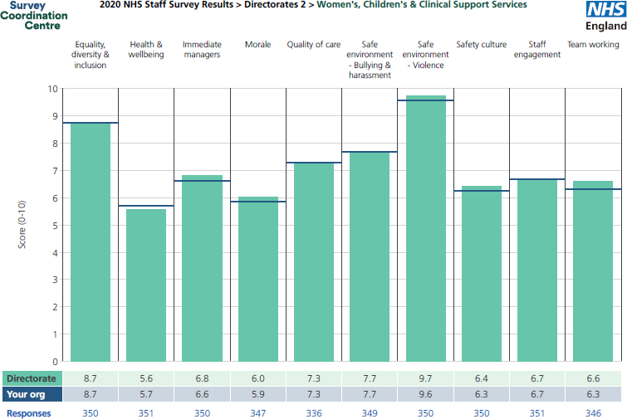
Divisional Picture – Women’s, Children’s & Clinical Support Services

- The WCCSS division received a 34% response rate (1% above the Trusts total response rate).
- Across the ten themes the Division have achieved an improved score compared to the Trust in the following areas:
  - Immediate line managers
  - Morale
  - Safe environment – Violence
  - Team working
  - Safety Culture

- The division have also equalled the Trust score in the following areas:
  - Equality, diversity & inclusion
  - Quality of care
  - Safe environment – bullying & harassment
  - Staff engagement

- The division is below the Trust score in the following area: Health & Wellbeing

Our Approach

  - Putting our people first

  - Taking time to think

  - Taking time to talk

Communication/Focus

  - Divisional Care Group Teams of three to take feedback from all staff within the care group on the results of the staff survey

  - Approach and ideas for WCCSS action plan:

- Circulate posters for inspiration and ideas (Attached)
- Equality, Diversion and Inclusion Strategy Session to be delivered on the 28th June. (All DDs and CGMs to attend)
- Discussion blog to be created via WCCSS on the Trust Intranet page
- Staff drop in sessions with Divisional Directors
- Link in with best performing (Top 3 Trusts) for staff survey

  - Plans to increase staff survey uptake for the division (33% to 50%)

Public Trust Board – 3rd June 2021 Item 20, Appendix 2

2020 Staff Survey –
Medicine & Long Term Conditions

Summary of results and plans for improvement

March 2021

Trust Overview
0.2 below Trust score
0.1 below Trust score
Equal to Trust score
Up to 0.2 above Trust score
0.3 & above Trust score
Equal to or above benchmark average
Best Score for Trust

- The Division of Medicine and Long Term Conditions received a 20% response rate (4% lower than 2019 and 13% lower than the Trust response rate).
- Across the ten themes the Division achieved an improved score compared to Trust-wide for ‘Immediate line managers’ and ‘Safety culture’
- Compared to 2019, improvements have been made in Health and Wellbeing / Morale / Quality of care / Safe environment
– Violence
 | Benchmark Average | Trust | Community | MLTC | Surgery | WCCSS | E&F | CEO &  Governance | Transformation & Strategy | Finance | Informatics | Nursing Directorate | Operations | P&C
Response Rate (%) | 45 | 33 | 42 | 20 | 25 | 34 | 36 | 74 | n/a | 51 | 37 | 51 | 38 | 57
EDI | 9.1 | 8.7 | 9.2 | 8.0 | 8.6 | 8.7 | 8.9 | 9.3 | 7.1 | 9.3 | 8.3 | 9 | 6.5 | 8.8
HWB | 6.1 | 5.7 | 5.9 | 5.5 | 5.3 | 5.6 | 6.1 | 5.9 | 6.8 | 7 | 4.9 | 5.8 | 3.4 | 6.8
Immediate Managers | 6.8 | 6.6 | 7.2 | 6.7 | 6.2 | 6.8 | 5.1 | 7.1 | 5.8 | 7.1 | 5.6 | 7.1 | 5.3 | 7.5
Morale | 6.2 | 5.9 | 6.1 | 5.7 | 5.7 | 6 | 5.9 | 5.9 | 4.7 | 5.9 | 4.8 | 5.8 | 5.2 | 6.2
Quality of Care | 7.5 | 7.3 | 7.6 | 7.1 | 7.2 | 7.3 | 7.4 | n/a | n/a | 7.3 | 6.5 | 6.9 | n/a | 7.5
Safe Environment Bullying & Harassment | 8.1 | 7.6 | 8.3 | 6.4 | 7 | 7.7 | 8.7 | 8.1 | 7.7 | 9.1 | 7.6 | 8.1 | 3.6 | 8.4
Safe Environment Violence | 9.5 | 9.5 | 9.7 | 8.6 | 9.5 | 9.7 | 9.5 | 10 | 9.6 | 9.8 | 9.9 | 9.8 | 8.1 | 9.9
Safety Culture | 6.8 | 6.3 | 6.6 | 6.4 | 6 | 6.4 | 6.1 | 6.6 | 5.9 | 5.7 | 5.1 | 6.2 | 5.4 | 6.5
Staff Engagement | 7 | 6.7 | 7 | 6.7 | 6.4 | 6.7 | 6.5 | 7.2 | 6.6 | 6.8 | 5.6 | 6.7 | 6.3 | 7.3
Team Working | 6.5 | 6.3 | 6.9 | 6.3 | 5.8 | 6.6 | 5.1 | 6.6 | 5.4 | 7.2 | 5.3 | 7.1 | 3.6 | 7

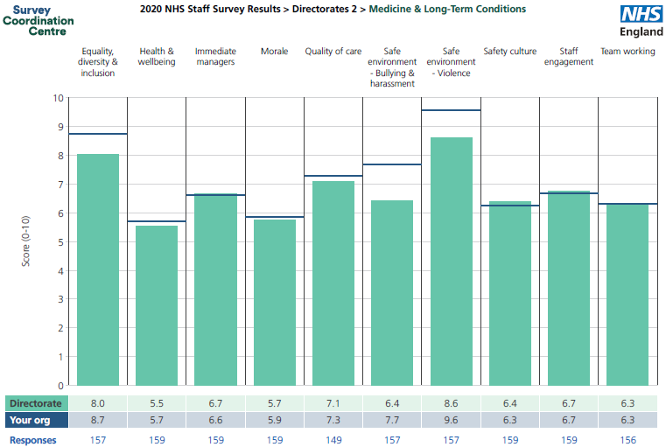

Divisional Picture – Medicine & Long-Term Conditions

Results

- Scores in 2/10 themes are below the worst peer benchmark average;

  - Safe environment – bullying & harassment
  - Safe environment – violence

- The division have also equalled the Trust score in the following areas:

  - Staff engagement
  - Team working

- The divisional results for safe environment – bullying and harassment has remained static at 6.4 for the second year running (against a Trust 2020 score of 7.7)

Progress So Far

  - Survey results discussed at April Divisional Quality Board (DQB), workshop held during DQB to develop action plan
  - Open house visits initiated to listen to staff concerns
  - #TeamMedicineAwards launched (6 months ago) to recognize staff/team contributions, awarded monthly at DQB
  - Feedback and Coaching process designed for UKME staff who have not been successful in securing job role
  - Cultural/Religious calender identified for the next 12 months to connect with staff by celebrating those events. Eid-ul-Fitr celebrated on May 13

Progress So Far

  - “Everyone Matters” campaign designed in order to allow staff to share their feedback and concerns anonymously
  - “Stay Interview” process designed to improve staff retention
  - As part of the induction process, a 30/60/90 day feedback process designed for new starters
  - #MedicineWeeklyWraps newsletter to include the 5 things staff need to know eg. Safety/Knowledge/Congratulations go to….
  - Health & Well Being boards in all staff rooms

Next Key Steps

  - Identify EDI training package and conduct training for Ward/Service Managers
  - Review concerns raised with FTSUG team and establish how Division and FTSUG share information
  - Divisional and Care Group team of 3 walk-abouts to be arranged
  - Team Time & Schwartz rounds currently being arranged by several wards and areas
  - Monthly Matron surgeries re-instated with Ward Managers
  - MAPA (Violence & aggression) training for ED and Ward teams arranged for June/July

MEETING OF THE PUBLIC TRUST BOARD - 3rd June 2021
Evaluation of progress against Trust Board Pledge. |  |  | AGENDA ITEM: 21
Report Author and Job Title: | Catherine Griffiths,  Director of People & Culture | Responsible Director: | Catherine Griffiths,  Director of People & Culture
Action Required | Approve ☐ Discuss ☐ Inform ☒ Assure ☐
Executive Summary | The terms of reference for the People and Organisational Development Committee were updated in August 2020 to reflect assurance that demonstrate the Trust Board’s compliance to its pledge to:  “Demonstrate through our actions that we listen and support people. We will ensure the organisation treats people equally, fairly and inclusively, with zero tolerance of bullying. We uphold and role model the Trust values chosen by you”.  The People and Organisation Development Committee approved a set of key performance indicators against which the impact of the Trust Board pledge could be measured which are shown at Appendix 1.  Addressing inequality within the workplace is fundamental to an improved colleague experience and organisational culture and the benefits realisation plan within the improvement programme captures this.  The people based metrics have been accepted by the People and Organisation Development Committee and the Improvement Board in relation to measuring the benefits of the Value Our Colleagues improvement programme and these are embedded in the accountability framework and the divisional performance reviews.  There is a significant cost to bullying and harassment within the workplace and this is being reviewed at system level.
Recommendation | The Trust Board asked to note the performance relating to the Trust Board pledge contained within the report.
Does this report mitigate risk included in the BAF or Trust Risk Registers? please outline | The following risk is held on the BAF; “Lack of an Inclusive and open culture impacts on staff morale, staff engagement and patient care”. In terms of controlling the risk, a first line level of defence is to ensure the workforce policy and procedural framework is legally and contractually  complaint and up to date with best practice.
Resource implications | The improvement program requires investment beyond the base budget in order to achieve the milestones and progress envisaged by 2022-2023 to create a consistently healthy organisational culture able to support and  achieve top quartile performance in the indicators set.

Legal and Equality and Diversity implications | Equality, diversity and inclusion is fundamental to the Value Our Colleagues Improvement Programme the impact of which is measured externally through the Workforce Race and Workforce Disability Equality Standards data, Gender Pay Gap and National Staff Survey.
Strategic Objectives | Safe, high quality care ☐ | Care at home ☐
Strategic Objectives | Partners ☐ | Value colleagues ☒
Strategic Objectives | Resources ☐

Introduction

In August 2020 the terms of reference for PODC were updated to reflect the requirement of the Committee to seek sources of assurance that demonstrated the Trust Board’s compliance to its pledge to “demonstrate through our actions that we listen and support people. We will ensure the organisation treats people equally, fairly and inclusively, with zero tolerance of bullying. We uphold and role model the Trust values chosen by you”.

At the time, the Committee were provided with a proposed set of key performance indicators against which the impact of the Trust Board Pledge could be measured over a 12 month period and Trust Board reviewed the cost of bullying and harassment within the organisation and approved the approach to developing a Just, Restorative and Learning culture within the Trust as a major part of the organisation development plan to change and improve the culture.
A number of people related indicators have now been approved by the Improvement Board, the People and Organisation Development Committee and Trust Board these are embedded in the accountability framework relating to staff experience.
Background

In March 2021 the Committee approved the Value Our Colleagues improvement trajectory, receiving the position for key people metrics relating to 2019 and the proposed targets required to achieve an outstanding CQC rating (Appendix 1). The trajectory plotted progress achieved in the foundation year one of the improvement programme (2020), to year 2 (2021) aligned with good performance on the people management metrics through to planned outstanding performance on people metrics by year 3 (2022-23).
Assessment

Of the proposed data set, the following Trust Board Pledge measures have been assessed as follows:
    - Employee engagement index score (NSS)
    - Equality, diversity and inclusion index score (NSS)
    - Harassment & Bullying index score (NSS)
    - WRES indicators
    - WDES indicators
    - Turnover
    - Staff recommendation as best place to work (NSS and local pulse survey)
    - % of staff saying the organisation takes a positive interest in their health and wellbeing (NSS)
    - No of SA days taken as a result of bullying and harassment (linked to NSS)
    - Increase in the number of ethnic minority colleagues in B7 and above roles
    - Reduction of B&H and Grievance case work relating to behaviours.
3

The update against the baseline information provided from 31 July 2020 against 31 March 2021 is provided below (table 1).
Table 1.

Measure | 2019 | 2020 | VOC KPI’s
1. Employee Engagement Score (NSS indicator) | 6.6 | 6.7 | ✓
2. % of staff saying their manager takes a positive interest in their health and wellbeing (NSS indicator) | 68.2% | 69.2% | ✓
3. No of SA days taken as a result of bullying and harassment. (STP comparison pending) | 4.64 days | 3.77 days | X
4. Reduction in voluntary turnover rates | 82% | 82.7% | ✓
5. Reduction of B&H and Grievance case work relating to behaviours. | 32 cases  (August 2019-  2020) | 37 cases (Sept  2020 – March  2021 | ✓
6. Increased BAME representation in B7 and above roles | Total 18.81%  B7 9.5%  B8a + 4.6% | Total 19.17%  B7 9.7%  B8a + 4.7% | ✓

As the table demonstrates between September 2020 and March 2021 there have been small improvements which indicate that operational and strategic interventions within the Value our Colleagues improvement programme are beginning to make positive impact.
There has been an increase in the number of concerns relating to behaviours represented in employment relations activity. Whilst the ultimate intention is to seek to create healthy organisational and team cultures to reduce such incidences, it is reassuring that colleagues are speaking up and seeking support to address inappropriate behaviours.
Recommendations

The Trust Board is asked to note the contents of this report and the people metrics being used to monitor outcomes that support the pledge.
The Trust Board is asked to note the People and Organisation Development Committee will seek assurance on realisation of the benefits contained within the Improvement Programme.

Public Trust Board – 3rd June 2021 Item 21, Appendix 1

Strategic Framework for
Organisation Development
Developing a Healthy Culture



Vision: Caring for Walsall Together
Ambition: To be rated as outstanding by the CQC for our services by 2022.
Strategic Objectives
Valuing Colleagues | Safe, high quality care |  | Care at home | Working with Partners |  | Using our resources well
Leadership, Culture & OD |  | Organisational Effectiveness |  |  | Making Walsall the Best Place to Work
- To design and implement an organisational development approach to support an inclusive and just culture.  - To equip the workforce with the necessary skills and frameworks to lead, design and deliver the aim of being an outstanding organisation.  - To develop and deliver a collaborative leadership development programme with Walsall Together partners and STP collaborative partners.  - To develop the values, behaviours within the Trust using NHSI culture programme to achieve the Board pledge evidenced through the national staff survey.  - To co-design EDI strategy with staff, patient, community/voluntary groups.  - Identify clear accountability framework for people management metrics in line with National People Plan. |  | - To identify and design new roles and career pathways to shape the future workforce for Walsall and across the Black Country STP.  - To develop a sustainable operational workforce plan as part of the Black Country STP.  - To implement the Black Country Collaborative Bank and reduce reliance on temporary workforce.  - To design and implement a shared approach to talent and succession planning to improve flexibility and agility of the workforce.  - To extend the equality, diversity, inclusion approach within the workforce.  - Develop the Trust approach to work/life balance and improve retention rates.  - To improve levels of attendance at work.  - To design a framework for introducing Divisional Boards for accountability and planning. |  |  | - To provide a structured and holistic approach to workplace health and wellbeing in collaboration with STP partners.  - To provide a structured and consistent approach to workplace education, learning and development with STP partners.  - Ensuring everyone feels they have voice, control and influence, developing the freedom to speak up approach and partnership with staff- side.  - To ensure the trust values are experienced by all and improve staff engagement scores and staff advocacy for Walsall as a place to work.  - To improve staff advocacy for Walsall as a place to be treated.  - Develop the Trust approach to corporate social responsibility and as a key employer within the community.  - To provide a structured approach to the pay, employment and benefits offer available.

Valuing our Colleagues – Moving from Baseline to Good to Outstanding
Measures BASELINE 2019 – Actual Results | FOUNDATION 2020 - Actual Results | GOOD 2021/2022 to OUTSTANDING 2022/2023 – Aspirational
National Staff Survey 2019  Recommend as a Place to Work FFT (Q18c)  BASELINE 47.8%  Recommend as a Place to be Treated FFT (Q18d)  BASELINE 49% | National Staff Survey 2020 Recommend as a Place to Work 52.3%  Recommend as a Place to be Treated FFT 53.4% | Recommend as a Place to Work FFT increasing to  GOOD all England average by 2021/2022 67% [survey 2020]  OUTSTANDING top quartile by 2022/2023 84% [survey 2020]  Recommend as a Place to be Treated FFT increasing to  GOOD all England average by 2022/2023 74% [survey 2020]  OUTSTANDING top quartile by 2022/2023 92% [survey 2020]
Staff saying they feel involved in improvements (Q4b)  BASELINE 70%  Staff Engagement  BASELINE 6.6  National Staff Survey Response Rate  BASELINE 31% | Staff saying they feel involved in improvements  70.5%  Staff Engagement  6.7  National Staff Survey Response Rate  33% | Staff saying they feel involved in improvements  GOOD 73%  OUTSTANDING 82%  Staff Engagement  GOOD 7.0 OUTSTANDING 7.6  National Staff Survey Response Rate  GOOD 45% [median survey 2020]  OUTSTANDING 80%
Improving Equality, diversity and Inclusion survey score in the NHS staff survey  BASELINE 8.8 | Equality, Diversity and Inclusion NSS theme Score  8.7 | Equality, Diversity and Inclusion NSS Theme Score  GOOD 9.1 [average]  OUTSTANDING 9.5 [best]
Sickness absence  BASELINE 6.82% | Sickness absence – Model Hospital – Target set 4.5% by 2022  4.9% [January 2021] | Sickness absence – Model Hospital GOOD 4.29% [median] OUTSTANDING 3.50% [top quartile]
Turnover to reach Trust target of 10 % by 2021 and top decile performance by 2022  BASELINE 11.64% | Turnover – Target set 10% by 2022  8.66% | Turnover – Target set 10% by 2022 GOOD % [top quartile] OUTSTANDING % [top decile]
Improving the staff wellbeing survey theme score in the NHS staff survey theme score  BASELINE 5.5  My manager takes an interest in my wellbeing (Q8f)  BASELINE 65% | Staff Wellbeing NSS theme Score  5.7  My manager takes an interest in my wellbeing (Q8f)  69% | Staff Wellbeing Theme Score  GOOD 6.1 [average]  OUTSTANDING 6.9 [best]  My manager takes an interest in my wellbeing (8f) GOOD 69 % [average] OUTSTANDING 77 % [best]
Improving WRES/WDES/Equality Performance against Equality Objectives – targets to be set to reflect community.  National Staff Survey – no equality differential on career opportunities, promotion to be evident by 2022 | Annual WRES /WDES Equality Data Quarterly review of actions at PODC Trust Board every 6 months | Staff are included and treated fairly and differential in NSS by equality characteristics reduces and discrimination is not tolerated

Valuing our Colleagues – Moving from Baseline to Good to Outstanding
Measures BASELINE 2019 – Actual Results | FOUNDATION 2020 - Actual Results | GOOD 2021/2022 to OUTSTANDING 2022/2023 – Aspirational
National Staff Survey 2019 Safety Culture – NSS Theme BASELINE 6.3  When errors, near misses or incidents are reported, my organisation takes action to ensure they do not happen again (Q16c)  BASELINE 59.6% | National Staff Survey 2020 Safety Culture NSS Theme 6.3  When errors, near misses reported (Q16c)  61.4% | Safety Culture NSS Theme increasing to  GOOD 2021/2022 6.8 [average 2020]  OUTSTANDING 2022/2023 7.4 [best 2020]  When errors,, near misses reported (Q16c)  GOOD 2022/2023 72.7% [average survey 2020]  OUTSTANDING 2022/2023 84.2% [best survey 2020]
Improving WRES/WDES/Equality Performance  BASELINE Indicator 2 WRES 2.73 recruitment  BASELINE Indicator 3 WRES 2.04 disciplinary BASELINE Indicator 4 WRES 0.94 access to training BASELINE Indicator 2 WDES TBC  BASELINE Indicator 3 WDES TBC BASELINE Indicator 4 WDES TBC | Improving WRES/WDES/Equality Performance  Indicator 2 WRES 1.52 recruitment  Indicator 3 WRES 0.65 disciplinary Indicator 4 WRES 1.34 access to training Indicator 2 WDES TBC  Indicator 3 WDES TBC Indicator 4 WDES TBC | Improving WRES/WDES/Equality Performance  Indicator 2 WRES 1.00 recruitment  Indicator 3 WRES 1.00 disciplinary Indicator 4 WRES 1.00 access to training Indicator 2 WDES 1.00 recruitment  Indicator 3 WDES 1.00 disciplinary Indicator 4 WDES 1.00 access to training
Reducing Bullying, Harassment & Discrimination – NSS Theme score  BASELINE 7.6 | Reducing Bullying, Harassment & Discrimination NSS theme score  7.6 | Reducing Bullying, Harassment & Discrimination NSS theme score  GOOD 2021/2022 8.1 [average 2020]  OUTSTANDING 2022/2023 8.7 [best 2020]
ER cases are concluded in line with just and learning culture resolved within time scale – reduction in formal cases. | 6 monthly Staff in Difficulty Report to JNCC, PODC, Trust Board May 2021 for October 2020 to March 2021  Nov 2021 for April 2021 to September 2021 | My organisation treats staff involved in an incident or near miss fairly (Q18a)  BASELINE WALSALL 2019 51.7%  FOUNDATION WALSALL 2020 48.2%  GOOD 2020 61.4% [average 2020]  OUTSTANDING 2020 71.1% [best 20
The opportunities for Flexible Working Patterns (Q5h)  BASELINE 50.9%  Gender Pay Gap – Hourly Wage Gap  BASELINE – women earn 77p for every £1 that men earn when comparing median hourly wages. Their pay is 23% lower. | Flexible Working Patterns (Q5h)  54.6%  FOUNDATION – women earn 86p for every £1 that men earn when comparing median hourly wages. Their pay is 14% lower. | Flexible Working Patterns (Q5h)  GOOD 2021/2022 55.5% [average 2020]  OUTSTANDING 2022/2023 64.9% [best 2020]  GOOD 2021/2022 ZERO GAP OUTSTANDING 2022/2023 ZERO GAP

Measures for Valuing Colleagues
Measures | Monitoring | Benefits
Recommend as a Place to Work FFT increasing to all England average by 2021 and to top quartile by 2022  Recommend as a Place to be Treated FFT increasing to all England average by 2022 | Measured through SFFT in Q1, 2 and 4 and NSS in Q3 | Staff feeling more valued, leads to reducing absence, increased retention, improved availability
Staff saying they feel involved in improvements increasing each quarter [Pulse Survey] Improved Staff Engagement score top quatile by 2021 and top decile by 2022 | Question to be included in [Pulse Survey] on involvement NSS each year | Provides a measure of staff morale and inclusion and staff engagement score
Quality of IPDR audit showing at least 80% positive responses and improved in NSS to top quartile by 2021 and top decile by 2022 | Monthly audit process developed including sample survey and sample auditing of appraisal documents – outputs reported monthly in Workforce Metric Report  NSS data reviewed in February annually | Staff receiving quality appraisals will feel more valued and supported, leading to reduced turnover and sickness, improved retention, clear career development pathways and structured talent management approach
Sickness absence reduced overall by at least 1% (KPI) by December 2020 and to top quartile by 2021 and top decile by 2022 | Monitored through ESR data and in Workforce Report  Each division will set specific targets based on hotspot areas and monitor through DMBs | Anticipated financial benefits and organisation effectiveness improvements through reduced reliance on temporary workforce (see PID)
Turnover to reach Trust target of 10 % by 2021 and top decile performance by 2022 | Monitored through ESR data and in People Report  Each division will set specific targets based on hotspot areas and monitor through DMBs | Anticipated financial benefits and organisational effectiveness improvements (see PID)
80% of staff report getting their breaks | Question in Pulse Survey to be developed | Staff wellbeing improved = reduced absence
Improving the staff wellbeing score as measured in the NHS staff survey to be top quartile by 2021 and top decile by 2022 | Annual NSS theme Score | Improved staff experience, improved wellbeing scores and reduced absence and reduced temporary workforce spend
Improving WRES/WDES/Equality Performance against Equality Objectives – targets to be set to reflect community.  National Staff Survey – no equality differential on career opportunities, promotion to be evident by 2022 | Annual WRES /WDES Equality Data Quarterly review of actions at PODC Trust Board every 6 months | Staff are included and treated fairly and differential in NSS by equality characteristics reduces and discrimination is not tolerated
Reducing Bullying, Harassment & Discrimination – achieving top quartile performance by 2021 and top decile by 2022 | Annual NSS theme score | Staff feel safe from harm at work = reduced turnover and sickness absence
ER cases are concluded in line with just and learning culture resolved within time scale – reduction in formal cases. | 6 monthly Staff in Difficulty Report | Staff feel supported appropriately – seeing a Just and Learning Culture develop

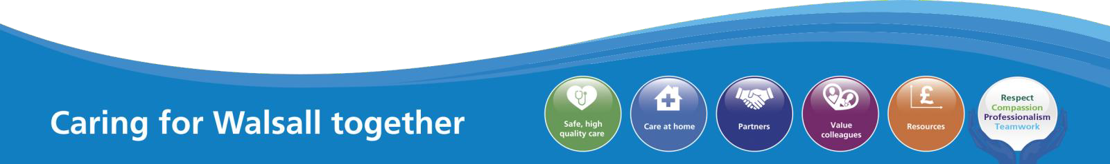
1

MEETING OF THE PUBLIC TRUST BOARD – 3rd June 2021
Safe Staffing Report |  |  | AGENDA ITEM: 22
Report Author and Job Title: | Caroline Whyte  Interim Deputy Director of Nursing | Responsible Director: | Ann-Marie Riley  Executive Director of Nursing
Action Required | Approve ☐ Discuss ☐ Inform ☒ Assure ☒
Executive Summary | - Registered Nurse (RN) /Midwife vacancy rate is currently just below 9% and has increased since last month.  - 16 overseas nurses are arriving in May and will commence their induction and introduction to departments. The total forecast is 125 overseas RN to be recruited by the end of 2021.  - There were 36 Clinical Support Workers (CSW’s) that have been recruited with the assistance of Walsall Housing Group and Walsall College that commenced in the Trust in April 2021. Current vacancy rate for CSW’s is 0.37%.  - Lowest fill rate was seen in the RN day shift at 91.72%. The overall fill rate (combined RN and CSW) was 95.7%.  - In April 2021, before consideration of escalation to Off Framework Agency, Matrons redeployed 494.5 hours of substantive RN and 319.5 hours of CSW during the twice daily Staffing Hub meetings.  - Staff experience audit for April 2021 this audit scored 91.33% which is an increase from 81% in March 2021. This audit contains 76 questions which fully align with the National NHS  Staff Survey 2020.
Recommendation | The Trust Board is requested to note the contents of the report
Does this report mitigate risk included in the BAF or Trust Risk Registers? please outline | BAF S01: We will deliver excellent quality of care as measured by an outstanding CQC rating by 2022  Corporate Risk No 2066: Lack of registered nurses and midwives
Resource implications | COVID-19 impact - staff are working in different ways and locations; risk to staff health and well-being; impact on training and continual professional development
Legal and Equality and Diversity implications | COVID-19 has impacted disproportionally on people who are men, from low socioeconomic backgrounds and from BAME backgrounds  Our local population is subject to multiple inequalities which affect quality of life, health and mortality.  Further work is required to consider how best we provide

 | assurance on equality, diversity and inclusion and the resulting impact on outcomes.
Strategic Objectives | Safe, high quality care ☒ | Care at home ☐
Strategic Objectives | Partners ☒ | Value colleagues ☐
Strategic Objectives | Resources ☒

2

Introduction

COVID-19 impact has reduced across the Trust with some services now involved in restoration of services. However, there are still some reconfigured areas within the acute departments which are working with COVID-19 streaming, different patient groups and vacancies/absences that are impacting ability to have complete fill of shift requirements. Corporate Risk 2066: Lack of registered nurses and midwives remains at 15.
  - Nurse Staffing Update

  - Vacancy Position

The RN and Midwifery vacancy rate for April is just below 9% (100 whole time equivalents) (see Chart 1). The slight increase in vacancies are attributable to two Divisions and can be seen in the charts below (Charts 2 and 3). The increase in midwives is predominantly due to the release of vacancies in response to the approval of the Birthrate Plus recommendations rather than in increase in leavers.
Chart 1: Nursing and Midwifery vacancy % (excluding Nurse Associates)
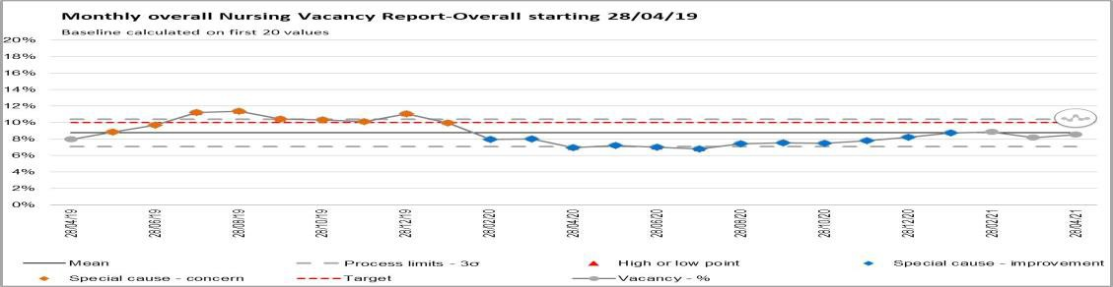

Chart 2: Divisional Vacancy breakdown WTE – MLTC (information via ESR)
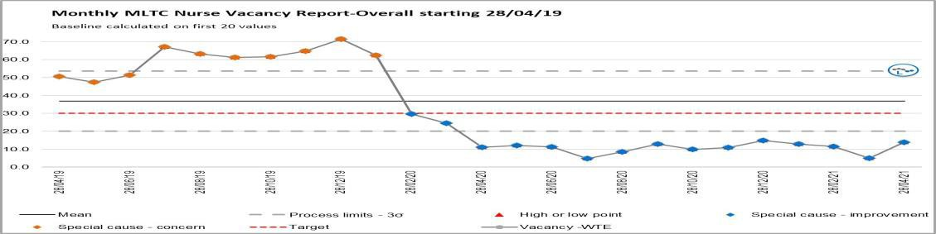

Chart 3: Divisional Vacancy breakdown WTE – Registered Midwifes (information via ESR)
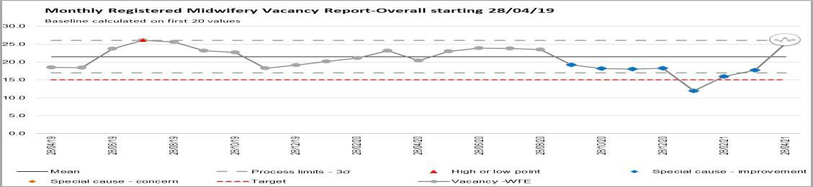

3

Rosters are designed to fill out of hours first and this is reflected in the fill rate as the lowest fill rate was seen in the RN day shift at 91.72% (Chart 4). The overall fill rate was 95.7%. The redeployment of staff and temporary staffing cover has supported the maintenance of ward fill rates.

Chart 4: Ward Area Staffing Fill Rates

  - Overseas Recruitment
16 overseas nurses have arrived in May and will commence their induction and introduction to departments. They are planned to attend Objective Structured Clinical Examination (OSCE) assessments within 12 weeks, depending upon OSCE testing opportunity. Pastoral care is being delivered by the Faculty of Research and Clinical Education Team and the established processes at Royal Wolverhampton Trust. There are a further 5 cohorts of overseas RNs between May and October 2021. The total forecast is 125 overseas RN to be recruited by the end of 2021. All cohorts will have a week induction and a half study day once per week.

  - CSW Recruitment

After recruitment with the assistance of Walsall Housing and Walsall College, CSW’s recruits have been allocated against Divisional vacancies. A total of 36 CSW’s started in post during April who where supported through a 2 week induction for fundamentals of care.

  - Trainee Nursing Associate Recruitment

There is a cohort of 12 trainee nursing associates planned for September 2021.

  - Staffing Hub Activities

The Staffing Hub is in place to oversee staffing levels across all areas and to facilitate the speedy escalation of issues in relation to staffing, acuity and outstanding shift demand. There is always a minimum of 72 hours staffing visibility within the Staffing Hub. Matrons ensure that in the twice daily staffing meetings opportunities are sought to redeploy personnel where this is safe to do so. In April, within the Staffing Hub meetings, Matrons redeployed 494.5 hours of RN and 319.5 hours of CSW. This is more than 1000 less than was redeployed in March 2021.
Red Flags are recorded, reviewed and mitigated when appropriate as part of the Staffing Hub meeting. Matrons oversee the accuracy of the Red Flags recorded and their appropriateness. In April there were 139 Red Flags that were raised and 28
4

were resolved and mitigated against. For areas where the risk cannot be fully mitigated the Divisional Directors of Nursing are expected to ensure additional oversight and support to those areas and staff are redeployed as necessary depending on any immediate risks.

  - Allocate System Roll Out

42 departments have attended for Roster Manager in Allocate to date and have moved into the Allocate system. There are 5 remaining departments to move into Allocate from RosterPro (RPC) that receive enhancements.

Allocate have changed the user interface (version 11) and the Trust will migrate from Version 10 to Version 11 by end of June 2021. This will require further training of 1-2 days to all current Allocate Managers (40 departments). Initial trial of Version 11 training has highlighted some issues with functionality that has been reported to Allocate.

2.0 Staff experience audits – Perfect ward

The corporate nursing team has been working closely with the performance team to cleanse and further develop the perfect ward audits. Within these suite of audits, a new monthly staff experience audit has been developed. For April 2021 this audit scored 91.33% (Chart 5) which is an increase from 81% in March 2021. This audit contains questions which align with the National NHS Staff Survey 2020.
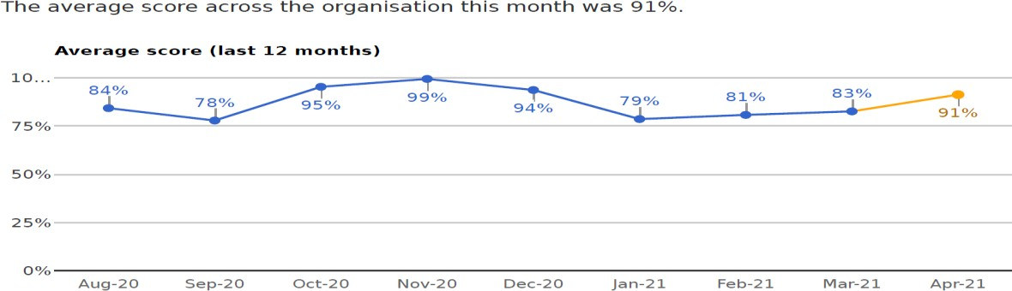Chart 5: Staff experience audit score

19 clinical areas completed this audit in April 2021, an increase from 8 areas in March. Scores varied from 74% to 100% (Chart 6). Highest scoring clinical areas are outlined in table 1 and lowest scoring areas in table 2. Results should be viewed with caution due to the limited numbers of staff that have taken part in the audits.

5

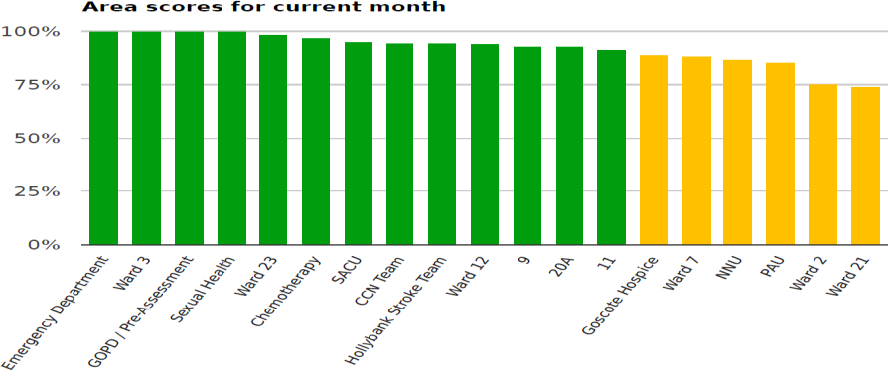Chart 6: Clinical area scores

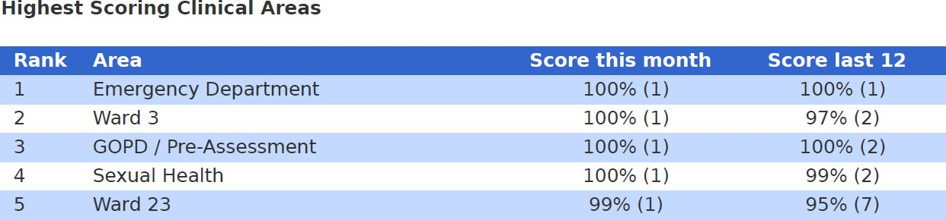Table 1: Highest scoring clinical audits

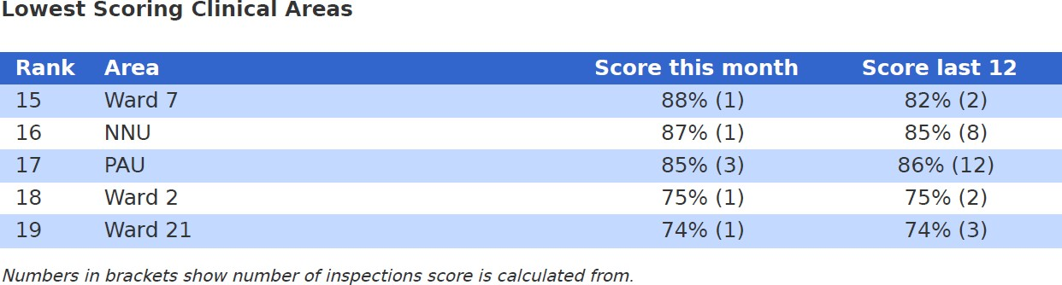Table 2: Lowest scoring clinical areas

The app has been developed to also support Divisional Leadership Teams and Board Members to collate audit data during walkabout visits. Ongoing developments and progress will be presented monthly to People and Organisational Development Committee.

6

MEETING OF THE PUBLIC TRUST BOARD – 3rd June 2021
Quarterly Report of the Freedom to Speak Up Guardians – Q4 20/21 |  |  | AGENDA ITEM: 23
Report Author and Job Title: | Freedom to speak Up Guardians:  Kim Sterling Val Ferguson Ayshia Aziz | Responsible Director: | Catherine Griffiths Director of People and Culture
Action Required | Approve ☐ Discuss ☐ Inform ☒ Assure ☒
Executive Summary | Effective speaking up arrangements are important to help to protect patients and improve the experience of NHS workers.  This report is provided to the Trust Board and the People and Organisational Development Committee at the end of each quarter to provide insight regarding the number of cases and themes that have been recorded and monitored. The quarter between 1st January 2021 and 31st March 2021 is covered here.  Compared to the previous reporting period (1 October 2020 to 31 December 2021) there has been an overall 68% increase in concerns reported.  The Board is asked to note that a full year review of Speak Up activity will be provided in June 2021.
Recommendation | The Trust Board is asked to:  - Note the report and discuss the contents within  - Commit to making Speaking Up routine day-to-day practise  - Support further work required to progress the FTSU function to improve the WHT safety culture
Does this report mitigate risk included in the BAF or Trust Risk Registers? please outline | The work programme described within this report will provide positive assurance to the committee on the following BAF risk:  Lack of an inclusive and open culture impacts on staff engagement, staff morale and patient care.
Resource implications | There are some costs implications associated with following this programme of work, all resource will be aligned through existing budgets.

Legal and Equality and Diversity implications | Colleagues from groups with protected characteristics often face additional barriers when raising concerns. The FTSU service and its activities ensures equality, diversity and inclusiveness are embedded across the workforce. The FTSU service will introduce a system to monitor the protected characteristics of colleagues raising concerns.
Strategic Objectives | Safe, high quality care ☒ | Care at home ☐
Strategic Objectives | Partners ☐ | Value colleagues ☒
Strategic Objectives | Resources ☐

Freedom to Speak Up Quarterly Report to PODC – Q4 2020/21

- Purpose

Freedom to Speak Up (F2SU) at Walsall Healthcare NHS Trust has continued to work to progress the F2SU objectives as set out within the Value Our Colleagues Improvement Programme.

This report is provided to the People and Organisational Development Committee and the Trust Board at the end of each quarter to provide insight regarding the number of cases and themes that have been recorded and monitored between 1st January 2021 and 31st March 2021.

- Background

Following the Francis Report into Whistleblowing in the NHS in 2005 and the subsequent review of Speaking Up, employees are encouraged to speak up about anything that impedes their ability to provide high quality care to patients.

The actions following Speaking Up will contribute to the further development of transparent and open culture and help to ensure that speaking up is business as usual across the Trust for all staff.

- Concerns raised and analysis

There were 37 concerns raised during the quarter (1st January 2021 to 31st March 2021) and the themes are represented diagrammatically below. In the same period last year, there were 25 cases raised though the FTSU. This represents a 68% increase in the number of cases.

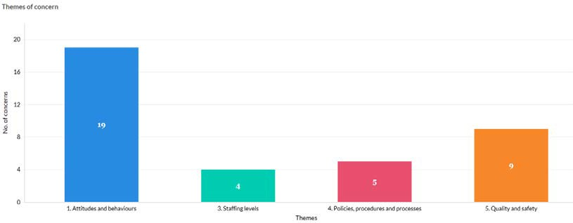

The above chart shows that over half of the concerns raised are behavioural based at 51%; 24 % are of quality and safety nature and 14% relate to policies procedures and processes. The remaining 11% were related to insufficient staff numbers.

The following chart shows the nature of the themes from each division.

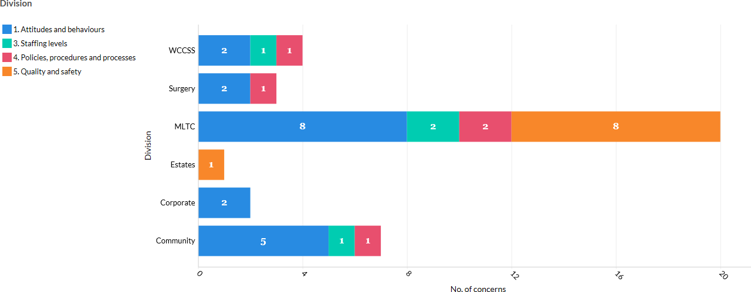

Freedom to speak cases relating to attitudes and behaviour are common across the majority of the divisions, with the exception of estates and facilities.

Quality and safety concerns were raised by colleagues from the estates and facilities division and the division of medicine and long term conditions (MLTC). Within the division of MLTC, 40% of the FTSU casework was related to patient safety and quality on one particular ward. This represents 89% of the total patient safety concerns raised in the organisation for this quarter.

Proportionality as a measure of a healthy speaking up culture

Division | Number of staff | % of Trust | % Concerns in Q4
Community | 847 | 20% | 19%
Corporate | 398 | 10% | 5%
Estates | 377 | 9% | 3%
MLTC | 815 | 20% | 54%
Surgery | 818 | 20% | 8%
WCCSS | 878 | 21% | 11%
Grand Total | 4,133 | 100% | 100%

Comparing the proportion of concerns received by divisions, concerns from colleagues in MLTC make up 54% of the concerns brought through the F2SU route. This is disproportionally higher than what would be expected, given that the number of employees in the division represents only 20% of the staff workforce. It indicates that colleagues based here are comfortable to use this route to escalate their concerns. The division would appear to have a culture that encourages speaking up.

There is under reporting in the rest of the organisation. This may be interpreted as colleagues are less likely to report issues and prefer other routes to address and escalate issues and concerns.

Triangulation of clinical incidences and speaking up cases

The table below illustrates the number of clinical incidents reported during this period,

Division | % Trust | Number of incidents  this quarter | % incidents | % Concerns
Community | 20 | 532 | 16 | 19
MLTC | 20 | 1793 | 55 | 54
Surgery | 20 | 263 | 8 | 8
WCCSS | 21 | 673 | 21 | 11

The number of concerns and incidents in the division of surgery represents the 8% of the total received from the trust. For this division, the data suggests an inconsistency between the size of the division and reporting of clinical incidents/speak up concerns, suggesting that

there may be a benefit for increasing awareness of the speak up service with colleagues working in that division.

The percentage of concerns and incidents reported in the community and MLTC divisions is very similar to the proportional size that each division represents in the organisation.

It would indicate that the confidence of colleagues to report incidents is high and they are bringing issues to be investigated. This would suggest that staff will take action to improve patient safety.

Who Speaks Up
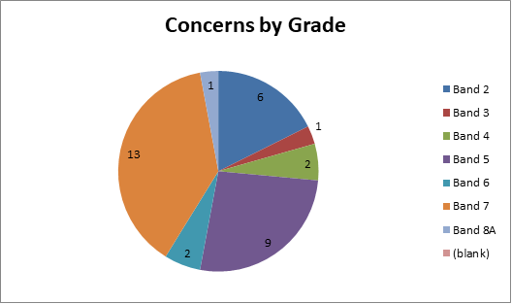

Colleagues at all levels of the organisation are represented in the figures for this quarter. Two thirds of cases (65%) are from colleagues who spoke up are graded bands 5 to 7.
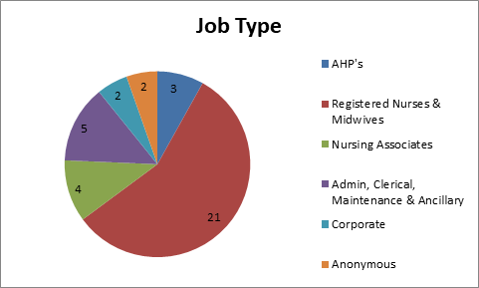

The diagram above highlights that in this quarter, that colleagues from some professional groups have not used the speaking up route to raise concerns. It suggests the reach and

accessibility of the F2SU service is not extending to colleagues from all job types across the width of the organisation. The annual report of F2SU activity over the last year will provide a complete illustration of who spoke up. This will enable the F2SU service to be tailored to address the barriers to speaking up that may exist for colleagues in certain job roles.

In the interim, full use should be made to further recruit and include of representatives from all professions and areas of the trust in the Colleagues Health and Well-being Assurance forum.

The introduction of training in Speaking Up in the trust will inform all colleagues in every profession and at all levels within the organisation about the importance of Speaking Up and how it is everyone’s business to contribute to improving patient safety.

- Activity of FTSU Guardian Team

  - Development of system for reporting divisional response rates and adherence to timescales for addressing concerns and feedback.
  - Development of communication plan for raising awareness of FTSU training modules and FTSU Confidential Contact Links
  - Re introduction of ‘Pull Up A Chair’ with NED for Speaking Up/Guardian for Colleague Wellbeing
  - Planning for FTSU virtual roadshows in the run up to Speak Up month in October.
  - Refresh of FTSU promotional information
  - Attendance and input into Staff Survey Engagement Task and Finish Group

- Recommendation

The report is noted and the Trust Board supports the continued implementation of the WHT Freedom to Speak Up Improvement Plan.


1

MEETING OF THE PUBLIC TRUST BOARD – 3rd June 2021
Walsall Together Partnership Board Highlight Report |  |  | AGENDA ITEM: 24
Report Author and Job Title: | Trish Mills Trust Secretary | Responsible Director: | Mrs Anne Baines –  Chair and Non- Executive Director
Action Required | Approve ☐ Discuss ☐ Inform ☒ Assure ☒
Executive Summary | The report provides the key messages from the Walsall Together Partnership Board (Partnership Board) meeting on 19th May 2021. Key points for the attention of the Trust Board are:  - All partner organisations were represented and the meeting was quorate. The level of partnership and shared debate on key items was highlighted as positive, with all partners able to both contribute to the presentation of papers they had contributed to, and comment equally in the discussions and sharing of concerns and risks welcomed.  - Patient/staff story presented by colleagues from Walsall Family Safeguarding regarding the support provided to a family where substance misuse risked the child and family resilience. We heard about how drug misuse colleagues from Walsall Beacon Project working with Children’s Social Care together with Mum to ensure a positive result and optimistic future for the family. Colleagues emphasised how working together across boundaries within the programme enables a strong base for provision and engagement increasing the potential for the family to thrive.  - An increase in adult safeguarding continues and was highlighted. Reassurance was given by the Director of Adult Social Care that numbers were considered to be within tolerance levels with the anticipation that this was a temporary situation. The Walsall Together Board will continue to monitor through the Operational Report  - Further detail was requested on the capacity and demand requirements for Multi-Disciplinary Teams (MDTs) where activity has reduced over recent months. Details of reasons for  reduction and potential solutions must be reviewed.

  - Although there is currently reduced occupancy within Care Homes, assurance was given that provider viability was not at risk.
  - Primary Care Networks reiterated their wish to be more fully involved in discussions and to play an effective collaborative/ partnership role.
  - Board approved a reframing of the Transformational Plan for Horizon 1 projects, following COVID-19 which had been undertaken by the Senior Management Team with representatives of all Partners. The priority of the Family Safeguarding Programme sustainability was reiterated across partners.
  - Board noted the significant progress made by the Resilient Communities Workstream led by One Walsall and Walsall Housing Group. In particular the links to reducing health inequalities were noted with detail provided on a number of key schemes including
    - Kindness Counts project targeting loneliness and social isolation
    - Mental Health first aid training in e.g. barber shops
    - Alignment to the Council’s Holiday Food and Activity Programme
    - Coproduction training for WT staff and community champions
    - Expansion of the whg/WHT anchor institution employment scheme
    - Social prescribing integrated reporting and identification of other opportunities for shared learning/alignment
    - Pathway development/alignment with Family Safeguarding in line with the ambition set out in the Changing Futures bid
    - Development of a partnership Engagement Model through the development of the Service User Group (membership and governance) and wider engagement on inequality
    - Contribution to the Outcomes Framework through defining measures of resilience, social value, independence etc.
  - In terms of risks, the Board requested a deep dive on the funding risk associated with Intermediate Care Services.
  - Success was reported in receipt of funding via the STP (250k) for specified spend for the ICP development on financial due diligence, further development of integrated reporting across


3
 | partners and organisational development.
Recommendation | Members of the Board are asked to note the report.
Risk in the BAF or Trust Risk Register | This report aligns to the BAF risks for Care at Home (S02) and COVID-19 (S06)
Resource implications | There are no new resource implications associated with this report.
Legal, Equality and Diversity implications | There are no legal, or equality & diversity implications in this paper, however the developing approach to health inequalities is noted.
Strategic Objectives | Safe, high quality care ☒ | Care at home ☒
Strategic Objectives | Partners ☐ | Value colleagues ☒
Strategic Objectives | Resources ☒


1
MEETING OF THE PUBLIC TRUST BOARD – 3rd June 2021
Care at Home Executive Report |  |  |  | AGENDA ITEM:
Report Author and Job Title: | Matthew Dodd Director of Transformation | Responsible Director: |  | Daren Fradgley Executive Director of Integration / Deputy  CEO
Action Required | Approve ☐ Discuss ☐ Inform ☒ Assure ☒
Executive Summary | This report provides an overview performance, risk, assurance, and transformation in the Care at Home Strategic domain. It covers:  - Operational performance for community services and Adult Social Care, situated within the context of the Walsall Together Partnership (Appendix 1);  - Board Assurance Framework (BAF) for Care at Home;  - An update on the transition to obtain Integrated Care Provider (ICP) status;  - An update on the Care at Home Improvement Programme.  Detailed discussions in these areas have been covered in the relevant Board Committees this month in addition to that noted in the Partnership Board highlight report.
Recommendation | Members of the Trust Board are asked to note the contents of this  report.
Does this report mitigate risk included in the BAF or Trust Risk Registers? please  outline | BAF Risk- S03 - Failure to understand population health and inequalities, integrate place-based services and deliver them through a whole population approach would result in a continuation if not widening of health inequalities.
Resource implications | There are no new resources implications associated with this  report.
Legal and Equality and Diversity implications | The issue of health inequalities continues to receive growing prominence in all forums across Walsall Together. It is reflected in the strategic objectives of the partnership and the associated BAF risk for Walsall Healthcare. There are multiple workstreams that  have given focus to this issue within the forward look programme.
Strategic Objectives (highlight which Trust Strategic objective this  report aims to support) | Safe, high quality care ☐ |  | Care at home ☒
 | Partners ☐ |  | Value colleagues ☐
 | Resources ☐

Care at Home Executive Summary June 2021

- PURPOSE OF THE REPORT

This report provides an overview performance, risk, assurance, and transformation in the Care at Home Strategic domain. The following attachments provide the evidence pertinent to the board requirements. Detailed discussions in these areas have been covered in the relevant Board Committees this month in addition to that noted in the Partnership Board highlight report.

  - Operational performance for community services and Adult Social Care, situated within the context of the Walsall Together Partnership (Appendix 1);
  - Board Assurance Framework (BAF) for Care at Home;
  - An update on the Care at Home Improvement Programme.

- PERFORMANCE, ASSURANCE AND RISK – COMMUNITY SERVICES

The key risks to community services and assurances around the level of service provision are included in Appendix 1 and all relevant Board Committees have been briefed on these risks in May.
Appendix 1 incorporates the Community Services data in the context of Walsall Together services. The report is evolving towards greater focus on assurance around the Tiers of the Walsall Together clinical operating model. The emergent balanced score card has highlighted two areas requiring further assurance, which will be reported back to Walsall Together Partnership Board in June:
- the throughput of locality Multidisciplinary Teams;
- the use of community beds within both the Intermediate Care Services pathways and the local authority long term bed stock.

  - Performance and Activity
In May, the issues to raise to Trust Board and provide assurance over involve:

Maintaining essential planned activity: the locality teams delivered more hours of care than in the same period for the previous 2 years and were able to meet 97% of demand.
The primary care MDT’s have recommenced but are slow to pick up volume and have lots of spare capacity currently. This is now a key focus for the operational teams

Avoiding hospital admission:

    - The Care Navigation Centre continued to operate as an escalation point for clinical deterioration in the community and responded to over 580 calls during the month. The CNC has a range of disposal routes for referrals (advice & guidance; referral to locality teams; referral to Rapid Response) and the correlation between the growth of the CNC and the reduction in referrals to the Rapid Response Service continues. The focus on Rapid Response is on extending its hours of availability to increase the number of referrals.
    - The Integrated Assessment Hub maintained its approach to reducing pressure at Walsall Manor Hospital through its three pathways aimed at Hospital Avoidance (56 patients), Early Supported Discharge (51 patients) and Assisted Discharge (62). It is worth noting that as this service beds in the patterns are changing and patients are more attendance are being avoided which is the effect we are hoping for.
    - The long-COVID pathway received was opened up to GP referrals in-month thereby expanding the range of people being supported for a long-term condition using the resources of Community Services
Supporting hospital discharge: The numbers of patients who are medically stable for discharge remained low at an average of 32 patients. Performance remains strong in this area with LoS retaining consistency. Use of ICS beds continues to fall to c60 but remains a gap of the funded 33 predicted for this year. This is a risk in full sight of the WTPB

- BOARD ASSURANCE FRAMEWORK

The BAF was reviewed following the Walsall Together Partnership Board and remains at a risk of 12. The key areas to note are:

  - The increased operational pressures due to Covid wave 2 have continued to abate and business continuity measures are being stood down in many areas of Community Services as capacity is better able to meet demand.
  - The transformation pace has now been addressed as Covid pressures reduce through the relaunch of both the Walsall Together Senior Management Team and the Clinical Professional Leadership Group meetings.
  - Vaccine delivery with operational teams mainly in primary care and latterly around the Saddlers Centre, retains the potential to dilute focus on core delivery items and to increase system pressure.
  - Maturing place-based teams in all areas of Walsall on physical health and Social Care. Additional integration required for Mental Health with IAPT and primary care but not established yet.

  - Significant maturity in communications and confidence in Walsall Together however public profile now needs to be established.
  - Advancing maturity of integrated performance data – work now commenced on aligned quality governance.

- ICP ROADMAP

The transition to delivery of an Integrated Care Provider (ICP) remains in progress. The key points of assurance for May include:

  - Work to review the Alliance Agreement, as reported last month, to strengthen the primacy of place versus system and to reflect areas of increased appetite for integration, such as a shared approach to risk management, has now commenced and all partners are engaged. Any changes to the Alliance Agreement will be presented for approval at partner governing bodies, as per the current schemes of delegation.
  - Additional funding from the STP has been secured to provide support across several areas including GP clinical leadership, financial due diligence, integrated outcomes and performance reporting, and workforce & OD.
  - An initial cut of data for the Outcomes Framework, population health profiles and local quality standards is on track to be presented to the Clinical & Professional Leadership Group in May. It is scheduled to be presented to the WTP Board before September to ensure it is available for the 2022/23 contracting round.
  - Transfer of the following services from the CCG are in discussion
    - Primary Care Pharmacy team
    - Continuing Healthcare Team
    - Early view on place based commissioning.
  - Other ICP’s across the system are increasingly coming to Walsall Together to replicate the blueprint we have followed.

The key risks remain in respect of the release of information to support financial due diligence, and to finalise the scope of services to be included in the full ICP contract. Work is continuing in parallel whilst these risks have been escalated to system level. Directors of Finance are fully sighted and leading on the mitigations for this risk.

- IMPROVEMENT PROGRAMME

The focus of the programme in May has been on developing a robust plan for outpatient transformation which considers how to re-engineer pathways rather than seeking to ‘lift & shift’ existent models of care.

Key areas of focus:

  - Creating new pathways for T&O using the First Contact Practitioners, who have the ability to initiate treatment plans at first presentation in primary care
  - Agreeing the use of Renal Physician sessions in primary care focusing on Chronic Kidney Disease
  - Establishing speciality MDTs, with an initial focus on Frailty, Chronic Heart Failure and Long Covid
  - Development of community models for the management of chronic respiratory conditions
  - Scoping the model and potential impacts of population health management (pilot) approaches for Diabetes and Frailty, working in conjunction with individual Primary Care Networks
  - Continued work on the Therapies service review, the Integrated Assessment Hub and the transition of the Safe @ Home scheme over to general patients requiring domiciliary pulse oximetry and not just Covid patients

- RECOMMENDATIONS

Members of the Trust Board are asked to note the contents of this report.


Latest Board/Committee/Group - 17/05/21 Version V1.05

Risk Summary
BAF Strategic Objective Reference  & Summary Tile: | BAF SO 02 - Care at Home; We will work with partners in addressing health inequalities and delivering care closer to home through integration as the host of Walsall together.
Risk Description: | Failure to work with partners and communities to understand population health and inequalities, integrate place-based services and deliver them through a whole population approach would result in a continuation of poor health and wellbeing and widening of health inequalities.
Lead Director: | Director of Integration.
Lead Committee: | Walsall Together Partnership Board.
Links to Corporate Risk Register: | Title: |  |  |  |  |  |  | Current Risk Score Movement:
Links to Corporate Risk Register: | - Risks in this area relate to Walsall Together programme risks. The biggest ones are associated with the limited investment and the size and complexity of the population health challenges.  - Non-programme risks relating to Community Services at the current time. These are updated through the divisional structure.  - Each organisation retains its own risk log although the section 75 presents the opportunity to start to bring the logs together.  - Risks associated with creating an ICP contract will be considered through a formal due diligence process, supported by NHSE/E.  - Operational capacity due to an increase in community prevalence of Covid since December 2020. |  |  |  |  |  |  | Likelihood = 3  Consequence = 4  12  Moderate  ↔
Risk Scoring
Quarter: | Q1 2021/22 | Q2 | Q3 | Q4 2020/21 | Rational for Risk Level: | Target Risk Level (Risk Appetite): |  | Target Date:
Likelihood: |  |  |  | 3 | - The increased operational pressures due to Covid wave 2 have continued to abate and business continuity measures are being stood down in many areas of Community Services as capacity is better able to meet demand.  - The transformation pace has now been addressed as Covid pressures reduce through the relaunch of both the Walsall Together Senior Management Team and the Clinical Professional Leadership Group meetings.  - Strongly established relationship with 50% of General Practice on robust vaccine delivery. Other practices chose not to connect with partnership and deploy alone.  - Vaccine delivery with operational teams mainly in primary care and latterly around the Saddlers Centre retains the potential to dilute focus on core delivery items and to increase system pressure.  - Maturing place-based teams in all areas of | Likelihood: | 2 | 30 June 2021
Consequence: |  |  |  | 4 |  | Consequence: | 4 | 30 June 2021
Risk Level: |  |  |  | 12  Moderate |  | Risk Level: | 8  Moderate | 30 June 2021

Walsall on physical health and Social Care. Additional integration required for Mental Health with IAPT and primary care but not established yet.
- Significant maturity in communications and confidence in Walsall Together however public profile now needs to be established.
- Advancing maturity of integrated performance data - Work now commenced on aligned quality governance.
- Risk Stratification process for COVID developed with partners which demonstrates the evolving maturity of the partnership.
- Substantial improvements in medically stable for discharge before and during Covid 19.
- Virtual clinics and community outpatients maturing and triage and referral services now in place during Covid and being planned for the long term.
- Partnership approach to managing care home support and intervention being embedded into business as usual.
- Strong evidence base being establish for ICP due diligence and work now progressing at pace with the support of the ICS and NHSI/E.
- The step up of the risk in Q3 20/21 has now been
de-escalated and predicted to fall through Q1 in 21/22.
Control & Assurance Framework - 3 Lines of Defence
 | 1st Line of Defence |  |  |  | 2nd Line of Defence | 3rd Line of Defence
Controls: | - Executive Director appointed.  - Non-Executive Director appointed.  - Partnership Board/Groups and meetings in place.  - Business Case developed.  - PMO/Project in place and reporting.  - Daily operational coordination taking place.  - Covid Vaccine delivery plan in place and operational. |  |  |  | - Alliance agreement signed by Partners.  - Governance structure in place and working.  - S75 in place and operational practices now maturing.  - Integration of performance data across the partnership is being progressed and reported to the Walsall Together Committee.  - Business case approved by all partners.  - Monthly report to Board and partner organisations. | - External assessment - CQC/Audit.  - STP Scrutiny.  - Health and Wellbeing Board Reporting.  - Overview and Scrutiny Committee.
Gaps in Controls: | - No strategic finance plan for investment across the partnership which potentially impacts on the delivery notwithstanding the recent investment from the Trust. This has been mitigated short term with Covid funding, but further work required to establish ongoing formal mechanisms through  ICP contracts.

- Commissioner contracts not yet aligned to Walsall Together although ICP planning will resolve this issue.
- Data needs further aligning to project a common information picture.
- Effective engagement with community in development with local groups limited due to Covid social restrictions.
- Organisational development for wider integrated working not yet outlined or agreed and delayed due to Covid.
- Enactment of section 75 in terms of monitoring meetings.
Assurance: | - Divisional quality board now starting to look at the integrated team response.  - Risk management established at a programme level and a service level integrating risks. | - Walsall Together included on Internal Audit Programme.  - Walsall Together Committee in place overseeing assurance of the partnership.  - STP oversight of ‘PLACE’ based model.  - Reporting to Board and Partners.  - Oversight on service change from other committees.  - ICP due diligence underway. | - NHSE/I support of Walsall Together.  - STP support.  - NHSE/I validation of ICP due diligence.
Gaps in Assurance: | - Limited in overall external assurance as regulators inspect individual organisations and as yet have not developed ‘PLACE’ based inspections although Walsall Together put forward as part of ICP development.  - For Community services and ACS within the Section 75 there is direct accountability to WT / WHT; these formal arrangements do not cover other partners hence limited accountability for delivery of Walsall Together strategic aims.
Future Opportunities
- Further development of the Governance around risk sharing.
- S75 Deployment based on other services relating to health prevention and public health commissions.
- PCN partnership alignment and risk share with building trust and confidence.
- Covid-19 offers an opportunity to increase the pace of delivery and more importantly stress test benefits before substantive deployment.
- Strategic partnership(s) with major primary care organisations to further accelerate vertical and horizontal integration of care in the borough.
- Formal contract through an ICP mechanism.
- Formal working with other partners to support their ability to achieve additional income and support via a partnership approach.
- CQC action oversight group.
Future Risks
- Insufficient promotion of success narrative.
- Inability to deliver enough investment up front to change demand flows in the system.
- Changes to commissioner & provider environment / landscape within the Black Country may change mechanisms for resourcing and resolution of service issues.
- A mechanism for gaining and sustaining resources to support strategic aims for 2021/22+ are unclear.
- National influences on constitutional targets moves focus from place to ICS.
- Retention of inspirational and committed leadership across partners.
- Estates - ability to fund the full business case offering (4 Health & Wellbeing Centres).
- Misalignment of provider strategies created by mergers or form changes or senior personnel turnover.
- Lack of uninterrupted community clinic space due to Covid Restrictions.
- Programme Resource - Capacity to deliver the WT programme will become more difficult as the same resource will be required to support the delivery of Covid-19 work streams, e.g. mass swabbing, flu vaccination programme, Covid-19 vaccination programme, outbreak management and the Covid-19 Management Service (CMS).
- Maintenance of the ICP agenda through the ICS Board by both the system partners and the Trust in relation to strategic objectives.

Future Actions (to further reduce the Likelihood / Consequence of the risk in order to achieve the Target Risk Level in line with the Risk Appetite)
No. | Action Required: | Executive Lead: | Due Date: | Progress Report: | BRAG:
1. | Agree an investment plan initially with commissioners through 2021/22 funding round to address the current gaps in funding provision. | Director of Integration | July 21 | Work is underway to confirm maintenance of transformation funding for the diabetes and care home services into established baselines. A longer-term conversation will then  need to be coordinated with other ICP’s through the ICS board for Health Commissioning.
2. | Agree & implement joint service development opportunities between Walsall Together and PCNs that foster improved  delivery of care through more integrated working. | Director of Integration | July 21 | Work has started on revised recruitment and management arrangements for roles such as First Contact Practitioners  and Pharmacists. Further opportunities are being identified.
3. | Refresh strategic case for Resilient Comm1unities, ensuring appropriate focus on reducing health inequalities and alignment of strategic objectives across partner organisations. | Director of Integration | July 21 | The Resilient Communities work stream has held three sessions.  The work stream has presented to WTPB (March 2021) the following next steps:  - Discussion at the CPLG to confirm the local population challenges that we want to address, aligning to population health management and inequalities priorities for the partnership.  - Establishment of the Steering group including confirmation of membership and Terms of Reference.  - Review of the multiple strands of work pertaining to citizen and communities engagement to create a single, defined approach.  - Review of the full proposal to Changing Futures and proposal for how some or all of the elements can be  taken forward without the external investment.
4. | Develop population health management strategy across Walsall Together and PCNs including the deployment of the population health module (Digital work stream). | Director of Integration | July 21 | This work is underway with the support of the STP Academy and Public health. The Population Health module as part of the Medway deployment is also in our test environment. The final strategy is interdependent with the  production of the Health & Well Being strategy which is focused on the end of Q2.
5. | Develop robust governance and legal frameworks for Walsall Together with devolved responsibility within the host (WHT) structure. This should include an outline governance structure  that shows the links to other WHT committees and acknowledge the transition to holding a formal ICP contract. | Director of Governance | July 21 | This work is on track as part of the ICP programme.
6. | Prepare for implementation of a formal ICP contract under a Lead Provider model with WHT as Lead Provider. This will include confirmation of all services in scope and a clear rationale for the change in the context of improving outcomes  for the population. | Director of Integration | July 21 | On track and formally reported to WTPB monthly


Walsall Together Partnership Operational Update: May 2021
Daren Fradgley

Director of Integration / Deputy CEO

Tier | Activity in-month | Mar-21 |  | Apr-21 |  |  | Scoring
Tier 0: Resilient Communities
Social Prescribing | No. referrrals received
MDTs | No. MDTs held | 24 |  | 28 |  |  | <20 | 20-24 | >24
 | No. referrrals received | 28 |  | 27 |  |  | <100 | 100-200 | >200
 | No. cases reviewed | 28 |  | 27 |  |  | <100 | 100-200 | >200
Workforce: Anchor institutions | No. staff employed by WHT via scheme
 | % staff still in post after 3 months
Tier 1: Integrated Primary, Long Term Conditions Management, Social & Community Services
Primary Care | Amber sites (undertake all aspects of contractual work with +ve Covid patients seen in RED sites) |  |  | 13
 | Green sites (undertake all aspects of contract - no face to face appointments) |  |  | 37
Community Services | Hours delivered by Locality teams | 10,905 |  | 10,347 |  |  | 6,000< | 6,000-9,500 | >9,500
 | Hours cancelled by Locality teams | 473 |  | 305 |  |  | >600 | 400-600 | 400<
 | % of hours demand unmet | 4% |  | 3% |  |  | >10% | 5-10% | 5%<
ASC | Care & support assessments & 3 conversations incoming / in progress (snapshot  in-month) | 393 |  | 478
 | Care and Support Assessments and 3 Conversations Completed - Total | 267
 | Monthly Adult contacts completed by Team | 1,113
 | Total Initial & Subsequent Reviews Completed | 388 |  | 223


[Emergent] Score Card for WT Tiers – Tier 2

Tier | Activity in-month | Mar-21 |  | Apr-21 |  |  | Scoring
Tier 2: Specialist Community Services
ASC Safeguarding Concerns | Concerns received | 297
 | Concerns progressing to s42 eqnuiry | 72
 | % of concerns progressing to s42 enquiry | 24%
 | Safeguarding cases in progress | 39
Care Homes | Care Home residents | 1,258 |  | 1,267 |  |  | 1,503< | 1,503-1,650 | >1,650
 | Vacancies | 436 |  | 430 |  |  | >291 | 144-291 | 144<
 | % vacant beds | 26% |  | 25% |  |  | >15% | 8-15% | 8%<
 | Total No of Care Homes | 57 |  | 58 |  |  | 53< | 53-56 | >56
 | Closed to admissions | 14 |  | 7 |  |  | >8 | 3.0-8.0 | 3<
 | % of available homes closed to admissions | 25% |  | 12% |  |  | >10% | 5-10% | 5%<

Tier | Activity in-month | Mar-21 |  | Apr-21 |  |  | Scoring
Tier 3: Intermediate Care, Unplanned Care & Crisis Services
Care Navigation Centre | Calls received | 550 |  | 580 |  |  | 316< | 316-512 | >247
Rapid Response Team | Referrals received | 232 |  | 210 |  |  | 160< | 160-247 | >247
 | % admission avoidance | 82% |  | 88% |  |  | 73%< | 73-86% | >86
Medically Stable For Discharge | Average number of MSFD in WMH | 30 |  | 32 |  |  | >51 | 41- 51 | 40<
 | Average number of days MSFD | 3.2 |  | 3.2 |  |  | >7.8 | 4.8 - 7.8 | 4.8<
Domiciliary & Bed Based Pathways | Domiciliary Pathways - Discharged ALOS | 30 |  | 27 |  |  | >25 | 21 - 25 | 21<
 | Domiciliary Pathways - Average service users | 188 |  | 181
 | Bed-based Pathways - Discharged ALOS | 29 |  | 46 |  |  | >36 | 24 - 36 | 24<
 | Bed-based Pathways - Average beds in use | 83 |  | 67
Integrated Assessment Hub | Hospital Avoidance | 44 |  | 56 |  |  | 20< | 20-28 | >28
 | Early Supported Discharge | 52 |  | 51 |  |  | 40< | 40-54 | >54
 | Assisted Discharge | 75 |  | 62 |  |  | 35< | 35-50 | >50

Tier 0: Resilient Communities

Social Prescribing
- The SP evaluation has been commissioned by whg and is being completed by HACT ( Housing Association Charities Trust ) . HACT have now begun to contact key stakeholders . We expect the evaluation to be completed over a 9-12 month period with a view to presenting the findings in March 2022. Colleagues from WT maybe asked to contribute to this piece of work .
- The SP programme is currently working with a gentleman aged 59 . Prior to the LW involvement this resident was isolated at home caring for his sister who has complex health needs and disabilities . He was referred by whg’s housing team who were concerned about his isolation . Initially he was very distrustful and reluctant to engage with the programme . Using Motivational Interviewing Techniques and Coaching conversation skills the SPLW developed a positive relationship beginning with ‘informal’ chats which helped him to relax and build the trust required to open up and tell us his wants and needs .
- This gentleman is impacted by the wider determinants of health . He lives in a disadvantaged community , is long term UE , is impacted by poverty and lacks the confidence and skills to self help .He and his sister are very reliant on clinical services and medication relying on the health service to make things better .
- The LW provided practical help and guidance around his income and benefits , this immediately reduced anxiety and stress enabling him to focus upon other things . He developed a 6 month plan which included taking part in social activities away from his caring responsibilities , walk and talk activities and arts and crafts . 12 weeks into the programme this gentleman has a different mindset he is positive and hopeful . He is currently keen to gain work experience and has begun to believe he can get more out of life . We think he can !

Tier 0: Walsall’s Voluntary & Community Sector – One Walsall
•The Community Renewal Fund has been launched by central Government. OW Development Team are actively brokering links between local VCS organisations, (interested in delivering against the fund outcomes), with a range of private, public and voluntary groups to develop innovative cross sector bids. A potential bid from the Black Country Healthcare NHS Foundation Trust with VCS support is currently being worked on. We believe if successful this will lead the way to greater cross sector working.
•A special event to recognise the efforts of volunteers during the pandemic is planned for Volunteer's week in June 2021. Funding has been obtained to provide an award of recognition and a full week of social media and content has been planned to share amongst partners and promote across the WT partnership. Further volunteers have been recruited for vaccine sites and liaison with DGFT continues.
•The sector is now seeing a return to ‘normal’ community projects, with local groups seeking support for a range of issues looking to bring back community cohesion within government guidelines e.g. community garden projects.
•OW continues to work with the Mental Health and Wellbeing Cell to focus on VCSE provision for bereavement, financial and social connectivity support, as demand for mental health support continues.

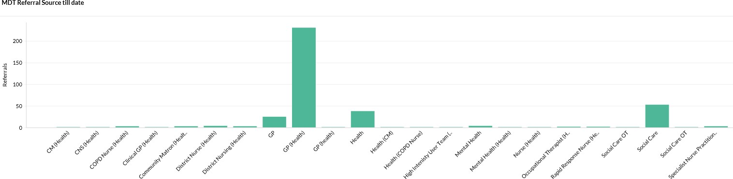

Tier 0: MDTs
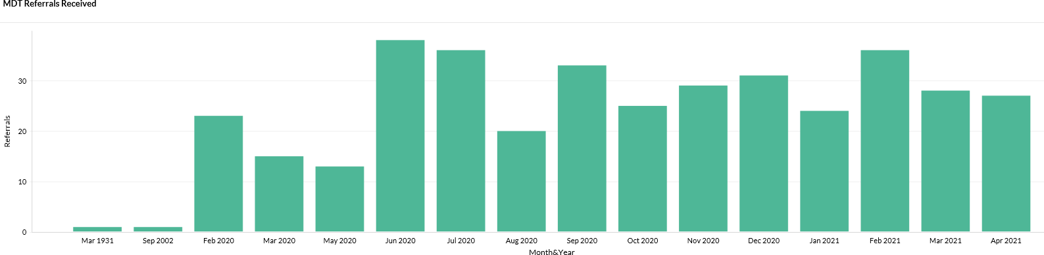
Demand is significantly below capacity for GP-led MDTs
The service is established for 7 x MDTs with up to 50 cases to be reviewed per week

In April, 27 cases were discussed (28 in March)

A review of the MDT function has now commenced which will look at referral criteria and ways of harnessing Consultants to support speciality MDTs

Tier 1: Primary Care Appointment Access ( Feb 2021)
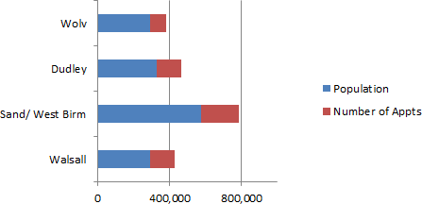
•Black Country STP
–573,256 appts
–466,933 attended (81.45%)
–58,652 – DNA (10.23%)
–47,671 – Not Booked(8.31%)
–2.59 ( appt vs patient)
CCG |  | Population |  | Number of  Appts | Appt vs pt
Walsall |  | 292,363 |  | 138,308 | 2.11
Sand/ West Birm |  | 575,791 |  | 207,519 | 2.77
Dudley |  | 328,000 |  | 138,804 | 2.36
Wolv |  | 290,686 |  | 88,625 | 3.27
Total |  | 1,486,840 |  | 573,256 | 2.59
 |  |  |  |  |  |  | 8

–Compared to August 2020 3.18 (appt vs patient)
•65.5 % F2F appts compared to 50% in August 2020
•34% Telephone
•Birmingham & Solihull – 2.45 (appt vs
patient)
Walsall Together | Collaborating for happier communities

Tier 1: Social Prescribing
 | Raw list size 2020-21 | Number of Referrals | % of referrals
East 1 | 33246 | 184 | 0.55%
East 2 | 42806 | 212 | 0.50%
North | 52162 | 677 | 1.30%
South 1 | 42776 | 303 | 0.71%
South 2 | 41070 | 532 | 1.30%
West 1 | 33376 | 268 | 0.80%
West 2 | 46516 | 827 | 1.78%
Total | 291952 | 3003 | 1.03%

  - Data on SP during
pandemic
Links required to have a consistent SP offer across Walsall
Most common SP Px need
= mental health services

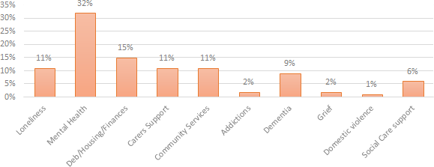

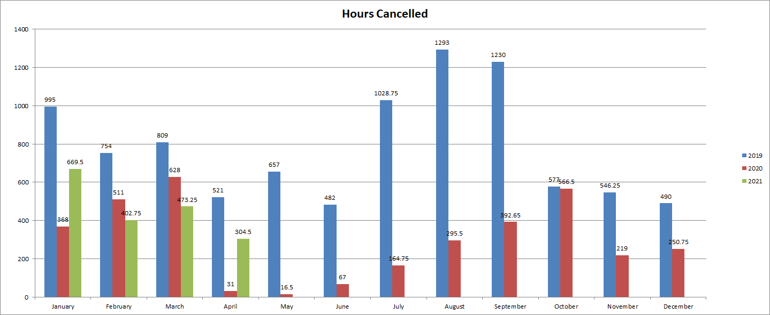

Tier 1:
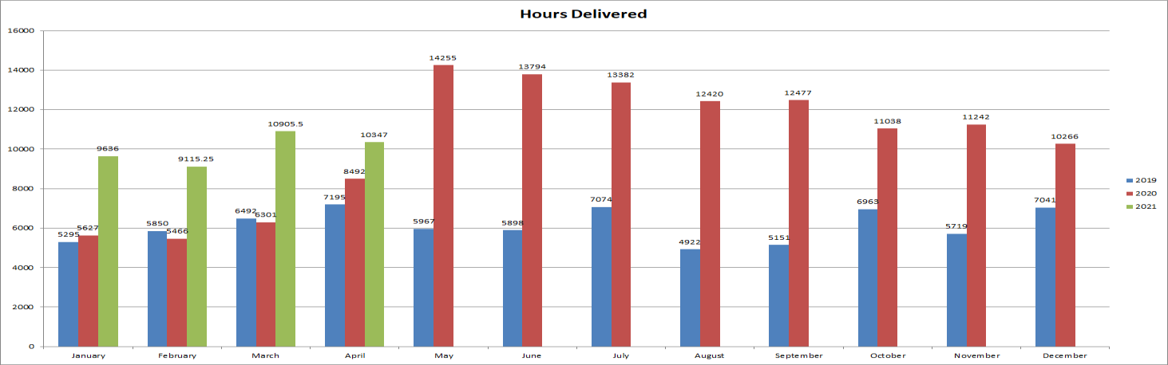
Community Nursing Capacity and Demand: In April 2021, Community Services delivered more hours and cancelled less hours of activity than before Covid
•
Absence levels within Community Services overall reduced during April, but pressures remained in two areas: therapy services staffing and demand within Phlebotomy
•
Proxy indicators of demand (hours delivered + cancelled) remain higher than pre-Covid

Tier 1:
Adult Social Care
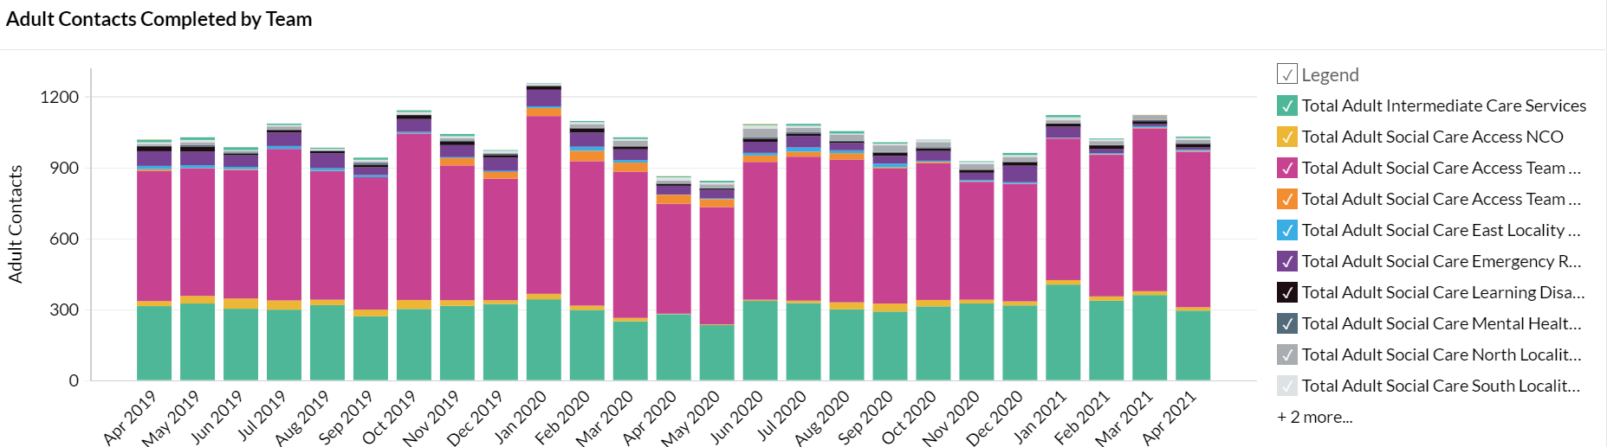

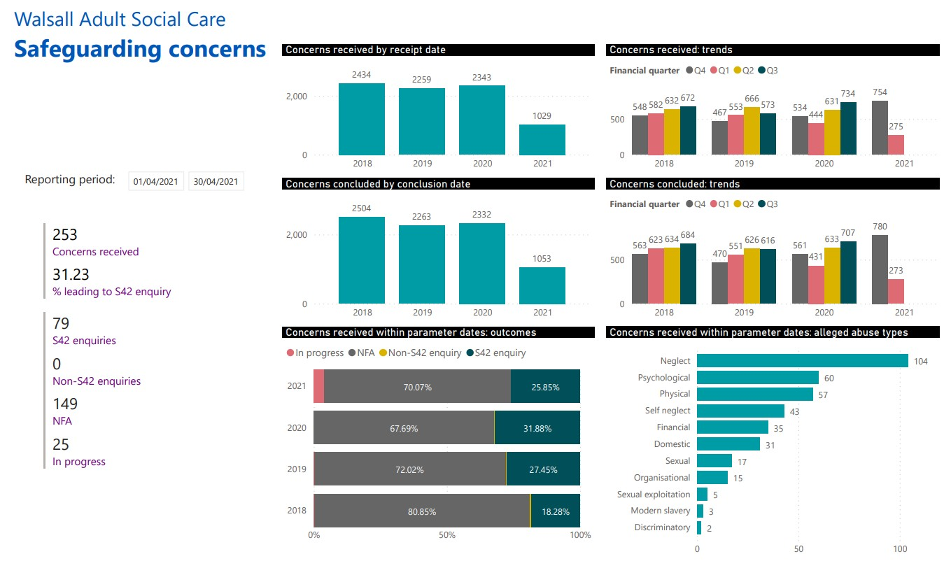Adult Social Care

ASC have received 253 concerns in April which is a reduction of 44 concerns for March 2021 which were 297.

The number of cases progressing to a s42 enquiry is slightly higher for April with 79 noting March was 72.

Safeguarding cases in progress has decreased with a timely response to safeguarding remaining the priority.

Neglect & Psychological abuse are the two highest categories of alleged abuse in this period.

Tier 2:

Care Homes Update
  - There are still no Covid deaths reported in the 58 homes since 28.02.21.
  - In April 2021 two homes reported an infection both having two staff members that were Covid positive. Their period of closure due to infection has passed. There been no residents reported as being Covid positive outside of our discharge setting.
•Bed Based providers will soon receive a Infection Control and Testing grants if they are compliant with the terms and conditions
•Occupancy in the market remains around 70% which is low in comparison to pre Covid levels.
•Ongoing question about future viability of some providers.
•Staff absenteeism was 5.24% at the end of March and has declined further to 4.60%. The actual
figure is 96 members of staff.
  - As of 10.05.21 - 94.67% of residents have received the first dose and 87.80% have received the 2nd dose.
•As pf 10.05.21 – 82.59% of staff members in bed based care are vaccinated and 61.25% have
received their second dose.

Care Homes Update

As per 10/05/2021:
•1267 residents
•430 vacancies
    - 0 homes with positive cases
•7 closed to admissions (6 due to no vacancies)
•51 open to admissions

Fatality data from 01/04/20 to date
Provider | Covid-19 - Confirmed or suspected  Deaths | Non Covid 19 related since 1st of April  2020
1 | 1 | 78
2 | 6 | 57
3 | 10 | 25
4 | 13 | 19
5 | 18 | 13
6 | 17 | 13
7 | 17 | 12
8 | 10 | 14
9 | 5 | 17
10 | 13 | 7

Tier 3:
Care Navigation Centre: Hours of availability have increased (November
2020) with highest number of calls recorded in January 2021
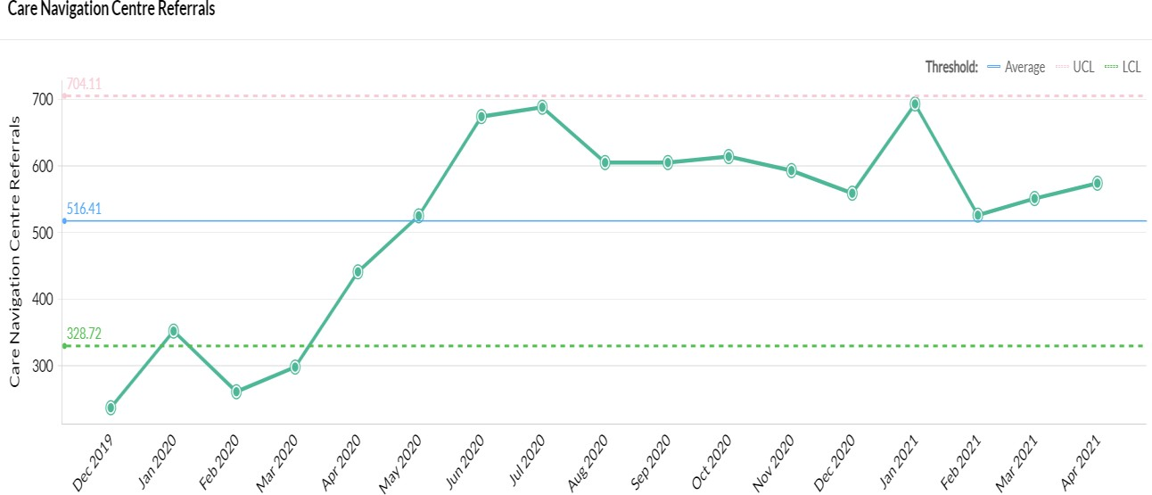
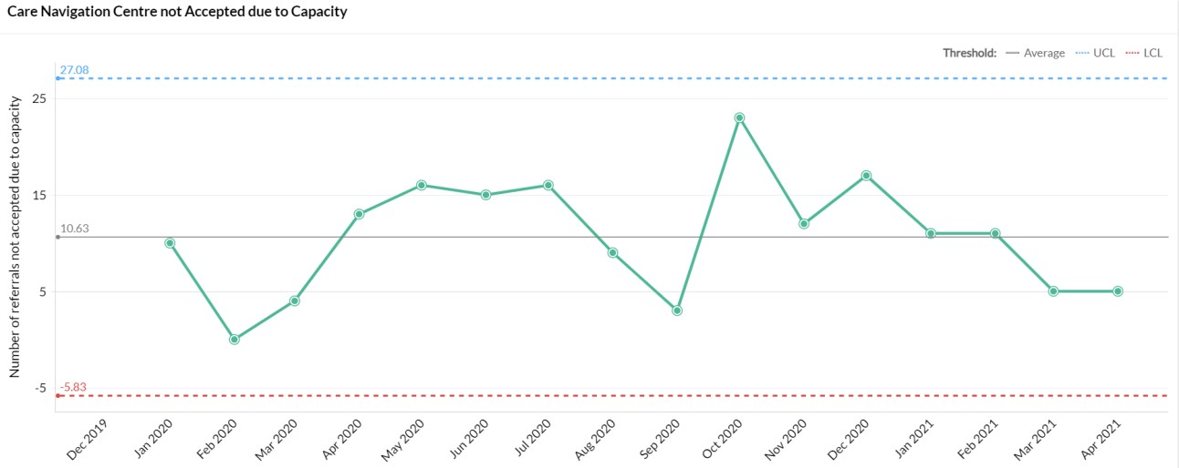
      - The CNC continue to support new services such as screening for long covid and escalation to the MDT through a step down referral and triage. With effect from 4th May this pathway has been opened for GP's to refer patients in order to access support and self care management for their patients.
      - The Safe at Home pathway continues to operate with patients being referred from Acute Hospital services and GP practices.
      - The operational hours for the CNC will be extended from 1st June onwards as part of the phased approach to expanding the service.

Tier 3: Rapid Response

The pattern of demand is changing [impact of CNC]

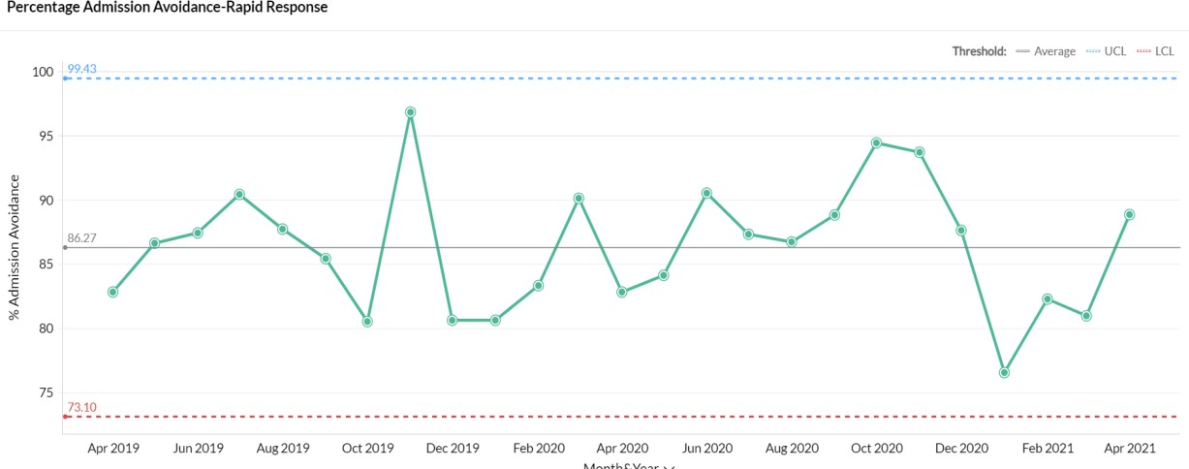
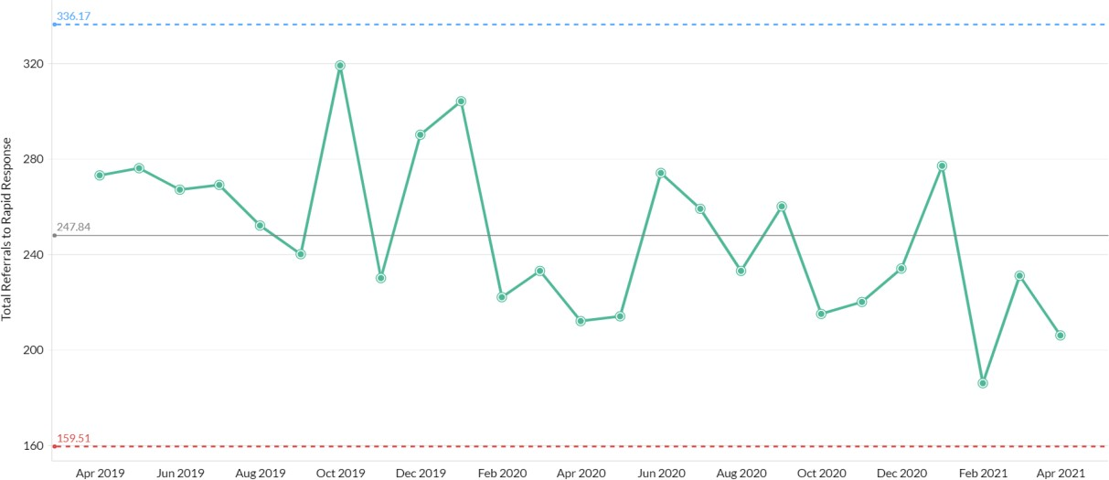Referrals into Rapid Response remain volatile and this needs to be viewed alongside the growing ability of the Care Navigation Centre to triage referrals into other services as well as the development of the enhanced care model into residential homes. Recruitment is underway to extend operational hours for Rapid Response until midnight, expectation is to be operational 1st July 2021

Rapid Response is now visible to NHS111 and WMAS as a direct referral / call disposal route

Tier 3: Medically Stable for Discharge (MSFD): numbers remain low
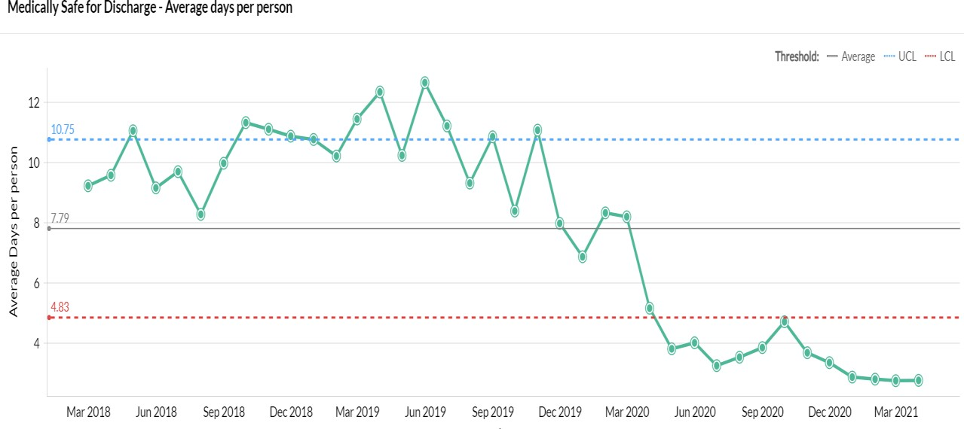
- The number of MSFD patients was at its
lowest level ever during March 2021
- As notified last month, a review of ICS is planned to commence during Q1 2021/22 as the flow through ICS community pathways will need to be accelerated in order to meet demand within the commissioned
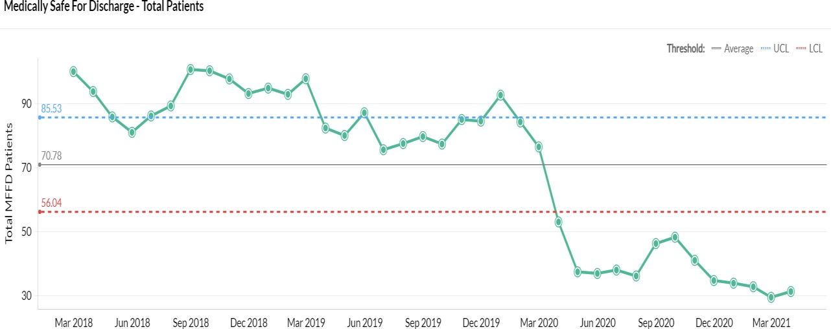
capacity. The review will be led by the new ICS commissioner who was due to start on 12/04/21.
- The risks associated with this were reviewed at the WT SMT on 09/04/21 and the funding options are to be considered by the Joint Commissioning Group

Tier 3: Domiciliary and Bed-Based Pathways
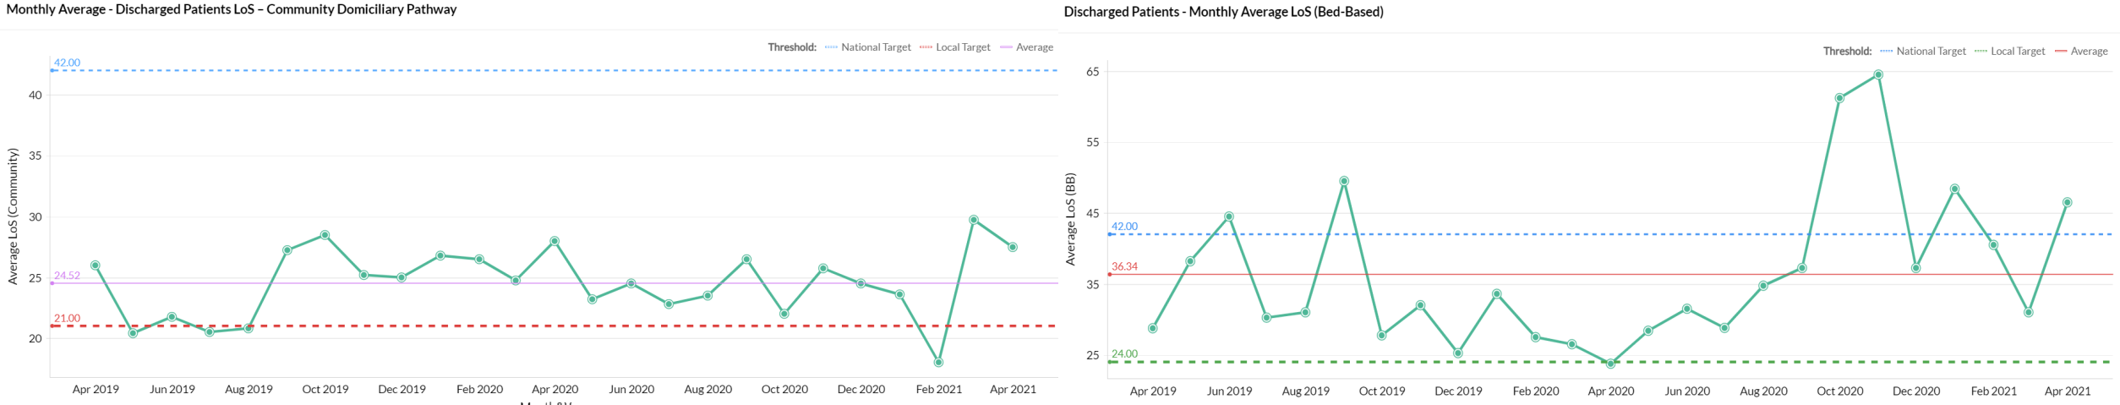
LoS has increased in the community pathways:
- There were a number of patients from the NWB pathway that transferred onto Reablement for care & support and then exited in March
- There were some therapy delays in terms of reviewing individuals once on the pathway
- Due to Covid, individuals have been more unwell and therefore have needed rehab/Reablement for a longer period of time
- Some of these individuals will have been in a bed based provision to start with and then transferred onto
the community pathway.

Tier 3/4:
Integrated Assessment Hub: Integrated Assessment Hub

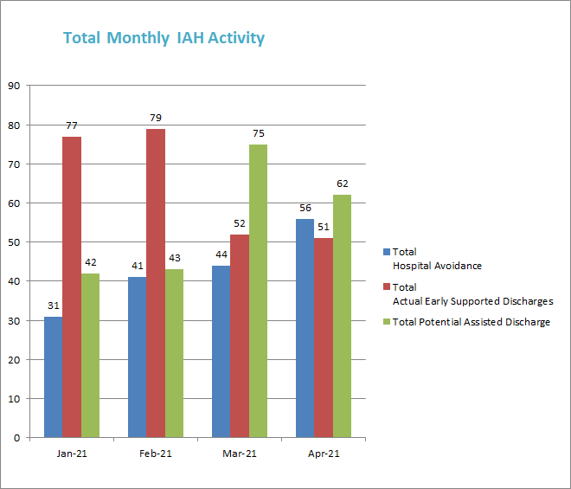Recruitment is still in progress with a view to moving to a 7 day service in May 2021.
- Hospital Avoidance: This IAH pathway enables people directly contacting the Frail Elderly Service or Ambulatory Care at the Manor with post- discharge complications to be seen by Rapid Response, Enhanced Care Home Support Team or CIT team instead and receive a community-based assessment & clinical review, thereby avoiding conveyance to hospital. The numbers of people accessing this pathway increased in April
- Early Supported Discharge: Patients who have been identified in ED, assessment units & wards are discharged into a community service (including DVTs from ambulatory). While the numbers dropped in March further work is required to understand whether this reflects the growth in use of the Hospital Avoidance & Assisted Discharge Pathways
- Assisted Discharge: IAH team signpost / support wards with navigating discharge pathways which result in a discharge same / next day (e.g. out of area patients; Safe at Home scheme; ICS; therapy)

Tier 4: Black Country Healthcare
Mental Health & Learning Disability – Operational Issues
- Trust has developed a short to medium term plan – the ‘Black Country Route’ – which reflects the steps and priorities of the national ‘roadmap’. Focuses on an operating model for the next three months which maintains Covid-secure working practices whilst carefully re-introducing some ‘normal’ activities (e.g. visiting for inpatients)
- As part of this plan, we have now returned inpatients services to a model of operation which is more similar to pre- pandemic working. Working age male PICU now up and running. We have maintained separate admission ward and red/green inpatient arrangements, but have introduced more flexibility in practices overall.
- We continue to manage Covid outbreaks as and when they occur.
- Continued efforts to encourage remaining staff to engage with the Covid-19 vaccination offer. Trust is working closely with locality partners to support the delivery of vaccines in the community to individuals with an LD or Severe MH problems (as part of JCVI cohort 6)
- Psychological wellbeing hub for staff in STP partners and third sector. More information about the Hub and a self- referral form can be accessed on the BCHFT website: www.blackcountryhealthcare.nhs.uk/our-services/hub.
- Current area of significant pressure (locally and nationally) is access to mental health inpatient beds for u-18s.
- Planning for community mental health transformation programme is progressing well – this has already been discussed with Walsall partners via CPLG and there is ongoing dialogue via this forum with Laura Brookes, Clinical Lead for this programme.

MEETING OF THE PUBLIC TRUST BOARD - 3rd June 2021
Work Closely with Partners |  |  |  | AGENDA ITEM: 26
Report Author and Job  Title: | Ned Hobbs, Chief  Operating Officer | Responsible  Director: |  | Ned Hobbs, Chief  Operating Officer
Action Required | Approve ☐ Discuss ☐ Inform ☒ Assure ☒
Executive Summary | This report provides an overview of the risks to delivery of the Work Closely with Partners Strategic Objective, mitigations in place to manage the risks identified, and actions identified to address gaps in controls and assurance.  The Work Closely with Partners Improvement Programme reflects the work of Divisional teams and the progression of functional integration between Acute Hospitals. This report gives a brief update on Urology, Dermatology, Radiology, Orthopaedics and Bariatric Surgery functional integration, and appends a list of  previously completed integration work.
Recommendation | Members of the Trust Board are asked to note the contents of this report.
Does this report mitigate risk included in the BAF or Trust Risk Registers? please outline | This report addresses BAF Risk S04 Work Closely with Partners to provide positive assurance the mitigations in place to manage this risk and the related corporate risks  There are no direct corporate risks associated with Partnership working. However increased partnership working provides a mitigation to the following Corporate risks;  2066- Nursing and Midwifery Vacancies  2072- Temporary workforce
Resource implications | There are no direct resource implications associated with this  report.
Legal and Equality and Diversity implications | There are no legal or equality & diversity implications associated with this paper.
Strategic Objectives | Safe, high quality care ☐ |  | Care at home ☐
Strategic Objectives | Partners ☒ |  | Value colleagues ☐
Strategic Objectives | Resources ☐

WORK CLOSELY WITH PARTNERS

- EXECUTIVE SUMMARY

COVID-19 affected the ability of the Trust to formally oversee and manage the programme of integration between Acute Hospital services. However, COVID-19 has also necessitated and accelerated significant collaboration between Trusts on many matters including mutual aid for Personal Protective Equipment, standardisation of policies in relation to the workforce, approaches to restoration and recovery planning, Critical Care mutual aid, mutual aid for the management of patients conveyed to Emergency Departments by ambulance, and shared learning to deal with a novel virus pandemic.

As a result, collaboration between Black Country Trusts is stronger due to the experience of this year. There is a clear appetite to use this opportunity to build upon those foundations and progress functional service integration where there is an opportunity to improve care for the patients we serve and/or to improve the working lives of our staff.

- BOARD ASSURANCE FRAMEWORK

The Working Closely With Partners BAF risk has been reviewed and updated. The risk has been brought up to date to reflect the evidence of successful partnership working, the demonstrable progress in functional service integration in further specialties now, and to recognise the approved Strategic Collaboration between The Royal Wolverhampton NHS Trust (RWT) and Walsall Healthcare NHS Trust (WHT), the new Integrated Supplies and Procurement Department (ISPD) alliance with RWT and University Hospitals North Midlands NHS Trust, and the introduction of a shared Chair and Chief Executive Officer between the Trust and RWT.

The risk score remains at a 9 (likelihood 3 x consequence 3).

- IMPROVEMENT PROGRAMME

The Work Closely with Partners Improvement Programme reflects the work of Divisional teams and the progression of functional integration between Acute Hospital specialties to support improved patient care, and improved working lives for our people.

Urology

Work continues to develop the full proposals for integration of Urology services between RWT and WHT, and the Collaborative Working Integration Executive Group between the two Trusts received a project update on Tuesday 25th May 2021.

A detailed audit of emergency workload for the WHT Consultant Urologist on-call has been completed to inform models for a joint on-call service.

The Commissioners have confirmed their expectations for the proposed model of care to be presented to the Black Country Urgent and Emergency Care Board, Black Country CCG Board and Clinical Reference Group (in parallel), followed by the Council’s Scrutiny Committee.

A further Urology working group meeting between both Trusts is scheduled for 26th May 2021.

Dermatology

The joint Dermatology Steering Group has made recommendations on the future structural form of the Dermatology service between WHT and RWT. These proposals were received at the Collaborative Working Integration Executive Group between the two Trusts on Tuesday 25th May 2021, and were supported with feedback given. The Steering Group will now be reconfigured to work through the structural integration of the department.

The Mohs Surgery business case was received at the Black Country & West Birmingham ICS Cancer Programme Board and was endorsed. It will be presented through the relevant Trust committees at RWT and WHT for formal approval.

The Dermatology Steering Group has received formal closure reports from 5 out of 6 of the established workstreams, following completion of the workstream objectives.

Radiology

The inaugural West Midlands Imaging Network Shadow Board meeting was held on 11th May 2020. The key deliverable workstreams were agreed as follows:
- Workforce plan

- Digital (Image Exchange process)
- Capital Equipment
- Procurement
- Demand & Capacity

The draft Memorandum of Understanding was discussed, and revisions will be made before formal adoption.

Orthopaedics

A WHT and RWT T&O Working Group has been established in May 2021 to review opportunities for collaboration in the provision of elective Orthopaedic services. Successful agreement has been reached for the first WHT operating list at Cannock Hospital, which is scheduled on the 8th July 2021.

A consensus between the two Trusts has been reached that WHT elective Orthopaedic operating at Cannock Hospital can be supported to improve access for elective operations, and the detailed options for future service models are being considered.

Bariatric Surgery

The number of Black Country & West Birmingham patients receiving Bariatric Surgery outside of the ICS has been reviewed, and is in excess of 200 patients per annum. Two consultant Upper Gastrointestinal Surgeons with Bariatric training from SWBH have been identified to participate in Bariatric surgery operating at WHT, with the first operating lists aiming to be scheduled in July 2021. This is the first step in seeking to ensure Black Country & West Birmingham patients can receive local access to Bariatric Surgery.

- RECOMMENDATIONS

Members of the Trust Board are asked to note the contents of this report.

APPENDICES

  - List of secondary care partnership integration already delivered
  - BAF SO3

APPENDIX 1

List of secondary care partnership integration already delivered

Recently integrated/networked services

ENT Consultant on-call rota with RWT and DGFT Sentinel Lymph Node Biopsy pathway with DGFT
Integrated Supplies and Procurement Department (ISPD) alliance with RWT and University Hospitals North Midlands NHS Trust
Offer of Colorectal Cancer Surgery capacity to other BCWB ICS partners Black Country Pathology Service with RWT, DGFT and SWBH
Payroll with RWT

Clinical Fellowship programme with RWT International Nurse recruitment programme with RWT

Historically integrated/networked services

Cardiology with RWT Renal with RWT Ophthalmology with RWT
Oral and Maxillofacial Surgery with RWT Oncology with UHB
Neurology with UHB

Hyper Acute Stroke with RWT Vascular Surgery with DGFT and RWT Haematology with RWT Rheumatology with SWBH

Latest Board/Committee - 06/05/2021 Version V1.02

Risk Summary
BAF Strategic  Objective Reference & Summary Tile: | BAF SO 03 - Working with partners; We will deliver sustainable best practice in secondary care, through working with partners across the Black Country and West Birmingham System.
Risk Description: | Failure to integrate functional and organisational form change within the Black Country will result in lack of resilience in workforce and clinical services, potentially damaging the trust’s ability to deliver sustainable high quality care.
Lead Director: | Chief Operating Officer.
Lead Committee: | Performance, Finance, & Investment Committee.
Links to Corporate Risk Register: | Title: |  |  |  |  |  |  | Current Risk Score Movement:
Links to Corporate Risk Register: | - There are no direct corporate risks associated with Partnership working. However increased partnership working provides a mitigation to the following Corporate risks;  - 2066 - Nursing and Midwifery Vacancies,  - 2072 - Temporary workforce. |  |  |  |  |  |  | Likelihood = 3  Consequence = 3  9  Moderate  ↔
Risk Scoring
Quarter: | Q1 2021/22 | Q2 | Q3 | Q4 2020/21 | Rational for Risk Level: | Target Risk Level (Risk Appetite): |  | Target Date:
Likelihood: |  |  |  | 3 | - This risk has been reduced to moderate due to the advancement of a number of key work streams.  - Executive group established across provider organisations to review opportunities for collaboration.  - Success of Black Country Pathology Service (BCPS).  - Transfer of WHT payroll service to RWT.  - Advanced collaboration in Dermatology including appointment of joint clinical director, and cross-site working of Consultant Dermatologists.  - Advanced discussions in Urology including cross site working.  - Integrated ENT on-call rota in place.  - Initial discussions re: bariatric services and radiology.  - STP Clinical Leadership Group, relevant restoration and recovery groups and relevant network collaboration continue to drive | Likelihood: | 2
Consequence: |  |  |  | 3 |  | Consequence: | 2
 |  |  |  |  |  |  |  | Q2 2021/22
Risk Level: |  |  |  | 9  Moderate |  | Risk Level: | 4  Low | Subject to assurance on and approval of Urology integration plan.

Clinical Strategy.
- Shared Clinical Fellowship Programme agreed with RWT, and first round of appointments made.
- Shared international nurse recruitment programme agreed with RWT, and first round of appointments made.
- New Integrated Supplies and Procurement Department (ISPD) alliance with Royal Wolverhampton NHS Trust and University Hospitals North Midlands NHS Trust commencing April 2021.
However, despite progress despite progress, integration plans are not all yet fully implemented and
the sustainability of the Urology service prevents the score being reduced further at this stage.
Control & Assurance Framework - 3 Lines of Defence
 | 1st Line of Defence |  |  |  | 2nd Line of Defence | 3rd Line of Defence
Controls: | - Sustainability review process completed.  - Regular oversight through the Board and its sub committees.  - Improvement Programme to progress clinical pathway redesign with partner organisations.  - Executive to Executive Integration oversight meeting established between WHT and RWT (first meeting held 10/03/21) and agreed to be held every 4-6 weeks.  - Black Country & West Birmingham Acute Care Collaboration Programme  Board established March 2021. |  |  |  | - Public Trust Board approved Strategic Collaboration between The Royal Wolverhampton NHS Trust and Walsall Healthcare NHS Trust at February 2021 Board meetings, and approved a Memorandum of Understanding at March 2021 Board meetings. | - Third line of control NHSE/I regulatory oversight.  - Black Country and West Birmingham STP plan and governance processes in place.
Gaps in Controls: | - Lack of co-alignment by our organisation and all neighbouring trusts.  - Lack of formal integration at Trust level across all four BCWB Acute Trusts.  - Mandated arrangements by regional networks.
Assurance: | - Track record of functional integration of clinical services including hyper acute stroke, vascular surgery, cardiology, rheumatology, ophthalmology, neurology, oncology, Black Country Pathology Service and OMFS. |  |  |  | - Demonstrable evidence of recent functional integration in ENT, Urology and Dermatology and with the clinical fellowship programme.  - Emerging commitment from BCWB Acute Collaboration partners to more formalised collaborative working.  - Audit Committee has oversight of partnership | - Progress overseen nationally and locally.

2 | P a g e

 |  | - Non-clinical service integration such as Payroll and Procurement. | working within its terms of reference.  - System Review Meetings providing assurance to regulators on progress.
Gaps in Assurance: |  | - Clinical strategy is still emerging.  - Additional pressures with Covid-19 have delayed acute collaboration, and organisational capacity is concentrated on managing the second and third waves of the pandemic.  - Limited independent assessment of integrated services or collaborative working arrangements.  - Embryonic independent evidence-base for successful collaborations to assess progress against.
Future Opportunities
- Consolidate other services, including back office functions.
- Collaborate with partner organisations outside the Black Country Acute Trusts, including community and third sector organisations.
- Promote Walsall as an STP hub for selected, well-established services.
- Collaborative working during COVID-19 presents an opportunity to accelerate some elements of clinical pathway redesign.
- Shared Chair and CEO with RWT creates opportunities to accelerate bilateral collaboration where applicable.
- First WHT elective Orthopaedic operating list scheduled to take place at Cannock in June 2021.
Future Risks
- Conflicting priorities and leadership capacity to deliver required changes.
- STP level governance does not yet have statutory powers.
- Lack of engagement/involvement with the wider public.
- Acute Hospital Collaboration may not progress at the anticipated pace due to the resurgence of COVID-19 coinciding with a challenging winter.
- Disrupted relationships with neighbouring trusts due to altered visions of the form and pace of future collaboration.
Future Actions (to further reduce the Likelihood / Consequence of the risk in order to achieve the Target Risk Level in line with the Risk Appetite)
No. | Action Required: |  | Executive Lead: | Due Date: | Progress Report: |  | BRAG:
1. | Keep abreast of Trust Acute collaboration discussions and  updates accordingly. |  | G. Augustine | Dec 2020 | COMPLETE - Trust Board endorsed the benefits of  BCWB Trust collaboration for the population of Walsall
2. | Develop over-arching programme plan to support individual projects for each phase (Phase 1, emergencies, Phase 2,  Elective/Cancer work). |  | Programme Manager | Dec 2020 | Delayed due to resurgence of Covid-19. To be incorporated into re-phased Improvement Programme  Plan for June 2021.
4. | Assess resource requirement to support Imaging Network programme |  | G Augustine & N Hobbs | Feb 2021 | COMPLETE  Delayed due to resurgence of Covid-19. To be  discussed at Black Country wide working group in April 2021.
5. | Approve Urology integration plan through QPES, PFIC and Trust Board (if applicable) |  | N Hobbs | June 2021 | Trust Management Board received proposal on 9th March setting out engagement and Consultation  requirements to enable approval.


1

MEETING OF THE PUBLIC TRUST BOARD – 3rd June 2021
Audit Committee Highlight Report |  |  | AGENDA ITEM: 27
Report Author and Job Title: | Trish Mills Trust Secretary | Responsible Director: | Mrs Mary Martin, Chair of Audit Committee (Non-Executive Director)
Action Required | Approve ☒ Discuss ☒ Inform ☒ Assure ☒
Executive Summary | This report provides the key messages from the Audit Committee meeting on 19th May 2021. The report sets out escalations for the attention of the Trust Board, and key issues discussed and work underway.  - The draft unaudited accounts and annual report were reviewed, and the External Auditors confirmed they were on track with their annual filings review. The final audited accounts and annual report will be discussed at the Audit Committee meeting on 23rd June and the Trust Board’s delegation is sought for the Audit Committee to approve the annual filings on behalf of the Board at that meeting in order to meet the national deadlines.  - The draft Head of Internal Audit Opinion was received and the final opinion will be reviewed at the June meeting. The draft currently reports partial assurance with improvement required, but notes a strengthened position with respect to risk management arrangements in year.  - The Internal Auditors presented the following audit reports and the Committee will continue to monitor progress against recommendations raised for:  - Temporary staffing review – medical. Rated partial assurance with improvement required. The Committee expressed their concern over two high rated findings related to authorisation in line with policies and procedures and monitoring of long term locum bookings, and requested these be addressed quickly  - Board Assurance Framework review. Rated partial assurance with improvement required  - The 2021/22 internal audit plan and 3 year strategy were approved, as was an escalation process for reviews and recommendations.


2

 | The next meeting of the Audit Committee will be held on 23rd June 2021.
Recommendation | Members of the Trust Board are asked to note the report and escalations, and provide the delegation to approve the annual  filings at the Committee’s 23 June meeting.
Does this report mitigate risk included in the BAF or Trust Risk Registers? please outline | Audit Committee is essential to Trust Board managing risk across the organisation.
Resource implications | Poor internal control and/or management of risk would almost  certainly result in financial loss.
Legal and Equality and Diversity implications | There are no legal or equality & diversity implications associated with this paper.
Strategic Objectives | Safe, high quality care ☒ | Care at home ☒
Strategic Objectives | Partners ☒ | Value colleagues ☒
Strategic Objectives | Resources ☒

