AGENDA
MEETING OF THE PUBLIC TRUST BOARD
Held in public on Thursday 6th May 2021from 10.30am to 3.00pm
Meeting held virtually via Microsoft Teams

# | Agenda Item | Purpose | Lead | Format | Time
OPENING ITEMS
1. | Chair’s welcome; apologies and confirmation of quorum | Inform | Steve Field | Verbal | 10.30
2. | Declarations of interest | Inform | Steve Field | Enclosure
3. | Minutes of last meeting | Approve | Steve Field | Enclosure
4. | Matters arising and action log | Review | Steve Field | Enclosure | 10.35
5. | Nolan Principles | Inform | Steve Field | Enclosure | 10.40
6. | Trust Values | Inform | John Dunn | Enclosure | 10.45
7. | Chair’s Report | Inform | Steve Field | Enclosure | 10.55
8. | Chief Executive’s Report | Inform | David Loughton | Verbal | 11.05
9. | COVID-19 BAF Risk | Assure | Ned Hobbs | Enclosure | 11.15
PATIENT STORY
10. | Patient Story – Emergency Department and  SACU | Discuss | Introduced by Ann-  Marie Riley | Video | 11.20
PROVIDE SAFE, HIGH QUALITY CARE
11. | Quality, Patient Experience and Safety Committee Report | Assure Inform | Pamela Bradbury | Enclosure | 11.35
12. | Safe High Quality Care Executive Report | Assure Inform | Matthew Lewis Ann-Marie Riley | Enclosure | 11.40
13. | Mortality Report Q4 | Assure | Matthew Lewis | Enclosure | 11.55
14. | Patient Experience Annual Plan and Strategy  21/22 | Approve | Ann-Marie Riley | Enclosure | 12.05
USE RESOURCES WELL
15. | Performance, Finance and Investment Committee Report | Assure Inform | John Dunn | Enclosure | 12.15
16. | Use Resources Well Executive Report | Assure Inform | Ned Hobbs Russell Caldicott | Enclosure | 12.20
CARE AT HOME
17. | Walsall Together Partnership Board Report | Assure  Inform | Anne Baines | Enclosure | 12.35
18. | Care at Home Executive Report | Assure Inform | Daren Fradgley | Enclosure | 12.40
1.00 – 1.30 COMFORT BREAK
STAFF STORY
19. | Maternity Team https://youtu.be/1ipH9gw-HVE | Discuss | Introduced by Ann- Marie Riley | Verbal | 1.30
VALUE OUR COLLEAGUES
20. | People and Organisational Development Committee Report | Assure Inform | Junior Hemans | Enclosure | 1.50

# | Agenda Item | Purpose | Lead | Format | Time
21. | Value Our Colleagues Executive Report | Assure Inform | Catherine Griffiths | Enclosure | 1.55
22. | Equality, Diversity and Inclusion Strategy | Approve | Catherine Griffiths | Enclosure | 2.10
23. | Safe Staffing Report | Assure | Ann-Marie Riley | Enclosure | 2.20
WORK CLOSELY WITH PARTNERS
24. | Work Closely with Partners Executive Report | Assure  Inform | Ned Hobbs | Enclosure | 2.30
GOVERNANCE AND WELL LED
25. | Audit Committee Report | Assure Inform | Mary Martin | Verbal | 2.45
CLOSING ITEMS
26. | Any other business | Discuss | Steve Field | Verbal | 2.55
27. | Questions from the Public | Discuss | Steve Field | Verbal
DATE AND TIME OF NEXT MEETING
Thursday 3rd June 2021 at 10.30am
EXCLUSION OF THE PRESS AND MEMBERS OF THE PUBLIC
Exclusion to the Public – To invite the Press and Public to leave the meeting because of the confidential
nature of the business about to be transacted (pursuant to Section 1(2) of the Public Bodies (Admission to Meetings) Act 1960).

Lead Presenters

Name of Lead | Position of Lead
Prof. Steve Field | Chair of Trust Board
Mr John Dunn | Vice Chair of Trust Board; Chair of Performance, Finance and Investment Committee
Mrs Pamela Bradbury | Non-Executive Director; Chair of Quality, Patient Experience and Safety Committee
Mrs Anne Baines | Non-Executive Director; Chair of Walsall Together Partnership Board
Mr Junior Hemans | Non-Executive Director; Chair of People and Organisational Development Committee
Mrs Mary Martin | Non-Executive Director; Chair of Audit Committee
Prof David Loughton | Interim Chief Executive Officer
Mr Daren Fradgley | Director of Integration
Dr Matthew Lewis | Medical Director
Ms Ann-Marie Riley | Director of Nursing
Mr Russell Caldicott | Director of Finance and Performance
Ms Catherine Griffiths | Director of People and Culture
Mr Ned Hobbs | Chief Operating Officer
Ms Jenna Davies | Director of Governance

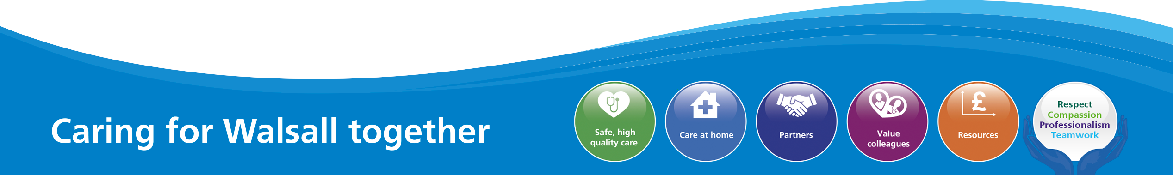
1

MEETING OF THE PUBLIC TRUST BOARD – 6th May 2021
Declarations of Interest |  |  |  | AGENDA ITEM: 2
Report Author and Job Title: | Trish Mills  Trust Secretary | Responsible Director: |  | Steve Field, Trust Board Chair
Action Required | Approve ☐ Discuss ☐ Inform ☐ Assure ☒
Executive Summary | The report presents a Register of Directors’ interests to reflect the interests of the Trust Board members.  The register is available to the public and to the Trust’s internal and external auditors, and is published on the Trust’s website to ensure both transparency and also compliance with the Information Commissioner’s Office Publication Scheme.
Recommendation | Members of the Trust Board are asked to note the report
Does this report mitigate risk included in the BAF or Trust Risk Registers? please outline | There are no risk implications associated with this report.
Resource implications | There are no resource implications associated with this report.
Legal and Equality and Diversity implications | It’s fundamental that staff at the Trust are transparent and adhere to both our local policy and guidance set out by NHS England and declare any appropriate conflicts of interest against the clearly defined rules.
Strategic Objectives | Safe, high quality care ☒ |  | Care at home ☒
 | Partners ☒ |  | Value colleagues ☒
 | Resources ☒

Register of Directors Interests at April 2021

Name | Position held in Trust | Description of Interest
Professor Steve Field | Chair | Chair: Royal Wolverhampton NHS Trust
 |  | Director: EJC Associates
 |  | Trustee for Charity: Pathway Healthcare for Homeless People
Trustee: Nishkam Healthcare Trust
Birmingham
 |  | Honorary Professor: University of Warwick
 |  | Honorary Professor: University of Birmingham
Mr John Dunn | Vice Chair  Non-executive Director | Non-Executive Director, Royal Wolverhampton  NHS Trust
Mrs Anne Baines | Non-executive Director | Director/Consultant at Middlefield Two Ltd
 |  | Associate Consultant at Provex Solutions Ltd
Ms Pamela Bradbury | Non-executive Director | STP Workforce Bureau (Vaccination Programme)
Partner, Dr George Solomon is a Non- Executive Director at Dudley Integrated Health
and Care Trust
Mr Ben Diamond | Non-executive Director | Director of the Aerial Business Ltd.
 |  | Volunteer at Gracewell of Sutton Coldfield Care Home
Partner - Registered nurse and General
Manager at Gracewell of Sutton Coldfield Care Home
 |  | Volunteer Vaccinator with St John's Ambulance
Mr Junior Hemans | Non-executive Director | Non-executive Director - Royal Wolverhampton NHS Trust
 |  | Visiting Lecturer – University of Wolverhampton
 |  | Director – Libran Enterprises (2011) Ltd
 |  | Chair/Director - Wolverhampton African Caribbean Resource Centre
 |  | Chair - Tuntum Housing Association (Nottingham)
 |  | Company Secretary – The Kairos Experience Ltd.
 |  | Member – Labour Party
 |  | Mentor – Prince’s Trust
Ms Mary Martin | Non-executive Director | Royal Wolverhampton NHS Trust - Non- Executive Director

Name | Position held in Trust | Description of Interest
 |  | Trustee/Director, Non-Executive Member of the Board for the charity - Midlands Art Centre
 |  | LTDTrustee/Director, Non-Executive - B:Music
 |  | Director - Friday Bridge Management Company Ltd
Non-Executive Director/Trustee - Extracare
Charitable Trust
Mr Paul Assinder | Associate Non- executive Director | Chief Executive Officer - Dudley Integrated  Health & Care Trust
 |  | Director of Rodborough Consultancy Ltd.
Governor of Solihull College & University
Centre
Honorary Lecturer, University of
Wolverhampton
 |  | Associate of Provex Solutions Ltd.
Mr Rajpal  Virdee | Associate Non-  executive Director | Lay Member, Employment Tribunal  Birmingham
Mrs Sally Rowe | Associate Non- Executive | Executive Director Children’s Services -  Walsall MBC
Trustee of the Association of Directors of
Children’s Services
Professor David Loughton | Interim Chief Executive | Chief Executive – Royal Wolverhampton NHS Trust
 |  | Health policy advisor to the Labour and Conservative Parties
 |  | Member – Dementia Health and Care Champion Group
 |  | Member of Advisory Board – National Institute for Health Research
 |  | Chair – West Midlands Cancer Alliance
Mr Daren Fradgley | Director of Integration | Director of Oaklands Management Company
 |  | Spouse, Helen Willan, is Systems Manager at West Midlands Ambulance Service
 |  | Clinical Adviser NHS 111/Out of Hours
 |  | Non-Executive Director at whg
Mr Russell Caldicott | Director of Finance and Performance | Member of the Executive for the West Midlands  Healthcare Financial Management Association (HFMA)
Dr Matthew Lewis | Medical Director | Spouse, Dr Anne Lewis, is a partner in general  practice at the Oaks Medical, Great Barr
 |  | Director of Dr MJV Lewis Private Practice Ltd.

Name | Position held in Trust | Description of Interest
Ms Jenna  Davies | Director of Governance | No Interests to declare.
Ms Catherine  Griffiths | Director of People and  Culture | Catherine Griffiths Consultancy ltd
 |  | Chartered Institute of Personnel (CIPD)
Mr Ned Hobbs | Chief Operating Officer | Father – Governor Oxford Health FT
Sister in Law – Head of Specialist Services St
Giles Hospice
Ms Ann-Marie  Riley | Interim Director of  Nursing | No interests to declare
Ms Glenda  Augustine | Director of Performance  & Improvement | No interests to declare

RECOMMENDATIONS

The Board is asked to note the report

MEETING OF THE PUBLIC TRUST BOARD HELD ON THURSDAY, 1st APRIL 2021 AT 10.30AM
HELD VIRTUALLY VIA MICROSOFT TEAMS

PRESENT

Members
Prof Steve Field Chair of the Board of Directors
Mr John Dunn Non-Executive Director; Vice Chair, Board of Directors
Mrs Anne Baines Non-Executive Director Mrs Pamela Bradbury Non-Executive Director Mr Ben Diamond Non-Executive Director
Mr Junior Hemans Non-Executive Director
Mr Paul Assinder Associate Non-Executive Director (until 3pm) Mrs Sally Rowe Associate Non-Executive Director
Mr Daren Fradgley Acting Chief Executive Officer
Dr Matthew Lewis Medical Director
Ms Ann-Marie Riley Director of Nursing
Mr Russell Caldicott Director of Finance and Performance Mr Ned Hobbs Chief Operating Officer
Ms Catherine Griffiths Director of People and Culture Ms Jenna Davies Director of Governance
Mrs Glenda Augustine Director of Planning and Improvement Mr Matthew Dodd Acting Director of Integration
Mr Rajpal Virdee Associate Non-Executive Director

In attendance
Mrs Trish Mills Trust Secretary
Ms Kim Sterling Freedom to Speak Up Guardian (for item 19) Ms Val Ferguson Freedom to Speak Up Guardian (for item 19) Dr Adi Kuravi Clinical Director for Critical Care (for item 16)
Ms Ly Fletcher Senior Sister for Critical Care (for item 16)
Mr Leigh Rogers Senior ACP, Emergency Department
Dr Mushal Naqvi Guardian of Safe Working (for item 20)
Mr Mike Sharon Strategic Advisor to Board, Royal Wolverhampton NHS Trust Mr Keith Wilshere Company Secretary, Royal Wolverhampton NHS Trust
Ms Roseanne Crossley Head of Business Planning and Development

001/21 | Welcome, Apologies and Confirmation of Quorum
 | Prof Field welcomed everyone to the meeting, and noted that there were no apologies received from Members for the meeting.
002/21 | Declarations of Interest
 | The register of interests was received by the Board, and the Chair requested Members to update the meeting if there were interests that were not noted. None were updated.
003/21 | Minutes of Last Meeting
 | The minutes of the meeting on 4th March 2021 were approved as a true record.

004/21 | Matters Arising and Action Log
The Board received the action log and noted updated position statements and the items for closure as follows:
Action 189/20 – Chairs of Board Committees involvement in mapping Integrated Care Provider (ICP) governance: Mr Fradgley updated the Board that, as noted in his CEO’s report, this is a work in progress with the national planning round for 2021/22 being delayed by a quarter, therefore there will be no contractual changes until 1 July. Chairs will be invited to participate in the mapping exercise as part of the due diligence work which will be done in phases as the service scope is more widely known. This item was closed.
Action 193/20 – Maternity Report: Monthly maternity report will be provided to the Quality, Patient Experience and Safety Committee with quarterly updated to Board. The report provides an overview of progress against a range of initiatives including Ockenden. First Board report will be July with highlight of Q1 position. This item was closed.
Dr Lewis noted one matter arising from the March meeting, with respect to the CCG risk register entry for the learning from deaths processes. He noted in that meeting it has been closed in February after 2.5 years, however it had in fact been on the risk register since 2011.
005/21 | Nolan Principles
Prof Field brought the attention of the Board to the seven principles of public life (the Nolan Principles). He thanked the Non-Executive Directors for their time and commitment to the people of Walsall and staff at the Trust.
Prof Field announced the six month appointment of Ms Mary Martin as a Non- Executive Director on the Board commencing from 1st April. Ms Martin was unable to join today’s meeting but will be welcomed from the May meeting.
006/21 | Trust Values
The Board received the Values of the Trust – those being:
- Respect
- Compassion
- Professionalism
- Teamwork
Mr Fradgley reflected on what the value of Teamwork means to him as Acting Chief Executive. He noted that when working collaboratively with colleagues it is equally important to acknowledge that everyone’s view counts. Sharing knowledge and expertise across boundaries and encouraging everyone to have a voice is also key. He pointed out that working in silos, not engaging others in the
work you undertake, and making decisions on behalf of others are actions

 | opposed to the value of Teamwork.
007/21 | Chief Executive’s Report
Mr Fradgley, Acting Chief Executive, presented his report, noting a continued de- escalation of pressure due to a fall in COVID-19 infection rates in the community. The Board Committees this month were presented with evidence of reduced bed occupancy, lower critical care rates, and reducing COVID-19 pressure on the community and integrated partnership teams though Walsall Together The national Emergency Preparedness, Resilience and Response has been de- escalated from level 4 to level 3. Mr Dunn asked Mr Fradgley to explain the practical implications of this level for the people of Walsall and our colleagues. Mr Fradgley responded that, for the people of Walsall it includes the stepping down of lockdown which the government is communicating on a regular basis, the first phase of which commenced on 29th March. In terms of the Trust, it includes a reduced commitment to responding to command and control meeting and events, and allows the Trust to refocus the same amount of rigour to restoration and recovery, and the health and wellbeing of staff. It also means a re-focus back to more detailed levels of governance. Mr Hobbs noted that the regional team are likely to use similar command and control structures as a blueprint for other matters including emergency care winter planning and restoration and recovery.
Vaccination rates for Trust staff are now in the upper quartile in the country, with live data showing 84.13% of staff has had their first vaccination, and 51.22% have had their second vaccination. Mr Fradgley noted the strategy is to move the hospital hub into the newly opened Saddlers Centre. Mrs Bradbury sought assurance that the Trust is not using bank staff who would normally work in the hospital to staff the vaccination centres, leading to reliance on agency staff for the acute and community settings. Mr Fradgley confirmed Trust resources are not being depreciated as a result, and this is checked daily to provide assurance to the Executive. Mr Assinder enquired whether the Trust is confident they have done everything possible to communicate with staff who have not been vaccinated. Mr Fradgley advised that the national profile for vaccination percentages was only ever expected to be between 70-75%. This is due to the fact that there is always going to be cohorts who, due to contra-indications, reasons of medical disposition, or refusal, would not be vaccinated. Mr Fradgley assured the Board that staff who have not been vaccinated have been reached through one to one conversations, individual contacts and appointments, and through the work of influential leaders in those groups, and that this continues. Mr Fradgley confirmed that every colleague has been given an offer of vaccine since 1st February.
He noted that the health and wellbeing of staff is front and centre and that this is reflected in the restoration and recovery plans which the Board Committees have reviewed in March. Mr Virdee enquired as to whether the Schwartz Rounds are taking place face to face or online. Mr Fradgley responded that this was a mixture of both.
Mr Fradgley noted marginal improvement in some areas of the staff survey, but emphasised that these improvements lack the pace and sustainability required for

the Trust to move to ‘Good’ and ‘Outstanding’, and is disappointingly stagnant in other areas.
The Board were informed that the CQC unannounced visit on 9th March looked at medical pathways in the safe and responsive domains. The report has not been received for factual accuracy checking however initial outcomes have been shared with Board members and will come to the relevant Committees in April and to the Board in May.
The Black Country and West Birmingham Sustainability Transformation Partnership (STP) will operate from 1st April in shadow form with Integrated Care System (ICS) status. Prof Field congratulated Mr Fradgley, Mrs Baines and the Walsall Together partnership on its success, noting that what they have established will be drawn on in the ICS for other areas. He noted that the sustainability of the ICS is key and working across Trusts, local councils, volunteer and housing groups is important to improve the quality of health of the people in Walsall and the provision of healthcare to those people.
The Trust remains on trajectory to deliver the initial plan of a £3.8m deficit, though with the additional £2.3m of central income and the benefit of £1.5m from STP risk share the forecast is now break even performance for the financial year (though the Trust will have a technical deficit representing the increase in annual leave provision). The Board congratulated the team for achieving a break even position for the second consecutive year.
008/21 | COVID-19 Board Assurance Framework Risk
 | The Board noted the de-escalation of the COVID-19 Board Assurance Framework (BAF) risk to a score of 15 as pressures are reduced. The COVID-19 risk will remain in place until recovery is sustained.
009/21 | Patient Story
BBC news footage was shared of the story of Walsall mum, Ellie Wright, who contracted COVID-19 when she was 30 weeks pregnant and could not start life- saving treatment until her baby had been delivered. Baby Leo James was born by emergency caesarean, 10 weeks premature and needed to be on a ventilator. The interview featured Ellie’s mum, Michelle, who was now looking after her grandson at home while Ellie recovered in hospital and Dr Kuravi, Clinical Director for Critical Care.
Prof Field felt the story epitomised the care of patients and the compassion of staff at the Trust and thanked Ms Wright and her family for sharing her story, and to the BBC for its use at this meeting. He also pointed out that this story was picked up by the BBC on the Trust’s social media feeds, and that it is these types of good news stories that should be shared more widely with staff and which will attract more people to want to work at, and be cared for, at the Trust.

PROVIDE SAFE, HIGH QUALITY CARE
010/21 | Quality, Patient Experience and Safety Committee Report
Mrs Bradbury, Chair of the Quality, Patient Experience and Safety Committee presented the highlight report from the Committee’s meeting on 25th March 2021, noting the following:
- The Committee heard the story of a patient where poor communication was a key feature. Mrs Bradbury and Mrs Riley have been in regular contact with the family who are assisting in the improvements being put in place as a result of the issues raised.
- The draft Quality Impact Assessment (QIA) policy was discussed and comments provided for the next iteration. The Committee was assured that there are existing QIA processes in place to capture changes in service in instances of business development, business cases and cost improvement programmes.
- An effectiveness review is underway of the groups reporting into the Committee, starting with the Clinical Effectiveness Group and Patient Safety Group.
- The Committee reviewed two matters that arose in the Audit Committee earlier in the year – those being the internal audit review on Electronic Discharge Summary (EDS), and medical equipment replacement.
  - The actions were reviewed and the committee noted the target to complete EDS within 48 hours.
  - The Committee was assured that all the previously identified high risk items of medical equipment had been replaced.
- The Maternity Services report was reviewed by the Committee, and a progress report on the action plan in place as a result of the Ockenden recommendations was provided. The Committee agreed to receive reporting by exception at future meetings. All maternity serious incidents will be reported to the Committee and on to the Board via this highlight report.
  - Whilst progress is being made through a detailed 2 stage action plan, the Committee remains concerned about venous thromboembolism (VTE) compliance, which is at 91.91% for February - below the compliance target of 95%.
- The BAF risk rating for Safe High Quality Care had reduced from 20 to 15, due largely to reduced additional capacity requirements and demand for staffing, and progress against CQC actions.
- The Committee received the Nutrition Ambition Strategic Plan 2021-2024 which launched in March.

011/21 | Safe, High Quality Care Executive Report
Mrs Riley and Dr Lewis presented the Safe, High Quality Care report, which included the Board Assurance Framework strategic risk for this objective, Improvement Programme workstream and performance dashboard and data.
Mrs Riley noted that the BAF and corporate risks have been reviewed and updated as required, with the gaps in control and assurance discussed in detail at the Quality, Patient Safety and Experience Committee and progress has been made to reduce the number of gaps overall.
Oversight of progress against the CQC ‘Must Do’ and ‘Should Do’ actions continues via the monthly CQC action plan oversight group, with 48/55 2019 actions and 23/29 2020 actions being completed. Prof Field requested that the next report highlights which of the outstanding actions are ‘Must Do’ actions and a fuller explanation of the reasons they remain outstanding. In the meantime, Mrs Riley will share the details of those with the Board by email.
Projects within the Safe, High Quality Care Improvement Programme have continued to progress despite the COVID19 pandemic. A significant programme of work is progressing at pace in relation to the Harm Free Care workstream. A new Nutrition Ambition was launched in March with Ambitions for maintenance of skin integrity and continence function in development; and work is underway to better align the nursing risk assessment documentation with that of Royal Wolverhampton NHS Trust.
Dr Lewis reported that the clinical audit monitoring arrangements are being reviewed and strengthened, with a clinical outcomes dashboard developed to track and drive improvement across national audit outcomes and actions.
VTE compliance for February remains below the Trust target of 95% at 91.91%. An action plan was in place a mandated process through the Electronic Patient Record (EPR) which will facilitate this performance in the future, Dr Lewis noted that preliminary data from March showed improvement to 94%.
Dr Lewis noted that Mental Capacity Act (MCA) assessment compliance continues to be below the Trust’s Standards, showing that February 2021 shows that 49% of patients who lacked capacity had a stage 2 assessment undertaken (43% in January 2021). Further work is ongoing to build the MCA assessment (and ReSPECT forms) into the EPR, in order to mandate full assessments. In the meantime, training and support is being delivered through MCA Champions in clinical areas. The addition of MCA assessments to the Perfect Ward app will also allow champions real time feedback on this standard.
The Sepsis 6 dashboard is now live in the trust and allows all teams to review real time data against agreed national standards. Performance against these standards will be monitored through monthly divisional sepsis reviews, overseen by Dr Lewis and Mrs Riley. The March Clinical Senate discussed the rationale, process and monitoring systems relating to sepsis management.
Mrs Riley noted that the lag in reporting for the performance dashboard is being investigated and work is underway to get that to the Quality, Patient Experience

and Safety Committee and the Board in a more timely way to provide current assurance. She noted that the two cases of Clostridium Difficile reported in February are under investigation, and that there have been none reported in March.
Action 011/21
Future reports on the CQC action plan to draw out which of the outstanding actions are ‘Must Do’ actions, and provide a fuller explanation as to why they remain outstanding. In the meantime Mrs Riley to provide this information by email to Board members before the next meeting.
USE RESOURCES WELL
012/21 | Performance, Finance and Investment Committee Report
Mr Dunn, Chair of the Performance, Finance and Investment Committee presented the highlight report from the Committee’s meeting on 24th March 2021, noting the following:
- The Committee reviewed and endorsed the planning for Quarter 1 2021/22.
- The Committee reviewed the Board Assurance Framework risks for Use Resources Well and Work Closely with Partners, and the associated corporate risks, noting that the Use Resources Well rating has reduced from 20 to 15.
- The risk appetite statements for Use Resources Well and Work Closely with Partners were reviewed by the Committee. They were approved subject to clarity on how the statements will be used and embedded in day to day activity.
- Financial performance remains strong, the Trust forecasting attainment of the 2021/22 financial plan and delivery of a break-even outturn (costs incurred off- set in full by income received). The delivery to forecast in year will result in the Trust having attained financial plans and break-even performance for two consecutive financial years.
- The Committee reviewed the surgical division recovery plans, and at the next meeting will look more broadly at restoration and recovery.
- Further discussion took place on the links between capacity, acuity and cost. The next meeting will focus on moving from the dominance of COVID-19 into restoration and recovery, with a focus on exit run rates and run rates going forward, as well as procedures in place at divisional level to control both medical and nursing temporary staffing.
013/21 | Use Resources Well Executive Report
Mr Hobbs and Mr Caldicott presented the Use Resources Well report, which included the Board Assurance Framework strategic risk for this objective, Improvement Programme workstream and performance metrics.
Mr Hobbs commended the performance of diagnostic services, noting that the Trust is now delivering the 4th best performance in the country. He advised that

the eight week elective surgery restoration programme commenced in the week commencing 8th March, building in gradual increases in elective operating theatre capacity to facilitate annual leave and recuperation for staff. Mr Hobbs noted that the Trust enters the period of recovery in a challenging position with respect to the number of patients experiencing long waits, particularly those waiting over 52 weeks for routine surgery, but that the Trust is in a strong relative position overall compared to other Trusts. The objective is to be operating on all priority 2 patients within 28 days of being listed for surgery and it is forecast that that will be delivered for all cases by the end of May. Getting the priority 3 cases within 3 months of listing for surgery will take slightly longer and is forecast to be reached in early Autumn.
Mr Hobbs paid tribute to the teams along the emergency care pathways in both the acute and community settings, noting that the Emergency Department has seen the best triage performance on record, excellent ambulance handover times, and significant improvement in the four hour emergency access standard. He confirmed that the current position for March was that this standard was now in excess of 93%.
Mr Caldicott advised the Board that the Trust has a deficit plan of £3.8m for the financial year, though has received notification of additional income of £3.8m that off-sets the deficit and as such is forecasting attainment of break-even performance for the second consecutive year. He noted that there is potentially a technical deficit position as the Trust is accruing for annual leave as staff have been unable to take leave as usual due to the pandemic, and nationally this is classified as being outside of breakeven.
The Trust received capital allocations in year totalling more than £20m, and whilst a key risk has centred on the ability to utilise this financing in year, Mr Caldicott is confident they will have been spent when the exercise to measure the works undertaken has been completed for the financial year.
The Trust has substantial cash holdings at the end of January 2021, with this balance including receipt of cash for one month’s block income in advance of normal payment timeframes. The Trust will be required to repay the income received in advance in March 2021, though cash projections confirm there will still be significant cash holdings post repayment and no risk to operations.
Planning for 2021/22 has been moved to Quarter 1 of the new financial year with current income allocations rolled forward into quarter 1 of 2021/22. This Q1 plan has been adopted by the Executive and Trust Management Board, and endorsed by the Performance, Finance, and Investment Committee.
Prof Field congratulated Mr Hobbs and Mr Caldicott on behalf of the Board for the excellent performance in an uncertain and changing allocation position.
Mr Virdee enquired as to how the STP was working together to meet targets more efficiently and whether the private sector capacity would continue into 2021/22. Mr Hobbs agreed that partnership support is critical and that the Trust has a good track record of assisting STP partners to relieve pressures, with the ambulance conveyance support to Dudley and Wolverhampton in January and the Colorectal
Cancer Surgery capacity offer as two recent examples. He confirmed that the

 | national contract with the independent sector that enabled Trusts to transfer to places like Spire Little Aston finished on 31 March, however the Trust has secured an agreement with Spire Little Aston to continue some general surgical and orthopaedic surgery there. Mr Caldicott added that there are financial incentives for elective performance which are only realised if the STP as a whole over- performs, so it is vital to interlink our performance as a system.
CARE AT HOME
014/21 | Walsall Together Partnership Board Report
Mrs Baines, Chair of the Walsall Together Partnership Board presented the highlight report from the Board’s meeting on 24th March 2021, noting the following:
- An increase in safeguarding activity was noted by around 25% on last year, and it was agreed that it was important for the partnership to be clear that safeguarding takes a whole system approach to address inequalities in both children and adult safeguarding.
- Primary Care Networks are looking at how they restart services during Quarter 1 of 2021/22 to ensure priority groups are the focus and without increasing volumes to unmanageable levels.
- Good and wide ranging debate was had on the Model of Care graphic for Walsall Together, which depicts the vision of how care will look for people and communities of Walsall. Adjustments will be made to reflect all areas of the partnership, particularly to reflect a person’s journey starting at the home, and reflecting a health, care and wellbeing approach in the partnership.
- The refreshed proposals for Resilient Communities was considered and approved. Timeframes and outcomes would be formulated over coming months.
- The ICP roadmap was discussed, and in particular the primary mental health and Improving Access to Psychological Therapies (IAPTS) services. It was reiterated that such services are in scope for the partnership and the rationale for that would be articulated to the STP.
- The Clinical and Professional Leadership Group (CPLG) presented revised terms of reference for initial Partnership Board discussion. Mrs Baines attended the CPLG and the Senior Management Team meetings in months and was assured by the robustness of the challenge and confirm discussions that took place there.
- Walsall Together has put on a series of roadshows across all partners which has been well attended, and provides an opportunity to learn more about the partnership.
- The partnership was mentioned recently in a BBC Radio 4 presentation on learning from COVID-19 and was given as an example of a partnership with a really effective response to COVID-19.

015/21 | Care At Home Executive Report
Mr Dodd presented the Care at Home report, which included the Board Assurance Framework strategic risk for this objective, Improvement Programme workstream and performance metrics.
Mr Dodd noted that whilst the partnership’s capacity increases as more staff return to work, there is also sustained demand overall for community services. Despite this, performance remains strong with a positive impact on admission avoidance. The Care Navigation Centre offers opportunities for referral to partners, providing the capacity for the Safe at Home and Pulse Oximetry Services. Performance on the number of patients medically stable for discharge remains strong and has reduced further in March. During the pandemic the process for patients discharged with complex needs was re-engineered and the partnership is now looking at what can be learnt from that and further embedded.
Mr Dodd noted that the BAF for Care at Home had de-escalated and is now at risk level 12, reflecting renewed interest and reinvigoration from partners post-wave three.
A Therapies Service review is underway looking at the gaps in provision and workload review to be factored into new models of care.
Prof Field commended the performance, leadership and partnership working displayed in Walsall Together. He also applauded the clear style of reporting for this strategic objective, which he would like to see replicated where possible throughout the Board reports.
Mr Virdee asked that the volunteers who helped with the vaccination programme are formally thanked on behalf of the Board, and Mr Dodd confirmed he would relay that to them and to partners.
Mr Virdee asked whether there was a plan was to increase the take-up of the vaccination of care home staff, which is at 73% in the report. Mr Dodd responded that there is recognition from partners that even in the cohort 1-9 there are people who have not been vaccinated and so there is a discussion ongoing for a further targeted approach.
Members discussed the need to have a development session to understand more thoroughly the issues around long-Covid, and the ways in which the Trust and the partnership are addressing this.
Mrs Bradbury sought assurance on the Trust’s state of readiness for the influx of patients once the primary care networks return to more normal levels of referral. Mr Dodd confirmed that they are working closely with the primary care networks so they are more readily able to access alternative pathways, first contact practitioners and community services. The Board requested Mr Dodd to keep a close eye on this and include the detail in future reports.
Action 015/21
A development session to be held to understand more thoroughly the issues around long-Covid, and the ways in which the Trust and the Walsall Together

 | partnership is addressing this.
VALUE OUR COLLEAGUES
016/21 | Staff Story
The Board had the opportunity to view a video where Dr Adi Kuravi (position), Senior Sister Ly Fletcher and Matron Angela Dixon reflected over the past 12 months in the critical care unit. The unit trebled its capacity twice during that time, initially in wave one and then for a more prolonged period in January and February.
The Board expressed their sincere thanks for the exemplary way in which the teams were led and the way they worked during this period, caring for the people of Walsall.
Dr Kuravi and Sister Fletcher commended their teams, who they relayed were ‘one big family’, which allowed them to notice when members of the team needed additional support, leading to a more target approach to health and wellbeing during the most challenging times. They both noted that, as pressures start to ease, some colleagues are only just now coming forward for support. Ms Griffiths assured the Board, Dr Kuravi and Sister Fletcher, that health and wellbeing support would remain in place for staff for as long as it was needed, recognising that for many there is a delayed reaction to the stresses and pressures.
Mr Hemans encouraged Dr Kuravi communicate more widely he led the team through the most challenging times; how having the foundation of teams that gelled and connected well made that possible; and how important it is to rest and recovery.
Sister Fletcher thanked the Board and the Executives, in particular Mr Hobbs, Dr Lewis and Mrs Riley, for checking in on the teams daily which provided much needed support. Dr Kuravi echoed this, and requested that the work on converting the door in room 2 to a window to allow patients a rehabilitation and visiting option is accelerated.
017/21 | People and Organisational Development Committee Report
Mr Hemans, Chair of the People and Organisational Development Committee presented the highlight report from the Committee’s meetings on 25th and 29th March 2021, noting the following:
- An extraordinary meeting was held on 29th March to discuss the staff survey results. An oversight group has been established to address engagement and survey results, and that group will report into the Committee. The Head of Marketing and Communications will join future meetings to ensure information is being effectively communicated to staff.
- The Committee reviewed the Workforce Race Equality Standards (WRES) and Workforce Disability Equality Standards (WDES) for the Trust for the
2019/20 year. The Committee noted improvements in the indicators

relating to recruitment and disciplinary. When comparing the WRES and WDES outcomes with the results of the 2020 national staff survey there is a clear deterioration across a number of indicators. The April meeting will review the implementation plan and key performance indicators for the Equality, Diversity and Inclusion Strategy, which are intended to address the issues and provide a trajectory for improvement.
- The Committee reviewed a further draft of the disciplinary policy, however was not in a position to approve the policy. Good progress has been made in month on the 7 areas of focus outlined by Baroness Harding in her letter to CEO’s and Trust Boards in May 2019, with two areas of partial assurance remaining. The first relates to training which will commence with a first cohort of staff in May. The second relates to the mechanisms in place by which data on investigations and disciplinary procedures is collated, recorded and regularly and openly reported at Board level. The Committee will receive further reporting on this in April, including the ‘colleague in difficulty report’ and employee relations dashboard.
- The Committee discussed the Board Assurance Framework (BAF) risk for Value our Colleagues, noting the complexity of the challenges with this particular BAF risk. The intention is to split the BAF to allow the assurance and gaps in assurance to be drawn out with more particularity, and this is supported by the Committee.
- The University of Birmingham Medical School visited the Trust on 9th March with the initial feedback from the University and the students being very good. The objectives for the coming year for education and training across the organisation were approved, including establishing a simulation faculty to allow students to access training more easily. Discussions to formalise the Education and Training Steering Group reporting into the Committee will be held in the coming weeks.
018/21 | Value Our Colleagues Executive Report and Staff Survey
Ms Griffiths presented the Value Our Colleagues report, which included the Board Assurance Framework strategic risk for this objective, Improvement Programme workstream, and workforce metrics.
Ms Griffiths highlighted that the staff survey results are not reflective of the position the Trust would desire or expect, and the oversight group established by the People and Organisational Development Committee will look at the results from the divisions and learn from where good practice is apparent and embedded. A just and learning culture will be fostered to enable the shift in behaviours to take place. Mrs Griffiths noted that the People and Organisational Development Committee approved the revised metrics to enable the Board to see where the baseline and foundation position is, and the journey to good and outstanding. Whilst the national NHS position will be applied through the People Plan, the Trust will also be looking to learn from other sectors such as local government, who have had excellent results in improving the culture on bullying and harassment.

Prof Field acknowledged that the Board has spent a significant amount of time discussing the staff survey results in private Board session, and that the People and Organisational Development Committee has established an oversight group to carry out more detailed work on the approach to address the results. The Board remains disappointed with the results, and whilst there have been statistically significant increases in some measures such as the key questions of whether staff would recommend the Trust as a place to work and as a place to be treated, these nevertheless remain significantly below the average. He urged members to increase their focus and to act collectively as a Board to improve what was happening and not to tolerate bullying, harassment or discrimination.
Mrs Baines noted there is light and shade in the results, and wished to congratulate Mrs Griffiths and her team in the People and Culture Directorate for the significant work they have done to begin to instil a culture of change at the Trust during her time on the Board. Ms Griffiths noted that the People and Culture Directorate is one example of a Directorate where the theme results are above the national average scores, as is the case for Directorates of Community, Finance and Performance, Governance and Chief Executive. The Oversight Task group will target these areas for learning as well as targeting the areas performing below the average to provide improvement support.
Mr Dunn echoed these points and requested Mrs Griffiths provide briefings on the messaging that Non-Executive Directors could share when they recommenced Board Walks. He requested that future reports to Board show what action has been taken and the expected outcomes so the Board can see the journey to Good and Outstanding in front of them.
Prof Field emphasised the importance of triangulating the divisional action plans with the issues arising from the Freedom to Speak Up Guardians and Board Walks.
Prof Field thanked Mr Fradgley for his actions in listening to staff in the maternity unit and making improvements requested.
Action 018/21:
Mrs Griffiths to provide briefings to Non-Executive Directors on the staff survey results and actions being put in place when they visit divisions on Board Walks
019/21 | Freedom To Speak Up Quarterly Report – Quarter 3 2020/21
The Freedom to Speak Up (FTSU) Guardians, Ms Kim Sterling and Ms Val Ferguson, presented their report for Quarter 3 2020/21, noting that the escalation mechanism approved by the People and Organisational Committee will support the closing of the feedback loop for colleagues who raise concerns and allow for swift action by the Guardians. Prof Field emphasised the importance of ensuring staff feel listened to and that action is swift.
Prof Field and Mr Fradgley will develop a joint statement encouraging staff to speak up freely, reinforcing the commitment that complaints will be taken seriously and can be made without fear of detriment. Ms Ferguson noted that
reports on detriment are now nationally reported to the Guardian Office,

however there remains some difficulty in ascertaining actual detriment.
Ms Sterling reported that FTSU training had now been approved as mandatory throughout the trust so that awareness on speaking up is improved. She noted that the highest concerns for the Quarter related to harassment/attitude and behaviour.
Mr Diamond, Non-Executive FTSU Lead, praised the Guardians for the way in which they have matured the FTSU function and instilled confidence in staff to speak up. He pointed out however that there is still a lot to do to ensure that staff embrace the culture of speaking out, therefore training of itself is not sufficient – it is the way the training is being applied an embedded that is important to track.
Mrs Baines enquired as to how the FTSU information is being triangulated with the staff survey, and Mrs Griffiths responded that the divisional breakdowns are being incorporated into heat maps to illustrate areas that require specific focus.
The Board enquired as to the support the Guardians have themselves from a health and wellbeing perspective, and Ms Sterling confirmed they have the psychological support provided by the Trust, the support of the People and Culture Directorate, and the wider network of Guardians they meet with regularly for support. Prof Field extended his direct support and availability to the Guardians at any time.
Action 019/20:
Development of a joint statement encouraging staff to speak up freely, reinforcing the commitment that complaints will be taken seriously and can be made without fear of detriment. The draft to be approved by Mr Diamond and Mr Hemans.
020/21 | Guardian of Safe Working Quarterly Report – August to October 2020
The Guardian of Safe Working, Dr Mushal Naqvi, presented her report for August to October 2020, noting that the People and Organisational Committee had committed to actions to identify colleagues to assist with data collection delays and with log-in issues, which will help with the identification of issues earlier and with communication. Dr Naqvi noted that during the Quarter, changes to the way in which the junior doctor forums and inductions were held had been well received. Whilst there had been a higher number of exception reports in September, this may be related to log-in issues.
Prof Field noted that, whilst the paper is somewhat out of date, the summaries were clear and he thanked Dr Naqvi for her report and for her role with the junior doctors.
021/21 | Establishment Review
Mrs Riley presented the establishment review, which had also been discussed at the People and Organisational Development Committee. She noted the review encompassed all inpatient ward areas and Hollybank.
Establishment reviews are undertaken twice a year using the Safer Nursing Care Tool (SNCT) (Shelford Group Model). SNCT data collection took place in

February 2020 and August 2020.
The report notes that the Trust has been through and is still in a period of unprecedented times, and staffing within ward areas has been altered in line with increased demands and higher acuity of patients. Additionally, wards have moved locations and operated through different patient pathways.
Mrs Riley made the Board aware that, on completion of the review she was not assured on the way in which acuity scoring is taking place. This is still being embedding and with the effect which COVID-19 has had on staffing it was not appropriate to bring the review recommendations at this time. Further work will be done to embed the acuity tool and the wards will be re-scored over the summer and return to the Board in September. That review will include community as well as ward areas.
The Board noted that the business case for maternity services staffing is on the agenda for today’s meeting, and that future business cases will go to the Performance, Finance and Investment Committee for nursing associates and ward 11.
Prof Field requested dedicated time in September to consider the establishment review.
022/21 | Safe Staffing
Ms Riley presented the safe staffing report which had also been considered at the People and Organisational Development Committee, noting that the staffing risk had reduced from a score of 20 to 15 due to a combination of additional capacity beds no longer being required; closure of the NIV unit; additional staffing requirement to meet acuity reduced; and the fill to vacancy, particularly with international recruitment.
Mrs Riley advised the Board that the Allocate system has been rolled-out to 40 areas in the Trust and the remaining eight areas, which were delayed due to COVID-19, will be online by September.
WORK CLOSELY WITH PARTNERS
023/20 | Work Closely with Partners Executive Report
Mr Hobbs presented the Work Closely with Partners report, which included the Board Assurance Framework strategic risk for this objective, and the Improvement Programme workstream, noting that the BAF risk score had decreased as a result of integration over last year including ENT (Ear, Nose and Throat), payroll, and clinical fellowship programmes. The revised proposal for the integration of urology has been discussed at Trust Management Board and will come through the Quality, Patient Experience and Safety Committee and Performance, Finance and Investment Committee in due course following engagement with the Overview Scrutiny Committee.
Mr Hobbs noted that the West Midlands Imaging Network workshop held this month did not reach a consensus view on the optimal way forward, and that work

will continue. Prof Field requested regular briefings on the collaborative working within the STP as he attends a number of regional meetings where he may be able to assist with such issues.
Mr Hobbs thanked military colleagues and Re:Act volunteers for the huge support during the most recent wave of the pandemic.
CHARITY
024/21 | Charitable Funds Committee Report
Mr Assinder, Chair of the Charitable Funds Committee presented the highlight report from the Committee’s meeting on 18th March 2021, noting the following
- A fresh approach to the fundraising strategy was agreed, with a steering group being formed to develop the strategy, implementation plan and KPIs for monitoring by the Committee.
- The Committee reviewed expenditure under £5,000 and noted spend of
£28,989.80 in the Quarter.
- The total of charitable fund balances at the end of February was £865,972 with expenditure commitments of £177,065.50. It was agreed that because of the rallying of the fund, the reserve policy would remain as it was with a £500,000 reserve.
- The COVID-19 fund, which comprises donations from the public and staff, has a balance currently of £26,000. £10,000 of which will be a contribution for a memorial garden, with the potential to use the balance for health and wellbeing initiatives for staff. The charity received £165,600 from the Captain Sir Tom funds which has thus far been committed for wheelchairs, the chapel refurbishment and the fundraising hub.
- A joint event has been planned with the Royal Wolverhampton NHS Trust and Ms Rawlings will attend Committee meetings going forward and Mr Assinder will attend their meeting to forge collaborative working ties for the charity.
Mr Assinder left the meeting.
GOVERNANCE AND WELL LED
025/21 | Audit Committee Report
Mr Dunn, Acting Chair of the Audit Committee, advised the Board that the Audit Committee held an extraordinary meeting on 29th March 2021 specifically to review the BAF. He thanked the Executive owners of the individual BAF risks for attending and providing the updated BAF, which enabled the Committee to have detailed discussions on gaps in controls and assurance, and actions to mitigate the risks. He thanked both internal and external auditors who were in attendance at the meeting also. The Committee was assured that the process for review of the BAF was robust and that each risk had been updated, noting that those
updated versions were included in the Executive Reports for each of the strategic

 | objectives at this meeting.
026/21 | Board Assurance Framework – Quarter 3 2020/21
 | Mr Fradgley noted that the BAF was presented to the Board as the Quarter 3 position. Whilst the updated BAF was presented with each Executive Report at this meeting, the Quarter 3 position allows the Board to see the movement in the risks through the year. This was noted by the Board.
CLOSING ITEMS
027/21 | Any Other Business
Maternity Services Business Case
Mr Dunn advised the Board that the business case was reviewed by the Performance, Finance and Investment Committee in March, and whilst the value was below the Committee’s threshold, it had been referred to the Board for approval as at that stage the funding source was not clear and it was seen as a cost pressure. He confirmed the business case is endorsed by the Committee, and the paper before the Board provides further information on funding.
The Board approved the business case, which supported recruitment within the Obstetric Unit at a cost of £711,000, noting the resources used to service enhancement in quality of care as per the national mandated Ockenden Report recommendations. The Board noted that the 2021/22 business plan will need to mitigate these costs, either through securing central income allocations, enhanced savings delivery and reinvestment or as a priority for investment from any development funds.
No other business was raised.
028/21 | Questions from Public
No questions were received from the public, and the Board resolved to invite the Press and Public to leave the meeting because of the confidential nature of the business about to be transacted (pursuant to Section 1(2) of the Public Bodies (Admission to Meetings) Act 1960.
The meeting finished at 2.50
 | The next meeting will take place on Thursday 6th May 2021

Ref | Date | Agenda Item | Action Note | Responsible | Due Date | Progress/Comment | Status
042/20 | 04 June 2020 | BAF and CRR | The BAF will continue to remain on the Board  agenda each month until further notice. | Director of  Governance | Monthly | Will remain open action for the  agenda for foreseeable future | Open
194/20 | 04 March 2021 | Mortality Report | Board development session looking at mortality more broadly from a prevention, promotion and treatment perspective. | Medical Director | 06/05/2021 | A board development session is being planned to include the impact of social determinants of health on local mortality. The intention is to include key representatives from PHE and Walsall Council to consider actions that can improve population  health in the borough. | Open
011/21 | 01 April 2021 | SHQC Executive Report | Future reports on the CQC action plan to draw out which of the outstanding actions are ‘Must Do’ actions, and provide a fuller explanation as to why they remain outstanding. In the meantime Mrs Riley to provide this information by email to Board  members before the next meeting. | Director of Nursing | 06 May 2021 | See SHQC Executive report at agenda item 12 | Complete
015/21 | 01 April 2021 | Care at Home Executive Report | A development session to be held to understand more thoroughly the issues around long-Covid, and the ways in which the Trust and the Walsall Together partnership is addressing this. | Acting Director of Integration Medical Director | 06 May 2021 | Development session on long Covid is being prepared – scope will cover impact on health inequalities, current services and proposed responses.  Verbal update will be provided to  the Trust Board in May | Open
018/21 | 01 April 2021 | Value our Colleagues Executive Report | Mrs Griffiths to provide briefings to Non-Executive Directors on the staff survey results and actions being put in place when they visit divisions on  Board Walks | Director of People and Culture | TBC |  | Open
019/20 | 01 April 2021 | FTSU Q3 Report | Development of a joint statement from Prof Field and Mr Fradgley encouraging staff to speak up and speak up freely and see it as a positive step, and reinforcing the commitment that complaints will be taken seriously and without fear of detriment. The draft to be approved by Mr Diamond and Mr  Hemans. | Director of People and Culture | 06 May 2021 |  | Open

Public Trust Board – 6th May 2021 Item 5.

The Seven Principles of Public Life ‘Nolan principles’
The Seven Principles of Public Life (also known as the Nolan Principles) apply to anyone who works as a public office-holder. This includes all those who are elected or appointed to public office, nationally and locally, and all people appointed to work in the Civil Service, local government, the police, courts and probation services, non- departmental public bodies (NDPBs), and in the health, education, social and care services. All public office-holders are both servants of the public and stewards of public resources. The principles also apply to all those in other sectors delivering public services.

Selflessness
Holders of public office should act solely in terms of the public interest.

Integrity
Holders of public office must avoid placing themselves under any obligation to people or organisations that might try inappropriately to influence them in their work. They should not act or take decisions in order to gain financial or other material benefits for themselves, their family, or their friends. They must declare and resolve any interests and relationships.

Objectivity
Holders of public office must act and take decisions impartially, fairly and on merit, using the best evidence and without discrimination or bias.

Accountability
Holders of public office are accountable to the public for their decisions and actions and must submit themselves to the scrutiny necessary to ensure this.

Openness
Holders of public office should act and take decisions in an open and transparent manner. Information should not be withheld from the public unless there are clear and lawful reasons for so doing.

Honesty
Holders of public office should be truthful.

Leadership
Holders of public office should exhibit these principles in their own behaviour. They should actively promote and robustly support the principles and be willing to challenge poor behaviour wherever it occurs.

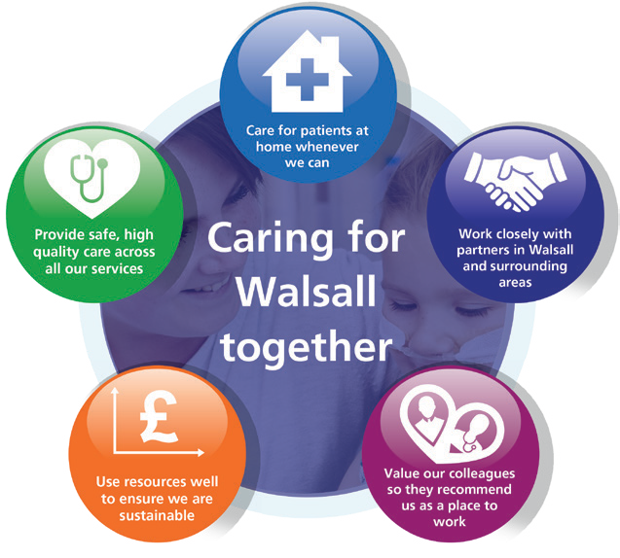Our Vision, Objectives & Values
Walsall Healthcare NHS Trust is guided by five strategic objectives which combine to form the overall ‘vision’ for the organisation.
Complementing this are our ‘values’, a set of individual behaviours that we wish to project amongst our workforce in order to deliver effective care for all.

Our Vision: Caring for Walsall together
“Caring for Walsall together” reflects our ambition for safe integrated care, delivered in partnership with social care, mental health, public health and associated charitable and community organisations.
Our Objectives: Underpinning the vision
The organisation has five strategic objectives which underpin our vision of ‘Caring for Walsall together’, and they are to:
Our Values: Upholding what’s important to us as a Trust
Our values, coupled with individual behaviours, represent what we wish to project in our working environments.
Respect | We are open, transparent and honest, and treat everyone with dignity and respect.  - I appreciate others and treat them courteously with regard for their wishes, beliefs and rights.  - I understand my behaviour has an impact on people and strive to ensure that my contact with them is positive.  - I embrace and promote equality and fairness. I value diversity and understand and accept our differences. I am mindful of others in all that I do.
Compassion | We value people and behave in a caring, supportive and considerate way.  - I treat everyone with compassion. I take time to understand people’s needs, putting them at the heart of my actions.  - I actively listen so I can empathise with others and include them in decisions that affect them.  - I recognise that people are different and I take time to truly understand the needs of others.  - I am welcoming, polite and friendly to all.
Professionalism | We are proud of what we do and are motivated to make improvements, develop and grow.  - I take ownership and have a ‘can-do’ attitude.  I take pride in what I do and strive for the highest standards.  - I don’t blame others. I seek feedback and learn from mistakes to make changes to help me achieve excellence in everything I do.  - I act safely and empower myself and others to provide high quality, effective patient-centred services.
Teamwork | We understand that to achieve the best outcomes we must work in partnership with others.  - I value all people as individuals, recognising that everyone has a part to play and can make a difference.  - I use my skills and experience effectively to bring out the best in everyone else.  - I work in partnership with people across all communities and organisations.

Work Closely with Partners;
We will deliver sustainable best practice in secondary care, through working with partners across the Black Country and West Birmingham System.
Value our Colleagues;
We will be an inclusive organisation which lives our organisational values without exception.
Use Resources Well;
We will deliver optimum value by using our resources efficiently and responsibly.
Care at Home;
We will host the integration of Walsall together partners, addressing health inequalities and delivering care closer to home.
Provide Safe, high-quality care;
We will deliver excellent quality of care as measured by an outstanding CQC rating by 2022.

MEETING OF THE PUBLIC TRUST BOARD – 6th May 2021
Trust Board Chair’s Report |  |  |  | AGENDA ITEM: 7
Report Author and Job Title: | Prof Steve Field, Trust Board Chair | Responsible Director: |  | Prof Steve Field, Trust Board Chair
Action Required | Approve ☐ Discuss ☐ Inform ☒ Assure ☐
Executive Summary | The paper includes details of key activities undertaken since the last Trust Board meeting.
Recommendation | Members of the Trust Board are asked to note the report
Does this report mitigate risk included in the BAF or Trust Risk Registers? please outline | The race code is mitigation under the People and Culture BAF risk
Resource implications | There are no resource implications associated with this report.
Legal and Equality and Diversity implications | This report sets out the commitment of the Board to equality, diversity and inclusion, and the work the Board has done this month to shape the Equality, Diversity and Inclusion Strategy.
Strategic Objectives | Safe, high quality care ☒ |  | Care at home ☒
 | Partners ☒ |  | Value colleagues ☒
 | Resources ☒

CHAIR’S REPORT – MAY 2021

- Interim Chief Executive Officer
I am pleased to confirm that Professor David Loughton CBE has taken up the role of Interim Chief Executive at the Trust from 20th April. David, who is, and will remain, Chief Executive at The Royal Wolverhampton NHS Trust, has been a Chief Executive for 34 years and brings a wealth of experience with him. I believe that David’s expertise and leadership brings a timely and high-quality response to enable Walsall’s improvement journey. This in an innovative opportunity to share, learn together and continue to make a positive difference for the people we serve.
I wish to thank Daren Fradgley for his hard work and dedication whilst holding the position of Acting Chief Executive.

- Audit Committee Chair
On 19th April, by way of e-approval in accordance with the COVID-19 Governance Continuity Plan, the Trust Board approved the appointment of Mrs Mary Martin as Chair of the Audit Committee for a period of six months. In making this decision members considered the following:
  - The Local Audit (Health Service Bodies Auditor Panel and Independence) Regulations 2015 (‘Regulations’) require that the Chair of the Audit Committee must be both independent and a Non-Executive Director of the Trust (5(1)).
  - Regulation 6(1) provides that an ‘independent’ member means the member is not in circumstances, and does not have relationships, which are likely to affect or could affect their judgement in discharging their duties as a member.
  - Regulation 6(2) provides that it is for the Trust Board to decide if a prospective member would be independent, and in deciding this, the factors in Regulation 6(5) must be taken into account.
  - Regulation 6(4) provides that, notwithstanding that any of the factors in regulation 6(5) apply, the Board has discretion to decide that member is independent.
Mrs Martin was appointed as a Non-Executive Director to the Walsall Healthcare NHS Trust on 1st April 2021 for a six month period, and she is also Non-Executive Director at the Royal Wolverhampton NHS Trust (RWT) and Chair of their Performance and Investment Committee. She therefore holds a cross-directorship under regulation 6(5)(f). Members took into account the following when making the appointment:
- The Audit Committee has been without a substantive Chair since the previous Chair left in December 2020. Mr Dunn has been acting in the role since that time.

- The relevant experience, both financial and from an Audit Committee perspective, that Mrs Martin has and brings to the committee at a time where year-end filings of annual accounts, annual report and quality account will be before the committee for consideration.
- The time limited appointment of six months to enable the annual filings to be reviewed and approved.
- The intention to undertake a skills mix review of the Board in the next six months with the intention to appoint an Audit Committee Chair at that time.
- RWT and the Walsall Healthcare NHS Trust have entered into a bi-lateral strategic collaboration to work together for the improvement of services for the people of Walsall and Wolverhampton, as agreed by both Boards in December 2020. This is the first step in a multi-lateral group with the wider ICS and is in keeping with the Long-Term Plan of the NHS, the recent White Paper and operational planning guidance.
- It has become increasingly common for dual appointments across Trusts, and NHSE/I are supporting of this direction of travel and of Mrs Martin’s appointment (noting however they appoint Non-Executive Directors, but not Chairs of Board Committees, which is a matter for the Trust Board).
- Any potential or perceived conflicts of interest which may arise on the agenda of the Audit Committee from time to time will be reviewed by the Director of Governance and managed in line with the Trust’s Standing Orders and Conflicts of Interest Policy.
I would like to express my thanks to Mrs Martin for accepting this role at this very important time in the year, where annual filings are reviewed and approved.

- Race Code Early Adopters
On 7th April Board members attended a joint development session with the Royal Wolverhampton NHS Trust on the Race Code 2020. The session was facilitated by the founder of the Race Code, Karl George. The Race Code focuses on governance as the route to developing a robust mechanism of transparency and accountability and a principled base approach to govern race equality. Both Trusts are proud to be involved in this important initiative as early adopters of the code.

- Acute Collaboration Programme Board
I continue to participate in the Acute Collaboration Programme Board with Daren Fradgley. Daren made some important points about integrated care and highlighted the success of Walsall Together, whilst we both participated in very positive discussions with colleagues from The Dudley Group NHS Foundation Trust, Royal Wolverhampton NHS Trust and Sandwell and West Birmingham Hospitals NHST Trust.

Latest Board/Committee – 20/04/2021 Version V0.02
Public Trust Board – 6th May 2021 Item 9
Risk Summary
BAF Strategic Objective Reference & Summary Tile: | BAF SO 06 - COVID; This risk has the potential to impact on all of the Trusts Strategic Objectives.
Risk Description: | The impact of Covid-19 and recovering from the initial wave of the pandemic on our clinical and managerial operations is such that it prevents the organisation from delivering its strategic objectives and annual priorities.
Lead Director: | Chief Operating Officer.
Lead Committee: | Trust Board
Links to Corporate Risk Register: | Title: |  |  |  |  |  |  | Current Risk Score Movement:
 | - 2051 - Inability to mitigate the impact of Covid-19, results in possible harm and poor patient experience to the people of Walsall.  - 2066 - There is a risk of lack of skilled registered nurses (RN's)/registered midwives (RM's) on a shift by shift basis affecting our ability to consistently maintain delivery of excellent standards of care.  - 2093 - Risk of staff contracting COVID-19 through the course of their duties in Walsall Healthcare NHS Trust.  - 2095 - Inability of the NHS supply chain to provide an adequate and on-going supply of PPE to meet the demand to ensure that Walsall Healthcare NHS staff are fully protected during the Covid-19 pandemic.  - 208 - Failure to achieve 4 hour wait as per National Performance Target of 95% resulting in patient safety, experience and performance risks (Risk score = 16).  - 2081 - Operational expenditure incurred during the current financial year exceeds income allocations, which results in the Trust being unable to deliver a break even financial plan (Risk Score = 16).  - 2082 - Failure to realise the benefits associated with the outcomes of the improvement programme work-streams, results in the Trust not delivering efficiencies required to attain agreed financial control targets, and deliver financial balance without central support, which therefore impacts on the Trusts ability to deliver financial and clinical sustainability (Risk Score = 16). |  |  |  |  |  |  | 12 (3X4)  ↓
Risk Scoring
Quarter: | Q1 (2021) | Q2 | Q3 | Q4 (2020) | Rational for Risk Level: | Target Risk Level (Risk Appetite): |  | Target Date:
Likelihood: |  |  |  | 3 | - Covid-19 is a novel virus and therefore there is only an emerging understanding of the disease, how it behaves and the likely trajectory of further resurgence in cases.  - The initial wave of Covid-19 had a profound impact on the services that the Trust provides, both in terms of urgent, emergency and critical care services to manage covid-19 positive patients (in the hospital and the community), and in terms of the reduction in capacity of elective care services. The initial wave had a particularly | Likelihood: | 2
Consequence: |  |  |  | 5 |  | Consequence: | 4
 |  |  |  |  |  |  |  | 30 June 2021 (at
 |  |  |  |  |  |  |  | which point the
 |  |  |  |  |  |  |  | Covid BAF risk
Risk Level: |  |  |  | 15  High |  | Risk Level: | 8  Moderate | would be  recommended to
 |  |  |  |  |  |  |  | be dissolved).
Page 1 of 5

significant impact on care home residents within the Borough’s population.
- The initial wave of Covid-19 had a profound impact on the workforce of the Trust. By May 2020, almost 1 in 4 Trust staff who have undergone a Covid-19 Antibody test have been antibody positive suggesting a significant proportion of the workforce has experienced the disease themselves. Moreover, the challenges of managing the initial wave of the pandemic has had significant psychological impact on staff too.
- The Trust is operating in an uncertain financial planning environment resulting in additional challenges to restoring and recovering services impacted by the initial wave of Covid-19, and planning for the 2021/22 financial year.
- Covid-19 has exposed existing significant health inequalities in the population the Trust serves. Covid-19 has exacerbated some existing inequalities in colleague experience within the Trust.
- Nosocomial deaths reported in Learning from Nosocomial Covid deaths report received at QPES 27/08/20, with further analysis presented to QPES 28/01/21 confirming 21 probable or definite nosocomial deaths from Covid in Wave 1.
- Planning assumptions for a second wave of Covid-19 cases assumed a peak at half the level of the April peak. In November 2020 the Trust exceeded 80% of the April peak in terms of Covid-19 positive bed occupancy. In January 2021 the Trust has exceeded 140% of the April peak. As of 15th March the Trust’s Covid-19 positive inpatients have reduced to 26% of the April peak.
- The Trust has had the 7th highest proportion of its hospital beds occupied by Covid-19 positive patients in the country in early November 2020, and the second highest proportion of its hospital beds occupied by Covid-19 positive patients in the Midlands during January 2021. The situation has improved over February and March and Ward 10, Ward 14 and the 6 extra capacity beds on
ward 4 are all now closed.

- The Trust has consistently had one of the highest Critical Care bed occupancy relative to baseline commissioned capacity across the Midlands region during the second wave. In January 2021 Critical Care bed occupancy has exceeded 250% of baseline commissioned capacity, peaking at 306% of baseline commissioned capacity. As of 15th March, the Trust’s Critical Care occupancy had reduced to below 150% of baseline commissioned capacity.
- As a result of reduced Critical Care occupancy, the Trust commenced it’s 8-week Elective Surgery restoration plan on 8th March 2021.
- The Trust has been successful in rolling out the Pfizer Vaccine to Patients, and staff across BCWB Health and Social Care organisations, with over 89% of high-risk staff having received their first vaccination, and over 70% of high risk staff having received their second vaccination (as of 19/04/21).
Control & Assurance Framework - 3 Lines of Defence
 | 1st Line of Defence |  |  |  | 2nd Line of Defence | 3rd Line of Defence
Controls: | Governance:  - Incident Command structure in place incorporating Strategic Command, Hospital Tactical Command, Walsall Together Community Tactical Command and Corporate Tactical Command.  - Bespoke Incident Command structure in place for Covid-19 Vaccination programme.  - Governance continuity plan in place to ensure Board and the Committees continue to receive assurance.  - Specific Covid-19 related SOPs and guidelines.  - ITU Surge Plan in place.  - Covid Streaming processes in place.  - Enhanced Health and Safety/IPC Process in place in relation to Covid-  19, with particular focus on social |  |  |  | - Individual committees consider specific impact relevant to their portfolio, i.e. Financial matters and Restoration and Recovery of elective services under PFIC; Quality, Safety and Patient experience matters under QPES and Workforce matters including staff wellbeing under P&ODC.  - Board Development sessions (x2) on approach to Restoration and Recovery from Wave 1.  - UEC and Covid resilience Winter Plan approved by Trust Board October 2020.  - Covid-19 Deaths incorporated into SJR processes  - Nosocomial Covid-19 Infections are subjected to RCA and reported to the Infection Control Committee. | - Regional and National Incident Control structure.

distancing, patient/staff, screening, zoning of Ward/Department areas, visiting guidance and PPE Guidance.
- Daily risk assessment (RAG rating) of Community Locality teams to prioritise resource according to need.
- Division of Surgery 8-week elective Surgery restoration plan commenced 8/3/21.
Gaps in Controls: | - Walsall borough disproportionately hard hit in second wave again. 7th highest proportion of beds occupied by Covid positive patients in the country, in early November 2020. One of the highest Critical Care bed occupancy levels relative to baseline funded Critical capacity in the Midlands Critical Care Network throughout waves 2 in the Autumn of 2020 and 3 over the Winter of 2020. The Trust has had the second highest proportion of its hospital beds occupied by Covid-19 positive patients in the Midlands during January 2021.  - Resurgence of Covid-19 cases has coincided with Winter pressures resulting in severe pressures on the emergency care pathway, and stretching the RN, medical and WHP workforce significantly.  - Significantly increased Critical Care demand resulting in a dilution of ratios of specialist Critical Care Nurses to patients, partially mitigated through use of Category B and Category C registrants.  - Significant reduction in elective surgical operating theatre capacity due to requirement to support Critical Care staffing, resulting in prolonged waits for elective surgery.  - Reduction in some elective Community services – particularly MSK therapies and Phlebotomy, to redeploy resource into non-elective pathways.  - Considerably higher demand than anticipated on key Covid-19 Community pathways including Community Pulse Oximetry monitoring (Safe at Home pathway) and Long Covid pathways.  - Ability for neighbouring Trust’s to manage demand from patients conveyed by ambulance resulting in additional ambulance patients being conveyed to Walsall Manor through WMAS Intelligent Conveyancing protocol.  - National directives and mandates impact on the Trust’s ability to make local decisions.  - Ability of the Midlands Critical Care Network to successfully manage demand Critical Care demand across the region.  - Unable to progress all elements of the improvement programme owing to capacity of senior leaders.  - Comprehensive OD/Culture Improvement plan.
Assurance: | - IPC Board Assurance Framework. | - Nosocomial Covid-19 infection rate in line with peer-reviewed published evidence.  - Antibody positive staff rate in line with BCWB peers.  - Financial top up requests in line (or lower) as a proportion of turnover than BCWB peers.  - Faculty of Research and Clinical Education evaluation of response to first wave.  - 60-day readmission rate for Covid-19 patients in line with peer-reviewed published evidence. | - Elective waiting times 2nd best in the country for Diagnostics (DM01) and Top 50 nationally for routine elective treatment (18-week Referral to Treatment) and GP referred Cancer treatment commencing within 62-days (Feb 2021).  - Elective 52-week wait performance 3rd best in the Midlands (Feb 2021).  - 4hr EAS performance 14th best in the country, and 3rd best in the Midlands (March 2021).  - Ambulance handover times (<30mins) best in the West Midlands (March 2021).  - CQC Assurance of the IPC Board

Assurance Framework
- Productivity of Vaccination Programme compares favourably with other Acute Trusts.
Gaps in Assurance: |  | - Lack of assurance of communications within the organisation to ensure staff feel well informed and engaged.  - Evidence of higher staff absence rates than BCWB peers during initial wave of Covid-19, absence rates consistent with peers in second/third wave.  - PODC still working to gain sufficient assurance on the vulnerable staff risk assessment process.
Future Opportunities
- With a more digital/virtual enabled organisation further opportunity to explore clinical application in improvement programme deliverables.
- Increased focus on Walsall Together and partnership working to support reduced reliance on hospital care, and to support reduced health inequalities in the borough.
- Covid-19 has necessitated closer collaboration with other Acute hospitals which can continue to be built upon.
- Increased profile and appreciation of the NHS within the general public could be harnessed to attract and retain staff.
- National planning guidance for Phase 3 (Recovery & Transformation) creates an expectation that services must not be reintroduced based on historical models.
- Identifying and adapting the workforce and professions to create a modern and adaptable workforce group.
Future Risks
- Potential for further resurgence in Covid-19 cases.
- Second wave of Covid-19 cases has coincided with Winter pressures including seasonal Influenza and norovirus, and delayed and advanced (in terms of disease progression) presentation of patients that have not accessed healthcare services in recent months.
- Ongoing pressure on community services associated with patients rehabilitating following Covid-19, including Long Covid patients.
- Delayed and/or prolonged impact of managing the initial wave, second wave and third wave of the pandemic on staff wellbeing and mental health.
- Potential workforce absence in the event of a second wave.
- Limited management and leadership capacity to address core objectives due to the significant demands of managing covid-19 pandemic, and the restoration and recovery of services affected by covid-19.
- More constrained financial operating environment.
- Logistical challenges of delivering the Covid-19 Vaccination.
Future Actions (to further reduce the Likelihood / Consequence of the risk in order to achieve the Target Risk Level in line with the Risk Appetite)
No. | Action Required: |  | Executive Lead: | Due Date: | Progress Report: |  | BRAG:
6. | Confirmation of 2021/22 Financial arrangements |  | DoF | Feb 2021 | Delayed due to delayed national planning guidance. Expected to be closed April/May 2021.

1
MEETING OF THE PUBLIC TRUST BOARD – 6th May 2021
Quality, Patient Experience and Safety Committee (QPES) Highlight Report |  |  | AGENDA ITEM: 10
Report Author and Job Title: | Trish Mills Trust Secretary | Responsible Director: | Mrs Pamela Bradbury – Chair of QPES (Non-  Executive Director).
Action Required | Approve ☐ Discuss ☒ Inform ☒ Assure ☒
Executive Summary | This report provides the key messages from the Quality, Patient Experience and Safety Committee meeting held on 29th April 2021. Of note are:  - The Committee was assured that the immediate actions to address patient safety concerns following the Health Education England (HEE) inspection on 1st April have been taken. Additional concerns about interdisciplinary friction, workload, educational opportunities, handover, access to clinics, availability of support and advocacy for the training posts are being addressed in an action plan, which is due to be presented to HEE no later than 21st May. The Medical Director will take direct oversight of the delivery of these actions.  - Phlebotomy services have been established in each of the four community clinics to address the waiting list. Walsall Together are looking at measures to address the waiting lists with the primary care networks.  - The Committee had detailed discussions on the ways in which the challenges with the therapies service have been addressed and were assured that good progress has been made appointing to the vacancies including the appointment of an Allied Health Professional Director to lead the service. The redesign of the service and re-profiling of the roles in the service is part of the Care at Home Improvement Programme, and the Committee will be monitoring the impact of this approach.  - The Committee were assured that safeguard training compliance has increased. Audits are underway to ensure that training is being appropriately applied and they will come to the Committee in May. A development session on safeguarding with the Non-Executive Directors is being developed.  - The Maternity Services update was presented by the Divisional

Director of Midwifery, Gynaecology & Sexual Health, Carla Jones-Charles and Clinical Director, Obstetrics & Gynaecology, Mr Fateh Ghazal, who reported they were on track with the Ockenden recommendations.

- The Committee commended the Patient Relations and Patient Experience team for their annual report. Their priorities for 2021/22 were approved and the more detailed SMART objectives will be reviewed in May to provide a baseline on which to monitor improvements quarterly by the Committee.

- The Medical Directorate and Division of Surgery were congratulated for initiating a programme to review the pathways for lung cancer patients following analysis of clinical incidents. This has led to cohesive multi-disciplinary team working, reduced waiting times and series incidents, and this learning and the improvement have been applied across the cancer specialities.

The next meeting of the Committee will take place on 27th May 2021
Recommendation | Members of the Trust Board are asked to note the escalations and any support sought from the Trust Board.
Risk in the BAF or Trust Risk Register | This report aligns to BAF risk S01 for safe high quality care and COVID-19 BAF risk S06.
Resource implications | There are no new resource implications associated with this report.
Legal, Equality and Diversity implications | There are no legal or equality & diversity implications associated with this paper
Strategic Objectives | Safe, high quality care ☒ | Care at home ☐
 | Partners ☐ | Value colleagues ☐
 | Resources ☐

MEETING OF THE PUBLIC TRUST BOARD – 6th May 2021
Safe High Quality Care – Executive Update |  |  |  |  |  | AGENDA ITEM: 13
Report Author and Job Title: | Ann-Marie Riley, Director of Nursing |  |  | Responsible Director: |  | Ann-Marie Riley, Director of Nursing  Matthew Lewis, Medical  Director
Action Required | Approve ☐ | Discuss ☐ | Inform ☒ |  | Assure ☒
Executive Summary | This report describes the continuing actions that are taking place to provide Safe, High Quality Care (SHQC) in the Trust. The report includes details relating to the Board Assurance Framework (BAF), the Corporate Risk Register and the Performance Report, relevant to SHQC.
Recommendation | - Note the update to Trust Board on actions relating to the Improvement Programme through the Quality, Patient Experience & Safety Committee (QPES) and supporting groups.  - Note the highlighted updates to BAF risk S01 and related risks on the Corporate Risk Register.  - Note the relevant updates and assurance in relation to the performance  report.
Does this report mitigate risk included in | This report highlights updates relevant to Board Assurance Framework (BAF)  Risk SO1 and provides assurance or mitigations in place to manage this risk. The related corporate risks are:
the BAF or Trust Risk | 208 - Failure to achieve 4 hour wait as per National Performance Target of 95%,
Registers? | resulting in patient safety, experience and performance risks.  274 - Failure to resource backlog maintenance and medical equipment
 | replacement. (This risk has been closed and replaced with 2398).
 | 2066 - Lack of registered nurses and midwives.
 | 2260 - Lack of a whole system approach across health and social care for the
 | management of Children and Young People (CYP) in mental health or
 | behavioural crisis. (This risk has been closed and replaced with 2437 and 2439).
 | 2437 - Service wide impact as a result of the risk of CYP are being admitted to
 | our acute Paediatric ward whilst awaiting a Tier 4 bed or needing a 'place of
 | safety'. (Internal factors.)
 | 2439 - External inadequate paediatric mental health and social care provision
 | leading to an increase in CYP being admitted to our acute Paediatric ward whilst
 | awaiting a Tier 4 bed or needing a 'place of safety'.
 | 2398 - Insufficient/ out-of-date equipment, utilised beyond its life cycle, has the
 | potential to result in sub-optimal patient care.
 | 2475 - The Mental Health Act (MHA) Code of Practice is not being applied in line
 | with CQC legislations in the day-to-day practices for providing safeguards &
 | protection for individuals who require mental health services.
Resource implications | Current resource implications relate to the delivery of the Safe High Quality Care improvement programme.

Legal and Equality Diversity implications | Failure to deliver safe, high quality care may result in further breaches of legal requirements under the Health and Social Care Act 2008
Strategic Objectives | Safe, high quality care ☒ | Care at home ☐
 | Partners ☐ | Value colleagues ☒
 | Resources ☒

PROVIDE SAFE HIGH QUALITY CARE – EXECUTIVE UPDATE

- EXECUTIVE SUMMARY

The delivery of safe, high quality care remains a key priority for the Trust.

The associated Board Assurance Framework (BAF) and corporate risks have been reviewed and updated as required. The gaps in control and assurance were discussed in detail at the Quality, Patient Safety and Experience Committee and progress has been made to reduce the number of gaps overall.
Oversight of progress against the CQC Must and Should Do actions continues via the monthly CQC action plan oversight group and progress against 2019 and 2020 actions is as follows:

  - 2019 Actions: 49 of the 55 actions have been completed; 3 actions are in progress, 3 of which are overdue; 3 actions are deferred.
  - 2020 Actions: 24 of the 29 actions have been completed; 4 actions are in progress, 2 of which are overdue; 1 action is deferred

Evidence of progress against outstanding and deferred actions was presented to the Quality, Patient Safety and Experience Committee and details are included further in the report.

Projects within the Safe, High Quality Care Improvement Programme have continued to progress despite the COVID-19 pandemic and some of the key highlights are:
  - Falls per 1000 bed days has reduced in month to 3.46
  - A new Skin Integrity Ambition is in draft and will launch in May
  - The performance against late observations has improved in month and is now above the trust target at 88.51%
  - The Enhancing Ward Experience volunteers initiative launched in March
  - Learning from complaints and other patient feedback channels has informed the 2021/22 patient priorities

- BOARD ASSURANCE FRAMEWORK (BAF)

Our strategic objective is to deliver excellent quality of care as measured by an outstanding CQC rating by 2022. The BAF for SHQC appears at Appendix 1. The Trust continues to have a low risk appetite for compromising quality and safety of patient care. Key updates on progress over the last month are highlighted below.

- Gaps in Control

  - VTE compliance for March is 94.45%. Divisional teams are now reporting on their performance and plans to Patient Safety Group (PSG). This is the best performance since August 2019.
  - Deterioration in the Trust’s complaints response performance – A process was completed to address contributing factors to the current performance level. Assurance can be provided that correct systems and processes are in place to oversee and manage complaints in a timely manner. Significant focus has been placed on the quality of responses which has caused some impact on the current performance.
  - There were no severe harm falls in March.
  - Mental Capacity Act compliance below the Trust’s Standards – Performance for March 2021 shows that 81% of patients who lacked capacity had a two stage assessment undertaken from 49% in February 2021. A Power BI dashboard is now available and now includes data about use of the ReSPECT form.
  - Sepsis audit frequency and performance – the Sepsis 6 dashboard is now live in the trust and allows all teams to review real time data against agreed national standards. Performance against these standards will be monitored through monthly divisional sepsis reviews, overseen by the Director of Nursing and Medical Director, Patient Safety Group and Performance Reviews. The Clinical Senate discussed the rationale, process and monitoring systems relating to sepsis management.
  - Mental Health: a new corporate risk has been added, which will be discussed in more detail through QPES in May 2021.

- Gaps in assurance

  - CQC ‘MUST’ and ‘SHOULD’ Do actions remain outstanding - Oversight of progress against the CQC Must and Should Do actions continues via the monthly CQC action plan oversight group and progress against 2019 and 2020 actions is as follows:
2019 Actions: 49 of the 55 actions have been completed; 3 actions are in progress, 3 of which are overdue; 3 actions are deferred.
2020 Actions: 24 of the 29 actions have been completed; 4 actions are in progress, 2 of which are overdue; 1 action is deferred.
The 5 overdue actions for 2019 / 2020 are detailed below along with a progress update/ mitigation actions (Table 1):

Table 1: Overdue actions for 2019 / 2020
Inspection report Date | Ref | Agreed action agreed with CQC / Taken from PCIP | Division | Executive Lead | Baseline Target Month | Progress Update
Jul-19 | SHOULD S16 | Ensure any storeroom where medication is stored is locked and doors are closed | Surgery | Medical Director | Dec-20 | Replacement door funding agreed. Will remain on the action log until the  replacement doors are fitted
Jul-19 | SHOULD S25 | To ensure policies are available and up to date | Critical Care | Medical Director | Dec-20 | Policy has been updated.  Ratification due 27 April 2020
Jul-19 | SHOULD 32 | Consider exploring ways of pathway options for patients requiring discharge from the critical care unit to expedite discharge | Critical Care | Medical Director | Dec-20 | Div Director of Ops Surgery will now oversee finalisation of the Business Case which was due in March
Sep-20 | MUST M26.3 | Local audits against specific CQC findings in relation to documentation to be undertaken | Urgent and Emergency Care | Director of Governance | Feb-21 | Local audits completed but still subject to amendments so to stay on action log until final version complete
Sep-20 | MUST M26.7 | 7) Measure effectiveness of SBAR tool against incident reporting for focussed themes | Urgent and Emergency Care | Director of Nursing | Jan-21 | Division has seen a positive impact of the tool and this action will be removed as outstanding before the next report but will continue to be monitored to ensure ongoing effectiveness

CQC Unannounced Inspection 9 March 2021

The CQC conducted an unannounced inspection across 5 medical wards on Tuesday 9 March 2021. Three inspectors were on site and visited wards 1, 2, 3, 16, and 17. A S29a warning notice was served on the Trust on the 31 March 2021. A factual accuracy amendment has been sent to the CQC and we await their response.

The draft CQC report was received into the Trust on 16 April 2021. This is currently being reviewed by the Division of Medicine for factual accuracy. An update on the final report, remedial actions and timescales will be reported at the next Quality, Patient Experience and Safety Committee and subsequently to Public Board.

  - NHSEI review in 2019 highlighted insufficient assurance on infection control standards resulting in RED rating – reassessment of cleanliness standards was cancelled by NHSEI due to COVID19. We are assured that improvement in standards has been sustained which has also been reflected in feedback from inspections by the CCG, NHSEI and CQC. NHSEI have not yet confirmed a re-inspection date although suggested that a re-inspection would be able to take place mid 2021
  - External audit assurance relating to the annual quality account has been deferred owing to COVID-19 – development of the 2021/22 quality account is underway

- LINK TO CORPORATE RISK

The aligned corporate risks have been reviewed in month:
208 - Failure to achieve 4 hour wait as per National Performance Target of 95%, resulting in patient safety, experience and performance risks.
274 - Failure to resource backlog maintenance and medical equipment replacement. (This risk has been closed and replaced with 2398).
2066 - Lack of registered nurses and midwives.
2260 - Lack of a whole system approach across health and social care for the management of Children and Young People (CYP) in mental health or behavioural crisis. (This risk has been closed and replaced with 2437 and 2439).
2437 - Service wide impact as a result of the risk of CYP are being admitted to our acute Paediatric ward whilst awaiting a Tier 4 bed or needing a 'place of safety'. (Internal factors.) 2439 - External inadequate paediatric mental health and social care provision leading to an increase in CYP being admitted to our acute Paediatric ward whilst awaiting a Tier 4 bed or needing a 'place of safety'.
2398 - Insufficient/ out-of-date equipment, utilised beyond its life cycle, has the potential to result in sub-optimal patient care.
2475 - The Mental Health Act (MHA) Code of Practice is not being applied in line with CQC legislations in the day-to-day practices for providing safeguards & protection for individuals who require mental health services.

- PERFORMANCE REPORT

The performance report was discussed at the Quality Performance and Safety Committee. A few key areas to report as follows:

4.1 Clostridium Difficile number of cases
Three cases were reported in March investigation. One patient, who sadly died, was unfortunately noted to have avoidable harm as the patient did not receive timely sampling. Learning and reiteration of expected practice has been circulated to staff by the Infection Prevention and Control team. The case has been discussed at IPC committee and the committee will oversee the related action plan.

4.2.% of observations rechecked within time
The prevalence of observations completed on time has increased in month from 84.14% in February to 88.51% in March, which is now above the Trust target of 85%.

  - Dementia Screening – As noted last month, the Director of Nursing undertook a review of the data collection mechanism process as there is limited assurance on the current performance data. A task and finish group was set up and the team are currently scoping

digital options to improve the collection and assurance process. progress updates will be reported to QPES.

  - Sepsis – Performance of sepsis checklist on adult e-sepsis dashboard is low with antibiotics administered within the hour in ED being 61.78% but an audit of 227 cases in ED in March 2021 showed 97.4%. This suggests that the e-sepsis tool is not accurately reflecting performance at present; the MLTC divisional team are preparing a local action plan with the QI team to determine the reasons for the discrepancy. A sepsis summit was held on March 16th during a Clinical Senate session, an agreed action plan to move forward which will be tracked via Patient Safety Group.

  - MCA assessment - Performance for March 2021 shows that 81% of patients who lacked capacity had a two stage assessment undertaken (compared with 49% in February 2021). A Power BI dashboard is now available and now includes data about use of the ReSPECT form.

  - Safeguarding training - significant progress has been made to ensure staff are receive appropriate safeguarding training and all areas are now in line with the Trust target with the exception of Adults Level 2.

- IMPROVEMENT PROGRAMME

The Safe High Quality Improvement Programme has continued in full despite the pandemic. A number of key highlights are

  - The second of our Harm Free Care ambitions will launch March 2021 (Skin Integrity).
  - Recruitment into research studies is significantly above target and the Trust position across the region has improved from last year
  - Relaunch of Mouth care Matters in March 2021 following discussion with infection control team and ward link nurses. Work is taking place in conjunction with the Royal Wolverhampton Trust to introduce an oral care assessment tool within the nursing documentation
  - Updated food record charts are being trialled on ward 11 and 16 to allow for more accurate calculation of nutritional intake.
  - A Standard Operating Procedure for weighing children on paediatrics has been developed to ensure accurate and timely weighing of children.
  - Work is ongoing with catering to provide staff training and improve the process to ensure patients with allergies are provided with appropriate food at mealtimes.
  - Walsall is the first acute Trust to pilot ‘Jelly Drops’ and this initiative, led by the ward manager, is being trialled on Ward 11. Jelly Drops offer an alternative solution to support patient hydration and patient comfort in relation to oral care.

- RECOMMENDATIONS

Members of the Trust Board are asked to note the update and progress made relating to the SHQC portfolio.
- APPENDICES

Appendix 1: BAF Risk S01 Appendix 2: Performance Report

Latest Board/Committee - 01/04/2021 Version V0.01
Public Trust Board – 6th May 2021 Item 12, Appendix 1

Risk Summary
BAF Strategic Objective Reference & Summary Tile: | BAF SO 01 - Safe, High Quality Care; We will deliver excellent quality of care as measured by an outstanding CQC rating by 2022.
Risk Description: | The Trust fails to deliver excellence in care outcomes, and/or patient/public experience, which impacts on the Trust’s ability to deliver services which are safe and meet the needs of our local population.
Lead Director: | Director of Nursing/Medical Director.
Lead Committee: | Quality, Patient Experience & Safety Committee.
Links to Corporate Risk Register: | Title: |  |  |  |  |  |  | Current Risk Score Movement:
 | - 208 - Failure to achieve 4 hour wait as per National Performance Target of 95%, resulting in patient safety, experience and performance risks.  - 274 - Failure to resource backlog maintenance and medical equipment replacement. (This risk has been closed and replaced with 2398).  - 2066 - Lack of registered nurses and midwives.  - 2260 - Lack of a whole system approach across health and social care for the management of Children and Young People (CYP) in mental health or behavioural crisis. (This risk has been closed and replaced with 2437 and 2439).  - 2398 - Insufficient/ out-of-date equipment, utilised beyond its life cycle, has the potential to result in sub-optimal patient care.  - 2437 - Service wide impact as a result of the risk of CYP are being admitted to our acute Paediatric ward whilst awaiting a Tier 4 bed or needing a 'place of safety'. (Internal factors.)  - 2439 - External inadequate paediatric mental health and social care provision leading to an increase in CYP being admitted to our acute Paediatric ward whilst awaiting a Tier 4 bed or needing a 'place of safety'. |  |  |  |  |  |  | ↔
Risk Scoring
Quarter: | Q1 (2021) | Q2 | Q3 | Q4 (2020) | Rational for Risk Level: | Target Risk Level (Risk Appetite): |  | Target Date:
Likelihood: |  |  |  | 3 | - The Trust’s Quality Strategy is out of date and doesn’t reflect the environment in which we are currently operating. There are gaps in oversight of the strategy and a lack of clear alignment to the Quality Priorities.  - We have strengthened clinical leadership and accountability at the tier 2 level of our governance with the Director of Nursing and Medical Director taking on the leadership in Patient Safety and Clinical Effectiveness.  - Evidence of lessons learnt from incidents and patient feedback is inconsistent. | Likelihood: | 2 | 31 December  2021
Consequence: |  |  |  | 5 |  | Consequence: | 5
Risk Level: |  |  |  | 15  High |  | Risk Level: | 10  Moderate
Page 1 of 5

- Robust acuity and activity review process for community activity.
- The Trust is leading the COVID Vaccination programme as part of the Walsall Vaccination programme thus far 84.5% of Trust staff have been vaccinated at Manor site, around 10,508 members of the pubic have been vaccinated at the Saddlers Centre.
- Progress and assurance against CQC Must and Should Do actions from inspections in 2019 and 2020.
- Staffing risk 2066 reduced to 15; robust plan to recruit 125 international nurses before the end Dec 2021 and to recruit to all clinical support vacancies before end April 2021.
- Concerns have been raised in relation to the staff experience on the NIV unit. As consequence of these concerns, and the reduction of critical care activity, the NIV unit has temporarily paused.
- Reduced COVID-19 cases enable the closure of additional capacity beds (Wards 14, 10 and additional beds on Ward 4) and subsequently reduced demand on staffing requirement.
- We currently do not respond to complaints within 30 days to the Trust target.
- Impact of pandemic of COVID-19 resulting in delays to patient treatment and potential for harm.
- Gaps in the number and quality of clinical guidance, policies and procedures to ensure safe and quality care.
- Duty of Candour below target performance level.
- Incomplete 7 Day Services to provide uniform levels of care throughout the week.
- Partial compliance against Ockenden recommendations.
- Potential to breach statutory requirements under the Mental Health Act due to inconsistent knowledge and application of Trust Policy.
- Gap in the Trust’s approach to patient engagement and patient involvement.
- Dementia screening data collection process under review.

Control & Assurance Framework - 3 Lines of Defence
 | 1st Line of Defence | 2nd Line of Defence | 3rd Line of Defence
Controls: | - Clinical audit programme & monitoring. Clinical divisional structures, accountability & quality governance arrangements at Trust, division, care group & service levels.  - Central staffing hub co-ordinating nurse staffing numbers in line with acuity and activity arrangements.  - Safety Alert process in place and assured through QPES.  - Perfect Ward app allows local oversight of key performance metrics.  - Freedom to speak up process in place, reporting to the People and organisational development committee.  - Covid-19 SJR undertaken for all deaths process of assurance for lessons learnt developed.  - CQC registration for the regulated activity of assessment or medical treatment for persons detained under the Mental Health Act 1983 at Manor Hospital.  - Monthly CQC Action Plan oversight meeting in place.  - Improvement programme in place to oversee and monitor improvements associated with the Trust delivery of Safe, and High Quality Care. | - Patient Experience group in place.  - Governance and quality standards managed and monitored through the governance structures of the organisation, performance reviews and the CCG/CQC.  - Learning from death framework supporting local mortality review.  - Faculty of Research and Clinical Education (FORCE) established to promote research and professional development in the trust. | - CQC Inspection Programme.  - Process in place with Commissioners to undertake Clinical Quality Review Meetings (CQRM).  - Royal College of Surgeons Invited Service Review of upper limb surgery.  - External Performance review meetings in place with NHSEI/CQC/CCG.
Gaps in Controls: | - Performance targets not being met for all activities, including complaints, Mental Capacity Act compliance and VTE assessments.  - Out of date clinical policies, guidelines and procedures.  - Training performance not meeting set targets.  - Quality Impact Assessment process is not yet established within the trust.  - Sepsis audit frequency and performance.  - CQC rating of ‘Requires Improvement’.  - NHSEI review of Division of Surgery, focussing on meetings, leadership, and governance highlighted remedial actions required.  - Dementia screening performance.
Assurance: | - Ward Review process in place which provides assurance on the quality of care; performance reported to QPES | - Patient priorities for 2021 identified which aim to improve patient experience. Assurance of impact via patient feedback. | - NHSI and CCG reviews of IPC practice in ED and Maternity have not highlighted any immediate concerns.

 |  | within the SHQC report.  - Signed SLA with Mental Health Trust to support the organisation to meet the requirements of our CQC registration for the regulated activity of assessment or medical treatment for  persons detained under the Mental Health Act 1983 at Manor Hospital. | - Learning Matters Newsletter published regularly. |  |  | - NHSEI scrutiny of Covid-19 cases/Nosocomial infections/Trust implementation of social distancing, Patient/Staff screening and PPE Guidance.  - Quality Review 6 monthly reviews in place with NHSEI/CQC.
Gaps in Assurance: |  | - CQC ‘MUST’ and ‘SHOULD’ do actions remain outstanding.  - NHSEI review in 2019 highlighted insufficient assurance on infection control standards resulting in RED rating. Division have made sustained improvement and external review of practice from NHSI, CCG and CQC have not highlighted gaps in practice. NHSI plan to re-inspect maternity services in April or May 2021.  - External audit assurance relating to the annual quality account has been deferred owing to COVID-19.  - Inconsistent evidence, both through quality governance structures and performance reviews, of practice having changed as a result of learning from adverse events.  - Gaps in assurance noted from the recent CQC inspection including management of sepsis and robust audit data.  - Lack of assurance regarding equality, diversity and inclusion and actions to reduced inequalities.  - Lack of evidence of risk assessments and quality impact assessments relating to staffing contingency planning and/or activity changes.  - Lack of robust strategic approach to ensuring effective patient/public engagement and involvement.  - Lack of clinical engagement and leadership oversight of the Quality Governance agenda.  - Lack of assurance regarding dementia screening data collection process.
Future Opportunities
- Improvement Programme offers a structured programme to achieve excellence in care outcomes, patient/public experience, and staff experience.
- Implementation of new technologies as a clinical or diagnostic aid (such as electronic patient records, e-prescribing & patient tracking; artificial intelligence; telemedicine).
- Development of Prevention Strategy.
- National Patient Safety Strategy will give an improved framework for the Trust to work.
- Well Led work stream working on quality governance structures and patient safety.
- Leadership Development programme to address and mitigate gaps within clinical leadership.
Future Risks
- Ongoing impact of Covid-19 plus additional significant time pressured programmes of work such as COVID vaccination, staff testing, etc. Communications across the organisation to share programme objectives.
- Performance targets not being met for all activities, including Mental Capacity Act and VTE.
- Sepsis audit frequency and performance.
- NHSEI review of Division of Surgery, focussing on meetings, leadership, and governance highlighted remedial actions required.
Future Actions (to further reduce the Likelihood / Consequence of the risk in order to achieve the Target Risk Level in line with the Risk Appetite)
No. | Action Required: |  | Executive Lead: | Due Date: | Progress Report: |  | BRAG:
1. | To strengthen the quality assurance framework there will be a review of the terms of reference of Patient Safety and Clinical Effectiveness Groups to allow greater scrutiny of divisional actions and offer increased assurance to QPES |  | Medical Director | 01/04/2021 | ML now chairs the Clinical Effectiveness Group (from February 2021); Ann-Marie Riley now chairs the Patient Safety Group (from March 2021). Amended terms of  reference agreed for CEG. Session to review TOR for PSG TBC.

2. | Develop a Clinical Audit Strategy and Policy | Director of Governance | 01/08/2021
3. | Oversight of progress to address out of date policies and procedures will be strengthened via the Clinical Effectiveness Group which be reflected in the revised terms of reference | Medical Director | 01/04/2021 | Review of terms of reference will take place during March.
4. | To support improvement in Trust complaints response compliance there will be a review of the current process to ensure timely response and sign off of complaints via both formal and informal routes | Director of Nursing | 30/04/2021 | Review of sign off process for non-complex complaints completed.
5. | A quality impact assessment framework will be developed to support executive oversight of change that could impact on quality/safety | Director of Governance | 01/03/2021
6. | NHSI re-inspection of cleanliness and IPC practice in maternity services | Director of Nursing | 31/05/2021 | No update to report.
7. | Further develop processes to provide assurance that lessons learnt from adverse events | Medical Director/  Director of Nursing | 03/09/2021 | Learning Matters newsletter (2nd edition) circulated Scoping of new ward performance boards continues.
8. | Development of Patient Engagement and Involvement Strategy | Patient Experience Lead/Lead for Patient  Involvement | 30/09/2021 | Work ongoing.
9. | Mandatory training performance trajectories in place and performance monitored via monthly Divisional Performance meetings | Medical Director/ Director of Nursing | Monitored monthly | Ongoing.
10. | Review of dementia screening data collection process. Initial deep dive completed. Scoping of improvement options commence April 2021 | Director of Nursing | 31/05/2021 | Scoping of improvement options to commence 16 April and be completed by 31/05/2021.
11. | Develop Maternity Services BAF | Director of Nursing | 31/05/2021

QUALITY, PATIENT EXPERIENCE SAFETY COMMITTEE

Oct-20 | Nov-20 | Dec-20 | Jan-21 | Feb-21 | Mar-21

2020/21  YTD | 2020/21  Target | 2019/20  YTD | SPC  Variance | SPC  Assurance

SAFE, HIGH QUALITY CARE
No. | Sleeping Accommodation Breaches
No. | HSMR (HED) nationally published in arrears
No. | SHMI (HED) nationally published in arrears
Rate | Crude Mortality Rate
No. | Number of Deaths in Hospital
% | % of patients who achieve their chosen place of death
No. | MRSA - No. of Cases
No. | Clostridium Difficile - No. of cases
% | Sepsis - % of patients screened who recieved antibiotics within 1 hour - ED (Adults only)
% | Sepsis - % of patients screened who received antibiotics within 1 hour - Inpatients (Adults only)
% | Deteriorating patients: Percentage of observations rechecked within time
Rate | Pressure Ulcers (category 2, 3, 4 & Unstageables) Hospital Acquired per 1,000 beddays
Rate | Pressure Ulcers (category 2, 3, 4 & Unstageables) Community Acquired per 10,000 CCG Population
No. | Pressure Ulcers (category 2, 3, 4 & Unstageables) - Hospital
No. | Pressure Ulcers (category 2, 3, 4 & Unstageables) - Community
No. | Falls - Total reported
Rate | Falls - Rate per 1000 Beddays

0 | 1 | 0 | 0 | 0 | 0
124.11 | 141.45 | 125.02 | 149.12
106.45 | 119.4 | 96.4
3.81 | 3.18 | 3.83 | 4.48
107 | 168 | 153 | 227 | 169 | 105
68.18% | 72.00% | 72.00% | 61.43% | 77.97% | 86.36%
0 | 0 | 0 | 1 | 0 | 1
5 | 2 | 0 | 2 | 2 | 3
 |  |  | 47.01% | 55.47% | 61.78%
 |  |  | 26.16% | 24.87% | 32.12%
85.13% | 82.38% | 83.96% | 81.10% | 84.14% | 88.51%
0.91 | 0.53 | 0.75 | 0.63 | 1.14 | 1.17
0.24 | 0.59 | 0.34 | 0.48 | 0.38 | 0.55
14 | 8 | 11 | 10 | 15 | 16
7 | 17 | 10 | 14 | 11 | 16
70 | 65 | 71 | 74 | 70 | 52
4.67 | 4.57 | 5.02 | 4.7 | 5.11 | 3.46

210 | 0 | 0
 | 100
 | 100
1518 |  | 1093
69.04% |  | 57.63%
2 | 0 | 4
32 | 26 | 36
52.92%
27.21%
 | 85.00%
133 |  | 128
161 |  | 86
762 |  | 932
 | 6.1

QUALITY, PATIENT EXPERIENCE SAFETY COMMITTEE

Oct-20 | Nov-20 | Dec-20 | Jan-21 | Feb-21 | Mar-21

2020/21  YTD | 2020/21  Target | 2019/20  YTD | SPC  Variance | SPC  Assurance

No. | Falls - No. of falls resulting in severe injury or death
No. | Falls - Avoidable Falls resulting in severe harm or injury (subject to RCAs)
No. | Falls - Unavoidable Falls resulting in severe harm or injury (subject to RCAs)
% | VTE Risk Assessment
No. | National Never Events
No. | Serious Incidents (inc cat 3 & 4 pressure ulcers, HCAI's & Falls) - Hospital Acquired
No. | Serious Incidents (inc cat 3 & 4 pressure ulcers, HCAI's & Falls) - Community Acquired
No. | Clinical incidents causing actual harm severity 3 to 5 - Hospital Acquired
No. | Clinical incidents causing actual harm severity 3 to 5 - Community Acquired
% | % of total incidents resulting in moderate, severe harm or death
% | Trust-wide Safety Index - % of medication incidents resulting in harm (one month in arrears)
No. | No. of reported medication incidents level 3, 4 or 5 (one month in arrears)
Rate | Midwife to Birth Ratio
% | One to One Care in Established Labour
% | C-Section Rates
% | Instrumental Delivery
% | Induction of Labour

2 | 1 | 0 | 0 | 2 | 1
91.24% | 90.93% | 91.08% | 90.75% | 92.06% | 94.45%
0 | 0 | 0 | 0 | 0 | 0
10 | 12 | 9 | 12 | 14 | 7
0 | 0 | 0 | 0 | 0 | 0
31 | 47 | 44 | 47 | 36 | 42
2 | 5 | 6 | 9 | 7 | 6
3.01% | 5.03% | 4.64% | 4.80% | 3.92% | 3.72%
26.00% | 25.00% | 12.00% | 23.00%
2 | 1 | 0 | 1
37.3 | 31.4 | 28.9 | 27.2 | 29.1 | 34.4
100.00% | 100.00% | 100.00% | 100.00% | 100.00% | 100.00%
26.21% | 26.58% | 33.70% | 27.44% | 32.51% | 33.33%
6.82% | 4.87% | 5.36% | 7.53% | 5.96% | 6.32%
39.03% | 43.19% | 41.30% | 43.68% | 37.10% | 42.11%

13 | 0 | 20
2 | 0 | 16
0 |  | 4
91.56% | 95.00% | 92.22%
0 | 0 | 1
115 |  | 94
0 |  | 5
378 |  | 287
77 |  | 29
3.67% |  | 2.37%
17.71% | 12.00% | 14.30%
10 | 0 | 4
 | 28
99.88% | 100.00% | 99.34%
29.81% | 30.00% | 30.16%
6.50% | 10.00% | 7.52%
41.12% |  | 39.09%

QUALITY, PATIENT EXPERIENCE SAFETY COMMITTEE

Oct-20 | Nov-20 | Dec-20 | Jan-21 | Feb-21 | Mar-21

2020/21  YTD | 2020/21  Target | 2019/20  YTD | SPC  Variance | SPC  Assurance

% | % of Emergency Readmissions within 30 Days of a discharge from hospital (one month in arrears)
% | Electronic Discharges Summaries (EDS) completed within 48 hours
% | Dementia Screening 75+ (Hospital) (Internal audit Dec17 onwards) - Methodology Under Review
% | Compliance with MCA 2 Stage Tracking
% | Complaints - % responded to within 30 working days
% | Complaints - % responded to within 45 working days
No. | No. of Open Complaints
No. | No. of Closed Complaints
No. | Longest Wait for an Open Complaint
No. | Clinical Claims (New claims received by Organisation)
No. | No urgent op to be cancelled for a second time
% | % of RN staffing Vacancies
% | Friends and Family Test - Inpatient (% Recommended)
% | Friends and Family Test - Outpatient (% Recommended)
% | Friends and Family Test - ED (% Recommended)
% | Friends and Family Test - Community (% Recommended)
% | Friends and Family Test - Maternity - Antenatal (% Recommended)

13.57% | 13.26% | 12.00% | 12.54% | 12.71%
86.65% | 85.00% | 84.25% | 82.22% | 82.49% | 83.34%
54.10% | 48.28% | 81.82% | 52.38% | 60.87% | 21.05%
52.38% | 32.50% | 34.88% | 43.48% | 46.00% | 81.25%
50.00% | 32.26% | 31.82% | 56.52% | 55.17% | 55.88%
63.64% | 35.48% | 50.00% | 69.57% | 68.97% | 61.76%
67 | 66 | 69 | 76 | 71 | 61
7 | 23 | 22 | 15 | 29 | 43
75 | 87 | 80 | 99 | 117 | 142
10 | 8 | 7 | 5 | 8 | 10
0 | 0 | 0 | 0 | 0 | 0
9.23% | 10.59% | 10.90% | 8.73% | 8.17%
92% | 87% | 85% | 87% | 88% | 88%
92% | 91% | 90% | 91% | 92% | 91%
75% | 79% | 79% | 82% | 84% | 83%
 |  |  | 100% | 93% | 91%
59% | 73% | 79% | 73% | 71% | 78%

13.64% | 10.00% | 11.50%
85.75% | 100.00% | 84.59%
66.52% | 90.00% | 69.32%
52.35% | 100.00% | 62.61%
49.08% | 80.00% | 43.45%
57.93% |  | 59.82%
212 |  | 211
103 |  | 132
0 | 0 | 0
 | 96%
 | 96%
 | 85%
 | 97%
 | 95%

QUALITY, PATIENT EXPERIENCE SAFETY COMMITTEE

Oct-20 | Nov-20 | Dec-20 | Jan-21 | Feb-21 | Mar-21

2020/21  YTD | 2020/21  Target | 2019/20  YTD | SPC  Variance | SPC  Assurance

% | Friends and Family Test - Maternity - Birth (% Recommended)
% | Friends and Family Test - Maternity - Postnatal (% Recommended)
% | Friends and Family Test - Maternity - Postnatal Community (% Recommended)
% | PREVENT Training - Level 1 & 2 Compliance
% | PREVENT Training - Level 3 Compliance
% | Adult Safeguarding Training - Level 1 Compliance
% | Adult Safeguarding Training - Level 2 Compliance
% | Adult Safeguarding Training - Level 3 Compliance
% | Children's Safeguarding Training - Level 1 Compliance
% | Children's Safeguarding Training - Level 2 Compliance
% | Children's Safeguarding Training - Level 3 Compliance

87% | 79% | 84% | 76% | 84% | 83%
73% | 77% | 78% | 80% | 71% | 59%
70% | 60% | 83% | 92% | 100% | 79%
89.85% | 90.15% | 90.46% | 90.00% | 91.41% | 93.00%
87.69% | 85.49% | 85.62% | 85.09% | 89.07% | 92.06%
96.44% | 95.88% | 94.97% | 93.42% | 94.21% | 95.48%
94.77% | 95.40% | 94.89% | 93.26% | 93.64% | 94.09%
69.26% | 71.50% | 71.92% | 73.69% | 75.16% | 81.22%
88.51% | 89.65% | 90.73% | 91.44% | 93.11% | 95.24%
90.60% | 90.35% | 89.25% | 88.98% | 90.12% | 92.14%
83.61% | 84.61% | 82.61% | 84.08% | 84.41% | 90.10%

 | 96%
 | 92%
 | 97%
93.00% | 85.00% | 90.73%
92.06% | 85.00% | 79.24%
95.48% | 95.00% | 96.46%
94.09% | 85.00% | 84.31%
81.22% | 85.00% | 58.50%
95.24% | 95.00% | 87.73%
92.14% | 85.00% | 86.35%
90.10% | 85.00% | 81.29%

QUALITY, PATIENT EXPERIENCE SAFETY COMMITTEE

Oct-20 | Nov-20 | Dec-20 | Jan-21 | Feb-21 | Mar-21

2020/21  YTD | 2020/21  Target | 2019/20  YTD | SPC  Variance | SPC  Assurance

RESOURCES
No. | Total Deliveries

351 | 301 | 276 | 277 | 283 | 342

3619 | 3525 | 3661

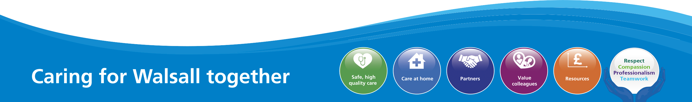
1

MEETING OF THE PUBLIC TRUST BOARD – Thursday 6TH MAY 2021
Hospital Mortality Report (Quarter 4, 2020/21) |  |  | AGENDA ITEM:
Report Author and Job Title: | Dr Manjeet Shehmar Deputy Medical Director | Responsible Director: | Dr Matthew Lewis Medical Director
Action Required | Approve ☐ Discuss ☐ Inform ☒ Assure ☒
Executive Summary | - In the last quarter, there have been 548 deaths at the Trust. A structured judgement (SJR) review has been raised for 153 deaths. In Q4, 91 SJRs have been completed. Care has been assessed as determined as level 3a or below in 8 cases (see text for grading).  - Year to date; as assessed by SJR level 1 review, death was not avoidable or probably not avoidable in 91.2% of SJRs completed, probably avoidable in 4.4%, and avoidable in 4.4%. All deaths which were probably avoidable/avoidable are investigated following the Trust Incident Reporting and Learning Management Policy.  - Learning from deaths is part of the Safe, High Quality Care (SHQC) Improvement Programme, with learning monitored via the Mortality Surveillance Group.  - Through the learning from deaths process, we have seen:  - The Clinical Commissioning Group (CCG) have closed risk 244: Failure to recognise and learn from events that contribute to deaths after gaining assurance through the Trust learning from deaths process, mortality surveillance group and mortality reports. This risk was added to the risk register in 2011.  - There are no Trust SHMI alerts for January to December 2020.  - The trust no longer has a SHMI alert for fractured neck of femur.  - The trust’s HSMR is rising and a project to address this has been initiated.
Recommendation | The Board is asked to note performance data and key areas for attention and learning
Does this report mitigate risk included in the BAF or Trust Risk Registers? | - BAF001 Failure to deliver consistent standards of care to patients across the Trust results in poor patient outcomes and incidents of avoidable harm.  - Performance against SHMI is recorded on the trust risk register.  - Systems and processes for the identification and learning from issues in care have been identified as ineffective by the CCG.
Resource implications | Continued employment of Medical Support Workers via the NHSI scheme to undertake SJRs until September.

Legal and Equality and Diversity implications | The equality and diversity implications to the trust for patients with learning disabilities are managed according to the trust policy and LeDeR recommendations.  National legislation relating to the review of child and perinatal deaths has been implemented.
Strategic Objectives | Safe, high quality care ☒ | Care at home ☒
 | Partners ☒ | Value colleagues ☒
 | Resources ☒

Introduction

This report details:

- Performance data relevant to the trust, compared with regional and national comparator sites, where appropriate
- Key areas for attention, together with analysis, actions and outcomes
- Future actions and developments in understanding mortality data

- PERFORMANCE

National Benchmarks
The Trust uses two national benchmarks as primary indicators for mortality, Hospital Standard Mortality rate (HSMR) and Standard Hospital Mortality Index (SHMI). Table 1 shows the Trust SHMI and HSMR. The appendices at the end of this report show SPC charts and benchmarks of mortality metrics.

Table 1: Trust mortality 2020-21
 | HSMR | SHMI | Crude mortality
Jan-20 | 118.16 | 97.59 | 4.22
Feb-20 | 110.72 | 94.72 | 3.95
Mar-20 | 144.51 | 130.88 | 5.80
Apr-20 | 133.78 | 142.82 | 8.08
May-20 | 120.02 | 118.49 | 5.67
Jun-20 | 101.29 | 110.77 | 3.90
Jul-20 | 98.24 | 90.14 | 3.85
Aug-20 | 99.22 | 112.27 | 3.80
Sep-20 | 113.80 | 109.18 | 3.60
Oct-20 | 124.11 | 106.45 | 3.81
Nov-20 | 141.45 | 119.40 | 3.18
Dec-20 | 125.02 | 96.44 | 3.83
Jan-21 | 149.12 |  | 4.48

- KEY AREAS FOR ATTENTION

Covid-19 Deaths Dashboard

There has been a total of 682 Covid positive deaths in the hospital (to 07/04/21). Covid deaths are scrutinised by the medical examiners and escalated at SJRs in line with the Learning from Deaths Policy. Any Covid deaths associated with a hospital acquired infection are reported with an incident via Safeguard.
Non Covid excess death rate

There have been 279 non Covid related deaths in Q4 2020 as compared to 329 in Q4 2020 and 281 in Q4 2019. This makes our excess death rate ratio 1.17 in Q4 2019/2020 and 0.85 in Q4 2020/2021 (table 2). Covid and non-Covid deaths are reviewed in line with the Learning from Deaths Policy to identify any avoidable

deaths. It is reassuring to see that the excess death rate has reduced in the last quarter.
Table 2: Q4 Non Covid excess death rate 2019-2021

Q4 Non-COVID Deaths | Number | Excess death rate
Jan - Mar 2019 | 281 | 1.17
Jan - Mar 2020 | 329

Jan - Mar 2020 | 329 | 0.85
Jan - Mar 2021 | 279

Process for reviewing deaths in hospital.

A number of reviews as referenced in the NQB guidelines as a minimal requirement undergo formal structured judgment review (SJR):
- All deaths where a bereaved family, carer or staff have raised a concern
- Patient deaths of those with a learning disability
- Patient deaths of those with a mental illness
- Unexpected deaths, such as following an elective procedure
- Particular groups where an alarm has been raised for example via HSMR, SHMI or CQC
- Deaths where learning will inform the providers quality improvement work
- All maternal deaths
- All child deaths, over 16 years of age
- All perinatal and still birth deaths.

Learning from deaths performance

The Trust has four medical examiners, two are anaesthetists and one is a microbiologist. Despite clinical pressures requiring these doctors to contribute to clinical care for Covid, the team have been able to maintain performance in scrutinising deaths shown in the figure 1:

Figure 1: Learning from deaths performance.
300
250
200
150
100
50
0

Number of Deaths Total Number for SJR Notes Delivered Completed Returns

Apr
May June
July
Aug
Sept
Oct
Nov
Dec
Jan
Feb
Mar

20 20
20 20 20 20
20 20
20 21
21 21

The medical support workers have been undertaking SJRs in medical and ICU specialities which has led to a reduction on the backlog due to Covid clinical pressure on those teams.

National Learning from Deaths Dashboard

- The Trust has adopted reporting via the National Learning from Deaths Dashboard(https://view.officeapps.live.com/op/view.aspx?src=https://www.englan d.nhs.uk/wp-content/uploads/2017/03/nqb-learning-from-deathsdashboard.xlsm). In the last quarter, there have been 548 deaths at the Trust. A structured judgement (SJR) review has been raised for 153 deaths. In Q4, 91 SJRs have been completed. Care has been assessed as level 3a or below in 8 cases.

- Year to date; as assessed by SJR level 1 review, death was not avoidable or probably not avoidable in 91.2% of SJRs completed, probably avoidable in in 4.4%, and avoidable in 4.4%. All deaths which were probably avoidable/avoidable are investigated following the Trust Incident Reporting and Learning Management Policy.
Table 3 shows the comparison of deaths and reviews year to date, quarterly and monthly. There have been 441 more deaths year to date and an additional 20 deaths compared to last year which were assessed as being potentially avoidable; of these, 22 deaths (from 2020/21) were in Q1 during the beginning of the first phase of Covid and related to learning from Covid (figure 2).

Table 3: National Dashboard Learning from Deaths Performance

Total Number of Deaths in Scope |  | Total Deaths Reviewed |  | Total Number of deaths considered to have been potentially avoidable (RCP<=3a)
This Month | Last Month | This Month | Last Month | This Month | Last Month
121 | 181 | 9 | 34 | 1 | 2
This Quarter (QTD) | Last Quarter | This Quarter (QTD) | Last Quarter | This Quarter (QTD) | Last Quarter
548 | 465 | 91 | 127 | 8 | 7
This Year (YTD) | Last Year | This Year (YTD) | Last Year | This Year (YTD) | Last Year
1650 | 1209 | 512 | 537 | 41 | 21

Criteria for grading quality of care during SJRs
1 – Very Poor
2 – Poor
3a Adequate less than 50/50. Probably avoidable issues that may have contributed to the death
3b Adequate more than 50/50 Possible avoidable issues that did not contribute to the death
4 – Good
5 - Excellent

Figure 2: Trend of Learning from Deaths Performance 2019-2020
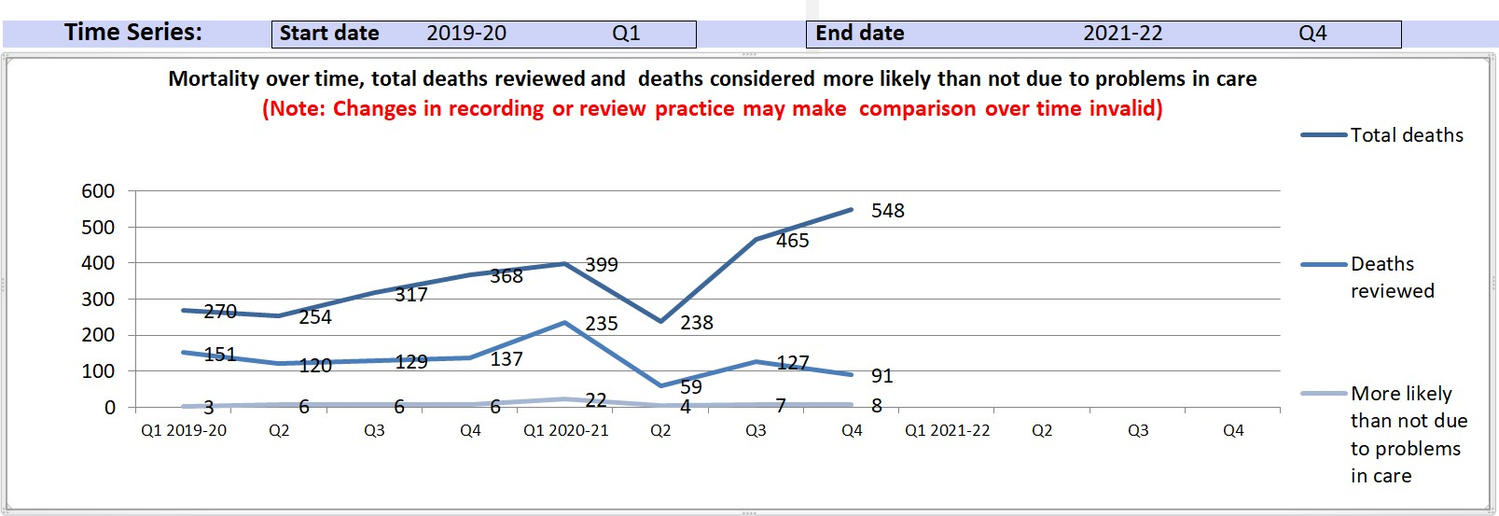
Deaths of patients with a learning disability

There were 4 deaths of patients with learning disability in Q4 2021 all of which have been reviewed in accordance with the National Learning Disabilities Mortality Review Programme (LeDer). No deaths were deemed to be potentially avoidable (table 4).

Table 4: Deaths of patients with a learning disability
Total Number of Deaths, Deaths Reviewed and Deaths Deemed more likely than not due to problems in care for patients with identified learning disabilities

Total Number of Deaths in scope |  | Total Deaths Reviewed Through the LeDeR Methodology (or equivalent) |  | Total Number of deaths considered to have been potentially avoidable by RCP SJR score  <=3a
This Month | Last Month | This Month | Last Month | This Month | Last Month
1 | 1 | 1 | 1 | 0 | 0
This Quarter (QTD) | Last Quarter | This Quarter (QTD) | Last Quarter | This Quarter (QTD) | Last Quarter
4 | 5 | 4 | 5 | 0 | 0
This Year (YTD) | Last Year | This Year (YTD) | Last Year | This Year (YTD) | Last Year
14 | 10 | 14 | 9 | 0 | 0

Figure 3: Alerts and notifications

The following Trust alerts have been received from the National HED database. There are no alerts in SHMI between Jan 2020 and Dec 2020.

Alert
CCS Diagnostic Expected Observed
Number
Alert

Alert
Period
Group
Death
Death
of
Discharges
HSMR Feb 2020 224 - Other 7.69
23
485 299.08 Red
- Jan perinatal
6
Score Level

 | 2021 | conditions
 | Feb 2020  - Jan 2021 | 14 - Cancer of colon | 5.52 | 15 | 441 | 271.7 | Red
 | Feb 2020  - Jan 2021 | 131 -  Respiratory failure; insufficiency; arrest (adult) | 7.5 | 19 | 47 | 253.21 | Red
 | Feb 2020  - Jan 2021 | 42 - Secondary malignancies | 9.22 | 20 | 253 | 216.87 | Red

Perinatal mortality

The perinatal mortality team has presented its improvement plan through MSG and will update quarterly. Main focus is on smoking cessation, antenatal risk assessment and aspirin prescribing to reduce placental insufficiency, recognition and faster treatment of asymptomatic bacteria to avoid preterm birth with a urinary tract infection. A new role of CTG lead has been created and appointed to with the aim of disseminating learning from better training. Learning is shared in maternity through a monthly newsletter and departmental meetings.
Colorectal cancer

The colorectal team have reviewed cases where death has occurred from cancer of the colon. There were 14 colon cancer deaths and 9 patients were palliative, of which 5 did not have surgery. If we consider the palliative patients separately, the observed deaths are in line with those expected. The learning for the team from this review was to ensure that palliative patients are referred to the palliative care team in order to ensure they receive the appropriate end of life care and so that we capture this on coding.
The respiratory team are reviewing their cases and working with the STP around deaths from respiratory conditions and will report back to MSG next month. The Trust cancer team are also reviewing the deaths from secondary malignancies.
- LEARNING FROM MORTALITY SURVEILLANCE GROUP

The Mortality Surveillance Group meets monthly to focus on the learning shared and implemented from the deaths within the speciality care groups. Each thematic focus group reports to the MSG quarterly.

Learning from Structured Judgments Reviews

Case specific actions following SI investigations, and local and level one investigation, are recorded and tracked through Safeguard and Patient Safety Group.

Examples of learning from mortality reviews in the last quarter include:
- Reducing avoidable deaths from diabetes by updates to the hyponatraemia guideline, ensuring correct and ongoing prescribing of long-term antibiotics.
- A reminder that the clinical frailty score should not be used where there is learning disability.
- Timely TURBT for initial diagnosis, long term survivorship for bladder cancer follow-up to be improved with more regular cystoscopies and better tracking of patients who are high risk.
- Joint working has been initiated with Royal Wolverhampton Trust to improve emergency access and care for urology patients through a combined on-call service.

QUARTERLY UPDATES FROM SHQC LEARNING FROM DEATHS THEMES

A review of lessons from SJRs from March 2019 to March 2020 shows themes of responding to deterioration, end of life care and cancer delays. Along with the red SHMI alert for fractured neck of femur and Covid, these themes form our focus for learning this year. These themes are included in the SHQC improvement programme and monitored quarterly at MSG.
Fractured neck of femur

Monthly mortality from fractured neck of femur is tracked through MSG. For quarter 4, mortality rates are reducing and the group will continue to monitor until there is a sustained reduction. Although there has been an impact of Covid on mortality from fractured neck of femur in both waves shown in Figure 1, the Trust no longer has a SHMI alert for deaths from fractured neck of femur.
Figure 4: Mortality from fractured neck of femur

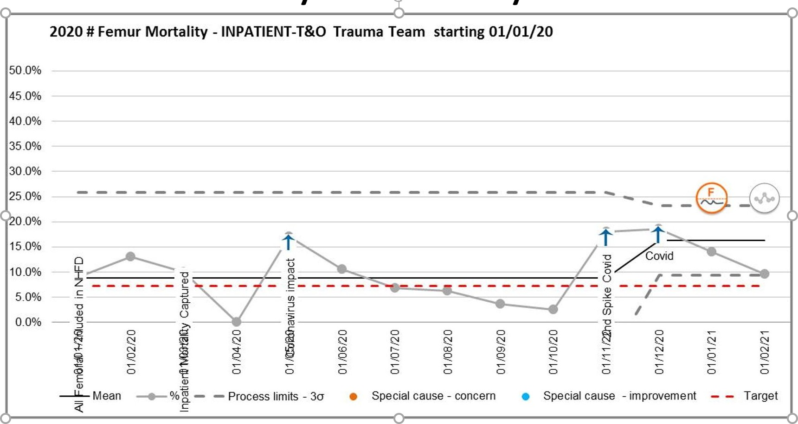

Further planned improvements include a new policy for enhanced recovery with the aim to provide a consultant delivered service, point of care testing in theatre recovery for blood loss and anaemia, progress with purchase of a cell salvage system. Cases are being drawn up for increased physiotherapy support and advanced nurse practitioners.
Reducing deaths from Cancer
Capacity and demand work has been completed for all tumour sites and with the exception of the breast service; all tumour sites are meeting the Two Week Wait Standard for an initial consultation (table 5).
Table 5: 1st Available Appointment by Site, reported as days since Referral.
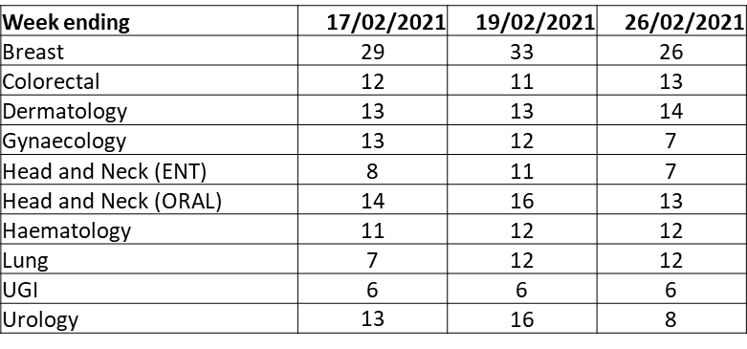
The Trust is meeting the 62 day treatment target (Table 6) of above 85% consistently since August 2020.
Table 6: 62 day referral to treatment STP comparator

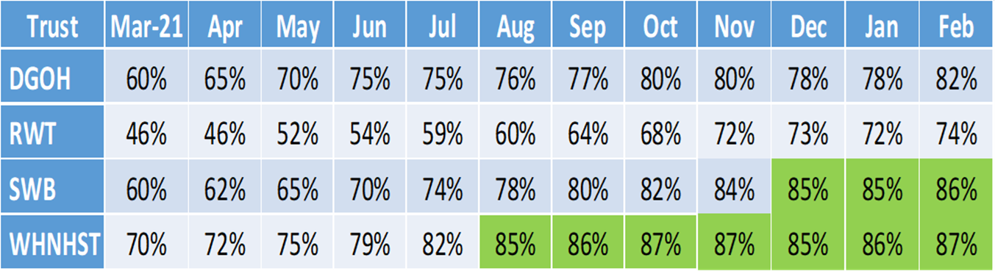

There are national diagnostic capacity challenges with breast cancer services. A clear improvement plan for the Trust includes initial triage to ensure the right investigations and pathways are initiated earlier, pre-appointment call to reduce DNA rates, a business case is underway to support the introduction of an Oncoplastic Fellow across the STP, as well as a Middle Grade Doctor / Advanced Care Practitioner to back fill clinics during periods of leave.
A business case is underway for expansion of the Acute Oncology Service to a 7 day service to strengthen the emergency pathway as a result of learning to reduce deaths from neutropenic sepsis.
A peer review is underway, replicating the approach taken to the Lung Improvement Programme – within Urology. Work has commenced with Urology which includes plans for collaboration with RWT (currently undergoing public consultation) which will in turn support in releasing time to care for cancer patients within the Urology Care Group.
Tracking improvements to reduce delays

A dedicated Trust cancer manager has started in post and a revised Clinical Harms Policy has been developed.
Patients on a clinical pathway with a Cancer of Unknown Primary (CUP) are now being formally tracked by the Cancer Team, with consultation, examination, diagnosis and treatment expedited where necessary.
A review of the Cancer Tracking and Fast track team is underway. Two Tumour Sites are currently not being tracked live, namely Upper GI and Colorectal. The aforementioned review will address that gap.
End of life care

The need to improve the end-of-life care pathway has been a consistent theme of learning from deaths. The recommended actions are driven and monitored via the SHQC and Walsall Together improvement plans. Updates are presented to MSG quarterly.
The Trust has implemented the new ReSPECT form and audit data shows that although more forms are being completed, there is a gap in assurance over quality of discussion. Audits of DNAR/CPR now include the quality of discussion with families

via the bereavement team. Feedback is given to the teams involved. The audits show that further work is required to improve the quality of the discussions at the end of life.
Deteriorating patient

A sepsis summit has been held on 16th March followed by an agreed improvement plan which will be tracked through patient safety group with Divisional performance. This includes correct de-escalation when a patient does not have sepsis, building the hospital at night and on calls teams to be able to respond faster to sepsis, training for sepsis awareness, the use of Fusion and E-sepsis.

QUARTERLY REPORTS

Child deaths report

The trust reviews child deaths through the Black Country Child Deaths programme (CDOP). Between 01/01/2020 and 11/03/21, 20 deaths have been reviewed. Of these 12 were males and 8 were females, 9 cases were perinatal or neonatal deaths and 7 children had chromosomal or genetic congenital abnormalities.
As a result from the reviews:

Walsall initiated and has implemented a virtual MDT meeting for any patient who is being discussed with more than one team at Birmingham Children’s Hospital (BCH) to enable better communication and joint working.
BCH now send antibodies on anyone with unknown rheumatological condition early to get results much quicker.
Bereavement boxes are now offered to each parent after learning that some parents were missed because staff assumed they lived together.
Perinatal mortality report

In October to December 2020, 4 cases were eligible for review by the National Perinatal Mortality Review Tool as shown in table 7 below:
Learning is highlighted in the alerts section above.

Appendices

Monthly Rolling Hospital Standardised Mortality Rate (HSMR)

The Trust HSMR is rising and initial work is to look at documentation and coding to improve data quality. A focus of work will be top capture co-morbidities and when a patient is on a palliative care pathway. Review of colorectal cancer HSMR alerts have shown that we have patients who are not set on a palliative care pathway because they have not been seen/referred to a palliative care consultant.
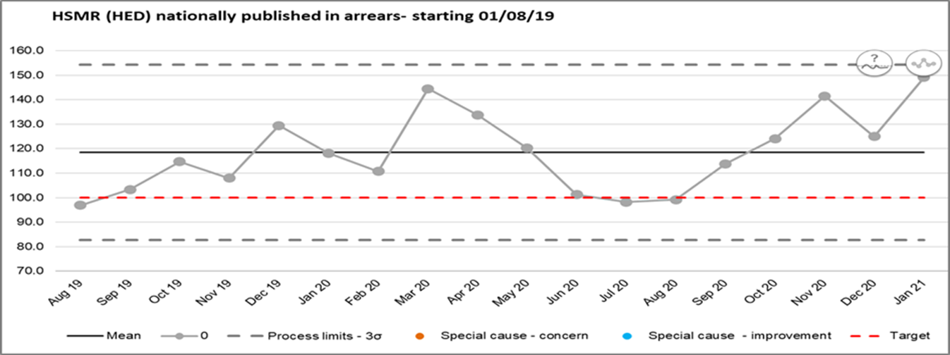

HSMR STP Benchmark
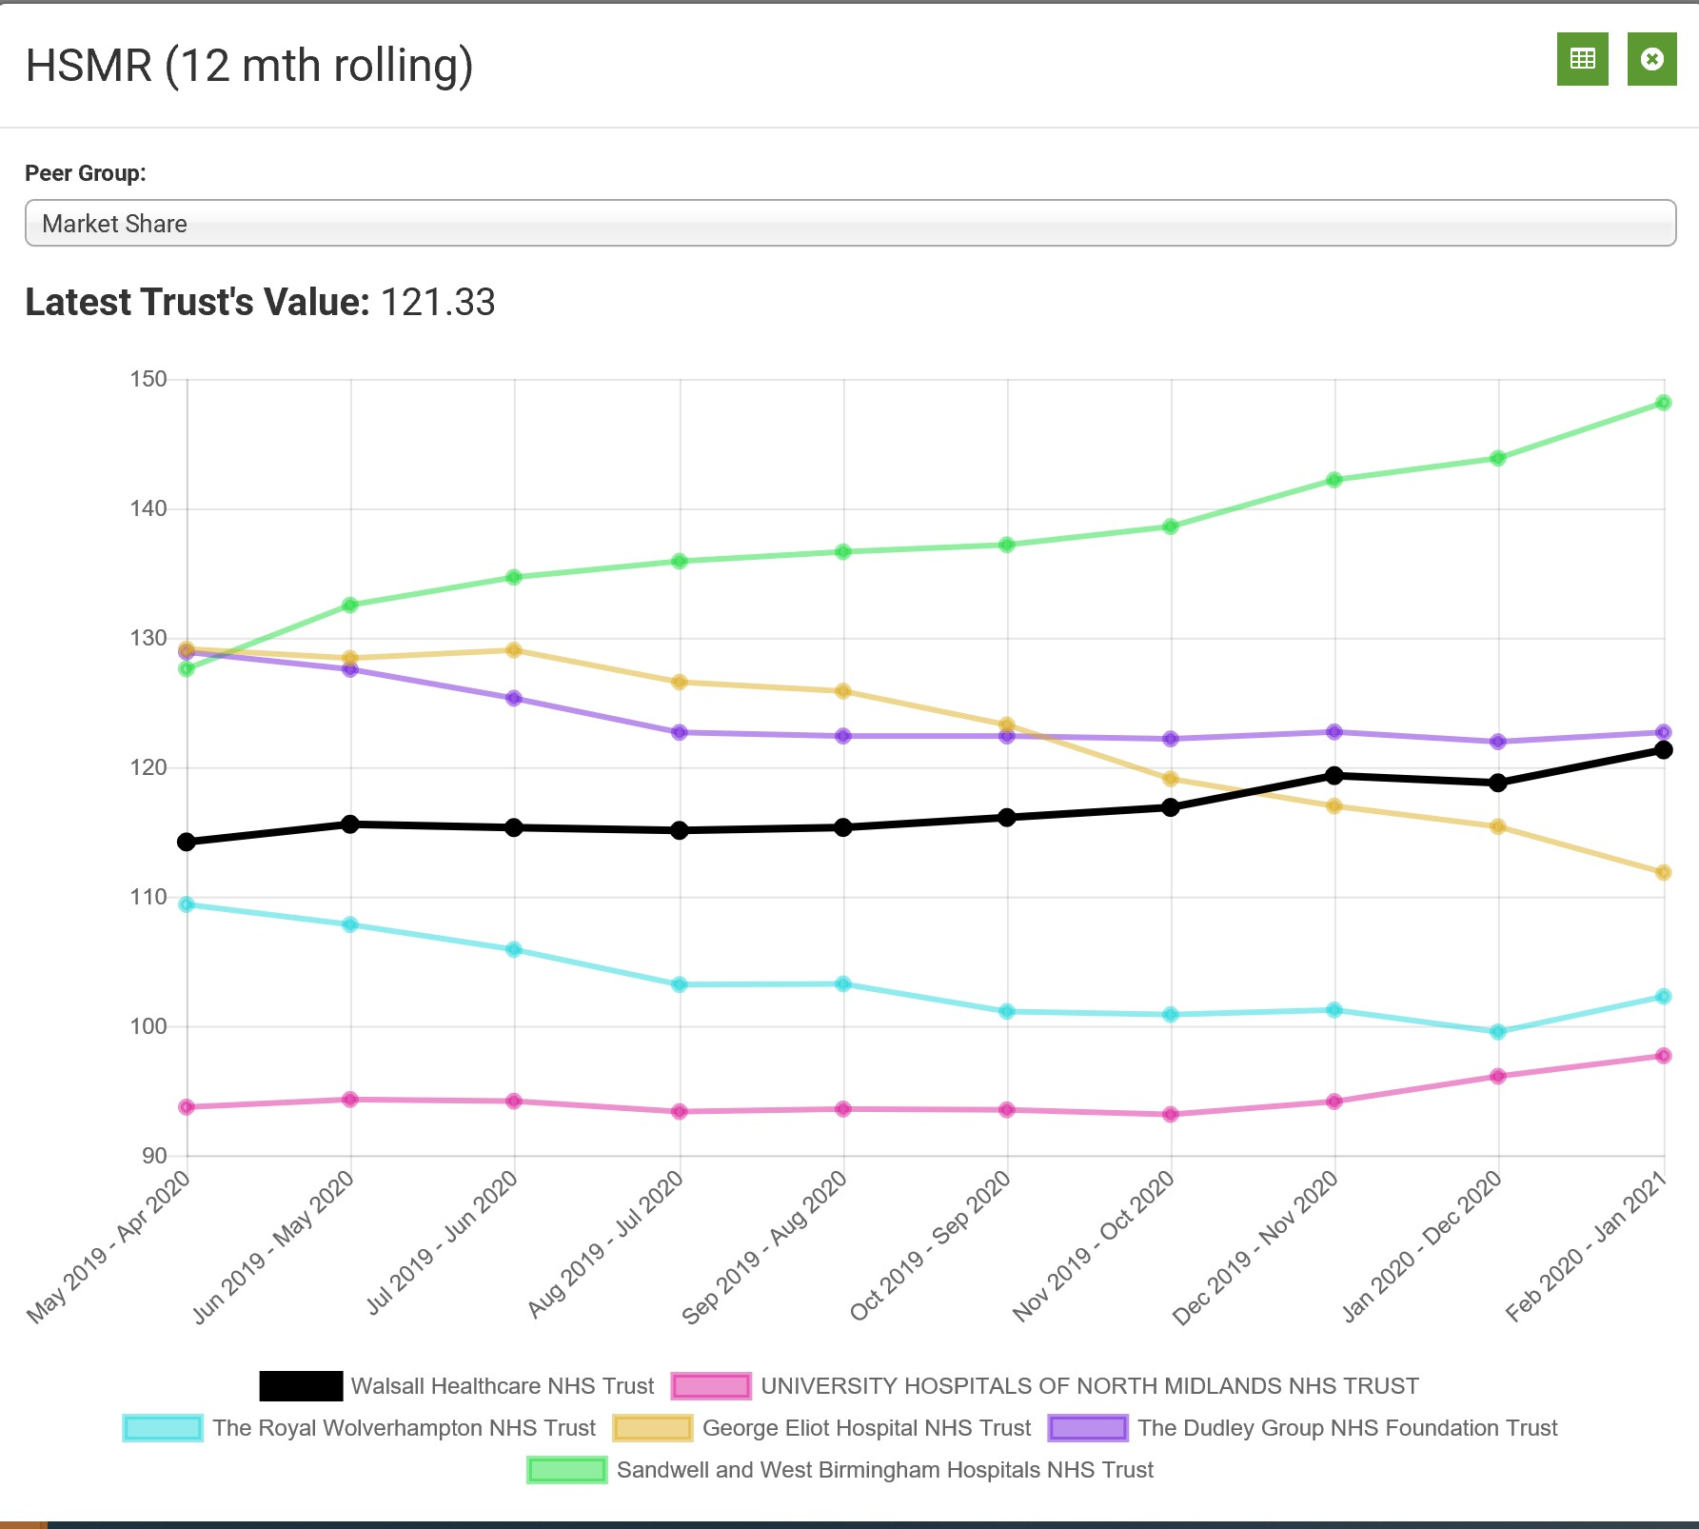

Standardised Hospital Mortality Index (SHMI)
Monthly SHMI
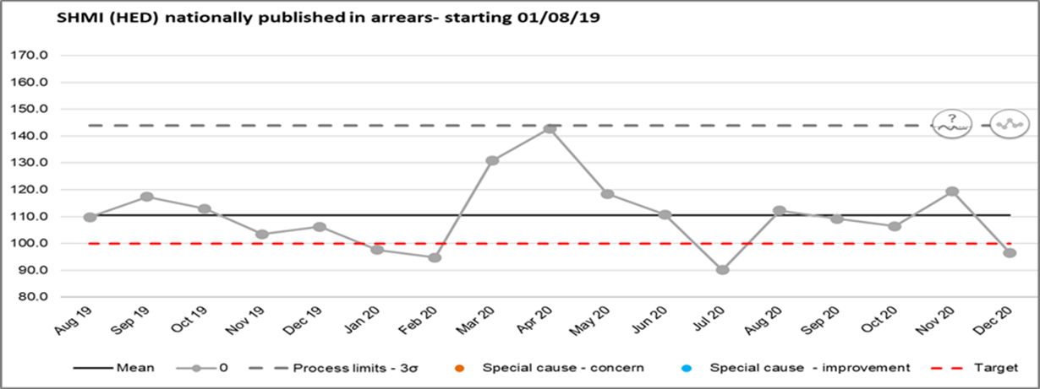
In Hospital Deaths
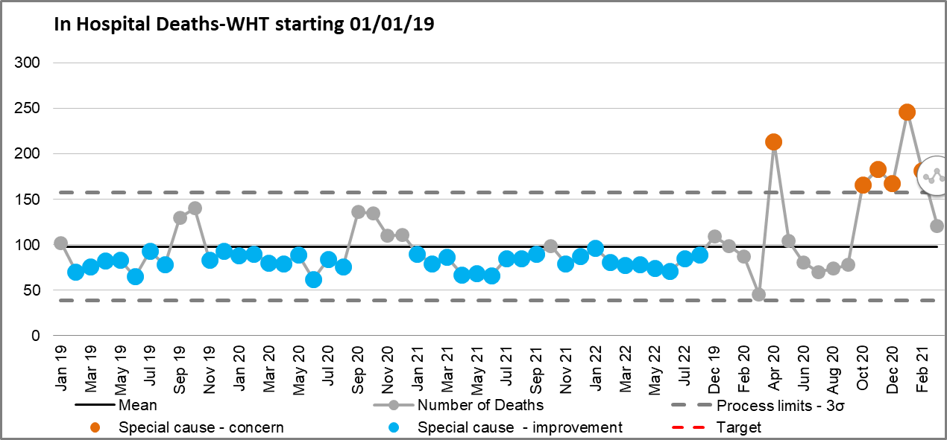

Crude Mortality 2015 – 2020 (deaths per 1000)
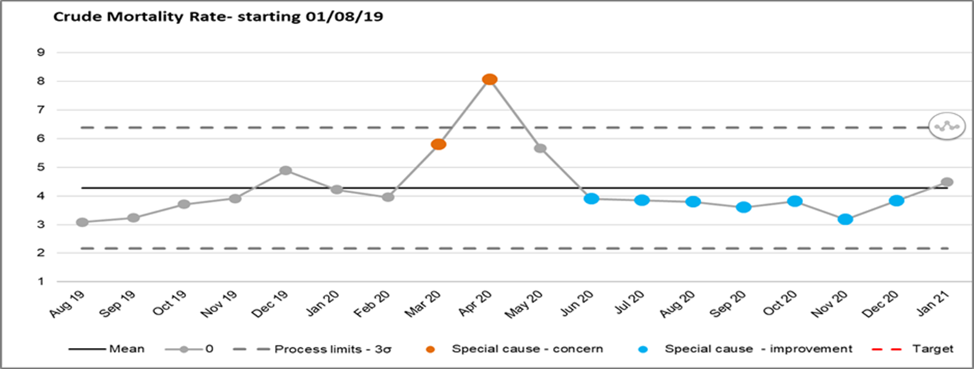

Glossary of Terms

HSMR Hospital Standard Mortality Rate SHMI Standard Hospital Mortality Index NQB National Quality Board

CQC Care Quality Commission NHSI NHS Improvement
SJR Structured Judgement Review ME Medical Examiner
MEO Medical Examiner Officer
LeDeR Learning Disability Mortality Review Programme LD Learning Disability
DNAR Do not attempt resuscitation MCA Mental Capacity Act
SI Serious Incident
RCA Root Cause Analysis
MTLC Medicine and Long Term Conditions division LFD Learning from Death
CuSuM Cumulative Summary, a performance indicator demonstrating persistent deviation from the mean
PALS Patient Advisory and Liaison Services CCG Clinical Commissioning Group
MSG Mortality Surveillance Group MDT Multidisciplinary Team

1

MEETING OF THE PUBLIC TRUST BOARD – 6th May 2021
Patient Relations & Experience Annual Report 2020/2021 |  |  |  | AGENDA ITEM: 14
Report Author and Job Title: | Garry Perry Head of Patient  Relations & Experience | Responsible Director: |  | Ann-Marie Riley Director of Nursing
Action Required | Approve ☒ Discuss ☒ Inform ☐ Assure ☐
Executive Summary | The attached annual report provides details of activity completed by the Patient Relations and Experience team from April 2020 to March 2021.  The report is specific in highlighting key data received via Complaints, Concerns, Compliments and the Friends and Family Test.  Learning Matters is highlighted in addition to recognising the fantastic work of our volunteers throughout the COVID-19 pandemic and the contribution to enhancing the patient experience made.
Recommendation | The Board is asked to note contents and activity and the 2021/2022 priorities approved by the Quality, Patient Experience and Safety Committee
Does this report mitigate risk included in the BAF or Trust Risk Registers? please outline | Delays in complaint investigations being undertaken can result in service improvement delays and therefore affect patient safety as there is a risk the same issue can reoccur.  Delay in investigations, and therefore a delay in the response being sent out to the patient/family, can result in poor patient/family experience and can affect the organisational reputation.
Resource implications | Poor Complaint handling can result in injustice payments recommended by the PHSO in lieu of additional distress caused
Legal and Equality and Diversity implications | There are no equality & diversity implications associated with this paper.  - CQC – Regulation 16 receiving and acting on complaints  - Local Authority Social Services and NHS Complaints (England) regulations 2009
Strategic Objectives | Safe, high quality care ☒ |  | Care at home ☐
 | Partners ☐ |  | Value colleagues ☐
 | Resources ☐

Patient Relations Annual Report 2020-2021

- PURPOSE OF REPORT

The purpose of the report is to provide information on the activity and feedback received by the Patient Relations Team in the past year 2019/2020 it highlights some of the key trends arising from contacts received and provides examples of the actions taken and lessons learned.

- BACKGROUND

The NHS and Social Care Complaint regulations 2009 require NHS bodies to provide an annual report on complaint handling and consideration, a copy of which must be available to the public. This report provides details of complaints and concerns received by Walsall Healthcare NHS Trust between 1 April 2020 and 31 March 2021 and Patient Relations service activity.

- DETAILS

See enclosed report

- RECOMMENDATIONS

The Board is asked to note contents and activity and the 2021/2022 priorities approved by the Quality, Patient Experience and Safety Committee

2

3

Patient Relations & Experience Annual Report 2020-2021
APPENDICES
1) Priorities 2021-2022

1.0 Introduction

During the last year the Patient Relations & Patient Experience Teams has come together as one function. This unified approach to capturing and acting on the feedback received by those who use our services is becoming clear. The Covid-19 pandemic undoubtedly affected the way in which the team has operated yet the team stepped up to the challenge impressively providing enhanced support to patients, carers and relatives – helping to alleviate some of the pressure felt by our hardworking clinical teams - carrying out and arranging video calls, supporting the bereaved, coordinating voluntary action and striving to make improvements based on both poor and positive experiences of those in our care.

The Team does all it can to be as responsive and proactive as possible aiming to provide on-the-spot advice, information and support for patients and relatives if they wish to raise issues. The team can also support patients when dealing with issues about NHS care and provide advice and information about local health services. Support is also provided to staff – particularly in supporting initiatives and programmes that make a difference and this report provides further detail of some of our activities during that has been a challenging and unprecedented time.
Section 1. Patient Relations
3719 contacts were received by the Patient Relations Team which included a total of 294 written complaints which includes 7 informal to formal complaints and 7 MP letters (a decrease of 31 written complaints overall for the year compared to 2019-2020) and an average of 14 contacts per working day. Overall increase of 59 contacts for the last year.

  - Patient Relations activity 2020-2021

Contact type | 2018-2019 | 2019-2020 | 2020-2021
Complaint requiring a written response | 318 | 309 | 280
Concern converted to a complaint | 22 | 10 | 7
Concern | 2402 | 2306 | 2026
Complaint dealt with as a concern | 13 | 23 | 16
Compliment | 527 | 536 | 416
Comments/Queries/suggestion/referred on/nhs choices/family liaison | 486 | 479 | 967
MP enquiry | 9 | 6 | 7
Total | 3777 | 3660 | 3719

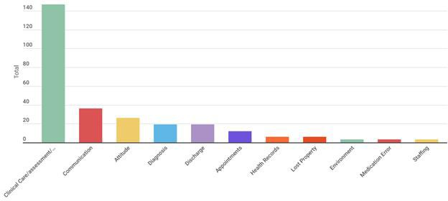
  - Complaints
This section details written complaints received during 2020/21.
There has been an overall decrease of 31 complaints compared to the previous year 2019/2020.

  - Complaints by Division

The Divisions of Medicine and Long Term Conditions (MLTC) and Surgery generated the greatest number of complaints, accounting for 76.8% of all complaints received. MLTC (143 complaints), Surgery (83), Women’s Children’s and Clinical Support Services (WCCS 56). Corporate functions, Urgent Care, Estates and Facilities and Adult Community account for the remainder.
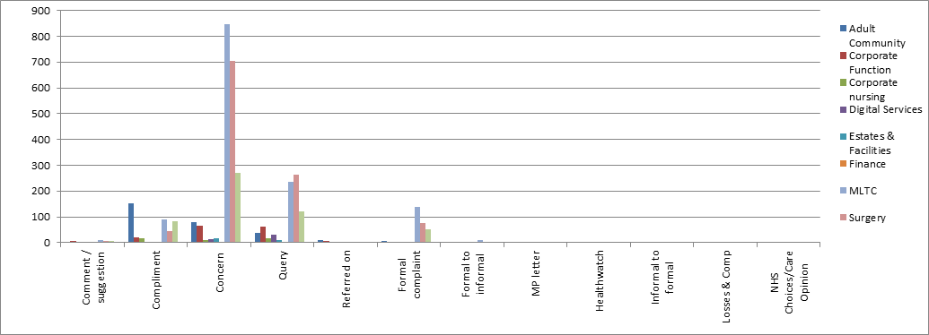
  - Complaints by category type
During 2020/2021, there were 409 complaint types by category with the main theme emerging from formal complaints being treatment care and supervision. This accounted for 50% of all complaint categories, 147 complaints fell within this domain.
The top category types from all complaints are highlighted in the table below.

2.3. Complaints by outcome

At the time of completing this report, the total number of complaints resolved was 278. 5 complaints were upheld with 119 not upheld and 136 partially upheld. 13 complaints due out in this period are ongoing with 5 withdrawn.
Outcome
160
140
120
100
80
60
40
20
0
Outcome
Upheld Not upheld Ongoing Partially upheld

  - Responding to complaints

We recognise that responding to patient complaints in a timely way is important however we are also keen not compromise the quality of our investigation or the completeness of our response. Due to the COVID19 pandemic NHS England and NHS Improvement supported a system wide “pause” of the NHS complaints process which allowed all health care providers in all sectors to concentrate their efforts on the front-line duties and responsiveness to COVID19.

The initial “pause” period was recommended for three months from March – June 2020. All health care providers could opt to operate as usual regarding the management of complaints if they wished to do so and this “pause” was not being enforced. We opted to continue management of complaints albeit the reduced level of clinical staff available did have some impact on our timeframes. Due to subsequent second and third wave rise in infections further guidance was issued in relation to complaint timeframes and non-enforcement of delays providing complainants were made aware. The Regulations do allow us to explain to the person making a complaint that the Covid-19 issue is causing strain on services and therefore complaints will take longer than normal to complete and answer.

We have at least up to six months to answer a complaint and then you can extend that as long as you explain to the complainant the reasons and write to them with this information. All this is covered by the Regulations 13(7) and 14(3) of the NHS and Social Care Complaints Regulations 2009.

% within timeframe
80
70
60
50
40
30
20
10
0
% within timeframe
Quarter 1 Quarter 2 Quarter 3 Quarter 4
Table 5. Complaints timeframe

  - Assurance
51% was the overall average number of complaints completed within timeframe for 2020/2021.
Based on the table below – the overall average score (number of days to complete) is 40 which given the current pressures this last year is not overly excessive. The overall longest wait for a response is 62.5 days which again has reduced considerably from 259.7 days in April 2020.

Division | Average Days to respond 01/04/20 to 31/03/21
Adult Community | 29.6
Corporate Function | 22
Estates And Facilities | 43.2
Medicine And Long Term Conditions | 52.6
Surgery | 58.7
Women’s Children’s and Clinical Support | 38.6
Table 6. Average days to respond

4.0 Parliamentary Health Service Ombudsman (PHSO) 2020/2021
3 cases were accepted via the PHSO for investigation. This equates to 1% of all complaints received. Themes emerging include: Concerns highlighted with regard to clinical care assessment and treatment, poor communication, inadequate pain management and poor nursing care.

The PHSO paused existing health casework and stopped accepting new health complaints on 26 March 2020 to help the NHS focus resource on tackling the Covid-
19 pandemic. Reviews of new case referrals and ongoing investigations were re-commenced on the 1 July 2020. There remains 2 cases open from the previous year 2019/2020. Of those closed in the previous year 1 complex and historic case was upheld. 1 case was partially upheld and 1 not upheld.

5.0 Concerns
There were a total of 3009 concerns received during 2020/2021, a decrease of 386 concerns from the previous year (3395).
This figure includes concerns (2042), comments, suggestions and queries and referred on (894), Family Liaison 58, Losses and Compensation 2, Health watch referrals 9, other PALS 9. MLTC equated for 38% (1147) of the total activity, with Surgery 33% (997) and WCCSS 13% (403).
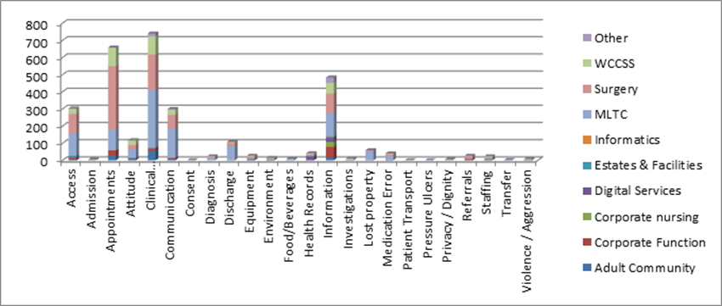
Table 7 - concerns by category and type
The main themes identified via the number of concerns raised are clinical care, assessment and treatment (740) 24.5%, Appointments (658) 21.8% and information
contacts (483), 16%.
6.0 Compliments
416 Compliments were received by the Trust. Women’s Services (62), Placed based teams (56), Palliative Care (34) and Corporate (25) accounted for the majority of compliments recorded – 54%.

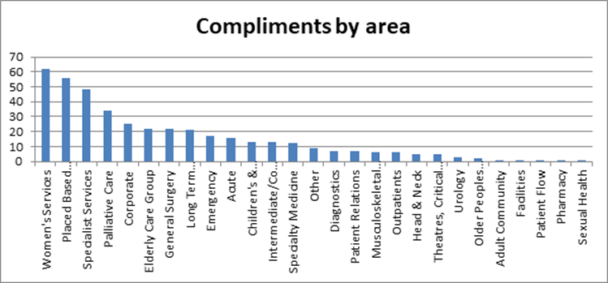
Table 8 – Compliments

“She was very professional and understood how my issue was affecting me. She went above and beyond to help me with my issues which have been outstanding since last year if not before.”

“I have worked as a GP partner at St Peter's Surgery for 13 years Sister H is most certainly the best nursing professional that has ever worked with my patients in the 13 years I have worked here (including all the community matrons/district nurse/COPD nurses that I have interacted with).”

“To whom it may concern, I just wanted to email you to let you know what an amazing job the antenatal team have been doing. I've had 5 pregnancies in total and I can honestly say this has been my best experience so far. Considering the current situation the staff in the antenatal unit have been so efficient and thorough with me, nothing has been too much trouble, everything is double checked, and I have felt safe and at ease every visit.”

“I attended the orthopedic clinic today to receive results from X-Ray's on my knee and shoulder the doctor and nurse gave me outstanding care and attention. I must admit I cried, knowing that something could at last be done. A big thank you. Also I have a big fear of lifts and the staff that also went in the lift with me.”

  - Learning Matters (PHSO)
Case 29510 – a written complaint was received in relation to poor midwifery care. The complainant felt she was not listened to and was dismissed. It was also stated that no new born baby checks were performed initially following the birth of her baby and mother was then moved from baby and her husband 10 minutes after birth to be stitched for an hour.
Learning: It was agreed that there will be a review of the equipment in the (induction of labour) bay so that in future if a woman delivers her baby in this location there would be adequate equipment so the midwife does not have to collect it and leave the woman alone. The action has been completed. One of the packs that are used for delivering a baby has now been placed in the store cupboard in the induction bay and replaced fter use. A communication has been sent to the team to ensure that
they all know that this equipment is available.

Learning: It was also agreed that the members of staff concerned will undergo additional training in terms of the process of induction of labour with particular attention to the assessment of the mother and baby throughout the induction period. It was arranged for the staff members involved to undertake the two day baby friendly training which focuses on skin to skin and breastfeeding, with the aim of improving patient experience going forward. Staff who have attended will be required to meet with the specialist midwife for infant feeding for an update on practice.
Case 29502 – a written complaint was received regarding the manner in which a member of staff assisted a patient back into bed. The main concern raised was regarding the manner in which the patient was spoken to who it was said lacked compassion and respect.

Learning: The member of staff in question advised that this is not the image that she wished to portray and offered her apologies. It was agreed that the member of staff concerned would complete a reflection on the way she dealt with the situation and it was also agreed that the concerns raised would be shared with the wider ward team for educational purposes.
Case 29133 - a written complaint was raised in relation to the patient’s medication not being prescribed correctly.
Learning: It was identified during the investigation that there was an omission in relation to the prescribing of the patient’s medication. When the patient was admitted to hospital he was seen by the on call team of doctors. The team prescribed the patient’s regular medications, however, there was medication prescribed on the patient previous EDS (discharge summary) which was not identified at the point of admission. It was agreed that there would be a review of the medication prescribing process on admission and the investigating lead shared the complaint with Ward 7 for learning and training purposes.

  - Learning Matters – Complaints and Concerns

Access to treatment – We continue to work with departments and teams in providing information in relation to why appointment delays and cancellations occurred due to the pandemic and how this was affecting overall patient satisfaction. The main issue seemed to be in the level of understanding of risk versus priority and clinical teams advised on how procedures were being prioritised for life threatening illness and conditions or adverse trauma. Providing information at point of contact does help provide reassurance and we managed this more proactively via a FAQ (frequently asked questions) link on the Trust website to provide information regarding appointments and procedures.

As we focus on re-set and recover we have provided support to the Division of Surgery in writing to all affected patients on a waiting list including provision of information in alternative formats and in an patient friendly way (following involvement of the patient reader panel).
Audiology issued advice following concerns on how its patients can make contact particularly as its open repair sessions for hearing aids have been suspended which includes battery replacements being posted out.
Learning was taken around care plans generated on admission to hospital. The main concerns raised were around the care provided on Ward 10 and the delay in obtaining a urine sample from the patient. Care plan reviews are carried out by trained nursing staff, these are updated weekly by nurses or sooner if required when there is a change in a patient’s condition. Matrons and ward managers now audit these care plans to ensure their efficacy and accuracy. It was also agreed that all members of staff involved in this complaint underwent additional training on other invasive ways to obtain a urine sample (with consent) when there is the issue of incontinence.

Learning was taken around the management of Paediatric patients suffering with constipation. The Paediatric Team reviewed their current practice around patients suffering with constipation to arrange frequent follow up appointments and to consider other underlying causes in case of no response to laxatives. The team also implemented a proforma which has the relevant questions to ask when looking for an underlying cause and prompts for further steps/investigations if a child is not taking medications / responding to medications.
Safeguarding - a parent was unhappy with a safeguarding allegation from physiotherapy paediatric department and subsequent follow up from social services. Parent felt this could have been handled differently.
Learning was taken via the staff involved who met with the Safeguarding Team Lead to discuss challenge and escalation with regards to safeguarding concerns. The staff member involved voluntarily attended additional training held by Walsall Safeguarding Partnership regarding Early Help and referral thresholds.

The Safeguarding Team Lead also liaised with the Safeguarding Nurse involved in this case regarding best practice advice being provided to practitioners and accurate recording of discussion in case notes.

  - Complaint Satisfaction Questionnaire

Our Trust feedback survey is based on the ‘I’ statements outlined in the Parliamentary and Health Service Ombudsman user-led vision. Answers are requested using a scale of 0-5 with 0 as completely disagree and 5 completely agree.
Feedback received is outlined as follows based on a 12% return rate (32 responses): Average score is 3.7 out of 5.

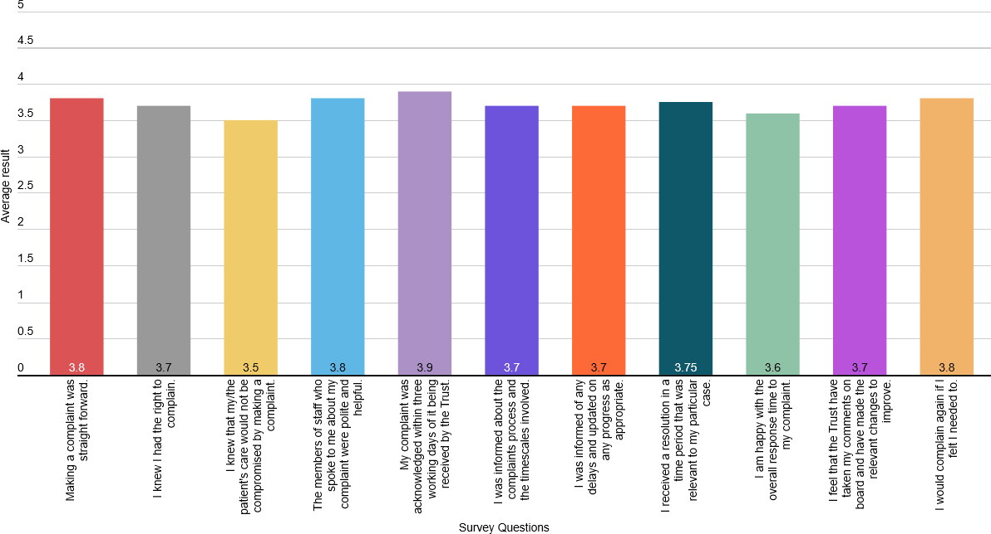
Table 9: Average survey outcomes – complaint satisfaction.

  - Equality Monitoring Survey
An equality monitoring form is in place and is issued at the point of acknowledgement with 14% (40) returned in 2020/2021.

    - Ethinicty: 39% of respondents identified themselves as White British, 13% Polish, 10% Black British, 3% Pakistani, 3% Bangladeshi and 7 British Asian.
    - Age: 23% were aged 31-40, 23% 51-60, 22% 21-30, 10% 41-50, 10% 61-70,
6% 51-60 3% 81plus.
    - Religion or belief: 42% Christianity, 29% no-religion, 10% Islam, 7% Buddhism, 6% did not specify

    - Sexual Orientation: 90% Heterosexual, 7% Bi-sexual, 3% preferred not to say
    - Gender: 52% Female, Male 42%, 6% did not answer
    - Gender re-assignment: 58% No, 42% did not say
    - Relationship status: 3% Married, 15% living with partner, 11% single, 2% did not respond
    - Pregnancy: 93% were not pregnant at time of making a complaint, 4% were. 3% preferred not to say
    - Disability: 74% stated no, 26% yes.

  - Inclusive learning from feedback
Following a complaint about lack of support for an inpatient with hearing loss, the trust has purchased six mobile digital interpreting units, called Wordskii on Wheels, or WOW. These units will enable bedside access to a British Sign Language (BSL) interpreter via video conferencing where quick access to an interpreter is needed. We have also incorporated learnings around this area into our Equality, Diversity and Inclusion e-learning package, so that staff across the trust have up-to-date guidance.

We are also developing a communications toolkit and we will make this available digitally in an accessible format to all trust staff. The toolkit will provide details on how to book and provide an interpreter, in addition to providing staff with some basic information about the communication needs people may have, including a picture, symbol, photo resource which can be used to help staff and patients communicate together.

The emergency department (ED) has now allocated two learning disability champions. These champions have met with the trust’s learning disability nurses and discussed how care can be improved when patients with learning disabilities attend ED and what reasonable adjustments can be implemented. The learning disability nurses are developing a resource package which will be given to the champions and reviewed monthly. The champions will be able to contact the nurses at any time for advice and support. They will also explore areas and pathways within accident and emergency which can be improved and how, with the learning disability nurses giving their continual support

8.0 Achievements against priorities

Our priorities for 2021/2022 are detailed at appendix 1. Key achievements against the 2020/2021 priorities are:
Introduce virtual meetings for patients/families rather than meeting face to face following COVID-19 adjustments.

Virtual meetings are offered we have conducted 22 formal meetings via teams/zoom this year and gave patients the option to wait until restrictions allow, receive a further written response or telephone meeting.

Piloting a complaint investigation ‘support hub’ with the division of Medicine. If successful we will roll this out across Divisions.

The investigation support hub was piloted and assisted the division of medicine with volume management and an overall reduction in the number of days to complete a response. We extended divisional access to the Hub during the height of the pandemic and although this has since been scaled back we provide support with locating and obtaining records, statements, and use of the investigation guide.
Develop an e-learning module with certification to replace the Trust complaints update which is out of date.

Due to the pandemic we ceased face to face training and begun to develop the e- learning package which will consist of three e-learning modules. Module 3 has been completed and an investigation guide has been produced, is in place and being used by complaints coordinators.
Improving the collection of Equality data, the team will also be scoping using the envoy messaging service to obtain feedback on the service.

Equality Monitoring was given a focus and in the last year this has improved from 5% of all complainants to near 15% this will remain a priority for the 2021/2022 year.

Section 2: Patient Experience

  - Friends and Family Test (FFT)

Over the last year, we have progressed further with our work for putting patients and carers’ voices at the heart of our services to ensure that the trust has a co-ordinated approach of ‘listening to’ and ‘learning from’ feedback. We have particularly increased patient involvement in production and design of services and clinical units.
88% of patients who used our hospital and community services gave a positive recommendation score.
14

This recommendation score is based on over 29,000 Friends and Family Test (FFT) surveys completed by our patients and service users. Our national survey results continued to show improvements and also highlight areas where more work is needed such as communication, patient involvement in decisions about care and treatment, arrangements around discharge and waiting times.

Due to the COVID-19 pandemic the submission of FFT data to NHS England and Improvement from all settings had also been temporarily suspended. With this in mind we decided to stop all collection methods and date submission with immediate effect for all services. We took a brief pause while we worked with Healthcare Communications to move away from using iPads and paper to collect the FFT data in inpatient areas and move towards SMS texting and Interactive Voice Messages. The Trust’s overall recommendation figure has seen a slight decrease when compared to the previous year, the number people who have responded to the Friends and Family Test is also lower than the previous year. The change in methodology, the lower response rate and the temporary suspension in the Friends and Family Test would explain why our overall recommendation rate is lower.

The chart below shows average FFT results for positive recommendation scores (%) for inpatients, emergency department, maternity services, outpatients and community services during 2020-2021.
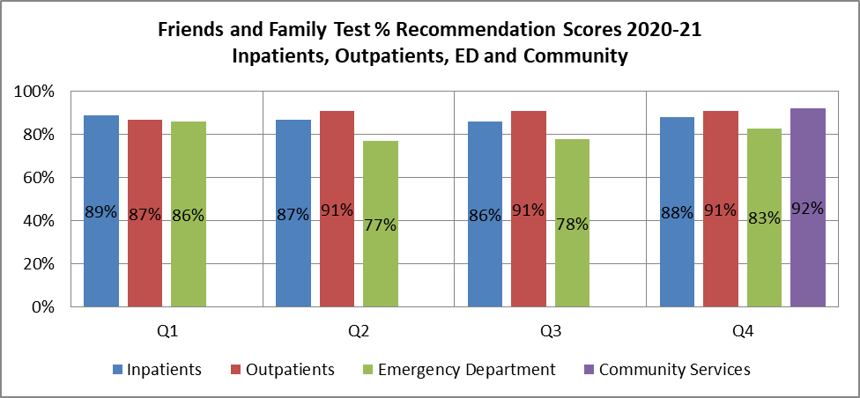
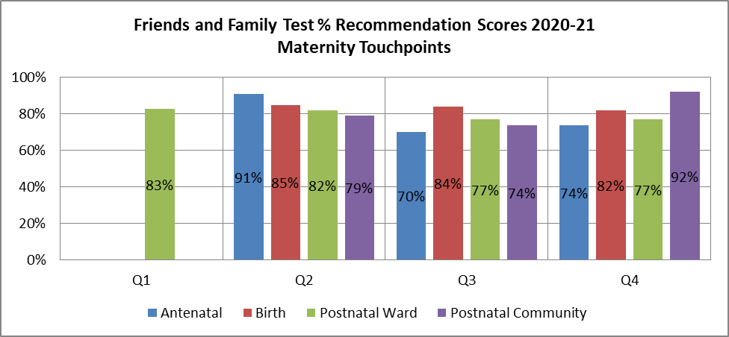

Table 10- Friends and Family Scores

Patients positively commented the most about staff attitude, implementation of care, the environment and the clinical treatment.

  - Patient & Partner involvement
Emergency Department (ED). In July 2020, a Patient Engagement Framework for the new ED build was initiated with the aim services will embed engagement with both patients and service users so that this does not end at the point of completion of the new ED build. The Terms of Reference for the Patient Engagement Group and the first matron led meeting with patients has been held via virtual means.
Staff on Ward 11 worked with dietitians and patients to focus on nutrition, looking at ways they can work with families and carers to better support patients and improve their recovery. The improvement project was developed to better meet the needs of its patients, some of whom are among the sickest in the hospital and require a lengthy stay. The project was developed after a complaint was received regarding nutrition and is a fantastic example of how teams can learn from complaints to improve the care and support they give to patients. Staff on the ward now take round a snacks trolley each day and have also installed a fridge on the ward so that food can be brought in from relatives.
Food: In Paediatrics, the senior sister and play specialist led a piece of work with the kitchens about redesigning the Children and Young Peoples (CYP) menu and a new supplier was identified. This happened following the involvement of children in the ‘Tops and Pants’ feedback about the quality of patient food.
Mealtime – Roll out Walsall Food Choices (#WalsallFoodFaves) project The trust has initiated a new meals choices menu incorporating dietetics requirements, procurement of an electronic menu system and tendering for new suppliers. A new nutritional ambition and subsequent strategy has been introduced following online and face to face engagement with patients who were in hospital.
Paediatric involvement forum has been initiated and virtual meetings held. The aim of the forum is to not only listen to the experiences of parents and children but involve them in the planning and design of future improvements.
One Walsall a third sector organisation within Walsall supported the recruitment and placement of emergency response volunteers.

Healthwatch Walsall – supported the Patient Relations team with the 7 day cover of family liaison during wave 1 of the COVID19 pandemic, helping to coordinate phone calls and deal with queries. The strengthened relationship has also included investigation of complaint referrals and feedback and as enter and view activity has been restricted carrying out virtual focus Friday events which has included a focus on hospital discharge, support for the deaf community and communication.

‘Walsall for All’ helped produce and update the Public Health England COVID-19 guidance in different languages and formats (available on the Trust website).

Making Connections –were our partners for our Winter Volunteer Project allowing access and additional support from local voluntary organisations providing help to those who require lower level support or require no support from Adult Social Care on discharge from hospital. Its remit is to provide access to the Making Connections Walsall (MCW) network which provides: Support with food shopping.
Befriending including possible access to “Neighbourhood Natters”. Prescription collection.
Help with heating.
Signposting into support from Money Home Job or other support. Signposting where appropriate to medical care professionals.
2.0 Volunteering

Enhancing Patient Experience is supported by our Voluntary service. There are currently 204 volunteers registered with the Trust of which 30 are actively volunteering in a variety of settings and undertaking a variety of activities predominately at the Hospital. There are a further five volunteers with us recruited via One Walsall.

Key achievements and improvements for 2020/21 include:
17
Established a process for keeping in contact with our existing volunteers where all receive regular personal phone calls.
Established a Fast Tract Process for volunteer recruitment which includes. We have created a rota for staff and volunteer coverage
We have created a Volunteer Hub in the office under the escalators. Responding to the drastically changed needs and urgency for tasks to support staff in the frontline creation of a ‘Response Volunteer’ role.
Response Volunteers are supporting the Trust in a number of ways:
‘Food Runs’ - delivering refreshments to staff who struggle to get away from the wards.
Sorting and delivering donated items to wards and community sites. Fetching and carrying small items across the trust as required.
Collection of IT equipment from wards and cleaning prior to delivery to IT Department.
Support was provided to the General Office team for collection of deceased patient property from wards and telephone contact then made with the family members to arrange collection. A process has been created including following the current infection control protocols.

1217 patients and their named kin were supported via the service. Set up in early December to help Walsall Manor Hospital patients receive personal belongings during their stay. Our brilliant volunteers have been running the Parcels to Patients service for us and are currently running for 5 days with scope to extend this to the weekend.
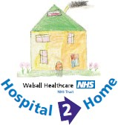
The Hospital 2 Home Project was launched following a successful bid to the NHSE winter volunteering fund. the project is there to help discharged patients who may be in need of extra support when leaving hospital e.g. this could be if the patients has no family or friends to support them when leaving hospital.
50 – 100 staff a day have benefitted from our partnership with Project Wingman to introduce an airport style first class lounge run by furloughed or redundant aviation crew. The lounge is there for staff to take a well-deserved break away from their busy work environment. The Project Wingman is now a Legacy Lounge running Monday – Friday, we currently have a total of 14 active airline crew who support the running of the lounge.
2547 patients have benefitted from video calling service to the Trust to help keep patients connected with their loved ones, while the hospital is restricted to visiting. The service has been warmly appreciated and has really made a difference to worried families restricted by visiting.

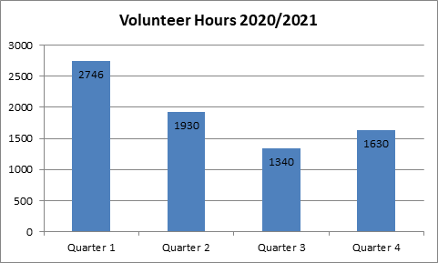The below chart shows the number of hours worked by our volunteer team by quarter. This gives us an annual total of 7646 hours.
Table 11 – Volunteer hours

  - Interpreting and Translation
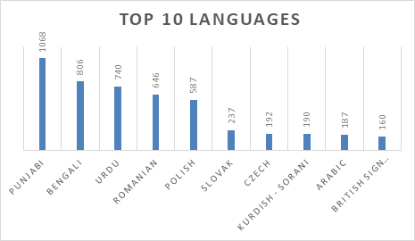
6770 bookings have been undertaken, 59% (3994 sessions) of these have been telephone, 38% (2573 sessions) face to face and 3% (203 sessions) video on demand calls. 231 patients/users completed feedback – the average score was 4.8% out of a maximum score of 5.

Table 12- Top 10 languages

The clear difficulties posed by the pandemic meant that the use of digital technology to support patients where English was not their first language was highlighted. During the past year we invested in four mobile video interpreting tablets – called WoW (Wordski on Wheels – which represents the digital application we have access too). Additionally we:

    - Partnered with ‘Walsall for All’ producing and updating Public Health England COVID-19 guidance in different languages and formats (available on the Trust website)
    - Arranged the translation of a ‘proning’ leaflet o support COVID19 patients with their recovery
    - BSL (British Sign Language) video transcript of Public Health England guidance was produced and placed on the Trust website including stay at home advice and what to do when support is required.

Garry Perry
Head of Patient Relations & Experience Report compiled – 12 April 2021

MEETING OF THE PUBLIC TRUST BOARD – 6th May 2021
Performance, Finance & Report | Investment | Committee | (PFIC) Highlight |  | AGENDA ITEM: 15
Report Author and Job Title: | Trish Mills, Trust Secretary |  | Responsible Director: |  | Mr John Dunn – Chair of PFIC (Non-  Executive)
Action Required | Approve ☐ | Discuss ☐ | Inform ☒ | Assure ☒
Executive Summary | This report provides the key messages from the Performance, Finance & Investment Committee meeting on 28th April 2021. Of note are:  - The Committee considered and approved the business case for expansion of the Respiratory Department with the appointment of 2 substantive Respiratory Consultants, 2 Respiratory Clinical Nurse Specialists and a respective increase in Clinical Measurements Unit and Imaging support. This will support the Trust’s ambition to reduce health inequalities in the borough by improving respiratory health.  - Financial performance remains strong, the Trust forecasting attainment of the 2021/22 financial plan and delivery of a break-even outturn (costs incurred off-set in full by income received). The delivery to forecast in year will result in the Trust having attained financial plans and break-even performance for two consecutive financial years. Key focus will be on ensuring the improvement programme delivers the required efficiencies in the second part of the year (Horizon 2).  - Operational (acute and community) is also evidencing strong performance, with the Committee commending the teams for recovery of diagnostic waiting time which is now 2nd best in the country (from a ranking of 4th in January). Excellent and consistent performance on patients medically stable for discharge remains key to enabling the emergency department pathways to admit inpatients and maintain strong ambulance handover times.  - A board development session on restoration and recovery will be held as soon as possible to understand more fully the
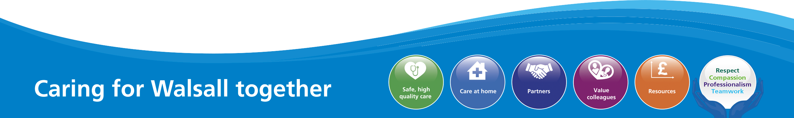
1

recovery timescales and risks. A Committee development session will take place thereafter to review the Q2-4 2021/22 planning ahead of its submission to the ICS in June.

- The Committee congratulated Mr Fradgley and Mrs Riley on the success of the vaccination programme, noting that 100,000 dose of the COVID-19 vaccination will have been administered by Walsall Together Vaccination Team across the Saddlers Centre and the Hospital Hub in the week commencing 4th May.

The next meeting of the Committee will take place on 26th May 2021.
Recommendation | Members of the Trust Board are asked to note the escalations and any support sought from the Trust Board.
Does this report mitigate risk included in the BAF or Trust Risk Registers? | This report aligns to the BAF risk for use of resources and working with partners, and associated corporate risks.
Resource implications | The resource implications are set out in this highlight report.
Legal and Equality and Diversity implications | There are no legal or equality & diversity implications associated with this paper
Strategic Objectives | Safe, high quality care ☐ | Care at home ☐
 | Partners ☒ | Value colleagues ☐
 | Resources ☒

MEETING OF THE PUBLIC TRUST BOARD – 6th MAY 2021
Use Resources Well Executive Report |  |  | AGENDA ITEM: 13
Report Author and Job Title: | Ned Hobbs, Chief Operating Officer Russell Caldicott, Director of Finance &  Performance | Responsible Director: | Ned Hobbs, Chief Operating Officer Russell Caldicott, Director of Finance &  Performance
Action Required | Approve ☐ Discuss ☐ Inform ☒ Assure ☒
Executive Summary | This report provides an overview of the risks to delivery of the Use Resources Well strategic objective, mitigations in place to manage the risks identified, and actions identified to address gaps in controls and assurance. It provides the Trust Board with assurance on performance for Use Resources Well and NHS constitutional standards successes and areas for improvement.  This report recognises the extraordinary circumstances that the Trust has operated in during the 2020/21 financial year, and the altered financial arrangements because of the national level 4 incident prompted by the COVID-19 pandemic.  It updates Board members on financial performance, attaining a  £0.14m surplus for the 2020/21 financial year (subject to audit of the financial statements). This represents the second successive year of achieving a surplus and delivering financial plan. This improvement over plan follows receipt of central income allocations, offsetting the impact on the Trust from being unable to recharge NHS bodies.  The report then focuses upon plans being developed for quarter 2 of the 2021/22 financial year (with quarter 1 plans already endorsed by members), with income allocations for this period based upon actual expenditure incurred during quarter 3 of 2020/21. The Trust is awaiting confirmation of income allocations relating to the period from 1st October 2021.  The report identifies key risks to delivery of 2021/22 financial plans centring upon temporary workforce and the need to deliver efficiencies to enable investment in services (Improvement

Programme delivery therefore key).

This report identifies continued strong operational performance following the extreme pressure experienced during the third wave of the Covid-19 pandemic in early 2021. It highlights exceptional constitutional standard performance in the DM01 6 week wait diagnostic standard and the 4-hour Emergency Access Standard, and strong benchmarked 18-week Referral To Treatment waiting times and 62-day Cancer waiting times. It highlights continued pan- Black Country challenges for waiting times for suspected Breast Cancer and Breast symptomatic patients.
Recommendation | Members of the Trust Board are asked to note the contents of this report, and the next steps:  - Re-forecasting elective restoration and recovery plans for 2021/22 following second and third waves of COVID-19 that have far exceeded the original planning parameters.  - Q1 2021/22 plan endorsed last month. Income for quarter 2 aligned to quarter 3 2020/21 expenditure (on Private Board agenda).  - The Trust is developing expenditure run rate plans for quarter 2 2021/22 (to be presented to PFIC in May 2021) for submission to Trust Board in June 2021, whilst continuing to develop income & expenditure models for the remainder of 2021/22.  - It is of note that post 30th September 2021 income allocations are still to be confirmed, and that the June 2021 plan for Trust Board will be for Q2 of 2021/22 only.  - Identification within the 2021/22 plan trajectories the use of temporary workforce and efficiency attainment (from the Improvement Programme).
Mitigate risk included in the BAF or Trust Risk Registers? | This report addresses BAF Risk S05 – Use Resources Well to provide positive assurance that there are mitigations in place to manage this risk and the related corporate risks.
Resource implications | This strategic objective is: We will deliver optimum value by using our resources efficiently and responsibly  Financial impacts are as described within the recommendations section, key areas of note.

Legal and Equality and Diversity implications | There is clear evidence that greater deprivation is associated with a higher likelihood of utilising Emergency Department services, meaning longer Emergency Access Standard waiting times will disproportionately affect the more deprived parts of the community we serve.  Whilst not as strongly correlated as emergency care, there is also evidence that socioeconomic factors impact the likelihood of requiring secondary care elective services and the stage of disease presentation at the point of referral. Consequently, the Restoration and Recovery of elective services, and the reduction of waiting times for elective services must be seen through the lens of preventing further exacerbation of existing health inequalities too.  The published literature evidence base for differential access to secondary care services by protected characteristic groups of the community is less well developed. However, there is clear evidence that young children and older adults are higher users of services, there is some evidence that patients who need interpreters (as a proxy for nationality and therefore a likely correlation with race) are higher users of healthcare services. And in defined patient cohorts there is evidence of inequality in use of healthcare services; for example end of life cancer patients were more likely to attend ED multiple times if they were men, younger, Asian or Black.  In summary, further research is needed to make stronger statements, but there is published evidence of inequity in consumption of secondary care services against the protected  characteristics of age, gender and race.
Strategic Objectives | Safe, high quality care ☐ | Care at home ☐
 | Partners ☐ | Value colleagues ☐
 | Resources ☒

USE RESOURCES WELL

- EXECUTIVE SUMMARY

This report provides an overview of the risks to delivery of the Use Resources Well strategic objective, mitigations in place to manage the risks identified, and actions identified to address gaps in controls and assurance. It provides the Trust Board with assurance on performance for Use Resources Well and NHS constitutional standards successes and areas for improvement.

This report recognises the extraordinary circumstances that the Trust has operated in during the 2021/22 financial year, and the altered financial arrangements because of the national level 4 incident prompted by the COVID-19 pandemic.

It updates Board members on attainment of a surplus for the 2020/21 financial year of £0.14m, representing the second consecutive year of achievement of a surplus and of financial plan (subject to Audit of the financial statements).

The report also confirms the moving of planning for the 2021/22 financial year into quarter 1 of the new financial year, and following the endorsement of the quarter 1 2021/22 financial plan (agreed in April’s Trust Board meeting) action being taken in development of a financial plan for quarter 2 of 2021/22 and for the remainder of the financial year (post 30th September 2021).

This report identifies continued strong operational performance following the extreme pressure experienced during the third wave of the Covid-19 pandemic in early 2021. It highlights exceptional constitutional standard performance in the DM01 6 week wait diagnostic standard and the 4-hour Emergency Access Standard, and strong benchmarked 18-week Referral To Treatment waiting times and 62-day Cancer waiting times. It highlights continued pan-Black Country challenges for waiting times for suspected Breast Cancer and Breast symptomatic patients.

- BOARD ASSURANCE FRAMEWORK

The Use Resources Well Board Assurance Framework (BAF) risk has been further updated to reflect the COVID-19 second and third waves exceeding planning parameters, and the significant uncertainty that remains for the 21/22 financial year. The risk remains at a score of 15 (consequence 5 x likelihood 3).

The BAF risk has been further updated again to include:
  - Attainment of 2020/21 financial plan and delivery of a surplus.
  - Updated NHS constitutional standard performance, showing continued improvement in national rankings.
  - Delivery of 115% of 19/20 elective/daycase procedural activity in March 2021.

Key financial risks are articulated within the corporate risk register and inform the Use Resources Well section of the Board Assurance Framework, namely;

  - Efficient running of the Trust, using every pound wisely in delivery of the financial plan and securing improved run rate performance to ensure financial sustainability in the longer-term.
    - Modelling trajectories for temporary workforce
    - Identification of efficiencies to enable re-investment into services
  - Capital resource availability to service current Estate backlog works requirements and future major capital developments

- PERFORMANCE REPORT

Financial

The Trust entered the 2020/21 financial year having attained planned financial outturn for 2019/20. However, the onset of COVID-19 has resulted in emergency budgets being set by NHSEI and the normal planning process halted.

The Trust attained a break-even financial position for the initial six months of the financial year (attaining break-even through requesting additional funds of £13.8m for the period as a top up). From month 7 onwards, the Trust has no longer received retrospective top up income to offset costs, instead the Trust negotiated an income settlement for the remainder of the financial year.

The Trust had a deficit plan of £3.8m for the financial year, the deficit for the Trust driven by omissions contained within NHSE/I’s income allocation methodology. However, the Trust has received additional income of £3.8m that off-sets these income allocation shortfalls and as such has attained a £0.14m surplus for the 2020/21 financial year.

Planning for 2021/22 has been moved to quarter 1 of the new financial year (current income allocations rolled forward into quarter 1 of 2021/22) with resource plans for quarter one completed. This Q1 plan was adopted by Executive and Trust Management Board, and recommended for adoption by Performance, Finance, & Investment Committee, and subsequently endorsed at April Private Board.

Income allocations for quarter 2 of 2021/22 are based upon expenditure incurred within quarter 3 of 2020/21 (paper to be presented to Private Board). The financial plan (driven by activity and manpower) will be presented to Performance, Finance, & Investment Committee in May 2021 for recommendation for adoption by Board members in June 2021.

The Trust is developing a full year financial model, to move beyond quarter 2 of 2021/22. However, the income allocation post 30th September 2021 is yet to be

confirmed and plans requiring submission in June 2021 only relate to the period to 30th September 2021 accordingly (to Q2 of 2021/22).

The financial plan for the remainder of the year will need to include clear trajectories for use of temporary workforce. Securing efficiencies from the Improvement Programme will be key to securing a balanced financial model for clinical care, and to enabling the financial latitude to invest in key developments moving forwards. It is expected that the income allocation post 30th September 2021 will be less than that of the initial two quarters of the financial year, though clearly any resurgence of the pandemic may impact on the resultant allocations.

Capital expenditure in 2020/21 totalled £21.8m, key elements being the Emergency Department and Acute Medicine new build enabling works of £6.1m, Urgent and Emergency Care Winter resilience of £4.1m, and theatres (to include Air Handling Units) of £3.7m. The Full Business Case (FBC) for the Emergency Department development is to be discussed at Private Trust Board.

The Trust has substantial cash holdings at the end of the financial year (c£43.5m) with this balance including receipt of cash for one month’s block income in advance of normal payment timeframes. The Trust will be required to repay the income received in advance in March 2021 (c£19.8m) but clearly post this re-alignment cash holdings will remain substantial and present no risk to operations.

Operational

Emergency Care:

Despite the highest month of Emergency Department attendances this financial year the Trust has, for the second consecutive month, recorded its best percentage of patients triaged within 15 minutes of arrival to ED since records began with 89.54% of patients triaged within 15 minutes of arrival in March 2021, and the best Ambulance Handover times (<30 minutes) in the West Midlands again in March 2021.

Following the deterioration in 4-hour Emergency Access Standard performance in January during the peak of Wave 3 of the pandemic, performance in March 2021 recovered strongly to 93.72% of patients admitted or discharged within 4 hours of arrival to ED, and the Trust was ranked 14th nationally out of 113 reporting Trusts – representing the highest 4-hour Emergency Access Standard ranking on record for the Trust. This has been achieved through concerted improvement effort along the non- elective pathway in both community and hospital settings, and particularly through significant internal improvements within the Emergency Department itself.

Elective Care:

Despite cessation of most routine 6 Week Wait (DM01) Diagnostics during March and April 2020, and the associated deterioration in waiting times, the Trust’s performance is now the 2nd best in the country (February 2021) out of 122 reporting Trusts, and has improved again in March 2021 to deliver the best month of performance since the onset of the pandemic, with just 1.12% of patients waiting over 6 weeks for their diagnostic test.

Despite cessation of routine elective surgical services during March and April 2020, and reduced elective operating capacity again since November 2020 over the second and third waves of the pandemic, the Trust’s 18-week RTT national ranking position remains in the Top 50, and it’s 52-week waiting time performance remains 3rd best in the Midlands.

The Division of Surgery developed an elective surgical restoration plan (presented through Performance, Finance & Investment Committee and Quality, Patient Experience and Safety Committee) that, over an 8-week period, cements in recuperation time (through annual leave) and psychological wellbeing support for staff that have worked on Critical Care during the pandemic, before material increases in routine elective surgical operating began. These plans commenced on 8th March 2021. The Division increased, as planned, to 6 elective operating theatres on 12th April 2021, and is on course to increase to a 7th elective operating theatre on 3rd May 2021. As a result the Trust has delivered 115% of 2019/20 average elective and daycase procedural activity in March 2021 representing strong recovery of Elective capacity and the first month since the onset of the pandemic that the number of patients treated has exceeded pre-Covid levels.

In February 2021, for 62-day Cancer performance the Trust was materially better than West Midlands average (59.2%) and in line with national average (69.7%), with 67.05% of our patients treated within 62 days of referral from their GP. Whilst in line with STP and West Midlands Cancer Alliance performance, both 2 week wait Suspected Cancer (all tumour sites) and 2 week wait Breast Symptomatic standards remain highly challenged across the Black Country. Additional Breast clinics are scheduled with the assistance of insourced Breast Imaging support. 2 Week Wait Breast Symptomatic standard performance will take until the end of May to recover fully, and there is a risk that performance will be adversely impacted by significant out of area referrals, predominantly from the Wolverhampton area.

- IMPROVEMENT PROGRAMME

The Use Resources Well component of the Improvement Programme was re-prioritised in light of the scale of the second wave of COVID-19. The focus for the Clinical Divisions has been on workstreams that improve emergency care pathways, as there was a direct benefit for the COVID-19 response. Highlights include the fact that Surgery

have delivered record Same Day Emergency Care rates through improvements to the Surgical Ambulatory Emergency Care pathway, taking the proportion of acute surgical patients managed without overnight hospital stay from less than 30% to over 50%. Medicine & Long Term Conditions have similarly delivered significant improvements with the number of patients being managed without overnight admission through the Frail Elderly Service (which is now in its new home alongside Community Services as part of our Integrated Assessment Unit) increasing by over 50% this year, and with significant increases in the number of patients managed through the Ambulatory Emergency Care unit too. This has culminated in the Trust being ranked second nationally for Same Day Emergency Care in medical specialties through the Ambulatory Emergency Care network. Furthermore, Medicine & Long Term Conditions average Length of Stay for those patients who do require overnight admission has reduced from over 9 days to less than 8 days over the course of this year.

In elective care, the Surgical Division have maximised the use of scarce elective operating theatre capacity over the year by transferring cases that can be done outside of an operating theatre setting into alternative procedure rooms, freeing up full elective operating theatre capacity for those cases that truly require it and reducing waiting times as a result. This has included establishing a Minor Operations Centre for Orthopaedics at Pelsall Village health centre including procedures for trigger finger and ganglion repair, the transfer of prostate biopsies into outpatient procedure room setting at the Manor Hospital for Urology, and the development of radio frequency ablation of varicose veins undertaken in an outpatient procedure room setting rather than operating theatres for Vascular Surgery.

The attainment of recurrent financial efficiency improvement through the Use Resources Well workstream is key to securing future sustainability of services, ensuring the Trust exits the 2020/21 financial year, and Q1 of the 2021/22 financial year, with a run rate that can be supported by the income earned by the Trust.

- RECOMMENDATIONS

Members of the Trust Board are asked to:
  - Note the contents of the report.
  - Note the following actions;
    - Re-forecasting elective restoration and recovery plans for 2021/22 following second and third waves of COVID-19 that have far exceeded the original planning parameters.
    - Q1 2021/22 plan endorsed last month. Income for quarter 2 2021/22 to be aligned to quarter 3 2020/21 expenditure (on Private Board).
    - The Trust is developing run rate plans for quarter 2 2021/22 (to be presented to PFIC & Trust Board in May 2021) with income & expenditure models for the remainder of 2021/22 to be developed.
    - It is of note that post 30th September 2021 income allocations are still to be confirmed, hence the June 2021 plans to Trust Board will relate to Q2 2021/22 only.

    - Identification within the 2021/22 plan trajectories for use of temporary workforce and efficiency attainment (from the Improvement Programme)

APPENDICES
1(a). Board Assurance Framework Risk S05
2(a). Performance Report (Finance and Constitutional Standards) 2(b). Performance Dashboard

Latest Board/Committee - 01/04/2021 Version V0.01
Public Trust Board – 6th May 2021 Agenda item 16, Appendix 1

Risk Summary
BAF Strategic Objective Reference & Summary Tile: | BAF SO 05 - Use Resources Well; We will deliver optimum value by using our resources efficiently and responsibly.
Risk Description: | The Trust’s financial sustainability is jeopardised if it cannot deliver the services it provides to their best value.  If resources (financial, human, physical assets & technology) are not utilised to their optimum, opportunities are lost to invest in improving quality of care.  Failure to deliver agreed financial targets reduces the ability of the Trust to invest in improving quality of care, & constrains available capital to invest in Estate, Medical Equipment & Technological assets in turn leading to a less productive use of resources.
Lead Director: | Chief Operating Officer.
Lead Committee: | Performance, Finance, & Investment Committee.
Links to Corporate Risk Register: | Title: |  |  |  |  |  |  | Current Risk Score Movement:
 | - Risk 208 - Failure to achieve 4 hour wait as per National Performance Target of 95% resulting in patient safety, experience and performance risks (Risk Score = 16).  - Risk 2398 - Insufficient/ out-of-date equipment, utilised beyond its life cycle, has the potential to result in sub-optimal patient care (Risk replaces the archived risk - 274) (Risk Score = 16).  - Risk 665 - Risk of a cyberattack (ransomware, spearfishing, doxware, worm, Trojan, DDoS etc) upon a NHS or partner organisation within the West Midlands Conurbation (Risk Score = 15).  - Risk 1005 - The Trust has insufficient resources available to ensure the essential maintenance of the Trust's Estate (Risk Score = 16).  - Risk 1155 - Failure to demonstrate fire stopping certification for all areas of the Trust would breach fire safety regulation, risking public/ patient safety (Risk Score = 16).  - Risk 2081- Operational expenditure incurred during the current financial year exceeds income allocations, which results in the Trust being unable to deliver a break even financial plan (Risk Score = 16).  - Risk 2082-Failure to realise the benefits associated with the outcomes of the improvement programme work-streams, results in the Trust not delivering efficiencies required to attain agreed financial control targets, and deliver financial balance without central support, which therefore impacts on the Trusts ability to deliver financial and clinical sustainability (Risk Score =16).  - Risk 2188 - A continued dependency on suboptimal legacy patient information infrastructure, will limit the flow of clinical information, reduce professional confidence and increase administrative burden for healthcare professionals, ultimately  impacting on patient care and the ability to transform healthcare services (Risk Score = 10). |  |  |  |  |  |  | ↔
Risk Scoring
Quarter: | Q1 (2021) | Q2 | Q3 | Q4 (2020) | Rational for Risk Level: | Target Risk Level (Risk Appetite): |  | Target Date:
Likelihood: |  |  |  | 3 | Evidence of risk control:  - Achievement of 19/20 financial plan.  - Adherence to revised financial arrangements | Likelihood: | 2 | 31 March 2022
Consequence: |  |  |  | 5 |  | Consequence: | 5
Risk Level: |  |  |  | 15 |  | Risk Level: | 10
Page 1 of 4

 |  |  |  | High | during 20/21 as a result of the Covid-19 pandemic, despite significant planning uncertainty  - Strong operational performance measured through constitutional standards, and associated operational performance metrics.  - Development of draft 5-year capital programme  - Majority of allied Corporate Risks associated with Use Resources Well mitigated to scores of 16 or less.  Evidence of risk gaps in control:  - The Trust experienced run rate risk for the 19/20 financial year that led to needing to re-forecast outturn during the financial year.  - High reliance on temporary workforce  - Lack of credible plan to address backlog maintenance requirements.  - Although the Trust can evidence improved productivity of many core services, there is not yet benchmarked comparative Model Hospital evidence to show improved relative productivity.  Evidence of planning uncertainty:  - The Trust has an Emergency Budget for the financial year 20/21, the principles of which will roll into Q1 of 21/22.  - Normal national financial planning cycle for 21/22 financial year was postponed due to the Covid-19 pandemic.  - Financial improvement planning and delivery has been impacted by Covid-19.  - Significant uncertainty still associated with H2 (Q3 and Q4) 2021/22 financial arrangements. |  | Moderate
Control & Assurance Framework - 3 Lines of Defence
 | 1st Line of Defence |  |  |  | 2nd Line of Defence | 3rd Line of Defence
Controls: | - Financial position reported monthly via Care Groups, Divisions, Divisional Performance Reviews and Executive Governance Structures.  - Revised financial governance in place for COVID-19 through the Trust’s Governance Continuity Plan.  - Board Development session for the Improvement Programme with |  |  |  | - Performance, Finance & Investment Committee in place to gain assurance.  - Audit Committee in place to oversee and test the governance/financial controls.  - Adoption of business rules (Standing Orders, Standing Financial Instructions and Scheme of Delegation).  - Use Resources Well work stream of the Improvement Programme has Governance | - Externally benchmarked Financial and operational productivity performance data, particularly (but not exclusively) through Model Hospital.

 | identified 3-year targeted financial benefits. | infrastructure in place.
Gaps in Controls: | - Business planning processes require strengthening.  - Accountability Framework has been approved, however needs review further to the NHSI Governance Review report.  - Leadership development needs at Care Group, Divisional and corporate support service levels, with commencement of leadership development programme deferred to Spring 2021 due to Covid-19 second wave.  - Covid-19 second and third waves have significantly exceeded planning parameter assumptions.
Assurance: | - Model Hospital Use of Resources assessments.  - Proportion of acute surgical patients managed without overnight hospital stay has risen from less than 30% to over 50%.  - Number of patients managed through the Integrated Assessment Unit’s Frailty service without overnight hospital stay has increased by over 50%.  - Inpatient Length of Stay in MLTC (excluding 0-day LoS) has reduced from over 9 days to less than 8 days on average.  - Number of Medically Stable for Discharge inpatients sustained at lowest level on record through 20/21. | - Internal Audit reviews of a number of areas of financial and operational performance  - Covid-19 ‘top-up’ resource in line with peers as a percentage of turnover.  - 2nd best in the country out of 122 reporting Trusts (Feb 2021) for 6 week wait (DM01) performance  - 14th best in the country out of 113 reporting Trusts (Mar 2021) for 4-hour Emergency Access Standard, and best in the West Midlands out of 14 reporting Trusts for Ambulance handover <30 mins  - 49th best in the country out of 121 reporting Trusts (Feb 2021) for 18-week RTT performance  - Better than West Midlands and in line with England average for Cancer 62-day waiting time performance | - Annual Report and Accounts presented to NHSE/I.  - NHSE/I oversight of performance both financial and operational.  - External Audit Assurance of the Annual Accounts.  - Medical specialties Same Day Emergency Care rates for ambulatory emergency care conditions rated second best in the country by the AEC Network.
Gaps in Assurance: | - NHSi Governance review highlighted areas of improvement for business process and accountability framework.  - Trust scored requires improvement on its assessment of ‘Use of Resources’ owing to low productivity and high staff and support costs being evident. Time lag on updating of some Model Hospital metrics means there is a delay in receiving independent assurance of improved financial and operational productivity metrics.  - External Audit limited due to Covid-19.  - Late confirmation of 21/22 financial architecture.  - NHS Digital Templar Execs external review (Cyber Operational Readiness Support) has identified improvements required for the Trust’s Cyber Security.
Future Opportunities
- Further Development of LTFM to include potential additional income sources, such as non-clinical commercial opportunities and repatriation of patients resident to Walsall currently receiving care out of area.
- Enhanced clinical economies of scale through Acute Hospital Collaboration (Working with Partners).
- Reduced reliance on inpatient hospital care through Walsall Together Partnership (Care at Home).
- Improved Equality, Diversity and Inclusion in the Trust to harness the skills of the whole workforce and leadership development programme for Care Group and Divisional leaders to enhance capability (Valuing Colleagues).
- Utilisation of national productivity benchmark information (e.g. GIRFT and Model Hospital) to target work through the Use of Resources Improvement Programme.
- Development of major capital upgrades (new Emergency Department) to support improved recruitment of staff.

- Harnessing the teamwork and innovation so evident throughout the Covid-19 pandemic to develop service improvements that lead to improved use of resources.
- Capitalising on the digital advancement during Covid-19 to harness technology to improve effective use of resources.
- Rationalising Estate requirements through increased remote working.
- Enhanced leadership capability through Well-led Improvement Programme work stream.
Future Risks
- Covid-19 second and third waves have significantly exceeded planning parameter assumptions, leading to increased costs delivering emergency and critical care, and reduced leadership time dedicated to long time resource planning during the height of the pandemic.
- Likely move away from PbR towards block contracts and the associated paradigm shift for elective care in particular.
- Adverse Covid-19 impact on ability to deliver improved productivity for elective care in 20/21, and early 21/22.
- Additional costs associated with safe non-elective and critical care during Covid-19.
- Significant changes to elective and non-elective demand during Covid-19, leading to difficulty planning for the future with confidence.
- Insufficient Capital to enable investments in the Estate, equipment and technology that would in turn support more effective use of resources, and significant lead time for deployment of capital.
- Impact of Covid-19 on the wider economy and supply chain markets may destabilise some costs of goods/services upon which the Trust relies.
- Workforce exhaustion and/or psychological impact from Covid-19 may result in higher sickness rates and/or colleagues deciding to leave the healthcare professions, and thus further reliance on temporary workforce.
Future Actions (to further reduce the Likelihood / Consequence of the risk in order to achieve the Target Risk Level in line with the Risk Appetite)
No. | Action Required: | Executive Lead: | Due Date: | Progress Report: | BRAG:
2. | Review and update Accountability Framework further to the NHSI Governance Review report. | R. Caldicott | Oct 2020 | Revisions to assessment, content and agenda in conjunction with the Divisional Directors, Trust Management Board, Executive and the Improvement Programme Board have been enacted and work on development of key metrics is progressing.  However, a key element of the review centres upon wider Trust consultation to gain ownership of the framework and metrics used for assessment. This has been difficult to progress in light of the pandemic which results in the current rating of amber.
3. | Financial regime post 31st September 2020 to be approved by Board in October 2020- Russell Caldicott | R. Caldicott | Oct 2020 | Complete
4. | All work-streams to have Improvement programme benefits defined. | G. Augustine | Oct 2020 | Complete - Presented to Trust Board Development Session on 1st October 2020.
5. | Development of 2021/22 Financial plan | R. Caldicott | March 2021 | Likely to be delayed due to delayed receipt of national planning guidance.

Use Resources Well

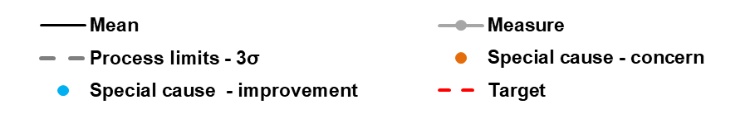SPC Key
ED - % within 4 hours – Overall (Type 1 & 3)

Narrative (supplied by Chief Operating Officer)
100%
95%
90%
85%
80%
75%
70%
65%
Emergency/Urgent Care
The Trust achieved the best ambulance handover performance in the region for the second consecutive month with 98.3% of patients being handed over within 30 minutes. Additionally, 89.5% of patients were triaged within 15 minutes of arrival to ED setting the best monthly performance on record.
Following the deterioration in 4-hour Emergency Access Standard performance in January 2021, during the peak of Wave 3 of the pandemic, performance in March 2021 has recovered further to 93.71% of patients admitted or discharged within 4 hours of arrival to ED. This is the second best month of EAS performance since August 2015 and has placed the Trust as 14th best performing acute trust nationally and 3rd regionally (Midlands).

RTT (18 weeks Referral to Treatment)
100%
95%
90%
85%
80%
75%
70%
65%
60%
55%
50%
Despite cessation of routine elective services due to Covid-19, the Trust’s 18- week National performance ranking remains in the Top 50. In March, as forecast, performance has improved from 66.82% in February to 68.72

The Division of Surgery has developed an elective surgical restoration plan that, over an 8-week period, cements in recuperation time (through annual leave) and psychological wellbeing support for staff that have worked on Critical Care during the pandemic, before material increases in routine elective surgical operating begin. These plans commenced on 8th March 2021. The Division increased, as planned, to 6 elective operating theatres on 12th April 2021, and is on course to increase to a 7th elective operating theatre on 3rd May 2021. The Trust undertook 115% of 19/20’s elective/daycase procedural activity in March 2021.

18 weeks RTT – Incomplete Pathways

Diagnostic waiting times & activity (DM01)
Despite cessation of most routine 6 Week Wait (DM01) Diagnostics during March and April 2020, and the associated deterioration in waiting times, the Trust’s performance is now the 2nd best in the country (February 2021) out of 122 reporting Trusts, and has improved to deliver the best month of performance since the onset of the pandemic in March 2021 with just 1.12% of patients waiting over 6 weeks. This is ahead of forecast trajectory and represents the best performance against the DM01 standard for 12 months.
45%
40%
35%
30%
25%
20%
15%
10%
5%
0%
Cancer
100%
95%
90%
85%
80%
75%
70%
65%
60%
In February, the Trust was materially better performing than West Midlands cancer alliance average performance of 59.2% and is line with the national average of 69.7%, with 67% of patients treated within 62 days of referral. Performance is expected to have improved to 70% in March with recovery of the 62 day standard by July 2021.
Cancer 62 Day RTT

Whilst in line with STP and West Midlands Cancer Alliance performance, both 2 week wait Suspected Cancer (all tumour sites) and 2 week wait Breast Symptomatic standards remain highly challenged across the Black Country.
Additional Breast clinics are scheduled with the assistance of insourced Breast Imaging support. 2 Week Wait Breast Symptomatic standard performance will take until May to recover fully, and there is a risk that performance will be impacted by significant out of area referrals, predominantly from the Wolverhampton area.
Diagnostic waiting times (DM01)

Financial Performance
Financial Performance to February 2021 (Month 11)
      - The Trust attained a surplus of £0.14m for the 2020/21 financial year, this represents achievement of a surplus for the second successive financial year (subject to the audit of the financial statements).
 | 20/21 Plan  £000s | 20/21 Actual  £000s | Variance  £000s
Income  Clinical Contract Income Additional Covid Top-up Education & Training Income  Other Income | 277,752  0  6,752  24,589 | 279,322  13,678  8,005  39,689 | 1,570  13,678  1,253  15,100
Subtotal Income | 309,094 | 340,694 | 31,600
Pay Expenditure Substantive Salaries Temporary Nursing Temporary Medical Temporary Other | (165,528)  (17,181)  (14,654)  (3,793) | (170,159)  (20,754)  (14,958)  (6,281) | (4,631)  (3,573)  (304)  (2,488)
Subtotal Pay Expenditure | (201,156) | (212,152) | (10,996)
Non Pay Expenditure Drugs  Clinical Supplies and Services  Non-Clinical Supplies and Services Other Non-Pay  Depreciation | (18,263)  (18,674)  (15,146)  (43,553)  (6,675) | (17,644)  (20,799)  (17,992)  (55,346)  (6,941) | 619  (2,125)  (2,846)  (11,793)  (266)
Subtotal Non Pay Expenditure | (102,310) | (118,721) | (16,411)
Interest Payable | (9,588) | (9,179) | 409
Subtotal Finance Costs | (9,588) | (9,179) | 409
Total Surplus / (Deficit) | (3,960) | 641 | 4,602
Donated Asset Adjustment | 90 | (503) | (593)
Adjusted Surplus / (Deficit) | (3,870) | 139 | 4,009

      - The surplus represents an improvement against plan of £4.01m (planned £3.87m deficit) following receipt of income from national allocations, the income received to offset the impacts of not being able to recharge for services to NHS bodies during the pandemic.
      - Temporary workforce expenditure remains over baseline plan and historic levels and a key driver of costs, this will be a key focus for the Trust in ensuring sustainable delivery of future financial models.
      - Other non pay expenditure is higher, largely due to monthly support costs for the Electronic Patient Record being chargeable this year and costs associated with delays to go live, combined with Covid-19 related costs incurred.

Capital
      - Capital expenditure totals £21.8m for the financial year 2020/2021
      - The plan increased in year to accommodate allocations secured for Critical Infrastructure Risk (£3.7m) which enabled replacement of the end of life theatre equipment and air handling units and capital funding to support Urgent and Emergency Care of £4.1m (these facilities now open and in use).
      - In addition, the Trust secured £6.1m of capital resources to support the commencement of enabling works associated with the new Emergency Department development.

Cash
      - Cash holding at the year end totalling approximately £43.5m.
      - The Trust has positive cash flows currently supported by receipt of cash a month in advance of normal mandate payments (a positive impact of £19.8m). The Trust has been notified the mandate for the month paid in advance will be reversed by April 2021, though with this reduction in cash payments the Trust is still projecting cash to be held in excess of £25m.
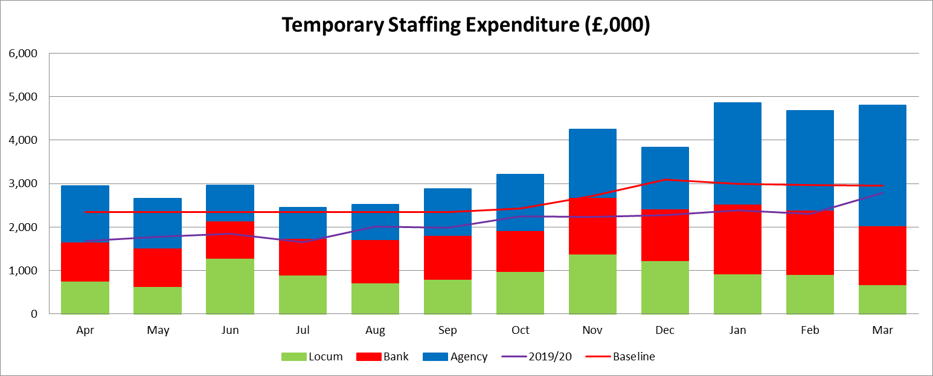
      - The Trust is holding substantial cash allocations at the end of the financial year. This is largely as a consequence of block contracts being received a month in advance since April 2020.

Efficiency attainment
      - The emergency budget planning letter and guidance states there was no efficiency requirement. However, development of Improvement Programme initiatives is key to ensuring financial sustainability moving forwards, with the outputs of this program to be reviewed by Performance, Finance and Investment Committee.
      - This will be a key aspect for development and endorsement of 2021/22 full year financial plans (and beyond) ensuring sustainability of services.

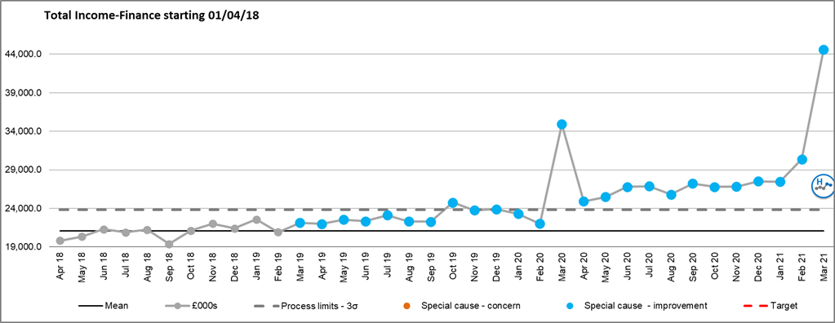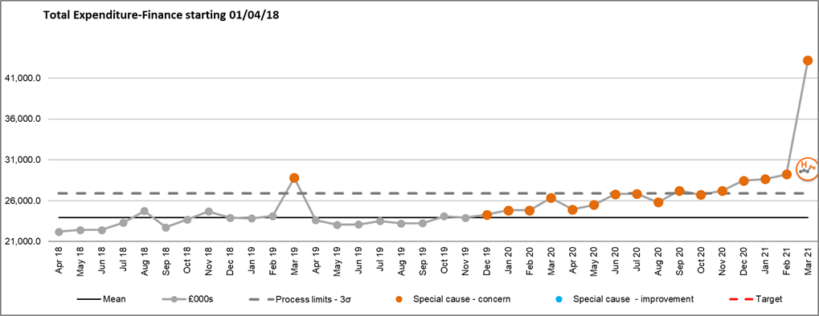Income and expenditure run rate charts

Income additional information
        - Income has continued to increase year on year, this reflects a level of tariff inflation/growth seen throughout the Trust
        - March 2020 saw the Trust move back on plan and receive the quarters Financial Recovery Fund (FRF) and Provider Sustainability Funds (PSF) in month accordingly
        - April’s income reflects the emergency budget income allocation (increasing monthly to reflect the increase in the top up of funding received)
        - February 2021 saw the receipt of additional NHSEI Income allocation to offset the ‘Lost Income’ assumed in the Deficit Plan
        - In Mar 2021 the Trust has received substantial non- recurrent income (£3.2m for annual leave accrual,
£4.5m to offset the value of Push stock, £3.7m Digital Aspirant Funding).

Expenditure additional information
        - March 2019 the Trust accounted for the ICCU Impairment of £6.2m
        - March 2020 costs increased to reflect the Maternity theatre impairment £1m & Covid-19 expenditure
        - Throughout April and May 2020 costs increased in support of COVID-19.
        - Costs increased further in June and July 2021 for elective restart and provision for EPR and Clinical Excellence Awards impacts on cost base.
        - A reduction in expenditure occurred in August due to the non-recurrent nature of Clinical Excellence Awards.
        - Increases in September reflected national releases of back dated Medical Pay Award, increased elective activity and remains high driven by the additional pressures of a second wave of COVID activity.
        - March 2021 spend includes non recurrent items such as Annual leave accrual, adjustments for Push stock, and non recurrent spend on the Digital Aspirant Programme offset by income.

PERFORMANCE, FINANCE AND INVESTMENT COMMITTEE

Oct-20 | Nov-20 | Dec-20 | Jan-21 | Feb-21 | Mar-21

2020/21  YTD | 2020/21  Target | 2019/20  YTD | SPC  Variance | SPC  Assurance

SAFE, HIGH QUALITY CARE
% | Total time spent in ED - % within 4 hours - Overall (Type 1 and 3)
% | Ambulance Handover - Percentage of clinical handovers completed within 15 minutes of recorded time of arrival at ED
No. | Ambulance Handover - No. of Handovers completed over 60mins
% | Cancer - 2 week GP referral to 1st outpatient appointment
% | Cancer - 62 day referral to treatment of all cancers
% | 18 weeks Referral to Treatment - % within 18 weeks - Incomplete
No. | 18 weeks Referral to Treatment - No. of patients waiting over 52 weeks - Incomplete
% | % of Service Users waiting 6 weeks or more from Referral for a Diagnostic Test
No. | No. of Open Contract Performance Notices
CARE AT HOME
% | ED Reattenders within 7 days
RESOURCES
% | Outpatient DNA Rate (Hospital and Community)
% | Theatre Utilisation - Touch Time Utilisation (%)
No. | Average Number of Medically Fit Patients (Mon&Thurs)
No. | Average LoS for Medically Fit Patients (from point they become Medically Fit) (Mon&Thurs)
£ | Surplus or Deficit (year to date) (000's)
£ | Variance from plan (year to date) (000's)

73.00% | 78.27% | 79.29% | 69.28% | 84.60% | 93.72%
57.04% | 61.85% | 57.67% | 49.06% | 51.04% | 59.86%
66 | 42 | 19 | 23 | 0 | 1
82.27% | 77.03% | 77.99% | 75.18% | 79.54%
65.35% | 77.11% | 82.35% | 75.32% | 67.05%
74.03% | 74.97% | 72.69% | 69.82% | 66.82% | 68.72%
14 | 37 | 110 | 324 | 687 | 768
12.35% | 17.92% | 15.53% | 4.87% | 1.45% | 1.12%
9 | 9 | 9 | 9 | 0
7.60% | 7.67% | 7.94% | 7.42% | 7.94% | 7.04%
12.93% | 13.23% | 12.85% | 13.18% | 11.46% | 11.74%
66.17% | 54.91% | 50.90% | 46.69% | 41.29% | 49.63%
48 | 41 | 34 | 34 | 33 | 29
5.00 | 4.00 | 4.00 | 3.00 | 3.00 | 3.00
72 | -330 | -1263 | -2470 | -1300 | 140
23 | 71 | 311 | 30 | 1967 | 4010

85.01% | 95.00% | 81.77%
64.34% | 100.00% | 62.37%
177 | 0 | 312
84.80% | 93.00% | 84.07%
72.17% | 85.00% | 80.93%
 | 92.00%
1981 | 0 | 0
14.92% | 1.00% | 1.63%
 | 0
7.85% | 7.00% | 7.60%
10.63% | 8.00% | 10.44%
53.18% | 75.00% | 85.42%

PERFORMANCE, FINANCE AND INVESTMENT COMMITTEE

Oct-20 | Nov-20 | Dec-20 | Jan-21 | Feb-21 | Mar-21

2020/21  YTD | 2020/21  Target | 2019/20  YTD | SPC  Variance | SPC  Assurance

£ | CIP Plan (YTD) (000s)
£ | CIP Delivery (YTD) (000s)
£ | Temporary Workforce Plan (YTD) (000s)
£ | Temporary Workforce Delivery (YTD) (000s)
£ | Capital Spend Plan (YTD) (000s)
£ | Capital Spend Delivery (YTD) (000s)

17100 | 20500 | 24400 | 28100 | 31900 | 35600
19600 | 23900 | 27700 | 32600 | 37200 | 4200
5400 | 8300 | 11200 | 13300 | 14300 | 21800

MEETING OF THE PUBLIC TRUST BOARD – 6th May 2021
Walsall Together Partnership Board Highlight Report |  |  | AGENDA ITEM: 17
Report Author and Job Title: | Trish Mills Trust Secretary | Responsible Director: | Mrs Anne Baines –  Chair and Non- Executive Director
Action Required | Approve ☐ Discuss ☐ Inform ☒ Assure ☒
Executive Summary | The report provides the key messages from the Walsall Together Partnership Board (Partnership Board) meeting on 21st April 2021. Key points for the attention of the Trust Board are:  - Primary Care Networks again reported increasing demand from non COVID-19 patients coming back to the practices, which will increase referrals to other partners over the coming months. The impact on partners of the increased demand is to be scoped so that a proactive approach can be developed.  - The operational update is now reported according to the tiers, rather than by partners. The Committee agreed this will support partnership working, which will mature further in the coming months to reflect where partners are working closely across tiers and sharing risks. The Trust Board is reminded that the Walsall Together tiers are:  - Tier 0 – Resilient Communities  - Tier 1 – Integrated Primary, Long Term Conditions Management, Social and Community Services  - Tier 2 – Specialist Community Services  - Tier 3 – Intermediate Care, Unplanned Care and Crisis Services  - Tier 4 – Acute Hospital Services  - The Committee heard from two Walsall Housing Group Community Champions. The champions are key to the successful engagement of vulnerable customers to ensure they are involved and included in all aspects of service redesign and transformation and is linked to the Resilient Communities tier.

- The Director of Public Health from Walsall Council provided an insightful presentation on health inequalities. This information will drive much of the direction of the partnership in the next 12 months.

- The risk register was reviewed, with the addition of the risk of effectively reaching cohorts 10-12 (the under 50s) for vaccinations that will take place at mass vaccination centres rather than through all of the primary care networks.

- Following the feedback from partners the final versions of the Model of Health, Care and Support, and the animation for the partnership were approval by the Board.

- Revised terms of reference for the Clinical and Professional Leadership Group (CPLG) were approved.

- The Care at Home Board Assurance Framework (BAF) is not discussed at the Partnership Board given that it is Walsall Healthcare Trust (WHT) specific. However the WHT Non- Executive Directors will now regularly meet with the Director of Integration and WHT team following the Partnership Board to review the BAF. The actions were reviewed and updated, and the risk rating agreed.
Recommendation | Members of the Board are asked to note the report.
Risk in the BAF or Trust Risk Register | This report aligns to the BAF risks for Care at Home (S02) and COVID-19 (S06)
Resource implications | There are no new resource implications associated with this report.
Legal, Equality and Diversity implications | There are no legal, or equality & diversity implications in this paper, however the developing approach to health inequalities is noted.
Strategic Objectives | Safe, high quality care ☒ | Care at home ☒
 | Partners ☐ | Value colleagues ☒
 | Resources ☒

MEETING OF THE PUBLIC TRUST BOARD – 6th May 2021
Care at Home Executive Report |  |  | AGENDA ITEM: 18
Report Author and Job Title: | Matthew Dodd Director of Transformation | Responsible Director: | Daren Fradgley Executive Director of Integration / Deputy  Chief Executive
Action Required | Approve ☐ Discuss ☐ Inform ☒ Assure ☒
Executive Summary | This report provides an overview performance, risk, assurance, and transformation in the Care at Home Strategic domain. It covers:  - Operational performance for community services and Adult Social Care, situated within the context of the Walsall Together Partnership (Appendix 1);  - Board Assurance Framework (BAF) for Care at Home (Appendix 2);  - An update on the transition to obtain Integrated Care Provider (ICP) status (Appendix 3);  - An update on the Care at Home Improvement Programme. Detailed discussions in these areas have been covered in the relevant Board Committees this month in addition to that noted in the Partnership Board highlight report.
Recommendation | Members of the Trust Board are asked to note the contents of this report.
Does this report mitigate risk included in the BAF or Trust Risk Registers? please outline | BAF Risk- S03 - Failure to understand population health and inequalities, integrate place-based services and deliver them through a whole population approach would result in a continuation if not widening of health inequalities.
Resource implications | There are no new resources implications associated with this report.
Legal and Equality and Diversity implications | The issue of health inequalities continues to receive growing prominence in all forums across Walsall Together. It is reflected in the strategic objectives of the partnership and the associated BAF risk for Walsall Healthcare. There are multiple workstreams that have given focus to this issue within the forward look programme.

Strategic Objectives (highlight which Trust Strategic objective this report aims to support) | Safe, high quality care ☐ | Care at home ☒
 | Partners ☐ | Value colleagues ☐
 | Resources ☐

Care at Home Executive Summary May 2021
- PURPOSE OF THE REPORT

This report provides an overview performance, risk, assurance, and transformation in the Care at Home Strategic domain. The following attachments provide the evidence pertinent to the board requirements. Detailed discussions in these areas have been covered in the relevant Board Committees this month in addition to that noted in the Partnership Board highlight report.

  - Operational performance for community services and Adult Social Care, situated within the context of the Walsall Together Partnership (Appendix 1);
  - Board Assurance Framework (BAF) for Care at Home (Appendix 2);
  - An update on the transition to obtain Integrated Care Provider (ICP) status (Appendix 3);
  - An update on the Care at Home Improvement Programme.

- PERFORMANCE, ASSURANCE AND RISK – COMMUNITY SERVICES

The key risks to community services and assurances around the level of service provision are included in Appendix 1 and all relevant Board Committees have been briefed on these risks in February
Community Services reported to the Performance, Finance and Investment Committee (PFIC) previously that the pressures on staffing and demand linked to COVID-19 were beginning to abate. This has continued in March but there are residual demand and service pressures which are highlighted in this report.
In March the issues to raise to PFIC and provide assurance over, involve three areas:

  - Outlining residual pressures
  - Key areas of performance
  - Specific Pressures / Concerns

  - Residual Pressures

Capacity: Absence within locality teams continued to reduce in March (albeit with some fluctuations) and there were more hours of care delivered than in previous months.
Demand: Referrals into community pathways from Walsall Manor Hospital for patients with Covid further reduced in March. The Safe at Home pathway was

opened up to GP referrals on 22/03/21 enabling intensive domiciliary monitoring and pulse oximetry for this cohort of patients. Referrals have been low, and as at 7th April, there were only 3 patients on the pathway compared with 67 at one point in January 2021.

Key residual risks:

    - Demand for community phlebotomy remains high, but the waiting time is managed at a week by redeploying other staff and triaging patients to clinics where appropriate.
    - Therapy services continued to experience high levels of absence in acute teams and high numbers of patients waiting in community teams, which required sustained redeployment of staff from elective services. A service review has commenced.

  - Performance & Activity:

Avoiding Hospital Admission:

The Care Navigation Centre continued to operate as an escalation point for clinical deterioration in the community and was also able to respond to over 540 calls during the month. The clinical teams supporting care homes were able to provide a full schedule of ward round within the homes.

The Integrated Assessment Hub saw greater numbers of patients through two pathways (Hospital Avoidance and Assisted Discharge) and lower numbers in Early Supported Discharge than in February (Hospital avoidance: 41; Early Supported discharge: 55; Assisted discharge: 83). Further work is required to understand whether the reduction in ESD reflects growth in utilisation of other pathways by the hospital teams.

The long-COVID pathway received a further 66 referrals in-month giving a cumulative number of 845 patients referred into the service.

Supporting Hospital Discharge:

The numbers of patients who are medically stable for discharge was at its lowest ever level of an average of 30 patients.

Therapy elective activity remained at a reduced level to address deficits in non- elective areas of therapy care and staff redeployed to support acute and community therapy teams.

Maintaining Community in-patient care:

Community in-patient services serving Stroke Rehabilitation and Palliative Care received referrals on a seven-day basis throughout and operated at 79.6% and 83% occupancy respectively during March.

Supporting the Vaccination Programme:

- Saddlers Walk In Centre: This opened in March 2021, overseen by Community Services. As at 19/04/21, it had delivered 11,398 vaccinations
- Care Homes: 472 vaccinations in total (245 first vaccinations & 227 second); this constitutes over 90% vaccination rates within the homes that they have been asked to support
- Domiciliary: 1,1460 vaccinations have been delivered up to 15th April (1,146 first vaccinations & 314 second)

- BOARD ASSURANCE FRAMEWORK

The BAF (Appendix 2) has been updated and remains at a risk of 12 which reflects both the recent abatement in service pressures and the programme reset work that is taking place via the Senior Management Team and the Clinical & Professional Leadership Group within Walsall Together. The BAF is now reviewed by the Walsall Healthcare Trust Non-Executive Directors, the Director of Integration and Walsall Together team following the Partnership Board on a monthly basis.

- ICP ROADMAP

The roadmap to delivery of an Integrated Care Provider (ICP) contract has been revised (Appendix 3) to reflect a) the delayed 2021/22 planning round and b) the implications as a result of the White Paper - Integration and Innovation: working together to improve health and social care for all. It is now clear that 2021/22 will be transition year in which the preparations for implementation of both the new legislation and associated contractual arrangements are undertaken. With regards to changes to the Walsall Healthcare contract (i.e. the split of acute and community into separate schedules), the delays to the national planning round means that there will be no contractual changes until 1st July. However, work continues across all workstreams, ensuring there is continued focus on implement changes that will support operation in shadow form as soon as possible.

The implications of the white paper on the wider partnership were discussed at a Walsall Together Partnership Board development session on 13th April and a series of

actions agreed in response. This includes some proposed revisions to the partnership Alliance Agreement to strengthen the primacy of place versus system and to reflect areas of increased appetite for integration, such as a shared approach to risk management. Any changes to the Alliance Agreement will be presented for approval at partner governing bodies, as per the current schemes of delegation.

The key risks remain in respect of confirming the final scope of services and releasing the information required to support financial due diligence – mitigations have been identified and all risks have been escalated to the Walsall Commissioning Health Board and senior STP colleagues.

- IMPROVEMENT PROGRAMME

Some highlights of the programme over the last month:

  - Planning has commenced with Surgery around their Outpatients improvement work. An emergent area of focus is around the integration of T&O pathways with the community (preventative) work by First Contact Practitioners and the MSK service
  - The Integrated Assessment Hub at Walsall Manor Hospital was piloted in Quarter 3 and the team expanded in January 2021. As outlined earlier, this scheme has a tangible impact on the numbers of patients in acute crisis who are able to be discharged and/or maintained at home
  - Community Services have considered working with Modality around community heart failure pathways. However, they have been able to address service pressures internally using case manager, improved access to diagnostics and MDT support from Cardiologists, so will not be pursuing a model with Modality. The key area for work with Modality at present is centered on heart failure diagnostics being worked up with Imaging
  - The service review within Therapies has commenced, with a workload review undertaken and initial meetings held with staff. This work will consider recruitment, capacity & demand, workload review, allocation & outcomes and new models of care

- RECOMMENDATIONS

Members of the Trust Board are asked to note the contents of this report.

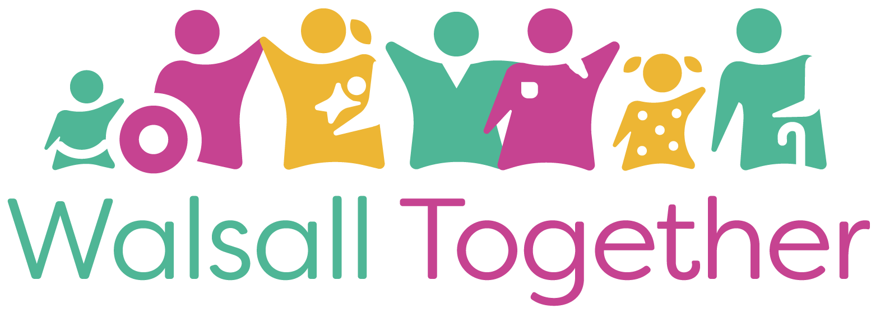
Public Trust Board – 6th May 2021 Item 18, Appendix 1

Walsall Together Partnership Operational Update: April 2021
Daren Fradgley
Director of Integration / Deputy CEO

Reporting Structured around WT Tiers
- Tier 0: Resilient Communities

Tier 1: Integrated Primary, Long Term Conditions Management, Social & Community Services

- Tier 2: Specialist Community Services

Tier 3: Intermediate Care, Unplanned Care & Crisis Services

- Tier 4: Acute Hospital Services

Tier 0: Resilient Communities

Social Prescribing
ü The SP evaluation has been commissioned by whg and is being completed by HACT ( Housing Association Charities Trust ) . HACT have now begun to contact key stakeholders . We expect the evaluation to be completed over a 9-12 month period with a view to presenting the findings in March 2022. Colleagues from WT maybe asked to contribute to this piece of work .
ü The SP programme is currently working with a gentleman aged 59 . Prior to the LW involvement this resident was isolated at home caring for his sister who has complex health needs and disabilities . He was referred by whg’s housing team who were concerned about his isolation . Initially he was very distrustful and reluctant to engage with the programme . Using Motivational Interviewing Techniques and Coaching conversation skills the SPLW developed a positive relationship beginning with ‘informal’ chats which helped him to relax and build the trust required to open up and tell us his wants and needs .
ü This gentleman is impacted by the wider determinants of health . He lives in a disadvantaged community , is long term UE , is impacted by poverty and lacks the confidence and skills to self help .He and his sister are very reliant on clinical services and medication relying on the health service to make things better .
ü The LW provided practical help and guidance around his income and benefits , this immediately reduced anxiety and stress enabling him to focus upon other things . He developed a 6 month plan which included taking part in social activities away from his caring responsibilities , walk and talk activities and arts and crafts . 12 weeks into the programme this gentleman has a different mindset he is positive and hopeful . He is currently keen to gain work experience and has begun to believe he can get more out of life . We think he can !

Tier 0: Walsall’s Voluntary & Community Sector – One Walsall
- Volunteering Supporting the System
- Registered Volunteers supporting Vaccine and LFT sites is up to 658 as we continue to work with the Work force Bureau. This provides the statutory sector with confidence that there will be a continued stream of volunteers over the coming spring and summer months. 30 volunteers for other covid related roles have supported a number of VCSE organisations, including befriending services, foodbanks and CAB.
- Mental Health Support
- Early discussion taking place with Walsall Public Health around commissioning extended mental health support from the sector from organisations who can support with specialist early intervention approaches, thus helping to reduce statutory waiting times and inappropriate referrals.
- Further work emerging from Mental Health Cell around financial advice and support for residents from the sector as well as bereavement and social support for residents (all of which will be relayed to the Communications Cell).
- OW Partnership Manager is currently working with 3 mental health organisations – who would never have considered working in partnership previously – but who see both the need and benefit of collaborative working.
- Support to Sustain VCSE Capacity for Referral
- £277,000 secured for community groups this quarter (bringing total for year to £806,000) with a further £288,013 pending bid decisions.
- Funders are now shifting focus from covid related projects to funds available for more familiar community projects, most of which provide opportunities to increase resilience and offer support to residents such as community gardens, peer support etc.
- Continued work around digital inclusion curating a range of digital tools (many of which are free) that we can promote to the wider sector that will enhance the work of the sector to support residents moving forward.

Tier 0: whg Resilient Communities
Workforce Development
  - whg's internal Employment and Training Team continue to work with Walsall
Manor Hospital supporting local residents to apply for Health Care Assistant posts . This contributes to Resilient Communities therefore reducing health inequalities which are driven by social and economic factors .
  - We are really pleased to report that as a direct result of the partnership work within WT a total of 29 unemployed residents have been appointed as clinical support workers within the Manor Hospital . This group have long standing barriers to work with some recently losing their job due to the pandemic . There is clear evidence that recruiting local people for local jobs contributes to a more stable workforce therefore reducing organisational costs . Importantly these jobs have provided disadvantaged residents with a career pathway within health and social care .
  - Reducing unemployment is a significant objective within the Resilient Communities programme . This is therefore a great outcome for the individual , the organisation and the wider community .

Tier 0: whg

Experts By Lived Experience customer voice .
To ensure health services represent local peoples aspirations and needs we are continuing to encourage local residents to work with colleagues from the CCG . This emerging work will influence the development of a broader engagement framework which can be used to contribute to the co- design of health services in the future . We now have a schedule of regular meetings to keep the conversation flowing !
In addition we are encouraging this small group of residents to ‘recruit’ other local people to join
patient forums which are led by Healthwatch .

Tier 1:
Community Nursing Capacity and Demand: In March 2021, Community Services delivered more hours and cancelled less hours of activity than before Covid
- Absence levels within Community Services overall reduced during April, but pressures remained in two areas: therapy services staffing and demand within Phlebotomy

- Proxy indicators of demand (hours delivered + cancelled) remain higher than pre-Covid

Hours Delivered

16000

14000
12000
10000
8000
6000
4000
2000
0

2019
2020
2021

1400
1200
1000
800
600
400
200
0

Hours Cancelled

2019
2020
2021

Care and support assessments and 3 conversations incoming/in progress as at snapshot date
120 Adult Intermediate Care Services
101
43
42
41
1
47
50
68

100
Adult Social Care Access Team Tier Two

Adult Social Care East Locality Team
80

Adult Social Care Learning Disabilities and Transitions Team
60
Adult Social Care Mental Health Team

40 Adult Social Care North Locality Team

20 Adult Social Care South Locality Team

0
3/31/2021
Adult Social Care West Locality Team

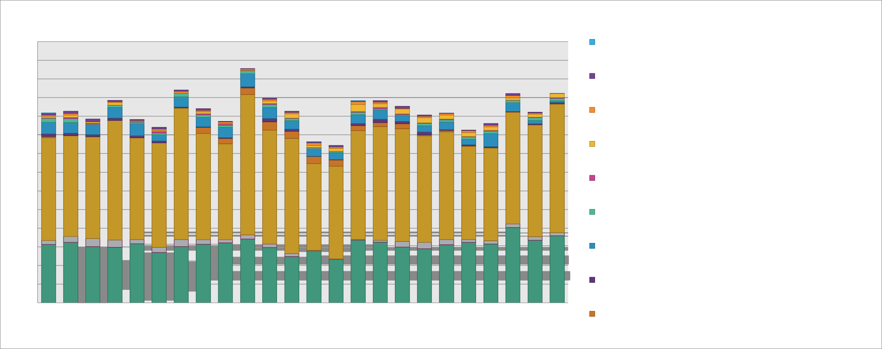

1400
1300
1200
1100
1000
900
800
700
600
500
400
300
200
100
0

Monthly Adult Contacts Completed by Team
Visual Impairment Team

Adult Social Care West Locality Team Adult Social Care West Locality Team Total
Adult Social Care South Locality Team Adult Social Care South Locality Team Total
Adult Social Care North Locality Team Adult Social Care North Locality Team Total
Adult Social Care Mental Health Team Adult Social Care Mental Health Team Total
Adult Social Care Learning Disabilities and Transitions Team Adult Social Care Learning Disabilities and Transitions Team Total
Adult Social Care Emergency Response Service Adult
Social Care Emergency Response Service Total

Adult Social Care East Locality Team Adult Social Care East Locality Team Total
Adult Social Care Access Team Tier Two

400

350
Care and Support Assessments and 3 Conversations Completed - Total

Adult Social Care West Locality Team Adult Social Care West Locality Team Total

Adult Social Care South Locality Team Adult Social Care South Locality Team Total

300 Adult Social Care North Locality Team*

250

200

150

Adult Social Care Mental Health Team Adult Social Care Mental Health Team Total

Adult Social Care Learning Disabilities and Transitions Team Adult Social Care Learning Disabilities and Transitions Team Total

Adult Social Care East Locality Team Adult Social Care East Locality
100 Team Total

50 Adult Social Care Access Team Tier Two

0 Adult Intermediate Care Services

250

200

150

100

50

0

Initial and Subsequent Review Outcomes
Sum of Long Term
206

112
37
3
2 3
11 11 1
2
Date | Sum of Total Initial and Subsequent Reviews Completed
Feb-21 | 334
Mar-21 | 388

Support - Decreased

Sum of Long Term Support - Ended

Sum of Long Term
Support - Increased

Sum of Long Term
Support - No Change

Mar-21
Initial and Subsequent Reviews Completed by Teams
100
82
84
80
63
Sum of Adult Intermediate Care Services
60
44 45
40
31
39
Sum of Adult Social Care Access Team Tier Two
20

0
0
Sum of Adult Social Care East Locality Team
Mar-21
Following the pressures reported in earlier months, the teams completed more reviews in March than in previous months

Tier 2:
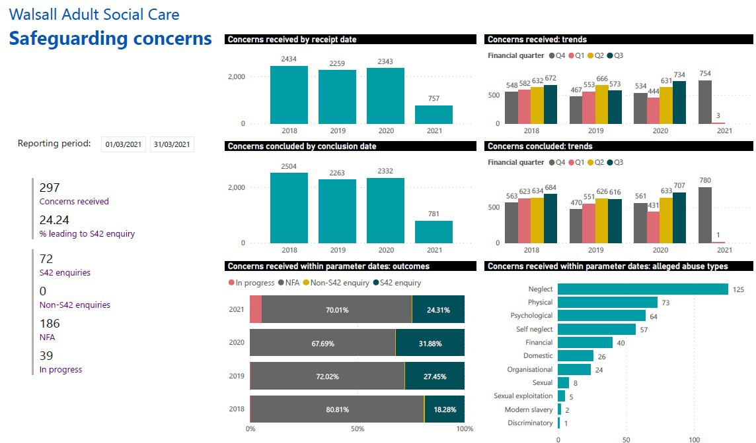
Adult Social Care

ASC have received 297 concerns in
March which is an increase on concerns for February 2021 which were 241.

The number of cases progressing to a s42 enquiry is slightly higher for March with
72 noting Feb was 61.

Safeguarding cases in progress has significantly increased from 17 to 39. There is no direct correlation to covid as people are now less restricted.

Neglect & Physical abuse remain the two highest categories of alleged abuse.

We have recently focussed upon those people who are subject to a safeguarding plan to provide assurance that all plans remain necessary.

Tier 2:

Care Homes Update
- There has been a continued decrease in deaths, the last reported Covid death was 28.02.21.
- There are currently no homes flagged as having an infection. There are no Covid residents outside of the discharge setting. There is only one Covid positive staff member.
- Bed Based providers are eligible for a further central government grant called the Infection Control and Testing Fund. Which runs the first quarter of this year. The fund is separated into two allocations – infection control and rapid testing.
- Residential occupancy hovers over 70%.
- Ongoing question about future viability of some providers.
- Staff absenteeism following a high of 10.98% at the end of January continued to decline to 5.24% where it has plateaued.
- At the end of February 93.45% of residents had received their first dose of the Covid vaccine. For staff members the percentage was 79.37%.
  - A new bed based provider has joined the market. Jaytee Care Demi House – 3 beds.

Care Homes Update

As per 07/04/2021:
•1258 residents
•436 vacancies
•2 homes with positive cases
•14 closed to admissions
•43 open to admissions

Fatality data from 01/04/20 to date
Provider | Covid-19 - Confirmed or suspected  Deaths | Non Covid 19 related since 1st of April  2020
1 | 1 | 74
2 | 6 | 54
3 | 18 | 12
4 | 17 | 12
5 | 13 | 16
6 | 17 | 7
7 | 10 | 14
8 | 5 | 17
9 | 13 | 7
10 | 6 | 9

Care Navigation Centre: Hours of availability have increased (November 2020) with highest number of calls recorded in January 2021
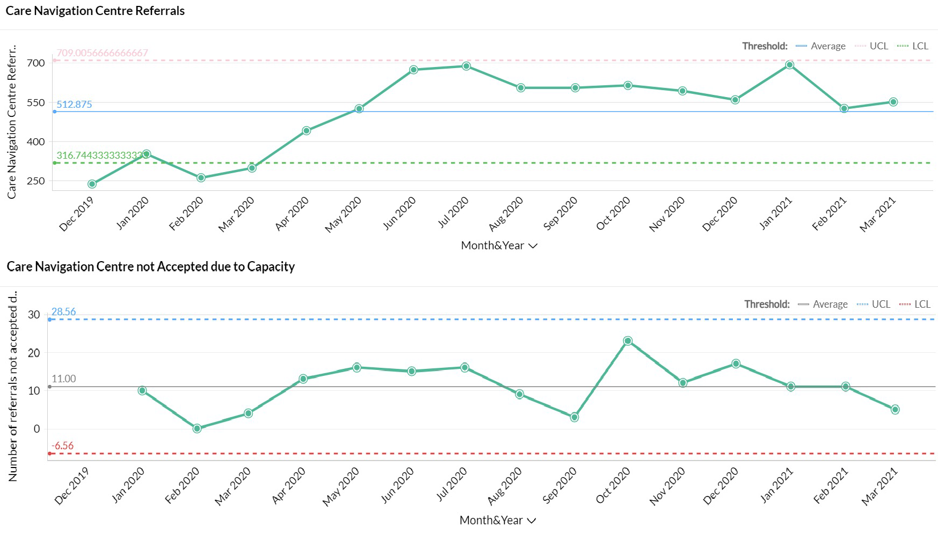
    - The volume of calls to the CNC continues to be high
    - The CNC continue to support new services such as screening for long covid and escalation to the MDT through a step down referral and triage via our local hospital, these numbers are not included in these figures.
    - The Safe at Home pathway continues as step down again from our local
hospital resulting in 73 patients been monitored at its peak, 221 referrals have been accepted to date (31st March). On 22nd March the pathway was opened up to step up from GP's. 7th April status is 3 patients on the pathway.

Tier 3: Rapid Response

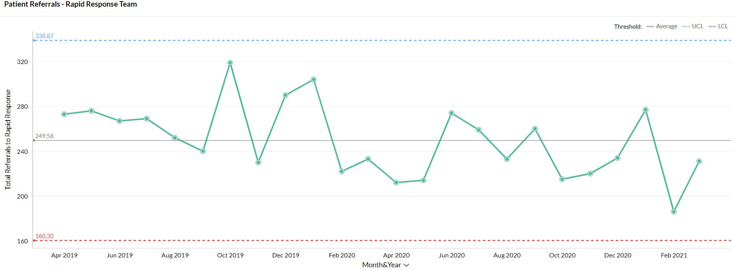
The pattern of demand is changing [impact of CNC]
Referrals into Rapid Response remain volatile and this needs to be viewed alongside the growing ability of the Care Navigation Centre to triage referrals into other services as well as the development of the enhanced care model into residential
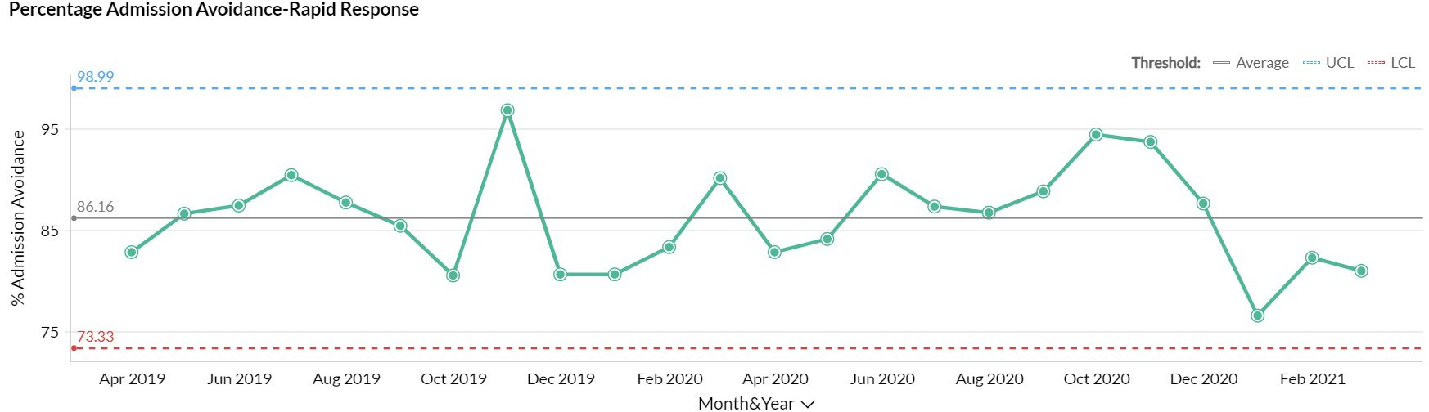
homes. Recruitment is underway to extend operational hours for Rapid Response until midnight, expectation is to be operational 1st July 2021

Rapid Response is now visible to NHS111 and WMAS as a direct referral / call disposal route

Tier 3: Medically Stable for Discharge (MSFD): numbers remain low
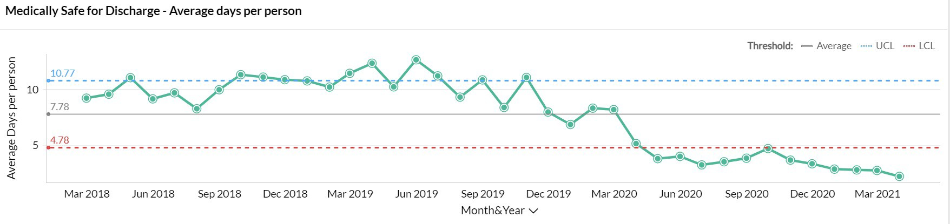
- The number of MSFD patients was at its lowest level ever during March 2021
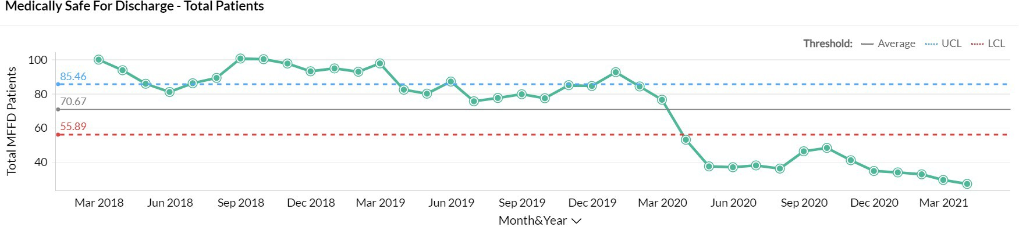
- As notified last month, a review of ICS is planned during Q1 2021/22 as the flow through ICS community pathways will need to be accelerated in order to meet demand within the commissioned capacity. The review will be led by the new ICS commissioner who was due to start on 12/04/21.
- The risks associated with this were reviewed at the WT SMT on 09/04/21 and the funding options are to be considered by the Joint Commissioning Group

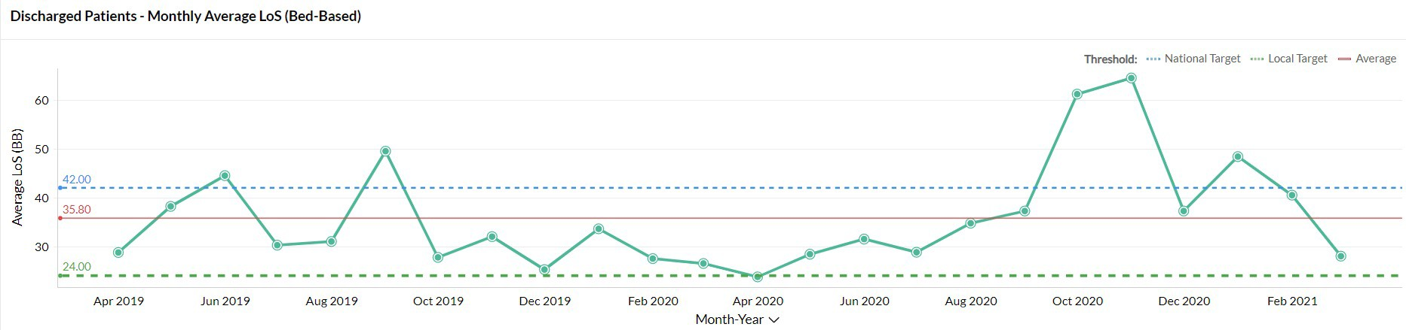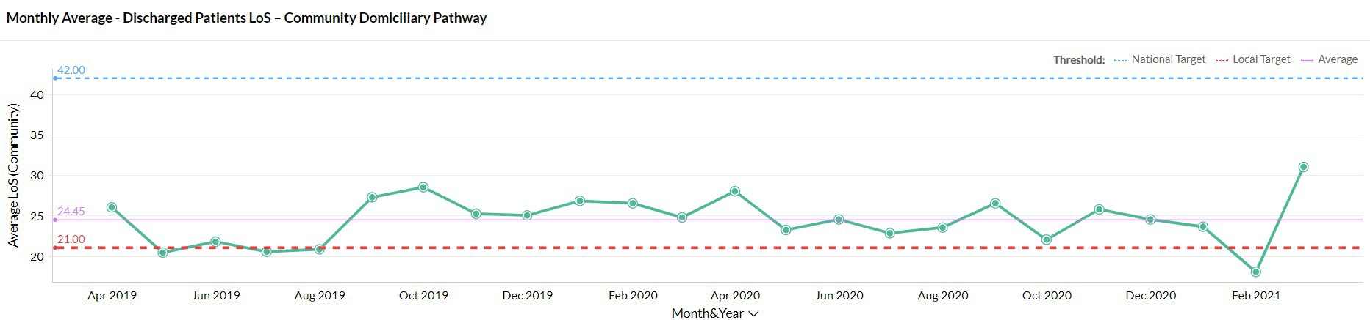Tier 3: Domiciliary and Bed-Based Pathways

LoS has increased in the community pathways:
- There were a number of patients from the NWB pathway that transferred onto Re ablement for care & support and then exited in March
- There were some therapy delays in terms of reviewing individuals once on the pathway
- Due to Covid, individuals have been more unwell and therefore have needed rehab/Reablement for a longer period of time
- Some of these individuals will have been in a bad based provision to start with and then transferred onto the community pathway.

Tier 3/4:
Integrated Assessment Hub: Integrated Assessment

Recruitment is still in progress with a view to moving to a 7 day service in April 2021.

 | Jan 21 | Feb 21 | Mar 21
Hospital  Avoidance | 29 | 29 | 41
Early supported Discharge | 73 | 82 | 55
Assisted Discharge | 39 | 52 | 83
Hub
- Hospital Avoidance: This IAH pathway enables people directly contacting the Frail Elderly Service or Ambulatory Care at the Manor with post-discharge complications to be seen by Rapid Response, Enhanced Care Home Support Team or IV team instead and receive a community-based assessment & clinical review, thereby avoiding conveyance to hospital. The numbers of people accessing this pathway increased in March
- Early Supported Discharge: Patients who have been identified in ED, assessment units & wards are discharged into a community service (including DVTs from ambulatory). While the numbers dropped in March further work is required to understand whether this reflects the growth in use of the Hospital Avoidance & Assisted Discharge Pathways
- Assisted Discharge: IAH team signpost / support wards with navigating discharge
Walsall Together | Collaborating for happier communities
same / ₁₉
result in a discharge
h
pathways whic

Latest Board/Committee – 06/05/21 Version V0.02
Public Trust Board – 6th May 2021 Item 18, Appendix 2

Risk Summary
BAF Strategic Objective Reference & Summary Tile: | BAF SO 02 - Care at Home; We will work with partners in addressing health inequalities and delivering care closer to home through integration as the host of Walsall together.
Risk Description: | Failure to work with partners and communities to understand population health and inequalities, integrate place-based services and deliver them through a whole population approach would result in a continuation of poor health and wellbeing and widening of health inequalities.
Lead Director: | Director of Integration.
Lead Committee: | Walsall Together Partnership Board.
Links to Corporate Risk Register: | Title: |  |  |  |  |  |  | Current Risk Score Movement:
 | - Risks in this area relate to Walsall Together programme risks. The biggest ones are associated with the limited investment and the size and complexity of the population health challenges.  - Non-programme risks relating to Community Services at the current time. These are updated through the divisional structure.  - Each organisation retains its own risk log although the section 75 presents the opportunity to start to bring the logs together.  - Risks associated with creating an ICP contract will be considered through a formal due diligence process, supported by NHSE/E.  - Operational capacity due to a increase in community prevalence of Covid since December 2020. |  |  |  |  |  |  | ↓
Risk Scoring
Quarter: | Q1 (2021) | Q2 | Q3 | Q4 (2020) | Rational for Risk Level: | Target Risk Level (Risk Appetite): |  | Target Date:
Likelihood: | 3 | 3 | 4 | 3 | - The increased operational pressures due to Covid wave 2 have started to abate and business continuity measures are being stood down in many areas of Community Services as capacity is better able to meet demand.  - The slow-down in some elements of functional transformation that this engendered are now being addressed through the relaunch of both the Walsall Together Senior Management Team and the Clinical Professional Leadership Group meetings.  - Strongly established relationship with 50% of General Practice on robust vaccine delivery. Other practices chose not to connect with partnership and deploy alone.  - Vaccine delivery with operational teams mainly in primary care and latterly around the Saddlers | Likelihood: | 2 | 30 June 2021
Consequence: | 3 | 3 | 4 | 4 |  | Consequence: | 4
Risk Level: | 12  Moderate | 12  Moderate | 16  High | 12  Moderate |  | Risk Level: | 8  Moderate
Page 1 of 4

Centre retains the potential to dilute focus on core delivery items and to increase system pressure.
- Maturing place-based teams in all areas of Walsall on physical health and Social Care. Additional integration required for Mental Health with IAPT and primary care but not established yet.
- Significant maturity in communications and confidence in Walsall Together.
- Advancing maturity in performance data - Work now commenced on aligned quality governance.
- Risk Stratification process for COVID developed with partners which demonstrates the evolving maturity of the partnership.
- Substantial improvements in medically stable for discharge before and during Covid 19.
- Virtual clinics and community outpatients maturing and triage and referral services now in place.
- Partnership approach to managing care home support and intervention
- Strong evidence base being establish for ICP due diligence.
Control & Assurance Framework - 3 Lines of Defence
 | 1st Line of Defence |  |  |  | 2nd Line of Defence | 3rd Line of Defence
Controls: | - Executive Director in post  - Non-Executive Director appointed  - Partnership Board/Groups and meetings in place.  - Business Case developed.  - PMO/Project in place and reporting.  - Operational coordination and twice daily battle rhythm in place.  - Covid Vaccine response plan in place with 50% of primary care. |  |  |  | - Alliance agreement signed by Partners.  - Governance structure in place and working.  - S75 in place and operational practices now maturing.  - Integration of performance data across the partnership is being progressed and reported to the Walsall Together Committee.  - Business case approved by all partners.  - Monthly report to Board and partner  organisations. | - External assessment - CQC/Audit.  - STP Scrutiny.  - Health and Wellbeing Board Reporting.  - Overview and Scrutiny Committee.
Gaps in Controls: | - No strategic finance plan for investment across the partnership which potentially impacts on the delivery notwithstanding the recent investment from the Trust. This has been mitigated short term with Covid funding, but further work required to establish ongoing formal mechanisms through ICP contracts.  - Commissioner contracts not yet aligned to Walsall Together although ICP planning will resolve this issue.  - Data needs further aligning to project a common information picture.  - Effective engagement with community in development with local groups limited due to Covid social restrictions.  - Organisational development for wider integrated working not yet outlined or agreed and delayed due to Covid.

 |  | - Enactment of section 75 in terms of Monitoring meetings.
Assurance: |  | - Divisional quality board now starting to look at the integrated team response.  - Risk management established at a programme level and a service level integrating risks. | - Walsall Together included on Internal Audit Programme.  - Walsall Together Committee in place overseeing assurance of the partnership.  - STP oversight of ‘PLACE’ based model.  - Reporting to Board and Partners.  - Oversight on service change from other committees.  - ICP due diligence underway. |  |  | - NHSE/I support of Walsall Together.  - STP support.  - NHSE/I validation of ICP due diligence.
Gaps in Assurance: |  | - Limited in overall external assurance as regulators inspect individual organisations and as yet have not developed ‘PLACE’ based inspections although Walsall Together put forward as part of ICP development  - For Community services and ACS within the Section 75 there is direct accountability to WT / WHT; these formal arrangements do not cover other partners hence limited accountability for delivery of Walsall Together strategic aims
Future Opportunities
- Further development of the Governance around risk sharing.
- S75 Deployment based on other services relating to health prevention and public health commissions.
- PCN partnership alignment and risk share with building trust and confidence.
- Covid-19 offers an opportunity to increase the pace of delivery and more importantly stress test benefits before substantive deployment.
- Strategic partnership(s) with major primary care organisations to further accelerate vertical and horizontal integration of care in the borough.
- Formal contract through an ICP mechanism.
- Formal working with other partners to support their ability to achieve additional income and support via a partnership approach.
- CQC action oversight group.
Future Risks
- Insufficient promotion of success narrative.
- Inability to deliver enough investment up front to change demand flows in the system.
- Changes to commissioner & provider environment / landscape within the Black Country may change mechanisms for resourcing and resolution of service issues
- Mechanisms for gaining and sustaining resources to support strategic aims for 2021/22+ are unclear
- National influences on constitutional targets moves focus from place to ICS.
- Retention of inspirational and committed leadership across partners.
- Estates - ability to fund the full business case offering (4 Health & Wellbeing Centres).
- Misalignment of provider strategies created by mergers or form changes or senior personnel turnover.
- Lack of uninterrupted community clinic space due to Covid Restrictions.
- Programme Resource - Capacity to deliver the WT programme will become more difficult as the same resource will be required to support the delivery of COVID-19 work
streams, e.g. mass swabbing, flu vaccination programme, Covid-19 vaccination programme, outbreak management and the covid-19 management Service (CMS).
Future Actions (to further reduce the Likelihood / Consequence of the risk in order to achieve the Target Risk Level in line with the Risk Appetite)
No. | Action Required: |  | Executive Lead: | Due Date: | Progress Report: |  | BRAG:
1. | Agree & implement joint service development opportunities between Walsall Together and PCNs that foster improved |  | Director of Integration | July 21 | Work has started on revised recruitment and management arrangements for roles such as First

 | delivery of care through more integrated working |  |  | Contact Practitioners and Pharmacists. Further opportunities are being identified
2. | Refresh strategic case for Resilient Communities, ensuring appropriate focus on reducing health inequalities and alignment of strategic objectives across partner organisations. | Director of Integration | July 21 | The Resilient Communities work stream has held three sessions  The work stream has presented to WTPB (March 2021) the following next steps:  - Discussion at the CPLG to confirm the local population challenges that we want to address, aligning to population health management and inequalities priorities for the partnership  - Establishment of the Steering group including confirmation of membership and a Terms of Reference  - Review of the multiple strands of work pertaining to citizen and communities engagement to create a single, defined approach  - Review of the full proposal  to Changing Futures and proposal for how some or all of the elements can be taken forward without the external investment
3. | Develop population health management strategy across Walsall Together and PCNs including the deployment of the population health module (Digital work stream). | Director of Integration | July 21 | This work is underway with the support of the STP Academy and Public health. The Population Health module as part of the Medway deployment is also in our test environment. The final strategy is  interdependent with the production of the Health & Well Being strategy which is focused on the end of Q2
4. | Develop robust governance and legal frameworks for Walsall Together with devolved responsibility within the host (WHT) structure. This should include an outline governance structure that shows the links to other WHT committees and acknowledge the transition to holding a formal ICP contract. | Director of Governance | July 21 | This work is on track as part of the ICP programme
6. | Prepare for implementation of a formal ICP contract under a Lead Provider model with WHT as Lead Provider. This will include confirmation of all services in scope and a clear rationale for the change in the context of improving outcomes for the population. | Director of Integration | July 21 | On track and formally reported to WTPB monthly

ICP Roadmap
Updated: 01/04/21

ICP Roadmap
co n ps.
Preparation for ICP contract and new legislation implications at Place level including population- based funding approach and potential transfer of CCG/ICS functions

APRIL 22
In scope services for Walsall Healthcare, Black Country Healthcare and Walsall Council (via section 75) will operate under a single ICP contract
mes into
of ICS Health & Abolition of
New legislation effect. Formatio Care Partnershi CCGs
Develop Integration Agreement with Primary Care Networks

During 2021/22 financial year, significant engagement across all partners and our citizens and communities to develop a 3-year Population Health & Inequalities Strategy, aligned to the Health & Well Being Board

Agreement in principle to work with Primary Care Networks, alignment of community services to the identified priorities for each PCN
COMPLETE
streams to
n to formal ICP S legislation
alth visiting

ord
NHSEI assurance process Self-assessment against Transaction Guidance
Section 75
School nursing/he Therapies
Shared care rec
Established work support transitio contract and IC
ommunity, nd mental
teams, co- ving single GPs
c a sed ei m
Integrated adult adult social care health place-ba located and rec referral forms fro
rtnership governance Alliance
Pa st nd
Walsall Together launch under Ho arrangements a Agreement
Strategy development:
- Resilient Communities and wider Engagement Model
- Personalised Care
Care White Paper ing legislative egrated care
Health & Social published outlin changes for int
April 21

Potential transfer of some CCG
functions for in scope services
Finalise Outcomes Framework and local quality standards for inclusion in the ICP contract

Strategy development:
- Population Health and Inequalities (1-year)
- People Plan

Q1 2021/22
Q2 2021/22

Refresh governance, legal and risk management frameworks for the partnership including a new Alliance Agreement
Finalise scope of services including provision of
- mental health (primary mental health, IAPT, PCN ARRS and FSM)
- Non-electives (ACS v SDEC)
- Any Qualified Providers
- Enhanced services
Mobilisation of services coming into scope in April 21
(outpatients, children’s and
maternity services)

Walsall Healthcare contact split into 2 schedules (acute and community)

Plan for deployment of a Living Directory – an ongoing, up-to- date directory of activities, the organisations involved in providing them and the community facilities and resources used to support them

Due diligence including financial risk assessment, following confirmation of total services in scope, and CQC well-led self- assessment
CURRENT | APRIL 21 | JUNE 21 | APRIL 22
In scope value up to £130m | Additional in scope value up to £xxm | Additional in scope value up to £1.1m | Additional in scope value up to £128m
Alliance Agreement and s.75 | WHT acute/  community split | Shadow ICP | ICP Contract and new legislation

Walsall Together | Collaborating for happier communities
2

Agenda Item 20 Maternity Unit – Staff Story

Please follow the link and view the staff story ahead of the Board meeting: https://youtu.be/1ipH9gw-HVE

MEETING OF THE PUBLIC TRUST BOARD – 6th May 2021
People and Organisational Development Committee (PODC) Highlight Report |  |  | AGENDA ITEM: 20
Report Author and Job Title: | Trish Mills Trust Secretary | Responsible Director: | Junior Hemans (Non- Executive Director and Chair)
Action Required | Approve ☐ Discuss ☐ Inform ☒ Assure ☒
Executive Summary | The report provides the key messages from the People and Organisational Committee meeting on 29th April 2021. Of note are:  - The Committee was assured that the immediate actions to address staff concerns following the Health Education England (HEE) inspection on 1st April have been taken. These related to interdisciplinary friction, workload, educational opportunities, handover, access to clinics, availability of support and advocacy for the training posts, and are being addressed in an action plan, which is due to be presented to HEE no later than 21st May. The Medical Director will take direct oversight of the delivery of these actions.  - The Committee reviewed progress against the 7 areas of focus for the disciplinary policy outlined by Baroness Harding in her letter to CEO’s and Trust Boards in May 2019, with one areas of partial assurance remaining, from two in March. This relates to training which will commence with a first cohort of staff in May and assurance on which will be closed in September. The Committee were assured as to the mechanisms in place by which data on investigations and disciplinary procedures is collated, recorded and regularly and openly reported at Board level. This will take the form of the ‘colleague in difficulty report’ and employee relations dashboard reported quarterly. The Committee approved a disciplinary policy statement of intent.  - The Committee plans to hear from all divisions/departments over the coming months to take a more detailed look at their staff survey results. Will Roberts from the division of surgery and Kelly Geffin from the community division joined the April meeting, sharing their survey results, team reflections, and action plans.  The Committee was assured that divisions are sharing

approaches that have led to good results so they can be replicated throughout the Trust.
- The Equality, Diversity and Inclusion Strategy is before the Board for this meeting, and is endorsed by the Committee. The objectives for the coming year were approved, and the next meeting will look at the assurance reporting and the role of the Equality, Diversity and Inclusion Group in providing exception reporting. The Committee commended the team for an excellent strategy and emphasises the importance of the strategy and its implementation being owned by all staff, with accountability for results embedded at all levels.
- The Committee were assured that good progress has been made appointing to the vacancies in the therapies service with 8 appointment made in month, including the appointment of an Allied Health Professional Director to lead the service. In addition to recruitment, the team are also profiling roles and redesigning the service. The Committee will see the outputs and outcome measures of that approach in future meetings, noting that reporting will also be to the Quality, Patient Experience and Safety Committee and the Walsall Together Partnership Board.
Recommendation | Members of the Trust Board are asked to note the report and the escalations for its attention.
Risk in the BAF or Trust Risk Register | BAF S04 – Culture (lack of an Inclusive and open culture impacts on staff morale, staff engagement, staff recruitment, retention and patient care)
Resource implications | There are no new resource implications associated with this report.
Legal, Equality and Diversity implications | This Committee supports the Trust’s approach to delivering equality, diversity and inclusion for the benefit of the patient population and staff who work for the Trust and who live in Walsall. .
Strategic Objectives | Safe, high quality care ☐ | Care at home ☐
 | Partners ☐ | Value colleagues ☒
 | Resources ☐

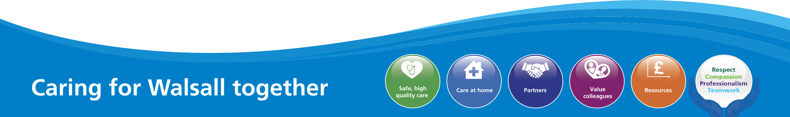

MEETING OF THE PUBLIC TRUST BOARD – 6th May 2021
Value our Colleagues – Executive Update |  |  | AGENDA ITEM: 21
Report Author and Job Title: | Catherine Griffiths – Director of People and Culture | Responsible Director: | Catherine Griffiths – Director of People and Culture
Action Required | Approve ☐ Discuss ☐ Inform ☒ Assure ☒  This report provides an update on actions taken last month relating to the Value Our Colleagues work-stream of the improvement programme. The following points seek to inform the Trust Board of progress, identify where assurance can be taken and where required to seek approval for actions proposed.  - The People and Organisation Development Committee approved the improvement trajectory for Value our Colleagues at their March meeting and this has been updated to include the Workforce Disability Equality Standard (WDES) indicators this is attached at appendix one. The committee received an assurance report on the Trust Board Pledge. This identifies the action areas following the National Staff Survey indicators of concern relating to discrimination and bullying and harassment. The metrics for good and outstanding performance have been set in reference to best performance in national data including Model Hospital and the National Staff Survey indicators. The peer support from the Royal Wolverhampton Trust will provide additional assurance on culture, behaviours and leadership and ensure action is taken to accelerate the improvement planned and to identify additional action and capacity required.  - The Trust Board can be assured that the plans for risk management have been reviewed by the People and Organisation Development committee. There is a gap between risk appetite and the level of risk identified within the BAF (Board Assurance Framework). The workforce metric report received at the People and Organisation Development Committee demonstrates improvement in a number of workforce metrics: statutory and mandatory compliance Trust-wide,  reached Trust target of 90% in month, this is in advance of recovery

plan which was end June 2021. The workforce vaccination programme has administered first dose to 85% of the substantive workforce and 54% second dose. Attendance at work remains on a stable improvement trajectory, the sickness absence levels in month was 4.06% against target of 4.5%. The improvement target for 2021- 2022 is to reach 3.5% by year end. The completion rates for appraisal and PDR requires improvement to meet Trust target of 90%, currently at 80%, recovery planning continues.

- The improvement programme foundation activity for 2020-2021 is complete, the People and Organisation Committee noted that all milestones planned have remained on target. A major milestone has been reached in finalising the Equality Diversity and Inclusion Strategy, which sets specific and time limited outcomes for Equality within the trust, the strategy is on today’s agenda for approval. The strategy has been co-designed with networks including patient groups, community, staff networks, staff-side and managers, it is a crucial strategy, supported by a targeted action plan to improve staff experience and to tackle and eliminate discrimination. The joint work with the Royal Wolverhampton Trust on adopting the Race Code will provide further governance for assurance on achieving race equality outcomes; the approach provides a framework for equality across other protected characteristics.

- The first Schwartz Round took place in the Trust on 29th April 2021 with a panel from the Critical Care Team sharing insights and experiences from “a year we will never forget”. The Health and Wellbeing walks started this month, these visits have been extended to non-executive colleagues and the programme of Board Walks within the trust has been refreshed. This month Project Wingman in Flight started up with airline style first class lounge hospitality delivered directly to front-line areas. The installation of eight outdoor Igloos completed this month, providing a space away from the front line for colleagues to take rest breaks. The Haven is an established place for support and reflection; the health and wellbeing team provide mindfulness and health and wellbeing support on a one to one basis. Extended opening will be put in place from May the Haven is now both open and staffed at weekends and evenings, this is an opportunity to place formal thanks on record to staff-side for their sponsorship of the Haven, they provide supplies of drinks and snacks
and personal support to the Haven on a regular and ongoing basis.

The Key Workers on Canvas project initiated this month, it brings together key workers across Walsall communities with local artists to capture the human contribution made and ongoing during the pandemic.

- The Staff Engagement and Experience Oversight Task Group completed the actions agreed at its first meetings which took place in March and April. The Pulse Survey was agreed at the People and Organisation Development Committee and will go live in May 2021, The People and Organisation Development Committee completed a ‘deep dive’ with the Community Directorate and Surgery Directorate to share good practice for learning and to share actions for improvement for areas requiring improvement. The schedule for learning from best practice trusts and best practice sectors is complete and a series of events and workshops arranged to learn from good practice.

- The first draft of the Operational Plan is complete. The Board can take positive assurances arising from work on workforce supply. The vacancy position for Healthcare Support Workers within the trust has reached zero vacancy as planned by the end of March 2021. The International recruitment programme led by the Royal Wolverhampton Trust will (subject to travel restrictions) bring the registered nursing vacancy level to a no vacancy position by October 2021. The trust is currently an outlier for use of agency on the Model Hospital and this is flagged as an opportunity for improvement, the trust operational plan sets the trust to reach a zero agency position by end of October 2021. There is focused work taking place with targeted recruitment in partnership with walsall housing group (whg) to close the vacancy gap for the housekeeping and porter support service within Estates and Facilities. The Trust met with partners including the West Midlands Combined Authority to further develop the thinking relating to anchor institution for employment, procurement and closing the health inequalities evident pre and post pandemic.
Executive Summary | This report provides an overview of the risks to delivery for the Value Our Colleagues’ strategic objective and provides an update on the mitigations in place to manage the risks identified, as well as the actions identified to  address gaps in controls and assurance. It provides the Trust Board with

assurance relating to the improvement programme Value Our Colleagues work-stream and performance against the Value Our Colleagues strategic objective, this report highlights successes and identifies assurance gaps
and areas for improvement.
Recommendation | - Members of the Trust Board are asked to note and approve the plans for workforce supply to reach zero agency position for registered nurses by end October 2021, subject to international travel conditions.  - Members of the Trust Board are asked to note and approve the improvement trajectory for staff experience metrics at appendix one.  - Members of the Trust Board are asked to note the update from the Oversight Group on staff engagement and experience and to note the work of the divisions on action planning.  - Members of the Trust Board are asked to approve the Equality, Diversity and Inclusion Strategy and action plan. The Board are asked to endorse the co-production approach and note the joint work with Royal Wolverhampton Trust on the Race Code.
Does this report mitigate risk included in the BAF or Trust Risk Registers? please outline | This report addresses BAF Risk SO4 to provide positive assurance the mitigations in place to manage this risk and the related corporate risks.
Resource implications | There are resource implications that flow from recommendations in the report. In the short-term the resource requirements are being met from base budgets. The improvement programme and OD approach will require investment beyond the base budget in order to achieve the milestones and progress envisaged by 2022. The investment case will be considered through trust governance including People and Organisation Development Committee, Performance Finance and Investment Committee and Quality Patient Experience and Safety Committee before further recommendation to Trust Board.

Legal and Equality and Diversity implications | There are significant issues relating to equality arising from matters addressed in the report. The Trust Board has been presented with the evidence base for differential staff experience based on ethnicity, disability, age, sexuality, gender, religion and other protected characteristics.
 | This goes to the heart of both the Trust Board pledge and the Trust values and supporting behaviours. The improvement programme seeks to mitigate the risk on the BAF, noting the low baseline and the considerable challenge of achieving outstanding performance across the metrics by 2022. In addition the valuing our colleagues work-stream seeks to ensure the systems the Trust relies upon can delivery equality of outcome relating to career progression, development, promotion, talent management and recruitment such that the workforce is representative of the communities it serves and can be seen as an anchor institution within Walsall.
 | The leadership and management development programmes both focus on equality outcomes and developing skills and understanding of an inclusive leadership approach, whilst leading for performance improvement in a compassionate framework that supports a just and learning culture.
Strategic Objectives | Safe, high quality care ☐ | Care at home ☐
 | Partners ☐ | Value colleagues ☒
 | Resources ☐

Value Our Colleagues – Improvement Programme

- EXECUTIVE SUMMARY

The Trust Board made a pledge relating to Value Our Colleagues as follows:

“We the Trust Board, pledge to demonstrate through our actions that we listen and support people. We will ensure that the organisation treats people equally, fairly and inclusively with zero tolerance of bullying. We uphold and role-model the Trust values chosen by you”

The evidence available demonstrates that the pledge is not met consistently across the Trust. There are areas of good practice from which we need to learn; equally there are areas of poor and discriminatory practice which run counter to the trust values and which are persistent in some areas. The cultural heat maps set out the qualitative metrics measuring staff experience and the degree to which the pledge is achieved by department level.

The purpose of the Value Our Colleagues enabling work-stream of the improvement programme is to deliver workforce improvement so colleagues recommend the Trust as a place to work and as a place to be treated. Colleague experience has a direct correlation with patient experience and outcomes.

The focus on developing leaders and managers to role model the behaviours and values of the trust is a critical lever to change the direction of travel and to appreciate and build on good practice, learn from it and embed it elsewhere. The peer support from the Royal Wolverhampton Trust will provide additional assurance on culture, behaviours and leadership and ensure action is taken to accelerate the improvement planned and to identify additional action and capacity required.
The National Staff Survey results evidence the assurance gap between risk appetite and the current position relating to staff experience. The journey from foundation through to good and outstanding for staff experience has been defined and the trajectory approved at the People and Organisation Development Committee. The metrics including the baseline position are attached at appendix one.

- BOARD ASSURANCE FRAMEWORK

The Board Assurance Framework (BAF) Risk S04 at Appendix 2 provides that a lack of an inclusive and open culture impacts on staff morale, staff engagement, staff recruitment, retention and patient care. The BAF is being reviewed and the revised version will be considered by the People and Organisation Development Committee in May the Board are asked to note the assurance gap between risk appetite and current position and note the improvement programme is the mechanism to bridge this gap.

- PERFORMANCE REPORT

The workforce metrics performance element of this report at Appendix 3 takes a standard set of quantitative metrics and tracks performance over time.

  - Statutory and mandatory compliance Trust-wide, reached Trust target of 90% in month, this is in advance of recovery plan which was end June 2021, the evaluation of e-learning alternative and user experience has evaluated well.

  - The workforce vaccination programme has administered first dose to 85% of the substantive workforce and 54% second dose. The LAMP (Loop-Mediated Isothermal Amplification) testing programme continues to grow with 98.8% negative result rate.

  - Attendance at work remains on a stable improvement trajectory: sickness absence levels during quarter 4 2020/21 were significantly lower than quarter 4 in previous years and COVID-19 related absence rates continue to decline. The sickness absence for 2020-21 year end average is at 5.31% including absence relating to COVID-19. The sickness absence rate in month was 4.06% against target of 4.5% [for comparison 2019-2020 was 6.82% at year-end]. The improvement target for 2021-2022 is to reach 3.5% by year end.

The qualitative metrics on staff experience are tracked against the improvement programme planned outcomes at appendix one.

- IMPROVEMENT PROGRAMME

There are 29 overarching projects in the Value Our Colleagues’ work-stream, these are structured into three sub-work-streams as follows:

  - Leadership, Culture and OD
  - Organisation Effectiveness
  - Making Walsall (and the Black Country) the best place to work

The People and Organisation Development Committee the re-prioritisation of the Value Our Colleagues work-stream is complete for year one, despite deploying resource to support the emergency response to the pandemic over the past 12 months.

The planned work for year two continues at pace within the current financial year 2021- 2022 requires the improvement to be embedded and to have positive impact on both the quantitative and qualitative metrics defined through the NHS People Plan and the Improvement Programme.

In particular the staff experience reporting through the NHS staff survey contains challenges relating to culture and behaviour or differential experience. A major milestone has been reached in finalising the Equality Diversity and Inclusion Strategy, which sets specific and time limited outcomes for Equality within the trust, the strategy is attached at appendix two with recommendation to the Trust Board to approve the document and endorse the approach. The strategy has been co-designed with networks including patient groups, community, staff networks, staff-side and managers, it is a crucial strategy, supported by a targeted action plan to improve staff experience and to tackle and eliminate discrimination. The joint work with the Royal Wolverhampton Trust on adopting the Race Code will provide further governance for assurance on achieving race equality outcomes; the approach provides a framework for equality across other protected characteristics.

The People and Organisation Development Committee received an update on the successful outcomes during April arising from the improvement programme, it is pleasing to report that further consolidation has taken place on the anchor employer approach within Walsall with plans initiated to learn from good practice and develop this throughout the Black Country STP through the People Board.

- WORKFORCE RECOVERY

The first Schwartz Round took place in the Trust on 29th April 2021 with a panel from the Critical Care Team sharing insights and experiences from “a year we will never forget”. The Health and Wellbeing walks started this month, these visits take place at weekends and evenings as well as day shifts and provide health and wellbeing information, hydration and snack packs directly to the ward areas and across community sites. These have been well received by colleagues and are being led by the communications and engagement team. The leadership of these visits has been extended to non- executive colleagues and the programme of Board Walks within the trust has been refreshed. This comprehensive programme will reach all areas of the trust with the aim of listening to colleagues and putting in place improvements suggested.
This month Project Wingman in Flight started up with airline style first class lounge hospitality delivered directly to front-line areas.
The installation of eight outdoor Igloos completed this month, providing a space away from the front line for colleagues to take rest breaks, this complements the existing rest room facilities already established within the Trust including the newly refurbished Doctors Mess, Costa, the Taste Café, The Canteen, The Modular Block canteen and shop, The Project Wingman Lounge in the MLCC and other large rest areas including the games room and the energy PODs available in the library and the community. The Haven is an established place for support and reflection; the health and wellbeing team provide mindfulness and health and wellbeing support on a one to one basis. During the health and wellbeing visits, colleagues asked for the Haven to be open at evenings and weekends and for health and wellbeing professional support to also be available at these times. The extended opening will be put in place during the month of May and the Haven is now both open and staffed at weekends and evenings, this is an opportunity to place formal thanks on record to staff-side for their sponsorship of the Haven, they provide supplies of drinks and snacks and personal support to the Haven on a regular and ongoing basis.
The Key Workers on Canvas project initiated this month, it brings together key workers across Walsall communities with local artists to capture the human contribution made and ongoing during the pandemic. The project delivery will take place across six months in total and will culminate in a community exhibition at Walsall Arboretum. It also includes the delivery of a mural for critical care colleagues and critical care patients; this will be led by colleagues in Critical Care.

- ENGAGEMENT AND EXPERIENCE - NHS STAFF SURVEY
The Staff Engagement and Experience Oversight Task Group completed the actions agreed at its first meetings which took place in March and April.

The Pulse Survey was agreed at the People and Organisation Development Committee and will go live in May 2021, the key questions focus on tracking staff experience in the trust. The framework for engagement was agreed and divisional action plans are formulated, the sub-groups have met and agreed an action plan which will be tested for effectiveness with the Pulse Survey in May.

The People and Organisation Development Committee completed a ‘deep dive’ with the Community Directorate and Surgery Directorate to share good practice for learning and to share actions for improvement for areas requiring improvement.

A schedule of Directorates attending for ‘deep dives’ into the survey indicators is in place, all Directorates will attend by September, before the next national staff survey takes place. The schedule for learning from best practice trusts and best practice sectors is complete and a series of events and workshops arranged to learn from good practice.

The Directorates are leading the research, learning and action planning from this exercise. The Terms of Reference for the Oversight Task Group was approved by the People and Organisation Development Committee. The elements are:

  - To improve the staff survey response rate to at least good by the 2021 survey the executive lead will be taken by the COO and by the Director of Integration.

  - To improve the advocacy scores for the trust and the staff engagement score to at least good by the 2021 survey, the engagement score is a proxy for healthy organisational culture and the executive team lead this.

  - To improve staff experience across the trust and eliminate the differential colleague experience based on ethnicity, age, disability, sexuality, gender, religion and other protected characteristics, the executive team lead this with the aim of matching good performance in the 2021 National Staff Survey. This is contained within the Trust Board Pledge and there is an assurance report on the agenda this month.

  - To take a Pulse Survey check by May 2021, the executive lead will be the Director for People and Culture.

- WORKFORCE SUPPLY
The first draft of the Operational Plan is complete. The Board can take positive assurances arising from work on workforce supply.

The vacancy position for Healthcare Support Workers within the trust has reached zero vacancy as planned by the end of March 2021.

The International recruitment programme led by the Royal Wolverhampton Trust will (subject to travel restrictions) bring the registered nursing vacancy level to a no vacancy position by October 2021. This will be supplemented by other planned recruitment for registered nurses based on turnover and predicted retirements.

The trust is currently an outlier for use of agency on the Model Hospital and this is flagged as an opportunity for improvement, the trust operational plan sets the trust to reach a zero agency position by end of October 2021.

There is focused work taking place with targeted recruitment in partnership with walsall housing group (whg) to close the vacancy gap for the housekeeping and porter support service within Estates and Facilities. The work with Walsall housing group to develop the anchor institution approach has been identified as good practice by NHSE/I, particularly relating to the cross sector working with health and social care. NHSE/I are using the Trust’s experience and learning to draw together a case study of best practice.

The Centre for Local Economic Studies CLES is evaluating the approach for economic impact. The Trust met with partners including the West Midlands Combined Authority to further develop the thinking relating to anchor institution for employment, procurement and closing the health inequalities evident pre and post pandemic.

- RECOMMENDATIONS

- Members of the Trust Board are asked to note and approve the plans for workforce supply to reach zero agency position for registered nurses by end October 2021, subject to international travel conditions.

- Members of the Trust Board are asked to note and approve the improvement trajectory for staff experience metrics at appendix one.

- Members of the Trust Board are asked to note the update from the Oversight Group on staff engagement and experience and to note the work of the divisions on action planning.

- Members of the Trust Board are asked to approve the Equality, Diversity and Inclusion Strategy and action plan. The Board are asked to endorse the co-production approach and note the joint work with Royal Wolverhampton Trust on the Race Code.

APPENDICES

- Improvement Programme – Staff Experience Metrics Improvement Trajectory from Baseline to good and outstanding.

- Board Assurance Framework

- Workforce Metrics

Public Trust Board – 6th May 2021 Agenda Item 21, Appendix 1
Strategic Framework for Organisation Development Developing a Healthy Culture

Vision: Caring for Walsall Together
Ambition: To be rated as outstanding by the CQC for our services by 2022.
Strategic Objectives
Valuing Colleagues | Safe, high quality care |  | Care at home | Working with Partners |  | Using our resources well
Leadership, Culture & OD |  | Organisational Effectiveness |  |  | Making Walsall the Best Place to Work
- To design and implement an organisational development approach to support an inclusive and just culture.  - To equip the workforce with the necessary skills and frameworks to lead, design and deliver the aim of being an outstanding organisation.  - To develop and deliver a collaborative leadership development programme with Walsall Together partners and STP collaborative partners.  - To develop the values, behaviours within the Trust using NHSI culture programme to achieve the Board pledge evidenced through the national staff survey.  - To co-design EDI strategy with staff, patient, community/voluntary groups.  - Identify clear accountability framework for people management metrics in line with National People Plan. |  | - To identify and design new roles and career pathways to shape the future workforce for Walsall and across the Black Country STP.  - To develop a sustainable operational workforce plan as part of the Black Country STP.  - To implement the Black Country Collaborative Bank and reduce reliance on temporary workforce.  - To design and implement a shared approach to talent and succession planning to improve flexibility and agility of the workforce.  - To extend the equality, diversity, inclusion approach within the workforce.  - Develop the Trust approach to work/life balance and improve retention rates.  - To improve levels of attendance at work.  - To design a framework for introducing Divisional Boards for accountability and planning. |  |  | - To provide a structured and holistic approach to workplace health and wellbeing in collaboration with STP partners.  - To provide a structured and consistent approach to workplace education, learning and development with STP partners.  - Ensuring everyone feels they have voice, control and influence, developing the freedom to speak up approach and partnership with staff- side.  - To ensure the trust values are experienced by all and improve staff engagement scores and staff advocacy for Walsall as a place to work.  - To improve staff advocacy for Walsall as a place to be treated.  - Develop the Trust approach to corporate social responsibility and as a key employer within the community.  - To provide a structured approach to the pay, employment and benefits offer available.

Measures BASELINE 2019 – Actual Results | FOUNDATION 2020 - Actual Results | GOOD 2021/2022 to OUTSTANDING 2022/2023 – Aspirational
National Staff Survey 2019  Recommend as a Place to Work FFT (Q18c)  BASELINE 47.8%  Recommend as a Place to be Treated FFT (Q18d)  BASELINE 49% | National Staff Survey 2020  Recommend as a Place to Work 52.3%  Recommend as a Place to be Treated FFT 53.4% | Recommend as a Place to Work FFT increasing to  GOOD all England average by 2021/2022 67% [survey 2020]  OUTSTANDING top quartile by 2022/2023 84% [survey 2020]  Recommend as a Place to be Treated FFT increasing to  GOOD all England average by 2022/2023 74% [survey 2020]  OUTSTANDING top quartile by 2022/2023 92% [survey 2020]
Staff saying they feel involved in improvements (Q4b)  BASELINE 70%  Staff Engagement  BASELINE 6.6  National Staff Survey Response Rate  BASELINE 31% | Staff saying they feel involved in improvements  70.5%  Staff Engagement  6.7  National Staff Survey Response Rate  33% | Staff saying they feel involved in improvements  GOOD 73%  OUTSTANDING 82%  Staff Engagement  GOOD 7.0 OUTSTANDING 7.6  National Staff Survey Response Rate  GOOD 45% [median survey 2020]  OUTSTANDING 80%
Improving Equality, diversity and Inclusion survey score in the NHS staff survey  BASELINE 8.8 | Equality, Diversity and Inclusion NSS theme Score  8.7 | Equality, Diversity and Inclusion NSS Theme Score  GOOD 9.1 [average]  OUTSTANDING 9.5 [best]
Sickness absence  BASELINE 6.82% | Sickness absence – Model Hospital – Target set 4.5% by 2022  4.9% [January 2021] | Sickness absence – Model Hospital GOOD 4.29% [median] OUTSTANDING 3.50% [top quartile]
Turnover to reach Trust target of 10 % by 2021 and top decile performance by 2022  BASELINE 11.64% | Turnover – Target set 10% by 2022  8.66% | Turnover – Target set 10% by 2022 GOOD % [top quartile] OUTSTANDING % [top decile]
Improving the staff wellbeing survey theme score in the NHS staff survey theme score  BASELINE 5.5  My manager takes an interest in my wellbeing (Q8f)  BASELINE 65% | Staff Wellbeing NSS theme Score  5.7  My manager takes an interest in my wellbeing (Q8f)  69% | Staff Wellbeing Theme Score  GOOD 6.1 [average]  OUTSTANDING 6.9 [best]  My manager takes an interest in my wellbeing (8f) GOOD 69 % [average] OUTSTANDING 77 % [best]
Improving WRES/WDES/Equality Performance against Equality Objectives – targets to be set to reflect community.  National Staff Survey – no equality differential on career opportunities, promotion to be evident by 2022 | Annual WRES /WDES Equality Data Quarterly review of actions at PODC Trust Board every 6 months | Staff are included and treated fairly and differential in NSS by equality characteristics reduces and discrimination is not tolerated

Measures BASELINE 2019 – Actual Results | FOUNDATION 2020 - Actual Results | GOOD 2021/2022 to OUTSTANDING 2022/2023 – Aspirational
National Staff Survey 2019 Safety Culture – NSS Theme BASELINE 6.3  When errors, near misses or incidents are reported, my organisation takes action to ensure they do not happen again (Q16c)  BASELINE 59.6% | National Staff Survey 2020  Safety Culture NSS Theme 6.3  When errors, near misses reported (Q16c)  61.4% | Safety Culture NSS Theme increasing to  GOOD 2021/2022 6.8 [average 2020]  OUTSTANDING 2022/2023 7.4 [best 2020]  When errors,, near misses reported (Q16c)  GOOD 2022/2023 72.7% [average survey 2020]  OUTSTANDING 2022/2023 84.2% [best survey 2020]
Improving WRES/WDES/Equality Performance  BASELINE Indicator 2 WRES 2.73 recruitment  BASELINE Indicator 3 WRES 2.04 disciplinary BASELINE Indicator 4 WRES 0.94 access to training BASELINE Indicator 2 WDES Base  BASELINE Indicator 3 WDES Base  BASELINE Indicator 5 WDES Base | Improving WRES/WDES/Equality Performance  Indicator 2 WRES 1.52 recruitment  Indicator 3 WRES 0.65 disciplinary Indicator 4 WRES 1.34 access to training Indicator 2 WDES 1.06  Indicator 3 WDES TBC  Indicator 5 WDES TBC | Improving WRES/WDES/Equality Performance  Indicator 2 WRES 1.00 recruitment  Indicator 3 WRES 1.00 disciplinary Indicator 4 WRES 1.00 access to training Indicator 2 WDES 1.00 recruitment  Indicator 3 WDES 1.00 disciplinary  Indicator 5 WDES 1.00 access to training
Reducing Bullying, Harassment & Discrimination – NSS Theme score  BASELINE 7.6 | Reducing Bullying, Harassment & Discrimination NSS theme score  7.6 | Reducing Bullying, Harassment & Discrimination NSS theme score  GOOD 2021/2022 8.1 [average 2020]  OUTSTANDING 2022/2023 8.7 [best 2020]
ER cases are concluded in line with just and learning culture resolved within time scale – reduction in formal cases. | 6 monthly Staff in Difficulty Report to JNCC, PODC, Trust Board May 2021 for October 2020 to March 2021  Nov 2021 for April 2021 to September 2021 | My organisation treats staff involved in an incident or near miss fairly (Q18a)  BASELINE WALSALL 2019 51.7%  FOUNDATION WALSALL 2020 48.2%  GOOD 2020 61.4% [average 2020]  OUTSTANDING 2020 71.1% [best 20
The opportunities for Flexible Working Patterns (Q5h)  BASELINE 50.9%  Gender Pay Gap – Hourly Wage Gap  BASELINE – women earn 77p for every £1 that men earn when comparing median hourly wages. Their pay is 23% lower. | Flexible Working Patterns (Q5h)  54.6%  FOUNDATION – women earn 86p for every £1 that men earn when comparing median hourly wages. Their pay is 14% lower. | Flexible Working Patterns (Q5h)  GOOD 2021/2022 55.5% [average 2020]  OUTSTANDING 2022/2023 64.9% [best 2020]  GOOD 2021/2022 ZERO GAP OUTSTANDING 2022/2023 ZERO GAP

Measures for Valuing Colleagues
Measures | Monitoring | Benefits
Recommend as a Place to Work FFT increasing to all England average by 2021 and to top quartile by 2022  Recommend as a Place to be Treated FFT increasing to all England average by 2022 | Measured through SFFT in Q1, 2 and 4 and NSS in Q3 | Staff feeling more valued, leads to reducing absence, increased retention, improved availability
Staff saying they feel involved in improvements increasing each quarter [Pulse Survey] Improved Staff Engagement score top quatile by 2021 and top decile by 2022 | Question to be included in [Pulse Survey] on involvement NSS each year | Provides a measure of staff morale and inclusion and staff engagement score
Quality of IPDR audit showing at least 80% positive responses and improved in NSS to top quartile by 2021 and top decile by 2022 | Monthly audit process developed including sample survey and sample auditing of appraisal documents – outputs reported monthly in Workforce Metric Report  NSS data reviewed in February annually | Staff receiving quality appraisals will feel more valued and supported, leading to reduced turnover and sickness, improved retention, clear career development pathways and structured talent management approach
Sickness absence reduced overall by at least 1% (KPI) by December 2020 and to top quartile by 2021 and top decile by 2022 | Monitored through ESR data and in Workforce Report  Each division will set specific targets based on hotspot areas and monitor through DMBs | Anticipated financial benefits and organisation effectiveness improvements through reduced reliance on temporary workforce (see PID)
Turnover to reach Trust target of 10 % by 2021 and top decile performance by 2022 | Monitored through ESR data and in People Report  Each division will set specific targets based on hotspot areas and monitor through DMBs | Anticipated financial benefits and organisational effectiveness improvements (see PID)
80% of staff report getting their breaks | Question in Pulse Survey to be developed | Staff wellbeing improved = reduced absence
Improving the staff wellbeing score as measured in the NHS staff survey to be top quartile by 2021 and top decile by 2022 | Annual NSS theme Score | Improved staff experience, improved wellbeing scores and reduced absence and reduced temporary workforce spend
Improving WRES/WDES/Equality Performance against Equality Objectives – targets to be set to reflect community.  National Staff Survey – no equality differential on career opportunities, promotion to be evident by 2022 | Annual WRES /WDES Equality Data Quarterly review of actions at PODC Trust Board every 6 months | Staff are included and treated fairly and differential in NSS by equality characteristics reduces and discrimination is not tolerated
Reducing Bullying, Harassment & Discrimination – achieving top quartile performance by 2021 and top decile by 2022 | Annual NSS theme score | Staff feel safe from harm at work = reduced turnover and sickness absence
ER cases are concluded in line with just and learning culture resolved within time scale – reduction in formal cases. | 6 monthly Staff in Difficulty Report | Staff feel supported appropriately – seeing a Just and Learning Culture develop

atest Board/Committee - 01/0 /2021 Version V0.01

Risk Summary
BAF Strategic Objective eference & Summary Tile: | BAF S0 04 - Value our Colleagues; We will be an inclusive organisation which lives our organisational values at all times.
isk Description: | ack of an inclusive and open culture impacts on staff morale, staff engagement, staff recruitment, retention and patient care.
ead Director: | Director of People and Culture.
ead Committee: | People & Organisational Development Committee.
inks to Corporate  isk egister: | Title: |  |  |  |  |  |  | Current isk Score Movement:
- 2072 - Inability to recruit and retain the right staff with the right skills which impacts on fundamentals of care (both patients and staff), and undermines financial efficiency.
- 707 - elates to a Failure to comply with equality, diversity and inclusion standards - further risk in implementation.
- 20 - Staff are exposed to infection with COVID-19 through contact with infected patients, visitors and colleagues. There is a risk of significant physical and mental illness, including death.
- 20 5 - The demand for 'Personal Protective Equipment' (PPE) has contributed to a national shortage of proper and effective PPE, resulting in delays in obtaining from supply chain, with the potential to impact on our ability to maintain key critical services and protect staff against COVID-19.
Risk Scoring
uarter: | 1 (2021) | 2 |  | (2020) | ational for isk evel: | Target isk evel ( isk Appetite): |  | Target Date:
ikelihood: |  |  |  |  | - Staff recommending Walsall as a place to work is below all England average [bottom quartile 2 2019-2020 and National Survey 2020].  - Staff recommending Walsall as a place to be treated is below all England average [bottom quartile 2 2019-2020 & National Survey 2020].  - Staff engagement score in NHS staff survey is below peer comparators.  - NHS staff survey indicates a lack of inclusive culture with differential staff experience in bullying, harassment, violence, career progression and promotion this is reflected in W ES and WDES experience metrics.  - NHS staff survey indicates a lack of open culture (speaking up) below peer comparators and OD work to 2020-2021 confirms experience.  - The model hospital data indicates bottom quartile performance on workforce indicators such as sickness absence and use of resources. | ikelihood: | 2 | 1 March 2022
Consequence: |  |  |  | 5 |  | Consequence: | 5
isk evel: |  |  |  | 20  igh |  | isk evel: | 0  o erate

Page of 5

- Historical W ES, WDES and Survey data indicates a lack of progress to tackle barriers to inclusion.
- Data and information shared via staff feedback mechanisms evaluating impact of COVID identifies staff and line managers being fatigued and fearful of the impact that any future waves will have on individuals and staffing levels.
- Data and information from staff engagement events have identified the existence of unhealthy organisation climates in several areas / departments across the Trust where staff have
shared stories of unreasonable treatment based on their race, disability, ethnicity and sexuality.
Control & Assurance Framework - Lines of Defence
 | 1st ine of Defence |  |  |  | 2nd ine of Defence | rd ine of Defence
Controls: | - Values launched and evaluated across the Trust.  - Staff engagement and communication approach in place.  - Policy on ero tolerance to violence in place.  - Behaviour Framework implemented and evidence of practicing behaviours in action to be reviewed within the IPD process framework.  - Values based appraisal process in place which incorporates Talent Management and the ability to track access to career progression and promotion.  - Health and Wellbeing approach based on holistic offering to staff being developed.  - Internal Mental First Aider network established, accredited training complete and network contact details and support available to staff promoted.  - estorative Just Culture work initiated and E casework triaged for opportunities for early resolution.  - Staff in at risk groups have been identified and managed appropriately |  |  |  | - PODC approved measures to monitor progress against Trust Board Pledge in place.  - F2SU strategy agreed at PODC and in place and oversight F2SU through PODC and the Board.  - F2SU and Inclusion Coordinator appointed for six months to support and progress activities.  - Faculty of eadership and Management Development commissioned and due to commence for Divisional eadership and Care Group Management Teams. Started.  - Annual review of disciplinary processes to ensure inclusive, compassionate and people-centred approach. | - uarterly deep dive of key workforce metrics by CCG.  - BCWB STP People Plan in development to support implementation of National NHS People Plan.  - Midlands NHSE&I monitoring of individual COVID-19 risk assessment performance.  - STP and regional NHSE&I monitoring of Trust performance regarding uptake of staff flu programme.  - W ES and WDES outcomes monitored at national and regional NHSE&I level.  - ES external quality review to be undertaken in 20/21.

according Wellbeing eview and Stratified isk Assessments.
- Staff identified as at higher risk of contracting Covid-19 and potentially suffering from more severe symptoms are prioritised for Covid-19 vaccine.
- Set of measures have been identified to monitor progress against workforce inequalities and employment inequality
in Walsall.
Gaps in Controls: | - Approaches and resources may be insufficiently robust or at scale to achieve meaningful change focus on re-prioritising resources from base budget for 2021-2022.  - Current Policy framework not fit for purpose - legacy policies are not aligned to the approach and the supporting education and development paused due to pandemic.  - eadership development programme is in its infancy and was delayed by the emergency response to the pandemic - re-started in March 2021.  - Management competency framework is not yet available, impact and evaluation not complete - framework complete and evaluation started launch May 2021.  - esourcing not yet stable - workforce metrics still demonstrate adverse trends for some metrics, others have improved baseline and improvement trajectory for good to outstanding to be reviewed by PODC in March 2021 for April Board.  - EDI targets at organisational and divisional level have not been developed however will be available for the 2021-2022 year as part of the cultural heat map approach.  - Ensuring colleagues identified as high risk are protected against redeployment which may enhance risks to personal health and safety, PODC approved updated approach for 2021-2022.  - Ensuring the individual Covid-19 stratified risk assessment process is fit for purpose approval of approach at PODC for next phase of review from April 2021.  - The Trust has not formally introduced the individual wellbeing plan which is a requirement on the NHS People Plan from March 2021 PODC approved plan to complete these by June 2021.
Assurance: | - BAME decision making forum has been established to advise and guide the Trust in its understanding of issues facing colleagues from BAME backgrounds in the workplace and what measures can be taken to improve their experiences.  - Audit of Individual COVID-19 isk Assessments undertaken to understand risk levels and outcomes of measures implemented to protect staff.  - eview of Individual COVID-19 isk Assessments with PHE, OH professionals and staff networks - January 2021.  - Benefits of 'Value our Colleagues' | - People and OD committee of the Board in place to seek assurance, through the cycle of business and review of workforce metric trends.  - EDI Strategy developed with colleague and patient consultation. Approved by PODC February 2021 for Trust Board in May 2021.  - EDI group led by a Non-Executive director in place to review approach to EDI and delivery of metrics in the EDI strategy framework and Equality Impact Assessment.  - PODC receive monthly updates regarding to assure robust arrangements in place to support colleagues through the impact of COVID.  - BAME cabinet provides strategic Board focus on EDI.  - Board development sessions to support co- design and approval of EDI strategy completed in | •

 | improvement programme agreed and overseen via Project Board, PFIC and PIDC.  - Targeted OD and H interventions form a specific work stream of the Value Our Colleagues Improvement  Programme, which allows us to track, monitor and provide assurance. | October 2020.
Gaps in Assurance: | - All elements of the Trust Board pledge, bullying harassment, discrimination and listening to the voice of staff.  - Evidence based approach to positive action interventions not yet in place to support EDI objective.  - Evaluation of ero tolerance to violence not yet evaluated.  - NHS staff survey results do not evidence an improvement in staff reporting of an inclusive and open culture. NHS Staff survey provides infrequent insight into staff engagement levels.  - The indicators for staff recommending the Trust as a place to work or a place to be treated have failed to improve significantly.  - The staff engagement score has worsened indicating lower levels of staff morale and role satisfaction.  - NHSE/I Governance and Accountability review highlighted areas of improvement associated with culture and leadership.  - No internal audit assurance gained in year.  - ine managers are required to ensure all staff have received an opportunity to undertake a wellbeing review and individual covid-19 risk assessment. Not all staff are recorded to have participated in the process.  - More targeted work is required to ascertain staff satisfaction of the individual Covid-19 risk stratification risk assessment.  - An audit against ES data is being undertaken to provide assurance regarding workforce and learning data quality (due to complete in April 21).
Future 0pportunities
- Capitalise on external resource/expertise to establish evidence based best practice to implement the Anchor Institution approach at pace.
- Closer working with through the STP/ WAB.
- Collaborative working with other Trusts to creatively address resourcing matters implement the collaborative bank as part of the strategic alliance with WT.
- New roles and scenario based workforce planning for full resourcing and consequent impact on staff morale approach to be operational.
- To work collaboratively on a Black Country Health and Wellbeing approach to make Walsall and the Black Country the best place to work.
- To develop a more structured and inclusive approach to widening participation and take the Anchor Institution employment model and scale this at pace.
- To develop the Trust's profile as an employer of choice by having clear pathways for career development.
- To become an anchor employer within Walsall attracting talent as a result of our EDI approach and strategy.
- Implementation of cultural ambassadors to enhance recruitment processes and recognise the value of diversity.
- Divisional Board Accountability Framework to monitor on Divisional EDI targets.
- Strategic intention to formalise partnership with strategic alliance to support learning and development opportunities for managers and staff at Walsall Healthcare NHS Trust have commenced.
- Develop civility and respect campaign with STP partners following national model.
- Implementation of regular colleague pulse check to understand staff engagement levels and get the task force in place to improve staff engagement within staff surveys.
Future Risks
- The capability and capacity of leaders does not support the development of a Just Culture approach in practice.
- ecruitment and retention activity does not result in improved performance, meeting targets for vacancy, turnover, absence and the trust remains below peer comparators within the STP.
- Continued impact of COVID on the physical and psychological health of individuals and workforce availability.

Future Actions (to further reduce the ikelihood / Consequence of the risk in order to achieve the Target isk evel in line with the isk Appetite)
No. | Action equired: | Executive ead: | Due Date: | Progress eport: | B AG:
1. | Draft Health & Wellbeing Strategy & Engage and Consult Key stakeholders | Catherine Griffiths | March 2021 | - Focus and rapid development and implementation of HWB interventions to support staff working through COVID-19.  - Continuous development of HWB conversations and developing process and skill set to support individual HWB plan conversations - updated presented to Nov PODC.  - HWB booklet completed and individual copy provided to all colleagues to signpost access to core HWB services.  HWB Strategy Framework completed for PODC
2. | Develop and Implement a leadership Development Programme | Catherine Griffiths | March 2021 | - Updates shared at Execs and TMB in October 2020  - FM D programme recommissioned following COVID-19 pause - commence 1 2021.  - Growth Mindset eadership Development Programme commissioned - due to be implemented from 20/21. For next financial year due to funding.  - Management Framework due to be launched on  20/21.  Collaborative approach established with WT and start of shared service from April 2021
. | Provide assurance regarding outcomes of individual COVID-19 isk Assessments | Catherine Griffiths | October 2020 | Detailed audit commissioned between 12-2 October 2020. Initial analysis to be reported to October PODC. Ongoing assurance reports provided monthly to PODC.

Public Trust Board – 6th May 2021 Agenda Item 21, Appendix 3
Workforce Metrics - Contents
1

Page 2 – COVID-19 Response Summary Page 3 – COVID-19 Related Absence Update Page 5 – Summary Dashboards
Page 10 – Workforce Metrics

Page 12 – Trust Analysis & Performance Drivers Page 13 – Spot Light Review (Sickness Absence) Page 14 – Appendix

MEETING OF THE PUBLIC TRUST BOARD – 6th May 2021
Equality Diversity and Inclusion Strategy and Delivery Plan 2021-2023 |  |  | AGENDA ITEM: 22
Report Author and Job Title: | Sabrina Richards Talent Inclusion and  Resourcing Lead | Responsible Director: | Catherine Griffiths Director of People and  Culture
Action Required | Approve ☒ Discuss ☐ Inform ☐ Assure ☐
Executive Summary | This report sets out Walsall Healthcare’s strategic approach to becoming a fully inclusive employer in line with the Equality Act 2010 for the benefit of colleagues and patients with a protected characteristic. The Equality, Diversity and Inclusion Strategy programme of work forms part of the Value Our Colleagues – Board improvement programme. The strategy has been extensively been developed in partnership with our staff networks, colleagues and patients
Recommendation | The Trust Board is requested to approve the Equality Diversity and Inclusion Strategy at Appendix 1 and Delivery Plan Annexure 2. The EDI strategy will be managed as a programme of work as part of the Value our Colleagues Board improvement programme of work and monitored by the People and Organisational Development Committee.
Does this report mitigate risk included in the BAF or Trust Risk Registers? please outline | The contents of this report relate to the BAF 04 - Value our Colleagues: We will be an inclusive organisation which lives our organisational values at all times  Risk Description: Lack of an inclusive and open culture impacts on staff morale, staff engagement, staff recruitment, retention and patient care.
Resource implications | In order to significantly enhance the equality diversity and inclusion agenda and deliver a number of high impact actions to eliminate discrimination and become an anti -racist organisation, dedicated resources will be required as part of the Value our Colleagues EDI programme of work to support the cultural changes that are necessary and urgent.

Legal and Equality and Diversity implications | The Equality, Diversity and Inclusion Strategy and Delivery Plan provide assurance that we are taking account of due regard to eliminate unlawful discrimination in line with the Equality Act 2010 by monitoring progress against the four equality objectives and the EDI delivery plan and associated KPIs.
Strategic Objectives | Safe, high quality care ☐ | Care at home ☐
 | Partners ☐ | Value colleagues ☒
 | Resources ☐

Equality, Diversity and Inclusion Strategy 2021-2023

- Context

The purpose of the report is to set out Walsall Healthcare’s strategic priorities for equality, diversity and inclusion in order to become a fully inclusive employer and ensure equality, diversity and inclusion action in service delivery in order to meet our legal obligations under the Equality Act 2010.

The Trust Board is asked to note that the contents of the strategy and delivery plan is predominantly informed by:
  - National legislative requirements such as the Workforce Race Equality Standard (WRES),
  - Workforce Disability Equality Standard (WDES),
  - Equality Act 2010
  - Gender Pay Gap reporting requirements
  - The National NHS People Plan
  - Equality Delivery system 3
  - Accessible Information Standard requirements
  - National and local NHS Staff Survey data
  - Black Country and West Birmingham ICS People Board priorities
  - The NHSE/I Race Equality and Inclusion Strategy for the Midlands region

- BACKGROUND

Our workforce data both quantitative and qualitative and anecdotal evidence illustrates some of the significant challenges we face in relation to improving colleague experience at the Trust in order to become a great place to work.

A snapshot of our data tells us that;

  - In the 2020 Staff Survey only 55.8% of colleagues from an ethnic minority background believed that the Trust provides equal opportunities for career progression and promotion compared to 81.8% of White colleagues.
  - 23.9% of colleagues from a Black Asian and Ethnic Minority background reported they had experienced discrimination from their line manager, Team leader or other colleagues compared with 7.3% of White colleagues that responded to this question in the 2020 Staff Survey

  - In our 2020 Workforce Race Equality Standard report if you were from a White background you were 1.52 times more likely to be appointed to a position at Walsall Healthcare from shortlisting across all posts when compared to a candidate from a Black Asian or Ethnic Minority background
  - Colleagues with a disability reported similar levels of differential experience with 23.8% of disabled colleagues who reported that they had experienced harassment bullying or abuse from their line manager in the 2020 Staff Survey.
  - Our Gender Pay Gap data tells us that women’s mean hourly wage is 14% lower than men’s. This means that there is a mean average difference of 14% in favour of male employees. This equates to women earning 86p for every £1 that men earn when comparing median hourly wages.

- Equality Diversity and Inclusion Strategy and Delivery Plan 2021-2023

Quantitative and qualitative data along with anecdotal evidence provides a useful evidence base to develop a set of equality objectives that will be monitored over the next three years in line with the requirements of the Public Sector Equality Duty (2011)
Our four equality objectives for the next three years are as follows; Objective 1
  - 18.0% of colleagues from a Black Asian and Ethnic Minority background are in
AFC pay grades 8a and above. Our objective is to increase this by 10% which would mirror our current overall ethnic minority workforce representation which is 28%.

Objective 2
  - To strive to become an anti-racist and anti- discriminatory organisation by creating a workplace culture and healthcare service which is fully inclusive for colleagues and patients with a disability ,from an ethnic minority background, LGBTQ+ background, and all of the other remaining protected characteristics ( age, sex, gender reassignment, marriage and civil partnership status and pregnancy and maternity status )

Objective 3
  - To embed equality analysis into service redesign, improvement programmes and governance structures to ensure equality, diversity and inclusion is at the heart of everything we do.

Objective 4
  - To have reached Anchor Employer status by collaborating with partners to form a system wide Anchor Employer Alliance by April 2022. This will be achieved by working with partners in the Borough and beyond to offer employment opportunities for disadvantaged communities and partnering with local businesses to offer supply chain opportunities within the region when these opportunities become available. We will also work more closely with local schools, colleges and universities to attract recruit and retain talented individuals to consider Walsall Healthcare as a place to work.

In line with the requirements of the NHS People Plan and NHS England and NHS Improvement we will take accelerated targeted actions to address the nine key areas of focus that have been included in the NHSE/I Race Equality and Inclusion Strategy for the midlands region. Our four equality objectives have been aligned to each of the nine key areas of focus which are as follows;

  - Key deliverable 1: Addressing the lack of compassion in leadership skills (EDI Strategy Equality Objective 2)
  - Key deliverable 2: Removing barriers to inclusive and compassionate health and well being support ( EDI Strategy – Equality Objective 2)
  - Key deliverable 3: Removing barriers to help staff speak up (EDI Strategy Equality Objective 2)
  - Key deliverable 4: Tackling racism and other types of discrimination (including bullying and harassment) (EDI Strategy Equality Objective 2)
  - Key deliverable 5: Eliminating racism and bias in disciplinary and grievance processes (EDI Equality Objective 2)
  - Key deliverable 6: Reward and celebrate when good practice is identified (EDI Equality Objective 2)
  - Key deliverable 7: Building accountability (EDI Equality objective 2 and 3)
  - Key deliverable 8: Eliminating racism/ bias in recruitment and progression-(EDI objective 1 2 and 3)
  - Key deliverable 9: Building a collaborative approach across systems (EDI Strategy objective 4)

The EDI Strategy delivery plan sets out the measures which will be used to track progress against achievement of our four equality objectives. It is proposed that the Equality Diversity and Inclusion Steering Group monitors and track progress with the EDI Strategy Delivery Plan on a quarterly basis and provides assurance to the People and Organisational Development Committee in relation to progress with the EDI delivery plan on a bi annual

basis (with additional reporting by exception if required). The EDI Strategy delivery plan can be found at Annexure 2.

The EDI Strategy Delivery Plan will be phased over a three year period as part of the Value Our Colleagues improvement programme .An example of the phasing plan is included in Annexure 3.

- RECOMMENDATIONS

  - The Trust Board are asked to approve the final draft of the EDI Strategy along with the 4 year objectives
  - Approve the Equality, Diversity and Inclusion Strategy Delivery Plan

APPENDICES

Annexure 1 - Revised EDI Strategy Annexure 2 - EDI Strategy Delivery Plan
Annexure 3 - EDI Strategy phasing plan (deliverables) example

Public Trust Board – 6th May 2021 Agenda item 22, Annexure 1

DRAFT EDI STRATEGY 2021-22
Inclusion for all

Introduction
Walsall Healthcare NHS Trust provides local general hospital and community services to around 270,000 people in Walsall and the surrounding areas. We are the only provider of NHS acute care in Walsall, providing inpatients and outpatients at the Manor Hospital as well as a wide range of services in the community. Walsall Manor Hospital houses the full range of district general hospital services under one roof. The £170 million development of our Pleck Road site was completed in 2010 and the continued upgrading of existing areas ensures the Trust has state of the art operating theatres, treatment areas and equipment.
We provide high quality, friendly and effective community health services from some 60 sites including Health Centre’s and GP surgeries. Covering Walsall and beyond, our multidisciplinary services include rapid response in the community and home-based care, so that those with long-term conditions and the frail elderly, can remain in their own homes to be cared for.
The Trust’s Palliative Care Centre in Goscote is our base for a wide range of palliative care and end of life services. Our teams, in the Centre and the community, provide high quality medical, nursing and therapy care for local people living with cancer and other serious illnesses, as well as offering support for their families and carers.
Our Long-term Vision, our values and objectives
Walsall Healthcare NHS Trust is guided by five strategic objectives which combine to form the overall ‘vision’ for the organisation.’ Our vision is underpinned by five strategic objectives which are to:
  - Provide Safe, high-quality care; We will deliver excellent quality of care as measured by an outstanding CQC rating by 2022
  - Care at Home; We will host the integration of Walsall together partners, addressing health inequalities and delivering care closer to home
  - Work Closely with Partners; We will deliver sustainable best practice in secondary care, through working with partners across the Black Country and West Birmingham System
  - Value our Colleagues; We will be an inclusive organisation which lives our organisational values without exception
  - Use Resources Well; We will deliver optimum value by using our resources efficiently and responsibly

Our organisation’s values
The Trust has a set of values which underpin and guide how we interact with colleagues and our patients these are;
Respect

- We are open, transparent and honest and treat everyone with dignity and respect
- I appreciate others and treat them courteously with regard for their wishes, beliefs and rights
- I understand my behaviour has an impact on people and strive to ensure that my contact with them is positive
- I embrace and promote equality and fairness.
- I value diversity and understand and accept our differences. I am mindful of others in all that I do
Compassion

- We value people and behave in a caring, supportive and considerate way”
- I treat everyone with compassion. I take time to understand people’s needs, putting them at the heart of my actions
- I actively listen so I can empathise with others and include them in decisions that affect them
- I recognise that people are different and I take time to truly understand the needs of others
- I am welcoming, polite and friendly to all

Professionalism

- We are proud of what we do and are motivated to make improvements, develop and grow”
- I take ownership and have a ‘can-do’ attitude. I take pride in what I do and strive for high standards
- I don’t blame others. I seek feedback and learn from mistakes to make changes to help me achieve excellence in everything I do
- I act safely and empower myself and others to provide high quality, effective patient-centred services
Teamwork

- We understand that to achieve the best outcomes we must work in partnership with others”
- I value all people as individuals, recognising that everyone has a part to play and can make a difference
- I use my skills and experience effectively to bring out the best in everyone else
- I work in partnership with people across all communities and organisations
During 2021 and beyond through the Value Our Colleagues Board Improvement Programme there will be a refocus on our Trust values to ensure that these values are being demonstrated by everyone that works for the Trust.

Our legal and moral obligation to promote Equality, Diversity and Inclusion- Why is Equality, Diversity and Inclusion Important to us at Walsall Healthcare?
As a Public Sector organisation and with the introduction of the Equality Act 2010, Walsall Healthcare NHS Trust is required to comply with the Public Sector Equality Duty 2011.This means that as a provider of public services we must proactively take steps to eliminate unlawful discrimination for people with a protected characteristic that work for us and use our services. There are nine protected characteristics that are protected from unlawful discrimination under the Equality Act 2010; namely age, race, religion and belief, sexual orientation, marriage and civil partnership status, pregnancy and maternity status, gender reassignment and disability and sex ( gender)
There are three aims of the general duty. The Act explains that having due regard for advancing equality involves;
  - Removing or minimising disadvantages suffered by people due to their protected characteristic
  - Taking steps to meet the needs of people from protected groups where these needs are different from the needs of other people
  - Encouraging people from protected groups to participate in public life or in other activities where their participation is disproportionately low.
There is also a moral and financial business case argument for delivering good equality, diversity and inclusion outcomes. Substantial research shows that increased levels of equality, diversity and inclusion bring many advantages to NHS organisations such as increased profitability, efficiency and creativity as well as stronger governance and better problem-solving abilities.
The NHS mandated equality frameworks such as the Workforce Disability Equality Standard,(WDES)The Workforce Race Equality Standard (WRES) and the Equality Delivery System 2 EDS2 and Accessible Information Standard (AIS) are core work streams throughout this document. The Trust has already implemented the WRES and the WDES and in 2018 the Trust carried out an EDS2 exercise. This is due to repeated again in 2021 to support equality diversity and inclusion improvements in service delivery.
The Accessible Information Standard sets out a consistent approach to identifying, recording, flagging, sharing and meeting communication needs of patients and carers with a disability. Since 2016, the Trust has made a number of AIS improvements and has partnered with 360 interpretation and translation service to ensure disabled patient’s communication requirements are met.

How we developed this strategy
To support the development of this strategy we have gathered extensive qualitative and quantitative feedback and information. In the summer of 2020 in partnership with our Communications Team, we developed a comprehensive EDI strategy consultation communications and engagement plan and undertook a number of engagement activities to help shape this strategy. We received 416 responses from our online and paper based surveys. We also undertook the following engagement activities to enable us to obtain a wide range of views from colleagues and patients;
  - Daily communications about the strategy through the daily dose and team brief using colleague stories to tell us their views about the improvements they wished to see take place at the Trust.
  - Visits to teams out in the community and a wide variety of staff groups at Walsall Manor Hospital to seek their views on what they want to see in the revised strategy
  - Information posted on social medial platforms Twitter, Face Book and Instagram
  - A copy of the EDI strategy consultation presentation along with the link to the EDI questionnaire was uploaded onto our intranet pages asking for feedback from colleagues
  - A series of presentations were delivered virtually to teams in the community and colleagues based at Walsall Manor hospital
  - We visited Patients on the wards and engaged them to complete our EDI survey and distributed a copy of the questionnaire to our external partners to ask for their feedback.
  - The Chair of The Trust hosted a number of Pull up a Chair with the Chair sessions to obtain feedback from colleagues about their experiences
  - We facilitated two EDI Board Development sessions and sent out a survey to the Board about EDI to obtain their views to help inform the development of this strategy.
  - We also collated a number of themes from the Freedom to Speak Up Guardians which also helped to inform the development of this strategy
We would like to acknowledge and thank all staff and patients and external partners who provided us with their feedback.

What are the aims of this strategy?
Equality, Diversity and Inclusion is core Board business and as a result -equality, diversity and inclusion must become the new normal; the way how we carry out our day to day operations and act as a set of core principles for how we treat our colleagues and patients.
The aims of this strategy are to;
  - Implement a robust and rigorous EDI framework to enable the Trust to become an anti-racist and anti-discriminatory organisation.
  - Support our Board to become a skilled anti-racist, anti-discriminatory Board, committed to, equipped and educated to drive the change
  - Ensure fairer representation of different groups of staff through recruitment and career progression activities at all levels across the organisation
  - Ensure all staff across each of the protected characteristics recommend Walsall as great place to work due to having a sense of belonging
  - Ensure that the public and patients are given the highest standard of care and support irrespective of their cultural or ethnic diversity and can see themselves represented in the Trust’s workforce
  - Educate all colleagues on equality, diversity and inclusion so they can clearly articulate what this is and can demonstrate how they live and breathe behaviours that support and promote inclusion.
  - Tackle health inequalities in the Borough for our diverse patient population in areas of high deprivation. In practice this will mean being able to evidence how our activities are contributing to the reduction of health inequalities in the Borough through the use of high quality data and intelligence using population health management approaches.

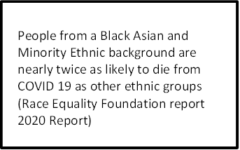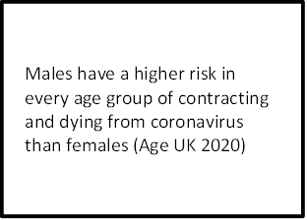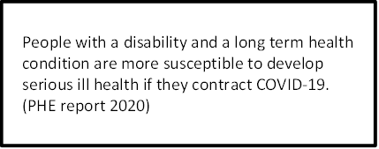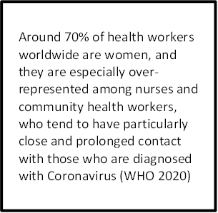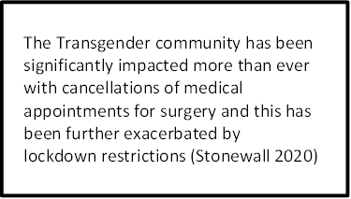The year of 2020 has been a significant and unprecedented year for the NHS dealing with the negative impact of the COVID -19 global pandemic. The coronavirus pandemic has not only resulted in significant pressure on our NHS but it has also had a devastating impact on our local communities and their families. The COVID-19 pandemic along with the resurgence of the Black Lives Matter movement has also highlighted stark racial inequalities with a disproportionate impact on our colleagues from a Black, Asian and Ethnic Minority background along with other inequalities for people with a protected characteristic as highlighted below.

Older and disabled people have experienced difficulties in accessing care due to reductions in the availability of appointments and planned surgeries during the pandemic (Age UK 2020)

Religious Faith groups have been severely impacted with the closures of places of worship with a significant increase in the rise of mental health issues (IDS 2020)

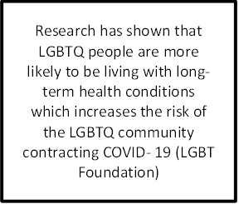

4 in 5 people that have died from coronavirus were aged over 70 or over (Age UK)

The NHS People Plan published in July 2020 sets out clear actions to support transformation across the whole NHS. It focuses on how we must all continue to look after each other and foster a culture of inclusion and belonging, as well as action to grow our workforce, train our people, and work together differently to deliver patient care. There are specific actions which are required of all NHS organisations between now and March 2021 to accelerate progress on equality, diversity and inclusion. The Table below illustrates the expectation from NHSE/I that all Trusts are expected to meet.

Recruitment and Promotion-In partnership with staff representatives, NHS organisations should overhaul recruitment and promotion practices to make sure that their staffing reflects the diversity of their community, and regional and national labour markets. This should include creating accountability for outcomes, agreeing diversity targets, and addressing bias in systems and processes. It must be supported by training and leadership about why this is a priority for our people and, by extension, patients.
Divergence from these new processes should be the exception and agreed between the recruiting manager and board-level lead on equality, diversity and inclusion (in NHS trusts, usually the chief executive).

Governance- By December 2021, all NHS organisations should have reviewed their governance arrangements to ensure that staff networks are able to contribute to and inform decision-making processes. Not only do staff networks provide a supportive and welcoming space for our people, they have deep expertise on matters related to equality, diversity and inclusion, which boards and executive teams need to make better use of. Staff networks should look beyond the boundaries of their organisation to work with colleagues across systems, including those working in Primary Care.

Regulation and Oversight- Over 2020/21, as part of its ‘well led’ assessment of trusts, the Care Quality Commission (CQC) will place increasing emphasis on whether organisations have made real and measurable progress on equality, diversity and inclusion and whether they are able to demonstrate the positive impact of this progress on staff and patients.

Health and Wellbeing
From September 2020, line managers should discuss equality, diversity and inclusion as part of the health and wellbeing conversations to empower people to reflect on their lived experience, support them to become better informed on the issues, and determine what they and their teams can do to make further progress.

Information and education From October 2020, NHS England and NHS Improvement will publish resources, guides and tools to help leaders and individuals have productive conversations about race, and to support each other to make tangible progress on equality, diversity and inclusion for all staff. The NHS equality, diversity and inclusion training will also be refreshed to make it more impactful and focused on action.

Accountability -By March 2021, NHS England and NHS Improvement will have published competency frameworks for every board- level position in NHS providers and commissioners. These frameworks reinforce that it is the explicit responsibility of the chief executive to lead on equality, diversity and inclusion, and of all senior leaders to hold each other to account on the progress they are making.

8
Leadership Diversity
Every NHS trust, foundation trust and CCG must publish progress against the Model Employer goals to ensure that at every level, the workforce is representative of the overall BAME workforce. From September 2020, NHS England and NHS Improvement will refresh the evidence base for action, to ensure the senior leadership (very senior managers and board members) represents the diversity of the NHS, spanning all protected characteristics.

Building Confidence to Speak Up
By March 2021, NHS England and NHS Improvement will launch a joint training programme for Freedom to Speak Up Guardians and WRES Experts. We are also recruiting more BAME staff to Freedom to Speak Up Guardian roles, in line with the composition of our workforce.

Tackling the Ethnicity Gap Across the NHS we must close the ethnicity gap in entry into formal disciplinary processes. By the end of 2020, we expect 51% of organisations to have eliminated the gap in the relative likelihood of entry into the disciplinary process. For NHS trusts, this means an increase from 31.1% in 2019. As set out in A Fair Experience for All, NHS England and NHS Improvement will support organisations in taking practical steps to achieving this goal, including establishing robust decision-tree checklists for managers, post action audits on disciplinary decisions, and pre-formal action checks.

CQC Well Led Domain
In February 2019 the CQC inspection highlighted that there were areas for improvement in relation to equality, diversity and inclusion citing that there were no staff networks in place to support the diversity of staff groups. Since the inspection, the Trust has implemented a Board Improvement Programme of which equality, diversity and inclusion is a core work stream and the Trust has also made progress in capturing and recording patient demographic data through the EPR Medway project. A Staff Inclusion Network has also been established with Staff Inclusion Network leads across the nine protected characteristics The Trust also established a BAME Shared Decision Making Forum chaired by a Matron. The next round of CQC inspections during 2021 and beyond will be heavily focused on NHS Trusts being able to demonstrate significant improvement with equality , diversity and inclusion.
NHS England and NHS Improvement draft regional Race Equality and Inclusion strategy (Midlands)
NHS England and NHS Improvement have recently published its draft Race Equality and Inclusion Strategy for the Midlands Region following extensive consultation with staff in the region following the first phase of Covid-19.The NHS people plan places priority on racial discrimination as an urgent issue to be addressed. This does not mean that other protected characteristics or aspects of equality and inclusion is less important. By addressing race inequalities, research has shown that this can have a beneficial impact on other staff groups as well as patient outcomes. It is for this reason that the draft regional strategy document is primarily focused on race. There are 9 key proposed actions below and these are as follows;

  - Remove barriers to inclusive and compassionate health and wellbeing support
  - Address the lack of leadership skills in leading with compassion and inclusion
  - Remove barriers to help staff speak up.
  - Address the structural racism, bullying, harassment and other types of discrimination, across the region.
  - Eliminate racism and bias in the disciplinary process.
  - Provide reward and celebration when leaders demonstrate progress.
  - Build a collaborative approach across the region with systems
  - Build accountability across the region.
  - Eliminate racism and bias in recruitment and progression

The local context and drivers for change -Health inequalities in Walsall Borough
Walsall is a metropolitan borough consisting of a mix of urban, suburban and semirural communities. It is one of the four local authorities that make up the Black Country sub region (with Dudley, Sandwell and Wolverhampton). Walsall has a local population of 281,293 (MYE 2017 ONS) and the local population is set to increase by 5.9% over 10 years to 290,200 by 2024.
Deprivation is deeply entrenched in Walsall and had worsened during the recession. Key facts are:
  - 44 out of 167 neighbourhoods (LSOAs) are now amongst the most deprived 10% in England compared to 34 in 2015.
  - The 2019 Index of Multiple Deprivation now ranks Walsall as the 25th most deprived English local authority (out of 317), placing Walsall within the most deprived 10% of districts in the country (33rd in 2015, 30th in 2010 and 45th in 2007).
  - There are extremes of deprivation, with central and western areas typically much more deprived than eastern areas, although pockets of deprivation exist even in the more affluent parts of the borough.
  - Walsall fares particularly badly in terms of income (16th), education, skills & training deprivation (11th) and employment (38th) and many of the issues that challenge the borough match the geography of deprivation.
  - The high and increasing levels of child poverty puts additional demands on services. Walsall ranks 17th for income deprivation affecting children index (IDACI 2019) with the Borough’s relative deprivation increasing over time (27th in 2015).
  - 1 in 3 (29.9%) aged under 16 years are living in low income families, higher than the national average of 20.1% (HMRC, 2016).
  - By the end of January 2017, 20.8% of primary school pupils were entitled to free school meals compared to the national average of 14.5% and 19.1% of secondary school pupils compared to 13.2% nationally (DfE June 2016).
Based on the rank of its average score, Walsall is now the 25th most deprived local authority district (out of 317). This puts it well within the most deprived 8% of areas in England, and is a worsening of position since 2015 when it was at 11% and in all previous releases of the indices over the past 15 years. However, this does not necessarily mean that Walsall is more or less deprived than it was previously in absolute terms, neither does it describe how the number of people experiencing deprivation has changed – what it does show is that the borough is now relatively more deprived when compared with other local authorities. It is entirely possible that improvements may have been made across Walsall as a whole over time, with fewer people living in deprivation as a result, but these have not been significant as the reduction in deprivation elsewhere.

The following map figure 4.0 below displays the geographical picture of deprivation across the Walsall borough, ranked against England as a whole. The colour shaded LSOAs (Lower-layer Super Output Areas) rank the most deprived as red & least as green. For instance, we can see that Area E (Blakenall) has a high proportion of the most deprived LSOAs in England, whereas parts of Aldridge & Streetly feature the least. It shows a very diverse picture, with east & west radically different from one another. Figure 4.1 groups the LSOAs into quintiles ranking them from most to least deprived. This also displays the gulf in deprivation geographically, between east & west.

Figure 4.0
Figure 4.1

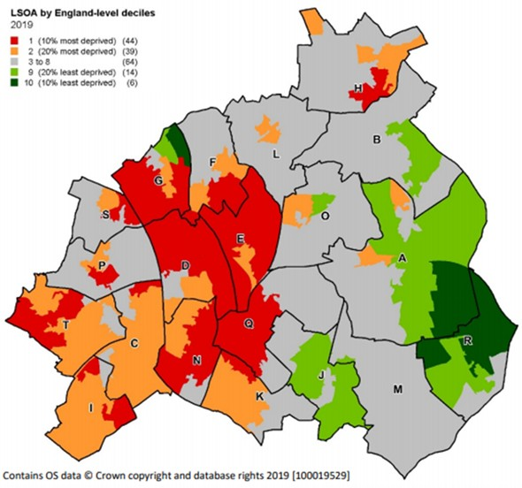
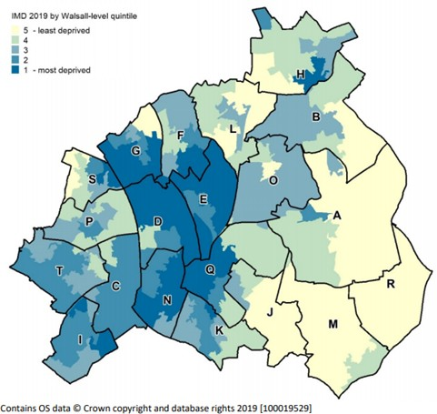

Walsall Together
Over the last two years the Walsall Together Partnership has been working closely to develop and provide services which will better meet the needs of our population, reduce inequalities and improve the health and well-being outcomes in Walsall. Focusing on prevention rather than treatment, the partnership is looking at ways to support our communities by equipping them with the tools and resources they need to improve the health and wellbeing of their population.
The partnership is working with Walsall Council and One Walsall to align the Resilient Communities Programmes, giving people better access to services such as social prescribers, Making Connections Walsall, housing, education and training information, Expert Patient Programme, Care Navigation and Co-ordination, carer support and opportunities to be involved in volunteering projects.
Health Watch Walsall has also been commissioned to support Walsall Together in engaging and communicating with service users, carers and the people of Walsall about the evolving integrated ways of working. They will take the lead in identifying and seeking the views of patients and the public on services delivered across the Walsall Together ICP, inform people of the benefits of integrated working and enable communities to be fully represented in the decision making process of future delivery of services and service change.
In line with the Black Country and West Birmingham Sustainability Transformation Plan (STP) to become an Integrated Care System (ICS) by April 2021, The move to an ICP will support the ambition of the partnership to deliver fully integrated services that are based on a population health approach to improve physical and mental health outcomes, promote wellbeing and reduce health inequalities across an entire population by focusing not just on health but on the wider determinants of health.
Future plans for the Walsall Together Partnership include working with the voluntary and community sector to engage with our communities, specifically with those people who are vulnerable or seldom heard, on issues such as the wider determinants of health including social isolation and the impact these have on the health and well-being outcomes for the population of Walsall.
Given the fact that over 60% of colleagues who work at the Trust, live in the Borough, the Trust has both a legal and moral responsibility to tackle and reduce health inequalities for the benefit of the residents of Walsall which includes colleagues working at Walsall Healthcare and their family members. It is important that our EDI strategy also compliments and underpins the Trust’s five year strategy and Patient Engagement and Experience strategy.

Workforce inequalities the local context – why do we need to take urgent accelerated action ?
We have collated extensive qualitative and quantitative feedback to help inform the development of this strategy and the data tells us that there is a compelling argument to take urgent and accelerated action to eliminate racism bias , uncivil and other forms of discriminatory behaviours and practices at our Trust. Our aim is for equality, diversity and inclusion to become the new normal. We now need to take accelerated and urgent action to reset our cultural norms to ensure we can demonstrate that we are well on our on way to becoming an anti racist, anti -discriminatory Trust. Incivility and behaviours, practices and processes that seek to undermine our efforts to become an inclusive and fair employer will no longer be tolerated at all levels in our Trust.
In 2018 our Trust Board Pledge set out a zero tolerance approach to tackling unlawful discriminatory behaviour and other behaviours and practices that are not in line with our Trust Values. Our Board Pledge states the following;
“We will demonstrate through our actions that we listen and support people. We will ensure the organisation treats people equally, fairly and inclusively, with zero tolerance of bullying. We uphold and role model the Trust values chosen by you”.
We are aware that progress has been slow and we are not where we wish to be. For the past three years there has not been any significant improvement in relation to equality, diversity and inclusion with differential outcomes for colleagues with a disability and colleagues from a Black Asian and Minority Ethnic background. Figure 1.4 below provides further details of some of the workforce inequalities identified from various Trust reports since 2018 until present.
In the 2020 Staff Survey 75.7% of colleagues reported that they believed Walsall Healthcare acts fairly in relation to career progression and promotion irrespective of ethnic background religion sexual orientation disability or age. This is a reduction from 76.3% in the 2019 Staff
In the 2020 Staff Survey only 55.8% of colleagues from an ethnic minority background believed that the Trust provides equal opportunities for career progression and promotion compared to 81.8% of White colleagues.

23.9% of colleagues from a Black Asian and Ethnic Minority background reported they had experienced discrimination from their line manager, Team leader or other colleagues compared with 7.3% of White colleagues that responded to this question in the 2020 Staff
Our Gender Pay Gap data tells us that women’s hourly wage is 14% lower than men. Women earn 86p for every £1 men earn when comparing median hourly wages
In our 2020 Workforce Race Equality Standard report if you were from a White background you were 1.52 times more likely to be appointed to a position at Walsall Healthcare from shortlisting across all posts when compared to a candidate from a Black Asian or Ethnic Minority background.
Colleagues with a disability also reported similar levels of differential experience with 23.8% of disabled colleagues who reported that they had experienced harassment bullying or abuse from their line manager in the 2020 Staff Survey.
The percentage of disabled staff compared to non disabled staff saying that they were satisfied with the extent to which their organisation values their work was 32.5% compared to 44.1% of non disabled colleagues.

Work of the Black Asian and Minority Ethnic Cabinet Task and Finish Group
The disproportionate impact of COVID-19 upon colleagues of Black, Asian and Minority Ethnic background, and the resurgence of the Black Lives Matter movement shone a spotlight on race inequality creating a widespread acceptance to take action. In May 2020 Walsall Healthcare Board established the BAME Cabinet on a task and finish basis to aid the acceleration of progress in this area. The BAME Cabinet comprised the CEO, Chair, Director of People and Culture as well as the Chair of People and Organisation Development Committee PODC, and other Non Executive Leads for EDI, Health and Wellbeing and FTSU. BAME Cabinet members agreed that the task and finish group would enable the Trust to achieve the following;
  - State our ambition for workforce race equity
  - Articulate what success looks like
  - Describe the approach and the steps along the way
  - Recognise the challenges
  - Explicitly articulate the mitigations as well as why we think these will be effective
  - Be clear on how we will hold ourselves and everyone else to account for delivery
The outcomes from these sessions and the EDI Board Development Sessions commissioned on behalf of the CEO concluded and secured Board commitment to ensure the following aims as set out on page 6 of this strategy document.
  - A skilled anti-racist, anti-discriminatory Board, committed to, equipped and educated to drive the change
  - Fairer representation of different groups at all levels, occupations, better colleague experience
  - Pride rather than uneasy shame in being a BAME board member of the Trust
  - The racists, homophobes and other bigoted people are the ones who will feel they do not fit in the Trust
  - Public and patients irrespective of background/characteristics will see themselves represented in the Trust offer
  - Whiteness is discussed as much as any other identities
  - The approaches we use to get there will be research based with clear evidence behind the actions to evidence success.

The work of the BAME Cabinet has been a key enabler in driving collective support for Equality, Diversity and Inclusion
Equality Diversity and Inclusion Strategy Objectives for the next two years
Quantitative and qualitative data along with anecdotal evidence provides a useful evidence base to develop a set of objectives that will be monitored over the next three years of our equality, diversity and inclusion strategy.
Our four objectives for the next two years are as follows; Objective 1
  - 18.0% of colleagues from a Black Asian and Ethnic Minority background are in AFC pay grades 8a and above. Our objective is to increase this by 10% which would mirror our current overall ethnic minority workforce representation which is 28%.
Objective 2
  - To work towards becoming an anti-racist and anti- discriminatory organisation by creating a healthy workplace culture and healthcare service which is fully inclusive for colleagues and patients with a disability ,from an ethnic minority background, LGBTQ+ background, and all of the other remaining protected characteristics ( age, sex, gender reassignment, marriage and civil partnership status and pregnancy and maternity status ) This will result in improvements in colleagues experience working at the Trust and better advocacy scores for both colleagues and patients.
Objective 3
  - To embed equality analysis into service redesign, improvement programmes and governance structures to ensure equality, diversity and inclusion is at the heart of everything we do
Objective 4

  - To have reached Anchor Employer status by collaborating with partners to form a system wider Anchor Employer Alliance by April 2022. This will be achieved by working with partners in the Borough and beyond to offer employment opportunities for disadvantaged communities.
Listening and responding to feedback : What did our colleagues and patients tell us about their experiences and what needs to change? ( EDI Strategy consultation exercise, Pull up a Chair with the Chair, FTSU Guardians, EDI Board Development sessions feedback)
In the summer of 2020 we undertook a number of engagement exercises to engage with our colleagues and patients to understand their perspective from an EDI lens and what they believe needs to change at Walsall Health care.
Qualitative themes from our extensive equality, diversity and inclusion strategy consultation exercise, or EDI Board Development Session, the Pull up a Chair with the Chair sessions and feedback from our Freedom to Speak Up Guardians report colleagues being subjected to racist taunts, bullying and uncivil behaviours. There were also reports of unfair working practices and our colleagues from a Black Asian and Minority Ethnic background and colleagues with a disability reporting that they believed they had been treated unfairly during the peak of the COVID - 19 wave 1 following feedback from the Virtual sessions with the Chair of the Equality, Diversity and Inclusion Group.
Below is a summary of some of the comments from our colleagues and patients engagement exercise during 2020

“We need to stamp out bullying, favouritism - I even believe there are differences between how groups of different Health Care Professionals are treated (despite other factors”

“We need to extend the duty of candour to require people to report poor behaviour in exactly the same way they would discuss something that goes wrong with someone's treatment. Take a 'civility saves lives' approach to explain that the impact of this not only impacts college wellbeing but also patient safety.”

“We need to actively listen and invest in our people. We need to ensure that discriminatory culture is not tolerated.
When clinicians/ staff talk about how difficult it is to speak to patients who do not speak English and complain about the cost of interpreter services; this is discriminatory. When black people are repeatedly given a lower standard of care due to bias in the health system and bias in clinical practice; this is discriminatory.”

17

“As a transgender male I feel inclusion is very important within every community as it means that everyone feels safe and accepted. I have had a lot of instances in other communities of people not including me because of being transgender so I think inclusion is a very important thing to have wherever you are”

“The Leadership culture is unacceptable and there are behaviours of speaking down to staff, pulling people from pillar to post”.
“Poor behaviour is endemic and accepted – eg it is left up to the junior members of staff to challenge their seniors about disparaging and discriminatory and racist, homophobic remarks.”

“This is not a nice environment for the staff. More people would come forward but they are scared.
Change now needs to happen”.

What are we going to do? - moving beyond ‘equality speak’ and taking meaningful and appropriate action
This strategy is about building the foundation for an inclusive and culturally sensitive NHS Trust. We are focusing our attention on the issues that have been raised over the years by our staff and we are giving our commitment to doing something about it. Using Roger Kline’s top ten actions as our guiding principles, the Board as a collective have committed to achieving the following;
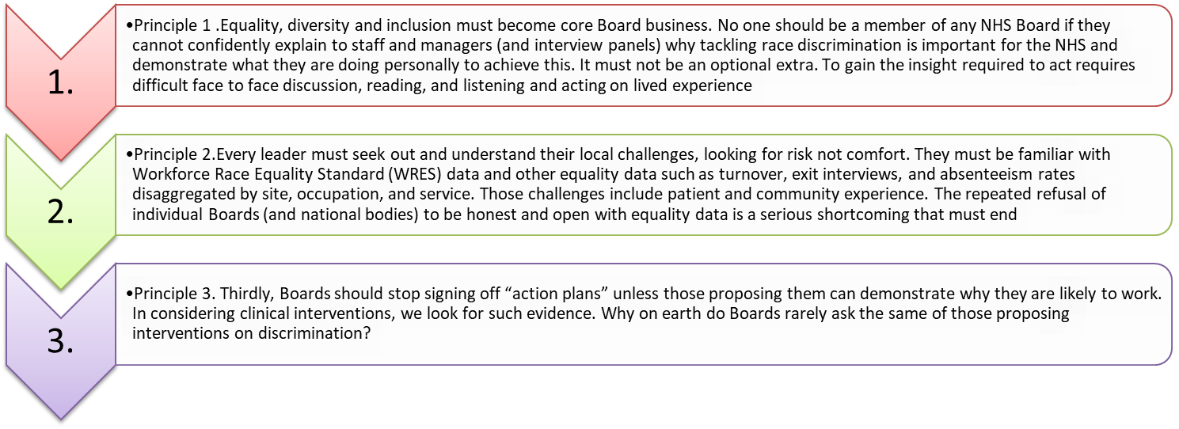

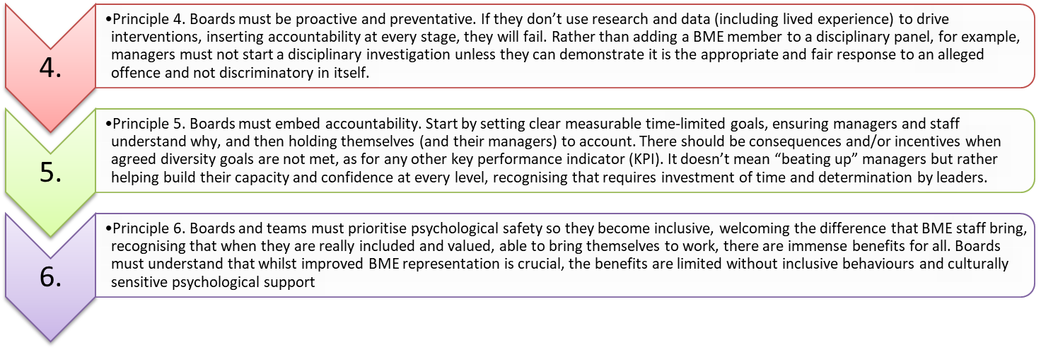

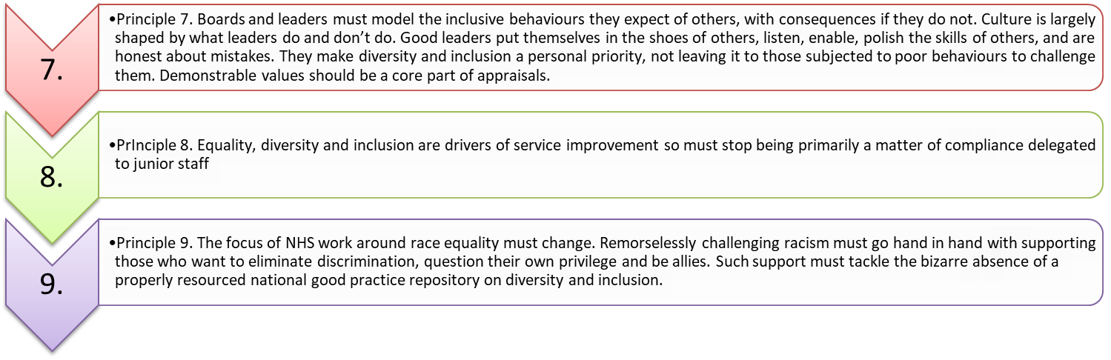
10.
- Principle 10. Finally, it is time to step up national accountability. Good governance has accountable metrics. Why, for example, are Trusts that cannot demonstrate serious progress on race equality still receiving a CQC Good or Outstanding rating? Strong statements on racism are helpful. But in 2020 anything less than decisive practical action is unforgivable

21
8. Eliminating racism/ bias in recruitment and progression- Implement Comply and Explain/100% uptake of Recruitment and Selection Training/Cultural Ambassadors on interview panels. Positive action leadership programmes . Pre assessment EDI diagnostic tools
7.Building accountability-. Implement the Equality Delivery System 3 across service areas and carry out a rolling programme of EDS3 assessments. Embed Equality Impact Assessments into service redesign and Board Governance structures. Establish an External Equality Advisory Group
9. A collaborative approach across systems- Establish a system wide BAME Network./Inclusion Network/Anti-Racist Action Plan/ Embed specific anti-racist specific interventions/ System wide Black Lives Matter Recruitment Campaign . Develop Anchor Employer Alliance
5. Eliminating racism and bias in disciplinary and grievance processes Mediation skills training for line managers and colleagues to ensure there is no disproportionate impact on ethnic minority representation colleagues involved in employee relations cases
/Investigation Skills Training for ethnic minority colleagues Increase the number of ethnic minority Investigating Managers/Implement revised disciplinary and grievance policy along with a co designed comprehensive training programme./ Cultural Ambassadors involvement in employee relation cases-
6. Reward and celebrate when good practice is identified
Implement Equality Charter Marks for WHT Establish recognition and reward process to celebrate inclusive leaders inclusive teams and inclusive and compassionate colleagues and promote through the BC &WB ICS and Trust Communications

NHSE/I: Regional Race Equality and Inclusion priorities for the Midlands region.
What are some of the actions we are going to take in the short medium and long term based on the NHSE/I regional priorities?
4.Tackling racism and other types of discrimination (including bullying and harassment) -Implement code of civility and respect/implement Just and Learning Culture
/Micro aggressions and Effective Ally- Dealing with Racism programme/Sign up to EDI Charter marks
/Early Adopters of the Race Code
1.Addressing the lack of compassion in leadership Skill/EDI Self-assessment exercise/ Inclusion Maturity Matrix/ Personal EDI objectives for Executive Directors/Sponsorship of Inclusion programme of work/ EDI Leadership development programmes
2. Removing barriers to inclusive and compassionate health and wellbeing support Develop culturally sensitive health and wellbeing provision for colleagues from a Black Asian and Ethnic Minority background
3. Removing barriers to help staff speak up Establish an external offer to encourage more staff to speak up / Enhance FTSU Dashboard/ Raise the profile of the Confidential Contact links /Implement a shared governance process for the Staff Inclusion Network and BAME Shared Decision Making Council

What does outstanding look like?

1.Addressing the lack of compassion in leadership Skills- ( EDI Equality Objective 2) | 2.Removing barriers to inclusive and compassionate health and wellbeing (EDI Equality  Objective 2) | 3.Removing barriers to help staff speak up  (EDI Objective 2)
- 100% of leaders will have had a 360 degree appraisal / Carried out an EDI self-assessment  - 100% of Executive team will have had an EDI objective and be working towards delivering on their objectives  - Increase in% staff survey results Q 5b the support I get from my immediate line manager increase in line with best performing Trusts and above benchmark comparator Trust  - Improvements in WRES Indicator 8 ( q17 staff survey 15% decrease in the no of ethnic minority staff that have experienced discrimination from their manager / team leader or other colleagues  - Improvements in WDES indicator 4 -20 % decrease in the number of disabled staff that state they had experienced bullying, harassment and abuse from their line manager or other colleagues  - % increase in staff advocacy scores- a great place to work in line with comparator benchmark of 67%  - % uptake of Civility and Respect Code of practice &/understanding micro aggressions /gaslighting development programmes  - WHT in Upper quartile of Model Hospital | - % increase staff survey questions in the number of staff that state their line manager/organisation takes a positive interest in their health and wellbeing ( (benchmark against comparator trust or higher %)  - Improvements in WDES indicator 4 - % decrease in the number of disabled staff that state they had experienced bullying, harassment and abuse from their line manager or other colleagues  - Increase in % staff survey results Q 5b the support I get from my immediate line manager increase in line with best performing Trusts  - Improvements in WRES Indicator 8 ( q17 staff survey 15% decrease in the number of ethnic minority staff that have experienced discrimination from their manager / team leader or other colleagues  - WHT in Upper quartile of Model Hospital | - % increase in the number of staff that state they feel confident to speak up about concerns (staff survey)in line with benchmark comparator  - Increase in the no of FTSU concerns received by external FTSU service with themes being triangulated to specific divisional areas and departments and subsequent actions being taken.  - Increase in % of overall concerns captured via FTSU dashboard reporting  - % increase in the number of colleagues raising concerns about civility and respect in the workplace  - Governance structures in place to support staff networks involvement in decision making  - Increase in the number of staff contacts via confidential contact links  - WHT comparators in line with the best performing Trusts

4. Tackling racism and other types of  discrimination (including bullying and harassment) EDI Objective 2 | 5. Eliminating racism and bias in disciplinary and grievance processes (EDI objective 2 and 3) | 6. Reward and celebrate when good practice is identified (EDI objective 2)
- Increase in% staff survey results Q 5b the support I get from my immediate line manager increase in line with comparator Trust  - Improvements in WRES Indicator 8 ( q17 staff survey % decrease in the no of staff that have experienced discrimination from their manager / team leader or other colleagues  - Improvements in WDES indicator 4 - % of disabled staff that state they had experienced bullying, harassment and abuse from their line manager or other colleagues  - % Improvements in staff advocacy scores- a great place to work | - Increase in% staff survey results Q 5b the support I get from my immediate line manager increase in line with benchmark comparator Trust  - Improvements in WRES Indicator 8 ( q17 staff survey  % decrease in the no of ethnic minority staff that have experienced discrimination from their manager  / team leader or other colleagues  - Improvements in WRES Indicator 3 the relative likelihood of ethnic minority staff entering into the disciplinary process when compared to white staff | - % increase in the of nominations being received to celebrate inclusive leaders/ inclusive and compassionate individuals as part of internal awards programme  - Number of inclusive leaders/teams/individuals that have been put forward for external awards  - EDI Charter Marks achieved
7.Building accountability (EDI objective 2 and 3) | 8. Eliminating racism/ bias in recruitment and  progression-(EDI objective 1 2 and 3) | 9. A collaborative approach across systems-  (EDI objective 2 and 4)
- Corporate accountability framework in place  - Improvements in EDI metrics within Director of People cultural heat map  - NHSE/I EDI Board competency framework implemented  - Equality Impact Assessment Framework embedded  - Divisional accountability structures in place  - Heads of Service /Service leads accountability framework in place ( EDI Metrics)  - EDS3 assessment framework in place across key services-  - Rolling programme of EDS3 assessments in place and being implemented | - % increase in the number of ethnic minority colleagues at Band 8a and above from 18.0% to 28% in line with overall number of ethnic minority colleagues in the workplace  - 20 % increase in the number of disabled and ethnic minority colleagues that state they believe their organisation provides opportunities for career development  - Improvements in WRES indicator 2 – the relative likelihood of ethnic minority colleagues reduced from 1.52 to below 1.00  - % of internal promotions gained by ethnic minority and disabled colleagues  - Information on recruitment comply and explain outcomes being reported to PODC  - Check and balance ( HBA) process in place for senior management recruitment | - Anti racist action plan in place  - System wide Ethnic Minority Network in place  - % take up of Black Lives Matter interventions across the region and (WHT specifically)  - Black Lives Matter interventions embedded across the system  - Working with system partners to build an Anchor Employer Alliance  - As part of our commitment to being an anchor employer we will achieve year on year % increases in the number of disabled people and disadvantaged communities gaining employment at the Trust

How are we going to communicate and monitor the implementation of this strategy?
This strategy will be circulated to Walsall Healthcare Board, members of the Trust Management Board, members of the Staff Inclusion Network ,BAME Shared Decision Making Council and the Equality, Diversity and Inclusion Group. We will also circulate this strategy to Divisional Boards which comprise of Divisional Directors, Deputy Divisional Directors and Care Group Managers and various teams across the organisation. We also publish this on our internal intranet pages.
Our intention is to obtain meaningful and insightful feedback as to whether the interventions over the next year are the right ones for our colleagues and patients. We hope to make it clear that our ambitions to become an inclusive and fair employer can only be realised with the genuine commitment of everyone that works at the Trust. We also hope to make it clear that there is no place at our Trust for colleagues whose actions and behaviours undermine our efforts to achieve good equality outcomes for the benefit of our colleagues and patients. Simply put, we must reinforce our zero tolerance approach to bullying, racism and uncivil behaviours.
We will produce several copies for our community sites and for our operational colleagues that do not have regular access to the intranet. We want to ensure that everyone who works for us is clear about what we are going to do become an anti racist, anti discriminatory organisation and the role they play in support of this ambition.
This strategy will also be published on our external website and copies will be made available for our partners organisations. We will also publicise this strategy on all of our social media websites which includes face book, twitter and Instagram and also through our regular communication channels such as the Trust’s corporate newsletter- Daily Dose and other internal communication mechanisms.
The delivery plan of this strategy and progress will be monitored and reported to the People and Organisation Development Committee through the Equality, Diversity and Inclusion Group. We will publish regular updates about our programme of work so that our colleagues understand the extent of the progress we are making and the impact that this strategy is making on colleague experience e.g the people that work for us and also the positive and beneficial impact and outcomes for our patients.

Equality Diversity & Inclusion - Diversity in Decision Making

Board Governance Improvement Programme

Mcrc»,- - 1 Mc>IUfy- - 4 Mc>IUft-' - 2
pi.:moc,-
=m>:""a»elct>Qo
IX'CQ"C::: riclro..o: NP ll0t
=noo.

ml Sir":=,
=
1. m1
J . ml Cl.·er.:01
:>Dcd--.
11:lCOQ
··· ··········
"11c<Onc:
oc-::: .., _.. on m1
OUTSTANDING 2D22

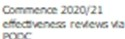
I . Bll Slr.=,
1. Bll

J. B)J
1 -"°<>'•""·""
aac.:o."'IQ.,,
a.iUt: e:(QU: e,
o--.er.::; : r.eJl"d.t:on:re:

1 . 1ED.I_..._
0 . ..
•, ..........

IIANE Cou-d COL Jin, 21110
OOIC0<1JC:cc,.,,cs;:;-Sh,rc,O OOd::on
...,_C>ocSel"<S)OnI) Tnz:z _,.,
o,cy 'St:.- Sllotlc::': "<I
11:·,:rc,,,...,.,,,oonon£4': ,
l)',er.:.,.,.,""""""'G,o.c,

..........
,•·
O"\.!.N:t -..TOl.t'O..IOe:

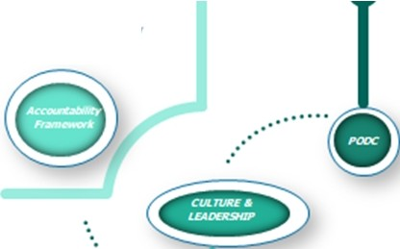Strategy, Performance andDiversity in Decision Makirg
ot n"' """ll'I"CAoa::D,.c.rc."ea':"..-,:
r:.
b0Cn l\!l'CI:l"'d:::ot't
....

EQ.,: .,_ c,-.er.:,,: ,.,
Ira.Don Slr":,ocv:""
EQ.,: ., ...
J.«;,ro,t:: on.: kZlr.:ra:.riCQC)l"C;l'rOffl 1'0CCOJ,>"""1y
o,,,cncy

k"n.£:,[O.i;,.,_
or :,.:rc
-..:onAoo«t­
:QQro.c. on.-:..TU:
s
r :cn
"'°""l'OCC
·kZ2.r:. rcoore
"""'l'0CC
a,,­
nu:z rc
-••
S:,"4nQ
--==on
I -
CIUIOI.--ce,
I:>tlCO,:.rtOl
o=cn:""

Fcn>ol n.. 2 GnQ> _,, TOR
m1 si,-,,ocv,,.,&;u>"'
-
2• .,,...._ED'IMru>

Eq.mly

:nl lnd uuon

y .c..e..o..,..,,.o...n
·- ··········· .... ..
- - - ··- ·--·-··
':l'wl:mJs:r:."Z:l:t.: Eo,,1;:. -:; Ot,)te :.c: .: 1"r'O':Of\C'IC' OCie"·1t:1V :
ll!iCCf\:. s .c:r.'ICttor«r".!. -:'hclttu:. EDrlcoor,:i:irc,, ft- :
80,:rd W.:"1.1:.7:: 0l f"'JC:ronlZ.1"te,:l,.W':'IQJ: rwt,:.z..r:.r\r :
J. 110.:,e cnc:r c:
ftcuct,C,C,n«
1, Rl:CDc I ,0:,Z I) l'0CC
I "IIOl'l>c,.:dCOc:
2, fol : .,... ""
ID<-·MY
J. .....
..........,c,:oc,o,\bC
"20"2'2'".'.-."."..=,-.,"""Cl r,,
¹ ,: ...,...,,..,

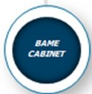
.:r f'eICoart:onp- c"Og'CnZ:inl"'l.yP00C.7!'l1c-.tOcmoko.n:ol."J'Oc..CU\ orroc.coo.Jc::arm'\.! Jcconoocn•• !:::
=
re::.t'f.:1'\:.rCJC dect::-onn:.llnQonrt on .:::.:ruc:.rec.
10<.,.TluZlo,rdcn O::tnJ<d; 1>l:oon1>a>Cc:o.,c,:.
s ,,,,,,..,
CWl.">Q­ C:CU'IC<

••

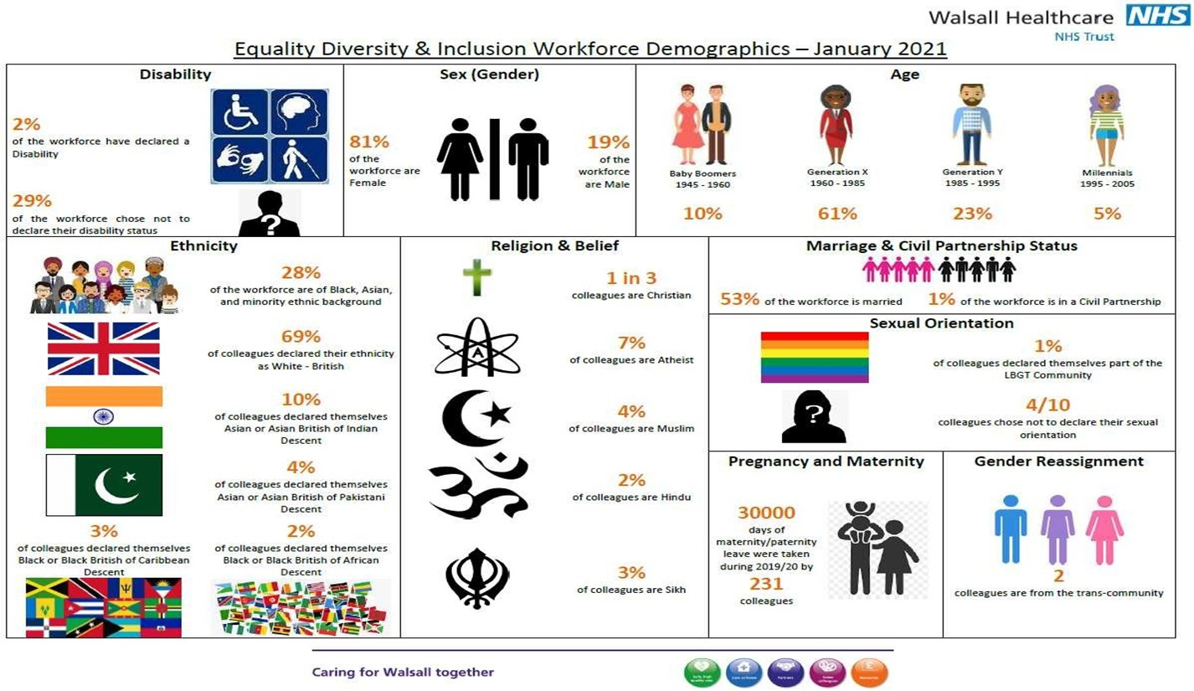
ANNEX B- EDI Workforce Demographics

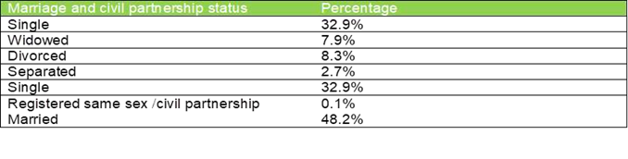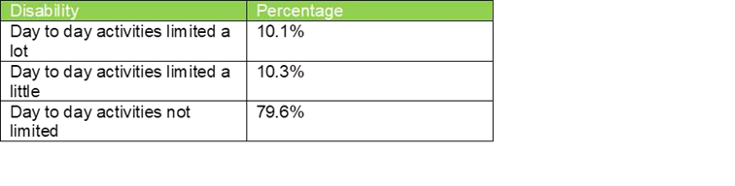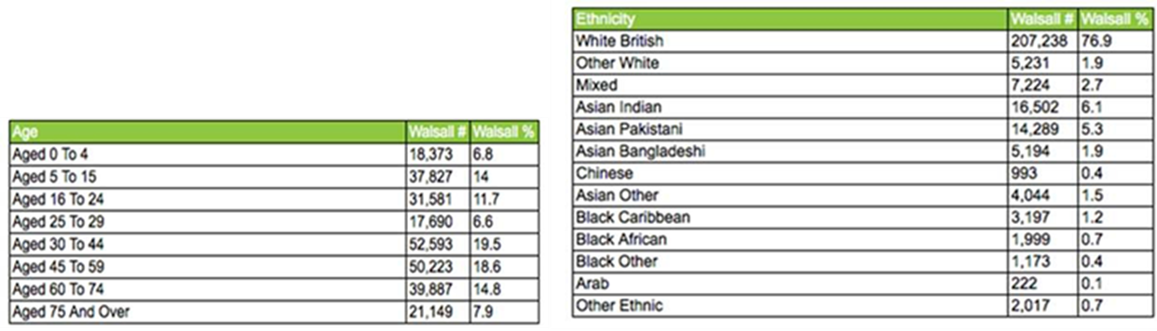ANNEX C- Walsall Community Demographics (Census 2011)
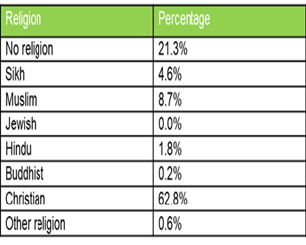

Sexual Orientation | Percentage
LGBTQ+ | 1%

Inclusion for all : Equality Diversity and Inclusion Delivery Plan 2021-23- Value Our Colleagues Improvement Programme Key considerations
We have identified 9 Key areas of focus which are aligned to the priorities within the NHS People Plan and the NHSE/I Race Equality and Inclusion Priorities for the Midlands Region. Our 9 key areas of focus are the actions we are going to take over the next 24 months. These nine key priorities are also aligned to our four EDI strategy Equality Objectives which are;
Objective 1 •18.0% of colleagues from a Black Asian and Ethnic Minority background are in AFC pay grades 8a and above. Our objective is to increase this by 10% by December 2022 which would mirror our current overall ethnic minority workforce representation which is 28%
Objective 2 •To become an anti-racist and anti- discriminatory organisation by creating a workplace culture and healthcare service which is fully inclusive for colleagues and patients with a disability ,from an ethnic minority background, LGBTQ+ background, and all of the other remaining protected characteristics ( age, sex, gender reassignment, marriage and civil partnership status and pregnancy and maternity status)
Objective 3• To embed equality analysis into service redesign, improvement programmes and governance structures to ensure equality, diversity and inclusion is at the heart of everything we do
Objective 4• To have reached Anchor Employer status by collaborating with partners to form a system wide Anchor Employer Alliance by April 2022. This will be achieved by working with partners in the Borough and beyond to offer employment opportunities for disadvantaged communities and partnering with local businesses to offer supply chain opportunities within the region when these opportunities become available. We will also work more closely with local schools, colleges and universities to attract recruit and retain talented individuals to consider Walsall Healthcare as a place to work.

In order to deliver this Strategy we need a robust delivery plan. Our Nine Point Delivery Plan for Equality and Inclusion has been mapped against the NHS People Plan and NHSI/E Midlands Race Equality and Inclusion priorities and developed in partnership with our staff networks and alongside the Value Our Colleagues improvement programme. This delivery plan will be refreshed annually with a progress report published within the Public Sector Equality Duty Annual Report. Progress will be measured through national benchmarking, and through engagement with staff, patients and communities.

The Nine Point Delivery Plan is set out below and is aligned to the NHSE/ I Race Equality and Inclusion

- Key deliverable 1: Addressing the lack of compassion in leadership skills (EDI Strategy Equality Objective 2)

- Key deliverable 2: Removing barriers to inclusive and compassionate health and well being support ( EDI Equality Objective 2)

- Key deliverable 3: Removing barriers to help staff speak up (EDI Equality Objective 2)

- Key deliverable 4: Tackling racism and other types of discrimination (including bullying and harassment) (EDI Strategy Equality Objective 2)
- Key deliverable 5: Eliminating racism and bias in disciplinary and grievance processes (EDI Equality Objective 2)

- Key deliverable 6: Reward and celebrate when good practice is identified (EDI Equality Objective 2)

- Key deliverable 7: Building accountability (EDI Equality objective 2 and 3)

- Key deliverable 8: Eliminating racism/ bias in recruitment and progression-(EDI Equality Objective 1 2 and 3)

- Key deliverable 9: Building a collaborative approach across systems (EDI Strategy objective 4)

Actions | Baseline data | How will we know this action has made an impact and difference? KD 1 | Yr 2 April 2022Target | Yr 3 -2023  April 2023 Target | Reporting / Governance VoC Ref | When | Who?
Key Deliverable 1: Addressing the lack of compassion in leadership skills (EDI Strategy Equality Objective 2- To become an anti-racist and anti- discriminatory organisation by creating a workplace culture and healthcare service which is fully inclusive for colleagues and patients with a disability ,from an ethnic minority background, LGBTQ+ background, and all of the other remaining protected characteristics ( age, sex, gender reassignment, marriage and civil partnership status and pregnancy and maternity status )
Year 2 delivery by April 2022
A 1.Ensure that senior leaders and their teams have the opportunity | - | Year on year | 100% of senior | - | EDIG | April 2022 | P&C
to carry out a self- assessment against the NHSE/I inclusion Maturity |  | improvement in | leaders |  | VoC – EDI
Matrix to support learning in relation to EDI |  | understanding and | complete self- |  | PODC
 |  | awareness of EDI | assessment
A 1.2 Develop a comprehensive Mandatory EDI Management and | - | All people managers will | 100% of | - | EDIG VoC- | April 2022 | P&C
Leadership Development Programme and ensure that anyone with a |  | understand the legal, | leaders |  | EDI
line management responsibility participates in the programme |  | moral imperative of the | participate in |  | PODC
A1.1.2 EDI training and development programme of lunch and learn |  | Equality Act 2010 and | programme
sessions: (Building inclusive culture, values, civility and respect, |  | the importance of
Bullying and Harassment, micro-aggressions, Equality Analysis) |  | managing diversity
A.1.3 Implement the Leadership Academy Reciprocal mentoring | - | Reciprocal mentoring | 100% of | - | EDIG | April 2022 | P&C
scheme for inclusion |  | scheme in place – | Executive | N/A | VoC- EDI |  | Exec
 |  | colleagues with a | members |  | PODC |  | Directors
 |  | protected characteristic | participation |  |  |  | Staff Inclusion
 |  | report 100% satisfaction |  |  |  |  | Network
 |  | Executive and Board |  |  |  |  | BAME
 |  | members will have |  |  |  |  | Council
 |  | gained deeper insights
 |  | into discrimination faced
 |  | by colleagues with a
 |  | protected characteristic
A1.4 Ensure all Executive Directors have at least 1 Equality, Diversity | - | EDI objectives | EDI objectives | - | - | April 2022 | CEO
and Inclusion Objective as part of their annual appraisal |  | incorporated into | incorporated |  | EDIG
 |  | Executive Director | into yr 2 |  | VoC- EDI
 |  | Appraisal | appraisal cycle |  | PODC

Actions | Baseline data | How will we know this action has made an impact and difference? KD 2 | Yr 2 2022  April 2022Target | Yr 3 -2023  April 2023 Target | Reporting / Governance VoC ref |  | When |  | Who?
Key Deliverable 2: Removing barriers to inclusive and compassionate health and wellbeing support ( EDI Strategy – Equality Objective 2 To become an anti-racist and anti- discriminatory organisation by creating a workplace culture and healthcare service which is fully inclusive for colleagues and patients with a disability ,from an ethnic minority background, LGBTQ+ background, and all of the other remaining protected characteristics ( age, sex, gender reassignment, marriage and civil partnership status and pregnancy and maternity status )
Year 3 Delivery by April 2023
A2: Develop a directory of culturally sensitive health and wellbeing provision for colleagues with a disability and for colleagues from a Black Asian and Ethnic Minority background- carry out targeted communications to ensure colleagues can access the directory and support on offer. | - | Colleagues from ethnic minority backgrounds and disabled colleagues are accessing culturally sensitive health and wellbeing support. | At least 50% of colleagues from ethnic minority and disabled backgrounds report being aware of support on offer and know how  to access it | 100% of colleagues from ethnic minority backgrounds report being aware of support on offer and know how to access it |  | EDIG  VoC- H&W PODC |  | April 2023 | BC and WB ICS BLM  Group
A2.1 Deliver an annual Leadership Conference which incorporates key messages and deliverables for line managers in relation to compassionate and inclusive leadership and ensuring the psychological wellbeing and safety of their teams | - | Annual leadership conference in place | At least 60% leaders attendance at annual conference | 95% leaders in attendance at annual conference |  | EDIG  VoC- Comms &Engagement |  | April 2023 | Executive Directors

Activity / Features | Baseline data | How will we know this action has made an impact and difference? KD 3 | Yr 2 2022  April 2022Target | Yr 3 -2023 April  2023 Target | Reporting / Governance VoC ref | When | Who?
Key Deliverable 3: Removing barriers to help staff speak up ( EDI Strategy Equality Objective 2 :To become an anti-racist and anti- discriminatory organisation by creating a workplace culture and healthcare service which is fully inclusive for colleagues and patients with a disability ,from an ethnic minority background, LGBTQ+ background, and all of the other remaining protected characteristics ( age, sex, gender reassignment, marriage and civil partnership status and pregnancy and maternity status )
Year 3 Delivery by April 2023
A.3 Explore options to establish and promote the BC and WB ICS | -% of colleagues | Colleagues report | % of | 0% of concerns | EDIG | April | BC and WB
External Equality Support service offer for colleagues with a protected | reporting concerns | feeling supported to | colleagues | being reported | PODC | 2023 | ICS BLM
group who do not feel confident speaking up about discrimination or | externally | speak up and are | reporting | externally as |  |  | Group
incivility linked to their protected group and encourage take up at |  | encouraged to speak up | concerns | colleagues are more
WHT through various communication channels- External organisation |  | and report concerns via | externally | confident to speak
to monitor up take and report themes back to source organisation via |  | FTSU |  | up internally via
HRDs/FTSU Guardians? |  |  |  | FTSU route due to
 |  |  |  | concerns being dealt
 |  |  |  | with and actions
 |  |  |  | taken
A3.3 Implement a shared governance process for the Staff Inclusion | - | Process in place for | 100% of staff | - | EDIG | April | Director of
Network, Ethnic Minority Shared Decision Making Council and Ethnic |  | shared governance in | networks |  | VoC-EDI | 2023 | People and
Minority support group and establish accountability measures and |  | decision making in place | report being |  | PODC |  | Culture &
outputs for all Staff Networks linked to shared decision making |  | for staff networks | able to |  |  |  | Director of
processes |  |  | contribute to |  |  |  | Governance
 |  |  | decision
 |  |  | making at the
 |  |  | Trust
A3.4 Deliver a FTSU Training programme to all people managers – | 0% baseline | Training programme | 50% of | 100% take up of | EDIG | April | Director of
include staff networks |  | rolled out across the | colleagues | training programme | VoC- values | 2023 | People and
 |  | organisation | participating in |  | and |  | Culture
 |  |  | the |  | Behaviours
 |  |  | programme |  | PODC

Actions | Baseline data | How will we know this action has made an impact and difference? KD 4 | Yr 2 2022  April 2022Target | Yr 3 -2023 April  2023 Target | Reporting / Governance VoC ref | When | Who?
Key Deliverable 4: Tackling racism and other types of discrimination (including bullying and harassment) ( EDI Strategy Equality Objective 1 and 2)18.0% of colleagues from a Black Asian and Ethnic Minority background are in AFC pay grades 8a and above. Our objective is to increase this by 10% by December 2022 which would mirror our current overall ethnic minority workforce representation which is 28%To become an anti-racist and anti- discriminatory organisation by creating a workplace culture and healthcare service which is fully inclusive for colleagues and patients with a disability ,from an ethnic minority background, LGBTQ+ background, and all of the other remaining protected characteristics ( age, sex, gender reassignment, marriage and civil partnership status and pregnancy and maternity status )
Year 2 Delivery April 2022
A 4. Implement the Just and Learning Culture training programme | - | Just and Learning culture embedded- reduction in | At least 50% of eligible | 100% of eligible staff participating in | EDIG  VoC- values | April 2022 | Deputy Director of
 |  | bullying harassment and | staff | programme | and |  | People and
 |  | abuse and incivility | participating |  | Behaviours |  | Culture
 |  |  | in programme |  | PODC
A4.1 Work with the Governance Forum to become early adopters of | - | Year on year reduction | Self- | Race Code action | EDIG VoC - | April | Talent
the Race Code – implement The Race Code Action Plan |  | in % of colleagues | assessment | plan being | EDI | 2022 | Inclusion and
 |  | reporting discrimination | exercise | implemented |  |  | Resourcing
 |  | on the grounds of race- | completed |  |  |  | Lead
 |  | WRES indicator 6 and 8
A4.2 Work with the Black Country and West Birmingham ICS Black | - | Year on year reduction in | Self- | Race Code action | EDIG VoC – | April | Talent
Lives Matter working group to design and develop targeted |  | % of colleagues reporting | assessment | plan being | EDI | 2022 | Inclusion and
interventions and development programmes- embed interventions |  | discrimination on the | exercise | implemented as part |  |  | Resourcing
into the day to day processes and ways of working at WHT as part of |  | grounds of race- WRES | completed | of the EDI Strategy |  |  | Lead
the Race Code action plan |  | indicator 6 and 8 |  | delivery plan
A4.3 Work with specific professional Medical bodies to encourage | - | Year on year reduction | 2% decrease | 2% decrease in | EDIG VoC – | April | Medical
more female consultants to take up positions at the Trust( Positive |  | in gender pay gap | in gender pay | gender pay gap | EDI | 2022 | Director &
Action) e.g Athena Swann |  |  | gap |  |  |  | Deputy
 |  |  |  |  |  |  | Director of
 |  |  |  |  |  |  | People and
 |  |  |  |  |  |  | Culture
A4.4 Implement EDI Charter Marks | Two Ticks symbol is | EDI Charter marks in | Disability | Inclusive Employers | EDIG VoC – | April | Talent
 | currently in place for | place | Confident | charter mark | EDI | 2022 | Inclusion and
 | recruitment |  | Mindful | achieved |  |  | Resourcing
 |  |  | Employer | Stonewall index Top |  |  | Lead
 |  |  | status | 100 index achieved
A4.5 Implement an EDI e- learning customer care training | - | EDI Customer Care E- | 50% | 100% participation in | EDIG VoC – | April | Talent
programme for front line patient facing colleagues and roll out across |  | learning programme | participation | e- learning | EDI | 2022 | Inclusion and
the Trust |  | developed | in e learning | programme |  |  | Resourcing
 |  |  | programme |  |  |  | Lead

A4.6 Implement a programme of disability access audits as part of a | Where it is | Disability Access audit | Access audit | Access audit of | EDIG VoC – | April | Talent
rolling programme of work working closely with the external Disability | reasonable and | programme in place | of Manor | community sites | EDI | 2022 | Inclusion and
Advisory Group | practical to do so |  | hospital site |  |  |  | Resourcing
 | implement the |  |  |  |  |  | Lead &
 | recommendations |  |  |  |  |  | Patient
 | from the Patient |  |  |  |  |  | Experience
 | Experience Manager |  |  |  |  |  | Manager
 | Disability Access
 | report in 2019 to
 | ensure Equality Act
 | requirements are
 | being adhered to
A4.7 Set up and establish an External Advisory Equality stakeholder | - | External Equality | EDS3 grading | EDS3 grading | EDIG VoC – | April | Talent
Group that can provide appropriate constructive challenge for the |  | Advisory Group | exercise | exercise completed | EDI | 2022 | Inclusion and
delivery of inclusive healthcare services via a rolling programme of |  | established and running | completed for | for at least 9 |  |  | Resourcing
EDS3 assessments- (service delivery) |  | effectively | 3 services - | services -year 2 |  |  | Lead
 |  |  | year 1
A4.8 Take concerted efforts to reduce our gender pay gap by working | Mean average gender | Year on year 2% | 2% decrease | 2% decrease in | EDIG VoC – | April | Medical
with colleagues within the Medical and Dental division in partnership | pay gap is 14% in | reduction in gender pay | in gender pay | gender pay gap | EDI | 2022 | Director &
with the P&C team | favour of males | gap | gap |  |  |  | Deputy
 |  |  |  |  |  |  | Director of
 |  |  |  |  |  |  | People and
 |  |  |  |  |  |  | Culture

Actions | Baseline data | How will we know this action has made an impact and difference? KD 5 | Yr 2 April  2022 Target | Yr 3 April  2023  Target | Reporting / Governance VoC ref | When | Who?
Key Deliverable 5: Eliminating racism and bias in disciplinary and grievance processes – (EDI Equality Objective 2) To become an anti-racist and anti- discriminatory organisation by creating a workplace culture and healthcare service which is fully inclusive for colleagues and patients with a disability ,from an ethnic minority background, LGBTQ+ background, and all of the other remaining protected characteristics ( age, sex, gender reassignment, marriage and civil partnership status and pregnancy and maternity status )
Year 3 Delivery April 2023
A5 Establish a comprehensive Mediation service |  | Conflict resolution methods in | Mediation | At least 40% | EDIG VoC – | April 2023 | Director of
 | - | place to resolve informal grievances and workplace | service in place | utilisation / uptake of | Values and Behaviours |  | People and Culture
 |  | tensions. Mediation service in |  | mediation | PODC
 |  | place and being used by |  | service
 |  | colleagues
A5.1Develop a Mediation skills training programme for line |  | Managers skilled and trained | At least 50% of | 100% of line | EDIG VoC – | April 2023 | Director of
managers and colleagues in line with the just and learning culture |  | in resolving conflicts at work in | line managers | managers | Values and |  | People and
approach to ensure there is no disproportionate impact or |  | line with just and learning | have | have | Behaviour |  | Culture
disparities on ethnic minority colleagues or disabled colleagues involved in employee relations cases | 0%baseline | principles | participated in the programme | participated in the | PODC
 |  |  |  | programme
A 5.2 Increase the number of ethnic minority and disabled Investigating Managers | - | We will have disabled colleagues and colleagues | Recruit at least 5 colleagues | Recruit a further 5 | EDIG VoC –  Values and | April 2023 | Director of People and
 |  | from a Black and Asian | from an ethnic | colleagues | Behaviour |  | Culture
 |  | background as part of the pool | minority | from an | PODC
 |  | of investigating managers | background and | ethnic
 |  |  | 5 colleagues | minority
 |  |  | with a disability | background
 |  |  |  | and 5
 |  |  |  | colleagues
 |  |  |  | with a
 |  |  |  | disability to
 |  |  |  | be part of a
 |  |  |  | team of
 |  |  |  | investigating
 |  |  |  | managers

A5.3 Implement revised disciplinary and grievance policy along with | Current policy in | Just and Learning principles | Revised | 50% of line | EDIG VoC | April 2023 | Director of
a co designed comprehensive training programme involving BAME | place which is | embedded in culture of the | disciplinary and | managers | Values and |  | People and
Shared Decision Making Council / Cultural Ambassadors and Staff | being rewritten | organisation | grievance policy | have | Behaviour |  | Culture
Inclusion Network members |  |  | and training in | participated | PODC
 |  |  | place at least | in the
 |  |  | 50% of line | training
 |  |  | managers are
 |  |  | participating in
 |  |  | the training

Actions | Baseline data | How will we know this action has made an impact and difference? KD 6 | Yr 2 2022  April 2022Target | Yr 3 -2023  April 2023 Target | Reporting / Governance VoC ref | When | Who?
Key Deliverable 6: Reward and celebrate when good practice is identified (EDI Equality Objective 2: To become an anti-racist and anti- discriminatory organisation by creating a workplace culture and healthcare service which is fully inclusive for colleagues and patients with a disability ,from an ethnic minority background, LGBTQ+ background, and all of the other remaining protected characteristics ( age, sex, gender reassignment, marriage and civil partnership status and pregnancy and maternity status )
Year 2 Delivery April 2022
A6. Provide explicit examples of what inclusive teams, leaders and |  | Awareness and knowledge of | 5% reduction | 10% | EDIG | April 2022 | Talent Inclusion
individuals look like and promote through Trust communications | - | what inclusivity looks like. | in HBA | reduction in | VoC- EDI |  | and Resourcing
 |  | Improvements in WRES | WRES/WDES | HBA |  |  | Lead & Internal
 |  | indicator 5,6,8 and WDES | figures and |  |  |  | Communications
 |  | indicators 4 and overall | improvements |  |  |  | Team
 |  | improvement in organisation | across all
 |  | culture | other
 |  |  | WRES/WDES
 |  |  | indicators
A6.1 Establish recognition and reward process to celebrate | - | Year on year increase in the | 20 | 40 awards | EDIG |  | Talent Inclusion
inclusive leaders, inclusive teams and inclusive and compassionate |  | number of awards being | submissions | submissions | VoC-EDI | April 2022 | and Resourcing
colleagues and promote through the Trust Communications |  | submitted to celebrate | being | being |  |  | Lead & Internal
 |  | inclusivity | received by | received by |  |  | Communications
 |  |  | comms team | comms team |  |  | Team

Actions | Baseline data | How will we know this action has made an impact and difference? KD 7 | Yr 2 2022  April 2022Target | Yr 3 -2023  April 2023 Target | Reporting / Governance VoC ref | When | Who?
Key Deliverable 7: Building accountability (EDI Equality objective 2 and 3 : To become an anti-racist and anti- discriminatory organisation by creating a workplace culture and healthcare service which is fully inclusive for colleagues and patients with a disability ,from an ethnic minority background, LGBTQ+ background, and all of the other remaining protected characteristics ( age, sex, gender reassignment, marriage and civil partnership status and pregnancy and maternity status ) To embed equality analysis into service redesign, improvement programmes and governance structures to ensure equality, diversity and inclusion is at the heart of everything we do
Year 2 Delivery April 2022
A7 Implement and embed EDI metrics into WHT accountability framework | WRES Indicators 2-9  WDES indicators 1-0 | EDI metrics embedded into WHT accountability framework | - | - | EDIG VoC –EDI PODC | April 2022 | Director of People and Culture  Executive Directors
A7.1 Implement and embed the Equality Impact Assessment Framework within our current governance structures to ensure consideration is given to due regard as part of our legal obligations under the Public Sector Equality Duty e.g through Board and  committee structures | - | EIA being completed for Board and committee reports | - | - | EDIG VoC- EDI | April 2022 | NHSBT Board
A7.2 Ensure progress on EDI metrics are being reported on regularly to the Board based on the following national legal and mandated standards  PSED 2011 annual report WRES annual report WDES annual report  Workforce EDI Metrics- EDI annual report Pulse survey EDI improvement metrics EDS3 grading exercise outcomes | WRES  /WDES annual report and metrics EDI annual report Pulse survey results | Regular reporting and transparency of data being reported on at Board level via EDI annual report and EDI Metrics dashboard | EDI Metrics dashboard developed | - | EDI  VoC-EDI PODC | April 2022 | Talent Inclusion and Resourcing Lead
A7.3 Deliver an annual Board EDI development Session  A7.4 Board sponsorship of Staff Inclusion Network across the nine protected characteristics | 2x EDI Board development sessions took place in 2020 1X Joint Board development  session with RWT And WHT in April 21 | Board confident in EDI matters and enhanced knowledge of inclusion practice. Annual Board Development sessions in place. | EDI Annual Board Development | - | EDI  VoC-EDI PODC | April 2022 | Talent Inclusion and Resourcing Lead

Actions | Baseline data | How will we know this action has made an impact and difference?  KD 8 | Yr 2 April  2022 Target | Yr 3 April  2023 Target | Reporting / Governance VoC ref | When | Who?
Key Deliverable 8: Eliminating racism and bias in recruitment and progression (EDI Equality Objective 1 and 2) 18.0% of colleagues from a Black Asian and Ethnic Minority background are in AFC pay grades 8a and above. Our objective is to increase this by 10% by December 2022 which would mirror our current overall ethnic minority workforce representation which is 28%. To become an anti-racist and anti- discriminatory organisation by creating a workplace culture and healthcare service which is fully inclusive for colleagues and patients with a disability ,from an ethnic minority background, LGBTQ+ background, and all of the other remaining protected characteristics ( age, sex, gender reassignment, marriage and civil partnership status and pregnancy and maternity status )
Year 3 Delivery April 2023
A8.1 Implement sponsorship and positive action leadership | - | Colleagues | At least 50% | 100% uptake | EDIG | April 2023 | Talent
programmes for talented colleagues with a disability , women and |  | participation in | uptake of | of positive | VoC-EDI |  | Inclusion and
colleagues from an ethnic minority background and in any other |  | positive action | positive | action |  |  | Resourcing
staffing cohorts where there are areas of under representation |  | leadership | action | leadership |  |  | Lead
 |  | programme | leadership | programmes
 |  |  | programmes
A8.2 Implement the Declaration of Interest Form for internal and | WRES indicator 2 is 1.52 ( | 100% of candidates | - | - | EDIG | April 2023 | Talent
external candidates and ensure this is being used as part of the pre | relative likelihood of White | declaring any |  |  | VoC-EDI |  | Inclusion and
interview process and during the interview process and report on | candidates being | interests at interview |  |  |  |  | Resourcing
outcomes to PODC | appointed for posts when | – Declaration of |  |  |  |  | Lead
 | compared to BAME | Interest being
 | colleagues | completed
A8.3 Ensure all Cultural Ambassadors are deployed onto interview | 10 CAs have participated | Improvements in | 60 CAs | - | EDIG | April 2023 | Talent
panels at band 6 and above for key posts wherever possible | in interviews since January | WRES indicator 2 ( | taking part in |  | VoC-EDI |  | Inclusion and
provide regular reports on progress with CAs via EDIG ,TMB and | 2020 | relative likelihood of | interviews |  |  |  | Resourcing
PODC |  | BAME candidates |  |  |  |  | Lead
 |  | being appointed from
 |  | shortlisting across all
 |  | posts

A8.4 Deliver career workshops and interview skills training for | 55.8% of colleagues from | Improvements in | 65% | 80% | EDIG | April 2023 | Talent
underrepresented groups | an ethnic minority | WRES indicator 7 | response in | response in | VoC-EDI |  | Inclusion and
 | background stated that |  | Staff Survey | Staff Survey |  |  | Resourcing
 | they believe the |  | results 2022 | results 2023 |  |  | Lead
 | organisation provides
 | opportunities for career
 | progression and promotion

Activity / Features | Baseline data | How will we know this action has made an impact and difference?  KD 8 | Yr 2 2022  April 2022Target | Yr 3 -2023  April 2023 Target | Reporting / Governance VoC ref | When | Who?
Key Deliverable 8: Eliminating racism/ bias in recruitment and progression-(EDI objective 1 and 2 )To become an anti-racist and anti- discriminatory organisation by creating a workpla culture and healthcare service which is fully inclusive for colleagues and patients with a disability ,from an ethnic minority background, LGBTQ+ background, and all of the other remaining protected characteristics ( age, sex, gender reassignment, marriage and civil partnership status and pregnancy and maternity status ) To embed equality analysis into service redesign, improvement programmes and governance structures to ensure equality, diversity and inclusion is at the heart of everything we do

Year 3 Delivery April 2023
A8.5 Develop pre assessment diagnostic EDI and values based | - | The number of senior posts | 100% of | - | EDIG | April | Talent
recruitment tools and processes for all senior level interviews Band 8 a |  | recruited using EDI /Values | posts at 8 a |  | VoC- EDI | 2023 | Inclusion and
and above. |  | based recruitment diagnostics | and above |  |  |  | Resourcing
 |  |  | recruited |  |  |  | Lead
 |  |  | using EDI
 |  |  | diagnostic
 |  |  | tools
A8.6 Implement comply and explain clause at Band 7 and above for | 18.0% of | Reporting on comply and | - | - | EDIG | April | Talent Inclusion
ethnic minority candidates and candidates with a disability | colleagues from | explain is taking place – |  |  | VoC- EDI | 2023 | and Resourcing
 | ethnic minority | Positive improvements on |  |  |  |  | Lead
 | backgrounds are | WRES indicator 2
 | at 8 a and above | More diverse candidates being
 | 0% of disabled | recruited at Band 8 a
 | colleagues are at
 | a senior level
 | Band 8a and
 | above

Actions | Baseline data – what does our data tell us?  (Data Sources) | How will we know this action has made an impact and difference?  KD 9 | Yr 2 2022  April 2022Target | Yr 3 -2023  April 2023 Target | Reporting / Governance VoC ref | When | Who?
Key Deliverable 9: Building a collaborative approach across systems (EDI Equality Objective 4) To have reached Anchor Employer status by collaborating with partners to form a system wide Anchor Employer Alliance by April 2022. This will be achieved by working with partners in the Borough and beyond to offer employment opportunities for disadvantaged communitie and partnering with local businesses to offer supply chain opportunities within the region when these opportunities become available. We will also work more closely with local schools, colleges and universities to attract recruit and retain talented individuals to consider Walsall Healthcare as a place to work
Year 3 Delivery April 2023
A9 Develop Anchor Employer Alliance working with system partners | - | Anchor Employer Alliance |  | - | EDIG |  | Director of
to encourage applications for job roles from people with a disability |  | established | - |  | VoC- | April 2023 | People and
and diverse communities |  |  |  |  | Organisation |  | Culture
 |  |  |  |  | effectiveness
A9.1 Through the Anchor Employer Alliance work with local schools |  |  | - | - | EDIC- VoC |  | Director
and colleges and university to attract recruit and retain talented | - | At least 20 % of new recruits |  |  | Organisation |  | of People
individuals to consider Walsall Healthcare as place to work- develop |  | sourced from local colleges |  |  | effectiveness | April 2023 | and
targets based on areas of under representation – track and monitor |  | and universities |  |  |  |  | Culture
progress
A9.2 Carry out a review of our supply chain with a view to determine |  | Supply chain review carried | - | - | EDI |  | Director of
the percentage of local businesses that have partnered with the Trust | - | out – partnering opportunities |  |  | VoC- | April 2023 | Finance
through procurement – develop a report with recommendations and |  | being advertised locally to |  |  | Organisation
report to EDIG on the outcome |  | encourage local businesses to |  |  | effectiveness
 |  | partner with Walsall as and
 |  | when opportunities become
 |  | available
A9.3 Conduct a review of our current supply chain to understand | - | A review of our supply chain | - | - | EDIG | April 2023 | Director of
whether current supply chain partners adopt ethical practices and |  | completed and WHT is |  |  | VoC |  | Finance
adhere to equality and diversity and inclusion practices – re -establish |  | assured of ethical practices. |  |  | Organisation
our commitment to eliminating Modern Day Slavery through our |  | Commitment to anti -Modern |  |  | effectiveness
supply chain – publish our position on external facing website |  | Day Slavery statement
 |  | practices published

Public Trust Board – 6th May 2021 Agenda item 22, Annexure 3

Delivery Time line for EDI

I I I I S S S S S S S S S S S S S S S S S S S S

P P I I S S S S S S S S

P P I I I I

P P I
P P I I I S P P P P P P P P I I I S S S S S S S
Refresh EDI Strategy Embedding EIA process
Year 2 of EDI strategy implementation plan deliverables
Year 3 EDI Strategy implementation plan deliverables

S S S S S S S S S S S S S S S S S S S S S S S S
S S S S S S S S S S S S I I I I I S S S S S S S
Leadership & Culture & OD
Ap M Ju Jul Au Se Oc NoDe JanFe M Ap M Ju Jul Au Se Oc NoDe JanFe M Ap M Ju Jul Au Se Oc NoDe JanFe M
Year 3
Year 2
Year 1
Domain
EDI

MEETING OF THE PUBLIC TRUST BOARD – 6TH MAY 2021
Safe Staffing Report |  |  | AGENDA ITEM: 23
Report Author and Job Title: | Caroline Whyte  Interim Deputy Director of Nursing | Responsible Director: | Ann-Marie Riley Director of Nursing
Action Required | Approve ☐ Discuss ☐ Inform ☒ Assure ☒
Executive Summary | - Registered Nurse (RN) / Midwife vacancy rate is currently just above 8% and has increased since last month.  - The cohort of 24 overseas nurses that were expected in April (subject to Visa and Covid-19 testing) is delayed until the beginning of May 2021. The total forecast is 125 overseas RN to be recruited by the end of 2021.  - There were 30 Clinical Support Workers (CSW) that have been recruited with the assistance of Walsall Housing and Walsall College that commenced in the Trust in March 2021.  - Off framework Agency use has been used to support the Intensive Care Unit (ICU), Emergency Department (ED) Ward 17 and Ward 29 during March 2021.  - Lowest fill rate was seen in the RN day shift at 93.38%. The overall fill rate (combined RN and CSW) was 98%, an increase since February 2021.  - In March 2021, before consideration of escalation to Off Framework Agency, Matrons redeployed 1587 hours of substantive RN and 498 hours of CSW during the twice daily Staffing Hub meetings.  - Electronic roster Key Performance Indicator’s (KPIs) are being evaluated and data will be included within this report on a monthly basis. Annual Leave headroom breaches have reduced and there are varying levels of performance with allocation of hours.  - Staff experience audit has been undertaken in March 2021 in 19 clinical areas in the trust with a score of 83%.  - The Project Wingman team have been taking their service mobile ‘Wingman on Wheels’ to staff in clinical areas.
Recommendation | The Trust Board is requested to note the contents of the report
BAF or Trust Risk Registers | BAF S01: We will deliver excellent quality of care as measured by an outstanding CQC rating by 2022  Corporate Risk No 2066: Lack of registered nurses and midwives
Resource implications | Covid-19 impact - staff are working in different ways and locations; risk to staff health and well-being; impact on training and continual professional development
Legal and Equality and | Covid-19 has impacted disproportionally on people who are men, from low socioeconomic backgrounds and from BAME backgrounds  Our local population is subject to multiple inequalities which affect

Diversity implications | quality of life, health and mortality.  Further work is required to consider how best we provide assurance on equality, diversity and inclusion and the resulting impact on outcomes.
Strategic Objectives | Safe, high quality care ☒ | Care at home ☐
 | Partners ☒ | Value colleagues ☐
 | Resources ☒

Introduction

Covid-19 continued to impact on trust services across both acute and community settings during March 2021 and has necessitated some use of Thornbury for the Intensive Care Unit (ICU) and the Emergency Department (ED) as well as the need to redeploy staff from other clinical areas. There has been reduced theatres / outpatient activity, reduced management time for ward / department leaders, corporate and specialist nursing teams working in clinical areas as well as RN, Nursing Associate (NA) and Clinical Support Worker (CSW) vacancies across the Trust.
  - Nurse Staffing Update

  - Vacancy Position

The RN and Midwifery vacancy rate for March 2021 is higher than February 2021 at just above 8% (Chart 1). Table 1 outlines the divisional RN vacancy position.
Chart 1: Nursing and Midwifery vacancy % (excluding Nurse Associates)
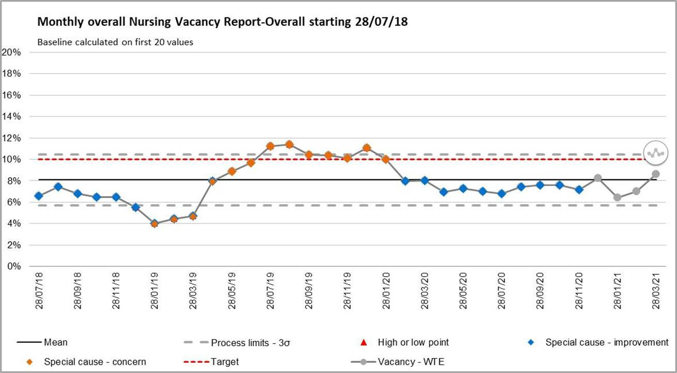

Table 1: Divisional Vacancy breakdown (information via ESR)
Division | Registered Nurse/ Midwife Vacancy Band  5/6/7 WTE | Band 4 (NA) Vacancy WTE | Band 3/2 Vacancy WTE (over recruited) | AHP  Vacancy WTE
MLTC | 6.15 | 36.63 | (20) | 0
SURGERY | 37.18 | 1.87 | (15.04) | 1.99
WCCCS | 44.54 | 0 | 10.24 | 4.84
COMMUNITY | 10.32 | 0 | 2.23 | 17.59
Total | 98.19 | 38.50 | 12.46 | 24.81

  - Overseas Recruitment

The planned cohort of overseas nurses that were arriving on the 12 April are delayed, date of arrival expected to be the beginning of May 2021 (subject to Visa and Covid-19 testing). They will start within the Trust as Band 3 staff. They are planned to attend Objective Structured Clinical Examination (OSCE) assessments within 12 weeks, depending upon OSCE testing opportunity. All cohorts will have a week induction and a half study day once per week. Pastoral care is being delivered by Team FORCE. There are a further 5 cohorts of overseas RNs arriving between June and October 2021. The total forecast is 125 overseas RN to be recruited by the end of 2021.

  - CSW Recruitment

On the 22 March 2021 there were 30 CSW staff that commenced in post after recruitment with the assistance of Walsall Housing and Walsall College. The staff have been allocated against Divisional vacancies and positions allocated by Divisional Directors of Nursing. There are a further 9 CSW’s to commence in April / May 2021. All of the candidates will be supported through a 2 week induction for fundamentals of care.

  - Nursing Associate Recruitment

There is a Cohort of 10 Nursing Associates (NA) planned for September 2021 who will be supporting plans to fill the NA vacancies within hospital ward areas. Interviews are being held within April 2021.

  - NHSI Agency Cap Breaches

NHSi Agency Cap Breaches (Chart 2) have continued to be reported weekly to NHSi and decreased on the previous month. Off framework use has been used to support ICU (264 hrs), ED (301 hrs), Ward 17 and Ward 29 (11.5 hrs each) during March.

Chart 2: Agency Cap Performance
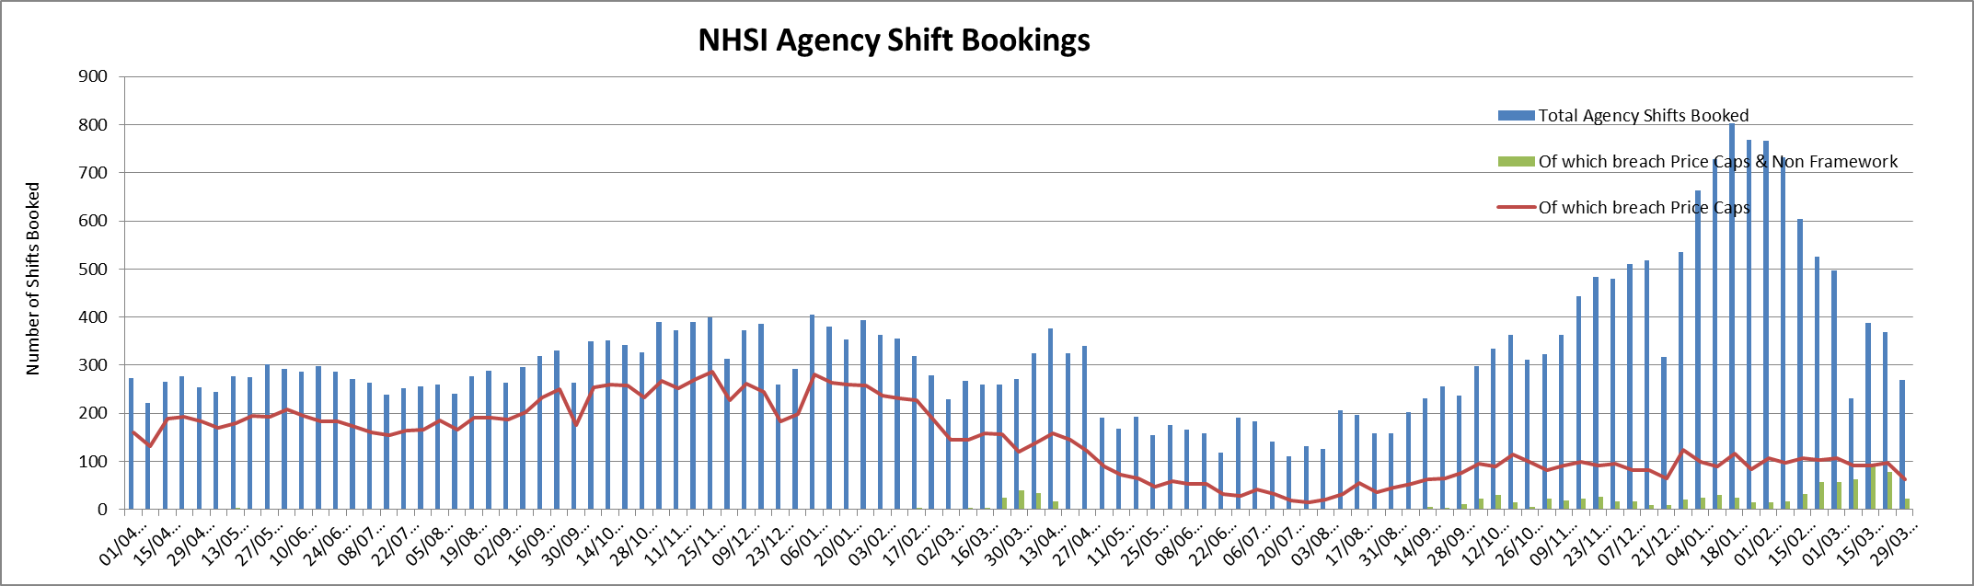

  - NHSI Model Hospital Staffing Fill Rates

Lowest fill rate was seen in the RN day shift at 93.38%% (Chart 4). The overall fill rate (combined RN and CSW) was 98%, an increase since February 2021. The redeployment of staff and temporary staffing cover has supported the maintenance of ward fill rates.

Chart 4: Ward Area Staffing Fill Rates
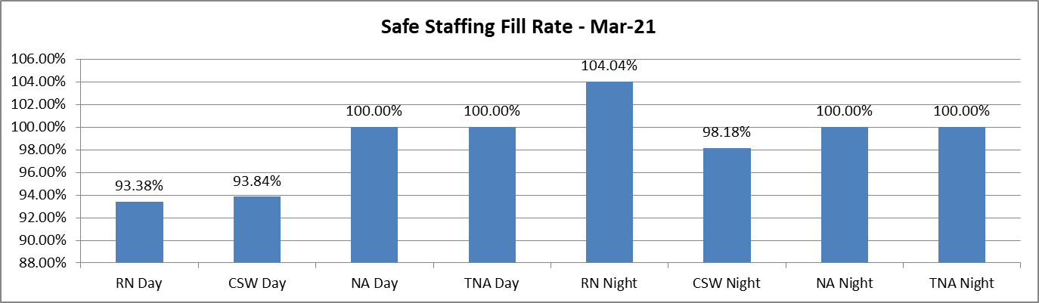

  - Staffing Hub Activities

The Staffing Hub is in place to oversee staffing levels across all areas and to facilitate the speedy escalation of issues in relation to staffing, acuity and outstanding shift demand. There is always a minimum of 72 hours forward planning of staffing visibility within the Staffing Hub. Matrons ensure that in the twice daily staffing meetings opportunities are sought to redeploy personnel where this is safe to do so. In March, within the Staffing Hub meetings, Matrons redeployed 1587 hours of RN and 498 hours of CSW.

Red Flags are recorded, reviewed and mitigated when appropriate as part of the Staffing Hub meeting. Matrons oversee the accuracy of the Red Flags recorded and their appropriateness. In March there were 174 Red Flags that were raised and 31 were resolved and mitigated against. For areas where the risk cannot be fully mitigated the Divisional Directors of Nursing are expected to ensure additional oversight and support to those areas and staff are redeployed as necessary depending on any immediate risks. A ‘deep dive’ was undertaken around the use of the 50% or more temporary RN on duty flag. When reviewing the data it is shown that the temporary staff being used consists of 88% substantive staff working on the bank.

The Community division has been providing support for the delivery of the Saddlers vaccination hub. This is monitored daily through the community division to gain assurance that this is not having an impact on the current community activity. This support has now been scaled back; however senior roles will still be supported. This will continue to be closely monitored.

  - Electronic Rostering (Eroster) Levels of Covid Related Absence

In addition to sickness absence, in the Eroster systems we have the recorded numbers of Covid-19 absence (see Table 3)

Table 3: Covid Related Absence in Erosters
Staff Type | Covid Related Absence Hours (Eroster)
RN | 3556 (increase since previous month - Feb 21)
CSW | 2310 (reduction since previous month - Feb 21)

Comparison of temporary staffing bookings for sickness and Covid-19 related absence highlights that for RN’s there was 250 hours ‘under booking’ of hours, for CSW there was 2688 hours less than the levels of absence (Table 4).

Maternity Leave bookings for CSW cover were closely aligned however for RN Maternity leave cover there were less temporary staffing requests than the level of absence in March (Table 5).

Table 4: Comparison of Sickness/Covid Absence against Temporary Staffing
Staff Type | Sum of Covid Related Absence Hours  + Sickness Absence | Temporary Staffing Hours Cover for Sickness and Covid related absence
RN | 9850 hrs (10,165 hrs last month) | 9600 hrs (variance = -250 hrs)
CSW | 7184 hrs (7,521 hrs last month) | 4496 hrs (variance = -2688 hrs)

Table 5: Comparison of Maternity/Paternity absence against Temporary Staffing
Staff Type | Maternity/Paternity Absence hrs | Temporary Staffing Hours Cover for maternity/paternity related absence
RN | 4734 | 2921 hrs (variance= -1813 hrs)
CSW | 1919 | 2170 hrs (variance= +251 hrs)

  - Allocate System Roll Out

40 departments have attended for Roster Manager in Allocate to date and have moved into the Allocate system. There are 8 remaining departments to move into Allocate from RosterPro (RPC) that receive enhancements. 50% of those are considered high risk with a plan to move over to the allocate system (ED / ED paediatrics / ED non-consultant / Ante- natal clinic). There are 6 departments yet to move into Allocate that work Monday - Friday only who do use the system for Bank temporary staffing.

The RPC system has had an extension of licence until September 2021 to accommodate further Roll out planning. Covid-19 pandemic has delayed roll out due to the inability to train clinical staff. Virtual methodologies have been tried without success so the commencement of training is being prioritised to areas that pay enhancements. ED is receiving training in April and will be live in Allocate on the 26th April.

In addition, Allocate have changed the user interface (version 11) and we therefore have to migrate from our Version 10 to Version 11 by end of May 2021 which will require further training of 1-2 days to all current Allocate Managers (40 departments).

Eroster KPI’s are being evaluated and data will be included within this report on a monthly basis. To summarise performance to date, Charts 5 and 6 demonstrate varying levels of progress. Further evaluation will be included in this report going forward following approval via Nursing Midwifery Advisory Forum (NMAF). Annual Leave headroom breaches have reduced and there are varying levels of performance with allocation of hours however; this is heavily impacted by the need to redeploy staff through rosters and the timing of that action being taken.

Chart 5: Eroster Under Allocation of Hours Char
t 6: Annual Leave breach of 14%
Under Allocation of Hours Comparison (pre/post Allocate)
700
600
500
400
300
Pre Allocate
Jan-21
200
100
0
MLTC RN MLTC CSW SURG RN SURG CSW WCCS RN WCCS CSW

3.5

Departments with AL Headroom Breaches

3
2.5

2
1.5
1
0.5
0

MLTC SURG WCCS

Pre Allocate Jan-21

  - Staff experience

Perfect ward
The corporate nursing team has been working closely with the performance team to cleanse and further develop the perfect ward audits. Within these suite of audits a monthly staff experience audit is undertaken. For March 2021 this audit scored 83%, a slight increase from the February score of 81%. 19 clinical areas completed an audit, an increase from 8 areas in February 2021.
Scores varied from 67% to 100% (Table 5). The expectation moving forward is that all clinical areas will complete the staff experience audit via the perfect ward app. Future reports will include performance by ward, division and trust. A monthly audit assurance meeting is planned to take place with divisional directors of nursing / midwifery by the Interim

Deputy Director of Nursing. Audit scores, result themes and actions taken will be discussed in these meetings.
Table 5: Staff experience audit by Ward / Department area – February 2021
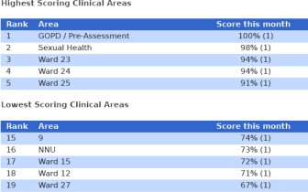

Recent paediatric mental health case
A recent admission of very complex young person with mental health who had a prolonged stay on the paediatric ward due to the lack of a suitable adolescent mental health placement, has left the ward staff traumatised by what they witnessed. This was a highly unusual case which has been reported as a serious incident and escalated to NHSe/i. In order to support staff, the following actions have been put in place:
- 2 debrief sessions have taken place, one was ran by occupational health and one has taken place in conjunction with the Mental Health Trust.
- A general ‘Support’ session with all staff invited has taken place with the assistance of occupation health, Freedom to Speak up Guardians, Human Resources and occupational health team.
- Staff have / are receiving 1:1 sessions with the mental health lead, their line managers and safeguarding leads.
- Staff were supported with occupational health.

Project Wingman on Wheels
The Project Wingman team have been taking their service mobile ‘Wingman on Wheels’ have seen the team using their galley trollies from 8.00pm throughout the night to care for our staff on the night shift handing out snacks and drinks.

MEETING OF THE PUBLIC TRUST BOARD – 6th May 2021
Work Closely with Partners |  |  |  | AGENDA ITEM: 24
Report Author and Job Title: | Ned Hobbs, Chief Operating Officer | Responsible Director: |  | Ned Hobbs, Chief Operating Officer
Action Required | Approve ☐ Discuss ☐ Inform ☒ Assure ☒
Executive Summary | This report provides an overview of the risks to delivery of the Work Closely with Partners Strategic Objective, mitigations in place to manage the risks identified, and actions identified to address gaps in controls and assurance.  The Work Closely with Partners Improvement Programme reflects the work of Divisional teams and the progression of functional integration between Acute Hospitals. This report gives a brief update on Urology, Dermatology and Radiology functional integration, and appends a list of previously completed integration work.
Recommendation | Members of the Trust Board are asked to note the contents of this report.
Does this report mitigate risk included in the BAF or Trust Risk Registers? please outline | This report addresses BAF Risk S04 Work Closely with Partners to provide positive assurance the mitigations in place to manage this risk and the related corporate risks  There are no direct corporate risks associated with Partnership working. However increased partnership working provides a mitigation to the following Corporate risks;  2066- Nursing and Midwifery Vacancies 2072- Temporary workforce
Resource implications | There are no resource implications associated with this report.
Legal and Equality and Diversity implications | There are no legal or equality & diversity implications associated with this paper.
Strategic Objectives | Safe, high quality care ☐ |  | Care at home ☐
 | Partners ☒ |  | Value colleagues ☐
 | Resources ☐

WORK CLOSELY WITH PARTNERS

- EXECUTIVE SUMMARY

COVID-19 affected the ability of the Trust to formally oversee and manage the programme of integration between Acute Hospital services. However, COVID-19 has also necessitated and accelerated significant collaboration between Trusts on many matters including mutual aid for Personal Protective Equipment, standardisation of policies in relation to the workforce, approaches to restoration and recovery planning, Critical Care mutual aid, mutual aid for the management of patients conveyed to Emergency Departments by ambulance, and shared learning to deal with a novel virus pandemic.

As a result, collaboration between Black Country Trusts is stronger due to the experience of this year. There is a clear appetite to use this opportunity to build upon those foundations and progress functional service integration where there is an opportunity to improve care for the patients we serve and/or to improve the working lives of our staff.

- BOARD ASSURANCE FRAMEWORK

The BAF risk has been reviewed and updated. The risk has been brought up to date to reflect the evidence of successful partnership working, the demonstrable progress in functional service integration in further specialties now, and to recognise the approved Strategic Collaboration between The Royal Wolverhampton NHS Trust (RWT) and Walsall Healthcare NHS Trust (WHT). Further updates incorporate:

  - The establishment of an Executive to Executive Integration oversight meeting between WHT and RWT (first meeting held 10/03/21) and agreed to be held every 4-6 weeks.
  - Black Country & West Birmingham Acute Care Collaboration Programme Board commenced March 2021.
  - New Integrated Supplies and Procurement Department (ISPD) alliance with Royal Wolverhampton NHS Trust and University Hospitals North Midlands NHS Trust commenced April 2021.
  - Introduction of shared Chair and Chief Executive Officer between the Trust and RWT.

The risk score remains at a 9 (likelihood 3 x consequence 3).

- IMPROVEMENT PROGRAMME

The Work Closely with Partners Improvement Programme reflects the work of Divisional teams and the progression of functional integration between Acute Hospital specialties to support improved patient care, and improved working lives for our people.

Urology

Trust Management Board received an update on 27th April from the Division of Surgery regarding joint proposals between RWT and WHT Urology services.

Consensus has been reached to progress to a likely Public Consultation whilst considering the full scope of the Urology Service, including emergency, elective and cancer pathways within the service across both sites.

Information has been shared between RTW and WHT to inform the scale of the current elective operating provided on each site. WHT represents 38% (n=3,644) of the elective spells in 2019/20, and 29% (n=251,080) of the operating minutes reflecting a lower complexity casemix at WHT.

A detailed 4 week audit of emergency workload for the WHT Consultant Urologist on- call is underway to establish the demand on the on-call team in the event of a joint on- call service. This in turn will inform the proposed arrangements for covering the Manor Hospital and the circumstances upon which a joint on-call team would need to provide treatment on the Manor Hospital site.

The Commissioners are confirming their expectations for the proposed model of care to be presented to the Black Country Urgent and Emergency Care Board, Black Country CCG Board and Clinical Reference Group (in parallel), followed by the Council’s Scrutiny Committee.

WHT will engage independent Consultant Urologist expertise as necessary to clinically peer review proposals, using Mr Simon Harrison, national Getting It Right First Time (GIRFT) Joint Clinical Lead for Urology as a conduit to secure such expertise.

Dermatology

The joint Dermatology Steering Group continues to meet and work is progressing well. The April meeting was postponed, but the Group next meets on 17th May 2021. The Steering Group has agreed that the structure of the two Dermatology services needs to be formalised, and an options appraisal considering the various options will be received which will assess the benefits and disbenefits of an SLA, remaining in its current form

as a Project, a Memorandum of Understanding, or a single joint service with a lead provider.

The clinical staff working across sites has been extended to 2 WHT Consultants and also now includes Specialist Trainee Registrars. The RWT Dermatology Matron is providing cross-site nursing leadership as well.

The Moh's Surgery business case has received Specialised Commissioner support and will be presented to the STP Cancer Network for the Black Country in May. Once approval has been formalised from the Cancer Network, it will be presented through the various Trust committees at RWT and WHT for formal approval.

Radiology

Pan-West Midlands Imaging Network workshops were held on 17th March 2021 and 15th April 2021, facilitated by NHSEI. A range of options were considered for configuration of collaborative Imaging Networks. Black Country & West Birmingham Chief Executive Officers have formally made the case for a configuration that includes a Black Country & West Birmingham business unit of the wider West Midlands network. However, the NHSEI regional leadership team have recommended implementation of option 3, a single West Midlands network with 2 business units (North and South).

The first West Midlands Imaging Network shadow Board meeting is scheduled for 11th May 2020 and Ned Hobbs, Chief Operating Officer, will be the Trust’s lead representative, with Dr Matthew Lewis, Medical Director, as his deputy.

- RECOMMENDATIONS

Members of the Trust Board are asked to note the contents of this report.

APPENDICES

- List of secondary care partnership integration already delivered
- BAF SO3

APPENDIX 1

List of secondary care partnership integration already delivered

Recently integrated/networked services
ENT Consultant on-call rota with RWT and DGFT Sentinel Lymph Node Biopsy pathway with DGFT
Integrated Supplies and Procurement Department (ISPD) alliance with RWT and University Hospitals North Midlands NHS Trust
Offer of Colorectal Cancer Surgery capacity to other BCWB ICS partners Black Country Pathology Service with RWT, DGFT and SWBH
Payroll with RWT
Clinical Fellowship programme with RWT International Nurse recruitment programme with RWT

Historically integrated/networked services
Cardiology with RWT Renal with RWT Ophthalmology with RWT
Oral and Maxillofacial Surgery with RWT Oncology with UHB
Neurology with UHB
Hyper Acute Stroke with RWT Vascular Surgery with DGFT and RWT Haematology with RWT

Latest Board/Committee - 01/04/2021 Version V0.01
Public Trust Board – 6th May 2021 Item 24, Appendix 2
Risk Summary
BAF Strategic Objective Reference & Summary Tile: | BAF SO 03 – Work Closely with Partners; We will deliver sustainable best practice in secondary care, through working with partners across the Black Country and West Birmingham System.
Risk Description: | Failure to integrate functional and organisational form change within the Black Country will result in lack of resilience in workforce and clinical services, potentially damaging the trust’s ability to deliver sustainable high quality care.
Lead Director: | Chief Operating Officer.
Lead Committee: | Performance, Finance, & Investment Committee.
Links to Corporate Risk Register: | Title: |  |  |  |  |  |  | Current Risk Score Movement:
 | - There are no direct corporate risks associated with Partnership working. However increased partnership working provides a mitigation to the following Corporate risks;  § 2066 - Nursing and Midwifery Vacancies,  § 2072 - Temporary workforce. |  |  |  |  |  |  | ↔
Risk Scoring
Quarter: | Q1 (2021) | Q2 | Q3 | Q4 (2020) | Rational for Risk Level: | Target Risk Level (Risk Appetite): |  | Target Date:
Likelihood: |  |  |  | 3 | - This risk has been reduced to moderate due to the advancement of a number of key work streams.  § Executive group established across provider organisations to review opportunities for collaboration.  § Success of Black Country Pathology Service (BCPS).  § Transfer of WHT payroll service to RWT.  § Advanced collaboration in Dermatology including appointment of joint clinical director, and cross-site working of Consultant Dermatologists.  § Advanced discussions in Urology including cross site working.  § Integrated ENT on-call rota in place.  § Initial discussions re: bariatric services and radiology.  § STP Clinical Leadership Group, relevant restoration and recovery groups and relevant network collaboration continue to drive | Likelihood: | 2
Consequence: |  |  |  | 3 |  | Consequence: | 2
 |  |  |  |  |  |  |  | Q2 2021/22
Risk Level: |  |  |  | 9  Moderate |  | Risk Level: | 4  Low | Subject to assurance on and approval of Urology integration plan.

Page 1 of 3

Clinical Strategy.
§ Shared Clinical Fellowship Programme agreed with RWT, and first round of appointments made.
§ New Integrated Supplies and Procurement Department (ISPD) alliance with Royal Wolverhampton NHS Trust and University Hospitals North Midlands NHS Trust commencing April 2021.
However, despite progress despite progress, integration plans are not yet fully implemented and the sustainability of the Urology service and current medical staffing vacancies prevent the score being reduced further at this stage.
Control & Assurance Framework - 3 Lines of Defence
 | 1st Line of Defence |  |  |  | 2nd Line of Defence | 3rd Line of Defence
Controls: | - Sustainability review process completed.  - Regular oversight through the Board and its sub committees.  - Improvement Programme to progress clinical pathway redesign with partner organisations.  - Executive to Executive Integration oversight meeting established between WHT and RWT (first meeting held 10/03/21) and agreed to be held every 4-6 weeks.  - Black Country & West Birmingham Acute Care Collaboration Programme  Board established March 2021. |  |  |  | - Public Trust Board approved Strategic Collaboration between The Royal Wolverhampton NHS Trust and Walsall Healthcare NHS Trust at February Board meetings, and approved a Memorandum of Understanding at March Board meetings. | - Third line of control NHSE/I regulatory oversight.  - Black Country and West Birmingham STP plan and governance processes in place.
Gaps in Controls: | - Lack of co-alignment by our organisation and all neighbouring trusts.  - Lack of formal integration at Trust level across all four BCWB Acute Trusts.  - Mandated arrangements by regional networks.
Assurance: | - Track record of functional integration of clinical services including hyper acute stroke, vascular surgery, cardiology, rheumatology, ophthalmology, neurology, oncology, Black Country Pathology Service and OMFS. |  |  |  | - Demonstrable evidence of recent functional integration in ENT, Urology and Dermatology and with the clinical fellowship programme.  - Emerging commitment from BCWB Acute Collaboration partners to more formalised collaborative working.  - Audit Committee has oversight of partnership working within its terms of reference. | - Progress overseen nationally and locally.

 |  |  | - System Review Meetings providing assurance to regulators on progress.
Gaps in Assurance: |  | - Clinical strategy is still emerging.  - Additional pressures with Covid-19 have delayed acute collaboration, and organisational capacity is concentrated on managing the second and third waves of the pandemic.  - Limited independent assessment of integrated services or collaborative working arrangements.  - Embryonic independent evidence-base for successful collaborations to assess progress against.
Future Opportunities
- Consolidate other services, including back office functions.
- Collaborate with partner organisations outside the Black Country Acute Trusts, including community and third sector organisations.
- Promote Walsall as an STP hub for selected, well-established services.
- Collaborative working during COVID-19 presents an opportunity to accelerate some elements of clinical pathway redesign.
- Shared Chair with RWT creates opportunities to accelerate bilateral collaboration where applicable.
Future Risks
- Conflicting priorities and leadership capacity to deliver required changes.
- STP level governance does not yet have statutory powers.
- Lack of engagement/involvement with the wider public.
- Acute Hospital Collaboration may not progress at the anticipated pace due to the resurgence of COVID-19 coinciding with a challenging winter.
- Disrupted relationships with neighbouring trusts due to altered visions of the form and pace of future collaboration.
Future Actions (to further reduce the Likelihood / Consequence of the risk in order to achieve the Target Risk Level in line with the Risk Appetite)
No. | Action Required: |  | Executive Lead: | Due Date: | Progress Report: |  | BRAG:
1. | Keep abreast of Trust Acute collaboration discussions and updates accordingly. |  | G. Augustine | Dec 2020 | Complete - Trust Board endorsed the benefits of BCWB Trust collaboration for the population of Walsall
2. | Develop over-arching programme plan to support individual projects for each phase (Phase 1, emergencies, Phase 2, Elective/Cancer work). |  | Programme Manager | Dec 2020 | Delayed due to resurgence of Covid-19. To be incorporated into re-phased Improvement Programme Plan for June 2021.
4. | Assess resource requirement to support Imaging Network programme |  | G Augustine & N Hobbs | Feb 2021 | Delayed due to resurgence of Covid-19. To be discussed at Black Country wide working group in April 2021.
5. | Approve Urology integration plan through QPES, PFIC and Trust Board (if applicable) |  | N Hobbs | June 2021 | Trust Management Board received proposal on 9th March setting out engagement and Consultation requirements to enable approval.

MEETING OF THE PUBLIC TRUST BOARD – 6th May 2021
Audit Committee Highlight Report |  |  | AGENDA ITEM: 25
Report Author and Job Title: | Trish Mills Trust Secretary | Responsible Director: | Mrs Mary Martin, Chair of Audit Committee (Non-Executive Director)
Action Required | Approve ☒ Discuss ☒ Inform ☒ Assure ☒
Executive Summary | This report provides the key messages from the Audit Committee meeting on 26th April 2021. The report sets out escalations for the attention of the Trust Board, and key issues discussed and work underway.  - The Internal Auditors presented the following audit reports and the Committee will continue to monitor progress against recommendations raised for:  - Compliance with the Attendance at Work Policy Review  - Board Assurance Framework and Risk Management Follow up Review  - Risk management review  - Walsall Together Review  - Core Financial Controls Review  - Temporary Nurse Staffing Review  - The Committee agreed a process whereby the Committee would approve deferrals or changes to the internal audit plan between meetings.  - Four planned Internal Audit Reviews have had to be cancelled. This has been the result of significant slippage in delivery of the audit plan caused by over-runs on other reviews. Trust staff have missed agreed deadlines for providing information and are slow to respond to emails which has partly been caused by the effect of the Pandemic on normal Trust working arrangements. These reviews will be considered for the 2021/22 annual plan.  - The Internal Auditors indicated that they expected their Annual

Internal Audit opinion to be a Partial Assurance opinion which is the same as last year but they did acknowledge that improvements have been made.

- The Committee noted a number of the internal audit recommendations were overdue, and requested that these were closed by the next scheduled meeting. The Executive owner of any recommendations rated ‘high’ that remains overdue will be in attendance at that meeting to discuss revised action plans.

- The 2021/22 Internal audit plan is still to be agreed. A draft plan has been shared with the committee and discussed by all the NEDs and should be finalised within the next two weeks.

- The External audit work is on track with no significant issues raised at this point.

- The reporting regime and targets for increased declarations of interest of decision making staff in the Trust were approved.

- The approach to 2020/21 effectiveness reviews for Board Committees was approved and they will commence in July.

The next meeting of the Audit Committee will be held in May 2021.
Recommendation | Members of the Trust Board are asked to note the report and escalations
Does this report mitigate risk included in the BAF or Trust Risk Registers? please outline | Audit Committee is essential to Trust Board managing risk across the organisation.
Resource implications | Poor internal control and/or management of risk would almost certainly result in financial loss.
Legal and Equality and Diversity implications | There are no legal or equality & diversity implications associated with this paper.

Strategic Objectives | Safe, high quality care ☒ | Care at home ☒
 | Partners ☒ | Value colleagues ☒
 | Resources ☒

