AGENDA
MEETING OF THE PUBLIC TRUST BOARD
Held in public on Thursday 1st April 2021from 10.30am to 3.15pm
Meeting held virtually via Microsoft Teams

# | Agenda Item | Purpose | Lead | Format | Time
OPENING ITEMS
1. | Chair’s welcome; apologies and confirmation  of quorum | Inform | Steve Field | Verbal | 10.30
2. | Declarations of interest | Inform | Steve Field | Enclosure | 10.30
3. | Minutes of last meeting | Approve | Steve Field | Enclosure | 10.30
4. | Matters arising and action log | Review | Steve Field | Enclosure | 10.35
5. | Nolan Principles | Inform | Steve Field | Enclosure | 10.40
6. | Trust Values | Inform | Daren Fradgley | Enclosure | 10.45
7. | Chief Executive’s Report | Inform | Daren Fradgley | Enclosure | 10.55
8. | COVID-19 BAF Risk | Assure | Daren Fradgley | Enclosure | 11.05
PATIENT STORY
9. | Baby Leo | Inform | Introduced by Ann- Marie Riley | Video | 11.10
PROVIDE SAFE, HIGH QUALITY CARE
10. | Quality, Patient Experience and Safety Committee Report | Assure Inform | Pamela Bradbury | Enclosure | 11.25
11. | Safe High Quality Care Executive Report  (incorporating Board Assurance Framework, Performance, and Improvement Programme) | Assure Inform | Matthew Lewis Ann-Marie Riley | Enclosure | 11.30
USE RESOURCES WELL
12. | Performance, Finance and Investment Committee Report | Assure Inform | John Dunn | Enclosure | 11.45
13. | Use Resources Well Executive Report (incorporating Board Assurance Framework,  Performance, and Improvement Programme) | Assure Inform | Ned Hobbs Russell Caldicott | Enclosure | 11.50
CARE AT HOME
14. | Walsall Together Partnership Board Report | Assure  Inform | Anne Baines | Enclosure | 12.10
15. | Care at Home Executive Report  (incorporating Board Assurance Framework, Performance, and Improvement Programme) | Assure Inform | Matthew Dodd | Enclosure | 12.15
12.30 – 1.00 COMFORT BREAK
STAFF STORY
16. | Critical Care Staff Story  https://youtu.be/csLeKYIruvA | Inform | Introduced by Ned Hobbs | Verbal | 1.00
VALUE OUR COLLEAGUES
17. | People and Organisational Development Committee Report | Assure Inform | Junior Hemans | Enclosure | 1.15

# | Agenda Item | Purpose | Lead | Format | Time
18. | Value Our Colleagues Executive Report (incorporating Board Assurance Framework,  Performance, and Improvement Programme) | Assure Inform | Catherine Griffiths | Enclosure | 1.20
19. | Staff Survey | Assure | Catherine Griffiths | Enclosure | 1.35
20. | Freedom to Speak Up Quarterly Report | Assure | Val Ferguson Kim Sterling | Enclosure | 1.45
21. | Guardian Of Safe Working Quarterly Report | Assure | Matthew Lewis presenting | Enclosure | 1.55
22. | Establishment Review | Approve | Ann-Marie Riley | Enclosure | 2.05
23. | Safe Staffing Report | Assure | Ann-Marie Riley | Enclosure | 2.15
WORK CLOSELY WITH PARTNERS
24. | Work Closely with Partners Executive Report (incorporating Board Assurance Framework  and Improvement Programme) | Assure Inform | Ned Hobbs | Enclosure | 2.25
CHARITY
25. | Charitable Funds Committee Report | Assure Inform | Paul Assinder | Enclosure | 2.35
GOVERNANCE AND WELL LED
26. | Audit Committee Report | Assure Inform | John Dunn | Verbal | 2.40
27. | Board Assurance Framework Q3 | Approve | Jenna Davies | Enclosure | 2.45
CLOSING ITEMS
28. | Any other business:  (a) Maternity Services Business Case | Approve | Ann-Marie Riley | Enclosure | 2.55
29. | Any other business | Discuss | Steve Field | Verbal | 3.10
30. | Questions from the Public | Discuss | Steve Field | Verbal | 3.10
DATE AND TIME OF NEXT MEETING
Thursday 6th May 2021
EXCLUSION OF THE PRESS AND MEMBERS OF THE PUBLIC
Exclusion to the Public – To invite the Press and Public to leave the meeting because of the confidential nature of the business about to be transacted (pursuant to Section 1(2) of the Public Bodies (Admission to
Meetings) Act 1960).

Lead Presenters

Name of Lead | Position of Lead
Prof. Steve Field | Chair of Trust Board
Mr John Dunn | Vice Chair of Trust Board; Chair of Performance, Finance and Investment Committee
Mrs Pamela Bradbury | Non-Executive Director; Chair of Quality, Patient Experience and Safety Committee
Mrs Anne Baines | Non-Executive Director; Chair of Walsall Together Partnership Board
Mr Junior Hemans | Non-Executive Director; Chair of People and Organisational Development Committee
Mr Daren Fradgley | Acting Chief Executive Officer

Name of Lead | Position of Lead
Dr Matthew Lewis | Medical Director
Ms Ann-Marie Riley | Director of Nursing
Mr Russell Caldicott | Director of Finance and Performance
Ms Catherine Griffiths | Director of People and Culture
Mr Ned Hobbs | Chief Operating Officers
Ms Jenna Davies | Director of Governance
Ms Val Ferguson | Freedom to Speak Up Guardian
Ms Kim Sterling | Freedom to Speak Up Guardian


1

MEETING OF THE PUBLIC TRUST BOARD – 1st April 2021
Declarations of Interest |  |  |  | AGENDA ITEM: 2
Report Author and Job Title: | Trish Mills Trust Secretary | Responsible Director: |  | Steve Field, Trust Board Chair
Action Required | Approve ☐ Discuss ☐ Inform ☐ Assure ☒
Executive Summary | The report presents a Register of Directors’ interests to reflect the interests of the Trust Board members.  The register is available to the public and to the Trust’s internal and external auditors, and is published on the Trust’s website to ensure both transparency and also compliance with the Information Commissioner’s Office Publication Scheme.
Recommendation | Members of the Trust Board are asked to note the report
Does this report mitigate risk included in the BAF or Trust Risk Registers? please outline | There are no risk implications associated with this report.
Resource implications | There are no resource implications associated with this report.
Legal and Equality and Diversity implications | It’s fundamental that staff at the Trust are transparent and adhere to both our local policy and guidance set out by NHS England and declare any appropriate conflicts of interest against the clearly defined rules.
Strategic Objectives | Safe, high quality care ☒ |  | Care at home ☒
Strategic Objectives | Partners ☒ |  | Value colleagues ☒
Strategic Objectives | Resources ☒

Name | Position held in Trust | Description of Interest
Professor Steve Field | Chair | Chair: Royal Wolverhampton NHS Trust
Professor Steve Field | Chair | Director: EJC Associates
Professor Steve Field | Chair | Trustee for Charity: Pathway Healthcare for Homeless People
Professor Steve Field | Chair | Trustee: Nishkam Healthcare Trust  Birmingham
Professor Steve Field | Chair | Honorary Professor: University of Warwick
Professor Steve Field | Chair | Honorary Professor: University of Birmingham
Mr John Dunn | Vice Chair  Non-executive Director | Non-Executive Director, Royal Wolverhampton  NHS Trust
Mrs Anne Baines | Non-executive Director | Director/Consultant at Middlefield Two Ltd
Mrs Anne Baines | Non-executive Director | Associate Consultant at Provex Solutions Ltd
Ms Pamela Bradbury | Non-executive Director | Dudley Group Foundation Trust – COVID-19 vaccination bank
Ms Pamela Bradbury | Non-executive Director | Partner, Dr George Solomon is a Non- Executive Director at Dudley Integrated Health  and Care Trust
Mr Ben Diamond | Non-executive Director | Director of the Aerial Business Ltd.
Mr Ben Diamond | Non-executive Director | Volunteer at Gracewell of Sutton Coldfield Care Home
Mr Ben Diamond | Non-executive Director | Partner - Registered nurse and General  Manager at Gracewell of Sutton Coldfield Care Home
Mr Ben Diamond | Non-executive Director | Volunteer Vaccinator with St John's Ambulance
Mr Junior Hemans | Non-executive Director | Non-executive Director - Royal Wolverhampton NHS Trust
Mr Junior Hemans | Non-executive Director | Visiting Lecturer – University of Wolverhampton
Mr Junior Hemans | Non-executive Director | Director – Libran Enterprises (2011) Ltd
Mr Junior Hemans | Non-executive Director | Chair/Director - Wolverhampton African Caribbean Resource Centre
Mr Junior Hemans | Non-executive Director | Chair - Tuntum Housing Association (Nottingham)
Mr Junior Hemans | Non-executive Director | Company Secretary – The Kairos Experience Ltd.
Mr Junior Hemans | Non-executive Director | Member – Labour Party
Mr Junior Hemans | Non-executive Director | Mentor – Prince’s Trust
Mr Paul  Assinder | Associate Non-  executive Director | Chief Executive Officer - Dudley Integrated  Health & Care Trust


3

Name | Position held in Trust | Description of Interest
 |  | Director of Rodborough Consultancy Ltd.
Governor of Solihull College & University
Centre
Honorary Lecturer, University of
Wolverhampton
 |  | Associate of Provex Solutions Ltd.
Mr Rajpal  Virdee | Associate Non-  executive Director | Lay Member, Employment Tribunal  Birmingham
Mrs Sally Rowe | Associate Non- Executive | Executive Director Children’s Services -  Walsall MBC
Mrs Sally Rowe | Associate Non- Executive | Trustee of the Association of Directors of  Children’s Services
Mr Daren Fradgley | Acting Chief Executive from 1 February 2021 Director of Integration | Director of Oaklands Management Company
Mr Daren Fradgley |  | Spouse, Helen Willan, is Systems Manager at West Midlands Ambulance Service
Mr Daren Fradgley |  | Clinical Adviser NHS 111/Out of Hours
Mr Daren Fradgley |  | Non-Executive Director at whg
Mr Russell Caldicott | Director of Finance and Performance | Member of the Executive for the West Midlands Healthcare Financial Management Association  (HFMA)
Dr Matthew Lewis | Medical Director | Spouse, Dr Anne Lewis, is a partner in general  practice at the Oaks Medical, Great Barr
Dr Matthew Lewis | Medical Director | Director of Dr MJV Lewis Private Practice Ltd.
Ms Jenna  Davies | Director of Governance | No Interests to declare.
Ms Catherine  Griffiths | Director of People and  Culture | Catherine Griffiths Consultancy ltd
Ms Catherine  Griffiths | Director of People and  Culture | Chartered Institute of Personnel (CIPD)
Mr Ned Hobbs | Chief Operating Officer | Father – Governor Oxford Health FT
Mr Ned Hobbs | Chief Operating Officer | Sister in Law – Head of Specialist Services St  Giles Hospice
Ms Ann-Marie  Riley | Interim Director of  Nursing | No interests to declare
Ms Glenda  Augustine | Director of Performance  & Improvement | No interests to declare
Mr Matthew Dodd | Acting Director of Integration | No interests to declare

RECOMMENDATIONS

The Board is asked to note the report

MEETING OF THE PUBLIC TRUST BOARD HELD ON THURSDAY, 4TH MARCH 2021 AT 10.30AM
HELD VIRTUALLY VIA MICROSOFT TEAMS

PRESENT

Members
Prof Steve Field Chair of the Board of Directors
Mr John Dunn Non-Executive Director; Vice Chair, Board of Directors
Mrs Anne Baines Non-Executive Director Mrs Pamela Bradbury Non-Executive Director Mr Ben Diamond Non-Executive Director
Mr Junior Hemans Non-Executive Director
Mr Paul Assinder Associate Non-Executive Director
Mrs Sally Rowe Associate Non-Executive Director
Mr Daren Fradgley Acting Chief Executive Officer
Dr Matthew Lewis Medical Director
Ms Ann-Marie Riley Director of Nursing
Mr Russell Caldicott Director of Finance and Performance Mr Ned Hobbs Chief Operating Officer
Ms Catherine Griffiths Director of People and Culture Ms Jenna Davies Director of Governance
Mrs Glenda Augustine Director of Planning and Improvement Mr Matthew Dodd Acting Director of Integration
Mr Rajpal Virdee Associate Non-Executive Director (attended from 13.15 to
13.50)

In attendance
Mrs Trish Mills Trust Secretary Ms Carla Jones-Charles Head of Midwifery
Mr Fateh Ghazal Consultant, Obstetrics and Gynaecology
Ms Jane Wilson Staff Side
Mr Keith Wilshere Trust Secretary, Royal Wolverhampton NHS Trust
Mr Mike Sharon Strategic Advisor to the Board, Royal Wolverhampton NHS
Trust
Ms Balbir Seimar Chief Community Engagement WASUP Ambassador Ms Alison Nunney Advanced Occupation Therapist, Stafford ESD and
Community Stroke Service
Mr Nakash Lewis Walsall Together
Ms Kim Sterling Freedom to Speak Up Guardian
Ms Roseanne Crossley Head of Business Development and Planning Mr Parmjit Chera-Japper Wellbeing Business & Project Manager, HR
Ms Karen Kiteley Community Outreach Lead Healthwatch Walsall

Apologies
Mr Rajpal Virdee Associate Non-Executive Director (apologies until 13.15)

185/20 | Welcome, Apologies and Confirmation of Quorum
 | Prof Field welcomed everyone to his first meeting of the Board as Chair and thanked members of the public and staff for their attendance in the meeting as observers, as well as welcoming Board members. The meeting was declared quorate and apologies for absence noted as above.

Prof Field began by stating the Trust’s vision which is ‘Caring for Walsall together’, which reflects our ambition for safe integrated care, delivered in partnership with social care, mental health, public health and associated charitable and community organisations. The Trust’s values of respect, compassion, professionalism and teamwork, which we strive to be present in all we do, enable us to deliver the vision through our five strategic objectives of:
- Provide safe high quality care – delivering excellent quality of care as measured by an outstanding CQC rating by 2022
- Care at home – hosting the integration of Walsall together partners, addressing health inequalities and delivering care closer to home
- Work closely with partners – delivering sustainable best practice in secondary care, through working with partners across the Black Country and West Birmingham system
- Value our colleagues – being an inclusive organisation which lives our organisational values without exception
- Use resources well – delivering optimum value by using our resources efficiently and responsibly.

Prof Field emphasised to the public and all who work in the Trust that its Directors adhere to the Seven Principles of Public Life (the Nolan Principles) of selflessness, integrity, objectivity, accountability, openness, honesty and leadership.
186/20 | Declarations of Interest
 | The register of interests was received by the Board, and the Chair noted that he is the Chair of the Royal Wolverhampton NHS Trust, and that Mr Dunn and Mr Hemans are Non-Executive Directors at the Royal Wolverhampton NHS Trust to encourage and facilitate joint working across the two organisations. He encouraged members to declare interests at specific agenda items where relevant.
187/20 | Minutes of Last Meeting
 | The minutes of the meeting on 4th February 2021 were approved as a true record.
188/20 | Matters Arising and Action Log
 | The Board received the action log and noted the completed items for closure, and those proposed for closure. There were no matters arising from the previous meeting that were not otherwise on the agenda or in the action log.
189/20 | Chief Executive’s Report
Mr Fradgley, Acting Chief Executive, presented his report, noting that it has been 12 months since the first COVID-19 positive patient at the Trust, and set out the significant pressures and challenges faced by staff during that time. He noted that a reduction in community infection rates had been sustained, translating into reduced occupancy of COVID-19 positive inpatients. Whilst there had been a reduction in Critical Care at the Manor Hospital it was still the most occupied site in the Strategic Transformation Partnership (STP).

Mr Fradgley thanked the local authority for their coordination of the testing for the South African variant in the community, noting that this had not materialised

beyond two cases.

He emphasised that the legacy of COVID-19 felt by staff will take a significant time and effort to deal with, and that the Executive team are working closely with the STP and the Royal Wolverhampton NHS Trust to ensure psychological effects are a focus during restoration and recovery. Communication to staff on this has increased, as has Executive visibility in meetings and visits.

Mr Fradgley advised that engagement will now commence with staff on the staff survey results of which there has been early sight. He noted that whilst some improvements have been made, there are cultural changes that need to embed to drive real improvement. The People and Organisational Development Committee will receive further details on the staff survey in March, and the Board in April.

Mrs Bradbury enquired about how the Board Committees would be sighted as to where decisions are made on service redesign and/or prioritisation of services as part of the Care at Home workstream and Walsall Together, and whether the quality impact assessments would come to the Quality, Patient Experience and Safety Committee. Mr Fradgley responded that the services referenced in his report – diabetes service and care homes – are both on the corporate risk registers that feed through to Board Committees. Nonetheless he noted that the wider governance issues form part of the Integrated Care Provider (ICP) programme of work, oversight of which is at the Walsall Together Partnership Board, however he welcomed Board Committee Chairs involvement in mapping that governance going forward.

Mr Assinder queried how, given the recent budget announcement, the Trust will ensure that it maintains its excellent investment in community care. Mr Fradgley responded that the Executive is looking in particular at how better use can be made of the current investments, and ensuring current and additional investments are explicit about the health inequalities they will address in an integrated way. Key to this will be retaining and building upon the learning from COVID-19 and the ways in which the pandemic has allowed us to make swift and effective changes we want to retain. Mrs Baines indicated that the focus of the model of care should be on keeping people as close to home as possible, and that pathways should have that as their key objective. Mr Caldicott added that the Improvement Programme will be the vehicle through which efficiencies are delivered and the Performance, Finance and Investment Committee with monitor the development of the business plan and prioritisation of the programme.
Action 189/20: Invitation extended to Board Committee Chairs for involvement in the mapping of the ICP governance, particularly as it relates to cross-committee sharing of information and assurance.
190/20 | Improvement Programme Prioritisation
 | Mrs Augustine presented an update on the Improvement Programme, including a summary review of the annual and phased delivery of projects in each workstream and a proposal for future, automated reporting of programme delivery. The Board

noted that 19 of the 121 Improvement Programme projects were paused due to COVID-19, and that to date it has not been possible to quantify the impact on programme efficiencies resulting from the project pause. Despite this each workstream had demonstrated significant benefits, including changes to the outpatients clinic; electronic patient record implementation; equality, diversity inclusion strategy development; and the Trust’s ranking as second nationally for same day emergency care. Mr Fradgley noted that the pandemic has provided opportunities for projects to accelerate and transform, including medically stable for discharge.

The Board noted that the national deferral of operational plan submissions for 2021/22 to the first Quarter of 2021/22 has given the Trust the opportunity to validate the delivery of the efficiency savings for 2020/21 at the end of the financial year, and refresh plans accordingly. This, and the stretch opportunity assessments, will be reported into the Performance, Finance and Investment Committee and thereafter into Board.

Mr Dunn commended the team for the discipline on reporting and progress, and for transparency of the programme. He requested that the programme is relaunched with focused targets for the remainder of the year. This should include greater visibility of all four parts of the balanced scorecard – people; quality; finance and performance – and how the Improvement Programme will integrate with the 2021/22 roll-out of annual objectives. It was agreed that this will come back to the Board, together with details of stretch targets.

Prof Field urged creative thinking in the Improvement Programme, particularly where technology could be harnessed to transform services. He challenged the executive to be even more ambitious when it came to children and adult social care, and any effect on transfers of resources to achieve this, both human and financial. Lastly, he looked to ensure that a unified response was sought with general medical practice in Walsall Together to strengthen those links.

Action 190/20: Details of Improvement Programme integration with 2021/22 roll- out of annual objectives and stretch targets to return to the Board.
PROVIDE SAFE, HIGH QUALITY CARE
191/20 | Quality, Patient Experience and Safety Committee Report
Mrs Bradbury, Chair of the Quality, Patient Experience and Safety Committee presented the highlight report from the Committee’s meeting on 25th February 2021, noting the following:

- The Committee’s discussion focused on the Board Assurance Framework for Safe, High Quality Care, and in particular the Committee was assured that a process is in place to complete the 2019 and 2020 must do and should do actions from CQC. Data capture for dementia screening will be reviewed to ensure the trends are accurate; and further the work to introduce a mechanism
in the electronic patient record to capture venous thromboembolism (VTE)

assessment is underway to improve performance. The Trust continues to fall short of the 95% target for VTE assessment.
- On 19th February the members of the Committee, along with the wider Board, attended a development session on the Ockenden Report. .
- The Committee has asked the Walsall Together Partnership Board to look at primary care referrals into secondary care, which are currently down by 40%, so that any impact on that increasing over the coming months can be factored into restoration and recovery.
- The importance of ensuring the quality impact assessment process was reviewed by the Committee at its March meeting was stressed by the Chair.
- The Committee were asked by the Performance, Finance and Investment Committee to look at the clinical harm review process for patients on the 52 week wait list. The Committee were assured that clinical harm reviews were being appropriately managed and a process was in place to assess patients, to monitor clinical harm and to learn from such assessments.
192/20 | Safe, High Quality Care Executive Report
Mrs Riley and Dr Lewis presented the Safe, High Quality Care report, which included the Board Assurance Framework strategic risk for this objective, Improvement Programme workstream and performance dashboard and data.

Mrs Riled informed the Board that 32 policies aligned to the Safe, High Quality Care workstream remain out of date, with the plan to have them updated by the end of Q1 2021/22.

The Board were informed that Mrs Riley was investigating the fluctuations in dementia screening performance to determine if they are as a result of performance issues or the need to drive the right behaviours with this metric. The Quality, Patient Experience and Safety Committee will receive the results of this in March.

Dr Lewis informed the Board that the most recent figure for VTE assessment for February is 91.9% which is better than it has been since July 2020, but still below the target of 95% and below the trajectory for recovery agreed with the Clinical Commissioning Group (CCG). The Board noted that a number of process changes had been made including the addition of Vvitalpac to the electronic patient record in September. Dr Lewis continues to press for enhanced performance from doctors at the time of clerking patients, and will continue to stress this and communicate the message in various forums.

Mental Capacity Act (MCA) assessment compliance is below the Trust’s standards. Steps taken to address this include the implementation of ReSPECT (Recommended Summary Plan for Emergency Care and Treatment) forms on 1st January 2021 and further education relating to MCA assessments. MCA Champions have been appointed to ward areas. Audit data collection has improved through a revised process, led by the Safeguarding Team, and further
work is ongoing to build the MCA assessment and ReSPECT forms into the

electronic patient record to mandate full assessments.

Dr Lewis highlighted that sepsis performance does not provide assurance the Trust is meeting the standards required of it. The action plan for CQC includes a sepsis nurse in the Emergency Department, and an e-sepsis module in the electronic patient record from which we can review data on a live dashboard. The Board were informed that the next steps in the action plan were to better understand the data coming through the dashboard to gain assurance on quality and impact. A clinical senate will be held on 16th March with a multi-disciplinary focus on sepsis management.

Prof Field commended the highlight report and the report from Dr Lewis and Mrs Riley for drawing out points of assurance. He remains concerned however with respect to VTE and sepsis, and urged improvement at pace. It was agreed that he and Dr Lewis would have discussions outside of the meeting when more time allowed for him to understand in more granularity these and the MCA issues.

Action 192/20: Prof Field and Dr Lewis to meet to discuss issues of concern with VTE and sepsis.
193/20 | Ockenden Report Update
Ms Jones-Charles and Mr Ghazal presented the Ockenden Report update and self- assessment. Both Ms Jones-Charles and Mr Ghazal noted that their action plans and work have been strengthened by the mutual support that partnership working with Shrewsbury and Telford, and the Royal Wolverhampton NHS Trust has brought, acknowledging also the assistance of external consultants.

Prof Field noted that a maternity report would be regularly received at the Quality, Patient Experience and Safety Committee and the Board. These reports would encompass the actions required of the Trust in line with the Ockenden Report but would report more broadly on maternity and neonatal care. He indicated that the feedback from the Board development session in February and from the Quality, Patient Experience and Safety Committee indicated a clearer and more optimistic position than the written document before the Board. It was therefore agreed to bring a revised assurance paper in April. Mr Dunn sought to have that as a simplified paper to allow the Board and the people of Walsall to see the assurance against the seven actions, showing progress; completion of actions; outstanding actions; those accountable for the actions; partnership working; and how we compare with others.

Mr Fradgley thanks Ms Jones-Charles and Mr Ghazal for their presentation.

Action 193/20: The maternity report, particularly as it relates to the Ockenden Report actions, be simplified to show progress against the actions, including those complete and outstanding; accountability for actions; partnership working; and how the Trust compares to others.
194/20 | Mortality Report

Dr Lewis presented the Mortality Report for Quarter 3 2020/21. The report indicates that in the last quarter there were 465 deaths at the Trust. A structured judgement review (SJR) has been raised for 88 deaths with 47 having been completed, with 3 where care has been classed as level 3a or below. Resources have been added to support SJRs, including the temporary recruitment of senior retired consultant physcians. Dr Lewis noted that deaths during COVID-19 have been higher, and the next report will look in more detail at the non COVID-19 deaths and whether patients with other conditions have been disadvantaged through the pandemic.

For the year to date as assessed by SJR level 1 review, death was not avoidable or probably not avoidable in 91.8% of SJR’s completed, probably avoidable in in 5.2%, and avoidable in 3%.

Learning from deaths is part of the Safe High Quality Care Improvement Programme, with learning monitored via the Mortality Surveillance Group. Dr Lewis advised that through the learning from deaths process, the Trust has seen:
- Reduced monthly Standard Hospital Mortality Index (SHMI) since April 2020
- Reduced mortality rates from fractured neck of femur until October 2020, with a potential impact of COVID-19 noted subsequently
- No further serious incidents associated with deaths from delays in the lung cancer pathway
- Implementation of the electronic patient record e-Sepsis module to recognise, escalate and respond faster to sepsis
- Improvements to reduce deaths from heart failure, head injuries and deaths of children.
- The CCG risk register entry for the learning from deaths processes closed in February after 2.5 years as they have received assurance from this. Dr Lewis acknowledged the work that has contributed to that from Mrs Bradbury and Dr Shemar, and the CCG leads Ms Price and Dr Teo.

Mr Diamond raised the issues of how we might understand the health inequalities that are leading to deaths, allowing us to address these from an integrated care perspective. It was agreed that a Board development day would be planned, jointly led by Dr Lewis and Mr Dodd, and involving Mr Diamond, where the Board looks more broadly at mortality from a prevention, promotion and treatment perspective.

Action 194/20: Board development session looking at mortality more broadly from a prevention, promotion and treatment perspective.
VALUE OUR COLLEAGUES
195/20 | People and Organisational Development Committee Report
 | Mr Hemans presented the highlight report from the Committee’s meeting on 25th February 2021 meetings, noting the following:

- The Committee discussed a self-assessment of the disciplinary policy against the seven recommendations made by Baroness Dido Harding in May 2019. Whilst there was assurance against some of the recommendations, it was recognised there were still improvements to be made to the policy and process to ensure the learnings from the events that led to the recommendations are embedded. The Board agreed for the Committee to approve the revised disciplinary policy on behalf of the Board, and discuss the mechanism for Board-level oversight of investigation and disciplinary procedures, which is one of the recommendations.
- Despite some of the Value our Colleagues Improvement Programme projects being paused during the pandemic there was good progress overall. The Committee’s focus will remain on the development of milestones and oversight of programme delivery.
- The risk appetite statement for Value our Colleagues was approved. The Value our Colleagues Board Assurance Framework, however that remains at a risk score of 20, with the Committee agreeing that was an appropriate score at this stage.
- A joint Board development session will take place between Walsall Healthcare NHS Trust and the Royal Wolverhampton NHS Trust to discuss the Race Code, its implementation, and adoption of its recommendations.
196/20 | Value Our Colleagues Executive Report
Ms Griffiths presented the Value Our Colleagues report, which included the Board Assurance Framework strategic risk for this objective, Improvement Programme workstream, and workforce metrics.

Ms Griffiths advised the Board that workforce recovery resources are supported by the Black Country Healthcare NHS Foundation Trust (BCHFT) through a staffing- hub providing colleagues direct and priority access to services under the IAPS (Improving Access to Psychological Services) approach. This is in addition to the existing specialist resource and builds upon the approach taken throughout the pandemic response: in providing specialist one to one and group support directly to colleagues on site on a 24/7 basis and the provision of health and wellbeing safe spaces. Mr Hobbs emphasised the importance of recognising the psychological impact on staff and welcomed these interventions.

The board noted the prioritisation of the Value our Colleagues workstream of the Improvement Programme over 2020/21, 2021/22 and 2022/23, these programmes being key in reducing the risk score on the Board Assurance Framework.

Ms Griffiths paid tribute to the partnership working with Walsall Housing Group to identify entrance level roles and attract local people to those roles. Fourteen candidates are now in employment, however the Trust continues to work with and support those who were not successful, and are looking to introduce the model and approach across STP.

Mr Hobbs pointed out that the divisional and care group leadership development

 | programmes that started this week and had received very good feedback from staff so far.
197/20 | Safe Staffing
Ms Riley presented the safe staffing report and assured the Board that robust systems are in place to maintain as safe a staffing as possible and to redeploy staff where we can. By the end of the year 125 international nurses will have joined the Trust through the Royal Wolverhampton NHS Trust clinical fellowship programme. Mrs Rowe commended this work and offered to share the learning from the local authority on how induction programmes might be adapted to address different cultural norms.

Prof Field pointed out that reliance on temporary staffing can affect the culture of an organisation, therefore reducing the number of agency staff is key to improving staff engagement and experience. He enquired as to the measures in place to reduce agency spend. Ms Riley responded that the bulk of the agency staff were utilised in Critical Care to support demand, and in the Emergency Department to maintain the streaming for COVID-19 and work to improve sepsis. In addition to recruitment to fill vacancies, training and development and transfer windows are being put in place. The Performance, Finance and Investment Committee are monitoring the controls in place for agency spend in detail.

Mr Hemans indicated that he would facilitate discussions across the People and Organisation Committees of the Trust and that at the Royal Wolverhampton NHS Trust to support our own home grown talent, and to be an employer of choice for clinical and non-clinical staff.

Mrs Baines queried what was in place in terms of assurance through the voice of frontline staff as to whether they feel that staffing is safe and that they are being listened to. Mrs Riley responded that she has a weekly call with ward sisters and matrons, twice-daily staffing meetings and face to face discussions with staff, and Executives do regular visits, all of which give staff an opportunity to raise concerns about staff safety.
USE RESOURCES WELL
198/20 | Performance, Finance and Investment Committee Report
Mr Dunn, Chair of the Performance, Finance and Investment Committee presented the highlight report from the Committee’s meeting on 24th February 2021, noting the following:

- There was good challenge on the scoring for the Use Resources Well Risk in the Board Assurance Framework, particularly given the excellent financial performance over the previous and current financial year, performance overall during COVID-19 this year, and the successful mitigations in place which should enable us to manage further uncertainty in the coming year. The risk was subsequently revised for this meeting and the risk score has been
reduced.

- Strong financial and operational performance has been maintained this through unprecedented demand and community infections.
- The Committee received a financial activity analysis showing the variance year on year and the Medical Director and Director of Nursing were present for discussions on temporary staffing expenditure. The Committee heard of the controls in place for nursing and medical staff, and those controls managed by the Chief Operating Officer overall as budget holder for the acute hospital service budgets. A further report will be discussed in March based on a weighted variance and setting out further details of the controls to enable the Committee to provide assurance to the Board on cost effectiveness.
- The committee endorsed the Service Level Agreement for Procurement services moving to the Integrated Supplies and Procurement Department (ISPD). An alliance between the University Hospitals of North Midlands and Royal Wolverhampton NHS Trust.
199/20 | Use Resources Well Executive Report
Mr Hobbs and Mr Caldicott presented the Use Resources Well report, which included the Board Assurance Framework strategic risk for this objective, Improvement Programme workstream and performance metrics.

Mr Caldicott advised the Trust attained a break-even financial position for the initial six months of the financial year (attaining break-even through requesting additional funds of £13.8m for the period as a top up). From month 7 onwards, the Trust no longer receives retrospective top up income to offset costs, instead has negotiated an income settlement for the remainder of the financial year. The Trust has a deficit plan of £3.8m for the financial year and as at Month 10 is performing slightly better than the financial plan with a deficit of £2.471m (a £0.03m improvement), with the income settlement off-setting costs incurred. Mr Caldicott has received confirmed that no income deduction will be made for not delivering historical elective activity. There is an opportunity that additional resources will be available from the STP which could move us into a £0.6m deficit.

The Trust funding to support the new Emergency Department and Acute Medicine development enabling works has been approved and the full business case will be considered by the Joint Investment Committee by the end of March.

The Trust has substantial cash holdings at the end of January 2021, with this balance including receipt of cash for one month’s block income in advance of normal payment timeframes. The Trust will be required to repay the income received in advance in March 2021, though cash projections of £20m post repayment.

Mr Caldicott noted there is a significant level of uncertainty around future income, with the Trust using the income levels for October, November and December for Q1 2021/22, however there is a need to understand the inflation allocations on top of this and how resources will feed through when developing plans for Q2 to Q4.
As it is almost certainly going to be a block arrangement, Mr Caldicott emphasised

the importance of the Improvement Programme to generate resources to invest and capture efficiencies.

Mr Hobbs reiterated Mr Dunn’s earlier comments regarding constructive scrutiny of the Use Resources Well Board Assurance Framework risk at the Performance, Finance and Investment Committee, and as a result the score on that risk had reduced from 20 to 15.

With respect to constitutional standards, Mr Hobbs noted the extraordinary pressure from COVID-19 experienced through January, peaking at 268 COVID-19 positive inpatients and Critical Care peaking in excess of 300% of baseline commissioned beds. This manifested in significant pressure on emergency pathways which is reflected in a deterioration of the 4 hour emergency access standard in January. Mr Hobbs paid tribute to staff working along the pathway in the acute and community settings for dealing with such extraordinary demand and maintaining very strong ambulance handover times despite this. Mr Hobbs assured the Board that with the decrease in COVID-19 positive inpatients in February, the 4 hour emergency access standard had materially improved.

The Board were informed that in elective care the Trust maintains strong diagnostic access performance and the second consecutive month of improvement with cancer 62 day wait performance.

The surgical division have commenced their elective recovery plan, which provides for an eight week period for staff working in Critical Care in waves two and three to have facilitated leave and to recuperate. Further information will be before the Performance, Finance and Investment Committee in March.
CARE AT HOME
200/20 | Walsall Together Partnership Board Report
Mrs Baines, Chair of the Walsall Together Partnership Board presented the highlight report from the Board’s meeting on 17th February 2021, noting the following:

- The impact of ‘long covid’ has been added to the Walsall Together risk register and the Senior Management Team will develop a proposal to address this in the 2021/22 funding round. A partnership response to the legacy of COVID-19 is being developed.
- A partner development session will take place on the legislative changes in the health and social care white papers to see what opportunities may be harnessed as a result of the proposed changes for all partners in Walsall Together.
- Whilst the programme is amber overall, there has been significant work undertaken both before and during the pandemic, reflecting leading practices and excellent performance.
- An approach to shared risk identification was agreed, and the risk relating to

the significant increase in operational service pressures has been added to the register.
- The Clinical Pathways Leadership Group which looks and the care pathways and developmental aspects has not met as frequently during COVID-19 and the Board expressed concern over some aspects of the programme being stalled. The group are considering whether a redesign of the group is required.
201/20 | Care At Home Executive Report
Mr Dodd presented the Care at Home report, which included the Board Assurance Framework strategic risk for this objective, Improvement Programme workstream and performance metrics.

Mr Dodd reiterated the demand, staffing and capacity pressures on the community during January compounded by a significant rise in the community infection rates and discharged patients enhanced care and monitoring. Business continuity measures have been put in place to manage this on a daily basis. Despite this, there are backlogs in therapy pathways, and the suspension of less urgent appointments has been an unavoidable position and the focus of s mitigated response.

Mr Dodd advised that the Care at Home Board Assurance Framework has been updated and remains at a risk score of 16 due to the residual service pressures across the partnership in dealing with staff absence and demand shifts.

With respect to the ICP roadmap, the partnership is ready to go in shadow form. The due diligence work in the finance work stream has commenced but confirmation is awaited from the STP regarding the full scope of services to be included in the ICP contract. This will dictate the extent of the due diligence work, which has to be commenced by 1st April 2021.

The majority of projects within Care at Home Improvement Programme have continued, although with some delays due to staff being diverted to support operational delivery. Mr Dodd pointed out the successes despite this, including the integrated assessment hub, and the initiatives delivered through Walsall Together including first contact practitioners and medically stable for discharge.

Mr Virdee joined at 13.15.

Prof Field Steve noted that the maternity units are seeing an increasing number of early births, small for dates and premature babies, and they tend to feed into community and need a lot of support. Mr Fradgley responded that the Walsall Together continuity of carer programme supports mums all the way to birth and post-delivery and are imbedded in community teams. He also drew the Board’s attention to the family safeguarding programme which is in its infancy, and brings the adult and children teams together to look at the cohesive way to safeguard
whole families. That programme, and the work that the mental health trust brings

to the programme have been delayed due to COVID-19 but should start again quickly now. Mrs Rowe echoed the importance of moving the family safeguarding programme forward at pace to support families along the continuum of pre-birth, maternal health and education.

Mrs Bradbury requested clarity on the vaccination figures for care homes and domiciliary care, as the bare figures did not provide assurance that we are on track to deliver these successfully. Mr Dodd responded that the partnership is not vaccinating all care homes and domiciliary care, but those that they are doing on behalf of the primary care networks have been dealt with and those the Trust were unable to reach or vaccinate we have referred back to the primary care networks.
WORK CLOSELY WITH PARTNERS
202/20 | Work Closely with Partners Executive Report
Mr Hobbs presented the Work Closely with Partners report, which included the Board Assurance Framework strategic risk for this objective, and the Improvement Programme workstream.

Mr Hobbs noted that the risk score on the Board Assurance Framework for Work Closely with Partners had decreased as a result of integration over last year including ENT (Ear, Nose and Throat), payroll, and clinical fellowship programmes. The revised proposal for the integration of urology will be discussed at the Trust Management Board next week and come through the Quality, Patient Experience and Safety Committee and Performance, Finance and Investment Committee in due course following engagement with the Overview Scrutiny Committee.

Prof Field commended the partnership working, and requested further information to be included on the plans to target high risk groups for urology to ensure the physical and mental health pathways are connected.
GOVERNANCE AND WELL LED
203/20 | Audit Committee Report
Mr Dunn, Acting Chair of the Audit Committee, presented the highlight report from the Committee’s extraordinary meeting on 22nd February 2021.

- The Board Assurance Framework was presented to the Committee for Quarter
3. Whilst the Committee was assured as to the process for risk management and for the Board Assurance Framework, the Quarter 3 report did not provide sufficient assurance on the up to date position, actions being aligned to gaps, or appropriate escalations. Given the high ratings and increased movement in some ratings in the quarter, the Committee recommends an extraordinary Audit Committee meeting before the end of the financial year to further review the Board Assurance Framework.

- The Terms of Reference for the Committee were amended to include the Chair of the Charitable Funds Committee as a voting member. The amended

 | Terms of Reference were approved by the Board.
204/20 | COVID-19 Governance Continuity Plan
Ms Davies presented the extension to the COVID-19 Governance Continuity Plan from 1st April to 30 June 2021, in line with NHSE/I guidance on reducing burden on Trusts and ensuring good governance. Mr Dunn confirmed that the Audit Committee had reviewed the plan at their February meeting and recommended it to the Board for approval.

The COVID-19 Governance Continuity Plan, extended from 1st April to 30 June 2021 was approved.
205/20 | Memorandum of Understanding – Walsall Healthcare NHS Trust and Royal  Wolverhampton NHS Trust
Prof Field declared an interest in this item for himself as chair of the Royal Wolverhampton NHS Trust, and for Mr Dunn and Mr Hemans as they are both Non-Executive Directors of the Royal Wolverhampton NHS Trust.

Ms Davies presented the Memorandum of Understanding, noting that it formalises the principles agreed at the December 2020 Board meeting for bi-lateral collaboration between the Trust and the Royal Wolverhampton NHS Trust.

The Memorandum of Understanding was approved.
CLOSING ITEMS
206/20 | Any Other Business
 | No other business was raised.
207/20 | Questions from Public
No questions were received from the public, and the Board resolved to invite the Press and Public to leave the meeting because of the confidential nature of the business about to be transacted (pursuant to Section 1(2) of the Public Bodies (Admission to Meetings) Act 1960.
The meeting finished at 1.40pm
 | The next meeting will take place on Thursday 1st April 2021.

Ref: | Date | Agenda Item | Action Notes | Who | Due Date | Progress / Comments | Status
042/20 | 04/06/20 | BAF & CRR | The BAF will continue to remain on the Board agenda  each month until further notice. | Director of  Governance | Monthly | Will remain open action for the agenda for foreseeable future | Open
189/20 | 04/03/21 | Chair's Report (Care at Home) | Invitation extended to Board Committee Chairs for | Acting Director of Integration | 01/04/2021 | Verbal update | Open
189/20 | 04/03/21 | Chair's Report (Care at Home) | involvement in the mapping of the ICP governance,  particularly as it relates to cross-committee sharing
189/20 | 04/03/21 | Chair's Report (Care at Home) | of information and assurance.
190/20 | 04/03/21 | Improvement Programme | Details of Improvement Programme integration with 2021/22 roll-out of annual objectives and stretch targets to return to the Board. | Director of Planning and Improvement | 01/04/2021 | The National Operating Planning Guidance is due on 25th  March 2021 and will inform the setting of the Trust 2021/22 Annual Plan, which will be aligned to the Trust five strategic objectives which are embedded in the Improvement Programme Workstreams. The proposal for the Annual Operating Plan will be presented to Board in due course.  The Trust Personal Development Review process is also structured around the Trust strategic objectives, values and behaviour demonstrating organisational commitment to delivery of the objectives. | Open
192/20 | 04/03/21 | SHQC Executive  Report | Prof Field and Dr Lewis to meet to discuss issues of  concern with VTE and Sepsis. | Medical Director | 01/04/2021 | Verbal update | Open
193/20 | 04/03/21 | Ockenden Report | The maternity report, particularly as it relates to the  Ockenden Report actions, be simplified to show progress against the actions, including those complete and outstanding; accountability for actions; partnership working; and how the Trust compares to others. | Director of Nursing | 01/04/2021 | Monthly maternity report will be provided to QPES with quarterly update to Board. The report provides an overview of progress against a range of inititiatives including Ockenden. First Board report would be July with highlight of Q1 position | Complete
194/20 | 04/03/21 | Mortality Report | Board development session looking at mortality  more broadly from a prevention, promotion and treatment perspective. | Medical Director | 06/05/2021 | Development session being scoped. Update will be provided to May meeting | Open

Public Trust Board – 1st April 2021 Item 5.
The Seven Principles of Public Life ‘Nolan principles’
The Seven Principles of Public Life (also known as the Nolan Principles) apply to anyone who works as a public office-holder. This includes all those who are elected or appointed to public office, nationally and locally, and all people appointed to work in the Civil Service, local government, the police, courts and probation services, non- departmental public bodies (NDPBs), and in the health, education, social and care services. All public office-holders are both servants of the public and stewards of public resources. The principles also apply to all those in other sectors delivering public services.

- Selflessness
Holders of public office should act solely in terms of the public interest.

- Integrity
Holders of public office must avoid placing themselves under any obligation to people or organisations that might try inappropriately to influence them in their work. They should not act or take decisions in order to gain financial or other material benefits for themselves, their family, or their friends. They must declare and resolve any interests and relationships.

- Objectivity
Holders of public office must act and take decisions impartially, fairly and on merit, using the best evidence and without discrimination or bias.

- Accountability
Holders of public office are accountable to the public for their decisions and actions and must submit themselves to the scrutiny necessary to ensure this.

- Openness
Holders of public office should act and take decisions in an open and transparent manner. Information should not be withheld from the public unless there are clear and lawful reasons for so doing.

- Honesty
Holders of public office should be truthful.

- Leadership
Holders of public office should exhibit these principles in their own behaviour. They should actively promote and robustly support the principles and be willing to challenge poor behaviour wherever it occurs.

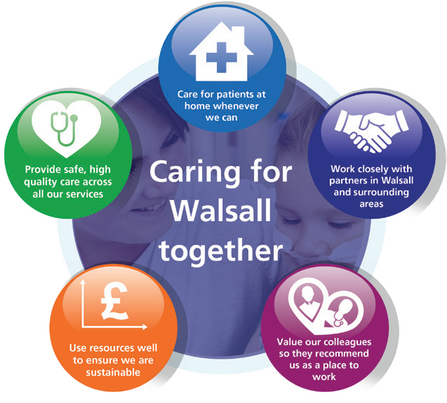Our Vision, Objectives & Values
Walsall Healthcare NHS Trust is guided by ﬁve strategic objectives which combine to form the overall ‘vision’ for the organisation.
Complementing this are our ‘values’, a set of individual behaviours that we wish to project amongst our workforce in order to deliver effective care for all.

Our Vision: Caring for Walsall together
“Caring for Walsall together” reﬂects our ambition for safe integrated care, delivered in partnership with social care, mental health, public health and associated charitable and community organisations.
Our Objectives: Underpinning the vision
The organisation has ﬁve strategic objectives which underpin our vision of ‘Caring for Walsall together’, and they are to:

Our Values: Upholding what’s important to us as a Trust
Our values, coupled with individual behaviours, represent what we wish to project in our working environments.
Respect | We are open, transparent and honest, and treat everyone with dignity and respect.  - I appreciate others and treat them courteously with regard for their wishes, beliefs and rights.  - I understand my behaviour has an impact on people and strive to ensure that my contact with them is positive.  - I embrace and promote equality and fairness. I value diversity and understand and accept our differences. I am mindful of others in all that I do.
Compassion | We value people and behave in a caring, supportive and considerate way.  - I treat everyone with compassion. I take time to understand people’s needs, putting them at the heart of my actions.  - I actively listen so I can empathise with others and include them in decisions that affect them.  - I recognise that people are different and I take time to truly understand the needs of others.  - I am welcoming, polite and friendly to all.
Professionalism | We are proud of what we do and are motivated to make improvements, develop and grow.  - I take ownership and have a ‘can do’ attitude.  I take pride in what I do and strive for the highest standards.  - I don’t blame others. I seek feedback and learn from mistakes to make changes to help me achieve excellence in everything I do.  - I act safely and empower myself and others to provide high quality, effective patient centred services.
Teamwork | We understand that to achieve the best outcomes we must work in partnership with others.  - I value all people as individuals, recognising that everyone has a part to play and can make a difference.  - I use my skills and experience effectively to bring out the best in everyone else.  - I work in partnership with people across all communities and organisations.


Provide Safe, high-quality care;
We will deliver excellent quality of care as measured by an outstanding CQC rating by 2022.

Care at Home;
We will host the integration of Walsall together partners, addressing health inequalities and delivering care closer to home.
Work Closely with Partners;
We will deliver sustainable best practice in secondary care, through working with partners across the Black Country and West Birmingham System.
Value our Colleagues;
We will be an inclusive organisation which lives our organisational values without exception.
Use Resources Well;
We will deliver optimum value by using our resources efﬁciently and responsibly.



MEETING OF THE PUBLIC TRUST BOARD – 1st April 2021
Chief Executive’s Report |  |  |  | AGENDA ITEM: 7
Report Author and Job Title: | Daren Fradgley, Acting Chief Executive Officer | Responsible Director: |  | Daren Fradgley, Acting Chief  Executive Officer
Action Required | Approve ☐ Discuss ☒ Inform ☒ Assure ☐
Executive Summary | This report provides the Acting Chief Executive’s (ACEO) overview of the risks to delivery of the Trust strategic objectives, together with actions the ACEO is leading and sponsoring, to address gaps in controls and assurance. It provides the Trust Board with a view into the delivery of our strategic objectives through the rapidly changing external tactical and strategic context, in particular the immediate context of the COVID-19 pandemic.
Recommendation | Members of the Trust Board are asked to note the content of the report.
Does this report mitigate risk included in the BAF or Trust Risk Registers? please outline | This report sets out the key risks to the delivery of our Trust strategic objectives and describes the ACEO’s personal areas of focus and action to mitigate those risks. The Board are invited to discuss the report and any changes it wishes to see in accountable officer focus in the coming weeks and months.
Resource implications | There are no resource implications associated with this paper.
Legal and Equality and Diversity implications | There are no legal or equality and diversity implications associated with this paper.
Strategic Objectives | Safe, high quality care ☒ |  | Care at home ☒
Strategic Objectives | Partners ☒ |  | Value colleagues ☒
Strategic Objectives | Resources ☒

CHIEF EXECUTIVE’S REPORT – 1ST APRIL 2021

- EXECUTIVE SUMMARY

I am pleased to report the Trust continues to see a de-escalation of pressure because of the COVID-19 pandemic. This is clearly because of a fall of the community infection rates that continues to have a positive impact on the demand that has presented over the winter months. The committee cycles this month were presented with evidence of reduced bed occupancy, lower critical care rates and reducing COVID-19 pressure on our community and integrated partnership teams though Walsall Together.

In contrast to this, the vaccination programme lead by Walsall Together continues to make substantial progress on vaccinating staff and the wider population groups in the identified high-risk cohorts of 1 – 9. I am pleased to report that at the time of writing 83% of all Trust staff had received at least one vaccination and close to 48% of that group had also received their second dose. Equally, 87.5% of staff with high risk assessments had received their first vaccine dose with similar second dose rates as the overall total. I am equally proud to report that the Saddlers mass vaccination centre went live in early March for all cohorts and has already delivered a substantial amount of vaccines to the Walsall population. I must pay tribute to the whole Walsall Together partnership for the focus, commitment, and dedication in the construction of the site and more importantly the staffing and wider resourcing on a daily basis. This site will likely be in operation for some months and can deliver between 4000 and 5000 doses per day if required.

The Trust continues a highly overt programme of health and wellbeing initiatives to support the staff because of the pressures of COVID-19. I reported last month that as the pressure starts to abate then the need for more of these services will be required in higher volumes which we are planning for and have ready to respond. In support of this, the programme of proactive support to staff to seek out the additional support needs is now underway and is proving to be successful in its aim.

The staff survey results were released this month and it is disappointing the see the lack of sustainable progress in this area. Whilst minor improvements are evident, they are not at a pace and scale that fosters sustainable change, nor do they demonstrate the scale of cultural change that the Trust is aiming to achieve.

Finally, the Trust welcomed the CQC this month who conducted an unannounced inspection in the Medicine pathways seeking assurance on the domains of safe and responsive criteria. The Trust is awaiting the formal feedback on the inspection which hadn’t been received at the time of writing and is anticipated within 50 days of the conclusion of the visit.

The remainder of my report highlights areas of focus through the strategic objectives of the organisation.

- BOARD ASSURANCE FRAMEWORK

  - Provide Safe, High Quality Care

The Trust continues to focus on the quality of care that we provide through the lens of the Improvement Plan. The areas of focus on the recent CQC visit have been triangulated and are consistent with the improvement areas identified. The data request for the CQC has now been concluded and the Trust awaits the feedback report. The initial unvalidated feedback has been shared with board members and it is hope that a draft report will be with the Trust in time for Private Board.

The Quality, Patient Experience and Safety Committee has spent time looking at plans this month to ensure the correct process is maintained for patient safety whilst restoration and recovery commences. This is supported by a reduction in the BAF risk evidenced later in this board pack and an improvement in staff due to a sustained reduction in sickness associated with COVID-19. Over the next few weeks this will improve further as the infection rates continue to fall and the shielding advice for staff vaccinated is expected to change and be reviewed on a case by case basis. The quality impact assessment covers these areas in some detail together with assurance reports to and gained by the Quality, Patient Experience and Safety Committee.

The role of the ICS will have a greater part to play in the future months as the expectations of restoration and recovery become clear together with the coordination of wider capacity and capability across the system. It is clear that the plan for the above will need to be delivered as a system and not just as a Trust in future years and when this relates directly to place based care this will also include primary and social care as the wider partnership takes it role.

  - Care at Home

Performance in key areas that relieve pressure on the hospital, such as medically stable and Integrated Assessment Hub, and the overall system such as the Care Navigation Centre and the COVID-19 pathways remains strong. It is a credit to the integrated approach not only our community teams but the wider Walsall Together Partnership that pressure abate continues but more importantly shows strong signs of improving in these areas as the COVID-19 pressure abates. As a result, the operation risk in this area now starts to reduce and is replaced in the updated BAF later in the agenda.
The recently released planning guidance recognises the pressure in community and the required response to Long Covid and therapy and urgent care challenges for the future. As a result, the teams are working through the options for future design and integration of these pathways whilst recognising the staffing pressures of therapies and alternative roles cannot in themselves resolve the workforce challenges.

Work continues to progress with the transition to a formal Integrated Care Provider (ICP) contract. Acknowledging that the national planning round for 2021/22 has been delayed by a quarter, there will be no contractual changes until 1st July. However, the local work is continuing to implement changes that will support operation in shadow form as soon as possible within quarter one. We are still awaiting confirmation from the commissioners about the full scope of services to be included but have already started the due diligence work which will be done in phases as service scope is more widely known.

  - Work Closely with Partners

The Trust continues its work on collaboration and has recently taken part in a series of events that will take this workstream forward in the near future.

The collaboration work with Wolverhampton continues at pace with an Exec to Exec meeting taking place that has established the outline of areas that Executives will work on in pairs. This area will form part of the system wide response to restoration and recovery with other partners and will pave the way for the new way of working for the future.

Members of the Executive team together with the Trust Chair took part in the first Black Country wide Acute Collaboration Programme Board. During this meeting the Trust agreed the programme of work moving forward and the areas of focus together with the final elements of the collaboration case. It is worth noting that this builds on areas of collaboration at this point and areas of joint work and opportunity but in the future will be a core work stream of the system wide partnerships.

It is also of note that the Black Country and West Birmingham STP has now been given Integrated Care System (ICS) status from the 1st April 2021 which moves the system into a position where integration will be easier and decision making will be established to work alongside the Trust Board. The ICS supports delivery through wider partners including the 5 place based partnerships in the system, of which Walsall Together is one.

  - Value our Colleagues

As noted earlier in the report, the work on supporting our staff from a robust health and wellbeing perspective continues and additional focus is now being placed on staff in hard to reach groups with the proactive use of techniques such as Schwartz rounds and action learning meetings. It is anticipated that staff that don not initially seek or understand how to connect with the support will do so from this intervention. The early evidence is positive and additional support has already been provided as a result of this work.

The results of the newly publish staff survey have been used as a call to action to tackle the challenges that the Trust faces with staff engagement and support. The creation of an oversight group reporting into the People and Organisational Development Committee has now taken place and this group will establish a pace of interventions that will challenge the results seen in the survey. This has also been followed up with a divisional and leadership conversation highlighting the critical importance of the view of the staff and their connection with the wider organisation. To this end, a series of quick actions to demonstrate both active listening and pace of change are underway. This has started initially with the repainting of areas of maternity together with the soon to be commissioned additional staff rest areas that are an area of great frustration for the staff in recent month. A communication campaign based on the approach of you said, we did is being extended and pushing the work and focus in this area forward together with additional support from the feedback of staff side and Freedom to Speak Up Guardians.

It should be noted that there is a lot of work to do in this area over the next few months if the Trust is going to be in a position to demonstrably improve the results of the next survey that are collected in September. Conversations about rapid and additional support are already underway and will be coordinated through the group above which will report into the People and Organisational Development Committee as outlined.

  - Use Resources Well

The Trust remains on trajectory to deliver the initial plan of a £3.8m deficit, though with the additional £2.3m of central income and the benefit of £1.5m from STP risk share the forecast is now break even performance for the financial year (though the Trust will have a technical deficit representing the increase in annual leave provision).

Operational performance during the last quarter has been scrutinised through PFIC and good progress has been made on creating capacity off the back of the COVID-19 reductions outlined. This is further supported by the continued gains in the medical fit for discharge performance we have kept length of stay and bed occupancy down. The latter is becoming more challenged due to the therapy delays in community and discharged pathways and an improvement plan in this area together with a people plan is being coordinated by the community division. This is being reported to all committees to ensure that future risks are mitigated.

At the time of writing, the operational planning guidance was about to be published but advanced briefings confirmed that 2021/22 would be divided into two planning horizons. The first will continue with the same financial and operational expectations as the last six months have been, the second horizon will focus on a new set of block arrangements which will support staff recovery, health and wellbeing, management of clinical risk through system coordinated restoration and recovery and ultimately challenge the response to health

inequalities. The Trust has plans in development for response to this plan and is in a strong position to provide a working draft through April’s committee structures for the first draft submission date in May 2021. In addition, the Trusts response to the creation of Walsall Together as an ICP and significant re-design of outpatients delivery as planned within the ICP where appropriate are expected to be consistent with the planning guidance of 25% of activity in this area requiring innovation and partnership working.

RECOMMENDATIONS

The Board are asked to note and discuss the content of this report.


Public Trust Board – 1st April Item 8

Risk Summary
BAF Reference and Summary Title: |  | BAF 06 COVID - This risk has the potential to impact on all of the Trusts Strategic Objectives.
Risk Description: |  | The impact of Covid-19 and recovering from the initial wave of the pandemic on our clinical and managerial operations is such that it  prevents the organisation from delivering its strategic objectives and annual priorities.
Lead Director: |  | Chief Operating Officer |  |  |  |  | Supported By: | All Executive Directors
Lead Committee:
Links to Corporate Risk Register: |  | Title |  |  |  |  |  |  |  | Current Risk Score
 |  | 2051- Inability to mitigate the impact of Covid-19, results in possible harm and poor patient experience to the people of  Walsall.  2066- There is a risk of lack of skilled registered nurses (RN's)/registered midwives (RM's) on a shift by shift basis affecting our ability to consistently maintain delivery of excellent standards of care  2093- Risk of staff contracting COVID-19 through the course of their duties in Walsall Healthcare NHS Trust  2095- Inability of the NHS supply chain to provide an adequate and on-going supply of PPE to meet the demand to ensure that Walsall Healthcare NHS staff are fully protected during the Covid-19 pandemic.  208 – Failure to achieve 4 hour wait as per National Performance Target of 95% resulting in patient safety, experience and performance risks (Risk score = 16)  2081- Operational expenditure incurred during the current financial year exceeds income allocations, which results in the Trust being unable to deliver a break even financial plan. (Risk Score =16)  2082-Failure to realise the benefits associated with the outcomes of the improvement programme work-streams, results in the Trust not delivering efficiencies required to attain agreed financial control targets, and deliver financial balance without central support, which therefore impacts on the Trusts ability to deliver financial and clinical sustainability. (Risk Score =16) |  |  |  |  |  |  |  | 15 (Major)
Risk Scoring
Quarter | Q1 |  | Q2 | Q3 | Q4 | Rationale for Risk Level |  |  | Target Risk Level  (Risk Appetite) |  |  | Target Date
Likelihood: | 4 |  | 4 | 4 |  | - Covid-19 is a novel virus and therefore there is only an emerging understanding of the disease, how it behaves and the likely trajectory of further resurgence in cases.  - The initial wave of Covid-19 had a profound impact on the services |  |  | Likelihood: |  | 2 | 30 June 2021 (at which point the Covid BAF risk would be  recommended
Consequence: | 5 |  | 5 | 5 |  |  |  |  | Consequence: |  | 5
Risk Level: | 20  (Major) |  | 20  (Major) | 20  (Major) |  |  |  |  | Risk Level: |  | 10  (Moderate)

 |  |  |  |  | that the Trust provides, both in terms of urgent, emergency and  critical care services to manage covid-19 positive patients (in the hospital and the community), and in terms of the reduction in capacity of elective care services. The initial wave had a particularly significant impact on care home residents within the Borough’s population.  - The initial wave of Covid-19 had a profound impact on the workforce of the Trust. By May 2020, almost 1 in 4 Trust staff who have undergone a Covid-19 Antibody test have been antibody positive suggesting a significant proportion of the workforce has experienced the disease themselves. Moreover, the challenges of managing the initial wave of the pandemic has had significant psychological impact on staff too.  - The Trust is operating in an uncertain financial planning environment resulting in additional challenges to restoring and recovering services impacted by the initial wave of Covid-19, and planning for the 2021/22 financial year.  - Covid-19 has exposed existing significant health inequalities in the population the Trust serves. Covid-19 has exacerbated some existing inequalities in colleague experience within the Trust.  - Nosocomial deaths reported in Learning from Nosocomial Covid deaths report received at QPES 27/08/20, with further analysis presented to QPES 28/01/21 confirming 21 probable or definite nosocomial deaths from Covid in Wave 1.  - Planning assumptions for a second wave of Covid-19 cases assumed a peak at half the level of the April peak. In November 2020 the Trust exceeded 80% of the April peak in terms of Covid-19 positive bed occupancy. In January 2021 the Trust has exceeded 140% of the April peak. As of 15th March the Trust’s Covid-19 positive inpatients have reduced to 26% of the April peak.  - The Trust has had the 7th highest proportion of its hospital beds occupied by Covid-19 positive patients in the country in early November 2020, and the second highest proportion of its hospital beds occupied by Covid-19 positive patients in the Midlands during January 2021. The situation has improved over February and March |  |  | to be dissolved).

and Ward 10, Ward 14 and the 6 extra capacity beds on ward 4 are all
now closed.
- The Trust has consistently had one of the highest Critical Care bed occupancy relative to baseline commissioned capacity across the Midlands region during the second wave. In January 2021 Critical Care bed occupancy has exceeded 250% of baseline commissioned capacity, peaking at 306% of baseline commissioned capacity. As of 15th March, the Trust’s Critical Care occupancy had reduced to below 150% of baseline commissioned capacity.
- As a result of reduced Critical Care occupancy, the Trust commenced it’s 8-week Elective Surgery restoration plan on 8th March 2021.
- The Trust has been successful in rolling out the Pfizer Vaccine to Patients, and staff across BCWB Health and Social Care organisations, with over 85% of high-risk staff having received their first vaccination, and over 48% of high risk staff having received their second vaccination (as of 12/3/21).
Control and Assurance Framework 3 Lines of Defence
 | 1st Line of Defence |  |  |  |  |  | 2nd Line of Defence | 3rd Line of Defence
Controls: | Governance:  - Incident Command structure in place incorporating Strategic Command, Hospital Tactical Command, Walsall Together Community Tactical Command and Corporate Tactical Command.  - Bespoke Incident Command structure in place for Covid-19 Vaccination programme.  - Governance continuity plan in place to ensure Board and the Committees continue to receive assurance.  - Specific Covid-19 related SOPs and guidelines  - ITU Surge Plan in place  - Covid Streaming processes in place  - Enhanced Health and Safety/IPC Process in place in relation to Covid-19, with particular focus on social distancing, patient/staff, screening, zoning of Ward/Department areas, |  |  |  |  |  | - Individual committees consider specific impact relevant to their portfolio, i.e. Financial matters and Restoration and Recovery of elective services under PFIC; Quality, Safety and Patient experience matters under QPES and Workforce matters including staff wellbeing under P&ODC.  - Board Development sessions (x2) on approach to Restoration and Recovery from Wave 1.  - UEC and Covid resilience Winter Plan approved by Trust Board October 2020.  - Covid-19 Deaths incorporated into SJR processes Nosocomial Covid-19 Infections are subjected to RCA and reported to the Infection Control Committee. | - Regional and National Incident Control structure.

visiting guidance and PPE Guidance
- Daily risk assessment (RAG rating) of Community Locality teams to prioritise resource according to need.
- Division of Surgery 8-week elective Surgery restoration plan commenced 8/3/21.
Gaps in Control | - Walsall borough disproportionately hard hit in second wave again. 7th highest proportion of beds occupied by Covid positive patients in the country, in early November 2020. One of the highest Critical Care bed occupancy levels relative to baseline funded Critical capacity in the Midlands Critical Care Network throughout waves 2 in the Autumn of 2020 and 3 over the Winter of 2020. The Trust has had the second highest proportion of its hospital beds occupied by Covid-19 positive patients in the Midlands during January 2021.  - Resurgence of Covid-19 cases has coincided with Winter pressures resulting in severe pressures on the emergency care pathway, and stretching the RN, medical and WHP  workforce significantly.  - Significantly increased Critical Care demand resulting in a dilution of ratios of specialist Critical Care Nurses to patients, partially mitigated through use of Category B and Category C registrants.  - Significant reduction in elective surgical operating theatre capacity due to requirement to support Critical Care staffing, resulting in prolonged waits for elective surgery.  - Reduction in some elective Community services – particularly MSK therapies and Phlebotomy, to redeploy resource into non-elective pathways.  - Considerably higher demand than anticipated on key Covid-19 Community pathways including Community Pulse Oximetry monitoring (Safe at Home pathway) and Long Covid pathways.  - Ability for neighbouring Trust’s to manage demand from patients conveyed by ambulance resulting in additional ambulance patients being conveyed to Walsall Manor through WMAS Intelligent Conveyancing protocol.  - National directives and mandates impact on the Trust’s ability to make local decisions.  - Ability of the Midlands Critical Care Network to successfully manage demand Critical Care demand across the region.  - Unable to progress all elements of the improvement programme owing to capacity of senior leaders.  - Comprehensive OD/Culture Improvement plan.
Assurance: | - IPC Board Assurance Framework | - Nosocomial Covid-19 infection rate in line with peer- reviewed published evidence.  - Antibody positive staff rate in line with BCWB peers.  - Financial top up requests in line (or lower) as a proportion of turnover than BCWB peers.  - Faculty of Research and Clinical Education evaluation of response to first wave  - 60-day readmission rate for Covid-19 patients in line with peer-reviewed published evidence. | - Cancer waiting times in line with national average  - Elective waiting times upper quartile for Diagnostics (DM01) and Top 40 nationally for routine elective treatment (18-week Referral to Treatment) nationally  - Elective 52-week wait performance 3rd best in the Midlands.  - Ambulance handover times and 12-hour Decision to Admit trolley wait performance amongst the best in the Midlands.  - CQC Assurance of the IPC Board Assurance Framework  - Productivity of Vaccination Programme compares favourably with other Acute Trusts.

- Lack of assurance of communications within the organisation to ensure staff feel well informed and engaged.
- Evidence of higher staff absence rates than BCWB peers during initial wave of Covid-19, absence rates consistent with peers in second/third wave.
- PODC still working to gain sufficient assurance on the vulnerable staff risk assessment process
Gaps in Assurance

Future Opportunities
- With a more digital/virtual enabled organisation further opportunity to explore clinical application in improvement programme deliverables
- Increased focus on Walsall Together and partnership working to support reduced reliance on hospital care, and to support reduced health inequalities in the borough.
- Covid-19 has necessitated closer collaboration with other Acute hospitals which can continue to be built upon.
- Increased profile and appreciation of the NHS within the general public could be harnessed to attract and retain staff.
- National planning guidance for Phase 3 (Recovery & Transformation) creates an expectation that services must not be reintroduced based on historical models
- Identifying and adapting the workforce and professions to create a modern and adaptable workforce
Future Risks
- Potential for further resurgence in Covid-19 cases.
- Second wave of Covid-19 cases has coincided with Winter pressures including seasonal Influenza and norovirus, and delayed and advanced (in terms of disease progression) presentation of patients that have not accessed healthcare services in recent months.
- Ongoing pressure on community services associated with patients rehabilitating following Covid-19, including Long Covid patients.
- Delayed and/or prolonged impact of managing the initial wave, second wave and third wave of the pandemic on staff wellbeing and mental health.
- Potential workforce absence in the event of a second wave.
- Limited management and leadership capacity to address core objectives due to the significant demands of managing covid-19 pandemic, and the restoration and recovery of services affected by covid-19.
- More constrained financial operating environment.
- Logistical challenges of delivering the Covid-19 Vaccination.
Further Actions (to further reduce Likelihood / Impact of risk in order to achieve Target Risk Level in line with Risk Appetite)
No. | Action Required | Executive Lead | Due Date | Quarter 4 Progress Report | BRAG
1. | Approval of UEC & Covid resilience Winter Plan | COO | Oct 2020 | Complete – approved at Trust Board 01/10/20
2. | Completion of £4.1m UEC & Covid resilience Estate works to  promote segregated pathways | COO | Dec 2020 | Complete
3. | Confirmation of M7-M12 Financial income settlement with  STP | DoF | Oct 2020 | Complete
4. | Evidence of outcomes of BAME/vulnerable staff risk  assessments to be presented to PODC | DoP&C | Nov 2020 | Complete
5. | Re-modelling of impact of second wave on elective activity,  waiting time performance and financial position | COO | Dec 2020 | Complete
6. | Confirmation of 2021/22 Financial arrangements | DoF | Feb 2021 | Delayed due to delayed national planning guidance. Expected to be  closed April/May 2021.
7. | Elective Surgery restoration plan to be presented to PFIC | COO | March 2021 | Complete – on agenda for March Committee


1
MEETING OF THE PUBLIC TRUST BOARD – 1st April 2021
Quality, Patient Experience and Safety Committee (QPES) Highlight Report |  |  | AGENDA ITEM: 10
Report Author and Job Title: | Trish Mills Trust Secretary | Responsible Director: | Mrs Pamela Bradbury – Chair of QPES (Non-  Executive Director).
Action Required | Approve ☐ Discuss ☒ Inform ☒ Assure ☒
Executive Summary | This report provides the key messages from the Quality, Patient Experience and Safety Committee meeting held on 25th March 2021. The meeting time and agenda was shortened to allow executives to focus their time on the response to the second wave of COVID-19. Of note are:  - The Committee heard two patient stories, the first which is also before the Trust Board, and the second being the story of a patient where poor communication was a key feature. The Chair of the Committee, Director of Nursing and others have been in regular contact with the family who are assisting in the improvements being put in place as a result of the issues raised.  - Discussion as to the prioritisation of patients during restoration and recovery highlighted that there was a Strategic Transformation Partnership (STP) approach to ensuring priority 2 patients receive surgery within 28 days. Sandwell and West Birmingham NHS Trust will begin with transfers of colorectal cancer patients to the Manor Hospital for surgery. The surgery team were commended for the work in this regard and for the net increase in capacity for surgery in the Black Country  - The draft Quality Impact Assessment (QIA) policy was discussed and comments provided for the next iteration. The Committee was assured that there are existing QIA processes in place to capture changes in service in instances of business development, business cases and cost improvement programmes. The risk management policy and process also addressed QIA, as did the emergency preparedness resilience and response governance structures established for the pandemic. The new policy provides for escalations to the  Committee of QIAs with a rating of 16 or above, as well as a bi-

annual report of all QIAs undertaken. The equality, diversity and inclusion elements of the QIA form will be reviewed to provide further robustness that inequalities are being proactively addressed.
    - An effectiveness review is underway of the groups reporting into the Committee, starting with the Clinical Effectiveness Group and Patient Safety Group. The overall review is due to complete in May. Revised exception reporting will be introduced to all Board Committees.
    - The Committee reviewed two matters that arose in the Audit Committee earlier in the year – those being the internal audit review on Electronic Discharge Summary (EDS), and medical equipment replacement.
      - The actions were reviewed and the committee noted the target to complete EDS within 48 hours. A review of the ways in which patients receive their discharge summary will also be undertaken to ensure that issues of language and accessibility to the information are being addressed.
      - The Committee was assured that all the previously identified high risk items of medical equipment had been replaced. The cohort of items for replacement are in the 21/22 capital program, which is part of a 5 year capital programme. The Committee noted the primary risk is the capital programme for 2021/22 not being formally signed off by the STP, but he Committee will monitor this and report back to the Board.
    - The Maternity Services report was reviewed by the Committee, and a progress report on the action plan in place as a result of the Ockenden recommendations was provided. The Committee agreed to receive reporting by exception at future meetings. All maternity serious incidents will be reported to the Committee and on to the Board via this highlight report. The detail of the serious incidents will then be fully discussed in private session with the Board.
    - Whilst progress is being made through a detailed 2 stage action plan, the Committee remains concerned about VTE compliance, which is at 91.91% for February - below the compliance target of 95%.
    - The Director of Nursing and the Medical Director focused the Committee’s attention on the gaps in controls and assurance in the Board Assurance Framework (BAF), on the corporate risks, and on the actions in place to address these. The BAF risk

rating had reduced from 20 to 15, due largely to reduced additional capacity requirements and demand for staffing, and progress against CQC action.
- The Committee noted that the quality performance dashboard is somewhat lagging it its reporting, and more detail on alignment options will come to future Committee meetings.
- The Committee were informed that the report from the unannounced CQC inspection that took place on 9th March towards 1, 2, 3, 16, and 17 had not yet been received. Once the draft report is received there is a ten day period for factual accuracy. Once the final report is received the Trust will have 30 days for an action plan to be provided to CQC. Actions related to quality, patient safety and experience will come back to the Committee.
- The Committee received the Nutrition Ambition Strategic Plan 2021-2024 which launched in March.

The next meeting of the Committee will take place on 29th April 2021
Recommendation | Members of the Trust Board are asked to note the escalations and any support sought from the Trust Board.
Risk in the BAF or Trust Risk Register | This report aligns to BAF risk S01 for safe high quality care and COVID-19 BAF risk S06.
Resource implications | There are no new resource implications associated with this report.
Legal, Equality and Diversity implications | There are no legal or equality & diversity implications associated with this paper
Strategic Objectives | Safe, high quality care ☒ | Care at home ☐
Strategic Objectives | Partners ☐ | Value colleagues ☐
Strategic Objectives | Resources ☐

MEETING OF THE PUBLIC TRUST BOARD – 1st APRIL 2021
Safe High Quality Care – Executive Update |  |  | AGENDA ITEM: 13
Report Author and Job Title: | Ann-Marie Riley, Director of Nursing | Responsible Director: | Ann-Marie Riley, Director of Nursing Matthew Lewis,  Medical Director
Action Required | Approve ☐ Discuss ☐ Inform ☒ Assure ☒
Executive Summary | This report describes the continuing actions that are taking place to provide Safe, High Quality Care (SHQC) in the Trust. The report includes details relating to the Board Assurance Framework (BAF), the Corporate Risk Register and the Performance Report, relevant to SHQC.
Recommendation | - Note the update to Trust Board on actions relating to the Improvement Programme through the Quality, Patient Experience & Safety Committee (QPES) and supporting groups.  - Note the highlighted updates to BAF risk S01 and related risks on the Corporate Risk Register.  - Note the relevant updates and assurance in relation to the performance report.
Does this report mitigate risk included in the BAF or Trust Risk Registers? please outline | This report highlights updates relevant to Board Assurance Framework (BAF) Risk SO1 and provides assurance or mitigations in place to manage this risk. The related corporate risks are:  Risk 208: Failure to achieve 4 hour wait as per National Performance Target of 95% resulting in patient safety, experience and performance risks.  Risk 274: Failure to resource backlog maintenance and medical equipment replacement.  Risk 2260: Lack of a whole system approach across health and social care for the management of Children and Young People (CYP) in mental health or behavioural crisis which will replace  Risk 1986: Delays in access to Tier 4 in-patient psychiatric care for Children and Young People.  Risk 2066: There is a lack of skilled registered nurses and  registered midwives on a shift by shift basis affecting our ability to

 | consistently maintain delivery of excellent standards of care, and excellent patient and staff experience.
Resource implications | Current resource implications relate to the delivery of the Safe High Quality Care improvement programme.
Legal and Equality Diversity implications | Failure to deliver safe, high quality care may result in further  breaches of legal requirements under the Health and Social Care Act 2008
Strategic Objectives | Safe, high quality care ☒ | Care at home ☐
Strategic Objectives | Partners ☐ | Value colleagues ☒
Strategic Objectives | Resources ☒

PROVIDE SAFE HIGH QUALITY CARE – EXECUTIVE UPDATE

- EXECUTIVE SUMMARY

The delivery of safe, high quality care remains a key priority for the Trust. This priority remains as strong as ever while delivering care in challenging circumstances through the current phase of the COVID19 pandemic.
The associated BAF and corporate risks have been reviewed and updated as required. The gaps in control and assurance were discussed in detail at the Quality, Patient Safety and Experience Committee and progress has been made to reduce the number of gaps overall.
Oversight of progress against the CQC Must and Should Do actions continues via the monthly CQC action plan oversight group and progress against 2019 and 2020 actions is as follows:

  - 2019 Actions: 3 actions have been completed in month meaning 48 of the 55 actions have been completed; 4 actions are in progress, 3 of which are overdue; 3 actions are deferred.
  - 2020 Actions: 4 actions have been completed in month meaning 23 of the 29 actions have been completed; 5 actions are in progress, 2 of which are overdue; 1 action is deferred.

Evidence of progress against outstanding and deferred actions was presented to the Quality, Patient Safety and Experience Committee.

Projects within the Safe, High Quality Care Improvement Programme have continued to progress despite the COVID19 pandemic and some of the key highlights are:
  - Falls per 1000 bed days remains below 6.1
  - A significant programme of work is progressing at pace in relation to our Harm Free Care workstream. A new Nutrition Ambition is launching in March with Ambitions for maintenance of skin integrity and continence function in development; and work is underway to better align the nursing risk assessment documentation with that of Royal Wolverhampton NHS Trust.

- BOARD ASSURANCE FRAMEWORK (BAF)

Our strategic objective is to deliver excellent quality of care as measured by an outstanding CQC rating by 2022. The BAF for SHQC appears at Appendix 1. The Trust continues to have a low risk appetite for compromising quality and safety of patient care. Key updates on progress over the last month are highlighted below.

- Gaps in Control

  - Clinical audit monitoring arrangements to be reviewed and strengthened - a clinical outcomes dashboard has been developed to track and drive improvement across national audit outcomes and actions. The dashboard will form part of the audit report to Patient Safety Group.
  - VTE performance continues to be below the Trust Target – VTE compliance for February remains below the Trust target of 95% at 91.91%. A paper was presented to Trust Management Board (TMB) on 9th March 2021 which outlined options to improve VTE assessment compliance rate and agree on future action to meet the target of 95% compliance.
  - Deterioration in the Trust’s complaints response performance – A process review has been completed to address contributing factors to the current performance level. Assurance can be provided that correct systems and processes are in place to oversee and manage complaints in a timely manner.
  - There were two severe harm falls in February 2021, these falls have been identified as serious incidents. Initial case reviews have been undertaken and full root cause analysis into these incidents will be undertaken.
  - Mental Capacity Act compliance below the Trust’s Standards – Mental capacity assessment performance for February 2021 shows that 49% of patients who lacked capacity had a stage 2 assessment undertaken (43% in January 2021). Further work is ongoing to build the MCA assessment (and ReSPECT forms) into Medway, in order to mandate full assessments. In the meantime, training and support is being delivered through MCA Champions in clinical areas.
  - Sepsis audit frequency and performance – the Sepsis 6 dashboard is now live in the trust and allows all teams to review real time data against agreed national standards. Performance against these standards will be monitored through monthly divisional sepsis reviews, overseen by the Director of Nursing and Medical Director, Patient Safety Group and Performance Reviews. The Clinical Senate discussed the rationale, process and monitoring systems relating to sepsis management.

- Gaps in assurance

  - CQC ‘MUST’ and ‘SHOULD’ Do actions remain outstanding - Oversight of progress against the CQC Must and Should Do actions continues via the monthly CQC action plan oversight group and progress against 2019 and 2020 actions is as follows:
2019 Actions: 3 actions have been completed in month meaning 48 of the 55 actions have been completed; 4 actions are in progress, 3 of which are overdue; 3 actions are deferred.
2020 Actions: 4 actions have been completed in month meaning 23 of the 29 actions have been completed; 5 actions are in progress, 2 of which are overdue; 1 action is deferred

Overdue and deferred actions were presented in detail to the Quality, Patient Experience and Safety Committee (QPES)
  - NHSEI review in 2019 highlighted insufficient assurance on infection control standards resulting in RED rating – reassessment of cleanliness standards was cancelled by NHSEI due to COVID19. We are assured that improvement in standards has been sustained which has also been reflected in feedback from inspections by the CCG, NHSEI and CQC. NHSEI have suggested that a re-inspection will be able to take place towards the end April/ beginning May 2021
  - External audit assurance relating to the annual quality account has been deferred owing to COVID-19 – development of the 2021/22 quality account is underway
  - Inconsistent evidence, both through quality governance structures and performance reviews, of practice having changed as a result of learning from Root Cause Analyses (RCAs) – a learning from incidents alert process is under consideration by the Governance team and will be progressed via the Well Led workstream
  - Lack of robust strategic approach to ensuring effective patient/public engagement and involvement – the Patient and Involvement Strategy development work has commenced. A more detailed launch plan will be developed during Quarter 1

- LINK TO CORPORATE RISK

There are four aligned corporate risks which have been reviewed this month:
  - 208 Failure to achieve 4 hour wait as per National Performance Target of 95%, resulting in patient safety, experience and performance risks
  - 274 Failure to resource backlog maintenance and medical equipment replacement
  - 2066 Lack of registered nurses and midwives - this risk has reduced to 15 due to reduced bed capacity, reduced number of COVID cases in the hospital and subsequent reduction on staffing demand
  - 2260 Lack of a whole system approach across health and social care for the management of Children and Young People (CYP) in mental health or behavioural crisis.

- PERFORMANCE REPORT

The performance report was discussed at the Quality Performance and Safety Committee. A few key areas to report as follows:

4.1 Clostridium Difficile number of cases
Two cases reported in February which are under investigation, there have been none to date in March.

4.2.% of observations rechecked within time
The prevalence of observations completed on time has increased in month from 81.10% in January to 84.14% in February 2021, which is just below the trust target of 85%. ED

performance continues to significantly contribute to the reduced overall performance figure (71.50%).

4.3 Dementia Screening – The Director of Nursing has undertaken a review of the data collection mechanism process. A task and finish group has been set up to consider options to improve the collection and assurance process and progress updates will be reported to QPES.

- IMPROVEMENT PROGRAMME

The Safe High Quality Improvement Programme has continued in full despite the pandemic. A number of key highlights are

  - Nurse Staffing – The Board was updated last month that we had agreement to recruit 50 international nurses. The first of these nurses are now planned to arrive in England during May. The Director of Nursing has secured funding for a further 75 international nurses who should be in the country before the end of December 2021.
  - The first of our Harm Free Care ambitions will launch March 2021 (Nutrition).
  - The CCG have closed risk 244: Failure to recognise and learn from events that contribute to deaths, after gaining assurance through the Trust learning from deaths process, mortality surveillance group and mortality reports
  - Recruitment into research studies is significantly above target and the Trust position across the region has improved from last year

- RECOMMENDATIONS

Members of the Trust Board are asked to note the update and progress made relating to the SHQC portfolio.
- APPENDICES

Appendix 1: BAF Risk S01 Appendix 2: Performance Report

Public Trust Board – 1st April Item 11, Appendix 1

Risk Summary
BAF Reference and Summary Title: |  | BAF 1: Safe, high quality care: We will deliver excellent quality of care as measured by an outstanding CQC rating by 2022
Risk Description: |  | The Trust fails to deliver excellence in care outcomes, and/or patient/public experience, which impacts on the Trust’s ability to deliver services which are safe and meet the needs of our local population.
Lead Director: |  | Director of Nursing/Medical Director |  |  |  |  | Supported By: | Non Executive Director (Pam Bradbury)
Lead Committee: |  | Quality, Patient Experience and Safety Committee
Links to Corporate Risk Register: |  | Title |  |  |  |  |  |  |  | Current Risk Score
 |  | - 208 Failure to achieve 4 hour wait as per National Performance Target of 95%, resulting in patient safety, experience and performance risks  - 274 Failure to resource backlog maintenance and medical equipment replacement  - 2066 Lack of registered nurses and midwives  - 2260 Lack of a whole system approach across health and social care for the management of Children and Young People (CYP) in mental health or behavioural crisis |  |  |  |  |  |  |  | 15 (High)
Risk Scoring
Quarter | Q1 |  | Q2 | Q3 | Q4 | Rationale for Risk Level |  |  | Target Risk Level  (Risk Appetite) |  |  | Target  Date
Likelihood: | 4 |  | 4 | 4 | 3 | - The Trust’s Quality Strategy is out of date and doesn’t reflect the environment in which we are currently operating. There are gaps in oversight of the strategy and a lack of clear alignment to the Quality Priorities  - We have strengthened clinical leadership and accountability at the tier 2 level of our governance with the Director of Nursing and Medical Director taking on the leadership in Patient Safety and Clinical Effectiveness.  - Evidence of lessons learnt from incidents and patient feedback is inconsistent.  - Robust acuity and activity review process for community activity.  - The Trust is leading the COVID Vaccination programme as part of the Walsall Vaccination programme thus far 81.48% of Trust staff have been vaccinated at Manor site, around 2000 members of the pubic have been vaccinated at the Saddlers Centre, and 141,075 members of the public have been vaccinated across Walsall (as of 17/3/21). This is predicted to impact on the numbers and the acuity of Covid patients being treated by the Trust.  - Progress and assurance against CQC Must and Should Do actions from inspections in 2019 and 2020.  - Staffing risk 2066 reduced to 15; robust plan to recruit 125 international nurses before the end Dec 2021 and to recruit to all clinical support vacancies before end April 2021.  - Concerns have been raised in relation to the staff experience on the NIV unit. As consequence of these |  |  | Likelihood: |  | 2 | 31 Dec  2021
Consequence: | 5 |  | 5 | 5 | 5 |  |  |  | Consequence: |  | 5 | 31 Dec  2021
Risk Level: | High 20 |  | High 20 | High 20 |  |  |  |  | Risk Level: |  | Mod 10 | 31 Dec  2021

concerns, and the reduction of critical care activity, the NIV unit has temporarily paused.
- Reduced COVID-19 cases enable the closure of additional capacity beds (Wards 14, 10 and additional beds on Ward 4) and subsequently reduced demand on staffing requirement.
- We currently do not respond to complaints within 30 days to the required target with current performance at 55.17%. We have reviewed and updated our complaint sign off process to reduce unnecessary delays for non-complex complaints.
- Impact of pandemic of COVID-19 resulting in delays to patient treatment and potential for harm
- Gaps in the number and quality of clinical guidance, policies and procedures to ensure safe and quality care.
- Duty of Candour below target performance level.
- incomplete 7 Day Services to provide uniform levels of care throughout the week.
- Partial compliance against Ockenden recommendations. A BAF risk will be developed in relation to this during March 2021.
- Potential to breach statutory requirements under the Mental Health Act due to inconsistent knowledge and application of Trust Policy.
- Gap in the Trust’s approach to patient engagement and patient involvement.
Control and Assurance Framework 3 Lines of Defence
 | 1st Line of Defence |  |  |  |  |  | 2nd Line of Defence | 3rd Line of Defence
Controls: | - Clinical divisional structures, accountability & quality governance arrangements at Trust, division, care group & service levels  - Central staffing hub co-ordinating nurse staffing numbers in line with acuity and activity  - Clinical audit programme & monitoring arrangements  - Safety Alert process in place and assured through QPES  - Perfect Ward app allows local oversight of key performance metrics  - Freedom to speak up process in place, reporting to the People and organisational development committee  - Covid-19 SJR undertaken for all deaths process of assurance for lessons learnt developed  - CQC registration for the regulated activity of assessment or medical treatment for persons detained under the Mental Health Act 1983 at Manor Hospital.  - Monthly CQC Action Plan oversight meeting in |  |  |  |  |  | - Patient Experience group in place  - Governance and quality standards managed and monitored through the governance structures of the organisation, performance reviews and the CCG/CQC  - Learning from death framework supporting local mortality review. | - CQC Inspection Programme  - Process in place with Commissioners to undertake Clinical Quality Review Meetings (CQRM)  - Royal College of Surgeons Invited Service Review of upper limb surgery  - External Performance review meetings in place with NHSEI/CQC/CCG

place
- Improvement programme in place to oversee and monitor improvements associated with the Trust delivery of Safe, and High Quality Care
•
Gaps in Control | - Performance targets not being met for all activities, including complaints, Mental Capacity Act and VTE  - Out of date clinical policies, guidelines and procedures  - Training performance not meeting set targets  - Quality Impact Assessment process is not yet established within the trust  - Sepsis audit frequency and performance  - CQC rating of ‘Requires Improvement’  - NHSEI review of Division of Surgery, focussing on meetings, leadership, and governance highlighted remedial actions required  - Faculty of Research and Clinical Education (FORCE) established to promote research and professional development in the trust
Assurance: | - Ward Review process in place which provides assurance on the quality of care; performance reported to QPES within the SHQC report  - Signed SLA with Mental Health Trust to support the organisation to meet the requirements of our CQC registration for the regulated activity of assessment or medical treatment for persons detained under the Mental Health Act 1983 at Manor Hospital. | - Patient priorities for 2021 identified which aim to improve patient experience. Assurance of impact via patient feedback | - NHSI and CCG reviews of IPC practice in ED and Maternity have not highlighted any immediate concerns  - NHSEI scrutiny of Covid-19 cases/Nosocomial infections/Trust implementation of Social distancing, Patient/Staff screening and PPE Guidance  - Quality Review 6 monthly reviews in place with NHSEI/CQC
Gaps in Assurance | - CQC ‘MUST’ and ‘SHOULD’ do actions remain outstanding  - NHSEI review in 2019 highlighted insufficient assurance on infection control standards resulting in RED rating . Division have made sustained improvement and external review of practice from NHSI, CCG and CQC have not highlighted gaps in practice. NHSI plan to reinspect maternity services in April or Mat 2021  - External audit assurance relating to the annual quality account has been deferred owing to COVID-19  - Inconsistent evidence, both through quality governance structures and performance reviews, of practice having changed as a result of learning from adverse events  - Gaps in assurance noted from the recent CQC inspection including management of sepsis and robust audit data  - Lack of assurance regarding equality, diversity and inclusion and actions to reduced inequalities  - Lack of evidence of risk assessments and quality impact assessments relating to staffing contingency planning and/or activity changes  - Lack of robust strategic approach to ensuring effective patient/public engagement and involvement  - Lack of clinical engagement and leadership oversight of the Quality Governance agenda.
Future Opportunities
- Improvement Programme offers a structured programme to achieve excellence in care outcomes, patient/public experience, and staff experience
- Implementation of new technologies as a clinical or diagnostic aid (such as electronic patient records, e-prescribing and patient tracking; artificial intelligence; telemedicine)
- Development of Prevention Strategy
- National Patient Safety Strategy, will give an improved framework for the Trust to work
- Well Led workstream working on quality governance structures and patient safety

- Leadership Development programme to address and mitigate gaps within clinical leadership
Future Risks
- Ongoing impact of Covid-19 plus additional significant time pressured programmes of work such as COVID vaccination, staff testing, etc. Communications across the organisation to share programme objectives
- Performance targets not being met for all activities, including Mental Capacity Act and VTE
- Sepsis audit frequency and performance
- NHSEI review of Division of Surgery, focussing on meetings, leadership, and governance highlighted remedial actions require
Further Actions (to further reduce Likelihood / Impact of risk in order to achieve Target Risk Level in line with Risk Appetite)
No. | Action Required | Executive Lead | Due Date | Quarter 4 Progress Report | BRAG
1. | To strengthen the quality assurance framework there will be a review of the terms of reference of Patient Safety and Clinical Effectiveness Groups to allow greater scrutiny of divisional actions and offer  increased assurance to QPES | Medical Director | 1/4/21 | ML will chair the Clinical effectiveness Group from February 2021; Ann-Marie Riley will chair the Patient Safety Group from March 2021 -amended terms of reference to be agreed
2. | Develop a Clinical Audit Strategy and Policy | Director of Governance | 1/8/21 | Dashboard development will further support monitoring
3. | Oversight of progress to address out of date policies and procedures will be strengthened via the Clinical Effectiveness Group which be reflected in the revised  terms of reference | Medical Director | 1/4/21 | Review of terms of reference will take place during March when chair of the Patient Safety Group transfers to the Director of Nursing on 1 March 2021
4. | To support improvement in Trust complaints response compliance there will be a review of the current process to ensure timely response and sign off of  complaints via both formal and informal routes | Director of Nursing | 30/4/21 | Review of sign off process for non-complex complaints completed
5. | All Executives with responsibility for CQC Must Do and  Should Do actions will provide strengthened oversight of progress with their actions and sign off of relating evidence | Director of Governance | 28/2/21 | Executive Leads provided updates of evidence that has been reviewed and signed off
6. | NHSEI review (2019) provided insufficient assurance on infection control standards in Maternity resulting in RED rating. Significant work has taken place to improve and sustain expected standards. We have requested a reinspection to enable a review of the  RED rating | Director of Nursing/Director of Infection, Prevention and Control | TBC | Previous dates arranged have been cancelled by NHSEI due to the COVID19 pandemic. NHSEI have suggested the revised inspection will take place end April/beginning May 2021
7. | A quality impact assessment framework will be developed to support executive oversight of change  that could impact on quality/safety | Director of Governance | 1/3/21 | Quality impact assessment framework in development and draft for consultation to be presented to March QPES
8 | NHSI re-inspection of cleanliness and IPC practice in maternity services | Director of Nursing | 31/5/21

9. | Further develop processes to provide assurance that lessons learnt from adverse events | Medical  Director/ Director of  Nursing | 03/9/21 | Learning Matters newsletter (2nd edition) circulated; scoping of new ward performance boards now underway
10. | Development of Patient Engagement and Involvement Strategy | Patient  Experience Lead/Lead for Patient  Involvement | 30/9/21
11. | Mandatory training performance trajectories in place and performance monitored via monthly Divisional Performance meetings | Medical  Director/ Director of Nursing | Monitored monthly




QUALITY, PATIENT EXPERIENCE SAFETY COMMITTEE
3.60 3.76 3.18 4.03
1093
57.63%
0.49 0.85 0.53 0.75 0.63 0.76
128
86

932

Sep-20 | Oct-20 | Nov-20 | Dec-20 | Jan-21 | Feb-21

2020/21  YTD | 2020/21  Target | 2019/20  YTD | SPC  Variance | SPC  Assurance

SAFE, HIGH QUALITY CARE
No. | Sleeping Accommodation Breaches
No. | HSMR (HED) nationally published in arrears
No. | SHMI (HED) nationally published in arrears
Rate | Crude Mortality Rate
No. | Number of Deaths in Hospital
% | % of patients who achieve their chosen place of death
No. | MRSA - No. of Cases
No. | Clostridium Difficile - No. of cases
% | Sepsis - % of patients screened who recieved antibiotics within 1 hour - ED (Adults only)
% | Sepsis - % of patients screened who received antibiotics within 1 hour - Inpatients (Adults only)
% | Deteriorating patients: Percentage of observations rechecked within time
Rate | Pressure Ulcers (category 2, 3, 4 & Unstageables) Hospital Acquired per 1,000 beddays
Rate | Pressure Ulcers (category 2, 3, 4 & Unstageables) Community Acquired per 10,000 CCG Population
No. | Pressure Ulcers (category 2, 3, 4 & Unstageables) - Hospital
No. | Pressure Ulcers (category 2, 3, 4 & Unstageables) - Community
No. | Falls - Total reported
Rate | Falls - Rate per 1000 Beddays

0 | 0 | 1 | 0 | 0 | 0
117.98 | 126.91 | 146.52 | 125.86
109.05 | 105.51 | 118.55
80 | 107 | 168 | 153 | 227 | 169
61.67% | 68.18% | 72.00% | 72.00% | 61.43% | 77.97%
0 | 0 | 0 | 0 | 1 | 0
2 | 5 | 2 | 0 | 2 | 2
 |  |  |  | 47.01% | 55.47%
 |  |  |  | 26.16% | 24.87%
89.15% | 85.13% | 82.38% | 83.96% | 81.10% | 84.14%
0.24 | 0.24 | 0.59 | 0.38 | 0.48 | 0.34
7 | 13 | 8 | 11 | 10 | 10
7 | 7 | 17 | 11 | 14 | 10
42 | 70 | 65 | 71 | 74 | 70
3.26 | 4.67 | 4.57 | 5.02 | 4.7 | 5.11

210 | 0 | 0
 | 100
 | 100
1413
67.88% |  |  |  | 
1 | 0 | 4 |  | 
29 | 26 | 36 |  | 
49.93%
25.70%
 | 85.00% |  |  | 
 |  |  |  | 
 |  |  |  | 
111 |  |  |  | 
145 |  |  |  | 
710 |  |  |  | 
 | 6.1 |  |  | 


QUALITY, PATIENT EXPERIENCE SAFETY COMMITTEE

Sep-20 | Oct-20 | Nov-20 | Dec-20 | Jan-21 | Feb-21

2020/21  YTD | 2020/21  Target | 2019/20  YTD | SPC  Variance | SPC  Assurance

No. | Falls - No. of falls resulting in severe injury or death
No. | Falls - Avoidable Falls resulting in severe harm or injury (subject to RCAs)
No. | Falls - Unavoidable Falls resulting in severe harm or injury (subject to RCAs)
% | VTE Risk Assessment
No. | National Never Events
No. | Serious Incidents (inc cat 3 & 4 pressure ulcers, HCAI's & Falls) - Hospital Acquired
No. | Serious Incidents (inc cat 3 & 4 pressure ulcers, HCAI's & Falls) - Community Acquired
No. | Clinical incidents causing actual harm severity 3 to 5 - Hospital Acquired
No. | Clinical incidents causing actual harm severity 3 to 5 - Community Acquired
% | % of total incidents resulting in moderate, severe harm or death
% | Trust-wide Safety Index - % of medication incidents resulting in harm (one month in arrears)
No. | No. of reported medication incidents level 3, 4 or 5 (one month in arrears)
Rate | Midwife to Birth Ratio
% | One to One Care in Established Labour
% | C-Section Rates
% | Instrumental Delivery
% | Induction of Labour

1 | 2 | 1 | 0 | 0 | 2
89.51% | 91.24% | 90.74% | 90.98% | 90.42% | 91.91%
0 | 0 | 0 | 0 | 0 | 0
11 | 10 | 12 | 9 | 12 | 14
0 | 0 | 0 | 0 | 0 | 0
17 | 31 | 47 | 44 | 47 | 36
8 | 2 | 5 | 6 | 9 | 7
2.49% | 3.01% | 5.03% | 4.64% | 4.80% | 3.92%
33.00% | 26.00% | 25.00% | 12.00% | 23.00%
1 | 2 | 1 | 0 | 1
28.5 | 37.3 | 31.4 | 28.9 | 27.2 | 29.1
97.20% | 100.00% | 100.00% | 100.00% | 100.00% | 100.00%
30.11% | 26.21% | 26.58% | 33.70% | 27.44% | 32.51%
4.55% | 6.82% | 4.87% | 5.36% | 7.53% | 5.96%
42.65% | 39.03% | 43.19% | 41.30% | 43.68% | 37.10%

12 | 0 | 20
2 | 0 | 16
0 |  | 4
91.14% | 95.00% | 92.22%
0 | 0 | 1
108 |  | 94
0 |  | 5
336 |  | 287 |  | 
71 |  | 29 |  | 
3.66% |  | 2.37% |  | 
17.71% | 12.00% | 14.30% |  | 
10 | 0 | 4 |  | 
 | 28 |  |  | 
99.39% | 100.00% | 99.20% |  | 
29.45% | 30.00% | 30.16% |  | 
6.52% | 10.00% | 7.52% |  | 
41.01% |  | 39.09% |  | 


QUALITY, PATIENT EXPERIENCE SAFETY COMMITTEE

Sep-20 | Oct-20 | Nov-20 | Dec-20 | Jan-21 | Feb-21

2020/21  YTD | 2020/21  Target | 2019/20  YTD | SPC  Variance | SPC  Assurance

% | % of Emergency Readmissions within 30 Days of a discharge from hospital (one month in arrears)
% | Electronic Discharges Summaries (EDS) completed within 48 hours
% | Dementia Screening 75+ (Hospital) (Internal audit Dec17 onwards) (one month in arrears)
% | Compliance with MCA 2 Stage Tracking
% | Complaints - % responded to within 30 working days
% | Complaints - % responded to within 45 working days
No. | No. of Open Complaints
No. | No. of Closed Complaints
No. | Longest Wait for an Open Complaint
No. | Clinical Claims (New claims received by Organisation)
No. | No urgent op to be cancelled for a second time
% | % of RN staffing Vacancies
% | Friends and Family Test - Inpatient (% Recommended)
% | Friends and Family Test - Outpatient (% Recommended)
% | Friends and Family Test - ED (% Recommended)
% | Friends and Family Test - Community (% Recommended)
% | Friends and Family Test - Maternity - Antenatal (% Recommended)

13.64% | 13.57% | 13.26% | 12.00% | 12.54%
84.98% | 86.65% | 85.00% | 84.25% | 82.22% | 82.49%
48.28% | 54.10% | 48.28% | 81.82% | 52.38% | 60.87%
46.67% | 52.38% | 32.50% | 34.88% | 43.48% | 46.00%
57.14% | 50.00% | 32.26% | 31.82% | 56.52% | 55.17%
66.67% | 63.64% | 35.48% | 50.00% | 69.57% | 68.97%
52 | 67 | 66 | 69 | 76 | 71
12 | 7 | 23 | 22 | 15 | 29
98 | 75 | 87 | 80 | 99 | 117
9 | 10 | 8 | 7 | 5 | 8
0 | 0 | 0
7.75% | 9.23% | 10.59% | 10.90% | 8.73%
88% | 92% | 87% | 85% | 87% | 88%
92% | 92% | 91% | 90% | 91% | 92%
73% | 75% | 79% | 79% | 82% | 84%
 |  |  |  | 100% | 93%
89% | 59% | 73% | 79% | 73% | 71%

13.74% | 10.00% | 11.50% |  | 
86.05% | 100.00% | 84.59%
68.52% | 90.00% | 69.32%
49.54% | 100.00% | 62.61%
48.10% | 80.00% | 43.45%
57.38% |  | 59.82% |  | 
169 |  | 211
93 |  | 132 |  | 
0 | 0 | 0 |  | 
 |  |  |  | 
 | 96% |  |  | 
 | 96% |  | 
 | 85% |  |  | 
 | 97% |  |  | 
 | 95% |  | 


QUALITY, PATIENT EXPERIENCE SAFETY COMMITTEE

Sep-20 | Oct-20 | Nov-20 | Dec-20 | Jan-21 | Feb-21

2020/21  YTD | 2020/21  Target | 2019/20  YTD | SPC  Variance | SPC  Assurance

% | Friends and Family Test - Maternity - Birth (% Recommended)
% | Friends and Family Test - Maternity - Postnatal (% Recommended)
% | Friends and Family Test - Maternity - Postnatal Community (% Recommended)
% | PREVENT Training - Level 1 & 2 Compliance
% | PREVENT Training - Level 3 Compliance
% | Adult Safeguarding Training - Level 1 Compliance
% | Adult Safeguarding Training - Level 2 Compliance
% | Adult Safeguarding Training - Level 3 Compliance
% | Children's Safeguarding Training - Level 1 Compliance
% | Children's Safeguarding Training - Level 2 Compliance
% | Children's Safeguarding Training - Level 3 Compliance

79% | 87% | 79% | 84% | 76% | 84%
70% | 73% | 77% | 78% | 80% | 71%
95% | 70% | 60% | 83% | 92% | 100%
93.34% | 89.85% | 90.15% | 90.46% | 90.00% | 91.41%
86.74% | 87.69% | 85.49% | 85.62% | 85.09% | 89.07%
97.18% | 96.44% | 95.88% | 94.97% | 93.42% | 94.21%
93.50% | 94.77% | 95.40% | 94.89% | 93.26% | 93.64%
67.33% | 69.26% | 71.50% | 71.92% | 73.69% | 75.16%
96.43% | 88.51% | 89.65% | 90.73% | 91.44% | 93.11%
89.94% | 90.60% | 90.35% | 89.25% | 88.98% | 90.12%
81.06% | 83.61% | 84.61% | 82.61% | 84.08% | 84.41%

96%
92%
97%
85.00%
85.00%
95.00%
85.00%
85.00%
95.00%
85.00%
85.00%

QUALITY, PATIENT EXPERIENCE SAFETY COMMITTEE

Sep-20 | Oct-20 | Nov-20 | Dec-20 | Jan-21 | Feb-21

2020/21  YTD | 2020/21  Target | 2019/20  YTD | SPC  Variance | SPC  Assurance

RESOURCES
No. | Total Deliveries

279 | 351 | 301 | 276 | 277 | 283

3277 | 3525 | 3661 |  | 


1
MEETING OF THE PUBLIC TRUST BOARD – 1st April 2021
Performance, Finance & Investment Committee (PFIC) Highlight Report |  |  | AGENDA ITEM: 12
Report Author and Job Title: | Trish Mills, Trust Secretary | Responsible Director: | Mr John Dunn – Chair of PFIC (Non-  Executive)
Action Required | Approve ☐ Discuss ☐ Inform ☒ Assure ☒
Executive Summary | This report provides the key messages from the Performance, Finance & Investment Committee meeting on 24th March 2021. Of note are:  - The Committee reviewed and endorsed the planning for Quarter 1 2021/22, which is before the Board for approval at this meeting. The Committee were also briefed by Mr Fradgley on the NHSE/I guidance for 2021/22 planning and will be flexible in holding any extraordinary meetings required to provide the necessary endorsements.  - The Committee reviewed the Board Assurance Framework risks for Use Resources Well and Work Closely with Partners, and the associated corporate risks, noting that the Use Resources Well rating has reduced from 20 to 15. The risk on the corporate risk registers (number 655) relating to cyber security will be reviewed in light of a recent external review. The Committee requested that the actions to mitigate the risks are further reviewed to ensure that, once completed, they are likely to materially change the risk rating.  - The risk appetite statements for Use Resources Well and Work Closely with Partners were reviewed by the Committee. They were approved subject to clarity on how the statements will be used and embedded in day to day activity.  - Financial performance remains strong, the Trust forecasting attainment of the 2021/22 financial plan and delivery of a break-even outturn (costs incurred off-set in full by income received). The delivery to forecast in year will result in the

 |  | Trust having attained financial plans and performance for two consecutive financial years. | break-even
 | - | Operational (acute and community) is also evidencing strong performance, Committee commended the teams for recovery of diagnostic waiting time which is now 4th best in the country. Excellent and consistent performance on patients medically stable for discharge remains key to enabling the emergency department pathways to admit inpatients and maintain strong  ambulance handover times. The Committee reviewed the
surgical division recovery plans, and at the next meeting will look more broadly at restoration and recovery, with particular emphasis on the longer waiting lists and prioritisation plans, lesson learned about ways of working in outpatients, and how we will be working as a partnership with the community. The
Committee will continue to monitor the breast cancer referrals
 |  | and the plans to recover those services to the end of May.
 | - | Further discussion took place on the links between capacity, acuity and cost. The next meeting will focus on moving from the dominance of COVID-19 into restoration and recovery, with a focus on exit run rates and run rates going forward, as well as procedures in place at divisional level to control both medical and nursing temporary staffing.
 | - | The Committee congratulated the team on the successful and efficient roll-out of the COVID-19 vaccinations, both in the Manor Hospital and at Saddlers.
 | - | A business case for maternity services was presented to the Committee and has been referred to the Board for approval. Whilst it is within the Committee’s delegated limit of £750,000, it is a cost pressure and therefore a matter for the Board to
 |  | approve.
 | - | Post implementation reviews of business cases were discussed, as was a template to ensure consistency of approach. The coming meetings will look in more detail at the cases for full review by the Committee.
 | - | The approval of the emergency department full business case

was deferred from the agenda of the NHSE/I Joint Investment Committee in March and will be discussed in April. The Board will consider the effect of this delay in private session.

The next meeting of the Committee will take place on 28th April 2021.
Recommendation | Members of the Trust Board are asked to note the escalations and any support sought from the Trust Board.
Does this report mitigate risk included in the BAF or Trust Risk Registers? | This report aligns to the BAF risk for use of resources and working with partners, and associated corporate risks.
Resource implications | The resource implications are set out in this highlight report.
Legal and Equality and Diversity implications | There are no legal or equality & diversity implications associated with this paper
Strategic Objectives | Safe, high quality care ☐ | Care at home ☐
Strategic Objectives | Partners ☒ | Value colleagues ☐
Strategic Objectives | Resources ☒

MEETING OF THE PUBLIC TRUST BOARD – 1st April 2021
Use Resources Well Executive Report |  |  | AGENDA ITEM: 13
Report Author and Job Title: | Ned Hobbs, Chief Operating Officer Russell Caldicott, Director of Finance &  Performance | Responsible Director: | Ned Hobbs, Chief Operating Officer Russell Caldicott, Director of Finance &  Performance
Action Required | Approve ☐ Discuss ☐ Inform ☒ Assure ☒
Executive Summary | This report provides an overview of the risks to delivery of the Use Resources Well strategic objective, mitigations in place to manage the risks identified, and actions identified to address gaps in controls and assurance. It provides the Trust Board with assurance on performance for Use Resources Well and NHS constitutional standards successes and areas for improvement.  This report recognises the extraordinary circumstances that the Trust has operated in during the 2020/21 financial year, and the altered financial arrangements as a consequence of the national level 4 incident prompted by the COVID-19 pandemic. It updates Board members on financial performance for Month 11 being a  £1.3m deficit, ahead of plan, and forecasting attainment of a break- even financial outturn at close of the financial year (following receipt of additional central income allocations) noting the remaining items of uncertainty / risks (revenue and capital).  The report confirms the moving of planning for the 2021/22 financial year into quarter 1 of the new financial year (income allocations from Quarter 3 2020/21 rolled forward into quarter 1 2021/22) with work being undertaken to develop resource plans that drive run rate modelling (to include developments and cost pressures) for 2021/22 by the Trust.  This report identifies the extreme pressure under which the Trust has been operating during the third wave of the COVID-19 pandemic, and the consequential impact on emergency care, critical care and elective care restoration and recovery. It highlights exceptional constitutional standard performance in DM01 6 week wait diagnostics, strong benchmarked 18-week Referral To

 | Treatment waiting times, improving benchmarked 62-day Cancer waiting times and improving absolute and benchmarked Emergency Access Standard performance. It highlights pan-STP challenges for waiting times for suspected Breast Cancer and Breast symptomatic patients.
Recommendation | Members of the Trust Board are asked to note the contents of this report, and the next steps:  - Re-forecasting elective restoration and recovery plans for 2021/22 following second and third waves of COVID-19 that have far exceeded the original planning parameters.  - Assessment of the quantified impact of the necessity to prioritise Improvement Programme workstreams, including the deferral of some schemes.  - Securing NHSEI agreement to the Full Business Case (FBC) associated with the Emergency Department development  - Development of plans for expenditure run rates moving into 2021/22, whilst uncertainty remains over income to be received beyond the 30th June 2021 as we await receipt of planning guidance  - Securing receipt of the additional income from NHSEI and STP (£3.8m) to attain a balanced financial plan and break- even for the 2021/22 financial year.
Does this report | This report addresses BAF Risk S05 – Use Resources Well to
Does this report | provide positive assurance that there are mitigations in place to
mitigate risk included in
mitigate risk included in | manage this risk and the related corporate risks.
the BAF or Trust Risk | manage this risk and the related corporate risks.
Registers?
Resource implications | This strategic objective is: We will deliver optimum value by using our resources efficiently and responsibly  October Public Trust Board approved the Trust’s Urgent and Emergency Care and COVID-19 resilience Winter Plan, at a cost of  £4.697m.  The return to a level 4 national incident due to the scale of the second wave of Covid-19 has not yet resulted in further resources being allocated to the Trust.

Legal and Equality and | There is clear evidence that greater deprivation is associated with a
Legal and Equality and | higher likelihood of utilising Emergency Department services, meaning longer Emergency Access Standard waiting times will disproportionately affect the more deprived parts of the community we serve.  Whilst not as strongly correlated as emergency care, there is also evidence that socioeconomic factors impact the likelihood of requiring secondary care elective services and the stage of disease presentation at the point of referral. Consequently, the Restoration and Recovery of elective services, and the reduction of waiting times for elective services must be seen through the lens of preventing further exacerbation of existing health inequalities too.  The published literature evidence base for differential access to secondary care services by protected characteristic groups of the community is less well developed. However, there is clear evidence that young children and older adults are higher users of services, there is some evidence that patients who need interpreters (as a proxy for nationality and therefore a likely correlation with race) are higher users of healthcare services. And in defined patient cohorts there is evidence of inequality in use of healthcare services; for example end of life cancer patients were more likely to attend ED multiple times if they were men, younger, Asian or Black.  In summary, further research is needed to make stronger statements, but there is published evidence of inequity in consumption of secondary care services against the protected characteristics of age, gender and race.
Diversity implications
Strategic Objectives | Safe, high quality care ☐ | Care at home ☐
Strategic Objectives | Partners ☐ | Value colleagues ☐
Strategic Objectives | Resources ☒

USE RESOURCES WELL

- EXECUTIVE SUMMARY

This report provides an overview of the risks to delivery of the Use Resources Well strategic objective, mitigations in place to manage the risks identified, and actions identified to address gaps in controls and assurance. It provides the Trust Board with assurance on performance for Use Resources Well and NHS constitutional standards successes and areas for improvement.

This report recognises the extraordinary circumstances that the Trust has operated in during the 2021/22 financial year, and the altered financial arrangements as a consequence of the national level 4 incident prompted by the COVID-19 pandemic. It updates Board members on financial performance for Month 11 being a £1.3m deficit and slightly ahead of plan for this financial year (the Trust on trajectory to attain break- even as an outturn for 2021/22) and on remaining items of uncertainty / risks (revenue and capital).

The report confirms the moving of planning for the 2021/22 financial year into quarter 1 of the new financial year (current income allocations rolled forward into quarter 1, 2021/22) with work being undertaken to develop resource plans that drive run rate modelling (to include developments and cost pressures) for the remainder of 2021/22 by the Trust.

This report identifies the extreme pressure under which the Trust has been operating during the third wave of the COVID-19 pandemic, and the consequential impact on emergency care, critical care and elective care restoration and recovery. It highlights exceptional constitutional standard performance in DM01 6 week wait diagnostics, strong benchmarked 18-week Referral To Treatment waiting times, improving benchmarked 62-day Cancer waiting times and improving absolute and benchmarked Emergency Access Standard performance. It highlights pan-STP challenges for waiting times for suspected Breast Cancer and Breast symptomatic patients.

- BOARD ASSURANCE FRAMEWORK

The Use Resources Well Board Assurance Framework (BAF) risk has been further updated to reflect the COVID-19 second and third waves exceeding planning parameters, and the significant uncertainty to the 21/22 financial planning arrangements. The risk was updated following extensive review and debate at

Performance, Finance & Investment Committee on 23rd February 2021, and consequently had its risk score downgraded from 20 (consequence 5 x likelihood 4) to 15 (consequence 5 x likelihood 3), on the grounds that:
  - The Trust achieved its 19/20 financial plan.
  - The Trust has adhered to revised financial arrangements during 20/21 as a result of the Covid-19 pandemic, despite significant planning uncertainty, and is on course to meet its 20/21 financial plan, delivering a break-even position.
  - The Trust has delivered strong operational performance measured through constitutional standards, and associated operational performance metrics.
  - The Trust has developed a draft 5-year capital programme
  - The majority of allied Corporate Risks associated with Use Resources Well are mitigated to scores of 16 or less.

The BAF risk has also been updated to more explicitly articulate the Controls and Assurance framework.

Key financial risks are articulated within the corporate risk register and inform the Use Resources Well section of the Board Assurance Framework, namely;
    - Efficient running of the Trust, using every pound wisely in delivery of the financial plan and securing improved run rate performance to ensure financial sustainability in the longer-term.
    - Capital resource availability to service current Estate backlog works requirements and future major capital developments

- PERFORMANCE REPORT

Financial

The Trust entered the 2020/21 financial year having attained planned financial outturn for 2019/20. However, the onset of COVID-19 has resulted in emergency budgets being set by NHSE/I and the normal planning process halted.

The Trust attained a break-even financial position for the initial six months of the financial year (attaining break-even through requesting additional funds of £13.8m for the period as a top up). From month 7 onwards, the Trust no longer receives retrospective top up income to offset costs, instead the Trust has negotiated an income settlement for the remainder of the financial year. The Trust has a deficit plan of £3.8m for the financial year, though has received notification of additional income of £3.8m that off-sets the deficit and as such is forecasting attainment of break-even

performance for the year. As at Month 11 the Trust is performing better than the financial plan with a deficit of £1.3m.

The operational plan for Q3 and Q4 of the current financial year developed through the restoration and recovery work and Covid-19 resilience/Winter Planning financial modelling was completed, the modelling identifying a likely income scenario and run rate model for the remainder of the financial year (presented through Board Development and received by the Performance, Finance and Investment Committee) which has been adhered to and met through the income settlement.

Whilst this plan delivers key service elements prioritised by Board, it does not deliver historic levels of elective activity. This had resulted in a key risk to the financial plan due to the uncertainty over the financial consequences of non-delivery of historic elective activity (for which NHSE/I can reduce income allocations at a Strategic Transformation Partnership (STP)) through the Elective Incentive Scheme. However, the Trust has now received formal confirmation no reduction to income in year will be actioned under this initiative (so the risk mitigated).

The Trust has secured income for the latter half of the financial year in the likely income scenario and run rate modelling. The STP as a whole is working to a deficit plan of
£27.1m with the Trust originally having a £3.8m deficit in year. The deficit for the Trust driven by omissions contained within NHSE/I’s income allocation methodology (the overall deficit of the STP a consequence of these income allocation shortfalls).

The Trust has received confirmation of additional income from the STP and national teams (offsetting these omissions) as debated within the recent Performance, Finance, and Investment Committee meetings, the forecast outturn re-stated to reflect this additional income (which upon receipt improves the forecast outturn to break-even).

Planning for 2021/22 has been moved to quarter 1 of the new financial year (current income allocations rolled forward into quarter 1 of 2021/22) with resource plans that detail the financial plan and run rate modelling (to include developments and cost pressures) for quarter one 2021/22 completed. This Q1 plan has been adopted by Executive and Trust Management Board, and recommended for adoption by Performance, Finance, and Investment Committee.

Performance, Finance and Investment Committee will receive plans for quarter two, three and four of 2021/22 following receipt of planning guidance soon to be released.

The Trust has also received capital allocations in year totalling more than £20m, key risks centring around the ability to utilise this financing in year (a particular focus being

the utilisation of capital infrastructure risk funds of £3.7m). However, this funding is insufficient to offset the backlog maintenance risk and an estates strategy paper has been provided to the Performance, Finance, and Investment Committee to assess risk in this regard, and to set out the draft 5-year capital programme to address Estates backlog maintenance items.

The Trust has submitted a request for funding to support the new Emergency Department and Acute Medicine development enabling works (as requested by NHSEI) which has been approved. In addition, submitting the Full Business Case (FBC) for the development. Timely approval of the Full Business Case will be critical to keeping the development to programmed completion timeframes.

Securing efficiencies from the Improvement Programme (to ensure the Trust exit run rate aligns to available income for 2021/22) is key to securing a balanced financial model for clinical care, and to enabling the financial latitude to invest in key developments moving forwards.

The Trust has substantial cash holdings at the end of January 2021, with this balance including receipt of cash for one month’s block income in advance of normal payment timeframes. The Trust will be required to repay the income received in advance in March 2021, though cash projections confirm there will still be significant cash holdings post repayment and no risk to operations.

Operational Elective Care:
Despite cessation of most routine 6 Week Wait (DM01) Diagnostics during March and April 2020, and the associated deterioration in waiting times, the Trust’s performance is now the 4th best in the country (January 2021) out of 122 reporting Trusts, and has improved to deliver the best month of performance since the onset of the pandemic in February 2021 with just 1.45% of patients waiting over 6 weeks. The Trust is the best performing Trust in the Black Country & West Birmingham for 6 Week Wait (DM01) Diagnostic waiting times.

The Adult Critical Care Network, has facilitated 64 transfers out of Level 3 patients to other Critical Care Units during the second and third waves (since 01/09/20) of the pandemic, but despite this the Trust’s Critical Care Unit has peaked at 306% occupancy compared to baseline commissioned capacity, was consistently over 250% of baseline commissioned capacity during the third wave, and has frequently had either the highest or one of the highest proportional over-occupancy levels in the Midlands

(West & East) region. Although Critical Care occupancy is decreasing, as of 17th March 2021 it was still at 139% of baseline commissioned capacity. As a consequence, routine elective surgery has needed to be reduced during November, December, January and February to release theatres and anaesthetic staff to support Critical Care which has negatively affected the restoration and recovery of elective surgery waiting times.

Despite cessation of routine elective services during March and April 2020, and reduced elective operating capacity again since November 2020 over the second and third waves, the Trust’s 18-week RTT national ranking position remains in the Top 50, and it’s 52-week waiting time performance remains 3rd best in the Midlands. The Division of Surgery has developed an elective surgical restoration plan that, over an 8- week period, cements in recuperation time (through facilitated annual leave) and psychological wellbeing support for staff that have worked on Critical Care during the pandemic, before material increases in routine elective surgical operating begin. These plans commenced on 8th March 2021, following 7 consecutive days of fewer than 17 patients on the Critical Care Unit, and target a return to 7 elective operating theatres from May 2021. The detail of the plans has been presented through Performance, Finance & Investment Committee and through Quality, Patient Experience & Safety Committee this month.

A consequence of the above is that the Trust will continue to have patients waiting in excess of 52-weeks for routine surgical treatment whilst there is insufficient operating theatre capacity to undertake both routine and urgent operations, and will do so in excess of the Trust’s original forecast as a result of the scale of Covid pressure on Critical Care that has been experienced. The Trust had 687 52-week breaches in February 2021, although Board members should take assurance that the Trust has the third lowest proportion of its elective waiting list over 52-weeks in the Midlands.

In January 2021, the Trust was the best performing Trust in the Black Country & West Birmingham for the second month running for treating patients within 62-days of referral from GP, with 75.3% of patients treated within 62 days of referral and was materially better performing than West Midlands (61.8%) and national (71.2%) averages. Whilst in line with STP and West Midlands Cancer Alliance performance, both 2 week wait Suspected Cancer (all tumour sites) and 2 week wait Breast Symptomatic standards remain highly challenged across the Black Country. Additional Breast clinics are scheduled with the assistance of insourced Breast Imaging support. 2 Week Wait Breast Symptomatic standard performance is expected to demonstrate further improvements in February’s reported performance, but it will take until May to recover fully.

Emergency Care:

The Trust has recorded its best percentage of patients triaged within 15 minutes of arrival to ED since records began with 85.53% of patients triaged within 15 minutes of arrival in February 2021, and the best Ambulance Handover times (<30 minutes) in the West Midlands in February 2021.

Following the deterioration in 4-hour Emergency Access Standard performance in January during the peak of Wave 3 of the pandemic, performance in February 2021 has recovered to 84.6% of patients admitted or discharged within 4 hours of arrival to ED, and is back in the top half of both regional and national rankings. The Trust was the 2nd best performing Trust in the Black Country & West Birmingham in February 2021. 4-hour Emergency Access Standard performance continues to improve further, with in excess of 90% of patients admitted or discharged within 4 hours of arrival in the first half of March.

The Trust’s Covid Contingency Ward (ward 10) and Covid Winter capacity (ward 14 and x6 beds on ward 4) have all closed ahead of planned closure dates within the Winter Plan.

- IMPROVEMENT PROGRAMME

The Use Resources Well component of the Improvement Programme has needed to be re-prioritised in light of the scale of the second wave of COVID-19. The focus for the Clinical Divisions has been on workstreams that improve emergency care, as there is a direct benefit for the COVID-19 response. Highlights include the fact that Surgery have delivered record Same Day Emergency Care rates through improvements to the Surgical Ambulatory Emergency Care pathway, and Medicine & Long Term Conditions have delivered significant improvements in the number of patients being managed without overnight admission through the Frail Elderly Service, which is now in its new home alongside Community Services as part of our Integrated Assessment Unit. This has culminated in the Trust being ranked second nationally for Same Day Emergency Care in medical specialties.

The attainment of recurrent financial efficiency improvement through the Use Resources Well workstream is key to securing future sustainability of services, ensuring the Trust exits the 2020/21 financial year, and Q1 of the 2021/22 financial year, with a run rate that can be supported by the income earned by the Trust. At the time of

writing, national planning guidance has not yet been received setting out the level of efficiency improvement required in 2021/22.

- RECOMMENDATIONS

Members of the Trust Board are asked to:
- Note the contents of the report.
- Note the following actions;
  - Re-forecasting elective restoration and recovery plans for 2021/22 following second and third waves of COVID-19 that have far exceeded the original planning parameters.
  - Assessment of the quantified impact of the necessity to prioritise Improvement Programme workstreams, including the deferral of some schemes.
  - Securing NHSEI agreement to the Full Business Case (FBC) associated with the Emergency Department development
  - Development of plans for expenditure run rates moving into 2021/22, whilst uncertainty remains over income to be received beyond the 30th June 2021 as we await receipt of planning guidance
  - Securing receipt of the additional income from NHSEI and STP (£3.8m) to attain a balanced financial plan and break-even for the 2021/22 financial year.

APPENDICES

1(a). Board Assurance Framework Risk S05
2(a). Performance Report (Finance and Constitutional Standards) 2(b). Performance Dashboard

Public Trust Board – 1st April Item 13, Appendix 1

Risk Summary
BAF Reference and Summary Title: | BAF 05 Use Resources Well; We will deliver optimum value by using our resources efficiently and responsibly
Risk Description: | The Trust’s financial sustainability is jeopardised if it cannot deliver the services it provides to their best value.  If resources (financial, human, physical assets, and technology) are not utilised to their optimum, opportunities are lost to invest in improving quality of care. Failure to deliver agreed financial targets reduces the ability of the Trust to invest in improving quality of care, and constrains available capital to invest in Estate, Medical Equipment and Technological assets in turn leading to a less productive use of resources.
Lead Director: | Chief Operating Officer | Supported By: | Director of Finance
Lead Committee: | PERFORMANCE, FINANCE, AND INVESTMENT COMMITTEE
Links to Corporate Risk Register: | Title |  |  | Current Risk Score
Links to Corporate Risk Register: | •Risk 208 – Failure to achieve 4 hour wait as per National Performance Target of 95% resulting in patient safety, experience  and performance risks (Risk score = 16)  •Risk 2398 - Insufficient/ out-of-date equipment, utilised beyond its life cycle, has the potential to result in sub-optimal patient care (Risk replaces the archived risk - 274) (Risk Score=16)  •Risk 665 - Risk of a cyberattack (ransomware, spearfishing, doxware, worm, Trojan, DDoS etc) upon a NHS or partner organisation within the West Midlands Conurbation. (Risk Score=15)  •Risk 1005- The Trust has insufficient resources available to ensure the essential maintenance of the Trust's Estate. (Risk Score=16)  •Risk 1155 - Failure to demonstrate fire stopping certification for all areas of the Trust would breach fire safety regulation, risking public/ patient safety. (Risk Score=16)  •Risk 2081- Operational expenditure incurred during the current financial year exceeds income allocations, which results in the Trust being unable to deliver a break even financial plan. (Risk Score =16)  •Risk 2082-Failure to realise the benefits associated with the outcomes of the improvement programme work-streams, results in the Trust not delivering efficiencies required to attain agreed financial control targets, and deliver financial balance without central support, which therefore impacts on the Trusts ability to deliver financial and clinical sustainability. (Risk Score =16)  •Risk 2188 - A continued dependency on suboptimal legacy patient information infrastructure, will limit the flow of clinical information, reduce professional confidence and increase administrative burden for healthcare professionals, ultimately impacting on patient care and the ability to transform healthcare services. (Risk Score = 10) |  |  | 15 (Major)
Risk Scoring

Quarter |  | Q1 | Q2 | Q3 | Q4 | Rationale for Risk Level |  |  | Target Risk Level  (Risk Appetite) |  | Target Date
Likelihood: |  | 4 | 4 | 4 |  | Evidence of risk control  - Achievement of 19/20 financial plan.  - Adherence to revised financial arrangements during 20/21 as a result of the Covid-19 pandemic, despite significant planning uncertainty  - Strong operational performance measured through constitutional standards, and associated operational performance metrics.  - Development of draft 5-year capital programme  - Majority of allied Corporate Risks associated with Use Resources Well mitigated to scores of 16 or less.  Evidence of risk gaps in control  - The Trust experienced run rate risk for the 19/20 financial year that led to needing to re-forecast outturn during the financial year.  - High reliance on temporary workforce  - Lack of credible plan to address backlog maintenance requirements.  - Although the Trust can evidence improved productivity of many core services, there is not yet benchmarked comparative Model Hospital evidence to show improved relative productivity.  Evidence of planning uncertainty  - The Trust has an Emergency Budget for the financial year 20/21, the principles of which will roll into Q1 of 21/22.  - Normal national financial planning cycle for 21/22 financial year was postponed due to the Covid-19 pandemic  - Financial improvement planning and delivery has been impacted by Covid-19.  - Significant uncertainty still associated with 2021/22 financial arrangements. |  |  | Likelihood: | 2 | 31 March 2022
Consequence: |  | 5 | 5 | 5 |  |  |  |  | Consequence: | 5 | 31 March 2022
Risk Level: |  | 20  (Major) | 20  (Major) | 20  (Major) |  |  |  |  | Risk Level: | 10  (Moderate) | 31 March 2022
Control and Assurance Framework 3 Lines of Defence
 | 1st Line of Defence |  |  |  |  |  | 2nd Line of Defence | 3rd Line of Defence
Controls: | - Financial position reported monthly via Care Groups, Divisions, Divisional Performance Reviews and Executive Governance Structures  - Revised financial governance in place for COVID-19 through the Trust’s Governance Continuity Plan  - Board Development session for the Improvement Programme with identified 3- year targeted financial benefits. |  |  |  |  |  | - Performance, Finance & Investment Committee in place to gain assurance  - Audit Committee in place to oversee and test the governance/financial controls  - Adoption of business rules (Standing Orders, Standing Financial Instructions and Scheme of Delegation)  - Use Resources Well workstream of the Improvement Programme has Governance infrastructure in place | - Externally benchmarked Financial and operational productivity performance data, particularly (but not exclusively) through Model Hospital.
Gaps in | - Business planning processes require strengthening

Control | - Accountability Framework has been approved, however needs review further to the NHSI Governance Review report  - Leadership development needs at Care Group, Divisional and corporate support service levels, with commencement of leadership development programme deferred to  - Covid-19 second and third waves have significantly exceeded planning parameter assumptions.
Assurance: | • | Model Hospital Use of Resources assessments | • | Internal Audit reviews of a number of areas of | - Annual Report and Accounts presented to NHSE/I  - NHSE/I oversight of performance both financial and operational  - External Audit Assurance of the Annual Accounts  - Medical specialties Same Day Emergency Care rates for ambulatory emergency care conditions rated second best in the country by the AEC Network.
Assurance: | • | Proportion of acute surgical patients managed |  | financial and operational performance
Assurance: |  | without overnight hospital stay has risen from | • | Covid-19 ‘top-up’ resource in line with peers as a
Assurance: | • | less than 30% to over 50%.  Number of patients managed through the | • | percentage of turnover.  4th best in the country out of 122 reporting Trusts
Assurance: |  | Integrated Assessment Unit’s Frailty service  without overnight hospital stay has increased by over 50%. | • | (Jan 2021) for 6 week wait (DM01) performance  47th best in the country out of 113 reporting Trusts (Feb 2021) for 4-hour Emergency Access Standard,
Assurance: | • | Inpatient Length of Stay in MLTC (excluding 0- |  | and best in the West Midlands out of 14 reporting
Assurance: |  | day LoS) has reduced from over 9 days to less  than 8 days on average | • | Trusts for Ambulance handover <30 mins  49th best in the country out of 121 reporting Trusts
Assurance: | • | Number of Medically Stable for Discharge |  | (Jan 2021) for 18-week RTT performance
Assurance: |  | inpatients sustained at lowest level on record | • | Best in the BCWB for the second consecutive month
Assurance: |  | through 20/21. |  | (Jan 2021) and better than West Midlands and
Assurance: |  |  |  | England average for Cancer 62-day waiting time
Assurance: |  |  |  | performance
Gaps in Assurance | - NHSi Governance review highlighted areas of improvement for business process and accountability framework.  - Trust scored requires improvement on its assessment of ‘Use of Resources’ owing to low productivity and high staff and support costs being evident. Time lag on updating  - External Audit limited due to Covid-19  - Late confirmation of 21/22 financial architecture.  - NHS Digital Templar Execs external review (Cyber Operational Readiness Support) has identified improvements required for the Trust’s Cyber Security.
Future Opportunities
- Further Development of LTFM to include potential additional income sources, such as non-clinical commercial opportunities and repatriation of patients resident to Walsall
currently receiving care out of area.
- Enhanced clinical economies of scale through Acute Hospital Collaboration (Working with Partners).
- Reduced reliance on inpatient hospital care through Walsall Together Partnership (Care at Home).
- Improved Equality, Diversity and Inclusion in the Trust to harness the skills of the whole workforce and leadership development programme for Care Group and Divisional leaders to enhance capability (Valuing Colleagues)
- Utilisation of national productivity benchmark information (e.g. GIRFT and Model Hospital) to target work through the Use of Resources Improvement Programme
- Development of major capital upgrades (new Emergency Department) to support improved recruitment of staff.
- Harnessing the teamwork and innovation so evident throughout the Covid-19 pandemic to develop service improvements that lead to improved use of resources.
- Capitalising on the digital advancement during Covid-19 to harness technology to improve effective use of resources.
of some Model Hospital metrics means there is a delay in receiving independent assurance of improved financial and operational productivity metrics
Spring 2021 due to Covid-19 second wave.

- Rationalising Estate requirements through increased remote working.
- Enhanced leadership capability through Well-led Improvement Programme workstream.
Future Risks
- Covid-19 second and third waves have significantly exceeded planning parameter assumptions, leading to increased costs delivering emergency and critical care, and reduced
leadership time dedicated to long time resource planning during the height of the pandemic.
- Likely move away from PbR towards block contracts, and the associated paradigm shift for elective care in particular.
- Adverse Covid-19 impact on ability to deliver improved productivity for elective care in 20/21, and early 21/22.
- Additional costs associated with safe non-elective and critical care during Covid-19.
- Significant changes to elective and non-elective demand during Covid-19, leading to difficulty planning for the future with confidence.
- Insufficient Capital to enable investments in the Estate, equipment and technology that would in turn support more effective use of resources, and significant lead time for deployment of capital.
- Impact of Covid-19 on the wider economy and supply chain markets may destabilise some costs of goods/services upon which the Trust relies.
- Workforce exhaustion and/or psychological impact from Covid-19 may result in higher sickness rates and/or colleagues deciding to leave the healthcare professions, and thus further reliance on temporary workforce.
Further Actions (to further reduce Likelihood / Impact of risk in order to achieve Target Risk Level in line with Risk Appetite)
No. | Action Required | Executive Lead | Due Date | Quarter 4 Progress Report | BRAG
2. | Review and update Accountability Framework further to the NHSI Governance Review report. | R. Caldicott | Oct 2020 | Revisions to assessment, content and agenda in conjunction with the  Divisional Directors, Trust Management Board, Executive and the Improvement Programme Board have been enacted and work on development of key metrics is progressing.  However, a key element of the review centres upon wider Trust consultation to gain ownership of the framework and metrics used for assessment. This has been difficult to progress in light of the pandemic which results in the current rating of amber.
3. | Financial regime post 31st September 2020 to be approved  by Board in October 2020- Russell Caldicott | R. Caldicott | Oct 2020 | Complete
4.  5. | All work-streams to have Improvement programme benefits defined.  Development of 2021/22 Financial plan | G. Augustine  R. Caldicott | Oct 2020  March 2021 | Complete – Presented to Trust Board Development Session on 1st October 2020  Likely to be delayed due to delayed receipt of national planning guidance.


Public Trust Board – 1st April Item 13, Appendix 2a

Use Resources Well - Performance

SPC Key
Narrative (supplied by Chief Operating Officer)
Emergency/Urgent Care
100%
95%
90%
85%
80%
75%
70%
65%
60%
55%
50%
ED - % within 4 hours – Overall
(Type 1 & 3)
The Trust has recorded its best percentage of patients triaged within 15 minutes of arrival to ED since records began, with 85.53% of patients triaged within 15 minutes of arrival in February 2021, and the best Ambulance Handover times (<30 minutes) in the West Midlands in February 2021.

Following the deterioration in 4-hour Emergency Access Standard performance in January 2021, during the peak of Wave 3 of the pandemic, performance in February 2021 has recovered to 84.6% of patients admitted or discharged within 4 hours of arrival to ED, and is back in the top half of regional and national rankings. The Trust was the 2nd best performing Trust in the Black Country & West Birmingham in February 2021. 4-hour Emergency Access Standard performance continues to improve further, with in excess of 90% of patients admitted or discharged within 4 hours of arrival in the first half of March.
18 weeks RTT – % of Incomplete Pathways <18 weeks
100%
95%
90%
85%
80%
75%
70%
65%
60%
55%
50%

RTT (18 weeks Referral to Treatment)
Despite cessation of routine elective services during March and April 2020, and reduced elective surgical operating capacity again since November 2020 over the second and third waves, the Trust’s 18-week RTT national ranking position remains in the Top 50, and it’s 52-week waiting time performance remains 3rd best in the Midlands. The Division of Surgery has developed an elective surgical restoration plan that, over an 8-week period, cements in recuperation time (through facilitated annual leave) and psychological wellbeing support for staff that have worked on Critical Care during the pandemic, before material increases in routine elective surgical operating begin. These plans commenced on 8th March 2021, following 7 consecutive days of fewer than 17 patients on the Critical Care Unit, and target a return to 7 elective operating theatres from May 2021.


Diagnostic waiting times & activity (DM01)
Despite cessation of most routine 6 Week Wait (DM01) Diagnostics during March and April 2020, and the associated deterioration in waiting times, the Trust’s performance is now the 4th best in the country (January 2021) out of 122 reporting Trusts, and has improved again in February 2021 to deliver the best month of performance since the onset of the pandemic with just 1.45% of patients waiting over 6 weeks. The Trust is the best performing Trust in the Black Country & West Birmingham for 6 Week Wait (DM01) Diagnostic waiting times, facilitating earlier diagnosis and thus enabling prompter treatment for patients.
50%
45%
40%
35%
30%
25%
20%
15%
10%
5%
0%

Use Resources Well - Performance

Cancer
In January 2021, the Trust was the best performing Trust in the Black Country & West Birmingham for the second month running for treating patients within 62-days of referral from GP, with 75.3% of patients treated within 62 days of referral and was materially better performing than West Midlands (61.8%) and national (71.2%) averages.
100%
95%
90%
85%
80%
75%
70%
65%
60%
55%
Cancer 62 Day RTT

Whilst in line with STP and West Midlands Cancer Alliance performance, both 2 week wait Suspected Cancer (all tumour sites) and 2 week wait Breast Symptomatic standards remain highly challenged across the Black Country.
Additional Breast clinics are scheduled with the assistance of insourced Breast Imaging support. 2 Week Wait Breast Symptomatic standard performance is
expected to demonstrate further improvements in February’s reported performance, but it will take until May to recover fully.
Diagnostic waiting times (DM01)
% of patients waiting <6 weeks

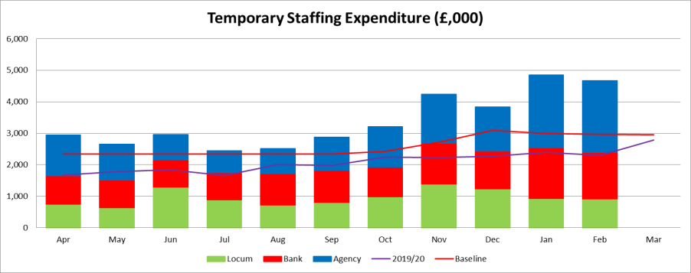
Financial Performance to February 2021 (Month 11)
Financial Performance
- The Trust has achieved ‘breakeven’ for months 1-6 of the 2020/21 financial year but the second half of the year will see a different funding regime. The Trust continues to receive a block level of funding however the retrospective ‘top up’ for Covid-19 funding is removed and has been issued to the STP as a one-off amount.
- The Operational Divisions and support functions have produced a Trust run rate plan for the remainder of the 2020/21 financial year, set to deliver; Urgent and Emergency care and Covid-19 resilience, Elective recovery and restoration and maintain measures endorsed for health and well-being and already committed investment in Walsall Together. The Trust has developed a balanced financial plan on this basis.
- The Trust forecasted a year to date deficit of £3.3m at February 2021 with the actual performance being ahead of plan at £1.3m deficit due to the receipt of an additional income allocation to offset ‘Lost income’ assumed in the financial plan relating to the IT SLA with the CCG, Property Services, car parking, R&D and accommodation charges. This had been offset through the retrospective top up funding available in month 1-6.
- Temporary workforce expenditure remains over baseline plan and historic levels, being driven by increased vacancies, COVID related absence, increased staffing levels, enhanced rates and increased use of escalation capacity.
- Other non pay expenditure is higher, largely due to monthly support costs for the Electronic Patient Record being chargeable this year and costs associated with delays to go live, combined with Covid-19 related costs incurred.
Capital
- The Trust has submitted a revised capital plan of £21.3m. This has increased during the year with additional capital becoming available or awarded to the Trust including urgent and emergency care (£4.1m), critical infrastructure (£3.7m) and allocation from the STP (£0.3m)
- The expenditure to date on capital totals £14.3m, £1.0m in February
Cash
- The Trust is holding substantial cash allocations at the end of February 2021. This is largely as a consequence of block contracts being received a month in advance since April 2020. The Trust will repay this advance block payment in March but will still be holding substantial cash holdings in excess of £20m.
Efficiency attainment
- The emergency budget planning letter and guidance states there was no efficiency requirement for Months 1-6. However, development of Improvement Programme initiatives is key to ensuring financial sustainability moving forwards, with the outputs of this program to be reviewed by Performance, Finance and Investment Committee.

 | YTD Feb Plan  £000s | YTD Feb Actual  £000s | YTD Variance  £000s
Income  Clinical Contract Income Additional Covid Top-up  Other Income (Education&Training) Other Income (Other) | 251,908  0  6,223  24,128 | 251,101  13,678  7,257  24,011 | (807)  13,678  1,034  (117)
Subtotal Income | 282,259 | 296,047 | 13,788
Pay Expenditure Substantive Salaries Temporary Nursing Temporary Medical  Temporary Other | (151,475)  (15,450)  (13,071)  (3,371) | (152,478)  (18,293)  (13,822)  (5,107) | (1,003)  (2,843)  (751)  (1,737)
Subtotal Pay Expenditure | (183,366) | (189,700) | (6,334)
Non Pay Expenditure Drugs  Clinical Supplies and Services  Non-Clinical Supplies and Services Other Non Pay  Depreciation | (16,798)  (17,122)  (14,076)  (39,409)  (6,044) | (16,062)  (14,211)  (15,717)  (46,697)  (7,009) | 736  2,911  (1,641)  (7,288)  (965)
Subtotal Non Pay Expenditure | (93,449) | (99,697) | (6,247)
Interest Payable | (8,787) | (8,113) | 673
Subtotal Finance Costs | (8,787) | (8,113) | 673
Total Surplus / (Deficit) | (3,342) | (1,463) | 1,879
Donated Asset Adjustment | 75 | 163 | 88
Adjusted Surplus / (Deficit) | (3,267) | (1,301) | 1,967

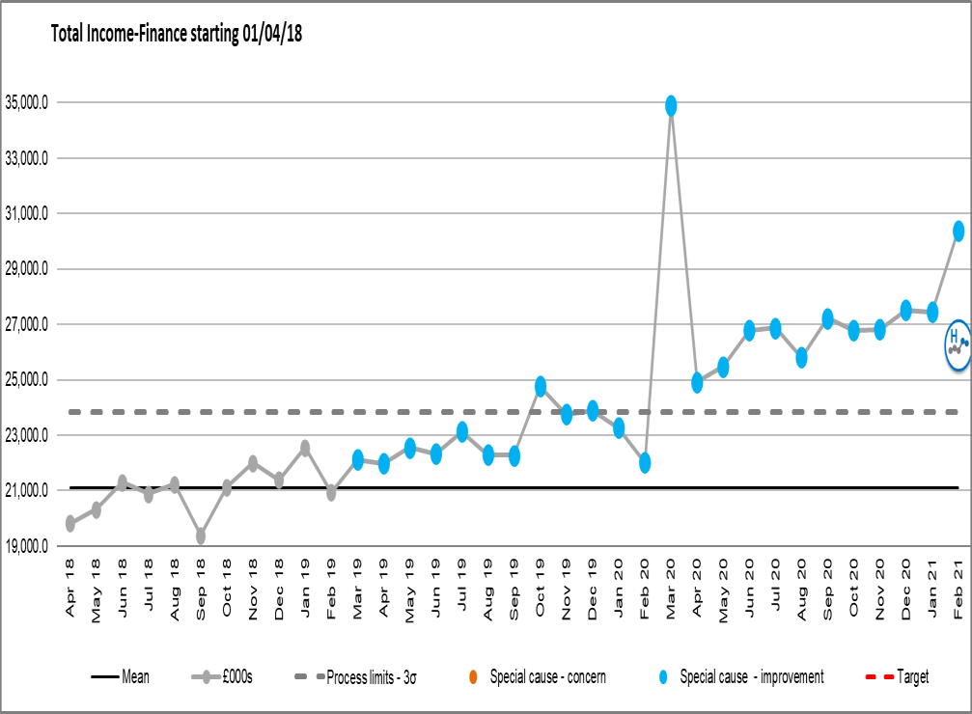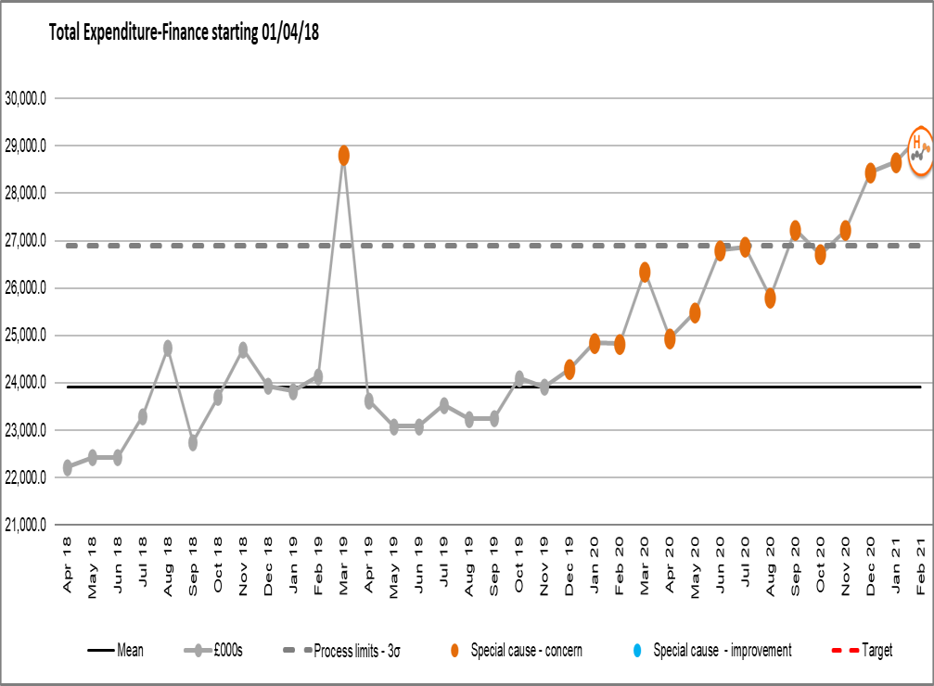Income and expenditure run rate charts

Income additional information
  - Income has continued to increase year on year, this reflects a level of tariff inflation and growth serviced through the Trust over this period
  - January and February 2020 income reduced as the Trust moved away from plan, losing central income from the Financial Recovery Fund (FRF) and Provider Sustainability Fund (PSF) during these months
  - March 2020 saw the Trust move back on plan and receive the quarters FRF and PSF in month accordingly
  - April’s income reflects the emergency budget income allocation (increasing monthly to reflect the increase in the top up of funding received)
  - From October there will no longer be retrospective top up funding received, block income has been agreed based on operation run rates
  - February 2021 saw the receipt of additional NHSEI Income allocation to offset the ‘Lost Income’ assumed in the Deficit Plan

Expenditure additional information
  - March 2019 the Trust accounted for the ICCU Impairment
of £6.2m
  - March 2020 costs increased to reflect the Maternity theatre impairment £1m & Covid-19 expenditure
  - Throughout April and May 2020 costs increased in support of COVID-19, with June and July seeing these costs increase further for elective restart and provision for EPR, Clinical Excellence Awards impacts on cost base, noting a reduction in expenditure in August due to the non recurrent nature of these. Spend increased again in September due to back dated Medical Pay Award, increased elective activity and non recurrent consultancy spend and remains high driven by the additional pressures of a second wave of COVID activity.

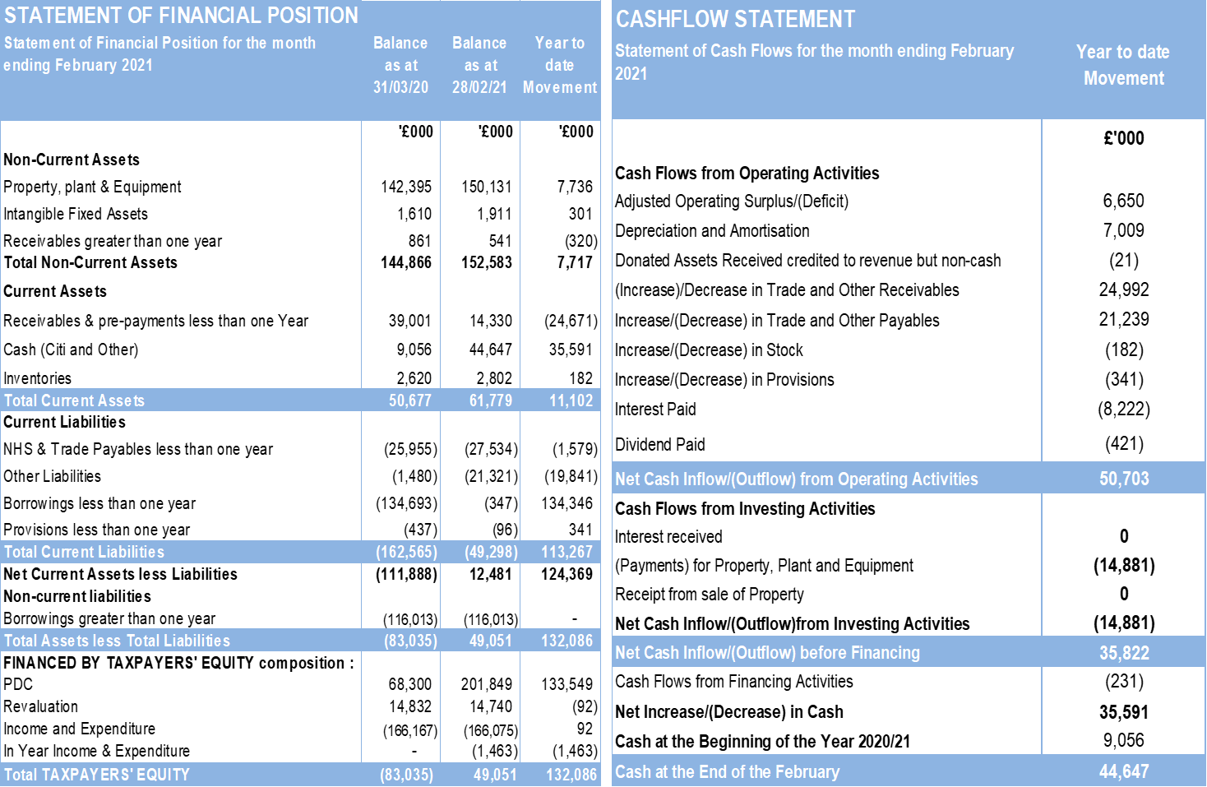Cash Flow Statement & Statement of Financial Position (M11)

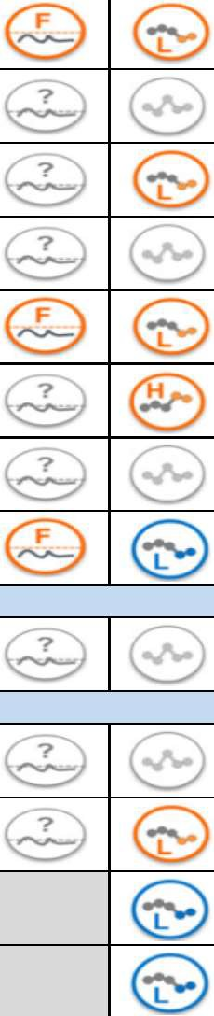
PERFORMANCE, FINANCE AND INVESTMENT COMMITTEE
46 48 41 34 34 33

Sep-20 | Oct-20 | Nov-20 | Dec-20 | Jan-21 | Feb-21

2020/21  YTD | 2020/21  Target | 2019/20  YTD | SPC  Variance | SPC  Assurance

SAFE, HIGH QUALITY CARE
% | Total time spent in ED - % within 4 hours - Overall (Type 1 and 3)
% | Ambulance Handover - Percentage of clinical handovers completed within 15 minutes of recorded time of arrival at ED
No. | Ambulance Handover - No. of Handovers completed over 60mins
% | Cancer - 2 week GP referral to 1st outpatient appointment
% | Cancer - 62 day referral to treatment of all cancers
% | 18 weeks Referral to Treatment - % within 18 weeks - Incomplete
No. | 18 weeks Referral to Treatment - No. of patients waiting over 52 weeks - Incomplete
% | % of Service Users waiting 6 weeks or more from Referral for a Diagnostic Test
No. | No. of Open Contract Performance Notices
CARE AT HOME
% | ED Reattenders within 7 days
RESOURCES
% | Outpatient DNA Rate (Hospital and Community)
% | Theatre Utilisation - Touch Time Utilisation (%)
No. | Average Number of Medically Fit Patients (Mon&Thurs)
No. | Average LoS for Medically Fit Patients (from point they become Medically Fit) (Mon&Thurs)
£ | Surplus or Deficit (year to date) (000's)
£ | Variance from plan (year to date) (000's)

83.50% | 73.00% | 78.27% | 79.29% | 69.28% | 84.60%
58.23% | 57.04% | 61.85% | 57.67% | 49.06% | 51.04%
20 | 66 | 42 | 19 | 23 | 0
86.57% | 82.27% | 77.03% | 77.99% | 75.18%
67.78% | 65.35% | 77.11% | 82.35% | 75.32%
68.66% | 74.03% | 74.97% | 72.69% | 69.82% | 66.82%
14 | 14 | 37 | 110 | 324 | 687
14.70% | 12.35% | 17.92% | 15.53% | 4.87% | 1.45%
9 | 9 | 9 | 9 | 9 | 0
6.63% | 7.60% | 7.67% | 7.94% | 7.42% | 7.94%
11.42% | 12.93% | 13.23% | 12.85% | 13.18% | 11.46%
43.61% | 66.17% | 54.91% | 50.90% | 46.69% | 41.29%
4.00 | 5.00 | 4.00 | 4.00 | 3.00 | 3.00
0 | 72 | -330 | -1263 | -2470 | -1300
0 | 23 | 71 | 311 | 30 | 1967

84.02% | 95.00% | 81.77% |  | 
64.79% | 100.00% | 62.37%
176 | 0 | 312
85.38% | 93.00% | 84.07%
72.79% | 85.00% | 80.93%
1213 | 0 | 0
16.29% | 1.00% | 1.63%
 | 0
7.94% | 7.00% | 7.60%
10.49% | 8.00% | 10.44%
54.21% | 75.00% | 85.42%

PERFORMANCE, FINANCE AND INVESTMENT COMMITTEE

Sep-20 | Oct-20 | Nov-20 | Dec-20 | Jan-21 | Feb-21

2020/21  YTD | 2020/21  Target | 2019/20  YTD | SPC  Variance | SPC  Assurance

£ | CIP Plan (YTD) (000s)
£ | CIP Delivery (YTD) (000s)
£ | Temporary Workforce Plan (YTD) (000s)
£ | Temporary Workforce Delivery (YTD) (000s)
£ | Capital Spend Plan (YTD) (000s)
£ | Capital Spend Delivery (YTD) (000s)

14100 | 17100 | 20500 | 24400 | 28100 | 31900
16300 | 19600 | 23900 | 27700 | 32600 | 37200
4500 | 5400 | 8300 | 11200 | 13300 | 14300

MEETING OF THE PUBLIC TRUST BOARD – 1st April 2021
Walsall Together Partnership Board Highlight Report |  |  | AGENDA ITEM: 14
Report Author and Job Title: | Trish Mills Trust Secretary | Responsible Director: | Mrs Anne Baines – Chair and Non- Executive Director
Action Required | Approve ☐ Discuss ☐ Inform ☒ Assure ☒
Executive Summary | The report provides the key messages from the Walsall Together Partnership Board (Partnership Board) meeting on 24th March 2021. Key points for the attention of the Trust Board are:  - Partners agreed that the operational update is maturing into a more integrated approach to reporting, noting that the next step is for it to move to a more balanced scorecard approach, making triangulation more effective.  - The Partnership was not assured that funding for diabetes and care home support services was resolved and looked for a resolution with Commissioners.  - An increase in safeguarding activity was noted by around 25% on last year, and it was agreed that it was important for the partnership to be clear that safeguarding takes a whole system approach to address inequalities in both children and adult safeguarding.  - Primary Care Networks are looking at how they restart services on during Quarter 1 of 2021/22 to ensure priority groups are the focus and without increasing volumes to unmanageable levels, particularly given the degree of infection control measure still in place which increases appointment turnaround times. This was echoed by Healthwatch, and Black Country Mental Health Trust also looking at what business as usual looks like post COVID-19. The Primary Care Networks are seeing an increase in non  COVID-19 patients coming back to the practices, which will increase referrals to other partners over the coming months.  - Revised reporting was discussed for the programme update, which is amber overall. It was agreed that reporting would reflect

not only progress, but outcomes and benefits also. Good and wide ranging debate was had on the Model of Care graphic for Walsall Together, which depicts the vision of how care will look for people and communities of Walsall. Adjustments will be made to reflect all areas of the partnership, particularly to reflect a person’s journey starting at the home, and reflecting a health, care and wellbeing approach in the partnership. The position (in the diagram) of schools and education as part of the good start to life philosophy was raised and a clearer link proposed. The Partnership Board will review the final iteration in April.
- The refreshed proposals for Resilient Communities was considered and approved. Timeframes and outcomes would be formulated over coming months. Whilst the resilient communities’ workstream’s bid for funding from Changing Futures was not successful, the work that went into this bid will form the basis for action plans and outcomes to be formed. The Partnership Board will continue to review progress against this element of the programme.

- The Integrated Care Provider (ICP) roadmap was discussed, and in particular the primary mental health and Improving Access to Psychological Therapies (IAPTS) services. It was reiterated that such services are in scope for the partnership and the rationale for that would be articulated to the Strategic Transformation Partnership (STP). Overall, good progress is being made in the ICP workstreams.

- The risk register was reviewed, with the addition of the risk to the ICS Step Up Pathways and the impact on services and the community. The step-up pathway accepts approx. 20 patients per week, of which 1 or 2 are into beds. This pathway is at-risk in terms of packages of care and beds from additional pressures in the system. This will be discussed in more detail in April. The Partnership Board were encouraged to hear that partners are beginning to share their own organisational risk registers to see where the partnership can assist with mitigation and management.

- The Clinical and Professional Leadership Group (CPLG) presented a revised terms of reference for initial Partnership Board discussion. The group is taking a ‘back to basics’ approach to the revision of their work, aligning with the

 | development of the Health and Wellbeing Board over the coming months to ensure strong alignment. A clearer view of the connectivity with the Health and Wellbeing Board will be discussed by the Partnership Board in the coming months.
Recommendation | Members of the Board are asked to note the report.
Risk in the BAF or Trust Risk Register | This report aligns to the BAF risks for Care at Home (S02) and COVID-19 (S06)
Resource implications | There are no new resource implications associated with this report.
Legal, Equality and Diversity implications | There are no legal, or equality & diversity implications in this paper, however the developing approach to health inequalities is noted.
Strategic Objectives | Safe, high quality care ☒ | Care at home ☒
Strategic Objectives | Partners ☐ | Value colleagues ☒
Strategic Objectives | Resources ☒

MEETING OF THE PUBLIC TRUST BOARD – 1st April 2021
Care at Home Executive Report |  |  | AGENDA ITEM: 15
Report Author and Job Title: | Matthew Dodd  Acting Director of Integration | Responsible Director: | Matthew Dodd  Acting Director of Integration
Action Required | Approve ☐ Discuss ☐ Inform ☒ Assure ☒
Executive Summary | This report provides an overview performance, risk, assurance, and transformation in the Care at Home Strategic domain. The following attachments provide the evidence pertinent to the board requirements. Detailed discussions in these areas have been covered in the relevant Board Committees this month in addition to that noted in the Partnership Board highlight report.  - Operational performance for community services and Adult Social Care, situated within the context of the Walsall Together Partnership (Appendix 1);  - Board Assurance Framework (BAF) for Care at Home (Appendix 2);  - An update on the transition to obtain Integrated Care Provider (ICP) status;  - An update on the Care at Home Improvement Programme  Performance, Assurance and Risk – Community Services  The key risks to community services and assurances around the level of service provision are included in Appendix 1 and all relevant Board Committees have been briefed on these risks in February  In February the issues to raise to Trust Board and provide assurance over, involve two areas:  - Outlining residual pressures  - Key areas of performance  Residual Pressures  The increased operational pressures due to COVID-19 wave 2 started to abate and business continuity measures were reduced in many areas of Community Services, as capacity was better able to

meet demand

- Capacity: While absence within locality teams remained high during February, the teams were able to reduce the amount of hours cancelled compared with the previous month.
- Demand: Referrals into community pathways for patients with Covid reduced during the month. This was in line with the drop in numbers treated at the Manor Hospital and as at 9th March, there were 9 patients on the Safe at Home pathway compared with 67 at one point in January 2021.

Key residual risks:
- Demand for community phlebotomy remained high, but the waiting time was been brought down to a week using bank staff
- Therapy services continued to experience high levels of absence in acute teams and high numbers of patients waiting in community teams, which required sustained redeployment of staff from elective services

Performance & Activity:
Avoiding Hospital Admission:
- The Care Navigation Centre continued to operate as an escalation point for clinical deterioration in the community and was also able to respond to over 500 calls during the month. The clinical teams supporting care homes were able to provide a full schedule of ward round within the homes.
- The Safe at Home pathway had 43 new referrals in-month and cumulatively has dealt with 213 people since its inception in Q3 2020/21
- The long-COVID pathway received a further 196 referrals in- month giving a cumulative number of 779 patients referred into the service

Supporting Hospital Discharge:
- The numbers of patients who are medically stable for discharge remained low at 35 patients
- Therapy elective activity remained at a reduced level to address deficits in non-elective areas of therapy care and

staff redeployed to support acute and community therapy teams

Maintaining Community in-patient care:
- Community in-patient services serving Stroke Rehabilitation and Palliative Care received referrals on a seven day basis throughout and operated at 94% and 78% occupancy respectively during February

Supporting the Vaccination Programme:
- The Saddlers Mass Vaccination site went live on 15th March 2021. Up to this time, Community Services deployed the staff earmarked for this service over to supporting the domiciliary and care home vaccination programme.

Board Assurance Framework
The BAF has been updated and has been reduced to a risk of 12 which reflects both the recent abatement in service pressures and the programme reset work that is taking place via the Senior Management Team and the Clinical & Professional Liaison Group within Walsall Together (Appendix 2).

ICP Roadmap
Work continues to progress with the transition to a formal Integrated Care Provider (ICP) contract. Acknowledging that the national planning round for 2021/22 has been delayed by a quarter, there will be no contractual changes until 1st July.
However, the local work is continuing to implement changes that will support operation in shadow form as soon as possible within quarter one.

There is a strong focus on agreeing the scope of services to be included in the ICP contract. Leaders across the Black Country and West Birmingham Strategic Transformation Partnership (STP) have agreed an initial model of services to be commissioned at place-level. However, several areas remain under discussion. The STP is looking to each place to give a clear rationale for the inclusion or exclusion of services and Walsall is in a strong position to influence the final decision given that the partnership here is more mature than in other areas. The

Walsall Together Partnership Board and Walsall Place Commissioning Committee will formally present the local view and rationale to the STP in April.

The direction of travel to ICP status remains in line with the Walsall Together business case and strategic objectives of Walsall Healthcare. The components that are in scope for 1st July 2021 will involve some reorganisation of services into acute and community contractual schedules, but with no change of overall provision or financial envelope of the provision of services outside of the Trust

As reported to the Board in March, the due diligence work in the finance work stream has commenced but confirmation is awaited from the STP regarding the full scope of services to be included in the ICP contract. This will dictate the extent of the due diligence work, which has to be commenced by 1st April 2021 and completed within 6 months of 2021/22. This has been escalated to the STP, who support our pace of work but are advising that we proceed in phases.

Improvement Programme
As reported to Trust Board last month the majority of projects within Care at Home have continued, although with some delays due to staff being diverted to support operational delivery.
Some highlights of the programme over the last month:

- Planning has commenced with Surgery around their Outpatient improvement work. An emergent area of focus is around the integration of T&O pathways with the community (preventative) work by First Contact Practitioners and the MSK service
- The Integrated Assessment Hub at Walsall Manor Hospital was piloted in Quarter 3 and the team expanded in January 2021. This service aims to prevent admissions and reduce length of stay by facilitating early discharge. In February it saw greater numbers of patients through its three pathways than in January (Hospital avoidance: 29; Early Supported discharge: 82; Assisted discharge: 52)
- Work has commenced with Modality to review opportunities

for joint working around community heart failure pathways
- The service review within Therapies is being incorporated into the Improvement Programme. This work will consider recruitment, capacity & demand, workload review, allocation & outcomes and new models of care.
Recommendation | Members of the Trust Board are asked to note the contents of this report and to note the full detail regarding due diligence on the ICP transition be received via all relevant Board Committees in April.
Does this report mitigate risk included in the BAF or Trust Risk Registers? please outline | BAF Risk- S03 - Failure to understand population health and inequalities, integrate place-based services and deliver them through a whole population approach would result in a continuation if not widening of health inequalities.
Resource implications | There are no new resources implications associated with this report.
Legal and Equality and Diversity implications | The issue of health inequalities continues to receive growing prominence in all forums across Walsall Together. It is reflected in the strategic objectives of the partnership and the associated BAF risk for Walsall Healthcare. There are multiple workstreams that have given focus to this issue within the forward look programme.
Strategic Objectives (highlight which Trust Strategic objective this | Safe, high quality care ☒ | Care at home ☒
 | Partners ☐ | Value colleagues ☐
report aims to support) | Resources ☐

Public Trust Board – 1st April Item 15, Appendix 1

Risk Summary
BAF Reference and Summary Title: |  | BAF SO2 - Care at Home – We will work with partners in addressing health inequalities and delivering care closer to home through integration as the host of Walsall together.
Risk Description: |  | Failure to work with partners and communities to understand population health and inequalities, integrate place-based services and deliver them through a whole population approach would result in a continuation of poor health and wellbeing and widening of health inequalities.
Lead Director: |  | Director of Integration |  |  |  |  | Supported By: | Anne Baines – Non-Executive
Lead Committee: |  | Walsall Together Partnership Board
Links to Corporate Risk Register: |  | Title |  |  |  |  |  |  |  |  | Current Risk Score
 |  | - Risks in this area relate to Walsall Together programme risks. The biggest ones are associated with the limited investment and the size and complexity of the population health challenges  - Non-programme risks relating to Community Services at the current time. These are updated through the divisional structure.  - Each organisation retains its own risk log although the section 75 presents the opportunity to start to bring the logs together  - Risks associated with creating an ICP contract will be considered through a formal due diligence process, supported by NHSE/E  - Operational capacity due to a increase in community prevalence of Covid since December 2020 |  |  |  |  |  |  |  |  | 12
Risk Scoring
Quarter | Q1 |  | Q2 | Q3 | Q4 | Rationale for Risk Level |  |  | Target Risk Level  (Risk Appetite) |  |  | Target Date
Likelihood: | 3 |  | 3 | 4 | 3 | - The increased operational pressures due to Covid wave 2 have started to abate and business continuity measures are being stood down in many areas of Community Services as capacity is better able to meet demand  - The slow-down in some elements of functional transformation that this engendered are now being addressed through the relaunch of both the Walsall Together Senior Management Team and the Clinical Professional Leadership Group meetings  - Strongly established relationship with 50% of General Practice on robust vaccine delivery. Other practices chose not to connect with partnership and deploy alone.  - Vaccine delivery with operational teams mainly in primary care and latterly around the Saddlers Centre retains the potential to dilute focus on core |  |  | Likelihood: | 2
Consequence: | 4 |  | 4 | 4 | 4 |  |  |  | Consequence: | 4 |  | 30 June 2021
Risk Level: | 12 |  | 12 | 16 | 12 |  |  |  | Risk Level: | Mod 10 |  | 30 June 2021

delivery items and to increase system pressure.
- Maturing place-based teams in all areas of Walsall on physical health and Social Care. Additional integration required for Mental Health with IAPT and primary care but not established yet.
- Significant maturity in communications and confidence in Walsall Together
- Advancing maturity in performance data – Work now commenced on aligned quality governance.
- Risk Stratification process for COVID developed with partners which demonstrates the evolving maturity of the partnership
- Substantial improvements in medically stable for discharge before and during Covid 19
- Virtual clinics and community outpatients maturing and triage and referral services now in place
- Partnership approach to managing care home support and intervention
- Strong evidence base being establish for ICP due diligence
- The step up of the risk level relates to the above factors. It is anticipated that
recovery back initially to 12 will be within Q4 – early Q1 21/22 and delivery to target as noted above. This trajectory will remain under constant review.
Control and Assurance Framework 3 Lines of Defence
 | 1st Line of Defence |  |  |  |  |  | 2nd Line of Defence |  | 3rd Line of Defence
Controls: | • | Acting Director appointed |  |  |  |  | • | Alliance agreement signed by Partners | External assessment – CQC/Audit STP Scrutiny  Health and Wellbeing Board Reporting Overview and Scrutiny Committee
Controls: | • | Non-Executive Director appointed |  |  |  |  | • | Governance structure in place and working.
Controls: | •  •  •  • | Partnership Board/Groups and meetings in place  Business Case developed PMO/Project in place and reporting  Operational coordination and twice daily battle rhythm in place |  |  |  |  | •  •  •  • | S75 in place and operational practices now maturing Integration of performance data across the partnership is being progressed and reported to the Walsall Together Committee  Business case approved by all partners  Monthly report to Board and partner organisations
Controls: | • | Covid Vaccine response plan in place with 50% of primary care
Gaps in Control | - No strategic finance plan for investment across the partnership which potentially impacts on the delivery notwithstanding the recent investment from the Trust. This has been mitigated short term with Covid funding, but further work required to establish ongoing formal mechanisms through ICP contracts  - Commissioner contracts not yet aligned to Walsall Together although ICP planning will resolve this issue  - Data needs further aligning to project a common information picture  - Effective engagement with community in development with local groups limited due to Covid social restrictions  - Organisational development for wider integrated working not yet outlined or agreed and delayed due to Covid  - Enactment of section 75 in terms of Monitoring meetings

Assurance: | - Divisional quality board now starting to look at the integrated team response.  - Risk management established at a programme level and a service level integrating risks | - Walsall Together included on Internal Audit Programme  - Walsall Together Committee in place overseeing assurance of the partnership  - STP oversight of ‘PLACE’ based model  - Reporting to Board and Partners  - Oversight on service change from other committees  - ICP due diligence underway | - NHSE/I support of Walsall Together  - STP support  - NHSE/I validation of ICP due diligence
Gaps in Assurance | - Limited in overall external assurance as regulators inspect individual organisations and as yet have not developed ‘PLACE’ based inspections although Walsall
Future Opportunities
- Further development of the Governance around risk sharing
- S75 Deployment based on other services relating to health prevention and public health commissions
- PCN partnership alignment and risk share with building trust and confidence
- Covid-19 offers an opportunity to increase the pace of delivery and more importantly stress test benefits before substantive deployment
- Strategic partnership(s) with major primary care organisations to further accelerate vertical and horizontal integration of care in the borough
- Formal contract through an ICP mechanism
- Formal working with other partners to support their ability to achieve additional income and support via a partnership approach
- CQC action oversight group
Future Risks
- Insufficient promotion of success narrative
- Inability to deliver enough investment up front to change demand flows in the system.
- National influences on constitutional targets moves focus from place to STP
- Retention of inspirational and committed leadership across partners
- Estates – ability to fund the full business case offering (4 Health & Wellbeing Centres)
- Misalignment of provider strategies created by mergers or form changes or senior personnel turnover
- Lack of uninterrupted community clinic space due to Covid Restrictions
- Programme Resource – Capacity to deliver the WT programme will become more difficult as the same resource will be required to support the delivery of COVID-19 workstreams, e.g. mass swabbing, flu vaccination programme, Covid-19 vaccination programme, outbreak management and the covid-19 management Service (CMS)
3
Together put forward as part of ICP development

Further Actions (to further reduce Likelihood / Impact of risk in order to achieve Target Risk Level in line with Risk Appetite)
No. | Action Required | Executive Lead | Due Date | Quarter 3 Progress Report | BRAG
1. | Agree a joint business plan for Walsall Together and PCNs that describes how the enhanced and additional roles within the PCN contract will integrate with community services | Director of Integration | Dec 20 | While good progress has been made in this area and agreement has been reached with PCN’s to host additional recruitment in roles such as First Contact Practitioners and Pharmacists, an agreement in principle and formal roadmap for achieving this is still being  developed. This is being supported by the commencement in post of the WT Business & Contracts Manager
2. | Refresh strategic case for Resilient Communities, ensuring appropriate focus on reducing health inequalities and alignment of strategic objectives across partner organisations | Director of Integration | Dec 20 | This work is underway and will be completed in March 2021. There have been three sessions held in February to review the key work streams and actions around this. A delivery report to the partnership board will be presented in March. This item has been delayed due to  C19 wave 2
3. | Develop population health management strategy across Walsall Together and PCNs including the deployment of the population health module (Digital workstream) | Director of Integration | Mar 21 | This work is underway with the support of the STP Academy and Public health. The Population Health module as part of the Medway deployment is also in our test environment. The final strategy is  interdependent with the production of the Health & Well Being strategy which is focused on the end of Q2
4. | Develop robust governance and legal frameworks for Walsall Together with devolved responsibility within the host (WHT) structure. This should include an outline governance structure that shows the links to other WHT  committees and acknowledge the transition to holding a formal ICP contract. | Director of Governance | Mar 21 | This work is on track as part of the ICP programme
6. | Prepare for implementation of a formal ICP contract under a Lead Provider model with WHT as Lead Provider. This will include confirmation of all services in scope and a clear rationale for the change in the context of improving  outcomes for the population. | Director of Integration | April 21 | On track and formally reported to WTPB monthly


Public Trust Board – 1st April Item 15, Appendix 2

Walsall Together Partnership Operational Update for Trust Board 1st April 2021

Matthew Dodd Acting Director of Integration

Reporting Structured around WT Tiers
- Tier 0: Resilient Communities

Tier 1: Integrated Primary, Long Term Conditions Management, Social & Community Services

- Tier 2: Specialist Community Services

Tier 3: Intermediate Care, Unplanned Care & Crisis Services

- Tier 4: Acute Hospital Services

Tier 0: Resilient Communities

whg H Factor (Health, Hope & Happiness)
Social Prescribing
whg are members of the National Association of Link Workers . Colleagues within the team are currently undertaking their Gold Award in Social Prescribing . This will ensure the service we deliver is in line with the SP national framework and standards .

During February the SP team recruited an additional 9 people to the programme . On average each Link Worker
supports around 25 people with the majority of them remaining on the programme between 6 to 12 weeks . The majority of people are struggling with issues such as relationship breakdown , poverty , drug and alcohol misuse and unemployment . Often they have low confidence a lack of trust in services . The first few weeks are spent unravelling their concerns which then gives them a chance to breathe and often for the first time really think about themselves . It is only at this point that we then support them to write their individual plan .

We offer a range of services and activities offering tasters to encourage people to try something new . An example of this is an arts activity called Life After Lockdown . Participants can draw paint or write about what they are looking forward to doing once the current lockdown eases . Lisa ( not her real name ) was encouraged to take part . She is a young woman with learning difficulties .She lives in a wellbeing scheme and had fallen out with her friends leading her to feel anxious and upset . She became obsessive about the situation drawing on her mum for ongoing support . Lisa's mum who is also her carer was exhausted and becoming anxious and feeling unwell herself . The arts activity gave Lisa something else to focus upon and she discovered she loved painting . Her mum reports that Lisa ‘ is now enthusiastic , motivated and happy , she was depressed and had given up but now cant wait to get up each day and begin painting, it has made her smile again ‘
.

Tier 0: Walsall’s Voluntary & Community Sector – One Walsall

•‘Business as usual’ in completing development tool which assesses OW
member VCSE organisation’s overall performance and sustainability is now receiving national recognition from NAVCA members. In addition, we will be hosting a reset and recovery forum for the sector coming shortly.

•Grant support to the sector is continuing to see an increase as sustainability starts to become a real concern for the sector. We are also supporting to bring together an alliance between a number of smaller groups to develop a Windrush application.
•One Walsall continues to support all comms in relation to the current COVID messages to community groups and the wider voluntary sector, with targeted communications in certain communities as appropriate.

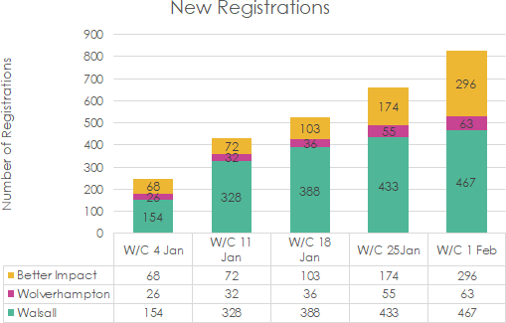
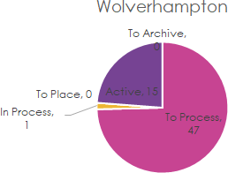
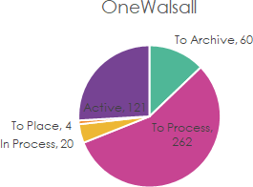
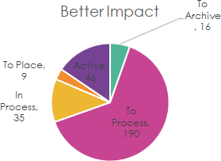
Between w/c 4th Jan – w/c 1st Feb (5 weeks):
826 Volunteers registered (average 142 per week): 467 via OneWalsall
63 via Wolverhampton CVS
296 via Better Impact (the central system)
Of the 826 Registrations:
499 Volunteers are to process 56 Volunteers are in process
195 Volunteers are fully processed
182 Volunteers are actively volunteering
Each registered volunteer receives a welcome email with a request to complete a risk assessment, and a declaration form where not included in registration.
Those that respond will have a screening interview and overview of the programme. They are asked to supply either an in-date DBS or two character references. It is anticipated that there will be an approximate 50% drop out rate.
Recruitment

Covid 19 Vaccination Programme Volunteers Recruitment
Progress Dashboard – W/C 08/02/21
Project Responsible Owner | Karen Brogan | Project Manager | Laura Copas and Jo Dolan

Tier 0:

Walsall’s Voluntary & Community Sector – One Walsall

•Walsall volunteer figures consistently outweigh those signed up across the rest of the Black Country (slide 16). One Walsall still working with DGFT Bureau to process and allocate volunteers. Volunteers featured on BBC WM morning radio sharing their positive experiences in late February.
•As of this week we have registered 600 plus vols and details of 73 have been

forwarded directly to the LA in relation to the Saddlers Centre.
•Working with Rethink a Provider Forum for Mental Health support was hosted with the One Walsall Partnerships Manager to identify support services around mental health and highlighting work to commissioners. Actions from this meeting now being progressed to move the conversation forward with providers in terms of support required to further enhance their capacity for rise in demand.

•Second State of the Sector survey now complete and will be evaluating the data of the next few weeks. We are also actively working with funders to understand how we can ensure that communities across the borough are able to access resources to help build back from the impacts of Covid.

Tier 0: whg H Factor
Workforce Development
- whg's internal Employment and Training Team continue to work with Walsall
Manor Hospital supporting local residents to apply for Health Care Assistant posts . A total of 114 local
residents responded to the recruitment campaign with 72 being assessed for interview .
- 42 of the group have been identified as having additional barriers to work (a lack of work experience and a lack of qualifications ) without intervention at this stage they will not meet the selection criteria .
- To narrow this skills gap the group will be offered the opportunity to complete a Sector Work Based training course . Completion of the course will enable the individual to move to the interview stage .
- This approach narrows the existing skills gap providing local residents with improved opportunities to secure employment .
- This contributes to Resilient Communities therefore reducing health inequalities which are driven by
social and economic factors .

Tier 0: whg H Factor

Integrated Care Programme - Experts By Lived Experience
We have encouraged and enabled two local residents to join the ICP working group . They are whg customers with important lived experience of accessing local health and social care services . They have an in-depth knowledge and a genuine understanding of inequality and
disadvantage . They are keen to use their experiences to assist in the design of services for Walsall
. They will therefore join the ICP working group and will be supported to contribute fully . To enable them to benefit from the experience we will support them to keep a reflective journal , recording their experiences, any challenges and opportunities their involvement has provided . The journals maybe used in future co-production activities whist also ensuring their involvement
is fully recognised and valued .
Funding Bid - Changing Futures
Unfortunately we have now been informed that the Changing Futures EOI was unsuccessful . This funding would have enabled the partnership to begin the work required to reduce health inequalities and develop Resilient Communities. Without investment in capacity building , community development and asset based work within communities health inequity will remain with disadvantaged communities continuing to have poor health and wellbeing . We have arranged a meeting with the STP to explore funding opportunities to tackle health inequalities .

Tier 1:

Primary Care
  - COVID Vaccination
    - All the sites that are running have been successful in delivering vaccine According to the
JCVI criteria
    - Vaccines in care homes has commenced some of which has been done by PCN’s and also collaborative working with Walsall Healthcare
    - There has been supply issues with the vaccines which has been a limiting factor for the PCN sites
  - Red sites
    - There have been days over the last months when the home visit service has been overwhelmed
  - General Practice
    - Running at full capacity and this has been compounded by the fact that staff are needed
at the vaccination site, staff off with COVID
    - We are continuing to use remote triage via telephone or econsults
    - Lateral flow testing has been implemented for staff

Tier 1:
Community Nursing Capacity and Demand: In February 2021, Community Services
delivered more hours and cancelled less hours of activity than before Covid
•

•
Community Nursing experienced high
levels of absence in January, which necessitated escalation measures to deliver core services. The absence levels improved slightly in February but the business continuity measures stayed in place as activity levels were lower than in previous months
Proxy indicator of demand (hours delivered + cancelled) remains higher than pre Covid
Hours Delivered

16000
14000
12000
10000
8000
6000
4000
2000
0

2019
2020

2021



1400
1200
1000
800
600
400
200
0
Hours Cancelled

2019
2020
2021



Tier 1:
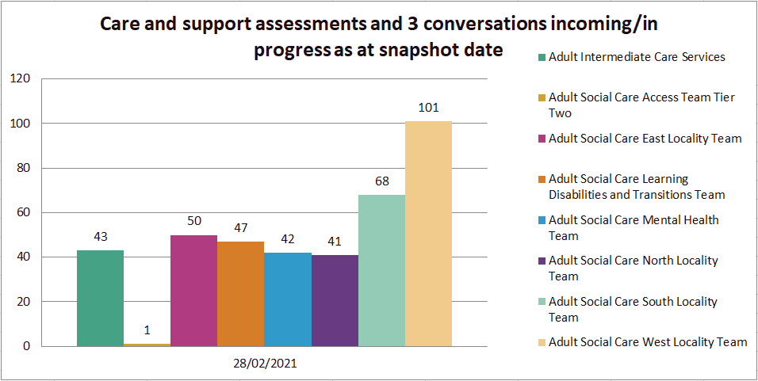
Adult Social Care
The number of new referrals is slightly higher than last month for our locality teams.
Assessments continue to be screened and prioritised.
Assessments awaiting allocation have
reduced.

Tier 1:

Adult Social Care

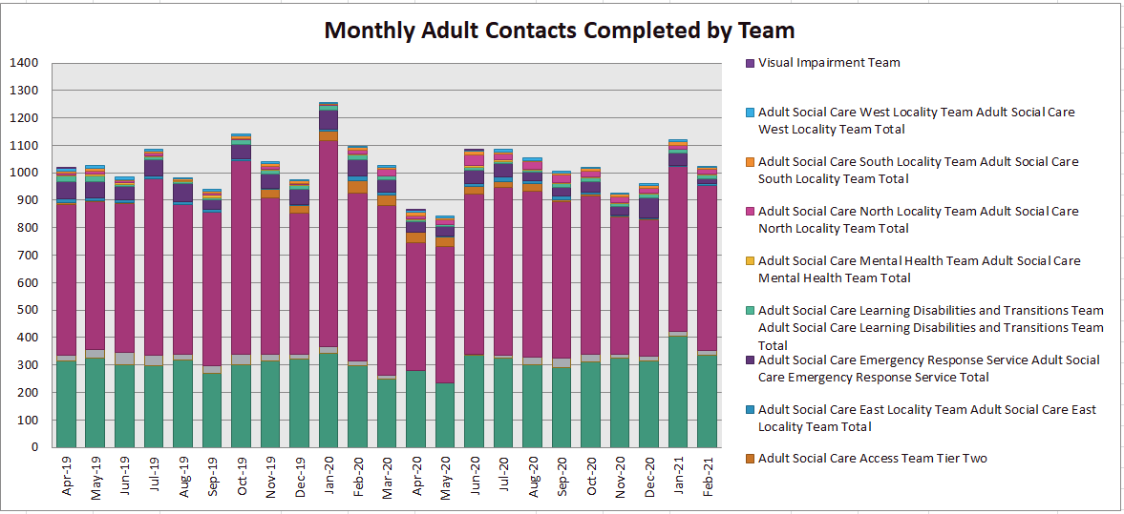

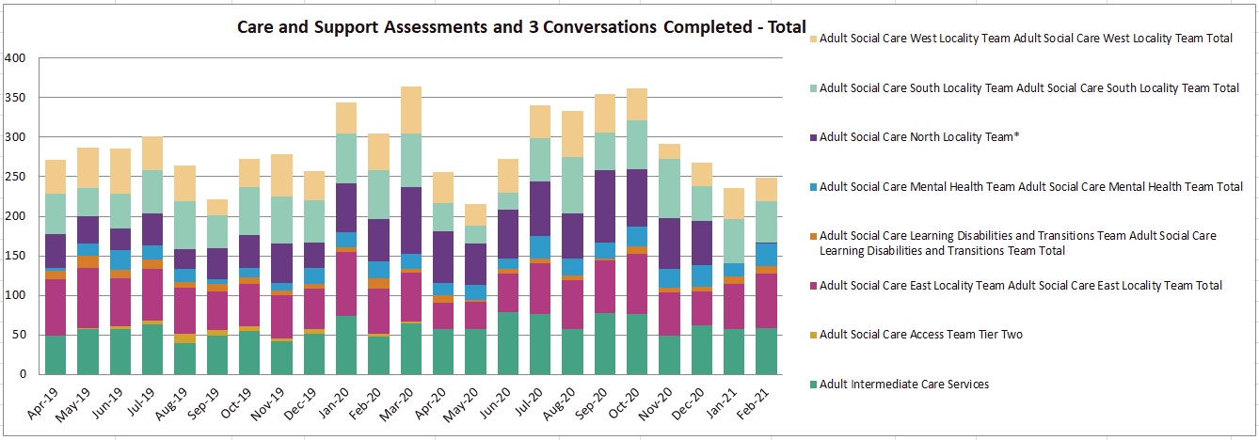
Assessments increased in February and marked an increase in capacity allowing for a
focus onto more of the planned work.

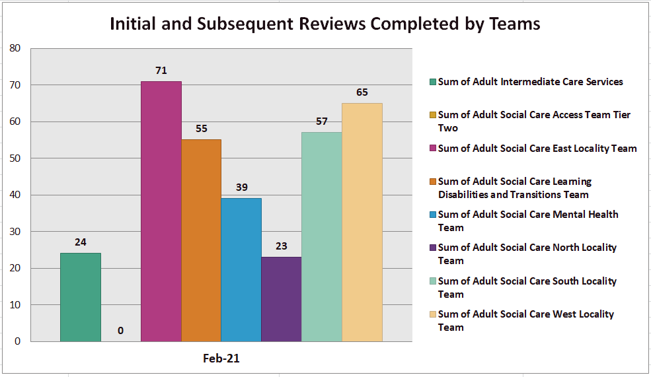
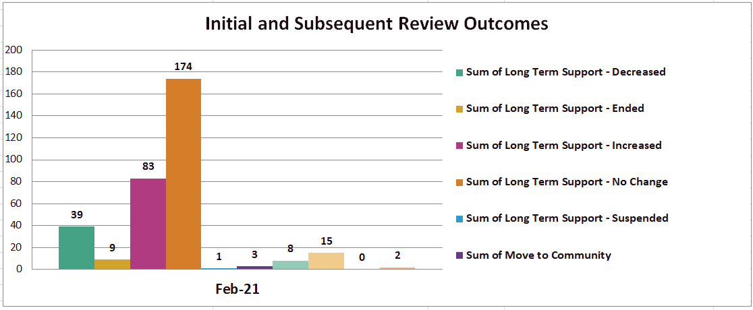
Date | Sum of Total Initial and Subsequent Reviews
Date | Completed
Feb-21 | 334

Tier 1 / 2

Maintaining community-led in- patient care

Holly Bank House
  - Since moving into the unit in April 2020 the average occupancy rate has been 79.6% with the unit attaining occupancy rates of 96% and 94% in January and February 21

Goscote Hospice
  - Since opening in October 2020 the average occupancy rate has been 83% with the unit attaining occupancy rates of 90% and 78% in January and February 21

Supporting the Vaccination Programme
Community Services supports some of the PCNs with their vaccine delivery & works clolsely with them if there are any problems with individual vaccinations
In February the service supported Oak Park
Vaccination Centre and also delivered
  - Care Homes: 4 vaccinations in February (245 in total to 9/2/21) – this constitutes over 90% vaccination rates within the homes that they have been asked to support
  - Domiciliary: 693 vaccinations were delivered on behalf of PCNs in February (1,107 vaccinations completed to 1/3/21)

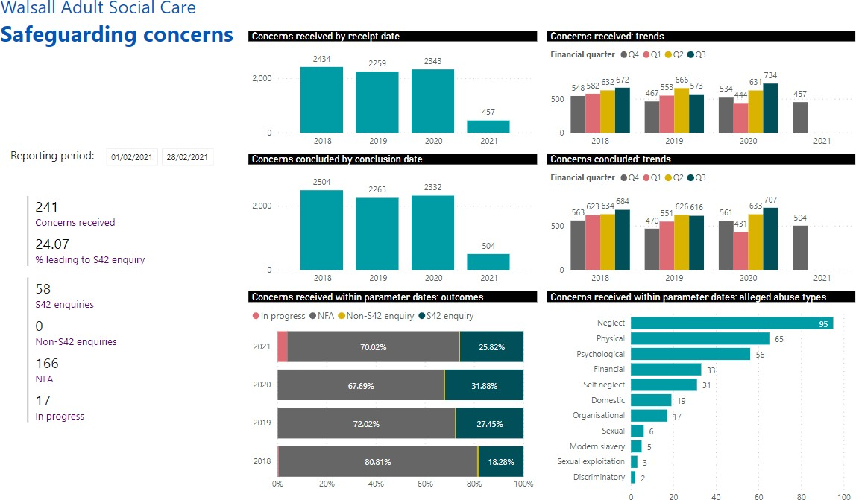
Adult Social Care

ASC have received 241 concerns in February which is an increase on concerns for January 2021 which were 215.

The number of cases progressing to a s42 enquiry is slightly higher for Feb with 61 noting Jan was 58.

Safeguarding cases in progression are 17 which suggests improved management as this number is reduced on January which saw 46 cases in progress.

Neglect & Physical abuse remain the two highest categories of alleged abuse.

Tier 2:

Care Homes Update

•There has been a sharp decrease in deaths, covid positive individuals and infections in
Walsall care homes after the peaks of January.
•Deaths in the third week of February exceeded the previous 5 year averages for Walsall. But for the rest of the month deaths were below what was expected.
•Bed Based providers have received the Rapid Response Grant from the government to
support their rigorous testing programme.
•Resident numbers are slowly lower from January and significant capacity remains
•Ongoing question about future viability of some providers
•Staff absenteeism following a high of 10.98% at the end of January has steadily declined to
6.32%
•At the end of February 90.26% of residents had received their first dose of the Covid
vaccine. For staff members the percentage was 73.05%.

Care Homes Update

As per 28/02/2021:
•

•1248 residents
•452 vacancies

•9 homes with positive cases
•20 closed to admissions

•37 open to admissions

Fatality data from 01/04/20 to date
Provider | Covid 19  Confirmed or  suspected Deaths | Non Covid 19 related since 1st of April  2020
1 | 1 | 69
2 | 6 | 50
3 | 17 | 10
4 | 13 | 14
5 | 18 | 9
6 | 17 | 6
7 | 10 | 13
8 | 5 | 17
9 | 13 | 6
10 | 6 | 9

Tier 3:
Care Navigation Centre: Hours of availability have increased (November
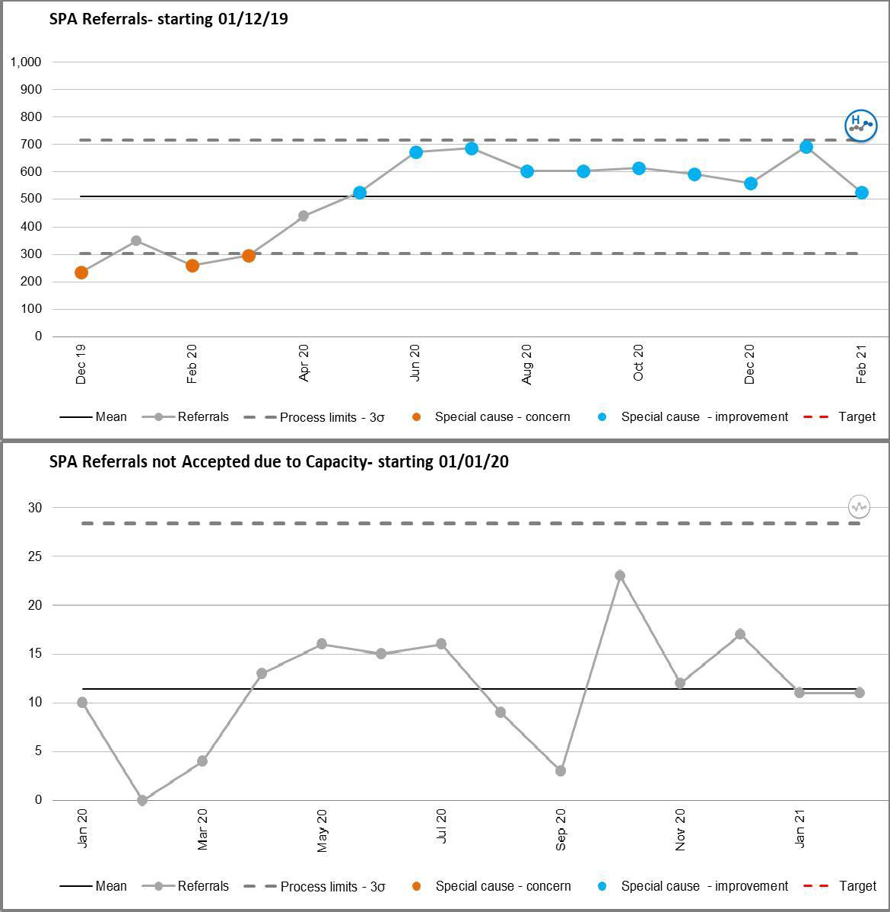
2020) with highest number of calls recorded in January 2021
- The volume of calls to the CNC continues to be high
- The CNC continue to support new services such as screening for long covid and escalation to the MDT through a step down referral and triage via our local
hospital, these numbers are not included in these figures.

Tier 3: Rapid Response
The pattern of demand is changing [impact of CNC]
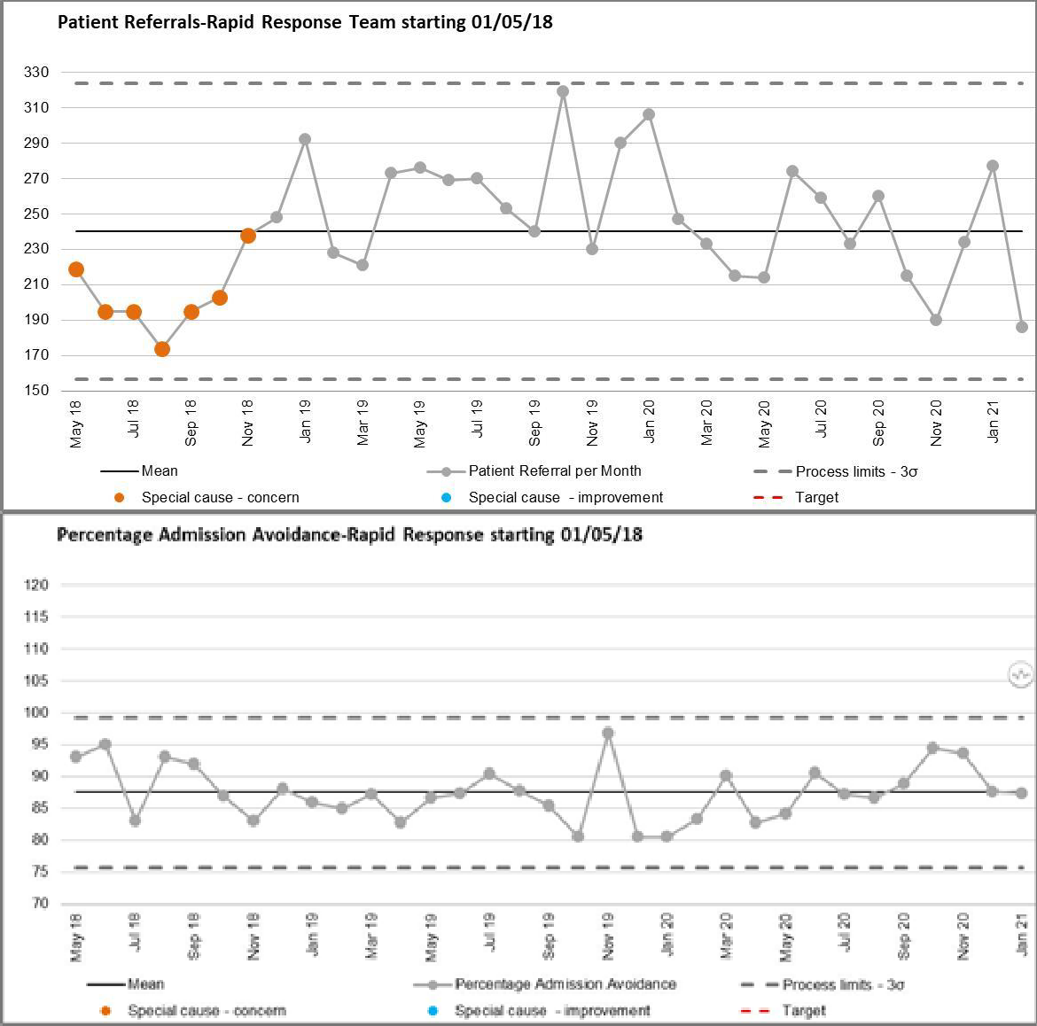

Referrals into Rapid Response remain volatile and this needs to be viewed alongside the growing ability of the Care Navigation Centre to triage referrals into other services as well as the development of the enhanced care model into residential homes. Recruitment is underway to extend operational hours for Rapid Response until midnight, MOC launches 16th March.

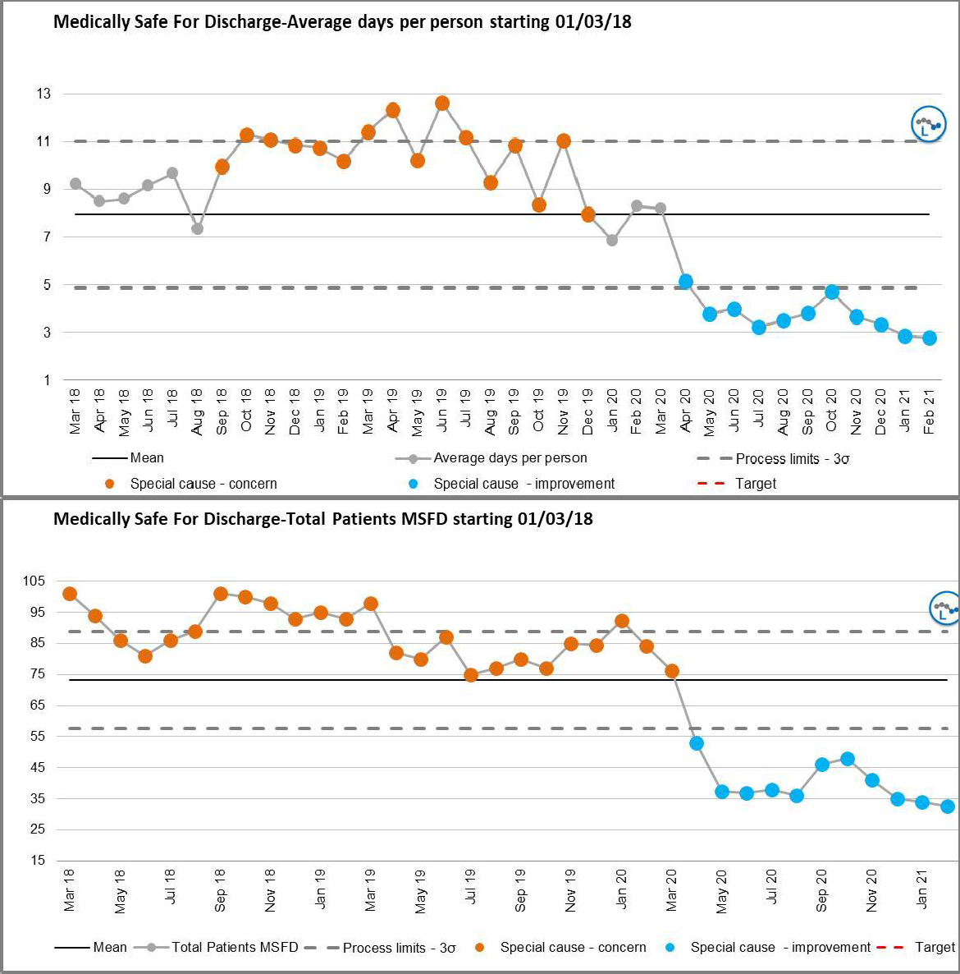
Tier 3: Medically Stable for Discharge (MSFD): numbers remain low
    - The number of MSFD patients remains
significantly lower this winter
    - A review of ICS is planned during Q1 2021/22 as the flow through ICS community pathways will need to be accelerated in order to meet demand within the commissioned capacity. The review will be led by the new ICS commissioner who is due to start on 12/04/21. In the interim, benchmarking is taking place and ICS are working to get as close to 34 beds by 1st April 2021
    - Commissioners have established a care home within the borough to operate as an interim setting for Covid positive patients requiring admission to a care home on discharge, this remains in place for February and March

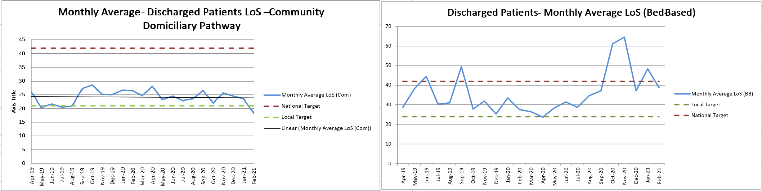
Tier 3: Domiciliary and Bed-Based Pathways

The LOS is reducing through the community ICS pathways. However it remains higher than the commissioned capacity will allow to absorb the current demand from MSFD patients at WMH

Tier 3/4:

Integrated Assessment Hub:
Recruitment is still in progress with a view to moving to a 7 day service in April 2021.
 | Jan 21 | Feb 21
Hospital Avoidance | 29 | 29
Early supported Discharge | 73 | 82
Assisted Discharge | 39 | 52

Integrated Assessment Hub
- Hospital Avoidance: The IAH has developed a pathway so that people directly contacting the Frail Elderly Service or Ambulatory Care at the Manor with post discharge complications are now seen by Rapid Response, Enhanced Care Home Support Team or IV team instead and receive a community based assessment & clinical review, thereby avoiding conveyance to hospital
- Early Supported Discharge: Patients who have been identified in ED, on the assessment units, on the wards and discharged into a community service (including DVTs from ambulatory)
- Assisted Discharge: IAH team signpost / support wards with navigating discharge pathways which result in a discharge same / next day (e.g. out of area patients; Safe at Home scheme; ICS; therapy)

Tier 3/4:
Avoiding Hospital Admission: Safe@Home and Long Covid:
Safe@Home
 | Jan 21 | Feb 21 | Cumulative
Patients referred for  Safe@Home | 133 | 43 | 213
Calls made  Safe@Home | 4,256 | 1,376 | 6,816

The Safe@Home step down pathway has been in place since November 2020. Patients referred onto this discharge pathway are provided with education and pulse oximetry monitoring for a period of 14 days.
During this monitoring period the CNC calls the patient 3 times per day for the first 9 days and then once per day thereafter to day 14 when patients are typically discharged. If there is any deterioration in the patient’s condition they are reviewed by the Rapid Response Team and referred to the Ambulatory Care Team for review. Since its inception the service has received 213 referrals and made 6,816 calls.
213
 | Jan 21 | Feb 21 | Cumulative
Patients referred for  Long Covid |  | 196 | 779
Contacts (F2F and
Telephone) Long Covid

Long Covid
Patients referred onto this discharge pathway are screened for Long Covid through a 6 week and 12 week triage through an MDT. The service has received 779 referrals to date with only 54 diagnosed with Long Covid that have been referred for treatment from Therapy, Psychology and Dietetics.
477
321
32

Tier 4:

Black Country Healthcare
Mental Health & Learning Disability – Operational Issues
  - Continuing pressure in inpatient services – due to both mental health demand and COVID
  - Continued work around our remodelled inpatient services, using specific admission wards and 'red/green' wards to try and reduce transmission and maximise safety. At the time of writing, discussions are live regarding how best to configure these arrangements.
  - Corporate staff continue to be redeployed to assist with COVID priorities where required
  - Trust has achieved 100% roll-out for lateral flow testing
  - Trust is continuing to roll out the Covid-19 vaccination programme to staff and inpatients. Staff vaccinations are being accessed primarily via Walsall Manor Hospital Hub, with a limited number of slots available at Black Country Living Museum and Tipton Sports Centre.
  - Active discussions with primary care colleagues on how Trust can support partners to deliver vaccines in the community to individuals with an LD or Severe MH problems (all now in JCVI cohort 6)
  - Psychological wellbeing hub for staff in STP partners and third sector. More information about the Hub and a self-referral form can be accessed on the BCHFT website: www.blackcountryhealthcare.nhs.uk/our- services/hub. If urgent mental health support is required, the Black Country 24/7 mental health helpline can be contacted on 0800 0086516.

MEETING OF THE PUBLIC TRUST BOARD – 1st April 2021
People and Organisational Development Committee (PODC) Highlight Report |  |  | AGENDA ITEM: 11
Report Author and Job Title: | Trish Mills Trust Secretary | Responsible Director: | Junior Hemans (Non- Executive Director and Chair)
Action Required | Approve ☐ Discuss ☐ Inform ☒ Assure ☒
Executive Summary | The report provides the key messages from the People and Organisational Committee meeting on 25th March 2021. The meeting time and agenda was shortened to allow executives to focus their time on the response to the second wave of COVID-19. Of note are:  - The Committee heard from Matron Angie Dixon and Dr Aditya Kuravi from our Critical Care Unit. It was a privilege to hear their reflections over the last twelve months, and for members of the Committee to formally record their appreciation and thanks for the incredible care the team have provided.  - An extraordinary Committee meeting is being held on 29th March to discuss the staff survey results. A verbal update will be provided at the April Board meeting.  - The Committee reviewed the Workforce Race Equality Standards (WRES) and Workforce Disability Equality Standards (WDES) for the Trust for the 2019/20 year. The Committee noted improvements in the indicators relating to recruitment and disciplinary. When comparing the WRES and WDES outcomes with the results of the 2020 national staff survey there is a clear deterioration across a number of indicators. The April meeting will review the implementation plan and key performance indicators for the Equality, Diversity and Inclusion Strategy, which are intended to address the issues and provide a trajectory for improvement.

- The Committee reviewed a further draft of the disciplinary policy, however was not in a position to approve the policy. Good progress has been made in month on the 7 areas of focus outlined by Baroness Harding in her letter to CEO’s and Trust Boards in May 2019, with two areas of partial assurance remaining. The first relates to training which will commence with a first cohort of staff in May. The second relates to the mechanisms in place by which data on investigations and disciplinary procedures is collated, recorded and regularly and openly reported at Board level. The Committee will receive further reporting on this in April, including the ‘colleague in difficulty report’ and employee relations dashboard.

- The Committee approved the workforce metrics improvement outcome metrics that define the journey from the baseline and foundation position through to good performance to outstanding performance by the 2022-2023 year.

- The Committee discussed the Board Assurance Framework (BAF) risk for Value our Colleagues, noting the complexity of the challenges with this particular BAF risk. The intention is to split the BAF to allow the assurance and gaps in assurance to be drawn out with more particularity, and this is supported by the Committee.

- The Committee reviewed the following reports, which are before the Trust Board for this meeting:

  - Safe staffing and establishment reviews.

  - The Freedom to Speak Up Guardians, Ms Val Ferguson and Ms Kim Sterling, presented their quarterly report. The Committee approved the escalation mechanism to support the closing of the feedback loop for colleagues who raise concerns and to allow for swift action by the Guardians.

  - The Guardian of Safe Working, Dr Mushal Naqvi, presented her report for Aug/Sep/Oct 2020. The Committee committed to actions to identify colleagues to assist with data collection delays and with log-in issues, which will help with the
2

identification of issues earlier and with communication.

- The Committee heard that the University of Birmingham Medical School visited the Trust on 9th March with the initial feedback from the University and the students being very good. The objectives for the coming year for education and training across the organisation were approved, including establishing a simulation faculty to allow students to access training more easily. Discussions to formalise the Education and Training Steering Group reporting into the Committee will be held in the coming weeks.
Recommendation | Members of the Trust Board are asked to note the report and the escalations for its attention.
Risk in the BAF or Trust Risk Register | BAF S04 – Culture (lack of an Inclusive and open culture impacts on staff morale, staff engagement, staff recruitment, retention and patient care)
Resource implications | There are no new resource implications associated with this report.
Legal, Equality and Diversity implications | This Committee supports the Trust’s approach to delivering equality, diversity and inclusion for the benefit of the patient population and staff who work for the Trust and who live in Walsall. .
Strategic Objectives | Safe, high quality care ☐ | Care at home ☐
Strategic Objectives | Partners ☐ | Value colleagues ☒
Strategic Objectives | Resources ☐



MEETING OF THE PUBLIC TRUST BOARD – 1st April 2021
Value our Colleagues – Executive Update |  |  | AGENDA ITEM: 18
Report Author and Job Title: | Catherine Griffiths – Director of People and Culture | Responsible Director: | Catherine Griffiths – Director of People and  Culture
Action Required | Approve ☐ Discuss ☐ Inform ☒ Assure ☒  This report provides an update on actions taken last month relating to the Value Our Colleagues work-stream of the improvement programme. The following points seek to inform the Trust Board of progress, identify where assurance can be taken and where required to seek approval for actions proposed.  - The People and Organisation Development Committee noted and approved the improvement outcome metrics that define the journey from the baseline and foundation position through to good performance to outstanding performance by the 2022-2023 year. The Committee noted that the Trust is one year into the three year improvement programme with foundation work completed. The remaining two years of the improvement programme and Organisation Development plan provide the trajectory for improvement and the committee approved the plan for monthly assurance updates on progress made against the trajectory with immediate escalation for variance to plan. The Improvement Programme metrics are attached at Appendix one. Many of the metrics derive from the national staff survey and the Workforce Race Equality Standards (WRES) and the Workforce Disability Equality Standards (WDES). The metrics for good and outstanding performance have been set in reference to best performance in national data including Model Hospital and the National Staff Survey indicators. The programme of continuing to learn from best practice both within the Strategic Transformation Programme (STP) and nationally will continue.  - The Trust Board can be assured that the plans for workforce recovery have been formed at Divisional level, considering activity and performance levels alongside workforce recovery requirements. This

month, in addition to the support from the Black Country Healthcare NHS Foundation Trust (BCHFT), work has started to establish Listening Circles within the trust particularly to support leadership teams with workforce and individual recovery. The Listening Circles are being delivered as part of the leadership development approach and these have been delivered with the Director of Education and Training at the Royal Wolverhampton Trust (RWT).The Listening Circle approach will be developed across the trust and will complement the existing Wellbeing offer. In this month, the steering group for Schwartz Rounds was convened and the first Schwartz Round will take place in the trust in April 2021.

3. The People and Organisational Development Committee reviewed the Board Assurance Framework (BAF) risk mitigations in place measure performance against key workforce metrics and these provide a benchmark for improvement. The Trust Board can be assured that the focus on staff experience and people metrics will take place each month through the divisional quality boards and the performance executive meetings using a consistent tool for comparison. The BAF was reviewed and approved at the committee and is attached at Appendix two. The People and Organisation Committee approved a schedule of monthly focus sessions division by division for assurance purposes to Trust Board. The qualitative and quantitative metrics within the cultural heat maps provide a holistic view on colleague experience broken down to divisional level. The People and Organisation Development Committee agreed to focus on Community Services at their April meeting as an area where the performance indicators, including staff survey results are significantly above trust score and also above the benchmark average for other trusts. The Committee determined that a positive communication message focused on high performing areas will help with supporting other areas with to learn and replicate. The areas that show performance below trust average are being supported with a range of organisation development activity. Every Division will report to the People and Organisation Development with their action plan and progress. The organisational culture work still requires an evidence base to provide assurance to Trust Board that the interventions have made a measurable difference in colleague experience. The assurance gaps relate to staff experience and engagement and bullying and harassment. The delivery date within
the BAF for evidenced impact is March 2022.

- The national staff survey divisional analysis provides a granular breakdown at divisional level. An extraordinary People and Organisation Development Committee has been convened for the committee to specifically review the divisional data in more depth and the planned actions to provide assurance to Board on the pace and depth of response. The People and Organisation Development Committee reviewed the plans put in place in response to the actions flowing from Private Board in March and noted and approved the following at their meeting:

  - The establishment of an Oversight Task Force reporting back to the committee on a monthly basis for assurance. The group is multi-disciplinary, and representative including staff side, FTSU Guardians, staff network leads and BAME Council Chair. The terms of reference provide the governance, attendance and frequency.
  - The performance metric of improving the staff survey response rate to at least national average by the 2021 survey the joint executive lead will be taken by the Chief Operating Officer and by the Director of Integration.
  - The performance metric of improving the advocacy scores for the trust and the staff engagement score to at least good by the 2021 survey, the engagement score is a proxy for healthy organisational culture and the executive team lead this.
  - To improve staff experience across the trust and eliminate the differential colleague experience based on ethnicity, age, disability, sexuality, gender, religion and other protected characteristics, the executive team lead this with the aim of matching good performance in the 2021 National Staff Survey.
  - To take a Pulse Survey trust wide by May 2021, the executive lead will be the Director for People and Culture.

- The Trust Board are asked to note that the flu vaccination rate at end of campaign is at 75%.

- The Trust Board are asked to note that the COVID-19 Hospital Vaccination Hub which opened on 8th December 2020 had as at the 25th March 2021 vaccinated 83.03% of Walsall Healthcare NHS Trust staff overall. Within this, 87.55% of our high-risk colleagues have been vaccinated [100% offer rate] 81.56% of our clinically extremely
vulnerable staff have been vaccinated [100% offer rate]. 76% of our

Black, Asian and Minority Ethnic colleagues have been vaccinated [100% offer rate] work continues with community and colleague networks to address the particular issues faced by colleagues in fully accessing the offer.

7. The Trust Board can take positive assurances arising from work on workforce supply, the vacancy position for Healthcare Support Workers within the trust will be at zero vacancy as a result of targeted recruitment in partnership with walsall housing group (whg) and Indeed. The provision of support through Royal Wolverhampton NHS Trust on international recruitment for nurses through RWT’s Clinical Fellowship programme will reduce nursing vacancies and the workforce operational plan will detail how other vacancies will be filled for groups such as Allied Health Professionals. The focus on developing the anchor institution approach will continue to mitigate corporate workforce risks and will also contribute to the strategic aims of the equality, diversity and inclusion strategy.
Executive | This report provides an overview of the risks to delivery for the Value Our
Executive | Colleagues’ strategic objective and provides an update on the mitigations in place to manage the risks identified, as well as the actions identified to address gaps in controls and assurance. It provides the Trust Board with assurance relating to the improvement programme Value Our Colleagues work-stream and performance against the Value Our Colleagues strategic objective, this report highlights successes and identifies assurance gaps and areas for improvement.
Summary
Recommendation | - Members of the Trust Board are asked to note the report and in particular note and approve the improvement trajectory for staff experience metrics.  - Members of the Trust Board are asked to note the BAF and the lines of assurance on closing the significant gap between risk appetite and current level of risk and note the milestones to bridge this gap within the improvement plan.  - Members of the Trust Board are asked to note the update on staff survey response and action planning.

Does this report mitigate risk included in the BAF or Trust Risk Registers? please outline | This report addresses BAF Risk SO45 to provide positive assurance the mitigations in place to manage this risk and the related corporate risks.
Resource | There are resource implications that flow from recommendations in the
Resource | report. In the short-term the resource requirements are being met from base budgets. The improvement programme and OD approach will require investment beyond the base budget in order to achieve the milestones and progress envisaged by 2022. The investment case will be considered through trust governance including People and Organisation Development Committee, Performance Finance and Investment Committee and Quality Patient Experience and Safety Committee before further recommendation to Trust Board.
implications
Legal and Equality | There are significant issues relating to equality arising from matters
Legal and Equality | addressed in the report. The Trust Board has been presented with the
and Diversity
and Diversity | evidence base for differential staff experience based on ethnicity, disability, age, sexuality, gender, religion and other protected characteristics.  This goes to the heart of both the Trust Board pledge and the Trust values and supporting behaviours. The improvement programme seeks to mitigate the risk on the BAF, noting the low baseline and the considerable challenge of achieving outstanding performance across the metrics by 2022. In addition the valuing our colleagues work-stream seeks to ensure the systems the Trust relies upon can delivery equality of outcome relating to career progression, development, promotion, talent management and recruitment such that the workforce is representative of the communities it serves and can be seen as an anchor institution within Walsall.  The leadership and management development programmes both focus on equality outcomes and developing skills and understanding of an inclusive leadership approach, whilst leading for performance improvement in a compassionate framework that supports a just and learning culture.
implications

Strategic Objectives | Safe, high quality care ☐ | Care at home ☐
Strategic Objectives | Partners ☐ | Value colleagues ☒
Strategic Objectives | Resources ☐

Value Our Colleagues – Improvement Programme

- EXECUTIVE SUMMARY

The Trust Board made a pledge relating to Value Our Colleagues as follows:

“We the Trust Board, pledge to demonstrate through our actions that we listen and support people. We will ensure that the organisation treats people equally, fairly and inclusively with zero tolerance of bullying. We uphold and role-model the Trust values chosen by you”

The evidence available demonstrates that the pledge is not met consistently across the Trust. There are areas of good practice from which we need to learn; equally there are areas of poor and discriminatory practice which run counter to the trust values and which are normalised in some areas. The cultural heat maps will set out the qualitative metrics measuring staff experience and the degree to which the pledge is achieved by department level.

The purpose of the Value Our Colleagues enabling work-stream of the improvement programme is to deliver workforce improvement so colleagues recommend the Trust as a place to work and as a place to be treated. Colleague experience has a direct correlation with patient experience and outcomes.

The focus on developing leaders and managers to role model the behaviours and values of the trust is a critical lever to change the direction of travel and to appreciate and build on good practice, learn from it and embed it elsewhere.

The National Staff Survey results evidence the assurance gap between risk appetite and the current position relating to staff experience particularly that relating to WRES and WDES data and although there have been improvements on the baseline there is a significant way to go. The journey from foundation through to good and outstanding for staff experience has been defined and the trajectory approved at the People and Organisation Development Committee. The metrics including the baseline position are attached at appendix one.

The impact of the COVID-19 emergency response and its aftermath on colleague wellbeing is significant and the time for reflection and workforce recovery is critical. The committee heard a staff story from the critical care unit and noted that the time to listen, hear and take action as a result is vital to colleague confidence and recovery.

- BOARD ASSURANCE FRAMEWORK

The Board Assurance Framework (BAF) Risk S04 provides that lack of an inclusive and open culture impacts on staff morale, staff engagement, staff recruitment, retention and patient care. The BAF is attached at appendix 2. The People and Organisation Development Committee approved the updated BAF the Board are asked to note the assurance gap between risk appetite and current position and note the improvement programme is the mechanism to bridge this gap.

- PERFORMANCE REPORT

The workforce metrics performance element of this report takes a standard set of quantitative metrics and tracks performance over time. The qualitative metrics on staff experience will be tracked against the improvement programme planned outcomes.

- IMPROVEMENT PROGRAMME

There are 29 overarching projects in the Value Our Colleagues’ work-stream, these are structured into three sub-work-streams as follows:

  - Leadership, Culture and OD
  - Organisation Effectiveness
  - Making Walsall (and the Black Country) the best place to work

The People and Organisation Development Committee the re-prioritisation of the Value Our Colleagues work-stream is complete for year one, despite deploying resource to support the emergency response to the pandemic over the past 12 months. The planned work for year two continues at pace.

- RECOMMENDATIONS

- Members of the Trust Board are asked to note the report and in particular note and approve the improvement trajectory for staff experience metrics.

- Members of the Trust Board are asked to note the BAF and the lines of assurance on closing the significant gap between risk appetite and current level of risk and note the milestones to bridge this gap within the improvement plan.

- Members of the Trust Board are asked to note the update on staff survey response and action planning.

APPENDICES

- Improvement Programme – Staff Experience Metrics Improvement Trajectory
- BAF SO4
- Workforce performance metrics

Public Trust Board – 1st April Item 18, Appendix 1

Strategic Framework for Organisation Development

Developing a Healthy Culture



Vision: Caring for Walsall Together
Ambition: To be rated as outstanding by the CQC for our services by 2022.
Strategic Objectives
Valuing Colleagues | Safe, high quality care |  | Care at home | Working with Partners |  | Using our resources well
Leadership, Culture & OD |  | Organisational Effectiveness |  |  | Making Walsall the Best Place to Work
- To design and implement an organisational development approach to support an inclusive and just culture.  - To equip the workforce with the necessary skills and frameworks to lead, design and deliver the aim of being an outstanding organisation.  - To develop and deliver a collaborative leadership development programme with Walsall Together partners and STP collaborative partners.  - To develop the values, behaviours within the Trust using NHSI culture programme to achieve the Board pledge evidenced through the national staff survey.  - To co-design EDI strategy with staff, patient, community/voluntary groups.  - Identify clear accountability framework for people management metrics in line with National People Plan. |  | - To identify and design new roles and career pathways to shape the future workforce for Walsall and across the Black Country STP.  - To develop a sustainable operational workforce plan as part of the Black Country STP.  - To implement the Black Country Collaborative Bank and reduce reliance on temporary workforce.  - To design and implement a shared approach to talent and succession planning to improve flexibility and agility of the workforce.  - To extend the equality, diversity, inclusion approach within the workforce.  - Develop the Trust approach to work/life balance and improve retention rates.  - To improve levels of attendance at work.  - To design a framework for introducing Divisional Boards for accountability and planning. |  |  | - To provide a structured and holistic approach to workplace health and wellbeing in collaboration with STP partners.  - To provide a structured and consistent approach to workplace education, learning and development with STP partners.  - Ensuring everyone feels they have voice, control and influence, developing the freedom to speak up approach and partnership with staff- side.  - To ensure the trust values are experienced by all and improve staff engagement scores and staff advocacy for Walsall as a place to work.  - To improve staff advocacy for Walsall as a place to be treated.  - Develop the Trust approach to corporate social responsibility and as a key employer within the community.  - To provide a structured approach to the pay, employment and benefits offer available.

Valuing our Colleagues – Moving from Baseline to Good to Outstanding

Measures BASELINE 2019 Actual Results | FOUNDATION 2020 Actual Results | GOOD 2021/2022 to OUTSTANDING 2022/2023 Aspirational
National Staff Survey 2019  Recommend as a Place to Work FFT (Q18c)  BASELINE 47.8%  Recommend as a Place to be Treated FFT (Q18d)  BASELINE 49% | National Staff Survey 2020 Recommend as a Place to Work 52.3%  Recommend as a Place to be Treated FFT 53.4% | Recommend as a Place to Work FFT increasing to  GOOD all England average by 2021/2022 67% [survey 2020]  OUTSTANDING top quartile by 2022/2023 84% [survey 2020]  Recommend as a Place to be Treated FFT increasing to  GOOD all England average by 2022/2023 74% [survey 2020]  OUTSTANDING top quartile by 2022/2023 92% [survey 2020]
Staff saying they feel involved in improvements (Q4b)  BASELINE 70%  Staff Engagement  BASELINE 6.6  National Staff Survey Response Rate  BASELINE 31% | Staff saying they feel involved in improvements  70.5%  Staff Engagement  6.7  National Staff Survey Response Rate  33% | Staff saying they feel involved in improvements  GOOD 73%  OUTSTANDING 82%  Staff Engagement  GOOD 7.0 OUTSTANDING 7.6  National Staff Survey Response Rate  GOOD 45% [median survey 2020]  OUTSTANDING 80%
Improving Equality, diversity and Inclusion survey score in the NHS staff survey  BASELINE 8.8 | Equality, Diversity and Inclusion NSS theme Score  8.7 | Equality, Diversity and Inclusion NSS Theme Score  GOOD 9.1 [average]  OUTSTANDING 9.5 [best]
Sickness absence  BASELINE 6.82% | Sickness absence – Model Hospital – Target set 4.5% by 2022  4.9% [January 2021] | Sickness absence – Model Hospital GOOD 4.29% [median] OUTSTANDING 3.50% [top quartile]
Turnover to reach Trust target of 10 % by 2021 and top decile performance by 2022  BASELINE 11.64% | Turnover – Target set 10% by 2022  8.66% | Turnover – Target set 10% by 2022 GOOD % [top quartile] OUTSTANDING % [top decile]
Improving the staff wellbeing survey theme score in the NHS staff survey theme score  BASELINE 5.5 | Staff Wellbeing NSS theme Score  5.7 | Staff Wellbeing Theme Score  GOOD 6.1 [average]  OUTSTANDING 6.9 [best]
My manager takes an interest in my wellbeing (Q8f)  BASELINE 65% | My manager takes an interest in my wellbeing (Q8f)  69% | My manager takes an interest in my wellbeing (8f)  GOOD 69 % [average]  OUTSTANDING 77 % [best]

Improving WRES/WDES/Equality Performance against Equality | Annual WRES /WDES Equality Data | Staff are included and treated fairly and differential in NSS by
Objectives – targets to be set to reflect community. | Quarterly review of actions at PODC | equality characteristics reduces and discrimination is not tolerated
National Staff Survey – no equality differential on career | Trust Board every 6 months
opportunities, promotion to be evident by 2022

Valuing our Colleagues – Moving from Baseline to Good to Outstanding

Measures BASELINE 2019 Actual Results | FOUNDATION 2020 Actual Results | GOOD 2021/2022 to OUTSTANDING 2022/2023 Aspirational
National Staff Survey 2019 | National Staff Survey 2020 | Safety Culture NSS Theme increasing to
Safety Culture – NSS Theme |  | GOOD 2021/2022 | 6.8 [average 2020]
BASELINE 6.3 | Safety Culture NSS Theme 6.3 | OUTSTANDING 2022/2023 | 7.4 [best 2020]
When errors, near misses or incidents are reported, my organisation | When errors, near misses reported (Q16c) | When errors,, near misses reported (Q16c)
takes action to ensure they do not happen again (Q16c) | 61.4% | GOOD 2022/2023 | 72.7% [average survey 2020]
BASELINE 59.6% |  | OUTSTANDING 2022/2023 | 84.2% [best survey 2020]
Improving WRES/WDES/Equality Performance | Improving WRES/WDES/Equality Performance | Improving WRES/WDES/Equality Performance
BASELINE Indicator 2 WRES 2.73 recruitment | Indicator 2 WRES 1.52 recruitment | Indicator 2 WRES 1.00 recruitment
BASELINE Indicator 3 WRES 2.04 disciplinary | Indicator 3 WRES 0.65 disciplinary | Indicator 3 WRES 1.00 disciplinary
BASELINE Indicator 4 WRES 0.94 access to training | Indicator 4 WRES 1.34 access to training | Indicator 4 WRES 1.00 access to training
BASELINE Indicator 2 WDES TBC | Indicator 2 WDES TBC | Indicator 2 WDES TBC
BASELINE Indicator 3 WDES TBC | Indicator 3 WDES TBC | Indicator 3 WDES TBC
BASELINE Indicator 4 WDES TBC | Indicator 4 WDES TBC | Indicator 4 WDES TBC
Reducing Bullying, Harassment & Discrimination – NSS Theme score  BASELINE 7.6 | Reducing Bullying, Harassment & Discrimination NSS theme score  7.6 | Reducing Bullying, Harassment & Discrimination NSS theme score  GOOD 2021/2022 8.1 [average 2020]  OUTSTANDING 2022/2023 8.7 [best 2020]
ER cases are concluded in line with just and learning culture resolved within time scale – reduction in formal cases. | 6 monthly Staff in Difficulty Report to JNCC, PODC, Trust Board May 2021 for October 2020 to March 2021  Nov 2021 for April 2021 to September 2021 | My organisation treats staff involved in an incident or near miss fairly (Q18a)  BASELINE WALSALL 2019 51.7%  FOUNDATION WALSALL 2020 48.2%  GOOD 2020 61.4% [average 2020]  OUTSTANDING 2020 71.1% [best 20
The opportunities for Flexible Working Patterns (Q5h) | Flexible Working Patterns (Q5h) | Flexible Working Patterns (Q5h)
BASELINE 50.9% | 54.6% | GOOD 2021/2022 | 55.5% [average 2020]
 |  | OUTSTANDING 2022/2023 | 64.9% [best 2020]
Gender Pay Gap – Hourly Wage Gap
BASELINE – women earn 77p for every £1 that men earn when | FOUNDATION – women earn 86p for every £1 that men earn when | GOOD 2021/2022 | ZERO GAP
comparing median hourly wages. Their pay is 23% lower. | comparing median hourly wages. Their pay is 14% lower. | OUTSTANDING 2022/2023 | ZERO GAP

Measures for Valuing Colleagues

Measures | Monitoring | Benefits
Recommend as a Place to Work FFT increasing to all England average | Measured through SFFT in Q1, 2 and 4 and NSS in Q3 | Staff feeling more valued, leads to reducing absence, increased
by 2021 and to top quartile by 2022 |  | retention, improved availability
Recommend as a Place to be Treated FFT increasing to all England
average by 2022
Staff saying they feel involved in improvements increasing each | Question to be included in [Pulse Survey] on involvement | Provides a measure of staff morale and inclusion and staff
quarter [Pulse Survey] Improved Staff Engagement score top quatile | NSS each year | engagement score
by 2021 and top decile by 2022
Quality of IPDR audit showing at least 80% positive responses and | Monthly audit process developed including sample survey and | Staff receiving quality appraisals will feel more valued and
improved in NSS to top quartile by 2021 and top decile by 2022 | sample auditing of appraisal documents – outputs reported monthly | supported, leading to reduced turnover and sickness, improved
 | in Workforce Metric Report  NSS data reviewed in February annually | retention, clear career development pathways and structured talent management approach
Sickness absence reduced overall by at least 1% (KPI) by December | Monitored through ESR data and in Workforce Report | Anticipated financial benefits and organisation effectiveness
2020 and to top quartile by 2021 and top decile by 2022 | Each division will set specific targets based on hotspot areas and monitor through DMBs | improvements through reduced reliance on temporary workforce (see PID)
Turnover to reach Trust target of 10 % by 2021 and top decile | Monitored through ESR data and in People Report | Anticipated financial benefits and organisational effectiveness
performance by 2022 | Each division will set specific targets based on hotspot areas and monitor through DMBs | improvements (see PID)
80% of staff report getting their breaks | Question in Pulse Survey to be developed | Staff wellbeing improved = reduced absence
Improving the staff wellbeing score as measured in the NHS staff survey to be top quartile by 2021 and top decile by 2022 | Annual NSS theme Score | Improved staff experience, improved wellbeing scores and reduced absence and reduced temporary workforce spend

Improving WRES/WDES/Equality Performance against Equality Objectives – targets to be set to reflect community.  National Staff Survey – no equality differential on career opportunities, promotion to be evident by 2022 | Annual WRES /WDES Equality Data Quarterly review of actions at PODC Trust Board every 6 months | Staff are included and treated fairly and differential in NSS by equality characteristics reduces and discrimination is not tolerated
Reducing Bullying, Harassment & Discrimination – achieving top quartile performance by 2021 and top decile by 2022 | Annual NSS theme score | Staff feel safe from harm at work = reduced turnover and sickness absence
ER cases are concluded in line with just and learning culture resolved within time scale – reduction in formal cases. | 6 monthly Staff in Difficulty Report | Staff feel supported appropriately – seeing a Just and Learning Culture develop

Public Trust Board – 1st April Item 18, Appendix 2
4Risk Summary
BAF Reference and Summary Title: |  | BAF 04 - Value our Colleagues - We will be an inclusive organisation which lives our organisational values at all times
Risk Description: |  | Lack of an inclusive and open culture impacts on staff morale, staff engagement, staff recruitment, retention and patient care
Lead Director: |  | Director of People and Culture |  |  |  |  | Supported By:
Lead Committee: |  | PEOPLE AND ORGANISATIONAL DEVELOPMENT COMMITTEE
Links to Corporate Risk Register: |  | Title |  |  |  |  |  |  |  | Current Risk Score
 |  | 2072 - Inability to recruit and retain the right staff with the right skills which impacts on fundamentals of care (both patients and staff), and undermines financial efficiency.  707 - Relates to a Failure to comply with equality, diversity and inclusion standards – further risk in implementation  2093 - Staff are exposed to infection with COVID-19 through contact with infected patients, visitors and colleagues. There is a risk of significant physical and mental illness, including death  2095 - The demand for 'Personal Protective Equipment' (PPE) has contributed to a national shortage of proper and effective PPE, resulting in delays in obtaining from supply chain, with the potential to impact on our ability to maintain key critical services and protect staff against COVID-19. |  |  |  |  |  |  |  | 20 (Major)
Risk Scoring
Quarter | Q1 |  | Q2 | Q3 | Q4 | Rationale for Risk Level |  |  | Target Risk Level  (Risk Appetite) |  |  | Target Date
Likelihood: | 4 |  | 4 | 4 | 4 | - Staff recommending Walsall as a place to work is below all England average [bottom quartile Q2 2019-2020 and National Survey 2020]  - Staff recommending Walsall as a place to be treated is below all England average [bottom quartile Q2 2019-2020 and National Survey 2020]  - Staff engagement score in NHS staff survey is below peer comparators  - NHS staff survey indicates a lack of inclusive culture with differential staff experience in bullying, harassment, violence, career progression and promotion this is reflected in WRES and WDES experience metrics  - NHS staff survey indicates a lack of open culture (speaking up) below peer comparators and OD work to 2020-2021 confirms experience  - The model hospital data indicates bottom quartile performance on workforce indicators such as sickness absence and use of resources  - Historical WRES, WDES and Survey data indicates a lack of progress to tackle barriers to inclusion.  - Data and information shared via staff feedback mechanisms evaluating impact of COVID identifies staff and line managers being fatigued and |  |  | Likelihood: |  | 2 | 31 March 2022
Consequence: | 5 |  | 5 | 5 | 5 |  |  |  | Consequence: |  | 5 | 31 March 2022
Risk Level: |  |  |  |  |  |  |  |  | Risk Level: |  | 8 | 31 March 2022

Deleted: .

fearful of the impact that any future waves will have on individuals and staffing levels.
- Data and information from staff engagement events have identified the existence of unhealthy organisation climates in several areas/departments across the Trust where staff have shared stories of unreasonable treatment based on their race, disability, ethnicity and
sexuality.
Control and Assurance Framework 3 Lines of Defence
 | 1st Line of Defence |  |  |  |  |  | 2nd Line of Defence | 3rd Line of Defence
Controls: | - Values launched and evaluated across the Trust  - Staff engagement and communication approach in place  - Policy on zero tolerance to violence in place  - Behaviour Framework implemented and evidence of practicing behaviours in action to be reviewed within the IPDR process framework  - Values based appraisal process in place which incorporates Talent Management and the ability to track access to career progression and promotion  - Health and Wellbeing approach based on holistic offering to staff being developed  - Internal Mental First Aider network established, accredited training complete and network contact details and support available to staff promoted.  - Restorative Just Culture work initiated and ER casework triaged for opportunities for early resolution.  - Staff in at risk groups have been identified and managed appropriately according Wellbeing Review and Stratified Risk Assessments.  - Staff identified as at higher risk of contracting Covid-19 and potentially suffering from more severe symptoms are prioritised for Covid-19 vaccine.  - Set of measures have been identified to monitor progress against workforce inequalities and employment inequality in  Walsall. |  |  |  |  |  | - PODC approved measures to monitor progress against Trust Board Pledge in place.  - F2SU strategy agreed at PODC and in place and oversight F2SU through PODC and the Board  - F2SU and Inclusion Coordinator appointed for six months to support and progress activities.  - Faculty of Leadership and Management Development commissioned and due to commence for Divisional Leadership and Care Group Management Teams. Started  - Annual review of disciplinary processes to ensure inclusive, compassionate and people-centred approach. | - Quarterly deep dive of key workforce metrics by CCG.  - BCWB STP People Plan in development to support implementation of National NHS People Plan.  - Midlands NHSE&I monitoring of individual COVID-19 risk assessment performance.  - STP and regional NHSE&I monitoring of Trust performance regarding uptake of staff flu programme. [  - WRES and WDES outcomes monitored at national and regional NHSE&I level.  - ESR external quality review to be undertaken in Q4 20/21.

Gaps in Control | - Approaches and resources may be insufficiently robust or at scale to achieve meaningful change focus on re-prioritising resources from base budget for 2021-2022  - Current Policy framework not fit for purpose – legacy policies are not aligned to the approach and the supporting education and development paused due to pandemic  - Leadership development programme is in its infancy and was delayed by the emergency response to the pandemic – re-started in March 2021  - Management competency framework is not yet available, impact and evaluation not complete – framework complete and evaluation started launch May 2021  - Resourcing not yet stable – workforce metrics still demonstrate adverse trends for some metrics, others have improved baseline and improvement trajectory for good to outstanding to be reviewed by PODC in March 2021 for April Board.  - EDI targets at organisational and divisional level have not been developed however will be available for the 2021-2022 year as part of the cultural heat map approach.  - Ensuring colleagues identified as high risk are protected against redeployment which may enhance risks to personal health and safety, PODC approved updated approach for 2021-2022.  - Ensuring the individual Covid-19 stratified risk assessment process is fit for purpose approval of approach at PODC for next phase of review from April 2021  - The Trust has not formally introduced the individual wellbeing plan which is a requirement on the NHS People Plan from March 2021 PODC approved plan to complete these by June 2021.
Assurance: | - BAME decision making forum has been established to advise and guide the Trust in its understanding of issues facing colleagues from BAME backgrounds in the workplace and what measures can be taken to improve their experiences.  - Audit of Individual COVID-19 Risk Assessments undertaken to understand risk levels and outcomes of measures implemented to protect staff.  - Review of Individual COVID-19 Risk Assessments with PHE, OH professionals and staff networks – January 2021.  - Benefits of ‘Value our Colleagues’ improvement programme agreed and overseen via Project Board, PFIC and PIDC  - Targeted OD and HR interventions form a specific workstream of the Value Our Colleagues Improvement Programme, which allows us to track, monitor and provide assurance | - People and OD committee of the Board in place to seek assurance, through the cycle of business and review of workforce metric trends.  - EDI Strategy developed with colleague and patient consultation. Approved by PODC February 2021 for Trust Board in May 2021  - EDI group led by a Non-Executive director in place to review approach to EDI and delivery of metrics in the EDI strategy framework and Equality Impact Assessment.  - PODC receive monthly updates regarding to assure robust arrangements in place to support colleagues through the impact of COVID.  - BAME cabinet provides strategic Board focus on EDI.  - Board development sessions to support co-design and approval of EDI strategy completed in October 2020.
Gaps in Assurance | - All elements of the Trust Board pledge, bullying harassment, discrimination and listening to the voice of staff.  - Evidence based approach to positive action interventions not yet in place to support EDI objective  - Evaluation of zero tolerance to violence not yet evaluated.  - NHS staff survey results do not evidence an improvement in staff reporting of an inclusive and open culture. NHS Staff survey provides infrequent insight into staff engagement levels.  - The indicators for staff recommending the Trust as a place to work or a place to be treated have failed to improve significantly.  - The staff engagement score has worsened indicating lower levels of staff morale and role satisfaction.

- NHSE/I Governance and Accountability review highlighted areas of improvement associated with culture and leadership
- No internal audit assurance gained in year
- Line managers are required to ensure all staff have received an opportunity to undertake a wellbeing review and individual covid-19 risk assessment. Not all staff are recorded to have participated in the process.
- More targeted work is required to ascertain staff satisfaction of the individual Covid-19 risk stratification risk assessment.
- An audit against ESR data is being undertaken to provide assurance regarding workforce and learning data quality (due to complete in April 21)
Future Opportunities
- Capitalise on external resource/expertise to establish evidence based best practice to implement the Anchor Institution approach at pace
- Closer working with through the STP/LWAB
- Collaborative working with other Trusts to creatively address resourcing matters implement the collaborative bank as part of the strategic alliance with RWT
- New roles and scenario based workforce planning for full resourcing and consequent impact on staff morale approach to be operational
- To work collaboratively on a Black Country Health and Wellbeing approach to make Walsall and the Black Country the best place to work
- To develop a more structured and inclusive approach to widening participation and take the Anchor Institution employment model and scale this at pace
- To develop the Trust’s profile as an employer of choice by having clear pathways for career development.
- To become an anchor employer within Walsall attracting talent as a result of our EDI approach and strategy.
- Implementation of cultural ambassadors to enhance recruitment processes and recognise the value of diversity.
- Divisional Board Accountability Framework to monitor on Divisional EDI targets
- Strategic intention to formalise partnership with strategic alliance to support learning and development opportunities for managers and staff at Walsall Healthcare NHS Trust have commenced.
- Develop civility and respect campaign with STP partners following national model.
- Implementation of regular colleague pulse check to understand staff engagement levels and get the task force in place to improve staff engagement within staff surveys.
Future Risks
- The capability and capacity of leaders does not support the development of a Just Culture approach in practice
- Recruitment and retention activity does not result in improved performance, meeting targets for vacancy, turnover, absence and the trust remains below peer comparators within the STP.
- Continued impact of COVID on the physical and psychological health of individuals and workforce availability.
Further Actions (to further reduce Likelihood / Impact of risk in order to achieve Target Risk Level in line with Risk Appetite)
No. | Action Required |  | Executive Lead | Due Date | Progress Report | BRAG
1. | Draft Health & Wellbeing Strategy & Engage and Consult Key stakeholders |  | Catherine Griffiths | March 2021 | - Focus and rapid development and implementation of HWB interventions to support staff working through COVID-19.  - Continuous development of HWB conversations and developing process and skill set to support individual HWB plan conversations – updated presented to Nov PODC.  - HWB booklet completed and individual copy provided to all colleagues to signpost access to core HWB services.  - HWB Strategy Framework completed for PODC
2. | Develop and Implement a leadership Development Programme |  | Catherine Griffiths | March 2021 | - Updates shared at Execs and TMB in October 2020  - FMLD programme recommissioned following COVID-19 pause – commence Q1 2021.

- Growth Mindset Leadership Development Programme commissioned – due to be implemented from Q4 20/21. For next financial year due to funding.
- Management Framework due to be launched on Q4 20/21.
- Collaborative approach established with RWT and start of shared service from April 2021
8. | Provide assurance regarding outcomes of individual COVID-19 Risk Assessments | Catherine Griffiths | October 2020 | - Detailed audit commissioned between 12-23 October 2020. Initial analysis to be reported to October PODC. Ongoing assurance reports provided monthly to PODC.

The following actions have been closed

Launch EIA Policy and Form
Review and relaunch equality impact assessment processes
Agree Valuing Colleagues Improvement Programme Benefits
Finalise and approve Equality, Diversity and Inclusion Strategy

1

Public Trust Board – 1st April Item 18, Appendix 3

February 2021 Workforce Metrics
Executive Lead Name: Catherine Griffiths
Executive Lead Title: Director of People and Culture
Document Author Name: Sebastian Smith – Cox
Document Author Title: Workforce Intelligence & Planning Lead

Contents

Page 2 – COVID-19 Response Summary Page 3 – SPC Summary Dashboards Page 7 – Workforce Metrics
Page 10 – Trust Analysis & Performance Drivers Page 11 – Appendix

MEETING OF THE PUBLIC TRUST BOARD – 1st April 2021
2020 National Staff Survey Results |  |  | AGENDA ITEM: 19
Report Author and Job Title: | Clair Bond, Deputy Director of People and  Culture | Responsible Director: | Catherine Griffiths, Director of People &  Culture
Action Required | Approve ☐ Discuss ☒ Inform ☒ Assure ☐
Executive Summary | The 2020 NHS Staff Survey was conducted during the period September to December 2020. The survey enables the Trust to understand colleague experience at work and how this has been shaped by the impact of COVID-19.  The response rate for the Trust was 33% representing a slight increase in the response rate from 31% in 2019. The median response rate for comparator Trusts was 45% in 2020.  Full copies of the benchmark reports are provided as appendices. In addition an internal analysis of organisational results is at appendix 1 to provide a focus on divisional results, areas of good practice and areas for targeted support for improvement. An Oversight Task Group on staff engagement and experience is in place to ensure effective oversight, diversity in decision making and to report to the People and Organisation Development Committee on assurances on action taken.  The results of the national staff survey with WRES and WDES data and the personal stories of discrimination and inequality experienced by colleagues due to difference or speaking out show there remains a significant challenge to achieve an inclusive culture that truly values colleagues. The Just and Learning Culture element of the Organisation Development Framework addresses this and sets out the approach for improvement. The Trust is 1 of 10 NHS trusts that accessed the 4-day accredited Restorative and Just Learning Programme, co- delivered by Northumbria University and Mersey Care NHS Foundation Trust, in 2020. Further cohorts of training are scheduled for May 2021 the policy framework has been reset and management development put in place.  The People and Organisation Development Committee noted the

early impact of this work on the improvement evidenced on WRES indicator relating to the relative likelihood of BME staff entering the Disciplinary process; this has significantly improved within the trust to the point of no adverse impact (from BME colleagues being twice as likely to be in a formal disciplinary process within the 2019 baseline), this is second in terms of performance within the Black Country STP following Sandwell and West Birmingham. The WRES indicators on disciplinary, recruitment and training identify systematic or institutional discrimination, where differential outcomes are evidenced at a national level. The WRES and WDES reports considered by the People and Organisation Development Committee are at Appendix 2 and the significant gaps in assurance are detailed within the Board Assurance Framework BAF. Whilst there has been improvement in some of the WRES and WDES indicators there is more to do, as set out in the improvement programme and the cultural elements i.e. staff experience indicators on bullying and harassment remain a significant concern.

There is a strong evidence base to suggest that organisations with high employee engagement scores will have higher CQC ratings, in receiving the results of the 2020 national staff survey the Board will require further assurance that people priorities will be progressed at pace with appropriate divisional leadership accountability to continue to strive towards the organisational ambition of being rated outstanding by CQC in 2022/23.
Recommendation | The Board are asked to note the report and the recommendations for next steps approved by the People and Organisation Development Committee.
Does this report | The following risk is held on the BAF; “Lack of an Inclusive and
Does this report | open culture impacts on staff morale, staff engagement and
mitigate risk included in | open culture impacts on staff morale, staff engagement and
mitigate risk included in | patient care”. The actions proposed in response to the 2020 NHS
the BAF or Trust Risk
the BAF or Trust Risk | National Staff Survey will form the basis of the 2021/22 priorities
Registers? please
Registers? please | for the Value Our Colleagues Improvement Programme.
outline | for the Value Our Colleagues Improvement Programme.
Resource implications | There is an investment case completed to ensure existing capacity is sufficient and in addition, where appropriate that the necessary skills sets are appointed or commissioned, drawing from national and regional offers and making the case for further investment via the Improvement Board.

Legal and Equality and Diversity implications | Equality, diversity and inclusion is one of the key themes within the staff survey results and includes Workforce Race and Workforce Disability Equality Standards data. The differential and discriminatory evidence provided has equality and diversity implications and has legal implications.
Strategic Objectives | Safe, high quality care ☐ | Care at home ☐
Strategic Objectives | Partners ☐ | Value colleagues ☒
Strategic Objectives | Resources ☐

Introduction

The 2020 NHS Staff Survey was conducted during the period September to December 2020 and was again run via mixed mode (i.e. a mix of paper and electronic questionnaires). A full census was undertaken whereby all Trust staff were invited and encouraged to participate in the survey.

The survey enables the Trust to understand the view of colleagues about their experiences at work in their organisations and how these have been shaped by the impact of COVID-19. In addition the national staff survey enables the Trust to benchmark performance against other combined Acute and Community Trusts. The response rate for the Trust in 2020 was 33% representing a slight increase in the response rate from 31% in 2019. This equates to 1,396 of the 4,198 eligible employees responding. The median response rate for comparator Trusts was 45% in 2020.

The responses are assessed against ten themes.

- Equality, Diversity & Inclusion
- Health and wellbeing
- Immediate Managers
- Morale
- Quality of Care
- Safe Environment – Bullying and Harassment
- Safe Environment – Violence
- Safety Culture
- Staff Engagement
- Team Working

For 2020, the theme of Quality Appraisals was removed in recognition that for many colleagues across the NHS, appraisal conversations would have been difficult to complete. This provided room for the survey to present questions relating to the experience and impact of COVID-19 on the respondent.

Assessment

The benchmark report identifies a slight improvement in six of the ten themes. With the exception of safe environment – violence, all of the Trust results fall in-between the worst and average scores with health and wellbeing and safety culture scoring only 0.2 above the worst benchmark.

Full copies of the benchmark reports are provided in the appendices. In addition an internal analysis of organisational results has been developed (appendix 1) to

support the conversations at Trust Management Board and Divisional Boards.

Although the Employee Engagement Index has increased from 6.6 and to 6.7 it remains 0.3 from the average score of 7.0 and 0.9 behind the best performing organisations.

There is a strong evidence base to suggest that organisations with high employee engagement scores will have higher CQC ratings. Engaged employees tend to be intrinsically motivated, are more likely to achieve their goals and learn from mistakes. The quality of culture, leadership and staff engagement can therefore significantly affect the quality of care and health outcomes of patients and the local population.

It is therefore important that the Trust and our leaders pay close attention to the proportion of employees who would recommend their organisation as a place to work or receive treatment, because this is a proxy for the level of engagement, and can predict CQC ratings. Staff engagement has a significant effect on patient satisfaction, hospital mortality rates, infection rates, absenteeism and staff turnover which are forerunners of CQC ratings.

Although there has been a great deal of focus on equality, diversity and inclusion and staff health and wellbeing at an organisational level, the national staff survey results reflect that many colleagues have not experienced an improvement in these areas on a day to day basis. When triangulating the results of the national staff survey with WRES and WDES data and the distressing stories that many brave colleagues have shared relating to experience of discrimination and inequality due to difference or speaking out it is clear that there remains a significant challenge to achieve an inclusive culture that truly values colleagues.

The WRES indicators on disciplinary, recruitment and training identify systematic or institutional discrimination, where differential outcomes are evidenced from key processes such as recruitment, access to training and disciplinary. This evidence is a national database of equality impact addressed within the National People Plan.

The WRES data for the Black Country STP on these is detailed below for benchmark purposes. The improvement trajectory for the Trust is contained within the outcome metrics of the Improvement programme, and the Equality, Diversity and Inclusion Strategy which details equality outcomes and targets.

WRES INDICATORS 2020 | Relative likelihood of BME staff entering the formal disciplinary  process compared to white staff | Relative likelihood of White Staff being appointed from shortlisting  compared to BME staff | Relative likelihood of White Staff accessing non- mandatory training  and CPD compared to BME staff
Black Country Partnership NHS Foundation Trust | 2.10 | 0.72 | 1.02
Dudley and Walsall Mental Health Partnership NHS  Trust | 2.73 | 2.57 | 0.61
Sandwell and West Birmingham  Hospitals NHS Trust | 0.35 | 1.01 | 1.29
The Dudley Group NHS Foundation  Trust | 0.74 | 2.58 | 1.91
The Royal Wolverhampton NHS  Trust | 1.33 | 1.41 | 1.16
Walsall Healthcare NHS Trust | 0.65 | 1.52 | 1.34

The WRES and WDES reports considered by the People and Organisation Development Committee are appended to this report and the significant gaps in assurance are detailed within the Board Assurance Framework BAF. Whilst there has been improvement in some of the WRES and WDES indicators from the trust baseline, there is more to do and the cultural elements i.e. staff experience indicators on bullying and harassment remain a significant concern.

Based upon the national staff survey results the Board will require further assurance that our people priorities will be progressed at pace with appropriate divisional leadership accountability to continue to strive towards the organisational ambition of being rated outstanding by CQC in 2022/23.

Analysis has been undertaken to identify variation between Divisions and Directorates across the Trust. This analysis, which identified both areas of excellent performance as well as areas where there is room for improvement has been shared with the Divisions and with the Trust Management Board. The approach for further improvements is set out below and within page 30 of Appendix 1.

Next Steps

The People and Organisation Development Committee reviewed the plans put in place in response to the actions flowing from Private Board in March and noted and approved the following at their meeting:
- The establishment of an Oversight Task Force reporting back to the committee on a monthly basis for assurance. The group is multi-disciplinary, and representative including staff side, FTSU Guardians, staff network leads and BAME Council Chair. The terms of reference provide the governance, attendance and frequency.
- The performance metric of improving the staff survey response rate to at least national average by the 2021 survey the joint executive lead will be taken by the COO and by the Director of Integration.
- The performance metric of improving the advocacy scores for the trust and the staff engagement score to at least good by the 2021 survey, the engagement score is a proxy for healthy organisational culture and the executive team lead this.
- To improve staff experience across the trust and eliminate the differential colleague experience based on ethnicity, age, disability, sexuality, gender, religion and other protected characteristics, the executive team lead this with the aim of matching good performance in the 2021 National Staff Survey.
- To take a Pulse Survey trust wide by May 2021, the executive lead will be the Director for People and Culture.

Analysis of results at organisational and divisional level will be reviewed at an extraordinary People and Organisation Development Committee. The Trust Management Board (TMB) and Joint Negotiating and Consultative Committee (JNCC) received detailed briefing.
For further assurance to Board the Divisional Performance Reviews will provide action and assurance reporting on the people metrics and cultural heat maps directly to the People and Organisation Development Committee which approved a schedule of attendance starting with Community.
Recommendations

The Board are asked to note the report and recommendations approved by the People and Organisation Development Committee above.


PUBLIC TRUST BOARD – 1st April
Item 19, Appendix 1

2020 Staff Survey

Summary of results and plans for improvement

March 2021

Contents
Page
- Background and context
- Executive Summary
- Headlines
- Overview of 2020 results by theme
- Covid-19 theme results
- Employee Engagement
- Morale
- Equality, diversity & Inclusion
- Health and Wellbeing
- Immediate line managers & Team working
- Safety, civility and respect
- Quality of care 15 – 27 Divisional Picture
- Conclusion
- Recommendations
- Taking Action

Annex

- Comparison of themes between 2019-2020
- Comparison of results between Trust and Peer Benchmark Average 2020
- Walsall employee engagement index
- Workforce Race Equality Standard (WRES)
- Workforce Disability Equality Standard (WDES)

The Trust received 3 x standard reports: (i) Full,
(ii) Summary and (iii) Directorate. A report detailing results at Care Group Level has been commissioned.
This year additional questions about Covid-19 were included to give a more in depth understanding of the impact that the pandemic has had on NHS staff.
The 2020 staff survey removed a section relating to the quality of appraisals in recognition of the fact the opportunity to complete PDR’s has been limited

Background and context

One of the largest workforce surveys in the world which has been conducted every year since 2003. |  | There are 10 themes which are scored on a scale that ranges from 0 (worst) to 10 (best). |  | The 2020 National Staff Survey took place between September 2020  and December 2020 |  | An independent company Quality Health was commissioned to conduct the survey to ensure total confidentiality of results.
The Trust is benchmarked against a peer group of 128 other Acute and Acute & Community Trusts. |  | A complete census of all staff employed as of 31 August 2020 across the Trust were asked to complete a survey. |  | Completion of the survey is not mandatory and was enabled by both paper and digital questionnaires. |  | The Trust achieved a response rate of 33% This is a 2% increase from 31% response rate in the 2019 Staff Survey.
The results will be used |  | Both NHSI and the CQC |  | The results also provide a |  | The extent to which our
as a base line to measure |  | review trust survey results |  | baseline against which |  | staff feel valued and
the impact of the People |  | to help decide who, |  | the impact of the Valuing |  | cared for directly impacts
Plan at a national level |  | where & what to inspect. |  | Colleagues work stream will be measured. |  | on the quality of care received by our patients.

Executive Summary
- The pandemic exposed inequalities across the workforce in the rawest sense highlighting a low sense of psychological safety for colleagues with protected characteristics, in particular; ethnicity, long term health conditions, religion and age. Through the Freedom to Speak Up function and Pull up a chair sessions, many colleagues have shared stories of suffering detriment as a result of difference or for raising concerns. This is reflected in the survey results and echoed by a failure to improvement against the theme of Safety Culture.

- There has been an improvement across 6 of the 10 themes between 2019 and 2020 (see page 6). Despite the survey being completed between September and December 2020 when Covid-19 cases were rising, the Trust saw an improved response rate of 33% compared to 30% in 2019. Although a disappointing response rate, this increase suggests that colleagues wanted to share their experience of not only what it is like to work at Walsall Healthcare NHS Trust, but how it has felt working in the context of Covid- 19.
- This year there has been a significant increase in the how staff advocate for the Trust, with 52.3% of colleagues that responded recommending us as a place to work (up from 48% in 2019) and 53.4% colleagues recommending us as a place to be treated, (up from 49% in 2019). Whilst an improvement, both scores remain significantly below the average of our peer benchmark group of 67% and 74.3% respectively and are a cause of concern given many of our colleagues and their families live within the community we serve.
- In response to the outcomes of the 2019 survey, three organisational priority areas were identified to enhance the working likes of colleagues; equality, inclusion and diversity, impact of immediate line managers and improving civility and respect across the workplace through a restorative just and learning culture. These areas were enshrined within the Value Our Colleagues Improvement Programme and can be mapped to the following themes in the national staff survey;
  - Equality, inclusion and diversity. In 2020 our score of 8.7 was a 0.1 decreased from 8.8 in 2019
  - Immediate line managers. In 2020 our score was 6.6 which was a 0.1 increase from 6.5 in 2019
  - Safe environment – bullying & harassment. In 2020 our score of 7.6 was unchanged from 2019.
- The pandemic quickly required a reprioritisation of the people agenda which focused on identifying and meeting health and wellbeing needs by practicing compassionate leadership at organisation level and setting the expectation that this was replicated and experienced by colleagues through their own senior and line managers. At organisational level EDI and expanding workforce supply were also core areas of focus.

Headlines

- There has been an improvement across 6 of the 10 themes between 2019 and 2020 (annex A) and a deterioration in the scores for equality, diversity and inclusion and team working for a second consecutive year (2019 and 2020).
- More colleagues participated in the survey this year (31%) compared to 2019 (31%) despite responding to the Covid-19 pandemic however remains considerably below the average response rate for the peer group of 45%.
- There was considerable variation in response rates across our division ranging from 76% (Corporate area) to 20% in a clinical division (see page 15)
- The most improved score was against the health and wellbeing index which saw a 0.2% gain. The other five improved areas saw an increase of 0.1% (see graph on page 6); immediate line managers, morale, quality of care, safe environment – violence and staff engagement.
- The Trust was equal to the peer benchmark average of 9.5% for safe environment – violence. This is likely to be attributable to reduced access for members of the public and is reflective at national level. Disappointingly across the other nine themes the Trust response was lower than the national average for the benchmark group.
- Three corporate divisions have achieved scores that are equal to or exceed the best scores in the peer group benchmark across five themes; immediate line managers, safe environment bullying & harassment, safe environment – violence and team working.
- In general corporate divisions tended to meet and exceed the Trust scores with the noticeable exception of the informatics services and operations directorate.
- 38.6% of colleagues who responded and worked in Covid-19 specific wards / areas report a worse experience than those who were redeployed, working remotely or shielding (see page 7).
- The number of colleagues reporting that they have experienced discrimination at wok from their manager / team leader or other colleague has increased to 11.4% and is 4.2% higher than in 2018. 7.3% of BME colleagues reported this in 2020 compared to 6.7% in 2019.
- The percentage of colleagues with a long term condition (LTC) or illness reporting having experienced bullying and harassment from manager in the last 12 months has increased for the 3rd consecutive year to 23.8%.
- Colleagues with LTC or illness and colleagues from a BME background reported lower levels of confidence in the ability of the organisation to provide equal opportunities for career progression and promotion,

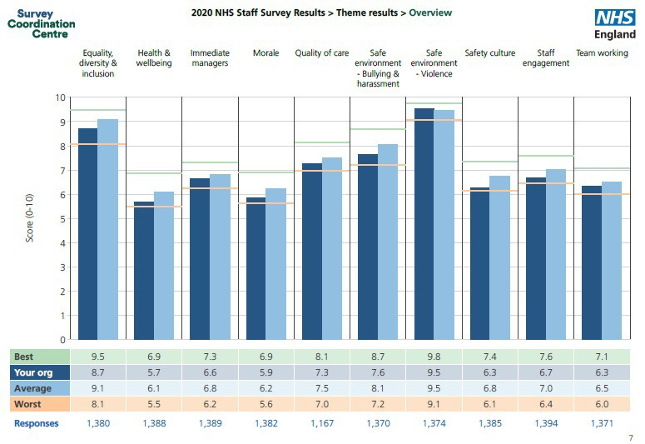

2020 Results by Themes

Covid-19 Theme

This years survey sought to understand the experiences of colleagues across the NHS that have been shaped by the working arrangements which applied to individuals during Covid-19. At Walsall Healthcare NHS Trust, there were a variety of experiences as illustrated in the table below.

Worked on a Required to Shielding for
- 38.6% of colleagues that responded to

All C-19 specific Redeployed work from
Shielding for household
the staff survey worked in a Covid-19

EDI HWB
Immediate
Managers | 6.6 | 6.3 | 6.7 | 7.1 | 6.8 | 6.8 | •
Morale | 5.9 | 5.6 | 5.8 | 6 | 6.2 | 5.6
Quality of Care | 7.3 | 7.2 | 7.5 | 7.1 | 7.8 | 7.8

Safe Environment Bullying & Harassment
Safe Environment Violence
Safety Culture Staff Engagement Team Working

5.7
 | ward or area |  | home/remotely | self | member | specific wards  Overwhelmingly these | or | areas.  colleagues
8.7 | 8.3 | 8.6 | 8.8 | 8.5 | 8.6 | have had a worse |  | experience

7.6

9.5

6.3
6.7
6.3

5.2

6.8

9.1

6.2
6.6
6.1

5.4

7.2

9.4

6.2
6.8
6.6

6.2 5.8

8 7.7

9.8 9.4

6.4 6.8
6.9 7.1
6.8 6.9

5.8

7.6

9.4

6.2
6.6
6.1

compared to others.

20% of respondents advised that they had been redeployed due to the Covid-19 pandemic at any time.

- 34.3% of respondents were required to work from home to the pandemic.

Employee Engagement Index (EEI)

Our Employee Engagement Index (EEI) score 2020 has increased to 6.7 (2019: 6.6), a return to the 2018 EEI, however is below the 7.0 average score for the peer benchmark group.

The EEI score is determined by nine indicators. Questions 2a, 2b, 2c regarding the motivation of staff, questions 4a, 4b, 4d about how involved staff feel in their role and their ability to contribute to improvements in their areas of work and questions 21c & 21d which reflect staff advocacy for Walsall Healthcare NHS Trust as a place to work and a place to be treated. Annex B provides a detailed analysis of the responses provided in these key questions over the last five years (2016-2020).

Of the 12 divisions, seven matched or exceeded the Trusts EEI score and three of those exceeded the peer benchmark average score of 7. Whilst two of these were corporate divisions (People & Culture and CEO & Governance), the Community Division achieved an EEI of 7.0. There are four divisions where the EEI was 0.2% or lower than the Trust’s score, three of which are corporate areas.

Colleague Advocacy has improved significantly from 2019 and is the highest score received by the Trust in the last five years. Whilst the improvement is welcomed, the significant distance from the average scores across the peer benchmark group must be considered in the context that a majority of our workforce live within the community we serve.

Advocacy |  | 2016  % | 2017  % | 2018 % | 2019  % | 2020 % | 2020  Av %
21c | I would recommend my organisation as a place to work | 47.5 | 47.3 | 51.7 | 47.8 | 52.3 | 66.9
21d If a friend or relative needed treatment, I would be happy with the standard of care provided by this organisation |  | 48.2 | 48.1 | 49.4 | 49 | 53.4 | 74.3

Morale

Theme score was 5.9 which is a slight increase from 5.8 in 2019 and matches the score of 5.9 in 2018. Within the peer benchmark the worst score was 5.6 and the highest score is 6.9.

Across the nine of the indicators within this theme the responses for WHCT are lower than the peer benchmark average. Five of the nine indicators have seen very slight improvements, most notably, these include: -

  - I am involved in deciding changes introduced that affect my work area / team / department. (0.04% improvement to 47.8% against peer benchmark average of 50.3%)
  - My immediate line manager encourages me (increase of 2% to 67%).
Improvements

  - Relationships at work are strained. improved to 37.4% from 40% in 2019 & 2018, although close to worst performing scores of 37.1 from peer benchmark group in 2020.
  - I often think about leaving this organisation. Improved to 32.5% in 2020 from 34.8% in 2019 and against the 2020 average peer benchmark of 26.7%

Deterioration

For two of the indicators there has been a slight deterioration

 | 2018  % | 2019  % | 2020  % | 2020  worst
Q4j. I receive the respect I deserve from my colleagues at work. | 67.3 | 66.4 | 64.9 | 62.8
Q6a. I have unrealistic time 21.6 20.2 20.6 18.6
pressures

The response to Q4j corresponds to an increase in workplace conflict requiring both informal and formal support from people based services including; HR, Trade Unions, F2SU and the Wellbeing Team.

Equality, Diversity & Inclusion

Theme score was 8.7 which is a decline from 8.8 in 2018 and 9.0 in 2018. 2020 peer group average score of 9.1

Equal opportunities
!
Discrimination

73% of staff reported that Walsall has made adequate adjustments to enable them to carry out their work. This is an increase for the second consecutive year from 71% in 2019 & 69.8% in 2018.
75.7% of staff feel that Walsall acts fairly with regard to career progression or promotion, regardless of ethnic background, gender, religion, sexual orientation, disability or age. This is a reduction over four consecutive years.
55.8% of BME colleagues believe that we provide equal opportunity for career progression and promotion compared to 81.8% of White colleagues. From a BME perspective the experience has worsened for the second consecutive year decreasing further from 63.2% in 2019.
Annex D & E provide further WRES & WDES data.
The number of staff reporting that they have experienced discrimination at work from both patients, service users, their relatives and members of the public has increased for the 3rd consecutive year to 8.1% (average 6.2%).

Worryingly the number of staff reporting that they have experienced discrimination at wok from their manager / team leader or other colleague has increased to 11.4% and is 4.2% higher than in 2018.
On what grounds have you experienced discrimination?
2016 % 2017 % 2018 % 2019 % 2020 % 2020
Av %
Ethnicity | 46.9 | 42.7 | 42.1 | 42.0 | 51.5 | 44.5
Gender | 18.5 | 20.4 | 25.5 | 22.9 | 16.0 | 19.9
Religion. | 8.0 | 10.2 | 12.2 | 8.6 | 11.3 | 3.8
Sexual Orientation 4.8 6.1 3.7 5.5 2.7 3.6
Disability 3.7 7.1 6.6 8.1 6.1 8.2
Age 15.7 21.9 22.6 21.5 25.1 18.9


54.2% said they have come into work in the last three months, despite not feeling well enough to perform their duties. This is a significant improvement to previous years , however is the worst performing score within the sector.
However
Colleagues suffering from a long term condition or illness reported an increase in feeling the pressure from managers to come to work when not well has from 28.5% to 35.2% in 2020.
49.8% of staff advised that during the last 12 months they have felt unwell as a result of work related stress. This response is significantly worse than 45.9% in 2019 and has increased for the 5th consecutive year.

Health & Wellbeing

Theme score of 5.7 which is an increase from 5.5 in 2019 against a 2020 peer group average score of 6.1
Organisational focus on HWB
Staff Health
54.6% of staff are satisfied with the flexible working opportunities. This is the highest score for 5 years and is likely to reflect working arrangements as a result of Covid-19.


26% of our staff believe that WHCT takes positive action on health and wellbeing. This has dipped slightly from 26.4% in 2019 and remains some distance behind the sector average of 31.7%
29.5% of staff advised that they had experienced musculoskeletal problems (MSK) as a result of work activities. This score has subtly increased year on year since 2016.

Working when ill

Immediate Line Manager & Team Working

Theme score was 6.6 which is an increase from 6.5 in 2019 against a peer benchmark group average of 6.8.
Work feedback and support
Inclusion & motivation

65% of our staff said they were satisfied with the support they received from their line manager. This is static from 2019 results and a reduction from 67.9% in 2018.

60.6% of staff said that their manager gave them clear feedback. This is an increase from 58.2% in 2019 and whilst tracks the peer group average (60.6%) remains lower than 2018 (62.4%).

Theme score was 6.3 which is a reduction for the second consecutive year from 6.5 in 2019 and 6.6 in 2018.
This year more than any has impacted on team working with many teams working remotely and at distance, and many others fragmented to provide resource to services to support the pandemic response. As teams begin to reform and embrace technology and remote working, teams will need time to process the impact of Covid-19 and review shared objectives.
The following percentage of staff said that their manager: -
• 65.3% …. Is supportive, a very slight increase from 2019 (65.1%).
• 54.2% ….. Asks for their opinion before making decisions that affect their work. An increase from 51.9% in 2019 and in line with peer benchmark average but remains below highest score in the last 5 years which was 55.7% in 2018
Team Working
• 69.2% ….Takes a positive interest in their health and wellbeing. An increase from 68.2% in 2019 which was a reduction of 5% from 2018 and the lowest score since 2015.
• 69.2% .. values their work, an improvement from 68% in 2019, yet lower than 72.2% in 2018.

Safety, Civility & Respect

Safety Culture
Staff experiencing bullying & harassment


Theme score 6.3 which is the same as 2019 and lower than the 2020 average of 6.8.
- 48.2% of staff feel that WHCT treats colleagues involved in an error, near miss or incident fairly, this is a second consecutive reduction and a 3% reduction on 2019 and only slightly higher than the worst score of 47.5%.
- 46.7% of colleagues receive feedback about changes made in response to reported errors, near misses and incidents. This is a significant decline of 8% over the last two years.
- 49% of colleagues are confident that WHCT would address their concerns. This is a decline of 4% over two years.

- 59% of colleagues advised that they felt safe to speak up about anything that concerns them within the organisation. This was a new question for 2020 and offers a critical insight into levels of psychological safety at the Trust. Our score is below the benchmark average of 65% and just above the worst score of 53.4%.
Theme score 7.6 which the same as 2019 and an overall reduction from 7.8 in 2018.
The following percentages of staff experienced at least one incident of bullying, harassment or abuse in the last 12 months:
29.6% …from patients / service users, their relatives or other members of the public (q13a). This is a decrease from 31% in 2019 and significantly below best benchmark score of 18%..


17.9%…from managers (q13b) against best benchmark score of 6.2% (18% in 2019)

23.1% …from other colleagues (q13c) against best benchmark score of 12.2%. (24.1% in 2019)

Quality of Care

Theme score has risen back to 7.3 in 2020 compared to 7.2 in 2019. The Trusts average theme score over the last 5 years has been 7.3. For 2020 the peer benchmark average is 7.5.

Q7a. I am satisfied with the quality of care I give to patients / service users | 77.8 | 78.1 | 77.6 | 74.3 | 76.7 | 82.0
Q7b. I feel that my role makes a difference to patients / service users | 86.1 | 89.3 | 87.3 | 87.7 | 87.3 | 89.7
Q7c. I am able to deliver the care I aspire to | 63.2 | 63.7 | 65.9 | 63.2 | 63.6 | 70.0

The has been a significant increase in the number of respondents agreeing that “care of patients / service users is my organisation's top priority” to 72% in 2020 compared to 68% in 2019 and is an improved score the 5th consecutive year. This corresponds with improved responses to questions including; ability to meet conflicting demands of role and there are enough staff at the organisation to help me do my job properly and is likely to be reflective of the atypical year and working conditions that have been in place to respond to the pandemic.

Divisional Overview

This overview highlights the variability in the theme scores across the different divisions. Whilst this variability can in part be attributed to the difference in size and complexity of the division and the impact that Covd-19 will have had on the experience of colleagues working within the divisions, there is no difference in terms of the required ownership of results and accountability for improvement by divisional leadership teams. The heat map below identifies safety culture as the most deteriorated theme (6 reds) closely followed by; immediate line manager, morale and team working. It should be noted that the Medical Directorate received too few responses to provide analysis against the ten themes.

Benchmark
CEO &
Transformation
Nursing

Response Rate (%) EDI
HWB

Immediate Managers Morale
Quality of Care

Safe Environment Bullying & Harassment

Safe Environment Violence Safety Culture
Staff Engagement

Team Working
Average | Trust | Community | MLTC | Surgery | WCCSS | E&F | Governance | & Strategy | Finance | Informatics | Directorate | Operations | P&C
45 | 33 | 42 | 20 | 25 | 34 | 36 | 74 | n/a | 51 | 37 | 51 | 38 | 57
9.1 | 8.7 | 9.2 | 8.0 | 8.6 | 8.7 | 8.9 | 9.3 | 7.1 | 9.3 | 8.3 | 9 | 6.5 | 8.8
6.1 | 5.7 | 5.9 | 5.5 | 5.3 | 5.6 | 6.1 | 5.9 | 6.8 | 7 | 4.9 | 5.8 | 3.4 | 6.8
6.8 | 6.6 | 7.2 | 6.7 | 6.2 | 6.8 | 5.1 | 7.1 | 5.8 | 7.1 | 5.6 | 7.1 | 5.3 | 7.5
6.2 | 5.9 | 6.1 | 5.7 | 5.7 | 6 | 5.9 | 5.9 | 4.7 | 5.9 | 4.8 | 5.8 | 5.2 | 6.2
7.5 | 7.3 | 7.6 | 7.1 | 7.2 | 7.3 | 7.4 | n/a | n/a | 7.3 | 6.5 | 6.9 | n/a | 7.5
8.1 | 7.6 | 8.3 | 6.4 | 7 | 7.7 | 8.7 | 8.1 | 7.7 | 9.1 | 7.6 | 8.1 | 3.6 | 8.4
9.5 | 9.5 | 9.7 | 8.6 | 9.5 | 9.7 | 9.5 | 10 | 9.6 | 9.8 | 9.9 | 9.8 | 8.1 | 9.9
6.8 | 6.3 | 6.6 | 6.4 | 6 | 6.4 | 6.1 | 6.6 | 5.9 | 5.7 | 5.1 | 6.2 | 5.4 | 6.5
7 | 6.7 | 7 | 6.7 | 6.4 | 6.7 | 6.5 | 7.2 | 6.6 | 6.8 | 5.6 | 6.7 | 6.3 | 7.3
6.5 | 6.3 | 6.9 | 6.3 | 5.8 | 6.6 | 5.1 | 6.6 | 5.4 | 7.2 | 5.3 | 7.1 | 3.6 | 7

  - below Trust score
Best Score for Trust
0.1 below Trust score
Equal to Trust score
Up to 0.2 above Trust score
  - & above Trust score
Equal to or above benchmark average

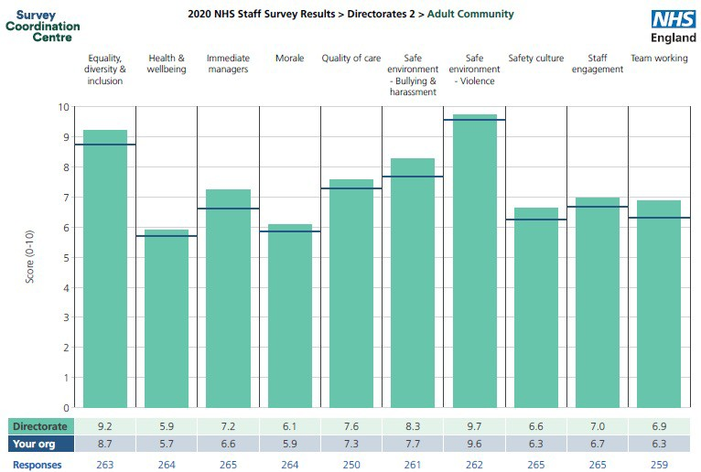
Divisional Picture – Community

Results
  - This is the second independent staff survey report received for the Community Division as in 2018 services were included as part of the MLTC division.
  - It is also relevant to consider that since the 2019 staff survey results, the Community Division has expanded with new services moving within its scope.
  - The division received a 42% response rate a 2% increase from 2019.
  - The division has exceeded all of the Trust scores
against each of the ten themes and has improved on 2019 scores in the following areas:
    - Equality, diversity and inclusion
    - Immediate line managers
    - Safe environment, bullying & harassment
    - Staff engagement.
  - Compared to divisional 2019 results there has been a slight decline in the following themes (which remain above the Trust scores)
    - Safe environment – violence
    - Team working

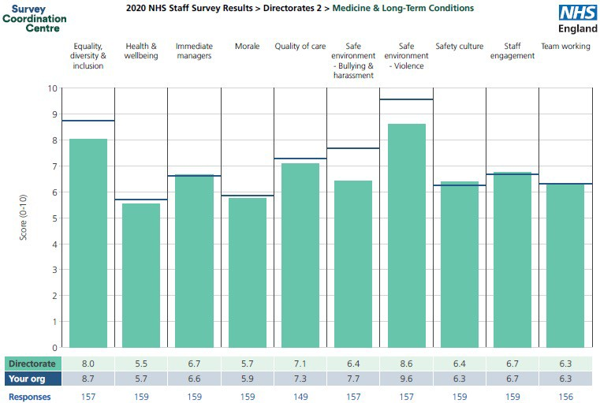
Divisional Picture – Medicine & Long-Term Conditions

Results
- The MLTC division received a 20% response rate (4% lower than 2019 and 13% lower than the Trust response rate).
- Scores in 2/10 themes are below the worst peer benchmark average;
  - Safe environment – bullying & harassment
  - Safe environment – violence
- Across the ten themes the Division have achieved an improved score compared the Trust in the following areas:
  - Immediate line managers
  - Safety culture
- The division have also equalled the Trust score in the following areas:
  - Staff engagement
  - Team working.
- Compared to 2019, the division have made improvements in the following areas:
  - Health and Wellbeing
  - Morale
  - Quality of care
  - Safe environment – Violence
- The divisional results for safe environment – bullying and harassment has remained static at 6.4 for the second year running (against a Trust 2020 score of 7.7)

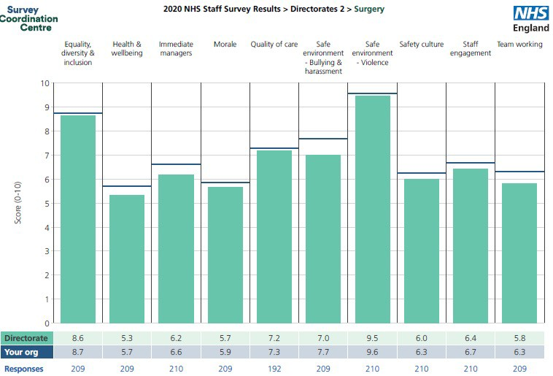

Divisional Picture – Surgery

Results
  - The Surgical division received a 25% response rate (8% below the trusts total response rate).
  - With the exception of a matching score of 9.5, across all other nine themes the division scores were below the Trust scores.
  - Scores in 4/10 themes are below the worst peer benchmark average;
    - Health & Wellbeing
    - Safe environment – bullying & harassment
    - Safety culture
    - Team working
  - When comparing division scores in 2020 against 2019 improvements in the following themes can be identified:
    - Equality, diversity & inclusion
    - Health & wellbeing
    - Immediate line managers
    - Morale
    - Safety culture
  - Against 2019 results, there has been a deterioration in the division across the following themes:
    - Quality of care
    - Safe environment – bullying & harassment
    - Team working

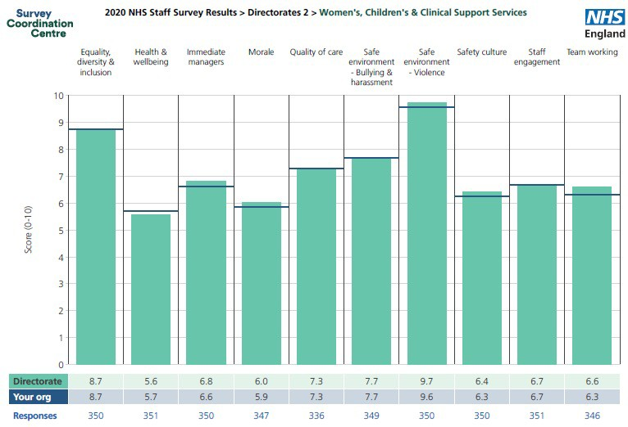

Divisional Picture – Women’s, Children’s & Clinical Support Services
Results
- The WCCSS division received a 34% response rate (1% above the Trusts total response rate).

- Across the ten themes the Division have achieved an improved score compared the Trust in the following areas:
  - Immediate line managers
  - Morale
  - Safe environment – Violence
  - Team working

- The division have also equalled the Trust score in the following areas:
  - Equality, diversity & inclusion
  - Quality of care
  - Safe environment – bullying & harassment
  - Staff engagement

- A comparison between 2020 divisional results with those from 2019 identifies that across all themes there is a reduction in scores with the exception of safe environment – violence.

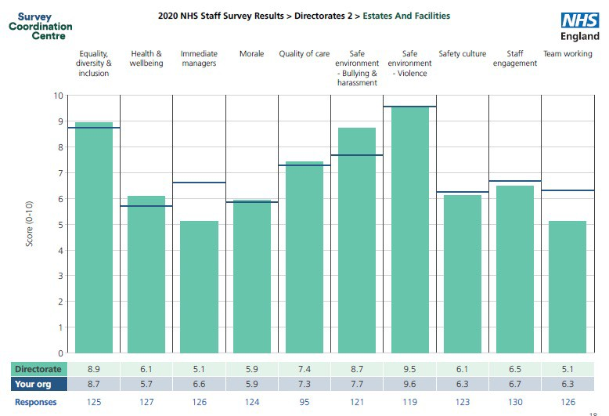

Divisional Picture – Estates and Facilities

Results
  - The Estates and Facilities division received a 36% response rate (3% above the trusts total response rate).

  - The Division has improved against the Trust scores in five themes;
    - Equality, diversity & inclusion
    - Health & wellbeing
    - Morale
    - Quality of care
    - Safe environment – bullying & harassment

  - Compared to 2019 result, the division has seen a deterioration across the following themes;
    - Immediate line managers
    - Team working

  - Scores in 2/10 themes are below the worst peer benchmark average;
    - Immediate managers
    - Team working

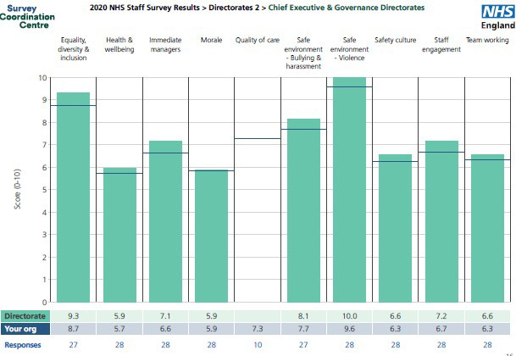

Divisional Picture – CEO & Governance

  - There is no direct 2019 comparison for the combination of CEO and Governance Directorate. Usually the CEO and Transformation and Strategy Divisions are combined due to the small size of the teams involved.

  - Overall across 9/1 themes the divisional scores have exceeded Trust scores and in 7/10 the results have equalled or exceeded the peer benchmark average score.

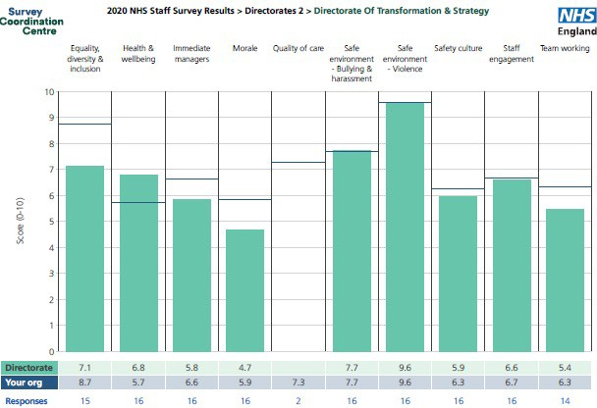
Divisional Picture – Transformation & Strategy

There is no direct 2019 comparison for the combination of CEO and Governance Directorate. Usually the CEO and Transformation and Strategy Divisions are combined due to the small size of the teams involved.

The division exceeds the Trust score in one area; Health and Wellbeing.

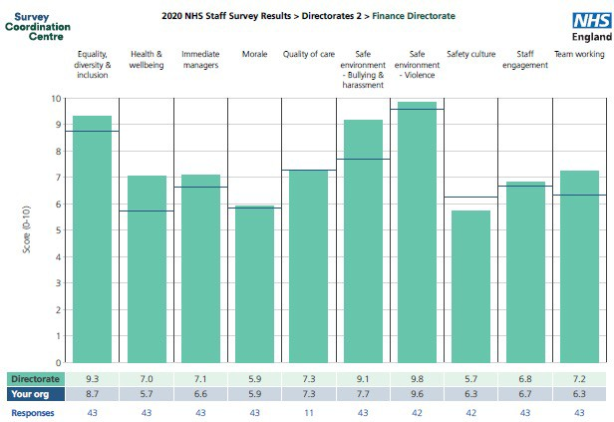

Divisional Picture – Finance

- The Finance division have improved their response rate from 45% in 2019 to 51% in 2020.
- Divisional results have either equalled or outperformed Trust scores in 9/10 areas. In comparison to 2019 results, the most improved themes include;
  - EDI
  - HWB
  - Safe environment – bullying & harassment
  - Staff engagement
  - Team working
- In 7/10 themes the division has equalled or exceeded average peer benchmark average.
- The division has the highest score for team working matching the best score in the peer benchmark group of 7.2.

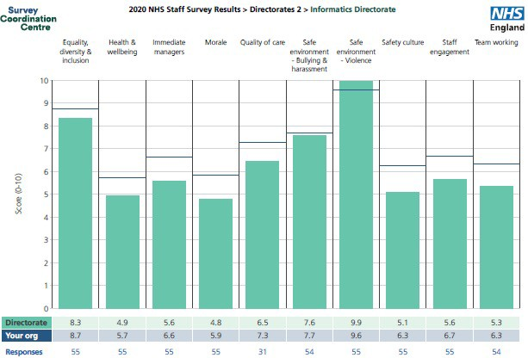
Divisional Picture – Informatics

  - The Informatics division have improved their response rate from 30% in 2019 to 37% in 2020.

  - 9/10 themes scored below the Trust scores and 7/10 scores fell below the worst scores peer benchmark group.

  - Compared to 2019 divisional results in all themes there has been a deterioration of scores.

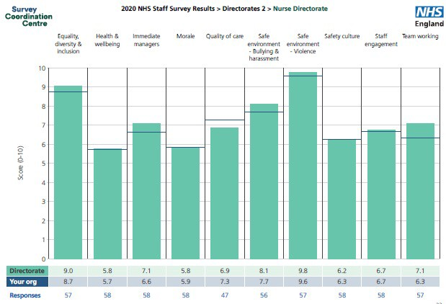

Divisional Picture – Corporate Nursing

- The division have improved their response rate from 45% in 2019 to 51% in 2020.
- Divisional results have either equalled or outperformed Trust scores in 7/10 areas. In comparison to 2019 results, the most improved themes include;
  - Immediate managers
  - Safe environment – bullying & harassment
- Compared to 2019 results there has been a deterioration in the following themes;
  - HWB
  - Morale
  - Quality of care
  - Staff engagement
  - Team working

- The score received by the division for Quality of care fell below the worst peer benchmark average of 7.0.

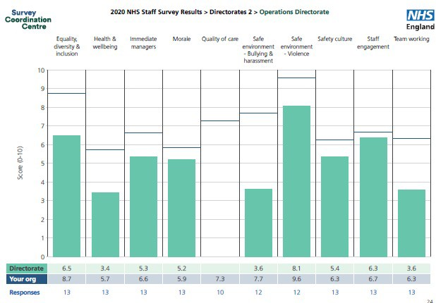
Divisional Picture – Operations

  - One of the smallest divisions (26 headcount) significantly improved response rate from 18% in 2019 to 38% in 2020.
  - In 2019 the response rate was too low to provide analysis against the themes.

  - Out of the 10 themes, 7/10 results fell below the worst scores across the peer benchmark group.

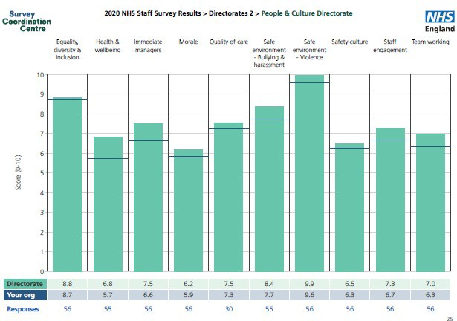

Divisional Picture – People & Culture

  - The only division to receive a response rate (57%) lower than 2019 response rate of 71%.

  - Against 2019 results, improvements have been made across all themes with the most significant being;
    - Morale
    - Health & Wellbeing
    - Staff engagement
    - Immediate line managers

  - The division exceed the best scores across the peer group benchmark in;
    - immediate line managers,
    - safe environment – bullying & harassment
    - safe environment – violence.

Conclusion

The 2020 results help us to begin to understand what impact is created when our we pay attention to the needs of our people. The next 12 months require a continued focus on how we support all colleagues to recover from Covid-19 on an individual, team and organisational perspective recognising that ensuring sustainable people / workforce recovery will enable the recovery of activity.

We must accept that there is a strong evidence base to support a correlation between high employee engagement scores higher CQC ratings. Engaged employees tend to be intrinsically motivated, are more likely to achieve their goals and learn from mistakes. The quality of culture, leadership and staff engagement can therefore significantly affect the quality of care and health outcomes of patients and the local population.

It is therefore important that the Trust and all leaders pay close attention to the proportion of employees who would recommend their organisation as a place to work or receive treatment, because this is a proxy for the level of engagement, and can predict CQC ratings.

Based upon the 2020 national staff survey results and reflecting on the levels of discrimination and detriment that colleagues, particularly those with a difference have described, the Board will require further assurance that our people priorities will be progressed at pace with appropriate divisional leadership accountability to continue to strive towards the organisational ambition of being rated outstanding by CQC in 2022/23.

.

Taking Action

Trust Board to note the action below for assurance

March 2021

- Analysis of results at organisational and divisional level presented to People and Organisational Development Committee, Trust Management Board and JNCC.
- Establish Staff Survey/Staff experience Task Group reporting to PODC involving representation from all divisions.
- Review of Directorate results at Divisional Boards and at Performance Review Meetings.
- Task Group established and engagement resource in place – with subject matter expert engaged to support the planning.

April 2021

- Divisional Boards and Performance Review Meetings to review departmental/unit based reports and agree local actions to increase response rates, increase employee engagement rates and colleague advocacy levels and update at Divisional Performance Reviews.
- Framework for local pulse surveys to measure EEI and colleague advocacy to be agreed via PODC.
- Staff Survey/Staff experience Task Group to review local action
- Divisions to report to PODC on a scheduled basis 3 times per year for accountability and assurance purposes

May 2021

- PODC to receive and approve Trust wide action plan from Staff Survey/Staff experience Oversight Group informed by agreed local action plans.
- Implementation of people cultural heat map at divisional level.
- Monthly review of people metrics outlined in Accountability Framework via Divisional Performance Reviews.
- Monthly Staff Survey/Staff experience Oversight Group
- Communication of actions plans locally and across the organisation
• Ongoing Formal review of progress at private board and PODC – assurance action plan in place.
May 2021
Assurance

Annex A: Comparison of results by theme 2018-20 Annex B: Comparison of results between
Trust and Peer Benchmark Average 2020
Theme | 2018  Score | 2019  Score | 2020  Score | 2020  National Average
Equality, diversity & inclusion | 9.0 | 8.8 | 8.7 | 9.1
Health & wellbeing | 5.7 | 5.5 | 5.7 | 6.1
Immediate Mangers | 6.8 | 6.5 | 6.6 | 6.8
Morale | 5.9 | 5.8 | 5.9 | 6.2
Quality of Care | 7.3 | 7.2 | 7.3 | 7.5
Safe environment Bullying & harassment | 7.8 | 7.6 | 7.6 | 8.1
Safe environment Violence | 9.4 | 9.4 | 9.5 | 9.5
Safety culture | 6.4 | 6.3 | 6.3 | 6.8
Staff engagement | 6.7 | 6.6 | 6.7 | 7.0
Team working | 6.6 | 6.5 | 6.3 | 6.5

Theme | 2020  Score | 2020  National Average
Equality, diversity & inclusion | 8.7 | 9.1
Health & wellbeing | 5.7 | 6.1
Immediate Mangers | 6.6 | 6.8
Morale | 5.9 | 6.2
Quality of Care | 7.3 | 7.5
Safe environment Bullying & harassment | 7.6 | 8.1
Safe environment Violence | 9.5 | 9.5
Safety culture | 6.3 | 6.8
Staff engagement | 6.7 | 7.0
Team working | 6.3 | 6.5

Annex C: Walsall Employee Engagement Index

Theme | Q | Statement | 2017 2018 2019 2020  % % % % |  |  |  | 2020  Av  %
Motivation | 2a | I look forward to going to work | 52 | 55 | 54 54 |  | 58.5
 | 2b | I am enthusiastic about my job | 70 | 71 | 71 | 70 | 73
 | 2c | Time passes quickly when I am working | 74 | 78 | 75 | 76 | 76
Involvement | 4a | There are frequent opportunities for me to show initiative in my role | 68 | 69 | 67 67 |  | 72
 | 4b | I am able to make suggestions to improve the work of my team/department | 71 | 72 | 69 | 70 | 73
 | 4d | I am able to make improvements happen in my areas of work | 53 | 55 | 51 | 53 | 55.4
Advocacy | 18a | Care of patients / service users is my organisation's top priority | 66 | 67 67.6 |  | 72  52 | 79.4
Advocacy | 21c | I would recommend my organisation as a place to work | 47 | 51 | 48 | 72  52 | 66.9

Annex D: Workforce Race Equality Standard (WRES)

 | BME | White | BME | White | BME | White
KF 25 % of staff experiencing harassment bullying or abuse from patients, relatives or the public in the last 12 months | 31.1% | 28.5% | 27.5% | 30.4% | 28% | 25.4%
KF26 % of staff experiencing harassment, bullying or abuse from staff in the last 12 months | 28.6% | 27.4% | 35.1% | 29.7% | 29.1% | 24.4%
KF21 % of staff believing that the organisation provides equal opportunities for career progression and promotion | 68% | 82.2% | 35.1% | 79.8% | 72.5% | 87.7%
Q17 % of staff that have experienced discrimination at work from managers, team leaders or other colleagues | 12.8% | 5.7% | 19.7% | 6.7% | 16.8% | 6.1%

Annex E:
Workforce Race Disability Standard (WDES)

 | 2018 |  | 2019 |  | 2020
 | Disabled | Non- disabled | Disabled | Non- disabled | Disabled | Non- disabled
% of staff experiencing HBA from patient, relative or member of the public in the last 12 months | 34.9% | 27.8% | 37.4% | 27.7% | 35.3% | 26.4%
% of staff experiencing HBA from manager in the last 12 months 16.3% 15.2% 21.2% 16.3% 23.8% 15.6%
% of staff experiencing HBA from other colleagues in the last 12 months | 23.3% | 20.4% | 28.9% | 21.7% | 28.3% | 21.3%
% of staff saying that the last time they experienced HBA at work they or a colleague reported it | 48.6% | 45.5% | 50.4% | 48.2% | 51.6% | 49.5%
% of staff who believe their organisation provides equal opportunities for career progression or promotion | 76.7% | 79.9% | 74.0% | 76.0% | 71.8% | 76.5%
% of staff who felt pressure from their manager to come to work despite not feeling well enough to perform their duties | 33.8% | 21.9% | 28.5% | 25.7% | 35.2% | 25%
% of staff satisfied with the extent to which the organisation values their work | 31.4% | 42.5% | 32.9% | 42.4% | 32.5% | 44.1%
% of disabled staff saying their employer has made reasonable 69.8% 73.4% 69.9% 73.5% 73.7% 75.5% adjustments to enable them to carry out their work.


Public Trust Board – 1st April Agenda item 19, Appendix 2(a)

MEETING OF THE PEOPLE AND ORGANISATION DEVELOPMENT COMMITTEE
Thursday 25th March 2021
Workforce Race Equality Standard and Workforce Disability Equality Standard Annual Reports 2020 |  |  | AGENDA ITEM: 12
Report Author and Job Title: | Sabrina Richards Talent Inclusion and Resourcing Lead | Responsible Director: | Catherine Griffiths Director of People and Culture
Action Required | Approve ☐ Discuss ☐ Inform ☒ Assure ☐
Executive Summary | This report provides information on the data submission for the Workforce Race Equality Standard (WRES) and Workforce Disability Equality Standard (WDES) Annual reports for 2020. The data reflects the period from 1st April 2019 until the end of March 2020. Each year Walsall Healthcare NHS Trust is required to submit annual returns to NHSE/I regarding progress against the WRES and WDES indicators  Summary of WRES findings  - The percentage of BAME colleagues that reported they had experienced harassment bullying and abuse from patients, relatives or members of the public in the past twelve months is 32.9%. This position has worsened since the previous year’s survey from 27.5% to 32.9% in 2020  - The percentage of BAME colleagues that had experienced harassment bullying and abuse from other colleagues is 36.0%. This position has worsened slightly from the previous year’s survey which was 35.1%  - The percentage of BAME colleagues that said they believed there are opportunities for career progression or promotion has deteriorated since the previous year’s survey which was 63.2% compared to this year’s results which is 55.8%  - The 2020 WRES national report stated that Walsall Healthcare is in the bottom of the league table in relation to harassment bullying and abuse of BAME colleagues on a national scale.  - If you are from a White background you are 1.52 times more likely to be appointed to a position at Walsall Healthcare

across all posts when compared to someone from a Black Asian and Ethnic minority background. This has improved since the previous year’s survey which was 2.73 times
- The relative likelihood of colleagues from a Black Asian and Ethnic minority background entering into the disciplinary process is 0.65 times more likely when compared with their white counterparts. This figure has significantly improved since the 2019 WRES data was published and has decreased from 2.04
- 23.9% of colleagues from a Black Asian and Ethnic minority background reported that they had experienced discrimination on the grounds of race by their manager/ team leader or other colleagues during the previous 12 months (2020 staff survey data).The position has worsened since the 2019 staff survey. In the 2019 staff survey this figure was 19.8%. Further targeted work is required to understand why this is the case.

Summary of the WDES findings

- There are more colleagues with a disability responding to the NHS staff survey questions about disability when compared to the number of disabled colleagues that have disclosed they have a disability on ESR which currently stands at 2.4%.
- The number of disabled colleagues that reported their employer has made adequate adjustments to be able to carry out their work is lower than non disabled colleagues. 73.4% for disabled colleagues and 75.5% for non disabled colleagues (2020 staff survey)
- The relative likelihood of disabled staff being appointed is
1.06 (a figure of below 1.00 is considered to be a positive indicator)
- In the 2019 annual staff survey 37.4% of disabled colleagues said that they had experienced Harassment Bullying and Abuse from patients relatives and members of the public compared with 27.7% of non disabled colleagues. The position has improved slightly since the 2019 survey. In the 2020 staff survey the percentage of disabled colleagues that
had experience Harassment Bullying and Abuse from

 | patient, relatives and members of the public is 35.3% compared with 26.4% of non disabled colleagues.
 |  | Workforce Race Equality Standards (WRES)
 |  | Dudley  Group | Sandwell &  WB | Walsall | Royal  Wolves
 | Population BME | 11.5% | 40.9% | 23.1% | 36.0%
 | Workforce representation | 19.9% | 40.0% | 28.0% | 28.8%
 | Recruitment *relative likelihood of white staff  v BAME staff | 2.58 | 1.01 | 1.52 | 1.37
 | Disciplinary - relative likelihood of BAME staff  disciplinary | 1.75 | 0.90 | 0.65 | 1.86
 | Training & CPD | 2.90 | 1.24 | 1.34 | 1.33
 | Harassment, Bullying & Abuse -  Public/Patients | 31.2% | 32.1% | 27.5% | 27.2%
 | Harassment, Bullying & Abuse - Staff | 33.0% | 21.8% | 35.1% | 28.6%
 | Career progression | 67.8% | 72.2% | 63.2% | 76.1%
 | Discrimination | 17.4% | 5.1% | 19.7% | 12.8%
 | Board representation - voting | 6.7% | 0.2% | 4.7% | 7.1%
 | Board representation - executive | 0.0% | ? | -4.2% | ?
- 21.2% of disabled staff compared to 16.3% of non disabled colleagues said that they had experienced Harassment Bullying and Abuse from their manager in the 2019 annual staff survey results. This year the position has worsened compared to the previous year’s survey with 23.8% of disabled colleagues reporting that they had experienced harassment bullying and abuse from their manager. For non disabled colleagues this was 15.6%

Figure 1.0 below provides further benchmarking detail when comparing WRES Data with partners within the Black Country Region

At the time of writing this report – all of the available benchmarking data for the WDES was not available for all Trusts in the Black Country Region.

Conclusion

Although there are slight improvements in the indicators relating to recruitment and access to CPD, when comparing the WRES and WDES outcomes with the results of the 2020 national staff survey there is a clear deterioration across a number of indicators. Our WRES outcomes are less positive for Harassment, Bullying and Abuse when compared to Sandwell and West Birmingham and the

Royal Wolverhampton Trust.

The WDES and WRES actions to redress the imbalance in the negative experiences of colleagues from a BAME background and colleagues with a disability have been incorporated into a detailed EDI delivery plan as part of the revised EDI Strategy. The final strategy will be circulated prior to the PODC meeting in April.

Accelerated high impact targeted interventions will be undertaken this year to ensure that our WRES and WDES position is significantly improved over the course of the next 12 months.
Recommendation | In receiving the report the Committee is requested note the contents and that actions to address and improve Trust performance within these important indicators will be detailed in the EDI delivery plan which will provided to PODC in April 2021.
Does this report mitigate risk included in the BAF or Trust Risk Registers? please outline | This report provides information related to the risk identified in the corporate risk register risk 707 : Failure to comply with equality, diversity and inclusion standards for services leads to poor experience for patients causing increased complaints, impact on patient and staff experience and potential regulatory action.
Resource implications | In order to significantly enhance the equality diversity and inclusion agenda and deliver a number of high impact actions to eliminate discrimination on the grounds of race and disability dedicated resources will be required as part of the Value our Colleagues EDI programme of work to support the cultural changes that are necessary and urgent.
Legal and Equality and Diversity implications | The WRES and the WDES provide assurance that we are taking account of due regard to eliminate unlawful discrimination in line with the Equality Act 2010 by monitoring progress against the workforce indicators contained within the WRES and WDES.
Strategic Objectives | Safe, high quality care ☐ | Care at home ☐
Strategic Objectives | Partners ☐ | Value colleagues ☒
Strategic Objectives | Resources ☐

Public Trust Board – 1st April Agenda item 19, Appendix 2(b)

Workforce Race Equality Standard (WRES)
Annual Report 2020

Introduction

The NHS Workforce Race Equality Standard (WRES) was made available to the NHS from April 2015, following sustained engagement and consultation with key stakeholders including a widespread of NHS organisations across England. The WRES is included in the NHS standard contract, and since July 2015, NHS trusts have been producing and publishing their WRES data on an annual basis.

The main purpose of the WRES is:

  - to help local, and national, NHS organisations (and other organisations providing NHS services) to review their data against the nine WRES indicators,
  - to produce action plans to close the gaps in workplace experience between white and Black and Ethnic Minority (BME) staff, and,
  - to improve BAME representation at the Board level of the organisation.

Introduction

There are nine WRES indicator. Four of the indicators focus on workforce data, four are based on data from the national NHS Staff Survey questions, and one indicator focuses upon BME representation on boards.

The WRES highlights any differences between the experience and treatment of white staff and BME staff in the NHS with a view to organisations closing those gaps through the development and implementation of action plans focused upon continuous improvement over time.

As a whole, the WRES indicator have been chosen to be as simple and straightforward as possible and are almost entirely based on existing data sources (Electronic Staff Records; NHS Staff Survey or local equivalent)

The overall data indicates that the number of colleagues working at the Trust from a Black Asian and Ethnic Minority background is currently 28.1% This figure is higher than the local population statistics for BAME communities which is currently 23.%
The overall percentage of colleagues from a Black Asian and Ethnic Minority background at 8 a and above is 18.07%
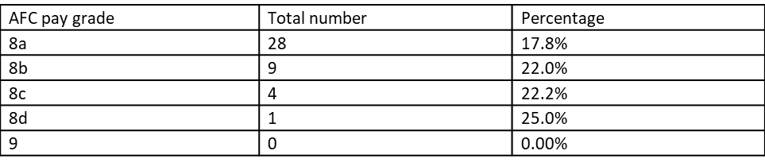
There is only 1 BAME colleague at VSM level

Executive Summary
If you are from a White background you are 1.52 times more likely to be appointed to a position at Walsall Healthcare across all posts when compared to someone from a Black Asian and Ethnic minority background. This has improved since the previous years survey which was 2.73 times
The relative likelihood of colleagues from a Black Asian and Ethnic minority background entering into the disciplinary process is 0.65 times more likely when compared with their white counterparts. This figure has significantly improved since the 2019 WRES data was published and has decreased from 2.04.The relative likelihood of white staff accessing non mandatory training and CPD is 1.34 times more likely when compared to colleagues from a Black and Asian background. Further investigation is required to understand why this figure has deteriorated since the previous year’s survey.
23.9% of colleagues from a Black Asian and Ethnic minority background reported that they had experienced discrimination on the grounds of race by their manager/ team leader or other colleagues during the previous 12 months (2020 staff survey data).The position has worsened since the 2019 staff survey. In the 2019 staff survey this figure was 19.8%. Further targeted work is required to understand why this is the case.

The percentage of BAME colleagues that reported they had experienced harassment bullying and abuse from patients, relatives or members of the public in the past twelve months is 32.9%. This position has worsened since the previous year’s survey from 27.5% to 32.9% in 2020
The percentage of BAME colleagues that had experienced harassment bullying and abuse from other colleagues is 36.0%. This position has worsened slightly from the previous year’s survey which was 35.1%
The percentage of BAME colleagues that said they believed there are opportunities for career progression or promotion has deteriorated since the previous years survey which was 63.2% compared to this years results which is 55.8%
The 2020 WRES national report stated that Walsall Healthcare is in the bottom of the league table in relation to harassment bullying and abuse of BAME colleagues on a national scale.

Workforce Race Equality Standard Metrics

Metric 1 Metric 2 Metric 3

Percentage of staff in each of Relative likelihood of staff being Relative likelihood of staff
the AfC Bands 1-9 or Medical appointed from shortlisting entering the formal disciplinary and Dental subgroups and across all posts process, as measured by entry VSM (including executive Board into a formal disciplinary
members) compared with the investigation percentage of staff in
the overall workforce
Metric 5 Metric 6 Metric 7
Percentage of staff Percentage of staff Percentage believing that trust experiencing harassment, experiencing harassment, provides equal opportunities for bullying or abuse from patients, bullying or abuse from staff in career progression or
relatives last 12 months Promotion or the public in last 12 months

Metric 9
Percentage difference between the organisations’ Board membership and its overall workforce disaggregated:
    - By voting membership of the Board
    - By executive membership of the Board
Metric 4

Relative likelihood of staff accessing non-mandatory training and CPD

Metric 8
In the last 12 months have you personally experienced discrimination at work from any of the following?
- Manager/team leader or other colleagues

Conclusions and recommendations

It is evident from the data presented that colleagues from a Black Asian and Ethnic Minority background are significantly under represented at senior levels. Specifically band 8 b 8C 8d band 9 and VSM level.
Over the forthcoming year there will be focus on ensuring there is a diverse talent pool that can step into senior leadership roles and this will involve supporting divisional areas to develop a talent pipeline in their respective area.
Targeted work will also be carried out across the trust to ensure improvements are made with WRES indicator 2- the relative likelihood of white staff being appointed across all posts from shortlisting when compared to BAME colleagues.
Walsall aspires to become an anchor employer organisation and as a result of this the Trust will continue to work with our partners such as the Walsall Housing Group to ensure employment opportunities are provided to members of our diverse population.

Conclusions and recommendations

In line with the Workforce Race Equality Team Model Employer report the Trust has agreed the following workforce targets to increase the representation of colleagues at Black and Asian colleagues at senior levels.
Our current data shows that 18.0% of colleagues are in AFC pay grades 8a and above. By the end of 2022 our goal is to increase this by 10% which would mirror our current overall BAME workforce representation which is 28%.
Working with our partners at a system level there will be interventions put in place to ensure that we are meeting our targets to achieve BAME parity at senior levels. There will also be robust measures put in place to significantly improve our current WRES data for indicators 4, 5,6,7,8 and 9
Through our anchor employer work we will also be working closely with our partners in the borough to ensure we are reaching out to a diverse pool of candidates so that we attract diverse communities to come and work at the Trust.

WRES METRIC 1

Staff Type |  | Pay Band | WHITE | BAME | ETHNICITY UNKNOWN | Staff In Headcount as at 25/01/2021 | BAME %
 |  | Overall | 274 | 54 | 3 |  | 16.3%
 |  | Apprentice | 0 | 0 | 0 |  | N/A
 |  | Band 1 | 0 | 0 | 0 |  | N/A
 |  | Band 2 | 0 | 0 | 0 |  | N/A
 |  | Band 3 | 0 | 0 | 0 |  | N/A
 |  | Band 4 | 0 | 0 | 0 |  | N/A
 |  | Band 5 | 74 | 13 | 1 |  | 14.8%
 |  | Band 6 | 143 | 35 | 1 |  | 19.6%
Overall |  | Band 7  Band 8A | 45  11 | 5  0 | 1  0 |  | 9.8%  0.0%
 |  | Band 8B | 0 | 0 | 0 |  | N/A
 |  | Band 8C | 1 | 1 | 0 |  | 50.0%
 |  | Band 8D | 0 | 0 | 0 |  | N/A
 |  | Band 9 | 0 | 0 | 0 |  | N/A
 |  | VSM | 0 | 0 | 0 |  | N/A
 |  | Trainee Grade | 0 | 0 | 0 |  | N/A
 |  | Career Grade | 0 | 0 | 0 |  | N/A
 |  | Consultant | 0 | 0 | 0 |  | N/A
 |  | Apprentice | 0 | 0 | 0 |  | N/A
 |  | Band 1 | 0 | 0 | 0 |  | N/A
 |  | Band 2 | 0 | 0 | 0 |  | N/A
 |  | Band 3 | 0 | 0 | 0 |  | N/A
 |  | Band 4 | 0 | 0 | 0 |  | N/A
 |  | Band 5 | 0 | 0 | 0 |  | N/A
Non-Clinical |  | Band 6  Band 7 | 0  0 | 0  0 | 0  0 |  | N/A  N/A
 |  | Band 8A | 0 | 0 | 0 |  | N/A
 |  | Band 8B | 0 | 0 | 0 |  | N/A
 |  | Band 8C | 0 | 0 | 0 |  | N/A
 |  | Band 8D | 0 | 0 | 0 |  | N/A
 |  | Band 9 | 0 | 0 | 0 |  | N/A
 |  | VSM | 0 | 0 | 0 |  | N/A
 |  | Apprentice | 0 | 0 | 0 |  | N/A
 |  | Band 1 | 0 | 0 | 0 |  | N/A
 |  | Band 2 | 0 | 0 | 0 |  | N/A
 |  | Band 3 | 0 | 0 | 0 |  | N/A
 |  | Band 4 | 0 | 0 | 0 |  | N/A
 |  | Band 5 | 74 | 13 | 1 |  | 14.8%
Clinical (Non-Medical) |  | Band 6  Band 7 | 143  45 | 35  5 | 1  1 |  | 19.6%  9.8%
 |  | Band 8A | 11 | 0 | 0 |  | 0.0%
 |  | Band 8B | 0 | 0 | 0 |  | N/A
 |  | Band 8C | 1 | 1 | 0 |  | 50.0%
 |  | Band 8D | 0 | 0 | 0 |  | N/A
 |  | Band 9 | 0 | 0 | 0 |  | N/A
 |  | VSM | 0 | 0 | 0 |  | N/A
Medical & Dental |  | Trainee Grade | 0  0  0 | 0  0  0 | 0  0  0 |  | N/A N/A  N/A
Career Grade
Consultant

0.65
2.04
WRES METRIC 2 3 and 4

 |  | Trend positive or negative
 | 2.73 | 1.52

4. Relative likelihood of BME staff accessing non mandatory training and CPD as compared to white staff | 2019 | 2020 | Trend positive or negative
0.94 |  | 1.34

WRES METRIC 5- 8

Staff Survey Data | 2018 |  | 2019 |  | 2020
 | BME | White | BME WHITE |  | BME | WHITE
5.KF 25 -% of staff experiencing | 31.1% | 28.5% | 27.5% 30.4% |  | 32.9% | 27.0%
harassment, bullying or abuse from
patients, relatives or the public in
the last 12 months
6.KF 26 -% of staff experiencing | 28.6% | 27.4% | 35.01% | 29.7% | 36.0% | 27.9%
harassment, bullying or abuse from
staff
7.KF 21- % of staff believing that | 68.0% | 82.2% | 63.2% 79.8% |  | 55.8% | 81.8%
the Trust provides equal
opportunities for career
progression and promotion
8. Q17 % of staff that have | 12.8% | 5.7% | 19.8% | 6.7% | 23.9% | 7.3%
experienced discrimination at work
from managers, team leaders and
other colleagues

WRES METRIC 9

Percentage difference between the organisations’ Board membership and its overall
workforce disaggregated:
  - By voting membership of the Board
  - By executive membership
of the Board
2019 2020 Trend positive/negative

-8.6 -4.7%

Public Trust Board – 1st April 2021 Agenda item 19, Appendix 2(c)

Workforce Disability Equality Standard (WDES)
Annual Report 2020

Introduction

- . The NHS Workforce Disability Equality Standard (WDES) came into force on 1 April 2019 and is a set of specific measures (metrics) that will enable Walsall Healthcare
NHS Trust to compare the experiences of disabled and non-disabled staff. This information is used to develop a local action plan, and enable Walsall Healthcare to demonstrate progress against the indicators of workforce disability equality.
- The WDES is important, because research shows that a motivated, included and valued workforce helps to deliver high quality patient care, increased patient satisfaction and improved patient safety. Currently only 2.4% of the workforce has declared a disability, therefore the implementation of the WDES will enable Walsall Healthcare NHS Trust to better understand the experiences of their disabled staff. It will support positive change for existing employees, and enable a more inclusive environment for disabled people working at the Trust.

Introduction

There are nine workforce disability equality metrics which have been developed to c.apture information relating to the workplace and career experiences of Disabled staff in the NHS.
- Research shows that Disabled staff have poorer experiences in areas such as bullying and harassment and attending work when feeling unwell, when compared to non-disabled staff. The ten metrics have been informed by research by Middlesex and Bedford Universities, conducted on behalf of NHS England/Improvement, and by Disability Rights UK on behalf of NHS Employers.
- This report has been informed by the annual WDES return to NHS England and NHS Improvement and the data has been collated during the period from the 1st April 2019 to the 31st March 2020.

- The relative likelihood of disabled staff being appointed is 1.06

Executive Summary
Colleagues that have disclosed their disability are in the junior pay grades Cluster 1-4 which represents AFC pay grades 1-4 2.4% in total when compared to the 2.4% of
.colleagues overall that have disclosed their disability on ESR
  - The second largest proportion of colleagues that have disclosed their disability are in Cluster 2 AFC pay grades 5,6,7 (2.5%)
  - There is a small proportion of colleagues that have disclosed their disability in AFC pay grades 8a and above which includes VSM (0.0%) (Cluster 3)
  - There isn’t a wide statistical variance between non clinical colleagues and clinical colleagues that have disclosed their disability on ESR.
  - There are more colleagues with a disability responding to the NHS staff survey questions about disability when compared to the number of disabled colleagues that have disclosed they have a disability on ESR which currently stands at 2.4%.
  - The number of disabled colleagues that reported their employer has made adequate adjustments to be able to carry out their work is lower than non disabled colleagues.
  - 73.4% for disabled colleagues and 75.5% for non disabled colleagues (2020 staff survey)

Executive Summary

- In the 2019 annual staff survey 37.4% of disabled colleagues said that they had experienced Harassment Bullying and Abuse from patients relatives and members of the public compared with 27.7% of non disabled colleagues. The position has improved slightly since the 2019 survey. In the 2020 staff survey the percentage of disabled colleagues that had experience Harassment Bullying and Abuse from patient, relatives and members of the public is 35.3% compared with 26.4% of non disabled colleagues.
- 21.2% of disabled staff compared to 16.3% of non disabled colleagues said that they had experienced Harassment Bullying and Abuse from their manager in the 2019 annual staff survey results. This year the position has worsened compared to the previous years survey with 23.8% of disabled colleagues reporting that they had experienced harassment bullying and abuse from their manager. For non disabled colleagues this was 15.6%
- Only 32.9% of disabled colleagues said that they were satisfied with the extent to which the organisation values their work compared to 42.4% of non disabled colleagues. For the 2020 reporting year this position has not improved significantly with only a slight improvement (32.5%)

WDES METRICS

WDES Metric WDES Metric 2 WDES Metric 3 WDES Metric 4

1Percentage of staff in AfC pay-bands or medical and dental subgroups and very senior managers (including Executive Board members) compared with the percentage of staff in the overall workforce.
Relative likelihood of non- disabled staff compared to Disabled staff being appointed from shortlisting across all posts.
Relative likelihood of Disabled staff compared to non- disabled staff entering the formal capability process, as measured by entry into the formal capability procedure.
a) Percentage of Disabled staff compared to non-disabled staff experiencing harassment, bullying or abuse from:
- Patients/Service users, their relatives or other members of the public
- Managers
- Other colleagues b)Percentage of Disabled staff
compared to non-disabled staff saying
that the last time they experienced harassment, bullying or abuse at work, they or a colleague reported it

WDES Metric WDES Metric 6
WDES Metric
WDES Metric 8 Percentage

5 Percentage of
Percentage of Disabled staff compared to non-disabled
7Percentage of Disabled staff
of Disabled staff saying that their employer has made adequate adjustment(s) to

Disabled staff compared staff saying that they have felt
to non-disabled staff pressure from their manager believing that the Trust to come to work, despite not provides equal feeling well enough to perform opportunities for career their duties.
progression or
promotion.
compared to non-disabled
staff saying that they are satisfied with the extent to which their organisation values their work

WDES Metric 9
a) The staff engagement score for Disabled staff, compared to non-disabled staff. b) Has your Trust taken action to facilitate the voices of Disabled staff in your organisation to be heard? (Yes) or (No)
enable them to carry out their work.

WDES Metric 10 Percentage difference between the organisation’s Board voting membership and
its organisation’s overall workforce, disaggregated:
- By voting membership of the Board.
- By Executive membership of the Board.

Conclusion

  - Walsall Healthcare is on a journey to become a disability confident organisation and a great place to work by narrowing the gap between how Disabled and Non-Disabled staff report their experiences and satisfaction levels in the metrics of WDES.
  - In order to support culture change and become a disability confident organisation we need to adopt innovative ways to engage with our disabled colleagues and improve disclosure rates so that disabled colleagues feel confident to talk about their disability.
  - The WDES action plan sets out the actions that Walsall Healthcare is going to take over the forthcoming year to improve disability equality in the workplace with support from Disability Equality Network Leads who form part of the Trust’s Staff Inclusion Network. These actions have now been incorporated within the Trust’s EDI Strategy Action Plan for 2021-2022
  - Accelerated and targeted efforts will also be taken to eliminate harassment bullying and abuse for colleagues with a disability

I WOES Metric 1 I
Walsall Healthcare ,,,1:kj
NHS Trust

- l iA J, , •

.,..,.._
.-.2
•• 0 •
I 1tn
•
0 I 1
'
3
I 74
•I : , 1 ■ t ;:.,t t-, • l ... .
D 0
0
t6
3
l ;J:, l - ;,t l H TL ?
:u,i.
u""'
In,,
I 7'
" " " -- • • • ,..
7'7'11.
IU'llo
,','.",.'

- · _,.. .. : 1 ,

..., .1

I I
'
•,i
l
I
I
4 ..6,.
,11,,
,I .

(Mf1I
"'
-6
in, 7
n::, IA
,_
5
...... c
a,c,O

··⁼-⁻ -
I I I
I C4
0 9
I I 2
I
I
,I.,
7 ,F
I 1.11,
IC,,
⁻⁵ .1",
I
D"I,
7.'...
......
...
,.'5,...
9'
t, '
J ,,...
,...
l 'y,,,.
I ,.....
·-

-- I

1 111

!,3

2
.."..

Ji
l 1.J'li.

,
_.,ell
0 15'
I
1 7
.]..
'
11'\,
I 0
.6.
l
,..
"

- 2
-,
-
ino-5
l J 1
I
l 1
1'9,
."".-..

-_a ,
'I 13
C4 16 4
I JI 1 I
\
)'I,
•
"Ii.
I .r.,.,.

...... 5 I 6
-
t: ti
-r;,

"""' 0
-
:i.n:i l
..-.:12
0
I
I
u
I I
SU I

...
_{I} ,'."..'
...
"
l
ri.

....,-.i J
..,..,5
..,..,11,
0
'
-n:":, 9
n::, C:
n::, 0
_ ,,.. IS 22
7
I 0 I
0

66
.•.=.,.
..-
:Ill!',
6,1
a
1
0
'""
:s U2 I U. 1111',
17
3
2
I
I -5.,.,2. '
4 2!"
3
I .\4•
I 2
•..
0 I
0 0
I
0
0 " ...
:'ze.n
'.".".'.".
2,t.,
J "•
I C '
"' "

c,an;I
,: u
,,_
•
0
[.n!IO ⁰
0
,, I
I
2 0
I I
36 II
A7 1
IDII
0 IH/.."..I.,
'"
'" ""
!to
."..

WDES METRIC 2 and 3

2019
Relative likelihood of non disabled staff being appointed from shortlisting compared to disabled staff
0.00
2020
Relative likelihood of non disabled staff being appointed from shortlisting compared to disabled staff
1.06
2019
Relative likelihood of disabled staff entering the formal capability process compared to non disabled staff
0.00
2020
Relative likelihood of disabled staff entering the formal capability process compared to non disabled staff
0.00

WDES Metric 4,5,6,7,8

WDES METRIC Disabled staf | f Non disabled | Disabled | Non disabled staff
2019 | staff | staff | 2020
 | 2019 | 2020
WDES Metric 4 37.4% | 27.7% | 35.3% | 26.4%
Percentage of Disabled staff compared to non-disabled staff 21.2% | 16.3% | 23.8% | 15.6%
experiencing harassment, bullying or abuse from: 28.9% | 21.7% | 28% | 21.3%
- Patients/Service users, their relatives or other members of 50.4%  the public  - Managers  - Other colleagues)  b)Percentage of Disabled staff compared to non-disabled staff saying that the last time they experienced harassment, bullying or abuse at work, they or a colleague reported it | 48.2% | 51.6% | 49.5%
WDES Metric 5 74.0%  Percentage of Disabled staff compared to non-disabled staff  believing that the Trust provides equal opportunities for career progression or promotion. | 76.0% | 71.8% | 76.5%
WDES Metric 6 28.5%  Percentage of Disabled staff compared to non-disabled staff  saying that they have felt pressure from their manager to come to work, despite not feeling well enough to perform their duties. | 25.7% | 35.2% | 25.0%
WDES Metric 7 32.9%  Percentage of Disabled staff compared to non-disabled staff  saying that they are satisfied with the extent to which their organisation values their work | 42.4% | 32.5% | 44.1%
WDES Metric 8 69.8% 73.7% 73.4% 75.5%
Percentage of Disabled staff saying that their employer has
made adequate adjustment(s) to enable them to carry out their work.

WDES Indicator 9 and 10

WDES Indicator 9a 2019 The staff engagement score for Disabled staff, compared to non disabled staff. 6.3 disabled staff: non disabled staff 6.7
WDES Indicator 9a 2020- The staff engagement score for Disabled staff, compared to non-disabled staff. 6.2 disabled staff : 6.8 non disabled staff
WDES Indicator 9b 2019 Has your Trust taken action to facilitate the voices of Disabled staff in your organisation to be heard? (Yes) or (No) - No
WDES Indicator 9b 2020 Has your Trust taken action to facilitate the voices of Disabled staff in your organisation to be heard? (Yes) or (No) - Yes
WDES Indicator 10 2019 Percentage difference between the organisation’s Board voting membership and its organisation’s overall workforce, disaggregated:
- By voting membership of the Board.
- By Executive membership of the Board.
-2%
WDES Indicator 10 2020 Percentage difference between the organisation’s Board voting membership and its organisation’s overall workforce, disaggregated:
- By voting membership of the Board.
- By Executive membership of the Board.
-2%



MEETING OF THE PUBLIC TRUST BOARD – 1st April 2021
Freedom to Speak Up Quarterly Report – Q3 |  |  | AGENDA ITEM: 20
Report Author and Job Title: | Val Ferguson Kim Sterling  Freedom to Speak Up  Guardians | Responsible Director: | Catherine Griffiths Director of People and Culture
Action Required | Approve ☐ Discuss ☐ Inform ☒ Assure ☒
Executive Summary | Analysis of the number of concerns generated though Freedom to Speak Up (FTSU) from 1st October 2020 to 31st December 2020.  Note the mandatory roll out of FTSU training.  To note that the Walsall Healthcare Trust (WHT) FTSU Improvement plan will be progressed through the Colleague Health and Wellbeing Group.  To give assurance for escalation of concerns is timely and adheres to the FTSU raising concerns protocol.  Triangulation of concerns, clinical incidents and Human Resource cases.
Recommendation | Members of the Trust Board are asked to:  - Note the report and discuss the contents within  - Commit to making Speaking Up routine day-to-day practise  - Support further work required to progress the FTSU function to improve the WHT safety culture  - Note continued implementation of the elements from the FTSU Improvement plan though the work of the Colleague Health and Wellbeing Assurance Group that is led by the Non-Executive Director for FTSU.  - To note that Speaking Up training is part of the mandatory package of training delivered to all in WHT.  - To provide assurance that FTSU concerns are being

 | addressed by divisions and the feedback delivered at appropriate timescales linked to the protocol for escalation. This will be detailed in quarterly exceptional reports.
Does this report mitigate risk included in the BAF or Trust Risk Registers? please outline | The work programme described within this report will provide positive assurance to the Board on the following BAF risk:  BAF S04 – Value Our Colleagues: Lack of an inclusive and open culture impacts on staff morale, staff engagement, staff recruitment, retention and patient care.
Resource implications | There are some costs implications associated with following this programme of work, all resource will be aligned through existing budgets.
Legal and Equality and Diversity implications | Black, Asian or minority ethnic (BAME) employees often face more barriers than non BAME employees when raising concerns.  The data available is not yet sufficient to reliably determine and evidence equality and diversity impacts. This is being addressed through collecting concerns electronically through the incident reporting system, Safeguard and work being undertaken by the Equality, Diversity and Inclusion Committee.
Strategic Objectives | Safe, high quality care ☐ | Care at home ☐
Strategic Objectives | Partners ☐ | Value colleagues ☒
Strategic Objectives | Resources ☐

Quarterly Report of the Freedom to Speak Up Guardians Quarter 3, 2020/21

Introduction

The intention of this report is to detail the number and nature of concerns raised though contact with the Trust’s Freedom to Speak Up (FTSU) Guardians during the period 1st October 2020 to 31st December 2020.

To enable and progress work of the Trust FTSU improvement plan, it is proposed that this work is progressed though the current Colleague Health and Wellbeing Assurance Group to ensure that the Trust meets all the elements of the plan.

FTSU is now established as the model for NHS Trusts to remove the barriers to raising patient safety concerns. Colleagues are encouraged and supported to escalate issues that prevent delivery of high quality, safe care. The Trust is committed to embedding this process in the culture of the organisation. This open culture will be demonstrated by employees who are confident to raise concerns and who are listened to and the issues they raise are addressed and acted on.

The People and Organisational Committee approved the rolling out of mandatory training to support FTSU in the Trust. This includes training of all employees, board members, temporary workers and volunteers.

In addition, the introduction of an FTSU escalation process with timescales is presented at Appendix 1.

Concerns raised and analysis
There were 25 concerns raised during the period (1st October 2020 to 31st December 2020) and the themes are represented diagrammatically below.

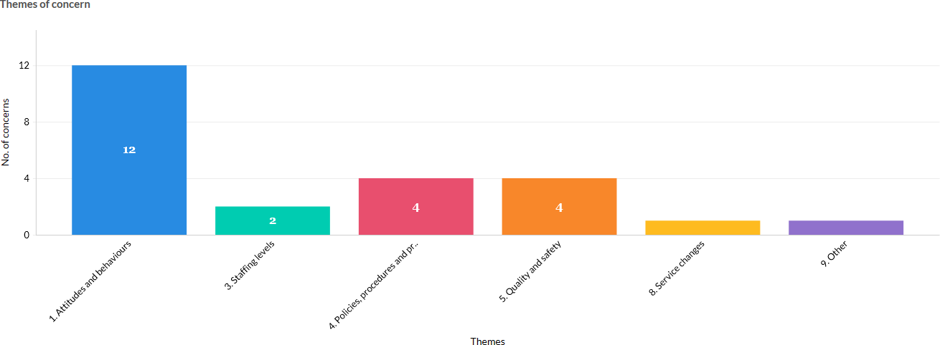

The organisation continues to hear from staff who are concerned about the attitudes and behaviours of their colleagues. This is reflected in the nature of the concerns raised to the FTSU Guardians where concerns of this nature represent 48% of concerns.

The following chart shows the nature of the themes from each division.
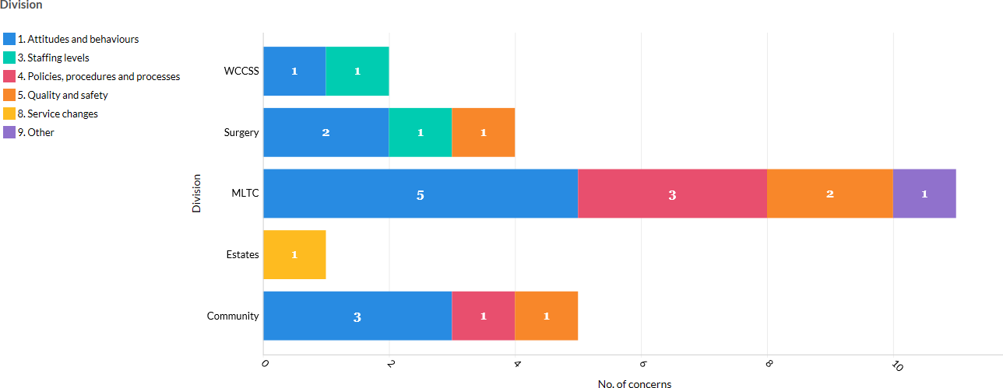

Cases relating to attitudes and behaviour are also a common theme across the divisions (except Estates and Facilities).

The table below highlights that within the WCCSS division, where employee numbers represent 21% of the Trust’s staff; FTSU concerns from this area of the organisation contribute 8% of concerns raised. This is disproportionally low given the size of the division. A requirement of the FTSU strategy is to demonstrate improvement in speaking up that will be evidenced by increasing numbers of concerns raised via all channels.

This is an area within the organisation where we do not as yet have a Confidential Contact Link (CCL) based. Assigning an existing CCL would allow closer working with colleagues to raise the awareness of Speaking Up and champion the benefits of raising concerns.

Division | Number of staff | % of Trust | % Concerns
Community | 847 | 20% | 14%
Corporate | 398 | 10% | 0%
Estates | 377 | 9% | 4%
MLTC | 815 | 20% | 50%
Surgery | 818 | 20% | 23%
WCCSS | 878 | 21% | 9%
Grand Total | 4,133 | 100% | 100%

Comparing the proportion of concerns received by divisions, concerns from employees in MLTC make up 50% of the concerns brought through the FTSU route. At this time of the pandemic, the majority of COVID-19 patients would be housed on the division’s wards. This is disproportionally higher than what would be expected, given that the number of employees in the division represents only 20% of the staff workforce. It appears that colleagues working in this division use the speaking up route for raising their concerns.
Colleagues subject to behaviours that put them in a psychologically unsafe place may not recognise patient safety issues nor have the confidence to raise them.

The table below shows the triangulation of the concerns raised, with that of the Bullying and Harassment (B&H) data from the employee relations casework over the same reporting period.

Division | Number of B&H cases | % B&H Cases
Community | 1 | 20%
WCCSS | 4 | 80%
Grand Total | 5 | 100%

The proportion of B&H cases in WCCSS division is higher than the proportion of the divisional size with respect to the number of employees. When compared to the number of concerns raised about bullying and harassment, there are considerably less raised in this division. This may be as a result of concerns being raised through other channels. However, the data suggests that the working environment is not conducive to raising concerns. This insight will be presented to the divisions for examination and analysis.

The table below illustrates an overall increase in the numbers of clinical incidents reported during the period.

Division | Number of Incidents Q2 | Number of incidents Q3
Community | 591 | 568 (3.9% decrease)
MLTC | 1180 | 1420 (20.3% increase)
Surgery | 607 | 667 (9.9% increase)
WCCSS | 537 | 528 (11.1% decrease)

The increasing number of clinical incidents submitted by colleagues in the MLTC division could suggest that again, this division has a culture where the confidence of staff to raise concerns is high.

In Walsall 28.2% employees are from a Black, Asian and Minority Ethnic (BAME) background and non-BAME employees represent 71% of the workforce. For this reporting period, BAME to non-BAME staff ratio is 52%:44% respectively, with 6% of staff choosing not to disclose their ethnicity. There is a higher proportion of staff from a BAME background reporting concerns.

The challenge for the Trust is to account for the disparities and continue the valuing colleague’s improvement work that will impact on levelling up and enhance staff experiences.

An organisation where staff are encouraged to raise concerns and their voices welcomed is one that can be described to have a healthy Speaking Up culture. An increase in the number of concerns is to be celebrated as it signals that staff are empowered and feel secure to do so.

A low reporting culture appears apparent in some divisions and could indicate that there are barriers to Speaking Up that need to be identified and addressed.

One of the ways that the Trust may improve its reporting culture is through training. The Trust is committed to raising awareness of Speaking Up and to demonstrate that will ensure Speaking Up training for employees is delivered and is consistent with guidelines from the National Guardians Office and NHSE/I (National Health Service England/Improvement). An element of the FTSU improvement plan involves training everyone in the Trust on the principles of FTSU. The Trust recognises that it is everyone’s responsibility to contribute to the creation of a safe environment that encourages Speaking Up.

Developed jointly by Health Education England (HEE) and the National Guardian Office (NGO), the training package offers free access to trusts for their workers who are able to complete the electronic learning through the e-Learning for Healthcare portal.

The training is made up of three modules Speak up, Listen Up, Follow up, each individually targeted at the level the learner is based within organisation. This allows workers at every grade to access their tailored module. Importantly, the trust will ensure that processes and procedures to monitor the take up of this training are established in line with the mandatory courses currently delivered.

This training was launched in October 2020 and the press release from the NGO is attached as Appendix 2 to this report.

Timescales and Feedback

Historically, the timely closing of cases brought through the FTSU Guardian route has been hindered. There has been no clear structure tied to a responsible officer to progress cases. The Guardians’ ability to resource this has been stretched. The escalation process presented at Appendix 1 will aim to address this. It clearly sets out the expectations and allows exception to be sought for cases where timings are breeched; feedback to the

individuals who disclose safety concerns and feedback to divisional teams are opportunities for the organisation to demonstrate that Speaking Up brings about positive changes.

Achievements this quarter:

- Recruitment of FTSU Operational Support Officer for three days a week.
- FTSU confidential contact links training commences this month. Regular peer to peer support meetings planned.
- Further development of FTSU electronic dashboard.
- Speak up month in October led by daily communications in Daily Dose, Facebook and Twitter. Drop-in sessions to departments limited due to pandemic but focused on community locations.

Recommendations

Members of the Trust Board are asked to:
- Note the report and discuss the contents within
- Commit to making Speaking Up routine day-to-day practise
- Support further work required to progress the FTSU function to improve the WHT safety culture
- Note continued implementation of the elements from the FTSU Improvement plan though the work of the Colleague Health and Wellbeing Assurance Group that is led by the Non-Executive Director for FTSU.
- To note that Speaking Up training is part of the mandatory package of training delivered to all in WHT.
To provide assurance that FTSU concerns are being addressed by divisions and the feedback delivered at appropriate timescales linked to the protocol for escalation. This will be detailed in quarterly exceptional reports

APPENDIX 1
Note: Days are calculated as working days. Periods of time can be extended depending on the complexity of the investigation.
* Any cases that exceed 3 months will be reported to the CEO as an exception by the FTSU Guardian.
9
FTSUG to report learning outcomes to PODC quarterly
FTSUG to give feedback to enquirer, to close case, and issue feedback survey.
Set date in diary for Follow Up (3-6 months)

Timescales for Raising Concerns Through FTSU Process

New enquiry received via FTSU route

Sign post to appropriate team | No | Is this a raising concern?  Unsafe patient care Unsafe working conditions | Yes | Obtain details Record new enquiry |  | 3  working days
 |  | Inadequate induction or staff training
 |  | Lack of/ poor response to patient safety incident  Suspicion of fraud  A bullying culture |  | FTSUG to review and share with appropriate Directors |  | 7  working days
 |  | Director / FTSUG to share concern with investigator to action |  | Is Director action required?
 |  |  |  | Contact to be made with enquirer |  | 12  working days

HR aspects
Investigation into concerns conducted
FTSU
HR

Outcomes and action plan shared with FTSUG
1-3
months*

FTSUG / DP&C to draft response / feedback

APPENDIX 2

Freedom to Speak Up Training Press Release

Press release 27th October 2020 National Guardian’s Office launches Freedom to Speak Up training for all workers

Speak Up, Listen Up, Follow Up’, a new e-learning package, is aimed at anyone who works in healthcare. Divided into three modules, it explains in a clear and consistent way what speaking up is and its importance in creating an environment in which people are supported to deliver their best.

The National Guardian’s Office, in association with Health Education England, has launched the first module aimed at all workers as part of its annual Speak Up Month campaign.

The first module ‘Speak Up’ is Core Training for all workers including volunteers, students and those in training, regardless of their contract terms. Its aim is to help everyone working in health to understand what speaking up is, how to speak up and what to expect when they do.

Dr Henrietta Hughes OBE, National Guardian for the NHS, said: “Workers’ voices form a key pillar of the People Plan. This e-learning will give all workers the tools to speak up, particularly those who may feel they are unable to, like trainees, bank staff, or volunteers.
But it is beholden on all leaders and managers within health to support this work, by listening to what workers are saying and acting upon what they hear.”

Importantly, this e-learning package is available to anybody, no matter where they work in health. Access is via Health Education England’s e-Learning for Healthcare https://www.elfh.org.uk/programmes/freedom-to-speak-up/

Dr Navina Evans, Chief Executive, HEE said: “From the front line to the Board table the ability to Speak Up is vital to patient safety. The culture and processes that make Speaking up possible must be underpinned by the knowledge of how to Speak Up and how to respond when somebody does. This new e-learning package makes sure that knowledge is in place so that the NHS really can ensure Freedom to Speak Up is embedded in every service, every team and every organisation.

“I am proud that we have worked with the National Guardian’s Office to make this happen and urge every Board to ensure their organisation uses this resource as we will ourselves.”

The Freedom to Speak Up Guardian network is now nearly 600 strong, of which nearly 30% are from independent sector providers, national bodies and primary care organisations. Over 35,000 cases have been raised to Freedom to Speak Up guardians since 2017.

Dr Henrietta Hughes OBE said: “A positive speaking up culture leads to better care for patients. And this is what drives over a million people to go to work for the NHS every day. By making this training available to all workers, wherever they work in health, our ambition is to give everybody the tools and the understanding so they feel empowered to speak up and supported when they do.

”This e-learning module is the first of three sessions for organisations to build upon their speaking up culture. Subsequent modules for all line and middle managers, and senior leaders including Executive and Non-Executive Directors, lay members and governors, will be launched later in the year.
For more information or interviews contact: comms@nationalguardianoffice.org.uk

About this training programme
This training is for everyone wherever they work in healthcare and explains in a clear and consistent way what speaking up is and its importance in creating an environment in which people are supported to deliver their best. It will help learners understand the vital role they play and the support available to encourage a healthy speaking up culture for the benefit of patients and colleagues.

Available to access via https://www.e-lfh.org.uk/programmes/freedom-to-speak-up/ The training is divided into three parts.
- Speak Up: Core training is for all workers including volunteers, students and those in training, regardless of their contract terms and covers what speaking up is and why it matters. It will help learners understand how to speak up and what to expect when they do.

- Listen Up: This training for all line and middle managers and is focussed more on listening up and the barriers that can get in the way of speaking up (available soon).

- Follow Up: This training is aimed at all senior leaders including Executive and Non- Executive Directors (and equivalents), lay-members and governors to help them understand their role in setting the tone for a good speaking up culture and how speaking up can promote organisational learning and improvement (available soon).
11

This training follows the National guidelines on Freedom to Speak Up training in the health sector in England published by the National Guardian’s Office in 2019

MEETING OF THE PUBLIC TRUST BOARD – 1st April 2021
Guardian Of Safe Working Hours Quarterly Report For Aug/Sep/Oct 20 |  |  |  | AGENDA ITEM: 21
Report Author and Job Title: | Mushal Naqvi, Guardian of Safe Working Hours  (GOSWH) | Responsible Director: |  | Matthew Lewis, Medical Director
Action Required | Approve ☐ Discuss ☐ Inform ☐ Assure ☒
Executive Summary | The report covers the following elements:  - Introduction and context of the Guardian of Safe Working Hours role  - Guardian’s quarterly report for August, September & October 2020  Summary of progress and concerns.
Recommendation | Trust Board is asked to note the report for assurance and discuss the contents
Does this report mitigate risk included in the BAF or Trust Risk Registers? please outline | There are no risk implications associated with this report
Resource implications | Implementation of the revised Junior Doctor contract may adversely impact on rotas and the ability to cover services effectively resulting in additional workforce requirements.
Legal and Equality and Diversity implications | There are no legal or equality & diversity implications associated with this paper
Strategic Objectives | Safe, high quality care ☒ |  | Care at home ☐
Strategic Objectives | Partners ☐ |  | Value colleagues ☒
Strategic Objectives | Resources ☒



GUARDIAN OF SAFE WORKING QUARTERLY (AUG/SEP/OCT 20) ON SAFE WORKING HOURS OF DOCTORS IN TRAINING

- PURPOSE OF REPORT

The purpose of the reports is to provide a report from the Guardian of Safe Working to the Board on the safety of doctors’ working hours and rota gaps as required under the terms and conditions of the 2016 Junior Doctor Contract.

- BACKGROUND

GUARDIAN OF SAFE WORKING - Safeguarding the working hours of doctors
The safety of patients is a paramount concern for the NHS. Significant staff fatigue is a hazard both to patients and to the staff themselves. The guardian of safe working has been introduced to protect patients and doctors by making sure doctors aren’t working unsafe hours.

To do this, the guardian will:
  - act as the champion of safe working hours
  - receive junior doctors trainees’ exception reports and record and monitor compliance against the 2016 terms and conditions of service for doctors in training
  - escalate issues to the relevant executive director or equivalent for decision and action
  - intervene to reduce any identified risks to junior doctors or their patients’ safety
  - undertake a work schedule review where there are regular or persistent breaches in safe working hours
  - distribute monies received as a consequence of financial penalties, to improve junior doctor training and service experience.

The role sits independently from the management structure, with a primary aim to represent and resolve issues related to working hours for the junior doctors employed by the Trust. The work of the guardian will be subject to external scrutiny of doctors’ working hours by the Care Quality Commission (CQC) and by the continued scrutiny of the quality of training by Health Education England (HEE). These measures ensure the safety of doctors and therefore of patients.

For more information about the guardian role, visit www.nhsemployers.org/juniordoctors

- EXECUTIVE SUMMARY

  - 58 exception reports were submitted this quarter
  - Exceptions submitted, peaked in the month of September, in excess of the usual range expected for the month. This could in part be explained by the problems encountered by junior doctors being able to access the exception reporting system, causing exceptions occurring in August to be reported in September, once log-in details were finally gained
  - Half of exceptions came from the General Surgery department, the other half being from General Medicine
  - The majority of exception reports in General Surgery related to the workload vs the staffing levels/service support available at the weekend and on Mondays and Fridays; I have therefore asked for a work schedule review in General Surgery
  - Since gaining admin support for the Guardian role, there has been a huge improvement in the number of exception reports being closed, as a consequence of supervisors being chased up to conducted review meetings with their trainees
  - Exceptions directly related to junior doctors attending induction, which is a recurring and predictable event, could be prevented through advanced planning
  - Equally, the induction process needs improving to ensure all trainees receive access to the exception reporting system. This would in turn, reduce the Guardian workload
  - In response to both the social distancing requirements relating to the coronavirus pandemic, but also, taking on board the feedback gained from last years’ trainees, a new approach to Junior Doctor Forum meetings has been taken
  - Despite the recent administrative assistance for the Guardian role, gaining timely information from medical staffing in particular, in order to complete the Guardian quarterly reports to standards laid out by NHS Employers still remains a challenge. A more effective system needs to be adopted to allow inclusion of this relevant information, which I suspect will lead to further quality improvements

Higher level data

Number of doctors in training (total) | Not made available by medical staffing
Number of doctors in training on 2016 TCS (total) | Not made available by medical staffing
Amount of time available in job plan for  Guardian role | 1 PA/4 hours per week
Admin support provided to Guardian (within the 37.5 hours per week worked by the Guardian admin support, additional responsibilities are also provided which include:  - appraisal & job planning administrator  - medical staffing support  - clinical fellowship programme support) | 1 WTE/37.5 hours per week
Amount of job plan time for educational supervisors | 0.25 PAs/trainee (with a maximum of  0.5 PAs/2 hours per week)

- Exception Reports

Total number of exception reports received per month within this quarter:
Immediat | Total | Service | Working | Educational TOTAL
e safety | hours of | support | hours/patter | opportunitie
concerns | work | availabl | n AND | s/support
(ISCs) | and/or | e | Service
 | pattern |  | support

AUG 20 | 0 | 1 | 1 | 2 | 0 | 4
 |  |  |  |  |  | (6.9%)
SEP 20 | 1 | 24 | 0 | 6 | 9 | 40
 |  |  |  |  |  | (69.0%
 |  |  |  |  |  | )
OCT 20 | 0 | 8 | 0 | 6 | 0 | 14
 |  |  |  |  |  | (24.1%
 |  |  |  |  |  | )
QUARTE | 1 | 33 | 1 | 14 | 9 | 58
R | (1.7%) | (56.9%) | (1.7%) | (24.1%) | (15.5%) | (100%)

The number of exception reports for this quarter was higher than expected for the month of September (previously, median number of reports per month = 10 with an interquartile range of 5 – 20).
Similar to previous quarters, FY1 level doctors submitted the majority of exception reports:

Exception reports by grade
Grade | No. exceptions carried over  from last report | No. exceptions raised | No. exceptions closed | No. exceptions outstanding
F1 | 0 | 52  (89.7%) | 48 + 3 | 1  (Educational)
F2 | 0 | 6  (10.3%) | 4 + 2 | 0
Total | 0 | 58  (100%) | 52 + 5  (89.7% +  8.6%) | 1  (Educational) (1.7%)

The mean number of days between an exception occurring and the exception being reported was 10.7 days (median = 4.5 days, range = 0 – 50 days)

Half of the exception reports related to Medicine with the other half from the department of Surgery:

Exception reports by department
Divisio n | Specialty | No. exception s carried over from last  report | No. exception s raised | No. exceptions closed | No. exceptions outstandin g
Medicin e | Acute Medicine  – AMU ward | 0 | 5 (8.6 %) | 4 + 1 | 0
Medicin e | Diabetes & Endocrinology  – ward 15 | 0 | 4 (6.9%) | 4 | 0
Medicin e | Gastroenterolo gy – ward 16 | 0 | 2 (3.4%) | 2 | 0
Medicin e | Respiratory – ward 17 | 0 | 18 (31.0%) | 14 + 3 | 1  (Educationa l)
Surgery | Gen Surg – wards 11 & 12 | 0 | 20 (34.5%) | 18 + 2 | 0
Surgery | Gen Surg – wards 20A & 23 | 0 | 1 (1.7%) | 1 | 0
Surgery | Gen Surg – on call | 0 | 8 (13.8%) | 8 | 0
Total | Med 29; Surg  29  (50%; 50%) | 0  (0%) | 58  (100%) | 51 + 6  (87.9% +  10.3%) | 1  (1.7%)

There has been a huge improvement in the number of exception reports being addressed by supervisors, with almost 90% of exceptions having had a review meeting conducted by the supervisor. The improvement is attributable to the newly acquired admin support for the guardian role, chasing up supervisors with regards to conducting review meetings with trainees. On personally reviewing 5 out of the 6 remaining outstanding reports, I organized payment as compensation for these exceptions, allowing them also to be closed. There was only one outstanding report which related to an educational exception, which is managed by the Director of Postgraduate Medical Education rather than the Guardian of Safe Working Hours.

Exception reports (response time)
Grade | Addressed within 48  hours | Addressed within 7 days | Addressed in longer than 7  days | Still open
F1 | 2 | 4 | 42 + 3 | 1  (Educational)
F2 | 0 | 0 | 4 + 2 | 0
Total | 2  (3.4%) | 4  (6.9%) | 46 + 5  (79.3% +  8.6%) | 1  (1.7%)

The mean number of days between an exception report being submitted by a trainee and a review meeting occurring between the trainee and their supervisor was 51 days (median = 52 days, range = 1 – 118 days). I suspect this reflects the fact there was some time before my newly gained admin support was granted access to the exception reporting system plus for her to grasp the exception reporting process. I hope to improve on this figure in the upcoming quarters.
The data regarding the resolution of exception reports for each month of this quarter is as follows:

TOIL | Payment | Work | Resolved Unresolved TOTAL
granted | for | schedule | – no
 | additional | reviews | action
 | hours |  | required

AUG 20  SEP 20  OCT 20  QUARTER | 1 2 0 1 0 4
AUG 20  SEP 20  OCT 20  QUARTER | 18 14 1 6 1 40
AUG 20  SEP 20  OCT 20  QUARTER | 3 11 0 0 0 14
AUG 20  SEP 20  OCT 20  QUARTER | 22 27 1 7 1 58  (37.9%) (46.6%) (1.7%) (12.1%) (1.7%)

- Work Schedule Reviews

As there appeared to be a reoccurring theme (insufficient workload compared to staff available) to the exception reports from the FY1s in General Surgery, specifically relating to the day shifts at the weekend and then also on Mondays and Fridays, I asked for a work schedule review to be conducted. Taking on board the lessons learnt during covid, where it was found beneficial to empower junior doctors in identifying a solution which worked for them, the FY1s were involved (together with medical staffing) in designing a rota they felt was fit for purpose. However, each potential rota the General Surgery FY1s designed was found to be non-compliant. Discussions were therefore held with the Surgery Divisional Director of Operations to explore gaining additional support in the form of advanced nurse practitioners and physician’s associates to ease the workload of the General Surgery FY1s on these particular days.

- Locum Bookings

Not made available by medical staffing.

- Locum Work Carried Out By Trainees

Not made available by medical staffing.

- Vacancies

Not made available by medical staffing.

- Fines
Fines by department
Department | Number of fines levied |  | Value of fines levied
General Surgery | 4 |  | £243.41
Total | 4 |  | £243.41
Fines (cumulative)
Balance at End of Last Quarter |  | Not known + £61.10
Fines Paid to GOSWH This Quarter |  | £243.41
Expenses This Quarter |  | £0
Total Paid to Trainees this Quarter |  | £744.87
Balance at End of this Quarter |  | Not known + £304.51

Qualitative Information

The junior doctor induction process this August was challenging due to adherence to the social distancing requirements. Some initial technical glitches were encountered, concerning me that trainees may not have grasped the exception reporting system. Consequently, to further support my Guardian of Safe Working Hours induction, I wrote a step by step guide for trainees on “How to Exception Report” and also provided a “Rota Rules at a Glance” and “Safety and Rest Factsheet” to form part of the induction pack for all training junior doctors joining the Trust. Additionally I recorded a “Guardian of Safe Working Hours” induction video which could be referred to by trainees whenever required, which has also proved useful if I am not available for junior doctor inductions due to my clinical commitments.
However, junior doctors attending inductions has frequently led to trainees experiencing exceptions, often being raised during the actual induction. Unfortunately, despite my requests, these exceptions generally were not reported formally by submitting an exception report. Nevertheless, I personally ensured these exceptions were addressed straight away. Induction is a predictable, recurring event (the largest induction occurring in August) where we should be able to pre-empt and mitigate such exceptions taking place.
Another induction issue, confirmed by an online trainee straw poll I conducted, concerned junior doctors reporting they had not received a log to access the exception reporting system as part of induction. On other occasions, where trainees were able to access the system, not

all trainees supervisor appeared on the pre-populated drop-down list. Log-in details for exception reporting are provided by the medical staffing department as part of induction, which also ensure all supervisors are entered on the system. These types of issues compound trainees submitting exception reporting, where last year’s trainees already described the process as time consuming. Additionally, this year, when trainees were not able to access the system or encountered any sort of exception related problem, I was their first port of call in each and every instance, which became rather onerous for the time allocated to the Guardian role. I would like to see improvements to the current induction process so this is automatic and straightforward.
As a consequence of covid and also in response to the feedback given by the last trainees at the end of year, I took a new approach to Junior Doctor Forum by recruiting representatives from each specialty within the Trust, from each level of doctor. The representatives receive a certificate for volunteering and attending monthly Junior Doctor Forum meetings, in addition to developing their leadership/management skills in terms of their e-portfolios. The meetings were deliberately coincided with the monthly Trust-wide Care Group Quality meetings, where non urgent work had already been reduced, therefore facilitating availability of the junior doctor representatives to attend an hour long meeting held on MS Teams. The first meeting each quarter is exclusively for junior doctors so they are freely able to discuss the issues they wish to raise at subsequent meetings. One of the quarterly meetings is a Guardian of Safe Working Hours JDF meeting and the remaining meetings are utilized by the Director of Postgraduate Medical Education. The JDF Reps are able to efficiently and effectively communicate concerns raised by peers within their department in addition to feed-backing to their colleagues. Communication with Junior Doctors has been further enhanced with the formation of a JDF WhatsApp group.
Issues Arising

There was one immediate safety concern which occurred in mid-September, originating from Medicine and relating specifically to the Respiratory ward:
“I would like to submit an exception report for the extended hours I am currently working on my ward – ward 17. I don’t believe we have enough staffing in place to make it a safe working environment and as a result myself and my colleagues are consistently staying
>30mins late every day, missing lunch, not drinking enough or going to the bathroom and missing extra teaching sessions (x-ray, grand round etc.).
In particular I highlight the following hours:

10th Aug – finished at 17:55 20th Aug – finished at 18:00
21st Aug – I and my F2 colleague stayed until 20:15 as there were just two juniors on the ward and excessive jobs. That day neither of us took a lunch break and so we went from breakfast till 9pm without eating a meal. I am sure you can see how unsafe that working

condition is. That evening I missed a social event with my friends because I was unable to finish on time.
24th Aug – after the long Friday, there were just two of us on the ward again. I stayed until 18:10 as I had an appointment and my colleague stayed until 7pm.
26th Aug – finished at 17:55 28th Aug – finished at 17:55
8th Sept – finished at 17:50, I did not have a bathroom break until 4pm 9th Sept – finished at 17:30
10th Sept – finished at 18:25

11th Sept – finished at 17:45, didn’t have a lunch break until 3pm 14th Sept – finished at 18:05
I can probably count on one hand the amount of times I’ve finished at the scheduled time and there have been many other days when I’ve not had a lunch break too. We are constantly having the nurses on our backs to do EDS’ and other jobs but we just don’t have the ability to do as much as we need to when we are so understaffed. I can’t speak for my colleagues but I feel extremely stressed by this situation and it’s making me feel upset and unsupported by the senior members of my team. I’ve had to miss social occasions with my friends for finishing too late to attend, I’ve been late to counselling sessions as I am unsure of when I will finish. I can’t attend the pharmacy to pick up my medication as they close at
6.30 and constantly finishing late results in me missing them. I feel as though my work life balance is thrown off and my mental health is suffering because of this.
Actions Taken to Resolve Issues

The ISC was highlighted to the clinical lead for Respiratory, the clinical supervisor for the junior doctor concerned and the Training Programme Director. Initially there was a delay in responding by the Respiratory department to the concerns raised, and so this was further escalated to the Divisional director of Medicine and Medical Director. The respiratory department did have a GPVTS vacancy this quarter which was felt to partly contribute to the situation; previously it would be unusual to get this number of exception reports from the Respiratory ward, but it is worth noting that the exceptions relating to the Respiratory department this quarter were submitted by a single trainee. For that reason the Training Programme Director ensured the junior doctor concerned was adequately supported and arranged regular meetings with the trainee during their rotation in Respiratory to ensure this was the case. It was identified that the clinical supervisor for this trainee was not able to be on site due to having to shield and so a new clinical supervisor was arranged for the trainee. Additionally, in response to the ISC, the Respiratory ward held a departmental meeting to discuss strategies to employ in order to address the issues raised.

Summary

As previous quarters, the majority of exception reports were submitted by FY1 level doctors. However, although at the start of this quarter the numbers of exception reports were within the expected limits, in September there was a dramatic rise in exception reports.
Half the exception reports were from the General Medicine department with the other half emanating from the General Surgery department. The main reason to exception report in General Surgery related to working hours or otherwise insufficient staffing levels/service support compared to workload, which then impacted on working hours, particularly at weekends but also on Mondays and Fridays. I have therefore asked for a work schedule review in General Surgery.
The recruitment of admin support to the Guardian role has meant a huge improvement of supervisors engaging with the exception reporting system by completing review meetings with trainees submitting exceptions over this quarter.
There are issues relating to the junior doctor induction process which are both predictable and preventable; I would therefore like to see improvements made on this regard.
In response to previous junior doctor feedback and also in keeping with social distancing rules required as part of the coronavirus pandemic, I developed a new approach to conducting Junior Doctor Forum meetings this year.
Questions for Consideration

As guardian, I am comfortable with the overall safety of working hours in the organisation in this quarter, but this is with the proviso that steps are taken to address the reoccurring exceptions from FY1s in General Surgery regarding the work load compared to the number of staff/service support available particularly during the day at weekends and also on Mondays and Fridays.
I would therefore ask the board to note the report and to consider the assurances provided by the Guardian.

MEETING OF THE PUBLIC TRUST BOARD – 1st April 2021
Establishment Review Paper |  |  | AGENDA ITEM: 22
Report Author and Job Title: | Caroline Whyte  Interim Deputy Director of Nursing | Responsible Director: | Ann-Marie Riley  Executive Director of Nursing
Action Required | Approve ☐ Discuss ☒ Inform ☒ Assure ☐
Executive Summary | There is a significant body of evidence to highlight the relationship between Registered Nurse staffing levels and the resulting impact on care delivery and patient experience.  The Trust remains committed to ensuring that the levels of nursing staff, which includes Registered Nurses, Midwives and Healthcare Assistants are correct to meet the care requirements of our patients across our inpatient wards. Establishment reviews are undertaken twice a year using the Safer Nursing Care Tool (SNCT) (Shelford Group Model).  SNCT data collection took place in February 2020 and August 2020. This paper outlines the findings of the review and the recommendations.  It is noted that the Trust has been through and is still in a period of unprecedented times and staffing within ward areas has been altered in-line with increased demands and higher acuity of patients. Additionally, wards have moved locations and operated through different patient pathways. This review has been undertaken using pre-Covid19 activity and ward locations.  Key areas to note:  - Recording of acuity is poorly undertaken in ward areas and the reliability of the SNCT data and further work and training is required to ensure the Trust is comparable with benchmarked data.  - The current SNCT Tool does not incorporate a specified outcome for the Nurse Associate (NA) Role. This has been raised with NHSI/E and they state that this work is in development.  - The paper highlights ward areas with a ratio of more than 1:10 on night shifts. No investment is being requested at the current time as there is no evidence that current staffing levels are negatively  impacting of quality of care delivery

- Quality concerns raised on ward 11 through patient complaints and harm have identified that additional nursing associate hours are required.
- The paper requests support to meet Birth-rate Plus recommendations.
- A review of investments requiring support will be presented through the Trust’s Performance, Finance and Investment Committee in
April
Recommendation | The Board is requested to note the contents of the report
Strategic Objectives | Safe, high quality care ☒ | Care at home ☐
Strategic Objectives | Partners ☒ | Value colleagues ☐
Strategic Objectives | Resources ☒

Establishment Review – February 2021

  - Establishment Review Methodology

  - Background and Context

There is a body of empirical evidence demonstrating the impact of inadequate nurse staffing levels and skill mix to poor patient outcomes. Safe staffing continues to be nationally recognised in several high-profile publications:
    - Hard Truths: The Report of the Mid-Staffordshire NHS Foundation Trust Public Inquiry (2013)
    - The Berwick Report (2013)
    - The Keogh Review (2013)
    - The Cavendish Review (2013)
    - Safe midwifery staffing for maternity settings: NICE guideline NG4 (NICE 2015)
    - Supporting NHS providers to deliver the right staff with the right skills in the right place at the right time: Safe, sustainable and productive staffing (National Quality Board 2016)
    - Care Hours Per Patient Day (Lord Carter 2016)
    - Safe, sustainable and productive staffing – an improvement resource for neonatal care (National Quality Board June 2018)
    - Safe, sustainable and productive staffing – an improvement resource for children and young people inpatient wards in acute hospitals (National Quality Board June 2018)
    - Safe, sustainable and productive staffing –an improvement resource for adult inpatient wards in acute hospitals (National Quality Board January 2018)
    - Safe, sustainable and productive staffing - an improvement resource for maternity services( National Quality Board January 2018)
    - Developing Workforce Safeguards (NHSI Oct 2018)

The National Quality Board (NQB) provides co-ordinated leadership for quality on behalf of the national bodies: Department of Health, Public Health England, NHS Improvement/England, Care Quality Commission and the National Institute of Care Excellence. The NBQ standard followed in this report mandates that the Trust Board receives reports on establishment reviews that include the following information:
    - The difference between the current and recommended establishments using an evidenced based tool
    - Details of the allowance given for planned and unplanned leave
    - Details of the supervisory allowance for ward sister or leader
    - Evidence of triangulation with evidence tools and professional judgement
    - The skill mix ratio before and after the review

    - Details any plans to finance additional staff if required
    - Information against key quality outcomes measures

  - Methodology and scope of review

This report highlights the establishment reviews in the following areas:

    - Adult inpatient wards
    - Community in-patient ward - Hollybank

There is not one single recommended tool for determining Nursing and Midwifery staffing levels. The NQB paper: Supporting NHS providers to deliver the right staff with the right skills in the right place at the right time: Safe, sustainable and productive staffing (2018) recommends that a number of approaches are used from acuity based tools to a crude nurse to bed ratio, supported by professional judgement.
Establishment reviews are undertaken twice a year using the Safer Nursing Care Tool (SNCT) (Shelford Group Model). Within this tool there is also an establishment review recommended methodology (Hurst model). A review was undertaken in February 2020 that did not received final ratification through NMAAF due to the Covid-19 pandemic however the establishment review data was completed. The most recent SNCT review was undertaken in August 2020 and establishment review conversations have taken place in October 2020 in the presence of departmental line management, Divisional Director of Nursing, Divisional Business Advisors and Corporate Nursing Team. It is worth noting that the current SNCT Tool does not incorporate a specified outcome for the Nurse Associate Role. This has been raised with NHSI/E and they state that this work is in development.

Safer Nursing Care Tool (SNCT)

SNCT is an acuity-based tool which has its foundations in the critical care patient classification (Comprehensive Critical Care, DH 2000). These classifications have been adapted to support measurement across a range of wards/specialities. The SNCT outcome data provides a starting point for the predicted establishment. In addition to this ward occupancy and activity, ward layout and a range of harm data should be considered alongside professional judgement to determine the final recommendation.
  - Recommendations

  - Reliability of SNCT data:

Recording of acuity is poorly undertaken in ward areas and the reliability of the SNCT data requires further work and training to gain a more accurate understanding of acuity in ward areas as the data collected differs significantly from the nationally benchmarked data.

Additionally, the tool does not incorporate a specified outcome for the Nurse Associate Role. This has been raised with NHSI/E and they state that this work is in development.

A programme of training will be delivered to senior nursing staff in ward areas once Covid-19 pressures have reduced.

  - Nurse Associates (Adult inpatient areas and Emergency Department)

Nurse Associates (NA’s) are a relatively new role nationally and plans had previously been put in place within the organisation to increase the numbers of NAs to support the vacancy position of registered nurses. The numbers of NAs training within the organisation has not matched the numbers converted into ward establishment’s budgets and there is not currently a pool of NAs to recruit to these roles nationally.

53.55 WTE NAs posts are within budgeted establishments across and only 10.25 WTE are in post leaving a vacancy gap in these clinical areas of 43.30 WTE. Vacancies are being backfilled by Band 5 temporary staffing via bank or agency routes which remains a costly option. However, there are 44 student NA trainees on programme with varying completion dates (Table 1). Delays to completion have been incurred due to Covid-19 restrictions and delays in university progress.

Table 1: Nurse Associate pipeline and qualification dates
Nurse associate cohort | Number due to qualify | Due to qualify
September 2018 | 6 | March 2021
March 2019 | 8 | June 2021
September 2019 | 13 | December 2021
March 2020 | 10 | March 2022
September 2020 | 7 | September 2022
Total | 44

During establishment reviews ward areas identified the continued use of NAs and desire to increase NA provision within their services. Admission / assessment areas expressed concern with the skill set of NAs due to high levels of acuity and clinical interventions (e.g. controlled drugs and Intravenous medication) and have therefore not requested NA provision at this time (Table 2).

Table 2: Nurse Associate on adult inpatient wards and ED
Ward | Current NA budget (WTE) | Current NA in post (WTE) | Current NA Gap (WTE budget vs in post) | Adjusted NA budget requirement post establishment review | Additional NA  requirements
1 | 7.50 | 0 | 7.50 | 5.20 | - 2.30
2 | 7.50 | 2.00 | 5.50 | 5.20 | - 2.30
3 | 2.53 | 1.61 | 0.92 | 5.20 | +2.67
4 (14) | 0 | 0 | 0 | 5.20 | +5.20
AMU 5/6 | 5.00 | 1.00 | 4.00 | 0 | - 5.00
7 | 0 | 0 | 0 | 0 | -
9 | 4.94 | 1.0 | 4.94 | 5.20 | +0.26
11 | 2.53 | 0 | 2.53 | 5.20 | +2.67
12 (SACU & short stay) | 0 | 1.00 | - 1.00 | 0 | -1.00
15 | 5.00 | 0.80 | 4.2 | 5.20 | +0.2
16 | 2.53 | 0 | 2.53 | 5.20 | +2.67
17 | 2.53 | 2.00 | 0.53 | 5.20 | +2.67
20 a/b | 1.00 | 0 | 1.00 | 0 | -1.00
29 | 5.00 | 0 | 5.00 | 5.20 | +0.20
ED | 7.49 | 1.84 | 5.65 | 7.49 | -
NA totals for ward areas | 53.55 | 10.25 | 43.30 | 59.49 | + 5.94 WTE

The continued use of temporary staffing to manage the vacancy gap is included within the current run rates of the Trust for quarter 1. The cost difference centring upon the movement from band 4 to band 5 (so an annual cost of approximately £4,000 per role) key mitigations centring upon;

- Fill of shifts is not at 100% (budgeted at 100% of band 4 / fill below 100% at band 5)
- Trust has initiated an overseas recruitment initiative, which will largely fill vacant RN roles and thus backfill would be expected through employed rates/bank
- New cohorts of NA are to take up post during 2021/22 to mitigate in part the need to identify backfill of these posts.

The below table indicates the pay differential of a band 4 verse the band 5 equivalent, the table detailing costs remaining within budgeted levels when the fill rate for band 5 RN is 87.89% verse current budgeted posts for NA’s.

Table 3: - Cost impact as a differential between NA and RN appointments
Description | WTE | Cost per post  £000's | Total Annual Cost  £000's
Nurse Associates budgeted  RN cover (at A4C rates) | 48.00  48.00 | 28,022  31,881 | 1,345,044  1,530,286
Cost impact based on current vacancies |  |  | 185,242
RN cover limited to financials | 42.19 | 31,881 | 1,345,044
To live within the budget fill rate would need to be |  | 87.89%
Memo: Annual Salary NA and RN  Remuneration Band 4  Band 5 | Annual Salary  21,892  24,907 | With on-costs  28,022  31,881

The current vacant NA roles are expected to reduce in December 2021, costs to be contained within plans for the initial quarter of 2021/22 (so will not form a pressure in Q1) and quarter 2 onwards to be managed largely within budgeted resource through maintaining fill at a rate below 100% at circa 90% of the establishment. However, if roles are filled at agency rates this is expected to increase costs.

A paper recommending the requirement to increase NA numbers through a further cohort to meet the 5.94 WTE gap identified through the establishment review will be presented separately to this paper. This will identify costs associated with training and back fill of study time.

  - Ward 11 specific recommendations:

Ward 11 has had challenges with Quality which have been contributed to by a higher level of activity and acuity than anticipated. Levels 1a and 1b patients have continued to be the higher proportion of patients on the area in both the February and October 2020 reviews. Intensive Care Unit (ICU) Outreach teams spend 43% of their time on Ward 11 and 60% of ICU Stepdown patients go to Ward 11. High levels, 24% of patients on average, of Total Parenteral Nutrition (TPN) have also contributed to higher levels of acuity as well as high levels of 1 to 1 sitters for patients. The complexity of these patients requires significant RN time. During 2020, quality concerns were raised on this ward area by relatives and reviews of the care provided demonstrated that patients were not receiving the timeliness of care they required which led to patient harm and poor outcomes.

It is recommended that Ward 11 is staffed to its SNCT outcome on days and an element of professional judgement is applied to both the day and night shift. It is proposed that the registrant establishment would increase by 1 registrant both day and night, but this role could be filled by an NA. This would allow a greater degree of oversight for significantly sick patients requiring escalation to ICU or step-down from ICU from the nurse in-charge who could manage the shift without taking a cohort of patients as in the current model for ICU.

Table 4 shows the summary outcomes for Ward 11.

Table 4: Ward 11 specific requirements
 | RN Day | CSW Day | RN Night | CSW Night
Ward 11 current staffing | 4 | 4 | 3 | 2
SNCT Outcomes | 5 (1 RN to 5 patients) | 3 | 3 (1 RN to 8.4 patients) | 2
Professional Judgement & SNCT outcome | 4 RN & 1 NA  (1 Registrant to 5 patients) | 4 | 3 RN & 1 NA | 2
Increase in staffing required | + 1 NA | 0 | + 1 NA | 0

A business case is required to be presented through the Performance, Finance, and Investment Committee (post presentation to Executive and Trust Management Committee) to secure identification of the resources as part of the 2021/22 business plans.

  - Wards meeting 1:10 ratio (RN to patient ratio)

Table 5 highlights areas with a 1:10 or more ratio at night across the ward areas and some of the SNCT outcomes did not meet that requirement based upon levels of acuity alone. To meet the Royal College of Nursing recommendation of 1:10 ratio at night, 6 ward areas have had professional judgement applied to night duty (Table 5). An investment of £686,310 would be required to meet this recommendation if requested in full.

The table below indicates the additional resources by ward that would be required to move to a 1:10 nurse to patient ratio. However, the paper does not recommend movement to these ratios at present owing to review of clinical incidents, should this change then the Trust may need to consider investment.

The ratios were increased temporarily during Covid-19 to ensure patient safety, as these ratios are now reduced the review of potential for clinical harm and need for seeking investment accordingly will need to be actively managed and escalated accordingly.

Table 5: Professional judgement / RCN recommendation uplift for 1:10 ratio at night
 | RN Night (SNCT recommended) | Increase in RNs per night | WTE required
Ward 1 (34 beds) | 4 | 1 | 5.2
Ward 2 (34 beds) | 4 | 1 | 5.2
Ward 3 (34 beds) | 4 | 2 | 10.4
Ward 12 (27 beds) | 3 | 1 | 5.2
Ward 29 (36 beds) | 5 | 1 | 5.2
TOTAL REQUIREMENT | 20 | 6 | 31.2

  - Maternity – Birthrate Plus

Birthrate Plus® (BR+) is a framework for workforce planning and strategic decision-making and has been in variable use in United Kingdom (UK) maternity units for a significant number of years.

It is based upon an understanding of the total midwifery time required to care for women and on a minimum standard of providing one-to-one midwifery care throughout established labour. The principles underpinning the BR+ methodology are consistent with the recommendations in the NICE safe staffing guideline for midwives in maternity settings, and have been endorsed by the Royal College of Midwives and Royal College of Obstetrics & Gynaecology.
Summary of Results

The recommendation is to provide total care to women and their babies throughout the 24 hours 7 days a week inclusive of 21% for annual, sick & study leave allowance and 12.50% for travel in community. Non-clinical midwifery roles are included.

The overall clinical establishment for total of births is summarised as follows:

(a) Walsall Manor Hospital | 115.06 WTE
(b) Community | 35.72 WTE
(c) Freestanding Birth Centre | 10.84 WTE
(d) Total Clinical WTE Hospital & Community | 161.62 WTE
(e) Additional Non-Clinical midwifery roles @ 9% | 14.55 WTE

The overall Clinical variance shows that whilst there is a positive variance in registered midwives (14.5 WTE), this is off set by the shortfall in suitably trained midwifery support workers at Band 3 (-8.76 WTE)
The Non Clinical variance is – 4.25 WTE registered midwives as currently the non-clinical team are being included in the WTE clinical midwifery staffing.
The overall Total Variance therefore is – 3.81 WTE. Total current funding including Matrons, Deputy HoM and HoM is 172.36, recommended is 176.17 WTE. This funding is required based on 3495 hospital births, 260 MLU births and 35 planned home births (3790 total). The funding requirement is £48,829, however, because the midwifery support will increase this results in a lower requirement of HCAs which can be reduced to cover this. Hence this can be funded through utilising 1.84 band 2 HCA posts that are within the maternity budget so there is no request for additional funding.
For the year 2019/2020 Walsall Maternity Unit delivered 3661 births (includes 14 MLU births). However, this did not include Unregistered births, Intrauterine transfers or born before arrival to hospital.
As requested by the Head of Midwifery if births were to reduce to 3690 per annum (as proposed in block contract arrangement) the total Clinical requirement would be 158.56 WTE, and Non Clinical 14.27 WTE (total of 172.83 instead of 176.17).
Financial Impact

The Trust targeted attainment of 4,200 births as part of determining the funded budgets for the Obstetric Department, with the actual births forecast to total below this number (hence the Obstetric department were holding vacancies to reflect the lower level of deliveries).
The total estimated value of posts held vacant in year is approximately £740,000, the intention to release these posts to support deliveries increasing to 4,200 for the 2021/22 financial year.
The release of the Ockenden report and National Recommendations for investment within Obstetric departments (including use of birth rate plus as a staffing tool) results in the Trust seeking to retain the targeted level of deliveries at 3,790, but release the funding (previously held) of £740,000 per annum to support this reduced level of deliveries.
This will feature as a business case for presentation and adoption at Performance, Finance and Investment Committee in March 2021, essentially the Division seeking agreement to utilise the c£740,000 of budget to service the enhanced quality recommendations as opposed to increases in deliveries in year.
End of report

1
MEETING OF THE PUBLIC BOARD March 2021
Safe Staffing Report |  |  | AGENDA ITEM: 23
Report Author and Job Title: | Caroline Whyte  Interim Deputy Director of Nursing | Responsible Director: | Ann-Marie Riley Executive Director of  Nursing
Action Required | Approve ☐ Discuss ☐ Inform ☒ Assure ☒
Executive Summary | - Registered Nurse (RN) /Midwife vacancy rate is currently just below 9% and has increased since last month.  - There is a planned cohort of 24 overseas nurses (subject to Visa and Covid-19 testing) who will start within the Trust as Band 3 staff during May. The total forecast is 125 overseas RN to be recruited by the end of December 2021.  - There is a planned start date of the 22 March 2021 for 30 Clinical Support Workers (CSW) that have been recruited with the assistance of Walsall Housing and Walsall College.  - Lowest fill rate was seen in the CSW day shift at 89.32%. The overall fill rate (combined RN and CSW) was 95%, an increase since January 2021.  - A number of additional capacity beds have now closed subsequently reducing the staffing demand. In view of this we have been able to reduce the Corporate Risk 2066: Lack of registered nurses and midwives from 20 to 15  - In February 2021, before consideration of escalation to Off Framework Agency, Matrons redeployed 2081 hours of substantive RN and 929 hours of CSW during the twice daily Staffing Hub meetings.  - Electronic roster Key Performance Indicator’s (KPIs) are being evaluated and data will be reported monthly to People and Organisational Culture Committee.  - Perfect Ward staff experience audits have now started to be undertaken in February 2021 with 8 clinical areas competing the audit. The question set includes questions from the national staff survey where the Trust performed below peers.
Recommendation | The Committee is requested to note the contents of the report
Does this report mitigate risk included in the BAF or Trust Risk Registers? please outline | BAF S01: We will deliver excellent quality of care as measured by an outstanding CQC rating by 2022  Corporate Risk No 2066: Lack of registered nurses and midwives

Resource implications | Covid-19 impact - staff are working in different ways and locations; risk to staff health and well-being; impact on training and continual professional development.
Legal and Equality and Diversity implications | Covid-19 has impacted disproportionally on people who are men, from low socioeconomic backgrounds and from BAME backgrounds  Our local population is subject to multiple inequalities which affect quality of life, health and mortality.  Further work is required to consider how best we provide assurance on equality, diversity and inclusion and the resulting impact on outcomes.
Strategic Objectives | Safe, high quality care ☒ | Care at home ☐
Strategic Objectives | Partners ☒ | Value colleagues ☐
Strategic Objectives | Resources ☒

2

Introduction

Covid-19 continues to impact on trust services across both acute and community settings and has necessitated both increased use of agency staffing (including use of Thornbury for the ICU and the ED) and also the need to redeploy staff from other areas although the impact is easing as the number of cases reduces. A number of additional capacity beds have been able to close reducing some of the staffing demand. In view of this, Corporate Risk 2066: Lack of registered nurses and midwives has been able to reduce from a score of 20 to 15 in March.
Nurse Staffing Update

  - Vacancy Position

The registered nurse (RN) and midwifery vacancy rate for January is just below 9% (Chart 1). Table 1 outlines the divisional RN vacancy position.

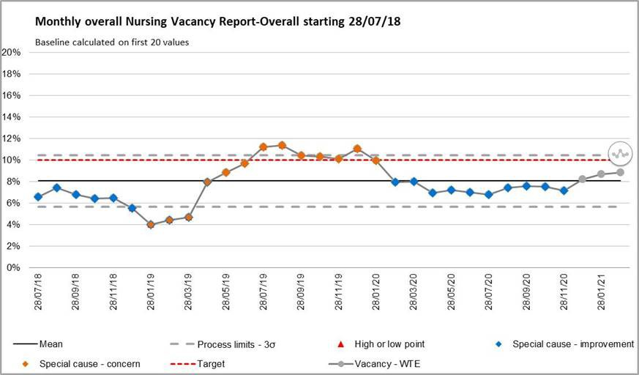
Chart 1: Nursing and Midwifery vacancy % (excluding Nurse Associates)

Table 1: Divisional Vacancy breakdown (information via ESR)
Division | Registered Nurse/ Midwife Vacancy Band  5/6/7 WTE | Band 4 Vacancy WTE | Band 3/2 Vacancy WTE | AHP  Vacancy WTE
MLTC | 12.60 | 30.04 | 7.52 | 0
SURGERY | 40.96 | 2.36 | 15.17 | 1.99
WCCCS | 42.05 | 0 | 15.73 | 4.84
COMMUNITY | 10.34 | 0 | 3.45 | 17.59
Total | 105.95 | 32.40 | 41.87 | 24.81

3

  - Overseas Registered Nurse Recruitment

There is a planned cohort of overseas registered nurses (RNs) due to arrive in England in May, subject to Visa and Covid-19 testing, who will start within the Trust as Band 3 staff. There are a further 5 cohorts of 15 overseas RNs between May and October 2021. The total forecast is 125 overseas RNs to be recruited by the end of December 2021.

  - Clinical Support Worker Recruitment

On the 22 March 2021 there is a planned start date for 30 clinical support worker (CSW) staff that have been recruited with the assistance of Walsall Housing and Walsall College. The staff have been allocated against Divisional vacancies by Divisional Directors of Nursing. A further 9 CSW’s will commence on 19 April 2021. All of the candidates will be supported through a 2 week induction for fundamentals of care.

  - Nursing Associate Recruitment

There is a Cohort of 10 Nursing Associates (NAs) planned for September 2021 who will be supporting plans to fill vacancies within hospital ward areas.

  - Establishment review
The establishment review was presented to the Performance, Finance and Investment Committee with particular attention on the Birthrate Plus recommendations. The Birthrate Plus recommendations were approved in principle and a separate paper is to be presented to Board for consideration for full approval.

  - NHSI Model Hospital Staffing Fill Rates

Lowest fill rate was seen in the CSW day shift at 89.32% (Chart 2). The overall fill rate (combined RN and CSW) was 95%, an increase since January 2021. The redeployment of staff and temporary staffing cover has supported the maintenance of ward fill rates.

4

Chart 2: Ward Area Staffing Fill Rates
110.00%
105.00%
100.00%
95.00%
90.00%
85.00%
80.00%
Safe Staffing Fill Rate - Feb-21
104.19%
100.00%
100.00%
96.95%
100.00% 100.00%
89.57%
89.32%
RN Day CSW Day NA Day TNA Day RN Night CSW Night NA Night TNA Night

  - Staffing Hub Activities

The Staffing Hub is in place to oversee staffing levels across all areas and to facilitate prompt escalation of issues in relation to staffing, acuity and outstanding shift demand. Matrons ensure that in the twice daily staffing meetings opportunities are sought to redeploy personnel where this is safe to do so. In February, Matrons redeployed 2081 hours of substantive RN and 929 hours of CSW during Staffing Hub meetings.

Red Flags are recorded, reviewed and mitigated as appropriate as part of the Staffing Hub meeting. Matrons oversee the accuracy of the Red Flags recorded.

Assurance can be provided that we have robust systems and processes in place to ensure we have the safest possible staffing levels.

  - Electronic Rostering (Eroster) Levels of Covid Related Absence

The recorded hours of Covid-19 absence can be seen Table 2 below Table 2: Covid Related Absence in Erosters
Staff Type | Covid Related Absence Hours (Eroster)
RN | 2989 (reduction  Jan 21) | since | previous | month-
CSW | 2385 (reduction  Jan 21) | since | previous | month-

1.6 Allocate System Roll Out

Forty departments have attended for Roster Manager in Allocate to date and have moved into the Allocate system. There are 8 remaining departments to move into Allocate from RosterPro (RPC). Four of these areas already have a plan to move over to the allocate system (ED / ED paediatrics / ED non-consultant / Ante-natal

5

clinic). The RPC system has had an extension of licence until September 2021 to accommodate further Roll out planning. Covid-19 pandemic has delayed roll out due to the inability to train clinical staff. Virtual methodologies have been tried without success so the commencement of training is being prioritised to areas that pay enhancements. ED is receiving training as a priority.
In addition, Allocate have changed the user interface (version 11) and we have to migrate from our Version 10 to Version 11 by end of May 2021 which will require further training of 1-2 days to all current Allocate Managers (40 departments).

Eroster KPI data is now included within the staffing report to PODC and will be reported on a monthly basis.

1.9 Staff experience audits – Perfect ward

Within the suite of audits a monthly staff experience audit is now undertaken which includes questions from the national staff survey where we have performed below peers. For February 2021 this audit scored 81% with 8 clinical areas completing this audit. The audit is still being embedded but the expectation is that all clinical areas using the app will complete the staff experience audit via the perfect ward app and performance will be reported to PODC monthly. A monthly assurance meeting with Divisional Directors of Nursing, chaired by the Deputy Director of Nursing reviews audit scores, themes and subsequent action plans.

END OF REPORT

6


1
MEETING OF THE PUBLIC BOARD March 2021
Safe Staffing Report |  |  | AGENDA ITEM: 23
Report Author and Job Title: | Caroline Whyte  Interim Deputy Director of Nursing | Responsible Director: | Ann-Marie Riley  Executive Director of Nursing
Action Required | Approve ☐ Discuss ☐ Inform ☒ Assure ☒
Executive Summary | - Registered Nurse (RN) /Midwife vacancy rate is currently just below 9% and has increased since last month.  - There is a planned cohort of 24 overseas nurses (subject to Visa and Covid-19 testing) who will start within the Trust as Band 3 staff during May. The total forecast is 125 overseas RN to be recruited by the end of December 2021.  - There is a planned start date of the 22 March 2021 for 30 Clinical Support Workers (CSW) that have been recruited with the assistance of Walsall Housing and Walsall College.  - Lowest fill rate was seen in the CSW day shift at 89.32%. The overall fill rate (combined RN and CSW) was 95%, an increase since January 2021.  - A number of additional capacity beds have now closed subsequently reducing the staffing demand. In view of this we have been able to reduce the Corporate Risk 2066: Lack of registered nurses and midwives from 20 to 15  - In February 2021, before consideration of escalation to Off Framework Agency, Matrons redeployed 2081 hours of substantive RN and 929 hours of CSW during the twice daily Staffing Hub meetings.  - Electronic roster Key Performance Indicator’s (KPIs) are being evaluated and data will be reported monthly to People and Organisational Culture Committee.  - Perfect Ward staff experience audits have now started to be undertaken in February 2021 with 8 clinical areas competing the audit. The question set includes questions from the national staff survey where the Trust performed below peers.
Recommendation | The Committee is requested to note the contents of the report
Does this report mitigate risk included in the BAF or Trust Risk Registers? please outline | BAF S01: We will deliver excellent quality of care as measured by an outstanding CQC rating by 2022  Corporate Risk No 2066: Lack of registered nurses and midwives

2

Resource implications | Covid-19 impact - staff are working in different ways and locations; risk to staff health and well-being; impact on training and continual professional development.
Legal and Equality and Diversity implications | Covid-19 has impacted disproportionally on people who are men, from low socioeconomic backgrounds and from BAME backgrounds  Our local population is subject to multiple inequalities which affect quality of life, health and mortality.  Further work is required to consider how best we provide assurance on equality, diversity and inclusion and the resulting impact on outcomes.
Strategic Objectives | Safe, high quality care ☒ | Care at home ☐
Strategic Objectives | Partners ☒ | Value colleagues ☐
Strategic Objectives | Resources ☒

3

Introduction

Covid-19 continues to impact on trust services across both acute and community settings and has necessitated both increased use of agency staffing (including use of Thornbury for the ICU and the ED) and also the need to redeploy staff from other areas although the impact is easing as the number of cases reduces. A number of additional capacity beds have been able to close reducing some of the staffing demand. In view of this, Corporate Risk 2066: Lack of registered nurses and midwives has been able to reduce from a score of 20 to 15 in March.
Nurse Staffing Update

  - Vacancy Position

The registered nurse (RN) and midwifery vacancy rate for January is just below 9% (Chart 1). Table 1 outlines the divisional RN vacancy position.

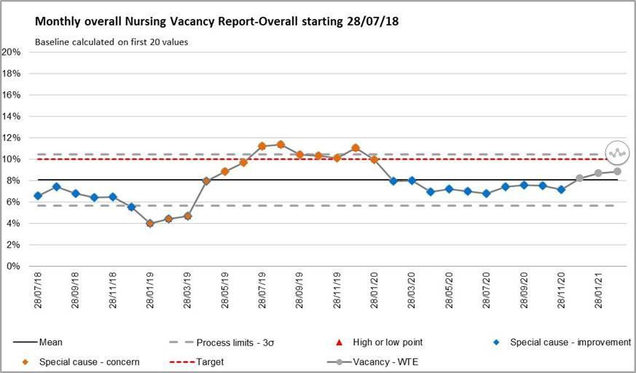
Chart 1: Nursing and Midwifery vacancy % (excluding Nurse Associates)

Table 1: Divisional Vacancy breakdown (information via ESR)
Division | Registered Nurse/ Midwife Vacancy Band  5/6/7 WTE | Band 4 Vacancy WTE | Band 3/2 Vacancy WTE | AHP  Vacancy WTE
MLTC | 12.60 | 30.04 | 7.52 | 0
SURGERY | 40.96 | 2.36 | 15.17 | 1.99
WCCCS | 42.05 | 0 | 15.73 | 4.84
COMMUNITY | 10.34 | 0 | 3.45 | 17.59
Total | 105.95 | 32.40 | 41.87 | 24.81

4

  - Overseas Registered Nurse Recruitment

There is a planned cohort of overseas registered nurses (RNs) due to arrive in England in May, subject to Visa and Covid-19 testing, who will start within the Trust as Band 3 staff. There are a further 5 cohorts of 15 overseas RNs between May and October 2021. The total forecast is 125 overseas RNs to be recruited by the end of December 2021.

  - Clinical Support Worker Recruitment

On the 22 March 2021 there is a planned start date for 30 clinical support worker (CSW) staff that have been recruited with the assistance of Walsall Housing and Walsall College. The staff have been allocated against Divisional vacancies by Divisional Directors of Nursing. A further 9 CSW’s will commence on 19 April 2021. All of the candidates will be supported through a 2 week induction for fundamentals of care.

  - Nursing Associate Recruitment

There is a Cohort of 10 Nursing Associates (NAs) planned for September 2021 who will be supporting plans to fill vacancies within hospital ward areas.

  - Establishment review
The establishment review was presented to the Performance, Finance and Investment Committee with particular attention on the Birthrate Plus recommendations. The Birthrate Plus recommendations were approved in principle and a separate paper is to be presented to Board for consideration for full approval.

  - NHSI Model Hospital Staffing Fill Rates

Lowest fill rate was seen in the CSW day shift at 89.32% (Chart 2). The overall fill rate (combined RN and CSW) was 95%, an increase since January 2021. The redeployment of staff and temporary staffing cover has supported the maintenance of ward fill rates.

Chart 2: Ward Area Staffing Fill Rates
Safe Staffing Fill Rate - Feb-21
110.00%
105.00%
100.00%
104.19%
100.00%
100.00%
100.00% 100.00%
96.95%
95.00%
90.00%
85.00%
80.00%
89.57%
89.32%
RN Day CSW Day NA Day TNA Day RN Night CSW Night NA Night TNA Night

  - Staffing Hub Activities

The Staffing Hub is in place to oversee staffing levels across all areas and to facilitate prompt escalation of issues in relation to staffing, acuity and outstanding shift demand. Matrons ensure that in the twice daily staffing meetings opportunities are sought to redeploy personnel where this is safe to do so. In February, Matrons redeployed 2081 hours of substantive RN and 929 hours of CSW during Staffing Hub meetings.

Red Flags are recorded, reviewed and mitigated as appropriate as part of the Staffing Hub meeting. Matrons oversee the accuracy of the Red Flags recorded.

Assurance can be provided that we have robust systems and processes in place to ensure we have the safest possible staffing levels.

  - Electronic Rostering (Eroster) Levels of Covid Related Absence

The recorded hours of Covid-19 absence can be seen Table 2 below Table 2: Covid Related Absence in Erosters
Staff Type | Covid Related Absence Hours (Eroster)
RN | 2989 (reduction  Jan 21) | since | previous | month-
CSW | 2385 (reduction  Jan 21) | since | previous | month-

1.6 Allocate System Roll Out

Forty departments have attended for Roster Manager in Allocate to date and have moved into the Allocate system. There are 8 remaining departments to move into Allocate from RosterPro (RPC). Four of these areas already have a plan to move over to the allocate system (ED / ED paediatrics / ED non-consultant / Ante-natal

5

6

clinic). The RPC system has had an extension of licence until September 2021 to accommodate further Roll out planning. Covid-19 pandemic has delayed roll out due to the inability to train clinical staff. Virtual methodologies have been tried without success so the commencement of training is being prioritised to areas that pay enhancements. ED is receiving training as a priority.
In addition, Allocate have changed the user interface (version 11) and we have to migrate from our Version 10 to Version 11 by end of May 2021 which will require further training of 1-2 days to all current Allocate Managers (40 departments).

Eroster KPI data is now included within the staffing report to PODC and will be reported on a monthly basis.

1.9 Staff experience audits – Perfect ward

Within the suite of audits a monthly staff experience audit is now undertaken which includes questions from the national staff survey where we have performed below peers. For February 2021 this audit scored 81% with 8 clinical areas completing this audit. The audit is still being embedded but the expectation is that all clinical areas using the app will complete the staff experience audit via the perfect ward app and performance will be reported to PODC monthly. A monthly assurance meeting with Divisional Directors of Nursing, chaired by the Deputy Director of Nursing reviews audit scores, themes and subsequent action plans.

END OF REPORT

MEETING OF THE PUBLIC TRUST BOARD 1st APRIL 2021
Work Closely with Partners |  |  | AGENDA ITEM: 24
Report Author and Job Title: | Ned Hobbs, Chief Operating Officer | Responsible Director: | Ned Hobbs, Chief Operating Officer
Action Required | Approve ☐ Discuss ☐ Inform ☒ Assure ☒
Executive Summary | This report provides an overview of the risks to delivery of the Work Closely with Partners Strategic Objective, mitigations in place to manage the risks identified, and actions identified to address gaps in controls and assurance.  The Work Closely with Partners Improvement Programme reflects the work of Divisional teams and the progression of functional integration between Acute Hospitals. This report gives a brief update on functional integration, and the establishment of the joint Royal Wolverhampton NHS Trust and Walsall Healthcare NHS Trust Executive to Executive Integration forum.
Recommendation | Members of the Trust Board are asked to note the contents of this report.
Does this report mitigate risk included in the BAF or Trust Risk Registers? please outline | This report addresses BAF Risk S04 Work Closely with Partners to provide positive assurance the mitigations in place to manage this risk and the related corporate risks  There are no direct corporate risks associated with Partnership working. However increased partnership working provides a mitigation to the following Corporate risks;  2066- Nursing and Midwifery Vacancies 2072- Temporary workforce
Resource implications | There are no resource implications associated with this report.
Legal and Equality and Diversity implications | There are no legal or equality & diversity implications associated with this paper.

Strategic Objectives | Safe, high quality care ☐ | Care at home ☐
Strategic Objectives | Partners ☒ | Value colleagues ☐
Strategic Objectives | Resources ☐

WORK CLOSELY WITH PARTNERS

- EXECUTIVE SUMMARY

COVID-19 has affected the ability of the Trust to formally oversee and manage the programme of integration between Acute Hospital services. However, COVID-19 has also necessitated and accelerated significant collaboration between Trusts on many matters including mutual aid for Personal Protective Equipment, standardisation of policies in relation to the workforce, approaches to restoration and recovery planning, Critical Care mutual aid, mutual aid for the management of patients conveyed to Emergency Departments by ambulance, and shared learning to deal with a novel virus pandemic.

As a result, collaboration between Black Country Trusts is stronger due to the experience of this year. There is a clear appetite to use this opportunity to build upon those foundations and progress functional service integration where there is an opportunity to improve care for the patients we serve and/or to improve the working lives of our staff.

- BOARD ASSURANCE FRAMEWORK

The Board Assurance Framework (BAF) risk has been reviewed and updated. The risk has been brought up to date to reflect the evidence of successful partnership working, the demonstrable progress in functional service integration in further specialties now, and to recognise the approved Strategic Collaboration between The Royal Wolverhampton NHS Trust (RWT) and Walsall Healthcare NHS Trust (WHT). Further updates incorporate:

  - The establishment of an Executive to Executive Integration oversight meeting between WHT and RWT (first meeting held 10/03/21) and agreed to be held every 4-6 weeks.
  - Black Country & West Birmingham Acute Care Collaboration Programme Board established March 2021.
  - New Integrated Supplies and Procurement Department (ISPD) alliance with Royal Wolverhampton NHS Trust and University Hospitals North Midlands NHS Trust commencing April 2021.

The risk score remains at a 9 (likelihood 3 x consequence 3).

- IMPROVEMENT PROGRAMME

The Work Closely with Partners Improvement Programme reflects the work of Divisional teams and the progression of functional integration between Acute Hospital specialties to support improved patient care, and improved working lives for our people.

Urology

Trust Management Board received an update on 9th March from the Division of Surgery regarding joint proposals between RWT and WHT Urology services.

The joint proposal for Phase One of this collaboration involves the consolidation of out of hours non-elective admissions at RWT, and the clinical model has been developed and approved by WHT Urology Care Group and WHT Surgery Division Team of Three and has been endorsed by WHT Patient Safety Group (21 January 2021). It has been developed and approved by RWT Clinical Lead for Urology, RWT Deputy Chief Operating Officer and RWT Divisional Director.

Phase Two will involve the integration of elective surgery services, and the proposed clinical model of care is still in development.

Both stages will be subject to engagement and consultation, with approval sought from Black Country & West Birmingham Urgent and Emergency Care Board, Black Country and West Birmingham Clinical Reference Group and Black Country and West Birmingham CCG Board. Once STP endorsement is received, a decision on the level of formal public engagement/consultation will be made through the Social Care and Health Overview and Scrutiny Committee. Quality, Patient Experience and Safety Committee will receive the proposed clinical model for scrutiny, and Performance, Finance & Investment Committee will receive the associated business case.

Colorectal Cancer Surgery

In recognition of the pan-Black Country & West Birmingham challenge of recovering timely access to urgent surgery, the Trust’s Division of Surgery has offered Colorectal Cancer operating capacity to BCWB Trusts. The Trust is in a position to do this due to:
- A ringfenced elective wing of the hospital (Outpatient & Daycase Centre)
- A dedicated Enhanced (care) Recovery Unit to provide higher dependency post- operative care within the ringfenced elective wing
- Excellent access to Critical Care siderooms for patients requiring post-operative Level 3 care, segregated from Covid-19 patients.

- Available non-Covid/‘Green’-stream operating theatres within the ringfenced elective wing
- Available non-Covid/‘Green’-stream post-operative ward capacity within the ringfenced elective wing.

The Division should be commended for considering the wider needs of patients needing time-critical Surgery across the STP, and at the time of writing Sandwell and West Birmingham NHS Trust are the first Trust to take up the offer to support timely surgery for Colorectal cancer patients, and indeed to free up operating capacity for other urgent cancer surgery at SWBH.

Dermatology

The joint Dermatology Steering Group continues to meet and work is progressing well. The Steering Group will be receiving a Project Closure report in April as a number of the workstreams have delivered on the agreed objectives and some workstream groups will be stood down following this. The Steering Group has agreed that the structure of the two Dermatology services needs to be formalised. An options appraisal as to the various options will be received which will consider the benefits and disbenefits of an SLA, remaining in its current form as a Project, a Memorandum of Understanding, or a single joint service with a lead provider.

Clinical staff are continuing to rotate across both sites and the Paediatric service at RWT has now been strengthened and supported through the collaboration. Currently under scope is a single management structure; the plan is for the Matron from RWT to spend up to 3 months working across both services, along with the joint CD. The value and benefits of this will be reviewed but is an extremely positive collaborative step forward.

The Moh's Surgery business case has gained Specialised Commissioner approval and will be presented to the STP Cancer Network for the Black Country, and The Dudley Group FT has also confirmed its support for the case. Once support has been formalised from the Cancer Network, it will be presented through the various Trust committees at RWT and WHT for formal approval.

Radiology

A pan-West Midlands Imaging Network workshop was held on 17th March 2021, facilitated by NHSEI. A range of options were considered for configuration of collaborative Imaging Networks, without a consensus preferred option. Black Country & West Birmingham representatives made the case for a configuration that includes a

Black Country & West Birmingham network. The next workshop is scheduled on 15th April 2021.

- RECOMMENDATIONS

Members of the Trust Board are asked to note the contents of this report.

APPENDICES

1. BAF SO3

Public Trust Board – 1st April Item 24, Appendix 1

Risk Summary
BAF Reference and Summary Title: |  | BAF S03 Working with partners; We will deliver sustainable best practice in secondary care, through working with partners across the Black Country and West Birmingham System
Risk Description: |  | Failure to integrate functional and organisational form change within the Black Country will result in lack of resilience in workforce and clinical services, potentially damaging the trust’s ability to deliver sustainable high quality care.
Lead Director: |  | Chief Operating Officer |  |  |  |  | Supported By: | Medical Director & Executive Director for Planning and Improvement
Lead Committee: |  | PERFORMANCE, FINANCE, AND INVESTMENT COMMITTEE
Links to Corporate Risk Register: |  | Title |  |  |  |  |  |  |  | Current Risk Score
 |  | - There are no direct corporate risks associated with Partnership working. However increased partnership working provides  a mitigation to the following Corporate risks; 2066- Nursing and Midwifery Vacancies 2072- Temporary workforce |  |  |  |  |  |  |  | 9 (Moderate)
Risk Scoring
Quarter | Q1 |  | Q2 | Q3 | Q4 | Rationale for Risk Level |  |  | Target Risk Level  (Risk Appetite) |  |  | Target Date
Likelihood: | 3 |  | 3 | 3 |  | This risk has been reduced to moderate due to the advancement of a number of  key work streams.  - Executive group established across provider organisations to review opportunities for collaboration  - Success of Black Country Pathology Service (BCPS)  - Transfer of WHT payroll service to RWT  - Advanced collaboration in Dermatology including appointment of joint clinical director, and cross-site working of Consultant Dermatologists.  - Advanced discussions in Urology including cross site working  - Integrated ENT on-call rota in place  - Initial discussions re: bariatric services and radiology  - STP Clinical Leadership Group, relevant restoration and recovery groups and |  |  | Likelihood: |  | 2 | Q2 2021/22  Subject to assurance on and approval of Urology integration plan.
Consequence: | 4 |  | 4 | 3 |  |  |  |  | Consequence: |  | 2
Risk Level: | 12 |  | 12 | 9 |  |  |  |  | Risk Level: |  | 4 (low)

relevant network collaboration continue to drive Clinical Strategy
- Shared Clinical Fellowship Programme agreed with RWT, and first round of appointments made.
- New Integrated Supplies and Procurement Department (ISPD) alliance with Royal Wolverhampton NHS Trust and University Hospitals North Midlands NHS Trust commencing April 2021.
However, despite progress despite progress, integration plans are not yet fully implemented and the sustainability of the Urology service and current medical staffing vacancies prevent the score being reduced further at this stage.
Control and Assurance Framework 3 Lines of Defence
 | 1st Line of Defence |  |  |  |  |  | 2nd Line of Defence | 3rd Line of Defence
Controls: | - Sustainability review process completed  - Regular oversight through the Board and its sub committees  - Improvement Programme to progress clinical pathway redesign with partner organisations  - Executive to Executive Integration oversight meeting established between WHT and RWT (first meeting held 10/03/21) and agreed to be held every 4-6 weeks.  - Black Country & West Birmingham Acute Care  Collaboration Programme Board established March 2021. |  |  |  |  |  | - Public Trust Board approved Strategic Collaboration between The Royal Wolverhampton NHS Trust and Walsall Healthcare NHS Trust at February Board meetings, and approved a Memorandum of Understanding at March Board meetings. | - Third line of control NHSE/I regulatory oversight  - Black Country and West Birmingham STP plan and governance processes in place
Gaps in Control | - Lack of co-alignment by our organisation and all neighbouring trusts  - Lack of formal integration at Trust level across all four BCWB Acute Trusts  - Mandated arrangements by regional networks
Assurance: | - Track record of functional integration of clinical services including hyper acute stroke, vascular surgery, cardiology, rheumatology, ophthalmology, neurology, oncology, Black Country Pathology Service and OMFS |  |  |  |  |  | - Demonstrable evidence of recent functional integration in ENT, Urology and Dermatology and with the clinical fellowship programme.  - Emerging commitment from BCWB Acute Collaboration partners to more formalised collaborative working.  - Audit Committee has oversight of partnership working within its terms of reference.  - System Review Meetings providing assurance to regulators on progress | - Progress overseen nationally and locally
Gaps in Assurance | - Clinical strategy is still emerging  - Additional pressures with Covid-19 have delayed acute collaboration, and organisational capacity is concentrated on managing the second and third waves of the
2

 |  | pandemic.
 |  | - Limited independent assessment of integrated services or collaborative working arrangements
 |  | - Embryonic independent evidence-base for successful collaborations to assess progress against.
Future Opportunities
- Consolidate other services, including back office functions
- Collaborate with partner organisations outside the Black Country Acute Trusts, including community and third sector organisations
- Promote Walsall as an STP hub for selected, well-established services
- Collaborative working during COVID-19 presents an opportunity to accelerate some elements of clinical pathway redesign
- Shared Chair with RWT creates opportunities to accelerate bilateral collaboration where applicable
Future Risks
- Conflicting priorities and leadership capacity to deliver required changes
- STP level governance does not yet have statutory powers
- Lack of engagement/involvement with the wider public
- Acute Hospital Collaboration may not progress at the anticipated pace due to the resurgence of COVID-19 coinciding with a challenging winter.
- Disrupted relationships with neighbouring trusts due to altered visions of the form and pace of future collaboration
Further Actions (to further reduce Likelihood / Impact of risk in order to achieve Target Risk Level in line with Risk Appetite)
No. | Action Required |  | Executive Lead | Due Date | Quarter 4 Progress Report | BRAG
1. | Keep abreast of Trust Acute collaboration discussions and  updates accordingly. |  | G. Augustine | Dec 2020 | Complete – Trust Board endorsed the benefits of BCWB Trust  collaboration for the population of Walsall
2. | Develop over-arching programme plan to support individual projects for each phase (Phase 1, emergencies,  Phase 2, Elective/Cancer work). |  | Programme Manager | Dec 2020 | Delayed due to resurgence of Covid-19. To be incorporated into re- phased Improvement Programme Plan for June 2021.
4.  5. | Assess resource requirement to support Imaging Network programme  Approve Urology integration plan through QPES, PFIC and Trust Board (if applicable) |  | G Augustine & N Hobbs  N Hobbs | Feb 2021  June 2021 | Delayed due to resurgence of Covid-19. To be discussed at Black Country wide working group in April 2021.  Trust Management Board received proposal on 9th March setting out engagement and Consultation requirements to enable approval.


1

MEETING OF THE PUBLIC TRUST BOARD – 1st April 2021
Charitable Funds Committee Highlight Report |  |  | AGENDA ITEM: 25
Report Author and Job Title: | Trish Mills Trust Secretary | Responsible Director: | Mr Paul Assinder – Chair and Associate Non-Executive Director
Action Required | Approve ☐ Discuss ☐ Inform ☒ Assure ☒
Executive Summary | The report provides the key messages from the Charitable Funds Committee meeting on 18th March 2021. Key points for the attention of the Trustees are:  - A fresh approach to the fundraising strategy was agreed, with a steering group being formed to develop the strategy, implementation plan and KPIs for monitoring by the Committee. Trustees will be requested to participate in consultation for the strategy in the coming months, and a further discussion will be held at the meeting in June.  - The Committee reviewed expenditure under £5,000 and noted spend of £28,989.80 in the quarter. Year to date (January 21) spend was £71,130.15, which is considerably lower than 2019/20 (£107k) levels due to the impact of the pandemic.  - The total of charitable fund balances at 1st April 2020 was  £369,791.79. The total balance on funds at 31st January 2021 was £745,104.77 with expenditure commitments of £177,065.50. However the Committee was advised that the fund had rallied in February, and closed the month at a value of £865,972. The increase was attributed to general market conditions. Given the current situation with the fund, it was agreed that the reserve policy would remain as it was with a £500,000 reserve.  - A communication will be developed from the Chair on the performance of the investment, particularly to fund managers. This will explain the fluctuations in the market and the more positive position of the fund. In addition, charity road shows that were delayed in 2020/21 are planned to start in Q2.  - The COVID-19 fund, which comprises donations from the public  and staff, has a balance currently of £26,000. £10,000 of the


2
fund will be used as a contribution for a memorial garden at the front of the hospital, with the potential to use the balance for health and wellbeing initiatives for staff. The charity received
£165,600 from the Captain Sir Tom funds which has thus far been committed for wheelchairs, the chapel refurbishment and the fundraising hub. The Committee noted that feedback on the provision of the wheelchairs has been extremely positive from patients and their families.
- The Committee reviewed the priorities it set for 2020/21, and whilst they had been affected by the pandemic, there had been progress - particularly in the last quarter - which would set the projects up for success in the first half of 2021/22.
- Members were requested to ensure their papers were both of sufficient quality for the Committee to discharge its duty, and received on time. A number of historical actions were discussed and revised as they were affected by the pandemic, including the development of a business marketing pack which has been deferred to Q2.

The Committee meets quarterly, with the next meeting taking place on 17th June 2021.
Recommendation | Trustees are asked to note the report.
Risk in the BAF or Trust Risk Register | This report aligns to the BAF risks for Care at Home (S02) and COVID-19 (S06)
Resource implications | There are no new resource implications associated with this report.
Legal, Equality and Diversity implications | There are no legal, or equality & diversity implications in this paper, however the developing approach to health inequalities is noted.
Strategic Objectives | Safe, high quality care ☒ | Care at home ☒
Strategic Objectives | Partners ☐ | Value colleagues ☒
Strategic Objectives | Resources ☒


1
TRUST BOARD- 1st April 2021
Quarterly Board Assurance Framework Report |  |  |  | AGENDA ITEM: 27
Report Author and Job Title: | Simone Smith  Head of Health & Safety and Risk | Responsible Director: |  | Jenna Davies  Director of Governance
Action Required | Approve ☒ Discuss ☐ Inform ☐ Assure ☐
Executive Summary | This report provides an overview and a review of risk management activity during. The paper provides a summary of the most recent changes over the past quarter (Quarter three to 31 December 2019).  The content of the paper is underpinned by the trust-wide Corporate Risk Register which has been reviewed monthly by the relevant Committee.  The BAF has undergone significant updates and changes during the Committees and the Board in January and February 2021.  Audit Committee meet on the 29th March 2021 to review and most recent BAF risks and were assured on progress and that the risks represent the current position.
Recommendation | Members of the Trust Board are requested to approve the Board Assurance Framework.
Does this report mitigate risk included in the BAF or Trust Risk  Registers? please outline | Risk implications are outlined within the document
Resource implications | There are no resource implications associated with this report.
Legal and Equality and Diversity implications | The BAF and indeed elements of risk assessments from part of our registration and licence requirements to both NHSE/I and CQC, which may result in regulatory or legal action under the Health and Social Care Act
Strategic Objectives | Safe, high quality care ☒ |  | Care at home ☒
Strategic Objectives | Partners ☒ |  | Value colleagues ☒
Strategic Objectives | Resources ☒

BOARD ASSURANCE FRAMEWORK – Quarter 3 2020 - 2021

- Index and Summary Board Assurance Framework as at Quarter 3 2020/21

Ref / Page | Summary Risk Title | Strategic Objectives Under Threat | 3 Lines of Defence |  |  |  |  | Change in Current Risk Score
Ref / Page | Summary Risk Title | Strategic Objectives Under Threat | 1st Line of Defence |  | 2nd Line of Defence |  | 3rd Line of  Defence | Q1 | Q2 | Q3 | Q4 | Change
Ref / Page | Summary Risk Title | Strategic Objectives Under Threat | Controls | Assurances | Controls | Assurances
BAF 1  Page 6 |  |  | • | • | • | • | • | 20 | 20 | 20
BAF 2  Page 9 |  |  | • | • | • | • | • | 12 | 12 | 16 |  | •
BAF 3  Page 11 |  |  | • | • | • | • | • | 12 | 12 | 9 |  | •
BAF 4  Page 13 |  |  | • | • | • | • | • | 16 | 20 | 20
BAF 5  Page 15 |  |  | • | • | • | • | • | 20 | 20 | 20
BAF 6  Page 17 |  |  | • | • | • | • | • | 20 | 20 | 25

  SO1 - Safe, high quality care |  |  |   SO3 - Deliver care at home |  |   SO4 -Work with Partners |   SO5 - Value our Colleagues: |   SO6 - Use Resources Well
 | BAF Action Plans Key to Progress Ratings
 | B | Complete / Business as Usual |  | Completed: Improvement / action delivered with sustainability assured.
 | GA / GB | On Track |  | Improvement on trajectory either:  A. On track – not yet completed or B. On track – not yet started
 | A | Problematic |  | Delivery remains feasible, issues / risks require additional intervention to deliver the required improvement e.g. Milestones breached.
 | R | Delayed |  | Off track / trajectory – milestone / timescales breached. Recovery plan required.

- 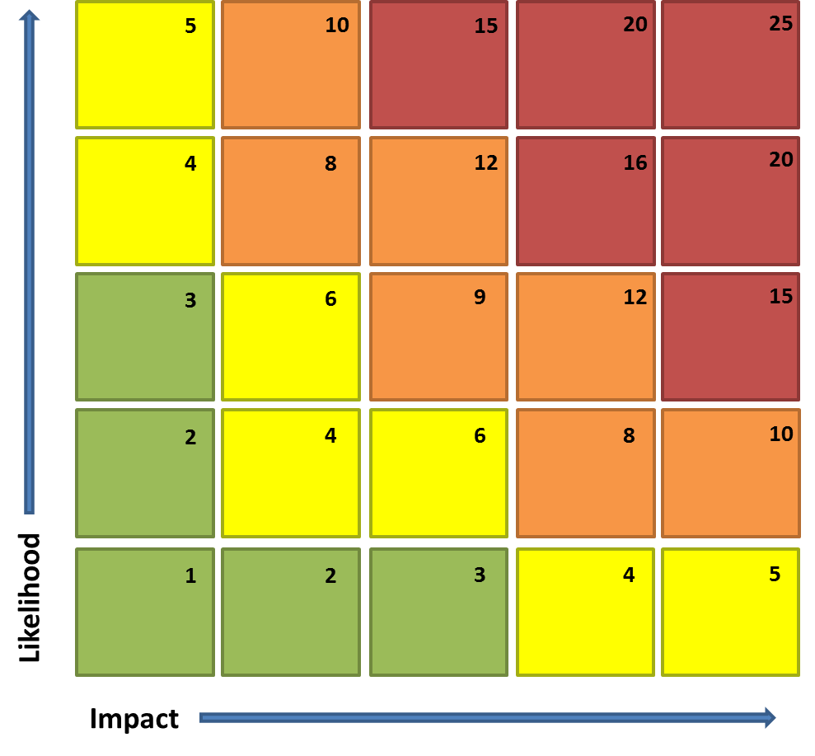Strategic Risk Heat Map

The maps shown above aim to illustrate where the risks set out within the BAF impact upon the achievement of our Strategic Objectives.

- Board Assurance Framework 2020/21

Risk Summary
BAF Reference and Summary Title: |  | BAF SO1: Safe, high quality care: We will deliver excellent quality of care as measured by an outstanding CQC rating by 2022
Risk Description: |  | The Trust fails to deliver excellence in care outcomes, and/or patient/public experience, which impacts on the Trust’s ability to deliver services which are safe and meet the needs of our local population.
Lead Director: |  | Director of Nursing |  |  |  |  | Supported By: | Medical Director
Lead Committee: |  | Quality, Patient Experience and Safety Committee
Links to Corporate Risk Register: |  | Title |  |  |  |  |  |  |  | Current Risk Score
 |  | - 208 Failure to achieve 4 hour wait as per National Performance Target of 95%, resulting in patient safety, experience and performance risks  - 274 Failure to resource backlog maintenance and medical equipment replacement  - 2066 Lack of registered nurses and midwives  - 2260 Lack of a whole system approach across health and social care for the management of Children and Young People (CYP) in mental health or behavioural crisis. |  |  |  |  |  |  |  | 20 (High)
Risk Scoring
Quarter | Q1 |  | Q2 | Q3 | Q4 | Rationale for Risk Level |  |  | Target Risk Level  (Risk Appetite) |  |  | Target  Date
Likelihood: | 4 |  | 4 | 5 |  | - Lack of a clear quality strategy impacts on our ability to accurately monitor and assure care outcomes  - Significant gap in the Trust’s approach to patient engagement and patient involvement.  - Impact of pandemic of COVID-19 resulting in changes in practice and delivery of care from central government command and control resulting in reactive policy and clinical practice changes  - Outstanding CQC Must and Should Do actions from 2019 inspection and new actions from 2020 inspection in Maternity and the Emergency Department  - Gaps in the number and quality of clinical guidance, policies and procedures to ensure safe and quality care  - Concerns that have been raised about delivery care through anonymous and overt routes (including safeguarding and CQC)  - Final report received by the Royal College of Surgeons relating to concerns into |  |  | Likelihood: |  | 2 | 31 March  2021
Consequence: | 5 |  | 4 | 4 |  |  |  |  | Consequence: |  | 5 | 31 March  2021
Risk Level: | High 20 |  | High 20 | High 20 |  |  |  |  | Risk Level: |  | Mod 10 | 31 March  2021

audit and data registration
- Duty of Candour below target performance level
- Failure to deliver 7 Day Services to provide uniform levels of care throughout the week
- Failure to demonstrate that the trust is identifying and addressing inequalities in health
- Delays in cancer diagnosis and treatment pathways
- Increased staffing pressures, and impact on staff resilience, caused by increased requirement in ITU, COVID pathway management, sickness absence and outbreak management
Control and Assurance Framework 3 Lines of Defence
 | 1st Line of Defence |  |  |  |  |  | 2nd Line of Defence | 3rd Line of Defence
Controls: | - Clinical Guidelines/Policies and Standard Operating Procedures in place  - Clinical divisional structures, accountability & quality governance arrangements at Trust, division, care group & service levels  - Central staffing hub co-ordinating nurse staffing numbers in line with acuity and activity  - Clinical audit programme & monitoring arrangements  - Safety Alert process in place  - Freedom to speak up process in place  - Covid-19 SJR undertaken for all deaths  - GIRFT Meetings reinstated  - Thrombosis committee reinstated  - Agreement and plan to implement the electronic sepsis bundle for adults and children.  - Process of assurance for lessons learnt being developed  - CQC registration for the regulated activity of assessment or medical treatment for persons  detained under the Mental Health Act 1983 at Manor Hospital. |  |  |  |  |  | - Patient Experience group in place  - Governance and quality standards managed and monitored through the governance structures of the organisation, performance reviews and the CCG/CQC  - Learning from death framework supporting local mortality review.  - Faculty of Research and Clinical Education (FORCE) established to promote research and professional development in the trust  - Perfect Ward app allows local oversight of key performance metrics | - Annual External Audit of Quality Account  - CQC Inspection Programme  - Process in place with Commissioners to undertake Clinical Quality Review Meetings (CQRM)  - NHSEI scrutiny of Covid-19 cases/Nosocomial infections/Trust implementation of Social distancing, Patient/Staff screening and PPE Guidance  - Quality Review 6 monthly reviews in place with NHSEI/CQC
Gaps in Control | - Clinical audit monitoring arrangements to be reviewed and strengthened  - VTE performance continues to be below the Trust Target

- Deterioration in the Trust’s complaints response performance
- Mental Capacity Act compliance below the Trusts Standards
- Out of date clinical Policies, Procedures and SOP’s
- Training performance not meeting set targets
- Mandatory training below acceptable levels of completion
- Quality Impact Assessment process is not yet established within the trust
- Preventing future deaths notice for VTE
- Sepsis audit frequency and performance
- New Electronic Patient Record not yet functioning at full capacity
Assurance: | - Quality Governance process are in place with oversight and escalation process in place throughout the organisation. Escalations are reported to QPES each month.  - Ward Review process in place which provides assurance on the quality of care  - Improvement programme in place to oversee and monitor improvements associated with the Trust delivery of Safe, and High Quality Care  - Signed SLA with Mental Health Trust to support the organisation to meet the requirements of our CQC registration for the regulated activity of assessment or medical treatment for persons detained under the Mental Health Act 1983 at Manor Hospital. | - Quality, Patient Experience and Safety Committee meets monthly and provides assurance to the Board on quality outcomes  - Duty of Candour is reported quarterly, and patient experience is reported monthly to QPES  - Patient priorities for 2021 identified, which will form part of Quality Account objectives | - External Performance review meetings in place with NHSEI/CQC/CCG  - Monthly Quality meetings with NHSEI and CQC  - External review undertaken on the SI processes  - CQC report (2019) showed improvement and the Trust was rated as ‘outstanding’ for caring  - NHSI and CCG reviews of IPC practice in ED and Maternity have not highlighted any immediate concerns.
Gaps in Assurance | - Outstanding CQC ‘MUST’ and ‘SHOULD’ do actions remain outstanding  - Trust CQC rating requires improvement  - Quality Concerns raised to CQC  - A number of national audits outcomes remain below national average  - NHSEI review insufficient assurance on infection control standards resulting in RED rating  - External audit Assurance relating to the annual quality account has been deferred owing to COVID-19  - Inconsistent evidence both through quality governance structures and performance reviews, of practice having changed as a result of learning from RCAs  - Gaps in assurance noted from the recent CQC inspection including management of sepsis and robust audit data; gaps in ability to have two paediatric nurses rostered each shift in paediatric ED  - Complaints highlighting failure to deliver consistently high standards of care, poor patient experience  - CQC inpatient survey 2019 results  - Lack of assurance regarding equality, diversity and inclusion and actions to reduced inequalities  - Lack of evidence of risk assessments and quality impact assessments relating to staffing contingency planning and/or activity changes

Future Opportunities
- Improvement programme offers consistency in methodologies and documentation used across transformation programmes
- Care Excellence Programme offer a structured programme to achieve excellence in care outcomes, patient/public experience and staff experience
- Availability and implementation of new technologies as a clinical or diagnostic aid (such as: electronic patient records, e-prescribing and patient tracking; artificial intelligence; telemedicine).
- Development of Prevention Strategy
- Development of a Quality Assurance Framework
- Opportunities to increase baseline registered nursing and trainee nursing associates being scoped. Progression with recruitment of 20 international nurses now in progress
Future Risks
- Resources to deliver the improvement programme.
- Impact of Covid-19 plus additional significant time pressured programmes of work such as COVID vaccination, staff testing etc
- Dependence on the success of interdependencies from other work-streams.
- Failure to develop and maintain relationships with key stakeholders.
- Finance and resources.
- Maintaining alignment between SHQC Programme priorities and the activities taking place in Divisions
- Communications across the organisation to share programme objectives
Further Actions (to further reduce Likelihood / Impact of risk in order to achieve Target Risk Level in line with Risk Appetite)
No. | Action Required | Executive Lead | Due Date | Quarter 3 Progress Report | BRAG
1. | Staffing Risk  - Red flag process being embedded, escalation SOP in development  - Implementation of Allocate in line with business case, review of KPI’s and temporary staff booking reasons  - QIA’s to be undertaken for every area that has nursing associate role within establishment  - Establishment review in progress  - Self-assessment against NHSI Developing Workforce Safeguards (2018) underway | Ann-Marie Riley | 30.11.2020 | The establishment review has concluded. Outputs from that and the Birthrate plus recommendations discussed at Executive meeting in January 2021 and recommendations to progress through relevant committees in February 2021 Funding secured to recruit 20 international nurses via RWT clinical fellowship model. Predicted start date by April 2021  Discussion underway with WHG to scope recruitment of trainee nursing associates | GA
2. | Care Excellence  - Care Excellence strategy in development  - Final phase of consultation to take place in September | Ann-Marie Riley & Matthew Lewis | 01/04/21 | The Professional Practice Model was chosen by staff. The draft strategy has been drafted, WT logo drafted and out for comments | GA

3. | Patient Experience  - Reviewing TOR for patient experience group  - We have developed 12 patient priorities – the action plans for these are underdevelopment | Ann-Marie Riley & Matthew Lewis | 1/12/20 | These actions are completed | B

Risk Summary
BAF Reference and Summary Title: |  | BAF SO2 - Care at Home – We will work with partners in addressing health inequalities and delivering care closer to home through integration as the host of Walsall together.
Risk Description: |  | Failure to work with partners and communities to understand population health and inequalities, integrate place-based services and deliver them through a whole population approach would result in a continuation of poor health and wellbeing and widening of health inequalities.
Lead Director: |  | Director of Integration |  |  |  |  | Supported By: | Anne Baines – Non-Executive
Lead Committee: |  | Walsall Together Partnership Board
Links to Corporate Risk Register: |  | Title |  |  |  |  |  |  |  |  | Current Risk Score
 |  | - Risks in this area relate to Walsall Together programme risks the biggest ones are associated with the limited investment and the size and complexity of the population health challenges  - None programme risks relating to Community Services at the current time. These are updated through the divisional structure.  - Each organisation retains its own risk log although the section 75 presents the opportunity to start to bring the logs together  - Risks associated with creating an ICP contract will be considered through a formal due diligence process, supported by NHSE/E  - Operational capacity due to a increase in community prevalence of Covid during Dec and January 2021 |  |  |  |  |  |  |  |  | 16 (High)
Risk Scoring
Quarter | Q1 |  | Q2 | Q3 | Q4 | Rationale for Risk Level |  |  | Target Risk Level  (Risk Appetite) |  |  | Target Date
Likelihood: | 3 |  | 3 | 4 |  | - Significant increase in operational pressure due to Covid wave 2  - Reorganisation of services to cope with unprecedented demand on services currently.  - Slow down in some elements of functional transformation because of current wave albeit other areas of delivery transforming at a faster pace.  - Strongly established relationship with 50% of General Practice on robust vaccine delivery. Other practices chose not to connect with partnership and deploy alone.  - Vaccine delivery with operational teams mainly in primary care initially has diluted focus on core delivery items and increased system pressure.  - Maturing place-based teams in all areas of Walsall on physical health and Social Care. Additional integration required for Mental Health with IAPT and primary care but not established yet.  - Significant maturity in communications and confidence in Walsall Together |  |  | Likelihood: | 2 |  | 30 June 2021
Consequence: | 4 |  | 4 | 4 |  |  |  |  | Consequence: | 4 |  | 30 June 2021
Risk Level: | 12 |  | 12 | 16 |  |  |  |  | Risk Level: | Mod 10 |  | 30 June 2021

- Advancing maturity in performance data – Work now commenced on aligned quality governance.
- Risk Stratification process for COVID developed with partners which demonstrates the evolving maturity of the partnership
- Substantial improvements in medically stable for discharge before and during Covid 19
- Virtual clinics and community outpatients maturing and triage and referral services now in place
- Partnership approach to managing care home support and intervention
- Strong evidence base being establish for ICP due diligence
- The step up of the risk level relates to the above factors. It is anticipated that recovery back initially to 12 will be within Q4 – early Q1 21/22 and delivery to target as noted above. This trajectory will remain under constant review.
Control and Assurance Framework 3 Lines of Defence
 | 1st Line of Defence |  |  |  |  |  | 2nd Line of Defence | 3rd Line of Defence
Controls: | - Executive Director recruited  - Non-Executive Director appointed  - Partnership Board/Groups and meetings in place  - Business Case developed  - PMO/Project in place and reporting  - Operational coordination and twice daily battle rhythm in place  - Covid Vaccine response plan in place with 50% of primary care |  |  |  |  |  | - Alliance agreement signed by Partners  - Governance structure in place and working.  - S75 in place and operational practices now maturing  - Integration of performance data across the partnership is being progressed and reported to the Walsall Together Committee  - Business case approved by all partners  - Monthly report to Board and partner organisations | Enactment of section 75 in terms of Monitoring meeting  External assessment – CQC/Audit STP Scrutiny  Health and Wellbeing Board Reporting Overview and Scrutiny Committee
Gaps in Control | - No strategic finance plan for investment across the partnership which potentially impacts on the delivery notwithstanding the recent investment from the Trust. This has been mitigated short term with Covid funding, but further work required to establish ongoing formal mechanisms through ICP contracts  - Commissioner contracts not yet aligned to Walsall Together although ICP planning will resolve this issue  - Data needs further aligning to project a common information picture  - Effective engagement with community in development with local groups limited due to Covid social restrictions  - Organisational development for wider integrated working not yet outlined or agreed and delayed due to Covid
Assurance: | - Divisional quality board now starting to look at the integrated team response.  - Risk management established at a  programme level and a service level integrating risks |  |  |  |  |  | - Walsall Together included on Internal Audit Programme  - Walsall Together Committee in place overseeing assurance of the partnership  - STP oversight of ‘PLACE’ based model | - NHSE/I support of Walsall Together  - STP support  - NHSE/I validation of ICP due diligence

- Reporting to Board and Partners
- Oversight on service change from other committees
- ICP due diligence underway
Gaps in Assurance |  | - Limited in overall external assurance as regulators inspect individual organisations and as yet have not developed ‘PLACE’ based inspections although Walsall Together put forward as part of ICP development
Future Opportunities
- Further development of the Governance around risk sharing
- S75 Deployment based on other services relating to health prevention and public health commissions
- PCN partnership alignment and risk share with building trust and confidence
- Covid-19 offers an opportunity to increase the pace of delivery and more importantly stress test benefits before substantive deployment
- Strategic partnership(s) with major primary care organisations to further accelerate vertical and horizontal integration of care in the borough
- Formal contract through an ICP mechanism
- Formal working with other partners to support their ability to achieve additional income and support via a partnership approach
- CQC action oversight group
Future Risks
- Insufficient promotion of success narrative
- Inability to deliver enough investment up front to change demand flows in the system.
- National influences on constitutional targets moves focus from place to STP
- Retention of inspirational and committed leadership across partners
- Estates – ability to fund the full business case offering (4 Health & Wellbeing Centres)
- Misalignment of provider strategies created by mergers or form changes or senior personnel turnover
- Lack of uninterrupted community clinic space due to Covid Restrictions
- Programme Resource – Capacity to deliver the WT programme will become more difficult as the same resource will be required to support the delivery of COVID-19 workstreams, e.g. mass swabbing, flu vaccination programme, Covid-19 vaccination programme, outbreak management and the covid-19 management Service (CMS)
Further Actions (to further reduce Likelihood / Impact of risk in order to achieve Target Risk Level in line with Risk Appetite)
No. | Action Required |  | Executive Lead | Due Date | Quarter 3 Progress Report |  | BRAG

1. | Agree a joint business plan for Walsall Together and PCNs that describes how the enhanced and additional roles within the PCN contract will integrate with community  services | Daren Fradgley | Dec 20 | Good progress has been made in this area and agreement has been reached with PCN’s to host additional recruitment in roles such as First Contact Practitioners and Pharmacists. I
2. | Refresh strategic case for Resilient Communities, ensuring appropriate focus on reducing health inequalities and  alignment of strategic objectives across partner organisations | Daren Fradgley | Dec 20 | This work is well underway and will be completed in Feb 2021. The key partners in this area have agreed 4 key focus areas and will bring a  delivery report to the partnership board. This item has been delayed due to C19 wave 2
3. | Develop population health management strategy across Walsall Together and PCNs including the deployment of  the population health module (Digital workstream) | Daren Fradgley | Mar 21 | This work is well underway with the support of the STP Academy and Public health. The Population Health module as part of the Medway  deployment is also in our test environment
4. | Develop robust governance and legal frameworks for Walsall Together with devolved responsibility within the host (WHT) structure. This should include an outline governance structure that shows the links to other WHT  committees and acknowledge the transition to holding a formal ICP contract. | Jenna Davies | Mar 21 | This work is on track as part of the ICP programme
5. | Agree a Communications & Engagement Strategy for Walsall, aligning work across all partner organisations, that clearly articulates the ambition for addressing health  inequalities and how we will achieve coproduction with our citizens and communities | Daren Fradgley | Dec 20 | First draft of this has been reviewed and includes the launch of new branding and identity. You tube animation, model of care graphic and broad patient and stake holder plan are either deployed or due to be  deployed in February. This item has been delayed due to wave 2 Covid but is recovering quickly
6. | Prepare for implementation of a formal ICP contract under a Lead Provider model with WHT as Lead Provider. This will include confirmation of all services in scope and a clear rationale for the change in the context of improving  outcomes for the population. | Daren Fradgley | April 21 | On track and formally reported to WTPB monthly
7 | Coordinate and delivery an enhanced emergency response plan as a result of unprecedented pressure of Covid wave 2 on services which mitigates clinical, operational and  reputational risks | Daren Fradgley | January 21 | This new risk and response is on track and comprehensive assurance has been provided to board committees during this monthly cycle.

Risk Summary
BAF Reference and Summary Title: |  | BAF S03 Working with partners; We will deliver sustainable best practice in secondary care, through working with partners across the Black Country and West Birmingham System
Risk Description: |  | Failure to integrate functional and organisational form change within the Black Country will result in lack of resilience in workforce and clinical services, potentially damaging the trust’s ability to deliver sustainable high quality care.
Lead Director: |  | Chief Operating Officer |  |  |  |  | Supported By: | Medical Director & Executive Director for Planning and Improvement
Lead Committee: |  | PERFORMANCE, FINANCE, AND INVESTMENT COMMITTEE
Links to Corporate Risk Register: |  | Title |  |  |  |  |  |  |  | Current Risk Score
 |  | - There are no direct corporate risks associated with Partnership working. However increased partnership working provides  a mitigation to the following Corporate risks; 2066- Nursing and Midwifery Vacancies 2072- Temporary workforce |  |  |  |  |  |  |  | 9 (Moderate)
Risk Scoring
Quarter | Q1 |  | Q2 | Q3 | Q4 | Rationale for Risk Level |  |  | Target Risk Level  (Risk Appetite) |  |  | Target Date
Likelihood: | 3 |  | 3 | 3 |  | This risk has been reduced to moderate due to the advancement of a number of  key work streams.  - Executive group established across provider organisations to review opportunities for collaboration  - Success of Black Country Pathology Service (BCPS)  - Transfer of WHT payroll service to RWT  - Advanced collaboration in Dermatology including appointment of joint clinical director, and cross-site working of Consultant Dermatologists.  - Advanced discussions in Urology including cross site working  - Integrated ENT on-call rota in place  - Initial discussions re: bariatric services and radiology  - STP Clinical Leadership Group, relevant restoration and recovery groups and relevant network collaboration continue to drive Clinical Strategy  - Shared Clinical Fellowship Programme agreed with RWT, and first round of |  |  | Likelihood: |  | 2 | 31 March 2021
Consequence: | 4 |  | 4 | 3 |  |  |  |  | Consequence: |  | 2 | 31 March 2021
Risk Level: | 12 |  | 12 | 9 |  |  |  |  | Risk Level: |  | 4 (low) | 31 March 2021

appointments made.
- Despite progress, integration plans are not yet fully implemented
Control and Assurance Framework 3 Lines of Defence
 | 1st Line of Defence |  |  |  |  |  | 2nd Line of Defence | 3rd Line of Defence
Controls: | - Collaborative working and integration executive group in place  - Sustainability review process completed  - Regular oversight through the Board and its sub committees  - Improvement Programme to progress clinical pathway redesign with partner organisations |  |  |  |  |  | - Approved Strategic Collaboration between The Royal Wolverhampton NHS Trust and Walsall Healthcare NHS Trust. | - Third line of control NHSE/I regulatory oversight  - Black Country and West Birmingham STP plan and governance processes in place
Gaps in Control | - Lack of co-alignment by our organisation and neighbouring trusts  - Lack of formal integration at Trust level across all four BCWB Acute Trusts  - Mandated arrangements by regional networks
Assurance: | - Track record of functional integration of clinical services including hyper acute stroke, vascular surgery, cardiology, rheumatology, ophthalmology, neurology, oncology, Black Country Pathology Service and OMFS |  |  |  |  |  | - Demonstrable evidence of recent functional integration in ENT, Urology and Dermatology  - Emerging commitment from Acute Collaboration partners to more formalised collaborative working.  - Audit Committee has oversight of partnership working within its terms of reference.  - System Review Meetings providing assurance to regulators on progress | - Progress overseen nationally and locally
Gaps in Assurance | - Clinical strategy is still emerging  - CCG currently in a state of transition  - Additional pressures with Covid-19 have delayed acute collaboration, and organisational capacity is concentrated on managing the second and third waves.  - Limited independent assessment of integrated services or collaborative working arrangements  - Embryonic independent evidence-base for successful collaborations to assess progress against.
Future Opportunities
- Consolidate other services, including back office functions
- Collaborate with partner organisations outside the Black Country Acute Trusts, including community and third party organisations
- Promote Walsall as an STP hub for selected, well-established services
- Collaborative working during COVID-19 presents an opportunity to accelerate some elements of clinical pathway redesign
Future Risks
- Conflicting priorities and leadership capacity to deliver required changes
- STP level governance does not yet have statutory powers
- Lack of engagement/involvement with the wider public

- Acute Hospital Collaboration may not progress at the anticipated pace due to the resurgence of COVID-19 coinciding with a challenging winter.
- Disrupted relationships with neighbouring trusts due to altered visions of the form and pace of future collaboration
Further Actions (to further reduce Likelihood / Impact of risk in order to achieve Target Risk Level in line with Risk Appetite)
No. | Action Required | Executive Lead | Due Date | Quarter 3 Progress Report | BRAG
1. | Keep abreast of Trust Acute collaboration discussions and  updates accordingly. | G. Augustine | Dec 2020 | Complete – Trust Board endorsed the benefits of BCWB Trust  collaboration for the population of Walsall | B
2. | Develop over-arching programme plan to support individual projects for each phase (Phase 1, emergencies,  Phase 2, Elective/Cancer work). | Programme Manager | Dec 2020 | Delayed due to resurgence of Covid-19.
4. | Assess resource requirement to support Imaging Network  programme | G Augustine & N  Hobbs | Jan 2020

Risk Summary
BAF Reference and Summary Title: |  | BAF 04 - Value our Colleagues - We will be an inclusive organisation which lives our organisational values at all times
Risk Description: |  | Lack of an inclusive and open culture impacts on staff morale, staff engagement, staff recruitment, retention and patient care
Lead Director: |  | Director of People and Culture |  |  |  |  | Supported By:
Lead Committee: |  | PEOPLE AND ORGANISATIONAL DEVELOPMENT COMMITTEE
Links to Corporate Risk Register: |  | Title |  |  |  |  |  |  |  | Current Risk Score
 |  | - 2072 - Inability to recruit and retain the right staff with the right skills which impacts on fundamentals of care (both patients and staff), and undermines financial efficiency.  - 707 - Relates to a Failure to comply with equality, diversity and inclusion standards.  - 2093 - Staff are exposed to infection with COVID-19 through contact with infected patients, visitors and colleagues. There is a risk of significant physical and mental illness, including death  - 2095 - The demand for 'Personal Protective Equipment' (PPE) has contributed to a national shortage of proper and effective PPE, resulting in delays in obtaining from supply chain, with the potential to impact on our ability to maintain key critical services and protect staff against COVID-19. |  |  |  |  |  |  |  | 20 (Major)
Risk Scoring
Quarter | Q1 |  | Q2 | Q3 | Q4 | Rationale for Risk Level |  |  | Target Risk Level  (Risk Appetite) |  |  | Target Date
Likelihood: | 4 |  | 4 | 4 |  | - Staff recommending Walsall as a place to work is below all England average [bottom quartile Q2 2019-2020]  - Staff recommending Walsall as a place to be treated is below all England average [bottom quartile Q2 2019-2020]  - Staff engagement score in NHS staff survey is below peer comparators  - NHS staff survey indicates a lack of inclusive culture with differential staff experience in bullying, harassment, violence, career progression and promotion  - NHS staff survey indicates a lack of open culture (speaking up) below peer comparators  - The model hospital data indicates bottom quartile performance on workforce indicators such as sickness absence and use of resources  - Historical WRES data indicates a lack of progress to tackle barriers to inclusion. |  |  | Likelihood: |  | 2 | 31 March 2021
Consequence: | 4 |  | 5 | 5 |  |  |  |  | Consequence: |  | 5 | 31 March 2021
Risk Level: | 16 |  | 20 | 20 |  |  |  |  | Risk Level: |  | 8 | 31 March 2021

- Data and information shared via staff feedback mechanisms evaluating impact of COVID identifies staff and line managers being fatigued and fearful of the impact that a second wave will have on individuals and staffing levels.
- Data and information from staff engagement events have identified the existence of toxic climates in several areas/departments across the Trust where staff have shared stories of unreasonable treatment based on their race, disability, ethnicity and sexuality.
Control and Assurance Framework 3 Lines of Defence
 | 1st Line of Defence |  |  |  |  |  | 2nd Line of Defence | 3rd Line of Defence
Controls: | - Values launched and evaluated across the Trust  - Staff engagement and communication approach in place  - Policy on zero tolerance to violence in place  - Behaviour Framework implemented and evidence of practicing behaviours in action to be reviewed within the IPDR process  - Values based appraisal process in place which incorporates Talent Management and the ability to track access to career progression and promotion  - Increased engagement through engagements and EDI champions  - Health and Wellbeing approach based on holistic offering to staff being developed.  - Internal staff mental health awareness champions identified.  - Restorative Just Culture work initiated and ER casework triaged for opportunities for early resolution.  - Staff in at risk groups have been identified and managed appropriately according Wellbeing Review and Stratified Risk Assessments.  - Staff identified as at higher risk of contracting Covid-19 and potentially suffering from more severe symptoms are prioritised for Covid-19 vaccine. |  |  |  |  |  | - Head of Talent, Resourcing and Inclusion appointed to lead the approach  - Analysis against actions required from NHS People Plan against actions progressed under the Valuing Colleagues Improvement Programme has been reviewed by PODC.  - PODC approved measures to monitor progress against Trust Board Pledge in place.  - STP funding achieved to support training and implementation of restorative just and learning culture. Cohorts for Walsall reserved for April/May 2021.  - F2SU strategy agreed at PODC and in place.  - Accredited RCN training programme for 60 Cultural Ambassadors has been implemented to support recruitment and selection processes.  - Outcomes of additional HR/OD to support work areas with complex people needs and poor staff experience monitored via PODC and Value Our Colleagues Improvement Programme.  - Internal Mental First Aider network established, accredited training complete and network contact details and support available to staff promoted.  - 15 x Freedom to Speak Up Confidential Contact Links appointed to support healthy workplace speaking up climate and signposting.  - Strategic intention to formalise partnership with strategic alliance to support learning and development opportunities for managers and staff at Walsall | - Quarterly deep dive of key workforce metrics by CCG.  - BCWB STP People Plan in development to support implementation of National NHS People Plan.  - Midlands NHSE&I monitoring of individual COVID-19 risk assessment performance.  - STP and regional NHSE&I monitoring of Trust performance regarding uptake of staff flu programme.  - WRES and WDES outcomes monitored at national and regional NHSE&I level.  - ESR external quality review to be undertaken in Q4 20/21.  - 2020 National Staff Survey results provide core indicator of staff engagement to enable local, regional and national benchmarking.

 | - Set of measures have been identified to monitor progress against workforce inequalities and employment inequality in Walsall.  - A range of HR / OD resources have been commissioned to support departments / teams in difficulty where there is poor colleague experience.  - Point of Care Foundation Team Time model steering group implemented – Team Time model planned for launch Q4 20/21.  - Customer satisfaction survey re HR Management and Advisory Service completed. | Healthcare NHS Trust have commenced.  - Fixed term appointment of Consultant of Occupational Health Medicine extended until February 2022.  - Audit of redeployment decisions for front line workers to understand the extent to which their personal health and safety is protected has been completed and reported to PODC (January 2021).  - F2SU and Inclusion Coordinator appointed for six months to support and progress activities.
Gaps in Control | - Lack of an approved EDI Strategy and Delivery Plan could inhibit the scale and pace of progress towards an inclusive culture  - Approaches and resources may be insufficiently robust or at scale to achieve meaningful change  - Current Policy framework not fit for purpose – legacy policies are not aligned to the approach  - Leadership development programme is in its infancy  - Management competency framework is not yet available, impact and evaluation not complete  - Resourcing not yet stable – workforce metrics still demonstrate adverse trends  - EDI targets at organisational and divisional level have not been developed.  - Ensuring colleagues identified as high risk are protected against redeployment which may enhance risks to persona health and safety.  - Ensuring the individual Covid-19 stratified risk assessment process is fit for purpose (clinical assessment tool due to be reviewed in January 2021).  - The Trust has not formally introduced the individual wellbeing plan which is a requirement on the NHS People Plan from March 2021.
Assurance: | - Engaging with the wider Trust and TMB on co- designing an Organisation Development Plan  – work packages and delivery through the improvement programme  - BAME decision making forum has been established to advise and guide the Trust in its understanding of issues facing colleagues from BAME backgrounds in the workplace and what measures can be taken to improve their experiences.  - Audit of Individual COVID-19 Risk Assessments undertaken to understand risk levels and outcomes of measures implemented to protect staff. | - People and OD committee of the Board in place to seek assurance, through the cycle of business and review of workforce metric trends.  - EDI group led by a Non-Executive director in place to review approach to EDI and delivery of metrics in the EDI strategy framework and Equality Impact Assessment.  - PODC receive monthly updates regarding to assure robust arrangements in place to support colleagues through the impact of COVID.  - BAME cabinet provides strategic Board focus on EDI.  - Board development sessions to support co-design and approval of EDI strategy completed in October 2020.  - Staff Inclusion Network established in May and meetings taking place with Network leads across the | - NHSi working with the Trust to develop the FTSU approach and to develop a strategic framework by Q2 for FTSU by 2020-2021  - NHS Leadership Academy working with the Trust on developing leadership capacity and capability, the delivery was scheduled for Q1 2020-21, paused due to Covid response. Revised implementation plan agreed at TMB to commence Q1 2021.  - NHSi partner for Retention programme – the 90 day plan is complete, impact on retention rate to be reviewed Q2 1920  - EDI WRES/WDES metrics and other EDI metrics developed for inclusion within the organisation’s accountability framework

• An audit against ESR data is being undertake to provide assurance regarding workforce and learning data quality.
• More targeted work is required to ascertain staff satisfaction of the individual Covid-19 risk stratification risk assessment.
recorded to have participated in the process.
• No internal audit assurance gained in year
• NHSE/I Governance and Accountability review highlighted areas of improvement associated with culture and leadership
• The staff engagement score has worsened indicating lower levels of staff morale and role satisfaction.
• The indicators for staff recommending the Trust as a place to work or a place to be treated have failed to improve significantly.
• NHS staff survey results do not evidence an improvement in staff reporting of an inclusive and open culture
• Evaluation of zero tolerance to violence not yet evaluated.
• Evidence based approach to positive action interventions not yet in place to support EDI objective
 | - Review of Individual COVID-19 Risk Assessments with PHE, OH professionals and staff networks – January 2021.  - Benefits of ‘Value our Colleagues’ improvement programme agreed. | protected characteristics. Communication leaflet and contact details shared with all colleagues.  - Targeted OD and HR interventions form a specific workstream of the Value Our Colleagues Improvement Programme.
Gaps in Assurance | - All elements of the Trust Board pledge, bullying harassment, discrimination and listening to the voice of staff.  - Lack of an approved EDI Strategy and Delivery Plan could inhibit the scale and pace of progress towards an inclusive culture  - Line managers are required to ensure all staff have received an opportunity to undertake a wellbeing review and individual covid-19 risk assessment. Not all staff are
Future Opportunities
- Capitalise on external resource/expertise to establish evidence based best practice
- Closer working with through the STP/LWAB
- Collaborative working with other Trusts to creatively address resourcing matters
- New roles and scenario based workforce planning for full resourcing and consequent impact on staff morale
- To work collaboratively on a Black Country Health and Wellbeing approach to make Walsall and the Black Country the best place to work
- To develop a more structured and inclusive approach to widening participation
- To develop the Trust’s profile as an employer of choice by having clear pathways for career development.
- To become an anchor employer within Walsall attracting talent as a result of our EDI approach and strategy.
- Implementation of cultural ambassadors to enhance recruitment processes and recognise the value of diversity.
- Board EDI development sessions scheduled for October 2020.
- Divisional Board Accountability Framework to monitor on Divisional EDI targets
- Strategic intention to formalise partnership with strategic alliance to support learning and development opportunities for managers and staff at Walsall Healthcare NHS Trust have commenced.
- Develop civility and respect campaign with STP partners following national model.
Future Risks
- The capability and capacity of leaders does not support the development of a Just Culture approach in practice

- Recruitment and retention activity does not result in improved performance, meeting targets for vacancy, turnover, absence and the trust remains below peer comparators within the STP.
- Continued impact of COVID on the physical and psychological health of individuals and workforce availability.
Further Actions (to further reduce Likelihood / Impact of risk in order to achieve Target Risk Level in line with Risk Appetite)
No. | Action Required | Executive Lead | Due Date | Quarter 3 Progress Report | BRAG
1. | Draft Health & Wellbeing Strategy & Engage and Consult Key stakeholders | Catherine Griffiths | March 2021 | - Focus and rapid development and implementation of HWB interventions to support staff working through COVID-19.  - Continuous development of HWB conversations and developing process and skill set to support individual HWB plan conversations – updated presented to Nov PODC.  - HWB booklet completed and individual copy provided to all colleagues to signpost access to core HWB services.  •
2. | Develop and Implement a leadership Development Programme | Catherine Griffiths | March 2021 | - Updates shared at Execs and TMB in October 2020  - FMLD programme recommissioned following COVID-19 pause – commence Q1 2021.  - Growth Mindset Leadership Development Programme commissioned – due to be implemented from Q4 20/21.  - Management Framework due to be launched on Q4 20/21.
3. | Launch EIA Policy and Form | Catherine Griffiths | October 2020 | - New forms and Policy agreed and in place. . Board and Executive paper EIA prompt sheet developed and uploaded on to Trust Corporate Communications Intranet web pages alongside Corporate communication templates  - EIA learning package with EIA Video launched with Policy. | B
4. | Review and relaunch equality impact assessment processes | Catherine Griffiths | March 2021 | - Options currently being explored to develop an online version of the EIA proforma via Cloud 2 intranet project and the functionality of share point. | B
5. | Agree Valuing Colleagues Improvement Programme Benefits | Catherine Griffiths | November 2020 | - Set of qualitative and quantitative benefit measures considered at Improvement Board workshop 02 October 2020. | B
6. | Finalise and approve Equality, Diversity and Inclusion Strategy | Catherine Griffiths | January 2021 | - Colleague and community engagement and consultation completed in September 2020.  - EDIC and Staff Inclusion Network BAME Decision Making Counsel engagement completed.  - Board Development sessions on the 5 & 19 October 2020 completed.  - Strategy to be received by PODC in December ahead of Trust Board consideration in January 2021.
8. | Provide assurance regarding outcomes of individual COVID-19 Risk Assessments | Catherine Griffiths | October 2020 | - Detailed audit commissioned between 12-23 October 2020. Initial analysis to be reported to October PODC. Ongoing | B

assurance reports provided monthly to PODC.

Risk Summary
BAF Reference and Summary Title: |  | BAF 05 Use Resources Well; We will deliver optimum value by using our resources efficiently and responsibly
Risk Description: |  | The Trust’s financial sustainability is jeopardised if it cannot deliver the services it provides to their best value.  If resources (financial, human, physical assets, and technology) are not utilised to their optimum, opportunities are lost to invest in improving quality of care. Failure to deliver agreed financial targets reduces the ability of the Trust to invest in improving quality of care, and constrains available capital to invest in Estate, Medical Equipment and Technological assets in turn leading to a less productive use of resources.
Lead Director: |  | Chief Operating Officer |  |  |  |  | Supported By: | Director of Finance
Lead Committee: |  | PERFORMANCE, FINANCE, AND INVESTMENT COMMITTEE
Links to Corporate Risk Register: |  | Title |  |  |  |  |  |  |  | Current Risk Score
 |  | •Risk 208 – Failure to achieve 4 hour wait as per National Performance Target of 95% resulting in patient safety, experience  and performance risks (Risk score = 16)  •Risk 274- Failure to resource backlog maintenance and medical equipment replacement costs results in the organisation being unable to deliver fundamental clinical services and care (Risk Score=20)  •Risk 665 - Risk of a cyberattack (ransomware, spearfishing, doxware, worm, Trojan, DDoS etc) upon a NHS or partner organisation within the West Midlands Conurbation. (Risk Score=15)  •Risk 1005- The Trust has insufficient resources available to ensure the essential maintenance of the Trust's Estate. (Risk Score=16)  •Risk 1155 - Failure to demonstrate fire stopping certification for all areas of the Trust would breach fire safety regulation, risking public/ patient safety. (Risk Score=16)  •Risk 2081- Operational expenditure incurred during the current financial year exceeds income allocations, which results in the Trust being unable to deliver a break even financial plan. (Risk Score =16)  •Risk 2082-Failure to realise the benefits associated with the outcomes of the improvement programme work-streams, results in the Trust not delivering efficiencies required to attain agreed financial control targets, and deliver financial balance without central support, which therefore impacts on the Trusts ability to deliver financial and clinical sustainability. (Risk Score =16)  •Risk 2188 (NEW) - A continued dependency on suboptimal legacy patient information infrastructure, will limit the flow of  clinical information, reduce professional confidence and increase administrative burden for healthcare professionals, ultimately impacting on patient care and the ability to transform healthcare services. (Risk Score = 10 |  |  |  |  |  |  |  | 20 (Major)
Risk Scoring
Quarter | Q1 |  | Q2 | Q3 | Q4 | Rationale for Risk Level |  |  | Target Risk Level  (Risk Appetite) |  |  | Target Date
Likelihood: | 4 |  | 4 | 4 |  | Evidence of risk control |  |  | Likelihood: |  | 2 | 31 March 2021

Consequence: |  | 5 | 5 | 5 |  | - Achievement of 19/20 financial plan. Evidence of risk gaps in control  - The Trust experienced run rate risk for the 19/20 financial year that led to needing to re-forecast outturn during the financial year.  - High reliance on temporary workforce  - Lack of credible plan to address backlog maintenance requirements. Evidence of planning uncertainty  - The Trust has an Emergency Budget for April 2020 to September 2020, and only received confirmation of October 2020 to March 2021 income levels in October 2020.  - Financial improvement planning and delivery has been impacted by Covid-19.  - Significant uncertainty associated with 2021/22 financial arrangements. |  |  | Consequence: | 5
Risk Level: |  | 20  (Major) | 20  (Major) | 20  (Major) |  |  |  |  | Risk Level: | 10  (Moderate)
Control and Assurance Framework 3 Lines of Defence
 | 1st Line of Defence |  |  |  |  |  | 2nd Line of Defence | 3rd Line of Defence
Controls: | - Finance reported monthly via Divisional Performance Reviews and Executive Governance Structures  - CIP Governance processes in place  - Revised financial governance in place for COVID-19  - Board Development session for the Improvement Programme with identified 3- year targeted financial benefits. |  |  |  |  |  | - Performance, Finance & Investment Committee in place to gain assurance  - Audit Committee in place to oversee and test the governance/financial controls  - Adoption of business rules (Standing Orders, Standing Financial Instructions and Scheme of Delegation)  - Use of Resources work-stream identified as part of the Improvement Programme | - Externally benchmarked Financial performance data.
Gaps in Control | - Business planning processes require strengthening  - Accountability Framework has been approved, however needs review further to the NHSI Governance Review report  - Trust scored requires improvement on its assessment of ‘Use of Resources’ owing to low productivity and high staff and support costs being evident  - Evidencing oversight of the controls in force to monitor and regulate temporary workforce – Implementation of Allocate progressing throughout the Trust (Medical and Nursing) and Internal Audit conducting a full review of controls in force.  - Leadership development needs at Care Group, Divisional and corporate support service levels, with leadership development programme deferred due to Covid-19 second wave.  - Covid-19 second wave has significantly exceeded planning parameter assumptions.
Assurance: | - Model Hospital Use of Resources assessments |  |  |  |  |  | - Internal Audit reviews of a number of areas of financial and operational performance | - Annual Report and Accounts presented to NHSE/I  - NHSE/I oversight of performance both financial and operational

 |  |  |  |  |  | - External Audit Assurance of the Annual Accounts
Gaps in Assurance |  | - NHSi Governance review highlighted areas of improvement for business process and accountability framework.  - External Audit limited due to Covid-19  - Internal Audit core financial controls not completed.  - Late confirmation of a confirmed Month 7 -12 20/21 financial plan, and late confirmation of 21/22 financial architecture.
Future Opportunities
- Further Development of LTFM to include potential additional income sources, such as non-clinical commercial opportunities and repatriation of patients resident to Walsall
currently receiving care out of area.
- Enhanced clinical economies of scale through Acute Hospital Collaboration (Working with Partners).
- Reduced reliance on inpatient hospital care through Walsall Together Partnership (Care at Home).
- Utilisation of national productivity benchmark information (e.g. GIRFT and Model Hospital) to target work through the Use of Resources Improvement Programme
- Development of major capital upgrades (new Emergency Department) to support improved recruitment of staff.
- Harnessing the teamwork and innovation so evident throughout the Covid-19 pandemic to develop service improvements that lead to improved use of resources.
- Capitalising on the digital advancement during Covid-19 to harness technology to improve effective use of resources.
- Rationalising Estate requirements through increased remote working.
- Enhanced leadership capability through Well-led Improvement Programme workstream.
Future Risks
- Covid-19 second wave has significantly exceeded planning parameter assumptions, leading to increased costs delivering emergency and critical care.
- Likely move away from PbR towards block contracts.
- Adverse Covid-19 impact on ability to deliver improved productivity for elective care in 20/21.
- Additional costs associated with safe non-elective and critical care during Covid-19.
- Significant impact on elective and non-elective demand during Covid-19, leading to difficulty planning for the future with confidence.
- Insufficient Capital to enable investments in the Estate, equipment and technology that would in turn support more effective use of resources, and lead time for deployment of capital.
- Planning guidance stipulation that receipt of FRF is 50% dependent on delivery of STP financial plan.
- Adverse impact of Britain's exit from the European Union on business continuity and the Trust’s financial position.
- Supply costs are more volatile within the market based on supply and demand associated with Covid-19.
- Workforce exhaustion and/or psychological impact from Covid-19 results in higher sickness rates and further reliance on temporary workforce.
Further Actions (to further reduce Likelihood / Impact of risk in order to achieve Target Risk Level in line with Risk Appetite)
No. | Action Required |  | Executive Lead | Due Date | Quarter 3 Progress Report |  | BRAG
2. | Review and update Accountability Framework further to  the NHSI Governance Review report. |  | R. Caldicott | Oct 2020

3. | Financial regime post 31st September 2020 to be approved  by Board in October 2020- Russell Caldicott | R. Caldicott | Oct 2020 | Complete | B
4. | All work-streams to have Improvement programme benefits  defined. | G. Augustine | Oct 2020 | Complete – Presented to Trust Board Development Session on 1st  October 2020 | B
5. | Development of 2021/22 Financial plan | R. Caldicott | March 2021

Risk Summary
BAF Reference and Summary Title: |  | BAF S06 COVID - This risk has the potential to impact on all of the Trusts Strategic Objectives.
Risk Description: |  | The impact of Covid-19 and recovering from the initial wave of the pandemic on our clinical and managerial operations is such that it  prevents the organisation from delivering its strategic objectives and annual priorities.
Lead Director: |  | Chief Operating Officer |  |  |  |  | Supported By: | All Executive Directors
Lead Committee:
Links to Corporate Risk Register: |  | Title |  |  |  |  |  |  |  | Current Risk Score
 |  | 2051- Inability to mitigate the impact of Covid-19, results in possible harm and poor patient experience to the people of  Walsall.  2066- There is a risk of lack of skilled registered nurses (RN's)/registered midwives (RM's) on a shift by shift basis affecting our ability to consistently maintain delivery of excellent standards of care  2093- Risk of staff contracting COVID-19 through the course of their duties in Walsall Healthcare NHS Trust  2095- Inability of the NHS supply chain to provide an adequate and on-going supply of PPE to meet the demand to ensure that Walsall Healthcare NHS staff are fully protected during the Covid-19 pandemic.  208 – Failure to achieve 4 hour wait as per National Performance Target of 95% resulting in patient safety, experience and performance risks (Risk score = 16)  2081- Operational expenditure incurred during the current financial year exceeds income allocations, which results in the Trust being unable to deliver a break even financial plan. (Risk Score =16)  2082-Failure to realise the benefits associated with the outcomes of the improvement programme work-streams, results in the Trust not delivering efficiencies required to attain agreed financial control targets, and deliver financial balance without central support, which therefore impacts on the Trusts ability to deliver financial and clinical sustainability. (Risk Score =16) |  |  |  |  |  |  |  | 25 (Catastrophic)
Risk Scoring
Quarter | Q1 |  | Q2 | Q3 | Q4 | Rationale for Risk Level |  |  | Target Risk Level  (Risk Appetite) |  |  | Target Date
Likelihood: | 4 |  | 4 | 4 |  | - Covid-19 is a novel virus and therefore there is only an emerging  understanding of the disease, how it behaves and the likely trajectory of further resurgence in cases.  - The initial wave of Covid-19 had a profound impact on the services that the Trust provides, both in terms of urgent, emergency and critical care services to manage covid-19 positive patients (in the |  |  | Likelihood: |  | 2 | 31 March 2021
Consequence: | 5 |  | 5 | 5 |  |  |  |  | Consequence: |  | 5 | 31 March 2021
Risk Level: | 20  (Major) |  | 20  (Major) | 20  (Major) |  |  |  |  | Risk Level: |  | 10  (Moderate) | 31 March 2021

hospital and the community), and in terms of the reduction in
capacity of elective care services. The initial wave had a particularly significant impact on care home residents within the Borough’s population.
- The initial wave of Covid-19 had a profound impact on the workforce of the Trust. By May 2020, almost 1 in 4 Trust staff who have undergone a Covid-19 Antibody test have been antibody positive suggesting a significant proportion of the workforce has experienced the disease themselves. Moreover, the challenges of managing the initial wave of the pandemic has had significant psychological impact on staff too.
- The Trust is operating in a uncertain financial planning environment resulting in additional challenges to restoring and recovering services impacted by the initial wave of Covid-19, and planning for the 2021/22 financial year.
- Covid-19 has exposed existing significant health inequalities in the population the Trust serves. Covid-19 has exacerbated some existing inequalities in colleague experience within the Trust.
- 43 probable or definite Nosocomial deaths reported in Learning from Nosocomial Covid deaths report received at QPES 27/08/20
- Planning assumptions for a second wave of Covid-19 cases assumed a peak at half the level of the April peak. In November 2020 the Trust exceeded 80% of the April peak in terms of Covid-19 positive bed occupancy. In January 2021 the Trust has exceed 140% of the April peak.
- The Trust has had the 7th highest proportion of its hospital beds occupied by Covid-19 positive patients in the country in early November.
- The Trust has consistently had one of the highest Critical Care bed occupancy relative to baseline commissioned capacity across the Midlands region during the second wave. In January 2021 Critical Care bed occupancy has exceeded 250% of baseline commissioned capacity
- The Trust has been successful in rolling out the Pfizer Vaccine to

 |  |  |  |  |  | Patients, and staff across Health and Social Care.
Control and Assurance Framework 3 Lines of Defence
 | 1st Line of Defence |  |  |  |  |  | 2nd Line of Defence | 3rd Line of Defence
Controls: | Governance:  - Incident Command structure in place incorporating Strategic Command, Hospital Tactical Command, Walsall Together Community Tactical Command and Corporate Tactical Command.  - Bespoke Incident Command structure in place for Covid-19 Vaccination programme.  - Governance continuity plan in place to ensure Board and the Committees continue to receive assurance.  - Specific Covid-19 related SOPs and guidelines  - ITU Surge Plan in place  - Covid Streaming processes in place  - Enhanced Health and Safety/IPC Process in place in relation to Covid-19, with particular focus on social distancing, patient/staff, screening, zoning of Ward/Department areas, visiting guidance and PPE Guidance |  |  |  |  |  | - Individual committees consider specific impact relevant to their portfolio, i.e. Financial matters and Restoration and Recovery of elective services under PFIC; Quality, Safety and Patient experience matters under QPES and Workforce matters including staff wellbeing under P&ODC.  - Board Development sessions (x2) on approach to Restoration and Recovery.  - UEC and Covid resilience Winter Plan approved by Trust Board.  - Covid-19 Deaths incorporated into SJR processes Nosocomial Covid-19 Infections are subjected to RCA and reported to the Infection Control Committee | - Regional and National Incident Control structure.
Gaps in Control | - Walsall borough disproportionately hard hit in second wave again. 7th highest proportion of beds occupied by Covid positive patients in the country, in early November 2020. One of the highest Critical Care bed occupancy levels relative to baseline funded Critical capacity in the Midlands Critical Care Network throughout waves 2a in the Autumn of 2020 and 2b over the Winter of 2020.  - Resurgence of Covid-19 cases has coincided with Winter pressures resulting in severe pressures on the emergency care pathway, and stretching the RN, medical and WHP  workforce significantly.  - Significantly increased Critical Care demand resulting in a dilution of ratios of specialist Critical Care Nurses to patients, partially mitigated through use of Category B and Category C registrants.  - Significant reduction in elective surgical operating theatre capacity due to requirement to support Critical Care staffing, resulting in prolonged waits for elective surgery.  - Ability for neighbouring Trust’s to manage demand from patients conveyed by ambulance resulting in additional ambulance patients being conveyed to Walsall Manor through WMAS Intelligent Conveyancing protocol.  - National directives and mandates impact on the Trust’s ability to make local decisions.  - Ability of the Midlands Critical Care Network to successfully manage demand Critical Care demand across the region.  - Unable to progress all elements of the improvement programme owing to capacity of senior leaders.

• PODC gaining assurance on the vulnerable staff risk assessment process
 | - Comprehensive OD/Culture Improvement plan.
Assurance: | - IPC Board Assurance Framework  • | - Nosocomial Covid-19 infection rate in line with peer- reviewed published evidence  - Antibody positive staff rate in line with BCWB peers.  - Financial top up requests in line (or lower) as a proportion of turnover than BCWB peers.  - Faculty of Research and Clinical Education evaluation of response to first wave | - Cancer waiting times in line with national average  - Elective waiting times upper quartile for Diagnostics (DM01) and routine elective treatment (18-week Referral to Treatment) nationally  - Elective 52-week wait performance 3rd best in the Midlands.  - Ambulance handover times and 12-hour Decision to Admit trolley wait performance amongst the best in the Midlands.  - CQC Assurance of the IPC Board Assurance Framework
Gaps in Assurance | - Lack of assurance of communications within the organisation to ensure staff feel well informed and engaged.  - Evidence of higher staff absence rates than BCWB peers during initial wave of Covid-19, absence rates consistent with peers in second/third wave.
Future Opportunities
- Lead role for the Vaccination Programme through Walsall Together.
- With a more digital/virtual enabled organisation further opportunity to explore clinical application in improvement programme deliverables
- Increased focus on Walsall Together and partnership working to support reduced reliance on hospital care, and to support reduced health inequalities in the borough.
- Covid-19 has necessitated closer collaboration with other Acute hospitals which can continue to be built upon.
- Increased profile and appreciation of the NHS within the general public could be harnessed to attract and retain staff.
- National planning guidance for Phase 3 (Recovery & Transformation) creates an expectation that services must not be reintroduced based on historical models
- Identifying and adapting the workforce and professions to create a modern and adaptable workforce
Future Risks
- Potential for further resurgence in Covid-19 cases.
- Second wave of Covid-19 cases coinciding with Winter pressures including seasonal Influenza and norovirus, and delayed and advanced (in terms of disease progression) presentation of patients that have not accessed healthcare services in recent months.
- Ongoing pressure on community services associated with patients rehabilitating following Covid-19.
- Risk of increase of infections/deaths in care homes and/or lack of timely assessments due to decrease in visits in order to protect residents.
- Delayed and/or prolonged impact of managing the initial wave of the pandemic on staff wellbeing.
- Potential workforce absence in the event of a second wave.
- Limited management and leadership capacity to address core objectives due to the significant demands of managing covid-19 pandemic, and the restoration and recovery of services affected by covid-19.
- More constrained financial operating environment.

- Logistical challenges of delivering the Covid-19 Vaccination.
•
Further Actions (to further reduce Likelihood / Impact of risk in order to achieve Target Risk Level in line with Risk Appetite)
No. | Action Required | Executive Lead | Due Date | Quarter 3 Progress Report | BRAG
1. | Approval of UEC & Covid resilience Winter Plan | COO | Oct 2020 | Complete – approved at Trust Board 01/10/20 | B
2. | Completion of £4.1m UEC & Covid resilience Estate works to  promote segregated pathways | COO | Dec 2020 | Complete | B
3. | Confirmation of M7-M12 Financial income settlement with  STP | DoF | Oct 2020 | Complete | B
4. | Evidence of outcomes of BAME/vulnerable staff risk  assessments to be presented to PODC | DoP&C | Nov 2020 | Complete | B
5. | Re-modelling of impact of second wave on elective activity,  waiting time performance and financial position | COO | Dec 2020 | Complete | B
6. | Confirmation of 2021/22 Financial arrangements | DoF | Feb 2021

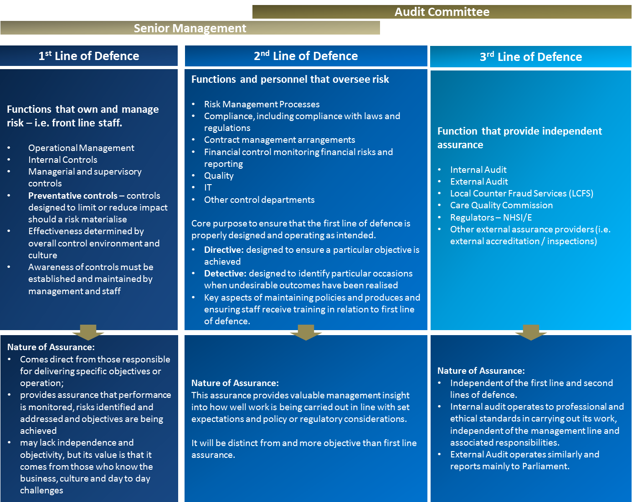

The Three Lines of Defence model provides a simple and effective way to enhance communications on risk management and control by clarifying essential roles and duties.

To ensure the effectiveness of the risk management framework, the board and senior management need to be able to rely on adequate line functions – including monitoring and assurance functions – within the organisation.

As illustrated here, the Three Lines of Defence model provides a means of explaining the relationship between these functions and as a guide to how responsibilities should be divided:

- the first line of defence – functions that own and manage risk
- the second line of defence – functions that oversee or specialise in risk management, compliance
- the third line of defence – functions that provide independent assurance

From Quarter 2 2019/20, the Three Lines of Defence Model was incorporated into the BAF against each Strategic Risk. Whilst this is expected to evolve further, it provides an alternative ‘lens’ for Board and Committee members to consider – particularly around identifying areas of potential weakness.

MEETING OF THE PUBLIC BOARD
Wednesday 1st APRIL 2021
Funding requirements and income impact to support Birth-Rate Plus and  Ockenden Recommendations. |  |  | AGENDA ITEM: 28
Report Author and Job Title: | Ann Marie Riley Director of Nursing | Responsible Director: | Ann Marie Riley Director of Nursing
Action Required | Approve ☒ Discuss ☒ Inform ☐ Assure ☐
Executive Summary | There is continued national scrutiny surrounding maternity services staffing and safety. The Ockenden Report, published in December 2020, highlights a need for services within England to ensure that they are staffed to the recommended level. This is a nationally mandated action required to be implemented by all providers of Obstetric Services across England.  One of the key recommendations of the Ockenden Report was regarding Maternity Workforce planning and requires that Maternity Services can demonstrate:  - An effective system of clinical workforce planning to the required standard  - An effective system of midwifery workforce planning to the required standard  Birth-rate plus is the national standard Midwifery workforce planning tool, endorsed by the Royal College of Midwives (RCM) and by the National Institute of Health and Clinical Excellence (NICE). Birth-rate plus reviews acuity and complexity of patients to identify required staffing levels for Maternity staffing. Ockenden also highlights that this will enable Maternity Services to implement quality improvements which has direct impact on safety both within Midwifery and Obstetric staffing.  In order to meet the Ockenden Report requirement in relation to staffing, this paper recommends: An increase in Clinical workforce presence, to enhance Obstetric staffing and implementation of the nationally recognised Birth-rate Plus Tool.
Recommendation | The Committee is asked to support recruitment within the Obstetric Unit at a cost of £711,000. The resources used to service enhancement in quality of care as per the national mandated  Ockenden Report recommendations.

 | Members are asked to note that the 2021/22 business plan will need to mitigate these costs, either through securing central income allocations, enhanced savings delivery and reinvestment or as a priority for investment from any development funds (through prioritisation of current financial envelopes for services).
Risk mitigation  included in the BAF or Trust Risk Registers | Risk Number 132  Risk Number 2257  Risk Number 2245
Resource implications | The utilisation of recurrent budgets previously created to service higher numbers of deliveries results in an adverse recurrent impact of £711k.  This will result in an increase in expenditure run rate and form a priority for investments recurrently when 2021/22 plans are developed.  The Trust is seeking funds from the STP to mitigate this financial impact, though owing to the financial climate cannot confirm funds to be received at this stage.
Legal and Equality and Diversity implications | Approval of this paper will improve the care of maternity patients and their babies, improving the numbers of healthy births by ensuring that all aspects of care is fully supported thereby reducing  perinatal and infant mortality in line with national targets.
Strategic Objectives | Safe, high quality care ☒ | Care at home ☐
Strategic Objectives | Partners ☐ | Value colleagues ☒
Strategic Objectives | Resources ☒

Obstetric Investment Case

- PURPOSE OF REPORT

The purpose of this report is to highlight the changes required to the multidisciplinary maternity workforce, to ensure appropriate staffing levels across all disciplines in response to the delivery of the Ockenden Report requirements (December 2020).
The Ockenden report actions are nationally mandated, required to be implemented by all providers of Obstetric Services across England, with the resultant impact upon the Maternity Service at Walsall resulting in the need to recruit to the Birthrate Plus recommendations.
This report identifies measures to be taken as a consequence of the recommendations from the report, financial costs associated with the investment and the potential resourcing options available to the Trust.

- BACKGROUND National Drivers
Safety in Maternity and Neonatal Services has been on the national agenda for a number of years and has seen increased focus since the release of the Ockenden Report in December 2020.

The Ockenden Report presented emerging findings and recommendations from an independent review of maternity services at the Shrewsbury and Telford Hospital NHS Trust that started in 2017 and initially involved 23 families. The current total number of families involved is 1862.

The report identified emerging themes from the review of the first 250 cases and highlighted 7 Immediate and Essential Actions (IEAs) required of all maternity services across England.

One of the required actions is compliance with Birthrate Plus recommendations which is a nationally recognised framework for Midwifery workforce planning (Birthrate plus reviews should be conducted 3 yearly).

Births

Following a CQC inspection in 2015 the Board approved a planned reduction in the number of births at Walsall Healthcare NHS Trust (WHT) to ensure sustainability of a safe service for our families. An agreement was made, in collaboration with neighbouring CCGs and Trusts, to reduce births from 4809 to 4200 (contracted activity), however actual activity was significantly lower, with 3603 births being delivered in 2017/18 and 3566 in 2018/19.

The demand for Walsall Maternity Services has also decreased as a direct result of a national downward trend in births. The latest national statistics on birth rate have also recently been published which shows a 2.5% decrease in the birth rate in England and Wales in 2019 compared to 2018 and a 12.2% decrease since the peak in 2012. The total fertility rate also decreased from 1.70 to 1.65 children per woman in 2019. This has only been lower in 1977 and during the years 2000 -2002.

Despite efforts to increase activity including a communications campaign to promote WHT Maternity Services, the organisation has been unable to increase activity to the contracted levels. This resulted in WHT delivering 3659 births in 2019/20 against a contract of 4200 births, with budgeted posts held vacant to off-set the financial impact of the reduced activity (income loss).

Birth-Rate Plus

Birthrate Plus is a nationally recognised framework for workforce planning and strategic decision-making that has been in use in many UK maternity units for a significant number of years.

It is based upon an understanding of the total midwifery time required to care for women and on a minimum standard of providing one-to-one midwifery care throughout established labour. The principles underpinning the Birthrate Plus methodology are consistent with the recommendations in the NICE safe staffing guideline for midwives in maternity settings, and have been endorsed by the Royal College of Midwives and the Royal College of Obstetricians and Gynaecologists.

Birthrate Plus caters for various models of providing care, such as traditional, community- based teams and caseload working. It is sensitive to local factors such as demographics of the population; socio-economic needs; rurality issues; complexity of associated neo-natal services, etc. The methodology remains responsive to changes in government policies on maternity services and clinical practices. Any maternity unit and service must be able to assess its staffing needs using a tried and tested system of workforce planning. Birthrate Plus

is the most widely used system for classifying women and babies according to their needs and utilises clinical outcome data to calculate the numbers of midwives required to provide intrapartum and postpartum care.

The maternity unit had a staffing review using the nationally accredited Birthrate Plus tool in 2017 which was set against a contracted 4200 births. The recommendations of this review were not implemented; however staffing was maintained at levels to provide a midwife to birth ratio of 1:28.

The Maternity Service is required to have a 3 yearly establishment review using the Birthrate Plus tool methodology. A further Birthrate Plus review was undertaken in 2020 against the reduced contracted activity level of 3790 births.

The contract for births has been set at 4200 in the contracting rounds since 2016. However, WHT has not achieved this level of activity for some years. The reduction in activity has been mitigated by the Maternity Service through operating an open and closed model on ward 25 (Ward Closures), with a significantly reduced staffing level.

Birthrate Plus®:

The maternity unit has had a staffing review using the nationally accredited tool, Birth rate plus, this is also part of the national recommendation in the Ockenden report (2020) and the national Transformation Programme (2016).
The Birthrate Plus report supports a minimal reduction in the number of Midwives (from current budgeted 149.52 wte for 4,200 births to 145.45 for 3790 births) despite the variance of the contract of 500 births. Birthrate Plus takes into account a broad range of factors including number of births, acuity, activity and the complexity of our population. Walsall is in the 10th most deprived districts in the country and 80% of our births are in the moderate to high risk categories which is higher than the national average.
To date the Maternity Service has not been able to fully implement its maternity transformation and innovation plans and has similarly not implemented the recommendations of either the 2017 or 2020 Birthrate Plus reviews. The respective risks in relation to lack of compliance with Birthrate Plus can be found on the Divisional risk register, (risk numbers 2245, 2257 and 132).
The Maternity service is able to fully implement Birth-rate Plus within its current staffing budget (the budget formed to support higher numbers of 4200 deliveries) but has been holding posts vacant owing to the reduced deliveries compared to plan on a non-recurrent basis. The current staffing model for the Maternity Service provides reduced resilience to deal with periods of peaks in activity and as a result impacts adversely on staffing levels

when there are absences e.g. maternity leave, long-term sickness or during periods of high levels of activity/acuity. There has been increased use of the staffing escalation policy which leads to Specialist Midwives and Midwife Managers being pulled away from quality improvement to support day to day activity. Whilst this is an agreed escalation as part of our business continuity plans, this is occurring too frequently.
The recruitment to all substantive posts will ensure staffing is in line with our current acuity and activity leading to improvements in the safety and care of mothers and babies receiving care at Walsall Healthcare Trust.
- PROPOSAL

Investment in Workforce redesign to provide sustainable staffing to deliver Ockenden Recommendations:

One of the key recommendations of Ockenden was Maternity Workforce planning and this includes that Maternity Services can demonstrate:

  - An effective system of clinical workforce planning to the required standard
  - An effective system of midwifery workforce planning to the required standard

The letter sent to Chief Executive Officers in December 2020 outlined the need for Trust Boards to have a plan in place to implement their Birthrate Plus recommendation. The Birthrate Plus recommendations were presented to Divisional governance in November 2020 and was shared with the Executive Director of Nursing on the 1st December 2020, and the Chief Operating Officer. The recommendations were presented to Performance and Finance Investment Committee in March 2021 and were approved in principle.

The Ockenden recommendations also outline the need for Obstetric Consultant Leadership in key areas:

  - Twice daily ward rounds (7 days per week)
  - Leading on Fetal Monitoring alongside a Midwifery Lead
  - Perinatal and Mortality Review Lead
  - Maternal Medicine and Perinatal Mental Health Leads
  - Audit and guidelines Leads
  - Quality Improvement Leads

Implementing the above would ensure that multidisciplinary training and working occurs within Walsall Healthcare NHS Trust. The Lead clinicians will ensure they are able to effectively lead on improving the practice of care, consolidating existing knowledge and keeping abreast of developments in the field. They will ensure that colleagues are engaged in the process to improve the safety of women and their babies.

The additional lead roles account for a further investment of 7 PAs. The service has reviewed the job plans based on a birth rate of up to 4000 births and reconfiguring of roles

as a result of recent staff turnover. This has provided flexibility to meet the recommendations within current resources subject to minimal additional investment, which will be met from within the Divisional budget. The delivery of the Ockenden recommendations will also require committed Administrative support.

- FINANCIAL IMPLICATIONS

The Division has a recurrent budget to service 4,200 births per annum. However, has historically non-recurrently held posts to support savings delivery and mitigate the reduction in the number of deliveries (reduced income).

The total value of posts held non-recurrently totals £711k per annum and this paper is seeking authority to release this budgeted (but held vacant to offset income reductions) resource to enhance quality of services in accordance with the Ockenden report recommendations.

To mitigate the increased costs for the service without the income from increased births, a development bid for funding has been made to the STP as part of the 2021/22 financial planning rounds, though owing to the current financial climate it is not possible to confirm if this bid will be successful. The paper therefore summarises the financial position to be:

Table 1: summary of financial position
Ref | Description | £000
1 | Investment required for action plan (Ockenden)  (net of Medical cost reduction for births less than 4,000) | 745
2  3 | Financed by;  Recurrent budget available  (held non-recurrently by the Division to mitigate lower actual births)  Additional shortfall  (to be identified through Divisional efficiencies) | (711)  (33)
4 | Residual shortfall | nil
5 | STP requested development funds | 745

There is a £745,000 requirement for resources to support the action plan developed in response to the nationally mandated Ockenden report findings (see table 1). The proposal being to seek approval for budgeted posts currently held vacant owing to deliveries being below plan to be released to recruit substantively to (item 2 in table 1).

Agreement to the above will result in an increased run rate cost for the Trust and is currently factored into the Q1 2021/22 plans, the following options are available to mitigate these costs:

- Seek additional resources from the STP national allocations
- Include as a cost any shortfall as a priority for resourcing through the development pot
- Re-prioritise resources for elective care to ensure overall financial balance as required

The Trust has now received national planning guidance, with funds totalling £80m hypothecated to support the enhancement of Obstetric Care in response to the Ockenden report (STP fair share totalling c£2m). However, the Trust is awaiting confirmation as to the level of resource to be received to support the financial costs associated with the recommended investment.

As the income allocation to the Trust remains uncertain, any release of budget will need to be treated as a first call on development funds and materialise as a cost pressure that requires resourcing within the 2021/22 financial plan (the cost included within the run rates for the first quarters 2021/22 financial planning).

The Director of Nursing, Chief Operating Officer and Director of Finance recognise and endorse the requirement to, if necessary, treat the development as a first call on 2021/22 development funds if STP funding is not received or re-prioritise services to ensure financial balance should development funds not be able to be identified (savings programs not create the headroom for investment in services).

- RECOMMENDATIONS

The Committee is asked to approve recruitment to the current budgeted posts at present held vacant owing to the reduced deliveries at a cost of £711,000 per year.

The investment of £711,000 per annum is to service enhancement in quality of care, as per the nationally mandated Ockenden report recommendations, in line with the Birthrate Plus workforce tool recommendations.
The funding mechanism, in order of preference, to be deployed is: Option 1: STP funding sought from nationally hypothecated funds
Option 2: Deliver efficiencies via 2021/22, first call on internal 2021/22 development fund Option 3: Re-prioritisation of elective non urgent funding to maintain overall financial balance

- NEXT ACTIONS

The business case is to be evaluated in accordance with the investment protocols through Performance, Finance and Investment Committee, examples of areas covered being;

- Actual costs incurred, STP income received and births compared to plan
- Enhanced Quality performance indicators achieved

It is of note these areas will be reviewed as part of the wider development of the financial plans for 2021/22 and recurrently onwards.

APPENDICES

Appendix 1 – Ockenden action plan (to include financial analysis)

